Mr. N. K. Kumbhar^{1*},
¹Department of Mechanical Engineering, GIT Khed, Mumbai University, India
*Corresponding Author: nkkumbhar@git-india.edu.in

Castor Oil-based Magneto-Rheological Fluids: Synthesis and Characterization
Abstract—Magneto-Rheological (MR) fluid technology is growing rapidly to satisfy challenging industrial applications. Few emerging high yield stress applications like MR brake, MR clutch, Liquid armour, etc. and low yield stress applications like MR damper, MR polishing tools, MR prosthetic knee, etc., still demand MR fluid formulation technology developments. MR fluid is a smart material that changes its phase from liquid to semisolid on the application of magnetic field and vice-versa within the shortest time of around 10 to 20 milliseconds. Commonly employed carrier fluids for the synthesis of commercially available MR fluids are mineral oils, synthetic oils, and silicone oils. However, fewer research articles are available on MR fluids that employ vegetable oils as a carrier fluid. In this research, the study of different MR fluid applications has been made and identified requirements for applications like working temperature, allowable off-state viscosity range, required yield stress etc. Likewise, the components of MR fluid have been selected and castor oil-based MR fluid samples are synthesized, which will suit low as well as high yield stress applications. Castor oil as a carrier fluid and carbonyl iron powder as a magnetic material with different concentrations has been used to synthesize different samples. Oleic acid is used as an antifriction additive, grease as a stabilizer, and used to reduce agglomeration guar gum coating. These MR fluid samples and commercially available Lord MR Fluid 132 DG have been characterized and the results have been compared to select the best possible MR fluid.

Index Terms—Magneto-Rheological (MR) fluid; Vegetable Oil; Castor Oil; Applications; Synthesis; Characterization

INTRODUCTION
Magneto-rheological (MR) fluid falls under the category of emerging and developing research materials whose rheological characteristics (viscosity, yield strength etc.) can be varied rapidly under the influence of the magnetic field. MR fluids are basically the suspensions of polarizable magnetic particles in the magnetically neutral carrier or base fluid. These suspended magnetic particles interact with the application of a magnetic field to produce a structure like a chain that is resistant to shear deformation or flow [1,2]. These chain-like structures limit fluid movement and thereby increase viscous suspension characteristics. This change in the material results in the rapid increase of apparent viscosity and hence reaches the semisolid state. Some additives and surfactants are also added in MR fluids in order to enhance their properties to suit the various industrial applications [3]. This fluid follows the Bingham plastic model and can be best explained with the help of equation I.
$τ = τ_{y(H)} + µ_{p}\dot{γ}$ (I)
Where $τ$ is the total yield stress produced, $τ_{y}$ is the yield stress produced due to applied magnetic field H, $µ_{p}$ is constant plastic viscosity and $\dot{γ}$ is the shear-strain rate.

Literature Review
Shetty and Prasad [4] synthesized and characterized honge oil-based MR fluids and they came to know that yield stress produced by these MR fluid samples could not exceed a typical value of around 45 kPa. Seval Genc [5] used several iron powder grades (grade A, grade B), PDMS and A surfactant in the synthesizing of MR fluids. MR fluids based on glycol ether have also been developed. One of the main outcomes of this research was the impact of remanent magnetization of 33 vol% iron, MnZn ferrite and NiZn ferrite-based MR fluids on the magnetic dipole-dipole interaction energy on the redistribution of MR fluids. Sarkar and Hirani [2] discussed MR fluid synthesis for braking application. Results demonstrated that the synthesized MR fluid is stronger and faster than Lord MRF 241ES. Kciuk et al. [6] reported MR particle experimental findings and evaluated their flow behaviour by changing the external magnetic field in relation to the interior structure development. The shape of the investigated MR fluids was examined, magnetic characteristics, sedimentation stability, and magneto-rheological parameters. Model MR fluids were created by Turczyn and Kciuk [7]. The basic characteristics of produced MR fluids were studied with their external magnetic field response and stability. The literature review also reveals that vegetable oil-based MR fluids can replace conventional oil-based MR fluids. However, no research articles report on castor oil-based MR fluids with varying magnetic powder concentrations.

Applications
Recent developments in MR fluid technology lead to the satisfaction of customer needs and application demands. Many advanced MR fluid applications are coming into the market and hence research is still going on to satisfy these competency levels of applications. A study on the following applications has been made and their requirements from yield stress, off-state viscosity and working temperature range point of view have been analyzed and tabulated in Table I. Allowable off-state viscosities range plays an important role in many applications as it may lead to power loss if exceeds a typical value.

TABLE I
Applications and Requirements
Sr. No. | Applications | Off State Viscosity Range (Pa.s) | Yield Stress (kPa) | Temp range (⁰C)
1 | Damper | 0.11 | 45-50 | 25-150
2 | Prosthetic knee | 0.09 | 35 | 10 to 70
3 | Polishing Tool | 0.07 | 40 | >100
4 | Semi-active suspension system | 0.07 | 45-50 | 10-140
5 | Adaptive landing gear for helicopter | 0.04 | 40-60 | -
6 | MR Brake | 0.27 | >150 | >80
7 | MR Clutch | 0.27 | >250 | >95
8 | Liquid Armor | 360 | >100 | -
9 | Heavy vehicle damper | 0.107 | 50-100 | 100-150

Table I shows most of the practical applications demand 35-100 kPa of yield stress and in this research paper, emphasis is made on such applications.

MR FLUID SYNTHESIS
The main phases of MR fluid synthesis are:
A. Selection of Components
B. Coating of carbonyl iron particles
C. Synthesis process

Selection of Components
Conventional MR fluid components with their major sub
components used for its formulation are as shown below:
MR fluid Components

Carrier Fluid Magnetic Particles Additives and
(e.g., Mineral Oil, (e.g., Electrolytic and Surfactants
Synthetic Oil, Carbonyl Iron powders) (Grease, Oleic Acid, Citric
Silicone Oil etc.) Acid, Aerosil 200 etc.)

1) Carrier Fluid:
Commonly used carrier fluids for conventional MR fluids synthesis are mineral oils, synthetic oils and silicone oils [9]; however, these are not environmental friendly as all are petroleum-based products. Research is going in many fields to find out alternative energy sources as petroleum-based products are likely to be depleted in few years. Hence these lead us to find out the replacement of these types of carrier fluids with vegetable oils. A study is made on different types of vegetable oils; their properties have been analyzed, as shown in Table II. A wide temperature range, less cost and viscosity made us select castor oil as a carrier fluid for further MR fluid synthesis.

TABLE II
Properties of vegetable oils
Properties\Carrier fluid | Honge oil | Castor oil | Maize oil | Sunflower oil
Viscosity (PaS) | 0.048 | 0.03 | 0.05 | 0.03
Flash point | 230 | 270 | 320 | 316
Pour point | -3 | -3.3 |  | -18
Cloud point | 19 |  | -14 | -9
Yield shear stress Kpa | 25-30 | 20-40 | - | 40
Market cost (Rs/lit) | 120 | 80 | 110 | 120

2) Magnetic Particles:
Commonly used magnetic particles are electrolytic and carbonyl iron particles [9]. A study is made on different properties of these iron particles, and we have selected carbonyl iron particles for our research. Magnetic iron particles of 10μm have been selected as at this size these particles are shows spherical shape which results in strengthening of bonds and reduces shape anisotropy. In literature, it has been found that the concentration of particles used is around 30-50% for conventional carrier fluids [10,11]; however, because of the low initial viscosity of the castor oil, 45-65% concentration is used for this research

2) Additives and Surfactants:
The additives help to keep the particles suspended in the carrier fluid. At the same time, the surfactants improve the surface properties of magnetic particles as they are absorbed in the surface of it [12]. In this research, oleic acid is used as an antifriction additive and grease as a stabilizer.

Coating of Carbonyl Iron Particles
Coated magnetic particles improve sedimentation, stability and decrease MR fluid agglomeration. The guar gum is selected for electrolytic and carbonyl iron powder coating in this investigation. By creating a coating layer of the CI powder, the guar gum substantially enhances the stability of the sedimentation and MR thixotropy [13]. The guar gum’s hydrogen bonds can play an essential role because they build up a network across all of the particles covered by guar gum.
In the MR fluids synthesis, specific water and guar gum power quantities were combined at 400 rpm for 30 minutes to create a guar gum water solution. First, the iron powder is cleaned with acetone, then dried and added to the gel and mixed at 600 rpm for 30 minutes. Ethanol then was progressively added to the gelatine combination, leading to the precipitation of guar gum and the formation of an iron powder coating layer.

Nomenclature
The nomenclature system used for this study is shown in Table III.

TABLE III
nomenclature
Sr. No | Nomenclature | Interpretation
1 | CIC 45% | 45% Carbonyl iron (CI) powder and castor oil
2 | CIC 55% | 55% Carbonyl iron (CI) powder and castor oil
3 | CIC 65% | 65% Carbonyl iron (CI) powder and castor oil

Synthesis Plan and Process
A mechanical stirrer is used for the Synthesis of MR fluids.
The first step is to mix carrier fluid (castor oil) and additives (grease and oleic acid) for 40 minutes at 500 rpm. Then the volume of coated magnetic particles is added to it and mixed for 24 hrs at 800 rpm. The detailed synthesis plan is shown in Table IV.
TABLE IV
synthesis plan
Sample  Name | Carrier Fluid | Metal particles | Additive  and surfactants (Grease+ Oleic Acid)
MRF CIC 45%  (250 ml) | Castor Oil [54% by vol.] | CI Powder  [45% by vol.] ~10μm | 1% by vol.
MRF CIC 55% (250 ml) | Castor Oil [44% by vol.] | CI Powder  [55% by vol.] ~10μm | 1% by vol.
MRF CIC 65%  (250 ml) | Castor Oil [34% by vol.] | CI Powder  [65% by vol.] ~10μm | 1% by vol.

These three MR fluid samples have been synthesized and then moved towards characterization for analyzing and comparing their properties.

Characterization
Three types of measurements have been done on the locally made MR fluids and lord 132 DG MR fluid sample. Rheological measurements have been carried out on Parallel plate rheometer, morphological measurements have been done with the help of scanning electron microscopy and magnetic properties of iron powder have been found out by using vibrating sample magnetometer.

Results and discussion
Morphological, rheological and sedimentation stability measurements on Lord MR fluid and synthesized MR fluid samples have been done and the results obtained have been compared to decide the superiority of particular MR fluid among all these MR fluid samples.

Morphological Measurements
Fig. 1 (a) shows the difference between the morphology of uncoated carbonyl iron (Fig 1 (a)) and coated carbonyl iron powders (Fig 1 (b)). As shown in Fig. 1 (b), the guar gum coating layer has been developed on the carbonyl iron particle surface
(a) (b)
Fig. 1 SEM images of (a) Uncoated carbonyl iron powder
(b) Coated carbonyl iron powder

Rheological Measurements
The OFF state and ON state measurements have been done on all the MR fluid samples.
1) OFF State Measurements
Lord Corporation 132 DG MR fluid and synthesized MR fluid samples have been tested on the Parallel Plate Rheometer. The viscosity for different samples is then compared to a changing shear rate, as illustrated in Fig. 2.
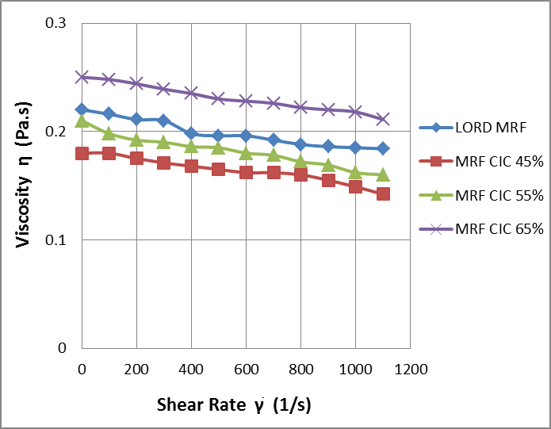
Fig. 2 OFF viscosity change with varying shear rates
As illustrated in Fig. 2, viscosity drops as the shear rate increases. The rate of decrease in viscosity needs to be less as possible. The rate of change of viscosity is greater for Lord MR fluid as compared to locally made MR fluid samples. From this point of view, CIC 45% and CIC 55% MR fluid samples depicts better results. As Off state viscosity of MR fluid CIC 65% is a bit high, and hence even viscosity decrease rate is less, its viscosity remains greater than the Lord MR fluid.

2) ON State Measurements
The rheological measurements have also been carried out in ON state means on the application of Magnetic Field.
As shown in Fig. 3, the maximum yield stress of MRF CCI 65% is about 90.34 kPa whereas MRF CIC 55%, 85.6 kPa; MRF CIC 45%, 75.23 kPa and Lord MRF shows 83.32 kPa of yield stress. As the percentage concentration of particles is more in CIC 65% and CIC 55%, they show higher yield stress than Lord MR fluid.
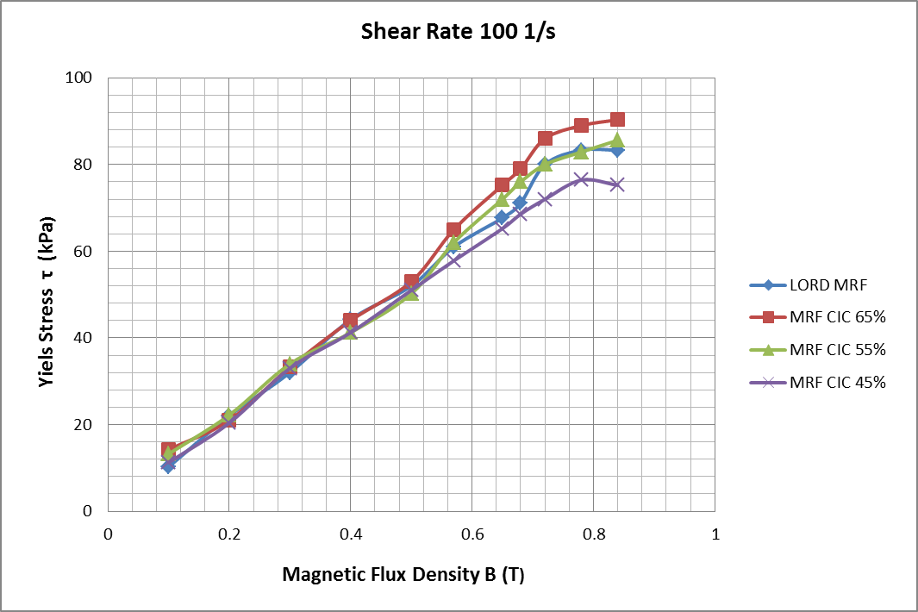

Fig. 3 Yield stress versus Magnetic flux density
3) Sediment Stability
The stability of the MR fluid samples relies on the iron particles concentration and also on the type of oil used. Sedimentation is the unwanted MR fluid property that makes it unstable. The sedimentation ratio can be calculated with the help of the following relation.
$Sedimentation Ratio=\frac{Volume of Supernatant}{Total Volume of MR Fluid} ×100\%$
Fig. 4 illustrates the sedimentation ratios of the particles with and without additives for different samples.
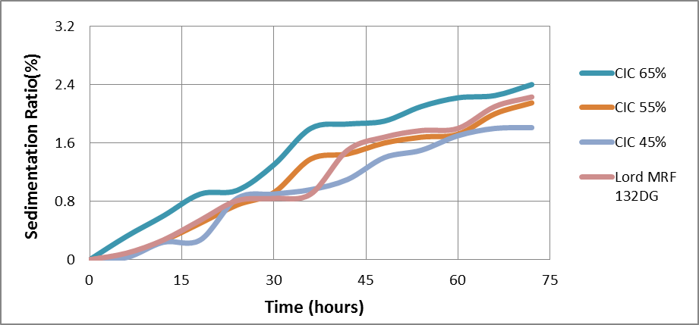
Fig. 4 Sedimentation ratios versus time
The combined effect of stabilizer (grease) and gaur gum coating on the sedimentation stability of the MR fluid is observed here. This effect greatly reduces sedimentation. This graph depicts that the sedimentation ratio for MR fluid CIC 65% is a bit more than Lord MR fluid. It is because of its particles concentration; however, CIC 55% and CIC 45% show better sedimentation stability than commercially available Lord MR fluid. This indicates that the stabilizer and coating of guar gum improve the stability of sedimentation of MR fluids.

Conclusions
Results and discussions can be concluded as follows:
- MR fluid sample CCI 65% is the best choice for high yield stress applications, but it shows a higher sedimentation ratio.
- MR fluid sample CCI 45% and CCI 55% suits well from yield stress as well as sedimentation point of view.
- CCI 45% MR fluid sample shows less off-state viscosity and yields better results than commercially available Lord MR fluid, and hence it is highly recommended for low yield stress applications.

Acknowledgement
“Authors thank Gharda Institute of Technology, Khed, and Veermata Jijabai Technological Institute, Matunga for providing support in carrying out this research’’.

References
[1] Park, B. J., Fang, F. F. and Choi, H. J., 2010, “Magnetorheology: Materials and Applications,” Soft Matter, pp. 5246–5253.
[2] Sarkar, C. and Hirani, H., 2013, “Synthesis and Characterization of Antifriction Magneto-rheological Fluids for Brake,” Defence Science Journal, Vol. 63, No. 4, pp. 408-412.
[3] Olabi, A. G. and Grunwald, A., 2007, “Design and Applications of Magneto-rheological Fluid, Materials and Design,” Elsevier, 8, pp. 2658–2664.
[4] Shetty, B. G. and Prasad, P.S.S., 2011, “Rheological Properties of a Honge Oil-based Magneto-rheological Fluid used as Carrier Liquid,” Defence Science Journal, Vol. 61, No. 6, pp. 583-589.
[5] Genc, S., 2002, synthesis and properties of magneto-rheological (MR) fluids, Ph.D. Dissertation, University of Pittsburgh.
[6] Kciuk, M., Kciuk, S., Turczyn, R., 2009, ‘Magnetorheological Characterization of Carbonyl Iron based Suspensions’, Journal of Achievements in Materials and Manufacturing Engineering, Vol. 33, pp. 135-141.
[7] Turczyn, R. and Kciuk, M., 2008, “Preparation and Study of Model Magnetorheological Fluids,” Journal of Achievements in Materials and Manufacturing Engineering, Vol. 27, pp. 131-134.
[8] http://www.lord.com/products-and-solutions/magneto-rheological-%28mr%29.xml
[9] Phule, P. P., 2001, “Magnetorheological (MR) Fluids: Principles and Applications,” Ph. D. Dissertation, University of Pittsburgh, USA.
[10] Spaggiari, A., 2013, “Properties and applications of Magnetorheological Fluids,” The Italian Research on Smart Materials and MEMS, pp. 57-61.
[11] Edward, J., Park, Luis Falcao da Luz, Suleman, A., 2007, “Multidisciplinary Design Optimization of an Automotive Magnetorheological Brake Design,” Computers and Structures, 86, pp. 207-216, Elsevier.
[12] Baranwal, D. and Deshmukh, T. S., 2012, “MR Fluid Technology and Its Application- A Review,” International J Emerging Technology and Advanced Engineering, pp. 563-569.
[13] Fang, C., Zhao, B.Y., Chen, L.S., Wu, Q. & Hu, N.L.K., 2006, “The effect of Green Additive Guar Gum on the Properties of Magnetorheological Fluid. Smart Mater. Struc., 14(1), pp. 94-99.

