Biodiversity in Western Rajasthan: Mammalian Diversity and Conservation Strategies
*Aazad Prakash Ojha¹, Khagendra Kumar², Vishu Vaishnav³
¹Udit Narayan P.G. College, Padrauna, Kushinagar (Uttar Pradesh)-274304
² Govt. College, Barmer (Rajasthan)-344001
³ G.D. Memorial College, Jodhpur (Rajasthan)-342005

*aazad.ojha@hotmail.com

ABSTRACT
Western Rajasthan (WR), located in northwestern India, is known for its unique arid and semiarid ecosystems, rich cultural heritage, and diverse mammalian fauna. This study, conducted from 2017 to 2022, investigated mammalian diversity, threats to their survival, and potential conservation strategies in WR. The region's harsh desert conditions, characterized by extreme temperature variations, low rainfall, and climatic events, support the adaptation of a wide range of mammalian species to arid environments. This study identified several small mammalian species, such as rodents and insectivores, as well as large predatory mammals, including the Indian grey wolf, striped hyena, Indian golden jackal, and the Indian desert fox. The prey population consists of ungulates such as blue bulls, blackbuck, and chinkara. However, the region's biodiversity is threatened by rapid urbanization, infrastructure development, population growth, and technological advancements, leading to habitat destruction and fragmentation. This study highlights the importance of conservation strategies such as protected area management, community engagement, habitat restoration, and anti-poaching efforts to mitigate these threats and preserve WR's unique mammalian diversity of WR. Furthermore, the research emphasizes the need for sustainable practices to address issues such as desertification and human-wildlife conflicts. By examining the distribution, status, and ecological roles of mammals in WR, this study aims to inform policy and management decisions to ensure long-term conservation of the region's biodiversity for future generations.

KEYWORDS: Biodiversity; Mammals; Thar Desert; Arid ecosystem; Sustainable practices.

INTRODUCTION:
Biodiversity encompasses species, genetic, and ecosystem diversity and plays a crucial role in ecosystem services vital for human survival, such as nutrient cycling, pollination, and climate regulation (Rathoure, 2024; Singh & Chaudhary, 2024). Beyond ecology, biodiversity impacts human well-being, economic systems, cultural values, and ethics (Kellert 1996; Rathoure 2024). However, the economic valuation and management of biodiversity complexity present challenges (Demir, 2013; Gustafsson, 2014). Sole economic approaches are insufficient, necessitating a comprehensive understanding that includes non-use values and sociocultural dimensions (Demir, 2013; Kellert, 1996). The co-production of facts and values indicates that managing the complexity of biodiversity is better than oversimplification (Gustafsson, 2014).
Western Rajasthan (WR), which is located in northwestern India, is notable for its cultural heritage and biodiversity. The arid and semi-arid landscapes support a unique ecosystem adapted to harsh desert conditions. The Great Indian Thar Desert (GITD) covers much of this region and features dunes, rocky outcrops, and sparse vegetation. Despite extreme heat and limited water, the area hosts diverse plant and animal species with specialized adaptations. WR's arid geography of WR, characterized by aeolian formations such as sand dunes, complicates groundwater assessment because of scarce water and concealed older geological formations (Khan et al., 2006). The climate of the region, influenced by the El Nino-Southern Oscillation (ENSO), features significant droughts with varying severity, duration, and peak, modulated by ENSO phases (Ganguli & Reddy, 2013). Vegetation displays distinct spectral characteristics in the visible and near-infrared spectra that are affected by climatic conditions and plant health (Kumar et al. 2002). Climate change also correlates with disease prevalence, such as mycetoma, which is influenced by increased rainfall and irrigation (Mathur & Bakshi, 2008). Desertification in the Pushkar — Budha Pushkar region of Aravallis, driven by human activities, underscores the need for sustainable practices (Kar, 1986).
WR's cultural heritage spans thousands of years and is influenced by various civilizations and dynasties, resulting in a blend of traditions, art, and architecture. Traditional practices and cultural beliefs have played a crucial role in conserving biodiversity in WR. The Bishnoi community's reverence for wildlife, particularly the blackbuck (Antilope cervicapra), illustrates how cultural values support conservation. For over 500 years, the Bishnois have protected animals and trees as part of their religious customs, successfully preserving significant blackbuck populations amid habitat loss. Another example is the sacred groves, or orans, which serve as biodiversity sanctuaries. Integrating these cultural practices into national conservation strategies, such as Community Conserved Areas (CCAs), underscores the importance of cultural heritage in contemporary conservation efforts (Pathak & Kothari, 2013). This region is dotted with ancient forts, palaces, and temples, highlighting its rich history. Local communities, including the Rajputs and tribal groups, maintain distinct customs and traditional crafts and enrich cultural tapestry. This blend of natural and cultural significance makes WR a compelling subject for ecological and cultural research. The WR ecosystem is notable for its unique physical characteristics and endemic species, such as the Great Indian Bustard (Ardeotis nigriceps) (Ojha et al., 2017a). The Thar Desert (TD) experiences extreme temperature variations, low rainfall, and climatic events such as dust storms. Despite harsh conditions, it supports diverse habitats and micro-ecosystems with species across various taxonomic groups. However, biodiversity is threatened by rapid urbanization, infrastructure development, population growth, and technological advancements, leading to habitat destruction and fragmentation. In Rajasthan, recent governmental initiatives have shown mixed results in biodiversity preservation. Conservation efforts in areas like Desert National Park have protected species such as the Great Indian Bustard (Ardeotis nigriceps), but urban growth and agricultural expansion have fragmented habitats (Athreya et al., 2016). The government has introduced compensation programs to mitigate human-wildlife conflicts, especially involving large predators like leopards and wolves. However, the effectiveness of these measures is debated, as rapid infrastructure development still threatens wildlife corridors and natural habitats (Johnson et al., 2018). Conservation strategies are critical to protect these species and their habitats.
This study, conducted from 2012 to 2022, focused on mammalian diversity in WR, covering various districts and tehsils. It investigates the presence of mammalian species, threats to their survival, and potential mitigation strategies for human-wildlife conflicts. By examining the distribution and status of large and small mammals, including endemic species, this study enhances our understanding of the region's ecological dynamics and informs conservation management. These findings highlight WR's importance of WR as a habitat for many mammalian species, including predators such as the Indian grey wolf (Canis lupus) and striped hyena (Hyaena hyaena) and prey species such as the blue bull (Boselaphus tragocamelus) and blackbuck (Antilope cervicapra) (Ojha et al., 2017a; Rajpurohit et al., 2011). This study addresses conservation challenges, such as habitat degradation, human-wildlife conflicts, and agricultural expansion. By examining mammalian diversity in WR and its threats, this study aims to develop effective conservation strategies, including protected area management, community engagement, habitat restoration, and anti-poaching efforts. A landscape view of the TD is shown in figure 1.
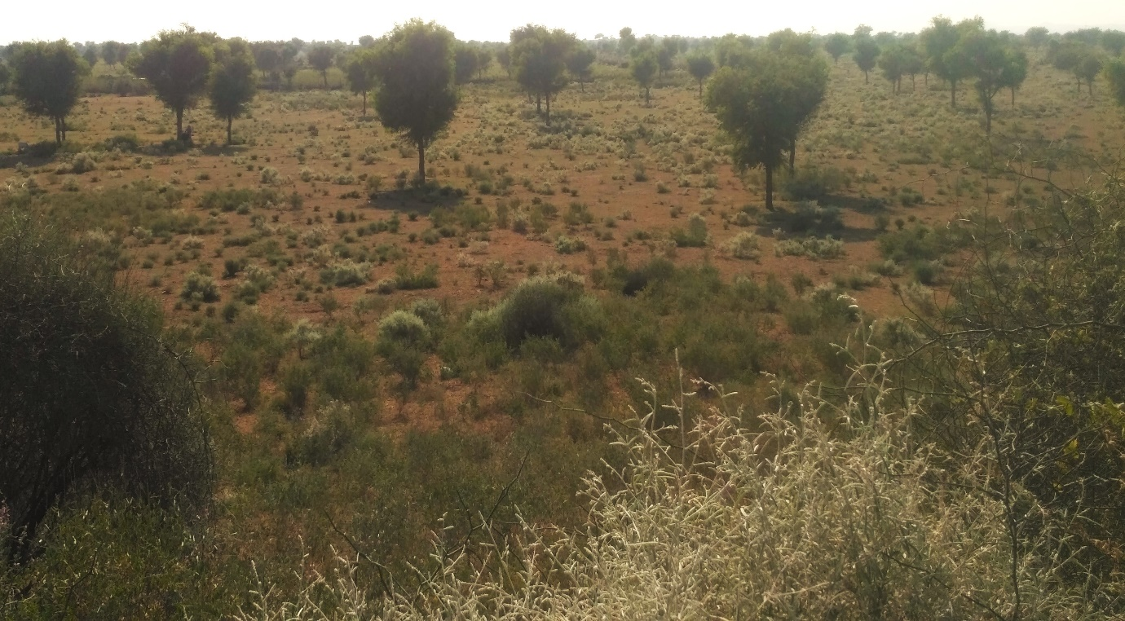
Figure 1: Landscape view of the Thar Desert showing habitat for mammalian species.

MAMMALIAN DIVERSITY IN WESTERN RAJASTHAN
Mammalian fauna in WR is vital for maintaining the ecological balance of the region. These species are adapted to harsh arid conditions and exhibit remarkable adaptability and endurance. The mammalian diversity in WR includes various species that are suited to arid environments. Several small mammalian species such as rodents and insects have been identified. House Shrew, an insectivore, is the most abundant in the eastern hilly zone of the state (Singh et al., 2013a). Rodents are the largest order of small mammals in Rajasthan, with 22 reported species including Petaurista philippensis, Vandeleuria oleracea, and several Mus species (Singh et al., 2013b). However, no endemic mammalian species have been reported in WR. Mammals have multifaceted ecological roles. Rodents, often considered pests because of their impact on crops, also play crucial roles in seed dispersal and soil aeration (Singh et al., 2013b). Urbanization and irrigation in Jodhpur have altered habitats, changed species composition, and highlighted the dynamic nature of these mammals' ecological roles in response to environmental changes (Singh, 2009). TD is home to significant predatory mammals, including the Indian grey wolf (Canis lupus), striped hyena (Hyaena hyaena), Indian golden jackal (Canis aureus), Indian desert fox (Vulpes v. pusilla), and wild boar (Sus scrofa). The prey population consisted of blue bulls (Boselaphus tragocamelus), blackbucks (Antilope cervicapra), and chinkara (Gazella g. benneti). Other notable consumers include rhesus macaques (Macaca mulatta), Hanuman langurs (Semnopithecus entellus), desert cats (Felis lybica), mongooses (Herpestes edwardsii), porcupines (Hystrix sp.), and desert hedgehogs (Hemiechinus auritus) (Ojha et al., 2017a). Rajpurohit et al. (2011) identified five mammalian predator species in the Jodhpur city periphery of Western Rajasthan (WR), while Ghosh (1996) documented approximately fifty mammalian species in this arid region. Some of the observed mammalian species are shown in figure 2.
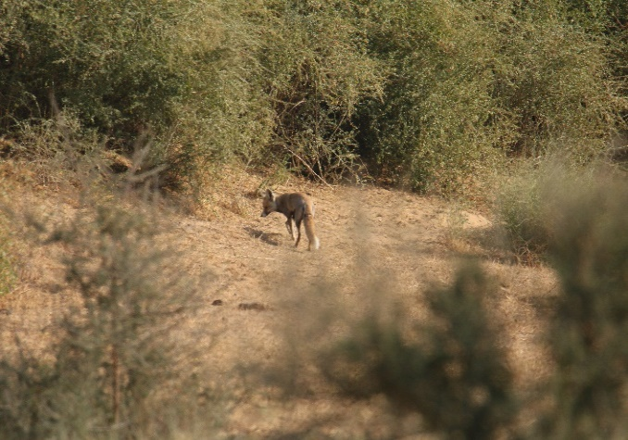
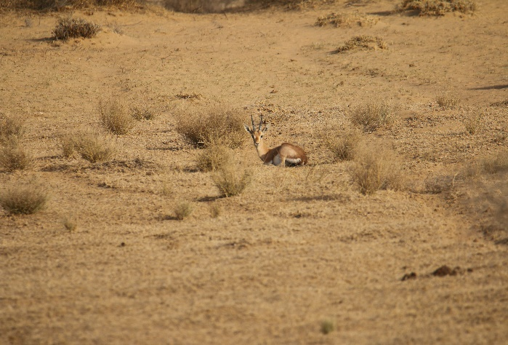

Figure 2: Mammals species documented during study (Left- Chinkara; Right- Desert Fox)
The WR livestock population surpasses that of wild animals, potentially jeopardizing biodiversity through extensive grazing. The primary grazers of natural vegetation in WR include ungulates, such as blackbuck, blue bull, chinkara, wild boar, and significant populations of desert hares, langurs, and squirrels (Saxena and Prakash, 1992; Ojha et al., 2023). Consequently, WR boasts of diverse mammalian fauna, including large, small, and endemic species.
Large mammals (LM), typically including wolves, panthers, wild dogs, hyenas, blue bulls, and chinkaras, lack a strict definition but are generally of substantial size. WR hosts many LM species adapted to arid conditions of the GITD, such as the Indian leopard (Panthera pardus), Asiatic lion (Panthera leo), Indian wolf (Canis lupus pallipes), and Indian wild ass (Equus hemionus) (Pocock, 1939; Nowell & Jackson, 1996; Gopal, 2005). This arid environment also supports a variety of small mammals, including rodents, shrews, bats, and carnivores, such as the desert fox (Vulpes v. pusilla) and the Indian desert jird (Meriones hurrianae) (Molur et al., 2005; Sagar & Singh, 2015). Despite their size, these small mammals are essential for seed dispersal, pest control, and maintenance of soil quality in desert ecosystems.
NATIVE (ENDEMIC) SPECIES IN THE WESTERN RAJASTHAN
The Western Region (WR) hosts several mammal species unique to its desert ecosystem, such as the Indian desert gerbil (Meriones hurrianae) and the long-eared hedgehog (Hemiechinus collaris) (Acharya et al., 2009; Molur et al., 2005). The presence of these species highlights the need to preserve the region's natural heritage. Scientists, conservationists, and zoologists are working to maintain the endemic status of these species. This underscores the importance of targeted conservation strategies and the continued research on the ecological needs and adaptations of these mammals. Potential threats like habitat loss or climate change require immediate attention, emphasizing the critical role of collaboration among scientists, conservationists, and policymakers in preserving the region's biodiversity (Ojha et al., 2024)
CONSERVATION CHALLENGES
Mammalian biodiversity faces significant threats from anthropogenic factors, such as habitat loss, fragmentation, human-wildlife conflict, and poaching. Habitat destruction and fragmentation reduce suitable environments, forcing animals closer to human settlements and intensifying conflict (Gupta et al., 2023). Poaching and illegal wildlife trade directly reduce populations and disrupt ecological balance (Becerra et al., 2022; Gomez et al., 2021). In western Argentina, although birds are frequently poached, mammals are disproportionately targeted for meat and fur (Becerra et al., 2022). In Asia, bears are increasingly used in traditional medicine and other parts of the world (Gomez et al., 2021). Illegal wildlife trade is a major global crime that affects biodiversity and ecosystem services (Wang, 2024). In WR, rapid urbanization, agriculture, and infrastructure development fragment habitats that threaten mammalian survival (Gopal, 2005). Habitat loss disrupts migration, reduces genetic diversity, and increases the vulnerability to extinction. Anthropogenic activities in WR push mammals into human settlements, leading to conflicts, especially with large carnivores, such as leopards and wolves (Athreya et al., 2016). These conflicts foster negative perceptions and retaliatory action. For instance, Ojha and Rajpurohit (2018) reported a wolf attack on humans in Bara Kalan Village, WR. Human population growth and expanded agriculture in WR pressure wild habitats, forcing mammals to shift to less-disturbed areas. Additionally, feral dogs in WR threaten native species, killing chinkara, blue bulls, black bucks, Indian desert foxes, rhesus monkeys, Hanuman langurs, desert cats, mongooses, porcupines, and desert hedgehogs (Ojha et al., 2024).

CONSERVATION MANAGEMENT APPROACHES IN WESTERN RAJASTHAN
Conservation efforts in Western Rajasthan include strategies such as establishing and managing protected areas and national parks, implementing government policies, and facilitating NGO and community-based programs. Key protected areas, such as Ranthambhore National Park and Sariska Tiger Reserve, along with Ramsar Sites, such as Keoladeo National Park, are vital for preserving biodiversity and supporting species such as tigers and migratory birds (Sharma et al., 2013). Community conservation practices, including sacred groves (orans) and species protection such as Blackbuck, involve local participation and highlight the need to recognize Community Conserved Areas (CCAs) (Pathak & Kothari, 2013).
Government initiatives, such as financial compensation for human-wildlife conflict (HWC), aim to balance human security and biodiversity but have been criticized for favoring charismatic megafauna over local livelihoods and being bureaucratically controlled (Johnson et al., 2018). NGOs contribute significantly to conservation, although their policies sometimes struggle to reconcile conservation with development. Organizations such as the IUCN and WWF have historically promoted national parks, occasionally in conflict with local development priorities (Macekura, 2015). Community-based conservation programs involving local participation have successfully resolved conflicts and reduced illegal wildlife extraction, suggesting sustainable models for tourism and conservation (Ngoka and Lameed, 2013).
Conservation initiatives in western Rajasthan involve a multifaceted approach that combines protected areas, governmental policies, and efforts from communities and non-governmental organizations. While protected areas serve as crucial biodiversity havens, government policies must be tailored to local needs, and NGO strategies should be in line with development objectives. These efforts encompass Desert National Park in the Jaisalmer and Barmer districts, various community reserves, and state-managed protected forests. Traditional practices, such as Oran land conservation and the Bishnoi community's wildlife stewardship, play a significant role. Ojha et al. (2017b) emphasize Oran conservation as an exemplary model for effective wildlife preservation in western Rajasthan.
A crucial step in safeguarding mammalian species in western Rajasthan is the involvement of the local communities. Engaging residents in protection efforts is essential for reducing human-wildlife conflicts and garnering support for conservation programs (Athreya et al. 2016). This can be achieved by collaborating with local communities and enlisting the help of religious leaders (Mahatmajee/Maharajee/Mollavijee) to educate people on the importance of wildlife conservation. Utilizing various media channels such as newspapers, television, radio, and posters, along with social media platforms such as Twitter, Instagram, and Facebook can serve as valuable tools for raising awareness and disseminating information. (Ojha et al. 2017b)
Thus, Implementing natural habitat restoration across the Wildlife Reserve (WR) is essential. Initiatives should address desertification, reforestation, land use planning, water conservation, and rainwater harvesting. These measures will restore degraded habitats, bolster ecosystem resilience, and provide crucial wildlife resources. Enhanced enforcement of wildlife and environmental protection laws is also necessary to combat poaching, hunting, and illegal wildlife trade, which are crucial for mammalian conservation. Strict law enforcement is essential for effective anti-poaching efforts in WR (Ojha et al., 2024).

CONCLUSION:
In conclusion, the biodiversity of Western Rajasthan, particularly its mammalian diversity, faces significant challenges due to anthropogenic pressures, habitat loss, and human-wildlife conflicts. The region's unique arid ecosystem supports a diverse array of species, from large predators to small endemic mammals, each of which plays a crucial ecological role. Conservation efforts in this area require a multifaceted approach that combines PA management, government policies, and community-based initiatives. The involvement of local communities, traditional conservation practices, and awareness campaigns is vital for successful conservation outcomes. Addressing challenges such as habitat fragmentation, poaching, and human-wildlife conflicts is crucial for preserving the region's biodiversity. Future conservation strategies should focus on habitat restoration, stricter law enforcement, and sustainable development practices to balance human needs with wildlife protection. By integrating scientific research, traditional knowledge, and innovative conservation approaches, Western Rajasthan can safeguard its rich mammalian diversity for future generations. Long-term monitoring programs and ecological studies are essential to track population trends and assess the effectiveness of conservation measures. Collaborative efforts between government agencies, research institutions, and non-governmental organizations can enhance the scope and impact of conservation initiatives. Additionally, promoting eco-tourism and sustainable livelihoods can create economic incentives for local communities to participate actively in biodiversity conservation efforts.

REFERENCES:

Acharya, P., Molur, S., & Walker, S. (2009). Mammals of South Asia: Volume 2. Universities Press.

Athreya, V., Odden, M., Linnell, J. D. C., & Karanth, U. (2016). A cat among the dogs: Leopard Panthera pardus diet in a human-dominated landscape in western Maharashtra, India. Oryx, 50(1), 156-162

Becerra, S., Borghi, C. E., & Marinero, J. (2022). Poaching and illegal wildlife trade in western Argentina. Ethnobiology and Conservation, 11. https://doi.org/10.15451/ec2022-01-11.05-1-15

Demir, A. (2013). Economic of biodiversity: The importance of studies aimed at assessing the economic value of biological diversity. African Journal of Agricultural Research, 8(43), 5375–5385. https://doi.org/10.5897/ajar2013.7850

Ganguli, P., & Reddy, M. J. (2013). Analysis of ENSO-based climate variability in modulating drought risks over western Rajasthan in India. Journal of Earth System Science, 122(1), 253–269. https://doi.org/10.1007/s12040-012-0247-x

Ghosh, A. K. (1996). The Thar desert ecosystem. In Faunal diversity in the Thar desert, gaps in research (pp. 1-18). Scipublishers.

Gopal, R. (2005). Conservation biology of the Indian wild ass Equus hemionus khur: Population structure and management implications. Current Science, 88(1), 27-30.

Gupta, S., Mishra, M. R., S., A., A., A., Kumaresan, P. R., Upadhyay, L., Saxena, A., & Magrey, A. H. (2023). Wildlife conservation and management: Challenges and strategies. Uttar Pradesh Journal of Zoology, 44(24), 280–286. https://doi.org/10.56557/upjoz/2023/v44i243840

Gustafsson, K. M. (2014). Biological diversity under development: A study of the co-production that is biological diversity. Journal of Integrative Environmental Sciences, 11(2), 109–124. https://doi.org/10.1080/1943815x.2014.925476

Gomez, L., Wright, B., Shepherd, C. R., & Joseph, T. (2021). An analysis of the illegal bear trade in India. Global Ecology and Conservation, 27, e01552. https://doi.org/10.1016/j.gecco.2021.e01552

Johnson, M., Weinthal, E., & Karanth, K. (2018). Compensation as a policy for mitigating human-wildlife conflict around four protected areas in Rajasthan, India. Conservation and Society, 16(3), 305. https://doi.org/10.4103/cs.cs_17_1

Kar, A. (1986). Physical environment, human influences and desertification in Pushkar—Budha Pushkar lake region of Rajasthan, India. The Environmentalist, 6(3), 227–232. https://doi.org/10.1007/bf02240266

Kellert, S. (1996). The value of life: biological diversity and human society. Choice Reviews Online, 33(09), 33–5189. https://doi.org/10.5860/choice.33-5189

Khan, M. A., Narain, P., & Moharana, P. C. (2006). Prospecting groundwater resources using RS-GIS—A case study from arid western Rajasthan of India. Journal of the Indian Society of Remote Sensing, 34(2), 171–179. https://doi.org/10.1007/bf02991822

Kumar, R., Ansari, N., Vyas, M. C., Singh, M., & Bishnoi, M. S. (2002). Reflectance of natural vegetation of western Rajasthan region in visible and near-infrared spectra. Defence Science Journal, 52(2), 181–189. https://doi.org/10.14429/dsj.52.2163

Macekura, S. (2015). Parks and poverty in Africa: Conservation, decolonization, and development (pp. 54–90). Cambridge University. https://doi.org/10.1017/cbo9781139680509.003

Mathur, D., & Bakshi, R. (2008). Incidence and changing pattern of mycetoma in western Rajasthan. Indian Journal of Pathology and Microbiology, 51(1), 154. https://doi.org/10.4103/0377-4929.40433

Molur, S., Srinivasulu, C., Srinivasulu, B., Walker, S., & Nameer, P. O. (Eds.). (2005). Status of South Asian mammals: Conservation Assessment and Management Plan (C.A.M.P.) workshop report, 2005. Coimbatore: Zoo Outreach Organisation.

Ngoka, P., & Lameed, G. (2013). Adapting a community-participatory wildlife conservation model to management of Nigerian national parks for sustainable tourism. WIT Transactions on State-of-the-Art in Science and Engineering, 70, 1–13. https://doi.org/10.2495/978-1-84564-810-7/01

Nowell, K., & Jackson, P. (1996). Wild cats: Status survey and conservation action plan. IUCN/SSC Cat Specialist Group.

Ojha, A. P., & Rajpurohit, L. S. (2018). First case of wolf attack on a human in western Rajasthan, India. Cheetal, 55(1), 45-46.

Ojha, A. P., Meena, A. K., Sharma, G., & Rajpurohit, L. S. (2017b). Human awareness and wildlife conservation in western Rajasthan. International Research Journal of Commerce Arts and Science, 8(9), 170-176. https://doi.org/10.32804/CASIRJ

Ojha A.P., Imran, Kumar, K. and Rajpurohit, A. (2024). Conservation of Mammalian Diversity in the Western Rajasthan: Challenges and Conservation Strategies. In Imran, H. Pathan S. Yadav (Eds). Conservation Efforts Effectiveness to Protect Endangered Species. (pp 01-08). INSPIRA publication, Jaipur (India).
Ojha, A. P., Sharma, M., Rajpurohit, L. S., & Chhangani, A. K. (2023). Survival of mammalian diversity in and around Human Landscape, in the Thar Desert, Rajasthan. In M. Sharma, H. Singh, & U. Singh (Eds.), Role of Sustainable Development in Environmental Conservation (pp. 34-51). Toronto, Canada: Pustak Bharati (Books India).

Ojha, A. P., Sharma, G., & Rajpurohit, L. S. (2017a). Ecology and conservation of golden jackal (Canis aureus) in Jodhpur, Rajasthan. Journal of Applied and Natural Science, 9(4), 2491-2495. https://doi.org/10.31018/jans.v9i4.1559

Pathak, N., & Kothari, A. (2013). Role of local people and community conservation in Rajasthan (pp. 285–297). Springer. https://doi.org/10.1007/978-3-319-01345-9_14

Pocock, R. I. (1939). The fauna of British India, including Ceylon and Burma. Mammalia: Volume 1. London: Taylor and Francis.

Rajpurohit, L. S., Sharma, G., Vijay, P., & Ram, C. (2011). Status of five species of predators in Thar Desert, Jodhpur District, Rajasthan (India). Zoo’s Print, 26, 18-20.

Rathoure, A. (2024). Biodiversity and its importance. Biodiversity International Journal, 7(1), 1–2. https://doi.org/10.15406/bij.2024.07.00204

Sagar, R., & Singh, H. S. (2015). Small mammal diversity in the arid region of Rajasthan, India: Implications for conservation. Tropical Ecology, 56(2), 235-247.

Saxena, S. K., & Prakash, I. (1992). Rehabilitation of arid grazing lands in the Thar desert. In M. K. Wali (Ed.), Ecosystem rehabilitation Vol. 2: Ecosystem analysis and synthesis (pp. 37-50). The Netherlands: SPB Academic Publications.

Sharma, B. K., Jain, A., Kulshreshtha, M., Singh, S., Sharma, S., & Kulshreshtha, S. (2013). In situ and ex situ conservation: Protected area network and zoos of Rajasthan (pp. 3–66). Springer. https://doi.org/10.1007/978-3-319-01345-9_1

Singh, D., & Chaudhary, S. (2024). Biodiversity and conservation. Shodh Sari-An International Multidisciplinary Journal, 03(01), 85–98. https://doi.org/10.59231/sari7658

Singh, H. (2009). Changing avian diversity in Jodhpur, Western Rajasthan (pp. 99–112). Springer Berlin Heidelberg. https://doi.org/10.1007/978-3-540-87409-6_9

Singh, H., Singh, P., & Sharma, B. K. (2013a). Impact of altered land use pattern on small mammalian diversity of hilly tracts of Rajasthan, India (pp. 79–92). Springer. https://doi.org/10.1007/978-3-319-01345-9_3

Singh, P., Sharma, B. K., & Tripathi, R. S. (2013b). Non-volant small mammals of Rajasthan (pp. 549–561). Springer New York. https://doi.org/10.1007/978-1-4614-0800-0_22

Wang, Z. (2024). Study on the reduction of illegal wildlife trade based on data prediction. Highlights in Science, Engineering and Technology, 100, 89–94. https://doi.org/10.54097/7ccacn65

