Songklanakarin Journal of Science and Technology
Original Article
Engine Performance and Emission Simulation for Dual Fuel SI Engine involving LPG and E25
(Prof. Venkata Ramayya Ancha¹, Dr. Ramesh Babu², and Awel Ahmed^{2*})
¹Mechanical Engineering, Faculty of Engineering, Jimma University, Jimma, Postal Code, Ethiopia
²Mechanical Engineering, Faculty of Engineering, Adama Science and Technology University, Adama, Postal Code, Ethiopia)
* Awel Ahmed, Email address: awelbale.2004@gmail.com
Abstract
This study demonstrates the effectiveness and emissions conditions of blending alternative fuels like alcohol and LPG with conventional fuels in a single-cylinder, four-stroke spark ignition (SI) engine. The study uses Ricardo WAVE, a 1-Dimensional engine simulator, to model the internal combustion engine with different mass fractions of LPG with E25. The results show that LPG-E25 fuel has the highest CO, NOx, and lowest HC emissions than gasoline and E25, indicating the need for an optimal mix of the two fuels. The study also examines the effects of intake manifold and valve overlap on engine performance at different RPMs. Reducing intake manifold temperature and increasing valve overlap can improve power, efficiency, and emissions control, thereby addressing fuel scarcity and environmental pollution. This approach could help combat fuel scarcity and environmental pollution.
Keywords: Ricardo wave simulation, LPG, E25, Combustion, Performances, Emissions.
1. Introduction
The depletion of natural resources and air pollution has become pressing issues for developed cities in recent decades (Ali et al., 2021). This article examines how environmental deterioration was affected between 1990 and 2014 by the use of renewable energy sources and the loss of natural resources. It implies that environmental deterioration is both positively and negatively impacted by economic expansion. The report emphasizes the necessity of increasing the use of renewable energy sources while reducing the use of fossil fuels through urbanization and merchandised trade. Although the "green economy" emphasizes the use of renewable energy sources, overconsumption of environmental goods can have negative environmental effects. Private ownership and free market incentives amplify the unfavorable correlation between environmental degradation and economic growth. The essay emphasizes how urgent it is to address global warming and create solutions. Because of the increased usage of cars and the rapid global advancement of technology and industrial growth, there has been a remarkable increase in the use of petroleum products over the past ten years (Talib & Al-dawody, 2021). Consequently, there is growing motivation to identify and use alternative fuels or to use eco-friendly substitute fuels. Requirements for alternative fuels include reducing environmental pollution, ensuring user safety and convenience, and having fair use costs. An alternative worth examining and utilizing is the use of Liquefied Petroleum Gas (LPG) and ethanol. To obtain good results in terms of fuel economy, exhaust emissions, and thermal efficiency, experts and researchers have conducted several theoretical and experimental investigations on SI engine supplied with LPG under varying operating conditions and standards (Hashem & Al-Dawidy, 2021). According to the analyzed research's findings, LPG-powered SI engines outperform conventional fuels in terms of performance, fuel economy, and emissions.
Many important engine characteristics employing the use of alternative fuels, combustion visualization in the cylinder, analysis of the geometry of the combustion chamber, and the effects of all related geometric and operating conditions on engine performance and emissions, could now be predicted thanks to advancements in engine modeling software.

Advantages of using an ethanol blend over various other fuels include:
- Fuel with a higher octane rating positively affects gasoline engines; the higher the fuel's octane rating, the better for gasoline engines.
- Higher proportion of ethanol lowers the amount of NOx in exhaust gas emissions.
- Ethanol and gasoline blends could lead to improved volumetric efficiency.
- Using ethanol as a fuel only suggests that oil-rich nations will have less influence over global oil prices and domination.
- Since oil imports have been the main driver of the global currency exchange, self-sufficient ethanol usage represents a huge game shift.
The use of LPG in the SI system has the following advantages over other fuels:
- It is inexpensive and instantaneous switch from LPG to gasoline fuel is possible
- Adding LPG to SI engines increased combustion effectiveness, decreased emissions, with lower gasoline consumption
- Due to its gaseous state, LPG upon entry into the combustion chamber forms a homogenous mixture of LPG and air, and it drastically lowers emissions of NOx.
- Under the same loading circumstances, an engine using LPG uses less gasoline for braking than an engine using conventional fuel.
- LPG has a high calorific value, fuel to burn more quickly, and for shorter periods, reducing the amount of fuel required.
- Using LPG at higher compression ratios and lower hammering levels can boost engine efficiency.
- When comparing LPG to traditional fuels, the cylinder temperature and pressure are higher.
Although figuring out how these alternative fuels, particularly LPG with E25, affect engine performance and exhaust emissions is crucial, there aren't many studies that have been published in the literature.
2. Alternative Fuels
  - Ethanol Fuel
In turbocharged spark-ignition engine performance prediction, the effect of alternative fuels and the inlet charged air temperature is numerically investigated on the performance of a turbocharged spark-ignition engine (Farzam et al., 2021). A one-dimensional engine and turbocharger model is created in engine simulation and performance analysis software and validated with former experimental results. Then, the model was run with four fuel types, including two gasoline types with different octane numbers and two ethanol-gasoline blend fuels E25 and E85. The results also demonstrate that in higher ethanol percent in blend fuels, all engine performance characteristics improve except brake-specific fuel consumption; as changing the fuel at constant fuel-to-air equivalence ratio from E25 to E85 in various revolutions per minute.
The effects of varying alcohol fractions in the gasoline-alcohol blends on engine performance and emissions are simulated (E25, E50, E85) (Conțiu & Chiriac, 2024). The findings from the simulation results indicate that the utilization of alcohol based blends with a high volumetric percentage of alcohol can result in a substantial increase in fuel consumption. This can be attributed to the lower heating value and stoichiometric air-fuel ratio of ethanol. Essentially, when aiming to achieve the same energy output through combustion, a greater quantity of fuel is required due to these lower values. The heating value of ethanol is lower than that of gasoline. For this reason, ethanol has higher fuel consumption as compared to gasoline. Despite this drawback, there is evidence of an inclination towards reduced emissions of other pollutants due to the enhanced combustion processes facilitated by the higher ratio of oxygenated compounds and a lower peak temperature.
In a four stroke SI engine, a comprehensive quasi dimensional two zone model was used to explore the emissions, performance and combustion of ethanol mixtures in petrol engine under various operating situations (Elshenawy & Razik, 2023). According to the study, ethanol improves engine mixture performance, emissions, and combustion while also increasing torque, effective pressure, and output power. In addition, there is an increase in cylinder pressure, thermal efficiency, volumetric efficiency, and fuel consumption.
The experimental was performed on the advantages of Ethanol-Gasoline Blends as Fuel Substitute for Last Generation SI Engines (Iodice et al., 2017). All the experimental activities indicate that using ethanol/gasoline-blended fuels, CO and HC emissions decrease for the leaning effect caused by the ethanol addition that increases the oxygen content and enhances combustion process. However, the higher ethanol/gasoline blend ratio result in a less emission reduction than those of low ratio blends due to incomplete combustion that occurs in the combustion chamber when the engine operates over a definite lean limit.
The tests are conducted to study experimentally the performance, combustion, and emission characteristics with E25, E30 and E35 ethanol-gasoline (Gasohol) blends on a single-cylinder, four strokes, computerized spark ignition engine (Delvi et al., 2019). The SI engine performs satisfactorily on ethanol-gasoline blends without any modification to the engine. Engine performance parameters like brake specific fuel consumption reduces with the gain in speed of the engine; however, the BSFC of the gasohol blends are higher than gasoline. The brake specific fuel consumption and brake thermal efficiency increases with the rise in ethanol proportion in gasoline. CO and HC emissions decrease dramatically by ethanol addition because of the lean burning of the fuel, and because of ethanol contains less carbon than gasoline.
The study was conducted to characterize and analyze the combustion phenomenon of a homogeneous torch ignition (HTI) engine and its impact on fuel consumption and lean limit operation using E25 fuel blend (Berlini et al., 2020). The homogenous torch ignition (HTI) system was experimentally analyzed in a commercial four-cylinder engine equipped with port-fuel injection. Tests were performed at a wide range of speeds and loads for stoichiometric and lean mixtures. Results show that the HTI system leads to a much faster combustion rate and low engine cycle-to-cycle variation due to enhanced ignition energy and turbulence levels. Furthermore, improved combustion phasing combined with reduced pumping losses and lower heat transfer to the cooling system decreased fuel consumption.
The modeling of combustion and emissions behavior on the effect of ethanol-gasoline blends in a four stroke SI engine was studied to covers the gab by investigation of ethanol blending with gasoline in mathematical model describing the combustion, performance and emissions of petrol engine (Elshenawy & Razik, 2023). A comprehensive quasi dimensional two zone model was used. The result shows that thermal efficiency was improved for E20 by 3%.Ethanol addition increased SFC value by average 7.2% for E20 with respect to gasoline. In comparison to gasoline, the increases in output power were obtained with ethanol percentages
  - LPG Fuels
Experimental investigations were carried out on combustion characteristics of lean burn SI Engine fueled with ethanol and LPG by involving injection of ethanol through a manifold into a carbureted LPG air mixture at a constant speed of 1500 rpm with a compression ratio of 10.5:1 (Science, 2019). The relationship between ethanol and LPG fuel was the basis for the study of the combustion parameters. In the instance of LE10, the highest in-cylinder peak pressure and heat release pattern were noted. With the fewest IMEP changes, steady combustion was also observed. In general, the LPG ethanol mixture with 10% ethanol showed better combustion properties. Therefore, this technique can be used in dual fuel technologies such as low burn engines when stable combustion performance is needed.

The utilization of liquefied petroleum gas (LPG) as an alternative automobile fuel in Nigeria was studied, focusing on varying different blend ratios of pro- pane and butane as an alternative fuel in a single-cylinder, four-stroke, and spark ignition (SI) engine (Ukpaukure et al., 2023). The experiment that was used to test the model constructed using the Ricardo WAVE, evaluated the usage of liquefied Petroleum Gas (LPG) as an alternative vehicle fuel. When the simulated engine was run on various LPG blend ratios and contrasted with RON95 fuel, its performance and emission characteristics were examined. The findings indicate that there is no discernible variation in the performance of the various blend ratios; nevertheless, as engine speed increases and LPG is used instead of normal gasoline, the engine's thermal efficiency increases by 20%. LPG used less gasoline specifically for the brakes. This was probably caused by the higher stoichiometric air/fuel ratio and higher heating value of LPG.

The performance and emission characteristics for enhancing LPG, hydrogen, and hydroxy with E20 were evaluated for the understanding of which fuel combination performs better in a gasoline engine (Rahman, 2019)(Rahman, 2018). Hydroxy-hydrogen-LPG could perform best in terms of brake thermal efficiency (BTE) and brake-specific fuel consumption (BSFC). The induction of gaseous fuel improves CO, CO₂, and HC emission but increases the NOx emission. The enhancement of hydroxy with E20 shows the best engine performance for highest BTE while lowest BSFC as well as lowest exhaust emissions (CO, HC, except NOx).

The experimental investigation of the use of LPG in a gasoline vehicle with a fuel stratified injection is performed to determine the applicability of LPG systems with hybrid LPG technology (Aydin & Katirci, 2022). As a result, it was observed that hybrid LPG system can be applied on gasoline engines with layered combustion system and although there is a loss of power in terms of vehicle performance, it was concluded that the use of LPG was advantageous compared to the use of gasoline fuel in regards to exhaust emissions and fuel saving.
The experiment was conducted on performance and emission characteristics of LPG in a spark ignition engine to understand the characteristics of a liquefied petroleum gas (LPG) compared to Pertamnina fuel product such as Pertamax (RON 92) and Pertamax Turbo (RON 98) in spark ignition engine (Rashid & Yeong, 2020). The experimental result showed that liquid fuel was reaching better motor performance than the LPG. On the other hand, HC, CO, and CO₂ of LPG fuelled engine resulted in the lowest emissions benefit over a wide range of engine operating condition.
Another study presented an experimental and numerical study of the effect of using liquefied petroleum gas (LPG) in place of gasoline on spark-ignition engine characteristics, including performance, combustion, and emissions (Talib et al., 2023). A parametric study of the effect of changing the compression ratio and ignition time on engine performance and emissions was numerically studied. The study explores the effects of using liquefied petroleum gas (LPG) instead of gasoline on spark-ignition engine characteristics. The engine was tested under various conditions and results showed that LPG reduced brake thermal efficiency and improved brake specific fuel consumption compared to gasoline. However, NOₓ emissions increased. LPG is a promising alternative fuel due to its low prices, better octane ratings, higher calorific values, and minor harmful emissions. Adding LPG to gasoline increases engine efficiency and resistance engine knocking, making it a promising alternative to gasoline in various applications.
Since ethanol has a lower energy density than gasoline, the impact of E25 on fuel efficiency is frequently measured as a decrease when compared to pure gasoline. E25 may burn less fuel efficiently than other fuels, but its benefits, such as lower emissions and improved combustion efficiency, may overshadow some of the drawbacks. Understanding these factors help to maximize engine performance and fuel-use strategies while utilizing E25 as a fuel. LPG-E25, a fuel blend consisting of ethanol and liquefied petroleum gas, presents a unique fuel for study because it burns in spark-ignition (SI) engines. There are several important aspects of LPG-E25 combustion studies in spark-ignition (SI) engines. Concerning engine performance, pollutants, flame stability and speed, combustion efficiency, and fuel economy, as of right now, we are aware of the blend's combustion characteristics. The blend may improve performance and combustion efficiency by combining the high energy content of LPG with the high oxygen content and octane rating of ethanol. In addition to reducing pollutants and affecting NOx emissions, it offers an alternative emission profile.

2. Materials and Methods
2.1. 1-D ENGINE MODELING
Ricardo WAVE Software is an effective tool for simulating and evaluating engine performance. It enables the modeling of different fuel kinds and engine setups. Certain features, like cylinder diameters, fuel injection systems, and operating conditions, are configured with the engine model.

Fig.1: Ricardo Wave Engine Simulation model
Number of cylinders | 1
Bore (mm) | 89
Stroke length (mm) | 61
Compression ratio | 8:1
Connecting rod length (mm) | 110
power output (kW) | 7.5 at 3000min⁻¹
2.2. Operating Parameters
The conditions at which the simulation will be run are referred to as operating parameters. An engine typically needs the following data:
- Inlet and exhaust wall temperatures
- Fuel flow rate, that fixes the fuel/air ratio;
- Engine running speed
- Average surface temperatures of the piston, head, and liner
- Ambient conditions
- Data on combustion
These are the minimal requirements needed to start the basic model. Temperatures in the intake manifold and exhaust manifold adjested since they vary substantially and impact expected performance. The model provides a range of typical operating temperatures for different engine sections. Later on, more test data will be needed to execute the model's correlation, such as:
- Dynamic pressures for intake and exhaust
- Trace of cylinder pressure
- Engine performance, including Engine power, Torque, and BSFC
Table: 2. Ducts definitions for wave modeling
Initial Conditions | Intake Port (duct 1 and duct 2) | Exhaust Port (duct 3 and duct 4)
Pressure | 0.75 bar | 1.05 bar
Temperature | 300 K | 900 K
Wall Temperature | (300, 310) K | (900, 400) K
Wall Friction | 0.15 | 0.1
Engine Models: Building a 1-D model of the entire engine, from the intake line to the exhaust line, is the task of the engine simulation model. All required data is contained in the main input file, and the output file provides information on engine geometry, operating conditions, time step output, engine summary, fuel burn progress summary, heat transfer, and performance. Simulation time, advanced inputs, and core engine statistics are all part of the model creation process. The package advances to the next instance if convergence is not achieved within the given tolerances.
Cylinder geometry: It describes the combustion chamber's architecture, volume zones, and geometric surfaces. It is determined by crank angle, cylinder volume, bore, stroke, connecting rod length, and compression ratio. This area can be multiplied by the Woschni heat transfer model.
Creation of Dual Fuels: First, liquefied petroleum gas (LPG) and E25 are combined to create a new fuel file. After the fuel file was prepared, its placement in the WAVE model was verified. The E25 is then set up as a fuel injector in the intake manifold, and the LPG is introduced into the LPG carburetor and mixed with air in its mixer.
Multi-Wiebe combustion model: The Multi-Wiebe combustion model is the one that enables WAVE to manage several fuels. It completes the curve parameters and establishes and violates the two Wiebe curves. The first and second curves were given the labels LPG and E25, respectively, and were set to depict the premixed combustion profile.
Emissions: Emissions sub-models calculate in-cylinder emissions of common engine species, using the Two Zones model for mission calculations. These models predict CO, HC, and NOx emissions.
Network Model: The flow network, constructed from flow elements, is the fundamental part of every model. Ambient elements are utilized in a model as sources and sinks of flow, and they are connected to the remainder of the flow network through a single duct. Through the use of valves, cylinders are connected to flow elements and precisely depict the planned system. A duct element represents a portion of a flow network that creates a one-dimensional flow. It is automatically partitioned into several computing cells using a discretization algorithm.
3. Results and Discussion
3.1. Engine Performance
Table 3 shows the cylinder pressure variation with gasoline, E25, and L90 fuel operation for the combustion engine simulated at various engine speeds. The maximum pressures for gasoline, E25, and L90 fuel combustion are 61.8 bar, 63.5 bar, and 65.9 bar at 6000 rpm, respectively. The L90 shows a pressure which is 3.78 % and 6.63 % higher than that for E25 and gasoline, respectively. The higher pressure with LPG can be attributed to its flammability and high octane number. In all cases, the cylinder pressures were seen to increase as engine speed increases. The maximum pressure seems to occur at a crank angle of 14.525 BTDC.
Table 3 Cylinder maximum pressure at different engine speeds
Crank angle (deg) | 14.625 BTDC
Engine Speed (rpm) | 2000 |  |  | 4000 |  |  | 6000
Fuels Maximum Pressure (bar) | Gasoline | E25 | L90 | Gasoline | E25 | L90 | Gasoline | E25 | L90
Fuels Maximum Pressure (bar) | 55.3 | 55.6 | 59.9 | 60.6 | 61.6 | 64.5 | 61.8 | 63.5 | 65.9
A plot of the various fuels' brake-specific fuel consumption (BSFC) vs engine speed is displayed in Fig. 6. An internal combustion engine's fuel conversion efficiency or economy is gauged by looking at the BSFC. It can be noted that the BSFC for the highest percentage of LPG fraction (L90) is lower than that of E25. This is because LPG has a higher heating value (46.6 MJ/kg) than E25 (40.43 MJ/kg) and gasoline (44 MJ/kg). The graphical representation demonstrates that compared to the E25 fuel blend, the one using LPG-E25 mix gives a superior fuel economy. The L90 fuel consumption is lowered compared to E25 by 5.02%. For all the fuels tested, fuel consumption decreases linearly with speed up to 3000 rpm and then increases in tandem with engine speed.
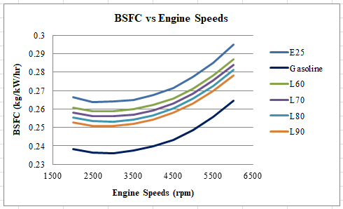
Fig. 3 Brake Specific Fuel Cnsumption
In the context of fuels, especially within automotive and engine management systems, the lambda value (λ) is a measure of the air-fuel ratio of a combustion process. Table 4 indicates the fuels lambda values for understanding and managing the optimal engine performance, fuel efficiency, and compliance with environmental regulations. It is critical for improving engine performance and emissions. The term lambda describes the relationship between the amount of oxygen that is present in a combustion chamber and the amount that is required for "stoichiometric" combustion. Therefore, the ratio will be one to one (1:1) and lambda will equal 1.00 when a mixture has precisely the amount of oxygen needed to burn the amount of fuel present. A lean mixture has a lambda greater than 1.00 when there is an excess of oxygen in the mixture relative to the fuel. When a mixture has too little oxygen in it relative to the fuel it is a rich mixture with lambda less than 1:00. Depending on the fuel type, the lambda shows nearly an increase with engine speed range. The L90 presents a leaner mixture than gasoline and E25 due to its higher mixing ability with air in gaseous form.
Table 4. Lambda Value
Fuel types | Lambda values
Gasoline | 0.98
E25 | 0.96
L60 | 1.06
L70 | 1.04
L80 | 1.02
L90 | 0.99
Automotive engines normally reach their charging efficiency peaks at 80% at half of their nominal speed, but as the speed increases, the efficiency declines. A maximum efficiency of 1.2 at 4500 rpm is observed for L90 fuels, which is higher than that of gasoline and E25. This may be attributed to the high mixing capacity of LPG.
The engine's capacity to introduce fresh air-fuel mixture charges into and out of cylinders is measured by volumetric efficiency. At 5000 rpm, the highest efficiency for gasoline, L90, and E25 fuels is 0.99, 0.94, and 1.00, respectively. The volumetric efficiency of E25 raises as the ethanol evaporation properties.
The power available at the crankshaft of an internal combustion engine is known as the braking power or B.P. for short. Engine power is plotted against engine speed in Fig.6. The maximum engine power for gasoline, E25, and LPG at higher fraction (L90) can be seen to be about 20.75 kW, 21.41 kW and 23.71 kW at 6000 rpm, respectively. The L90 has a B.P. that is higher than gasoline and E25 by 14.27 % and 10.73 %, respectively. This is due to the high octane number of LPG fuel along with its higher combustibility.
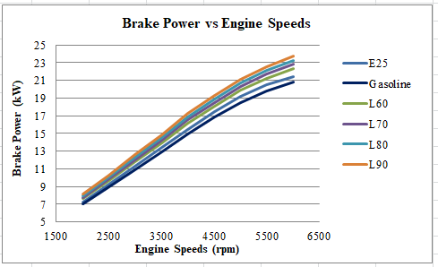
Fig. 6 Brake Power
The impact of speed on engine torque is displayed in Fig. 7. The outcome demonstrates that, for all fuels up to 4000 rpm, engine torque rises linearly with engine speed. Subsequently for all fuels, the torque reduces with engine speed past 4000 rpm. The torque output rises as the LPG fraction does. The maximum torque values are 35.7 Nm, 36.9 Nm, and 41.2 Nm for gasoline, E25, and L90, respectively. The maximum torque of L9 is 15.4 %, 11.65 % more than that of gasoline and E25, respectively. LPG fuel has a higher octane number than gasoline and E25 that improves combustion and hence results in more torque output than for others.
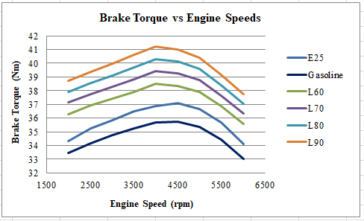
Fig. 7 Engine Torque
The proportion of braking power generated per unit of fuel input energy is an engine's brake thermal efficiency, or BTHE. Because ethanol contains more oxygen, it burns more quickly, increasing internal pressure and temperature and raising BTHE.
The average pressure that compresses the engine's piston to produce torque output is known as the brake mean effective pressure, or BMEP. At 4500 rpm, the L90 has a higher BMEP of 13.12 bar, which could be the result of increased engine output and improved combustion efficiency.

3.2. Emissions
Fuel combustion produces pollutants like CO, HC, and NOx. Carbon monoxide emissions occur due to incomplete combustion, while hydrocarbons remain in the products. NOx emissions are caused by high chamber temperatures, with fuel type playing a significant role.
Gasoline emits moderate to high amounts of CO, especially when less sophisticated control systems are used. Because ethanol burns cleaner when using E25, emissions are reduced. When mixed with E25, LPG-E25 produces emissions that are often lower than those of gasoline alone. This combination greatly cuts CO emissions.
Under partial load conditions, inadequate air suction leads to the production of hydrocarbons, which are organic molecules that come from incomplete combustion of hydrocarbon fuel. Compared to gasoline and E25 fuels, LPG produces fewer hydrocarbons. This is because LPG is flammable and readily mixes with air in its gaseous state. Compared to gasoline and LPG fractions, ethanol produces more hydrocarbon emissions during combustion because of its low diffusivity and difficulty igniting at low temperatures.
When compared to gasoline and E25 emissions, NOx generation in LPG fractions increases linearly with engine speed. Nox emissions from LPG-E25 are higher due to increased combustion temperatures and complicated interactions between ethanol and LPG in fuel mixtures. Controlling NOx emissions in such mixtures requires careful engine tune and calibration.
- Effect of Intake Manifold Temperature on Engine Power, Torque and BSFC
Engine performance and efficiency are maximized when lower intake temperatures are maintained through effective intake manifold cooling. Torque for L90 fuel improves at 200 K from 2000 rpm to 4000 rpm, with a maximum of 41.22 Nm. The power generated at temperatures of 200 K differs little from that at 310 K. This suggests that incoming fuel gets denser as the temperature of the fuel charging in the intake manifold drops, resulting in an increase in engine torque and power. For intake manifold temperatures of 200 K and 310 K, the minimal brake-specific fuel consumption is 0.247 kg/kW/hr and 0.250 kg/kW/hr at 3000 rpm, respectively. Better fuel vanishing and more efficient burning are encouraged by cooler air, which improves combustion and increases power and torque. Lowering the intake manifold temperature could potentially lead to better fuel efficiency and more miles traveled.
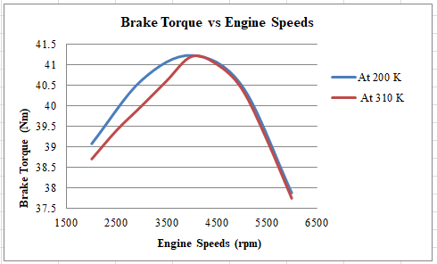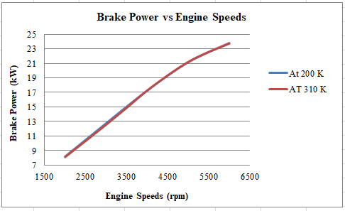
Fig. 13 Brake Torque Fig. 14 Brake Power
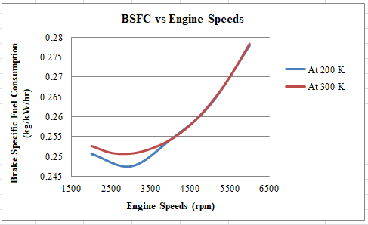
Fig. 15 Brake Specific Fuel Consumption
- Effect of the Valve Overlap on Engine Power, Torque and BSFC
Valve overlap occurs when the engine cycle shifts from exhaust to intake stroke, allowing the combustion chamber to receive fresh intake air or a fuel-air mixture simultaneously. This affects engine performance parameters such as power, torque, and BSFC. Increased valve overlap can enhance power output at higher RPMs due to better exhaust gas scavenging and improved intake of fresh air-fuel mixture, leading to more complete combustion and higher power. The maximum engine torque increased by 3.13% at 82 degrees of valve overlap at 4000 rpm, indicating enhanced scavenging and improved intake filling contribute to higher torque at high speed. Engines with higher valve overlap shows a lower BSFC at high RPMs due to improved combustion efficiency and better utilization of the air-fuel mixture. At 82 degree valve overlap, the BSFC reduced by 0.21% compared to 75 degree valve overlap, indicating that enhanced scavenging and intake filling improves overall engine efficiency, leading to better fuel economy relative to power output at those speeds.
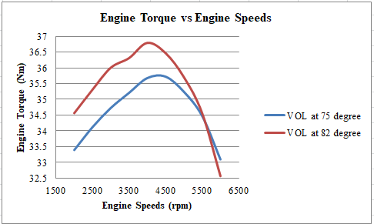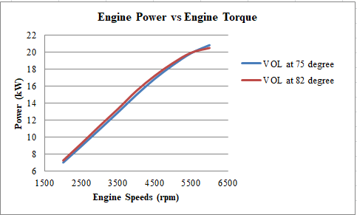
Fig. 16 Brake Torque Fig. 17 Brake Power
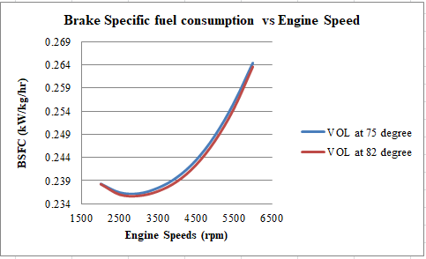
Fig. 18 Brake Specific Fuel Consumption

Conclusions
In order to address fuel shortages and environmental contamination, this research looks into the usage of alternative fuels in spark-ignition engines, such as ethanol-gasoline combustion (E25) and LPG-E25 mix. The performance of a spark ignition engine and the exhaust emissions of gasoline, E25, and LPG fuels were assessed using a 1-D model simulation. According to the study, L90 fuel outperforms E25 and gasoline in terms of brake mean effective pressure, engine torque output, charging efficiency, volumetric efficiency, and cylinder pressure. By maintaining reduced intake temperatures, increasing torque and power, and guaranteeing a denser air-fuel mixture, efficient intake manifold cooling enhances engine performance and efficiency. Engine power, torque, and brake-specific fuel consumption are all impacted by valve overlap; greater overlap enhances both fuel consumption and exhaust gas scavenging. Pollutants such as CO, HC, and NOx are released during fuel combustion, while incomplete combustion and residual hydrocarbons in the products also release CO monoxide. The kind of fuel is a major factor in NOx emissions, which are caused by high chamber temperatures. Moderate to high levels of CO are released by gasoline, however when E25 is used, ethanol burns cleaner and releases fewer emissions. When combined with E25, LPG-E25 emits fewer emissions than gasoline alone, which dramatically lowers CO emissions. Insufficient air suction causes the formation of hydrocarbons when there is a partial load. As a result of its quick mixing with air and flammability, LPG generates fewer hydrocarbons. Since it is more difficult to ignite at low temperatures and has a low diffusivity, ethanol emits more hydrocarbons into the atmosphere. Although LPG-E25 emissions are higher because of higher combustion temperatures and complex interactions, NOx generation in LPG fractions increases linearly with engine speed. Proper engine calibration and tuning are necessary to control NOx emissions.

Acknowledgments
I would like to express my sincere gratitude to those who have supported and contributed to this research.

REFERENCES
Ali, A., Audi, M., & Roussel, Y. (2021). Natural resources depletion, renewable energy consumption and environmental degradation: A comparative analysis of developed and developing world. International Journal of Energy Economics and Policy, 11(3), 251–260. https://doi.org/10.32479/ijeep.11008
Aydin, F., & Katirci, S. N. U. R. (2022). Experimental investigation of the use of LPG in a gasoline vehicle with a fuel stratified injection. Sādhanā, 0123456789. https://doi.org/10.1007/s12046-021-01801-2
Berlini, R., Ant, F., Augusto, T., Moreira, A., & Souza, F. De. (2020). Exploring the lean limit operation and fuel consumption improvement of a homogeneous charge pre-chamber torch ignition system in an SI engine fueled with a gasoline-bioethanol blend. 197. https://doi.org/10.1016/j.energy.2020.117300
Chiong, M. S., Mohamad, M. Bin, Soon, C. M., & Rajoo, S. (2023). 1-D ENGINE MODELING OF 4- CYLINDER. 1(2022), 19–27.
Conțiu, R., & Chiriac, R. (2024). On the influence of different alcohol-type biofuels on performance and engine emissions of an SI engine. IOP Conference Series: Materials Science and Engineering, 1303(1), 012025. https://doi.org/10.1088/1757-899x/1303/1/012025
Delvi, H. A., Faheem, M., Khan, S. A., Kumar, M. K., & Kareemullah, M. (2019). Effect of ethanol-gasoline blends on performance, combustion and emission characteristics of spark ignition engine. Journal of Advanced Research in Fluid Mechanics and Thermal Sciences, 62(2), 209–220.
Elshenawy, A. A., & Razik, S. M. A. (2023). Modeling of combustion and emissions behavior on the effect of ethanol – gasoline blends in a four stroke SI engine. 15(3), 1–16. https://doi.org/10.1177/16878132231157178
Farzam, R., Jafari, B., & Kalaki, F. (2021). Turbocharged spark-ignition engine performance prediction in various inlet charged air temperatures fueled with gasoline–ethanol blends. International Journal of Engine Research, 22(7), 2233–2243. https://doi.org/10.1177/1468087420931718
Hashem, G. T., & Al-Dawidy, M. (2021). Use of LPG in SI engine- A review study. Al-Qadisiyah Journal for Engineering Sciences, 14(1), 52–59. https://doi.org/10.30772/qjes.v14i1.751
Iodice, P., Senatore, A., Langella, G., Amoresano, A., Industriale, I., & Federico, N. (2017). Advantages of Ethanol – Gasoline Blends as Fuel Substitute for Last Generation Si Engines. 36(4), 1173–1179. https://doi.org/10.1002/ep
Islam, M. T. (2020). A Review on Liquefied Natural Gas as Fuels for Dual.
Kamal, S., Eqqab, I., & Raphael, R. (2022). Influence of intake air temperature on the performance of gasoline engines using a different type of fuel. 15, 229–237.
Kiran, M. B. (2023). A Study of LNG as Fuel for Vehicles- A Review. i, 1–9. https://doi.org/10.46254/af03.20220495
Lindstad, E., Eskeland, G. S., Rialland, A., & Valland, A. (2020). Decarbonizing maritime transport: The importance of engine technology and regulations for LNG to serve as a transition fuel. Sustainability (Switzerland), 12(21), 1–19. https://doi.org/10.3390/su12218793
Niculae, L. (2020). On the possibility to simulate the operation of a SI engine using alternative gaseous fuels ScienceDirect On the possibility to simulate the operation of a SI engine using alternative gaseous fuels.
Rahman, A. (2018). Induction of hydrogen , hydroxy , and LPG with ethanol in a common SI engine : a comparison of performance and emission characteristics.
Rahman, A. (2019). Induction of hydrogen , hydroxy , and LPG with ethanol in a common SI engine : a comparison of performance and emission characteristics. 3033–3040.
Rashid, Z. A., & Yeong, A. F. M. S. (2020). Performance and emission characteristics of LPG in a spark-ignition engine Performance and emission characteristics of LPG in a spark- ignition engine. https://doi.org/10.1088/1742-6596/1517/1/012037
Science, E. (2019). Investigations on combustion characteristics of lean burn SI engine fuelled with Ethanol and LPG. https://doi.org/10.1088/1755-1315/265/1/012020
Tadros, M., Ventura, M., & Soares, C. G. (2018). Optimization procedure to minimize fuel consumption of a four-stroke marine turbocharged diesel engine. Energy. https://doi.org/10.1016/j.energy.2018.11.146
Talib, G., Al-dawody, M. F., & Sarris, I. E. (2023). The characteristics of gasoline engines with the use of LPG : An experimental and numerical study. International Journal of Thermofluids, 18(March), 100316. https://doi.org/10.1016/j.ijft.2023.100316
Thanh, T. N., & Phu, D. N. (2022). A Study of CNG Fuel System Uses Mixer for Engine of the Suzuki Viva Motorcycle. 11(1), 37–42. https://doi.org/10.18178/ijmerr.11.1.37-42
Ukpaukure, Y. H., Aimikhe, V., & Ojapah, M. (2023). The Evaluation of Liquefied Petroleum Gas ( LPG ) Utilization as an Alternative Automobile Fuel in Nigeria. 1–12. https://doi.org/10.4236/ojee.2023.121001
Wavebuild, S. S., & Parameters, S. G. (n.d.). SI Tutorial , Phase 1 - Building a Single Cylinder Model.
Yontar, A. A., & Doğu, Y. (2016). 1-D Modelling Comparative Study to Evaluate Performance and Emissions of a Spark Ignition Engine Fuelled with Gasoline and LNG. 5003, 4–7.
Yontar, A. A., & Doğu, Y. (2018). Environmental Effects Experimental and numerical investigation of effects of CNG and gasoline fuels on engine performance and emissions in a dual sequential spark ignition engine. Energy Sources, Part A: Recovery, Utilization, and Environmental Effects, 00(00), 1–17. https://doi.org/10.1080/15567036.2018.1495783

