Dear Editor-in-Chief,
I am pleased to submit our manuscript entitled "Forecasting Tomato Production in South Asia: Insights from Advanced Time Series Models and Machine Learning Techniques" for consideration for publication in the Journal of Statistical Computation and Simulation (JSCS).
Our study aligns closely with JSCS's aims and scope, particularly in the areas of computer algorithms related to statistics, studies in statistical inference using simulation techniques, and the implementation of interactive statistical systems. Specifically, our research contributes to the field in the following ways:
- We employ and compare multiple advanced time series models and machine learning techniques, including ARIMA, Exponential Smoothing, Score Driven Models, and XGBoost, to forecast tomato production in five major South Asian economies.
- Our study leverages an extensive historical dataset spanning six decades (1961-2021), allowing for robust long-term forecasts up to 2028.
- We demonstrate the application of machine learning, particularly XGBoost, to capture complex nonlinear relationships in agricultural production patterns, showcasing the potential of these techniques in statistical forecasting.
- Our research provides a comparative analysis of different statistical and computational methods across multiple countries, offering insights into the performance of various algorithms in different contexts.
- The study illustrates the use of simulation techniques in model evaluation and selection, aligning with JSCS's focus on statistical inference through simulation.
We believe our manuscript makes a valuable contribution to the field of statistical computation and simulation, particularly in the application of advanced computational methods to time series forecasting. The rigorous methodology and comprehensive approach of our study align well with the high standards of JSCS.
This manuscript is not under consideration for publication elsewhere, and all authors have approved the manuscript and agree with its submission to JSCS. We have no conflicts of interest to disclose.
We look forward to your response and thank you for your consideration.
Sincerely,
Abdullah Mohammad Ghazi Al khatib
Email: abdullah1991.alkhatib@damascusuniversity.edu.sy; genius.275@hotmail.com
ORCID ID: https://orcid.org/0000-0002-1352-2348

Forecasting Tomato Production in South Asia: Insights from Advanced Time Series Models and Machine Learning Techniques
Abdullah Mohammad Ghazi Al khatib ^{1*}, Bayan Mohamad Alshaib ², Pradeep Mishra ³, Motee Asaad Alshalaby ⁴, Binita Kumari ⁵, Shikha Yadav ⁶
¹Department of Finance and Banking, Faculty of Economics, Damascus University, Damascus, Syrian Arab Republic, abdullah1991.alkhatib@damascusuniversity.edu.sy; genius.275@hotmail.com.
²Department of Finance and Banking, Faculty of Economics, Damascus University, Damascus, Syrian Arab Republic, bayan1992.alshaib@damascusuniversity.edu.sy; bayanalshaibm@gmail.com.
³College of Agriculture,Rewa, Jawaharlal Nehru KrishiVishwaVidyalaya (JNKVV),India, pradeepjnkvv@gmail.com.
⁴Department of Finance and Banking, Faculty of Economics, Damascus University, Damascus, Syrian Arab Republic, motee.sh68@damascusuniversity.edu.sy.
⁵Department of Agricultural Economics, Rashtriya Kisan (PG) College, Shamli- 247776, Uttar Pradesh, India, b.binitakumari@gmail.com.
⁶Department of Geography, Miranda house, University of Delhi, India, shikhayadav356@gmail.com.
*Corresponding Author: Abdullah Mohammad Ghazi Al khatib, Department of Finance and Banking, Faculty of Economics, Damascus University, P.O. Box 30621, Damascus, Syrian Arab Republic.
Emails: abdullah1991.alkhatib@damascusuniversity.edu.sy; genius.275@hotmail.com
ORCID ID: https://orcid.org/0000-0002-1352-2348

Declarations of interest: I have nothing to declare

Funding: This research did not receive any specific grant from funding agencies in the public, commercial, or not-for-profit sectors.

Highlights:
- Forecasted tomato production in major South Asian countries using advanced models
- Compared ARIMA, Exponential Smoothing, Score Driven, and XGBoost models' performance
- Score Driven models outperformed other models in most countries
- Provided forecasts until 2028, indicating increasing trends and slight decline
- Emphasized regular updates, local factors for improving forecast accuracy

Forecasting Tomato Production in South Asia: Insights from Advanced Time Series Models and Machine Learning Techniques
Abstract:
Tomato production is a crucial component of the agricultural sector in South Asian countries. Accurate forecasting of tomato production is essential for effective agricultural planning, resource allocation, and ensuring food security in the region. This study aims to investigate the patterns and forecast tomato production in five major South Asian countries: Bangladesh, China, India, Pakistan, and Sri Lanka, utilizing advanced time series models and machine learning techniques. A comprehensive time series dataset of tomato production from 1961 to 2021 was employed. The study applied various modeling techniques, including ARIMA, Exponential Smoothing, Score Driven models, and XGBoost. Model performance was evaluated using information criteria, error metrics, and diagnostic tests. The XGBoost model outperformed other models for Bangladesh, while Score Driven models exhibited superior performance for China, India, Pakistan, and Sri Lanka. The selected models generated forecasts up to 2028, revealing a stable outlook for Bangladesh, increasing trends for China, India, and Pakistan, and a slight decline for Sri Lanka. This study contributes to the understanding of tomato production dynamics in South Asia and offers guidance for agricultural planning, resource allocation, and food security policies. The findings provide valuable insights into the future trends of tomato production in the region, enabling stakeholders to make informed decisions and adapt to potential changes in the agricultural landscape.
Keywords: Tomato production, South Asia, Time series analysis, Machine learning, XGBoost, Score Driven Models, ARIMA, Exponential Smoothing

Introduction
The nightshade family boasts a remarkable member, the tomato (Solanum lycopersicum), a perennial herb that is easily cultivated and exhibits high genetic uniformity and reproductive rate due to self-pollination (Rick, 1980). Tomato reigns as the second most significant fruit or vegetable crop globally, surpassed only by potato (Quinet et al., 2019), with a staggering production of over 200 million metric tons in 2020 (FAOSTAT, 2021). Consequently, predicting tomato production is crucial for devising and implementing effective adaptation and mitigation strategies.
South Asia, a region characterized by diverse climates and high vulnerability, presents both challenges and opportunities for tomato production. This region contributes approximately 20% of the world's tomato output, with India being the second-largest producer, following China (FAOSTAT, 2021). Tomatoes are composed of roughly 90% water, with the remaining 5-7% consisting of soluble and insoluble solids, citric acid, vitamins A, C, and E, and minerals (Pedro and Ferreira, 2007). Remarkably, the nutritional value of tomatoes is nearly twice that of apples (Barman, 2007). Tomatoes are beneficial for liver health and have a detoxifying effect on the body, while tomato juice works wonders on sunburned skin due to its unique vitamin C content (Bhowmik et al., 2012). Lycopene, a potent antioxidant found abundantly in tomatoes, reduces the risk of cardiovascular diseases and cancer. Moreover, tomatoes have been explored as edible vaccines for various diseases, including malaria, coronavirus, human immunodeficiency virus, cholera, hepatitis B, and anthrax (Shchelkunov et al., 2006; Davod et al., 2018; Massa et al., 2019; Sohrab, 2020). Given its nutritional value and extensive cultivation, tomato is aptly referred to as a protective food (Waheed et al., 2020). Even the byproducts of tomato processing, such as lipids, proteins, and other components, are utilized for bioenergy production and the creation of value-added products like lycopene and pectin (El Mashad et al., 2019). Tomatoes are consumed both fresh and in processed forms, with approximately 80% of all commercially grown tomatoes being used to produce processed products like juice, soup, and ketchup (Viuda-Martos et al., 2014). The tomato agroindustry provides income to many rural communities, contributing to poverty alleviation (Barron and Rello, 2008).
The demand-supply gap in tomato production in South Asian nations is a critical issue affecting food security, rural livelihoods, and agricultural sustainability in the region. With countries like India, Pakistan, and Bangladesh being significant producers of tomatoes, the region faces a paradox of high demand coupled with insufficient supply due to various challenges, including infrastructural deficits, limited access to modern agricultural technology, and post-harvest losses (Hensman, 2022).
This gap not only impacts farmers' incomes but also has broader economic implications, highlighting the urgent need for effective solutions to optimize production and distribution. The complexities of the tomato market in South Asia are further exacerbated by factors such as seasonal price fluctuations, varying quality standards, and inefficient marketing channels (Arah et al., 2015).
Agriculture is inherently uncertain, making accurate and timely predictions invaluable for policymakers to provide necessary recommendations. To bridge the demand-supply gap in tomatoes, prediction plays a vital role in enabling policymakers to formulate appropriate policies.
  - Research Gaps
The current body of literature on forecasting tomato yields in South Asian countries using advanced statistical methods reveals several significant gaps. Existing studies have predominantly focused on individual countries, neglecting comprehensive regional analyses that could provide valuable insights into broader agricultural trends and patterns across South Asia. While traditional statistical models like ARIMA have been widely employed, there is a notable scarcity of research utilizing advanced machine learning approaches for yield prediction in this region. Additionally, there is an absence of comprehensive studies comparing the efficacy of multiple modeling methodologies such as ARIMA, Exponential Smoothing, Score Driven Models, and XGBoost for forecasting tomato production in South Asia. Most existing forecasts are short-term, lacking the extended time horizons necessary to inform long-term policy decisions and agricultural expansion strategies.
This study addresses these gaps and contributes to the existing literature in several key ways. We present a novel, cross-country analysis that integrates agricultural data across five major South Asian economies: Bangladesh, China, India, Pakistan, and Sri Lanka. This approach offers unique insights into regional trends and country-specific variations. Our study employs and compares a broader range of advanced time series models and machine learning techniques, including ARIMA, Exponential Smoothing, Score Driven Models, and XGBoost. This comprehensive methodological approach allows for a robust evaluation of various forecasting models in diverse agricultural contexts. Unlike previous studies, we incorporate cutting-edge machine learning techniques such as XGBoost, which have not been extensively applied in this specific context. This integration contributes a new dimension to the literature on agricultural forecasting in South Asia. Our analysis provides long-term projections, offering valuable insights for policymakers and agricultural planners to develop sustainable strategies for food security and agricultural development. We discuss the implications of our forecasts for food security, adaptation, and mitigation strategies in South Asia, bridging the gap between statistical analysis and practical policy recommendations.
This paper is structured as follows: Section 2 provides a comprehensive review of related literature; Section 3 delineates the data sources and methodological framework; Section 4 presents the results and offers an in-depth discussion of the findings; and Section 5 concludes with policy recommendations and directions for future research.
- literature review
Many researchers have focused on predicting tomato production using a range of methods. Hossain (1980) employed an ARIMA model to forecast production in Bangladesh, while Hoshi (2000) developed a daily harvest prediction model for cherry tomatoes based on environmental and harvest data. Yamamoto (2018) created a system to calculate harvest time and yield using temperature forecasts and field sensor data. Qaddoum (2013) proposed an automatic tomato yield predictor for greenhouses, utilizing environmental variables and past yield data. Cho et al. (2021) combined a deep learning model and a statistical model to forecast tomato yields using time series data and environmental factors, finding that temperature, humidity, and CO2 levels were the most influential factors. Bashir et al. (2022) investigated the impact of climate variability on tomato production in Pakistan, using dynamic forecasting techniques to quantify the effects of temperature and rainfall shocks on tomato output and prices.
(Nimbrayan et al. 2022) examined the trends and forecasts of tomato production in Haryana and India, using various statistical methods and data from 1991 to 2018. It found that tomato productivity in Haryana would not increase significantly, while tomato yield in India would rise. It noted that the area under tomatoes in Haryana would expand, but the productivity would remain constant. It observed that the productivity in India would improve, even though the area under tomatoes would not change. Miljanovic et al. (2014) used production, productivity, and area under cultivation data of tomato in Serbia from 1991-2010 to predict these production characteristics of tomato until 2015 by employing Autoregressive Integrated Moving Average (ARIMA) model. Hossain and Abdulla (2015) used secondary data on yearly tomato production from 1971 to 2013 in Bangladesh and forecasted tomato production by using Box-Jenkins ARIMA model. ARIMA (0,2,1) was found to be the best fitted model for both period under estimation and beyond that. Ibrahim and Mahmud (2017) fitted ARIMA (0,0,1), ARIMA (2,0,1) and ARIMA (0,0,1) to predict winter, summer, and indigo tomato crop, respectively in Egypt for the period 2016 to 2020. Chitikela et al. (2021) used artificial intelligence-based time series interventions such artificial neural network (ANN) and Support vector regression (SVR) alongside ARIMA model to predict tomato supplies and prices in Hyderabad, India during COVID-19 pandemic. The ANN model had better performance than the other two models in both training and test data sets. Nimbrayan et al. (2022) predicted tomato production, area, and productivity in India as well as Haryana state by using ARIMA model. They found ARIMA model to be more suitable for predicting area [ARIMA (2,0,0)] and productivity [ARIMA (0,1,0)] in Haryana while in case of India the model was most suited for forecasting area [ARIMA (0,1,0)] and production [ARIMA (1,0,0)]. Non-linear autoregressive exogenous (NARX), ARIMA and multi-layer perception (MLP) networks are some of the most commonly methods used for predicting future values of a time series data. However, new approaches like deep learning methods have been employed by recent studies.
  - Background of tomato production in South Asian countries
About 15 per cent of world’s tomato production comes from south Asia and South Asian country, China is the largest producer of tomato in the world (Gupta, et al., 2021). Current study has been taken up to predict tomato production in countries of South Asia.
  - Contributions of this Paper
This study makes several significant contributions to the existing literature on agricultural forecasting in South Asia. Firstly, it leverages an extensive historical dataset spanning six decades (1961-2021) to generate robust projections of tomato output in five key South Asian economies. This comprehensive time series analysis distinguishes our research from previous works, enabling more reliable long-term forecasts for the region's major tomato-producing nations. We employ and compare state-of-the-art models, including ARIMA, Exponential Smoothing, Score Driven Models, and XGBoost, to identify the optimal forecasting technique for each country. Notably, the integration of advanced machine learning methods, particularly XGBoost, allows us to capture complex nonlinear relationships in tomato cultivation patterns, enhancing the accuracy and reliability of our projections. Our study extends predictions up to 2028, providing actionable intelligence for policymakers to boost output, plan adaptations, and ensure food security in the region. By analyzing multiple South Asian countries concurrently, we facilitate cross-country comparisons and offer nuanced, region-specific recommendations. The rigorous analytical approach, coupled with an extensive forecasting horizon, significantly advances the existing literature on modeling and projecting tomato production in South Asia. This comprehensive methodology not only enhances our understanding of regional agricultural trends but also provides a robust framework for future studies in agricultural forecasting and policy planning.
3. Research Design and Approach
This study utilizes time series data from five South Asian countries: Bangladesh, China, India, Pakistan, and Sri Lanka. The data spans from 1961 to 2021. We applied multiple forecasting models, including ARIMA, Exponential Smoothing, Score Driven Models, and XGBoost, to compare their effectiveness in predicting tomato production. The models were evaluated based on their accuracy, and robustness.
The selection of ARIMA, Exponential Smoothing, Score Driven Models, and XGBoost was guided by their proven effectiveness in capturing different aspects of time series data. ARIMA and Exponential Smoothing are well-suited for linear trends, while Score Driven Models and XGBoost excel in handling non-linearities and complex interactions, which are common in agricultural output data.
3.1. Data Acquisition
To analyze tomato output trends in key South Asian nations, yearly production data from 1961 to 2021 was sourced from the Food and Agriculture Organization (FAO) of the United Nations database. The extensive 60-year period was selected to identify long-term patterns and trajectories in tomato cultivation.
3.2. Data Cleaning and Preparation
The acquired dataset underwent rigorous preprocessing to ensure data quality and integrity. Inconsistencies, anomalies, and missing values were meticulously examined and addressed. Visual exploration of the time series was conducted to pinpoint any outliers or unusual observations. Suitable interpolation methods were applied to estimate and fill in missing data points, maintaining the continuity of the time series.
3.3. Forecasting Model Construction
3.3.1. Autoregressive Integrated Moving Average (ARIMA) Modeling
ARIMA models were developed following the Box-Jenkins approach (Ray et al. 2023a). The Augmented Dickey-Fuller test was employed to assess stationarity and determine the required differencing (Yadav et al,.2024; Rahman et al. 2022; Al khatib et al. 2021; Abotaleb et al. 2021; Mishra et al. 2021; Mohammed et al. 2021; and Mishra et al. 2020).
The Autocorrelation Function (ACF) and Partial Autocorrelation Function (PACF) plots were analyzed to identify the optimal autoregressive (AR) and moving average (MA) orders. Model selection was based on minimizing the Akaike Information Criterion (AIC) and Bayesian Information Criterion (BIC). Prior to finalizing the best-fitting ARIMA model for each time series, diagnostic tests, such as the Ljung-Box Q test, were conducted to ensure model adequacy (Yadav et al,.2024; Ray et al. 2023b; Mishra et al. 2023; Yadav et al. 2022; Niranjan et al. 2022; Yonar et al. 2022; Raghav et al. 2022)
    - Exponential smoothing methods
are a family of forecasting techniques that use weighted averages of past observations to predict future values. The weights decay exponentially as the observations get older, giving more importance to the recent ones. This way, exponential smoothing methods can capture the underlying patterns of the time series, such as level, trend, and seasonality. Brown (1959), Winters (1960), and Holt (2004).
    - XGBoost: A Machine Learning Approach
To capture the complex non-linear relationships in the tomato yield data, the XGBoost algorithm was utilized. This powerful ensemble method constructs a series of regression trees to model intricate patterns and interactions among variables (Yadav et al,.2024). The model's predictive performance was optimized through meticulous hyperparameter tuning, ensuring the best possible fit to the data. To mitigate the risk of overfitting, a rigorous ten-fold cross-validation technique was employed, providing a robust assessment of the model's generalization ability. Furthermore, feature importance plots were generated to quantify the relative contribution of each predictor variable to the overall forecasting accuracy (Mishra et al 2024; Chen & Guestrin 2016; Noorunnahar et al. 2023; Mishra et al 2023b; Mishra et al 2023c; Suder et al 2024; Liu et al 2024).
We implemented XGBoost using the following hyperparameters, optimized through grid search:
max_depth: 6
learning_rate: 0.1
n_estimators: 1000
subsample: 0.8
colsample_bytree: 0.8
The grid search was performed using 5-fold time series cross-validation to ensure robustness of the model across different time periods.
    - Introducing Score-Driven Models for Time-Varying Parameters
This study investigates a model with a time-varying hidden $m×1$ vector $θ_{t}$ that influences a sequence of observations $y = (y0 1, . . . , y0 n )0$. The evolution of $θ_{t}$is governed by a function that incorporates the score of the data probability function, as proposed by Creal et al. (2013) and Harvey (2013). The updating mechanism for $θ_{t}$is given by:
$$θ_{t+1}=ω+\sum_{i=1}^{p}{A_{i}s_{t-i+1}}+\sum_{j=1}^{q}{B_{j}θ_{t-j+1}},$$
where $ω$ is a vector of constants, and $A$and $B$ are unknown coefficients determined by the fixed parameter vector $ϕ$. The scaled score function $s_{t}$ is defined as:
$s_{t}=S_{t}⋅r_{t},r_{t}=\frac{∂log⁡p(y_{t}∣θ_{t},F_{t-1};ϕ)}{∂θ_{t}},t=1,…,n,$
with $r_{t}$ representing the score vector of the data probability $p(y_{t}∣θ_{t},F_{t-1};ϕ)$. The information set $F_{t-1}$ may contain variables beyond the past values of$θ_{t}$ and $y_{t}$. The scaling matrix $S_{t}$ can take various forms, such as unit scaling, the inverse of the Fisher information matrix, or the square root of the Fisher inverse information matrix, the latter ensuring unit variance for $S_{t}$ .
A key feature of this model is the ability to perfectly predict $θ_{t}$ one step ahead based on past information. Score-driven models offer three primary advantages: (i) the 'filtered' estimates of $θ_{t}$ are optimal in a Kullback-Leibler sense; (ii) the data-driven nature of score-driven models simplifies their likelihood; and (iii) these models exhibit forecasting performance comparable to parameter-driven models, as demonstrated by Koopman et al. (2016). The second advantage facilitates the estimation of fixed parameters using maximum likelihood methods. We estimated the parameters using maximum likelihood estimation with the R package 'GAS'.

    - The optimal model selection
To evaluate and select the optimal model, a combination of in-sample goodness-of-fit measures and out-of-sample predictive accuracy was employed. The training dataset, spanning from 1961 to 2014, was utilized to assess model adequacy using various information criteria, error metrics such as Root Mean Square Error (RMSE), Mean Absolute Percentage Error (MAPE), and Mean Absolute Error (MAE), as well as diagnostic tests specific to each model. The models that exhibited the best performance on the training data were then applied to generate forecasts for the holdout period, ranging from 2015 to 2021, to evaluate their ability to generalize to unseen data. The model that achieved the optimal balance between goodness-of-fit and predictive accuracy, while minimizing error metrics, was selected as the most suitable for each country.
After identifying the best-fitting model for each state, the selected models for each state were utilized to forecast tomato production for the years 2022 to 2028. The accuracy of these predictions was evaluated by comparing the forecasted values with the observed data. The chosen models underwent further analysis to gain a deeper understanding of the future trends in tomato production
4. Results and Discussion
4.1. Summary Statistics
Figure 1 presents a historical overview of tomato production in major South Asian countries, namely Bangladesh, China, India, Pakistan, and Sri Lanka, from 1961 to 2021. The data is represented in thousand metric tonnes (000MT). The figure is a line graph where the y-axis represents the quantity of tomatoes produced and the x-axis represents time, marked at decade intervals from 1960 to 2020. Different colored lines represent different countries, allowing for a clear comparison of production trends across these nations over the six-decade period.
The trajectory of tomato production in China, depicted by the orange line, exhibits a remarkable upward trend, particularly after the year 2000, where the line steepens sharply. This steep ascent suggests a dramatic surge in the quantity of tomatoes produced in China. Over the course of six decades, spanning from 1961 to 2021, China's tomato output has witnessed a staggering growth, escalating from approximately 4,825.89 million metric tonnes to an impressive 67,636.72 million metric tonnes. In contrast to China's steep rise, the blue line, which represents India's tomato production, displays a more tempered increase. Although India has experienced a notable expansion in its tomato output over the past six decades, the growth rate appears more gradual compared to China's. In 1961, India's tomato production stood at around 464 million metric tonnes, and by 2021, it had risen to over 21,181 million metric tonnes, demonstrating a significant yet comparatively moderate increase.
The black and red lines representing Bangladesh and Pakistan, respectively, are relatively flat with slight fluctuations. This indicates minimal change in tomato production in these countries over the years. The green line representing Sri Lanka remains flat throughout, indicating no significant change in its tomato production.
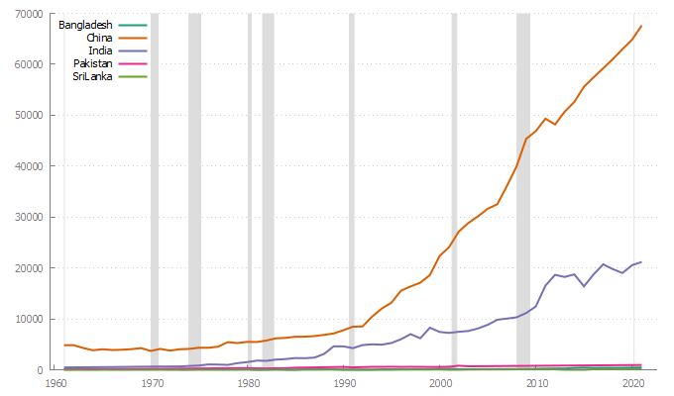
Figure 1: A graphical representation of tomato production trends in key South Asian nations from 1961 to 2021, measured in thousands of metric tonnes
Table 1 presents an in-depth quantitative overview of tomato output across key nations in South Asia, spanning the years 1961 to 2021. The analysis encompasses five countries, providing a broad perspective on the tomato production landscape in the region
The table is divided into three sections, each providing different statistical measures:
Central Tendency and Range: This section includes the mean, median, minimum, and maximum values of tomato production for each country. For instance, the mean production in Bangladesh was 131.91 000MT, while the maximum reached 447.82 000MT.
Dispersion and Distribution Shape: This section presents the standard deviation (Std. Dev.), coefficient of variation (C.V.), skewness, and excess kurtosis. These measures provide insights into the variability, relative variability, asymmetry, and tailedness of the distribution of tomato production, respectively. For example, the standard deviation of tomato production in India was 6677.1 000MT, indicating a high dispersion around the mean.
Percentiles and Missing Observations: The final section shows the 5% and 95% percentiles, the interquartile range (IQ range), and the number of missing observations. These values give a sense of the distribution’s tails, the range within which the central half of the observations lie, and the completeness of the data, respectively. For instance, the 5% and 95% percentiles for China are 3834.3 000MT and 62780 000MT, respectively, suggesting a wide spread in the data.

Table 1: Summary Statistics production of tomato in Major South Asian Countries during the period 1961-2021, in thousand metric tonnes (000MT)
Variable | Mean | Median | Minimum | Maximum
Bangladesh | 131.91 | 86.015 | 46.771 | 447.82
China | 20765. | 8466.1 | 3700.2 | 67637.
India | 6595.2 | 4603.4 | 464.00 | 21181.
Pakistan | 498.84 | 536.22 | 86.44 | 943.01
SriLanka | 40.222 | 32.236 | 6.8180 | 101.40
Variable | Std. Dev. | C.V. | Skewness | Ex. kurtosis
Bangladesh | 113.02 | 0.85684 | 1.6956 | 1.4206
China | 20596. | 0.99187 | 0.96979 | -0.55679
India | 6677.1 | 1.0124 | 0.97684 | -0.37853
Pakistan | 265.52 | 0.53227 | 0.028271 | -1.3062
SriLanka | 27.937 | 0.69457 | 0.71374 | -0.84025
Variable | 5% Perc. | 95% Perc. | IQ range | Missing Values
Bangladesh | 49.127 | 411.12 | 69.261 | 0
China | 3834.3 | 62780. | 29631. | 0
India | 496.50 | 20471. | 9047.7 | 0
Pakistan | 101.03 | 911.92 | 481.55 | 0
SriLanka | 7.3062 | 90.423 | 47.850 | 0

4.2. Comparison on training dataset
Table 2 showcases a comparative analysis of the predictive capabilities of four distinct modeling approaches, namely ARIMA, Exponential Smoothing, Score Driven models, and the XGBoost machine learning algorithm, in estimating tomato production across key South Asian nations. The empirical evidence indicates that the XGBoost model exhibits superior performance compared to the ARIMA, Exponential Smoothing, and Score Driven models assessed in the table. This conclusion is supported by the consistently lower values observed across various performance indicators.
The findings presented in Table 2 strongly suggest that the XGBoost model stands out as the most effective technique for anticipating tomato production, based on the training dataset. The model's capacity to uncover intricate patterns and relations within data, as showed by the reliably lower error metrics across different nations, underscores its potential to generate more precise predictions.
Table 2: MAE, RMSE, and MAPE for training data set (1961-2014)
 | ARIMA |  |  |  | Exponential Smoothing |  |  | Score Driven models |  |  | XGBoost
Country | MODEL | MAE | RMSE | MAPE | MAE | RMSE | MAPE | MAE | RMSE | MAPE | MAE | RMSE | MAPE
Bangladesh | ARIMA  (3,2,0) | 7.46 | 13.98 | 6.446 | 8.47 | 19.24 | 6.16 | 7.7 | 18.05 | 5.68 | 4.15 | 6.75 | 3.93
China | ARIMA  (5,2,1) | 612.55 | 869.66 | 4.442 | 1066 | 1608 | 6.37 | 628 | 988.8 | 5.05 | 426.1 | 538.4 | 5.16
India | ARIMA  (1,1,0) | 481.98 | 853.47 | 8.226 | 488 | 889 | 8.38 | 469 | 869.8 | 7.98 | 271.6 | 369.6 | 9.17
Pakistan | ARIMA  (1,0,0) | 27.559 | 43.82 | 6.555 | 27.792 | 43.064 | 6.844 | 34.08 | 47.25 | 11.14 | 11.57 | 17.22 | 4
SriLanka | ARIMA  (1,1,0) | 4.58 | 6.16 | 19.18 | 4.58 | 6.14 | 19.48 | 4.65 | 5.81 | 20.96 | 3.82 | 4.7 | 16.94

4.3. Comparative Analysis of Tomato Production Prediction Models
Table 3 showcases a comparative Analysis of Tomato Production Prediction Models for validation dataset.
Accurate prediction of tomato production is crucial for effective agricultural planning and decision-making. This study conducts a comprehensive comparison of four distinct modeling approaches: ARIMA, Exponential Smoothing, Score Driven models, and XGBoost, across five countries: Bangladesh, China, India, Pakistan, and Sri Lanka. The performance evaluation is based on the validation sample from 2015 to 2021, utilizing RMSE, MAE, and MAPE metrics. The comparative analysis reveals notable variations in model performance across different countries. In Bangladesh, XGBoost emerges as the superior model, exhibiting lower error metrics compared to ARIMA, Exponential Smoothing, and Score Driven models. This finding aligns with the observations of Al khatib (2023), who highlights the ability of machine learning techniques to capture complex hidden nonlinear patterns that traditional econometric and time series modeling may overlook. Conversely, in China, India, Pakistan, and Sri Lanka, Score Driven models consistently achieve the top performance, with minor error values compared to other models. This suggests that the underlying characteristics of the tomato production time series in these countries may differ from those in Bangladesh, warranting a tailored modeling approach. Each modeling approach exhibits unique strengths and limitations. XGBoost demonstrates robust performance in capturing complex, non-linear relationships in the data (Yadav et al,.2024). However, it may be prone to overfitting, potentially leading to weaker performance on unseen data. On the other hand, exponential smoothing methods excel at capturing the underlying patterns of the time series, such as level, trend, and seasonality. ARIMA models continue to be a valuable tool for stationary time series forecasting, offering lower computational complexity. As noted by (Al khatib et al. 2021), the use of a new forecasting model does not necessarily guarantee more robust forecasts compared to old ones. However, ARIMA are limited by their linearity, which may hinder their effectiveness in capturing non-linear relationships, as highlighted by Mishra et al. (2023b). The ability of models to generalize well to unseen data is a critical consideration. Score Driven models demonstrate better generalization capabilities, as they can handle non-stationarity and outliers effectively. Non-linear models, such as Score Driven models, XGBoost, and exponential smoothing, have the potential to capture non-linear dynamics more accurately, leading to improved prediction accuracy. A thorough analysis and evaluation of multiple models are essential for identifying the most suitable approach for each case. The findings of this study emphasize the importance of considering country-specific dynamics and tailoring the modeling approach accordingly. This comparative analysis of tomato production prediction models across five countries provides valuable insights into the strengths and limitations of different modeling approaches. The results highlight the need for a nuanced understanding of the underlying characteristics of each time series and the importance of selecting the most appropriate model based on those characteristics. Future research could explore the integration of multiple modeling techniques to leverage their complementary strengths and further improve prediction accuracy.
Table 3: MAE, RMSE, and MAPE for validation sample (2015-2021)
 | ARIMA |  |  | Exponential Smoothing |  |  | Score Driven models |  |  | XGBoost
Country | MAE | RMSE | MAPE | MAE | RMSE | MAPE | MAE | RMSE | MAPE | MAE | RMSE | MAPE
Bangladesh | 39.39 | 50.56 | 10.08 | 22.09 | 26.8 | 5.53 | 22.3 | 24.7 | 5.6 | 17.6 | 20.9 | 4.33
China | 689 | 855 | 1.13 | 2007 | 2039 | 3.21 | 306.3 | 417 | 0.47 | 3781 | 4244 | 5.93
India | 1379 | 1687 | 7.03 | 1366 | 1508 | 6.89 | 1103 | 1229 | 5.53 | 1300 | 1560 | 6.53
Pakistan | 14.81 | 14.81 | 1.63 | 14.81 | 14.81 | 1.63 | 0.168 | 0.198 | 0.018 | 0.012 | 0.0124 | 0.0014
SriLanka | 9.6 | 11 | 10.97 | 10.04 | 11.73 | 11.48 | 7.53 | 10.02 | 8.88 | 9.68 | 11.88 | 10.56

4.4. Summary of the best performing models
Table 4 presents the Optimal Methodologies for Predicting tomatoes in Prominent Nations of the Southern Asian Subcontinent.
Accurate tomato production forecasting is paramount for effective agricultural planning, resource allocation, and policy-making in South Asian countries. This study conducts a thorough evaluation of various forecasting models, including XGBoost and Score Driven models, across five major tomato-producing nations: Bangladesh, China, India, Pakistan, and Sri Lanka. The assessment is based on the models' performance on both training and validation datasets, ensuring a comprehensive understanding of their predictive capabilities.
In Bangladesh, XGBoost emerges as the undisputed champion of tomato production forecasting. This advanced machine learning algorithm consistently outperforms other models across both training and validation datasets. The superior performance of XGBoost in Bangladesh can be attributed to its ability to capture complex non-linear relationships and interactions among various factors influencing tomato production (Mishra et al., 2023a). By leveraging an ensemble of decision trees and gradient boosting, XGBoost effectively learns from the intricate patterns within the data, resulting in highly accurate predictions (Chen & Guestrin, 2016).
Interestingly, while XGBoost showcases exceptional performance on the training data in China, India, Pakistan, and Sri Lanka, it is the Score Driven models that steal the spotlight on the validation set. This intriguing finding underscores the need of assessing models on unseen data to gauge their true predictive power and generalizability (Al khatib et al., 2021).
Score Driven models, also known as generalized autoregressive score (GAS) models, have gained popularity in recent years due to their ability to adapt to time-varying parameters and capture dynamic dependencies in time series data (Creal et al., 2013). These models utilize the score function, which measures the sensitivity of the likelihood function to parameter changes, to update the model parameters over time (Blasques et al., 2014). By allowing for time-varying parameters, Score Driven models can effectively capture the evolving nature of tomato production, accounting for factors such as weather fluctuations, technological advancements, and market dynamics.
The findings of this study have significant implications for agricultural decision-making and policy formulation in South Asian countries. By identifying the best-performing models for tomato production forecasting, stakeholders can make informed decisions based on reliable and accurate predictions. The results highlight the need for a nuanced approach, tailoring the choice of forecasting model to the specific characteristics and dynamics of each country.
Furthermore, the discrepancy between the performance of XGBoost on training and validation datasets in China, India, Pakistan, and Sri Lanka raises important questions about model generalizability and the risk of overfitting. Future research should delve deeper into understanding the factors contributing to this discrepancy and explore techniques to mitigate overfitting, such as regularization and cross-validation (Mishra et al., 2023b).
This study provides a comprehensive evaluation of tomato production forecasting models in major South Asian countries, revealing the superiority of XGBoost in Bangladesh and the effectiveness of Score Driven models in China, India, Pakistan, and Sri Lanka. The findings emphasize the importance of considering country-specific dynamics and the need for rigorous model evaluation on both training and validation datasets. By leveraging the insights gained from this study, decision-makers can make informed choices and implement effective strategies to optimize tomato production and ensure food security in the region.

Table 4: Optimal Methodologies for Predicting tomatoes in Prominent Nations of the Southern Asian Subcontinent
Country | training dataset | validation dataset | The Optimal model
Bangladesh | XGBoost | XGBoost | XGBoost
China | XGBoost | Score Driven models | Score Driven models
India | XGBoost | Score Driven models | Score Driven models
Pakistan | XGBoost | Score Driven models | Score Driven models
SriLanka | XGBoost | Score Driven models | Score Driven models

4.5. Projections for Tomato Production in Major South Asian Countries (2022-2028)
Table 5 showcases the projected tomato production figures for the leading South Asian nations from 2022 to 2028, derived from the selected predictive models. The key findings are as follows:
1. Bangladesh: The XGBoost model anticipates a consistent tomato production level of approximately 407 thousand metric tons throughout the forecast period.
2. China: Based on the Score Driven models, tomato production is expected to rise from 69,812.45 thousand metric tons in 2022 to 82,666.84 thousand metric tons by 2028.
3. India: The Score Driven models project an upward trend in tomato production, increasing from 21,748.02 thousand metric tons in 2022 to 25,159.54 thousand metric tons by 2028.
4. Pakistan: According to the Score Driven models, tomato production is forecasted to grow from 958.04 thousand metric tons in 2022 to 1,047.37 thousand metric tons by 2028.
5. Sri Lanka: In contrast to the other countries, the Score Driven models predict a slight decline in tomato production for Sri Lanka, from 88.79 thousand metric tons in 2022 to 86.58 thousand metric tons by 2028.
These projections provide valuable insights into the potential future trends of tomato production in the major South Asian countries, enabling stakeholders to make informed decisions and plan accordingly.
Table 5: the projected tomato production figures for the leading South Asian nations from 2022 to 2028
Year | Bangladesh | China | India | Pakistan | SriLanka
2022 | 407.14 | 69812.45 | 21748.02 | 958.0481 | 88.79635
2023 | 407.51 | 71954.85 | 22316.53 | 972.9353 | 88.42768
2024 | 407.73 | 74097.25 | 22885.03 | 987.8225 | 88.059
2025 | 407.76 | 76239.64 | 23453.53 | 1002.71 | 87.69033
2026 | 407.70 | 78382.04 | 24022.04 | 1017.597 | 87.32166
2027 | 407.72 | 80524.44 | 24590.54 | 1032.484 | 86.95299
2028 | 407.75 | 82666.84 | 25159.04 | 1047.371 | 86.58431

4.6. Supplementary Analysis:
The chosen models effectively captured the essential patterns in the data for all-time series, as evidenced by the stationary residuals exhibiting white noise characteristics. The supplementary figures (2-6) illustrate the forecasted tomato production values for 2022-2028, demonstrating the models' precision and efficacy. These figures display the actual and predicted tomato production values, along with residual diagnostic plots.
Figure 2 shows the historical and forecasted tomato production in Bangladesh using the XGBoost model for 1961-2028. The predicted values closely follow the historical trend, and the residuals plot exhibits white noise without significant autocorrelation, indicating a well-specified model. The normal probability plot confirms the errors' normal distribution, further validating the model's accuracy in reproducing historical values and its reliability for future forecasts.
Figure 3 presents the actual and predicted tomato production in China using Score Driven models for 1961-2028. The forecasted values show a strong agreement with the actual values. The residuals are randomly scattered around zero with constant variance, and the normal probability plot confirms the normality assumption. These results highlight the model's precision in fitting the data and its effectiveness for generating forecasts.
Figure 4 displays the historical and forecasted tomato production for India using Score Driven models for 1961-2028. The predicted values closely match the observed values. The residuals plot shows no discernible patterns, meeting the model adequacy criteria. The normal plot verifies the normal distribution of residuals. These findings demonstrate the model's robustness in in-sample fitting and its dependability for predicting future values.
Figure 5 illustrates the actual and forecasted tomato production in Pakistan using Score Driven models for 1961-2028. The predicted path closely tracks the historical patterns. The residuals show white noise properties with zero mean and constant variance. The normal probability plot confirms the normality assumption. These results emphasize the model's success in explaining past data and its validity for generating future projections.
Figure 6 presents the historical and forecasted tomato production for Sri Lanka using Score Driven models for 1961-2028. The predicted path closely matches the observed values. The residuals are randomly distributed, satisfying the model assumptions. The normal plot verifies the normal distribution of residuals. These findings indicate the model's accuracy and effectiveness in forecasting tomato production for Sri Lanka.
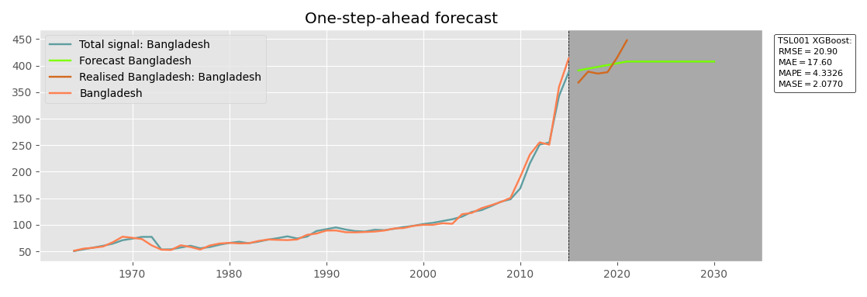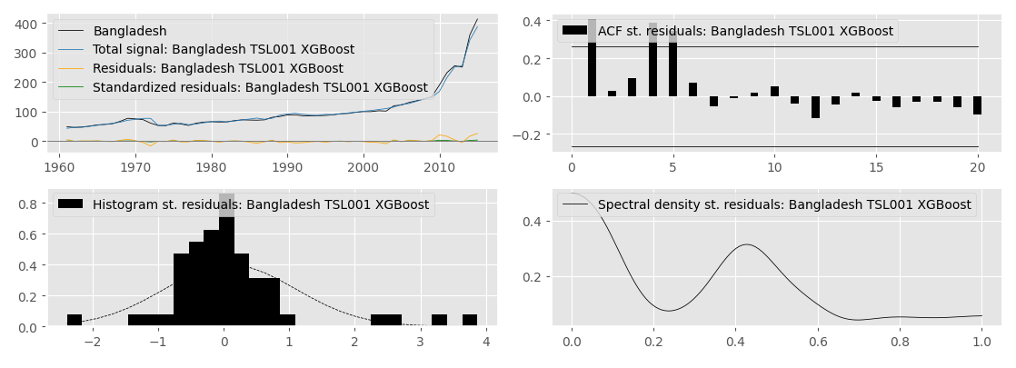
Figure 2: A visual comparison of observed and predicted tomato production values in Bangladesh from 1961 to 2028, along with residual diagnostic plots, using the XGBoost algorithm
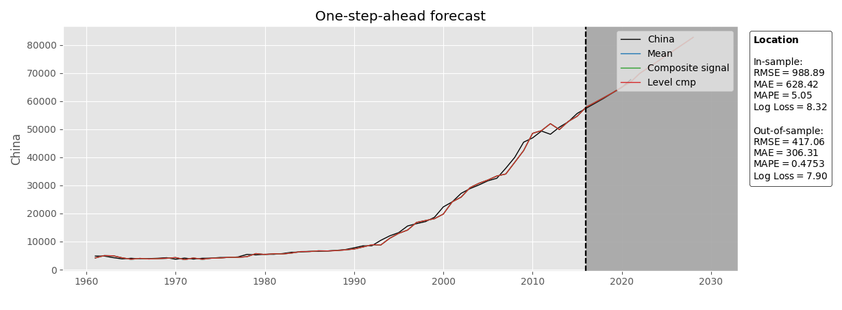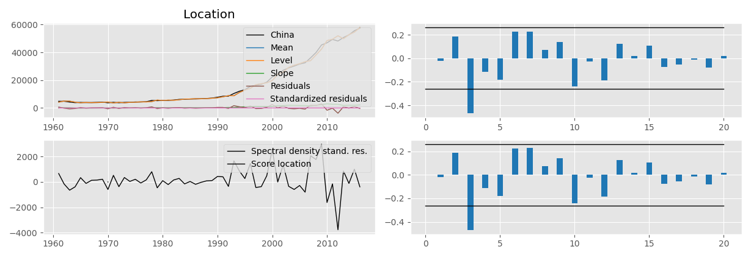
Figure 3: An illustration of the actual and forecasted tomato production in China between 1961 and 2028, accompanied by residual diagnostic charts, employing Score Driven models
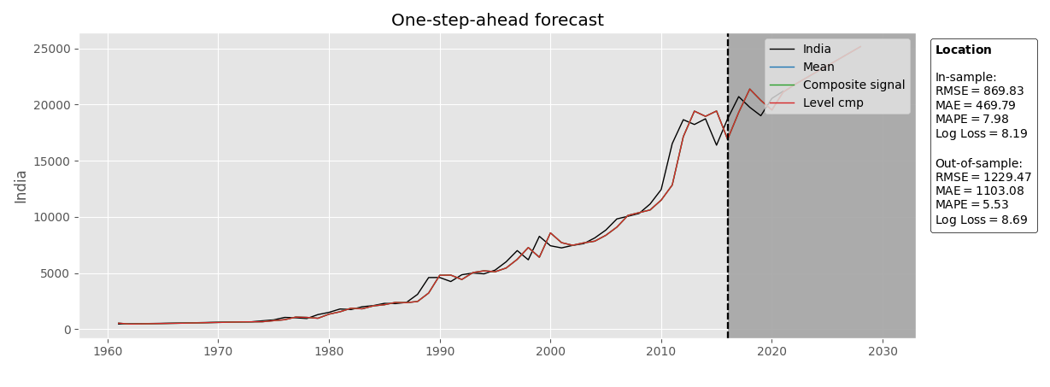
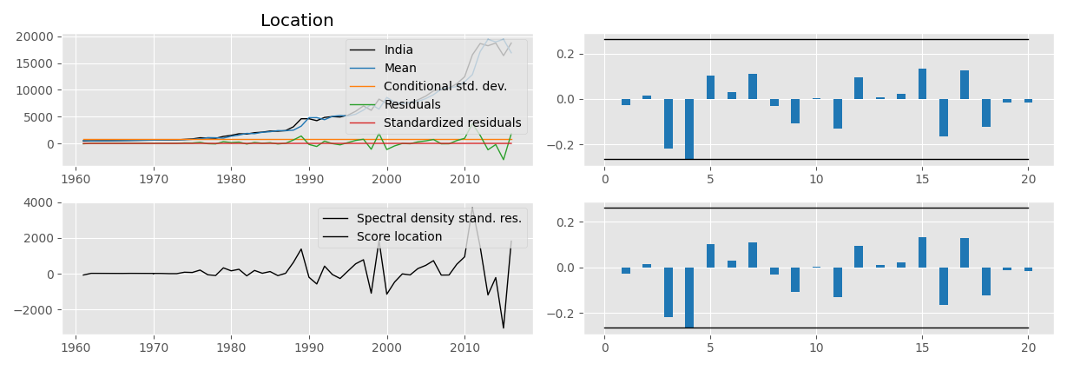
Figure 4: A depiction of the real and projected tomato production in India from 1961 to 2028, supplemented by residual diagnostic graphs, utilizing Score Driven models

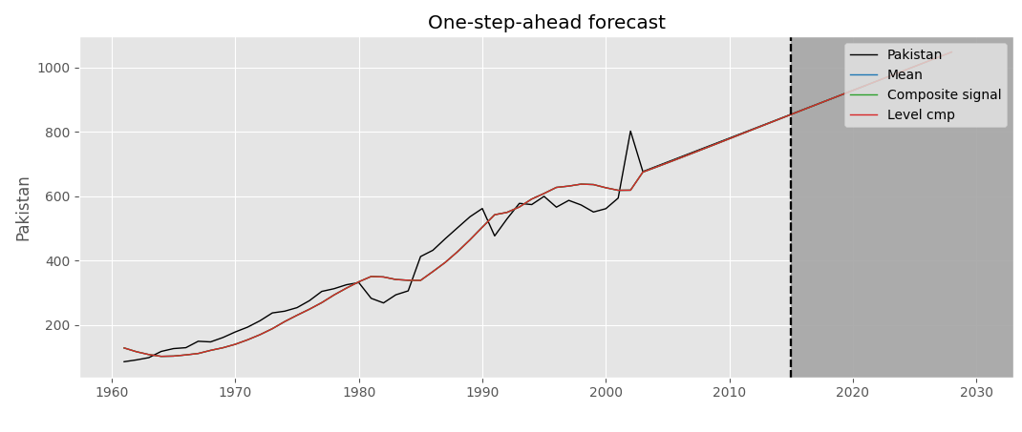
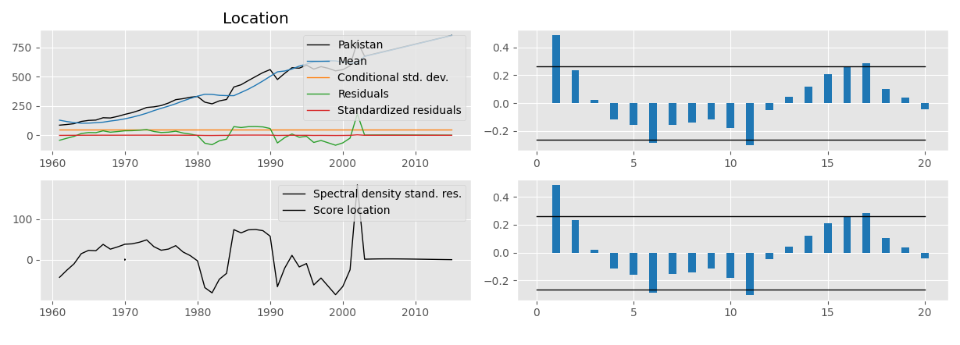
Figure 5: A portrayal of the observed and anticipated tomato production in Pakistan during the period 1961-2028, complemented by residual diagnostic plots, using Score Driven models

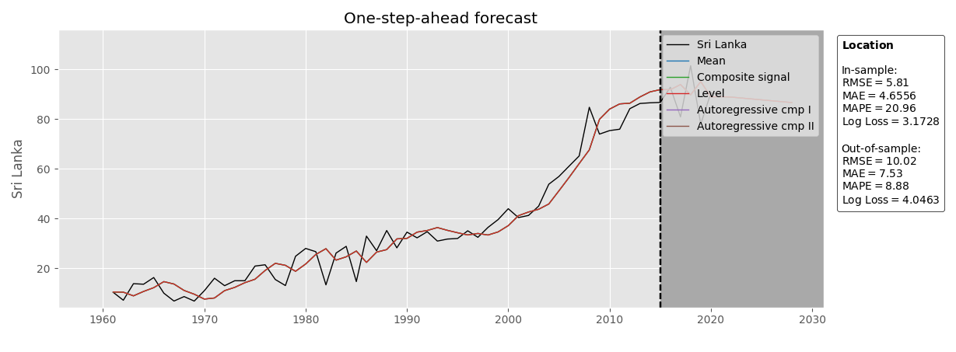
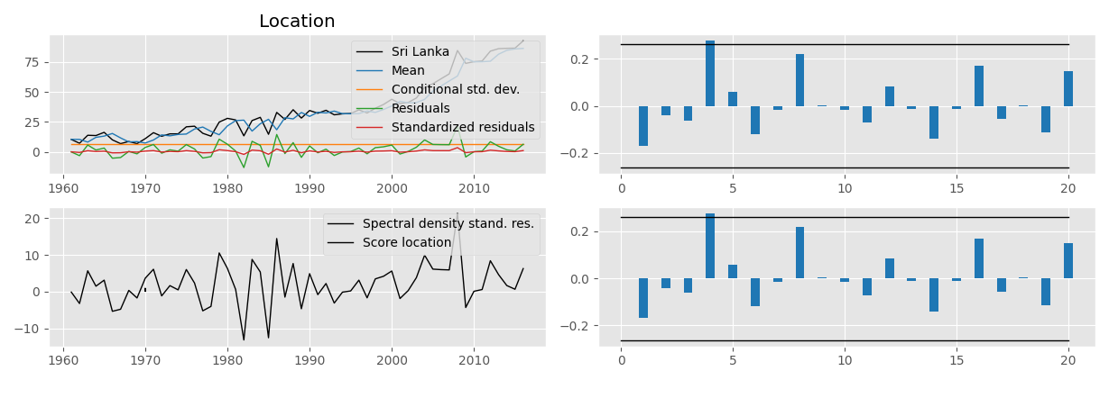
Figure 6: A representation of the actual and predicted tomato production in Sri Lanka from 1961 to 2028, accompanied by residual diagnostic charts, applying Score Driven models

  - Conclusion:
This study provides a comprehensive analysis of tomato production patterns and forecasts in five major South Asian countries: Bangladesh, China, India, Pakistan, and Sri Lanka. By employing a diverse set of modeling techniques, including ARIMA, Exponential Smoothing, Score Driven models, and XGBoost, we capture the complex dynamics of tomato production in the region. The rigorous model selection process, based on information criteria, error metrics, and diagnostic tests, ensures the reliability and accuracy of our findings.
The application of machine learning algorithms, particularly XGBoost, demonstrates the potential of non-linear approaches in capturing the intricate patterns of tomato production. The superior performance of XGBoost for Bangladesh and Score Driven models for the other countries highlights the importance of considering country-specific characteristics when modeling agricultural production.
The long-term forecasts generated by the selected models provide valuable insights for policymakers, farmers, and stakeholders in the tomato industry. The projections indicate a stable outlook for Bangladesh, increasing trends for China, India, and Pakistan, and a slight decline for Sri Lanka. These findings can inform strategic decision-making, resource allocation, and the development of targeted policies to support sustainable tomato production in the region. The study’s long-term forecasts up to 2028 provide a critical window for policymakers to develop and implement strategies aimed at mitigating potential food security risks, particularly in countries like Sri Lanka, where a slight decline in production is anticipated.
Furthermore, this study contributes to the broader field of agricultural research by showcasing the application of advanced modeling techniques and machine learning algorithms in forecasting crop production. The successful implementation of these approaches in the context of tomato production in South Asia paves the way for their adoption in other agricultural domains, enabling more accurate predictions and evidence-based decision-making.
In conclusion, this study provides a comprehensive and data-driven analysis of tomato production in South Asia, offering valuable insights for stakeholders and contributing to the advancement of agricultural research. The findings underscore the importance of considering country-specific factors and the potential of machine learning in forecasting crop production. As we navigate the challenges of ensuring food security and sustainable agriculture, this study serves as a foundation for future research and policy formulation in the region.
References:
Abotaleb, M., Ray, S., Mishra, P., Karakaya, K., Shoko, C., Al Khatib, A., ... and Balloo, R. (2021). Modelling and forecasting of rice production in south Asian countries. Ama, Agricultural Mechanization in Asia, Africa & Latin America 51: 1611-1627.
AL Khatib AMG, Yonar H, Abotaleb M, Mishra P, Yonar A, Karakaya K, Badr A, Dhaka V, (2021). Modeling and forecasting of egg production in India using time series models. Eurasian J Vet Sci 37 (4): 265-273
Al Khatib, A. M. G. (2023). The complexity of financial development and economic growth nexus in Syria: A nonlinear modelling approach with artificial neural networks and NARDL model. Heliyon, 9(10), 1-18. https://doi.org/10.1016/j.heliyon.2023.e20265
Arah, I. K., Kumah, E. K., Anku, E. K., & Amaglo, H. (2015). An overview of post-harvest losses in tomato production in Africa: causes and possible prevention strategies. Journal of Biology, Agriculture and Healthcare, 5(16), 78-88.‏
Barman, S.C. (2007). Real adoption impact measure of tomato technologies on production at farmers’ level in Bangladesh. Bangladesh Journal of Scientific and Industrial Research, 42(1): 15-28.
Barron, M.A. and Rello, F. (2008). The impact of the tomato agroindustry on the rural poor in Mexico. Agricultural Economics, 23(3): 289-297.
Bashir, M. K., Malik, A. U., Farrukh, M. U., Hameed, S., Kamran, M. A., & Ziaf, K. (2022). FORECASTING TOMATO PRODUCTION UNDER CLIMATE VARIABILITY IN PAKISTAN. JAPS: Journal of Animal & Plant Sciences, 32(1).‏ https://doi.org/10.36899/JAPS.2022.1.0417.
Bhowmik, D., Kumar, K.P.S., Paswan, S. and Srivastava, S. (2012). Tomato- A natural medicine and its health benefits. Journal of Pharmacognosy and Phytochemistry, 1(1): 33-43.
Blasques, F., Koopman, S. J., & Lucas, A. (2014). Maximum likelihood estimation for generalized autoregressive score models. Tinbergen Institute Discussion Paper, TI 2014-029/III.
Brown, R. G. (1959). Statistical forecasting for inventory control. McGraw/Hill.
Chen, T., & Guestrin, C. (2016, August). Xgboost: A scalable tree boosting system. In Proceedings of the 22nd acm sigkdd international conference on knowledge discovery and data mining (pp. 785-794). https://doi.org/10.1145/2939672.2939785.
Chitikela, G., Admala, M., Ramalingareddy, V.K., Bandumula, N., Ondrasek, G., Sundaram, R.M. and Rathod, S. (2021). Artificial-Intelligence-based time-series intervention models to assess the impact of the COVID-19 pandemic on tomato supply and prices in Hyderabad, India. Agronomy, 11(9):1878.
Cho, W., Kim, S., Na, M.H., & Na, I.S. (2021). Forecasting of Tomato Yields Using Attention-Based LSTM Network and ARMA Model. Electronics. https://doi.org/10.3390/electronics10131576.
Creal, D. D., S. J. Koopman, and A. Lucas (2013). Generalized autoregressive score models with applications. Journal of Applied Econometrics 28(5), 777–795.
Davod J., Fatemeh D.N., Honari H., Hosseini R. (2018). Constructing and transient expression of a gene cassette containing edible vaccine elements and shigellosis, anthrax and cholera recombinant antigens in tomato. Molecular Biology Reports,45:2237–2246.
El Mashad, H.M., Zhao, L., Zhang, R. and Pan, Z. (2019). Chapter 5- Tomato. In: Pan, Z., Zhang, R. and Zicari, S. (eds) Integrated Processing Technologies for Food and Agricultural By-Products, Academic Press. Pp 107-131.
FAOSTAT (2021). Available at: http://www.fao.org/faostat/en/#home [Accessed January 22, 2024].
Gupta, B.K., Dwivedi, S.V., Mishra, B.P., Mishra, D., Ojha, P.K., Verma, A.P. and Kalia, A. (2019). Adoption gap analysis in tomato cultivation in Banda district of Bundelkhand (UP). Indian Journal of Extension Education, 57(4): 126-130.
Harvey, A. C. (2013). Dynamic Models for Volatility and Heavy Tails: With Applications to Financial and Economic Time Series, Volume 52. Cambridge: Cambridge University Press.
Hensman, G. H. (2022). Challenges in tomato cultivation and marketing: a thematic analysis.‏
Holt, C. C. (2004). Forecasting seasonals and trends by exponentially weighted moving averages. International journal of forecasting 20(1), 5–10.
Hoshi, T., Sasaki, T., Tsutsui, H., Watanabe, T., & Tagawa, F. (2000). A daily harvest prediction model of cherry tomatoes by mining from past averaging data and using topological case-based modeling. Computers and Electronics in Agriculture, 29, 149-160. https://doi.org/10.1016/S0168-1699(00)00142-3.
Hossain, M.M. and Abdulla, F. (2015). On the production behaviors and forecasting the tomatoes production in Bangladesh. Journal of Agricultural and Development. 4(5): 66-74.
Hossain, M.M., & Abdulla, F. (1980). On the production behaviors and forecasting the tomatoes production in Bangladesh.
Ibrahim, S.A.S. and Mahmoud, R.F. (2017). Predicting tomato crop production. Egyptian Journal of agricultural Research, 95 (1): 475-494.
Koopman, S. J., A. Lucas, and M. Scharth (2016). Predicting time-varying parameters with parameter-driven and observation-driven models. Review of Economics and Statistics 98(1), 97–110.
Liu, F., Wang, R., & Fang, M. (2024). Mapping green innovation with machine learning: Evidence from China. Technological Forecasting and Social Change, 200. https://doi.org/10.1016/j.techfore.2023.123107. ‏
Massa, S., Paolini, F., Marino, C., Franconi, R., Venuti, A. (2019). Bioproduction of a therapeutic vaccine against human papillomavirus in tomato hairy root cultures. Frontiers in Plant Science, 10: 452.
Miljanovic, G., Mutavdzic, B., Novkovic, N. and Janosevic, M. (2014). Predictions of tomato production characteristics in Serbia. Presented in fifth International Scientific Symposium, Agrosym.
Mishra, P., Al Khatib, A. M. G., Lal, P., Anwar, A., Nganvongpanit, K., Abotaleb, M., ... and Punyapornwithaya, V. (2023a). An Overview of Pulses Production in India: Retrospect and Prospects of the Future Food with an Application of Hybrid Models. National Academy Science Letters 46 (5) 1-8.‏https://doi.org/10.1007/s40009-023-01267-2
Mishra, P., Al Khatib, A. M. G., Sardar, I., Mohammed, J., Karakaya, K., Dash, A., ... &Dubey, A. (2021). Modeling and forecasting of sugarcane production in India. Sugar Tech 23(6): 1317-1324.‏
Mishra, P., Al Khatib, A. M. G., Sardar, I., Mohammed, J., Ray, M., Manish, K., ... and Rono, K. (2020). Modelling and forecasting of COVID-19 in India. Journal of Infectious Diseases and Epidemiology 6(5): 1-11.‏
Mishra, P., Al khatib, A.M.G., Mohamad Alshaib, B. et al. (2023c). Forecasting Potato Production in Major South Asian Countries: a Comparative Study of Machine Learning and Time Series Models. Potato Res. https://doi.org/10.1007/s11540-023-09683-z.
Mishra, P., Al Khatib, A.M.G., Yadav, S. et al. (2024). Modeling and forecasting rainfall patterns in India: a time series analysis with XGBoost algorithm. Environ Earth Sci 83, 163. https://doi.org/10.1007/s12665-024-11481-w.
Mishra, P., Alakkari, K. M., Lama, A., Ray, S., Singh, M., Shoko, C., ...and Karakaya, K. (2023b). Modeling and Forecasting of Sugarcane Production in South Asian Countries. Current Applied Science and Technology 23 (1): 1-15.‏ https://doi.org/10.55003/cast.2022.01.23.002
Mohammed, J., Al Khatib, A. M. G., Mishra, P., Adjei, P., Singh, P. K., Priya, S. K., and Das, S. S. (2021). Modeling and forecasting of Covid-19 from the context of Ghana. African Review of Economics and Finance 13(2): 124-141.‏ ‏
Nimbrayan, P.K., Jaslam, P.K., & Chandanshive, A.V. (2022). Modelling and Forecasting of Area, Production and Productivity of Tomatoes in Haryana and India. Indian Journal of Extension Education. https://doi.org/10.48165/IJEE.2022.58231
Nimbrayan, P.K., Jaslam, P.K.M. and Chandanshive, A. (2022). Modelling and forecasting of area, production, and productivity of tomatoes in Haryana and India. Indian Journal of Extension Education, 58(2): 205-208.
Niranjan, H. K., Kumari, B., Raghav, Y. S., Mishra, P., Al Khatib, A. M. G., and Abotaleb, M. (2022). Modeling and Forecasting of Tea Production in India. Journal of Animal and Plant Sciences 32(6):1598-1604.
Noorunnahar, M., Chowdhury, A. H., & Mila, F. A. (2023). A tree based eXtreme Gradient Boosting (XGBoost) machine learning model to forecast the annual rice production in Bangladesh. PloS one, 18(3), 1-15.‏ https://doi.org/10.1371/journal.pone.0283452
Pedro, A.M.K. and Ferreira, M.M.C. (2007). Simultaneously calibrating solids, sugars and acidity of tomato products using PLS2 and NIR spectroscopy. Analytica Chimica Acta, 595: 221-227.
Qaddoum, K., Hines, E.L., & Iliescu, D. (2013). Yield Prediction for Tomato Greenhouse Using EFuNN. International Scholarly Research Notices, 2013, 1-9. https://doi.org/10.1155/2013/430986.
Quinet, M., Angosto, T., Yuste-Lisbona, F. J., Blanchard-Gros, R., Bigot, S., Martinez, J. P., & Lutts, S. (2019). Tomato fruit development and metabolism. Frontiers in plant science, 10, 1554.‏ https://doi.org/10.3389/fpls.2019.01554.
Raghav, Y. S., Mishra, P., Alakkari, K. M., Singh, M., Al Khatib, A. M. G., &Balloo, R. (2022). Modelling and forecasting of pulses production in south asian countries and its role in nutritional security. Legume Research-An International Journal 45(4): 454-461.‏
Rahman, U. H., Ray, S., Al Khatib, A. M. G., Lal, P., Mishra, P., Fatih, C., ...&Alakkari, K. (2022). State of Art of SARIMA model in second wave on COVID-19 in India. International Journal of Agricultural and Statistical Sciences, 18 (1): 141-152.‏
Ray, S., Al Khatib, A.M.G., Kumari, B., Biswas, T., Nuta, A.C. and Mishra, P. (2023a). Forecasting cash crop production with statistical and neural network model. J. Crop and Weed 19(1): 194-201. https://doi.org/10.22271/09746315.2023.v19.i1.1679
Ray, S., Mishra, P., Ayad, H., Kumari, P., Sharma, R., Kumari, B., Al Khatib, A.M.G., T amang, A. &Biswas, T. (2023b). Prediction of Fruit Production in India: An Econometric Approach. Journal of Horticultural Research 31(1): 25-34. https://doi.org/10.2478/johr-2023-0005
Rick, C.M. (1980). Tomato. In: Fehr, W.R. and Hadley, H.H. (eds) Hybridization of crop plants. American Society of Agronomy, Crop Science Society of America, Madison. pp 669-680.
Shchelkunov, S.N., Salyaev, R.K., Pozdnyakov, S.G., Rekoslavskaya, N.I., Nesterov, A.E., Ryzhova, T.S., Sumtsova, V.M., Pakova, N.V., Mishutina, U.O. and Kopytina, T.V. (2006). Immunogenicity of a Novel, Bivalent, Plant-Based Oral Vaccine against Hepatitis B and Human Immunodeficiency Viruses. Biotechnology Letters, 28:959–967.
Sohrab, S.S. (2020). An edible vaccine development for coronavirus disease 2019: The concept. Clinical and Experimental Vaccine Research, 9: 164-168.
Suder, M., Gurgul, H., Barbosa, B., Machno, A., & Lach, Ł. (2024). Effectiveness of ATM withdrawal forecasting methods under different market conditions. Technological Forecasting and Social Change, 200. https://doi.org/10.1016/j.techfore.2023.123089. ‏
Viuda-Martos, M., Sanchez-Zapata, E., Sayas-Barbera, E., Sendra, E., Perez-Alvarez, J. A. and Fernandez-Lopez, J. (2014). Tomato and tomato byproducts. Human health benefits of lycopene and its application to meat products: A review. Critical Review of Food Science and Nutrition. 54: 1032-1049.
Waheed, K., Nawaz, H., Hanif, M.A. and Rehman, R. (2020). Chapter 46- Tomato. In: Hanif, M.A., Nawaz, H., Khan, M.M. and Byrne, H.J. (eds) Medicinal plants of South Asia. Elsevier. pp 631-644.
Winters, P. R. (1960). Forecasting sales by exponentially weighted moving averages. Management science 6(3), 324–342.
Yadav, S., Al khatib, A. M. G., Alshaib, B. M., Ranjan, S., Kumari, B., Alkader, N. A., ... & Kapoor, P. (2024). Decoding Potato Power: A Global Forecast of Production with Machine Learning and State-of-the-Art Techniques. Potato Research, 1-22.‏ https://doi.org/10.1007/s11540-024-09705-4.
Yadav, S., Mishra, P., Kumari, B., Shah, I. A., Karakaya, K., Shrivastri, S., ...& Al Khatib, A. M. G. (2022). Modelling and Forecasting of Maize Production in South Asian Countries. Economic Affairs, 67(4): 519-531.
Yamamoto, K., Seida, K., Nishiyama, J., Hayashi, K., Daishi, S., & Tanaka, M.S. (2018). Predicting System of Harvest Time and Yield of Tomato. 2018 IEEE 7th Global Conference on Consumer Electronics (GCCE), 437-439. https://doi.org/10.1109/GCCE.2018.8574865.
Yonar, H., Yonar, A., Mishra, P., Abotaleb, M., Al Khatib, A. M. G., Makarovskikh, T., and Cam, M. (2022). Modeling and forecasting of milk production in different breeds in Turkey. The Indian Journal of Animal Sciences 92(1): 105-111.‏

Statements & Declarations
Funding: The authors declare that no funds, grants, or other support were received during the preparation of this manuscript.

Competing Interests: The authors have no relevant financial or non-financial interests to disclose.

