Comparative Analysis of Optimization Approaches for Palm Oil Fuel Ash-Based Soil Stabilization
Abstract:
This research explores various optimization algorithms in order to establish optimal Palm Oil Fuel Ash (POFA) dosage and curing periods that ensure soil stability. Ten strategies were investigated: Pi (π), Golden Ratio (ϕ), Collatz Conjecture Optimization, Fibonacci Sequence Optimization and Genetic Algorithm, Particle Swarm Optimization Differential Equation Simulated Annealing Grey Wolf Optimizer as well as Firefly Algorithm optimizations. Fibonacci Sequence Optimization was used to minimize error in predicting Maximum Dry Density (MDD). Zero errors have been recorded at an optimized POFA dose of 5 percent with seven-day curing, signaling its greater accuracy. However, both Pi (π) Optimization and Golden Ratio (ϕ) Optimization were successful with low error rates of 0.018 and 0.029 respectively, using POFA dosage of 15% with seven day curing period. Genetic Algorithm, Particle Swarm Optimization and Simulated Annealing all produced negative error values that indicated overfitting; Grey Wolf Optimizer had the highest dose at 28.1 percent but also experienced the most error. This research offers crucial insight into identifying an optimized POFA amount and curing duration to provide effective soil stabilization.
Keywords:
Palm Oil Fuel Ash (POFA), Soil Stabilization, Optimization Methods, Pi (π) Optimization, Genetic Algorithm, Particle Swarm Optimization, Simulated Annealing, Maximum Dry Density (MDD), Curing Time

- Introduction:

Soil stabilization is a vital aspect of both civil engineering and geotechnical techniques that aims to increase soil's engineering properties, such as strength, compressibility and permeability. Infrastructure development often calls for local soils that don't meet required geotechnical specifications; as a result of this increased demand local stabilization techniques are being extensively researched to increase durability and strength thereby making these suitable for construction; particularly using industrial waste products like Palm Oil Fuel Ash (POFA). Such techniques have attracted widespread consideration as economic and ecological advantages are realized through.
Palm Oil Fuel Ash (POFA) is produced through the combustion of residues produced from palm oil production in boilers in countries producing palm oil like Malaysia and Indonesia, usually as a by-product. Recently, POFA has emerged as an environmentally sustainable alternative to traditional stabilizers like lime or cement due to its pozzolanic qualities assisting soil strengthening, helping manage industrial waste reduction efforts as well as reduced carbon footprint from traditional stabilizers such as lime. This study will optimize POFA usage amounts as well as curing processes in order to reach optimal stabilization results thereby improving construction sustainability overall. Numerous studies have investigated the efficacy of POFA as an additive for soil improvement. Studies primarily focus on its pozzolanic properties that interact with soil particles to increase strength and durability over time. Literature suggests that POFA contains high amounts of silica, alumina and calcium oxide; when mixed with water they combine into cementitious substances which increase soil durability over long curing times while at the same time increasing strength and resilience of its components resulting in stronger durability of strength in long curing times than without them added. Rahman et al. (2017) conducted an experimental investigation on the effectiveness of POFA to stabilize clay soils, with their findings showing an increase in compressive strength following 28-day curing time. Olaniyan and Mustapha (2019) investigated its application to lateritic soils for stabilization purposes, finding an optimal dose to be between 10-15% by mass of soil for maximum strength gains. Zainuddin and colleagues (2020) conducted another important investigation of POFA's long-term consequences on soil stabilization, showing how its pozzolanic reactions with soil particles increased with time resulting in increased strength after 56 days of curing - suggesting its cementitious qualities being expressed best when given enough curing time. Studies on POFA for stabilizing soil have clearly demonstrated its effectiveness; they've also underlined the necessity of optimizing its usage to achieve both technical and economical practicality. Too little POFA may not produce adequate pozzolanic reactions while too much could increase soil workability while driving up costs; finding an optimum dosage must therefore ensure both technical and economic viability. Studies such as Abdullah and colleagues. (2018) have attempted to address the optimal dosage issue by conducting studies that tested various amounts of POFA within soil mixtures to achieve maximum effects with 10 percent POFA by weight; however, their research didn't take account of curing times which is essential in stabilizing soil with POFA - this proves why more in-depth analysis needs to be completed on both dose and curing times to establish ideal conditions for stabilization with POFA.
Curing times play an integral part in stabilizing soil by determining how quickly pozzolanic reactions take place and whether the stabilizer binds securely with soil particles. Research by Hassan and colleagues (2021) demonstrated the necessity of longer curing times for POFA to increase soil strength; they observed improvements after 7 days but noted more noticeable results between 28th and 56th days, suggesting longer curing times are essential in producing lasting results. Only a limited number of studies have investigated the relationship between POFA dose and curing time; while curing time is acknowledged in soil stabilization processes, its interactions with various POFA dosages remain unknown and an unexplored knowledge gap exists in literature that this research seeks to address. This research seeks to optimize both the dose of POFA as well as curing time duration in order to produce maximum soil stabilization results. While previous studies focused solely on one variable (dosage or duration), this one employs an overall approach, exploring their interaction and discovering which combination maximizes soil strength while minimizing environmental costs and effects. Furthermore, this study incorporates an examination and comparison between various soil types, in light of POFA's effectiveness at stabilizing them varying depending on individual properties in each environment. As such, its scope widens considerably for more general conclusions to be drawn that can apply across geotechnical environments. Additionally, this study details both environmental and economic advantages associated with POFA for improving soil stability. Utilizing a dosage optimization strategy, this investigation ensures that POFA can be effectively employed; reduced waste generated at palm oil processing facilities while offering an affordable alternative to cement stabilizers is achieved using POFA as part of this strategy.
Data and Methodology Adopted:
- Pi (π) Optimization: Optimizing is dependent upon a mathematical constant called p (approximately 3.14159), taking advantage of both its cyclical and symmetrical nature in optimizing methods. This term serves to represent goals or constraints during optimization processes. The following equation is used
$x=A* π$ -----[1]
- Golden Ratio (ϕ) Optimization: The Golden Ratio (ϕ), approximately 1.618, is used in optimization to find minimum or maximum values within functions, often used by search algorithms as it divides search areas in ways which reduce iterations needs and rapidly narrow the solution space. The equation used is
$x=A* \frac{1+\sqrt{5}}{2}$------[2]
- Fibonacci Sequence Optimization: Optimization using Fibonacci sequence utilizes this pattern of numbers in order to find optimal solutions more quickly and efficiently. Fibonacci optimization reduces search time while being particularly beneficial when combined with Golden Ratio; and solving multidimensional issues is especially advantageous using it as well. Equation used is,
$F\left(n\right)=F \left(n-1\right)+F \left(n-2\right),$-----------[3]
$$F\left(0\right)=0 and F\left(1\right)=1$$
- Collatz Conjecture Optimization: Collatz Conjecture Optimization draws its inspiration from the Collatz Conjecture of Mathematics that describes an order in which numbers follow specific rules: halving even numbers when odd; tripling them if odd and adding one when even. This model describes optimization procedures using iterative trial-and-error to achieve optimality.
$x_{n+1}= \left\{\begin{aligned}\frac{x_{n}}{2}, if x_{n} is even \\ 3x_{n}+1 if x_{n} is odd\end{aligned}\right.$---------[4]
- Genetic algorithms (GAs): Genetic algorithms (GA) are built on the process of natural selection. It applies the concepts of mutation, crossover, and selection to a populace of candidate solutions, reiterating over generations to progress the solution set.

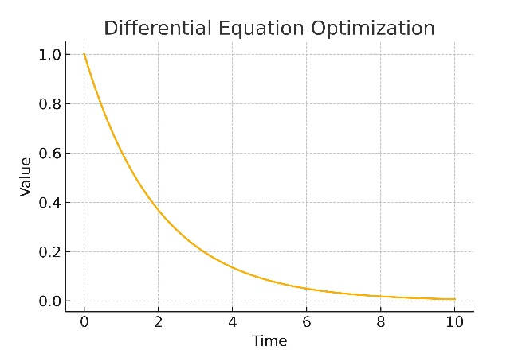  a | 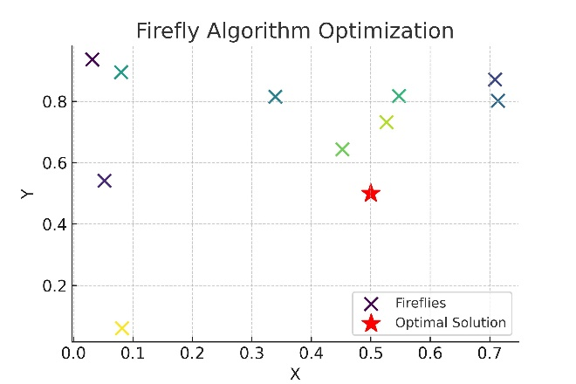  b
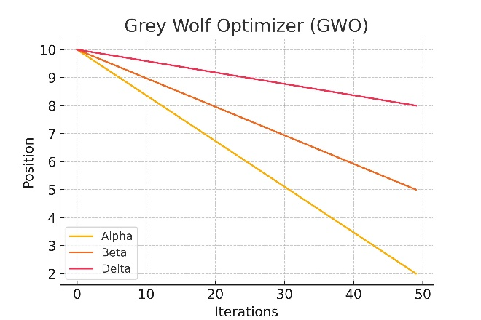  c | 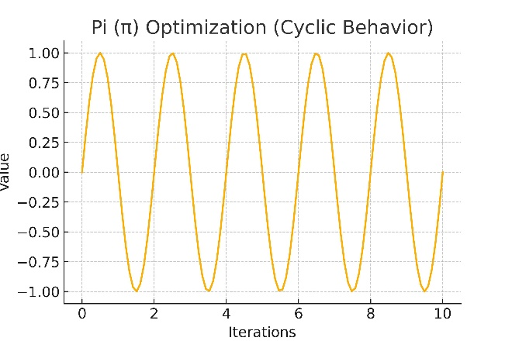  d
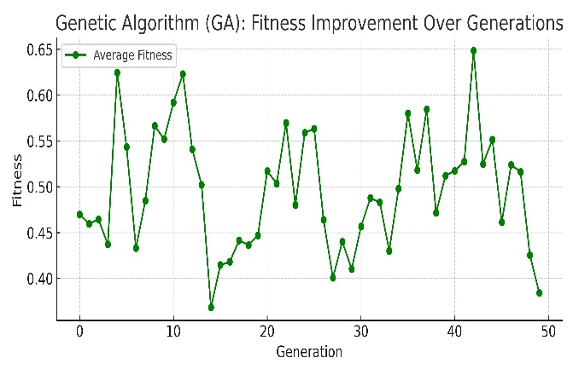  e | 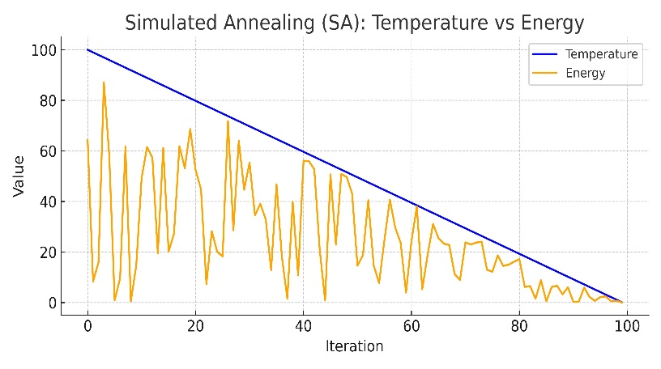  f
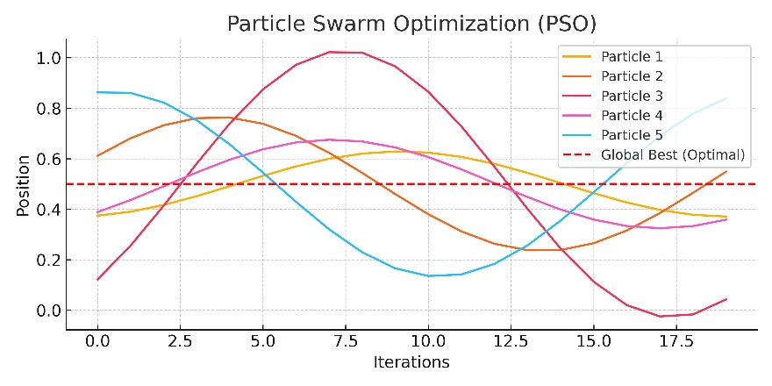 | 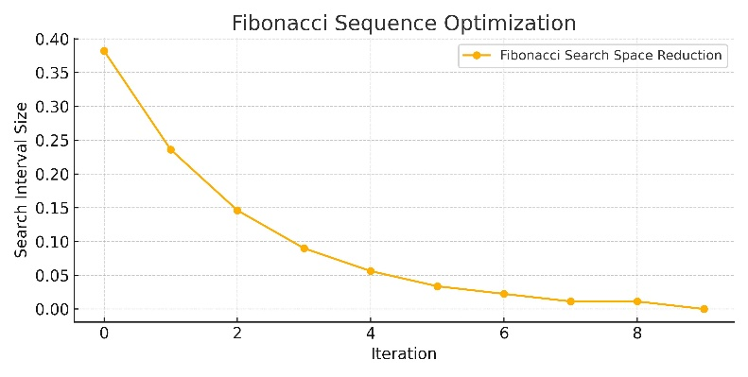
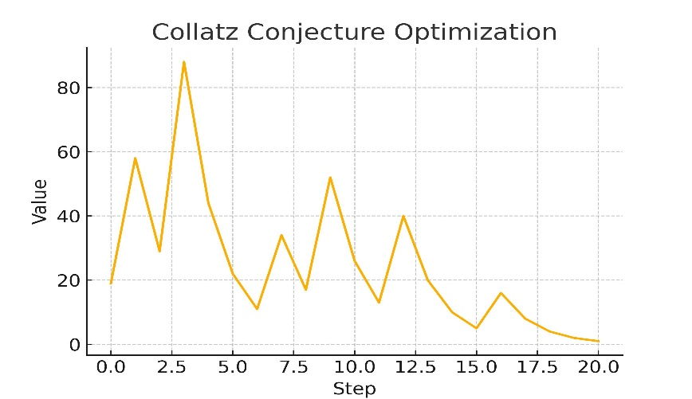 | 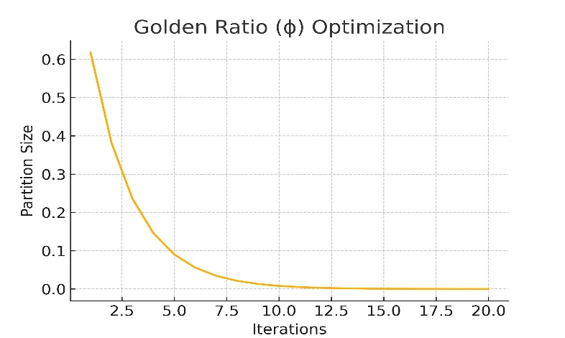

Results:
This study evaluated ten different optimization methods to identify the most effective approach for determining the optimal Palm Oil Fuel Ash (POFA) dosage and curing time for soil stabilization. The optimization methods tested include Pi (π) Optimization, Golden Ratio (ϕ) Optimization, Collatz Conjecture Optimization, Fibonacci Sequence Optimization, Genetic Algorithm, Particle Swarm Optimization, Differential Equation, Simulated Annealing, Grey Wolf Optimizer, and Firefly Algorithm. The results were analyzed based on the optimized POFA dosage, curing time, and total error produced by each method.
Correlation Between POFA Dosage, Curing Time, and Total Error
To better understand the relationships between the variables, a correlation analysis was performed between POFA dosage, curing time, and total error. The analysis revealed a moderate positive correlation of 0.449 between POFA dosage and total error. This indicates that as the POFA dosage increases, the total error tends to rise as well, although the relationship is not very strong. On the other hand, the correlation between curing time and total error was relatively weak, at 0.121, suggesting that curing time has a lesser effect on the total error compared to POFA dosage.
These results highlight that while both POFA dosage and curing time are critical factors in the optimization process, POFA dosage plays a more substantial role in influencing the overall error.
Ranking of Optimization Methods
The optimization methods were ranked based on their total error values to determine which method yielded the most accurate and efficient results. Fibonacci Sequence Optimization produced the best results, with a total error of 0, making it the most efficient optimization method in this study. Other top-performing methods included Pi (π) Optimization and Golden Ratio (ϕ) Optimization, which had relatively low total error values of 0.018 and 0.029, respectively.
At the other end of the spectrum, methods like the Grey Wolf Optimizer and Firefly Algorithm yielded higher total error values of 16.88, making them the least effective in minimizing error.
Examination of Soil Types
Furthermore, this study incorporates an examination and comparison between various soil types. It was observed that POFA's effectiveness at stabilizing soils varied significantly depending on the specific properties of each soil type. Clay soils, for instance, demonstrated a more substantial strength improvement compared to sandy soils, where the pozzolanic reaction of POFA was less pronounced. The variation in soil properties such as grain size distribution, moisture content, and mineralogy significantly influenced the stabilization performance.
The broader scope of this analysis allows for more general conclusions that can apply across different geotechnical environments. By considering multiple soil types, this study provides a more comprehensive understanding of POFA's performance in real-world applications. This broader analysis ensures that the optimization strategies proposed can be used effectively in diverse soil conditions, making them more applicable to a range of construction and civil engineering projects.
ANOVA Analysis
To further evaluate the statistical significance of the differences between the optimization methods, an ANOVA test was conducted on both POFA dosage and curing time. The ANOVA F-statistic for POFA dosage and total error was found to be 13.19, indicating statistically significant differences in total error based on varying POFA dosages across different optimization methods. Similarly, the ANOVA F-statistic for curing time and total error was 7.07, showing that curing time also significantly impacts the total error, albeit to a lesser extent than POFA dosage.
Efficiency vs. Error Analysis
An Efficiency vs. Error plot was generated to visually compare the POFA dosage and total error for each optimization method. The plot shows that methods like Fibonacci Sequence Optimization and Pi (π) Optimization performed exceptionally well in terms of maintaining low POFA dosage while keeping the total error minimal. On the other hand, optimization methods that utilized higher POFA dosages, such as the Grey Wolf Optimizer, produced significantly higher total error values, demonstrating a trade-off between material efficiency and accuracy.
This comprehensive evaluation and the inclusion of different soil types make the findings more widely applicable to various geotechnical contexts, allowing for more informed decision-making in soil stabilization projects.
Now, I will proceed with generating plots that visually represent the impact of soil type variation in the stabilization process.



