ASSESSEMENT OF SELECTED PLASMA PROTEIN LEVELS IN NIGERIAN PROSTATE CANCER PATIENTS AND IN-SILICO THERAPEUTIC TARGETING OF AR SIGNALING

ZAKARI, SULEIMAN
(22PCP02390)

AUGUST, 2024

ASSESSEMENT OF SELECTED PLASMA PROTEIN LEVELS IN NIGERIAN PROSTATE CANCER PATIENTS AND IN-SILICO THERAPEUTIC TARGETING OF AR SIGNALING

BY

ZAKARI, SULEIMAN
(22PCP02390)
BSc. Biochemistry, Ahmadu Bello University Zaria, Kaduna State

Nigeria.

A DISSERTATION SUBMITTED TO THE SCHOOL OF POSTGRADUATE STUDIES IN PARTIAL FULFILLMENT OF THE REQUIREMENTS FOR THE AWARD OF THE DEGREE OF MASTER OF SCIENCE (M.Sc.) IN BIOCHEMISTRY IN THE DEPARTMENT OF BIOCHEMISTRY, COLLEGE OF SCIENCE AND TECHNOLOGY, COVENANT UNIVERSITY, OTA, OGUN STATE, NIGERIA

AUGUST, 2024
ACCEPTANCE

This is to attest that this dissertation is accepted in partial fulfilment of the requirements for the award of a Master of Science (M.Sc.) in Biochemistry in the Department of Biochemistry, College of Science and Technology, Covenant University, Ota, Nigeria.

Miss. Adefunke F. Oyinloye _____________________
(Secretary School of Postgraduate Studies) Signature and Date

Prof. Akan B. Williams _____________________
(Dean, School of Postgraduate Studies) Signature and Date

DECLARATION

I, ZAKARI, SULEIMAN (22PCP02390), hereby declare that this research work was carried out by me under the supervision of Prof. Olubanke O. Ogunlana in the Department of Biochemistry, College of Science and Technology, Covenant University, Ota, Ogun State. I attest that the dissertation has not been presented wholly or partially for the award of any degree elsewhere. All sources of data and scholarly information used in this dissertation were duly acknowledged.

ZAKARI, SULEIMAN ___________________________
Signature and Date

CERTIFICATION
We certify that the dissertation titled “ASSESSEMENT OF SELECTED PLASMA PROTEIN LEVELS IN NIGERIAN PROSTATE CANCER PATIENTS AND IN-SILICO THERAPEUTIC TARGETING OF AR SIGNALING” is an original work carried out ZAKARI SULEIMAN (22PCP02390) in the Department of Biochemistry, College of Science and Technology, Covenant University, Ota, Ogun State, Nigeria under the supervision of Prof. Olubanke O. Ogunlana. We have examined and found this work acceptable as part of the requirement for the award of a Master of Science (M. Sc.) degree in Biochemistry.

Prof. Olubanke O. Ogunlana ______________________
(Supervisor) Signature and Date

Prof. Solomon O. Rotimi ______________________
(Head of Department) Signature and Date

Prof. Joseph O. Adebayo ______________________
(External Examiner) Signature and Date

Prof. Akan B. Williams ______________________
(Dean, School of Postgraduate Studies) Signature and Date

DEDICATION

I would like to dedicate my project to God for his direction and protection over my life. Also, my family members that have constantly supported and encouraged me throughout my academic journey.

ACKNOWLEDGMENT
I give thanks to the Most High for making it possible for me to finish this academic pursuit within the allocated time frame. Despite facing difficulties and obstacles, I finished the journey through God's glory. I sincerely thank the Covenant Applied Informatics and Communication Africa Centre of Excellence (CApIC-ACE) for providing financial and research assistance for my postgraduate study.
My profound gratitude and appreciation go out to my supervisor, Prof. Olubanke O. Ogunlana, for her outstanding guidance and contributions that made this project successful. I sincerely thank the faculties and other staff of the Biochemistry Department, Covenant University, for their contributions to my education, specifically our H.O.D, Prof. S.O Rotimi, for his benevolence in helping us get samples for the study. I am also immensely grateful to Dr. Wisdom D. Cleanclay for her motherly guidance throughout my program.
I am also grateful for the fatherly support and contributions of Mr. Andrew David Adejo, the immediate past Permanent Secretary of the Federal Ministry of Education Abuja, for his invaluable guidance and assistance. I also sincerely thank Prof. Innocent A.O. Ujah _{OON, MNI} and Prof. Stephen Abah (Vice Chancellor and DVC Academics, Federal University of Health Sciences Otukpo, Benue State) for their kind support and consideration towards my academic development. May God bless all of them and their families abundantly.
I also want to express a deep appreciation to my family, including my parents, my siblings, as well as my political leaders; Hon. Ada Fedrick Okwori (National Coordinator, Ward2Ward Initiative), Dr. Idris Omede (Former N.M.A President and Commissioner of Health, Kogi state), and my friend and fellow A.B.U Zaria Alumnus, and Senior Comrade Tijani Muhammed Kabiru (Fmr. NANS President). They have been my constant source of inspiration and motivation.
Lastly, I would like to thank my dear friends; Modupeoluwa Omesu, Adewale Adebosoye, Ayeni Timothy, Amuji Doris, Nnaji Precious and Aondakaa Ephraim, with whom we have worked harmoniously throughout my stay at Canaanland, Ota.

 |  |  |  | TABLE OF CONTENTS
Content |  |  |  |  | Page
OVER PAGE
TITLE PAGE |  |  |  |  | i
ACCEPTANCE |  |  |  |  | ii
DECLARATION |  |  |  |  | iii
CERTIFICATION |  |  |  |  | iv
DEDICATION |  |  |  |  | v
ACKNOWLEDGEMENTS |  |  |  |  | vi
TABLE OF CONTENTS |  |  |  |  | vii
LIST OF FIGURES |  |  |  |  | x
LIST OF TABLES |  |  |  |  | xi
LIST OF ABBREVIATIONS |  |  |  |  | xii
ABSTRACT |  |  |  |  | xiii
CHAPTER ONE: INTRODUCTION |  |  |  |  | 1
1.1 |  | Background to the Study |  |  | 1
1.2 |  | Statement of Problem |  |  | 2
1.3 |  | Research Questions |  |  | 3
1.4 |  | Aim and Objective of Study |  |  | 3
1.5 |  | Justification for the Study |  |  | 3
1.6 |  | Scope of the Study |  |  | 4
CHAPTER TWO: LITERATURE REVIEW |  |  |  |  | 5
2.1 |  | The Prostate Gland |  |  | 6
62.2 |  | Prostate Cancer |  |  | 8
2.3 |  | Incidence and Risk Factors of Prostate Cancer |  |  | 9
2.4 |  | Diagnosis of Prostate Cancer |  |  | 10
2.5 |  | Treatment of Prostate Cancer |  |  | 12
 |  | 2.5.1 |  | Androgen Deprivation Therapy (ADTs) | 14
 |  | 2.5.2 |  | Androgen Receptor Signaling Inhibitors (ARSIs) | 15
 |  | 2.5.3 |  | Combination Therapies | 17
2.6 |  | Molecular Aspects of Prostate Cancer |  |  | 18
 |  | 2.6.1 |  | The Androgen Receptor (AR) Signaling Pathway | 20
 |  | 2.6.2 |  | Steroid Receptor Coactivator-3 (SRC-3) | 22
 |  | 2.6.3 |  | Speckle-type POZ protein (SPOP) | 26
CHAPTER THREE: MATERIALS AND METHODS |  |  |  |  |  |  | 32
3.1 | Materials |  |  |  |  |  | 32
 | 3.1.1 |  | Equipment’s |  |  |  | 32
 | 3.1.2 |  | Reagents |  |  |  | 32
3.2 | Methodology |  |  |  |  |  | 32
 | 3.2.1 |  | Study Population |  |  |  | 32
 | 3.2.2 |  | Study Area |  |  |  | 32
 | 3.2.3 |  | Inclusion and exclusion criteria |  |  |  | 32
 | 3.2.4 |  | Sampling Technique |  |  |  | 33
 | 3.2.5 |  | Blood Collection |  |  |  | 33
 | 3.2.6 |  | Ethical Clearance |  |  |  | 33
 | 3.2.7 |  | Enzyme-linked Immunosorbent Assay (ELISA) |  |  |  | 33
3.3 | Computational Analysis |  |  |  |  |  | 34
 | 3.3.1 |  | Ligand selection and preparation |  |  |  | 35
 | 3.3.2 |  | Protein Preparation |  |  |  | 35
 | 3.3.3 |  | Virtual screening and molecular docking |  |  |  | 35
 | 3.3.4 |  | Absorption Distribution Metabolism Excretion and Toxicity (ADMET) |  |  |  | 35
3.4 | Methods of Statistical Analysis |  |  |  |  |  | 36
CHAPTER FOUR: RESULTS |  |  |  |  |  |  | 37
4.1 | ELISA Quantification of Human SPOP, AR, and SRC-3 |  |  |  |  |  | 37
4.2 | Computational Analysis |  |  |  |  |  | 40
 | 4.2.1 Ligands |  |  |  |  |  | 40
 | 4.2.2 Physicochemical Properties |  |  |  |  |  | 42
 | 4.2.3 Drug-likeness results |  |  |  |  |  | 42
 | 4.2.4 Virtual screening and molecular docking analyses |  |  |  |  |  | 42
 | 4.2.5 Predicted ADMET profiles of the isolated compounds |  |  |  |  |  | 50
CHAPTER FIVE: DISCUSSION |  |  |  |  |  |  | 53
5.1 | Human SPOP, AR, SRC-3 Protein Quantification by ELISA Assay |  |  |  |  |  | 53
5.2 | Computational Analysis |  |  |  |  |  | 54
CHAPTER SIX: CONCLUSION AND RECOMMENDATIONS |  |  |  |  |  | 59
6.1 | Summary |  |  |  |  | 59
6.2 | Conclusion |  |  |  |  | 60
6.3 | Contributions to knowledge |  |  |  |  | 60
6.4 | Recommendations |  |  |  |  | 61
REFERENCES |  |  |  |  |  | 62

LIST OF FIGURES
Figure No. | Title | Page
Figure 1 | The prostate gland | 6
Figure 2 | Androgen signaling pathway | 21
Figure 3 | Dysregulated AR signalling in PCa | 22
Figure 4 | Structure of SPOP protein | 27
Figure 5 | The ubiquitin-proteasome system | 29
Figure 6 | Bar graph of the levels (Mean+SEM) of SPOP, AR, and SRC-3 in disease and control samples | 37
Figure 7 | Estimation plot of Welch's t test of SPOP protein in disease and control samples | 38
Figure 8 | Estimation plot of Welch's t test of AR protein in disease and control samples | 38
Figure 9 | Estimation plot of Welch's t-test of SRC-3 protein in disease and control samples | 39
Figure 10 | Scatter matrix plot of the correlation of SPOP, AR and SRC-3 levels of the correlation of SPOP, AR and SRC-3 levels | 40
Figure 11 | Chemical structures of selected pure compounds from Caesalpinia bonduc | 41
Figure 12 | The 2D and 3D views of the COMP1, 2, 3, 4 and Enzalutamide interactions with mutant SPOP | 45
Figure 13 | The 2D and 3D views of COMP1, 2, 3, 4 and Apalutamide interactions with AR-V7 | 49

LIST OF TABLES
Table No. | Title | Page
Table 1 | Combination therapies targeting AR and PI3K/AKT/mTOR pathways | 17
Table 2 | Coding exons of SPOP gene | 26
Table 3 | Physicochemical Properties of the Selected Pure Compounds Isolated from Caesalpinia bonduc and the standard compounds, Enzalutamide and Apalutamide | 42
Table 4 | Adherence of isolated and reference compounds to the known drug-likeness guidelines | 42
Table 5 | Molecular docking analysis of pure compounds showing estimated binding free energy and interacting residues in the binding site of mut SPOP | 53
Table 6 | Molecular docking analysis of pure compounds showing estimated binding free energy and interacting residues in the binding site of AR-V7 | 57
Table 7 | Predicted molecular adsorption profile of selected pure compounds of Caesalpinia bonduc | 51
Table 8 | Predicted molecular metabolism profile of selected pure compounds from Caesalpinia bonduc | 51
Table 9 | Predicted molecular toxicity profile of isolated compounds of selected pure compounds from Caesalpinia bonduc | 52

LIST OF ABBREVIATIONS
Abbr | Full meaning
ADT | Androgen deprivation therapy
ADMET | Absorption Distribution Metabolism Excretion and Toxicity
AR | Androgen Receptor
AR-V7 | Androgen Receptor Variant 7
ARSIs | Androgen Receptor Signaling Inhibitors
ctDNA | circulating tumor DNA
COMP1 | 4,4'-dihydroxy-2'-methoxy-chalcone (2'-methoxyisoliquiritigenin)
COMP2 | 7,4'-dihydroxy-3,11-dehydrohomoisoflavanone
COMP3 | 5,7,3',4'-tetrahydroxy-flavone (Luteolin)
COMP4 | 7,3',4'-tetrahydroxy-3-methoxyflavone (quercetin-3-methyl ether)
DHEA | Dehydroepiandrosterone
DHT | Dihydrotestosterone
ELISA | Enzyme-linked immunosorbent assay
Pca | Prostate cancer
PSA | Prostate-Specific Antigen
SPOP | Speckle Type POZ Protein
SRC-3 | Steroid Receptor Coactivator 3

ABSTRACT
Prostate cancer (PCa) is one of the most common male cancers and one of the main cancer-related causes of mortality in men. In 2020, there were more than 1.4 million fresh instances of PCa worldwide. Therefore, more new and efficient therapeutic targets and biomarkers are needed urgently for better PCa management. This study aimed to quantify SPOP, AR, and SRC-3 proteins in PCa patients and non-cancer controls, and screen the potential inhibitors toward mutated SPOP and Androgen Receptor Variant 7 (AR-V7) computationally. A case-control study design was used, selecting 40 PCa patients with histologically confirmed cases and 40 healthy controls. Plasma levels of SPOP, AR, and SRC-3 were estimated by ELISA. Moreover, computational analysis, with the use of simulations, was conducted to predict the physiochemical properties of some selected compounds from Caesalpinia bonduc, drug-likeness, and binding affinity toward mutant SPOP and AR-V7.The mean SPOP, AR, and SRC-3 levels did not differ significantly between PCa and controls (p > 0.05). Pearson correlation analysis revealed a very strong positive correlation between AR and SRC-3 levels (r = 0.9, p < 0.0001), SPOP and AR levels was moderately high (r = 0.7, p < 0.0001), while the correlation between SPOP and SRC-3 was more moderate (r = 0.6, p < 0.0001). Computational analyses identified 4 C. bonduc compounds; 4,4'-dihydroxy-2'-methoxy-chalcone (2'-methoxyisoliquiritigenin), 7,4'-dihydroxy-3,11-dehydrohomoisoflavanone, 5,7,3',4'-tetrahydroxy-flavone (Luteolin), 7,3',4'-tetrahydroxy-3-methoxyflavone (quercetin-3-methyl ether) designated as COMP1, COMP2, COMP3 and COMP4 respectively, with favorable physicochemical properties and drug-likeness. Molecular docking showed that COMP2 and COMP3 exhibited stronger binding affinities to mutant SPOP than Enzalutamide. COMP2, COMP3, and COMP4 also showed stronger binding to AR-V7 than Apalutamide. While SPOP, AR, and SRC-3 levels did not differ between PCa and controls, correlation results suggest a meaningful interplay between SPOP, AR, and SRC-3 in the context of prostate cancer. Larger cohort proteomic profiling studies should be conducted to validate this study's findings and establish the clinical relevance of protein profiling in prostate cancer management. Computational analyses identified C. bonduc compounds: Luteolin, quercetin-3-methyl ether, 7,4'-dihydroxy-3,11-dehydrohomoisoflavanone with promising therapeutic potential targeting mutant SPOP and AR-V7. For their clinical utility to be established, more validation is necessary.

CHAPTER ONE
INTRODUCTION
  - Background of the Study
Among the world's major causes of death today is cancer. According to GLOBOCAN 2020, about 10 million cancer deaths and 19 million new instances of the disease have been documented worldwide, according to estimates (Sung et al., 2021). Prostate cancer (PCa) affects a small walnut-shaped organ called the prostate gland in the male reproductive system and is one of the cancers. It is among the most frequent cancers diagnosed in men, It continues to be a major cause of cancer mortality worldwide (Ellinger et al., 2022). The frequency of PCa has risen over the past few years, with an approximately 1 in 52 males between the ages of 50 and 59 developing the disease in their lifetime (Nevedomskaya, Baumgart & Haendler, 2018). Age increases the risk of PCa, with men over fifty being diagnosed with the majority of cases. In 2020, the number of new cases of cancer exceeded 1.4 million worldwide (Wang et al., 2022). Men from Europe, Northern America, Latin America, and the Caribbean have high incidences, but lower death rates when compared to those from Asia and Africa which have shown lower incidence and higher PCa mortality rates (Osadchuk & Osadchuk, 2022). A lot of factors could be responsible for the disparities in incidence and mortality of PCa according to geographic and racial distribution (Wang et al., 2022; Badal et al., 2020).
In Africa, specifically Nigeria, prostate cancer poses a growing challenge to public health due to its increasing prevalence. In diagnosing and treating cancers, interest in developing and implementing biomarkers has widely increased over recent years (Sinobiologoical, 2023). Biomarkers are biological substances present in bodily fluids such as blood or tissue, indicating an abnormal process, condition, or disease. They have great potential to significantly improve precision medicine through early cancer detection, prognosis, and therapy response tracking. This creates, in oncology, an everlasting quest for early diagnosis and the establishment of effective treatment strategies. Although tissue biopsies have been used for many years as a cornerstone of cancer diagnosis and management, this need for non-invasive biomarkers is rapidly changing the landscape of cancer diagnosis and treatment. Non-invasive biomarkers range from a high diversity of circulating tumor DNA and exosomes to microRNAs and metabolites (Lianidou, Strati & Markou, 2014; Marrugo-Ramírez, Mir & Samitier, 2018). Biomarkers of this nature enable early detection and real-time monitoring, allowing the development of opportunities to apply individualized treatment strategies. Identifying and validating these biomarkers in the era of precision medicine bears the colossal potential to revolutionize the clinical landscape of cancer care (Zakari et al., 2024).
According to (Nakazawa et al., 2021), SPOP is a member of the E3 ubiquitin ligase that controls the degradation of several proteins implicated in the advancement of cancer, including the androgen receptor. The SPOP gene has been associated with PCa mutations, and altered protein levels may indicate aberrant AR signaling (Szwarc et al., 2014). Detecting SPOP protein levels might offer perceptions of the functional status of AR in PCa patients. Elevated SPOP levels may correlate with enhanced AR activity, while reduced levels could indicate a potential loss of function due to mutations (Grbesa et al., 2021). Therefore, SPOP may function as a biomarker to identify people who could gain from targeted therapies to modulate AR signaling. One known factor influencing the development of PCa is the androgen receptor (AR) (Feng & He, 2019). Quantifying AR protein levels in plasma could provide valuable prognostic information, as higher levels of AR may be associated with more aggressive disease and resistance to conventional therapies. Additionally, the detection of AR variants, such as AR-V7, could help identify patients who are less likely to respond to androgen deprivation therapy (ADT) and may require alternative treatment strategies. Therefore, AR levels could serve as a predictive biomarker for treatment response and disease progression. SRC-3 is a coactivator that enhances AR transcriptional activity and is implicated in the development of resistance to AR-targeted therapies (Szwarc et al., 2014). Elevated SRC-3 levels have been linked to advanced PCa and poor clinical outcomes (Li, Deng & Chen, 2021). Measuring SRC-3 protein levels in plasma could provide insights into the tumor's reliance on AR signaling and its potential for resistance to therapy. As such, SRC-3 could function as a biomarker for identifying patients at risk of treatment failure, allowing for timely intervention with alternative therapeutic approaches.
The detection of SPOP, AR, and SRC-3 protein levels in PCa patients presents a viable method for finding biomarkers that could enhance diagnosis, prognosis, and treatment strategies. Every one of these proteins is essential to the molecular pathways connected to PCa, making them valuable candidates for further investigation as biomarkers. If successful, the research outcomes may also contribute to enabling the creation of novel treatment approaches customized to the molecular profiles of PCa patients, ultimately leading to improved treatment efficacy and patient outcomes.
  - Statement of the Research Problem
Prostate cancer represents a significant global health challenge, exhibiting particularly concerning trends in Sub-Saharan Africa. While developed nations have historically reported higher incidence rates, African countries and black Men are experiencing a concerning rise in both incidence and mortality rates (Marima et al., 2021; Dronca et al., 2023). This disparity emphasizes how urgently study is needed focused on understanding the unique aspects of PCa in African populations, paving the way for tailored diagnostic, prognostic, and therapeutic strategies. While biomarkers like the AR, SPOP, SRC-3 have been implicated in PCa, their specific roles in African patients remain poorly understood (Blattner et al., 2017). The heterogeneity of PCa necessitates investigation into the molecular underpinnings driving its development and progression in Nigeria. SPOP, SRC-3, and the androgen receptor are significant PCa pathogenesis players, making them relevant investigative targets.
  - Research Questions
- What are the specific SPOP mutations present in prostate cancer patients from Southwest Nigeria, and how do they differ from known mutations in other populations?
- What are the SPOP, AR, and SRC-3 protein levels in PCa patients compared to healthy people from Southwest Nigeria?
- Is there a statistically significant correlation between the AR, SPOP, SRC-3 protein levels in the study cohorts?
- What are the binding affinities of selected compounds against mutant SPOP and AR-V7, and how do these compare to standard therapeutic agents?
- What are the interaction profiles of selected compounds with mutant SPOP and AR-V7, and how do these interactions contribute to their potential therapeutic efficacy?
  - Aim and Objectives
This work aims to investigate variations in SPOP gene and assess the levels of SPOP AR, and SRC-3 proteins in Nigerian PCa patients and explore the In-Silico therapeutic targeting opportunities of the androgen receptor signaling pathway. This has the potential to make significant contributions to our understanding of their roles in our population. The specific objectives are to:
- Identify and characterize SPOP mutations in prostate cancer patients from Nigeria using Sanger sequencing.
- Quantify the levels of SPOP, AR, and SRC-3 proteins in prostate cancer patients vs. healthy controls.
- Assess the correlation between SPOP, SRC-3, and AR levels in the study cohorts.
- Evaluate the binding affinities of selected compounds against mutant SPOP and AR-V7 and compare these affinities to those of standard therapeutic agents.
- Analyze the interaction profiles of selected compounds with mutant SPOP and AR-V7 and determine how these interactions may contribute to their potential therapeutic efficacy.
  - Justification for the Study
PCa is the second most common cancer to receive a diagnosis, and it is also the sixth most common cause of cancer-related mortality internationally for males (Culp et al., 2020). Due to population expansion and aging, By 2040, it is anticipated that there will be approximately 2.3 million new instances of PCa worldwide, with 740,000 deaths from the disease (Culp et al., 2020). PCa presents a significant and growing health burden in Sub-Saharan Africa, with Nigeria bearing a substantial portion of this burden. Despite this, research on the molecular drivers of PCa in African populations, particularly in the context of personalized medicine, remains limited. This lack of understanding contributes to disparities in diagnosis, treatment, and, ultimately, outcomes for Nigerian men. This study's justification is rooted in the pressing need to improve our comprehension of the molecular environment surrounding PCa in Nigeria, specifically focusing on the roles of SPOP, SRC-3, and AR. By investigating these biomarkers in a population under-represented in current research, this study will contribute valuable insights into the unique aspects of PCa in this demographic.
  - Scope of the Study
The range of this inquiry encompasses an investigation of SPOP mutations in prostate cancer patients from Nigeria. This study was conducted at some selected tertiary hospitals in Nigeria, enrolling a defined cohort of diagnosed patients with PCa and a control group of men without the disease. The study will involve collecting blood samples from all participants. Plasma samples will be analyzed to quantify SPOP, SRC-3, and AR circulation levels using highly sensitive molecular techniques like ELISA. Additionally, in silico analyses will be employed to explore potential therapeutic targets within the identified molecular pathways, leveraging publicly available databases and bioinformatics tools. The findings will contribute to a deeper understanding of PCa in Nigerian men and inform the development of targeted therapeutic strategies.

CHAPTER TWO
LITERATURE REVIEW
2.1 The Prostate Gland
The prostate gland is a little gland located right below the bladder in men (Figure 1). It produces and secretes a fluid that constitutes a sizable portion of semen. It is situated anterior to the rectum, superior to the urogenital diaphragm, and posterior to the inferior pubis symphysis. It has a horse-chestnut shape, envelops the urethra immediately below the bladder's base (Svintsitskaya, Hryn & Katsenko, 2021). It contains a variety of substances, including spermine, potassium, amino acids, zinc, citric acid, prostaglandins, and enzymes such as acid lactic dehydrogenase, prostate-specific antigen, phosphatase, and glucuronidase. Sperm are supported and shielded by the prostatic fluid while they traverse the female reproductive system. By encouraging sperm viability and motility, these secretory substances improve fertility. Physically, the prostate may help regulate the bladder's ability to release urine through mass, musculature, and position. It also helps to neutralize the acidity of the vagina, which can be harmful to sperm. The amount and composition of prostatic fluid produced can vary depending on various factors such as age, health, and sexual activity.
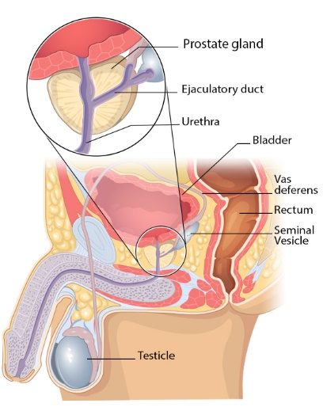
Figure 1: The male reproductive system showing the prostate gland (CDC, 2023).
At 9 to 10 weeks of embryonic stage, the prostate, which develops from the urogenital sinus, becomes visible for the first time (Aaron, Franco & Hayward, 2016). In the urogenital sinus mesenchyme, testosterone from the fetal testis at this time promotes the formation of endodermal buds. The urogenital sinus mesenchyme causes the urogenital sinus epithelium to go through prostatic ductal morphogenesis and differentiation under the influence of androgens. A coordinated series of actions take place during the complex androgen-dependent process of prostatic growth in both the gland's stromal and epithelial compartments. While the urogenital sinus mesenchyme in the presence of androgen is necessary for epithelial differentiation, the presence and differentiation status of the developing prostatic epithelium are necessary for stromal differentiation (Budipitojo et al., 2020). Until adolescence, its development enters a dormant stage. The gland's size during this time span stays constant at 1g. A significant androgen-driven rise in gland size that reaches 20g around the age of 20 characterizes the pubertal phase (Handelsman, 2000). Because of hyperplasia, inflammation, and atrophy in its transitional zone, the prostate gland's size remains constant for nearly 30 years before increasing starting at age 50.
In males, the testes' Leydig cells serve as the body's main source of androgens like testosterone (Gurung, Yetiskul & Jialal, 2021). These cells respond to the pituitary gland's luteinizing hormone (LH), which stimulates them to produce and secrete testosterone. However, the adrenal cortex, which is part of the adrenal gland located on top of the kidneys, also contributes to the production of androgens in males. The adrenal cortex produces a precursor hormone called dehydroepiandrosterone (DHEA), which may be transform to testosterone in peripheral tissues such as testes (Gurung, Yetiskul & Jialal, 2021). Androgens, which include testosterone and 5-dihydrotestosterone (DHT), are responsible for the growth, differentiation, and maintenance of prostatic tissues and the development of male sexual organs and secondary sex characteristics (Carpenter et al., 2021). Testosterone and DHT have distinct functions during the development of male sexual differentiation. Testosterone and its metabolite DHT play important roles in developing and differentiating male reproductive structures. The androgen receptor interacts differently with each androgen, with DHT binding to the receptor with higher affinity than testosterone (Alemany, 2022). For instance, tissues that are androgen-sensitive and react to DHT rather than testosterone include the penis, scrotum, prostate gland, and urethra. Compared to testosterone, DHT is a more powerful androgen with a higher affinity for the androgen receptor, which explains why it is the active ligand in these tissues (Feng & He, 2019). Nevertheless, testosterone can achieve high local concentrations through diffusion from neighboring testis during sexual differentiation to make up for its lower androgenic potency. The testosterone signal is amplified by conversion to DHT in locations that are further away, such as the urogenital sinus and urogenital tubercle. In addition to its role in the development of male reproductive structures, testosterone and DHT also have many other physiological functions in males, including the regulation of secondary sexual characteristics, such as body hair growth, muscle mass, and voice deepening, as well as the maintenance of bone density and the production of sperm (Molina, 2013).
2.2 Prostate Cancer
A common and complicated illness is prostate cancer (PCa), which continues to be a significant health concern worldwide. Characterized by the uncontrolled growth of cells in the prostate gland, this malignancy primarily affects older men. The incidence of PCa has risen over the years, and its impact on public health underscores the need for comprehensive research and effective management strategies. The risk factors for developing prostate cancer include age, family history, ethnicity, and genetic predisposition. African American men are at a higher risk, highlighting the influence of both genetic and environmental factors. It is crucial to remember that the prevalence of PCa is predicted to rise as a result of both population aging and economic growth. Three known risk factors for PCa are getting older, being black, and having a family history of the condition. The incidence of PCa varies widely across different populations and regions, with higher incidence rates and low mortality being observed in Western countries compared to Asian and African populations (Wang et al., 2022). However, this is in contrast to African countries, including Nigeria, which has a low incidence but a higher mortality. These disparities could be due to environment, variations in genetic factors, improved access to health care and increased awareness of the disease (Badal et al., 2020). According to some hospital-based studies, between 8 and 10% of men had subclinical PCa at autopsy, which was comparable to earlier reported Nigerian studies with less extensive tissue sampling but much less than estimates for other populations like African-Americans and African-Americans (Bosland et al., 2021). To learn more about the actual prevalence and natural history of PCa in Nigeria and Africa as a whole, more extensive studies are needed.
2.3 Incidence and Risk Factors of Prostate Cancer
The incidence of PCa varies widely across different populations and regions, with higher incidence rates and low mortality being observed in Western countries compared to Asian and African populations (Wang et al., 2022). However, this in contrast to African countries including Nigeria, that has low incidence but higher mortality. This disparities could be due to environment, variations in genetic factors and improved access to health care and increased awareness of the disease (Badal et al., 2020). Family history, age, genetics, and lifestyle choices are among the risk factors for PCa that have been identified. According to a cohort study on PCa risk factors among West African men, lack of information, regular alcohol and tobacco use, inactivity, and obesity were all linked to the disease (Oladoyinbo et al., 2020). Genetic, lifestyle, and environmental factors contribute to the incidence of prostate cancer, among which age is the most significant risk factor, with the incidence of the disease increasing with age. Family history of PCa is also an important risk factor, with men who have a first-degree relative with the disease having a higher risk of developing PCa. Genetics also play a significant role in the development of PCa, with specific genetic variations in genes, such as the AR gene, being associated with an increased risk of the disease (Conteduca et al., 2019). Lifestyle factors, including diet and physical activity, have also been shown to impact prostate cancer risk. For example, a diet high in animal fat and low in fruits and vegetables has been linked to an increased risk of prostate cancer, while physical activity has been associated with a reduced risk of the disease. In particular, in populations with a high burden of the disease, like Nigeria, more research is needed to ascertain the relative contributions of genetic, lifestyle, and environmental factors to the incidence of PCa. We can work to lessen the effects of this disease on men and their families by understanding the incidence and risk factors for PCa.
2.4 Diagnosis of Prostate Cancer
Several diagnostic tests and biomarkers have been created to facilitate the detection and management of PCa. Therefore, it is conceivable to effectively treat and, in some cases, completely eradicate prostate cancer if detected very early (Alarcón-Zendejas et al., 2022). Hence, a necessity exists for efficient methods of prompt identification of PCa. The following are some diagnostic tests and biomarkers for prostate cancer managements;
- Prostate-Specific Antigen (PSA) Test
The PSA test is a common diagnostic method for PCa. It measures the level of PSA in the blood. PCa may be indicated by high levels of PSA, a protein that the prostate gland produces (Mahmoud et al., 2023). However, there are concerns about the over diagnosis and overtreatment of indolent PCa due to the absence of precision in the PSA. In some cases, elevated PSA levels may be due to non-cancerous conditions, such as an enlarged prostate or prostatitis (Mahmoud et al., 2023). Several modifications to the PSA test have been developed to increase its specificity, including the use of PSA density and PSA velocity.
- Multiparametric Magnetic Resonance Imaging (mpMRI)
PCampMRI is a non-invasive imaging method that has demonstrated potential in identification and localization. With the use of this approach, which combines functional and anatomical imaging, precise images of the prostate gland can be obtained, making it possible to identify areas that may require a biopsy.
- Prostate Cancer Antigen 3 (PCA3)
PCA3 is a biomarker that is overexpressed in PCa tissue. The PCA3 test measures the level of PCA3 mRNA in urine samples collected after a digital rectal exam. The PCA3 test has shown promise in improving the detection specificity of PCa, particularly among males with high PSA levels and negative biopsy results.
- Prostate Health Index (PHI)
A blood test called the PHI test combines the pro PSA isoform, free PSA, and total PSA. The Food and Drug Administration has approved PHI (FDA). A combined score from this test can be used to estimate the likelihood of prostate cancer after biopsy. Farha and Salami (2022) indicate that this test is the most reasonably priced prostate cancer test that is commercially accessible in the United States and that it complies with the National Comprehensive Cancer Network (NCCN) recommendations. The PHI test has been shown to improve the specificity of prostate cancer detection compared to the traditional PSA test, particularly in men with PSA levels between 2 and 10 ng/mL.
- Myprostate Score (MPS)
MPS is an early screening method for prostate cancer that combines three specific urinary markers (TMPRSS2: ERG fusion gene expression, PCA3, and PSA) to generate a score between 0 to 100. This score range increases with the probability of identifying Gleason score greater or equal to 7 prostate cancer and is categorized into low, intermediate, or high-risk groups. The urinary gene expression assay requires a urine sample after a digital rectal exam (DRE). Jiao et al. (2021) found that MPS is a more cost-effective approach than magnetic resonance imaging (MRI) in guiding biopsy decisions for men with unspecified PSA levels. However, it is important to note that MPS is not yet approved by the FDA and is not recommended by the NCCN.
- 4Kscore Test
Blood tests known as the 4Kscore test examine the concentrations of four kallikrein markers in the blood: human kallikrein-related peptidase 2 (hK2), total PSA, free PSA, and intact PSA. When compared to the conventional PSA test, it has been demonstrated that the 4Kscore test increases the accuracy of prostate cancer detection. The latest advances in diagnostic tests and biomarkers for prostate cancer have shown promise in improving the accuracy and specificity of prostate cancer detection. The use of these tests and biomarkers in combination with traditional diagnostic methods may improve the detection of clinically significant prostate cancer and reduce the over diagnosis and overtreatment of indolent disease.
2.5 Treatment of Prostate Cancer
As a form of cancer affecting men (Rosellini et al., 2021), and its effective treatment is crucial in reducing its impact on patients and society. Active surveillance is a management strategy in which patients are monitored regularly with blood tests, digital rectal exams, and imaging studies to detect any progression of the cancer. Primary prevention is a treatment option for patients with low-risk PCa that has been shown to be safe and effective in a small number of patients (Mohler et al., 2019). PCa treatment differs depending on the cancer's stage and grade, as well as the patient's age and overall health. Active surveillance, surgery, radiation therapy, hormonal therapy, chemotherapy, and a combination of treatments are all treatment options for PCa (Mohler et al., 2019). Treatment for PCa will be determined by a number of factors, including the cancer's stage, the patient's overall health, and personal preferences. In the field of cancer treatment, a relatively new type of agent called "antibody-drug conjugates" (ADCs) has shown promising clinical outcomes for various malignancies, including breast cancer (Rosellini et al., 2021; Davis, 2022). ADCs are innovative compounds that link cytotoxic agents to specific antibodies that can identify antigens expressed by cancer cells. Researchers are currently investigating several potential antigens (STEAP1, TROP2, PSMA, CD46, and B7-H3), as suitable targets for ADCs in the treatment of prostate cancer The most frequent form of treatment for localized prostate cancer is surgery, which may entail a radical prostatectomy, or removal of the entire prostate gland. This can be done laparoscopically or through an open incision with tiny incisions and specialized tools. Due to its lower morbidity, robotic-assisted laparoscopic prostatectomy has gained popularity as a method for radical prostatectomy (Bertolo et al., 2021). Surgery may also be used in some circumstances to remove any lymph nodes that might have cancerous cells in them.
Another option for treating prostate cancer is radiation therapy, which can be used either alone or in conjunction with other therapies. Radiation therapy kills cancer cells by using high-energy X-rays or other forms of radiation. Patients with PCa frequently receive radiation therapy, which can be delivered via external beam radiation therapy (EBRT) or brachytherectomy (Bryant et al., 2021). EBRT delivers high doses of radiation from outside the body, whereas brachytherapy entails inserting small radioactive pellets directly into the prostate gland. Both treatments have similar success rates and can be used alone or combined with other therapies. The use of proton therapy, which employs charged particles, can reduce excess radiation delivered to patients compared to photon radiation therapy and consequently reduce the risk of gastrointestinal, genitourinary, and sexual toxicities (Bryant et al., 2021). However, proton therapy is controversial due to its higher cost and lack of high-level evidence supporting its advantages in improving patient quality of life, reducing toxicity, and improving cure rates. Nevertheless, numerous clinical trials and outcome reviews have demonstrated its efficacy in managing prostate cancer. Hormone therapy is another option for the treatment of PCa, and works by reducing the level of testosterone, which can slow or stop the growth of prostate cancer cells (Student et al., 2020). Hormone therapy may involve the use of drugs or surgical castration, and may be used as a primary treatment or in combination with other treatments. Androgen receptor (AR) signaling plays a critical role in the proliferation and survival of PCa cells (Student et al., 2020). When given androgen deprivation therapy (ADT), the majority of patients with metastatic prostate cancer experience high rates of early response. Nonetheless, despite prolonged treatment, disease progression is always seen, with tumor cells starting to proliferate again. Under ADT despite low serum testosterone levels, the idea that CRPC is caused by the reactivation of AR signaling makes sense given the rise in serum PSA, an androgen-responsive gene product produced into the blood by PCa cells. PCa treatment is a difficult and unique process, and the best course of action will depend on a number of variables. The three main types of treatment are surgery, radiation therapy, and hormone therapy, though a combination of therapies may be used to give patients the best results. Prostate cancer treatment options will continue to advance, and this will be essential to improving patient outcomes and lessening the disease's effects.
2.5.1 Androgen Deprivation Therapy
Androgen Deprivation Therapy (ADT) is a typical prostate treatment option that lowers androgens, such as testosterone, which bind to and activate AR (Fujita & Nonomura, 2019). However, many of cancerous cells eventually are immune to ADT, and the development of castration resistant PCa (CRPC) is often implicated with increased AR activity. ADT can substantially lower the amount of available androgens in men with PCa, which in turn lowers AR's transcriptional activity (Ban et al., 2021). AR itself experiences numerous changes as the course of treatment progresses in response to these changes. Prostate cancer that is resistant to treatment and no longer relies on androgens for growth and survival is known as castration-resistant prostate cancer. By using androgen ablation therapy, CRPC is targeted. There are five different types of probable development mechanisms for CRPC. AR mutations, higher concentrations of co-activators, or enhanced synthesis of the potent androgen dihydrotestosterone all increase sensitivity to low levels of androgen in the blood in the hypersensitive pathway. The AR and androgen continue to be essential for the growth of tumors that use this mechanism. All of these ultimately lead to androgen-independent AR activation, which is the fundamental reason for anti-androgen therapy resistance. AR can be stimulated regardless of the existence of other hormones and medications, such as progesterone, flutamide, bicalutamide, and enzalutamide, and sustain its transcription activity to promote PCa carcinogenesis. The gene amplification and some acquire genetic abnormalities can cause this. The existing treatments for advanced prostate cancer comprise inhibitors of androgen synthesis that suppress the production of testosterone and/or DHT, as well as inhibitors of AR that prevent the binding of ligands at the LBD (El Kharraz et al., 2021). Nevertheless, LBD-specific therapies may become ineffective due to AR genetic variations and discrepancies. Because they both play crucial part in its gene transcription action and are less susceptible to AR alternative splicing than the LBD, the DBD and NTD have therefore emerged as new targets for inhibition (Severson et al., 2022).
2.5.2 Androgen Receptor Signaling Inhibitors (ARSIs)
Androgen receptor signaling inhibitors are quite a type of medication utilized for treating PCa. Because AR signaling promotes tumor growth, medicines known as AR signaling inhibitors (ARSIs), which work to block AR signaling, have long been used in clinical settings. The majority of individuals treated with ARSIs develop a castration-resistant (CRPC) phenotype, which is unfortunate because the therapeutic efficacy of ARSIs is transient (Jamroze, Chatta & Tang, 2021). These drugs work by blocking the activity of AR, which are androgen-binding proteins present in prostate cells and stimulate the growth and spread of PCa. These medications can be used to treat PCa on their own or in conjunction with other therapies like radiation therapy or chemotherapy. They can also be used to manage the symptoms of advanced prostate cancer. There are several types of androgen receptor signaling inhibitors, including:
- Anti-androgens: These drugs impair androgen from forming complex to its receptors, preventing the cancer cells from receiving the signal to grow and divide. Examples include bicalutamide, flutamide, and nilutamide.
- GnRH agonists: These drugs reduce the production of androgens by the testes by inhibiting the release of gonadotropin-releasing hormone (GnRH) from the hypothalamus. This causes reduction in testosterone levels in the body, which can slow the growth of prostate cancer. Examples include leuprolide and goserelin.
- CYP17 inhibitors: These drugs block an enzyme called CYP17, which is involved in the production of androgens in the adrenal gland and in the prostate cancer cells themselves. Examples include abiraterone acetate.
- Androgen receptor antagonists: These drugs block the activity of androgen receptors directly, preventing them from stimulating the growth of prostate cancer cells. Examples include enzalutamide and apalutamide.
The biotransformation of androgens in the body is the foundation that drives the creation of medications for PCa (Takayama, 2018). Androgens are synthesized from cholesterol, which is converted into pregnenolone and then into various hormones, including DHEA, androstenedione, and testosterone (Zhang et al., 2022). Enzymes involved in androgen synthesis include CYP11A1, 3β-HSD, and CYP17A1. DHEA biogenesis from cholesterol is crucial in the treatment of PCa individuals who may have rising androgen levels and overactive AR because DHEA is a crucial forerunner in androgen biosynthetic pathways in the prostate. Abiraterone, enzalutamide, apalutamide, and darolutamide are drugs recommended by the NCCN for PCa treatment and act on the androgen axis by targeting androgen synthesis and metabolism pathways (Zhang et al., 2022). These medications, renowned as ARSI, are used to block pathways, restore DHEA levels in the body, and impede AR signaling, which are the main causes of ARSI resistance.
2.5.3 Combination Therapies
One potential combination therapy for PCa is the use of AR inhibitors such as enzalutamide or abiraterone acetate, in combination with PI3K inhibitors such as buparlisib or idelalisib. The combination of these drugs has been shown to have a synergistic effect in preclinical studies, resulting in decreased proliferation of cancer cells and increased apoptosis. Table 1 lists some of these dual-targeting combination therapies. In a preclinical study, (Thomas et al., 2013) found that combining an AKT inhibitor with an anti-androgen prolonged the stabilization of the disease in a CRPC model. The AKT inhibitor in the androgen-sensitive and castration-resistant phases of the LNCaP mouse xenograft, AZD5363 proved anticancer activity. It also successfully decreased propagation and induced apoptosis in PCa cell lines expressing AR (Toren et al., 2015). But after about 30 days of treatment, increasing PSA levels signaled AZD5363 resistance. It was discovered that AZD5363 enhanced AR transcriptional activity, AR binding to androgen response elements, and AR-dependent gene expression, including PSA and NKX3.1 (Thomas et al., 2013). Combining AZD5363 with the antiandrogen bicalutamide prevented these side effects and prolonged the inhibition of tumor growth and stabilized PSA in CRPC in vivo. Additionally, in vitro experiments revealed a synergism reduction in cell preponderance and trigger of apoptosis Synergistic inhibition of cell proliferation and induction of apoptosis were also observed in vitro (Toren et al., 2015). Another approach is to target both AR and PI3K pathways with a single drug. For example, a novel drug called AZD5363 has been developed that inhibits both PI3K and AKT, a downstream effector of PI3K, as well as AR signaling. This medication is presently being assessed in clinical trials after demonstrating encouraging outcomes in preclinical research.
Table 1. Combination therapies targeting AR and PI3K/AKT/mTOR pathways
Target | Agent | Phase | Administration | Condition | I.D on Clinicaltrial.gov
AKT | AZD5363 | III | Docetaxel | mCRPC | NCT05348577
AKT | MK2206 | II | Bicalutamide | High-Risk of Progression | NCT01251861
AKT | Capiversertib | II | Abiraterone acetate | High Risk Localized PCa | NCT05593497
PI3K | AZD8186 | I | Docetaxel | mPCa with PTEN Mut | NCT03218826
PI3K | GSK2636771 | I | Enzalutamide | PTEN(-) mCRPC Mut | NCT02215096
Mtor | Sepanisertib | II | Monotherapy | CRPC | NCT02091531
Mtor | Everolimus | I | + standard radiation therapy | PCa with rising PSA | NCT01548807

2.6 Molecular Aspects of Prostate Cancer and Non-Invasive Biomarkers
Advancements in molecular biology have shed light on the intricate mechanisms underlying prostate cancer development and progression. Numerous genetic and molecular abnormalities influence the complex process of cancer progression; people with tumors have been shown to have more genetic mutations (Zhao et al., 2022). PCa, among other types of cancer, develops and progresses in part due to the androgen receptor (AR), a transcription factor (He et al., 2018). The androgen receptor (AR) signaling pathway, which plays a pivotal role in male sexual development and maintenance of masculine characteristics, is intricately linked to prostate cancer development and progression. Dysregulation of AR signaling is often implicated in the pathogenesis of prostate cancer, contributing to disease progression and therapeutic resistance. Genes that support cell growth and survival are activated when AR binds to unique region on the DNA androgen response elements (AREs) (Manzar et al., 2023). In PCa, AR is expressed more frequently, and its activity is crucial for the growth and survival of prostate cancer cells. Numerous studies have demonstrated that inhibiting AR can successfully stop prostate cancer cells from growing (Fernandez-Perez et al., 2023).
Prostate cancer is marked by a diverse genetic landscape, encompassing both germline and somatic mutations (Stover et al., 2022). Germline mutations, such as those in BRCA1, BRCA2, and HOXB13 genes, can confer an increased risk of prostate cancer. Somatic mutations in genes like TP53, PTEN, and SPOP are frequent drivers of disease progression (Abeshouse et al., 2015). Within the realm of primary prostate cancers, there is a notable occurrence of recurring mutations in genes such as TP53, SPOP, and FOXA1 (PCF/SU2C International Prostate Cancer Dream Team et al., 2018). Additionally, it's common to observe deletions affecting RB1, PTEN, and CHD1, as well as amplifications involving MYC (Quigley et al., 2018). Furthermore, ETS family gene fusions, including the well-known TMPRSS2-ERG fusion, are prevalent. The utilization of comprehensive genomic sequencing has provided valuable insights into the spectrum of alterations in metastatic castration-resistant prostate cancer (mCRPC), shedding light on the genomic landscape. Interestingly, even within this subgroup of metastatic tumors, the mutation rate remains relatively low, hovering at 3–4 mutations per megabase (Mb) (Grasso et al., 2012; Lawrence et al., 2014).Somatic mutations in mCRPC tumors manifest in several genes that experience relatively rare alterations in primary prostate cancers. These genes encompass PIK3CA, PIK3CB, RSPO, BRAF, RAF1, APC, CTNNB1, and ZBTB16 (PLZF) (Robinson et al., 2015).
Alterations in the androgen receptor (AR) are prevalent in mCRPC but rarely appear in primary, treatment-naïve prostate cancer. These AR alterations are closely linked to resistance against androgen therapy. They encompass single nucleotide variations (SNVs), amplification of the AR gene locus, structural rearrangements of AR, and amplifications affecting an AR enhancer. Deletions and mutations involving PTEN and TP53 are present in a substantial proportion, ranging from 40% to 50%, of mCRPC cases. A noteworthy fraction of patients also carries deficiencies in DNA repair proteins, potentially making them responsive to poly(ADP-ribose) polymerase (PARP) inhibitor therapy.
2.6.1 The Androgen receptor Signaling Pathway
The AR pathway is essential for controlling the prostate growth and differentiation. The biochemical activity of androgen is started by testosterone or DHT attaching to its specific receptor, the AR, activating it (Figure 2). When unattached from its ligand, AR is found in the cytoplasm as a component of an inactive complex that also contains the heat shock proteins HSP40, HSP70, and HSP90 (Ratajczak, Lubkowski & Lubkowska, 2022) includes additional chaperone proteins to guard against receptor deterioration. These proteins play a crucial function in maintaining an accessible AR shape and preventing premature AR degradation.
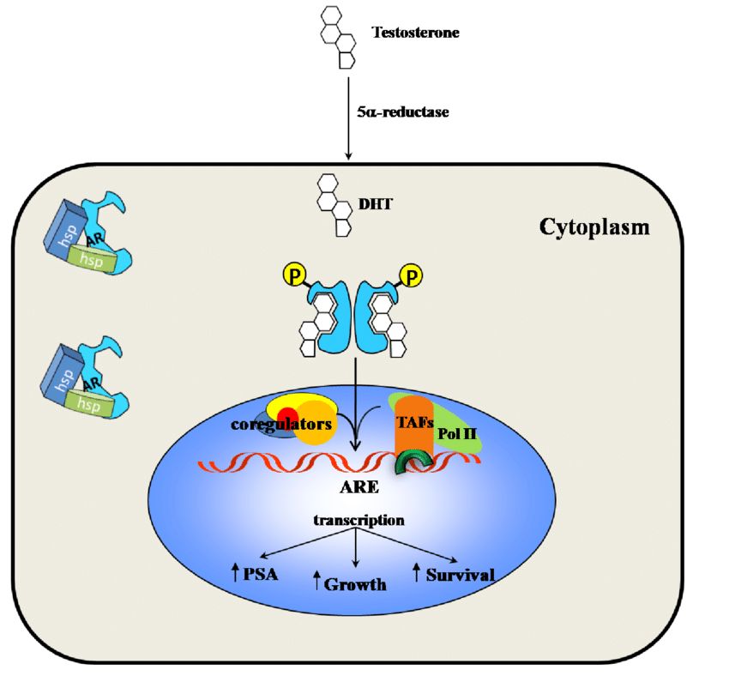
Figure 2: Androgen signaling pathway (Peyman, 2010)
The AR undergoes a conformational change when it binds to a particular ligand, creating a more compact and stable form of the receptor. When AR is activated, it separates from heat shock proteins and moves to the nucleus, engaging in homodimer interactions with DNA androgen response elements (Messner et al., 2020). A second dimerization interface is needed to bind to an AR response element since AR employs the DBD to bind to ARE elements. The protein-protein and protein-DNA connections that allow for this unexpected structure are preserved, and some AR-specific dimerization contacts are responsible for the AR specificity of AR response elements. As seen in Figure 2, in order to control the gene-specific expression that affects the development and survival of target cells, the active DNA-bound AR can entice co-regulator proteins and fundamental transcriptional machinery (Takayama, 2018).
The dysregulation of AR signaling in PCa leads to an increased reliance on androgen signaling by the cancer cells for growth and survival. Not only does AR signaling support the growth and survival of PCa cells, but it can also play a role in the development of ADT resistance. Numerous processes, including as mutations or amplifications of the AR gene, elevated AR expression, and the activation of alternate signaling pathways, contribute to this (Figure 3).
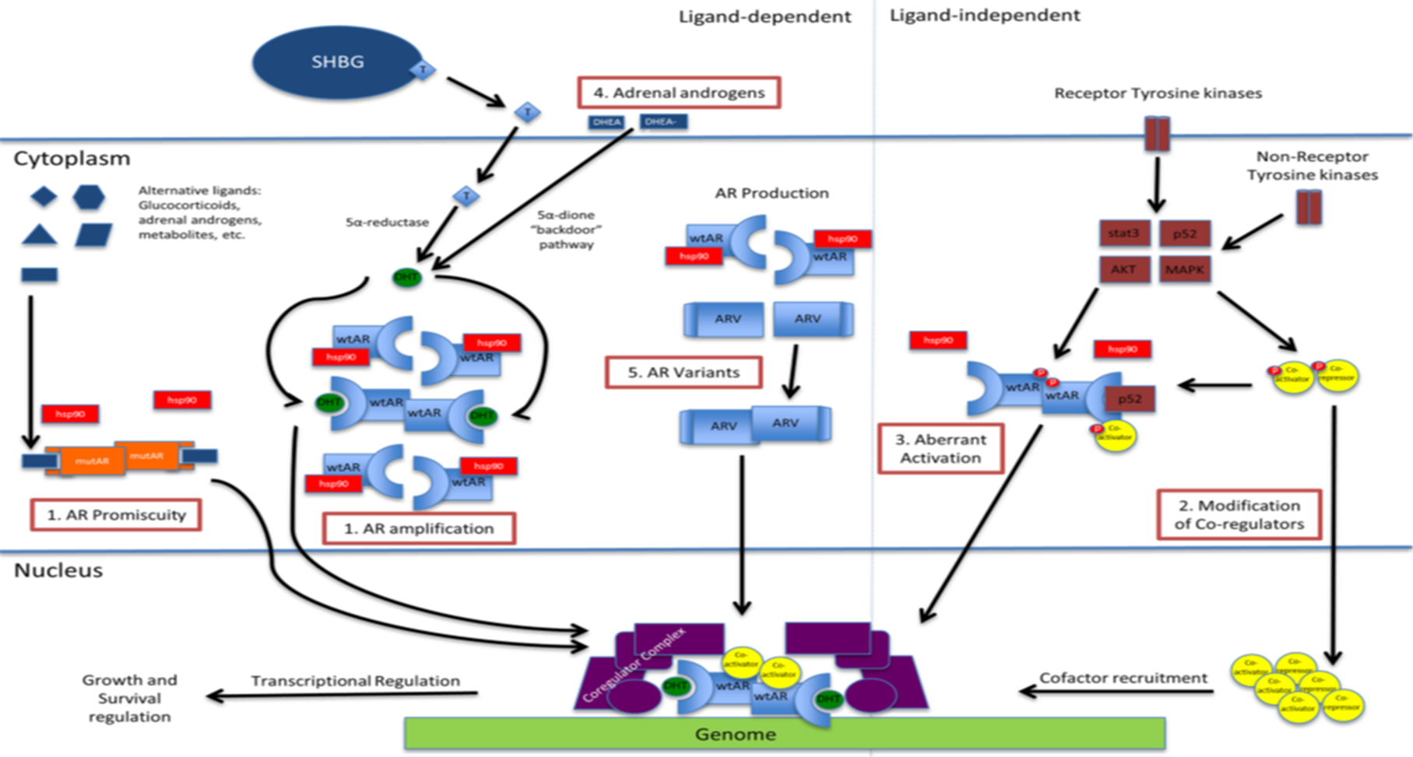
Figure 3: Dysregulated Androgen Receptor signaling in PCa (Chandrasekar et al., 2015)
As a result, targeting the AR signaling pathway is an important therapeutic strategy in the therapy of PCa, and there are several drugs that specifically target AR signaling, such as enzalutamide, abiraterone, and apalutamide.
2.6.2 Steroid Receptor Coactivator-3
The Androgen Receptor (AR) directly interacts with Steroid Receptor Coactivator-3 (SRC-3) a member of Steroid Receptor Coactivator family proteins and boosts its transcriptional activity (Szwarc et al., 2014). The SRC family, consisting of three evolutionarily conserved transcriptional coregulators, is made up of SRC-1 (also called NCOA-1), SRC-2 (also called NCOA-2), and SRC-3 (also called NCOA-3). In the end, these coregulators influence gene regulation via modulating the interface between the transcriptional machineries and AR. Prostate cancer aggression is linked to SRC-1 expression, and inhibiting SRC-1 expression in prostate cancer cells changed the regulation of AR target genes and stunted their growth. SRC-1, however, has a different role in a murine prostate cancer model than does SRC-3, which is necessary for the growth and metastasis of prostate cancer in mice (Tien et al., 2013). PCa, both primary and metastatic, increases SRC-2. Androgen deprivation causes SRC-2, which activates PI3K signaling and encourages the development of castration-resistant prostate cancer (CRPC) and spread (Qin et al., 2022). Additionally, SRC-2 promotes lipogenesis and metabolic reprogramming, which are significantly elevated in metastatic prostate malignancies, by reductively carboxylating alpha-ketoglutarate (Dasgupta et al., 2015).
The development of CRPC requires SRC-3 because it increases Akt activity and S6K1 expression (Tien et al., 2013). Through ubiquitination, SPOP, a tumor suppressor in prostate cancer, increases SRC-3 turnover. Mutants linked to PCa and associated with SPOP are unable to bind with SRC-3, which hinders its ubiquitination (Geng et al., 2013). Additionally, research has demonstrated that AR interacts with other signaling pathways, such as the PI3K/Akt pathway (Pungsrinont, Kallenbach & Baniahmad, 2021). Two essential routes that regulate cellular growth, survival, and metabolism are phospholipase 3-kinase (PI3K) and androgen receptor (AR) signaling. Many malignancies, including PCa, have been linked to the emergence and spread of crosstalk between these two pathways. Numerous growth hormones and cytokines can initiate the PI3K signaling pathway, which is necessary for cell growth, metabolism, and survival. PI3K activation results in the production of phosphatidylinositol-3,4,5-trisphosphate (PIP3), which in turn recruits and activates several downstream effectors, including Akt and mTOR. By blocking apoptotic pathways and turning on signaling pathways that support protein synthesis and glucose metabolism, Akt encourages cell growth and survival. On the other hand, via controlling protein synthesis and autophagy, mTOR encourages cell growth and proliferation.
SRC-3 functions by augmenting AR's transcriptional function, which raises the expression of genes linked to the development of prostate cancer. It was also shown that SRC-3 is an essential regulator of the survival and proliferation of PCa cells. Research indicates that it plays a crucial function in fostering the growth of cancer by being necessary for the proliferating prostate cancer cells (Zhou et al., 2005). PCa, both primary and metastatic, amplifies SRC-3, suggesting that it plays a crucial role in the disease's progression (Fujita & Nonomura, 2019). The potential of SRC-3 as a therapeutic target in the treatment of PCa is underscored by its participation in the disease. Targeted treatments for patients with prostate cancer may be developed as a result of our growing understanding of its function in AR signaling and cancer growth.
Numerous research studies underscore the crucial role played by SRC-3 in the progression of PCa. SRC-3, also recognized as Amplified in Breast Cancer 1 (AIB1) or Nuclear receptor coactivator 3 (NCoA3), emerges as a vital coactivator that directly interacts with the Androgen Receptor and significantly influences AR-driven transcriptional activity in PCa cells (Dahiya & Heemers, 2022). SRC-3 is amplified in both primary and metastatic PCa, indicating its significance in disease progression (Fujita & Nonomura, 2019). SRC-3 functions as a co-activator, augmenting the activity of the AR in PCa. This interaction contributes to the androgen signaling pathway, which is crucial for PCa creation and course (Gnanapragasam et al., 2001). The involvement of SRC-3 in PCa underscores its potential as a therapeutic target in treating this disease. Understanding its role in AR signaling and cancer growth may pave the way for the development of targeted therapies for prostate cancer patients.
Additionally, clinical resistance to aromatase inhibitors and tamoxifen depends on SRC-3 (Osborne et al., 2003). This resistance is attributed to SRC-3's involvement downstream of growth factor signaling pathways, enabling it to bypass ER inhibition in Breast Cancer cells. Genomic alterations was shown to contribute to resistance to endocrine therapy, including mutations in the ER gene's ligand-binding domain, allowing receptor activation in the absence of estrogen signaling (Rotimi et al., 2021). Target gene activation that occurs without the need of hormones is induced by upstream signalling pathways, which include metabolic factors that impact SRC-3. It is encouraging that medications that target SRC-3, like SI-2 and phospho-bufalin, have shown encouraging results in mice models of breast cancer (Song et al., 2016). These collective findings underscore the importance of SRC activity in Breast Cancer and its potential as a therapeutic target.
Evaluating SRC-3 dysregulation in PCa patients can be a useful biomarker. Customizing treatment techniques may be made easier by identifying patients who exhibit high SRC-3 expression or activity. Treatments that target SRC-3 may be more beneficial for patients with SRC-3 dysregulation. ADT resistance has been linked to SRC-3 dysregulation in response to endocrine treatments (Axlund et al., 2010). The creation of techniques to overcome resistance to medication can be guided by an understanding of the role that SRC-3 plays in this phenomenon. Combination treatments or cutting-edge methods to target SRC-3-driven resistance mechanisms may be used in this. The value of individualized treatment is shown by the research of SRC-3 dysregulation in PCa. Treatment effectiveness can be increased while reducing side effects by customizing care based on the unique molecular features of each patient's tumor, including the presence or absence of SRC-3.
2.6.3 Speckle-type POZ protein (SPOP)
The SPOP gene in humans that encodes the SPOP protein. It plays a crucial role in cellular regulation, particularly in protein degradation and post-translational modifications. The interlink between the AR, SPOP, and SRC-3 in PCa is crucial for understanding disease mechanisms. SPOP, a substrate-binding adaptor, interacts with AR, a key player in prostate cancer initiation and progression (Eryilmaz et al., 2024; Zhang, Jin & Huang, 2023b). SPOP mediates the polyubiquitination of various substrates, including AR and SRC-3, impacting cancer-relevant pathways like androgen/AR signaling (Zhang, Jin & Huang, 2023b).
The SPOP gene is situated on chromosome 17, specifically at the long arm of the chromosome, known as 17q21.2 (Yang & Zhu, 2022). This genomic location is important because alterations or mutations in this gene can have significant consequences for cellular function. The SPOP gene consists of multiple exons and introns. Exons are the coding regions of the gene that are transcribed into messenger RNA (mRNA) and eventually translated into the SPOP protein. Introns are non-coding regions that are removed during mRNA processing. The gene structure includes several exons that are transcribed into messenger RNA (mRNA) and subsequently translated into the SPOP protein. The precise organization of exons and introns may vary among species, but in humans, the SPOP gene generally consists of 8 exons. Here is a brief overview of the exons in the SPOP gene:
Table 2. Coding exons of SPOP gene.
Exon | Function
1 | The first exon is non-coding and often contains regulatory elements that control gene expression and transcription.
2 | This exon encodes the N-terminal region of the SPOP protein, including a substrate-binding cleft and a BTB domain, which is involved in protein-protein interactions.
3 | Encodes additional portions of the N-terminal region of the SPOP protein.
4 | Contains sequences coding for the middle region of the SPOP protein.
5 | Encodes the central portion of the protein, including the MATH domain, which is involved in substrate binding.
6 | Encodes more of the central region of the SPOP protein.
7 | Contains sequences coding for the C-terminal region of the SPOP protein.
8 | The last exon encodes the final part of the C-terminal region of the SPOP protein.

The SPOP protein plays a critical role in protein degradation pathways, particularly by acting as a substrate adaptor for the Cullin3-RING E3 ligase complex. This complex targets specific proteins for ubiquitination and subsequent degradation in proteasomes. SPOP's substrate-binding cleft, encoded by exons 2 and 3, is essential for its recognition of target proteins. SPOP has a modular structure that plays a pivotal role in cellular functions, particularly in protein homeostasis and degradation (Yang & Zhu, 2022). Key features of the SPOP protein include:

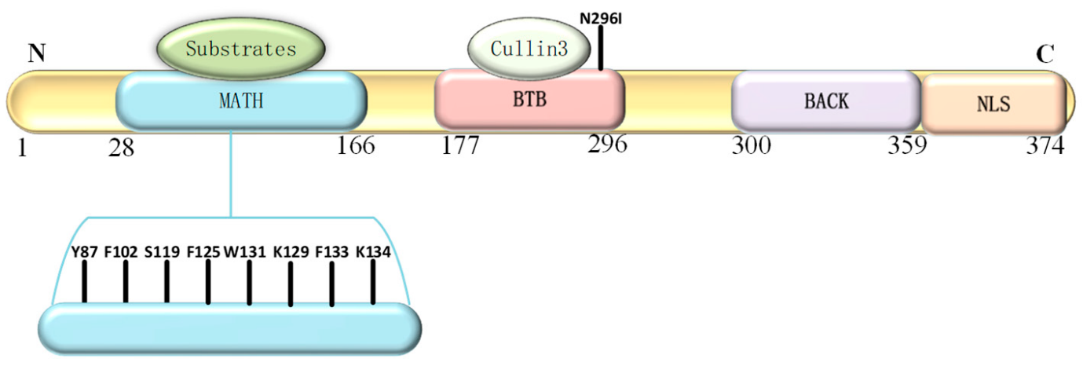
Figure 4. Structure of SPOP protein showing its component domains (Yang & Zhu, 2022)
- N-terminal MATH Domain: The MATH (Meprin and TRAF homology) domain is located within the central region of the SPOP protein. This domain is responsible for substrate recognition and binding. It plays a pivotal role in mediating the interaction between SPOP and its target proteins, which are subsequently targeted for ubiquitination and degradation.
- BTB Domain: The BTB (Bric-a-brac, Tramtrack, Broad-complex) domain is located at the N-terminal region of the SPOP protein. It functions as a protein-protein interaction domain, allowing SPOP to interact with other proteins and form complexes. This domain is involved in the assembly of the Cullin3-RING E3 ligase complex, which plays a crucial role in protein degradation pathways.
- BACK Domain: The BACK (BTB and C-terminal Kelch) domain is situated between the MATH domain and the POZ domain within the SPOP protein. This domain contains a series of Kelch-like repeats that are involved in protein-protein interactions and substrate recognition. The BACK domain is known to interact with specific protein targets, contributing to the substrate specificity of SPOP. It plays a crucial role in facilitating the assembly of the Cullin3-based E3 ubiquitin ligase complex, which is responsible for targeting proteins for ubiquitin-mediated degradation.
C-terminal Nuclear Localization Sequence (NLS): The C-terminal region of the SPOP protein contains a nuclear localization sequence (NLS). This sequence is responsible for directing the protein to the cell nucleus. The NLS allows SPOP to enter the nucleus, where it can participate in various cellular processes, including gene regulation and protein degradation. The nuclear localization of SPOP is essential for its interactions with other nuclear proteins and for executing its functions related to substrate recognition and protein degradation.
Mutations in SPOP can impair its binding to AR, influencing cancer pathogenesis (Zhang, Jin & Huang, 2023a). Additionally, higher expression of SPOP has been associated with earlier clinical stages and better overall survival in prostate cancer, indicating its potential as a biomarker for diagnosis and prognosis (He et al., 2021). Understanding the intricate relationship between SPOP, AR, and SRC-3 provides insights into the molecular mechanisms underlying prostate cancer progression. Understanding the SPOP gene and its protein product is essential for grasping its significance in various cellular processes and its involvement in diseases, especially cancer. SPOP identifies specific target proteins through the recognition of consensus binding motifs present in these substrates. Once identified, SPOP facilitates the transfer of ubiquitin molecules onto these target proteins, tagging them for degradation by the proteasome or other cellular processes (Figure 6).
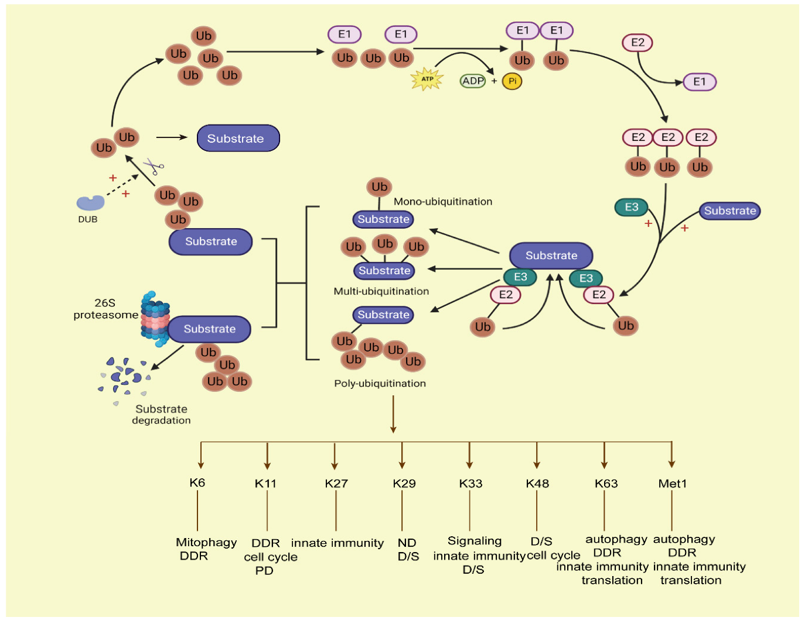
Figure 5: The ubiquitin-proteasome system where SPOP functions (Wang et al., 2023)
Mutations in SPOP could disrupt this finely tuned regulation, potentially contributing to cancer initiation and progression (Rider & Cramer, 2015). Its ability to mediate both degradable and non-degradable polyubiquitination adds to its significance (Zhang, Jin & Huang, 2023b). Some of the notable substrates that SPOP targets for ubiquitination include androgen receptor (AR), SRC-3, TRIM24, BRD4, PD-L1, 53BP1, GLP/G9a, c-Myc, and SENP7, among others. This wide array of substrates highlights the multifaceted role of SPOP in cellular processes. Importantly, cancer-associated mutations in SPOP often disrupt its binding to substrates and its ability to polyubiquitinate them (Zhang, Jin & Huang, 2023b). This disruption has far-reaching consequences on various cancer-related pathways. These pathways encompass androgen/AR signaling, crucial for prostate cancer, DNA repair and methylation mechanisms, cellular stress surveillance, regulation of cancer metabolism, and immune responses. SPOP mutations have been particularly associated with cancer, notably in prostate cancer (Clark & Burleson, 2020). Mutations in the SPOP gene can lead to altered substrate recognition, resulting in dysregulation of cellular processes (Shi et al., 2019). In prostate cancer, SPOP mutations are often found in localized tumors and can impact the regulation of the androgen receptor (AR) signaling pathway. Dysfunctional SPOP activity in AR signaling can contribute to the development of castration-resistant prostate cancer, a more aggressive form of the disease. Several mutations in the SPOP gene have been identified in prostate cancer. 260A>G The most common mutations are clustered within the substrate-binding MATH domain of the SPOP protein (Abumsimir et al., 2021; Buckles et al., 2014). Some of the well-known SPOP mutations in prostate cancer include:
- Y87N: This mutation involves a tyrosine-to-asparagine substitution at amino acid position 87 in the MATH domain of SPOP.
- Y87C: This mutation involves a tyrosine-to-cysteine substitution at amino acid position 87 in the MATH domain of SPOP.
- F102C: This mutation results in a phenylalanine-to-cysteine substitution at amino acid position 102.
- F102S: This mutation results in a phenylalanine-to-serine substitution at amino acid position 102.
- F133V: This mutation involves a phenylalanine-to-valine substitution at amino acid position 133.
- F133L: This mutation results in a phenylalanine-to-leucine substitution at amino acid position 133.
- G111E: This mutation results in a glycine-to-glutamic acid substitution at amino acid position 111.
- W131G: This mutation involves a tryptophan-to-glycine substitution at amino acid position 131.
- Q165H: This mutation results in a glutamine-to-histidine substitution at amino acid position 165.
- N296I: This mutation results in an asparagine-to-isoleucine substitution at amino acid position 296.
These mutations have been detected in subsets of prostate cancer patients, and their functional consequences can vary. Notably, SPOP mutations have been associated with altered androgen receptor (AR) signaling and can impact the stability and activity of the AR protein. Some SPOP mutations have been linked to the development of aggressive and treatment-resistant prostate cancer. SPOP mutations in the substrate-binding MATH domain can disrupt its ability to interact with AR, impairing AR ubiquitination, and resulting in increased AR protein stability. As a consequence, the dysregulated AR becomes more resistant to degradation and retains higher transcriptional activity, promoting aberrant cell growth and survival in prostate cancer. The mutations are associated with clinical and genomic features such as high Gleason scores and absence of ERG fusions (Huang, 2023). SPOP is a tumor suppressor gene, and its mutations can contribute to the development and progression of prostate cancer (Rider & Cramer, 2015; Shi et al., 2022). Research indicates that SPOP mutations can enhance cancer cell proliferation, invasion, and immune escape (Shi et al., 2022). In a recent study, it was found that prostate cancer (PCa) with SPOP hotspot mutations, such as F133V, develop resistance to BET inhibitors due to abnormal increase in BET proteins (Zhang et al., 2021). However, a previously unknown mutation, Q165P, located at the edge of the SPOP MATH domain in both primary and metastatic PCa of a patient, was discovered in another study (Yan et al., 2019). The Q165P mutation leads to structural changes in the MATH domain, disrupting SPOP dimerization and substrate degradation. Unlike tumors with the F133V hotspot mutation, PCa patient-derived xenografts (PDXs) and organoids with the Q165P mutation showed modest sensitivity to BET inhibitors.
A striking attribute of prostate cancers featuring SPOP mutations is their distinctiveness in terms of genomic alterations (Nakazawa et al., 2022). Notably, these cancers differ from counterparts without SPOP mutations by lacking rearrangements in the ETS family of genes. This divergence in genomic alteration patterns suggests that the presence of SPOP mutations exerts a considerable influence on the molecular makeup and genetic underpinnings of prostate cancer. These findings collectively spotlight the central role of SPOP in prostate cancer and its potential to shape the disease's genetic landscape (Nakazawa et al., 2021). The recurrent mutations within the substrate-binding cleft of SPOP underscore the significance of this specific region in the pathogenesis of prostate cancer and potentially pave the way for targeted interventions aimed at modulating the downstream effects of these mutations. Understanding the role of SPOP mutations in prostate cancer provides insights into potential therapeutic strategies targeting this molecular pathway. It's essential to note that research on the SPOP gene and its mutations is an ongoing and dynamic field. New studies to identify additional mutations would provide more insights into the functional significance of known mutations.

CHAPTER THREE
MATERIALS AND METHODS
3.1 Materials
3.1.1 Equipment
The equipment for this research includes Gel Comb and Tray, PCR machine, Eppendorf tubes, Micropipette and tips, Gloves, Marker, Tube racks, NanodropTM 2000/2000c Spectrophotometer 7300 Thermal cycler (Bio-Rad), Weighing balance, Zymo© Quick-DNA Miniprep Kit, Electrophoretic machine, Ecotherm Microcentrifuge, Freezer (–80°C), DNA extraction kit, ELISA kit and Sanger sequencer.
3.1.2 Reagents
The following reagents will be used for this research: PCR buffer, 3% agarose gel, Primers, ethidium bromide, DNase-free water, Ethidium bromide, Primer sets, PCR Supermix, Agarose Powder, Loading Dye, ELISA Kits, TBE Buffer and TBE 2X.
3.2 Methods
3.2.1 Study Population: A case-control design of 80 participants: 40 histologically diagnosed prostate cancer patients attending hospital and 40 apparently healthy men as control.
3.2.2 Study Area: The primary study area will be the Lagos State University Teaching Hospital (LASUTH), University of Lagos Teaching Hospital (LUTH), Cancer Research Lab domiciled at Covenant University Ota.
3.2.3 Inclusion and exclusion criteria
Inclusion criteria
- Men 40 – 75 years of age who have been diagnosed with prostate cancer
- Men who have been clinically diagnosed with PCa and are willing to participate
Exclusion criteria
- Men that are outside the age range of 40 - 75
- Unwilling and Non-Nigerian men
- Individuals with a history of other types of cancer
3.2.4 Sampling Technique: Eligible volunteers who met the inclusion criteria were enrolled in the study and informed that their blood samples would be used for a research project. The samples were collected only after obtaining written informed consent.
3.2.5 Blood Collection: Blood samples from participants were collected and preserved in vacutainer tubes containing EDTA as an anticoagulant. Subsequently, the samples were separated, and the plasma was extracted and stored at -20ͦ C for further analysis.
3.2.6 Ethical Clearance: This research was carried out in line with the Helsinki Declaration which is the cornerstone document for human research. This study obtained ethical approval from the Covenant Health Research Ethics Committee (CHREC). Informed consent was also obtained from all individuals before participation in the study.
Extraction and Quantification of Genomic DNA from Blood: For genotyping analysis, whole blood was digested with 500ul of a mixture of lysis buffer and proteinase k. Genomic extracted from buffy coat utilizing the QIAamp DNA Blood Mini Kit (Qiagen, Hilden, Germany), following the manufacturer's recommended protocol. The extracted DNA's quality and quantity was determined spectrophotometrically at 260nm using a NanoDrop spectrophotometer, while its integrity was evaluated by subjecting it to electrophoresis on a 1% agarose gel. Following the analysis, the isolated DNA samples was properly preserved at a temperature of -20℃ until the time of further analysis.
PCR Amplification and Sanger Sequencing
In our study, we amplified exon-specific products, the exon 6 of SPOP gene of size 248 bp using polymerase chain reaction (PCR). We utilized exon-specific primers (forward: TTTTCTATCTGTTTTGGACAGG and reverse: CAAAGCCACAACTTGTCAGTG (Buckles et al., 2014). The PCR reaction mixture consisted of genomic DNA (3.5 ng), 1× AmpliTaq Gold PCR buffer, 2.0 mmol/L MgCl₂, 0.2 mmol/L of each dNTP, 0.4 µmol/L sense primer, 0.4 µmol/L antisense primer, and 0.5 units of AmpliTaq Gold DNA polymerase. The PCR amplification was performed using a DNA Engine Peltier Thermal Cycler (Bio-Rad, Hercules, CA, USA). Subsequently, we purified the PCR amplicons using exonuclease I (USB/Affymetrix, Santa Clara, CA, USA) and shrimp alkaline phosphatase (USB/Affymetrix). Finally, direct Sanger sequencing was carried out using both forward and reverse PCR primers. To confirm mutations, we performed bi-directional sequencing of an independent PCR product from the original genomic DNA template. All sequencing procedures were conducted at the Inqaba Genomic Biotech Company Facility in Ibadan, Oyo State, Nigeria.
Sequence Alignment and Analysis
We conducted a sequencing analysis using the following steps. First, individual AB1 files were manually based on BioEdit v7.2. Subsequently, we verified the final sequences through nBLAST. Next, we performed putative amino acid translations within BioEdit. To validate protein derivatives across exon sequences, we utilized BLASTp. Our wild-type reference was the Human Genome retrieved from the GenBank database at the National Center for Biotechnology Information (NCBI). Specifically, we compared nucleotide sequences with the Homo sapiens chromosome 17, NA24385 reference primary assembly (GenBank: CP139526.2), starting from position 50,112,984 nt. For derived protein sequences, we employed the speckle-type POZ protein (Homo sapiens) NCBI Reference Sequence NP_001007229.1, beginning at position 77. Finally, all sequences (nucleotides and proteins) were aligned to the wild type using the Clustal-W multiple sequence alignment executed in BioEdit. Further analysis of clinical parameters such as Gleason score, tumor stage, PSA levels, and other relevant clinical factors in relation to the presence of SPOP mutations.
3.2.7 Enzyme-linked immunosorbent assay (ELISA)
To measure AR target gene expression and investigate the effects of mutations on SPOP protein stability and its interaction with AR signalling proteins we assess the circulating levels of AR, SPOP, and SRC-3 proteins using enzyme-linked immunosorbent assay (ELISA) technique, as previously described by . Quantification of AR, SPOP and SRC-3 protein levels was done using Human AR, Human SPOP, and Human SRC-3 ELISA Kits from BIOVATION Inc China following the manufacturer's recommended protocol. The absorbance readings and subsequent calculations provided quantitative data on the protein levels.
3.2.7.1 Quantification of Human SPOP
The ELISA assay for detecting SPOP protein in plasma from human prostate cancer patients and controls was conducted with precise steps to ensure accuracy. Plasma samples were collected using EDTA as anticoagulants and centrifuged at 2000-3000 r.p.m. for 20 minutes, with the supernatant carefully removed. A standard curve was prepared by adding 100 µl of standards to the wells and diluting them sequentially. Samples were added to the wells with a 5-fold dilution, mixed gently, and incubated at 37°C for 30 minutes. The wells were washed five times using a diluted wash solution. The HRP-conjugate reagent was added and incubated again at 37°C for 30 minutes, followed by another washing step. Colour development was initiated by adding Chromogen Solutions A and B and incubating at 37°C for 15 minutes in the dark. The reaction was stopped with a Stop Solution, changing the colour from blue to yellow, and absorbance was measured at 450 nm. The concentrations of SPOP protein were determined by plotting a standard curve and comparing the absorbance values, adjusted by the dilution factor.
3.2.7.2 Quantification of Androgen Receptor
The ELISA assay for detecting AR protein in plasma from human prostate cancer patients and controls was conducted with precise steps to ensure accuracy. Plasma samples were collected using EDTA as anticoagulants and centrifuged at 2000-3000 r.p.m. for 20 minutes, with the supernatant carefully removed. A standard curve was prepared by adding 100 µl of standards to the wells and diluting them sequentially. Samples were added to the wells with a 5-fold dilution, mixed gently, and incubated at 37°C for 30 minutes. The wells were washed five times using a diluted wash solution. The HRP-conjugate reagent was added and incubated again at 37°C for 30 minutes, followed by another washing step. Colour development was initiated by adding Chromogen Solutions A and B and incubating at 37°C for 15 minutes in the dark. The reaction was stopped with a Stop Solution, changing the colour from blue to yellow, and absorbance was measured at 450 nm. The concentrations of AR were determined by plotting a standard curve and comparing the absorbance values, adjusted by the dilution factor.
3.2.7.3 Quantification of Steroid Receptor Co-Activator-3
The ELISA assay for detecting SRC-3 protein in plasma from human prostate cancer patients and controls was conducted with precise steps to ensure accuracy. Plasma samples were collected using EDTA as anticoagulants and centrifuged at 2000-3000 r.p.m. for 20 minutes, with the supernatant carefully removed. A standard curve was prepared by adding 100 µl of standards to the wells and diluting them sequentially. Samples were added to the wells with a 5-fold dilution, mixed gently, and incubated at 37°C for 30 minutes. The wells were washed five times using a diluted wash solution. The HRP-conjugate reagent was added and incubated again at 37°C for 30 minutes, followed by another washing step. Colour development was initiated by adding Chromogen Solutions A and B and incubating at 37°C for 15 minutes in the dark. The reaction was stopped with a Stop Solution, changing the colour from blue to yellow, and absorbance was measured at 450 nm. The concentrations of SRC-3 were determined by plotting a standard curve and comparing the absorbance values, adjusted by the dilution factor.
3.3 Computational Simulations for Therapeutic Trageting
Computational techniques were used to simulate and predict the interactions between the AR, SPOP, and SRC-3 against selected pure compounds for the identification of potential drug targets.
3.3.1 Ligand selection and preparation
The procedures in this research closely followed those previously outlined (Iheagwam et al., 2019; Gbore, Zakari & Yusuf, 2023). The bioactive substances from C. bonduc with potential anti-cancer properties were sourced from Ogunlana's work in 2012 (Ogunlana, 2012). The 2D structures of these compounds; 4,4-dihydroxy-2-methoxy-chalcone (2-methoxyisoliquiritigenin), 7,4-dihydroxy-3,11-dehydrohomoisoflavanone, 5,7,3-tetrahydroxy-flavone (Luteolin), and 7,3,4-tetrahydroxy-3-methoxyflavone (quercetin-3-methyl ether) were sketched with MarvinSketch 22.13 and Schrodinger Maestro 11.5 2D sketcher, while those of the standard drugs Enzalutamide and Apalutamide were obtained from the PubChem database (https://pubchem.ncbi.nlm.nih.gov/). The ligands were prepared using the Ligprep module of Maestro 11.5, which utilized the OPSL3 forcefield and generated various ionization states for each compound at a physiological pH of 7.2 ± 0.2.
3.3.2 Protein Preparation
The 3D crystal structures of human mutant SPOP and AR-V7 were modelled with the Robetta Server using their sequence retrieved from Uniprot with IDs O43791 and P10275-3 respectively. The predicted structures were validated and assessed using Molprobity and SavesServer. Model 1 and Model 3 of the predicted 3D structures of SPOP and AR-V7 were selected based on this assessment and used for further analysis.
3.3.3 Virtual screening and molecular docking
We used PyRx software to conduct virtual screening and molecular docking of 16 compounds with mutant SPOP and AR-V7. The potential active binding sites of the proteins with the most favorable volume, surface area, and druggability score were chosen for this investigation after we performed a blind docking. Four compounds showed the highest dock scores: 4,4-dihydroxy-2-methoxy-chalcone (2-methoxyisoliquiritigenin), 7,4-dihydroxy-3,11-dehydrohomoisoflavanone, 5,7,3-tetrahydroxy-flavone (Luteolin), and 7,3,4-tetrahydroxy-3-methoxyflavone (quercetin-3-methyl ether). The best-docked poses with the highest binding energies were chosen for further analysis. Additionally, blind virtual screening was performed to identify potential compounds with higher binding affinity than enzalutamide and apalutamide, standard drugs for these targets. The resulting conformations were visualized using Discovery Studio Visualizer and PyMol.
3.3.4 Absorption Distribution Metabolism Excretion and Toxicity/Pharmacokinetics Prediction (ADMET) Analysis
The compounds' absorption, distribution, metabolism, excretion, and toxicity (ADMET) were analyzed using the web servers SwissADME and admetSAR to assess their pharmacokinetic profile, drug-likeness, bioavailability, and toxicity.
3.4 Methods of Statistical Analysis
Data was collected, and descriptive statistics were done using Microsoft Excel. At the same time, further statistical analyses were performed using GraphPad Prism10.2.3 (GraphPad Software, Inc., La Jolla, CA, USA) and OriginPro software. P < 0.05 was considered statistically significant. Student's t‐test was used to evaluate the mean difference in plasma levels of SPOP, AR, and SRC-3 between prostate cancer patients (cases) and healthy controls. Pearson correlation was used to test the significance, strength and direction of the relationship in the mean levels of SPOP, AR, and SRC-3 proteins. Clinical variables, such as age and Gleason score, were compared using the chi-squared test.

CHAPTER FOUR
RESULTS
4.1 SPOP Mutation Identification and Clinical Correlations
In prostate cancer patients, SPOP mutations were found in 8 out of 40 study cohorts (8.1%). These mutations targeted previously identified mutations. Notably, the most frequently mutated residue was F133 (50%), followed by Y87 (15%), W131, and F102 (9%). Additionally, mutations at F125 (3%), K129 (2%), F104 (2%), and K135 (2%) were observed. All these mutations were missense mutations and clustered within the substrate-binding MATH domain of exon 6. Interestingly, mutations at F104 and K135 had not been described previously.
4.2 Levels of Human AR, SPOP and SRC-3 proteins
The levels of SPOP, SRC-3 and AR proteins in plasma samples from prostate cancer patients versus non‐cancer subjects are presented in Figure 6. There are variations in protein concentrations among prostate cancer patients and controls, particularly between SPOP and AR, SCR-3 proteins (Figure 6).
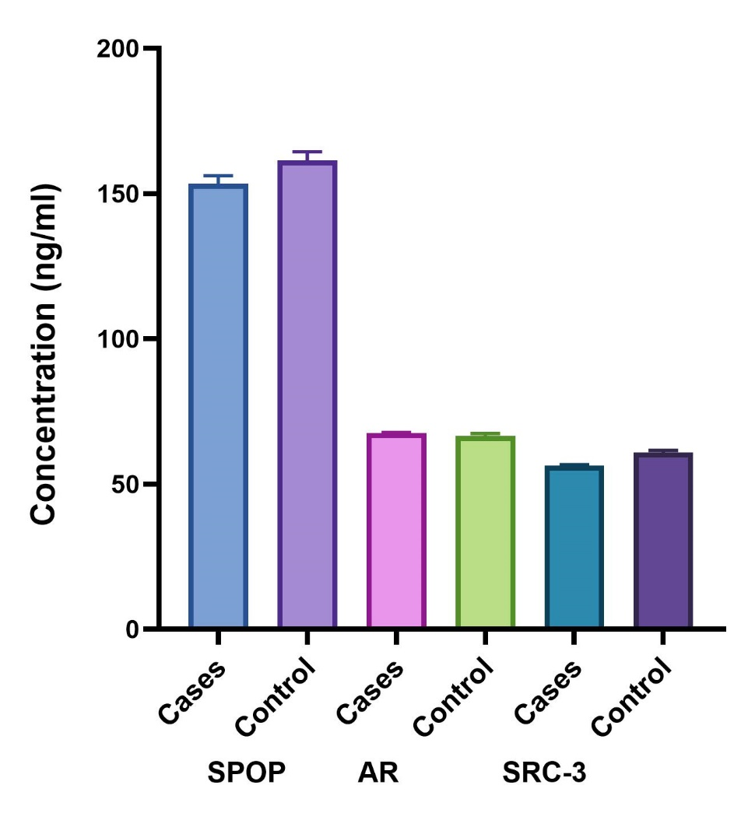
Figure 6: The bar graph visualizes the levels (Mean+SEM) of SPOP, AR, and SRC-3 in disease and control samples
Figures 7, 8, and 9 shows the estimation plots of Welch's t-test for each protein comparing disease and control samples. These plots typically show the distribution of data points and the estimated difference between groups with confidence intervals. The mean SPOP protein levels was 153.5 ng/ml (95% CI, 119.0-187.9) in cancer plasma samples versus 161.4 ng/ml (95% CI, 123.3-199.5) in non‐cancer plasma samples. There was no significant difference in the plasma levels of SPOP between cancerous versus non‐cancer samples (Figure 8).
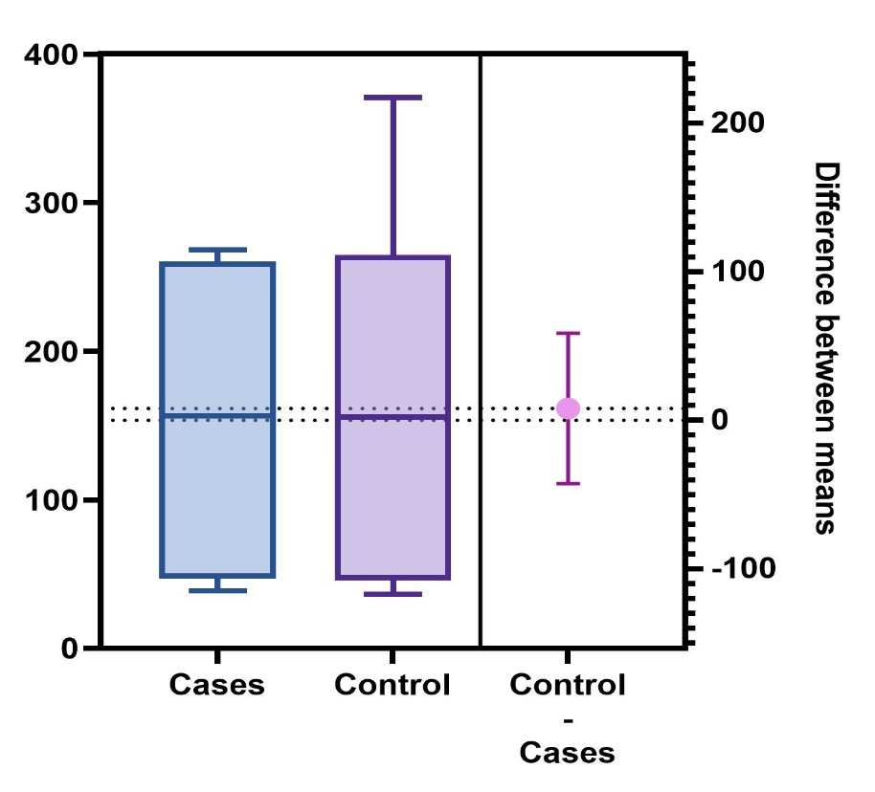
Figure 7: Estimation plot of Welch's t test of SPOP protein in disease and control samples
The mean AR concentration was 67.42 ng/ml (95% CI, 63.18-71.66) in cancer plasma samples versus 66.58 ng/ml (95% CI, 56.41-76.76) in non‐cancer plasma samples (Figure 9)
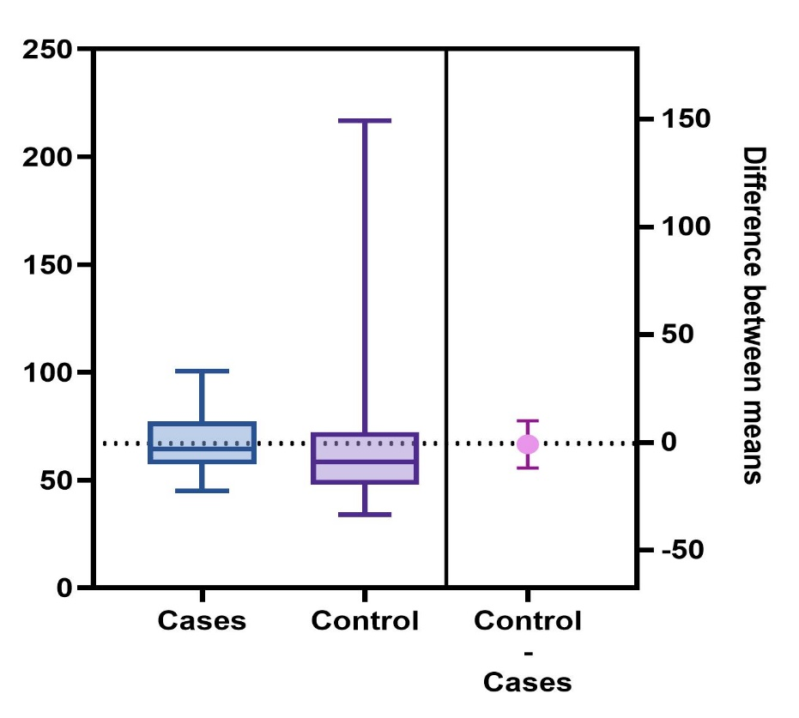
Figure 8: Estimation plot of Welch's t test of AR protein in disease and control samples
The mean SRC-3 concentration was 56.35 ng/ml (95% CI, 52.51-60.18) in cancer plasma samples versus 60.88 ng/ml (95% CI, 52.37-69.39) in non‐cancer plasma samples.
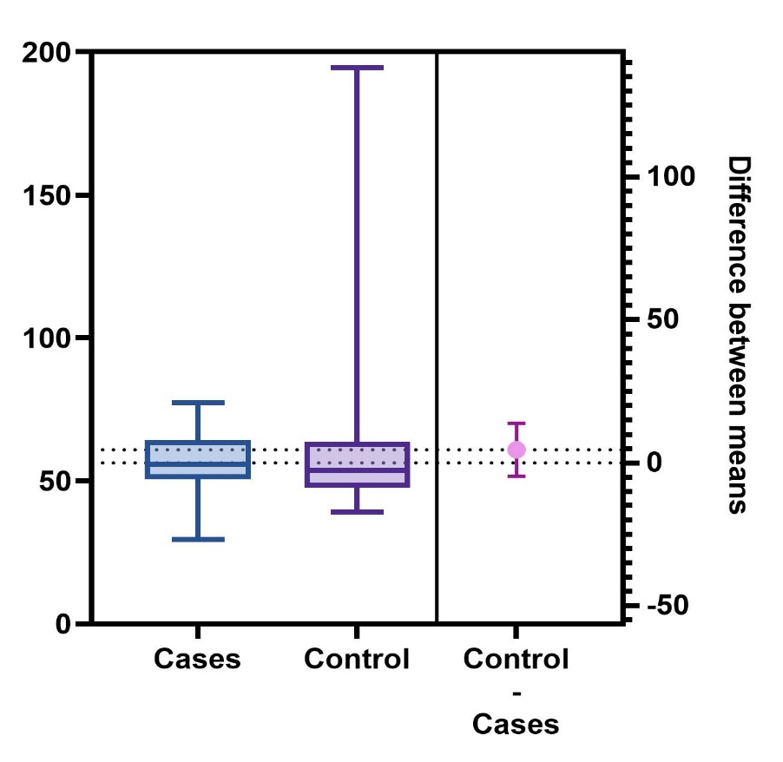
Figure 9: Estimation plot of Welch's t-test of SRC-3 protein in disease and control samples
The Pearson correlation analysis provides important insights beyond comparing mean protein levels (Figure 13). The Pearson correlation coefficient (r) between AR levels and SRC-3 was an exceptionally high 0.9, indicating a very strong, positive, and statistically significant (p < 0.0001). This extremely robust correlation implies that AR levels are distributed similarly to SRC-3 levels. This could imply that these proteins may work synergistically in the context of PCa progression and response to treatment. The correlation between SPOP and AR levels while still statistically significant (p < 0.0001), was moderately high (r = 0.7). Also, the correlation between SPOP and SRC-3 was still statistically significant (p < 0.0001), was more moderate (r = 0.6). The results indicate positive relationship between three protein levels. All the correlations are statistically significant, providing evidence that the interplay between SPOP, AR, and SRC-3 is meaningful in the context of prostate cancer.

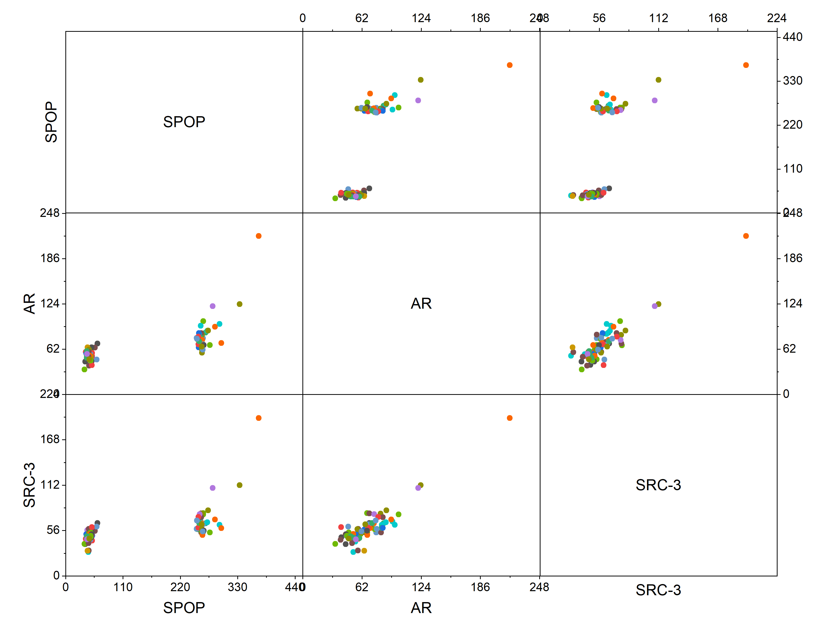
Figure 10: Scatter matrix plot of the correlation of SPOP, AR and SRC-3 levels. The plot visually represents the relationships between the protein levels. Each scatter plot in the matrix shows the distribution of two variables and helps identify patterns, trends, or outliers. This visual representation can complement the statistical results by providing a clearer picture of how the proteins interact with one another.
4.2 Therapeutic Potentials of Pure Compounds using Computational simulations
4.2.1 Ligands
The pure compounds of C. bonduc were already identified (Ogunlana, 2012). The chemical structures of the selected compounds for the analysis, including 4,4'-dihydroxy-2'-methoxy-chalcone, 7,4'-dihydroxy-3,11-dehydrohomoisoflavanone, 5,7,3',4'-tetrahydroxy-flavone (Luteolin), and 7,3',4'-tetrahydroxy-3-methoxyflavone (quercetin-3-methyl ether), are depicted COMP1, COMP2, COMP3 and COMP4 respectively. The structure of COMP1, COMP2, COMP3 and COMP4 was identified as 4,4'-dihydroxy-2'-methoxy-chalcone (2'-methoxyisoliquiritigenin), 7,4'-dihydroxy-3,11-dehydrohomoisoflavanone, 5,7,3',4'-tetrahydroxy-flavone (Luteolin), and 7,3',4'-tetrahydroxy-3-methoxyflavone (quercetin-3-methyl ether) respectively (Figure 11).
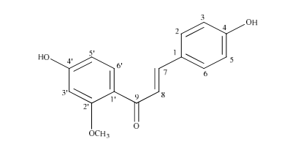
4,4'-dihydroxy-2'-methoxy-chalcone (TCB9)
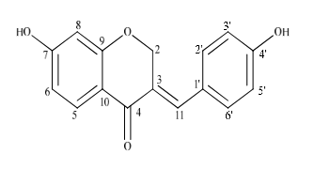

7,4'-dihydroxy-3,11-dehydrohomoisoflavanone (TCB11)

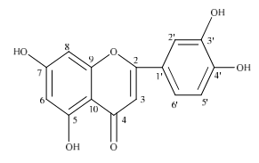
5,7,3',4'-tetrahydroxy-flavone (TCB15)

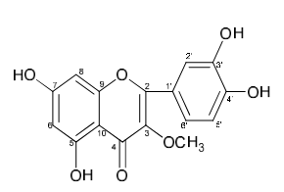

7,3',4'-tetrahydroxy-3-methoxyflavone (TCB16)

Figure 11. Chemical structures of the selected pure compounds from Caesalpinia bonduc
4.2.2 Physicochemical Properties
The physical characteristics of the compounds were determined, including their water solubility, hydrogen bond donors and acceptors, molecular weight, lipophilicity (LogP), and polar surface area. Table 4 presents the physicochemical properties of the isolated compounds, including lipophilicity (LogP), water solubility, molecular weight, hydrogen bond donors and acceptors, and polar surface area. The properties of the compounds demonstrate their drug-likeness and potential for therapeutic applications.
Table 3. Physicochemical Properties of the Selected Pure Compounds Isolated from Caesalpinia bonduc and the standard drugs, Enzalutamide and Apalutamide
Compounds | Molecular Weight  (g/mol) | Lipophilicity  (LogP) (iLOGP) | Water Solubility (ESOL) | Hydrogen Bond Donors | Hydrogen Bond Acceptors | Polar Surface Area  (Å²)
COMP1 | 270.28 | 2.05 | -3.55  (Soluble) | 2 | 4 | 66.76
COMP2 | 268.26 | 2.00 | -3.53 (Soluble) | 2 | 4 | 66.76
COMP3 | 286.24 | 1.89 | -3.71 (Soluble) | 4 | 6 | 111.13
COMP4 | 316.26 | 2.00 | -3.89 (Soluble) | 4 | 7 | 120.36
Enzalutamide | 464.44 | 2.92 | -4.94 (Moderately Soluble) | 1 | 7 | 108.53
Apalutamide | 477.43 | 2.69 | -4.62 (Moderately Soluble) | 1 | 8 | 121.42

4.2.3 Drug-likeness results
When evaluating a compound's suitability as a drug, it is important to consider its physicochemical properties and their alignment with various filter criteria such as Ghose filter, Veber rule, Egan rule, and Muegge rule and the Lipinski rule of 5 (RO5). Table 5 shows that the isolated compounds adhered to all known drug-likeness guidelines as with the Enzalutamide and Apalutamide, the reference compounds.
Table 4. Adherence of isolated and reference compounds to the known drug-likeness guidelines.

Compounds | Lipinski | Veber | Ghose | Egan | Muegge
COMP1 | Yes | Yes | Yes | Yes | Yes
COMP2 | Yes | Yes | Yes | Yes | Yes
COMP3 | Yes | Yes | Yes | Yes | Yes
COMP4 | Yes | Yes | Yes | Yes | Yes
Enzalutamide | Yes | Yes | Yes | Yes | Yes
Apalutamide | Yes | Yes | Yes | Yes | Yes

4.2.4 Virtual screening and molecular docking analyses
Molecular docking studies and virtual screening were carried out to assess the binding affinities of the compounds with mutated SPOP and ARV7. Table 5 shows the results of virtual screening and molecular docking of the identified compounds against Mutated SPOP. Binding energy provides insights into the degree to which a substance interacts with a target protein's binding site with intensity and attraction (as illustrated in table 5). A compound with a lower binding energy is preferred as a potential drug candidate, while a compound with a higher binding energy is less desirable. The results indicate that COMP2 and COMP3 exhibited stronger binding affinities to mutated SPOP compared to the reference compound Enzalutamide.

Table 5. Molecular docking analysis of pure compounds showing estimated binding free energy and interacting residues in the binding site of mut SPOP.

Compounds | 2D Structure | Binding Affinity of Compound at Mode 0 (kcal/mol) | Interacting Residues of Mutant SPOP and types of Interactions
COMP1 | 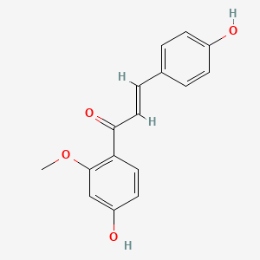 | -5.9 | PHE257, ILE258, ARG284, ALA281 - Conventional Hydrogen Bonds;  ARG221, PRO223 - Alkyl/Pi-Alkyl
COMP2 | 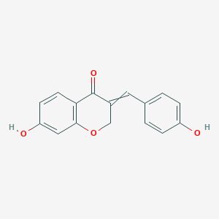 | -6.9 | ARG284 - Conventional Hydrogen Bonds; PRO223, ARG221 - Pi-Alkyl
COMP3 | 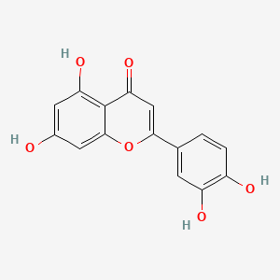 | -7.1 | PHE257, ILE258, ARG284, and ALA281- Conventional Hydrogen Bonds;  ARG264 - Pi-Cation;  ARG221, ARG284 - Pi-Alkyl
COMP4 | 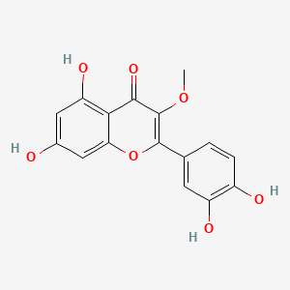 | -6.8 | GLU118, GLU113 THR114 -Conventional Hydrogen Bonds; ALA116, PRO223, ALA227 - Pi-Alkyl
Enzalutamide | 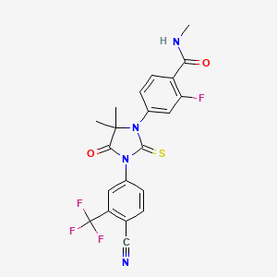 | -6.8 | ARG284, ARG121 -Coventional Hydrogen Bonds; ARG284, ALA116 - Carbon Hydrogen Bond; GLU283 -Halogen (Fluorine); GLU118 - Pi-Anion  GLU283- Amide-Pi Stacked; PRO223, VAL287 -Alkyl/PiALkyl

Figure 12 presents the views in 2D and 3D (A) 4,4'-dihydroxy-2'-methoxy-chalcone (2'-methoxyisoliquiritigenin), (B) 7,4'-dihydroxy-3,11-dehydrohomoisoflavanone, (C) 5,7,3',4'-tetrahydroxy-flavone (Luteolin), (D) 7,3',4'-tetrahydroxy-3-methoxyflavone (quercetin-3-methyl ether), and (E) Enzalutamide interactions with mutant SPOP.

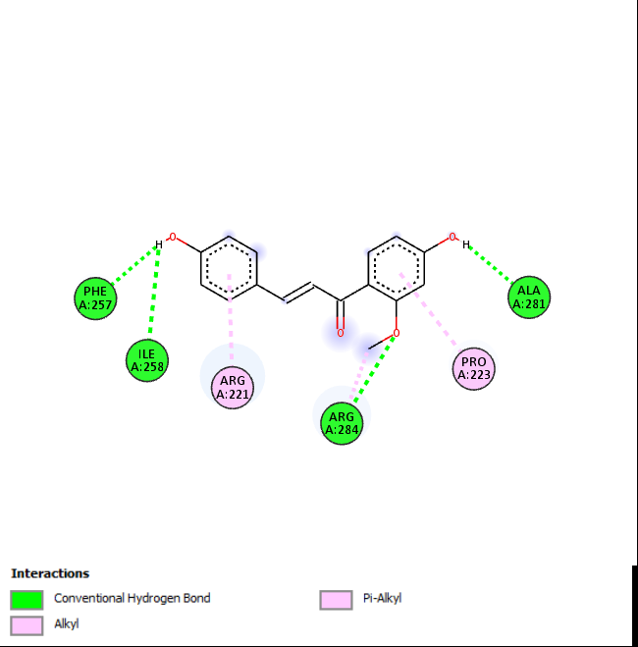 | 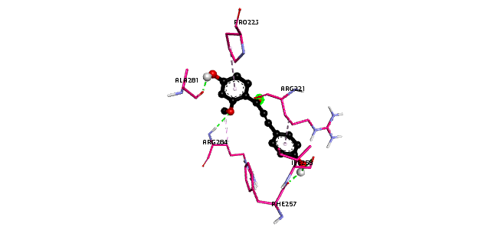
(A): COMP1

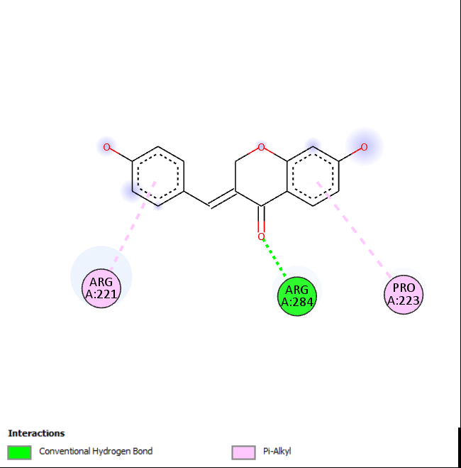 | 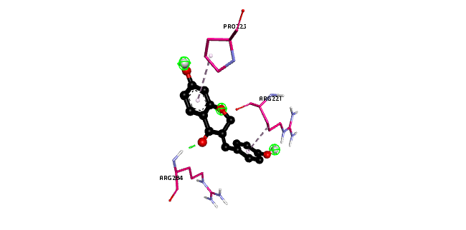
(B): COMP2

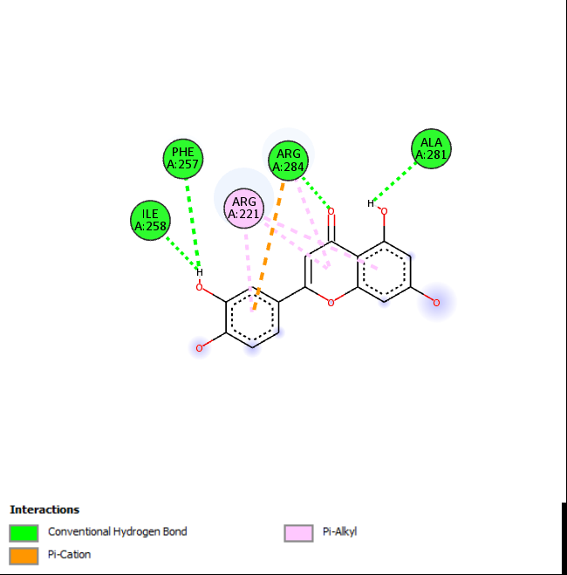 | 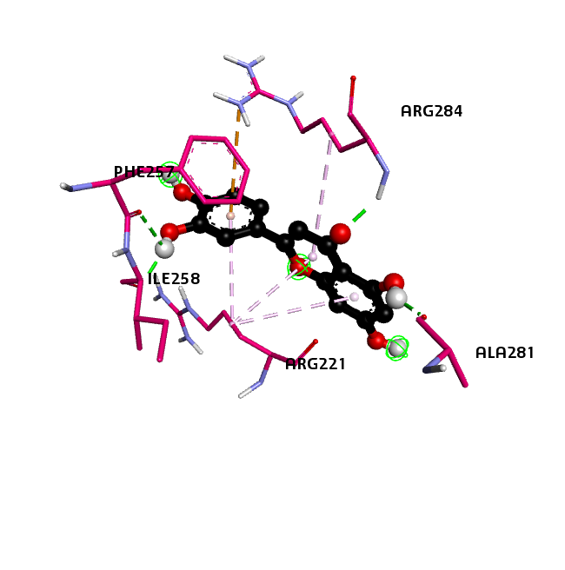
(C): COMP3

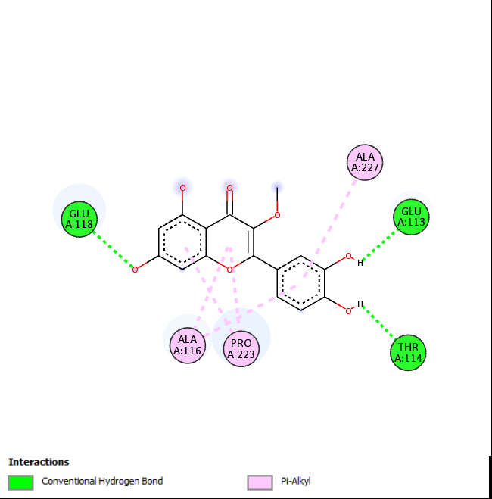 | 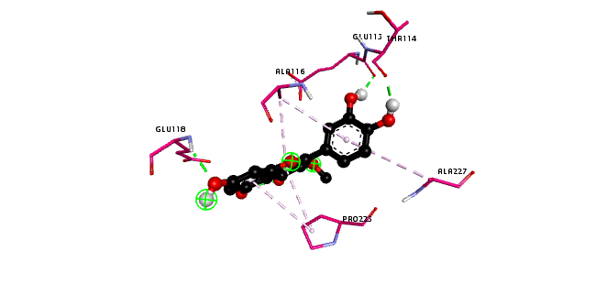
(D): COMP4

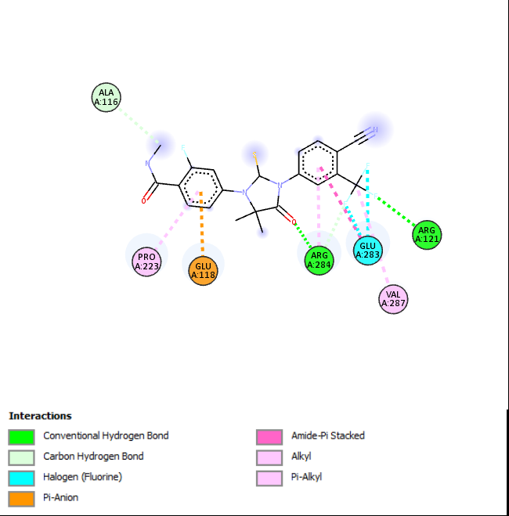 | 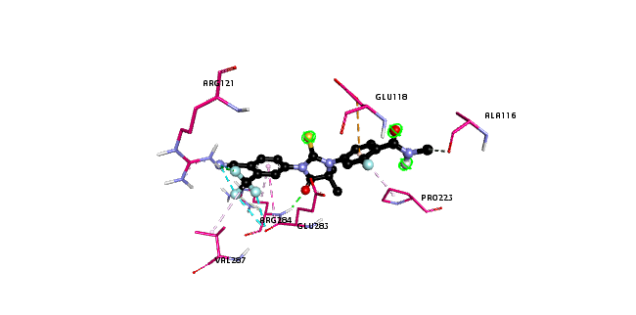
(E): Enzalutamide
Figure 12. The views in 2D and 3D COMP2 COMP3 COMP4 and Enzalutamide interactions with mutant SPOP using autoDock vina.

Molecular docking analysis of substances with interacting residues at the binding site of AR-V7 and estimated binding free energy (Table 6). COMP2, COMP3, and COMP4 showed stronger binding affinities to AR-V7 compared to the reference compound Apalutamide.

Table 6. Molecular docking analysis of pure molecules displaying interacting residues in the binding site of AR-V7 and estimated binding free energy

Compounds | 2D Structure | Binding Affinity of Compound at Mode 0 (kcal/mol) | Interacting Residues of Mutant AR-V7 and types of Interactions
COMP1 |  | -6.4 | GLU238, LYS241 - Pi-Anion/Pi-Cation; CYS240- Pi-Sulfur; TYR269 - Pi-Pi Stacked; LYS237, LEU254 - Pi-Alkyl
COMP2 |  | -7.6 | VAL30 -Amide-Pi Stacked; ARG31, ILE34, ALA52, PRO49, ALA372, PRO342 - Pi-Alkyl
COMP3 |  | -7.2 | LYS237, GLN262 -Conventional Hydrogen Bonds; CYS240- Pi-Sulfur; LYS241, LEU254, ILE232 - Pi-Alkyl
COMP4 |  | -7.1 | LYS349 -Conventional Hydrogen Bond; SER346, LEU347- Carbon Hydrogen Bond/Pi-Donor Hydrogen Bond; TYR348, SER346- Unfavourabl Donor-Donor/Unfavourable Acceptor-Acceptor; ARG264- Pi-Cation; LYS349 -Pi-Sigma; LEU341 - Pi-Alkyl
Apalutamide | 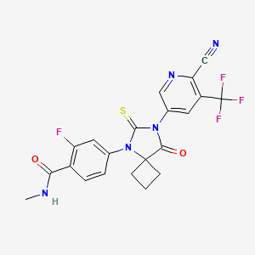 | -7.0 | SER29 -Carbon Hydrogen Bond; GLU32 - Halogen (Fluorine); VAL30, LEU26, LEU5, VAL33 -Alkyl/Pi-Alkyl

In Figure 13, the views in 2D and 3D of (A) 4,4'-dihydroxy-2'-methoxy-chalcone (2'-methoxyisoliquiritigenin), (B) 7,4'-dihydroxy-3,11-dehydrohomoisoflavanone, (C) 5,7,3',4'-tetrahydroxy-flavone (Luteolin), (D) 7,3',4'-tetrahydroxy-3-methoxyflavone (quercetin-3-methyl ether), and (E) Apalutamide interactions with AR-V7.

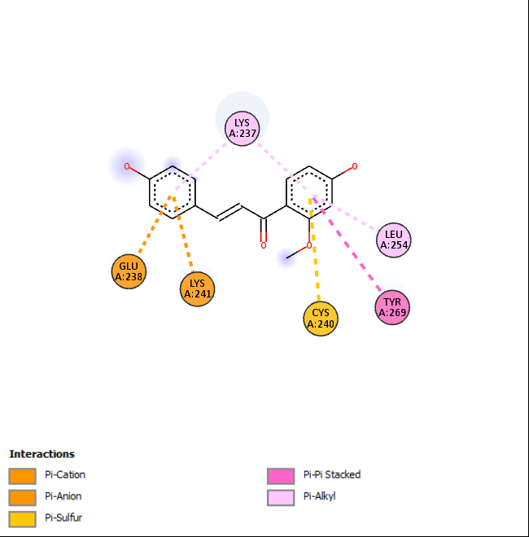 | 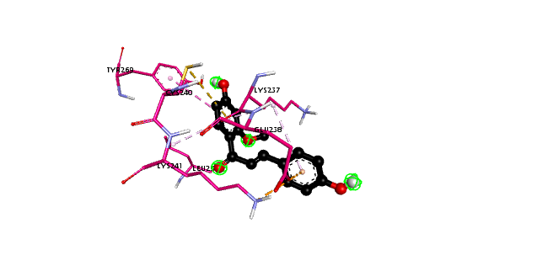
(A): COMP1

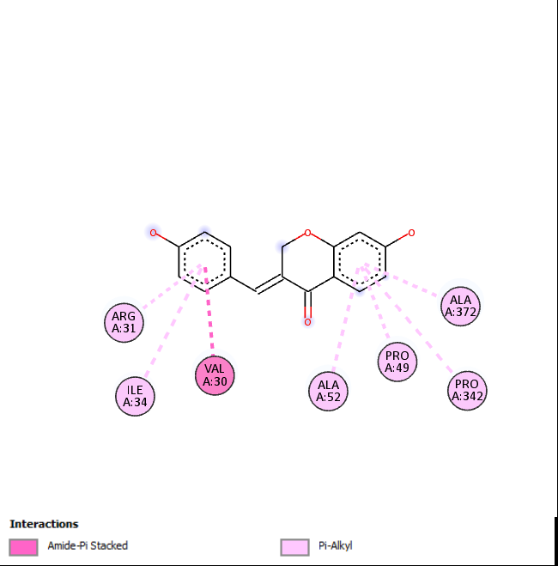 | 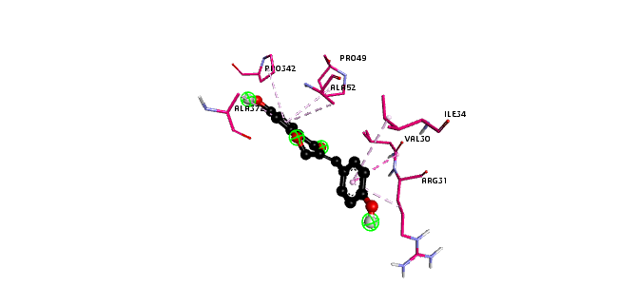
(B): COMP2

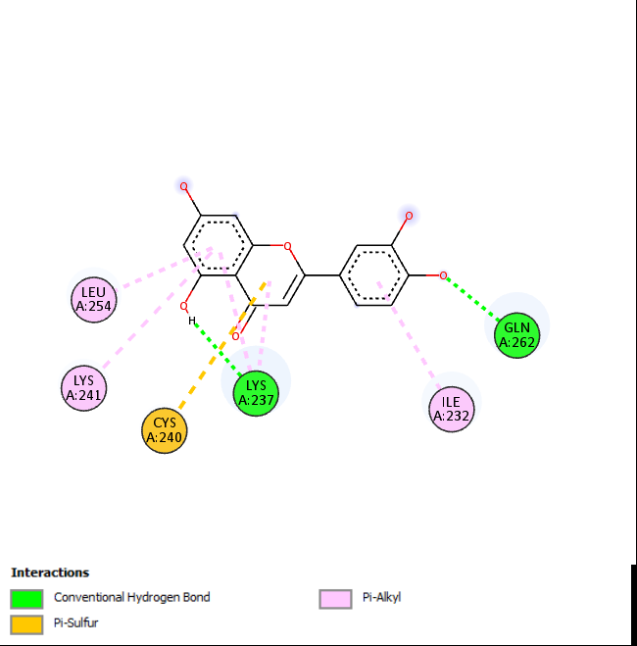 | 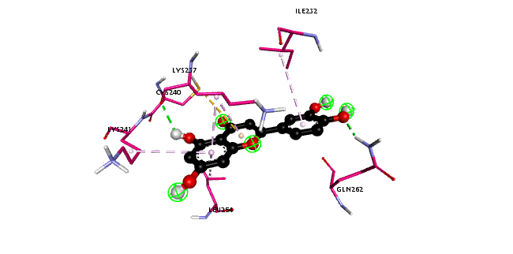
(C): COMP3

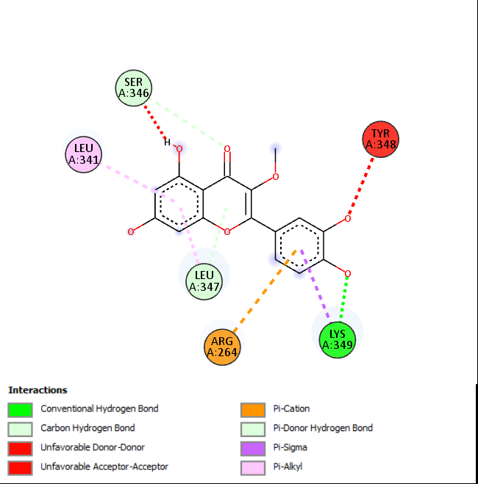 | 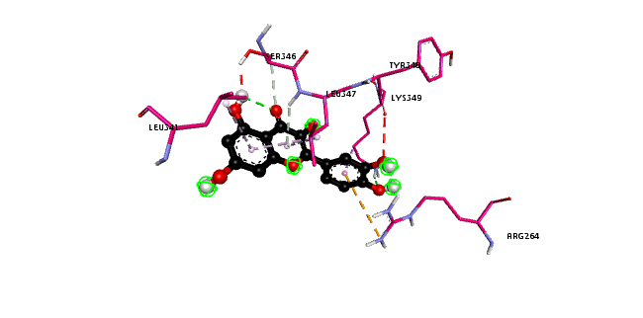
(D): COMP4

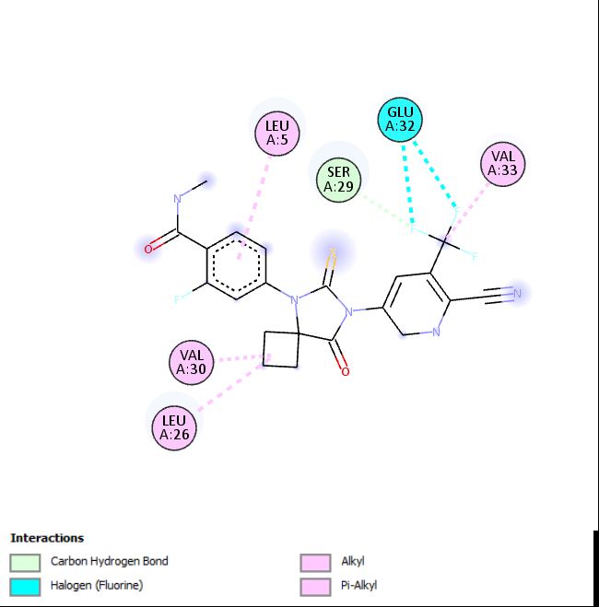 | 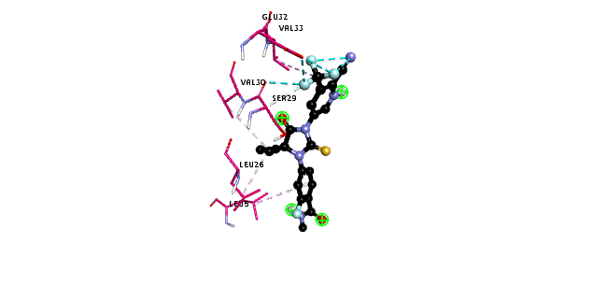
(E): Apalutamide

Figure 13. The views in 2D and 3D of COMP1, COMP2, COMP3, COMP4 and Apalutamide interactions with AR-V7.
4.2.5 Predicted molecular adsorption, metabolism, and toxicity profiles of the isolated compounds
Table 7, Table 8, and Table 9: Predicted molecular adsorption, metabolism, and toxicity profiles of the isolated compounds. These tables provide insights into the predicted molecular adsorption, metabolism, and toxicity profiles of the isolated compounds. This includes assessments related to intestinal absorption, skin permeability, P-glycoprotein substrate and inhibitor status, as well as potential toxicity indicators. The results aid in understanding the therapeutic potential and safety profiles of the compounds.

Table 7. Estimated molecular adsorption profile of specific pure Caesalpinia bonduc chemicals and the reference.

Compounds | Intestinal absorption (human) (%Absorbed) | Skin Permeability (log Kp) | P-glycoprotein substrate | P-glycoprotein I inhibitor | P-glycoprotein II inhibitor
COMP1 | 91.81% | -2.79 | Yes | No | No
COMP2 | 94.95 | -2.86 | Yes | No | No
COMP3 | 81.13 | -2.74 | Yes | No | No
COMP4 | 76.07 | -2.74 | Yes | No | No
Enzalutamide | 90.15 | -2.85 | No | Yes | Yes
Apalutamide | 92.39 | -3.16 | No | Yes | No

Table 8. Estimated molecular metabolic profile of isolated chemicals from Caesalpinia bonduc in comparison to the reference

Compounds | CYP2D6 substrate | CYP3A4 substrate | CYP1A2 inhibitor | CYP2C19 inhibitor | CYP2C9 inhibitor | CYP2D6 inhibitor | CYP3A4 inhibitor
COMP1 | No | Yes | Yes | Yes | Yes | No | Yes
COMP2 | No | Yes | Yes | Yes | Yes | No | Yes
COMP3 | No | No | Yes | No | Yes | No | No
COMP4 | No | No | Yes | No | No | No | No
Enzalutamide | No | Yes | No | Yes | Yes | No | Yes
Apalutamide | No | Yes | No | Yes | Yes | No | Yes

Table 9. Predicted molecular toxicity profile of isolated compounds of selected pure compounds from Caesalpinia bonduc and the standards
Compounds | AMES toxicity | Max. tolerated dose (human) (log mol/kg) | hERG I inhibitor | hERG II inhibitor | Oral Rat Acute Toxicity (LD50) (mol/kg) | Hepatotoxicity | Skin Sensitisation
COMP1 | Yes | -0.36 | No | No | 2.21 | No | No
COMP2 | Yes | -0.29 | No | No | 2.23 | No | No
COMP3 | No | 0.49 | No | No | 2.46 | No | No
COMP4 | No | 0.52 | No | No | 2.53 | No | No
Enzalutamide | No | -0.13 | No | No | 2.64 | Yes | No
Apalutamide | No | -0.78 | No | No | 3.07 | Yes | No

CHAPTER FIVE
DISCUSSION
5.1 Association of SPOP Mutation with Clinicopathologic Characteristics

5.2 Human SPOP, AR, SRC-3 Protein Levels
The ELISA results for the SPOP, AR, and SRC-3 protein in plasma samples from human prostate cancer patients provide insight into the protein concentration levels and their potential implications. ELISA is a powerful technique used to detect and measure specific proteins and antibodies in biological samples, and it is frequently used in clinical and research settings to diagnose diseases and monitor biomarker levels (Kinman, 2012; Clevaland, 2023). The mean SPOP protein levels were 153.5 ng/ml in the plasma samples from prostate cancer patients, compared to 161.4 ng/ml in non-cancerous control samples. The mean levels of AR and SRC-3 proteins were also measured. The mean AR concentration was 67.42 ng/ml in cancer samples and 66.58 ng/ml in non-cancer samples. Similarly, the mean SRC-3 concentration was 56.35 ng/ml in cancer samples and 60.88 ng/ml in non-cancer samples. This slight difference between the protein levels suggests that there might not be a significant alteration in their levels between the two groups. This observation is crucial as it indicates that their concentration alone may not serve as a reliable biomarker for distinguishing between PCa patients and healthy individuals. The results show that there are no statistically significant differences in the mean levels of SPOP, AR, and SRC-3 proteins between prostate cancer patients and non-cancer controls. The overlapping distributions of these protein levels between the disease and control groups suggest that the overall concentrations are quite similar.
The slight difference in the higher mean value of AR protein concentration in prostate cancer compared to non-cancer samples does not appear to be clinically meaningful, as the overall distributions are highly overlapping, and the difference is not statistically significant. SPOP-mutant prostate cancer has been associated with increased expression of androgen receptor-regulated genes and better overall survival outcomes following treatment with hormonal therapies (Cavalcante et al., 2023), this could also be seen where the concentration in cases was higher than control.
The estimation plots of Welch's t-test for each protein comparing disease and control samples further highlighted that there are no significant differences in the concentrations of SPOP, AR, and SRC-3 proteins between the two groups. Insights from the correlation analysis between SPOP, AR, and SRC-3 levels (Figures 13) showed that between AR levels and SRC-3 was an exceptionally high correlation of 0.9, indicating a very strong, positive, and statistically significant (p < 0.0001). This extremely robust correlation implies that AR levels are distributed similarly to SRC-3 levels. This could imply that these proteins may work synergistically in the context of prostate cancer progression and response to treatment. The correlation between SPOP and AR levels while still statistically significant (p < 0.0001), was moderately high (r = 0.7). Also, the correlation between SPOP and SRC-3 was still statistically significant (p < 0.0001), was more moderate (r = 0.6). The results indicate positive relationship between three protein levels. All the correlations are statistically significant, providing evidence that the interplay between SPOP, AR, and SRC-3 is meaningful in the context of prostate cancer.
The study had a small sample size, and the researchers were limited in their ability to gather detailed information on the clinical parameters of the patients. Additionally, there were no data on tumor stage/grade and patient demographics which prevented the researchers from determining the relationship between these protein levels and prognostic variables and outcomes
5.2 Computational Analysis for Therapeutic Targetting
The already identified potential bioactive compounds from Caesalpinia bonduc leaves was utilized by in silico methods to screen and identify compounds with inhibitory and cytotoxic potential against mutated SPOP and AR-V7, which are associated with aggressive and treatment-resistant prostate cancer (He et al., 2022). The computational analyses revealed promising insights into the potential therapeutic targeting of the AR signaling pathway in prostate cancer. The investigation of the physicochemical properties and drug-likeness of the isolated compounds from Caesalpinia bonduc leaves, namely COMP1, 2, 3, and 4, provided valuable comparative data with the standard prostate cancer drugs Enzalutamide and Apalutamide. Enzalutamide, an FDA-approved second-generation androgen receptor antagonist, works by preventing the nuclear translocation of the stimulated AR, thereby inhibiting its localization to androgen response elements (AREs) and inducing apoptosis in CRPC cells. However, patients may develop resistance to Enzalutamide through various mechanisms, such as changes in AR quantity or structure, over-activation of the glucocorticoid receptor (GR), and activation of alternative signaling pathways. Apalutamide, another novel AR inhibitor, also targets the AR signaling axis but with improved central nervous system (CNS) safety compared to Enzalutamide. Resistance to Apalutamide has been linked to AR mutations, splicing variants, and PI3K pathway activation.
The physicochemical properties of the isolated compounds with known prostate cancer standard drugs, Enzalutamide and Apalutamide, reveal distinct trends. The isolated compounds generally exhibit lower molecular weights, lower lipophilicity (LogP) values, and better water solubility compared to the reference drugs. This higher weight and lipophilicity are due to the presence of fluorine (halogen) elements in the reference drugs (Benedetto Tiz et al., 2022). Moreover, they demonstrate higher numbers of hydrogen bond donors and acceptors, as well as larger polar surface areas, indicating potential differences in their molecular interactions. These findings provide valuable insights into the unique physicochemical profiles of the isolated compounds, which can influence their drug likeness and suitability for therapeutic applications. The results indicate that all the compounds, including COMP1, 2, 3, 4, Enzalutamide, and Apalutamide, adhere to the known drug-likeness guidelines such as Lipinski, Veber, Ghose, Egan, and Muegge rules. This suggests that all the compounds possess physicochemical properties aligning with established drug-likeness criteria, indicating their potential for use in therapy. The consistent adherence across the compounds underscores their promise as potential drug candidates.
The molecular docking analysis of the pure compounds reveals insights into the interaction residues in the binding site and the predicted binding free energy against mutant SPOP. COMP3 demonstrates the highest binding affinity with a calculated value of -7.1 kcal/mol, followed by COMP2 (-6.9 kcal/mol), Enzalutamide (-6.8 kcal/mol), TCB16 (-6.8 kcal/mol), and COMP1 (-5.9 kcal/mol). Interacting residues and types of interactions vary across the compounds, indicating diverse binding mechanisms. Comparatively, COMP4 exhibits the strongest binding affinity, with a notable involvement of conventional hydrogen bonds and additional interactions such as Pi-Cation and Pi-Alkyl interactions. COMP2 also demonstrates significant conventional hydrogen bonding and Pi-Alkyl interactions, contributing to its favorable binding affinity. Enzalutamide, while sharing a similar binding affinity with COMP4, displays a distinct interaction profile involving conventional hydrogen bonds, carbon hydrogen bonds, halogen interactions, and Pi-Anion interactions. These findings suggest that COMP2 and 3 exhibit promising binding affinities and interaction profiles compared to the standard drugs Enzalutamide and Apalutamide, indicating their potential as candidates for further evaluation in targeting mutant SPOP. Table 6 showcases the calculated free energy of binding and the interacting residues inside the binding site of mutant AR-V7. COMP2 demonstrates the highest binding affinity with a calculated value of -7.6 kcal/mol, followed by COMP3 (-7.2 kcal/mol), COMP4 (-7.1 kcal/mol), Apalutamide (-7.0 kcal/mol), and TCB9 (-6.4 kcal/mol). Interacting residues and types of interactions vary across the compounds, indicating diverse binding mechanisms.
COMP2 exhibits the strongest binding affinity, with interactions including Amide-Pi Stacked and Pi-Alkyl interactions. COMP3 also demonstrates significant conventional hydrogen bonds and Pi-Alkyl interactions, contributing to its favorable binding affinity. COMP4 displays involvement in conventional hydrogen bonds, carbon hydrogen bonds, Pi-Cation, and Pi-Alkyl interactions, contributing to its strong binding affinity. Apalutamide showcases interactions such as carbon hydrogen bonds, halogen interactions, and Pi-Alkyl interactions. These findings suggest that COMP2, 3, and 4 exhibit promising binding affinities and interaction profiles compared to the standard drug Apalutamide, indicating their potential as candidates for further evaluation in targeting mutant AR-V7.
The anticipated molecular adsorption profile of the chosen pure Caesalpinia bonduc compounds compared to Enzalutamide and Apalutamide reveals insights into their intestinal absorption, skin permeability, and interactions with P-glycoprotein. In terms of intestinal absorption, COMP2 demonstrates the highest percentage absorbed (94.95%), followed by Apalutamide (92.39%) and COMP1 (91.81%). However, COMP3 and Enzalutamide also exhibit favorable intestinal absorption at 81.13% and 90.15%, respectively. Regarding skin permeability, all compounds including COMP1, 2, 3, and 4, Enzalutamide, and Apalutamide demonstrate similar log Kp values, indicating comparable potential for skin permeation. In terms of P-glycoprotein interactions, COMP1, 2, 3, and 4 are identified as P-glycoprotein substrates without inhibitory effects on P-glycoprotein I or II. In contrast, Enzalutamide and Apalutamide exhibit varying interactions with P-glycoprotein as inhibitors or non-substrates.
The predicted molecular metabolism profile of the selected pure compounds compared to the standard cancer drugs Enzalutamide and Apalutamide provides insights into their interactions with key cytochrome P450 enzymes (CYP). Both COMP1 and 2 are identified as substrates for CYP3A4 and inhibitors of CYP1A2, CYP2C19, and CYP3A4. Additionally, COMP1 and 2 are substrates for CYP2C9 and inhibitors of CYP3A4. In contrast, COMP3 and 4 do not exhibit substrate activity for the tested CYP enzymes. In comparison, both Enzalutamide and Apalutamide are substrates for CYP3A4 and inhibitors of CYP1A2, CYP2C19, and CYP3A4, similar to COMP1 and 2. However, they differ in their interactions with CYP2D6, with Enzalutamide being a substrate and inhibitor of CYP2D6, while Apalutamide is not.
The predicted molecular toxicity profile of the compounds compared to the standard cancer drugs Enzalutamide and Apalutamide provides valuable insights into their potential toxicological properties. Both COMP1 and 2 exhibit AMES toxicity and negative values for the maximum tolerated dose (human), indicating potential toxicity concerns. However, COMP3, and 4 do not show AMES toxicity and have positive values for the maximum tolerated dose, suggesting lower toxicity risks. In terms of hERG inhibition, all compounds including COMP1, 2, 3, and 4, as well as Enzalutamide and Apalutamide, are identified as non-inhibitors for both hERG I and hERG II. Regarding oral rat acute toxicity (LD50), all compounds demonstrate similar LD50 values in the range of 2.21 to 3.07 mol/kg, indicating comparable acute toxicity profiles. Hepatotoxicity is observed in both Enzalutamide and Apalutamide, while the compounds from Caesalpinia bonduc do not exhibit hepatotoxicity in this analysis. The cytotoxic activity of the flavonoids was tested on two cancer cell lines, BGC-823 and HeLa, and moderate cytotoxic activity was observed suggesting a structure-activity relationship (Ogunlana et al., 2015). The possible anti-cancer flavonoids that were extracted from the young twigs and leaves of Caesalpinia bonduc was evaluated by Iheagwam et al. 2019, using molecular docking and in silico analysis to identify the interaction between these flavonoids and cancer therapeutic target proteins such as tyrosine kinase (TK), vascular endothelial growth factor (VEGF), and matrix metalloproteinases (MMP) (Iheagwam et al., 2019). The results showed that the isolated phytochemicals had good binding affinity with the target proteins and exhibited drug-like properties. The study provides valuable insights into the potential use of these flavonoids as therapeutic molecules for cancer treatment.
These findings align with previous research that has demonstrated the pharmacological properties of Caesalpinia bonduc in various medicinal applications, including anti-diabetic, and anti-cancer and anti-inflammatory activities (Iheagwam et al., 2019). Our findings suggest that these compounds could potentially be developed as targeted therapeutics for prostate cancer patients with Mutated SPOP and ARV7. A study by Ogunlana et al. (2013) evaluated the acute and sub-acute toxicological effects of the ethanolic extract of Caesalpinia bonduc leaves and young twigs on albino rats (Ogunlana et al., 2013). In the acute study, no mortality was observed, but there were significant alterations in biomarkers and liver damage. In the sub-acute study, changes in biomarkers were observed at higher extract doses, but no significant difference was found in the recovery groups. The study concludes that the extract could be toxic to certain organs in both acute and sub-acute treatments.
A study by Rotimi et al. 2015, examined the effect of quercetin on oxidative stress in a model of acute pancreatitis caused by L-arginine in rats. It was found that quercetin reversed the increase in plasma lipase and α-amylase activities caused by L-arginine, restored antioxidant enzyme activities and glutathione levels, and prevented L-arginine-induced alterations in enzyme activities in rat organs (Rotimi et al., 2015). This suggests that quercetin has a protective effect against oxidative damage in pancreatitis. The present study highlights the significance of Caesalpinia bonduc as a valuable source of bioactive compounds for developing novel prostate cancer drugs. The in silico findings presented here provide a foundation for further experimental validation and optimization of these compounds, potentially leading to the development of effective therapies targeting Mutated SPOP and ARV7 in prostate cancer patients.
The selected pure compounds from Caesalpinia bonduc demonstrate favorable intestinal absorption and skin permeability comparable to or even better than the standard drugs Enzalutamide and Apalutamide. Additionally, their interactions with P-glycoprotein suggest potential differences in their efflux transporter interactions compared to the standard drugs. They exhibit diverse interactions with key CYP enzymes, with COMP1 and 2 sharing similarities with the standard drugs Enzalutamide and Apalutamide. These findings provide valuable insights into the potential metabolic interactions of the compounds and their comparability to established cancer drugs. Also, they demonstrated varied toxicity profiles, with COMP3 and 4 showing lower toxicity concerns compared to COMP1 and 2. Additionally, the absence of hepatotoxicity in the compounds from Caesalpinia bonduc distinguishes them from the standard drugs Enzalutamide and Apalutamide.

CHAPTER SIX
CONCLUSION AND RECOMMENDATIONS
6.1 Summary
One of the main causes of cancer-related mortality among men globally is prostate cancer (PCa), as a result of its poor diagnosis and prognosis, hence, novel diagnosis biomarkers and therapeutic targets are crucial for its management (Ellinger et al., 2022). More than 1.4 million new cases of prostate cancer were found globally in 2020 (Wang et al., 2022). Compounds from Caesalpinia bonduc has been reported to possess anticancer activity (Ogunlana, 2012; Chakrabarti et al., 2003; Gupta et al., 2003). This study aimed to investigate Speckle Type POZ Protein (SPOP) mutations and quantify the levels of SPOP, Androgen Receptor (AR), and Steroid Receptor Coactivator 3 (SRC-3) proteins in PCa patients and non-cancer controls and to screen for potential inhibitors targeting mutated SPOP and Androgen Receptor Variant 7 (AR-V7) computationally. The methodology involves case-control study conducted with 40 histologically diagnosed PCa patients and 40 healthy controls. Plasma SPOP, AR, and SRC-3 levels were quantified using Enzyme-linked immunosorbent assay (ELISA), while the SPOP gene mutation will be detected using Sanger sequencing. Computational analyses were performed to predict the physicochemical properties, drug-likeness, and binding affinities of selected compounds from C. bonduc against mutated SPOP and AR-V7. The mean concentrations of SPOP, AR, and SRC-3 proteins did not differ significantly between prostate cancer patients and healthy controls. However, the pearson correlation results suggest a meaningful interplay between SPOP, AR, and SRC-3 in the context of prostate cancer. The computational analyses identified four compounds from Caesalpinia bonduc with favorable physicochemical properties, drug-likeness, and potential binding affinities to mutated SPOP and AR-V7. The standard drugs Enzalutamide and Apalutamide are both used in the treatment of prostate cancer, particularly in cases where the disease has progressed despite initial hormone therapy. Enzalutamide is a nonsteroidal antiandrogen that inhibits the androgen receptor (AR) and is approved for the treatment of metastatic castration-resistant prostate cancer (mCRPC). Apalutamide, on the other hand, is a second-generation androgen receptor inhibitor that is also approved for the treatment of mCRPC. In this study, the performance of the novel compounds isolated from Caesalpinia bonduc, was compared to that of Enzalutamide and Apalutamide. COMP3 demonstrated the highest binding affinity to mutated SPOP with a calculated value of -7.1 kcal/mol, while COMP2 showed the highest binding affinity to AR-V7 with a calculated value of -7.6 kcal/mol. The findings suggest that COMP2 and 3 have the potential to be developed as targeted therapeutics for prostate cancer patients with mutated SPOP and AR-V7. The stronger binding affinities and diverse interaction profiles of these compounds compared to Enzalutamide and Apalutamide indicate that they may be more effective in targeting these undruggable proteins.
6.2 Conclusion
In conclusion, while there are no significant differences in the overall levels of SPOP, AR, and SRC-3 proteins between prostate cancer patients and healthy controls, the Pearson correlation analysis suggest a meaningful interplay between SPOP, AR, and SRC-3 in the context of prostate cancer. The positive, strong and significant relationship between AR and SRC-3 levels suggest that the interplay and balance of these proteins may be crucial in understanding the underlying biology and potential therapeutic targets in prostate cancer. The computational analyses highlight the potential therapeutic properties of specific compounds from Caesalpinia bonduc, which warrant further experimental validation and optimization of these compounds, potentially leading to the development of effective therapies targeting Mutated SPOP and AR-V7 in prostate cancer patients. The compounds exhibit potential for targeting AR activity, which is crucial for the proliferation and survival of prostate cancer cells. This suggests a potential role in addressing anti-androgen resistance in prostate cancer. Also, this study highlights the significance of natural products in drug discovery and development and underscores the need for further research in this area.
6.3 Contributions to Knowledge
This study contributes to the existing knowledge in the following ways: It highlights the importance of analyzing protein concentration differences within prostate cancer patient groups and non-cancer samples. This approach provides more insights into the underlying biology of the disease. Our study’s more important findings seem to be to targeting of the "undruggable" AR-V7 and mutant SPOP, which drive prostate cancer into the CRPC. The compounds Luteolin, quercetin-3-methyl ether and 7,4'-dihydroxy-3,11-dehydrohomoisoflavanone exhibit promising binding affinities and interaction profiles compared to the standard drugs Enzalutamide and Apalutamide, indicating their potential as candidates for further evaluation as novel prostate cancer therapies. These findings pave the way for further investigation into the development of novel therapeutic agents.
6.4 Recommendations
Based on the findings of this study, the following recommendations are made:
- Further research is needed to elucidate the functional significance of the strong positives correlations of SPOP, AR, and SRC-3 protein levels. This may involve in-vitro and in-vivo studies to understand the impact of these reltionships on tumor progression and treatment response.
- Larger cohort proteomic profiling studies should be conducted to validate this study's findings and establish the clinical relevance of protein profiling in prostate cancer management in this population.
- Preclinical studies should be carried out to evaluate the therapeutic potential of compounds like Luteolin and 7,4'-dihydroxy-3,11-dehydrohomoisoflavanone, which showed promising results in the computational analyses. These studies should assess these compounds' efficacy, safety, and pharmacokinetic properties.
- If the preclinical studies are successful, clinical trials should be designed to evaluate the efficacy of these compounds in PCa patients, particularly those with SPOP mutations or AR-V7 expression.
- The development of personalized treatment approaches based on individual protein profiles should be explored, as this may lead to more effective and targeted therapies for prostate cancer patients.

REFERENCES
Aaron, L., Franco, O.E. & Hayward, S.W. (2016) Review of Prostate Anatomy and Embryology and the Etiology of Benign Prostatic Hyperplasia. Urologic Clinics of North America. 43 (3), 279–288. doi:10.1016/j.ucl.2016.04.012.
Abeshouse, A., Ahn, J., Akbani, R., Ally, A., Amin, S., et al. (2015) The Molecular Taxonomy of Primary Prostate Cancer. Cell. 163 (4), 1011–1025. doi:10.1016/j.cell.2015.10.025.
Abumsimir, B., Mrabti, M., Laraqui, A., Saif, I., Lamsisi, M., Ennaji, Y., Ameur, A., Koraishi, S.I. & Ennaji, M.M. (2021) Common genetic alterations of SPOP-MATH domain in prostate cancer tissues and association with pathological tumor characteristics *. doi:10.1101/2021.09.09.21263201.
Alemany, M. (2022) The Roles of Androgens in Humans: Biology, Metabolic Regulation and Health. International Journal of Molecular Sciences. 23 (19), 11952. doi:10.3390/ijms231911952.
Badal, S., Aiken, W., Morrison, B., Valentine, H., Bryan, S., Gachii, A. & Ragin, C. (2020) Disparities in prostate cancer incidence and mortality rates: Solvable or not? The Prostate. 80 (1), 3–16. doi:10.1002/pros.23923.
Ban, F., Leblanc, E., Cavga, A.D., Huang, C.-C.F., Flory, M.R., Zhang, F., Chang, M.E.K., Morin, H., Lallous, N., Singh, K., Gleave, M.E., Mohammed, H., Rennie, P.S., Lack, N.A. & Cherkasov, A. (2021) Development of an Androgen Receptor Inhibitor Targeting the N-Terminal Domain of Androgen Receptor for Treatment of Castration Resistant Prostate Cancer. Cancers. 13 (14), 3488. doi:10.3390/cancers13143488.
Benedetto Tiz, D., Bagnoli, L., Rosati, O., Marini, F., Sancineto, L. & Santi, C. (2022) New Halogen-Containing Drugs Approved by FDA in 2021: An Overview on Their Syntheses and Pharmaceutical Use. Molecules. 27 (5), 1643. doi:10.3390/molecules27051643.
Bertolo, R., Garisto, J., Bove, P., Mottrie, A. & Rocco, B. (2021) Perioperative Outcomes Between Single-Port and “Multi-Port” Robotic Assisted Radical Prostatectomy: Where do we stand? Urology. 155, 138–143. doi:10.1016/j.urology.2021.06.005.
Blattner, M., Liu, D., Robinson, B.D., Huang, D., Poliakov, A., Gao, D., Nataraj, S., Deonarine, L.D., Augello, M.A., Sailer, V., Ponnala, L., Ittmann, M., Chinnaiyan, A.M., Sboner, A., Chen, Y., Rubin, M.A. & Barbieri, C.E. (2017) SPOP Mutation Drives Prostate Tumorigenesis In Vivo through Coordinate Regulation of PI3K/mTOR and AR Signaling. Cancer Cell. 31 (3), 436–451. doi:10.1016/j.ccell.2017.02.004.
Bosland, M.C., Nettey, O.S., Phillips, A.A., Anunobi, C.C., Akinloye, O., Ekanem, I.A., Bassey, I.E., Mehta, V., Macias, V., Kwast, T.H. & Murphy, A.B. (2021) Prevalence of prostate cancer at autopsy in Nigeria—A preliminary report. The Prostate. 81 (9), 553–559. doi:10.1002/pros.24133.
Bryant, C.M., Henderson, R.H., Nichols, R.C., Mendenhall, W.M., Hoppe, B.S., et al. (2021) Consensus Statement on Proton Therapy for Prostate Cancer. International Journal of Particle Therapy. 8 (2), 1–16. doi:10.14338/IJPT-20-00031.1.
Buckles, E., Qian, C., Tadros, A., Majumdar, S., Cvitanovic, J., Zabaleta, J., Estrada, J., Wilson, J. & Liu, W. (2014) Identification of speckle-type POZ protein somatic mutations in African American prostate cancer. Asian Journal of Andrology. 16 (6), 829. doi:10.4103/1008-682X.132470.
Budipitojo, T., Mahesty, S.R.N., Padeta, I. & Khasanah, L.M. (2020) Reproductive Glands of the Sunda Porcupine (Hystrix Javanica).
Carpenter, V., Saleh, T., Min Lee, S., Murray, G., Reed, J., Souers, A., Faber, A.C., Harada, H. & Gewirtz, D.A. (2021) Androgen-deprivation induced senescence in prostate cancer cells is permissive for the development of castration-resistance but susceptible to senolytic therapy. Biochemical Pharmacology. 193, 114765. doi:10.1016/j.bcp.2021.114765.
Cavalcante, L., Deshmukh, S.K., Ribeiro, J.R., Carneiro, B.A., Dizon, D.S., Angara, K., Mattox, T., Wu, S., Xiu, J., Walker, P., Oberley, M., Nabhan, C., Huang, H. & Antonarakis, E.S. (2023) Opposing Roles of SPOP Mutations in Human Prostate and Endometrial Cancers. JCO Precision Oncology. (7), e2300088. doi:10.1200/PO.23.00088.
CDC (2023) What Is Prostate Cancer? | CDC. 2023. Prostate Cancer. https://www.cdc.gov/cancer/prostate/basic_info/what-is-prostate-cancer.htm [Accessed: 13 February 2023].
Chakrabarti, S., Biswas, T.K., Rokeya, B., Ali, L., Mosihuzzaman, M., Nahar, N., Khan, A.K.A. & Mukherjee, B. (2003) Advanced studies on the hypoglycemic effect of Caesalpinia bonducella F. in type 1 and 2 diabetes in Long Evans rats. Journal of Ethnopharmacology. 84 (1), 41–46. doi:10.1016/S0378-8741(02)00262-3.
Chandrasekar, T., Yang, J.C., Gao, A.C. & Evans, C.P. (2015) Targeting molecular resistance in castration-resistant prostate cancer. BMC Medicine. 13 (1), 206. doi:10.1186/s12916-015-0457-6.
Clark, A. & Burleson, M. (2020) SPOP and cancer: a systematic review. American Journal of Cancer Research. 10 (3), 704–726.
Clevaland, C. (2023) ELISA Technique. 2023. Cleveland Clinic. https://my.clevelandclinic.org/health/articles/24990-elisa [Accessed: 28 June 2024].
Conteduca, V., Gurioli, G., Brighi, N., Lolli, C., Schepisi, G., Casadei, C., Burgio, S.L., Gargiulo, S., Ravaglia, G. & Rossi, L. (2019) Plasma androgen receptor in prostate cancer. Cancers. 11 (11), 1719.
Culp, M.B., Soerjomataram, I., Efstathiou, J.A., Bray, F. & Jemal, A. (2020) Recent Global Patterns in Prostate Cancer Incidence and Mortality Rates. European Urology. 77 (1), 38–52. doi:10.1016/j.eururo.2019.08.005.
Dasgupta, S., Putluri, N., Long, W., Zhang, B., Wang, J., Kaushik, A.K., Arnold, J.M., Bhowmik, S.K., Stashi, E., Brennan, C.A., Rajapakshe, K., Coarfa, C., Mitsiades, N., Ittmann, M.M., Chinnaiyan, A.M., Sreekumar, A. & O’Malley, B.W. (2015) Coactivator SRC-2–dependent metabolic reprogramming mediates prostate cancer survival and metastasis. Journal of Clinical Investigation. 125 (3), 1174–1188. doi:10.1172/JCI76029.
Davis, I.D. (2022) Triplet therapy for prostate cancer. The Lancet. 399 (10336), 1670–1671. doi:10.1016/S0140-6736(22)00427-5.
Dronca, R., Rao, R., Maniaci, M., Odedina, F., Kaninjing, E., Ashing, K., Rotimi, S., Salinas, M., Rashad, S., Merriweather, A., McCall, J., Erefah, E. & Yahaya, A. (2023) Abstract B046: Feasibility of patient-centered home care (PCHC) to reduce disparities in Black men (BM) with advanced prostate cancer (CaP): An iCCaRE Consortium for prostate cancer in Black men project. Cancer Epidemiology, Biomarkers & Prevention. 32 (1_Supplement), B046–B046. doi:10.1158/1538-7755.DISP22-B046.
El Kharraz, S., Dubois, V., Royen, M.E., Houtsmuller, A.B., Pavlova, E., et al. (2021) The androgen receptor depends on ligand‐binding domain dimerization for transcriptional activation. EMBO reports. 22 (12). doi:10.15252/embr.202152764.
Ellinger, J., Alajati, A., Kubatka, P., Giordano, F.A., Ritter, M., Costigliola, V. & Golubnitschaja, O. (2022) Prostate cancer treatment costs increase more rapidly than for any other cancer—how to reverse the trend? EPMA Journal. 13 (1), 1–7. doi:10.1007/s13167-022-00276-3.
Eryilmaz, I.E., Vuruskan, B.A., Kaygisiz, O., Cecener, G., Egeli, U. & Vuruskan, H. (2024) The Mutational and Transcriptional Landscapes of Speckle-Type POZ Protein (SPOP) and Androgen Receptor (AR) in a Single-Center pT3 Prostatectomy Cohort. Journal of Environmental Pathology, Toxicology and Oncology. 43 (1), 15–29. doi:10.1615/JEnvironPatholToxicolOncol.2023048095.
Feng, Q. & He, B. (2019) Androgen receptor signaling in the development of castration-resistant prostate cancer. Frontiers in oncology. 9, 858.
Fernandez-Perez, M.P., Perez-Navarro, E., Alonso-Gordoa, T., Conteduca, V., Font, A., et al. (2023) A correlative biomarker study and integrative prognostic model in chemotherapy-naïve metastatic castration-resistant prostate cancer treated with enzalutamide. The Prostate. 83 (4), 376–384. doi:10.1002/pros.24469.
Fujita, K. & Nonomura, N. (2019) Role of Androgen Receptor in Prostate Cancer: A Review. The World Journal of Men’s Health. 37 (3), 288. doi:10.5534/wjmh.180040.
Gbore, D.J., Zakari, S. & Yusuf, L. (2023) In silico studies of bioactive compounds from Alpinia officinarum as inhibitors of Zika virus protease. Informatics in Medicine Unlocked. 38, 101214. doi:10.1016/j.imu.2023.101214.
Geng, C., He, B., Xu, L., Barbieri, C.E., Eedunuri, V.K., Chew, S.A., Zimmermann, M., Bond, R., Shou, J., Li, C., Blattner, M., Lonard, D.M., Demichelis, F., Coarfa, C., Rubin, M.A., Zhou, P., O’Malley, B.W. & Mitsiades, N. (2013) Prostate cancer-associated mutations in speckle-type POZ protein (SPOP) regulate steroid receptor coactivator 3 protein turnover. Proceedings of the National Academy of Sciences. 110 (17), 6997–7002. doi:10.1073/pnas.1304502110.
Gnanapragasam, V.J., Leung, H.Y., Pulimood, A.S., Neal, D.E. & Robson, C.N. (2001) Expression of RAC 3, a steroid hormone receptor co-activator in prostate cancer. British Journal of Cancer. 85 (12), 1928–1936. doi:10.1054/bjoc.2001.2179.
Grasso, C.S., Wu, Y.-M., Robinson, D.R., Cao, X., Dhanasekaran, S.M., et al. (2012) The mutational landscape of lethal castration-resistant prostate cancer. Nature. 487 (7406), 239–243. doi:10.1038/nature11125.
Grbesa, I., Augello, M.A., Liu, D., McNally, D.R., Gaffney, C.D., Huang, D., Lin, K., Goueli, R., Robinson, B.D., Khani, F., Deonarine, L.D., Blattner, M., Elemento, O., Davicioni, E., Sboner, A. & Barbieri, C.E. (2021) SPOP mutation confers sensitivity to AR-targeted therapy in prostate cancer by reshaping the androgen-driven chromatin landscape. doi:10.1101/2021.04.20.440154.
Gupta, M., Mazumder, K., Kumar, R.S. & Kumar, T.S. (2003) STUDIES ON ANTI-INFLAMMATORY, ANALGESIC AND ANTIPYRETIC PROPERTIES OF METHANOL EXTRACT OF CAESALPINIA BONDUCELLA LEAVES IN EXPERIMENTAL ANIMAL MODELS. Iranian Journal of Pharmacology and Therapeutics. https://www.semanticscholar.org/paper/STUDIES-ON-ANTI-INFLAMMATORY%2C-ANALGESIC-AND-OF-OF-Gupta-Mazumder/0723505d82ecd008e8b9ea5d07c22d7e74180d00.
Gurung, P., Yetiskul, E. & Jialal, I. (2021) Physiology, male reproductive system. In: StatPearls [Internet]. StatPearls Publishing. p.
Handelsman, D.J. (2000) Androgen Physiology, Pharmacology, Use and Misuse. In: K.R. Feingold, B. Anawalt, M.R. Blackman, A. Boyce, G. Chrousos, et al. (eds.). Endotext. South Dartmouth (MA), MDText.com, Inc. p. http://www.ncbi.nlm.nih.gov/books/NBK279000/.
He, Y., Chen, J., Peng, X., Xia, Y. & Su, Y. (2021) Clinicopathological and prognostic significance of speckle-type POZ protein in cancers: a systematic review and meta-analysis. Cancer Cell International. 21 (1), 626. doi:10.1186/s12935-021-02329-5.
He, Y., Hooker, E., Yu, E.-J., Wu, H., Cunha, G.R. & Sun, Z. (2018) An Indispensable Role of Androgen Receptor in Wnt Responsive Cells During Prostate Development, Maturation, and Regeneration. Stem Cells (Dayton, Ohio). 36 (6), 891–902. doi:10.1002/stem.2806.
He, Y., Xu, W., Xiao, Y.-T., Huang, H., Gu, D. & Ren, S. (2022) Targeting signaling pathways in prostate cancer: mechanisms and clinical trials. Signal Transduction and Targeted Therapy. 7 (1), 198. doi:10.1038/s41392-022-01042-7.
Huang (2023) Cancer Epigenetics and Functional Genomics Laboratory - SPOP in Prostate Cancer. 2023. Mayo Clinic. https://www.mayo.edu/research/labs/cancer-epigenetics-functional-genomics/projects/spop-prostate-cancer [Accessed: 28 August 2023].
Iheagwam, F.N., Ogunlana, O.O., Ogunlana, O.E., Isewon, I. & Oyelade, J. (2019) Potential Anti-Cancer Flavonoids Isolated From Caesalpinia bonduc Young Twigs and Leaves: Molecular Docking and In Silico Studies. Bioinformatics and Biology Insights. 13, 117793221882137. doi:10.1177/1177932218821371.
Jamroze, A., Chatta, G. & Tang, D.G. (2021) Androgen receptor (AR) heterogeneity in prostate cancer and therapy resistance. Cancer Letters. 518, 1–9. doi:10.1016/j.canlet.2021.06.006.
Kinman, T. (2012) ELISA: Purpose, Procedure, and Results. 19 July 2012. Healthline. https://www.healthline.com/health/elisa [Accessed: 28 June 2024].
Lawrence, M.S., Stojanov, P., Mermel, C.H., Robinson, J.T., Garraway, L.A., Golub, T.R., Meyerson, M., Gabriel, S.B., Lander, E.S. & Getz, G. (2014) Discovery and saturation analysis of cancer genes across 21 tumour types. Nature. 505 (7484), 495–501. doi:10.1038/nature12912.
Li, L., Deng, C.-X. & Chen, Q. (2021) SRC-3, a steroid receptor coactivator: implication in cancer. International journal of molecular sciences. 22 (9), 4760.
Li, S., De Camargo Correia, G.S., Wang, J., Manochakian, R., Zhao, Y. & Lou, Y. (2023) Emerging Targeted Therapies in Advanced Non-Small-Cell Lung Cancer. Cancers. 15 (11), 2899. doi:10.3390/cancers15112899.
Lianidou, E.S., Strati, A. & Markou, A. (2014) Circulating tumor cells as promising novel biomarkers in solid cancers. Critical Reviews in Clinical Laboratory Sciences. 51 (3), 160–171. doi:10.3109/10408363.2014.896316.
Lopez-Gonzalez, L., Sanchez Cendra, A., Sanchez Cendra, C., Roberts Cervantes, E.D., Espinosa, J.C., Pekarek, T., Fraile-Martinez, O., García-Montero, C., Rodriguez-Slocker, A.M., Jiménez-Álvarez, L., Guijarro, L.G., Aguado-Henche, S., Monserrat, J., Alvarez-Mon, M., Pekarek, L., Ortega, M.A. & Diaz-Pedrero, R. (2024) Exploring Biomarkers in Breast Cancer: Hallmarks of Diagnosis, Treatment, and Follow-Up in Clinical Practice. Medicina. 60 (1), 168. doi:10.3390/medicina60010168.
Manzar, N., Ganguly, P., Khan, U.K. & Ateeq, B. (2023) Transcription networks rewire gene repertoire to coordinate cellular reprograming in prostate cancer. Seminars in Cancer Biology. 89, 76–91. doi:10.1016/j.semcancer.2023.01.004.
Marima, R., Hull, R., Mathabe, K., Setlai, B., Batra, J., Sartor, O., Mehrotra, R. & Dlamini, Z. (2021) Prostate cancer racial, socioeconomic, geographic disparities: targeting the genomic landscape and splicing events in search for diagnostic, prognostic and therapeutic targets. American Journal of Cancer Research. 11 (4), 1012–1030.
Marrugo-Ramírez, J., Mir, M. & Samitier, J. (2018) Blood-Based Cancer Biomarkers in Liquid Biopsy: A Promising Non-Invasive Alternative to Tissue Biopsy. International Journal of Molecular Sciences. 19 (10), 2877. doi:10.3390/ijms19102877.
Messner, E.A., Steele, T.M., Tsamouri, M.M., Hejazi, N., Gao, A.C., Mudryj, M. & Ghosh, P.M. (2020) The Androgen Receptor in Prostate Cancer: Effect of Structure, Ligands and Spliced Variants on Therapy. Biomedicines. 8 (10), 422. doi:10.3390/biomedicines8100422.
Miyamoto, D.T., Lee, R.J., Stott, S.L., Ting, D.T., Wittner, B.S., Ulman, M., Smas, M.E., Lord, J.B., Brannigan, B.W., Trautwein, J., Bander, N.H., Wu, C.-L., Sequist, L.V., Smith, M.R., Ramaswamy, S., Toner, M., Maheswaran, S. & Haber, D.A. (2012) Androgen Receptor Signaling in Circulating Tumor Cells as a Marker of Hormonally Responsive Prostate Cancer. Cancer Discovery. 2 (11), 995–1003. doi:10.1158/2159-8290.CD-12-0222.
Mohler, J.L., Antonarakis, E.S., Armstrong, A.J., D’Amico, A.V., Davis, B.J., et al. (2019) Prostate Cancer, Version 2.2019, NCCN Clinical Practice Guidelines in Oncology. Journal of the National Comprehensive Cancer Network. 17 (5), 479–505. doi:10.6004/jnccn.2019.0023.
Molina, P.E. (2013) Chapter 8. Male Reproductive System. In: Endocrine Physiology. 4th edition. New York, NY, The McGraw-Hill Companies. p. accessmedicine.mhmedical.com/content.aspx?aid=57307916.
Nakazawa, M., Fang, M., H. Marshall, C., Lotan, T.L., Isaacsson Velho, P. & Antonarakis, E.S. (2022) Clinical and genomic features of SPOP ‐mutant prostate cancer. The Prostate. 82 (2), 260–268. doi:10.1002/pros.24269.
Nakazawa, M., Fang, M., Issacsson Velho, P. & Antonarakis, E.S. (2021) SPOP mutations in prostate cancer: Clinical and genomic features. Journal of Clinical Oncology. 39 (6_suppl), 151–151. doi:10.1200/JCO.2021.39.6_suppl.151.
Nevedomskaya, E., Baumgart, S.J. & Haendler, B. (2018) Recent Advances in Prostate Cancer Treatment and Drug Discovery. International Journal of Molecular Sciences. 19 (5), 1359. doi:10.3390/ijms19051359.
Ogunlana, O., Ogunlana, O., Adeneye, A., Udo-Chijioke, O., Dare-Olipede, T., Olagunju, J. & Akindahunsi, A. (2013) Evaluation of the toxicological profile of the leaves and young twigs of Caesalpinia bonduc (linn) roxb. African Journal of Traditional, Complementary and Alternative Medicines. 10 (6), 504. doi:10.4314/ajtcam.v10i6.20.
Ogunlana, O.O. (2012) PHYTOCHEMICAL, BIOLOGICAL AND TOXICOLOGICAL STUDIES OF THE EXTRACTS OF YOUNG TWIGS AND LEAVES OF GRAY NICKER NUT. Ota, Nigeria, Covenanat University. http://eprints.covenantuniversity.edu.ng/1156/1/CUGP070176-Olubanke%20Olujoke%20Ogunlana.pdf.
Ogunlana, O.O., He, W.J., Fan, J.T., Zeng, G.Z., Ji, C.J., Zheng, Y.Q., Olagunju, J.A., Akindahunsi, A.A. & Tan, N.H. (2015) Report: Cytotoxic flavonoids from the young twigs and leaves of Caesalpinia bonduc (Linn) Roxb. Pakistan Journal of Pharmaceutical Sciences. 28 (6), 2191–2198.
Oladoyinbo, C.A., Akinbule, O.O., Bolajoko, O.O., Aheto, J.M., Faruk, M., Bassey, I.E., Odedina, F., Ogunlana, O.O., Ogunsanya, M., Suleiman, A.M., Obialor, S. & Gali, R. (2020) Risk Factors for Prostate Cancer in West African Men: The Prostate Cancer Transatlantic Consortium (CaPTC) Cohort Study. Cancer Health Disparities. 4. https://www.companyofscientists.com.
Osadchuk, L.V. & Osadchuk, A.V. (2022) Role of CAG and GGC Polymorphism of the Androgen Receptor Gene in Male Fertility. Russian Journal of Genetics. 58 (3), 247–264. doi:10.1134/S1022795422020119.
PCF/SU2C International Prostate Cancer Dream Team, Armenia, J., Wankowicz, S.A.M., Liu, D., Gao, J., et al. (2018) The long tail of oncogenic drivers in prostate cancer. Nature Genetics. 50 (5), 645–651. doi:10.1038/s41588-018-0078-z.
Peyman, T. (2010) (PDF) Androgen Receptor Modulation by non-Androgenic Factors and the Basal Transcription Factor TAF1. 2010. https://www.researchgate.net/publication/260403239_Androgen_Receptor_Modulation_by_non-Androgenic_Factors_and_the_Basal_Transcription_Factor_TAF1 [Accessed: 13 February 2023].
Pungsrinont, T., Kallenbach, J. & Baniahmad, A. (2021) Role of PI3K-AKT-mTOR Pathway as a Pro-Survival Signaling and Resistance-Mediating Mechanism to Therapy of Prostate Cancer. International Journal of Molecular Sciences. 22 (20), 11088. doi:10.3390/ijms222011088.
Qin, L., Chung, Y.-M., Berk, M., Naelitz, B., Zhu, Z., Klein, E., Chakraborty, A.A. & Sharifi, N. (2022) Hypoxia-reoxygenation couples 3βHSD1 enzyme and cofactor upregulation to facilitate androgen biosynthesis and hormone therapy resistance in prostate cancer. Cancer research. 82 (13), 2417–2430.
Quigley, D.A., Dang, H.X., Zhao, S.G., Lloyd, P., Aggarwal, R., et al. (2018) Genomic Hallmarks and Structural Variation in Metastatic Prostate Cancer. Cell. 174 (3), 758-769.e9. doi:10.1016/j.cell.2018.06.039.
Ratajczak, W., Lubkowski, M. & Lubkowska, A. (2022) Heat Shock Proteins in Benign Prostatic Hyperplasia and Prostate Cancer. International Journal of Molecular Sciences. 23 (2), 897. doi:10.3390/ijms23020897.
Rider, L. & Cramer, S.D. (2015) SPOP the mutation. eLife. 4, e11760. doi:10.7554/eLife.11760.
Robinson, D., Van Allen, E.M., Wu, Y.-M., Schultz, N., Lonigro, R.J., et al. (2015) Integrative Clinical Genomics of Advanced Prostate Cancer. Cell. 161 (5), 1215–1228. doi:10.1016/j.cell.2015.05.001.
Rosellini, M., Santoni, M., Mollica, V., Rizzo, A., Cimadamore, A., Scarpelli, M., Storti, N., Battelli, N., Montironi, R. & Massari, F. (2021) Treating Prostate Cancer by Antibody-Drug Conjugates. International Journal of Molecular Sciences. 22 (4), 1551. doi:10.3390/ijms22041551.
Rotimi, S., Rotimi, O., Iyanda‐Joel, W., Adelani, I., Oguamanam, N. & Ohamobi, O. (2015) Effects of Quercetin on L‐Arginine‐Induced Acute Pancreatitis in Rats. The FASEB Journal. 29 (S1). doi:10.1096/fasebj.29.1_supplement.856.4.
Severson, T., Qiu, X., Alshalalfa, M., Sjöström, M., Quigley, D., Bergman, A., Long, H., Feng, F., Freedman, M.L., Zwart, W. & Pomerantz, M.M. (2022) Androgen receptor reprogramming demarcates prognostic, context-dependent gene sets in primary and metastatic prostate cancer. Clinical Epigenetics. 14 (1), 60. doi:10.1186/s13148-022-01278-8.
Shi, Q., Zhu, Y., Ma, J., Chang, K., Ding, D., et al. (2019) Prostate Cancer-associated SPOP mutations enhance cancer cell survival and docetaxel resistance by upregulating Caprin1-dependent stress granule assembly. Molecular Cancer. 18 (1), 170. doi:10.1186/s12943-019-1096-x.
Shi, X., Wang, Y., Zhang, L., Zhao, W., Dai, X., Yang, Y.-G. & Zhang, X. (2022) Targeting bromodomain and extra-terminal proteins to inhibit neuroblastoma tumorigenesis through regulating MYCN. Frontiers in Cell and Developmental Biology. 10, 1021820. doi:10.3389/fcell.2022.1021820.
Sinobiologoical (2023) Cancer Biomarker Discovery | Sino Biological. 2023. https://www.sinobiological.com/resource/cancer-biomarker/discovery [Accessed: 4 June 2023].
Stover, E.H., Oh, C., Keskula, P., Choudhury, A.D., Tseng, Y., et al. (2022) Implementation of a prostate cancer‐specific targeted sequencing panel for credentialing of patient‐derived cell lines and genomic characterization of patient samples. The Prostate. 82 (5), 584–597. doi:10.1002/pros.24305.
Student, S., Hejmo, T., Poterała-Hejmo, A., Leśniak, A. & Bułdak, R. (2020) Anti-androgen hormonal therapy for cancer and other diseases. European Journal of Pharmacology. 866, 172783. doi:10.1016/j.ejphar.2019.172783.
Sung, H., Ferlay, J., Siegel, R.L., Laversanne, M., Soerjomataram, I., Jemal, A. & Bray, F. (2021) Global Cancer Statistics 2020: GLOBOCAN Estimates of Incidence and Mortality Worldwide for 36 Cancers in 185 Countries. CA: a cancer journal for clinicians. 71 (3), 209–249. doi:10.3322/caac.21660.
Svintsitskaya, N., Hryn, V. & Katsenko, A. (2021) Anatomy of the Urinary and Reproductive Systems. Structural Features in Childhood. Abnormalities.
Szwarc, M.M., Kommagani, R., Lessey, B.A. & Lydon, J.P. (2014) The p160/Steroid Receptor Coactivator Family: Potent Arbiters of Uterine Physiology and Dysfunction1. Biology of Reproduction. 91 (5). doi:10.1095/biolreprod.114.125021.
Takayama, K. (2018) The Biological Role of Androgen Receptor in Prostate Cancer Progression. In: M. Estrada (ed.). Advances in Testosterone Action. IntechOpen. p. doi:10.5772/intechopen.76360.
Thomas, C., Lamoureux, F., Crafter, C., Davies, B.R., Beraldi, E., Fazli, L., Kim, S., Thaper, D., Gleave, M.E. & Zoubeidi, A. (2013) Synergistic Targeting of PI3K/AKT Pathway and Androgen Receptor Axis Significantly Delays Castration-Resistant Prostate Cancer Progression In Vivo. Molecular Cancer Therapeutics. 12 (11), 2342–2355. doi:10.1158/1535-7163.MCT-13-0032.
Tien, J.C.-Y., Liu, Z., Liao, L., Wang, F., Xu, Y., Wu, Y.-L., Zhou, N., Ittmann, M. & Xu, J. (2013) The Steroid Receptor Coactivator-3 Is Required for the Development of Castration-Resistant Prostate Cancer. Cancer Research. 73 (13), 3997–4008. doi:10.1158/0008-5472.CAN-12-3929.
Toren, P., Kim, S., Cordonnier, T., Crafter, C., Davies, B.R., Fazli, L., Gleave, M.E. & Zoubeidi, A. (2015) Combination AZD5363 with Enzalutamide Significantly Delays Enzalutamide-resistant Prostate Cancer in Preclinical Models. European Urology. 67 (6), 986–990. doi:10.1016/j.eururo.2014.08.006.
Tortorella, E., Giantulli, S., Sciarra, A. & Silvestri, I. (2023) AR and PI3K/AKT in Prostate Cancer: A Tale of Two Interconnected Pathways. International Journal of Molecular Sciences. 24 (3), 2046. doi:10.3390/ijms24032046.
Ugwumba, F. & Nnabugwu, I. (2022) Prostate cancer characteristics: A descriptive analysis of clinical features at presentation in the last decade in a black African community. Annals of African Medicine. 21 (2), 153. doi:10.4103/aam.aam_101_20.
Wang, J., Xiang, Y., Fan, M., Fang, S. & Hua, Q. (2023) The Ubiquitin–Proteasome System in Tumor Metabolism. Cancers. 15 (8), 2385. doi:10.3390/cancers15082385.
Wang, L., Lu, B., He, M., Wang, Y., Wang, Z. & Du, L. (2022) Prostate Cancer Incidence and Mortality: Global Status and Temporal Trends in 89 Countries From 2000 to 2019. Frontiers in Public Health. 10, 811044. doi:10.3389/fpubh.2022.811044.
Yan, Y., Ma, J., Wang, D., Lin, D., Pang, X., et al. (2019) The novel BET‐CBP/p300 dual inhibitor NEO2734 is active in SPOP mutant and wild‐type prostate cancer. EMBO Molecular Medicine. 11 (11), e10659. doi:10.15252/emmm.201910659.
Yang, X. & Zhu, Q. (2022) SPOP in Cancer: Phenomena, Mechanisms and Its Role in Therapeutic Implications. Genes. 13 (11), 2051. doi:10.3390/genes13112051.
Zakari, S. (2024) Unveiling the latest insights into Androgen Receptors in Prostate Cancer. International Journal of Medical Biochemistry. 101–113. doi:10.14744/ijmb.2024.93585.
Zakari, S., Cleanclay, W.D., Bella-Omunagbe, M., Zakari, H., Ogbu, C.O., Uti, D.E. & Ogunlana, O.O. (2024) The role of SRC-3 in prostate cancer progression and implications for therapeutic targeting: A systematic review. Journal of Pharmacy & Pharmacognosy Research. 12 (5), 994–1007. doi:10.56499/jppres23.1916_12.5.994.
Zakari, S., Ekenwaneze, C.C., Amadi, E.C. & Ogunlana, O.O. (2023) Unlocking the Secrets of Androgen Receptors in the Susceptibility, Progression, and Treatment of Prostate Cancer. doi:10.20944/preprints202305.0720.v2.
Zhang, H., Jin, X. & Huang, H. (2023a) Data from Deregulation of SPOP in Cancer. American Association for Cancer Research. doi:10.1158/0008-5472.c.6514377.
Zhang, H., Jin, X. & Huang, H. (2023b) Deregulation of SPOP in Cancer. Cancer Research. 83 (4), 489–499. doi:10.1158/0008-5472.CAN-22-2801.
Zhang, H., Zhou, Y., Xing, Z., Sah, R.K., Hu, J. & Hu, H. (2022) Androgen Metabolism and Response in Prostate Cancer Anti-Androgen Therapy Resistance. International Journal of Molecular Sciences. 23 (21), 13521. doi:10.3390/ijms232113521.
Zhang, J., Gao, K., Xie, H., Wang, D., Zhang, P., et al. (2021) SPOP mutation induces DNA methylation via stabilizing GLP/G9a. Nature Communications. 12 (1), 5716. doi:10.1038/s41467-021-25951-3.
Zhao, J., Sun, G., Zhu, S., Dai, J., Chen, J., et al. (2022) Circulating tumour DNA reveals genetic traits of patients with intraductal carcinoma of the prostate. BJU international. 129 (3), 345–355. doi:10.1111/bju.15530.
Zhou, H.-J., Yan, J., Luo, W., Ayala, G., Lin, S.-H., Erdem, H., Ittmann, M., Tsai, S.Y. & Tsai, M.-J. (2005) SRC-3 Is Required for Prostate Cancer Cell Proliferation and Survival. Cancer Research. 65 (17), 7976–7983. doi:10.1158/0008-5472.CAN-04-4076.

