Optimization of Square Base Tapered twisted Hollow Tube Using CCD Approach in RSM
Dr. Mohd Reyaz Ur Rahim¹, Dr. Mohd Faizan Hasan²
¹Assistant Professor Department of Mechanical Engineering, Integral University, lucknow.
²Associate Professor Department of Mechanical Engineering, Integral University, lucknow.
Abstract
The structural performance and design optimization of square base tapered hollow tubes which have gained increasing use in a variety of industrial applications are examined in this paper. A finite element model of a thin-walled square tube is developed to examine key design parameters like tapered angle, wall thickness, and twist angle to estimate the key performance parameters, which included buckling load, strain energy, stress, and specific strain energy. The study is performed by using Centered Central Composite Design (CCD) approach with Response Surface Methodology (RSM) to predict these outcomes with greater accuracy. 3D surface plots were utilized to examine the interactions among the different design parameters to find the optimal process conditions. An extensive analysis of these tubes is presented in this research, which also offers insights into their advantages over conventional designs and shows how the tapering design factors affect performance. The results make a significant contribution to the advancement of tapered hollow tube design and application across multiple engineering domains.
Key words: Buckling load, Tapered angle, Twist angle, CCD-RSM, Optimization
Introduction:
Hollow columns carrying axial compressive loads are main structural elements in many modern structures, therefore the problem of buckling occurring in such structures constitutes a vital aspect of engineering calculations. Although buckling does not necessarily result in structural failure, the loss of structural stability usually leads to the loss of load-carrying capacity by the entire structure. The more lightweight the structure is, the greater the risk of stability loss. The primary issue with contemporary load-bearing structures is how they behave after buckling. When the post-buckling equilibrium path is stable (Fig.1), the loss of stability does not lead to the failure of a load-carrying structure [1]. Nonetheless, up until it reaches the limit state, which is referred to as a limit point, the structure can function securely.

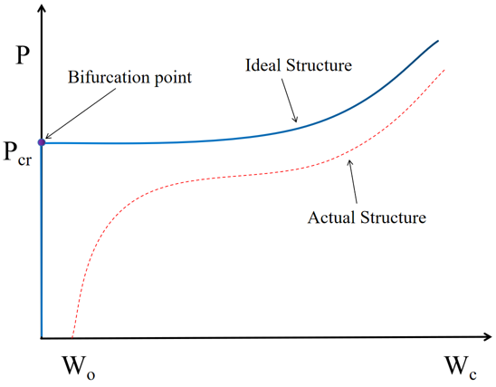
Fig.1. Load (P) versus total deflection (Wc) in a uniformly compressed structure[1]
Thin-walled tubes, especially those with rectangular or circular cross sections, have been widely used in automotive structures and trains for increasing the energy absorption efficiency, weight reduction, strength, and manufacturing. Compared with traditional straight tubes, the tapered thin-walled tubes are preferred since they are more likely to provide a desirable constant mean crush load-deflection response during axial crushing [2]. When compared to straight tubes, tapered tubes have a steady crush load and deformation response because they can sustain both axial and oblique impact loads.
Due to the wide applications of the tapered thin-walled tubes, their load-deformation response and energy absorption performance under axial loading, as well as other important characteristics have been studied [3-8]. Mamalis et al. [9-10] have also performed the axial compression on steel thin-walled frusta of semi-apical angles from 5° to 10° at elevated strain rates. These investigations looked at a range of tapered tubes with circular or rectangular cross sections and varying taper degrees. All the computer analyses and simulations involved in those studies are performed through shell-element models (detailed models) which achieved computational accuracy by high fidelity to the physical geometry [11-14]. Still, beam element models are the preferred method for simulating thin-walled tubes since they enable rapid and effective computer simulation in addition to providing users with a rough understanding of how many alternative designs will behave. Marques et al. [11] derived an Ayrton–Perry formulation for columns with non-uniform cross sections and proposed new design rules for tapered columns. They suggested adding a component to the column design equations in Eurocode [12] to account for the second-order effects of tapering columns, which was subsequently confirmed by experiments of Tankova et al. [13]. The idea of using such such element models, called concept models, have been demonstrated in previous literature and applied for quasi-static and impact analyses [14-15].
Nuguyen et al. [16] used artificial neural network (ANN) to predict the critical buckling load of web-tapered columns. They used finite element method to generate a wide database set of 269 specimens to develop ANN model. To estimate the critical buckling load of the web-tapered columns taking into account different input variables, an ANN-based formula was presented.
Bazeos and Karabalis [17] introduced an approximate method to calculate the elastic buckling load for tapered columns with different end conditions and restrained by prismatic beams using simple design charts. Their design charts were based on best fitting curves of wide range of web-tapered columns solved by exact formulation that was presented by Karabalis and Bazeos [18]. Based on the tapering ratio and the end conditions of the column, the placement of a critical cross section of the web-tapered column was ascertained from these design charts. The critical buckling load was determined based on the moment of inertia of this critical cross section and the well-known buckling length factors [19-22].
Many researchers [23-26] developed finite element (FE) formulations to determine the elastic buckling loads for tapered columns with general non-prismatic cross sections. These studies address a variety of topics, including cross section type, flexibility of connections, and boundary conditions for tapered columns. Kucukler and Gardner [27-28] developed a stiffness reduction function for axial and bending strength which can be incorporated into finite element analysis.
This paper aims at creating concept models for the twisted tapered thin-walled tubes, which can be used for axial buckling analysis. In developing such model a parametric study was then carried out to investigate the influence of the design parameters, the modeling methodology put forward using Central Composite Design (CCD) approach in RSM and the algorithmic optimization approach to get the most effective design parameters.
Material and method:
In this study, the material used was 316 stainless steel, its nominal chemical composition is shown in Table 1. The chromium-rich oxide surface film that forms on these steels is invisible and sticky, giving them their anti-corrosion characteristics. It is in the presence of oxygen that this oxide produces and repairs itself. These steels' ability to withstand corrosion is a result of this oxide layer. Nickel (the primary gammagenous element in austenitic stainless steels), molybdenum, copper, titanium, aluminum, silicon, niobium, nitrogen, sulfur, and selenium are additional elements added to improve certain qualities. Fig 2 and 3 shows the variation of density, Young’s modulus, Bulk modulus, shear modulus and Poisson’s ratio w.r.t temperature.

Table 1 The chemical compositions (wt %) of AISI 316
C | Si | Mn | P | S | Cr | Mo | N | Ni
0.007 | 0.8 | 1.86 | 0.012 | 0.006 | 17.99 | 1.48 | 0.024 | 12.31

Fig. 2 Variation of density w.r.t temperature

Fig. 3 Variation of material properties w.r.t temperature
The twisted tapered tubes are created with a square base as shown in fig. 4 in which the extrusion height was kept as 30 mm which is kept constant and the square base dimensions was taken as 25 mm, Meshing of 0.8 mm was used to performed linear buckling analysis using Ansys workbench after running number of programs at different mesh size to get the optimal mesh size for accurate value. During the analysis the tubes were subjected to compressive load at one end while the other end was kept fixed maintaining the fixed free column condition for each program. The input parameters considered for the analysis are as shown in table 1.
Fig. 4. Geometry of twisted tapered tube (Isometric and top view)

Table 2 Independent input variables and their coded levels for the central composite design
Independent Input Variation | Levels of coded variables
Independent Input Variation | -α | Low | Medium | High | +α
Tapered Angle (degree) | 0⁰ | 3.75⁰ | 7.5⁰ | 11.25⁰ | 15⁰
Thickness (mm) | 0.25 | 0.438 | 0.625 | 0.813 | 1
Twist Angle (degree) | 0⁰ | 22.5⁰ | 45⁰ | 67.5⁰ | 90⁰

The parameters used for linear buckling analysis were analyzed by standard response surface methodology (RSM) design called central composite design (CCD). The RSM method is useful for fitting a quadratic surface and aids in analyzing the interaction between the parameters as well as process parameter optimization with the least amount of experimentation [29]. RSM is a set of statistical and mathematical methods that are helpful in creating empirical models, refining and optimizing process parameters, and determining how several influencing elements interact [30].
RSM is a statistical technique that determines the regression model and optimizes an output variable (response) that is influenced by multiple independent factors using quantitative data from the linked experiment (input variables).
A 2^{n} factorial run with 2n axial runs typically makes up a CCD, and center runs are used to measure the experimental error. The two factorials in this experimental design are coded by ±α notation and are supplemented by two axial points (±α, 0, 0...0), (0, ± α, 0...0)... (0, 0, ± α...0) and center points nc (0, 0, 0... 0). Each variable is analyzed three times, and as the number of variables (n) increases, so does the number of runs needed to fully replicate the design. CCD was used to calculate the quadratic effect since 2n factorial designs are unable to quantify the individual effect of second order independently for every factor in this study, there are three design levels: ±α, 0, ±1. Table 2 displays the independent variables together with their coded levels and uncoded for the central composite design. The results of the simulation are all shown in Table 3.

Tapered Model Analysis:
These models are used to promote design optimization. The Face Centered, Central Composite Design (CCD) approach in Response Surface Methodology (RSM) is an engineering technique used to build the Coded and Actual Empirical model when the results are hard to quantify directly. Most engineering projects need simulations and tests to evaluate design objective and constraint functions as a function of design factors. One way to reduce this load is to create approximation models, or proxy models. Among these models is RSM. Based on simulating the simulator's reaction to a small number of carefully selected data points, a model is developed using Design Expert 13.Using Central Composite Design (CCD), the levels of significant components and their interactions were examined and predicted. Table 3 defines the number of experiments (N) needed for CCD in codded and uncoded form. Thus, three significant factors including tapered angle (β), thickness (t), Twist angle (α) are listed in Table 2. Levels are defined according to limits using design expert software. 20 trail runs were conducted for significant test.
The following second-order polynomial equations have yields with key factors and interactions based on multiple regression analysis of the answer that was obtained. F and P-values were the two significant factors in the investigation, and the ANOVA was used to control the validity of the models.
Table 3 Coded and un-coded level of experimental variables of the CCD
No. of Run | Coded Form |  |  | Actual Form
No. of Run | Tapered Angle  (degree) | Thickness (mm) | Twist Angle (degree) | Tapered Angle  (degree) | Thickness (mm) | Twist Angle (degree)
1 | -1 | -1 | -1 | 3.75 | 0.438 | 22.5
2 | 1.68179 | 0 | 0 | 15 | 0.625 | 45
3 | 0 | 0 | 0 | 7.5 | 0.625 | 45
4 | 1 | 1 | 1 | 11.25 | 0.813 | 67.5
5 | -1 | 1 | 1 | 3.75 | 0.813 | 67.5
6 | 0 | 0 | 0 | 7.5 | 0.625 | 45
7 | 0 | 0 | 0 | 7.5 | 0.625 | 45
8 | -1.68179 | 0 | 0 | 0 | 0.625 | 45
9 | 1 | -1 | -1 | 11.25 | 0.438 | 22.5
10 | 1 | 1 | -1 | 11.25 | 0.813 | 22.5
11 | 0 | 0 | 0 | 7.5 | 0.625 | 45
12 | 0 | 0 | 1.68179 | 7.5 | 0.625 | 90
13 | 0 | 0 | 0 | 7.5 | 0.625 | 45
14 | 0 | 1.68179 | 0 | 7.5 | 1 | 45
15 | 0 | -1.68179 | 0 | 7.5 | 0.25 | 45
16 | 0 | 0 | -1.68179 | 7.5 | 0.625 | 0
17 | -1 | -1 | 1 | 3.75 | 0.438 | 67.5
18 | 1 | -1 | 1 | 11.25 | 0.438 | 67.5
19 | 0 | 0 | 0 | 7.5 | 0.625 | 45
20 | -1 | 1 | -1 | 3.75 | 0.813 | 22.5
Table 4 Independent parameters and theirs output responses
No. of Run | Tapered Angle  (degree) | Thickness (mm) | Twist Angle (degree) | Buckling Load (N) | Mass (gm) | Strain Energy (J) x 10⁻¹¹ | Stress (kPa) | Specific Strain Energy (J/kg) x 10⁻¹¹
1 | 3.75 | 0.438 | 22.5 | 7622.3 | 9.49 | 0.86 | 267.34 | 90.67
2 | 15 | 0.625 | 45 | 35033 | 10.15 | 2.41 | 323.30 | 237.39
3 | 7.5 | 0.625 | 45 | 25848 | 12.41 | 1.15 | 230.73 | 92.82
4 | 11.25 | 0.813 | 67.5 | 63255 | 14.63 | 0.97 | 195.76 | 66.57
5 | 3.75 | 0.813 | 67.5 | 59813 | 17.71 | 0.37 | 111.90 | 20.75
6 | 7.5 | 0.625 | 45 | 25848 | 12.41 | 1.15 | 230.73 | 92.82
7 | 7.5 | 0.625 | 45 | 25848 | 12.41 | 1.15 | 230.73 | 92.82
8 | 0 | 0.625 | 45 | 26467 | 14.78 | 0.43 | 129.24 | 29.41
9 | 11.25 | 0.438 | 22.5 | 9003.7 | 7.94 | 5.61 | 843.89 | 706.31
10 | 11.25 | 0.813 | 22.5 | 55851 | 14.43 | 0.85 | 169.84 | 58.70
11 | 7.5 | 0.625 | 45 | 25848 | 12.41 | 1.15 | 230.73 | 92.82
12 | 7.5 | 0.625 | 90 | 34077 | 12.79 | 1.45 | 242.56 | 113.26
13 | 7.5 | 0.625 | 45 | 25848 | 12.41 | 1.15 | 230.73 | 92.82
14 | 7.5 | 1 | 45 | 94244 | 19.48 | 0.23 | 133.65 | 11.72
15 | 7.5 | 0.25 | 45 | 2311.8 | 5.06 | 7.18 | 1403.10 | 1417.96
16 | 7.5 | 0.625 | 0 | 20543 | 12.29 | 1.07 | 258.60 | 87.24
17 | 3.75 | 0.438 | 67.5 | 12053 | 9.75 | 1.49 | 364.78 | 153.01
18 | 11.25 | 0.438 | 67.5 | 11845 | 8.06 | 5.72 | 776.72 | 709.13
19 | 7.5 | 0.625 | 45 | 25848 | 12.41 | 1.15 | 230.73 | 92.82
20 | 3.75 | 0.813 | 22.5 | 43173 | 17.31 | 0.19 | 67.43 | 10.80

Results and Discussion
The response surface plot and regression analysis of the simulation data were created using the statistical "Design expert" software. To estimate the statistical parameters, ANOVA is employed. Based upon the design of experiment an extensive parametric study was carried out to examine the effect on buckling load, strain energy, stress and specific strain energy by varying the input design parameters.
Combined effect of twist angle, tapered angle and thickness on buckling load
The response surface methodology was used to investigate the individual and interaction effect of the three-factor on buckling load of square base tapered hollow tube. Based on ANOVA, the results obtained for the effects of input factors on buckling load, corresponding three-dimensional response surface plots are shown in Figs. 5 (a, b & c) and the respective output value of the input parameters are presented in Table. 4. The final empirical model in terms of a input factor for buckling load is shown in Eq. (1), where negative signs signify inhibitory effect, whereas positive signs signify synergistic effects. Based on the regression technique, polynomial (second-order) mathematical models for the response of Buckling Load have been established as shown in equation (1)

Final equation in terms of actual factors
Buckling Load =+27328.25099-1645.91585 Tapered Angle-1.19030E+05 Thickness-88.79680 Twist Angle+2657.20214 Tapered Angle * Thickness-16.03763 Tapered Angle * Twist Angle+497.11420 Thickness * Twist Angle+85.33001 Tapered Angle²+1.58769E+05 Thickness ²+0.671513 Twist Angle² (1)
The buckling load value ranges from 2311.8N to 94244N. Figs. 5 (a, b & c) demonstrate the interactions between the input variables in three-dimensional response surface plots. The values of the y-axes in the Figs. 5 (a, b & c) are the buckling load values. Fig. 5 (a) indicates the combined effect of thickness and tapered angle which shows that by increasing thickness and taper angle the buckling load also increases, Fig. 5 (b) indicates the combined effect of twist angle and tapered angle which shows that by varying twisting angle and taper angle have least significance on buckling load and Fig. 5 (c) shows the combined effect of twist angle and thickness on buckling load which indicates that by varying taper angle has less significance as compared to thickness to get maximum buckling load. By using the response surface analysis method, it was observed from Table 4 and Figs. 5 (a, b & c) that the thickness has found to be the major effect on the buckling load in comparison to the taper angle and the twist angle. It was observed that with the increase in twist angle, buckling load increases from 22546.6N to 29850N with the increase of 32.39%, whereas with the increase in taper angle the buckling load increases from 24904.1N to 29212.3N with the increase of 17.29% and the effect of thickness on buckling load has more impact as compared to the other parameters and was found to be from 8585.75N to 54294.2N with the percentage change of 532.37% which is higher among the other input parameters.
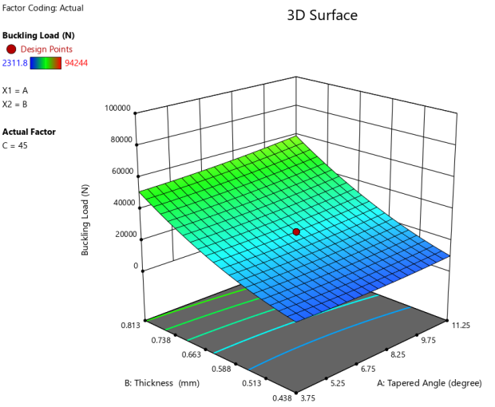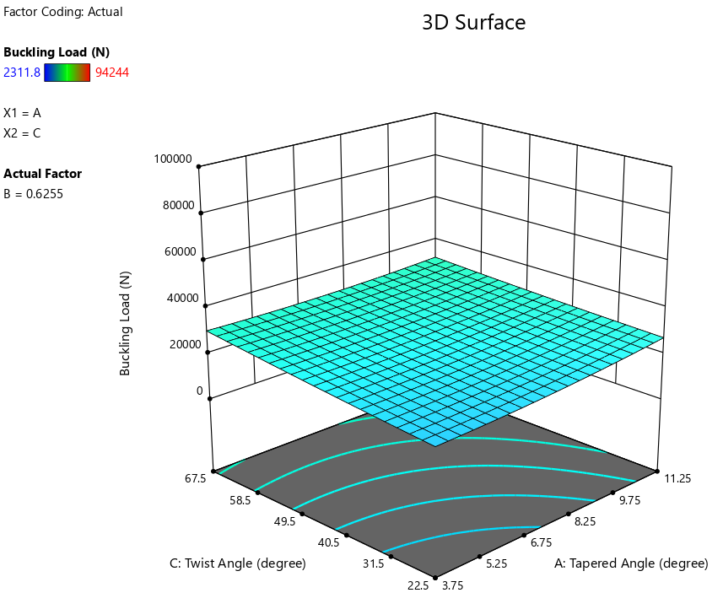 (a) (b)
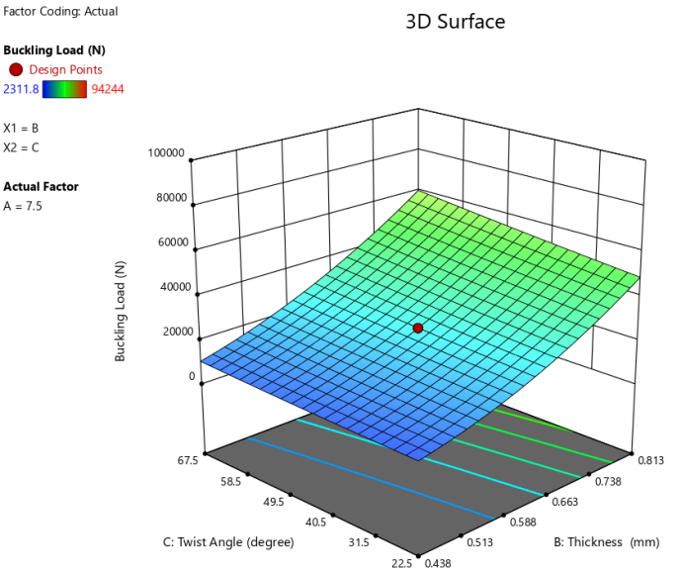
(c)
Fig. 5. Response surface graph for buckling load; (a) variation of taper angle and thickness (b) variation of twist angle and taper angle, (c) variation of twist angle and thickness

Combined effect of twist angle, tapered angle and thickness on stress

In this section the response surface methodology was used to investigate the individual and interaction effect of the three-factor on stress of square base tapered hollow tube. Based on ANOVA, the results obtained for the effects of input factors on stress load, corresponding three-dimensional response surface plots are shown in Figs. 6 (a, b & c) and the respective output value of the input parameters are represented in Table. (4). The final empirical model in terms of a input factor for stress is shown in Eq. (2), where negative signs signify inhibitory effect, whereas positive signs signify synergistic effects. Based on the regression technique, polynomial (second-order) mathematical models for the response of stress have been established as shown in Equation (2)
Final equation in terms of actual factors
Stress=+1661.08783+130.28329Tapered Angle-5125.18694Thickness+0.893684 Twist Angle-142.42921Tapered Angle * Thickness-0.271354Tapered Angle * Twist Angle+1.19410Thickness * Twist Angle-0.198029Tapered Angle²+3777.71396Thickness ²+0.006504Twist Angle² (2)

The stress value ranges from 67.426 kPa to 1403.1 kPa. Figs. 6 demonstrate the interactions between the input variables in three-dimensional response surface plots. The values of the y-axes in the Figs. 6 (a, b & c) are the stress values. Fig. 6 (a) indicates the combined effect of thickness and tapered angle which shows that by increasing taper angle the stress also increases whereas by increasing the thickness the stress decreases, Fig. 6 (b) indicates the combined effect of twist angle and tapered angle which shows that by varying twisting angle the stress increases but not much as compare to the taper angle which shows a tremendous amount of gain in the stress value. Fig. 6 (c) shows the combined effect of twist angle and thickness on stress which shows that by varying taper angle the stress increases whereas it decreases with the increase in thickness. By using the response surface analysis method, it was observed from Table 4 and Figs. 6 (a, b & c) that the thickness has found to be the major effect in controlling the stress in comparison to the taper angle and the twist angle. It was observed that with the increase in twist angle, stress increases from 225.545 kPa to 234.131kPa with the increase of 3.81%, whereas with the increase in taper angle the stress increases from 126.214 kPa to 321.307 kPa with the increase of 154.57% and at last the effect of thickness on stress has more impact as compared to the other parameters and was found to be from 624.434 kPa to 94.277 kPa with the percentage change of -84.90% by increasing the thickness. It clearly shows that the thickness has more controlling affect on stress as compared to twist angle and taper angle.

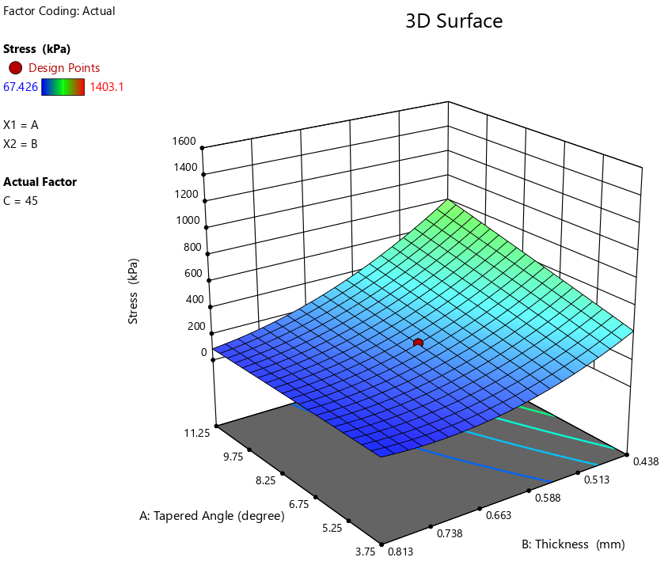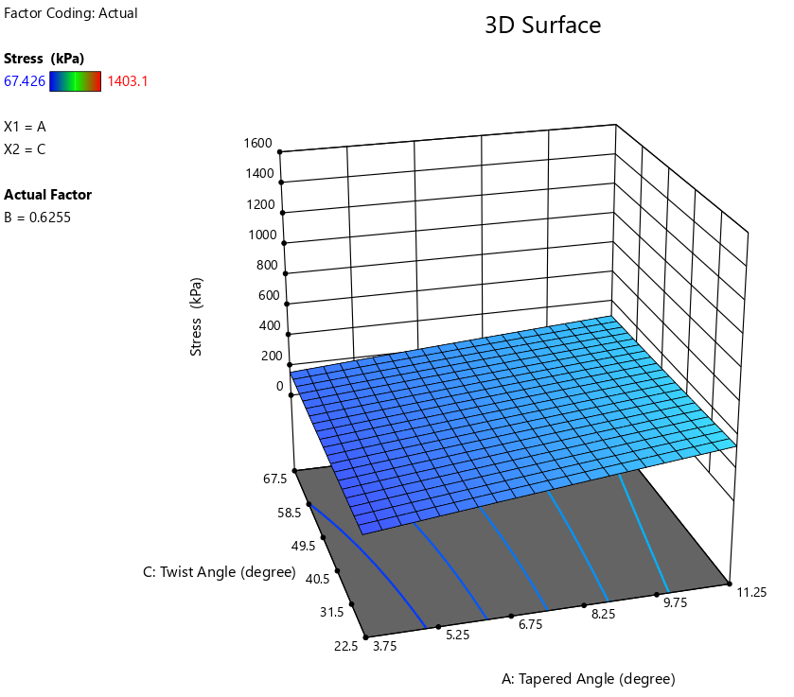
- (b)
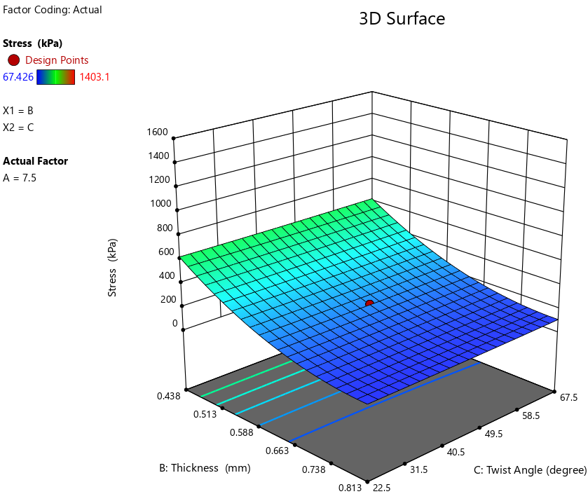
(c)
Fig. 6. Response surface graph for stress; (a) variation of taper angle and thickness (b) variation of twist angle and taper angle, (c) variation of twist angle and thickness

Combined effect of twist angle, tapered angle and thickness on strain energy
The response surface methodology was used to investigate the individual and interaction effect of the three-factor on strain energy of square base tapered hollow tube. Based on ANOVA, the results obtained for the effects of input factors on strain energy, corresponding three-dimensional response surface plots are shown in Figs. 7 (a, b & c) and the respective output value of the input parameters are represented in Table. (4). The final empirical model in terms of a input factor for strain energy is shown in Eq. (3), where negative signs signify inhibitory effect, whereas positive signs signify synergistic effects. Based on the regression technique, polynomial (second-order) mathematical models for the response of strain energy have been established as shown in Equation (3)

Final Equation in Terms of Actual Factors
Strain Energy = +5.05136+1.04653Tapered Angle-20.65992Thickness+0.012543Twist Angle-1.36888Tapered Angle * Thickness-0.000854Tapered Angle * Twist Angle-0.012809Thickness * Twist Angle+0.005620Tapered Angle²+18.47489Thickness ²+0.000076Twist Angle² (3)

The strain energy value ranges from minimum 0.18698 x 10⁻¹¹ J to maximum 7.1773 x 10⁻¹¹ J. Figs. 7 (a, b & c) demonstrate the interactions between the input variables in three-dimensional response surface plots. The values of the y-axes in the Figs. 7 (a, b & c) are the strain energy values. Fig. 7 (a) indicates the combined effect of thickness and tapered angle which shows that by increasing thickness the strain energy decreases and on increasing the taper angle the strain energy increases, Fig. 7 (b) indicates the combined effect of twist angle and tapered angle which shows that by increasing the twisting angle and taper angle the strain energy also increases and Fig. 7 (c) shows the combined effect of twist angle and thickness on strain energy which indicates that increasing the twisting angle the strain energy also increases whereas by increasing the thickness the strain energy decreases. By using the response surface analysis method, it was observed from Table 4 and Figs. 7 (a, b & c) that the combination of twisting angle and taper angle has found to be the major effect on the strain energy in comparison to the thickness. It was observed that with the increase in twist angle, strain energy increases from 1.0957 x 10⁻¹¹ J to 1.3216 x 10⁻¹¹ J with the increase of 20.62%, whereas with the increase in taper angle the strain energy increases from 0.36394 x 10⁻¹¹ J to 2.1352 x 10⁻¹¹ J with the increase of 486.69% and the effect of thickness on strain energy has more impact as compared to the other parameters and was found to be decreasing from 3.3933 x 10⁻¹¹ J to 0.2467 x 10⁻¹¹ J with the percentage change of -92.73% on increasing the thickness.

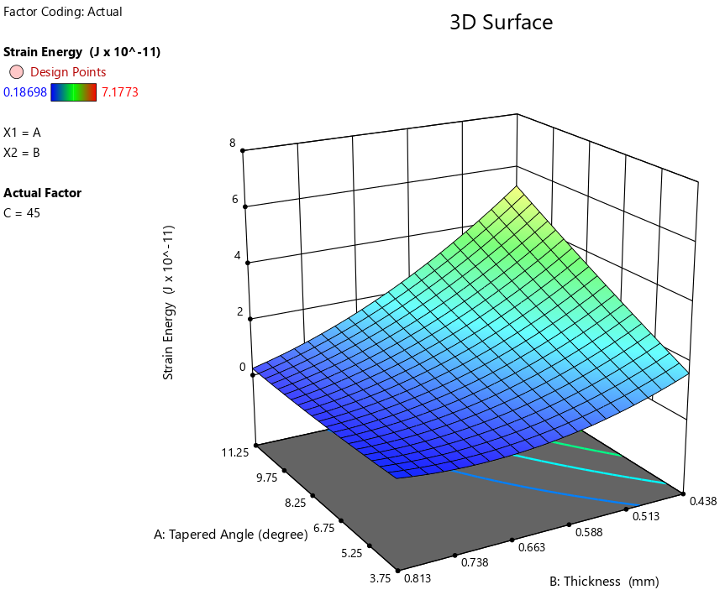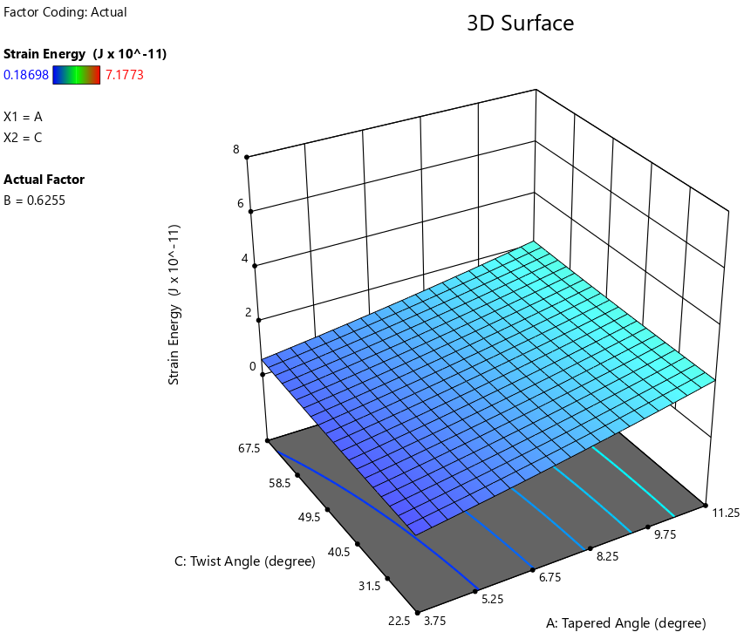
- (b)
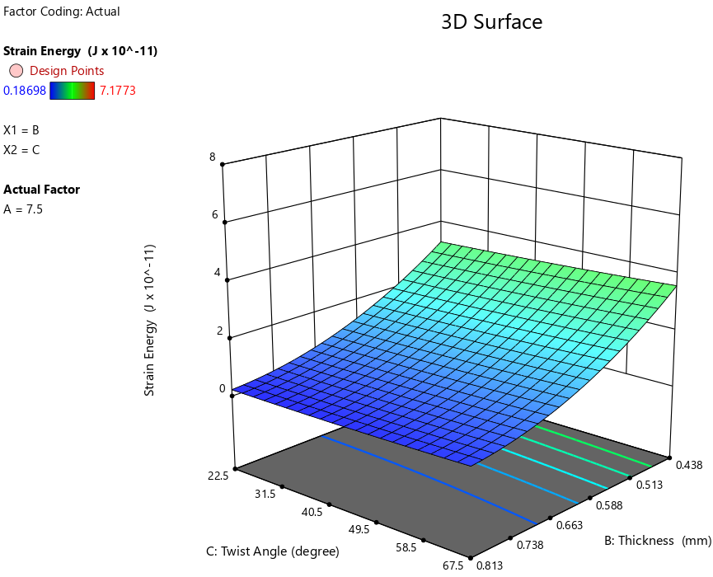
(c)
Fig. 7. Response surface graph for strain energy; (a) variation of taper angle and thickness (b) variation of twist angle and taper angle, (c) variation of twist angle and thickness

Combined effect of twist angle, tapered angle and thickness on specific strain energy

The response surface methodology was used to investigate the individual and interaction effect of the three-factor on specific strain energy of square base tapered hollow tube. Based on ANOVA, the results obtained for the effects of input factors on specific strain energy, corresponding three-dimensional response surface plots are shown in Figs. 8 (a, b & c) and the respective output value of the input parameters are represented in Table. (4). The final empirical model in terms of a input factor for specific strain energy is shown in equation (4), where negative signs signify inhibitory effect, whereas positive signs signify synergistic effects. Based on the regression technique, polynomial (second-order) mathematical models for the response of specific strain energy have been established as shown in Equation (4)

Final Equation in Terms of Actual Factors
Specific Strain Energy = +1512.97756 + 144.14431 Tapered Angle-5370.21357Thickness+2.12729Twist Angle-191.44851Tapered Angle * Thickness-0.091261Tapered Angle * Twist Angle-1.40121Thickness * Twist Angle+0.512629Tapered Angle²+4342.86234Thickness ²-0.002130Twist Angle² (4)

The specific strain energy value ranges from 10.80 x 10⁻¹¹ J/kg to 1417.96x 10⁻¹¹ J/kg. Figs. 8 (a, b & c) demonstrate the interactions between the input variables in three-dimensional response surface plots. The values of the y-axes in the Figs. 6–8 are the specific strain energy values. Fig. 8 (a) indicates the combined effect of thickness and tapered angle which shows that by increasing thickness the specific strain energy decreases, whereas on increasing the taper angle the specific strain energy increases, Fig. 8 (b) indicates the combined effect of twist angle and tapered angle which shows that by increasing the twisting angle and taper angle the specific strain energy increases and Fig. 8 (c) shows the combined effect of twist angle and thickness which shows that by increasing taper angle specific strain energy increases where as it decreases by increasing the thickness. By using the response surface analysis method, it was observed from Table 4 and Figs. 8 (a, b & c) that the twist angle and tapered angle have the major effect on the specific strain energy in comparison to the thickness of the tube. It was observed that with the increase in twist angle, specific strain energy increases from 76.5 x 10⁻¹¹ J/kg to 93.36 x 10⁻¹¹ J/kg with the increase of 22.03%, whereas with the increase in taper angle the specific strain energy increases from 11.6 x 10⁻¹¹ J/kg to 198.1 x 10⁻¹¹ J/kg with the increase of 1607.76% and the effect of thickness on specific strain energy has the least impact as compared to the other parameters and was found to be decreasing from 507.9 x 10⁻¹¹ J/kg to 11.72 x 10⁻¹¹ J/kg with the percentage change of -97.69%.

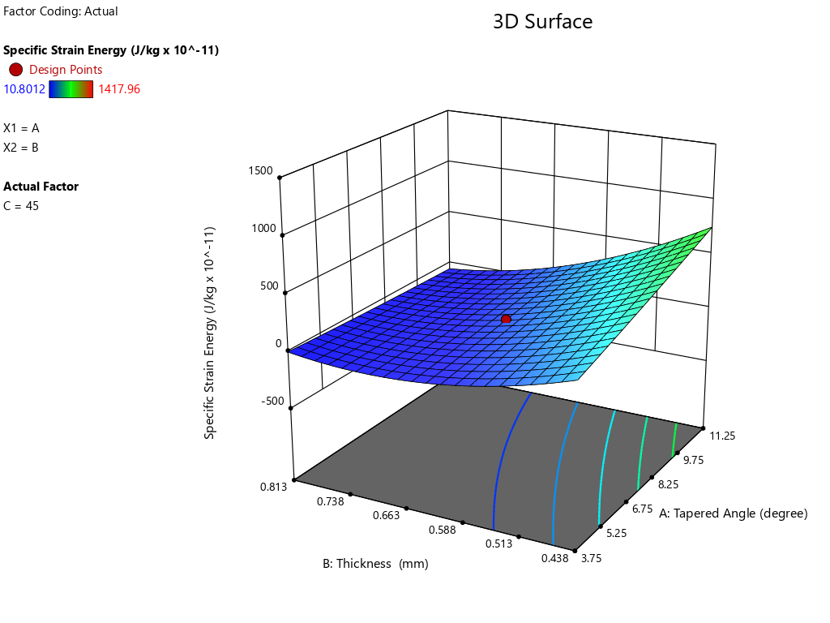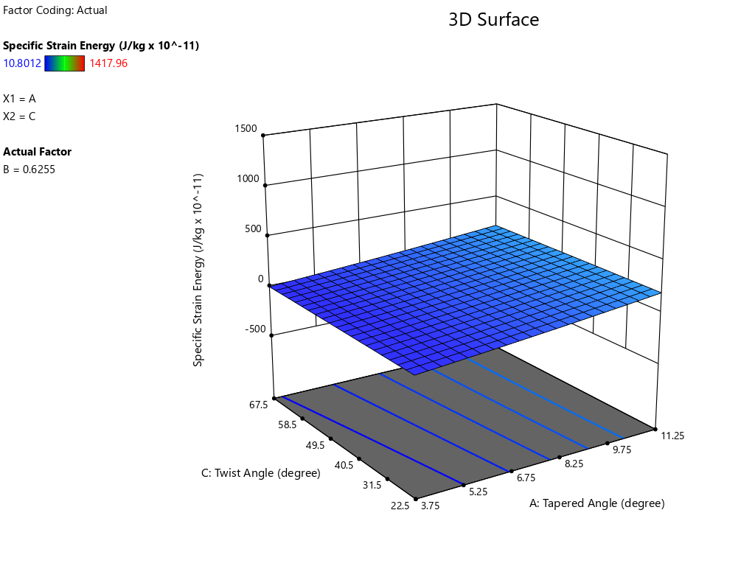
- (b)
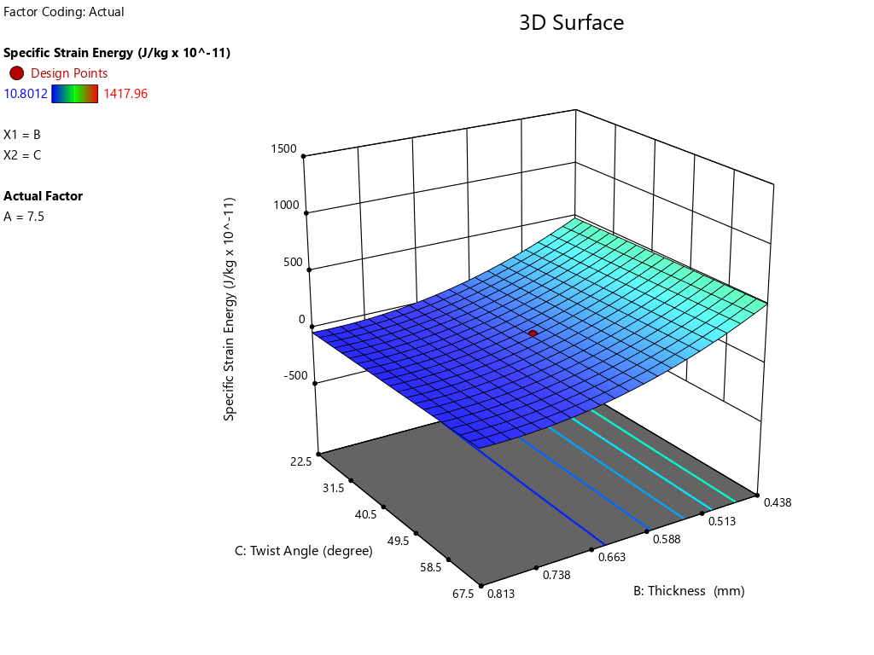
(c)
Fig. 8. Response surface graph for specific strain energy; (a) variation of taper angle and thickness (b) variation of twist angle and taper angle, (c) variation of twist angle and thickness

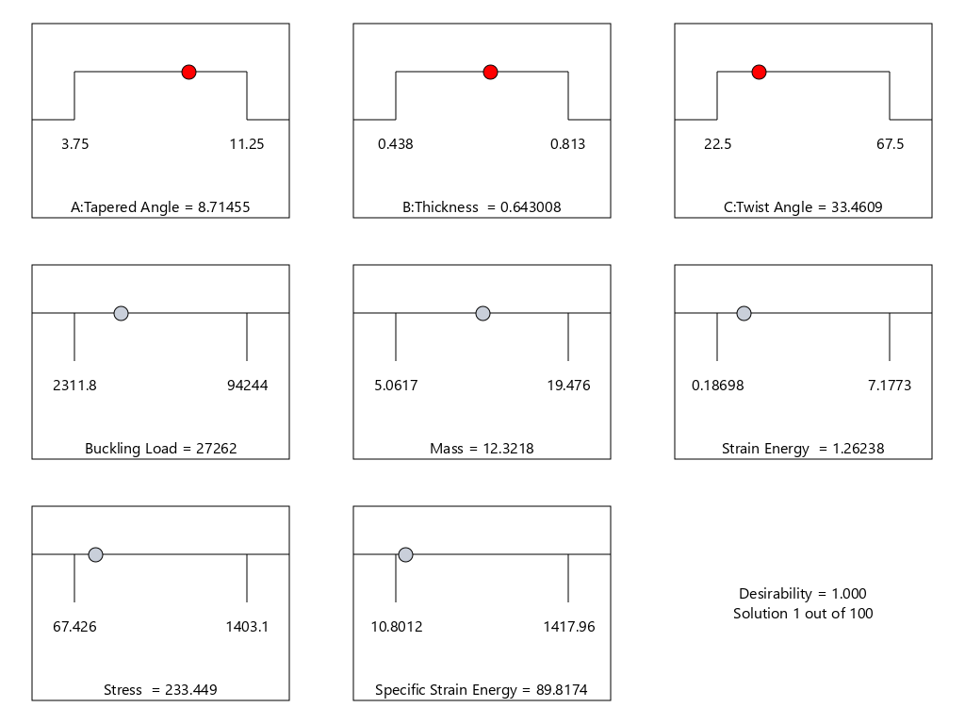
Fig. 9. Optimal Process Parameters
CCD-RSM optimization:
Fig. 9 displays the ideal option for achieving optimal process parameters values such as tapered angle (A) = 8.714⁰, thickness (B) = 0.643, twist angle(C) =33.460⁰, buckling load=27262 kN, mass=12.321 kg, strain energy=1.262 x 10⁻¹¹ J, stress= 233.449 Pa, specific strain energy= 89.817 x 10⁻¹¹ J/kg for optimal buckling load, strain energy, stress and specific strain energy are under desirability = 1. These optimum values are implemented for a confirmation test.
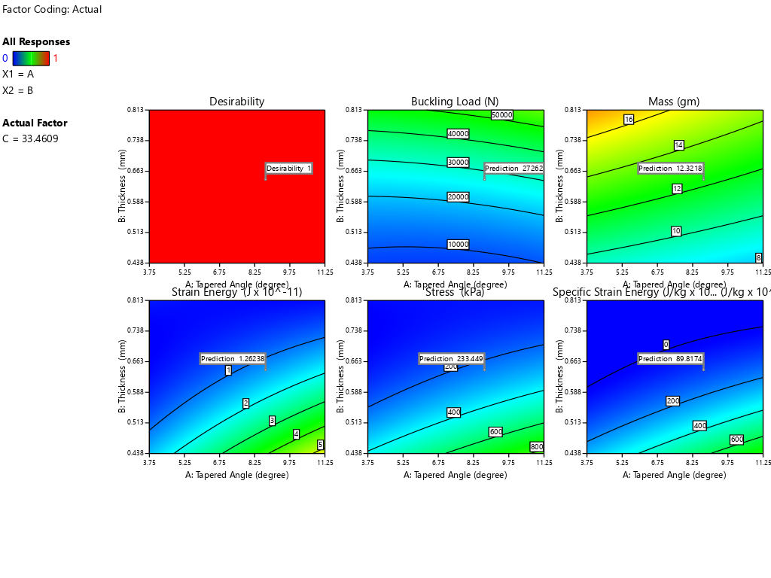

Fig. 10. Desirability plot displays the optimum solution recommended by the software
Conclusion

In this paper, the geometric input parameters taper angle, twist angle and thickness of the hollow tube is analyzed using a response surface methodology (RSM). The study involves the simulation of three-dimensional finite element models, square base tapered hollow tube subjected to axial compressive load. The output parameters during the analysis was considered as linear buckling load, stress, strain energy and specific strain energy. The results obtained has the following observations.
- For buckling load: The study shows that increasing the thickness significantly enhances the buckling load, demonstrating a more substantial impact than both taper angle and twist angle. The maximum observed buckling load was 94,244 N. The percentage changes in the buckling load with the variations in taper angle, twist angle, and thickness were found to be as 17.30%, 32.40%, and 532.37%, respectively.
- For stress: It was observed that both taper angle and twist angle contribute to an increase in stress, while an increase in thickness results in a reduction in stress. The maximum stress recorded was 1,403.1 kPa. The percentage change in stress due to taper angle, twist angle, and thickness was found to be 154.57%, 3.81%, and -84.90%, respectively. From the mentioned data values it has been found the the stress should be minimized with the variation in the input parameters and hence thickness is showing the best behavior as compared to the tapered angle and twisting angle.
- For strain energy: The analysis indicates that an increase in taper angle and twist angle leads to an increase in strain energy, whereas an increase in thickness causes a decrease in the strain energy. The peak strain energy achieved was 7.1773 x 10⁻¹¹ J. The percentage variations in strain energy with respect to taper angle, twist angle, and thickness were determined as 486.69%, 20.61%, and -92.73%, respectively which shows that increasing the thickness is not in favour to get more strain energy and hence least input thickness is more to be used. Taper angle has the more impact as compared to the twist angle even both shows the increasing trend of strain energy with their increasing variation.
- For specific strain energy: Similarly, specific strain energy was found to increase with both taper angle and twist angle, while it decreased with an increase in thickness. The maximum specific strain energy recorded was 1,417.96 x 10⁻¹¹ J/kg. The percentage changes in specific strain energy due to taper angle, twist angle, and thickness were observed to be 1,607.76%, 22.04%, and -97.69%, respectively.
- The optimization studies identified common optimal ranges, resulting in the following optimal values: taper angle (A) = 8.7140°, thickness (B) = 0.643 mm, twist angle (C) = 33.4600°, buckling load = 27,262 kN, mass = 12.321 kg, strain energy = 1.262 x 10⁻¹¹ J, stress = 233.449 Pa, and specific strain energy = 89.817 x 10⁻¹¹ J/kg.

References
- Rozylo, Patryk, et al. "Experimental and numerical study of the buckling of composite profiles with open cross section under axial compression." Applied Composite Materials 24 (2017): 1251-1264.
- Reid, S. R., & Reddy, T. Y. (1986). Static and dynamic crushing of tapered sheet metal tubes of rectangular cross-section. International Journal of Mechanical Sciences, 28(9), 623-637.
- Paavola, J., & Salonen, E. M. (1999). Strain and stress analysis of a curved tapered beam model. Computers & structures, 72(4-5), 565-577.
- Liu, Y. C., & Dag, M. L. (2009). Concept modeling of tapered thin-walled tubes. Journal of Zhejiang University-SCIENCE A, 10, 44-53.
- Lee, B. K., & Oh, S. J. (2000). Elastica and buckling load of simple tapered columns with constant volume. International Journal of Solids and Structures, 37(18), 2507-2518.
- Liu, Y. C., & Dag, M. L. (2009). Concept modeling of tapered thin-walled tubes. Journal of Zhejiang University-SCIENCE A, 10, 44-53.
- Nagel, G. M., & Thambiratnam, D. P. (2005). Computer simulation and energy absorption of tapered thin-walled rectangular tubes. Thin-walled structures, 43(8), 1225-1242.
- Gupta, N. K., Sheriff, N. M., & Velmurugan, R. (2006). A study on buckling of thin conical frusta under axial loads. Thin-walled structures, 44(9), 986-996.
- Mamalis, A. G., & Johnson, W. (1983). The quasi-static crumpling of thin-walled circular cylinders and frusta under axial compression. International Journal of Mechanical Sciences, 25(9-10), 713-732.
- Mamalis, A. G., Johnson, W., & Viegelahn, G. L. (1984). The crumpling of steel thin-walled tubes and frusta under axial compression at elevated strain-rates: some experimental results. International Journal of Mechanical Sciences, 26(11-12), 537-547.
- Marques, L., Taras, A., da Silva, L. S., Greiner, R., & Rebelo, C. (2012). Development of a consistent buckling design procedure for tapered columns. Journal of Constructional Steel Research, 72, 61-74.
- ECCS-European Convention for Constructional Steelwork. (2015). Design of steel structures: eurocode 3: design of steel structures, part 1-1: general rules and rules for buildings. John Wiley & Sons.
- Tankova, T., Martins, J. P., da Silva, L. S., Simoes, R., & Craveiro, H. D. (2018). Experimental buckling behaviour of web tapered I-section steel columns. Journal of Constructional Steel Research, 147, 293-312.
- Prater Jr, G., Shahhosseini, A. M., Kuo, E. Y., Mehta, P. R., & Furman, V. T. (2005). Finite element concept models for vehicle architecture assessment and optimization. SAE transactions, 1667-1675.
- Liu, Y. C., & Day, M. L. (2006). Simplified modelling of thin-walled box section beam. International Journal of Crashworthiness, 11(3), 263-272.
- Nguyen, T. H., Tran, N. L., & Nguyen, D. D. (2021). Prediction of critical buckling load of web tapered I-section steel columns using artificial neural networks. International Journal of Steel Structures, 21(4), 1159-1181.
- Bazeos, N., & Karabalis, D. L. (2006). Efficient computation of buckling loads for plane steel frames with tapered members. Engineering Structures, 28(5), 771-775.
- Karabalis, D. L., & Beskos, D. E. (1983). Static, dynamic and stability analysis of structures composed of tapered beams. Computers & Structures, 16(6), 731-748.
- Rahim, Mohd Reyaz Ur, Shagil Akhtar, and Prem Kumar Bharti. "Finite element analysis for the buckling load of corrugated tubes." International Journal of Advanced Engineering, Management and Science 2.7 (2016): 239536.
- Rahim, Mohammad Reyaz Ur, Shagil Akhtar, and P. K. Bharti. "Comparative analysis of buckling load of circular and corrugated tubes by utilizing key performance indicators." International Journal of Applied Mechanics and Engineering 22.3 (2017): 789-797.
- Rahim, Mohd Reyaz Ur, and Prem Kumar Bharti. "Buckling Analysis of Innovative Corrugated Column by using Response Surface Methodology." Acta Marisiensis. Seria Technologica 17.2 (2020): 8-17.
- Umer, Afaque, Adil Ata Azmi, and M. Reyaz Ur Rahim. "Numerical study on buckling behavior of thin-walled corrugated tubes under quasi-static axial and oblique loading." Materials Today: Proceedings 5.9 (2018): 19109-19115.
- Karabalis, D. L., & Beskos, D. E. (1983). Static, dynamic and stability analysis of structures composed of tapered beams. Computers & Structures, 16(6), 731-748.
- Kim, M. C., Chang, K. C., & Lee, G. C. (1997). Elastic and inelastic buckling analysis of thin-walled tapered members. Journal of engineering mechanics, 123(7), 727-737.
- Valipour, H. R., & Bradford, M. A. (2012). A new shape function for tapered three-dimensional beams with flexible connections. Journal of Constructional Steel Research, 70, 43-50.
- Chiorean, C. G., & Marchis, I. V. (2017). A second-order flexibility-based model for steel frames of tapered members. Journal of Constructional Steel Research, 132, 43-71.
- Kucukler, M., & Gardner, L. (2018). Design of laterally restrained web-tapered steel structures through a stiffness reduction method. Journal of Constructional Steel Research, 141, 63-76.
- Kucukler, M., & Gardner, L. (2019). Design of web-tapered steel beams against lateral-torsional buckling through a stiffness reduction method. Engineering Structures, 190, 246-261.
- Montgomery, D. C. (2017). Design and analysis of experiments. John wiley & sons.
- Khuri, A. I., & Cornell, J. A. (2018). Response surfaces: designs and analyses. CRC press.
- Montgomery, Douglas C. Design and analysis of experiments. John wiley & sons, 2017.
- Rahim, Mohd Reyaz Ur, and Prem Kumar Bharti. "Energy absorption characteristics of thin-walled sinusoidal corrugated tube using RSM-CCD." Production Engineering Archives 26.4 (2020): 144-153.
- Moradi, Saber, and Henry V. Burton. "Response surface analysis and optimization of controlled rocking steel braced frames." Bulletin of earthquake engineering 16.10 (2018): 4861-4892.
- Rahim, Mohd Reyaz Ur, and Prem Kumar Bharti. "Buckling Analysis of Innovative Corrugated Column by using Response Surface Methodology." Acta Marisiensis. Seria Technologica 17.2 (2020): 8-17.

