Improving electrical conductivities of scrap melted aluminum conductor by pre-melt treatment.
Abstract
This review article provides an overview of how to improve the electrical conductivity of scrap melted aluminum conductor by using several types of pre-melt treatments in the cable industry. This pre-melt treatment alone cannot achieve high-purity aluminum from scraps. However, combining it with in-melt treatment, which uses different fluxing chemicals and gases, we can produce high-purity aluminum from aluminium scrap. The energy consideration of the melt process dictates removing unwanted elements in the scrap stream. Compared to many metals, aluminum presents a high degree of difficulty in removing tramp elements during melting.
Therefore, with no simple thermodynamic solution, producers must identify strategies throughout the production process to mitigate this elemental accumulation. There are a variety of solutions to deal with the negative impact of recycling due to the accumulation of undesired elements, such as a trade-off between cost and improvement in scrap recycling potential. Pre-melt treatment is critical to achieving the desired purity with the combination of in-melt treatment. Once high impurity enters the melting process, it becomes difficult to purify, and we can ease in-melt treatment by using this pr-melt treatment. Aluminum is the most widely used nonferrous metal for many applications, such as electrical conductivity applications, foil, beverage cans, cooking and food processing, architectural structures, and boats and aircraft due to its low density and high conductivity properties. Aluminum can be produced from two types of sources: from its ore and scrapes. Due to its wide usage, the availability of aluminum scraps is high enough, and this recycling has many environmental and economic benefits. However, the presence of deleterious impurities in recycled aluminum is the main drawback, especially for electrical applications, since electrical conductivity property highly depends on the purities of the materials. Several studies and literature suggest that accumulating unwanted elements is a growing problem, and removing unwanted elements in the scrap stream is dictated by energy consideration of the melting process. Today, most industries use dilution scraps with primary aluminum to decrease the effects of impurities. There are a variety of solutions to deal with the accumulation of undesired elements that apply before melting and in the melting process. This work provides an overview of methods for removing unwanted elements from aluminum scraps before melting, specifically for electrical conductivity applications.
Keywords: scraps, conductivity, pre-melt treatment, resistivity, impurity

Introduction
Aluminum is the second most plentiful and is the most widely used nonferrous metallic element on the earth. Aluminum and aluminium alloy are used for foil, beverage cans, cooking and food processing, architectural and electrical applications, and structures for boats, aircraft and other transportation types. Aluminum has the highest corrosion resistance because of naturally occurring surface oxide films (Al₂O₃)(Campbel, 2008). This combination of properties has allowed aluminum to compete for many applications. This combination of properties has allowed aluminium to compete for many applications. The need for improved electrical and mechanical properties and new applications has continuously developed new Al alloys with specific chemical compositions (Timelli, 2018).
Aluminium is a better electrical conductor than copper on an equal weight and cost basis. Its high thermal conductivity leads to applications such as radiators and cooking utensils. Its low density is essential for different applications. Wrought aluminium alloys display an excellent combination of strength and ductility. Aluminium alloys are among the easiest of all metals to form and machines. The precipitation-hardening alloys can be formed in a soft state and then heat-treated to much higher strength levels after forming operations are complete. In addition, aluminium and its alloys are not toxic and are among the easiest to recycle of any structural materials (Campbel, 2008). The ease with which aluminium may be fabricated into any form is one of its critical assets. Often, it can compete successfully with cheaper materials that have a lower degree of workability. Any method known by foundrymen can cast the metal. It can be rolled rod or stranded into the cable of any desired size and type. There is almost no limit to the different profiles in which the metal can be extruded (Internationa, 2001).

Electrical conductivity and Effects of impurity
The material's electrical conductivity depends on the material's purities and electrical resistance of the materials. Pure aluminium has a resistivity of 2.64 x10⁻⁸Ωm at 20℃ with a mean temperature coefficient over the range 0-100℃ of 4.42x10⁻³/℃. Thus, it has about 66% of pure copper (IACS) conductivity at 20℃. The density of aluminium is 2.7 compared with 8.9 for copper; hence, weight for weight, the conductivity of aluminium is 2.1 times that of copper and exceeds that of all known materials except the alkali metals.
Electrical resistance is a property of all materials by a measure of which it opposes electrical current. It is defined as Ohm's law.
R=$\frac{V}{I}$ 1
where V= applied potential (voltage)and I=current strength in ampere. However, resistance depends on a uniform conductor's cross-section, purity, and length. Resistance calculation from specific resistivity given as
R= $\frac{ρ*L}{A}$ 2
where ρ is specific resistivity, L is the length of the conductor, and A is the area of the conductor.
Resistivity is the resistance of a conductor whose length and cross-section area =1. This fundamental property of all metal's resistivity increases with temperature. For pure metal, resistivity at a given temperature is constant. Matthiessen's rule is concerned with electron mobility, which in turn decides metals' electrical conductivity and resistivity. The electrical conductivity of a metal can be explained well by the free electron model of metals. Metal contains free electrons, but those free electrons are confined within the metal unless an electrical field is applied. Then, the free electron travels through the metal and connected conductor. Electron mobility is hampered if the electron undergoes collision with impurities. That is why the presence of impurities lowers the conductivity of a metal. Electrons are scattered by impurities in atoms, and as a result, the electrical conductivity of a metal decreases. Conversely, resistivity increases. Electrons are also scattered by phonons (lattice vibration). As the temperature is raised, lattice vibration increases, resulting in a greater concentration of phonons. These phonons can scatter free electrons, lowering the electrical conductivity.
The DC resistivity of Metals
Matthiessen's rule is the customary approximation used in discussing metal resistivity. Matthiessen's rule- the statement that the electrical resistivity ρ of a metal can be written as
ρ=ρ_{L}+ρ_{i} 3
a_{ll} is due to the scattering of conduction electrons by lattice vibrations and i_{s} scattered by impurities and imperfections. If the impurity concentration is small, it i_{s} temperature-independent.
The impurity level of aluminium is related to the electrical resistivity (and conductivity) of aluminium. Impurities increase the themetality of a pure metal due to the lattice distortion that affects electron scattering, which is partially responsible for the electrical conducting property of the metal. Matthiessen's rule shows the dependency of electron mobility on electron scattering contributions from impurities and lattice phonons. Electron mobility defines electrical conductivity and resistivity.

Aluminium scrap recycling
Aluminium recycling has several critical environmental and economic benefits; compared to other high-volume materials, aluminium production has one of the enormous energy differences between primary and secondary output: 186 MJ/kg for primary compared to 10–20 MJ/kg for secondary [1]. With energy and cost savings in mind, many producers now have targets for increasing their usage of secondary materials. However, accumulating impurities in this recycled material stream provides a significant, long-term compositional barrier [2]. Many studies and literature suggest that accumulating unwanted elements is a growing problem in all recycled material streams. In the case of aluminium, the problematic impurities list is extensive, including but not limited to Si, Mg, Ni, Zn, Pb, Cr, Fe, Cu, V, and Mn [4, 5]. In addition to those impurities, some oxides may include and inhibit the flow of electrons, reducing electrical conductivity. Metal recycling is a metallurgical process governed by the laws of thermodynamics.
Aluminium scrap is generated in many steps of the manufacturing process and is used by the user. During manufacturing, aluminium material is lost either during the melting step to form dross or in one of the many machining operations applied to the aluminium piece. When the scrap is generated at a subsequent manufacturing operation, it will likely return to a recycling operation. It will typically be returned to the original alloy since the pedigree is known. This type of scrap has the highest value due to its known pedigree (Gopienko, 2019)

Processing of Recycled Aluminum to Granules
Recently, processing aluminium scraps (chips and used drink cans) has attracted increasing attention. Aluminium scrap has a complex chemical composition based on aluminium (> 90%). The main impurities are magnesium, zinc, silicon, iron, etc.. Sources of impurities are the composition of the alloy for producing drink cans (Al-Mg alloy containing up to 3%–4% Mg) and mechanical impurities that enter the scrap due to inefficient sorting, classification, and storage of the scrap.
Nowadays, worldwide, the primary method of processing aluminium scrap is remelting in units of several types. The melt is usually cast into ingots. In some cases, the melt is granulated or gas atomized to produce powder of recycled aluminium (for example, APV powders in Russia). These remelting-casting technologies are power-consuming.
Cyanidation is the mining industry's primary technique to recover precious metals. This hydrometallurgy technique consists of an electrochemical process that oxidizes gold and reduces oxygen with cyanide solutions at a pH above 10.5. Many factors are critical for precious metals dissolution from Waste Printed Circuit Boards (WPCBs) during cyanidation, especially pretreatment techniques and leaching conditions. WPCBs have high concentrations of plastics and copper, which can interfere with the dissolution of precious metals since copper can react to cyanide, decreasing the amount required for gold dissolution. Therefore, the usual methods employed consist of shredding and roasting the WPCBs to decrease particle size and eliminate plastics. In addition, acidic leaching is used to dissolve as much copper as possible from the WPCBs; therefore, several acids have been assessed, and nitric acid was demonstrated to be the most effective leaching agent for copper removal.
Nevertheless, due to large metal particle sizes (>100 am) and the presence of reagents that can react to cyanide (copper), it is essential to increase the cyanide salt concentration from 2 to 4 g/L, as well as leaching residence times from hours to days. It is vital to consider that despite nitric acid's effectiveness in copper dissolution, the best gold and silver recovery results were obtained when ammonia leaching was employed as pretreatment for copper removal. The explanation lies in NH3's ability to displace cyanide to generate more free cyanide for gold dissolution. Precious metal recovery from WPCBs is conditioned by pretreatment techniques and cyanidation conditions, which are essential for process efficiency. (torre, 2018).

Scrap preparation.
Due to the vast usage of aluminium metals for different applications, the availability of aluminium scrap is high. However, based on their previous application, their purity differs. So, one should consider during scrap recycling for what purpose recycling is doing. The scrap background must be high purity for electrical conductor production because the maximum purity of aluminium is required for electrical application, and electrical conductivity highly depends on material purity. During scrap collection for conductor production, the scrap may be previously used conductor, household scraps, and high purity scraps. Using automotive scraps may create difficulty in achieving high-purity products because of their high impurity content.
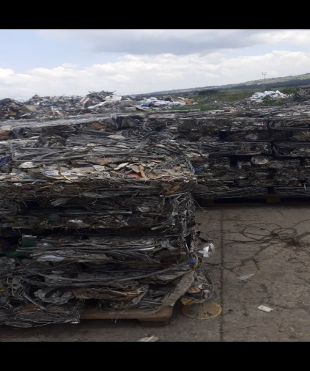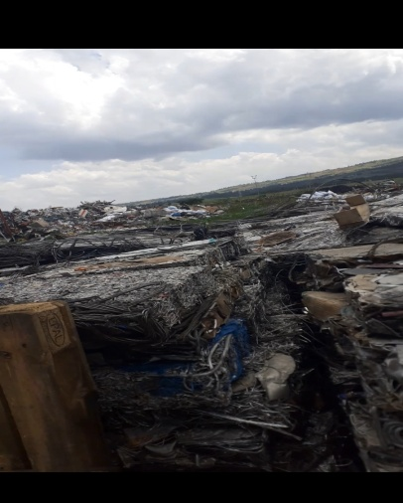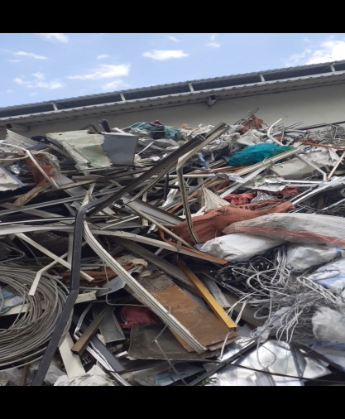
The figure shows prepared aluminium scraps for electrical conductor production at the Bmet cable industry in Ethiopia.

Pre-melt treatment
Physical separation technologies can be applied to a wide range of scrap streams; they are typically used for scraps that have been shredded. Most automotive scraps, for example, go through some shredding process scrap (Gabrielle Gaustada, 2011).

Magnetic separation
Magnetic separation is used to separate aluminium scrap from ferrous metal components. Typically, a conveyor belt with scrap materials is fed near another belt equipped with NdFeB magnets. As the scrap nears this magnet, the ferromagnetic portion is attracted to the magnet and pulled onto the second conveyor belt. In contrast, the nonferrous scrap component falls into the collection bin. This technology is used only to separate aluminium scrap from magnetic materials inclusion but not other impurities such as plastics, glass, rubber, etc.
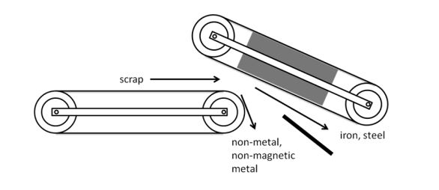
Magnetic separation (Timelli, 2018)

Air separation
Technologies using air to separate scrap streams are known by many names: wind fitting, air knives, elutriation, wind, air columns, etc. Their differing names refer to the slightly different mechanisms by which they work. Conveyor belt systems often use suction to pull off lightweight materials in shredded scraps such as plastic, rubber, and foam. In a vertical air separation system, the recycled material system is fed through a column with air pushing upwards; the heavy metals are collected at the bottom, and other materials are pushed through various feeds further up. (Gabrielle Gaustada, 2011)

Eddy current separation
This separation is based on inducing eddy currents in metals and was initially developed to sort aluminium household wastes. Following the Faraday law, a time-variable magnetic field generates electromotive forces perpendicular to the magnetic field. The induced electromotive forces generate current if the magnetic field is within a conductive material. (Timelli, 2018) The magnetic field can be controlled with the speed of the rotor. The eddy current (i) generated in a scrap metal can be given by
i=$\frac{\left(k*ν*B\right)*σ*A}{L}$
A is the cross-sectional area, L is thickness, σ is conductivity, B is magnetic field flux density, ν is the oscillation frequency, and (k*ν*B) is the potential difference across a scrap fragment (Gabrielle Gaustada, 2011). An electromagnetic system is another recent application of eddy current that improves the separation process between nonferrous metals.
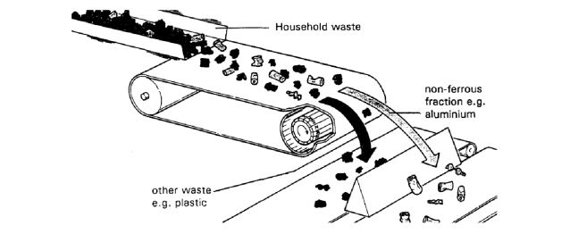
Conveyor-type eddy-current separator (Timelli, 2018).
The extension of this technology takes advantage of the fact that metals with varying conductivity will produce varying eddy currents and be thrown at different distances.
Elements | Electrical conductivity (x10^⁶Ωcm)⁻¹ | Elements | Electrical conductivity (x10^⁶Ωcm)⁻¹
Al  Mn  Sb  Pb  Cr  Fe  Ni | 0.670  0.006  0.028  0.048  0.077  0.093  0.143 | Fe  Zn  Mg  Cu  Ag | 0.093  0.166  0.226  0.596  0.630
Electrical conductivity (x10^⁶Ωcm)⁻¹
Table electrical conductivity of several metals (Gabrielle Gaustada, 2011).

Material | Density (Kg/dm³)
Aluminum  Lead  Copper  Stainless steel  Brass and bronze.  Zinc  Magnesium  Polyvinyl chloride  Polystyrene  Polypropylene  Rubber  Wood  Polymeric foam | 2.6-2.9  10.7-11.3  7.5-9.0  7.5-7.7  5.0-7.0  5.2-7.2  1.7-1.9  1.4  1.0-1.1  0.9  0.8-0.9  0.4-0.8  0.01-0.6

Table densities of aluminium and contaminated materials (Gabrielle Gaustada, 2011; Timelli, 2018)

Heavy media separation
Heavy media separation uses water-based slurries with known specific gravity to separate nonferrous materials with differing densities. A water bath with a specific gravity equal to 1 separates the non-metallic fraction. The particular gravity then increased through the addition of magnetite or ferrosilicon powder. Thus, one specific gravity bath equal to 2.5 separates magnesium and higher-density plastics. Then, the third bath with a specific gravity of 3.5 can separate casting and wrought aluminium alloys, leaving behind heavier metals such as copper, lead, and zinc (Timelli, 2018).
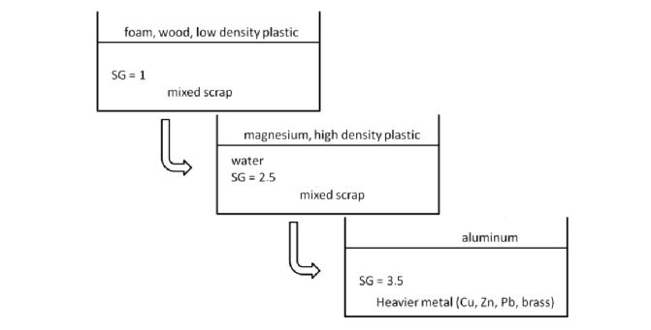
The three steps of sink float technology with different specific gravities (SG) (Timelli, 2018)
Hand sorting
Hand sorting can distinguish aluminium from other materials, such as copper and zinc, but it is still a challenge to differentiate between different aluminium alloys. (Timelli, 2018)

Colour sorting.
Colour sorting takes advantage of the colour difference between scraps to separate zinc, copper, brass, and stainless steel from aluminium. The most basic application of colour sorting is when metals are sorted by hand, a prevalent practice in countries with low labour costs. This colour sorting can also occur through an automated process. A computer analyzes images of each scrap and, based on specified colour ranges, directs them to different feeds. (Gabrielle Gaustada, 2011)

Hot crush
Hot crush is the thermal-mechanical separation of wrought and cast aluminium alloys that takes advantage of the difference between the solidus temperature. Because the cast alloys have lower melting temperatures than the wrought alloys, holding or soaking the mixed scrap at a temperature below the eutectic (~550℃) will weaken the casting along their grain boundaries. A subsequent mechanical crushing or grinding causes those alloys to break, and they can separate from the wrought with various particle size screening processes (Gabrielle Gaustada, 2011). This method is currently one of a few ways to successfully separate aluminum scraps in the industry.

