PERFORMANCE IMPROVEMENT OF SOLAR PV CELLS USING PHASE CHANGE MATERIA

ABSTRACT

Solar energy is utilized for producing electricity through photo-voltaic cells. When the solar radiation falls on the surface of the Photo-Voltaic (PV) cells, they absorb up to 80% of the incident radiation. However, very few percent of the energy from this absorbed radiation is converted into electricity owing to the low conversion efficiency of the Photo-Voltaic cells. The operating temperature of solar panel reaches very high in hot climates. To lower the operating temperature of solar panel, one can either improve the cooling of the panel using free and forced convection, known as Active Cooling, or using the absorption of the excess heat by modifying the architecture of panels, known as Passive Cooling. The passive cooling includes the use of Phase Change Materials (PCM) located on the back of solar panels.
The main objective of this work is to study the various aspects affecting the temperature rise in Photo-Voltaic (PV) cell and to make use of heat-absorbing materials like Phase Change Material (PCM) to decrease the operating temperature of PV cell and to increase its electric efficiency. The simulation is performed in ANSYS Fluent 19.2 by using different systems such as PV/PCM, PV/T-PCM (‘T’ represents Thermal) and its results are studied. The Solar panel is placed at an inclination of 25⁰ to the horizontal surface and annual average data of solar flux, ambient temperature and wind speed at the Durgapur location has been taken from the Photovoltaic Geographical Information System (PVGIS)-solar website. The time step of 0.1 seconds is taken Semi Implicit Method for Pressure Linked Equations (SIMPLE) algorithm and Pressure Staggering Operation (PRESTO) methods are adopted to solve the model.
The results show that the temperature reached for only PV system after 2 hours is 118.23⁰C
This is reduced by 15.60⁰C and 30.97⁰C after the addition of PV/PCM and PV/T-PCM systems respectively. The melting fraction obtained for only PCM is 0.93 and after the addition of PV/PCM and PV/T-PCM it has been reduced to 0.83 and 0.78 respectively. Though the difference between the melting fraction of PV/PCM and PV/T-PCM is relatively less but there is a drastic decrease in temperature of the PV cell due to addition of Natural Convection. The efficiency of the only PV cell is 6.65% and it is increased to 8.59% and 10.23% after the addition of PV/PCM and PV/T-PCM system respectively.
Keywords: Phase Change Material, Photo-Voltaic Cells, Natural Convection, Solar panel, Ansys Simulation.

TABLE OF CONTENTS

CERTIFICATE OF RECOMMENDATION ii
CERTIFICATE OF APPROVAL iii
DECLARATION iv
ACKNOWLEDGEMENT v
ABSTRACT vi
LIST OF FIGURES viii
LIST OF TABLES ix
NOMENCLATURE x
SCOPE OF STUDY xi
1. INTRODUCTION 1
1.1. Introductory Remarks 1
1.2. Photo –Voltaic (PV) Cells 2
1.3. Phase Change Materials (PCM) 4
1.3.1. Definition of PCM 4
1.3.2. Applications of PCM 6
2. LITERATURE REVIEW 7
3. MODELLING & METHODOLOGY 12
3.1. Modelling 12
3.1.1. Geometry Model 12
3.1.2. Software 13
3.1.3. Numerical Model 13
3.2. Methodology 15
3.2.1. Governing equations 16
3.2.2. Boundary Conditions 18
3.2.3. Mesh Generation 19
3.2.4. Grid Independence Test 20
3.2.5. Solution Procedure for Simulation of numerical model 24
4. RESULTS & DISCUSSION 26
4.1. Introductory Remarks 26
4.2. Validation 26
4.2.1. Solar Panel 26
4.2.2. Phase Change Material (PCM) 27
4.3. Results and Discussions 31
4.3.1. Simulation of PCM 32
4.3.2. Simulation of PV/PCM system 34
4.3.3. Simulation of PV/T-PCM system 35
4.3.4. Comparison of Results 37
5. CONCLUSIONS & SCOPE OF FUTURE WORK 41
5.1. Conclusions 41
5.2. Scope for Future Work 41
6. REFERENCES 43

LIST OF FIGURES

Figure 1 Schematic Diagram of Natural convection through PV/T-PCM 2
Figure 2 Classification of PCM 5
Figure 3 Graph showing various PCMs with different properties [2] 6
Figure 4 Effect of Panel temperature on its efficiency [3] 7
Figure 5 Temperature Profile in PCM Domain Using the Two Approaches [4] 8
Figure 6 I-V and P-V characteristics at the constant illumination when the temperature changes [6] 9
Figure 7 Exploded view of Assembled Solar Panel 12
Figure 8 Meshing of assembled Solar panel 20
Figure 9 Grid Independence test results for air velocity 21
Figure 10 Grid Independence test results for outlet air temperature 22
Figure 11 Grid Independence Results for Average temperature of PCM 23
Figure 12 Grid Independence Results for Liquid Fraction of PCM 24
Figure 13 Temperature distribution of Solar panel model after 3600 seconds 26
Figure 14 Temperature contour of Solar Panel after 3600sec using Transient Thermal condition 27
Figure 15 Comparison of PCM melting between Vikas et al and Present Results 31
Figure 16 Temperature contour of Solar PV cell after 7200 seconds 32
Figure 17 Liquid fraction Contour of Only PCM after 2 hours (3 Dimensional) 33
Figure 18 Liquid fraction Contour of Only PCM after 2 hours (Planar view) 33
Figure 19 Liquid fraction contour of PCM in PV/PCM system after 2 hours 35
Figure 20 Temperature contours of PV and PCM in PV/PCM system after 2 hours 35
Figure 21 Liquid fraction contour of PCM in PV/T-PCM system after 2 hours 36
Figure 22 Temperature contour of PV and PCM in PV/T-PCM system 37
Figure 23 Temperature variation of PV Cell with time in different systems 37
Figure 24 Liquid Fraction variation of PCM with Time in different systems 38
Figure 25 Variation of PV cell Efficiency with time in different systems 39
Figure 26 Maximum Air outlet temperature 40

LIST OF TABLES

Table 1 Components of Solar Panel 13
Table 2 Thermo-Physical properties of Rubitherm-35HC (RT35HC) 15
Table 3 Grid Independence test results for Natural Convection 21
Table 4 Grid Independence Test Results for PCM melting 23
Table 5 Thermo-physical properties of Paraffin Wax [23] 28
Table 6 Liquid Fraction Contours 30
Table 7 Validation results for melting of PCM 30
Table 8 Variation in temperature of Solar PV cell with time 32
Table 9 Variation in liquid fraction of PCM with time 33
Table 10 Results for simulation of PV/PCM system 34
Table 11 Results for simulation of PV/T-PCM 36

NOMENCLATURE

P_{op} – Operating pressure (Pa)
M_{w} – Molecular weight of gas (kg/kmol)
R – Universal gas constant (J mol⁻¹K⁻¹)
T – Temperature (K)
T₀ – Operating temperature (K)
$v_{l}$ – Volume liquid fraction
K – Thermal Conductivity (W/m-K)
C_{p} – specific heat (KJ/kg-K)
$h_{f}$ – Latent heat of liquid (KJ/kg)
T_{s} – Solidus temperature (K)
T_{l}, T_{f} – Liquidus temperature (K)
$h_{0}$ – Enthalpy at operating temperature (KJ/kg)
$T_{∞}$ - Ambient temperature (K)
$g$ – Gravitational constant (m²/s)
$k_{se}$ – Effective thermal conductivity of solid (W/m-K)
$k_{fe}$ – Effective thermal conductivity of the fluid (W/m-K)
$u_{0}$ – Inlet velocity (m/s)
$q"$ – Heat flux (W/m²)
$a$ – Absorption coefficient of gas
$n$ – Refractive index of gas
$r$ – Cartesian coordinate in space (x, y, z)
$s$ – Unit vector in the direction of beam
$T_{pv}$ – PV cell temperature (K)
$T_{ref}$ – Reference temperature of PV panel (K)
Greek Symbols
$μ$ – Viscosity (kg/ms)
$ρ$ – Density (kg/m³)
$ρ_{0}$ – Constant density (kg/m³)
$β$ – Thermal Expansion Co-efficient (K⁻¹)
$α_{a}$ – Specific surface area (m²)
$β_{ref}$ –Thermal Expansion coefficient at reference temperature (K⁻¹)
$η_{pv}$ – Electric efficiency of PV panel
$σ$ – Stefan Botlzman Constant (W/m²K⁴)
$σ_{s}$ – Scattering coefficient of gas
$η_{ref}$ – Electric efficiency of PV panel at a reference condition
Abbreviations
PCM – Phase Change Material
PV – Photo-Voltaic
PV/T – Photo-Voltaic and Thermal
PVGIS –Photovoltaic Geographical Information System
SIMPLE – Semi Implicit Method for Pressure Linked Equations
DO – Discrete Ordinates
PRESTO – Pressure Staggering Operation
RTE – Radiative Transport equation

SCOPE OF STUDY

The research is carried to find the various factors that affect the performance of the Solar PV Cell and the losses that are inculcated due to the rise in temperature of Solar PV Cell. The study projects the use of “Phase Change Materials (PCM)” to absorb the heat of PV cell and to keep its maximum operating temperature to a minimum and to further decrease it Natural Convection is introduced through air passage which flows over the Solar Panel. During the simulation, various factors such as geographical location, the tilting angle of solar panel, PCM flow buoyancy effect, liquefaction factor, thermal stratification, Discrete Ordinates (DO) Radiation model, thermo-physical properties of PCM are considered. This research is a step towards increasing the efficiency of Solar PV cell by using PCM.

The research would provide the necessary details about the simulation of PV cell embedded with PCM and also introducing Natural convection to increase the heat transfer efficiency of Solar PV cell and the output results of liquid fraction and temperatures are compared to conclude which model works effectively.

INTRODUCTION

Introductory Remarks
There is a rapid increase in the energy demands due to the advancements of scientific technologies due to this global warming is also becoming a serious issue in the world. The solution for this problem is to increase the efficiency of energy production and to utilise the maximum amount of renewable energy. The decline in the cost of Solar PV modules is leading to the competition of energy production by using conventional energy techniques of solar cells. Electricity can be generated either with Solar radiation by using Photo-Voltaic cells or from thermal energy by converting heat into electricity. When the incoming solar radiation falls on the surface of the Solar cells it absorbs about 80% of the incident radiation. However, a very small amount of energy is absorbed from this incident radiation leading to the low efficiency of the Photo-Voltaic cells which is about 15-20% under standard testing conditions. For every kelvin degree rise in operating temperature of the solar cells, there is an efficiency drop of 0.4% to 0.5% of solar cells. The rest of the absorbed heat increases the operating temperature of the solar cells so this heat has to be removed to increase the efficiency of the Solar PV cells. Basically, two types of cooling techniques are adapted Active Cooling and Passive Cooling. In Active Cooling external device has to be used such as a pump to pump the water through channels in water cooling systems or a blower/fan to blow the air over the solar panel to remove heat in the form of forced convection this type of cooling causes the difficulties when used in water-scarce areas (deserts) and it also increases the operating costs. In Passive Cooling systems, no external power is supplied for cooling instead modifications are made in the architecture of the solar panel such as attaching fins to the panel to increase the heat dissipation or adding the air vent to decrease the maximum temperature of Solar cells or attaching the heat-absorbing materials such as PCM to the backside of Solar cells to absorb the heat.
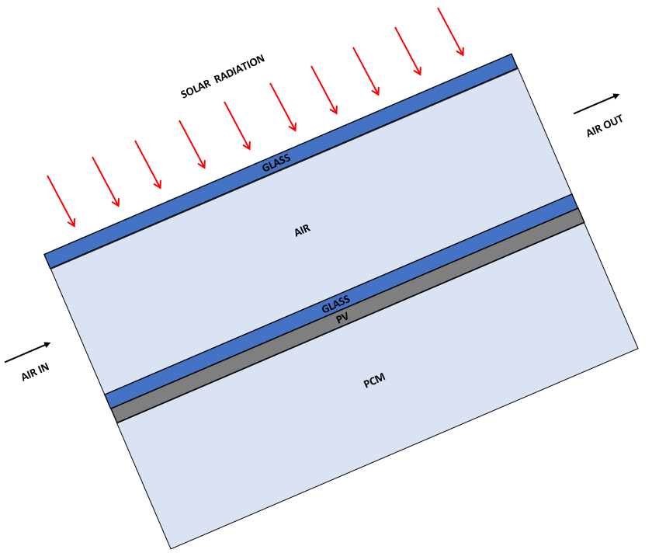
Figure 1 Schematic Diagram of Natural convection through PV/T-PCM
In this study cooling of PV cell by using Phase change Material is simulated for 2 hours the Solar panel is placed in optimum inclination of 25⁰ to the horizontal as per the geographical location of Durgapur, India. Two different configurations are used for this experiment in the first combination PCM is attached to the backside of the PV cell which is represented as PV/PCM and in the second combination additional to PCM air passage is also introduced to remove the heat by natural convection represented as PV/T-PCM. RUBUTHERM 35-HC is selected as PCM and the effects of conventional currents on melting rate are studied. The variation in operating temperatures and the change of PV efficiency is studied for both the systems and results are compared to check the effectiveness of systems.

Photo –Voltaic (PV) Cells
The conversion of solar energy into electrical energy has become an important source of energy due to its abundant availability almost all around the earth and solar energy is now a part of satellite and space-travel technology by using the advantage of the quantum nature of sunlight. This technology exploits the bandgap of semi-conductor materials to produce electrons and conduct them in a favoured direction using a p-n junction. The most important advantage of the Solar panels is that they can be made individually in different sizes as per our requirement and are made available in many power outputs and they do not have any physical moving parts.

The working principle of solar cell is the generation of electricity on exposure to sunlight is called the Photo-Voltaic effect. Solar cells are made up of semi-conductors mainly silicon and comprise three layers the top called n-type is comparatively thin and contains a high concentration of electrons the bottom layer called the p-type layer contains a high concentration of holes. When p-type and n-type semi-conductors are joined it forms a p-n junction. On forming a p-n junction the electrons of the n-type material try to reach the p region creating the negatively charged layer similarly the holes of the p-type material try to reach the n region creating the positively charged layer this region between the two layers is known as the depletion region of the semi-conductor, sunlight penetrates the top thin layer easily to reach the depletion region due to the deficiency of the charge in the depletion region it contains the neutral atoms these neutral atoms are broken when the photons from the sunlight strike the depletion layer this knocks the electron from the neutral atoms leaving behind the holes and producing the free charge carriers. If the energy of a photon is less than the bandgap the electron may not excite and this increases the kinetic energy of electron which leads to an increase in temperature then the electrons move towards the n-type layer and the holes move towards the p-type layer due to the electric field present in the depletion region on connecting an electronic circuit the electrons flow through it generating electricity. There are many silicon cells inside the solar panel which all together generate the electricity which is sufficient for providing the electricity to a residential home or by using more number of Solar panels together a Solar Power Plant can also be set up. A characteristic residential solar panel will have 60 cells linked together which may produce 220 to 400 watts of power and a commercial panel will have 72 cells linked together.

Two major types of solar cells are used for residential and commercial applications, based on the type of silicon crystal used for manufacturing namely Monocrystalline and Polycrystalline which are most common. There are other ways of making cells like thin-film cells, organic cells, dye-sensitized solar cells, polymer cells. A Monocrystalline solar cell is built from a single crystal of silicon whereas a polycrystalline solar cell is built by melting many fragments of silicon crystals collectively. In terms of efficiency, Monocrystalline PV cells are generally more efficient. The reason for this is being usage of a single, aligned crystal of silicon, ensuing in easier movement of electrons. Polycrystalline solar cells have many fragments of silicon aligned in different directions which makes it difficult for the movement of electrons. However, solar cells built from polycrystalline silicon are less expensive as they involve simple and fewer specialized manufacturing processes.

A few other reasons for the lower efficiency of solar cells, apart from an increase in temperature are a superficial reflection of light from the solar panel, the cell being in the shadow of current collecting electric contacts, the internal resistance of the silicon cell. Superficial reflection of light from the solar panel can be minimised by Anti-Reflection coatings which can lessen the reflection from a cell to 3% from over 30% from an unprotected cell. The shading effect of the Cells can be decreased by reducing the area of electric contacts or by manufacturing them transparently.

Phase Change Materials (PCM)
When there is inequality between the energy demand and energy availability storing the energy in some forms becomes very important. The applications which use especially solar energy need some device to store the energy because the supply of solar energy is periodic and not available at all the time. Natural solar energy storage by biomass, oceans, hydro-potential at high altitudes by evaporation from water bodies and the following condensation offers long term buffer between supply and demand. Availability of solar energy depends on the time of the day, the season of the year and also obstruction of solar radiation due to cloudy days. Applications like solar water heating, space cooling and heating, thermal walls etc. need a large amount of thermal energy to be stored. Thermal energy is generally stored in the form of sensible heat, latent heat or chemical reaction.

Definition of PCM
Phase Change Material (PCM) is a substance that is capable of storing and releasing large amounts of thermal energy due to its high heat of fusion. PCM stores energy in the form of latent heat thermal energy. They occur in 3 states of matter and in four different processes as solid to vapour, vapour to liquid, solid to liquid and solid to solid of all these processes solid to liquid and vice versa is mostly used for various applications because it is very difficult to store the energy in the vapour form due to low specific heat capacity and also requires a huge space to store as the density of the gas is very less compared to solid and liquid. Latent heat phase transformation is an isothermal process in which heat is absorbed at a constant temperature (transition temperature). Some of the phase change materials that are commonly used for latent heat thermal energy storage are paraffin waxes and non-paraffins of organic type, inorganic salts, and eutectics of organic and inorganic compounds. Solid to liquid phase transforming PCMs are mainly classified as organic, inorganic and eutectic PCMs.
Figure 2 Classification of PCM
PCMs used in the application for the storage of solar energy uses solid to liquid transformation. For the effective performance of the PCM, it has to be selected based on certain characteristics.
- Melting point suitable for a particular application
- High thermal conductivity in both solid and liquid phases
- High specific heat
- Non-Corrosiveness
- Non – toxic, Chemical stability
- Non-poisonous, non-flammable, non-polluting and non-explosive
- Inexpensive, Easily available etc.,

The most commonly used PCMs under inorganic classification are hydrated salts. They have high latent heat storage capacity, non-flammable with an undercooling problem during phase change being the main disadvantage which leads to irreversible transitional phase. They are available at lower prices. Paraffins, carbohydrates, fatty acids, fatty alcohols come under organic PCMs. Their advantages are recyclability, melting consistently, high heat of melting and freezing without ample undercooling than inorganic PCMs. Their disadvantages are lower solid-state thermal conductivity and higher prices. Eutectic PCM is a mixture of pure compounds with a volumetric storage density higher than that of organic substances. As they are new in the field of energy storage applications, the data of their thermo-physical properties are limited.
Figure 3 Graph showing various PCMs with different properties [2]

Applications of PCM
The application that requires a high amount of thermal heat storage use PCM as its prominent substance. The high latent heat capacity of the PCM has a prominent role in eradicating the problem of fluctuating supply of energy while using renewable energy sources and many kinds of research are also being conducted for using PCM in various applications. The ability of the material to store high latent heat has made it easy to use on various other conventional methods which work on the principle of energy storage. Based on a similar idea with a stress on performance, cost and reliability, researchers started including PCMs in concentrated solar power applications.

The PCMs are used in a wide variety of applications such as thermal storage in solar power plants waste heat recovery systems such as solar water heaters, thermo-regulating fibres, space cooling and heating systems. It is also being used in the walls of houses where they absorb the heat during the daytime and release the heat during the night to keep the house warm in cold seasons. They are also used in the transport sector such as in the transport of food, medicines etc. in automobiles they are used in exhaust gas heat recovery and in controlling emissions of the IC engines. PCMs are also used in electronic devices to decrease the maximum operating temperature of the devices, thermal management of the Solar PV Cell, thermal energy storage applications in the space industry.

Various PCMs are testified for bio-medical practices such as micro-encapsulated PCMs for transport and storage of medicines and for the thermal shielding of tissue neighbouring tumours at the time of cryosurgery.

LITERATURE REVIEW
S.Verma et al. has discussed various methods for cooling of the Solar PV Cell concentrating mainly on two reasons that are to enhance the working efficiency of the Solar PV Cell and to increase the life span of the Solar cell. The cooling methods that are briefly discussed in this study are Heat sink, heat pipe, PCM material based, micro channel, thermoelectric (Peltier).

T. Kozak et al. studied the influence of the ambient air on the efficiency of the Solar PV Cell though there are many other methods to cool the Solar PV Cell they require some initial cost or operation costs for working so they investigated the ambient air and from below Figure 4 we can observe that as the temperature of the solar panel is increasing its efficiency is decreasing which gives the inverse proportion relation between Solar panel temperature and Solar Cell Efficiency which helps us in our research further.
Figure 4 Effect of Panel temperature on its efficiency [3]

Sellami.A et al. has modelled a heat transfer in a PCM and studied the performance of two approaches in the first approach they have considered the conduction mode of heat transfer and in the second approach additional to conduction they also considered the natural convection mode of heat transferred which has occurred during the melting of the PCM. From figure.5 below, we can see that the second approach gives a good result which also includes the heat transfer using natural convection.

The equation for Phase transition governed by the conduction mode of heat transfer:
$ρc_{p_{app}}\left(T\right)\frac{∂T}{∂t}=\frac{∂}{∂x}k\left(T\right)\frac{∂T}{∂x}$ (2.1)

The equation for Phase transition governed by both conduction and flow velocity:
$ρCp\frac{∂T}{∂t}+∇⋅\left(-k∇T\right)+ρCp\vec{u}⋅∇T=0$ (2.2)
In Equation: the third term on the left-hand side resembles the heat transfer due to flow velocity.
Figure 5 Temperature Profile in PCM Domain Using the Two Approaches [4]
H. Liu et al. has developed a model of metal honeycomb structure which is sandwiched between the fluids and then performed the numerical simulation to prove that honeycomb structure can be used to enhance the heat transfer efficiency.
Governing Equation for Solid matrix:
$k_{se}\frac{∂^{2}T_{s}}{∂y^{2}}-hα_{a}\left(T_{s}-T_{f}\right)=0$ (2.3)
Governing Equation for Fluid phases:
$k_{fe}\frac{∂^{2}T_{f}}{∂y^{2}}+hα_{a}\left(T_{s}-T_{f}\right)=ρ_{f}c_{p}u_{0}\frac{∂T_{f}}{∂x}$ (2.4)

Furkan Dincer et al. studied the different factors that are affecting the efficiency of solar cells such as Cell Temperature, Energy Conversion Efficiency and Maximum power point tracking. From figure 6. We can observe that up to a certain limit the power output is increasing along with the increase in temperature and on further increase in temperature power output drops steeply.
Figure 6 I-V and P-V characteristics at the constant illumination when the temperature changes [6]
Mittleman et al. conducted a scaling and numerical analysis of combined convection and radiation heat transfer in inclined 2D channels with uneven heating and for their application in thermal management of rooftop PV panels. Based on the experiment performed it is said that the cooling rate increases monotonically with an increase in channel spacing.

Huang et al. conducted both experimental and numerical simulations on PV-PCM system with and without internal fins and found that fins enabled a more uniform distribution of temperature in the system. The fins have reduced the movement of the molten PCM which occurred due to the natural convection.

Ma et al. made a comparison between the CFD model and 1D thermal resistance model of a PV-PCM system with RT35HC as PCM and conducted a sensitivity analysis by a two-variable analysis from which it is recommended that phase change temperature of PCM to be 5K higher than ambient.

Akshayveer et al. has experimented investigating the drop in maximum temperature of the Solar PV cell after introducing the air duct between the glass and the solar panel there is a drop of 35% in the maximum temperature of the solar PV Cell.

W.Z. Leow et al. has conducted an experimental simulation by using ANSYS software and observed the performance of the solar panel assembly by using different air velocities and observed as we keep on increasing the air velocity the maximum temperature of the solar panel decreases simultaneously.

Babak Kamkari et al. has modelled a PCM rectangular enclosure and studied that the natural convections due to an inclination of Solar Panel affects melting time and heat transfer rate of the PCM heat transfer for the horizontal enclosure id more than that of the vertical enclosure.

Stefano.A et al. has modelled a 2D heat transfer through PCM using the Ansys Fluent software and results show that better performance is achieved when compared to heat transfer without PCM it is observed that the peak power has been increased up to 9%.

Jiaxin Zhao et al. have modelled the PCM integrated into the Solar Panel and simulated. The result indicates that the temperature of the Solar panel has reduced by up to 24.9⁰C and the heat transfer rate between PCM and Solar Cell due to natural convection is 4 to 5 times more as compared to conduction.

Ilya et al. have experimented on the modelled battery pack whose side walls are fixed with the Phase Change Material (PCM) and the results show that for longer cycles and medium cycles the drop in the peak temperature is 4⁰C and 13⁰C respectively. The study also suggests that the thermal conductivity of the PCM can also be enhanced by using thermally conductive structures.
Objectives of the Thesis
By the study of the literature review, it has been observed that most of the research related to the cooling of Solar PV cells is carried either by using different types of PCMs, enhancing thermal conductivity of the PCM by using Nano-particles or by using some external sources (passive cooling) such as fans, water pumps etc. but study done on cooling the Solar PV Cell by modifying the architecture of the solar panel along with the use of PCM is limited. The present work is aimed to bridge the aforesaid gaps. The objectives of the work are as follows:
- Experimental simulation investigation of heat transfer from a PV panel in the tropical wet and dry climate of Durgapur, West Bengal, India.
- Evaluation of operating temperatures of PV cells in different cases of an only PV cell, PV/PCM, Air PV/T-PCM.
- To see the effect of real-time atmospheric conditions like Solar flux, ambient temperature, wind velocity and inclination of the Solar panel.
- To explore the advantages and disadvantages over one another between different types of architecture of the Solar panel.
- To include the effects of both convection and radiation from the top surface of the PV panel.
- To use Discrete Ordinates Radiation model for air passage due to natural convection.
- To compare the operating temperatures recorded in different configurations with the same PCMs and determine which configuration gives the maximum reduction in the operating temperature.

MODELLING & METHODOLOGY

Modelling

Geometry Model
The Solar Panel consists of Glass, EVA sheet, Solar PV Cell, EVA2 sheet, Tedlar sheet, Aluminium frame from top to bottom in chronological order as is viewed in the below Figure 7. All these components are 3D modelled by using the SOLIDWORKS 2018 software. It is CAD (Computer-Aided Design) software that is used to produce various designs and models in both 2D and 3D. The individually designed components are then assembled to form a solar panel. Following which the Solar panel model is saved in “x_t* (Parasolid)” format and it is imported in ANSYS FLUENT SOFTWARE. The Solar panel is designed to maintain the standards that are readily available in the market.
Specifications of the Solar PV Cell:
- Polycrystalline Cells type Panel(32 Cells)
- Capacity - 40 W, 12V
- Voltage: Voltage at Max Power (V_{max}) - 18V, Open Circuit Voltage (V_{oc}) - 22V
- Current: Current at Max Power (I_{max}) - 2.23A, Short Circuit Current (I_{sc}) - 2.42A
- Dimensions (mm): 668*449(L*B)
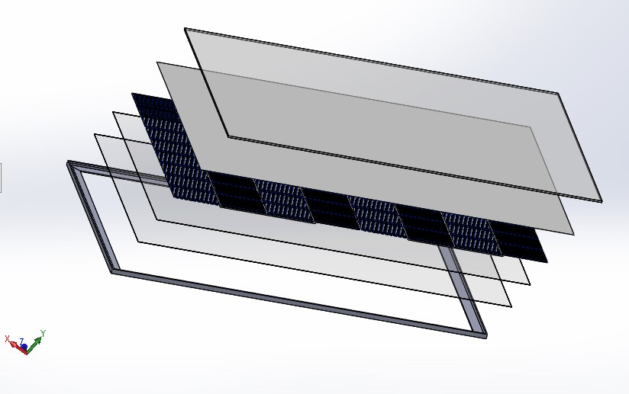
Figure 7 Exploded view of Assembled Solar Panel

The thermo-physical properties of each layer in the Solar panel are mentioned in the below:
S. No | Components | Thickness (cm) | Thermal Conductivity (W/m-K) | Specific heat Capacity  (J/Kg-K) | Density (Kg/m³)
1 | Glass | 0.3 | 1.8 | 500 | 3000
2 | EVA (Ethylene Vinyl Acetene) | 0.05 | 0.35 | 2090 | 960
3 | Solar Cell | 0.04 | 148 | 677 | 2330
4 | EVA2 (Ethylene Vinyl Acetene) | 0.05 | 0.35 | 2090 | 960
5 | Tedlar | 0.01 | 0.2 | 1250 | 1200
6 | Aluminium Frame | 0.2 | 204 | 996 | 2707
Table 1 Components of Solar Panel
EVA (Ethylene-Vinyl Acetene): This material has the property of good radiation transmission and low degradability to sunlight. It is made of thermoplastic polymer and is used as an encapsulating agent when heat is applied to a solar panel it acts as an insulating film around the PV cells.
Tedlar: It is the very last layer of the Solar panel and is made of polymers or a combination of polymers it also acts as an insulating layer to protect the Solar panel from Hazardous DC Voltage.

Software
ANSYS FLUENT 19.2 is used for the study of Transient temperature distribution in Solar panel and also the Melting and Solidification of PCM. ANSYS is a CFD tool widely employed by various engineers and researchers for design and analysing the performance of the model by which the cost of prototype and repeated modification of design time reduces. It can also work integrated with other CAD and FEA software such as (Solid works, Catia, Creo etc., ) by importing the models that are designed in those modules and solve them. It also has a designing module and the 2D models which are used for calculating the melting time of the PCM are designed in the ANSYS Design Modeller.
ANSYS Transient Thermal software is used for simulations where the temperature of the model is tending to vary with time as in the case of Solar panel. It gives us the flexibility of getting the values of temperature, convection, heat flux etc. at the required time step and location.

Numerical Model
The Solar panel model is created to study the distribution of temperature in PV cells when PCM is attached to it and also including the natural convection of air by which the radiation passes through the air before reaching the PV cell. The solar panel is inclined at 25⁰ to the horizontal surface facing towards the south direction as per the geographical location of Durgapur city, West Bengal (23.5204° N, 87.3119° E). The upper layer (glass) of the solar panel is induced with 900W/m² of solar radiation which is the average annual solar radiation of Durgapur. The weather data like ambient temperature, Solar irradiation, Inclination and direction of the Solar panel are taken from the PV-GIS database.

When Solar radiation is incident on the glass layer of panel some part of that radiation is converted into electric energy and the rest of the energy is absorbed by the PCM by conduction and convection through the PV panel the radiation and convection losses of the top layer are taken care by assigning heat transfer co-efficient.
$h={5.7+3.8v}_{∞}$ W/m²K 10 h = heat transfer co-efficient $v_{∞}$ = Wind velocity, m/s
Here as the surrounding air is assumed to be stagnant the wind velocity is assumed zero.

For the calculation of Melting and Solidification, a 2D model of 150mm*20mm is designed which is inclined to 25⁰ to the horizontal surface and Air passage also has a similar dimension of 150mm*20mm in ANSYS Modeller. ANSYS Fluent 19.2 uses the method of enthalpy balance which uses the enthalpy to calculate the liquid fraction (fraction of volume which is in liquid form) of the PCM. Based on the enthalpy balance liquid fraction is computed at each zone of cell and if a liquid fraction is between 0 and 1 that is called as Mushy Zone it also acts as the dividing wall between the solid and liquid zone. Mushy zone behaves like a porous medium whose porosity decreases from 1 to 0 when material solidifies and the velocity of that zone also becomes zero.
In Fluent setup pressure-based solver is selected along with Transient time and gravitational force and direction is given. To solve the model SIMPLE algorithm scheme is adopted in Ansys Fluent and for Spatial Discretization of pressure interpolation PRESTO is selected and the rest of the options in solver are kept default. The accurate solutions for the Transient models can be obtained by using the second-order implicit Transient formulation. Radiation heat transfer also has to be introduced in this simulation for which DISCRETE ORDINATE radiation model has been selected and remaining default values are unchanged it is suggested to use coupled method to get the solution converged quickly and for better results, Second-Order Upwind for Discrete ordinates is selected. To solve the model a time step of 0.1 seconds is selected and a maximum of 5 iterations per time step is taken.

Selection of the PCM is the most important factor to be considered while using the PCM in any kind of application because there are various types of PCM’s and they all have different thermo-physical properties and they operate under different temperature ranges so we have to choose them according to the operating environment of the application. The PCM selected during this simulation is RUBITHERM-35HC (RT35HC) it comes under the category of Paraffin types of PCM. The reason for selecting this material is that it has operating conditions that are close to solar panel and its specific heat capacity is also relatively high when compared to the other PCM’s in its group. Thermo-physical properties have been mentioned in below Table 2.
Property | Unit | Value
Solidus temperature | K | 307.65
Liquidus temperature | K | 309.15
Latent heat of fusion | KJ/kg | 220
Density (solid) | Kg/m³ | 830.90
Density (liquid) | Kg/m³ | 778.20
Volumetric thermal expansion coefﬁcient | 1/K | 8.65e-4
Speciﬁc heat capacity (solid) | KJ/Kg-K | 5.00
Speciﬁc heat capacity (liquid) | KJ/Kg-K | 2.10
Thermal conductivity (solid) | W/m-K | 0.65
Thermal conductivity (liquid) | W/m-K | 0.166
Dynamic viscosity (T=309.15 K) | mPa-s | 4.4
Linear viscosity coefﬁcient | 1/K | 0.021
Darcy constant | Kg/m²-s | 10¹⁰
Table 2 Thermo-Physical properties of Rubitherm-35HC (RT35HC)

Methodology
The Solar panel model consists of Glass, Air duct, Solar PV cells, PCM for the computational process. In the glass and solar PV cell conduction mode of heat transfer dominates whereas in PCM and the air both the conduction and the convection mode of heat transfer takes place. Since the PCM is attached to the Solar panel they both are equally inclined initially when PCM is in solid-state there is no convection but when it starts melting the liquid zone in PCM starts moving due to which convection heat transfer also takes place the Governing equations which are used in ANSYS Fluent for solving this model are discussed later in this section. Due to the solar radiation, there is a small amount of heat generation inside the Solar cells which is also responsible for the temperature rise of PV cell but it occurs at a microscopic level. To analyse the Solar panels considering the above reasons and real-time atmospheric conditions few assumptions are made into considerations which are as follows:
- Solar heat is evenly distributed on the Panel.
- PCM and Air are both incompressible and Newtonian fluids.
- No-slip condition at walls of PCM and Air duct.
- Laminar fluid flow.
- Viscous heating is not considered in the melted layer of PCM.
- No internal heat generation in PCM.
- No thermal resistance at the interface of the layers.
- The surface is assumed to be clean and clear.
- The Outlet pressure of air is equal to atmospheric pressure.
- Density, Thermal Conductivity and Specific heat capacity of PCM vary as piece-wise linear.

Governing equations
Mass Conservation Equation:
$\frac{∂\left(ρ\vec{u}\right)}{∂t}+∇⋅\left(ρ\vec{u}\right)=0$ (3.1)

Momentum Conservation Equation:
$\frac{∂\left(ρ\vec{u}\right)}{∂t}+∇⋅\left(ρ\vec{u}⋅∇\right)=∇⋅\left(μ∇\vec{u}\right)-∇P+S$ (3.2)

Where S is called the Source term which further consists of two terms Boussinesq term
[ $ρgβ\left(T-T_{0}\right)$] and Darcy term [$-\frac{C{\left(1-v_{l}\right)}^{2}}{v_{l}^{3}+ϵ}\vec{u}$] (3.3)

The Darcy term controls the transition of the solid phase to the liquid phase at the solid-liquid interface of the PCM. In the Darcy term, C represents the Mushy constant which is generally in the range of 10⁵-10⁸ the relation between the mushy constant and the viscosity of the fluid is inversely proportional which means for the low value of C solid face tends to acts as highly viscous fluid so in this experiment we are considering an approximation of C = 10⁶ is constant. To avoid the numerical error $" ϵ "$ constant is taken a very small value of 0.00001 as liquid fraction tends to zero initially. For the flow of air through the passage, Boussinesq approximation has been considered because in this model air density is the function of temperature Boussinesq approximation treats density as a constant in all the solved equations except for the buoyancy term in the momentum equation due to which the computational load reduces and there are very high chances that the solution gets converged quickly.

Boussinesq model approximation:
$\left(ρ-ρ_{0}\right)g \sim ρ_{0}β\left(T-T_{0}\right)g$ (3.4)
The criteria to use this model is the temperature difference should be low and satisfy
$β\left(T-T_{0}\right)≪1$ (3.5)
By using this approximation we can eliminate the value of constant density and it is only used in the Energy equation for Buoyancy term which is an important factor in the Natural Convection.
The air flowing through the duct is considered as an incompressible-ideal gas whose density varies with the change in temperature which is an important phenomenon in the process of Natural Convection.
$ρ=\frac{P_{op}}{\frac{R}{M_{ω}}T}$ (3.6)
The energy conservation equation that is solved for liquid PCM and air region is:
$\frac{∂\left(ρC_{p}T\right)}{∂t}+∇⋅\left(ρC_{p}\vec{u}T\right)=∇⋅\left(k∇T\right)-\frac{∂\left(ρv_{l}h_{f}\right)}{∂t}$ (3.7)
The second term on the right side represents the latent heat absorption during melting phase change and it is not valid for air since there is no phase change of air which makes the latent heat term to be zero (0). The term “C_{p}T” is also called total specific enthalpy. It is generally represented as ‘H’.
Total specific enthalpy = Sensible enthalpy + latent heat
$H=h_{0}+\int_{T_{0}}^{T}{CpⅆT}+v_{l}L$ (3.8)
The term in the above equation represents the latent heat of PCM in liquid form.
Where $v_{l}$ = 0 if T < T_{s} (Solid)
$v_{l}$ = 1 if T > T_{l} (Liquid)
$v_{l}= \frac{T - T_{s}}{T_{l }- T_{s}}$ if T_{s} > T > T_{l} (Mushy) 18,
Radiative Transport Equation
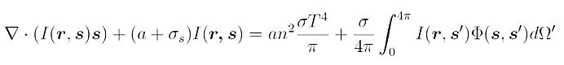(3.9)
The above equation is used as a Governing equation in the DO radiation model when we are solving the problems that also involve the heat transfer through radiation in gases. Radiation has to be considered when the temperature difference is large. Since the temperature difference between the glass and air in the passage is more in our experiment we have to consider the RTE equation.
The first and second term of the equation on the left-hand side indicates Rate of Change of Intensity (it highly depends on mesh size) and Absorption respectively. The first and second terms on the right-hand side of the RTE equation represents the Emission and Scattering of radiation.
Electric efficiency equation
The relation of electric efficiency of PV panel with temperature is given by Evans et al because the efficiency of the Solar PV cell depends on operating temperature. We are performing the study on PV Cell of Silicon type whose properties are $β_{ref}$ = 0.00392K⁻¹ and $η_{ref}$ = 0.124.
$η_{pv}=η_{ref} [1-β_{ref}(T_{pv}-T_{ref})]$ (3.10)
The transmissivity of glass ($τ_{glass}$) and absorptivity of PV panel ($α_{pv}$) are 0.95 and 0.9 according to CJ. Smith et al

Boundary Conditions
At time t = 0, T = $T_{∞}$
$T_{∞}$ = 300 K
Initially, the Solar panel and PCM is assumed to be at ambient temperature. On the topmost surface (glass) of the Solar panel constant Solar irradiation of 900W/m² is made to incident.
No-Slip condition – at the walls of Air duct and PCM
The sidewalls of PCM are considered to be adiabatic walls (q” = 0W/m²)
The top layer and bottom are open to the atmosphere so convection heat transfer is considered as $h={5.7+3.8v}_{∞}$ W/m², where the velocity of air becomes zero due to the assumption of stagnant-air condition.
The air inlet condition is stagnation inlet and the air outlet condition is stagnation outlet since at both interfaces air is at ambient condition.
To solve the PV/T-PCM air acts as a medium to transfer heat for which DO Radiation model with the coupled condition is used and other default values are kept constant.
The Solar panel has different layers and the resistance between the layers is neglected.
Between the interfaces of different layers in Solar panel heat transfer takes place through conduction but for Air and PCM both conduction and convection takes place. Mushy Constant (C) for Solidification and Melting model is taken as C = 1000000
For PCM Solidus temperature = 307 K
Liquidus temperature = 309 K
Viscosity = 0.0044 kg/m-s (constant)

Mesh Generation
ANSYS Fluent 19.2 uses the set of governing equations and solves the model numerically by using the Finite Volume Method. A different number of meshes is generated by changing the different parameters like no of edges and the calculations are used to evaluate the Grid independence test which is discussed later in the same section. The mesh generation for plane objects is relatively easy which can be done by using the face meshing in face meshing quadrilateral elements are formed but coming to the assembly meshing such as Solar panel it is difficult to generate the mesh because it has many contact points and surfaces which have to be taken care of for this meshing tools like Patch Confirming method, Edging, Refinement, Automatic method were made use to get the high-quality mesh in Patch confirmation method tetrahedrons mesh elements are formed which give good result but it also increases the computing time it is always necessary to check the quality of the mesh to get a better result. The solar panel assembly that we have modelled has 160882 nodes and 71987 elements.
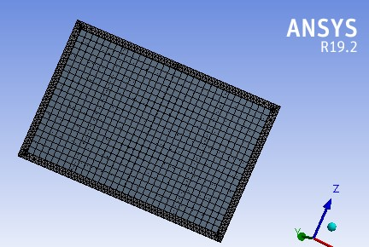
Figure 8 Meshing of assembled Solar panel

Grid Independence Test
It is important to evaluate the accuracy of the result while performing the CFD solutions because one cannot rely on the results obtained are accurate or not so we have to find out whether the solution depends on the grid or not and this can be done by using Grid independence test in which we vary the mesh sizes and check the output result for each type of mesh we get, the variation in the obtained solution is observed for the relative errors between two consecutive mesh types and the mesh type which gives less error within the acceptable limits it is considered as a good mesh for accurate results.

Natural Convection
In this test, we have considered an Air duct that is sandwiched between the two glass layers as in the Solar panel model and it is provided with an inlet and outlet and heat flux is applied on the top surface of the glass layer as per our experiment. Air inlet boundary condition is taken as stagnant air inlet as the flow is assumed to be laminar and for Air outlet, the boundary condition is pressure-outlet as it is at atmospheric pressure. Timestep of 0.1sec and a maximum of 5 iterations for time step is taken for accurate results. To study the Grid Independence test Air outlet temperature and Air outlet velocity are considered by varying the mesh in terms of a number of divisions in edge sizing as it has different layers (glass and air). Below Table 3 mentions the various output parameters of the simulation.

Name | Edge Sizing Number of Divisions | No of mesh nodes | No of mesh Elements | Air outlet temperature (K) | Air outlet velocity (m/s)
DP 0 | 100 | 4221 | 4000 | 335.6992 | 0.0021
DP 1 | 200 | 4221 | 4000 | 336.8171 | 0.0021
DP 2 | 300 | 6622 | 6300 | 336.8808 | 0.001997
DP 3 | 400 | 9504 | 9085 | 336.8569 | 0.001908
DP 4 | 500 | 12525 | 12000 | 336.9047 | 0.001859
DP 5 | 600 | 15626 | 15000 | 336.8952 | 0.001797
DP 6 | 700 | 18927 | 18200 | 336.9385 | 0.001743
DP 7 | 800 | 22400 | 21573 | 336.9822 | 0.001699
DP 8 | 900 | 26730 | 25810 | 336.9534 | 0.001658
DP 9 | 1000 | 31031 | 30000 | 336.9858 | 0.001622
DP 10 | 1100 | 34131 | 33000 | 336.9938 | 0.001587

Table 3 Grid Independence test results for Natural Convection

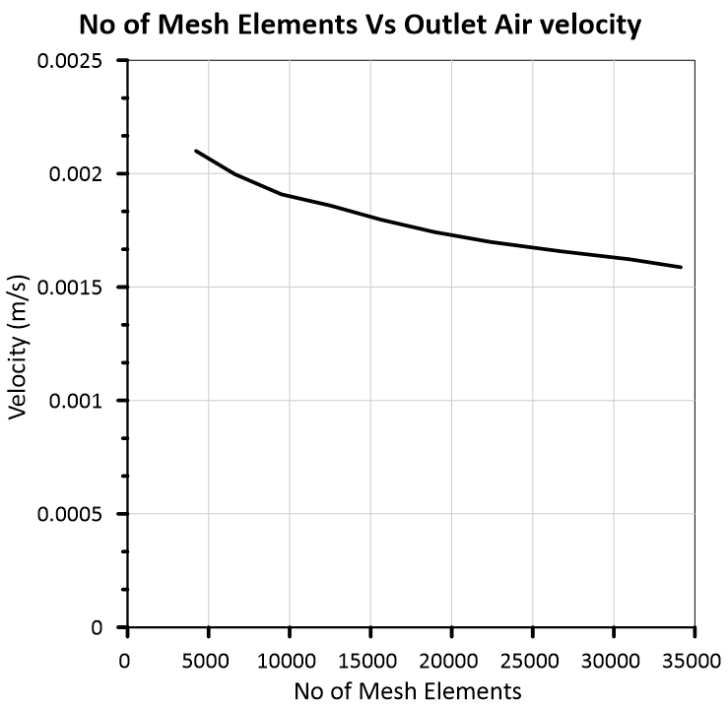
Figure 9 Grid Independence test results for air velocity
Figure 9 gives the relation between No of Mesh elements and outlet air velocity and we see that as the mesh elements increase the graph is getting linear by decreasing the error between two consecutive results and Relative error of 0.2% is observed from results which says increasing the number of mesh elements doesn’t give a noticeable error during simulations. So edge sizing divisions which are 1100 or above are considered as best mesh size for this model.
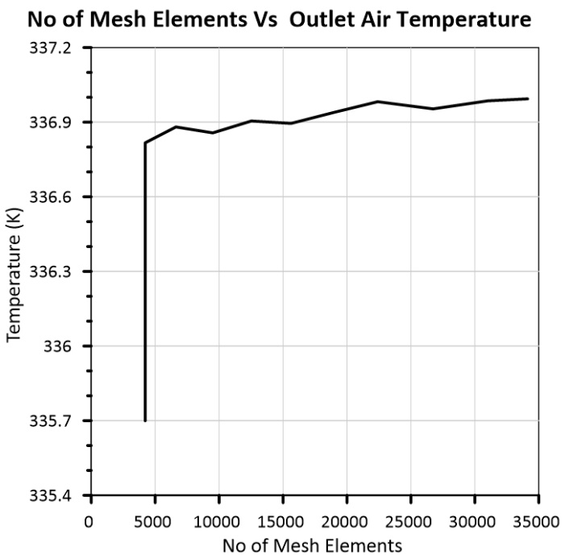
Figure 10 Grid Independence test results for outlet air temperature
From Figure 10 we observe that after the first point there is no sudden change in the temperature and there is linearity in the graph and as the number of mesh elements increase solution is getting better and accurate concluding number of mesh elements >= 35000 do not alter the output result and the Relative error of 0.0023% is obtained when taken at high mesh elements >= 35000.

Phase Change Material (PCM)
A PCM model is considered and the heat flux of 900W/m² is applied on its top surface and the boundary condition for remaining surfaces is considered as an adiabatic wall. A time step of 0.1 seconds and a maximum of 5 iterations per time step are selected. To perform the Grid Independence test Liquid fraction and Temperature are considered as parameters. To measure temperature a line is considered along the centre of PCM which is perpendicular to its horizontal surface and to measure liquid fraction surface is selected and its average is taken as a liquid fraction is measured by using the mass-average method. The results that are obtained by varying the mesh element size are mention in Table 4.

Name | Element size (m) | Mesh Nodes | Mesh Elements | PCM Temperature (K) | Liquid fraction
DP 0 | 0.001 | 3876 | 3750 | 300.9702 | 0.024765
DP 1 | 0.0009 | 4788 | 4648 | 300.9393 | 0.023619
DP 2 | 0.0008 | 6080 | 5922 | 300.9156 | 0.022437
DP 3 | 0.0007 | 7776 | 7597 | 300.4123 | 0.019548
DP 4 | 0.0006 | 10584 | 10375 | 300.3148 | 0.017236
DP 5 | 0.0005 | 15251 | 15000 | 300.9101 | 0.019141
DP 6 | 0.0004 | 23814 | 23500 | 300.9202 | 0.018922
DP 7 | 0.0003 | 42168 | 41750 | 300.9475 | 0.018581
DP 8 | 0.0002 | 94376 | 93750 | 300.9105 | 0.016861
DP 9 | 0.0001 | 376251 | 375000 | 300.9205 | 0.016678
Table 4 Grid Independence Test Results for PCM melting
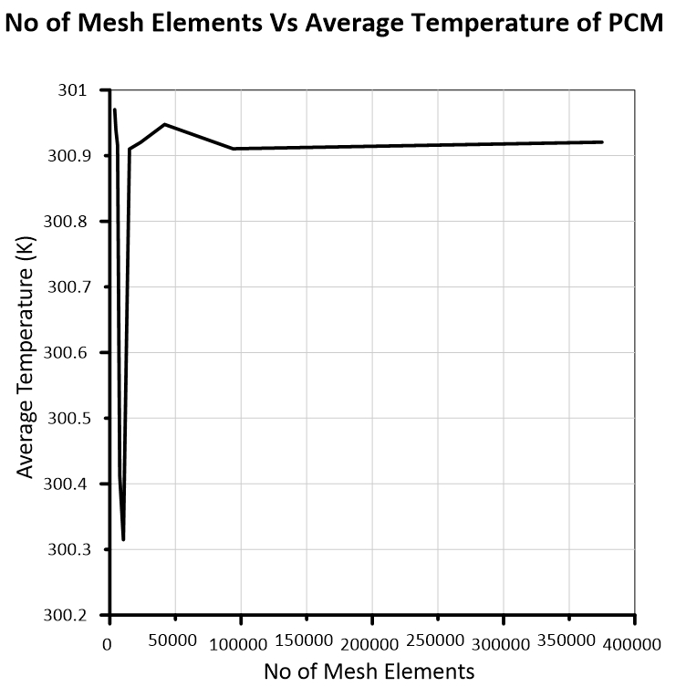
Figure 11 Grid Independence Results for Average temperature of PCM
From Figure 11 we analyse that after the number of mesh elements has increased to 100000 the line becomes linear giving almost same output result for temperature even after altering the mesh size and the Relative error obtained is 0.0033%. Considering this we can say that number of mesh elements > 100000 would give accurate results for our numerical experiment.

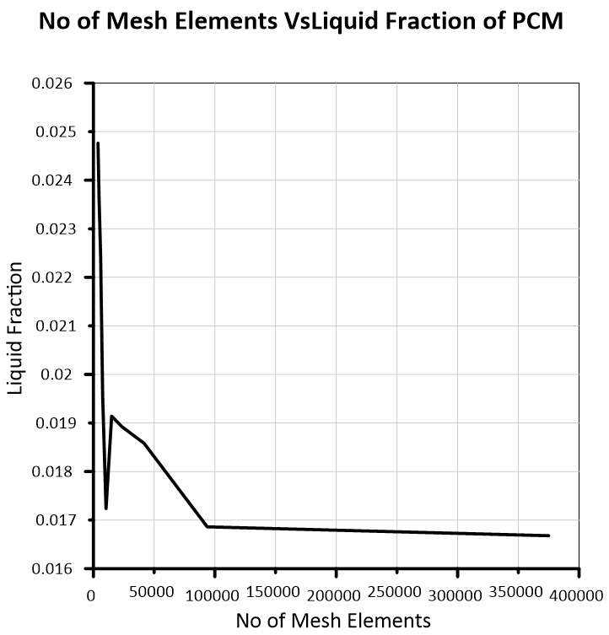
Figure 12 Grid Independence Results for Liquid Fraction of PCM
Figure 12 gives the relation between variations in Liquid fraction while varying the size of mesh element. When the number of mesh elements is more than 100000 the graph becomes linear showing a negligible difference in the liquid fraction of two consecutive results and the Relative error obtained is 1.08% so from the above observations we can say that mesh size <= 0.0001 m would give the accurate results and this size can be used in the numerical experiment.

Solution Procedure for Simulation of numerical model
- Import the model from the CAD Software into ANSYS Fluent 19.2 or we can design the model in ANSYS Design Modeller itself and the unit system has to be followed carefully.
- Generate the Mesh of good quality and if the model is complex makes use of various meshing methods to improve quality. Select surfaces/edges and name them accordingly so that they can be used in the setup process to give boundary conditions.
- In setup select Double precision and Series to process the solution. The solver is by default Pressure-based and it is not to be changed as we are using the incompressible fluids.
- Select the Transient model and give the value and direction of gravity acting on model.
- From the Model section turn on the energy equation and Solidification and Melting and give the value of Mushy constant ‘C’. In the case of Natural Convection Radiation model should also be turned on with a Discrete Ordinate Radiation model with the coupled condition when air passage is introduced.
- Add materials to the setup and give its thermo-physical accordingly.
- Apply the boundary conditions such as heat flux, air inlet velocity, the ambient temperature on named surfaces and edges.
- In the Methods section select the SIMPLE method as a couple of relations between Pressure and Velocity and use PRESTO as Pressure Interpolation scheme for improved accuracy use Second order scheme.
- Initialise the solution and add contours for edges/surfaces/bodies for which we want to get solution animations.
- Then set the time step size as 0.1 seconds and maximum iterations per time step as 10 and calculate the solution. (we can also save time steps at regular intervals to export the solution animation)

RESULTS & DISCUSSION

Introductory Remarks
Results of Transient thermal heating of Solar PV cell and simulation of melting of PCM in different arrangements and their liquid fractions with time are discussed in this chapter. The operating temperatures of the Solar PV cell and the electric efficiencies of the Solar cells are also compared. Various factors related to the melting of PCM are also discussed. The Validation results are also discussed in this chapter.

Validation

Solar Panel
The experimental simulation for Solar Panel using Transient Thermal is validated against the previous results of the W Z Leow et al 11. Where the transient thermal simulation is done on the solar panel assembly by using the ANSYS software. The boundary conditions used in the experimentation are Solar heat flux is taken as 1000W/m² and is incident on the topmost surface (glass) of the Solar panel and the ambient temperature is taken as 35⁰C. This simulation is performed for the period of 3600seconds and the maximum temperature of the surface of the assembled solar panel is taken considering the wind velocity of the ambient atmosphere as 0.43m/s. the maximum temperature of the surface of the Solar panel obtained is 88.239⁰C.
Figure 13 Temperature distribution of Solar panel model after 3600 seconds
To validate the simulation similar boundary conditions are taken as in W Z Leow et al literature and simulation is performed for 3600seconds using Transient Thermal simulation and the maximum temperature that has been obtained is 84.941⁰C.
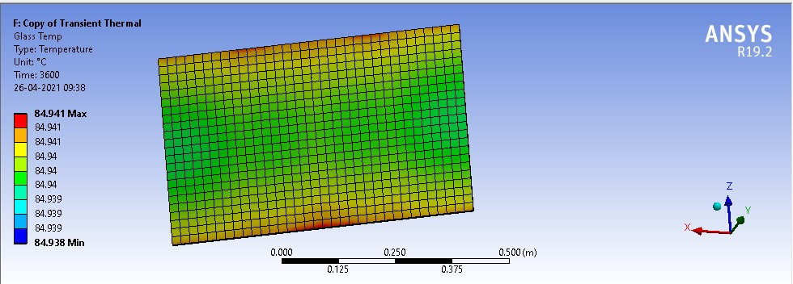
Figure 14 Temperature contour of Solar Panel after 3600sec using Transient Thermal condition
h_{c} = 12.12-1.16V+11.16V^{0.5} h_{c} = Heat transfer coefficient (W/m²K)
V = 0.43m/s (as mentioned in W Z Leow et al) V = Velocity (m/s)
h_{c} = 19.23 W/m²K

Validation results of temperature
 | Temperature
W Z Leow et al | 88.239⁰C
Present Results | 84.941⁰C

The magnitude of error obtained between the validation paper and the obtained results is about 3.73%. The reason for the error is slight variation in thermo-physical properties of different layers of the solar panel and the accuracy of the meshing method because the results get vary based on the type and number of meshing elements and by the magnitude of percentage error obtained we can conclude that the experimental simulation has been conducted in accordance to that of mentioned in the literature paper.

Phase Change Material (PCM)
The melting of the PCM is validated by using the results of Vikas et al. Where the simulation for melting of PCM is performed in ANSYS Fluent software and paraffin wax has been considered as the PCM for the above experimentation. The modelling of PCM is done as a 2D rectangular plane with 100mm*150mm as the dimension of length and height respectively. The Boundary conditions that are applied are left side wall of PCM model has constant heat flux of q” =2500W/m² and remaining three sides are considered as adiabatic walls (perfectly insulated: q” =0W/m²). A 2D model has been created as per the above experiment and all the Boundary conditions are applied and melting simulation is performed using ANSYS Fluent software.

  Property
  Value
Density (kg/m3) | 870 at T= 300K  780 at T= 340K
Specific heat (J/kgK) | 2900
Thermal conductivity (W/mK) | 0.24 at T= 300K  0.22 at T= 340K
Viscosity (Ns/m2) | 0.0057933
Latent heat (J/kg)
  190000
 | 331
  Solidus temperature (K)
Liquidus temperature (K) | 331.8
Table 5 Thermo-physical properties of Paraffin Wax [23]
To reproduce these results SIMPLE algorithm is selected which gives a coupling relation between pressure and velocity and for pressure interpolation, PRESTO is selected. The calculations are done using ANSYS Fluent 19.2. These simulations are done for a time of 4 hours. By observing both the results we can see that their matching is very good and the very slight variation between both these results is due to the meshing size of the elements since we have used “Automatic mesh” while performing the meshing operation.

Time | Vikas et al [23] | Obtained Result
30 min | 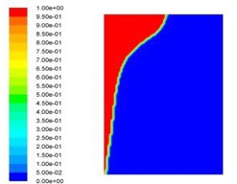 | 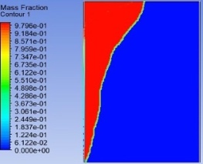
60 min | 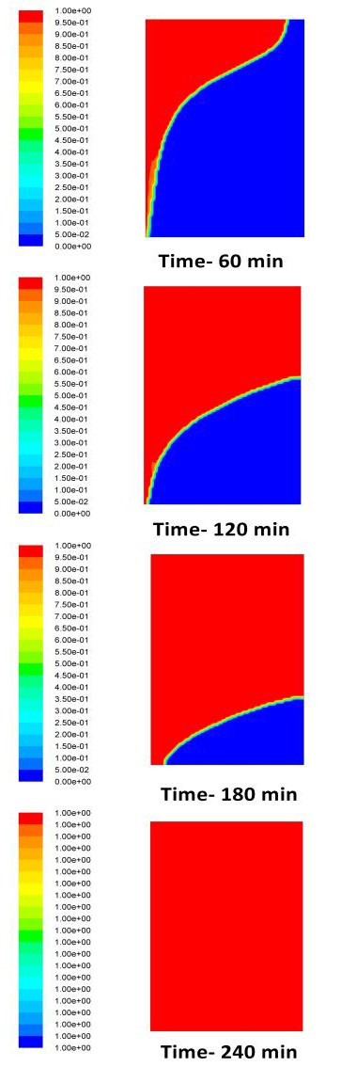 | 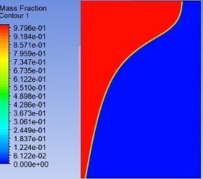
90 min | 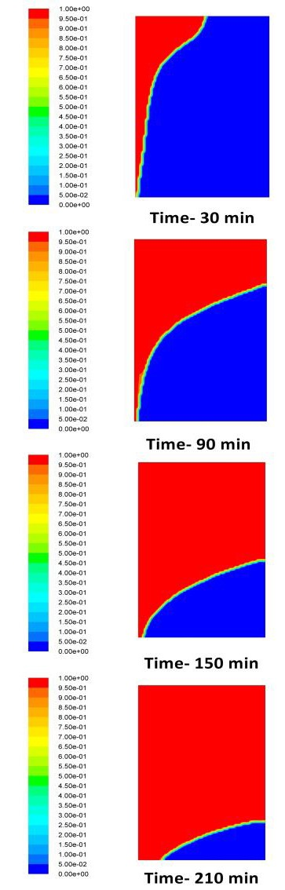 | 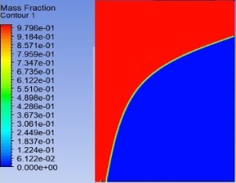
120 min |  | 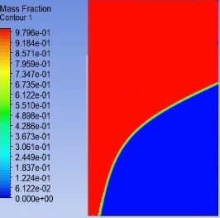
150 min |  | 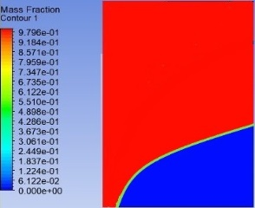
180 min |  | 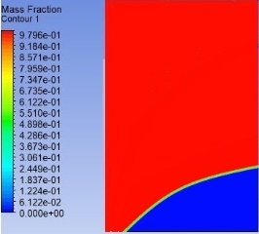
210 min |  | 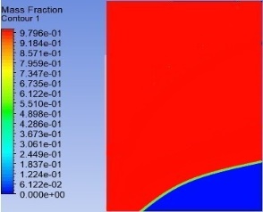
240 min |  | 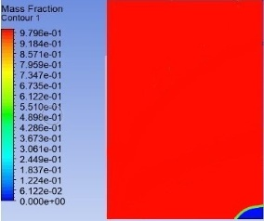
Table 6 Liquid Fraction Contours
From the above results, we can observe that as time passes the melting rate of the PCM has increased gradually because initially, the melting occurs only through the mode of conduction but as PCM starts melting due to the density difference between the solid and the liquid zone it starts to flow and during this natural convection heat transfer also contributes due to which melting rate of PCM is increased we can see that the validation results and the obtained results tabulated in below Table 7 are in conformity so we can say that the methodology that we have used for the simulation of PCM in ANSYS is fair and in accordance with the above obtained results. The magnitude of percentage errors are also tabulated in which the largest error obtained is 10.05% and lowest error is 0.22 % and the remaining errors are in the range of 1-5%.
Time (mins) |  | 30 | 60 | 90 | 120 | 150 | 180 | 210 | 240
Liquid  Fraction | Vikas et al [31] | 0.17 | 0.32 | 0.44 | 0.59 | 0.71 | 0.80 | 0.86 | 1
Liquid  Fraction | Present Results | 0.1971 | 0.3151 | 0.4359 | 0.5967 | 0.7455 | 0.8236 | 0.8581 | 0.932
Magnitude of % Error |  | 10.05 | 1.531 | 0.93 | 1.135 | 5.00 | 2.95 | 0.22 | 6.79
Table 7 Validation results for melting of PCM
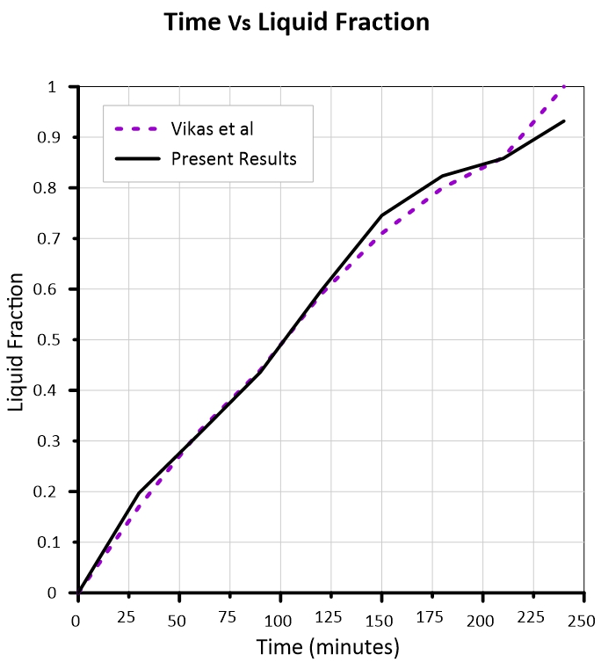
Figure 15 Comparison of PCM melting between Vikas et al and Present Results

Results and Discussions
In this section simulation results of Solar panel and PCM are discussed briefly. The simulation is done considering the ambient conditions keeping the inclination of Solar panel as 25⁰ and due to this, it is observed that the melting rate of the PCM is also affected because of heat transfer through both conduction and convection. The time step of 0.1 seconds is taken and a maximum of 5 iterations per time step is considered for the better convergence of the solution. It has been observed that the operating temperature of the PV panel is decreased when we use PV/PCM system and it is further decreased when Natural convection is introduced additionally into the system (PV/T-PCM). The results of optimum temperature in different combinations are compared in this section. The constant heat flux of 900W/m² is applied on the top surface (glass) of the Solar panel using Transient thermal condition and the variation of the temperature of the Solar PV cell with time is tabulated in the Table 8.
Time (seconds) | Temperature (⁰C)
72 | 34.764
144 | 41.898
334.76 | 57.045
574.83 | 71.584
890.17 | 85.14
1334.1 | 97.254
2032.7 | 107.26
2752.7 | 112.59
3472.7 | 115.35
4192.7 | 116.77
4912.7 | 117.51
5632.7 | 117.89
6352.7 | 118.09
6776.3 | 118.17
7200 | 118.23
Table 8 Variation in temperature of Solar PV cell with time
Here we can observe that the temperature of the Solar PV cell keeps on increasing with time as it is incident with constant heat flux and at the end of 7200 seconds the temperature reached by the Solar PV cell is 118.23⁰C. At such high temperatures, the efficiency of the PV cells decreases drastically as discussed by T. Kozak et al3. So we need to keep this temperature to as minimum as possible to increase the efficiency.
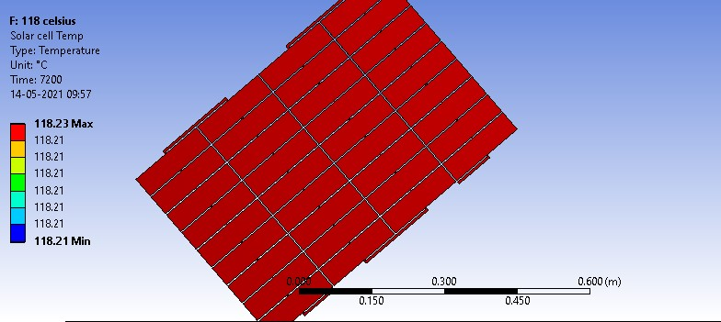
Figure 16 Temperature contour of Solar PV cell after 7200 seconds

Simulation of PCM
A 2D modelled 150mm*20mm is taken as Rubitherm 35-HC PCM and simulation is performed on it for a real time period of 2 hours and the results such as temperature and liquid fraction are observed. The constant heat flux of 900W/m² is applied directly on the top surface of PCM and its liquid fraction values are observed as mentioned in below Table 9. At the end of 2 hours, almost 93% of the PCM has been converted in liquid form.

Time (mins) | Liquid Fraction
0 | 0.00000
10 | 0.03416
20 | 0.10499
30 | 0.18699
40 | 0.27941
50 | 0.37717
60 | 0.47167
70 | 0.59397
80 | 0.65484
90 | 0.74266
100 | 0.82099
110 | 0.88541
120 | 0.92997
Table 9 Variation in liquid fraction of PCM with time
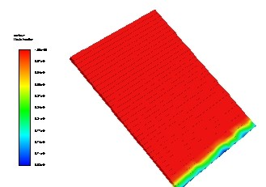
Figure 17 Liquid fraction Contour of Only PCM after 2 hours (3 Dimensional)
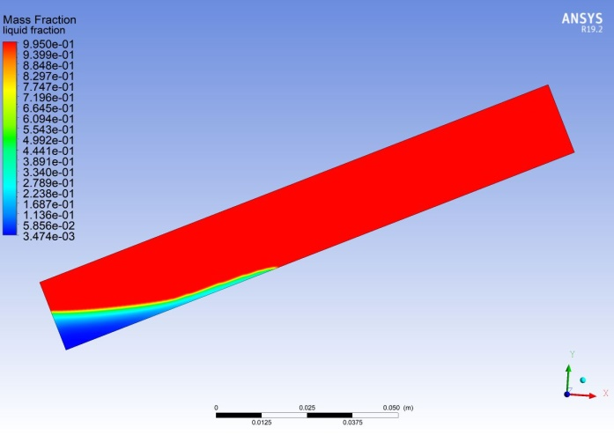
Figure 18 Liquid fraction Contour of Only PCM after 2 hours (Planar view)
Figure 18 represents the melting of PCM and from this, we can see that the melted zone is on the top of the solid zone because the density of the solid is more than that of liquid and this leads to the development of Buoyancy forces inside the PCM enclosure and due to this the PCM tends to melt faster than usual because initially, the only mode of heat transfer in PCM is conduction as the solid zone gets melted the flow velocity adds in convection mode of heat transfer so the melting rate is increased. The temperature gradually increases because of the turbulence effect of liquid PCM and once it completely melts properties becomes constant. The red zone represents the liquid zone and the blue zone represents the solid zone and the zone which is separating both solid and liquid zone is called a mushy zone which acts as a wall between two zones and it has the property of the porous medium.

Simulation of PV/PCM system
In this simulation a 2D model comprised of Glass, PV cell and PCM are assembled together from top to bottom in the chronological order as mentioned. The constant heat flux of 900W/m² is applied on the top surface of the glass and simulated for real time period of 2 hours and results of PCM liquid fraction, PV temperature are obtained which are mentioned in Table 10:
Time(mins) | Average Temperature of PV cell (⁰C) | Liquid fraction
0 | 27 | 0
10 | 37.6099 | 0.026594
20 | 44.2558 | 0.090413
30 | 51.5257 | 0.1658285
40 | 57.18296 | 0.230614
50 | 63.60928 | 0.311665
60 | 69.9525 | 0.385459
70 | 75.79041 | 0.461398
80 | 81.6613 | 0.5403799
90 | 87.4061 | 0.620228
100 | 93.0813 | 0.69623
110 | 98.9982 | 0.766368
120 | 102.3965 | 0.828948
Table 10 Results for simulation of PV/PCM system
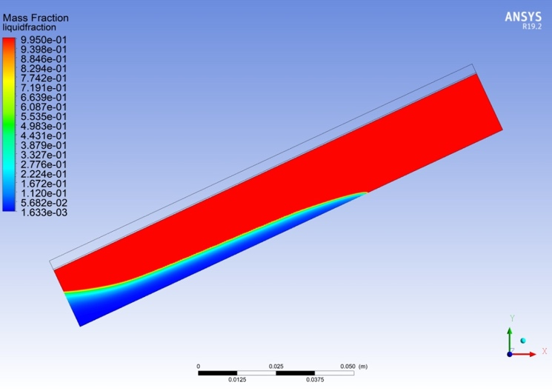
Figure 19 Liquid fraction contour of PCM in PV/PCM system after 2 hours
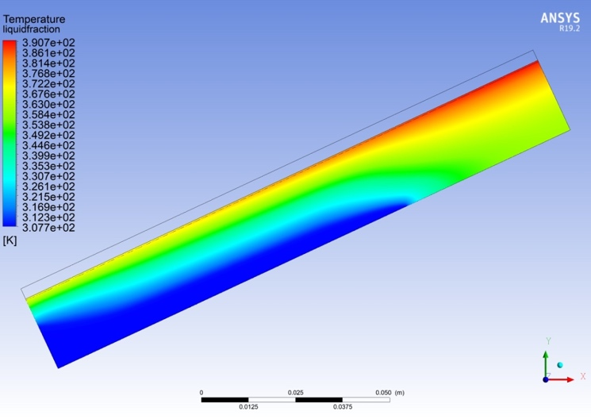
Figure 20 Temperature contours of PV and PCM in PV/PCM system after 2 hours
The simulation at the end of 2 hours gives the average temperature of PV cell is obtained as 102.3965⁰C and 82.898% of the PCM is converted to liquid form. We can see that at the top of the right side high-temperature thermal stratification is formed which leads to the unsymmetrical and fast melting on the top side due to convection. Here the liquid fraction of PCM is less compared to only PCM case because some amount of heat is absorbed by glass and PV cell before reaching PCM. Similarly, some amount of heat is absorbed by PCM from PV cell through conduction heat transfer.

Simulation of PV/T-PCM system
For this simulation a 2D model consisting of air passage between two glasses, PV cell and PCM is created and constant heat flux of 900W/m² is incident on the surface of the top glass for 2 hours and the heat radiation to reach PV cell it has to pass two layers of glass and a layer of air so to solve this model Discrete Ordinate Radiation Model has been considered because gases (air) also produce some radiation because of the high-temperature difference between glass and air. From this simulation Liquid fraction of PCM, Air outlet temperature, PV temperature and mass flow rate of the air at the outlet are obtained and the results are tabulated in Table 11 and this simulation is continued for real-time simulation of 2 hours.
Time (minutes) | Maximum Air-outlet temperature (⁰C) | liquid-fraction | Mass flow rate  (kg/s) | PV Cell temperature(⁰C)
0 | 27.0000 | 0.00000 | 0 | 27.0000
10 | 91.8458 | 0.00001 | 6.28E-06 | 33.0183
20 | 100.3791 | 0.02939 | 1.94E-05 | 37.6925
30 | 100.4763 | 0.08457 | 3.10E-05 | 42.0211
40 | 100.4820 | 0.15978 | 4.59E-05 | 45.2751
50 | 85.8019 | 0.23594 | 2.59E-05 | 49.7685
60 | 94.3668 | 0.31766 | 1.61E-05 | 54.2491
70 | 107.0641 | 0.40248 | 1.69E-05 | 57.5658
80 | 105.8924 | 0.48846 | 1.63E-05 | 60.2963
90 | 106.3676 | 0.57388 | 1.53E-05 | 62.6024
100 | 106.7334 | 0.65271 | 1.34E-05 | 65.0250
110 | 107.1672 | 0.72116 | 1.02E-05 | 68.0599
120 | 107.5708 | 0.77867 | 6.36E-06 | 71.7247
Table 11 Results for simulation of PV/T-PCM
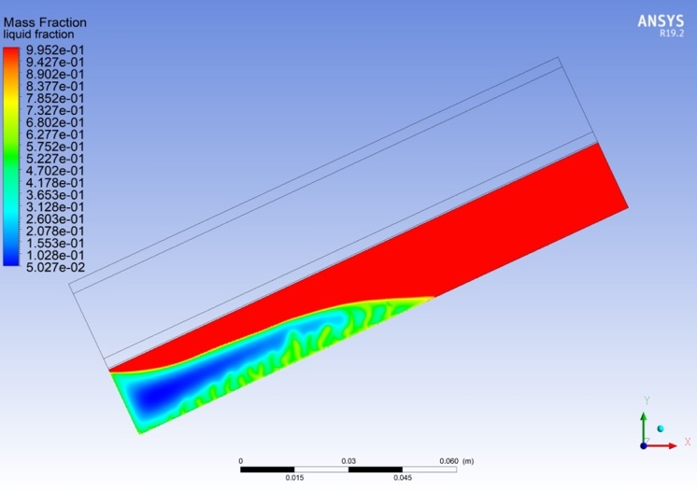
Figure 21 Liquid fraction contour of PCM in PV/T-PCM system after 2 hours
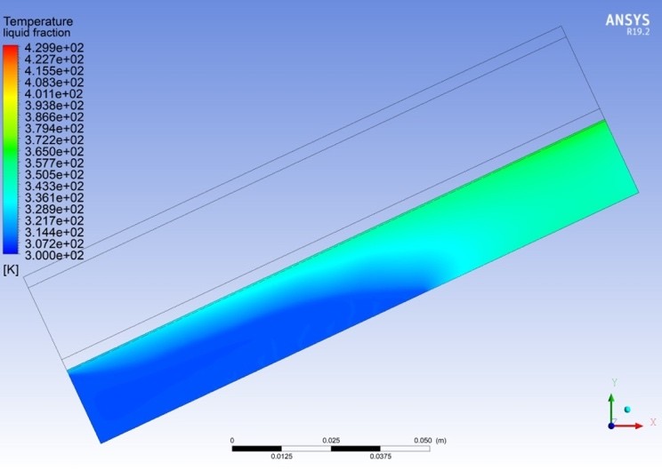
Figure 22 Temperature contour of PV and PCM in PV/T-PCM system
At the end of the simulation liquid fraction of PCM is 0.7786 which says that 77.86% of the PCM is in liquid form whereas the maximum air outlet temperature obtained is 107.57⁰C and the temperature of the PV panel is 71.72⁰C.

Comparison of Results
PV Cell Temperature
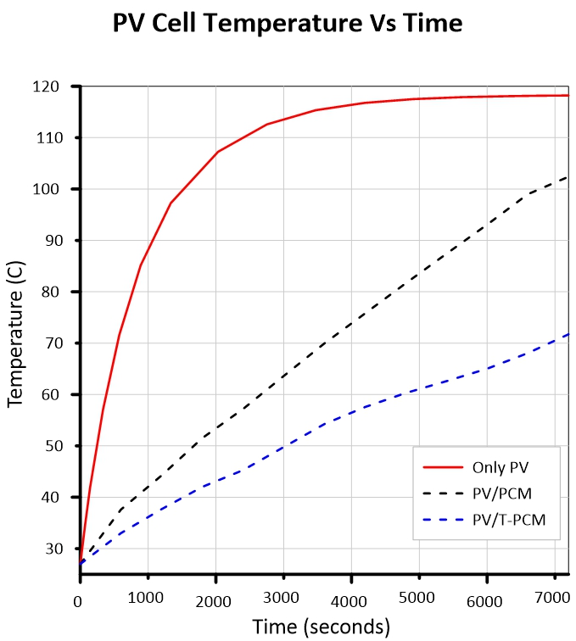
Figure 23 Temperature variation of PV Cell with time in different systems
Variation in temperature of PV cell with respect to time for different systems is shown in Figure 23. When the constant heat flux of 900W/m² is directly incident on the PV cell the temperature of the PV cell rises rapidly as it doesn’t have any heat sink so that heat can be removed from it and during this the maximum temperature reached is 118.23⁰C. When PCM is added to the PV cell which is also called as PV/PCM system the temperature of the PV cell is reduced to 102.39⁰C because more amount of heat is absorbed by the PCM which is fixed right beneath the PV cell by adding the PCM there is a temperature drop of 15.84⁰C. Further adding the Natural convection Air passage the temperature of PV cell reduces to 71.72⁰C because some more amount of heat from the radiation is taken away by the air by the process of Natural convection where the air gets heated and its density decreases with an increase in temperature and due to density difference buoyancy forces are developed in the air passage pushing away the hot air through the outlet zone. By adding the air passage (PV/T-PCM) system the temperature further decreased by 30.97⁰C. A temperature drop of 13.39% and 29.95% is observed in PV/PCM and PV/T-PCM systems respectively when compared to the only PV cell.
Melting Rate of PCM
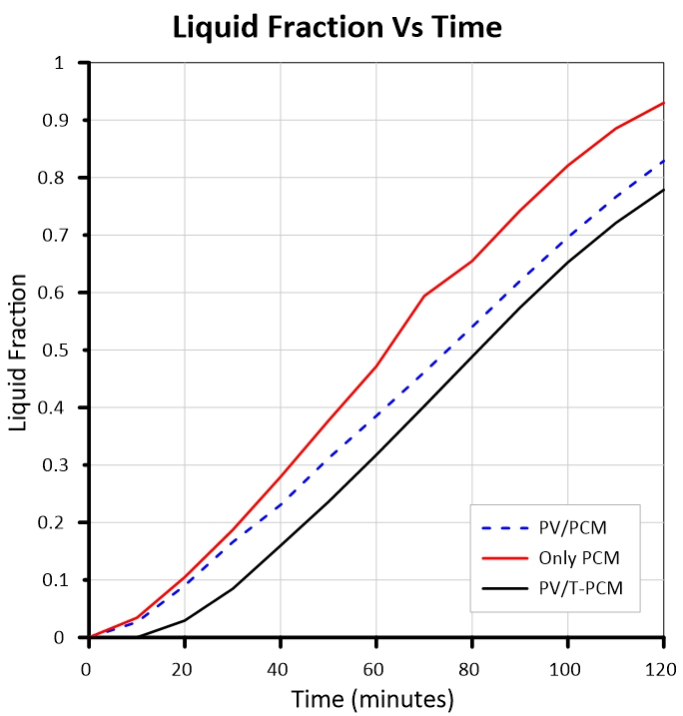
Figure 24 Liquid Fraction variation of PCM with Time in different systems
The melting of PCM initially is only due to the conduction because of viscous forces as it starts melting and converts part of its solid zone to liquid zone the buoyancy forces are developed because of density difference between solid and liquid and melted PCM starts to move flow. Due to phase change, transient incompressible flow is developed and this is responsible for the convective currents that are formed in the PCM enclosure as discussed by Babak Kamkari et al12. After the start of convective currents its melting rate increases because both conduction and convection mode of heat transfer is acting on PCM and when convective heat transfer decreases because of more heat being absorbed in the form of latent heat melting rate decreases again. When the only PCM has been incident with a constant heat flux of 900W/m² on its surface the liquid fraction obtained after 2 hours is 0.93 after the introduction of the PV/PCM system liquid fraction reduced to 0.83 and there is decrement of 10% in melting of PCM. When the PV/T-PCM system is introduced the liquid fraction is further decreased to 0.78 which is a further decrement of 5% in melting of PCM because air acts as a partial resistance for heat and extracts the heat in the form of natural convection. There is a total decrement of 10.75% and 6.41% in the melting of PCM after the addition of PV/PCM and PV/T-PCM respectively. The performance of the PV panel is also increased due to a decline in melting rate.
PV Cell Efficiency
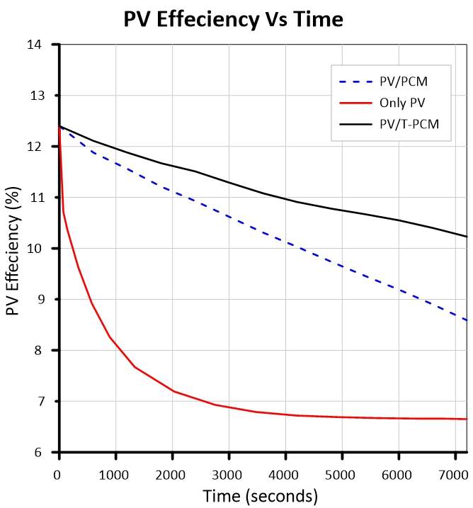
Figure 25 Variation of PV cell Efficiency with time in different systems
The efficiency of the PV cell decreases with the increase in the temperature as discussed in T. Kozak et al.3. At first, the efficiency of the PV cell decreases rapidly due to the increase in temperature because the entire waste heat is being absorbed by the PV itself and during this, the efficiency obtained after an incident of 900W/m² constant heat flux after 2 hours is 6.65%. When PV/PCM system is attached the efficiency increases to 8.59% as some amount of heat is absorbed by the PCM and when PV/T-PCM has introduced the efficiency further increases to 10.23% because in this system waste is not only being absorbed by the PCM but some part of the heat is also being removed by Natural convection of air. There is an increment of 29.17% and 19.09% in efficiency of PV cell after addition of PV/PCM and PV/T-PCM respectively.
Air Outlet Temperature
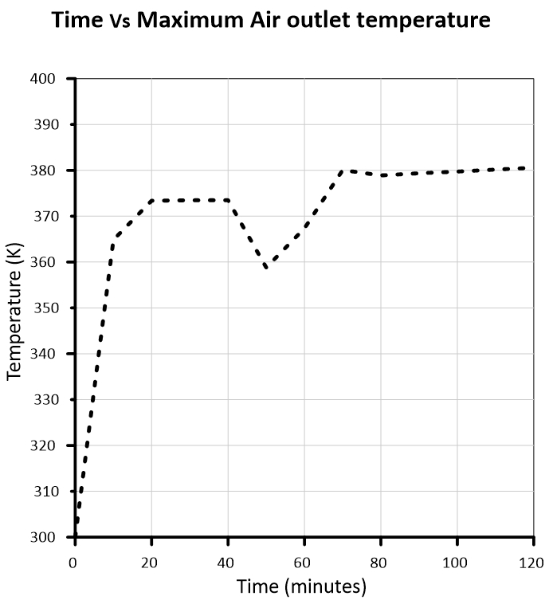
Figure 26 Maximum Air outlet temperature
The maximum air outlet temperature obtained is 107⁰C this is because the heat flux is directly incident on the surface of the glass right beneath which has an air channel so air gets heated in the channel its density decreases which leads to the formation of buoyancy forces and natural convection occurs. The temperature drop in the plot is due to the increase in melting rate of PCM where more amount of heat is absorbed during the formation of convective currents and after it diminishes the properties become constant leading to constant air outlet temperature. The hot air at the outlet can also be used for other purposes which requires heat. The air passage has an important role in decreasing the temperature of PV Cell.

CONCLUSIONS & SCOPE OF FUTURE WORK

Conclusions
In this study, the thermal behaviour of PV and PCM are studied by using the CFD analysis by considering the real-time atmospheric conditions. Investigation of PV cell temperature, the liquid fraction of PCM, PV cell efficiency and air outlet temperature is done for PV/PCM and PV/T-PCM systems. The simulation of heat transfer in PCM is validated against Vikas et al 23 and is found to be in close agreement and the PV cell is validated against W Z Leow et al 11 and the obtained results are found in the acceptable range. The mode of heat transfer in PCM is initially due to conduction and after melting of PCM convective currents are developed due to buoyancy forces leading the heat transfer through both conduction and convection. Grid independence tests are done to choose the optimum grid and simulation results are presented for such grids and the grid arrangement which gives the least relative error is chosen for the simulation process. Results obtained for PV/PCM and PV/T-PCM are compared. RT35-HC is used as a PCM for our entire simulation.
It is found that by using the PCM along with PV the operating temperature is decreased by 13.39% and it is further decreased by 29.95% when Natural convection is introduced to the system. The liquid fraction is decreased by 10.75% and 6.41% by the addition of PV/PCM and PV/T-PCM system by the addition of air duct there is not very much decrease in the melting rate but there is a drop of 29.95% in temperature of the PV Cell.
The efficiency of the PV also increased which is our main concern in this study there is an increase of 29.97% and 19.07% PV cell efficiency when PV/PCM and PV/T-PCM are added respectively. The results indicate that PV cell works better when it is used with PV/T-PCM system where the operating temperature and liquid fraction are relatively low and it can make work it for long hours. Hence we can conclude that the passive way of cooling has been effective in cooling PV cell and the PV/T-PCM system is considered the best.

Scope for Future Work
The present work can be extended by using the different PCM materials and analysing the performance of PV cell under atmospheric conditions of Durgapur City. Increasing the thermal conductivity of the PCM by using Nano-materials which are called Nano-enhanced Phase Change Materials (NE-PCM) to increase the heat transfer efficiency in PCM enclosure. Thermal stratification leads to an increase in temperature of PV at the top side so different possibilities can be explored to reduce the thermal stratification such as using the honeycomb structure inside the PCM enclosure to distribute the heat in PCM evenly. Other passive cooling methods such as the use of fins can be explored to further increase heat transfer and the best optimum system can be selected.

REFERENCES

S.A. Nada, D.H. El-Nagar, “Possibility of using PCMs in temperature control and performance enhancements of free stand and building integrated PV modules”, Renewable Energy 127 (2018) 630-641
Shrey Verma, Subhashree Mohapatra, Subhankar Chowdhury, Gaurav Dwivedi, “COOLING TECHNIQUES OF THE PV MODULE: A REVIEW” Energy Centre, Materials Today: Proceedings 38 (2021) 253–258
Tomasz Kozak, Wiltold Maranda, Andrzej Napieralski, Gilbert De Mey, Alexis De Vos “Influence of Ambient Temperature on the Amount of Electric Energy Produced by Solar Modules” MIXDES 2009, 16th International Conference "Mixed Design of Integrated Circuits and Systems", June 25-27, 2009.
Sellami, A., Elotmani, R., Kandoussi, K., Eljouad, M., Hajjaji, A., & Boutaous M. “Temperature regulation of PV solar cell under PCM cooling system”. 2016 International Renewable and Sustainable Energy Conference (IRSEC).
H. Liu, Q.N. Yu, Z.C. Zhang, Z.G. Qu, C.Z. Wang, “Two-equation method for heat transfer efficiency in metal honeycombs: An analytical solution”, International Journal of Heat and Mass Transfer 97 (2016) 201-210
Furkan Dinçer, Mehmet Emin Meral (2010). “Critical Factors that Affecting Efficiency of Solar Cells”, Smart Grid and Renewable Energy, 01(01), 47-50
Gur Mittelman, Aiman Alshare, Jane H. Davidson. 2009. “A model and heat transfer correlation for rooftop integrated photovoltaics with a passive air cooling channel.” Solar Energy 1150–1160.
M.J. Huang, P.C. Eames , B. Norton. 2004. “Thermal regulation of building-integrated photovoltaics using phase change materials.” International Journal of Heat and Mass Transfer 2715–2733.
Tao Ma, Jiaxin Zhao, Zhenpeng Li. 2018. “Mathematical modelling and sensitivity analysis of solar photovoltaic panel integrated with phase change material.” Applied Energy 1147-1158
Akshayveer, Ajeet Pratap Singh, Amit Kumar, Om Prakash Singh. 2020 “Effect of natural convection and thermal storage system on the electrical and thermal performance of a hybrid PV-T/PCM systems” Materials Today: Proceedings 39 (2021) 1899–1904
W.Z. Leow, Y.M. Irwan, M. Asri, M. Irwanto, A.R. Amelia, Z. Syafiqah, I. Safwati. , March 2016. “Investigation of Solar Panel Performance Based on Different Wind Velocity Using ANSYS” Vol. 1, No. 3, pp. 456 ~ 463
Babak Kamkari, Hossein Shokouhmand, Frank Bruno. 2014. “Experimental investigation of the effect of inclination angle on convection-driven melting of phase change material in a rectangular enclosure” International Journal of Heat and Mass Transfer (72), 186–200.
Stefano Aneli, Roberta Arena, Antonio Gagliano. June 2020. “Technica Italiana – Italian Journal of Engineering Sciences” Vol. 64, No. 2-4, pp. 186-192
Jiaxin Zhao, Zhenpeng Li, Tao Ma.2019. “Performance analysis of a photovoltaic panel integrated with phase change material” Energy Procedia 158 (2019) 1093–1098
Ilya T’Jollyn, Jasper Nonneman, Wim Beyne, Michel De Paepe. 2018. “1D SIMULATIONS OF THERMALLY BUFFERED PRISMATIC BATTERIES THROUGH THE APPLICATION OF PCMS” Proceedings of the 16th International Heat Transfer Conference, IHTC-16
H.G. Teo, P.S. Lee, M.N.A. Hawlader. “An active cooling system for photovoltaic modules” Applied Energy 90 (2012) 309–315
PVGIS website https://re.jrc.ec.europa.eu/pvg_tools/en/tVPools.html#P
M.A. Hassab, Medhat M. Sorour, M. Khamis Mansour, Mostafa M. Zaytoun. “Effect of volume expansion on the melting process’s thermal behavior”. Applied Thermal Engineering 115 (2017) 350–362.
Moritz Faden, Andreas König-Haagen, Stephan Höhlein, Dieter Brüggemann, “An implicit algorithm for melting and settling of phase change material inside macrocapsules” January 2017 International Journal of Heat and Mass Transfer 117 (2018) 757-767.
ANSYS FLUENT 15.0 Guide
D.L. Evans, L.W. Florschuetz, Cost studies on terrestrial photovoltaic power systems with sunlight concentration, Sol. Energy 19 (3) (1977) 255–262.
C.J. Smith, P.M. Forster, R. Crook, Global analysis of photovoltaic energy output enhanced by phase change material cooling, Appl. Energy 126 (2014) 21–28.
Vikas, Ankit Yadav, S.K. Soni. May 2017. “ Simulation of Melting Process of a Phase Change Material (PCM) using ANSYS (Fluent)” International Research Journal of Engineering and Technology (IRJET) Volume: 04 Issue: 05 Page No: 3289-3294

