Privacy Preservation in Real-time: Inpainting using YOLO

Sejal Parate¹, Dnyanda Nandapurkar², Rupam Patil³, Aditya Nandanwar⁴
^{1,2,3,4} Student, Dept. of Artificial Intelligence and Data Science, Vishwakarma Institute of Information Technology, Kondhwa, Pune, Maharashtra, India

---------------------------------------------------------------------***---------------------------------------------------------------------
Abstract - With the rise of video surveillance, maintaining a balance between accurate object detection and privacy preservation has become essential. This study introduces a system that employs YOLOv8 for real-time object detection and segmentation, combined with inpainting techniques to obscure sensitive areas in live video feeds. The system is designed to protect privacy by automatically detecting and masking specific objects while preserving the overall functionality of the surveillance. By evaluating various YOLOv8 models, this research highlights the system's effectiveness in achieving both high detection accuracy and privacy protection. The proposed approach addresses critical ethical concerns, offering a practical solution for privacy-conscious surveillance applications without compromising on performance.

Key Words: YOLO, Instance Segmentation, Object Detection, Real-time Inpainting, Privacy preservation

1. INTRODUCTION

In today's world, where video surveillance is everywhere, the challenge of balancing real-time object detection with privacy protection has become more important than ever. Video feeds play a crucial role in various sectors, from enhancing public safety to analyzing consumer behavior in retail. The ability to identify and track objects as they appear in real-time is essential, but it also raises significant concerns about the privacy of individuals who may unknowingly be captured in these video streams.

The motivation for this research comes from the growing need to practice ethical data handling in a world that increasingly relies on digital surveillance. As video analytics become more embedded in daily life, the importance of protecting individual privacy cannot be overstated. This project is driven by the belief that technological innovation must go hand-in-hand with ethical considerations. The goal is to create a system that not only preserves privacy but also maintains the efficiency and accuracy of object detection.

This research seeks to address the dual challenge of improving object detection accuracy while simultaneously ensuring that privacy is protected through novel inpainting techniques. Recent advancements in deep learning and computer vision have led to remarkable progress in object detection and segmentation. Algorithms like YOLO and Faster R-CNN have made it possible to process video in real-time, opening up new possibilities in fields like autonomous driving, security, and smart cities. However, despite these advancements, privacy-enhancing features are often lacking. Many existing solutions do not sufficiently conceal sensitive information, leaving privacy concerns unresolved. By integrating object detection, instance segmentation, and inpainting into a single framework, this research offers a practical solution for privacy protection in real-time video surveillance. The proposed system provides a comprehensive approach to safeguarding privacy in digital applications. This work not only contributes to the field of computer vision but also addresses the urgent need for ethical data practices in an increasingly monitored world.

2. RELATED WORK

2.1 Facial Blurring

Facial blurring, similar to pixelation, is a highly effective method for privacy protection in visual identification tasks. For instance, study [1] combines facial recognition algorithms with Gaussian blur techniques to selectively blur faces in videos, balancing privacy and recognition accuracy effectively. Author [2] presents a real-time multi-face blurring method using Viola Jones for detection, Color-Space for tracking, Template Matching for comparison, and Gaussian filter for obscuring faces. The ethical implications of facial recognition technology are significant. While it enhances security, it raises concerns about surveillance and potential misuse, necessitating careful consideration to gain public trust and acceptance.
2.2 Image-based Inpainting

Despite the growing importance of image inpainting in computer vision, there is a notable scarcity of thorough review works that analyze the various methodologies and their effectiveness. Image inpainting based on deep learning utilizing models like autoencoders, U-net, GANs, and transformers by study [3] accurately restore images by preserving texture and structure, enhancing traditional methods significantly. Author [4] proposes an image inpainting model using gated convolution and spectral normalization in deep learning, enhancing feature extraction and addressing training difficulties for improved results. Another notable method [5] , utilizes gated convolution and multi-level attention mechanisms to effectively repair images, achieving good performance metrics and visual results. However, this method struggles to extract effective features and accurately assign high weights to undamaged regions.
2.3 Video-based Inpainting

In the domain of video inpainting, [6] proposes ViLocal, a forensic scheme for video inpainting localization using contrastive learning with a 3D Uniformer encoder, enhancing detection of inpainted regions in videos. Trusted Video Inpainting Localization network (TruVIL) [7] employs deep attentive noise learning for accurate video inpainting localization, enhancing robustness and generalization in identifying inpainted regions. Author [8] proposes video inpainting through internal learning with diffusion models, achieving state-of-the-art results without relying on deep learning or optical flow estimation. [9] presents a method for deep video inpainting localization using spatial and temporal traces, outperforming existing techniques in detecting and locating inpainted regions in videos. Furthermore, a novel deep learning algorithm for video painting was introduced by [10], which fills corrupt areas in videos with temporal consistency, making videos semi-erect and temporally smooth in near-real-time. ProPainter [11], a pioneering work in video inpainting, is an advanced framework featuring dual-domain propagation and an efficient transformer, outperforming previous methods by 1.46 dB in PSNR while maintaining high efficiency. Nevertheless, memory and computational constraints often limit the temporal range of feature propagation, posing challenges for long-term consistency.
[12] introduces a real-time Video Inpainting algorithm for RGB-D pipeline reconstruction, achieving 23 FPS on a laptop, enhancing color accuracy for pipeline inspection robots. A framework for real-time memory-based video inpainting using transformers was proposed by [13], achieving over 20 fps throughput while maintaining decent inpainting quality. Another notable contribution [14], presents a novel real-time video compression method using inpainting, achieving FullHD decompression in real-time with superior quality and speed compared to previous approaches. Achieving real-time performance in video compression poses a significant challenge, especially when simplified frame-by-frame reconstructions are employed, which often ignore temporal redundancies. This simplification can lead to inconsistencies, making it difficult to maintain time consistency in video painting.
3. PROPOSED SYSTEM

3.1 Backend

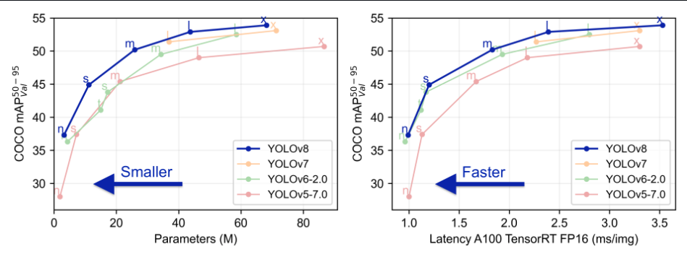
Fig-1: Comparison of YOLO models (Ultralytics)
In order to inpaint objects in real-time, we employed a state-of-the-art approach to achieve the necessary speed, accuracy, and efficiency. We aimed to detect the target object in real-time and mask it with background pixels to successfully inpaint the object. Given the challenge of performing this task in real-time, we chose YOLO (You Only Look Once) as our preferred solution. The YOLO architecture has proven to be a robust and effective framework for various vision AI tasks such as detection, segmentation, tracking, classification, and pose estimation [15]. YOLOv8, released by Ultralytics in 2023, outperforms previous YOLO versions, as illustrated in Fig-1. Pre-trained on the COCO dataset, the model is capable of identifying and segmenting over 80 object classes. YOLOv8 meets the demands of real-time applications by processing frames in a single pass [15].
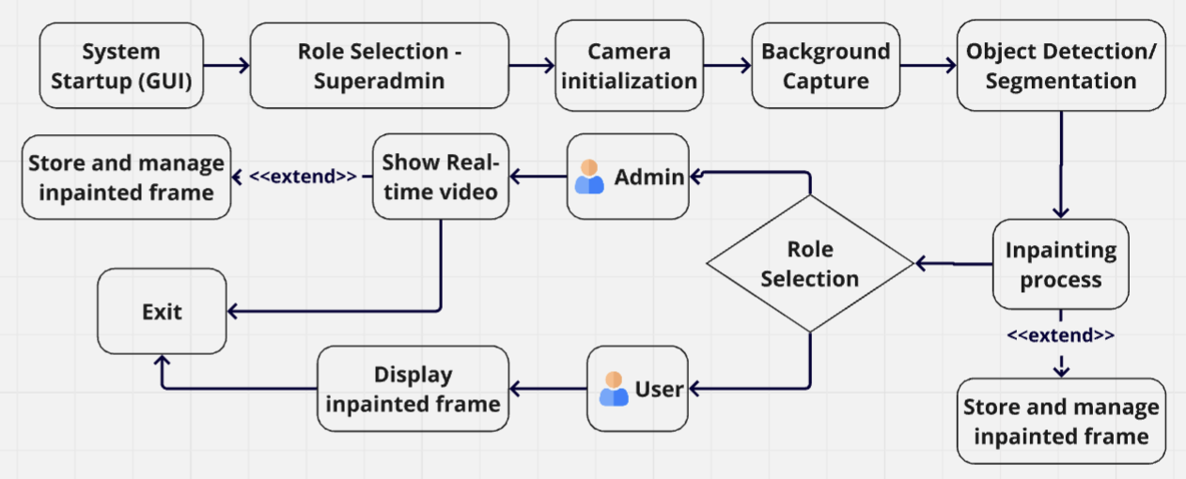
Fig-2: System Workflow
Fig-2 outlines the workflow of our proposed system. Our comprehensive privacy-enhancement application captures live video, detects the target object in the frame using a YOLOv8 model, and inpaints it to obscure its appearance. To add an extra layer of security, we have assigned specific privileges to certain users. There are three types of users who can interact with the system: Superadmin, Admin, and User. Only the Superadmin can initiate the inpainting process after successfully authenticating their credentials. The Superadmin can also view both the real-time original video and the real-time inpainted video side-by-side. The Admin is able to view the real-time original video frame, while the User can only watch the stored inpainted video provided by the Superadmin. The privilege of storing the inpainted frames in the database and managing them is exclusive to the Superadmin and Admin. This functionality can only be triggered after the inpainting is successfully completed. The entire application becomes functional only when the Superadmin initiates the inpainting process. After the inpainting is completed and the Superadmin clicks the “continue” button, the Admin and User roles are then able to interact with the application.
For the inpainting process, the system first initializes the camera to capture the background for 45 seconds. The background should remain static, without the target object in the frame or any distractions. This background is later used for inpainting, helping to obscure the detected objects. Once the background is successfully captured, the Superadmin is notified. After capturing the background, the system uses the YOLOv8 model to detect objects in the live video feed. To inpaint the target object, we considered two approaches: using object detection or instance segmentation. Object detection creates bounding boxes around the target object. These bounding boxes are axis-aligned, meaning they are always rectangular and do not conform exactly to the shape of the detected object. When inpainting, the entire area within the bounding box is replaced with corresponding areas from the background frame. This might lead to over-inpainting, where the background is applied to areas that do not contain the object, resulting in a larger, less precise area being obscured. On the other hand, instance segmentation provides a pixel-wise mask for each detected object. This mask conforms exactly to the shape of the object, identifying the precise outline of the target object and replacing it with the corresponding background. However, the simplicity of object detection could lead to faster processing times compared to instance segmentation. To create a mask, the system checks whether the object in the live feed is the actual target object and whether the confidence score of detecting this target object is greater than 0.5, ensuring reliable detection. If both conditions are met, the mask corresponding to the detected object is updated to ‘255’ (white), which is used to identify the area of the frame that will be inpainted. The masked area is then replaced with the corresponding background pixel values. The target object can be changed by modifying the class index (refer to the YOLOv8 documentation for all possible target objects). The YOLOv8 model has several variants for object detection and instance segmentation. As the number of parameters in the model increases, the accuracy improves, but it may start to lag, resulting in poor performance in real-time. In the later sections, we compare these variants, highlighting their use cases.
3.2 Frontend
Fig-3 shows the initial role selection UI. The Superadmin is asked for credentials, adding an extra layer of security. Once the credentials are authorized, the inpainting process can be started by clicking on the ‘Apply privacy enhancement button” as shown in Fig-4. Note that a static background should be chosen for this purpose. Both the ‘Before privacy enhancement’ view and ‘After privacy enhancement’ view are visible only to the Superadmin. Once the inpainting process is completed, the Superadmin can either store it in the database, or click on ‘Continue’, leading to a new Role selection window to pop up. The Admin and User can access their privileges through this interface.

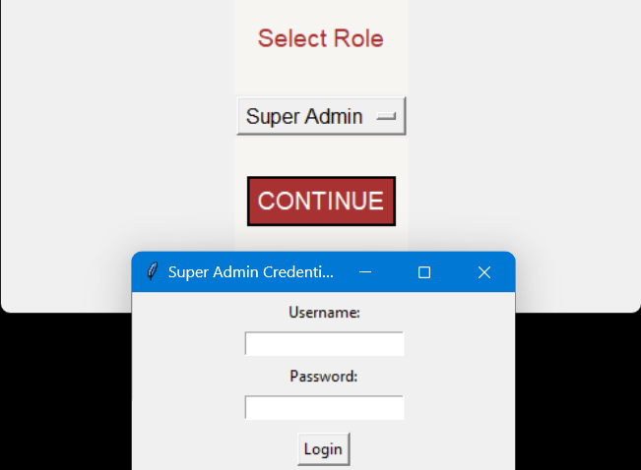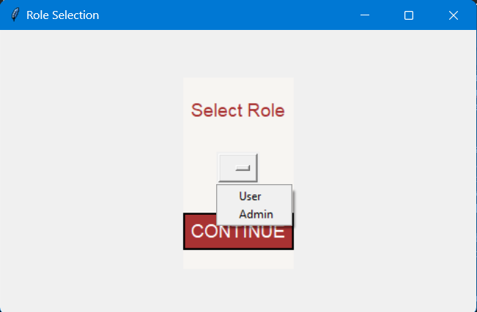
Fig-3: Role selection UI
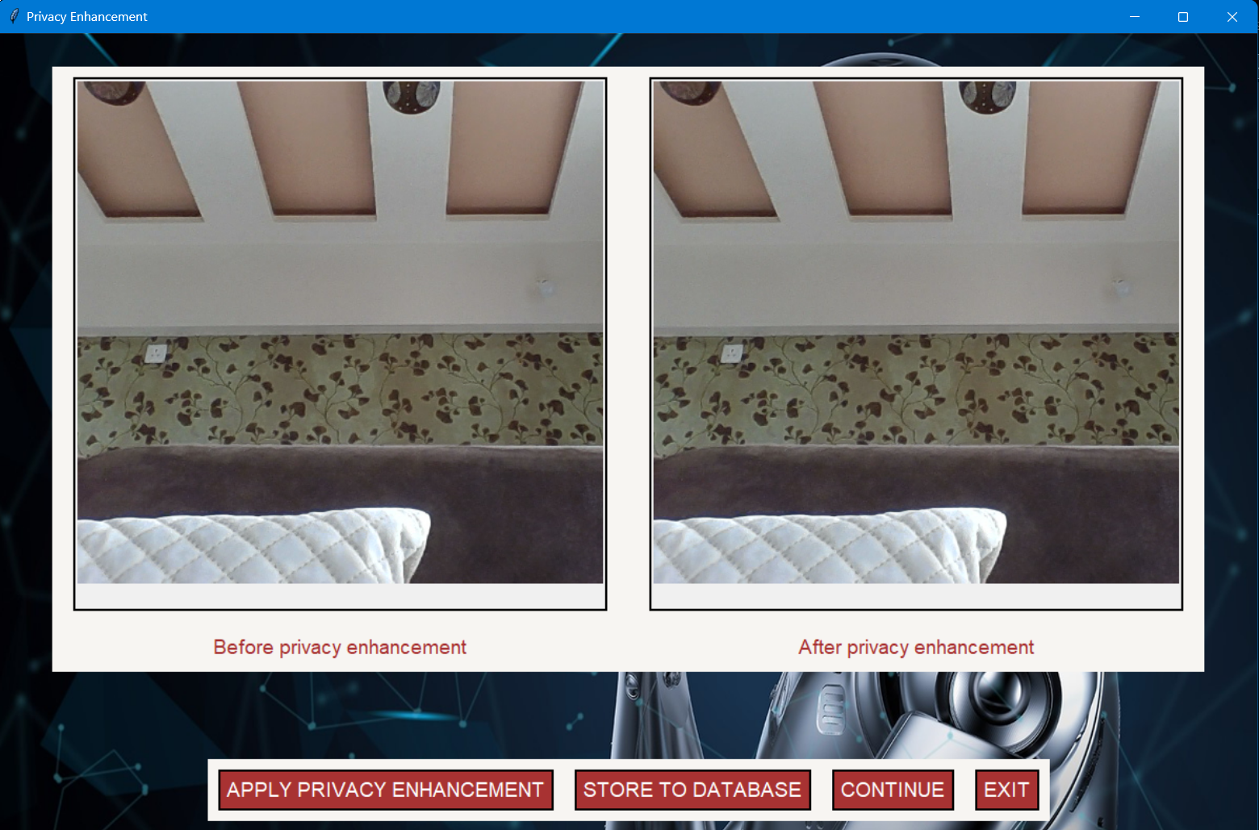
Fig-4: Inpainting process initiated by Superadmin
3. RESULTS AND DISCUSSION

Fig-5 shows the results of the object detection-based inpainting approach, while Fig-6 presents the results of the instance segmentation-based inpainting approach. We have attempted to inpaint various objects with both plain and cluttered backgrounds. As clearly demonstrated, both approaches perform well. Defining the specific object to be inpainted offers more precise control over the inpainting process compared to global inpainting methods.

It was observed that object detection produced a more visually seamless inpainting effect compared to instance segmentation. Object detection, which relies on bounding boxes, resulted in inpainting that was less noticeable, particularly under suboptimal lighting conditions. Take a look at the teddy bear and suitcase in Fig-5 and Fig-6. The blunt edges associated with object detection appeared to blend more naturally with the surrounding image, making the manipulation less apparent. On the other hand, instance segmentation, despite its precise masking, led to more discernible inpainting due to the clear outlines of objects. These results suggest that object detection may be preferable in scenarios with challenging lighting, where minimizing the visibility of inpainting is crucial. However, the presence of shadows from the object being inpainted remains a challenge for both approaches.
Fig-5: Results of object detection based inpainting approach
Fig-6: Results of instance segmentation based inpainting approach
In Fig-7, a banana is being inpainted in real-time using both approaches. The object detection-based approach results in over-inpainting, where areas that do not exactly contain the object are also masked and inpainted. Fig-5 also illustrates a scene with overlapping or occluded objects (such as the banana overlapping the hand). In such cases, the inpainting process may struggle to accurately fill in regions occupied by multiple objects, potentially leading to visual artifacts or inconsistencies.

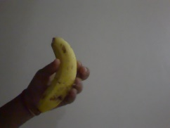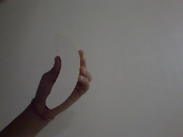
Fig-7: Inpainting a banana
Table-1: Comparison of evaluation metrics for different YOLOv8 variants

Evaluation metrics

YOLOV8 variants |  |  | Avg. PSNR | Avg. SSIM | Avg. MSE
YOLOV8 variants | Instance Segmentation | yolov8n-seg | 29.136 | 0.947 | 81.527
YOLOV8 variants | Instance Segmentation | yolov8s-seg | 29.979 | 0.949 | 66.593
YOLOV8 variants | Instance Segmentation | yolov8m-seg | 31.553 | 0.912 | 49.59
YOLOV8 variants | Object Detection | yolov8n | 30.767 | 0.952 | 70.049
YOLOV8 variants | Object Detection | yolov8s | 29.919 | 0.951 | 67.357
YOLOV8 variants | Object Detection | yolov8m | 30.815 | 0.914 | 54.973

Table-1 compares the evaluation metrics for different YOLOv8 variants, namely yolov8n, yolov8s, and yolov8m. Instance segmentation generally results in higher PSNR and lower MSE values, indicating more accurate inpainting with fewer errors compared to object detection. Object detection, on the other hand, achieves slightly higher SSIM values, which suggests a marginally better preservation of structural details, though with potentially more noticeable inpainting errors. As the model size increases (from 'n' to 'm'), both instance segmentation and object detection variants show improvements in PSNR and reductions in MSE, demonstrating that larger models generally produce better inpainting results. This indicates that higher variants of YOLOv8 provide more promising results, provided there are sufficient computational resources (preferably a GPU).

4. CONCLUSION

Our proposed system successfully tackles the challenge of protecting privacy in real-time video streams by seamlessly combining object detection, instance segmentation, and inpainting into one cohesive system. By using advanced techniques, the system quickly and accurately identifies objects in live video feeds, which is essential for adapting to changing environments in real time. By focusing on pixel-level detection, the system can inpaint only the necessary areas, reducing the computational load while maintaining precision in obscuring sensitive information. The inpainting module works effectively to blend these areas seamlessly with the surrounding content, keeping the video looking natural. An user-friendly interface makes it easy for anyone to configure settings and manage video feeds, ensuring the system is accessible and straightforward to use. Its reliability, robustness, and scalability make it a versatile solution for a wide range of surveillance applications, providing a practical way to balance technological innovation with the need to protect privacy.

5. FUTURE SCOPE

Improving security, especially for the Super Admin role, is also a key focus. Implementing two-factor authentication will add an extra layer of protection, reducing the chances of unauthorized access.

Fore coming versions of the YOLO model can be tested for improved performance. Our proposed system utilizes a generalized model of YOLOv8, where class indices are passed as parameters to inpaint objects of interest in real-time video streams. This approach allows for flexible and efficient handling of various objects that need privacy protection. However, to further enhance the accuracy of the inpainting process, fine-tuning the model can be done to specifically identify and inpaint targeted objects more precisely.

The current system requires a static background during the initial background capture to ensure accuracy. However, for future improvements, the system could be enhanced to adapt to dynamic backgrounds. This adaptation would involve periodically updating the background model to reflect environmental changes, such as varying lighting conditions or moving objects, ensuring that privacy enhancements remain effective even as the scene evolves. This capability would make the system more robust and versatile, particularly in real-world applications where the environment is rarely static.

In future, focus can be shifted on refining hardware integration to significantly boost the system's efficiency. By leveraging specialized hardware, such as GPUs and AI accelerators, the system will be able to process data more rapidly, which is essential for maintaining real-time operations. Additionally, the implementation of the system on compact, low-power chips like Raspberry Pi will enable the system to be directly integrated into surveillance cameras, transforming them into intelligent devices capable of performing real-time privacy protection on the edge. By reducing reliance on centralized processing and enabling more localized, efficient operations, this hardware integration will support broader deployment in various settings, from small-scale surveillance systems to large, distributed networks. The ultimate goal is to create a powerful, efficient, and adaptable system that meets the diverse needs of modern surveillance technology.

ACKNOWLEDGEMENT (Optional)

The authors can acknowledge any person/authorities in this section. This is not mandatory.

REFERENCES
[1] | C. D. Sawarkar and D. G. B. Sawarkar, "Face Identification and Bluring the Face Using Deep Learning Based Approaches in Videos," International Journal for Multidisciplinary Research (IJFMR), 2024.
[2] | A. R. Ali and B. N. Dhannoon, "Real Time Multi Face Blurring on Uncontrolled Environment based on," Iraqi Journal of Science, 2019.
[3] | Z. Xu, X. Zhang, W. Chen, M. Yao, J. Liu, T. Xu and Z. Wang, "A Review of Image Inpainting Methods Based on Deep Learning," Applied Sciences, 2023.
[4] | Y. Jiao, F. Xiao, S. Huang, H. Lu and Z. Lu, "Image Inpainting based on Gated Convolution and spectral Normalization," Frontiers in Computing and Intelligent Systems, 2023.
[5] | H. Xiang, W. Min, Z. Wei, M. Zhu, M. Liu and Z. Deng, "Image inpainting network based on multi-level attention mechanism," IET Image Processing, 2023.
[6] | Z. Lou, G. Cao and M. Lin, "Video Inpainting Localization with Contrastive Learning," Journal of Latex Class Files, 2015.
[7] | Z. Lou, G. Cao and M. Lin, "Trusted Video Inpainting Localization via Deep Attentive Noise Learning," ArXiv, 2024.
[8] | N. Cherel, A. Almansa, Y. Gousseau and A. Newson, "Infusion: internal diffusion for inpainting of dynamic textures and complex motion," ArXiv, 2023.
[9] | S. Wei, H. Li and J. Huang, "Deep Video Inpainting Localization Using Spatial and Temporal Traces," in ICASSP 2022 - 2022 IEEE International Conference on Acoustics, Speech and Signal Processing (ICASSP), 2022.
[10] | S. Degadwala, D. Vyas, U. Chakraborty, H. Biswas and A. R. Dider, "Moving Object Inpainting using Deep Learning," in 2021 5th International Conference on Trends in Electronics and Informatics (ICOEI), 2021.
[11] | S. Zhou, C. Li, K. C. Chan and C. Change, "ProPainter: Improving Propagation and Transformer for Video Inpainting," in 2023 IEEE/CVF International Conference on Computer Vision (ICCV), 2023.
[12] | L. Wang, T. Tian, X. Yan, F. Ruan, G. J. Aaditya, H. Choset and L. Li, "Real-Time Video Inpainting for RGB-D Pipeline Reconstruction," in 2023 IEEE/RSJ International Conference on Intelligent Robots and Systems (IROS), 2023.
[13] | G. Thiry, H. Tang, R. Timofte and V. L. Gool, "Towards Online Real-Time Memory-based Video Inpainting Transformers," ArXiv, 2024.
[14] | S. Andris, P. Peter, R. M. K. Mohideen, J. Weickert and S. Hoffmann, "Inpainting-based Video Compression in FullHD," in Scale Space and Variational Methods in Computer Vision: 8th International Conference, SSVM 2021, 2021.
[15] | M. N. Sinanoglu and S. Kaya, "Local Climate Zone Classification Using YOLOV8 Modeling in Instance Segmentation Method," International Journal of Environment and Geoinformatics, 2024.

