Research Article

An efficient Model for Detecting Application layer DDoS attack in Mobile Ad-Hoc Network
Prof. Kiran Salunke* and Dr. Suresh Kurumbanshi
*Department of Computer Engineering, MPSTME, Shirpur Campus, India
Department of Information Technology, MPSTME, Shirpur Campus, India
*Email address: kiran.salunke@nmims.edu

Abstract
Distributed Denial of Service i.e. DDoS attacks are the most destructive attacks that may be launched against wireless networks. The MANET is an obvious solution to the anytime, anywhere network in the age of heterogeneous networks. All mobile gadgets wirelessly communicate and organize themselves. The Distributed Denial of Service (DDOS) is a severe danger to the security and communication of the mobile node in a MANET. However, with the time network, defenses against these attacks became more lackluster, and network infrastructure grew stronger with time. Additionally, they make use of valid application layer requests, which in turn creates a challenging environment for defense systems in place to identify them. DDoS attacks have recently begun targeting web applications to create disturbance in user service. Finding distinctive characteristics for DDoS attack detection with a high classification accuracy to label the user as either valid or illegal depending on selected attributes is proposed in this work. The results of the suggested model can be tested in terms of assessment parameters.
Keywords: DDoS, Cyber-attacks, application layer, denial of service, detection, Security

1. Introduction
Contemporary evolution in wireless communication technology increases the maneuverability of devices, which has given rise to MANET [1]. A mobile ad-hoc network, or MANET, is a wireless, pre-foundation-free network of mobile devices that self-organizes and is composed over time. Nodes in MANETs are designed with routing capability to support automation, disaster recovery, and dependable and efficient military communication [2]. The changing uncovering of neighboring nodes is a vital function of MANET nodes to create a dynamic network for packet movement from sources to destinations [3]. Communication between mobile nodes must be secure at all times. In MANET, controlling node membership and monitoring node behavior becomes increasingly important due to the absence of centralized access points [4].
Users can now access information and services without being limited by time or location thanks to web applications that run on the application layer. Nowadays, people may conduct financial transactions, purchase and sell goods, interact with friends, and search for information all from the convenience of the household. Extensive e-commerce businesses started to seize the opportunity to offer their services online by putting their resources to use. Numerous governments have expanded their internet services in addition to competing enterprises. Since a large portion of enterprises and services are powered by online apps, it is imperative for administrations, commercial proprietors, and different governments to guarantee all the websites and therefore, their facilities are always accessible to consumers. The dynamic finding of neighboring nodes is a crucial function of MANET nodes to create a dynamic network for packet movement from sources to destinations. Communication between mobile nodes must be secure at all times. In MANETs, controlling node membership and monitoring node behavior becomes increasingly important due to the absence of centralized access points. Several things can lead to MANET security problems, such as malicious and self-serving node attacks that result in the discarding of data-carrying packets. Interruptions in communication between network nodes may ensue from this.

In the complex world of Mobile Ad Hoc Networks (MANETs), where order and chaos coexist in a delicate balance, nodes flit about like digital fireflies, forming transient connections in a symphony of decentralized communication. Imagine, if you will, an intricate tapestry woven from threads of pure connectivity, each thread representing a node—be it a laptop, mobile, desktop, or tablet—each dancing to the rhythm of spontaneous networking. The sheer dynamism of this ecosystem is mind-boggling, as nodes dynamically forge and sever links, creating a pulsating web of interactions that epitomizes the quintessence of modern networking marvels. The beauty of this system is only rivaled by its complexity, as the network continuously reconfigures itself, adapting to the ceaseless ebb and flow of its components.
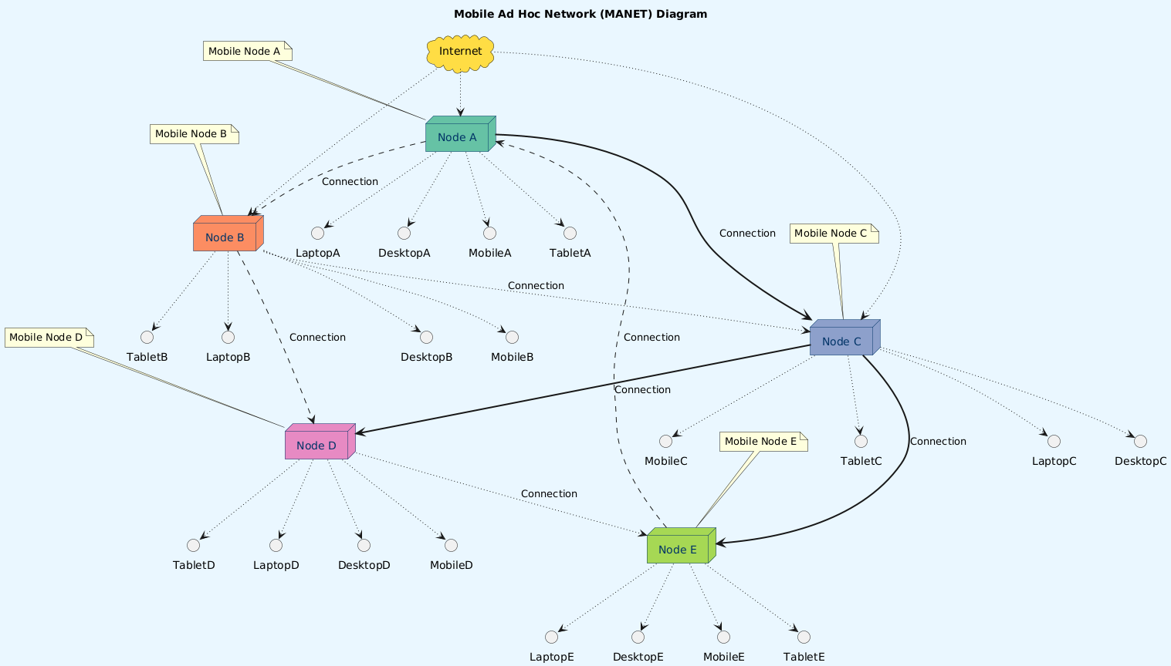
Yet, within this mesmerizing dance lies a vulnerability that could unravel the entire tapestry with terrifying speed. The very traits that make MANETs so versatile—openness, lack of centralized control, and constant flux—also render them exceptionally susceptible to the pernicious threat of Distributed Denial of Service (DDoS) attacks. Picture an invisible adversary orchestrating a symphony of digital chaos, flooding the network with malicious traffic, and overwhelming its capacity to process legitimate data. The attacker, wielding an arsenal of compromised devices, unleashes a relentless torrent of data packets, jamming the pathways and effectively silencing the nodes. The impact is catastrophic, plunging the network into disarray, crippling communications, and obliterating the very essence of connectivity that defines a MANET.
Protecting MANETs from such malevolent forces is not merely a technical challenge; it is a critical imperative in our hyper-connected world. These networks often underpin vital applications, from military operations to disaster recovery, where the uninterrupted flow of information can mean the difference between order and chaos, safety and peril. Ensuring robust defenses against DDoS attacks involves a blend of advanced detection mechanisms, resilient design strategies, and real-time adaptive responses. In safeguarding MANETs, we not only preserve the integrity and reliability of these fascinating networks but also uphold the trust and security of the countless applications that depend on their seamless operation.

As all web applications use the application layer of wireless ad-hoc networks and MANET is the answer to anytime anywhere network, for attackers it becomes very lucrative to target networks. There are several attacks like jellyfish, blackhole, and wormhole which can disturb ongoing online sessions but denial of Service and most importantly the Distributed denial of Service i.e. DDoS is the most dangerous version of it becomes more difficult to detect as it uses legitimate requests to launch an attack on the server. It aims to exhaust network resources so that legitimate user will be unable to access the network in their respective session. It is also reported that the Russian government was involved in US presidential elections.

Attackers typically use policy disagreements between the government and themselves as justification for targeting government websites. DDoS attacks against various government websites have been carried out by the international hacker collective Anonymous; most lately, the government of Spain was targeted in the provision of Catalan independence [5]. These kinds of attacks have also been directed towards the governments of the United States of America [6], Ireland [7], India [8], and Brazil [9] in recent years. These attacks highlight the lack of security measures and underlying vulnerabilities in the government infrastructure. Websites for banks and online retailers are frequently the targets of DDoS attacks. Arbor Networks tracked approximately 125 thousand DDoS attacks weekly during the 18 months of the year 2015 and 2016 respectively [10].
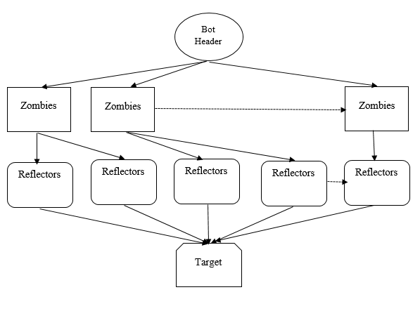
Figure 1 Botnet
A botnet is a network of infected computers that work together to achieve a goal under the direction of a single master as shown in Fig. 1. A further degree of annoyance was caused by tricking a computer into launching a DDoS attack. The innocent machines referred to as "reflectors" receive a devious association request from a "zombie" system within the botnet. The interaction appeal will deceive the reflector into believing that the independent server is reaching out to them, and resembling any good machine, it will try to make contact again to determine its needs. When a sufficient number of remorseless "reflectors" ping the server at the same time, a denial-of-service attack is launched. Table 1 highlights recent DDoS attacks in the world, which critically explain the severity of these attacks [11].
Table 1 Impact of DDoS
Target | Role of target | Year | Intention
Google [23] | Search Engine | 2023 | To take down service
Cloudflare [29] | Remote access | 2021 | To take down cloud service
Telegram [26] | Messenger | 2019 | To take down communication service
Spanish bank [25] | Website | 2018 | To stop Monetary Transactions
Amazon AWS Division[30] | Cloud Computing | 2019 | To make AWS Services offline
HSBC [27] | Website | 2016 | To stop Monetary Transactions
BOA [28] | Website | 2012 | To stop Monetary Transactions
GitHub [23] | Offers housing of websites | 2018 | To make Servers offline
Dyn [24] | DNS Provider | 2016 | Websites went down
Valtia [32] | Heating Systems  Provider | 2016 | Temperature modification  botched in a city in Finland
Trafikverket [33] | Sweden Transport Administration | 2017 | Reservations website miscarried
MTN [34] | Internet provider | 2016 | Internet was absent in portions of the country

2. BACKGROUND

2.1 DoS and Application Layer DDoS attack.

Among the earliest types of attacks against web applications are denial of service (DoS) attacks. What can be regarded as a DoS attack was first used in the late 1990s, according to reports [19]. Since then, they have developed into the lion's share of all prevalent attacks on worldwide websites. The number of attackers involved is what separates a DoS attack from a Distributed DoS (DDoS) attack. A denial-of-service attack generally suggests one or a small group of attackers. DDoS attacks can necessitate large groups of people and are more widespread. Zombies or bots are systems that have already been infected with malware and are posing as attackers on the representation of real attackers. to create a botnet which is a group of compromised systems, attackers typically use a huge quantity of these bots to launch a DoS attack.
As network bandwidth can be easily depleted with a large volume of requests, many DDoS attacks target it. Attackers solely torrent the server with a lot of network packets, thereby utilizing all possible bandwidth. For this, network layer protocols such as User Datagram Protocol (UDP) and Internet Control Message Protocol (ICMP) are implemented. Two things changed over time. Servers were able to bid better and more bandwidth, and networks and servers became more resilient in detecting DDoS attacks at the network layer. DDoS attacks at the application layer are extremely focused. Attacks can be conducted against the CPU, memory, database, or socket connections. Application-layer attacks are distinct from other types of attacks due to a few subtle differences as they are launched with legitimate requests and low traffic volume and they have a resemblance with flash events. An unexpected increase in genuine customer traffic to a website, usually because of a significant event or, aimed at e-commerce sites, a massive sale is known as a "flash event."
The four main layer 7 protocols that have been used in application layer DDoS attacks are HTTP, SOAP, DNS, and SIP. Out of this HTTP is vastly used to launch attacks. The purpose of HTTP was to make it easier for a web server and a human user to communicate via a web browser. Since HTTP is a TCP-based connection-oriented protocol, communication cannot begin until a TCP connection is made. This agreement is upheld until the conclusion of the correspondence. Attackers have frequently used various HTTP features for malicious purposes. Because HTTP was created with entire users including those with limited bandwidth in mind, it enables users to split an HTTP message up into several packets. An attacker can maintain an infinitely long connection if he wrecks his HTTP messages into minuscule packets. An attacker who can preserve numerous contacts open for an infinite amount of time can commendably power the server to reject genuine connections because web applications have a preconfigured limit on the number of socket connections they can uphold concurrently.

2.2 DoS And Application Layer DDoS attack

The first line of defense is the user puzzle. A denial of service attack stems primarily from an attacker's ability to dispatch self-acting requests to the web server. This is achieved by using easy DDoS tools or scripts that are available online which is free of cost, or by using botnets. Therefore, preventing automated requests from accessing the system is the fundamental line of defense against any kind of DDoS attack. A straightforward method for accomplishing this is by using user puzzles. A user puzzle is a necessary step that is relatively easy for a human user to accomplish but very difficult for a self-acting system to accomplish. It can be handled by a suitable image processing method.
Subsequent is detecting application DDoS attacks with several aspects like analyzing statistics, dynamics, templates,s and semantics of incoming requests to the server. Many attackers use HTTP requests to launch application layer DDoS attacks. The following table summarizes the various research work proposed in the detection aspect along with its mechanism, features exploited, and limitations. Table 2 highlights all prevailing detection schemes along with features used for detecting application layer DDoS attacks. This table also highlights the approach for detection as well as its limitations, which can be further modified for improvement.
Table 2 Detection Mechanisms
Work | Features | Detection Approach | Restrictions
Chonka et al. [12] | XML features | Neural network | Large variability
Ni et. al. [13] | HTTP request | Traffic Estimation | Assuming regular traffic pattern
Devi & Yogesh [14] | HTTP request | Access Matrix | The request sequence is ignored
Johnson Singh et. al. [15] | HTTP count | entropy | Time complexity
Singh & De [16] | HTTP count | IP addresses | Time complexity
Xie & Yu [17] | Page popularity | HsMM | High complexity
Khan et al. [18] | DNS requests | Chaos Theory | 66 % accuracy
Sengar et al. [19] | SIP Request | Hellinger distance | Fails for low-rate attacks
Golait & Hubballi [20] | SIP Request | PCDTA | Separate model for each connection

There are four stages of a defense strategy namely prevention, detection, differentiation, and mitigation to protect web servers against DDoS attacks. Although a great deal of study has been done on DDoS attack prevention strategies, they are still insufficient to stop DDoS attacks since new and varied attack types can always be launched, for which there are no known attack patterns in the database. To properly exterminate the DDoS attack utilizing mitigation strategies, the detection phase of the attack must be carried out while the attack is still in progress. The detection strategies that fall under this category are anomaly-based, signature-based, and hybrid detection, which combines both of these approaches. Once it has been established that the DDoS Attack is being carried out on a web server, the mitigation portion of DDoS Defense must be implemented. By lessening the severity of a DDoS attack, the mitigation mechanism guarantees that all legitimate users will complete their requests. Once more, there are two kinds of mitigation phases: capability-based mitigation systems and filtering-based mitigation systems. It might be difficult for researchers to discriminate between valid traffic and DDoS attacks because the attackers always use more sophisticated strategies to target servers. The main targets of these DDoS attacks are well-known websites. It implies that there will not be any symptoms to deal with these attacks effectively soon. Privacy preservation also can be considered along with these aspects. [31] [11]

3. Proposed Methodology

This paper proposed a DDOS Attack Detection model in MANET as the request made by the user can be categorized as either legitimate or non-legitimate by the attack detection using the suitable classifier. Fig. 2 shows the proposed model for DDoS attack detection at the application layer with the mobile ad-hoc network in consideration. The classifier can be trained using the suitable DDOS dataset to determine whether the received request of the user is a valid user or an illegal user. This should be the training phase; several procedures were carried out, including pre-processing, feature mining, feature assorting, and sorting. Pre-processing should be the first step in formatting the data to improve classification accuracy before using it for training. Here, the redundant data can be removed, the non-numerical data can be numeralized.
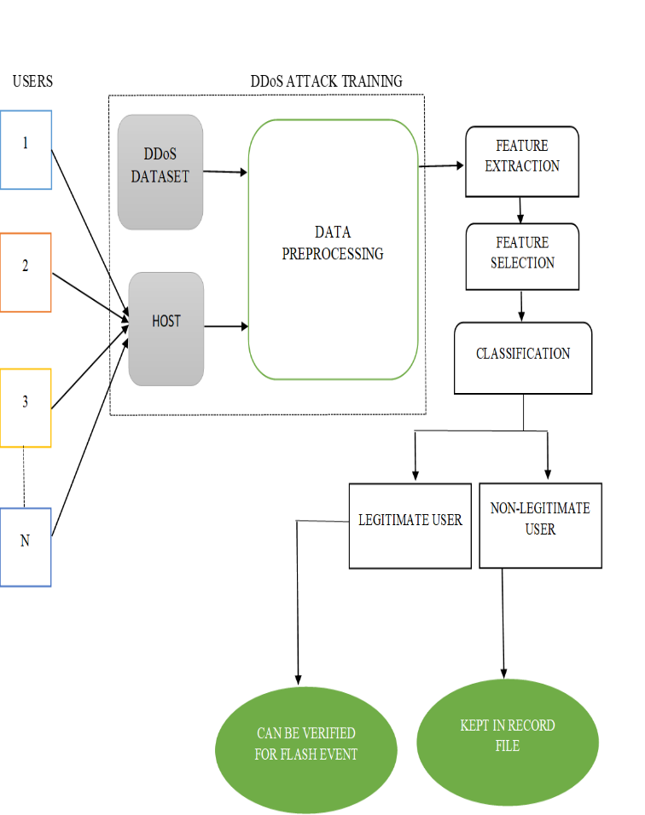
Figure 2 Proposed Model for application layer DDoS attack detection
The feature extraction procedure is proposed to be carried out after pre-processing to extract the important features from the pre-processed data. Features such as source port, destination port, flow duration, source IP address, all backward packets, all forward packets, timestamps, protocol, etc. It can be drawn out from the pre-processed data. The next stage can be featuring selection, which can reduce a large set of features by selecting effective features from the extracted features. Following successful DDOS attack training and achieving the outcomes as a valid user and illegal user, the MANET request will be subjected to the well-equipped system. If the user is authentic, the request will be processed further; if not, it will be compiled into the log file. If we can add a mitigation phase along with a check of differentiation for flash events after the detection phase then it will act as a complete shield for MANET to safeguard the application layer from DDoS attacks.
To detect whether the received request of the user is a legitimate user or a non-legitimate user, the classifier is trained by utilizing the DDOS dataset in this phase. Various processes like pre-processing, Feature Extraction (FE), Feature Selection (FS), and classification were undergone in the training phase. The input data acquired as of the DDOS dataset is provided by,
[
]
da
d
d
d
d
T
T
T
T
T
,..,
,
,
3
2
1
=

(1)

Where the number of input data was represented by.

3.1 Preprocessing

For elevating classification accuracy, the initial step taken to format the data before utilizing the data for training is pre-processing. Here, the duplicate data is eliminated, and the non-numerical data along with the data is normalized by preprocessing the data initially. The process is described below,

3.1.1 Data de-duplication
By leaving a single copy to be amassed, duplicate copies of similar data are eradicated in the data de-duplication process. Here, Map-reduce is employed to perform data de-duplication. Two tasks namely map and reduce were performed by the Map Reduce model. The individual data as of the input training data are broken down into several key-value pairs in the map task. The input given to the reduced task is the output as of the map where the reduced task aggregates along with combines those data pairs into smaller data. From the Map Reduce technique, the obtained non-duplicate data is finally expressed as,

(2)

Where the number of non-duplicate data is signified by.

3.1.2 Numeralization
Non-numerical data like strings, Boolean, etc are contained in the data after the removal of duplicate data. For classification purposes, these non-numerical data are transformed into numerical data. Therefore, the generalized data is provided by,

(3)

Where the numeralized data is signified as.

3.1.3 Normalization
For elevating the training process’s speed, the data is normalized in a particular range by utilizing the normalization process. Here, Z-Score normalization is utilized to normalize the numeralized data. The process of normalizing every value in data such that the average of all values is 0 and the Standard Deviation (SD) is 1. The normalized data is provided by,

(4)
Where the mean of generalized data is represented by and the SD of generalized data is
signified by.

3.2 Feature Extraction

To extract the vital features of the preprocessed data, the feature extraction process was eventuated after preprocessing. As for the preprocessed data, the features like source port, destination port, flow duration, destination IP address, total backward packets, source IP address, timestamps, total forward packets, protocol, etc are extracted. The extracted features are expressed as,

(5)

Where the number of extracted features is proffered by.

3.3 Feature Selection

By choosing the effective features as of the extracted features, a large set of features is diminished by utilizing an FS technique. Here, the Brownian motion-centered Harris Hawks Optimization (BM-HHO) Algorithm was utilized to choose the optimal features from the extracted features. The hunting strategies of Harris Hawks were the inspiration for the HHO, which is a population-centered optimization technology. Three stages included in HHO are,

- Exploration
- Transformation of exploration
- Exploitation

To surprise the prey, the Hawks attack collaboratively in many directions in this algorithm. Grounded on the plots’ nature and prey’s escaping patterns, several chase styles were exposed. Without consuming too much energy, the prey is caught by the hawks easily grounded on the strategy. The algorithm’s performance was elevated by the proposed Brownian motion techniques in the work that augment the soft besiege’s performance in the prevailing HHO. Hence, BM-HHO is the proposed model. The three stages of BM-HHO are described below,

3.3.1 Exploration stage
The hawks are initialized as (extracted features) initially. Grounded on the prey’s location, the hawks perched in random places at this exploration stage. Grounded on the intended prey, the fitness value is computed for all these possible solutions in each iteration. Grounded on classification accuracy, the fitness value is computed here. The Hawks that are expressed mathematically utilized two diverse strategies,

(6)

Where, the current iteration is proffered as, the hawk’s position in the next iteration is represented as, the position of random hawk population is signified as, the current position of hawks is indicated as the prey’s position is notated as are random numbers in the interval (0,1), the lower and upper bounds of variables are symbolized as and along with represents the average position of hawks in current iteration which is expressed as,

(7)

Where the position of each hawk is notated as.

3.3.2 Transformation of exploration
The major fact in the transition stage is the escape energy of prey, which is mathematically expressed as,
(8)

Where, the initial energy of prey varying randomly in the interval (-1, 1) is modeled as, and the maximal number of iterations is notated as. To determine the prey’s position, hawks continue the exploration stage. The prey’s location has been determined when and the exploitation stage gets initiated.

3.3.3 Exploitation stage
The hawk attacked the prey utilizing the four chasing strategies and prey-escaping behavior at the exploitation stage. For a successful attack, escaping energy and potential for escape are requisite. When, be the potential of escape assuming that the prey has successfully escaped. The prey is not successfully escaped, when.

The prey’s energy is high when and but the prey has a low tendency to escape. The Hawks conducted the soft besiege strategy in this case. It is formulated mathematically as,

(9)

(10)

Where, the variation betwixt the prey’s and hawks’ current position is modeled as, the prey random jump procedure is indicated as, which is computed utilizing the Brownian motion technique.

(11)

Where, the constant is signified as, the number of sudden motions is notated as, the diffusion parameter is symbolized as, and the prey random jump procedure is indicated as.

Both the prey’s energy and escape tendency are very low when and. The Hawks conducted the hard besiege strategy in this case.
This strategy is mathematically formulated as,

(12)

The tendency to escape and prey's energy is high when and. The Hawks performed a soft besiege with a progressive rapid dive strategy in which the Hawks gradually dived smoothly. In two ways, the hawk’s position is updated. By estimating the prey’s next move, the hawks move towards the prey initially, which is expressed as,

(13)

Grounded on the comparison flanked by the previous dive and the possible outcome, the Hawks decided whether to dive or not in the second step. Otherwise, grounded on the Levy Flight (LF) pattern, the irregular dives were engendered by the Hawks. It is expressed as,

(14)

Where, the problem’s size is signified as, the randomly determined vector is symbolized as, and the LF is notated as, which can be computed by employing,

(15)
(16)

Where, the random values inside (0, 1) are proffered as, the constant is modelled as, and its value is set to 1.5 and the standard gamma function is notated as. Grounded on classifier accuracy, the fitness is computed. Therefore, updating the Hawks' position is expressed as,

(17)

The prey tends to escape when and. However, the prey’s energy is lower. The Hawks conducted the hard besiege with a progressive rapid dive strategy in this case. The calculation of and are provided by,

(18)

(19)

Thus, the updated hawk’s position is evaluated by utilizing the equation (16).

The optimal features were chosen by the proposed model utilizing BM-HHO as of the extracted features for further classification in a similar way of attacking the prey grounded on certain strategies.

3.4 Classification

To classify whether the user is a legitimate user or a legitimate user, the optimal features are trained to utilize an X-SPCNN classifier after FS. A class of neural networks is CNN. The Convolution Layer (CL), Pooling Layer (PL), and Fully Connected Layer (FCL) comprised the CNN. Uncertainty scaling and vanishing gradient issues are contained in the prevailing CNN algorithm. In the prevailing algorithms, the Xavier SoftPlus technique is utilized to tackle these issues. Hence, X-SPCNN is the proposed model. Figure 3 exhibits the X-SPCNN’s architecture.

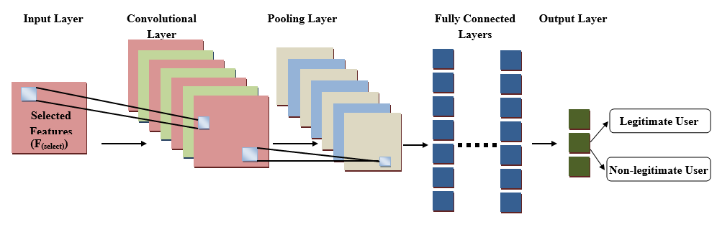
Figure 3: Architecture of X-SPCNN

The steps of X-SPCNN are explained below,

Primarily, the input fed to the CL is the optimal feature. As for the input, the first layer is the CL which is utilized to extract the features. A set of filters are contained and each filter convolves with the input along with engendering an activation map. The CL’s output is expressed as,
(20)

Where, the channel index is indicated as, the coordinates of optimal features are notated by, the convolutional kernel is provided by, which are randomly taken and the Softplus Activation function is signified as which is a ReLU function’s smooth approximation utilized to constrain the output to be always positive. The Softplus Activation function can be articulated as,

(21)

To diminish the computational cost, the convolved feature map’s size is diminished by the down sampling which is also known as PL, after the CL. The input taken is the convolution output’s small regions, which are sub-sampled to engender a single output. The PL’s output is provided by,
(22)

Where the down sampling that retains the maximal value in the pooled area is signified as. By utilizing flattening, the output is transformed into a single long linear vector after all convolutions pooling layers. The input given to the FCL is the flattened output. A neural network is contained in the FCL where it multiplies the input with a weight matrix and sums a bias vector along with the neurons. To elevate the weighted inputs, the Xavier Initialization technique is employed to initialize the weight in this layer. Therefore, the weight is initialized as,

(23)

Where the number of input paths towards a neuron is proffered by and the number of output paths towards a neuron is signified by. The FCA's output is given by,

(24)

The classified output is engendered by the softmax activation function, which is given by,

(25)

The MANET request will be tested with the trained system after successful DDOS attack training along with attaining the outcomes as a legitimate user and a legitimate user. The further process will be executed if the user is legitimate, otherwise, the request will be amassed into the log file.

4. Dataset
The employed CIC-Darknet2020 dataset is crucial for detecting application layer DDoS attacks. It contains information about network traffic that was taken from a darknet network. In the CICDarknet2020 dataset, a two-layered approach is applied to synthesize benign and darknet traffic in the first layer. The audio-stream, browsing, chat, email, P2P, transfer, video-stream, and VOIP are produced by the second layer of the internet. information gathered by the Canadian Institute for Cybersecurity at the University of New Brunswick. This dataset was gathered in order to assess novel methods for classifying internet traffic.
5. Results
This section conducts a study of the proposed model and draws comparisons with existing methodologies. The working platform used to apply the methodology is Python. The experiential analysis of the suggested model is carried out using the publicly accessible datasets.
First, a fitness vs. iteration analysis is conducted to check how close are given features to optimal features and compared to the existing Harris Hawks Optimization (HHO), Rock Hyraxes Swarm (RHS), Monarch Butterfly Optimization (MBO), and Crow Search Algorithm (CSA) for the proposed Brownian Motion-based Harris Hawks Optimization (BM-HHO) algorithm. The DDoS attack detection analysis is carried out for the proposed Xavier SoftPlus Convolutional Neural Network (XP-CNN) and is compared with the RNN, Deep Belief Network (DBN), CNN, and DNN in terms of metrics like accuracy, precision, recall, F-Measure, and training time.
Table 3 FITNESS Vs ITERATIONS
Iterations | Proposed BM-HHO | HHO | RHS | MBO | CSA
10 | 118 | 97 | 78 | 58 | 37
20 | 136 | 118 | 95 | 76 | 51
30 | 158 | 137 | 117 | 98 | 76
40 | 178 | 157 | 137 | 116 | 98
50 | 198 | 175 | 154 | 137 | 117
Table 3 displays the suggested BM-HHO algorithm along with the fitness vs. iteration analysis of the dominant HHO [35], RHS [36], MBO [37], and CSA [38] algorithms. The least effective CSA algorithm was the one that was currently in use. But for every iteration, the suggested BM-HHO algorithm yields the highest fitness value. The suggested model outperformed the popular HHO, RHS, MBO, and CSA algorithms with a fitness value of 198 after 50 iterations. The fitness vs. analysis graph for the values in Table 1 is shown in Figure 4.

Figure 4: Fitness vs Iteration Analysis

Table 4 Performance analysis of the proposed XP-CNN algorithm
Metrics/ Techniques | Proposed XP-CNN | RNN | DBN | CNN | DNN
Accuracy | 96.5609 | 95.7671 | 93.3450 | 91.5492 | 90.6574
Precision | 96.5778 | 95.8477 | 93.4256 | 91.6955 | 90.6574
Recall | 96.8745 | 94.8756 | 93.8476 | 91.8653 | 90.5478
F-Measure | 96.3545 | 95.4578 | 93.6875 | 91.1548 | 90.6849
Table 4 compares the proposed XP-CNN method with the current RNN, DBN, CNN, and DNN algorithms in terms of accuracy, precision, recall, and F-measure. Here, the XP-CNN method that was suggested performed better in all metrics, while the DNN that was in use performed worse. The accuracy of the suggested XP-CNN method was 0.81% and 6.51% higher than that of the DNN algorithm that was currently in use. The suggested approach outperformed the current RNN [39], DBN [40], CNN [42], and DNN [41] algorithms in terms of precision, with a 96.5778% accuracy rate. Furthermore, compared to the current techniques, the recall and F-measure values of the proposed XP-CNN algorithm are greater. It is appropriate to use the proposed XP-CNN method for effective DDoS attack detection in MANET. The suggested XP-CNN's performance metrics are shown in figure 5.
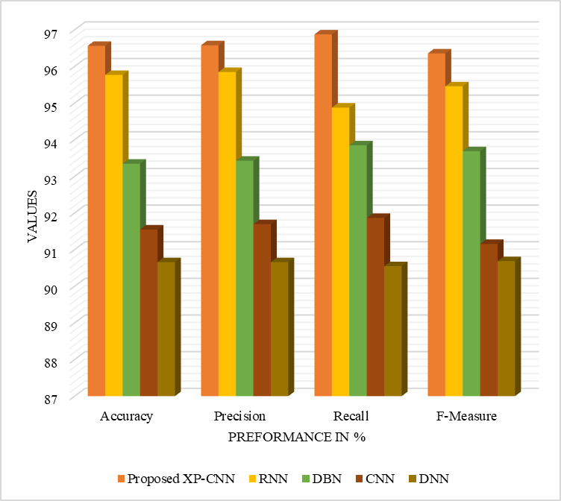
Figure 5: XP-CNN algorithm in comparison with the existing methods

6. Conclusion
The performance study of the proposed XP- CNN system is compared with the existing algorithms in methodical means. When it comes to accuracy, precision, F-measure, and recall, the results showed that the suggested XP-CNN method performs better than the dominant algorithms. With an accuracy of 96.56%, the suggested technique outperforms the traditional algorithms. The suggested model divides users into groups that are legitimate and non-legitimate using the XP-CNN algorithm. By developing a revolutionary cryptographic technique for data security and energy-efficient data transfer, the task can be improved.

7. References

- Gurung, Shashi, and Siddhartha Chauhan. "Performance analysis of black-hole attack mitigation protocols under gray-hole attacks in MANET." Wireless Networks 25 (2019): 975-988.
- Rani, B. Sandhya, and K. Shyamala. "Energy efficient load balancing approach for multipath routing protocol in ad hoc networks." 2019 Second International Conference on Advanced Computational and Communication Paradigms (ICACCP). IEEE, 2019.
- Doss, Srinath, et al. "APD-JFAD: accurate prevention and detection of jellyfish attack in MANET." Ieee Access 6 (2018): 56954-56965.
- Hammamouche, Assia, et al. "Lightweight reputation-based approach against simple and cooperative black-hole attacks for MANET." Journal of information security and applications 43 (2018): 12-20.
- I. S. Magazine, Anonymous Attacks Spanish Government Sites, 2017. [Online]. Available: https://www.infosecuritymagazine.com/news/anonymous-attacks-spanish/

- Incapsula, Analysis of Vikingdom DDoS Attacks on U.S. Government Sites, 2015. [Online]. Available: https://www.incapsula.com/blog/ kingdom-DDoS-attacks-us-government.html
- Silicon, Irish Government Websites Taken Down By DDoS Attacks, 2017. [Online]. Available: http://www.silicon.co.uk/e-regulation/irish- government-websites-DDoS-184428
- Register, Anonymous turns its DDoS cannons on India, 2012. [Online]. Available: https://www.theregister.co.uk/2012/05/18/ anonymousddosindiasites/
- Corero, DDoS Attacks Plague Olympic & Brazilian Government Websites, 2016. [Online]. Available: https://www.corero.com/blog/749- DDoS-attacks-plague-olympic--Brazilian-government-websites.html
- A. Networks, 2016 DDoS Attack Statistics, 2016. [Online]. Available:https://www.arbornetworks.com/arbor-networks-releases-global-ddos-attack-data-for-1h-2016

- Salunke, Kiran, and U. Ragavendran. "Shield techniques for application layer DDoS attack in MANET: a methodological review." Wireless Personal Communications 120.4 (2021): 2773-2799.
- A. Chonka, Y. Xiang, W. Zhou, and A. Bonti, “Cloud security defense to protect cloud computing against http-dos and xml-dos attacks,” Journal of Network and Computer Applications, vol. 34, no. 4, pp. 1097–1107, 2011.

- T. Ni, X. Gu, H. Wang, and Y. Li, “Real-time detection of application- layer DDoS attack using time series analysis,” Journal of Control Science and Engineering, vol. 2013, p. 4, 2013.

- S. R. Devi and P. Yogesh, “An effective approach to counter application layer DDoS attacks,” in Computing Communication & Networking Technologies (ICCCNT), 2012 Third International Conference on. IEEE, 2012, pp. 1–4.

- K. Johnson Singh, K. Thongam, and T. De, “Entropy-based application layer DDoS attack detection using artificial neural networks,” Entropy, vol. 18, no. 10, p. 350, 2016.

- K. J. Singh and T. De, “Mlp-ga based algorithm to detect application layer DDoS attack,” Journal of Information Security and Applications, vol. 36, pp. 145–153, 2017.

- Xie, Yi, and Shun-Zheng Yu. "Monitoring the application-layer DDoS attacks for popular websites." IEEE/ACM Transactions on Networking 17.1 (2008): 15-25.
- M. S. Khan, K. Ferens, and W. Kinsner, “A chaotic measure for cognitive machine classification of distributed denial of service attacks,” in Cognitive Informatics & Cognitive Computing (ICCICC), 2014 IEEE, 13th International Conference on. IEEE, 2014, pp. 100–108.

- H. Sengar, H. Wang, D. Wijesekera, and S. Jajodia, “Fast detection of denial-of-service attacks on IP telephony,” in Quality of Service, 2006. IWQoS 2006. 14th IEEE International Workshop on. IEEE, 2006, pp. 199–208.

- D. Golait and N. Hubballi, “Detecting anomalous behavior in VoIP systems: A discrete event system modeling,” IEEE Transactions on Information Forensics and Security, vol. 12, no. 3, pp. 730–745, 2017.

- Russian interference in the 2016 u.s. election 2018 [Online]. https://www.fbi.gov/wanted/cyber/russian-interference-in-2016-u-s-election
- ‌O. Powell, “Largest DDoS attacks ever reported by Google, Cloudflare, and AWS,” Cyber Security Hub, Oct. 13, 2023. https://www.cshub.com/attacks/news/record-breaking-ddos-attack
- S. Ranger, “GitHub hit with the largest DDoS attack ever seen,” ZDNet, Mar. 01, 2018. https://www.zdnet.com/article/github-was-hit-with-the-largest-ddos-attack-ever-seen/
- N. Woolf, “DDoS attack that disrupted internet was largest of its kind in history, experts say,” The Guardian, Oct. 26, 2016. https://www.theguardian.com/technology/2016/oct/26/ddos-attack-dyn-mirai-botnet
- PYMNTS, “Bank Of Spain Site Disrupted Via DoS Attack - PYMNTS.com,” Aug. 28, 2018. https://www.pymnts.com/news/security-and-risk/2018/bank-of-spain-dos-attack-online-banking-hackers/
- J. Porter, “Telegram blames China for ‘powerful DDoS attack’ during Hong Kong protests,” The Verge, Jun. 13, 2019. https://www.theverge.com/2019/6/13/18677282/telegram-ddos-attack-china-hong-kong-protest-pavel-durov-state-actor-sized-cyberattack
- H. Osborne, “HSBC suffers online banking cyber-attack,” the Guardian, Jan. 29, 2016. https://www.theguardian.com/money/2016/jan/29/hsbc-online-banking-cyber-attack
- I. S. M. G. • December 11 2012, “5 Banks Targeted for New DDoS Attacks,” www.bankinfosecurity.com. https://www.bankinfosecurity.com/5-banks-targeted-for-new-ddos-attacks-a-5346
- “Cloudflare Detects a Record 71 Million Request-Per-Second DDoS Attack,” InfoQ. https://www.infoq.com/news/2023/02/cloudflare-ddos-attack/
- J. Porter, “Amazon says it mitigated the largest DDoS attack ever recorded,” The Verge, Jun. 18, 2020. https://www.theverge.com/2020/6/18/21295337/amazon-aws-biggest-ddos-attack-ever-2-3-tbps-shield-github-netscout-arbor
- Salunke, Kiran, and U. Ragavendran. "An overview of privacy-preserving schemes for VANET." International Conference on Intelligent Data Communication Technologies and Internet of Things (ICICI) 2018. Springer International Publishing, 2019.
- L. Mathews, “Hackers Use DDoS Attack To Cut Heat To Apartments,” Forbes. https://www.forbes.com/sites/leemathews/2016/11/07/ddos-attack-leaves-finnish-apartments-without-heat/
- Catalin Cimpanu, “DDoS Attacks Cause Train Delays Across Sweden,” BleepingComputer, Oct. 13, 2017. https://www.bleepingcomputer.com/news/security/ddos-attacks-cause-train-delays-across-swed
- Tubbs, “MTN weathers DDOS attack,” ITWeb, May 05, 2015.https://www.itweb.co.za/content/nG98Yd7LrpGqX2PD
- Katib, Iyad, and Mahmoud Ragab. “Hybrid harris hawks optimization based deep DDoS attack detection in the IoT environment." Mathematics 11.8 (2023): 1887.
- Raveendranadh, Bokka, and Sadasivam Tamilselvan. "An accurate attack detection framework based on exponential polynomial kernel‐centered deep neural networks in the wireless sensor network." Transactions on emerging telecommunications technologies 34.3 (2023): e4726.
- Babu, Kunda Suresh, and Yamarthi Narasimha Rao. "Improved Monarchy Butterfly Optimization Algorithm (IMBO): Intrusion Detection Using Mapreduce Framework Based Optimized ANU-Net." Computers, Materials & Continua 75.3 (2023).
- H. Beitollahi, D. M. Sharif and M. Fazeli, "Application Layer DDoS Attack Detection Using Cuckoo Search Algorithm-Trained Radial Basis Function," in IEEE Access, vol. 10, pp. 63844-63854, 2022
- Yousuf, Omerah, and Roohie Naaz Mir. "DDoS attack detection in Internet of Things using recurrent neural network." Computers and Electrical Engineering 101 (2022): 108034.
- Li, Yijie, et al. "DDoS attack detection method based on feature extraction of deep belief network." IOP Conference Series: Earth and Environmental Science. Vol. 252. No. 3. IOP Publishing, 2019.
- Khempetch, Thapanarath, and Pongpisit Wuttidittachotti. "DDoS attack detection using deep learning." IAES International Journal of Artificial Intelligence 10.2 (2021): 382.
- Singh, Sukhvinder, and S. K. V. Jayakumar. "DDoS attack detection in SDN: optimized deep convolutional neural network with optimal feature set." Wireless Personal Communications 125.3 (2022): 2781-2797.

