1. Introduction

The general architecture of any network built on MANETs has both common and design-specific features. For instance, these networks rely on a distributed approach to represent both the source and destination of a request in the form of a mobile node or a few nodes transmitting the same message. A recommended approach is to switch from single-hop communication with the final destination to a multiple-hop route across the infrastructure. However, the availability of different pathways means that each node should choose the next one to direct the message. Therefore, it narrows down to choosing a proper metric to measure the distance between two nodes, which can be the number of hops, the amount of data sent over the given period, or even the power of a signal that can be successfully sent to the potential recipient. In general, this characteristic is vital for rendering MANETs functional as illustrated in Figure 1.

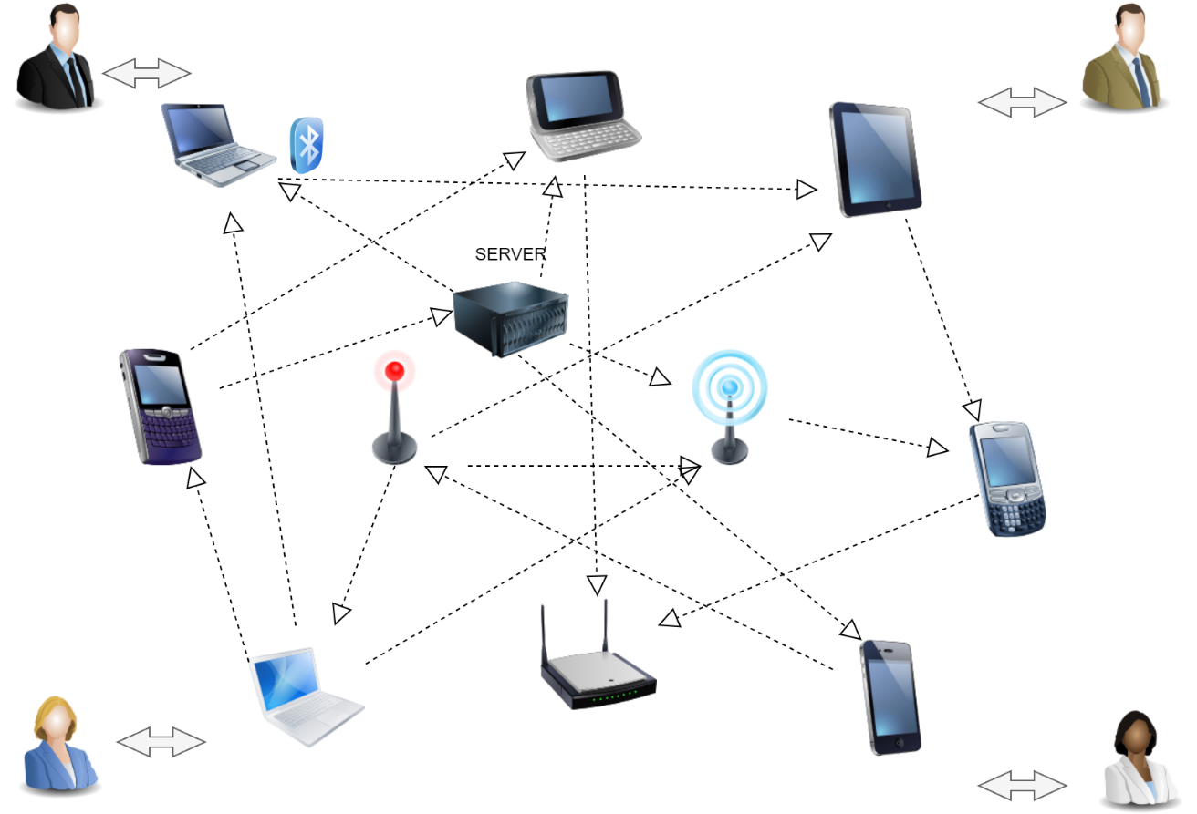
Figure 1 MANET

Security, however, is a main concern in MANETs particularly due to the absence of centralized control points. Without these, handling node association and monitoring the conduct in the network become increasingly difficult [6]. Numerous threats like selfish and malicious nodes often tend to ruin the effectiveness of the network by plummeting the data packets, causing extensive communication failures. Of the many problems, MANETs’ security is widely jeopardized by DoS, Black Hole, Wormhole, Jellyfish, and DDoS attacks. Since DDoS is a large-scale form of attack—it is the most disastrous―as it bombards the system with requests. As a result, the targeted network collapses and is unable to serve authentic clients with their services [7] [8].

New detection methods have been proposed to minimize the risks. These include cluster, entropy, and ML approaches. Specifically, to constitute a group and select a group head, a weight-based cluster algorithm is applied. Additionally, entropy-based systems analyze the incoming traffic and respond when an anomaly is detected. Furthermore, advanced methods developed within the domain of machine learning, which contain Convolutional Neural Networks, Recurrent Neural Networks, and Artificial Neural Networks can be effectively used to determine whether a client is a legitimate user or a malefactor. However, the problem of load balancing is still significant because all incoming traffic transmitted by legitimate users should be distributed across the network nodes so that they are not overloaded with tasks [9].

Load balancing is an issue for node performance optimization. To achieve response times, client requests have to be distributed as efficiently as possible among nodes on the network. Different approaches have been proposed to balance server traffic and energy consumption while detecting DDoS attacks. Although machine learning has made strides in addressing DDoS detection, current methods still have significant limitations, mainly in load balancing and distinguishing between genuine applications and DDoS traffic. Therefore, I propose a method in which Xavier Soft-Plus Convolutional Neural Network, IP spoofing detection, and the PCC-based Linear-Layer Crossover Mutation Invasive Weed Optimization algorithms are used. This system leverages IP spoofing detection to identify DDoS attacks on MANETs. In other words, it discriminates between attacks and genuine activities in separating DDoS attacks and flash events, which are usually comparable to application-level DDoS attacks [10].

The most problematic part of DDoS attack detection in MANETs is the network’s dynamic nature, which means that fixed threshold values will not work. Considering that the number of users in the network is changing hastily, these values will not remain constant. This affects the packet threshold values, which also have to be adjusted. It is challenging to separate the packets that can be considered a flash event and the ones that are recognized as DDoS attacks. This is vital because genuine users’ packets also need more resources, while DDoS packets have to be blocked to ensure that genuine users’ service is not interrupted. In other words, the challenge is to see if one or two resources can process the throughput. However, at present, existing systems still cannot detect whether the normal packet is transmitted in time by a pretend entity, which is a significant challenge. IP traceback is another problem for fragmented data analysis. Even if there are suspicions that the attacker is using IP spoofing to hide the route, the path cannot be detected necessarily [31].

The proposed model seeks to address these limitations by designing a robust framework for DDoS attack detection, mitigation, and flash event discrepancy in MANETs. The solution hinges on enhancing detection accuracy, improving load balancing mechanisms, and overcoming the drawbacks present in existing models.

This paper is organized as follows: Section 2 discourses associated works on DDoS detection and mitigation strategies. Section 3 elaborates on the proposed methodologies for detection and load balancing. Section 4 presents a performance breakdown of the techniques, and Section 5 completes the paper with concluding observations and recommendations for forthcoming research.

2. Related Work

In a related work, S. Sokkalingam and R. Ramakrishnan proposed a Particle Swarm Optimization (PSO) algorithm fine-tuned with hybrid Harris Hawks Optimization for optimizing SVM parameters in an intelligent IDS for DDoS attacks. Similarly, B. Raveendranadh and S. Tamilselvan also applied rock hyraxes swarm optimization algorithms in their IDS. In their work, H. Beitollahi, D.M. Sharif, and M. Fazeli applied Monarch Butterfly Optimization for load balancing in cloud settings. Seraj et al. also developed a cuckoo search algorithm-trained radial source function for detecting application-layer DDoS attacks. Adwan Yasin and Mahmoud Abu Zant proposed a Timer-Based Baited Technique for detecting and isolating MANET black Hole Attacks. This model, an upgraded version of AODV, uses timers and luring to detect single and cooperative BHS. However, the proposal also failed to outperform the compared models. Sankara Narayanan and G. Murugaboopathi proposed the Modified Secure AODV protocol to help overcome Worm Hole Attacks. The presentation of MSADOV is better than AODV and SAODV and the load is distributed equally through packet forward ratios and round-trip times. However, the need to modify and recompile the simulator when user codes change is a disadvantage of MSADOV [33][34][35][36][11][12].

Ramesh Vatambeti et al. introduced GWO for handling DDBG in MANET [13]. GWO performed setup-based data aggregation and the trust to acquire a detection accuracy of 98.5%, lowered the packet loss, and increased throughput. However, the technique significantly failed in the local search operation. Mohd Naseem et al. developed EE-LB-AOMDV, an Efficient Energy Constraints – Centered Load Balanced multipath routing Protocol [14]. It classed multiple paths based on average hop count, round-trip time, and remaining energy. The model, performed best in PD and lagging time, but was not secure from malicious attacks. Zulfiqar Ali Zardari et al. proposed CDS based IDS node to detect dual attacks of MANET [15]. The model successfully detected malicious node attacks but encountered challenges in long-term monitoring.

Abdullah Emir Cilet et al. developed a 93.99% DNN-based model to handle DDoS detection on the CICDDoS2019 dataset [16]. However, a vast quantity of data was required to maintain the performance. Neha Agrawal and Shashikala Tapaswi developed the approach in the frequency domain for LDDoS attack detection using PSD [17]. A false positive rate of 3.7% and a false negative rate of 4.9% were achieved by the method, but it is computationally expensive. P. Chandra Sekar and H. Mangalam developed a MANET load balancing using a 3rd generation mobility[18]. It was an effective approach, but whenever a user’s code changes, it requires the simulator to be recompiled. V. Keerthika and N. Malarvizhi developed the H-BOWT with 2-opt AODV for BHA [19]. The model used ABC for securing paths but was slow in tasks linked to step-by-step processing.

Sengathir Janakiraman et al. Using ICMF [20] also proposed an Integrated Context-Centered Mitigation Framework to protect the MANET from Rendezvous Point attacks. GTIDF and ICMF seem to improved network performance but are not able to solve the attacks made on the root node. The work of R. Bhuvaneswari and Ramachandran [21] used fictitious node verification to detect DoS attacks in OLSR-based MANET. However, such a protocol was unsuitable for real-time environments subject to high levels of node mobility. M. Anbarasan et al. [22] proposed an encryption protocol using trustworthy MANETs to alleviate DoS attacks and reduce memory overhead. However, it was not optimized for larger MANETs. M. Islabudeen and M.K Kavitha Devi developed the Smart Approach for Intrusion Detection and Prevention System (SA-IDPS) Based on Machine Learning [23]. It dealt with four kinds of attacks (DoS, Probe, U2R, and R2L), however working on infinite data made the model complex. Mukul Shukla et al. [24] work on Elliptic Curve Cryptography for the protection of MANETs against Wormhole and Blackhole attacks gives good performance with few nodes but a lot more computational overhead by increasing the number of in-network nodes.

Toklu and Simsek [25] also presented a dual-layer High-Rate, Low-Rate DDoS Attack Detection System It was good at discerning between valid traffic and attack traffic, but it stopped working the moment multiple attackers came into play. Other optimization algorithms also were employed in secondary research into DDoS detection (e.g., SMO, IWO) [41][42][43][44]. Although these methods were promising, their long response times made it difficult to take action.

In this paper, we develop the first complete MANET defense against app-layer DDoS attacks in terms of detection/mitigation & Differentiating from flash events, and evaluate its performance with metrics: accuracy; precision, recall & latency.

3. Detection and Mitigation System for Application Layer DDoS Attack

This phase exploits new techniques such as X-SPCNN, DSRC, and I-CMIWO using PCC with some sort of variation for classifying flash events. The setup is organized in two stages: first, it detects an attack and then mitigates it. When the detection phase is being conducted, to classify user requests as legitimate or non-legitimate an X-SPCNN classifier is. Following the detection, PCC-based I-CMIWO and DSRC techniques will be implemented to observe and handle its output. the block drawing of the projected model illustrated in Figure 2.

3.1 DDOS Attack Detection Phase

In the classifier-training step, a DDoS dataset is used to train the model for classifying whether or not a particular request by the user can be classified as legitimate or non-legitimate. The training phase involves several processes such as pre-processing, feature extraction , feature selection , and classification. Data from the DDoS dataset are preprocessed and made ready for the training classifier.
N_{input} ​= Number of input data (1)

3.1.1 Preprocessing

First and foremost, an important step to follow while training your data is Data Preprocessing to improve Classification accuracy. The pre-processing phase involves getting rid of duplicated records and standardizing data whether they are non-numeric or numeric. This explanation can be viewed here:

Data de-duplication: In context to improve classification accuracy, the first step comes as a pre-processing that helps us render appropriate attention towards de-duplication and normalization. De-Duplication: Removing duplicate entries; It uses the MapReduce framework for data de-duplication. During this process, the map duty splits input data into key-value sets and then reduces various such keys with values to a single unique record without duplicate records. This cleaned data in a multi-matched format this is now ready for analysis and training.

N_{nd} ​= Number of non-duplicate data (2)

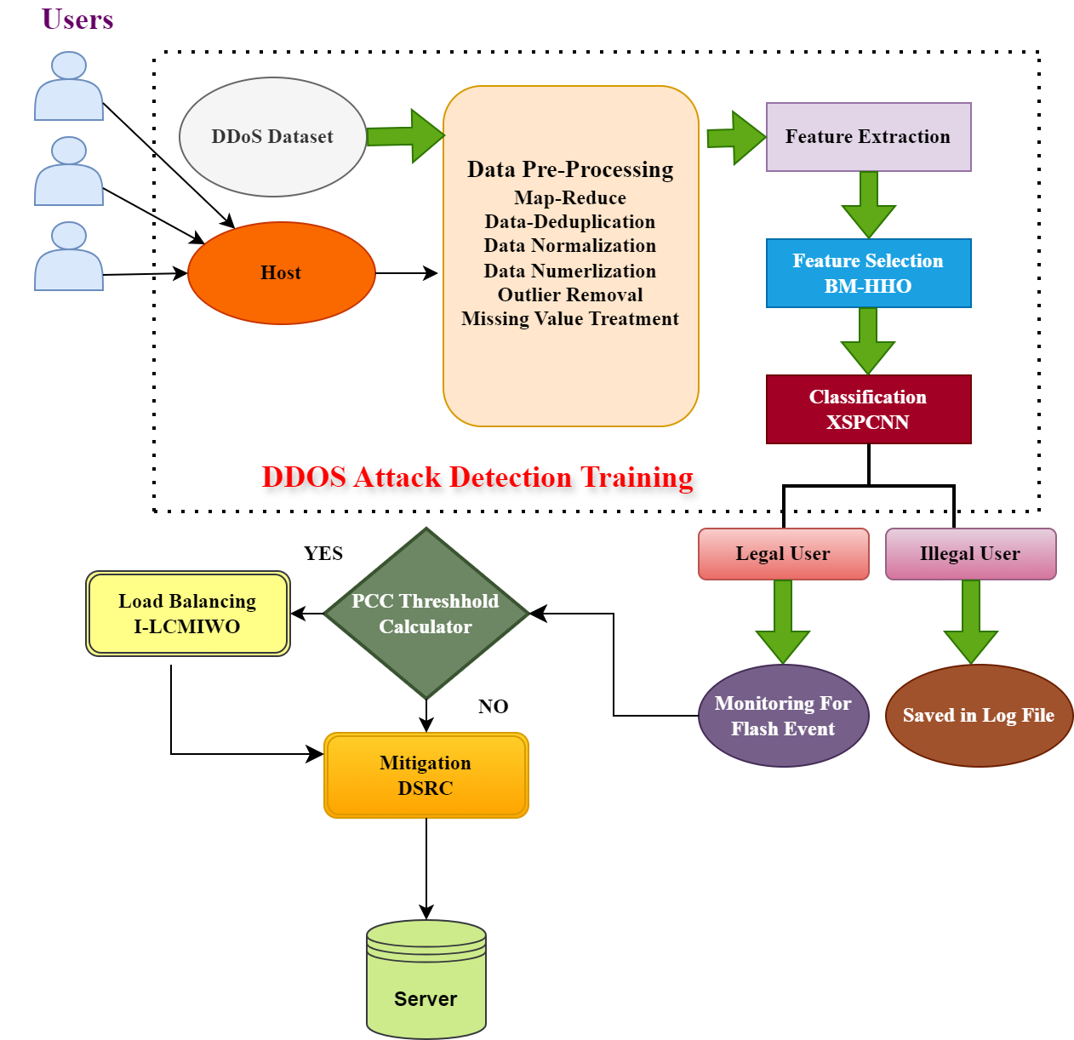

Figure 2: Block diagram of the proposed model

Numeralization: Even after deduplicating, the dataset has nonnumerical data such as strings and boolean values. Conversion of these non-numerical data into numerical kind is executed to classify.

N_{num} ​= Numeralized data (3)

Normalization: Data Normalization is cast to gauge the values in an exact assortment which helps accelerate the training process. For this purpose, Z-Score normalization is used, which standardizes the numeric data by scaling each value to make it so that your dataset will have a mean 0 or SD (Standard Deviation) of 1. Normalizing like this makes the data have 0 mean and a variance = 1 i.e. scaling them down to get normal distribution of values for each feature.

$Zscore=\frac{Nnum-μnum }{σnum}$ (4)

Nnum = generalized data
μnum = mean of the generalized data
σnum = standard deviation (SD) of the generalized data
For Dealing with the Missing Values along with recognizing and handling missing values in the dataset, the imputation technique is measured here, along with the imputation with mean or deletion of missing value instances.

3.1.2 Extraction of Features

Next comes Feature extraction which extracts the main features of data after preprocessing. From the preprocessed dataset, key features such as source IP address, time-stamp elements entries, source port, destination port, flow duration, destination IP address, total backward packets, entire forward packets, and protocol are extracted.

N_{feat​} = Number of extracted features
(5)
3.1.3 Feature Selection

To evaluate the significant feature to enhance learning performance, we propose an efficient and embedded Filter method known as the Brownian Motion centered Harris Hawks Optimization (BM-HHO) Algorithm. this method of feature selection is useful when there are a huge number of features and only a few relevant ones have to be selected from them. Three Steps are needed in the BM-HHO Algorithm which is Inspired by how Harris Hawks employ collaborative hunting strategies, through a population-based optimization approach.

Exploration: This is the first phase in which you are looking for interesting regions of the feature space.

Exploration Transformation: The algorithm learns from the exploration results and refines its search strategy, which addresses increased sensitivity to critical features.

Greedy Stage: Here the algorithm takes notice of those promising features ultimately increasing its selection.

In BM-HHO hawks cooperate and attack the prey in different ways of chase strategies according to the escape patterns of the target prey and environments. This way of hunting requires less energy while increasing the chances of catching prey. The proposed BM-HHO model based on the Brownian motion method is hardware-independent, and it has been shown to outperform the general HHO models by adding a series of effective techniques to feature selection. This article further describes the stages of the BM-HHO algorithm in detail.

Exploration stage:

The first step is initializing the hawks using your extracted features. In the exploration stage, hawks are located randomly according to the position of prey. In every iteration, these positions are evaluated by their fitness value based on the classification accuracy. This fitness measure is responsible for deciding how well each hawk's position (or subset) has performed.

P_{hawk​=}Position of each hawk (6)

To remain competent throughout their lifetimes, the Hawks incorporate two unique treatment tactics Exploration: how to invigorate searching for new (possibly best) arrangements or feature subsets by arbitrarily moving hawks in space of features. Purpose should focus on exploitation – i.e., further refining and optimizing the best current positions, leveraging what has been learned during exploration about where that would be most promising. This allows a compromise to be searched for between a wide search of possible solutions and a high focus on promising ones contributing together with the rest feature selection process performance.

A set of parameters, keep track of the iterations in BM-HHO, and locate the hawk at each iteration. Where the random hawk population is located is shown as their existing location of the hawks. The position of the prey is also recorded and random numbers are generated which are produced with an interval (0, 1). Also, we specify the minor and superior bounds of variables as well as the current individuals’ average position in iteration. It is those balance elements that guide optimization and feature selection decisions to make certain of relatively fine-tuned adjustments to the Hawks’ movements from iteration to iteration

Exploration using Transformation: The main statistic in the evolution phase is the escape umph of prey, which is mathematically articulated as,

E_{Prey} = 2⋅ (1− t / Tmax​​) (7)

Where:
- E_{Prey} = escape the energy of prey
- t = current iteration
- Tmax = maximum number of iterations

Where, the preliminary energy of prey shifting indiscriminately in the intermission (-1, 1) is modeled as E_{Prey}, to regulate the prey’s location, hawks remain in the exploration stage. The prey’s position has been resolute when E_{Prey} ≤ 1 and the exploitation stage gets started.

Exploitation stage: the hawk confronted the prey exploiting the four hurtling policies and prey-escaping conduct at the exploitation step. For an efficacious attack, escaping energy and probable escape are obligatory. When, be the potential of escape pretentious that the prey has efficaciously escaped. The prey does not efficaciously escape when E_{Prey} ≥ 0.5

It is formulated mathematically as,

P_{new}​=P_{hawk​+}J⋅E⋅(P_{prey}​−P_{hawk}​) (8)

Where:
- J = jump strength modeled using Brownian motion
- P_{prey} = position of prey
- E= escape energy

Thus, the restructured hawk’s location is assessed by exploiting the equation (9) & the optimum features were selected by the proposed model employing BM-HHO as of the mined features for supplementary sorting in an alike way of aggressive prey grounded on convinced approaches.

3.1.4 Categorization

After feature selection, the optimal features are used to train the X-SPCNN classifier. This is an enhanced CNN using the Xavier initialization method and the Soft Plus activation function. The domination of the CNN algorithm is getting better and contains many additional improvements over time but neither has it solved the uncertainty scaling issue nor vanishing gradients. These problems can be solved by the Xavier Soft Plus method in existing algorithms. Figure 3 displays the architecture of the proposed X-SPCNN.
.
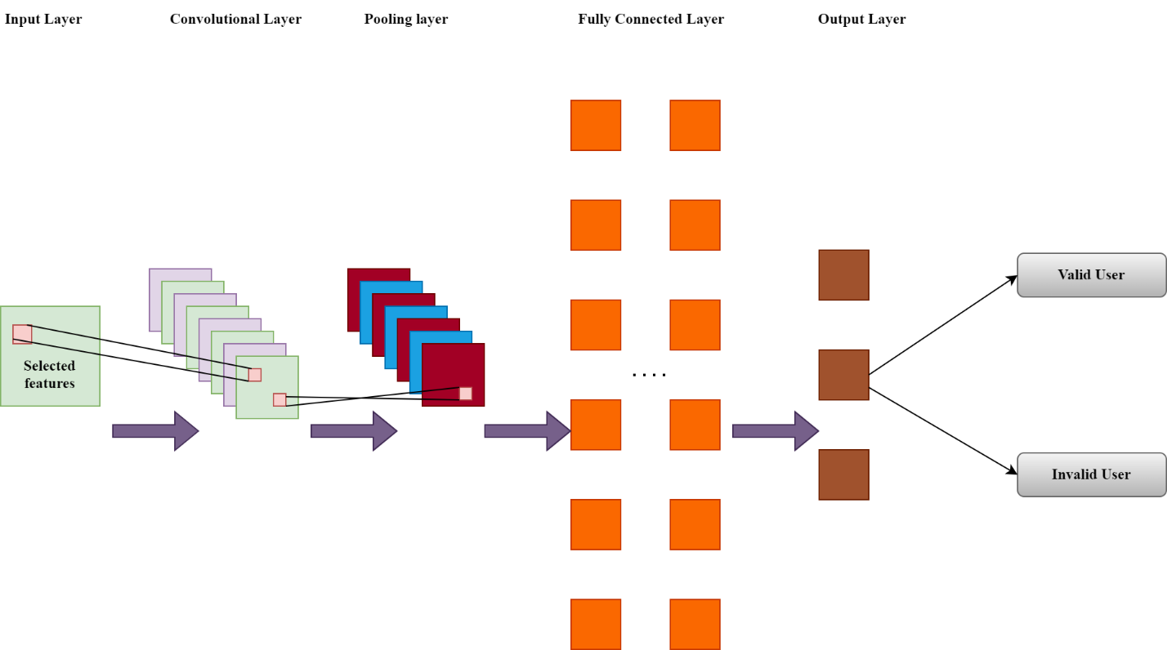

Figure 3: Architecture of X-SPCNN

The phases of X-SPCNN are described below,

After feature selection, the optimal features are used to train the X-SPCNN classifier. This is an enhanced CNN using the Xavier initialization method and the Soft Plus activation function.

Convolution Layer: The convolution operation extracts features from the input.

O_{CL} = A$\sum_{i=1}^{n}{wi .Xi+b}$
Where:
- O_{CL} ​ = output of the convolution layer
- Wi = convolution kernel
- Xi ​ = input features
- b = bias term
- A = activation function (Soft Plus)

Soft Plus Activation Function:
A(x) = ln (1+e^{x}) (9)
Pooling Layer: After the convolution operation, down-sampling is applied to reduce the computational cost.
O_{PL}= max (O_{CL}) (10)

Fully Connected Layer (FCL): The flattened output is passed through the FCL. Xavier Initialization is used to initialize the weights.
W_{FCL}∼N (0, 1 / N_{input}) (11)

Soft-max Activation Function: The final classification is performed using the SoftMax activation function.

P(y=i) = e^{zi} / ∑e^{zj} (12)

for 1 ≤ j ≤ N

Where:
- Zi= input to the Soft-max function for class i
- N = number of classes

3.2 Mitigation Segment

The request is observed for flash events before mitigation. The Pearson Correlation Coefficient (P_{CC}) is used to detect flash events if a big quantity of valid requests is acknowledged.

$Pcc= \frac{Σ((Sᵢ - μs)(Cᵢ - μc)) }{√[Σ(Sᵢ - μs)² * Σ(Cᵢ - μc)²] }$ (13)

Where,
Sᵢ and Cᵢ are individual sample points,
μs and μ_{c} are the means of S and C
If the PCC is below the threshold θ, the request is mitigated. Otherwise, it is advanced to the load-balancing stage.

3.2.1 Load balancing

Load balancing is a process of distributing tasks across resources to prevent traffic congestion. In this context, we employ the Interpolation–Crossover Mutation Invasive Weed Optimization (I-CMIWO) Algorithm. This algorithm is designed to maintain valid requests and reduce flash events by balancing load based on bandwidth requirements. The concept of bandwidth refers to the maximum data transmission capacity over an internet connection in a given period. The I-CMIWO algorithm builds upon the classical Invasive Weed Optimization (IWO) technique, which is inspired by weed colonization. However, to address performance issues due to standard deviation (SD) variability in the classical IWO, we enhance the process by introducing Interpolation Crossover Mutation (ICM). I-CMIWO includes four major iterative search phases: Initialization, Reproduction, Spatial Dispersal, and Competitive Selection.

Phase 1: Initialization

The algorithm starts with priming a population of weeds for legitimate requests. This population is randomly distributed across the search space.

Phase 2: Reproduction

In this phase, each weed produces several seeds proportional to its fitness level. Weeds with higher fitness levels produce more seeds. The fitness is calculated based on minimizing response time for user requests. We use interpolation to determine the number of seeds each weed produces. This interpolation fills in values between known data points, allowing optimal seed reproduction.

Si = (Fcurrent − Fmin / Fmax − Fmin) Smax (14)

Where:
- Si ​ is the number of seeds produced by the i^{th} weed,
- Fcurrent is the fitness of the current weed,
- Fmin & Fmax​ are the minimum and maximum fitness values,
- Smax is the maximum number of seeds allowed.

Phase 3: Spatial Dispersal

After reproduction, seeds are scattered randomly in the search space. Instead of using the standard deviation process to generate new seed positions, Crossover Mutation (CM) is applied to enhance exploration. Crossover combines position vectors from multiple weeds to generate new, optimized positions for the seeds. The seed placement is optimized with merging vectors as shown in Figure 4

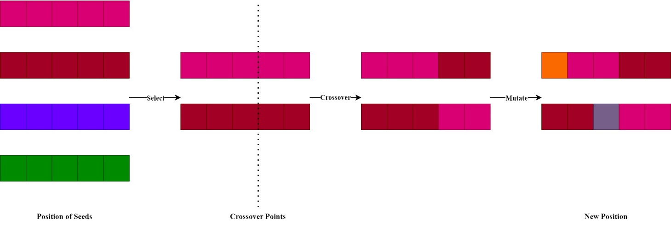
Figure 4: Procedure of crossover mutation method

Phase 4: Competitive Selection

At this stage, weeds compete for survival. Weeds with advanced fitness standards are more likely to subsist, while those with inferior fitness values are culled. The procedure remains iteratively till an all-out number of repetitions is reached or the optimal resolution is found. The weed with the highest fitness value is measured as the optimal solution.
This load-balancing approach ensures that user requests are queued based on bandwidth requirements. Requests requiring higher bandwidth are prioritized, similar to the selection of the fittest weed based on fitness values.

The proposed model maintains a balance between legitimate requests by scheduling them in the queue of bandwidth for which the requested user is waiting. Higher bandwidth demanding requests are given more priority and are similar to the selection of the fittest solution based on fitness values.

3.2.2 Mitigation

Mitigation strategies aim to minimize the impact of malicious requests. A common technique is to alter packets that use false source IP addresses. In this model, we employ the Double Shift Right and Complement (DSRC) technique to handle legitimate requests that fall below the bandwidth threshold or are part of balanced legitimate requests.

Let’s assume the balanced legitimate request is denoted by R_{legit} and the IP address of the request is IP_{orig}

First, the IP address is converted into an 8-bit binary number:

B_{orig}=bin (IP_{orig}) (14)

After binarization, a double shift right operation is performed on the binary number:

B_{shifted} = B_{orig} >> 2 (15)

Next, the 1’s complement of the shifted binary number is taken by inverting all bits:

B_{complement} =∼ B_{shifted} (16)

Finally, the modified binary IP address IP_{mod} is obtained:

IP_{mod} = int (B_{complement}) (17)

This DSRC technique helps prevent malicious requests from taking control of the system, ensuring that legitimate traffic is prioritized and securely managed.

4. Performance Assessment

Here, the experiment on a proposed model is done empirically and compared with existing methods. This evaluation is also done using public datasets to validate the performance of our model.

4.1 Performance Analysis

The performance evaluation considered only two metrics: DDoS attack detection and load balancing. A fitness versus iteration analysis is separately conducted for feature selection (FS) to access these aspects. It turns out that this analysis is used to identify the user, and sits in a position of controlling model performance for both type DDoS attacks as well as load balancing.

4.1.1 Description of Dataset

The employed CIC-Darknet2020 dataset includes data from darknet network traffic, which is used to launch application layer DDoS Attacks. For the CICDarknet2020 dataset, an orchestration of two layers is used to generate benign and darknet traffic in the primary layer. The subsequent layer creates the chat, email, audio stream, video stream, browsing, p2p transfer, audio stream, browsing, and VOIP on the internet. Data from the Canadian Institute for Cybersecurity at the University of New Brunswick They collected this dataset to assess new techniques for internet traffic classification.

4.1.2 DDoS attack detection Performance exploration

The performance of the developed Brownian Motion-based Harris Hawks Optimization algorithm is evaluated based on the fitness versus iteration analysis. The comparison of the proposed approach with well-known algorithms like Monarch Butterfly Optimization, Rock Hyraxes Swarm optimization, Harris Hawks Optimization and Crow Search Algorithm is provided based on the relative level of optimal fitness achieved over iterations. At the same time, the recital of DDoS attack detection based on the Xavier Soft-Plus Convolutional Neural Network approach is evaluated based on such metrics as accuracy, precision, recall, F-Measure, and training time. The comparison of the developed algorithm with other well-known models like Deep Neural Network, Deep Belief Networks, Recurrent Neural Networks, Convolutional Neural Networks is illustrated and reveals the benefits of using the proposed approach.

Table 1: Fitness versus Iteration Investigation

Iterations | Proposed BM-HHO | Harris Hawks Optimization | Rock Hyraxes Swarm optimization | Monarch Butterfly Optimization | Crow Search Algorithm
10 | 118 | 97 | 78 | 58 | 37
20 | 136 | 118 | 95 | 76 | 51
30 | 158 | 137 | 117 | 98 | 76
40 | 178 | 157 | 137 | 116 | 98
50 | 198 | 175 | 154 | 137 | 117

Table 1 provides a comparison of fitness versus iterations produced by the projected BM-HHO algorithm and existing Harris Hawks Optimization (HHO), Rock Hyraxes Swarm (RHS) optimization, Monarch Butterfly Optimization (MBO), and Crow Search Algorithm (CSA). as can be seen, the CSA method provides the poorest results as compared to the mentioned methods. On the other side, the fitness values provided by the discussed algorithm remain the best in comparison to all other alternatives. In particular, after 50 iterations, the fitness values equal to 198, which is better than the performances of HHO, RHS, MBO, and CSA algorithms. Figure 5 also provides a graphical representation of these results in Table 1.

Figure 5: Fitness vs Iteration Study

Table 2: Performance investigation of projected XP-CNN in contrast with the existing RNN, DBN, CNN, and DNN algorithms

Metrics/ Techniques | Recurrent Neural Network | Deep Belief Network | Convolutional Neural Network | Deep Neural Network | Proposed XSP-CNN
Accuracy | 95.7671 | 93.3450 | 91.5492 | 90.6574 | 98.9609
Precision | 95.8477 | 93.4256 | 91.6955 | 90.6574 | 98.5778
Recall | 94.8756 | 93.8476 | 91.8653 | 90.5478 | 98.8745
F-Measure | 95.4578 | 93.6875 | 91.1548 | 90.6849 | 98.3545

Table 2 contains the performance comparison of the projected XSP-CNN algorithm with various existing models within MANETs. These include the RNN, DBN, CNN, and DNN models. The performance measurement includes accuracy, precision, recall, and F-measure metrics. As may be seen, the proposed XP-CNN algorithm consistently outperforms the existing DNN model in all measures. Specifically, the algorithm improves the accuracy by 6.51% with a margin of 0.81 over the other DNN variants. While the DNN models achieve a precision rate of 95.96%, the XP-CNN model scores 98.9609%. It is also notable that the proposed model has higher scores in recall and F-measure. As a result, it is more effective at detecting DDoS attacks in MANETs. For a visual comparison, one may analyze Figure 6 and Figure 7 showing a comparison graph for various models.

Figure 6 Training Time Analysis

Figure 7: Performance investigation of the projected XP-CNN algorithm in contrast with the prevailing approaches

Figure 8 shows the CPU memory usage in incorporating the proposed XP-CNN algorithm for Application layer DDoS attack Detection while Figure 9 shows sensitivity & specificity analysis.
.

Figure 8 CPU Memory Usage Analysis

Figure 9 CPU Sensitivity & Specificity Analysis

4.1.3 Load Balancing Performance Inspection

The relative investigation of the projected I-CMIWO algorithm with the existing Rider optimization Algorithm, Invasive Weed optimization, Spider Monkey optimization and Butterfly optimization Algorithm is shown in Table 5. The various features on which the comparative analysis is conducted include average waiting time, throughput, processing time, response time, load balancing, and latency. The information presented in Table 5 indicates that the proposed interpolation based cross-over mutation Invasive Weed Optimization (I-CMIWO) algorithm is improved than the existing algorithms in terms of processing time, average waiting time, response time, latency, load balancing, and throughput. Thus, the above description indicates that the projected I-CMIWO algorithm is improved than the prevailing algorithms, shows how better it is, and proves that it can overcome the existing algorithms in all the parameters specifically they are required to optimize the performance of the system.

Figure 10: Process Time Analysis

Figure 10 shows the proportional investigation of process time between the proposed I-CMIWO and existing algorithms. Process time is a critical aspect where a model can be considered optimal when minimized. As portrayed in the image, the I-CMIWO algorithm recorded the least process time compared to the existing Rider optimization Algorithm, Invasive Weed optimization, Spider Monkey optimization and Butterfly optimization Algorithm. Precisely, the process time of the proposed model was 16,847ms for 500 requests, which was the least among the algorithms compared. This shows that the I-CMIWO load balancing algorithm enhances process time efficiency by completing processes in a lesser period than the methodologies in comparison.

Table 3: Mean waiting time inspection

No. of Requests | Proposed  I-CMIWO | Rider Optimization Algorithm | Spider Monkey Optimization | Invasive Weed Optimization | Butterfly Optimization Algorithm
100 | 164 | 214 | 243 | 184 | 281
200 | 307 | 376 | 408 | 351 | 438
300 | 418 | 534 | 602 | 476 | 661
400 | 543 | 703 | 786 | 621 | 874
500 | 746 | 914 | 1002 | 842 | 1129

The experiential analysis of the average waiting time of the proposed I-CMIWO algorithm with the prevailing algorithm is presented in Table 3 and shown in Figure 11. Based on the table, the BOA algorithm had the highest average waiting time. This is in contrast to the proposed I-CMIWO algorithms, which had the most reduced time. At 300 requests, the proposed model had an average waiting time of 418ms but the prevailing Invasive Weed Optimization, Rider Optimization Algorithm, Spider Monkey Optimization and Butterfly Optimization Algorithm had averages of 476 ms, 534 ms, 602 ms, and 661ms. In summary, based on Table 3, the proposed methodology has a lower average waiting time concerning other prevailing models during load balancing.

Figure 11: Average waiting time analysis

Figure 12: Response time analysis

In figure 12, the proposed I-CMIWO response time analysis is compared with the present Rider optimization Algorithm, Invasive Weed optimization, Spider Monkey optimization and Butterfly optimization Algorithm. the slower response time occurs if the server’s response time is the total weight of tasks assigned to it. The I-CMIWO response time is minimum as compared to IWO, ROA, and other algorithms. The I-CMIWO time response is 100 request takes 3698ms, 200 request, 300 request, 400 request, and 500 request, taking 4067ms, 4465ms, 4926ms, and 5514ms, respectively. The I-CMIWO data and time split overlap the prevailing data and time according to the execution state. The analysis shows that the time performance is more efficient than prevailing methodologies.

Figure 13: Relative study founded on Latency

As shown in Figure 13, the proposed I-CMIWO algorithm obtained latency 848ms lower than the prevailing IWO algorithm and 3227ms lower than the BOA algorithm for 400 requests. Consequently, the proposed I-CMIWO algorithm significantly reduces the latency between Invasive Weed Optimization, Rider Optimization Algorithm, Spider Monkey Optimization and Butterfly Optimization Algorithm, guaranteeing excellent performance in delay reduction.

Figure 14: Load Balancing Phase

An experiential analysis of the proposed algorithm load balancing with existing algorithms for different numbers of requests are presented in Figure 14. Load balancing refers to managing and distributing network traffic across multiple servers using a load balancer. The critical element of network performance is the improvement of load balancing. The existing IWO method performed better than the ROA, SMO, and BOA algorithms. However, the proposed method of I-CMIWO performed better than IWO. For the number of requests 400, and 500, the proposed algorithm had processing time, 0.485214ms, and 0.574123ms. The method also performed better than Invasive Weed Optimization, Rider Optimization Algorithm, Spider Monkey Optimization and Butterfly Optimization Algorithm. Therefore, with the proposed I-CMIWO algorithm, traffic is effectively managed, thus less network congestion than existing methods.

Table 4: Throughput Measurement

No. of Requests | Proposed  I-CMIWO | Invasive Weed Optimization | Rider Optimization Algorithm | Spider Monkey Optimization | Butterfly Optimization Algorithm
100 | 952 | 1135 | 1428 | 1856 | 2157
200 | 1247 | 1497 | 1936 | 2415 | 2954
300 | 1486 | 1873 | 2382 | 2765 | 3324
400 | 1865 | 2318 | 2912 | 3357 | 3762
500 | 2375 | 2651 | 3175 | 3862 | 4215

As clearly indicated in Table 4, the throughput analysis of the implemented I-CMIWO algorithm compared to the present prevailing algorithms i.e. ROA, SMO, and BOA showed that the implementation of the proposed system reduced the time required to transmit packets. Specifically, the throughput for 100 requests became 952ms. The same value computed for the ROA, SMO, BOA, and IWO was 1428ms, 1856ms, 2157ms, and 1135ms, respectively. As a result, it can be inferred that the I-CMIWO process is more efficient in terms of throughput. Figure 15 shows the throughput analysis outcome.

Figure 15: Throughput Analysis

Figure 16 Comparison with Existing Techniques

Figure 16 highlights the advantage of proposed method over implemented and prevalent methodologies. In Addition to accuracy the proposed methodology also has an edge over prevalent algorithms in terms of complete protection against application layer DDoS attack with mitigation and flash Event Differentiation which can act as complete shield.

5. Conclusion

This paper highlights a novel approach towards Application layer DDoS Attack detection and Mitigation with a distinction of such actions from flash Events. Incorporated XSP-CNN algorithm in the system effectively determines whether one transformation is being done by legitimate users or not, it is possible for the system utilizing I-CMIWO algorithm to balance loads, so that legitimate users are not deprived of their conversion traffic. The dataset knowing for both systems and tools to perform is available. The XSP-CNN scheme appears to be effective and efficient enough, as the performance analysis of the algorithm discovered a vast improvement compared to traditional algorithms. As a result, accuracy was measured at 98.96%, much higher than conventional algorithms. Moreover, precision, F-measure and recall also outperform the performance characteristics of the standard algorithms. The performance of the I-CMIWO algorithm, load balancing efficiency, Process time, average waiting time, response time, latency, load balancing and throughput shows that it is Quite evident that the methodology proposed not only offers optimum performance characteristics, while also consumes lower amounts of time than proposed methodologies for process completion. This Proposed model provide complete Shield for all challenges regarding Application layer DDoS attack in MANET. Further, this method can be modified using an innovative cryptographic framework for secure data and power efficient data transmission.

