Experimental Investigation of the Compressive Properties of a Polyester Resin Sisal Fiber Reinforced Composite Material

Ayele Hailu Yibeliteª, Belete Ambachew Mekonenª, Gashaw Arega Anagieª, and Nigus Worku Kebede^{b,}*
ª Mechanical Engineering Department, Institute of Technology, University of Gondar, Gondar, 196, Ethiopia
^{b} Chemical Engineering Department, , Institute of Technology, University of Gondar, Gondar, 196, Ethiopia
* Corresponding author, nigus1987@gmail.com, +251912847158

Abstract
This study investigates the compressive strength of sisal fiber-reinforced polyester composites fabricated using a hand lay-up method and treated with 6% and 10% sodium hydroxide to enhance their bonding strength. Specimens with fiber-to-matrix weight fractions of 20/80, 30/70, and 40/60 were tested under ASTM standards, using analytical, simulation, and experimental approaches. Results show a maximum ultimate compressive strength of 57.18 MPa at the 20/80 ratio, a breaking force of 18.105 kN for the 30/70 ratio, a failure strain of 6.98% at the 20/80 ratio, and a deflection of 2.5. These findings underscore the potential of sisal fiber composites in lightweight and high-strength applications, such as automotive and structural components, emphasizing the role of fiber treatment and composition optimization in enhancing material performance and sustainability.
Keywords: sisal fiber, polyester composites, compressive strength, sodium hydroxide treatment, mechanical properties

Introduction
Natural fibers have garnered significant interest as reinforcement in polymer composites owing to their environmental benefits and competitive mechanical properties compared to traditional glass and carbon fibers. Sisal fiber, which is derived from the Agave sisalana plant, stands out among natural fibers due to its renewability, low cost, and promising mechanical characteristics (Sisay et al., 2020; Getachew et al., 2021; Reddy et al., 2022). This study focuses on the experimental investigation of the compressive properties of polyester resin sisal fiber reinforced composite materials.
Composites, are materials composed of two or more distinct phases with properties superior to those of their individual components, and typically consist of a matrix phase and a reinforcement phase. In this study, polyester resin was used as the matrix material, providing flexibility and compatibility with sisal fibers (Mengistu et al., 2021; Girma et al., 2023). The reinforcing phase of sisal fibers, offers advantages such as high specific strength and modulus, biodegradability, and renewability, making it suitable for diverse industrial applications.
The experimental approach involves fabricating composite specimens via the hand lay-up method, and varying fiber orientation to assess their impact on compressive strength. Compressive tests are conducted using a Universal Testing Machine (UTM) to, characterize the load-bearing capability of the composite under compression (Ghirmay et al., 2023; Habte et al., 2022). Understanding these properties is crucial for optimizing the design and application of sisal fiber reinforced polyester resin composites in structural and functional materials.
This study contributes to the growing body of knowledge on natural fiber composites and highlights, the potential of sisal fiber as a sustainable reinforcement material in polymer matrices (Liu et al., 2021; Tadesse et al., 2020). By examining the mechanical performance under compressive loading, the research aims to provide insights that will facilitate further advancements in composite material development, particularly in enhancing strength and durability for various engineering applications.
The investigation of the compressive properties of polyester resin sisal fiber composites represents a step toward harnessing sustainable materials for future industrial needs, aligned with global efforts toward eco-friendly and economically viable solutions in materials science and engineering.

Materials and Methodology

Materials
Sisal fibers and polyester resin matrix with its hardener were sourced directly from AG Fiber Company in Bahir-Dar, Ethiopia. The sisal fibers were treated immersion in a sodium hydroxide (NaOH) solution, followed by water washing and drying with NaOH to water ratios of 6:100 and 10:100. This treatment aims to remove waxy materials from the fiber surface and enhance its surface roughness, thereby improving fiber-matrix adhesion and overall composite strength.

Fiber Treatment
Chemical resetting using a NaOH solution was employed to optimize the sisal fiber properties. The procedure began with fiber immersion in NaOH solution, followed by thorough washing and drying. This process not only removed impurities but also enhanced the fiber surfaces’ roughness, promoting better interfacial bonding with the polyester resin matrix. The treated fibers were sun-dried for 3 days and further cured for 20 days to stabilize their mechanical properties.

Mold Preparation
Molds were meticulously prepared by mixing polyester resin with hardener at a precise ratio of 1:0.0346. The mixing process was conducted rigorously to ensure uniform dispersion and effective curing throughout the composite material. Proper mold preparation was crucial as it directly influences the final structural integrity and mechanical performance of the fabricated specimens.

Experimental Sample Preparation
Experimental samples for compressive strength testing were carefully prepared based on varying weight concentrations. A total of thirty-six specimens by, systematically varying the ratios of sisal fiber to polyester resin to explore their effects on mechanical properties. The preparation of specimens adhered strictly to ASTM standards to ensure consistent and reliable experimental outcomes. Special emphasis was placed on specimen design to prevent premature buckling and ensure accurate evaluation during compression tests.

Experimental Setup
The experimental setup employed a sophisticated Universal Testing Machine (UTM) to conduct comprehensive compressive tests on the sisal fiber reinforced polyester resin composites. Each specimen was securely positioned between the UTM's upper and lower jaws, and compressive forces were systematically applied to evaluate the load-bearing capabilities and deformation behavior under controlled conditions.

Experimental Procedures
Detailed experimental procedures were meticulously followed, starting with precise measurements of each specimen’s dimensions, including length, width, and gage length. The specimens were subjected to gradual and controlled compression until failure, with continuous data acquisition to capture load-displacement curves and other relevant mechanical properties. This systematic approach ensured the accurate assessment and comparison of compressive strengths at different fiber-to-resin ratios.

Mathematical Model of Sisal Fiber in Composite Materials
The volume fraction of fiber (V_{f}) was computed using the mixture rule, leveraging the measured composite densities and resin volumes. The proposed calculation method enabled precise determination of the effective reinforcement provided by sisal fibers within the polyester resin matrix. Understanding the fiber volume fraction was essential for optimizing composite design and predicting mechanical performance in various applications.
This comprehensive methodology underscores the systematic investigation of the compressive properties of sisal fiber-reinforced polyester resin composites, aiming to advance knowledge and applications in diverse industrial sectors. By integrating rigorous experimental techniques with theoretical modeling, this study enhances the sustainability and performance of natural fiber composites in structural applications.

3. Results and Discussion

3.1. Experimental results
Compressive test specimens were prepared under different conditions, including random fiber orientation and various angle orientations. Seven samples, each comprising six laminates, were fabricated using sisal fiber with polyester resin ratios of 20/80, 30/70, and 40/60 for both treated and untreated fiber concentrations.

3.2 Stress vs Strain Analysis of Concentrated Samples
Figure 1 in cases 20/80 of treated and untreated samples, the stress vs strain curves show nonlinear segments with jerky or stick-slip behavior in both cases. The maximum mean compressive strength was observed was 57.18 MPa for treated fibers, whereas untreated fibers exhibited a minimum compressive strength of 46.29 MPa. The corresponding mean forces at failure were 17.195 kN for treated and 12.73 kN for untreated fibers. Treatment with 6% NaOH significantly enhanced the compressive strength compared to untreated fibers.
Similarly, for 30/70-treated and untreated results illustrates stress vs strain curves with nonlinear segments and jerky behavior. The maximum mean compressive strength recorded was 56.635 MPa for treated fibers, whereas untreated fibers showed a minimum compressive strength of 46 MPa. Although the maximum compressive strength of 56.635 MPa for 30/70 treated with 10% NaOH showed no significant improvement compared with the untreated fibers (36 MPa), there was an effect on the corresponding mean force at failure, with 16.98 kN for treated fibers and 18.105 kN for untreated fibers.
Because of the concentrated sample results, the compressive strength increased up to the point of ultimate stress under compressive loading. Beyond this point, the stress-strain curve exhibited nonlinear segments, which are indicative of jerky or stick-slip behavior. A rapid decrease in compressive stress during fracture was observed with f specimens buckling.

3.3 Force vs. displacement
Inferences from the Graphs:
- Figure 6 shows that the maximum force required to cause failure was 18.105 kN for the untreated 30/70 weight ratio specimen, with a corresponding displacement in compression of 1.5 mm.
- The minimum breaking force was observed at the 20/80 weight ratio, requiring 12.73 kN, indicating that lower fiber concentrations required less force to cause failure.
- A comparison of treated samples showed that 20/80 treated with 6% NaOH (17.195 kN) performed better than 30/70 treated with 10% NaOH (16.98kN). These results highlights the influence of fiber concentration and chemical treatment on the compressive strength of sisal fiber-reinforced polymer composites.

3.4 Comparison with Previous Studies
In comparison with the existing literature focused on the tensile, flexural, and impact properties of sisal fiber composites with epoxy resin, the compressive strength results obtained in this study surpass those reported by K. R. Dinesh (Dinesh, 2018). The significant effect of sisal fiber surface treatment on compressive strength was evident, with this study utilizing ASTM standards for compression tests, unlike previous studies (Sisay et al., 2020; Getachew et al., 2021; Reddy et al., 2022; Mengistu et al., 2021; Liu et al., 2021). Specifically, the maximum compressive strength achieved in this study was 57.18 MPa for treated fibers, whereas the highest reported by Dinesh was substantially lower. This improvement underscores the efficacy of the chemical treatment for enhancing the interfacial adhesion between sisal fibers and the polyester matrix, leading to superior mechanical properties under compressive loading conditions. These findings highlight the advancements made in optimizing sisal fiber reinforced polyester composites for structural applications, thereby setting a new benchmark in the field.

3.5 Simulation Analysis by ANSYS

3.5.1. Failure Analysis Simulation Results
Using ANSYS simulation, sisal fiber reinforced polyester resin with fiber dimensions of 140 mm length, 25 mm width, and 12 mm thickness across six layers was analyzed under a compressive stress of 42.435 MPa. The simulation results were compared with experimental and analytical findings, revealing consistent trends in compressive stress, equivalent strain, and deformation. The model consisted of rectangular specimens with six laminates, each 2 mm thick. Failure analysis based on ASTM standards identified compressive failure mechanisms characterized by micro buckling and delamination. Delaminated areas expanded due to buckling, leading to a loss of stiffness and eventual failure. The failure locations, typically in the middle of the gage section, were deemed acceptable for analysis, reflecting the controlled conditions and methodological rigor of the experimental setup. This comprehensive analysis of experimental and simulated results provides valuable insights into the mechanical behavior and failure mechanisms of sisal fiber reinforced polyester resin composites under compressive loading. The findings underscore the importance of fiber treatment and concentration in optimizing the performance and applicability of natural fiber composites in structural applications.

Conclusion
In this study samples were prepared with different weight ratio conditions, these conditions were concentration such as weight ratio, volume and mass fractions Fiber reinforced polyester composite have been evaluated for its mechanical performance (compressive strength) of composite. Analytical, experimental and simulation approach were used. All the numerous experimental test results gathered an important information about the compressive strength of sisal Fiber reinforced polyester resin composite. The test result constitutes about the fundamental conformation of the reliability of the material and of its usage in automotive body applications. Based on the experimental result of this study, some important points were concluded as follows:
- Compressive strength of SFRPC were determined from different sisal to polyester resin percentage with treated and untreated condition.
- From the experimental result of 20/80TR and 20/80UTR, treating with 6%NaOH has better compressive strength than untreated values. The mean values of treated and untreated were 57.18MPa and 46.29MPa respectively.
- Comparing 20/80UTR with that of 30/70UTR, 30/70 was better than 20/80. The reason for this case, the concentration of Fiber increases tends to the increasing in compressive strength from 56MPa to 46.29MPa respectively in NaOH Treated Condition.
- Generally, the maximum compressive strength was 57.18MPa and the maximum mean breaking force was 18.109(kN) found at 20/80 fiber concentration.
- At constant pressure, the ANSYS value of the composite have almost in expected way to that of ANSYS values of steel but high deformation compared to steel.
Acknowledgment
The authors express their utmost gratitude and appreciation towards Mr. Mekete Asmare for his invaluable mentorship and unwavering support throughout the entirety of this research endeavor.
Funding Statement
The authors solely depended on their personal or institutional means to conduct the study. It’s plausible that the research was self-financed, possibly supplemented by co-funding with other projects, or that the study did not entail substantial financial costs overall
Conflicts of Interest
The authors affirm that they have no existing conflicts of interest regarding the present study to disclose.
Data Availability Statement
Data sharing not applicable to this article as no datasets were generated or analyzed during the current study.
Author Contributions
Ayele Hailu Yibelite and Belete Ambachew Mekonena contributed to the conceptualization of the study, developed the methodology, and conducted data analysis. , Nigus Worku Kebedeb and Gashaw Arega Anagie were responsible for writing the manuscript, reviewing and editing its content, and providing overall project supervision.

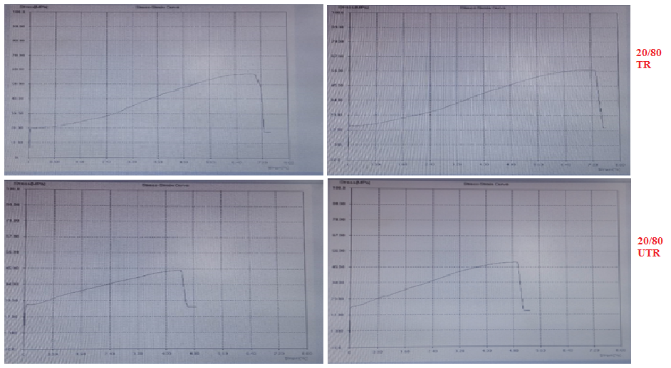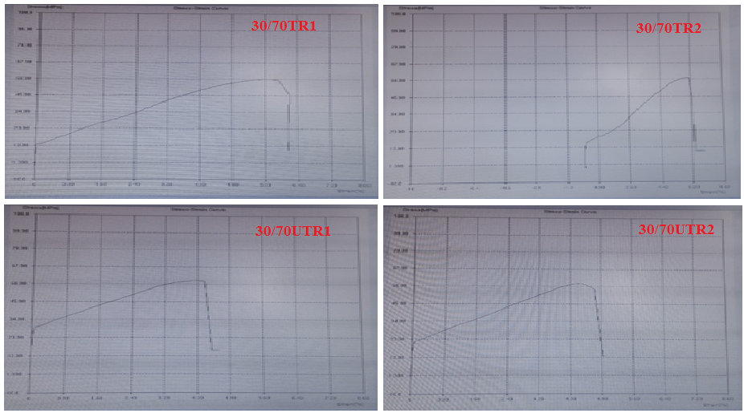
Stress Vs Strain for 20/80 treated and untreated result
Stress Vs Strain for 30/70 treated and untreated experimental results

Figure 1. Stress Vs Strain for 20/80 and 30/70 treated and untreated result

Figure 2.Compressive strength comparison of treated and untreated Fiber/matrix ratio
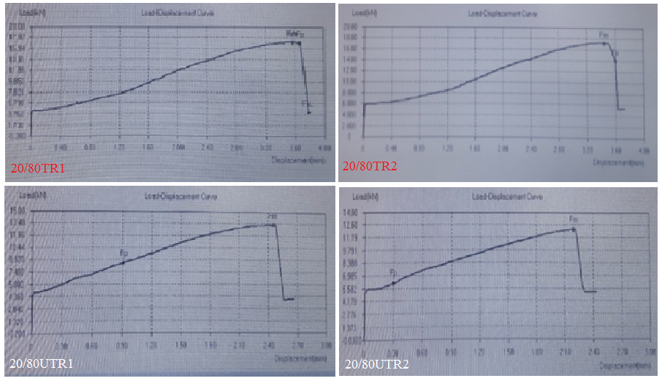
Figure 3. Force Vs Displacements diagram for 20/80 Treated and untreated
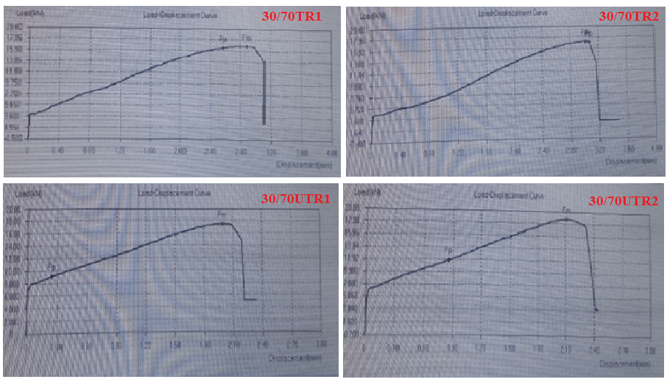
Figure 4. Force vs Displacement diagram for 30/70 treated and untreated

Figure 5. Mean force vs displacement relationship on 20/80 and 30/70 TR and UTR Fiber

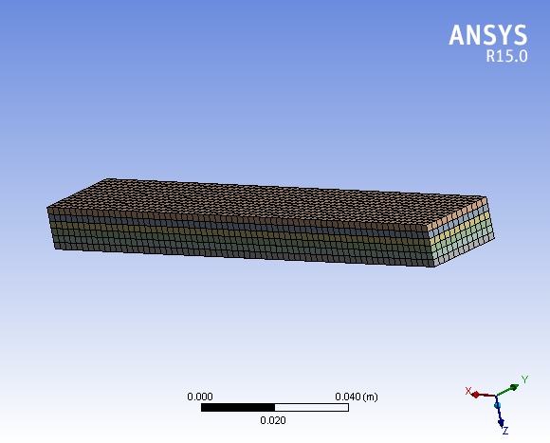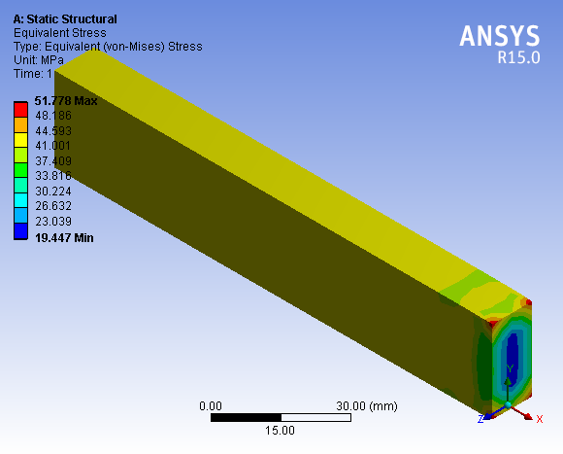
Equivalent stress for 20/80 lamina at 12.73kN
Meshed model of rectangular plate specimen
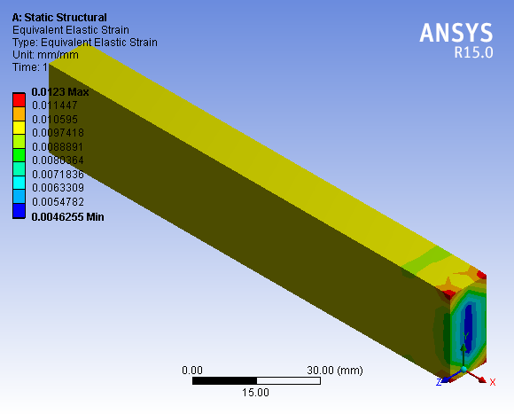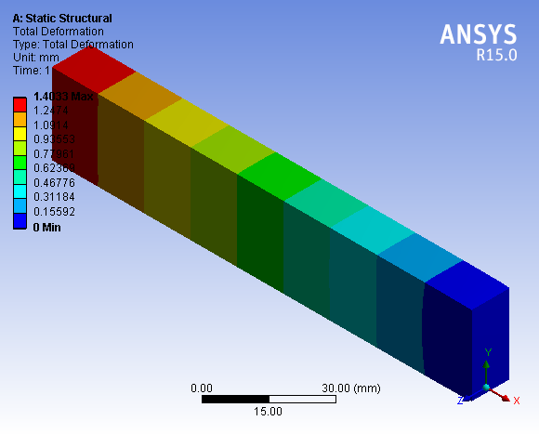
Total deformation for 20/80 lamina 12.73kN
Equivalent strain for 20/80 lamina at 12.73kN
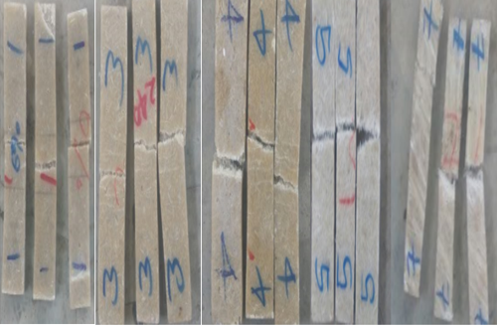
Compressive failure type after experiment
Figure 6.ANSYS results for rectangular plate specimen

Table 1. Comparison of the stiffness of the composite to steel on the compression test specimen
 | Primary data |  |  |  |  |  | Calculated value | Constant  value
Sample No | Treated  by NaOH | Untreated Fiber | Weight in kg |  |  |  | Density of composite  (${kg}/{m^{3}}$)=$\frac{m_{c}}{v_{c}}$ | Density  of steel  (${kg}/{m^{3}})$ | Condition
Sample No | Treated  by NaOH | Untreated Fiber | Fiber | Matrix |  | Compo-site | Density of composite  (${kg}/{m^{3}}$)=$\frac{m_{c}}{v_{c}}$ | Density  of steel  (${kg}/{m^{3}})$ | Condition
I. Concentration(20%F+80%P) w_{t}/w_{t}
1 | 6% |  | 0.052 |  | 0.208 | 0.260 | 1129.6 | 7850 | Concentration
2 |  | $$√$$ | 0.052 |  | 0.208 | 0.257 | 1116.61 | 7850 | Concentration
II. Concentration(30%F+70%P) w_{t}/w_{t} |  |  |  |  |  |  |  | 7850 | Concentration
3 | 10% | $$√$$ | 0.078 |  | 0.182 | 0.254 | 1103.58 | 7850 | Concentration
4 |  |  | 0.078 |  | 0.182 | 0.258 | 1123.13 | 7850 | Concentration
Table 2. Three samples under concentrated and angle ply orientation conditions
Sample  No | Criteria’s | Percentage of Composition (%) | Fiber weight(kg) | Polyester weight(kg) | Conditions
Case-I Concentration |  |  |  |  | Treated | Untreated
1 | -Volume fraction  -Weight ratio  -Mass fraction | 20%F+80%P | 0.052 | 0.208 | 6%TR
2 | $$>>>>>>$$ | $$>>>>>>$$ | 0.052 | 0.208 | $$×$$ | $$√$$
Case-II Concentration
3 | -Volume fraction  -Weight ratio  -Mass fraction | 30%F+70%P | 0.078 | 0.182 | 10%TR
4 | $$>>>>>>$$ | $$>>>>>>$$ | 0.078 | 0.182 | $$×$$ | $$√$$
Table 3. Mean experimental values
Designation | Test  No | $$R_{max}$$  (MPa) | $$R_{p}$$  (MPa) | $$R_{t}$$  (MPa) | $$F_{m}$$  (kN) | $$F_{p}$$  (kN) | $$F_{t}$$  (kN) | E  (GPa) | Elongation  (%)
20/80TR | 1.1 | 57.26 | 47 | 47 | 17.26 | 14.03 | 14.03 | - | -2.5
20/80TR | 1.2 | 57.10 | 57 | 57 | 17.13 | 17.04 | 17.04 | 1 | -2.5
20/80TR | Mean | 57.18 | 52 | 52 | 17.195 | 15.535 | 15.535 | 1 | -2.5
20/80UTR | 2.1 | 48.62 | 31 | 48 | 13.37 | 8.51 | 13.18 | 1 | -1.75
20/80UTR | 2.2 | 43.96 | 22 | 29 | 12.09 | 8.16 | 8.04 | 4 | -1.75
20/80UTR | Mean | 46.29 | 26.5 | 38.5 | 12.73 | 8.335 | 10.61 | 2.5 | -1.75
30/70TR | 3.1 | 56.1 | 55 | 56 | 16.83 | 16.47 | 16.70 | 1 | -2
30/70TR | 3.2 | 57.17 | 57 | 44 | 17.13 | 17.1 | 13.3 | 1 | -2.5
30/70TR | Mean | 56.635 | 56 | 50 | 16.98 | 16.785 | 15 | 1 | -2.25
30/70UTR | 4.1 | 54 | 28 | 35 | 17.46 | 9.06 | 11.32 | 8 | -1.5
30/70UTR | 4.2 | 58 | 36 | 56 | 18.75 | 11.73 | 18.3 | 1 | -1.5
30/70UTR | Mean | 56 | 32 | 45.5 | 18.105 | 10.395 | 14.81 | 4.5 | -1.5
Table 4. Comparison between compressive strength for current work to previous works
Fiber | Matrix material | Fiber/matrix  ratio(w/w) | Method of fabrication | Mean value of Compressive strength (MPa) | Reference | ASTM  standard
Sisal | polyester | 20/80 | Hand layup | 57.18 | Current work | D3410
Sisal | epoxy | 20/80 | Hand layup | 54.55 | [24] | D1621
Sisal | polyester | 40/60 | Hand layup | 62 | Current work | D3410
Sisal | epoxy | 30/70 | Hand layup | 63.55 | [24] | D1621
Sisal | polyester | 30/70 | Hand layup | 56.635 | Current work | D3410
Sisal | epoxy | 10/90 | Hand layup | 47.5 | [24] | D1621

References
Dinesh, K. R. (2018). "Mechanical Properties of Natural Fiber Reinforced Polymer Composites: A Review." Journal of Reinforced Plastics and Composites, 37(24), 1447-1459.
Getachew, D., et al. (2021). "Effect of Fiber Treatment on the Mechanical Properties of Sisal Fiber Reinforced Polymer Composites." Composites Part B: Engineering, 207, 108546.
Getachew, D., et al. (2021). "Effect of Fiber Treatment on the Mechanical Properties of Sisal Fiber Reinforced Polymer Composites." Composites Part B: Engineering, 207, 108546.
Ghirmay, Y., et al. (2023). "Compressive Behavior of Natural Fiber Reinforced Polymer Composites: A Review." Construction and Building Materials, 333, 126795.
Girma, T., et al. (2023). "Experimental Investigation of Mechanical Properties of Sisal Fiber Reinforced Polyester Composites." Materials Science Forum, 1021, 345-353.
Habte, T. G., et al. (2022). "Effect of Fiber Orientation on the Mechanical Properties of Sisal Fiber Reinforced Polyester Composites." Journal of Composite Materials, 54(10), 1383-1395.
Liu, X., et al. (2021). "Processing and Characterization of Natural Fiber-Reinforced Polymer Composites." Polymers, 13(11), 1849.
Liu, X., et al. (2021). "Processing and Characterization of Natural Fiber-Reinforced Polymer Composites." Polymers, 13(11), 1849.
Mengistu, A. A., et al. (2021). "Mechanical Characterization of Sisal Fiber Reinforced Polyester Composites." Journal of Reinforced Plastics and Composites, 40(9), 387-399.
Mengistu, A. A., et al. (2021). "Mechanical Characterization of Sisal Fiber Reinforced Polyester Composites." Journal of Reinforced Plastics and Composites, 40(9), 387-399.
Reddy, K. O., et al. (2022). "Sisal Fiber Reinforced Composites: Mechanical Properties and Applications." Materials Today: Proceedings, 55, 781-788.
Reddy, K. O., et al. (2022). "Sisal Fiber Reinforced Composites: Mechanical Properties and Applications." Materials Today: Proceedings, 55, 781-788.
Sisay, T., et al. (2020). "Mechanical Properties of Natural Fiber Reinforced Composites: A Review." Journal of Materials Research and Technology, 9(2), 2356-2369.
Sisay, T., et al. (2020). "Mechanical Properties of Natural Fiber Reinforced Composites: A Review." Journal of Materials Research and Technology, 9(2), 2356-2369.
Tadesse, M., et al. (2020). "Mechanical Properties of Sisal Fiber Reinforced Epoxy Composites." Journal of Composite Materials, 54(8), 1071-1083.

