The impact of flipped learning on soft skills for enhanced employability

Niranchana Priya Viswanathan
Research scholar, Faculty of Management Studies, SRM Institute of Science and Technology (deemed to be University) Research Kattankulathur,
Chennai, Tamil Nadu, India
nv8723@srmist.edu.in

Co-author: Dr. S. Arun Kumar
Associate professor, Faculty of Management Studies, SRM Institute of Science and
Technology (deemed to be University) Research Kattankulathur,
Chennai, Tamil Nadu, India
arunkums@srmist.edu.in

Abstract
Purpose – Flipped learning moves instructional activities such as lectures and direct instruction outside the classroom. Flipped learning has been demonstrated to improve soft skills, such as communication, problem-solving, teamwork, and critical thinking, which are necessary for managerial roles. The association between flipped learning and soft-skill development was quantitatively examined.
Design/methodology/approach –The study employs descriptive and inferential statistics to evaluate survey data.
Findings – This study shows that flipped learning improves soft skills and may prepare graduates for modern workplaces. The experimental results with 200 undergraduate and postgraduate management students at a private university in India confirmed our premise that flipped learning improves soft skills. A self-paced approach to flipped learning encourages independence and self-directed learning, which are valued in the workplace.
Originality – Technological advances and globalisation will change work environments and boost the demand for soft skills. Flipped learning provides management students with better employability tools by focusing on active involvement and soft skills needed in modern organisations.
Keywords: Flipped learning, Management studies, soft skills, Employability, Impact evaluation

Paper type: Research paper

Introduction

In the age of rapidly changing global job sector traditional education and industry requirements are moving in opposite directions. As the demand or employers worldwide is turning towards graduates with technical knowledge as well as soft skills and practical experience. University level, where local universities are in turn reorganising curriculums to match what industry is increasingly demanding of them and which students will be set up as the ideal employees. One such solution is the concept of the flipped learning that serves as a sort of bridge and helps learners in moving away from passive to active learning, enabling them to fill this gap between theory and practice. The purpose of this study is to investigate the linkages between flipped learning methodologies, soft skills education, and graduate employability in a local context.
This would like to state the global condition due to the lack of qualified labour in most industries around, while also from a local side how universities are bringing themselves to answer this new demand. This study examines the relationship between flipped learning and soft skill development in management education and its possible impact on graduates' preparation for the dynamic needs of the modern workplace .Graduates with strong, soft skills are in demand now more than ever (e.g. technical expertise, interpersonal skills, adaptability, collaboration, and more .Traditional education emphasises theoretical knowledge but may not prepare students for the complex and varied workplace difficulties they. Flipped learning improves academic knowledge and develops soft skills that employers value. According to students improve their critical thinking, communication, and peer collaboration by actively participating. Problem-solving and group projects teach teamwork, conflict resolution, and cohesive presentations, which are essential for professional success .The self-paced strategy of pre-recorded lectures and reading materials encourages independence and self-directed learning, which are valued in the industry .Learning to manage one's own process and adapt to different learning styles might increase employability in today's dynamic work market that’s why it’s important to do this study because flipped learning has the potential to greatly enhance soft skills such as critical thinking, communication, and teamwork, which are highly valued by employers. By allowing students to take more control of their learning and collaborate with their peers, flipped learning can help develop these essential skills that are necessary for success in the workplace.
As the job market becomes increasingly competitive, having strong soft skills is crucial for standing out to potential employers and advancing in one's career. In addition to improving academic performance, flipped learning can also have a positive impact on students' employability by equipping them with the necessary soft skills. The interactive and collaborative nature of flipped learning encourages students to engage in discussions, work in teams, and think critically about the material, all of which are highly desirable qualities in the workforce. Employers are increasingly looking for candidates who not only have the technical skills required for a job but also possess effective communication, problem-solving, and adaptability skills, all of which can be fostered through flipped learning. By incorporating this innovative teaching method into their curriculum, educators can better prepare students for the challenges of the modern workplace and help them succeed in their careers.
The background of the research highlights the importance of students engaging in discussions, working in teams, and thinking critically about the material to cultivate desirable qualities for the workforce. Employers are seeking candidates who not only possess technical skills but also effective communication, problem-solving, and adaptability skills, all of which can be developed through flipped learning. By integrating this teaching method into their curriculum, educators can better equip students for the demands of the modern workplace and set them up for success in their careers. In this study, JMP software have been used for its robust statistical analysis capabilities, particularly in handling complex data sets and providing dynamic visualizations, which are essential for exploring relationships between constructs like Flipped Learning, Soft Skills, and Employability. This tool together offers a powerful combination for analysing educational interventions and their impacts on skill development and employability.Owing to technological advances and globalisation, soft skills will be in demand as work environments change Flipped learning gives management students’ tools that boost employability by focusing on active involvement and the soft skills needed in current organisations .
Literature review

In the rapidly evolving landscape of higher education, particularly in management studies, there is a growing emphasis on developing pedagogical approaches that enhance students' soft skills and employability, With the ever-evolving higher education management studies in place, there is a clear need to change how we teach and what are the pedagogical methods which will make our students ready for that corporate race. Flipped learning has become a popular approach for tackling this gap between understanding theoretical concepts and active application, as evident among other innovative methods. Flipped learning and soft skills, employability for management education Time is ripe to explore the impact of flipped learning on inculcating soft skills in students which supports them even after they are placed at jobs. the research on which this study is based has its theoretical foundation in two parallel constructs: self-directed learning rears experience-based learning (Experiential Learning Theory). Self-Directed Learning Theory originated by Knowles (1975) postulates that the learner takes primary responsibility and initiative for the educational process, from identifying learning needs to evaluating learning. The flipped classroom model drives students to actively work with course material prior to lecture, promoting self-regulation and metacognitive abilities as a result. Kolb’s experiential learning theory (1984) says that learning is a continuous cycle of concrete experience, reflective observation, abstract conceptualization, and active experimentation. This cycle is inherently supported through the adoption of flipped learning since it allows students to learn an idea in theory and apply it on actual business scenarios. This relationship to experiential learning theory suggests that flipped learning may be particularly efficacious for training soft skills, those that necessitate a degree of direct practice including communication, teamwork, and adaptability.
The literature review proposes several hypotheses to investigate that would contribute to a deeper understanding of the flipped learning experience: Longitudinal studies that track changes in student soft skills and employability over time following an initial experience with flipped learning. Other research to examine soft skills-focused on flipped learning versus traditional lecture-based approaches Examine the use of technology in implementing flipped learning and its impact on developing soft skills. Study the possible mechanisms by which flipped learning may influence soft skill development and employability of management graduates. The key aim of the present research revolves around investigating flipped learning in improving soft skills and employability among management students. Flipped learning in soft skills vs lecture-based learning Suggestions for future empirical research on the link between flipped learning and soft skills in management studies and proposed hypotheses The global implications of these findings are profound. The global job market is becoming tougher & fast-paced, leading to higher requirements for graduates with soft skills in India. This research has the potential to influence how management schools train their students for the workforce, by providing us a deeper understanding on how flipped learning could develop these skills. Furthermore, the results may offer encouraging implications for international policymakers and educational institutions by developing new policies and tools to assist in better preparing graduates for the job market. More broadly, this research contributes to the ongoing conversation about how active learning strategies cultivate skills needed in the 21st-century workforce. With technological transformations shaking up industries around the world, and an ever-changing work environment, there is a greater necessity for universities to produce graduates with a solid foundation in soft skills and agility.
Conceptual model
To develop a conceptual model that shows how flipped learning affects soft skills in management courses, integrate a theoretical framework with empirical evidence and practical implications, flipped learning's impact on soft skills and management education employability is shown in this conceptual model .
Components of conceptual model
Implementing flipped learning
This includes methods for delivering pre-class content and encouraging active learning before the class. This involves choosing digital resources, creating interactive activities, and using technology to enhance flipped learning .
Development of soft skills
Flipped learning targets communication, teamwork, leadership, critical thinking, problem-solving, and people skills, according to the conceptual model It examined how flipped learning interventions improve soft skills .
Employability results
Flipped learning improves soft skills and employability. This covers students' professional preparation, soft-skill application in real-world situations, and transferability to various management roles and industries.
The conceptual model provides mediating elements that may affect flipped learning and soft-skill development. These may include student motivation, instructor support, learning environment, and collaboration technology .
Relationships in the conceptual model
Flipped learning implementation → soft skills development.
The model explores how specific methods and content delivered through the flipped learning approach contribute to the acquisition and refinement of soft skills among management students.
Soft skills development → employability outcomes
This relationship elucidates how cultivated soft skills directly translate into enhanced employability, career readiness, and success in the management domain .
Flipped learning implementation → employability outcomes.
The conceptual model also examines the direct impact of flipped learning implementation on the employability outcomes of management students, considering the holistic influence of the educational approach on students' professional preparedness .
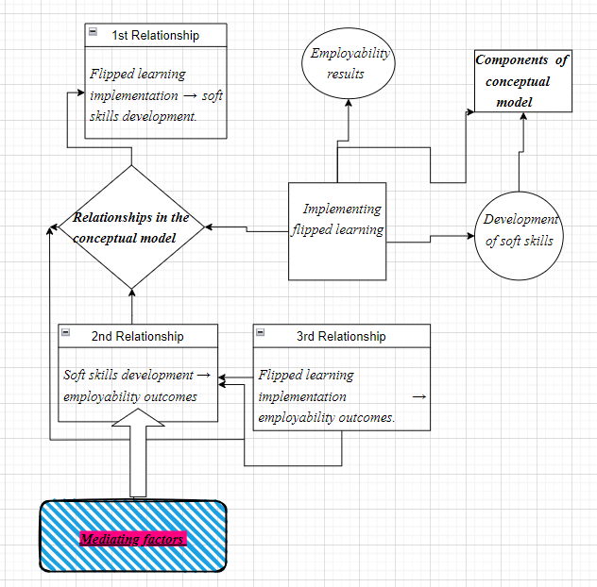
Figure 1: Conceptual Model with Mediating Factors and relationships
Mediating factors → soft skills development and employability outcomes
This approach accounted for many mediating aspects of flipped learning, soft skill development, and employability. It examined contextual and instructional elements that may enhance or moderate the influence of flipped learning on student outcomes. The conceptual model aims to show how flipped learning, soft skills development, and employability outcomes interact in management education. Future research can systematically investigate the complex dynamics of flipped learning's impact on students' soft skills and career prospects by delineating the conceptual model's key components and relationships, improving our understanding of educational interventions that affect professional success .

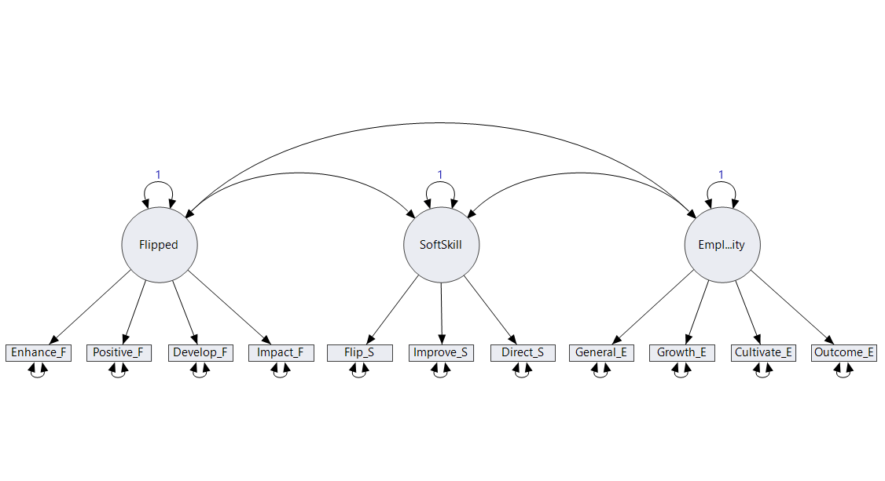
Figure 2. Conceptual model (linkage between the factors)
This Figure 2 above shows the path model (conceptual model) of flipped learning, soft skills, and employability with undergraduate and postgraduate students who are passing out and looking for employability.The image presents a structural equation model diagram illustrating the relationships between three main constructs: Flipped, Soft Skill, and Employability. Each construct is represented by a circle and is connected to several observed variables, shown as rectangles. Flipped is linked to five variables: Enhanced_ Flipped , Positive _Flipped, Development _Flipped, Impact_ Flipped, and Flipped _Soft skill. Soft Skill is connected to three variables: Improve_ Soft skill, Direct_ Soft skill, and General_ Employability ,Employability is associated with three variables: Growth_ Employability, Cultivate_ Employability, and Outcome_ Employability. The constructs are interconnected by curved arrows, indicating correlations or covariances between them. Each construct also has a self-directed arrow labelled "1", representing residual variance or error terms. This model visualizes the hypothesized relationships between flipped learning, soft skills, and employability factors.
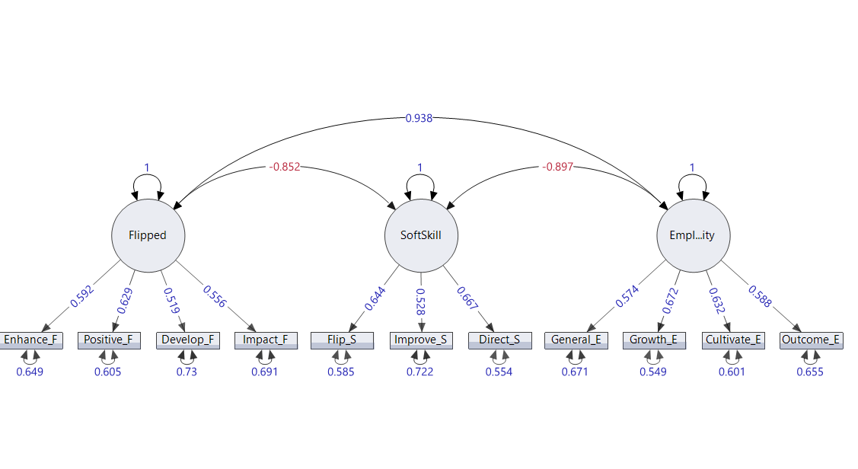Figure 2. Path model by using the JMP tool
Figure 2 for this study, JMP software could be especially beneficial for the statistical analysis and data visualizations related to Flipped Learning, Soft Skills and Employability. Its facilities for structural equation modelling can accommodate the multiple step paths we need to comprehend in order study these constructs Using JMP's interactive visualization tools, researchers can probe the data for patterns that could reveal subtle associations between variables. A user-friendly interface makes it available to educational researchers who may not have a lot of experience programming. In addition, activities with design of experiments like those that JMP makes easy might be worthwhile for a study incorporating planned interventions in flipped learning contexts as well. Its capacity to process massive datasets and conduct intricate statistical analyses makes the software ideal for such academic research work.
- Flipped:
  - Enhance_ Flipped (0.649)
  - Positive_ Flipped (0.605)
  - Develop_ Flipped (0.73)
  - Impact_ Flipped (0.691)
  - Flipped_ Soft skill (0.585)
- Soft Skill:
  - Improve_ Soft skill (0.722)
  - Direct_ Soft skill (0.554)
  - General_ Employability (0.671)
- Employability:
  - Growth_ Employability (0.549)
  - Cultivate_ Employability (0.601)
  - Outcome_ Employability (0.655)
The diagram also shows correlations between the constructs:
- Flipped and Soft Skill: -0.852
- Soft Skill and Employability: -0.897
- Flipped and Employability: 0.938
These correlations indicate strong relationships between the constructs, with a particularly strong positive correlation between Flipped and Employability, and strong negative correlations between Soft Skill with both Flipped and Employability. This model visually represents how various aspects of educational and skill development interact and influence each other in a structured analysis.
Hypotheses
HO1: Flipped learning in management education positively correlates with improvements in students' communication, teamwork, and leadership skills, leading to enhanced employability.
HO2: Engagement in collaborative activities and discussion-based learning facilitated by flipped learning is associated with the development of better people skills and the ability to work effectively in teams.
HO3: Flipped learning in management education is positively related to the enhancement of students’ critical thinking and problem-solving abilities, thereby contributing to their employability in real-world business scenarios.
HO4: The sustained use of flipped learning in management education leads to long-term improvements in students' soft skills, which directly affect their employability and career success.
Methodology
Its quantitative element comprises surveys with Likert scales assessing soft skills like communication, teamwork, and critical thinking pre- and post-intervention; For an understanding of the impact on students, while quantitative data is compiled via student questionnaires and MCQs, qualitative data will be collected using student focus groups, teacher observations and reflection journals. Survey instruments using validated scales to measure soft skills and employability factors, Structured questionnaires were used for the surveys. Then the qualitative data were collected by interviews and focus group discussions to provide better understanding of experiences and perceptions.
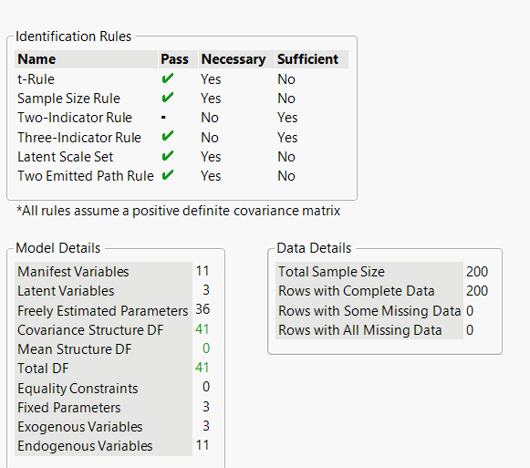
Table 1: Data Details
Using statistical methods including correlation and regression, data analysis will be used to evaluate the different relationships between flipped learning and soft skills development. The sample draws on undergraduate and postgraduate students from a range of schools, purposively sampled to reflect diverse experiences with flipped learning. Represents in the above table 1 This study met the sample size requirements since it had 210 survey respondents and sampled (n = 200) until data saturation with a large enough sample to provide rich, deep information and ease of representation. This inclusive approach further undertakes a refined analysis of how flipped learning can improve soft skills and employability.
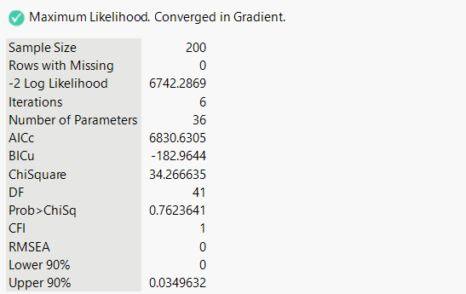
Measure 1: Source Authors own work.
Measure 1 above shows the chi-square statistic for this model, listed in the Summary of Fit report, is 34.27 with 41 degrees of freedom. The corresponding p-value was 0.7624, which was not statistically significant. Therefore, we can conclude that this model fits the data well. CFI values greater than 0.90 and RMSEA values less than 0.10 are preferred (Fan et al., 1999; Steiger, 1990). Here, a CFI of 1 and RMSEA of 0 indicated an excellent fit. It can be concluded that the survey is a good instrument for measuring latent constructs of flipped learning, soft skills, and employability among management students. The normalised residual heat map had no values that exceeded 2.0 units.
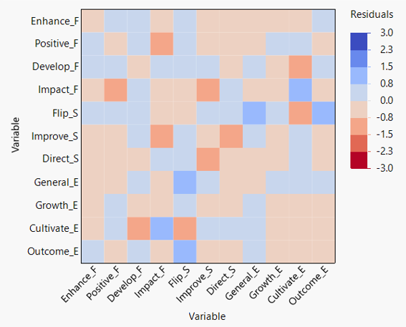
Measure 2. Standardised Factor Loadings > 0.7
The Measure 2 table above represents the colour scale ranges from dark blue (positive residuals around 3.0) to dark red (negative residuals around -3.0), with white representing residuals close to 0.Most cells are light-coloured, suggesting many residuals are close to zero. There are some notable darker blue and red cells, indicating stronger positive and negative residuals for certain variable pairs. The diagonal of the matrix has consistently light colours, which is expected as these represent residuals of variables with themselves. Some variables like "Enhance_ Flipped", "Positive_ Flipped", and "Development _ flipped" seem to have more intense colours in their rows/columns, suggesting they may have stronger relationships or larger residuals with other variables. The heatmap is symmetrical across its diagonal, which is typical for correlation or residual matrices.
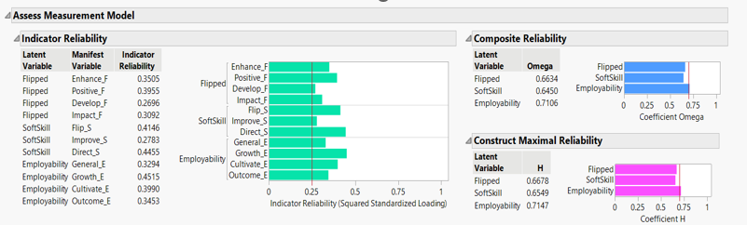
Measure 3. The assess measurement model.
The assessment measurement model Measure 3 above shows how dependable the contracts are, and all the contracts are built and have a value of 0.25, which crosses the green line in the graph. The composite reliability variable (Campbell and Fiske, 1959) shows the values of flipped skills (0.6634), soft skills (0.6450), and employability (0.7106). The construct maximum reliability value shows the flipped learning as (0.6678), soft skill as (0.6549) and employability as (0.7147), which shows that the students are under the flipped learning methodology of learning is highly dependable for their employability and their skills have been improved .This image provides information on indicator reliability, composite reliability, and construct maximal reliability.
Indicator Reliability:
- Most indicators show moderate to good reliability (above 0.3)
- The highest reliability is for Employability's Outcome_ Employability (0.5343)
- The lowest reliability is for Flipped Development_ Flipped (0.2696)
Composite Reliability (Omega):
- Flipped: 0.6634
- Soft Skill: 0.6450
- Employability: 0.7106
Construct Maximal Reliability (H):
- Flipped: 0.6678
- Soft Skill: 0.6549
- Employability: 0.7147

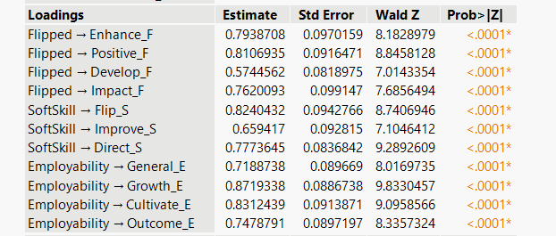
Measure 4. AVE > 0.7 Good, >0.5 acceptable
Average Variance Extracted (AVE),Convergent Validity, Measure 4 above: Standardised Factor Loadings > 0.7, Discriminant Validity Measure: 3 above Constructs should not be highly correlated. If two constructs were highly correlated (greater than 0.85), we explored the combination of the constructs.
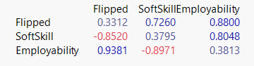
Measure 5. Corelation author own source
Measure 5 above represents the correlations between the latent variables are below the diagonal line.0.3312,0.3795,0.3813 show that the diagonal construct validity matrix and square factor correlation of the latent variables are above the diagonal (Measure 4).The Average Variance Extracted (AVE) is a measure of Convergent Validity. The diagonal values in the construct validity matrix represent the AVE. The diagonal entry for each latent variable should be higher than the entries above and to the right (Steiger, 1990).Visual levels of the AVE for each construct should be greater than the squared correlation between the constructs. This small table shows correlations between three factors: Flipped, Soft Skill, and Employability.
- Strong positive correlation (0.9381) between Employability and Flipped
- Strong negative correlation (-0.8971) between Employability and Soft Skill
- Moderate negative correlation (-0.8520) between Soft Skill and Flipped

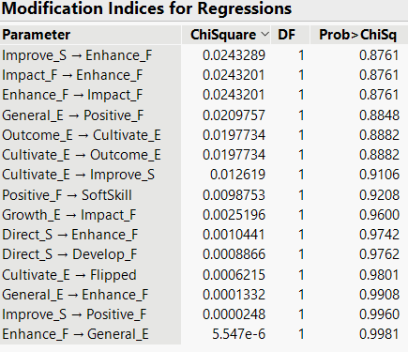
Measure 6.(a) :Modification indices for Regressions
Measure 6 (a)above shows the regression modification for this study, all the factors that have been verified with the regression model, and all rely on values between 0.8761 and 0.9981, which indicates a constant regression value of 1, which fits the regression model of the study. All factors had a strong and positive impact on the influence of employability on undergraduate and postgraduate students. This table shows various parameter relationships and their corresponding chi-square values, degrees of freedom (DF), and probability values. Most relationships have exceptionally low chi-square values and high probabilities (Probability>Chi Square), indicating that these modifications would not significantly improve the model fit. The relationship with the lowest p-value (0.8761) is "Improve Soft skill → Enhance Flipped development" and "Impact Flipped → Enhance Flipped".
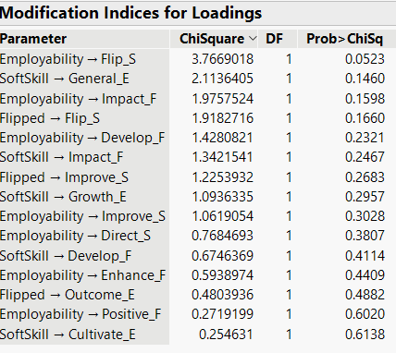
Measure 6.(b) :Modification Indices for Loadings
The above Measure 6(b) represents.
  - Parameter: Shows the relationships between variables or constructs
  - Chi Square: Displays the chi-square statistic for each potential modification.
  - DF: Stands for Degrees of Freedom, which is one for all rows in this case.
  - Probability>Chi Square: Represents the p-value or probability associated with the chi-square statistic.
The above Data Rows lists various relationships between constructs (Employability, Soft Skill, Flipped) and their indicators. Each row represents a potential modification to the model. The relationship with the lowest p-value (0.0523) is "Employability → Flipped_ Soft skill", suggesting this modification might potentially improve the model fit, although it is still above the typical 0.05 threshold for statistical significance. Most relationships have high p-values (>0.10), indicating that these modifications would not significantly improve the model fit. The chi-square values range from about 0.25 to 3.77, with most being below 2.0.This table is typically used in the context of model modification in structural equation modelling. Lower p-values (Probability>Chi Square) suggest that adding the corresponding parameter to the model might improve its fit. However, in this case, most modifications have limited potential for improving the model, as indicated by the high p-values. It provides insights into potential areas for model refinement, but the current model has a good fit since no modification indices show highly significant improvements. The relationship between Employability and Flipped_ Soft skill shows the lowest p-value (0.0523), but it is still above the typical significance threshold.

Results and findings

The Modification Indices table reveals insights into potential model improvements. The most notable relationship is between Employability and Flipped_ Soft skill, with a chi-square value of 3.7692 and a p-value of 0.0523. This suggests a potential, albeit weak, link between employability and a flipped learning indicator. Other relationships show less significant potential for model enhancement, with p-values ranging from 0.1641 (Soft Skill → Outcome_ Employability, chi-square 1.9372) to 0.9392 (Flipped → Improve_ Soft skill, chi-square 0.0057).The consistently high p-values (>0.05) across most relationships indicate that the current model structure is relatively robust. The degrees of freedom (DF) being one for all relationships suggests simple, one-parameter modifications are being considered. Overall, these indices imply that major structural changes to the model are unnecessary, as no modification shows a statistically significant improvement at the conventional 0.05 level. This analysis supports the model's current configuration while highlighting potential areas for minor refinement, particularly in exploring the relationship between employability and flipped learning components.

Discussion
A deeper conversation on the sustained impact of flipped learning for enhancing students' non-cognitive skills as they transition to work is an important tangent that would provide a comprehensive lens into its bigger influence. Although this study only shows short-term benefits in key areas such as communication or teamwork, problem-solving, and critical-thinking skills, future research needs to investigate how these advantages influence long-term professional success. Further research might explore to what extent the soft skills developed through flipped learning and taught in school are maintained and promoted when students transfer into professional life.
The impact of flipped learning on graduate’s career progression, job performance and adaptability in response to changing workplace needs could be further investigated over the course of longitudinal studies. Research could also examine the role of flipped learning in preparing students to independently continue their learning and maintain transferrable skills over a career, where practitioners face new challenges with changes in professional practice. From there, employers' viewpoints may also be included to see if the soft skills learned through flipping results in defined outcomes (sales improvement, leadership, promotion). Knowing these longer-term effects would give a more complete picture of the return-on-investment delivered by flipped learning in terms of employability and allow educational institutions to hone their curricula for better industry alignment.
Limitations of the Study
A potential limitation of this study is that the sample included two hundred students at a private university in India which provides constraint to generalization. Future studies are needed to replicate these findings in larger, more diverse samples from various educational and cultural backgrounds. A second restriction concerns the self-report nature of our data, which can motivate such that students tend to overestimate their soft skills development. Other types of objective assessments such as peer-evaluations may provide a clearer perspective. The study's short-term orientation does not allow observing the long-term employability outcomes of flipped learning and, thus, calls for longitudinal research. The study did not progress past access to technology and student engagement, both of which are necessary for the success of flipped learning. It is also assumed that the role of instructors and a comparison with other modern teaching methods are understudied. Working on those constraints might give a much better and more differentiated insight into flipped learning in relation to soft skills.
Future Suggestions
Future research then discusses research recommendations in various fields that need to be studied further for a comprehensive understanding of how flipped learning influences soft skills and employment. The study could have been improved in several ways, the most important would be to increase sample size with broader and more representative samples across multiple universities from different countries. Finally, longitudinal studies that follow students into their careers allowing to qualify the long-term benefits of flipped learning would be ideal. For the future, it might be interesting for studies to incorporate objective measurements like peer evaluations or real-world performance variables to give a less biased representation of soft-skills advancements.
Finally, it may be informative to study instructors themselves within the flipped learning environment, including an evaluation of the effects of various pedagogical strategies on student performance. Comparison of flipped learning with other innovative teaching strategies (e.g., project-based, or blended learning) would offer a clearer picture on its effectiveness. Lastly, to fully leverage the potential of flipped learning, the role of technological accessibility in student engagement and characteristic must also be taken into consideration.
Conclusion

Educators and institutions wishing to implement flipped learning strategies successfully need to pay greater attention to the following. One is providing the required technology infrastructure ( reliable internet, digital access ) without which not all students can prepare pre-class materials. This calls for institution to invest in content development methods that allow faculty members to build interactive, high-quality content which promotes critical thinking and self-learning. From a pedagogical perspective, adopt flipped learning but with caution and in tandem with other learning strategies from the active side of learning techniques such as project-based learning to offer a complete education experience.
The continuous self-assessment should go hand in hand with a 360-degree evaluation, Peer Reviews and on real-world Applications to assess their soft skills effectively. In addition, institutions can form feedback loops where students reflect on their own learning process and outcomes, to help students further develop self-awareness and soft skills. Lastly, blending flipped with career services and industry partnerships would offer students practicum and applied applications of these skills in a real-world professional environment facilitating the transition from academic learning to workplace. Through addressing each of these dimensions, flipped learning has the potential to be a key driver in employability for 21st century education.

References

