Countries With The Best Mental Healthcare In The World – Mapped

https://www.william-russell.com/blog/countries-best-mental-healthcare/

Where are the best places to live for mental health?
Rank | Country | Long Hours | Leisure Time | Green Spaces | Avg Temp (°C) | Avg Rainfall (mm) | Govt Mental Health Spend | Rank Score
1 | Sweden | 1.1% | 15.2 | 68.7 | 2.1 | 624 | 9.0% | 7.13
2 | Germany | 4.3% | 15.6 | 32.7 | 8.5 | 700 | 11.3% | 6.60
3 | Finland | 3.8% | 15.2 | 73.7 | 1.7 | 536 | 5.6% | 6.47
4 | France | 7.7% | 16.4 | 31.5 | 10.7 | 867 | 15.0% | 6.40
5 | The Netherlands | 0.4% | 16.1 | 11 | 9.3 | 778 | 7.1% | 6.27
6 | Italy | 4.1% | 16.5 | 32.1 | 13.5 | 832 | 3.5% | 6.07
7 | Canada | 3.7% | 14.6 | 38.7 | -5.4 | 537 | 10.6% | 5.80
8 | Norway | 2.9% | 15.6 | 33.4 | 1.5 | 1,414 | 13.5% | 5.73
9 | Slovenia | 4.4% | 14.8 | 61.5 | 8.9 | 1,162 | 5.8% | 5.53
10 | Australia | 13.0% | 14.4 | 17.4 | 21.7 | 534 | 7.8% | 5.47
11 | Ireland | 5.3% | 15.3 | 11.4 | 9.3 | 1,118 | 6.0% | 5.13
12 | Estonia | 2.4% | 14.9 | 56.1 | 5.1 | 626 | 2.9% | 5.20
13 | Latvia | 1.3% | 13.8 | 54.9 | 5.6 | 667 | 5.3% | 5.07
14 | Czech Republic | 5.6% | 15.1 | 34.7 | 7.6 | 677 | 4.0% | 5.07
15 | Greece | 6.4% | 14.7 | 30.3 | 15.4 | 652 | 3.9% | 4.93
16 | Switzerland | 0.4% | 15.1 | 32.1 | 5.5 | 1,537 | 5.1% | 4.80
17 | New Zealand | 15.1% | 14.9 | 37.6 | 10.6 | 1,732 | 9.0% | 4.67
18 | South Africa | 18.1% | 14.9 | 14.1 | 17.8 | 495 | 3.0% | 4.53
19 | Japan | 17.9% | 14.1 | 68.4 | 11.2 | 1,668 | 6.2% | 4.33
20 | South Korea | 25.2% | 14.7 | 64.5 | 11.5 | 1,274 | 3.8% | 4.27
21 | United Kingdom | 12.2% | 14.9 | 13.2 | 8.5 | 1,220 | 9.7% | 4.13
22 | Brazil | 7.1% | 14.4 | 59.4 | 25.0 | 1,761 | 1.0% | 4.07
23 | Israel | 15.4% | 13.7 | 6.5 | 19.2 | 435 | 3.4% | 3.87
24 | Poland | 6.0% | 14.4 | 31 | 7.9 | 600 | 2.6% | 3.80
25 | Chile | 9.7% | 13.3 | 24.5 | 8.5 | 1,522 | 2.1% | 2.07
26 | Iceland | 15.1% | 14.1 | 0.5 | 1.8 | 1,940 | 5.7% | 1.60

Hook, K., & Vera, E. (2020). Best Practices in Global Mental Health: An Exploratory Study of Recommendations for Psychologists. International perspectives in psychology : research, practice, consultation, 9(2), 67–83. https://doi.org/10.1037/ipp0000125

Best Countries in the World for Mental Health Treatments
By
Medical Tourism Magazine
https://www.magazine.medicaltourism.com/article/best-countries-in-the-world-for-mental-health-treatments

Best Countries in the World for Mental Health Treatments
In recent years, mental health has gained significant attention worldwide, leading to a surge in the demand for quality mental health treatments. This increasing awareness has spotlighted various countries that excel in providing exceptional mental health care, making them attractive destinations for those seeking comprehensive and effective treatment. This article aims to explore the best countries in the world for mental health treatments, focusing on their unique strengths and offerings in this specialized field.

Sweden: Pioneering Mental Health Care
Sweden stands out as a leader in mental health care, known for its patient-centered approach and state-of-the-art facilities. The country's focus on early intervention and preventive care, along with its extensive research in psychiatric treatments, makes it a top destination for individuals seeking advanced mental health care.

Germany: Excellence in Psychiatric Treatments
Germany is renowned for its precision and excellence in medical treatments, which extends to its mental health care services. With a blend of traditional and innovative therapies, Germany offers a holistic approach to mental health, focusing on both physical and psychological well-being.

Canada: A Holistic Approach to Mental Wellness
Canada's inclusive and holistic approach to mental health care makes it a preferred destination. The country emphasizes community-based treatments, and its diverse range of therapies includes both modern and traditional practices, catering to a wide array of mental health needs.

Australia: Integrative Mental Health Practices
Australia is notable for its integrative approach to mental health, combining medical expertise with alternative therapies. This comprehensive approach ensures that patients receive tailored treatments, making Australia a sought-after destination for those seeking personalized mental health care.

Netherlands: Innovative Therapeutic Techniques
The Netherlands is at the forefront of innovative mental health treatments. Known for its progressive and open-minded approach to mental health, the country offers a variety of pioneering therapeutic techniques, making it a top choice for individuals seeking cutting-edge mental health care.

Japan: Blending Tradition with Modern Psychiatry
Japan offers a unique blend of traditional practices and modern psychiatric techniques. Its focus on holistic well-being, combined with advanced medical technology, provides a balanced approach to mental health, appealing to those who seek a harmonious blend of old and new.

United Kingdom: Comprehensive Mental Health Services
The United Kingdom boasts a comprehensive mental health system, with a wide range of services catering to different mental health conditions. The country's emphasis on research and development in psychiatric care ensures that patients have access to some of the latest and most effective treatments.

United States: A Hub for Psychiatric Research
The United States is a hub for psychiatric research and offers a vast array of mental health treatments. With some of the world's leading mental health professionals and institutions, the U.S. is a key destination for those seeking high-quality mental health care.

Switzerland: Privacy and Luxury in Mental Health Care
Switzerland offers a unique combination of luxury and privacy in its mental health treatments. Known for its high-end facilities and discreet services, Switzerland is a preferred choice for those seeking exclusive and personalized mental health care.

Singapore: A Rising Star in Mental Health
Singapore is rapidly emerging as a leading destination for mental health treatments in Asia. Its investment in mental health infrastructure and emphasis on patient-centric care make it a promising choice for individuals seeking advanced and compassionate mental health services.
In conclusion ,as mental health continues to be a crucial aspect of overall well-being, these countries stand out for their exceptional contributions to mental health care. Each offers unique strengths, from innovative treatments and research to holistic and patient-focused approaches, making them ideal destinations for those seeking the best in mental health treatments. For industry professionals, understanding the diverse landscapes of these top countries can provide valuable insights into the evolving field of mental health tourism.
To receive a free quote for medical tourism procedures please click on the link: https://www.medicaltourism.com/get-a-quote
For those seeking medical care abroad, we highly recommend hospitals and clinics who have been accredited by Global Healthcare Accreditation (GHA). With a strong emphasis on exceptional patient experience, GHA accredited facilities are attuned to your cultural, linguistic, and individual needs, ensuring you feel understood and cared for. They adhere to the highest standards, putting patient safety and satisfaction at the forefront. Explore the world's top GHA-accredited facilities here. Trust us, your health journey deserves the best.
Learn about how you can become a Certified Medical Tourism Professional→
Disclaimer: The content provided in Medical Tourism Magazine (MedicalTourism.com) is for informational purposes only and should not be considered as a substitute for professional medical advice, diagnosis, or treatment. Always seek the advice of your physician or other qualified health provider with any questions you may have regarding a medical condition. We do not endorse or recommend any specific healthcare providers, facilities, treatments, or procedures mentioned in our articles. The views and opinions expressed by authors, contributors, or advertisers within the magazine are their own and do not necessarily reflect the views of our company. While we strive to provide accurate and up-to-date information, We make no representations or warranties of any kind, express or implied, regarding the completeness, accuracy, reliability, suitability, or availability of the information contained in Medical Tourism Magazine (MedicalTourism.com) or the linked websites. Any reliance you place on such information is strictly at your own risk. We strongly advise readers to conduct their own research and consult with healthcare professionals before making any decisions related to medical tourism, healthcare providers, or medical procedures.
____________________________
https://www.who.int/news-room/feature-stories/detail/transforming-national-mental-health-systems--best-practices-from-the-who-special-initiative-for-mental-health

WHO

Transforming national mental health systems: best practices from the WHO Special Initiative for Mental Health
28 April 2023
The WHO Special Initiative for Mental Health is on its way to achieving its target: ensuring one hundred million people across nine participating countries have access to affordable, quality mental health services.
A mid-term review of the Initiative’s progress highlights important advancements in national mental health policies and increased provision of services for people living with mental health conditions. The map below (Fig 1) highlights some of the key country milestones reached since the Initiative launched five years ago:
Fig 1: Country-level achievements through the Special Initiative for Mental Health
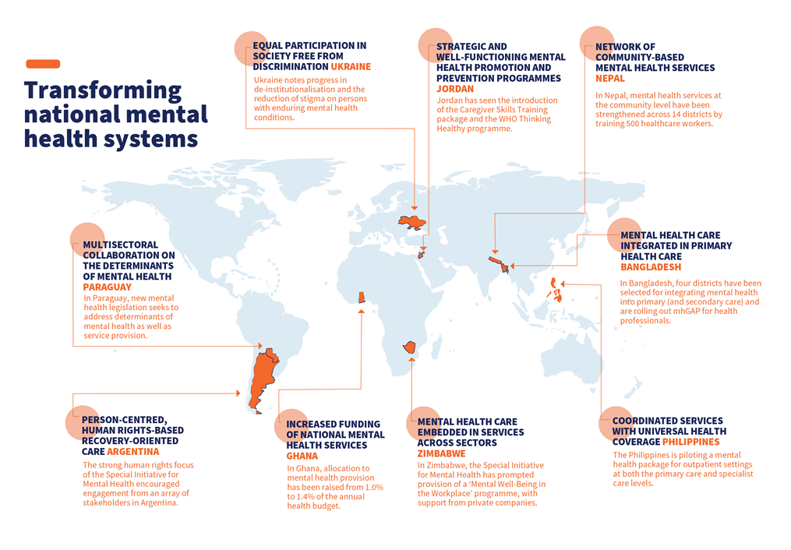
Bolstering the building blocks of mental health care
Across nine participating countries, the Special Initiative for Mental Health engages all health system building blocks: service delivery, health workforce, health information systems, access to essential medicines, financing, leadership and governance. To date, three of these areas have particularly benefited from the Initiative’s approach:
1) Leadership and governance. Through a collaborative and inclusive planning process, the Special Initiative for Mental Health engaged a wide range of stakeholders including officials from Ministries of Health, people with lived experience of mental health conditions and local advocates. In Jordan, planning for the initiative received high-level engagement from national authorities, leading to a review of the national Mental Health and Substance Use Action Plan, and the adjustment of national mental health priorities to match the global agenda.
Similarly, as a result of support from Special Initiative for Mental Health, Bangladesh endorsed a National Mental Health Policy (2022) and began implementing their National Mental Health Strategic Plan (2020-2030). Paraguay has passed legislation on mental health access, while Ghana has appointed a governing board to its mental health authority.
2) Health workforce. The WHO Special Initiative for Mental Health also boosts mental health workforce capacity through various training programmes, including mhGAP, Self Help+ and QualityRights. Zimbabwe saw a national roll-out of QualityRights in mental health training across multiple stakeholder groups. Speaking about the impact of the training, a mental health nurse in Zimbabwe said: “Before I trained in QualityRights, if a client complained about the medication, I would not listen to their concerns because I thought that I knew what was best for them. But now, I ask clients if they are experiencing any side effects and if the medication is working for them.” General health staff in primary health care facilities across Zimbabwe were also trained to identify, manage and support people living with mental disorders.
In Jordan, mhGAP was integrated into the pre-service national training curriculum for family physicians. As a result, 31% of primary health centres across the Kingdom now provide mhGAP services—compared to only 17% in 2021. In Nepal, 47 health facilities with personnel providing mental health services received supervision, enhancing the quality of service delivery.
3) Service delivery. As part of the initiative, countries have also developed new services focused on expanding access to mental health care. Paraguay introduced virtual consultations, resulting in a 500% increase in mental health care coverage. Argentina committed to increasing mental health service delivery in communities and general hospitals to promote the transition of mental health care from psychiatric hospitals to accessible community, primary and secondary health care services.
Elsewhere, Ukraine endorsed Community Mental Health Teams (CMHTs) as a national service model and included recovery-focused, person-centred community care within services provided to patients under the State Programme of Medical Guarantees. Hospitals hosting CMHTs are now better prepared to support their clients during the war, given the mobile, innovative and multidisciplinary way in which the CMHTs work. Since the beginning of Russia’s war with Ukraine, CMHTs have provided over 23,000 consultations, reaching more than 1,400 people with severe mental disorders.
Increasing political prioritisation and funding for mental health
By involving senior leadership across countries, training the health workforce and rolling-out new mental health services—the WHO Special Initiative for Mental Health has placed a spotlight on this often-neglected area of public health and supported countries to take action. One respondent to the Initiative’s recent mid-term review highlighted its impact, noting: “being part of the Initiative created momentum and put mental health on the list of priorities for national authorities and resulted in an updated national action plan for mental health.”
Importantly, government leadership on mental health is translating to increased investment in mental health services across the implementing countries, which is vital to improving access to mental health care in these populations. In the Philippines, the central government’s budget for mental health is set to increase to 1 billion pesos this year, a sharp increase from 57 million pesos in 2022. The government has already invested 10.4 million USD for free access to mental health medicines, 164 million USD to pilot a new benefit package for mental health outpatient primary care and 293 million USD to support access to mental health services. Similarly, in Ghana, the Ministry of Health’s allocation for mental health has been raised from 1.0% to 1.4% of its annual budget.
Looking to the future, WHO will use the learnings from the Initiative’s rollout in nine countries to encourage more countries to scale-up mental health services, ultimately expanding access to quality and affordable mental health care – for all.
__________________--
https://www.cnbctv18.com/photos/healthcare/mental-health-day-2022-top-countries-offering-best-treatment-14893031-9.htm

From Sweden to Australia — Top countries offering the best mental health treatment
SUMMARY
Since the COVID-19 pandemic, there has been a growing understanding of the importance of mental health and how to better take care of it. While individuals can take many steps to improve their own mental health, a large number of mental disorders require external intervention. The level of government spending on developing mental-health infrastructure is one of the best predictors of the quality of mental health treatment. Here are some of the top countries which offer the best mental health treatment.
Sweden | With a strong public health network, a culture that promotes work-life balance and plenty of ways to decompress, Sweden offers some of the best mental health treatment as well as one of the best places for having great mental health in the first place. (Image: Shutterstock) Germany | Germany is one of the countries with an extensive support network to help those suffering from mental illnesses and also to help to readjust to everyday life after treatment. A culture that strictly keeps work life during work hours also helps in mental well-being. Finland | Often voted as one of the happiest populations in the world, Finland offers many of the same benefits as neighbouring Sweden. The country is also constantly working on improving its mental health infrastructure and decreasing the stigma around mental health issues. France | Perhaps one of the world’s best places to work in terms of work-life balance, France is famous for providing a great setting to recharge your mental health. Heavy spending on national healthcare programs also means that mental health treatment is easily accessible, free and effective. The Netherlands | The Netherlands has one of the best public healthcare systems in the world. The country’s focus on mental health is present throughout all age groups. The country is home to some of the world’s happiest children and teenagers. Italy | Home of the phrases ‘La Dolce far Niente (the joy of doing nothing) and ‘La Dolce vita’ (the good life), Italy has revamped its mental health infrastructure after being brutally battered during the first wave of the COVID-19 pandemic in 2020. Norway | The Scandinavian country has invested heavily in mental health intervention and has one of the strongest social security nets in the world. Canada | While Canada is one of the best countries in terms of mental healthcare treatment quality and has far happier citizens than the neighbouring US, most of the mental healthcare is taken care of through family doctors and primary care doctors. Slovenia | After the COVID-19 pandemic, Slovenia has taken a concerted effort to improve its mental health infrastructure. The country has instituted several new programs, opened several institutions and increased the number of mental health services that it offers its citizens. Australia | While Australia already offered free mental healthcare from its public hospitals, in recent years it has taken efforts to make mental healthcare more accessible to its highly dispersed population outside of major population centres. The country has also focused on improving people’s physical health in order to boost mental well-being.

