- METHODOLOGY

The main focus of the research is to analyze the role of co-operatives in sustaining the livelihoods of local rural communities in Bhojpur District in Bihar. The secondary data will supplement primary data for proper data analysis to get the desired result. Secondary data shall be collected from published books, journals, reports, thesis magazines, bulletins and web searching. Descriptive survey design will be used in this mixed method approach to the study. Observation method will be employed as the main research instrument. Purposive sampling technique will be adopted.

With the aid of a structured schedule, primary data will be collected from the area of study in order to elicit information, and interviews will be conducted with respondents to elicit the desired information. The Household Assets, Income, and Social Capital data will be sourced from the "India Human Development Survey-II" for the purpose of constructing the schedule framework.

Based on the crop coverage data for paddy and wheat provided by the Agriculture Department of the Bhojpur District, three blocks each were selected based on the crop coverage of paddy and wheat. Based on the wheat coverage data provided, three blocks were selected based on three strata: high, medium, and low coverage. Included in the high coverage block is Jagdishpur. The block with medium coverage is Garhani, while the block with low coverage is Behea. Two panchayats were chosen from each of the three blocks based on whether they had high or low crop coverage. From Jagdishpur high coverage panchayat, Kaura and Chakwa have high coverage and low coverage, respectively. We have Echari as a high coverage panchayat and Kurkuri as a low coverage panchayat within the Garhani block, which has medium coverage. From the Behea block, which has low wheat coverage, we selected Shiopur as the high coverage panchayat and Kalyanpur as the low coverage panchayat. On the basis of paddy coverage data, three blocks were simultaneously selected based on three strata: high, medium, and low coverage. high-coverage block, namely Jagdishpur. Two panchayats were chosen from Jagdishpur based on the High and Low strata. From high coverage, the Basauna panchayat is chosen, and from low coverage, the Bimawan panchayat. Two panchayats with high and low crop coverage were selected from the Agaion Block with medium crop coverage. Ratnarh panchayat has the highest crop coverage, and Sewatha panchayat has the lowest. On the basis of high and low crop coverage data, two panchayats, Matukpur and Nathmalpur, were selected from the Barhara low coverage block. And from the total of twelve panchayats listed above, six wheat coverage panchayats and six paddy coverage panchayats were selected. In addition, two villages were selected at random from each of the 12 panchayats. Randomly selected, there were a total of twenty-four villages. Thirteen samples were collected from each of the twenty-four villages, yielding a total of 312 respondents.

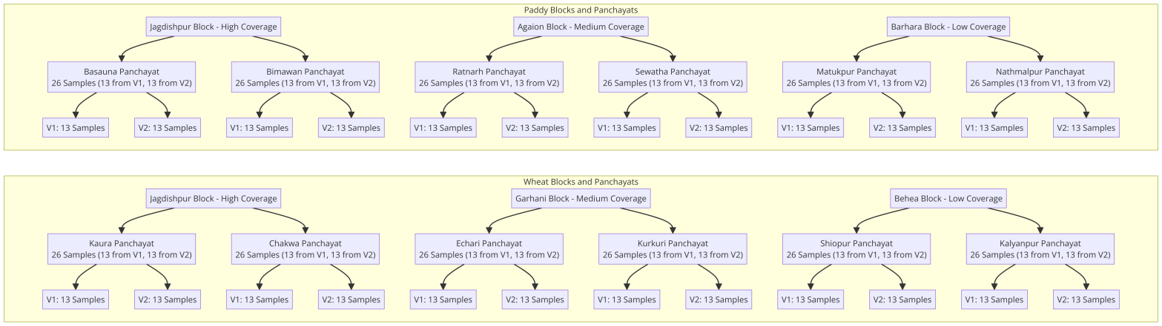

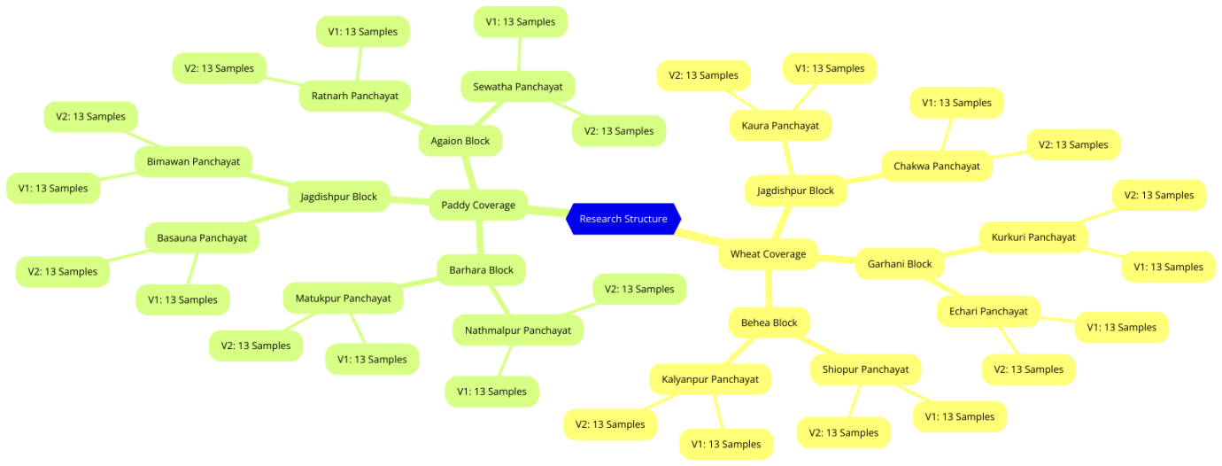

Data will also be collected from 5 PACs from different Panchayats of Jagdishpur, Agaion, Barhara, Garhani, Behea blocks of Bhojpur District. Two sets of schedule shall be prepared- one for office bears of PACs/Vyapar Mandal and one from farmers who are supplying food grains to PACs for procurement as getting different forms of subsidies from PACs Office bearers. PACs shall be questioned about offtake of food grains from farmers, credit, subsidies on fertilizers, pesticide, distribution of seeds etc.
Meeting with officials of the block as well as district, including District Cooperative officer, banks, executive and staff of all the tiers of the co-operative structure of the state will be done to get secondary data and published material relating to co-operative.
Data collected from the study will be arranged, coded and analyzed through the use of statistical package for social sciences(SPSS) computer programme. The statistical measures which will be employed for interpretation of data are- Percentage, Mean score, Standard deviation, Coefficient of variation, Rank order, Score gap, Coefficient of correlation, Regression, Test of significance will be employed in the study.

