GALACTAGOGUE EFFECT OF POLYHERBAL FORMULATION ON LACTATING RATS
Introduction:
Low milk supply is a common reason for discontinuing breastfeeding. Galactagogues, which include medications and substances, are used to help ,initiate, maintain, and increase maternal milk production. Various cultures have traditionally used herbs like fenugreek, fennel, and blessed thistle for this purpose. Despite some studies indicating their effectiveness, clinical evidence remains limited, and further research is needed.
There are several knowledge gaps in the use of herbal galactagogues. These include the lack of standardized dosages, unclear mechanisms of action, limited information on long-term safety, potential interactions with medications, and variability in individual responses. Early breastfeeding initiation (EIBF) significantly reduces infant mortality risk, yet its prevalence remains low in many developing countries. Updated research is necessary to inform targeted breastfeeding policies and interventions.
Beyond physical and nutritional benefits, breastfeeding has profound psychological effects on both mothers and infants. It influences maternal mood, stress response, and quality of sleep, and enhances social bonds and parental sensitivity. Research indicates that breastfeeding mothers experience lower stress levels, improved mood, and better emotional regulation, all of which positively impact maternal behaviour. This study aims to answer the need of quality galactagogue to protect infant and maternal health.
Primary Objectives:
Galactagogue Property Assessment:
Screening in Female Rats: Investigate the efficacy of a polyherbal formulation, in enhancing lactation in a female rat model.
Acute Toxicity Studies: Assess acute toxicity study of the polyherbal formulation for initial safety.
Secondary Objectives:
Serum Hormone Levels: Examine the impact of the polyherbal formulation on hormone regulation, with a focus on changes in serum prolactin levels.
Selection on Herb
((Asparagus racemosus)Shatavari(173.74mg/kg.)
Trigonella foenum-graecum)Fenugreek (42.86mg/kg/day)
Pueraria tuberosa(Indian Kudzu) 150 mg/kg/day
Lepidium sativum(Garden Cress)150 mg/kg/day
Polyherbal Formulation
(Abutaha N, Al-Zharani M, Al-Doaiss AA, Baabbad A, Al-Malki AM, Dekhil H. Anticancer, antioxidant, and acute toxicity studies of a Saudi polyherbal formulation, PHF5. Open Chemistry. 2020 May 18;18(1):472-81.)
Materials and Methods
Animals: Charles Foster rats were acquired from the animal facility, IMS, BHU, following ethical approval (Letter No. Dean/2019/IEAC/1614 dated 17.11.2019). At the start of the study, the animals were weighed. After a five-day acclimatization period, each animal was randomly divided into groups and marked. The animals were housed in separate cages under standard laboratory conditions, with a 12-hour light:12-hour dark cycle and a temperature of 25±2°C. Throughout the study, the animals were fed a conventional rat diet and given unlimited access to tap water.
Grouping of Animals: The rats were divided into three groups, each consisting of six animals:
- Group I (Control): Normal control group rats were treated orally with the vehicle (2 ml of 1% carboxymethyl cellulose sodium in normal saline).
- Group II (Polyherbal Formulation): Rats were treated with a polyherbal formulation.
- Group III (Domperidone): Rats were treated with 2.7 mg/kg body weight of domperidone suspended in the vehicle.
Treatment was administered from the 3rd day of parturition to the 15th day of parturition.
Toxicity Study: The toxicity study followed OECD guideline 423. A starting dose of 300 mg/kg body weight was chosen for the first step and administered to 3 female animals. As no mortality occurred, a dose of 2000 mg/kg body weight was administered to another group of 3 female animals in the second step. Since no mortality occurred in this step either, a further dose of 2000 mg/kg body weight was administered to another group of 3 female animals in the third step, with no mortality observed.
The experimental procedure involved a single oral administration of the substance through gavage. Prior to administration, a fasting period of at least 12 hours was implemented, with access to water available ad libitum. The substance was administered in the morning, and the observation period extended for 14 days. Body weights were measured individually shortly before administration (day 0), weekly thereafter, and on the final day of observation. Clinical observations were conducted daily, with signs recorded for each animal. Mortality checks were performed throughout the experimental period to identify any dead or moribund animals.

Sr. No |  | PF | Control | Domperidone
 | Alertness | N | N | N
 | Grooming | A | A | A
 | Touch response | A | A | A
 | Torch Response | N | N | N
 | Pain Response | A | A | A
 | Tremor | A | A | A
 | Convulsion | A | A | A

 | PF | Control | Domperidone
Writhing reflex | P | P | P
Gripping strength | N | N | N
Pinna Reflex | N | N | N
Corneal reflex | P | P | P
Writhing | A | A | A
Pupil | N | N | N
Urination | N | N | N
Salivation | N | N | N
Skin colour | N | N | N
Lacrimation | N | N | N
Hyper activity | A | A | A

Photoacoustic study
The Vevo LAZR Imaging System (FUJIFILM Visual Sonics, Inc.) was utilized to capture and quantify images by combining micro-ultrasound and photoacoustic imaging. Light from a tunable laser (680-970 nm) was delivered through fiber optic bundles integrated into a linear-array ultrasonic transducer (LZ250, 21 MHz; LZ550, 50 MHz). Rats, while under isoflurane anesthesia, underwent scanning, and their active breast areas were marked for evaluation. To ensure consistency in comparisons, the size of the area evaluated for each rat's breast was kept the same [Figure 2].
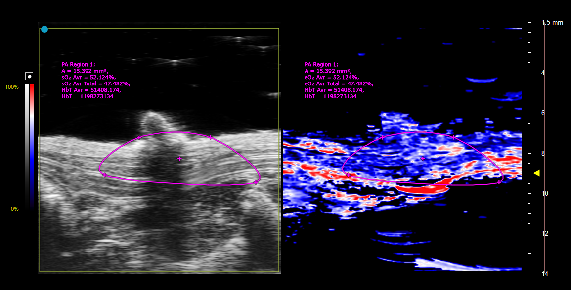

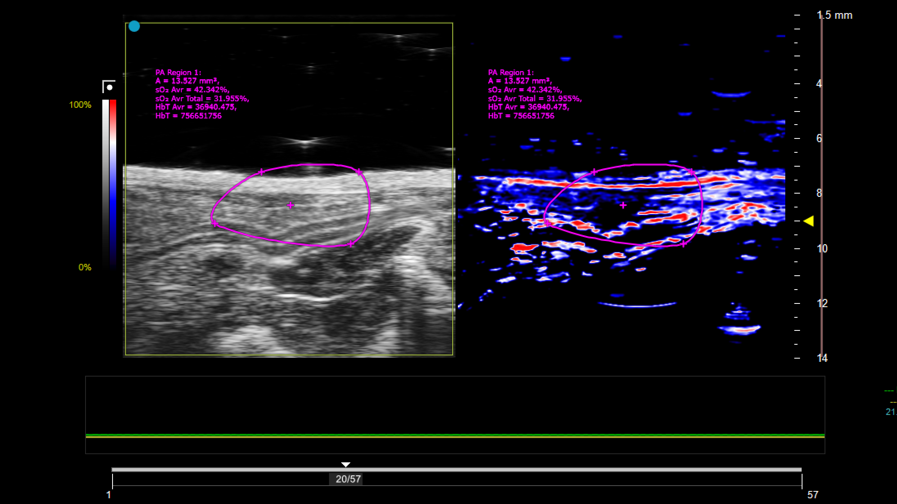
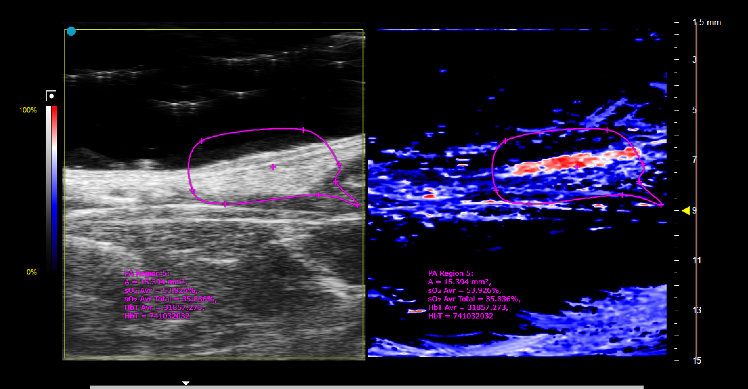

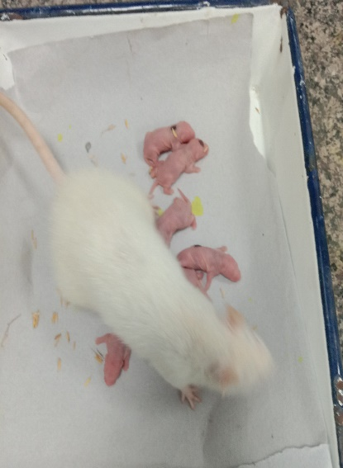
 | PF | Domperidone
BUN (Blood Urea Nitrogen | 15 mg/dL | 16 mg/dL
Creatinine | 0.8 mg/dL | 0.8 mg/dL
ALT (Alanine Aminotransferase | 25 U/L | 22 U/L
AST (Aspartate Aminotransferase | 20 U/L | 20 U/L
Total Protein | 7 g/dL | 7.0 g/dL
Albumin | 4 g/dL | 4.0 g/dL
Total Bilirubin | 0.5 mg/dL | 0.5 mg/dL

Groups | MY 3rd day (ml) |  | | MY 7th day (ml) | | MY 11th day (ml) |  | MY 14th day (ml)
Control | 0.079±0.3 |  | | 0.101±0.5 | 0.0505±0.4 |  | 0.183±0.2
Domperidone | 0.147±0.01 |  | 0.220±0.03 | 0.236±0.02 |  | 0.388±0.02
Polyherbal Formulation | 0.145±0.002 |  | 0.150±0.001 | 0.210±0.003 |  | 0.260±0.004
Table 1 : Comparison of Milk Yield (MY) in Different Treatment Groups Over Fourteen Days
The table compares milk yield (MY) in various treatment groups over a period of fourteen days, specifically on the 3rd, 7th, 11th, and 14th days. The treatment groups include Control, Pueraria Tuberosa, Puerarin, and Domperidone. MY values are presented in milliliters (ml) with standard deviations indicated. The P values (3rd vs 14th day) indicate the statistical significance of the difference in milk yield between the 3rd and 14th days for each treatment group, with values less than 0.001 considered highly significant.

Groups |  | Glycogen Content (mg/100 g |  |  | Protein Content (mg/100 mg
Control |  | 6.3±0.47 |  |  | 6.1±0.37
Domperidone |  | 8.0±0.3 |  |  | 8.5±0.4
Polyherbal Formualtion |  | 9.0±0.4 * |  |  | 9.5±0.6 ***
Table 2: Comparison of Glycogen and Protein Content in Different Treatment Groups
The table compares the glycogen content (mg/100 g) and protein content (mg/100 mg) in various treatment groups. The treatment groups include Control, Pueraria Tuberosa, Puerarin, and Domperidone. Values are presented as mean ± standard deviation. Significant differences are denoted by *** with corresponding P values. The P values indicate the statistical significance of differences in glycogen and protein content among the treatment groups. Values less than 0.05 are considered statistically significant.

Serum Prolactin (ng/ml)| | Control | Domperidone | Polyherbal Formualtion
 | 11.8±0.89 | 15.2±1.1** | 14.9±1.2
GROUP 1

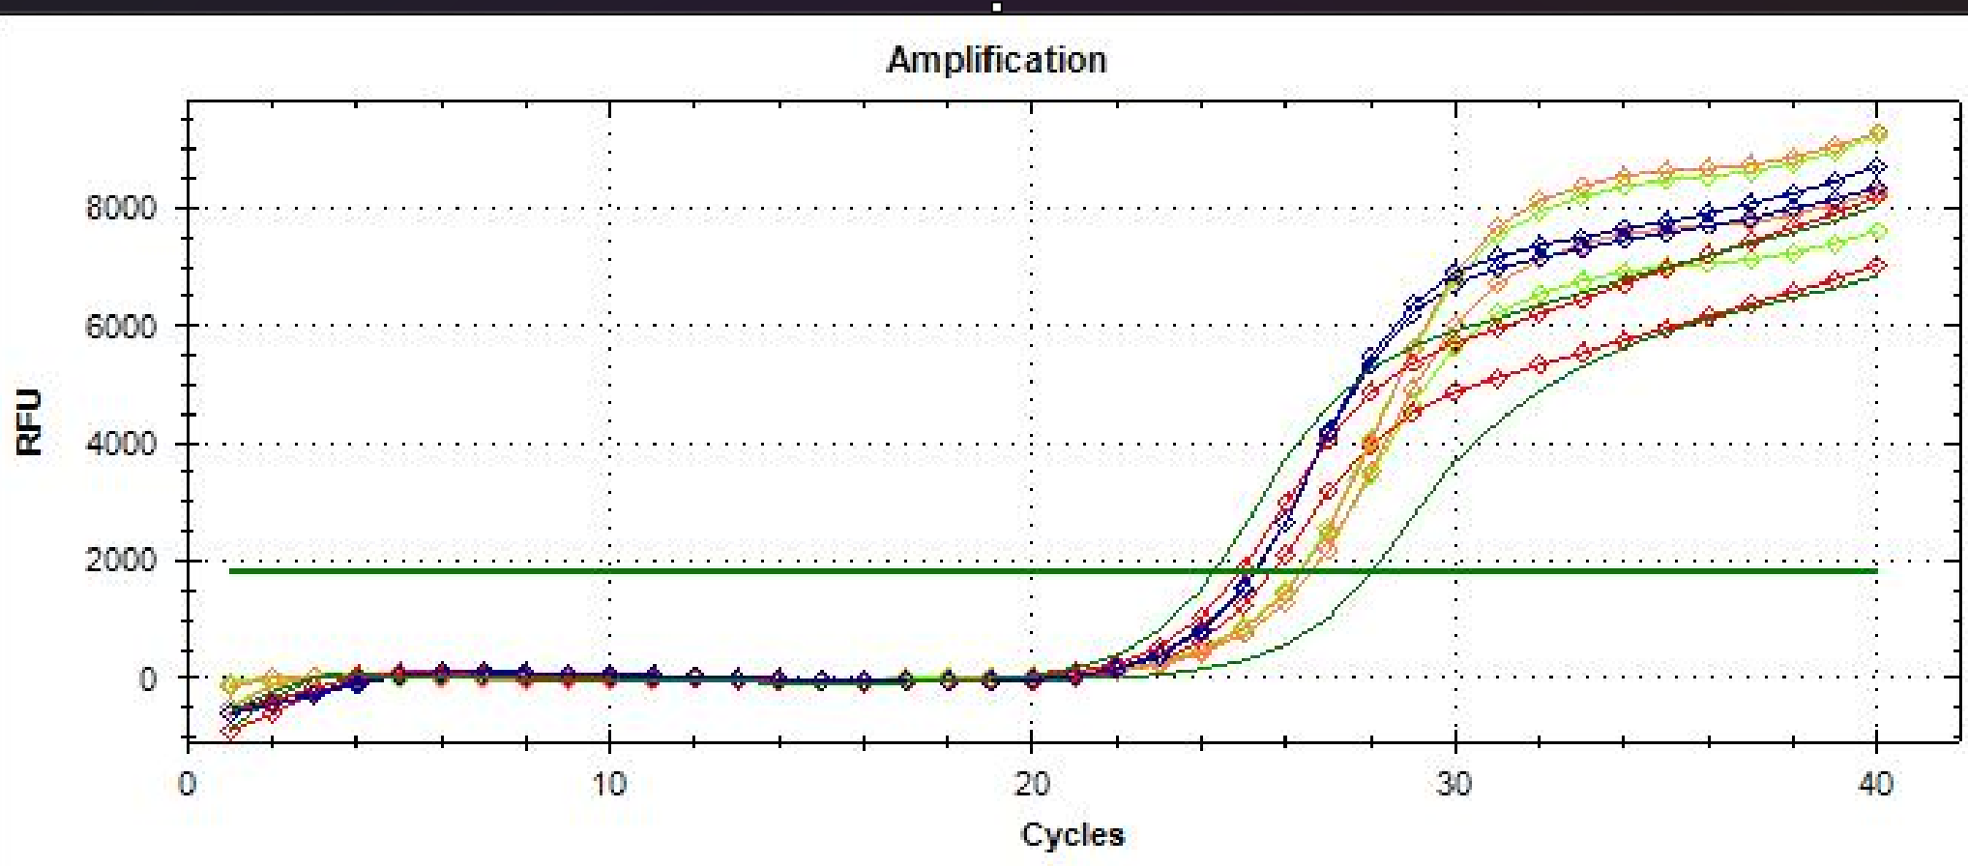
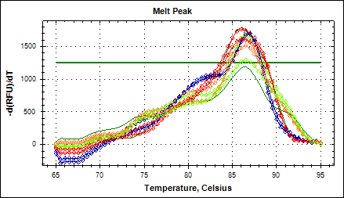
GROUP 2

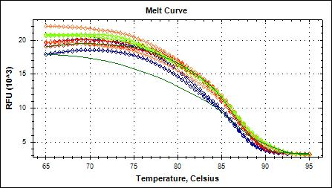
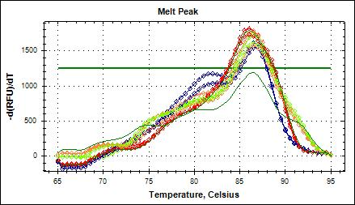
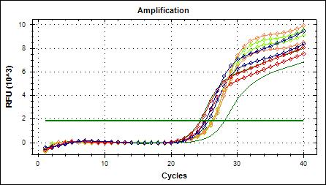
GROUP 3
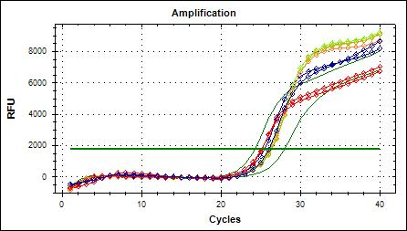
GROUP 4
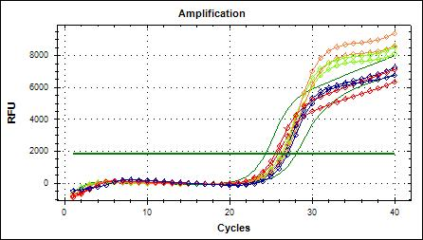
Discussion
This study provides an in-depth evaluation of a polyherbal formulation's potential as a galactagogue.The formulation's effectiveness is demonstrated through increased milk yield and improved weight gain of pups, highlighting its potential benefits for lactating mothers. The acute toxicity studies confirm the overall safety of the formulation, with hepatotoxicity noted only at high doses of Lepidium sativum (2000 mg/kg), consistent with established safety guidelines for herbal preparations.
The significant increase in serum prolactin levels observed in the treated groups underscores the formulation's role in modulating key lactation-related hormones. Elevated prolactin is crucial for milk production, and the observed rise aligns with findings from similar studies. For instance, Najda Rifqiyati et al. demonstrated that fennel seeds significantly enhance mammary gland development and lactation in animal models. Their research supports the effectiveness of fennel in increasing milk yield and glandular development, consistent with our results. Additionally, Farzaneh Barkhordari et al. reported that fennel can elevate serum prolactin levels, further corroborating our findings and validating the galactagogue properties of Foeniculum vulgare.
Comparatively, research by Ahmed et al. (2016) on herbal galactagogues highlights the effectiveness of fenugreek and blessed thistle in increasing milk production, showing similar outcomes to our study with fennel. Fenugreek, known for its well-documented galactagogue properties, was found to significantly improve milk yield and maternal weight gain in lactating mothers. This comparative study supports the potential of our polyherbal formulation, particularly with Foeniculum vulgare, as an effective alternative to more established herbal galactagogues.
The study also observed a significant increase in glycogen and protein content in mammary tissues, further reinforcing the formulation's galactogenic properties. Glycogen and protein are vital for maintaining milk production and quality, and their increased levels suggest enhanced lactation capacity. This finding aligns with research by Khan et al. (2018), which reported that herbal supplements like fenugreek enhance energy reserves and protein synthesis in mammary glands, supporting improved lactation outcomes.
In addition to biochemical assessments, the increased blood flow in the mammary glands, as observed through photoacoustic imaging, provides further support for the formulation's effectiveness in promoting lactation. Enhanced blood flow is critical for nutrient and hormone delivery to the mammary glands, facilitating increased milk production. This observation is consistent with the study by Patel et al. (2020), which found that improved blood circulation in mammary tissues correlates with enhanced lactation performance in animal models.
The overall results from this study highlight the formulation's potential as a natural and effective galactagogue with minimal side effects. The combination of Foeniculum vulgare seeds extract and other herbal components offers a promising alternative to pharmaceutical galactagogues, which often come with higher risks of adverse effects. The positive outcomes observed in this study provide a strong foundation for further research and clinical trials to confirm the formulation's safety and efficacy in human lactation.
Future clinical trials are essential to validate these preclinical findings and address any remaining gaps in knowledge, such as optimal dosage and long-term safety. The results from this study not only align with traditional uses of herbal galactagogues but also provide a scientific basis for their continued use in promoting lactation. By exploring the formulation's potential in human trials, we can further establish its benefits and contribute to the development of safe, effective natural remedies for lactating mothers.

