Assessing and Mapping of the Soil Fertility Status of Achewa Area Irrigable Land, Southwestern Gambella, Ethiopia.
Wasihun Mengiste¹, Dereje Tsegaye ¹ , Samuel Dagalo2 and Teshome Yitbareke ³
1, Corresponding author: PhD Candidate (soil and water Management), College of Agricultural Sciences, Arba Minch University Ethiopia.
Email: wasihunmengiste@gmu.edu.et
1, Associate Professor (soil science), College of Agricultural Sciences, Arba Minch University, Email: dereje.tsegye@amu.edu.et
2, Associate Professor (Irrigation Engineering), Faculty Water Resources Engineering and Irrigation Engineering, Arba-Minch University, Ethiopia. Email:
samuel.dagal@amu.edu.et

3, Associate Professor (soil science), Departments of Natural Resource Welkite University, Ethiopia, Email: teshome.yitbark@wku.edu.et

Corresponding Author:
Wasihun mengistie
Email: wasihunmengiste@gmu.edu.et

Assessing and Mapping of the Soil Fertility Status of Achewa Area Irrigable Land, Southwestern Gambella, Ethiopia.
Wasihun Mengiste¹ , Dereje Tsegaye¹, Samuel Dagalo², and Teshome Yitbareke ³
1, College of Agricultural Sciences, Arba Minch University, Ethiopia
2, Faculty of Water Resources Engineering and Irrigation Engineering, Arba-Minch University, 3, Department of Natural Resources Management, College of Natural Resources, Welkite University, Ethiopia
Abstract
An appropriate land use decision making and sustainable soil management for agricultural production depends on the soil fertility knowledge of the area. The mian purpose of the study was to assess and map the soil fertility status of the Achewa area irrigable land of sowthwestern Gambella, Ethiopia.. The study area was categorized in to three slope positions: lower slope (0.5-1%), middle slope (1-2%) and upper slope (2-5%). A total of nine compsite soil samples were collected within 0-20 cm depth and selected soil physical and chemical parameters were analysed following standard laboratory procedures.The result showed that the lower slope had clay loam textural class while the middle and upper slopes had clay textural class. Soil pH ranged from slightly acidic in the upper slope to slightly alkaline in the lower slope.Organic carbon status ranged from medium to high, total nitrogen low to high, available micronutrinets medium to high, percent base saturation and available phosphorus high.The result of the study asserts variation in soil properties across the study area. Therefore, the soil fertility management of the area should take in to consideration the spatial soil fertility varation. Total nitrogen, organic carbon and available micronutrines were soil fertility constraints of the upper slope position. . To improve the fertility status of the upper slope position, integrated soil fertility management practices shoulde be implemented, the use of organic and inorganic fertilizers. Periodic soil test based soil fertility management should be practiced in the study area so as to maintain the fertility of the soils for optimum and sustainable agricultural production.
Keywords: soil fertility, slope gradient, soil texture, soil pH, integrated soil fertility management.

INTRODUCTION
Soil fertility is a crucial factor for agricultural and ecosystem function, as it supports and sustains vegetation, helps maintain natural resources like water, air, and wildlife habitats, and minimizes nutrient wastage, thereby reducing environmental impact and promoting optimal production [1]. Soil productivity and fertility are directly related to ensuring food security for the growing world population. Soil with sufficient plant nutrients is a valuable natural resource that plays a critical role in sustaining agricultural products. Therefore, the productivity and sustainability of a given agricultural sector depend heavily on soil fertility and productivity[2].
Assessing and mapping the soil fertility status is a crucial aspect of agricultural research and land management, with direct implications for crop productivity, food security, and sustainable agricultural practices [3]. In Ethiopia, a country characterized by diverse agroecological zones and a significant agricultural sector, understanding the soil fertility status is of paramount importance [4]. The fertility of the soil directly influences agricultural productivity, making it essential to have a comprehensive understanding of the soil's nutrient composition, organic matter content, pH levels, and the availability of essential elements like nitrogen, phosphorus, potassium, and micronutrients.
Ethiopia's agroecological diversity, ranging from highlands to lowlands, gives rise to a wide range of soil types and fertility levels. Soil fertility in the country is influenced by various factors, including soil texture, organic matter content, and nutrient availability [3] . However, the soil quality in Ethiopia has experienced significant degradation over the years due to soil erosion, deforestation, overgrazing, and improper agricultural practices [4]. These detrimental practices pose substantial challenges to maintaining soil fertility and hinder efforts to enhance agricultural productivity sustainably.
Global Positioning Systems (GPS) and Geographic Information Systems (GIS) have made it easier to describe spatial variability across a field. Using Geographic Information Systems (GIS), one can collect, store, retrieve, transform, and display spatial data. Soil fertility maps can be produced using GIS, providing spatial and temporal information about soil fertility, which helps to formulate the best fertilizer recommendations based on the soil fertility conditions at a given site. Soil fertility factors can be mapped accurately and their spatial relationships can be computed using these technologies. Based on geostatistical analysis, many studies have been done to characterize the spatial variability of soil properties [5]. It is therefore important to know the spatial variability of soil nutrients in order to manage soil fertility sustainably. A common geostatistical method for analyzing soil fertility variations is ordinary kriging. According to Ismaili et al.[6], ordinary kriging (using either exponential or spherical models) is more accurate than the two other methods (IDW and splines) for predicting soil properties pH, OM, P, and K spatially since it provides a higher level of prediction accuracy[7].
To address these challenges, it is crucial to undertake systematic assessments and mapping of the soil fertility status across different regions of Ethiopia, particularly the current study area of Achewa Area Irrigable Land. To gain a comprehensive understanding of soil fertility in a specific area, advanced techniques such as the Global Positioning System (GPS) can be employed. The integration of spatial information, including agro-climatic zones, topography, land use, and soil management, through Geographic Information Systems (GIS), offers a powerful tool for deriving valuable insights [8]. By generating maps through GIS, it becomes possible to visualize and analyze the spatial distribution of soil fertility, serving as a decision-support tool for nutrient management [9]. While limited studies have been conducted on soil fertility in the past [10], no research has been carried out to map the soil fertility status of Achewa small-scale irrigation farms. Therefore, there is a significant knowledge gap that needs to be addressed in order to effectively manage and optimize soil fertility in this specific context.

2. Material and methods
2.1.1. Description of the study area
The Achewa small-scale irrigation scheme is situated in Itang special district , within the Gambella Region of Ethiopia. Covering an area of 250 hectares, the scheme is positioned at 8°22′ 12″ latitude and 34°16′ 46″ longitude, with an elevation of 470 meters above sea level. The Baro River serves as the primary water source for irrigation, flowing consistently throughout the year. The region experiences an average annual rainfall of 1024.9 mm, which is characterized by erratic and uneven distribution across seasons and years. The mean annual minimum and maximum air temperatures in the area are recorded at 21.19°C and 39.84°C, respectively. The predominant soil types found in the irrigated zone include Vertisols, Fluvisols, and Alluvialsols.
2.1.2. Site Characteristics
The study area was divided into three groups based on major land characteristics. Therefore, the lower slope unit of the research site had nearly level terrain (0.5–1%), the middle slope unit was situated on gently sloping ground (1 - 2%), and the upper slope unit was situated on a gently sloping surface (2 - 5%).

Table 1: Slope gradient, location, and physiographic characteristics of the irrigation farm
Land unit | Slope gradient |  | Elevation
 | % | Class |  | Latitude | longtitude
Lower slope | 0.5-1 | Nearly level | 420 | 8⁰ 11′ 11″ | 34⁰ 15′ 29″
Middle slope | 1-2 | Very gently sloping | 430 | 8⁰ 19′ 13″ | 34⁰ 15′ 46″
Upper slope | 2-5 | Gently slopping | 438 | 8⁰ 22′ 12″ | 34⁰16′ 31″

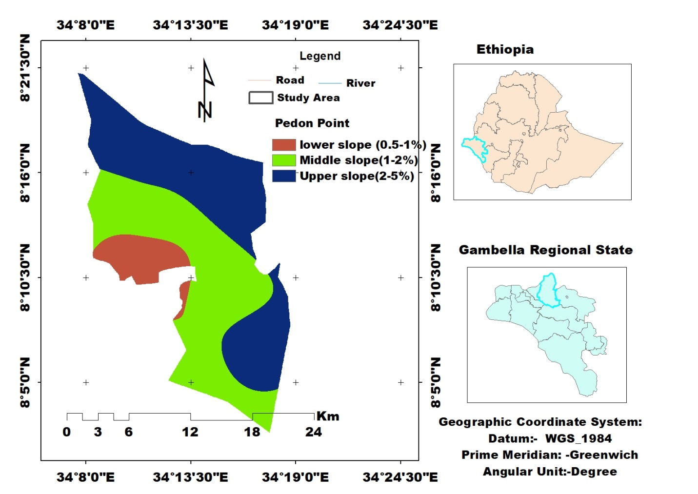
Figure 1: Map of the study area and slope position

Figure 2: Monthly mean temperature and rainfall of the study area (2010-2021) of the study area
The farming system in the study area is a mixed farming system that integrates both crops and livestock. a system that relies on irrigation agriculture, livestock rearing, fishing, and farming for livelihood. The major crops cultivated in the district include cereals such as sorghum, maize, and cowpea, as well as horticultural crops such as mango, banana, citrus fruits, pepper, and tomato. Maize and sorghum are the most commonly grown crops, followed by cowpeas. Livestock reared in the area include cattle, goats, and poultry, which provide meat, milk, and eggs for the local population. Fishing is also a significant source of livelihood, with various fish species caught from the Baro River. The main soil types found in the irrigated fields are Vertisols, Fluvisols, and Alluvialsols.
2.2. Soil sample collection and analysis
A representative composite soil samples were taken from each slope categories of the study afrea (lower, middle and upper slopes). A total of nine composite soil samples were collected within the depth of 0 to 20 cm by taking 20 to 25 sub-samples from the entire area of each slope category.
A Global Positioning System (GPS) was utilized to ensure accurate geolocation data for each sampling site.

These samples were then dried and pulverized with a mortar and pestle, thoroughly mixed , and sieved through a 2-mm sieve. The particle size distribution of the soil was determined by the hydrometer (Bouyoucos) method, as outlined by [11].
The particle density of the soil was determined through the pycnometer method, while the bulk density of undisturbed soil was determined through the core sampler method [12]. Subsequently, the values of bulk density and particle density obtained above were used to estimate soil porosity.
$$TP\left(\%\right)= \left[1-BD/PS\right]*100$$

A pH meter was used to measure the soil pH with a soil-to-water ratio of 1:2.5. Soil paste extracts were tested for electrical conductivity using a conductivity meter [11]. The organic carbon content was determined by [13] oxidizing carbon with potassium dichromate in a sulfuric acid solution. The organic matter value was calculated by multiplying the organic carbon percentage by 1.724. To determine the total nitrogen content, the Kjeldahl procedure was employed, which converted organic matter into ammonium sulfate [14]. The available phosphorus was analyzed following Olsen method [23]. By employing the ammonium acetate extraction method, exchangeable bases (Ca, Mg, K, and Na) were determined. Sodium chloride solution was used to leach soil samples and measure their cation exchange capacity (CEC). The concentration of ammonium ion in the percolate was utilized to calculate CEC [15]. Using the DTPA method [25], micronutrients (Fe, Mn, Zn, and Cu) were extracted and the reading was made using atomic absorbation spectrophotometer. Finally, the percent base saturation (PBS) was computed as the percentage of the sum of the exchangeable bases to the CEC of the soil.

2.3. Statistical analysis
Soil data from three landscape positions were explored with STATA software version 18. Analysis of variance (ANOVA) was performed to determine if there were statistically significant differences between soil properties at each location. For the mean comparisons, an LSD test was conducted at a significance level of 5%. Furthermore, a Pearson correlation analysis was conducted to examine the relationships among the selected soil physical and chemical properties. Based on the findings, fertility maps were generated for variables such as pH, OM, TN Av. P CEC, and PBS using Arc GIS 10.4, which employed ordinary kriging interpolation methods for mapping purposes.

2.4. Mapping of soil Fertility (GIS-based Mapping)
The soil map was developed by utilizing the Global Positioning System (GPS) to record the geographical coordinates of each soil observation and mapping unit in the field. To create a spatial distribution map of soil parameters, ArcGIS software was employed. The irrigation farm was divided into three slope classes, and the corresponding coordinate points marked using GPS were entered into the GIS environment. By digitizing the recorded boundary points, polygons were created for both the irrigation farm and each slope gradient. The final step involved mapping the selected soil fertility parameters, which included soil pH, organic matter (OM), total N, available P, CEC, and PBS.

3. RESULT AND DISCUSSION
3.1. Selected soil physical properties
3.1.1. Soil color
The soil colors of the study area were examined in both dry and moist conditions. In the case of the lower slope position, the color was brown (7.5YR 4/3) to dark reddish brown (5YR 3/3), under dry and moist conditions, similarly, for the middle slope, the color was reddish brown (5YR 4/3) to brown (7.5YR 5/4), under dry and moist conditions. Lastly, for the Upper slope, the color obtained from reddish brown (5YR4/3) to dark reddish brown (5YR3/3) under both dry and moist conditions. These variations in soil color patterns in the Achewa irrigation farm area can be attributed to several factors, including management practices, organic matter content, and other soil chemical compositions. The presence of iron compounds in different states of oxidation may explain the reddish-brown color observed in the lower slope and middle slope, as suggested by [16]. On the other hand, the relatively higher clay and organic matter content in the Upper slope could account for its dark brown color.
Table 2: Mean Values of Soil color, particle size distribution, textural class, bulk density (BD), and total porosity (TP), in the Achewa small-scale irrigation farm in each topographic position of the study area
Sampling site |  | Soil color |  | Soil particle distribution (%) |  |  | Textural class | BD(g/cm³ | TP (%)
Sampling site |  | dry | Moist | Sand | Silt | Clay | Textural class | BD(g/cm³ | TP (%)
Lower slope | Mean  SE  CV | 7.5YR4/3 | 5YR3/3 | 38.50  4.27  19.22 | 23.67  1.76  12.91 | 37.83  3.32  15.20 | Clay Loam | 1.30  0.03  4.69 | 50.82  1.43  4.45
Middle slope | Mean | 5YR5/3 | 5YR3/2 | 18.67 | 27 | 54.33 | Clay | 1.50 | 42.76
Middle slope | SE |  |  | 0.88 | 1.52 | 2.18 |  | 0.027 | 1.03
Middle slope | CV |  |  | 8.18 | 9.76 | 6.96 |  | 3.11 | 4.17
Upper slope  LSD(0.05) | Mean | 5YR4/3 | 5YR3/3 | 28 | 26.33 | 45.66 | Clay | 1.34 | 49.43
Upper slope  LSD(0.05) | SE(+) |  |  | 1.15 | 1.2 | 1.45 |  | 0.01 | 0.43
Upper slope  LSD(0.05) | CV |  |  | 7.14 | 7.91 | 5.51 |  | 1.49 | 1.52
Upper slope  LSD(0.05) |  |  |  | 0.02 | 0.46 | 0.15 |  | 0.00 | 0.00
LSD =least significant difference, CV = coefficient SE= standard error of the mean, BD = bulk density, TP = total porosity
3.1.2. Soil particle size distribution
Soil samples obtained from the Achewa area display varying proportions of sand, silt, and clay fractions across the slope position. The highest sand fraction was found in the lower slope position followed by and upper slope positions, there was a consistent increase in clay content from the lower slope position to the upper slope position compared to the silt and sand fractions (Table 2). The higher sand fractions were observed in the lower slope mainly contributed by sediment deposition from the river and the upper slope to the lower slope. The average sand particle percentage values were highest in the lower slope position (38.50%), followed by the upper slope (28%), and the middle slope position (18.67%) whereas the average silt particles were observed to be 23.67%, 27%, and 26% from the lower to upper slope positions, respectively. Similarly, the clay particles accounted for 37.83%, 54.33%, and 45.66% in the three slope positions, respectively. According to the USDA soil texture triangle classification system, the soils in the lower slope position had clay loam textural class whereas the middle and upper slope position had clay textural class.
Generally, it was observed that the clay content showed an increasing trend as the slope gradient increased, while the sand content showed a reverse trend. This could be due to the seasonal deposition of sand particles from the upper catchment of the river, which is transported by the Baro River, On the other hand, another possible explanation could be that fine particles, such as clay, are more susceptible to erosion. According to [17], reported that variations in soil texture may be caused by variations in parent material, topography, in situ weathering, and translocation of clay. This study contradicts the findings of [18], which found higher clay content in lower elevations of Abajarso Sub-Watershed soils. The particle size distribution varies significantly with slope position except for silt content in the irrigated fields at (P < 0.05).
The variation in particle size distribution with slope position, excluding silt content in irrigated fields, can be attributed to differences in erosion, deposition, and soil formation processes. On different slopes, processes such as water runoff, erosion, and sediment deposition lead to distinct distributions of sand, silt, and clay, which affect soil texture and fertility. For instance, upper slopes often experience higher erosion rates, which can reduce fine particles like silt, while lower slopes may accumulate these particles through deposition. This variation influences soil fertility by altering water retention, nutrient availability, and root growth conditions, making soil texture mapping essential for effective soil management and fertility optimization [19].
3.1.3. Soil bulk density and total porosity
Soil bulk density values were influenced by slope gradient and it showed a highly significant difference (P < 0.05) among the three slope positions (Table 2). The highest mean bulk density value (1.50 g/cm3) was recorded at the middle slope, followed by the upper slope (1.34 g/cm3) and the lower slope position (1.30 g/cm3) (Table 2). The relatively higher bulk density values at the middle slope position could be attributed to animal trampling or grazing. The middle slope is more accessible for grazing, leading to increase animal traffic in this area. Consequently, the soil at this position is more compact than at the upper and lower slopes, explaining the higher bulk density values.
The observed spatial variation in bulk density can be attributed to variations in soil organic matter content, soil texture, and the intensity of cultivation [20]. Increased soil organic matter (SOM) lowers bulk density by enhancing soil structure and aggregation. SOM forms stable aggregates that improve soil porosity and reduce compaction, creating more voids within the soil. This increases pore space and reduces the mass of soil per unit volume, thus lowering bulk density [21]. These findings align with previous research by [12], which demonstrated an inverse relationship between soil bulk densities and pore space as well as soil organic matter content in different topographies.
Bulk density (Bd) is vital for soil fertility as it affects porosity, aeration, and nutrient availability. In this study, bulk density values of 1.3 to 1.5 g/cm³ are moderate, indicating a good balance between soil structure and compaction. This range typically supports effective root growth and water infiltration. However, densities near 1.5 g/cm³ may suggest some compaction, which could limit nutrient uptake. Proper soil management is crucial to maintain optimal soil health and productivity [22].
According to the rating of [23], 1.6 and 1.4 g/cm³ as critical BD values for loam/clay loam and clay textures, respectively, therefore the soils in the study area lie in this range, thus soils are satisfactory for plant growth and root restriction would be less likely to occur. In support of this finding,[24] also emphasized that the soil bulk density values falling within the ranges observed in this study are conducive to healthy root development.
Table 2 The total porosity values show significant differences (P < 0.05) across the three sampling sites. These variations likely result from differences in soil management practices, bulk density, and particle size distribution among the different slope positions. All these factors influence the bulk density and total porosity of the soils.
In general, the total porosity of soils showed variation in relation to bulk density, as depicted in Table 2. According to the rating given by [25], the percent average total porosity across all sampling sites was categorized as very high (> 40%). Total porosity tends to increase as bulk density decreases, whereas it decreases as bulk density increases. Comparatively, the middle slope position had the lowest total porosity value of 42.76%, while the lower slope position had the highest value of (53.58%). Notably, higher values of total porosity were associated with higher organic matter contents and lower bulk density values. These findings are consistent with the findings [26], who studied the soils of Becheke Sub-Watershed in the Haramaya District of East Hararghe, Ethiopia. Similarly,[27] reported that low total porosity was a reflection of the low organic matter content observed around the western Ethiopia Abobo area.
These results highlight the critical role of organic matter in maintaining soil structure and porosity. The higher organic matter content in the lower slope positions likely contributes to the increased porosity and lower bulk density observed. This relationship underscores the importance of managing soil organic matter to enhance soil health and productivity.

3.2. Selected soil physical properties
Effects of slope gradient on Soil Reaction (pH), Electrical Conductivity, Organic Matter, Total Nitrogen and available Phourphours
3.2.1. Soil pH and Electrical Conductivity (EC). Soil pH was highly significantly (P<0.05) affected by the slope gradient. However, lower slope and middle slope positions did not show significant variations in soil pH in the study area. According to the classification set by [28], the mean soil pH values in the study area vary from slightly alkaline (7.35) in the lower slope to neutral (7.14) in the middle slope followed by slightly acidic (6.61) in the upper slope position (figure 3).
The analysis of variance (ANOVA) reaveld that soil pH across the irrigation sampling sites revealed a significant variation (P < 0.05), as outlined in (Table 2). The results revealed that the slope gradient played a significant role in determining the mean soil pH values recorded in different areas. Specifically, the upper slope exhibited the lowest mean soil pH value (6.61), while the lower slope displayed the highest mean soil pH value (7.37) . The reason behind this The upper slope had the lowest soil pH (6.61) due to increased leaching of basic cations, higher organic matter decomposition, and soil erosion, which reduce buffering capacity and increase acidity [29]. Consequently, the higher pH value observed on the lower slope could be attributed to an increase in basic cations. This finding is consistent with previous research conducted by [30], which proposed that the pH rise might be attributed to the accumulation of bases that have been displaced laterally due to erosion. These results emphasize the influence of slope gradient on soil pH and highlight the potential effects of erosion-induced cation movement on soil acidity levels.
Based on Pearson correlation analysis, soil pH was moderately positively correlated with Ca (r = 0.28), K (r = 0.75), clay (r = 0.63), and a strong positive correlation with PBS (r=0.97). It indicates that these soil properties can change as a result of the soil pH, and it examines whether other physicochemical properties of the soil are available as well.
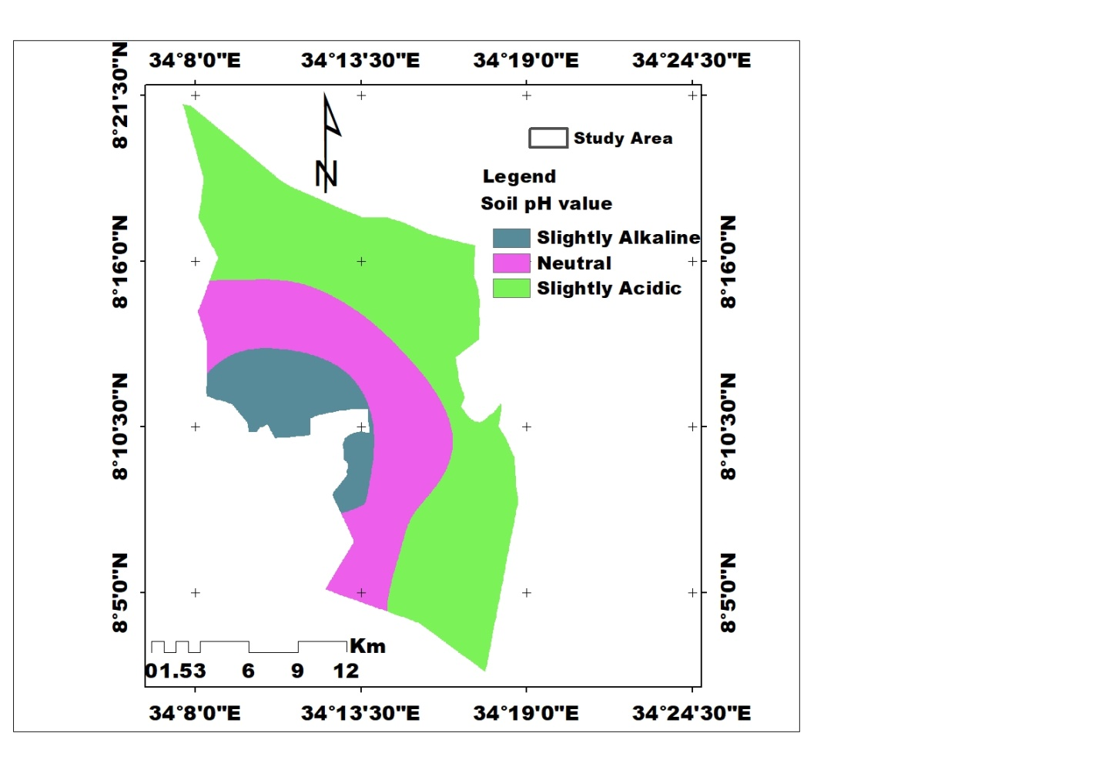
Figure 3: Spatial Distribution of soil pH in the Achewa small-scale irrigation area
3.2.2. Electrical conductivity (Ec). The mean value of electrical conductivity (EC) in the study area did not show significant variation across topographic positions. Relatively, the lower slope position had the highest soil EC at 1.80 dS/m, followed by the middle slope at 1.69 dS/m, and the lowest was recorded at the upper slope position at 1.29 dS/m. The ANOVA results showed no significant variation in electrical conductivity (EC) across slope gradients, likely due to uniform irrigation and soil management practices. Consistent practices ensure even distribution of water and solutes, reducing differences in soil salinity. The generally low EC values across all slopes further indicate that slope gradient has minimal impact on EC measurements [31]. The coefficient of variation (CV) further confirmed low variation in the lower and middle slope positions, with medium variation in the upper slope. Despite these variations, the EC values were generally minimal and did not necessitate specific remedial measures or management practices to address soil salinity.
Table 3: Mean Values of Soil (pH), electrical conductivity (EC), organic matter (OM), total nitrogen (TN), and available Phosphorus (Av. P) in Achewa small-scale irrigation farm in each topographic position of the study area
Sampling site |  | pH 1:2.5) | EC  (dS m⁻¹) | OM (%) | TN (%) | Av. P (mg kg-1)
Lower slope | Mean | 7.37^{b} | 1.80ª | 5.40^{c} | 0.31^{b} | 28.88^{b}
Lower slope | SE(±) | 0.04 | 0.09 | 0.18 | 0.020 | 0.82
Lower slope | CV | 1.02 | 9.21 | 6.01 | 11.09 | 4.93
Middle slope | Mean | 7.14^{b} | 1.69ª | 4.60^{b} | 0.24ª | 24.12ª
Middle slope | SE(±) | 0.072 | 0.089 | 0.05 | 0.012 | 0.87
 | CV | 1.75 | 9.17 | 2.06 | 8.44 | 6.29
Upper slope | Mean | 6.61ª | 1.29ª | 3.97a | 0.17ª | 22.29ª
Upper slope | SE(±) | 0.10 | 0.17 | 0.11 | 0.027 | 1.39
Upper slope | CV | 2.71 | 23.96 | 4.81 | 27.26 | 10.87
LSD |  | 0.001 | NS | 0.01 | 0.005 | 0.012
Means in the same letter are not significantly at 5% ,Standard error of the mean (SE), TN, total nitrogen, Av. P available phosphorus, pH, soil reaction, and EC, electrical conductivity

3.2.3. Soil organic matter (SOM): The analysis of variance indicated that there were significant variations in organic matter (OM) content among the sampling sites (p<0.05). There could be several reasons for this, including variations in soil composition, plant life, and the way the land is managed in the area being studied. A mean soil organic matter content of 5.40% was found in the lower slope position, 4.60% in the middle slope position, and 3.97% in the upper slope position (Table 3).
The soils of the lower slope also showed a comparatively higher organic matter (OM) content compared to the other sampling sites. This could be attributed to the continuous accumulation of alluvial deposits from decayed and undecayed plant and animal residues along the river, which enhances the organic matter content in the surface soils of the area[32]. Additionally, the highest organic matter content in the lower slope sampling site could be attributed to the moisture level of the soil, which decreases the decomposition process. This, in turn, lowers the soil temperature and results in comparably better biomass production, thus contributing to a higher organic matter content of the soil. This result is consistent with the work of [33] in Nitisol of Southwestern Ethiopia.
In the current study area, where soil is classified as having medium to high levels of soil organic matter (SOM) across all three slope positions, this high SOM content significantly enhances soil fertility. Increased SOM improves soil structure, water retention, and nutrient availability, which supports better plant growth and productivity. The high soil organic matter (SOM) content in the study area is likely due to local agricultural practices, where farmers leave weeds in the fields rather than removing them. This practice contributes to increased SOM, as the decomposing plant material adds organic matter to the soil, enriching its content and enhancing overall soil fertility. For effective soil fertility mapping and management, recognizing and maintaining these SOM levels is essential for optimizing soil health and agricultural output [34].

According to the OM content rating criteria established by [37], the overall OM content of the soils of the Achewa small-scale irrigation area was in the range of medium to very high (figure 4). Moreover, cover cropping and mulching of weeds inside the farm which is a common practice in the area during field management, might have also contributed to the better accumulation of OM in the study area. As a result, this finding is in disagreement with that of [34] who recorded a low SOC in the Abobo area.

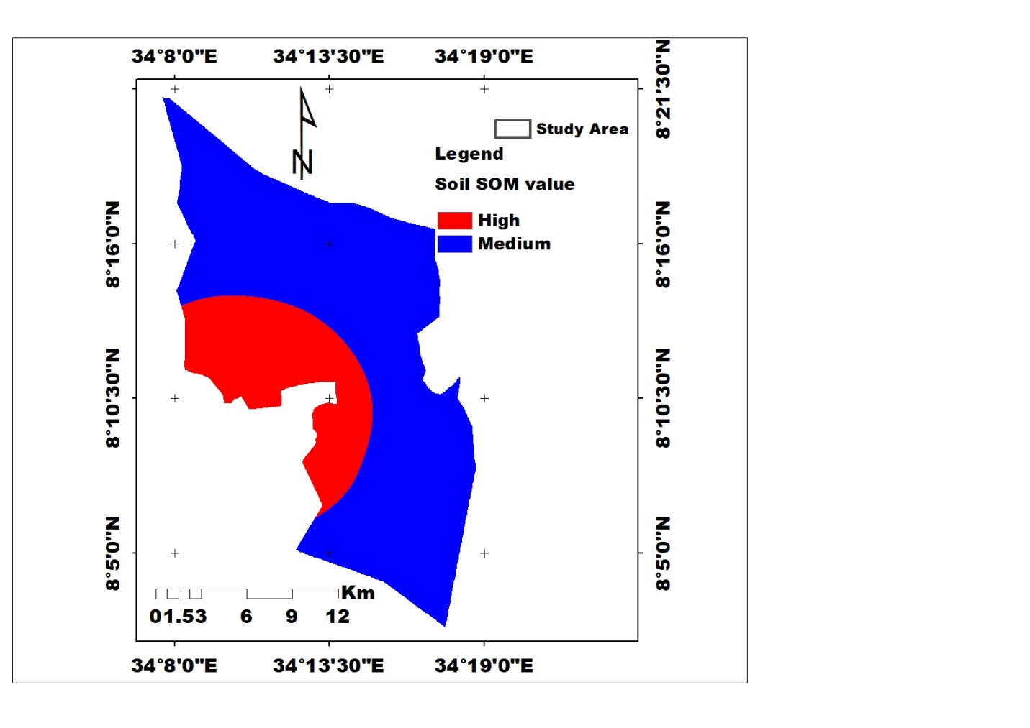
Figure 4: Spatial Distribution of Organic Matter in the Achewa small-scale irrigation area

3.2.4.Total Nitrogen: There was significant difference in total nitrogen (TN) content among the slope position at (p<₋ 0.007). The lower slope position had the highest mean value of TN (0.31%), followed by the middle slope position (0.24%), the while upper slope soil had the lowest mean value (0.17%) (Table 5).
The study found that the lowest TN value was on the upper slope position (0.17%), while the highest value was on the lower slope position (0.31%). This could be due to the fact that the soils at the lower altitudes receive high fluvial material from the upper slopes.
On the other hand, the soil in the upper slope position exhibited the lowest TN content, which could be attributed to insufficient input application, removal of crop residue, continuous cultivation, and lower OM content in the irrigation area. This finding aligns with previous studies [36,38] that have demonstrated nitrogen loss resulting from complete removal of crop residue and continuous cultivation, which accelerates the rapid rate of mineralization. Furthermore,[39,40], discovered that nearly level and gentle slopes had the highest TN levels. According to [41] , soils with TN content below 0.1%, between 0.1-0.2%, 0.2-0.3%, 0.3-0.4%, and above 0.4% are classified as very low, low, medium, high, and very high, respectively. Applying this classification, the soil in the study area was classified as low in the upper slope position, medium in the middle slope, and high in the lower slope position (Figure 5).
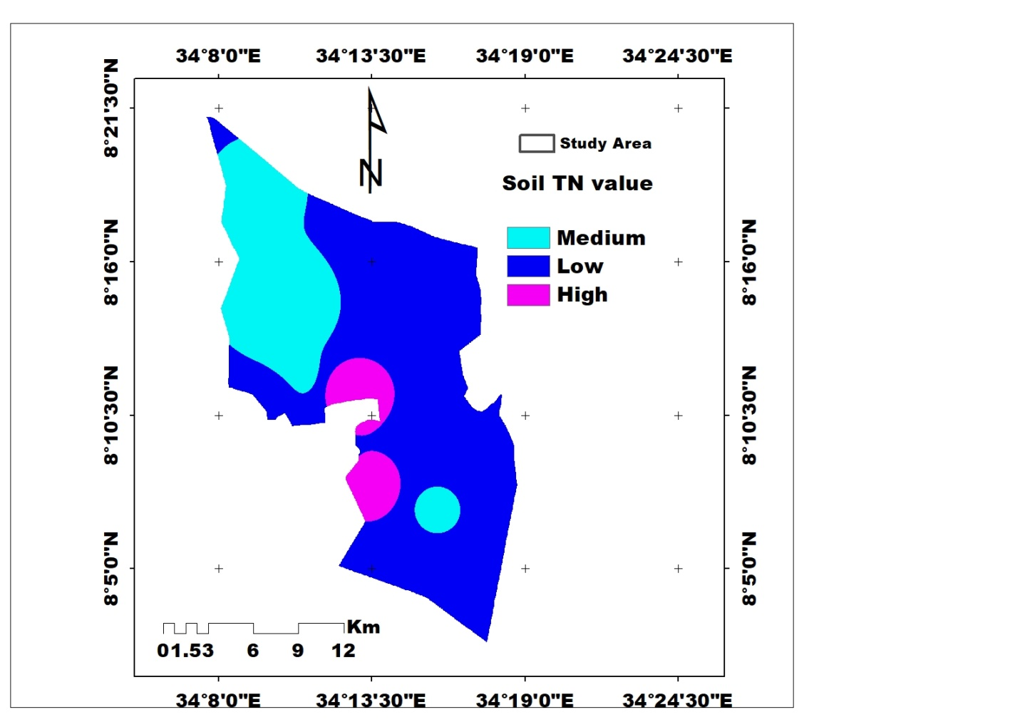
Figure 5: Spatial Distribution of total nitrogen in the Achewa small-scale irrigation area
3.2.5. Available phosphorus
The results of an analysis of variance showed that the soil's available phosphorus (Av,P) content varied significantly with slope position (p<0.05), indicating that the physiographic positions of the study area had an impact on the status of available phosphorus. The average available P was (28.88 mg kg⁻¹) for the lower slope, (24.12 mg kg⁻¹) for the middle slope, and (22.29 mg kg⁻¹) for the upper slope in the study area. It was found that the highest level of available P was detected on the lower slope (28.88 mg kg⁻¹) while the lowest level was recorded on the upper slope (22.29 mg kg⁻¹). This could be attributed to the nature of the soils parent material and organic matter content at the respective topographic location. Furthermore, cultural practices contribute to the establishment of AvP in the area by allowing crop residues to decompose naturally within the field, which enhance soil fertility . This finding is in line with previous studies [32,36] that reported higher available P values in the western Ethiopia Gambella region soil. It was also reported that P availability in the soils might have been favored by the warm climatic conditions of the study area along with the preferred pH range [41]. Based on the rating suggested by [42], the available P contents of soil in the study area were found to be high (figure 6), indicating that available P would not be a limiting nutrient for agricultural production in the area.
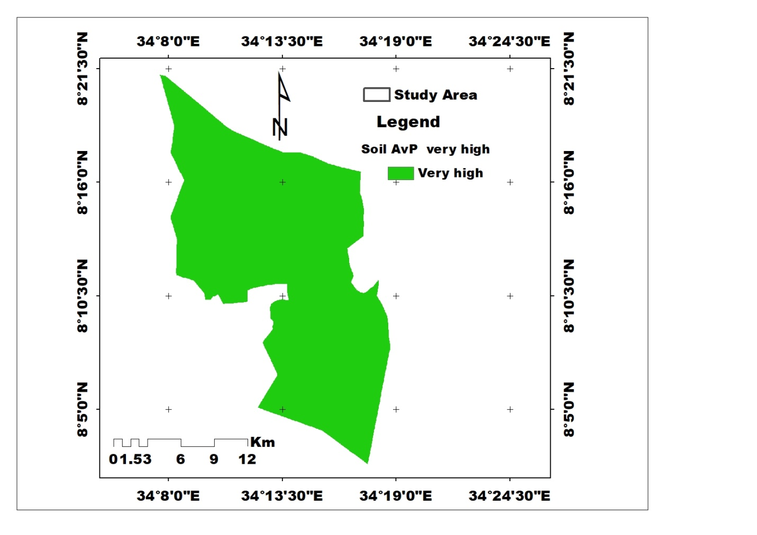
Figure 6: Spatial Distribution of Available phosphorus in the Achewa small-scale irrigation area
3.3. Exchangeable Bases, Cation Exchange Capacity, and Percent Base Saturation
3.3.1. Exchangeable bases. Table 4 displays the average exchangeable base values across different topography positions. The slope gradient did not affect the levels of exchangeable calcium and exchangeable magnesium. However, the slope gradient did have an impact on the levels of exchangeable potassium and exchangeable sodium. The mean values for exchangeable Ca²⁺ were 13.03, 14.73, and 13.86 cmol(+)/kg in the lower, middle, and upper slope positions, respectively. For exchangeable Mg²⁺, the values were 14.43, 12.12, and 12.01 cmol(+)/kg from the lower slope to the upper slope position. The values for K⁺ were 0.78, 0.44, and 0.77 cmol(+)/kg, and for Na⁺, they were 0.31, 0.36, and 0.60 cmol(+)/kg from the lower to the upper slope positions, respectively

The order of exchangeable bases within the exchange complex follows Ca²⁺ > Mg ²⁺ > K⁺ > Na⁺. Divalent cations (such as Ca and Mg) exhibit a higher charge density, resulting in a stronger attraction to colloidal sites compared to monovalent cations (like K⁺ and Na⁺). Consequently, divalent cations are more likely to be distributed on exchangeable bases within the exchange complex due to their greater affinity for colloidal sites. These findings align with previous studies by [26, 30, 35]
On the other hand, the higher exchangeable bases in the lower slope position could be due to slower water movement on flat slopes, allowing for nutrient accumulation. The flatness of the area allows for retaining more moisture, contributing to higher exchangeable base levels. Low erosion rates and greater moisture retention on flat slopes explain the similarity in exchangeable base levels across slope positions. similar results were reported by [44] on soil fertility in Daro Labu, a district of Eastern Ethiopia. According to the ratings provided by the [45], all three slope positions had high exchangeable calcium and magnesium whereas exchangeable potassium and sodium were rated as medium to high in the three slope positions.

Table 4: Mean Values Exchangeable bases, Cation Exchange Capacity (CEC) Percent Base Saturation (PBS) of soils in Achewa small-scale irrigation farm in each topographic position of the study area.
Sampling site |  | Exchangeable bases |  |  |  |  |  |  |  |  | CEC (Cmol (+)/kg) |  |  | PBS (%)
Sampling site |  | Ca | Mg |  | K |  | Na
Lower slope | Mean | 14.73ª |  | 12.43ª | 0.78ª |  | 0.60^{b} |  |  |  | 34.13ª |  |  |  | 87.84^{b}
Lower slope | SE(+) | 0.88 |  | 0.49 | 0.026 |  | 0.047 |  |  |  | 0.84 |  |  |  | 0.86
Lower slope | CV | 10.38 |  | 6.93 | 19.62 |  | 13.64 |  |  |  | 4.26 |  |  |  | 1.70
Middle slope | Mean | 13.03ª |  | 12.12ª | 0.44a^{b} |  | 0.36ª |  |  |  | 32.62ª |  |  |  | 84.77^{b}
Middle slope | SE(+) | 0.23 |  | 0.40 | 0.053 |  | 0.06 |  |  |  | 0.87 |  |  |  | 3.88
Middle slope | CV | 3.10 |  | 5.72 | 21.28 |  | 32.03 |  |  |  | 7.68 |  |  |  | 1.85
Upper slope | Mean | 13.86ª |  | 12.01ª | 0.77^{b} |  | 0.31^{b} |  |  |  | 31.02ª |  |  |  | 77.87ª
Upper slope | SE(+) | 0.55 |  | 0.45 | 0.052 |  | 0.035 |  |  |  | 0.94 |  |  |  | 1.54
Upper slope | CV | 6.91 |  | 6.52 | 11.90 |  | 5.85 |  |  |  | 5.25 |  |  |  | 3.43
LSD(0.05) |  | NS |  | NS | 0.02 | 0.02 |  |  |  |  | 0.13 |  |  |  |  | 0.03
Means in the same letter(s) are not significantly different at 5%, LSD = least significant difference, SE=standard error CV = coefficient variation, CEC= Cation Exchange Capacity, PBS = percentage base saturation.

3.3.2. Cation Exchange Capacity (CEC) of the soil
A statistical analysis of variance indicated that soil CEC was unaffected by slope gradient and not statistically significant. This was evident in the coefficient of variation also showed lower variation across the sampling sites; however, there was a slight numerical variation between the sites, which could be ascribed to differences in soil properties like texture, organic matter content, and mineral composition. (P<0.05).

Table 5 shows that the highest and lowest soil cation exchange capacity (CEC) values, measuring 34.13 cmol ₍₊₎ kg⁻¹ and 31.02 cmol ₍₊₎ kg⁻¹, were observed in the lower and upper slopes, respectively. The impacts of slope position on CEC values were evident, as the lower slope exhibited a higher mean CEC value compared to the middle and upper slopes. This variation can be attributed to erosion and the landscape's position, which resulted in the removal of fine particles, basic cations, and organic matter from the topsoil. These results align with a study by[30] which also observed higher values of cation exchange capacity CEC in the lower slope position. The Pearson correlation results from our study show that the CEC had a significant negative correlation (p ≤ 0.05) with silt content (r = -0.71), and positive but not significant correlations with Ca (r = 0.21), Mg (r = 0.63), (Na) (r = 0.12), TN,(r=0.23), Available P, (r=34) and soil OM content (r = 0.28). These findings suggest that the amount of organic matter and exchangeable bases in the soil may have influenced the CEC values in our study.
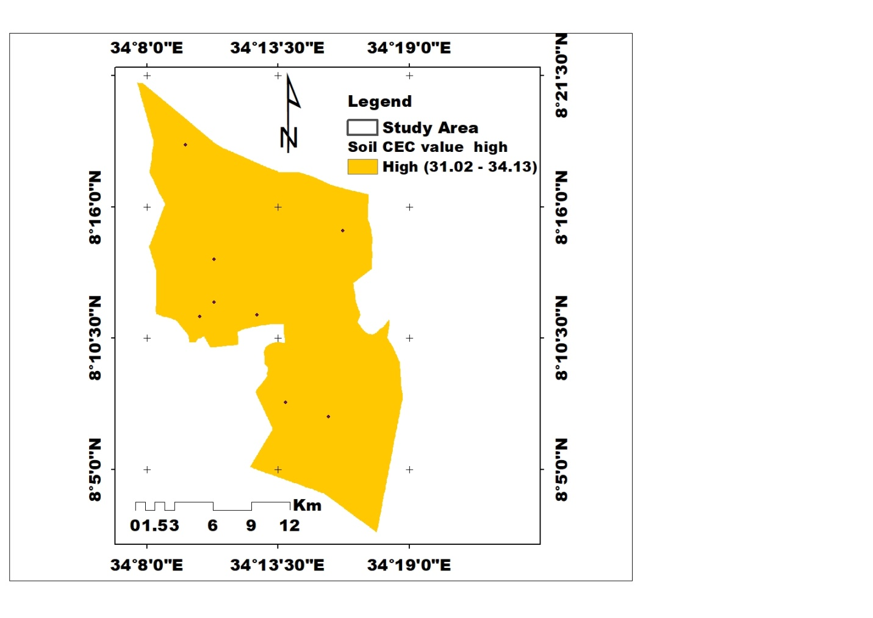
Figure 7: Spatial Distribution of CEC in the Achewa small-scale irrigation area
3.3.3. Percent Base Saturation (PBS). Analysis of variance showed that the PBS of the soils in the study area varied significantly (P < 0.05) among the slope gradients (Table 5). The highest (85.20% and the lowest (77.87%) mean values of PBS were recorded in lower slope and upper slope positions, respectively, However, lower slope and middle slope positions did not show significant variations in PBS in the study area. according to the ratings suggested by [23], the PBS value of the study area was classified as high PBS status, therefore the values recorded indicated that soils in the study area are very weakly leached [23]. The distribution trends of PBS were similar to those of CEC, exchangeable Ca, and Mg, as factors influencing these soil attributes also affect the PBS percentage. The higher value of PBS in the study area is linked to a higher value of soil organic matter content, clay particles, and cultural practices used in the study area, which would increase PBS in the irrigation farm. This result was consistent with the research conducted by various researchers in Gambella soil Vertisols and fluvisols [32,33,44]. Pearson’s correlation matrix, which showed a positive correlated with pH, (r = 0.97), Ec (r = 0.72), and clay (r = 0.89) (Table 6), and negatively correlated with OM, r= -0.79, TN, (r =-0.59), and Av. P, (r= 0.72).
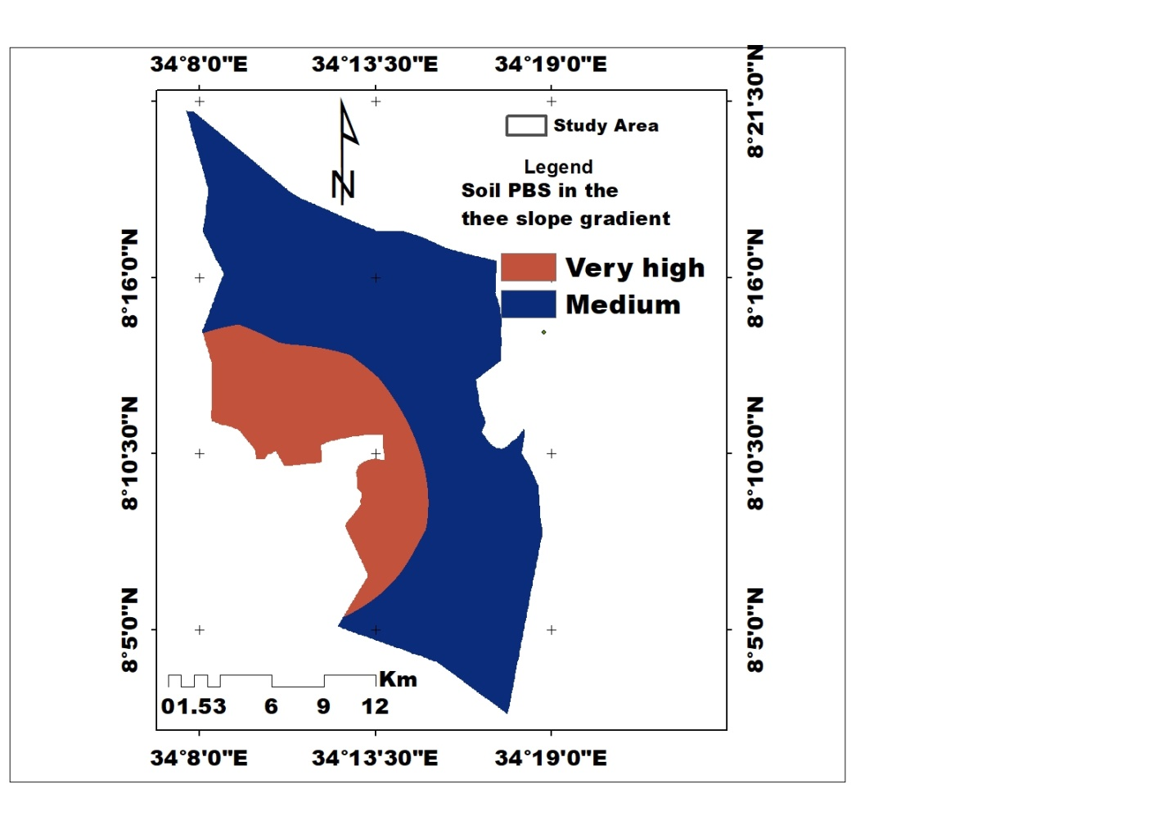
Figure 8: Spatial Distribution of PBS in the Achewa small-scale irrigation area
3.4. Soil Micronutrients
The results of the analysis of variance on the micronutrient contents of four elements (Fe, Mn, Zn, and Cu) in a study area revealed significant variation (P < 0.05) across the study area. The highest mean values of Fe were 20.31 mg kg⁻¹ in the lower slope, 16.95 mg kg⁻¹ in the upper slope and followed by 14.71 mg kg⁻¹ in the middle slope position; for the mean value of Mn the highest was in the lower slope position and lowest in the middle position (18.25 and 6.65 mg kg⁻¹) respectively; for extractable Cu higher value was in lower slope position (3.57) and the lower in the upper slope position (2.66) whereas for extractable Zn was observed vice versa (Table 5). According to the interpretative values for DTPA-extractable micronutrients set by [47], extractable Fe in all three sampling sites was rated as high, Mn was rated as medium in all sampling sites, Zn was rated as high and medium, Cu was rated as medium in all the study area . The lower slope position site generally had the highest average of extractable micronutrients, except for Zn. The elevated levels at the lower slope were linked to the soil's deposition and organic matter content. Organic matter can serve as a chelating agent, binding to micronutrients and increasing their accessibility to plants [48] Furthermore, organic matter can enhance soil structure and porosity, resulting in improved retention and release of micronutrients [49]. Therefore, the presence of organic matter in fluvisols could be the reason for the high extractable micronutrient levels, even in soils with low pH ranges. This result is in harmony with the findings of [50].
Table 5: Extractable micronutrients of soils in Achewa small-scale irrigation farm in each topographic position of the study area.
Sampling site |  | Extractable Micronutrients
Sampling site |  | Fe | Mn | Cu | Zn
Lower slope | Mean | 20.31^{c} | 18.25^{b} | 3.57^{b} | 1.35ª
Lower slope | SE | 0.52 | 1.14 | 0.10 | 0.102
Lower slope | CV | 4.50 | 10.91 | 5.19 | 15.40
Middle slope | Mean | 14.71ª | 6.65ª | 2.96^{ab} | 1.94^{b}
Middle slope | SE(+) | 0.39 | 0.40 | 0.31 | 0.16
Middle slope | CV | 4.62 | 10.63 | 9.57 | 9.19
Upper slope | Mean | 16.95^{b} | 7.66ª | 2.66ª | 2.09^{b}
Upper slope | SE | 0.36 | 0.24 | 0.20 | 0.14
Upper slope | CV | 3.70 | 5.45 | 13.17 | 12.10
LSD |  | 0.00 | 0.00 | 0.019 | 0.012
Means in the same letter(s) are not significantly different at 5% , LSD=, least significant difference, standard error, CV = coefficient variation,
The variation in soil micronutrients observed in the study can be attributed to factors such as soil pH, organic matter (OM) content, and variations in soil management practices. Soil pH plays a crucial role in determining the solubility and availability of micronutrients in the soil. The study found a significant correlation (p≤0.05) between soil pH and micronutrient levels, indicating that changes in pH can affect the availability of these essential nutrients.

Table 6: Pearson correlation matrix among selected physico-chemical soil parameters
 | Sand | Silt | Clay | BD | Tp | pH | Ec | OM | TN | AvP | Ca | Mg | Na | k | CEC | PBS
Sand | 1.00
Silt | -0.62 | 1.00
Caly | -0.96** | 0.39 | 1.00
BD | -0.69* | 0.30 | 0.71* | 1.00
TP | 0.69* | -0.30 | -0.71* | -0.99** | 1.00
pH | -0.71 | 0.59 | 0.63 | 0.28 | -0.28 | 1.00
Ec | -0.54 | 0.48 | 0.47 | 0.37 | -0.37 | 0.76* | 1.00
OM | 0.44 | -0.43 | -0.37 | -0.30 | 0.30 | -0.83** | -0.78* | 1.00
TN | 0.69* | -0.47 | -0.65 | -0.82** | 0.82** | -0.57 | -0.67* | 0.69* | 1.00
AvP | 0.56 | -0.36 | -0.53 | -0.34 | 0.34 | -0.73* | -0.52 | 0.86** | 0.70* | 1.00
ca | -0.54 | -0.05 | 0.66 | 0.26 | -0.26 | 0.62* | 0.58 | -0.56* | -0.47 | -0.66 | 1.00
Mg | 0.27 | -0.20 | -0.25 | 0.04 | -0.04 | -0.29 | 0.36 | 0.12 | 0.03 | 0.48 | -0.12 | 1.00
Na | 0.77* | -0.41 | -0.76* | -0.80** | 0.80* | -0.28 | -0.31 | 0.17 | 0.72* | 0.38 | -0.41 | 0.19 | 1.00
k | -0.29 | 0.38 | 0.20 | 0.002 | 0.003^{ns} | 0.75* | 0.49 | -0.69* | -0.15* | -0.47* | 0.32 | -0.22 | 0.10 | 1.00
CEC | 0.46 | -0.71* | -0.30 | -0.16 | 0.16 ^{ns} | -0.50 | 0.004 | 0.28 | 0.23* | 0.34 | 0.21 | 0.63 | 0.12 | -0.35 | 1.00
PBS | -0.76* | 0.54 | 0.71* | 0.34 | -0.34^{ns} | 0.97** | 0.65 | -0.79** | -0.59 | -0.72* | 0.63 | -0.25 | -0.28 | 0.63 | -0.52 | 1
NS= non- Significant, * = Significant at P ≤ 0.05, ** = highly significant at P ≤ 0.01,

4. . Conclusion
In this study, the fertility status of soils in the study area was assessed by analyzing their physical and chemical properties after the crop harvest in the 2023 cropping season. Composite soil samples were collected from the surface and analyzed in the laboratory. The soils were assessed and categorized into fertility levels, namely low, medium, high, and very high, using established rating classifications from various authors. To visualize the spatial distribution of soil fertility, maps were created using ArcMap techniques. Key parameters such as soil pH, organic matter (OM), total nitrogen (TN), percent base saturation (PBS), cation exchange capacity (CEC), and available phosphorus (AP) were incorporated into the mapping process.
The results showed that clay was the dominant particle size fraction, followed by sand and silt. Clay loam and clay were the textural class of the study area. The soils exhibited favorable bulk density and total porosity values, indicating a low risk of root restriction and providing suitable conditions for plant growth. Soil pH varied across the study area due to the slope gradient, ranging from slightly acidic to moderately alkaline. Soil organic matter content, TN, PBS, available P, CEC, exchangeable Ca, Mg, K, and extractable micronutrients were higher in the lower slope position, likely influenced by the erosion and deposition process.
In contrast, the upper slope positions showed lower values in soil chemical properties, likely due to erosion, leaching of nutrients, and loss of topsoil. These findings highlight the need for soil conservation measures and nutrient management practices to address the decline in soil fertility in the upper slope positions. It is recommended to incorporate organic materials and utilize organic fertilizers as part of integrated soil fertility management strategies to restore soil fertility and enhance agricultural productivity.
However, it should be noted that soil fertility assesment alone is not sufficient to ensure soil productivity, as other factors such as irrigation water quality and crop suitability also influence soil productivity. Therefore, a comprehensive approach considering these factors is crucial for sustainable soil management and improved agricultural outcomes.

Data Availability
The data used to support the findings of this study are available from the corresponding author upon request.
Conflicts of Interest
The authors declare that have no conflicts of the interest
Author’s contribution
All authors contributed to this works. The corresponding authors contributed mainly, and others three authors gave advice and contributed to other related works

5. REFERENCE
[1] D. Patel and M. Lakdawala, “Study of soil’s nature by pH and soluble salts through EC of Kalol-Godhra taluka territory.,” Chem. Sin., vol. 5, no. 2, pp. 1–7, 2014.
[2] N. Sanginga and P. L. Woomer, Integrated soil fertility management in Africa: principles, practices, and developmental process. CIAT, 2009.
[3] A. Bationo, J. O. Fening, and A. Kwaw, “Assessment of soil fertility status and integrated soil fertility management in Ghana,” Improv. Profitab. Sustain. Effic. Nutr. Site Specif. Fertil. Recomm. West Afr. Agro-Ecosyst. Vol. 1, pp. 93–138, 2018.
[4] M. Eshetu, L. Wogi, and N. Demissie, “Soil Fertility Assessment and Mapping under Different Land Use Types along Toposequence at Danka Watershed in Dinsho Districts of Bale Highland Oromia, Southeastern Ethiopia,” Int. J. Plant Soil Sci., vol. 36, no. 5, pp. 847–872, 2024.
[5] Z.-P. Liu, M.-A. Shao, and Y.-Q. Wang, “Spatial patterns of soil total nitrogen and soil total phosphorus across the entire Loess Plateau region of China,” Geoderma, vol. 197–198, pp. 67–78, Apr. 2013, doi: 10.1016/j.geoderma.2012.12.011.
[6] M. Khan, M. Islam, M. S. Amin, and M. Bhuiyan, “Spatial variability and geostatistical analysis of selected soil,” Bangladesh J. Sci. Ind. Res., vol. 54, no. 1, pp. 55–66, 2019.
[7] Y.-Q. Song, X. Zhao, H.-Y. Su, B. Li, Y.-M. Hu, and X.-S. Cui, “Predicting Spatial Variations in Soil Nutrients with Hyperspectral Remote Sensing at Regional Scale,” Sensors, vol. 18, no. 9, p. 3086, Sep. 2018, doi: 10.3390/s18093086.
[8] H. A. Adornado and M. Yoshida, “Crop Suitability and Soil Fertility Mapping using Geographic Information System (GIS),” Agric. Inf. Res., vol. 17, no. 2, pp. 60–68, 2008, doi: 10.3173/air.17.60.
[9] R. Teena, S. Meti, M. Nagaraj, H. Yogeeshapa, H. Hadimani, and V. Shreepad, “Soil fertility mapping of arecanut growing areas in Sirsi Hobli of Uttara Kannada district, Karnataka,” 2023.
[10] W. Mengiste, M. Mohammed, and T. Yitebarek, “Evaluation of the effect of land use types on selected soil physico-chemical properties in Itang-kir area of Gambella region, Ethiopia,” J Biol Agric Healthc., vol. 5, no. 11, 2015.
[11] J. R. Okalebo, K. W. Gathua, and P. L. Woomer, “Laboratory methods of soil and plant analysis: a working manual second edition,” Sacred Afr. Nairobi, vol. 21, pp. 25–26, 2002.
[12] P. Gupta, “Soil plant water and fertilizer analysis. Agrobios pub,” Bikaner India, 2000.
[13] A. Walkley and I. A. Black, “An examination of the Degtjareff method for determining soil organic matter, and a proposed modification of the chromic acid titration method,” Soil Sci., vol. 37, no. 1, pp. 29–38, 1934.
[14] C. A. Black, Methods of Soil Analysis. Sponsored by the American Society of Agronomy and the American Society for Testing Materials. American Society for agronomy, 1965.
[15] H. Chapman, “Cation‐exchange capacity,” Methods Soil Anal. Part 2 Chem. Microbiol. Prop., vol. 9, pp. 891–901, 1965.
[16] H. Foth, “Soil chemistry,” Fundam. Soil Sci., 1990.
[17] A. Thangasamy, M. Naidu, N. Ramavatharam, and C. R. Reddy, “Characterisation, classification and evaluation of soil resources in Sivagiri micro-watershed of Chittoor District in Andhra Pradesh for sustainable land use planning,” 2015.
[18] K. Abate, M. Mohammed, and K. Kibret, “Soil fertility assessment and mapping of spatial variability at Amareganda-Abajarso sub-watershed, north-eastern Ethiopia,” East Afr. J. Sci., vol. 10, no. 1, pp. 1–14, 2016.
[19] R. Weil and N. Brady, “The nature and properties of soils, 15th edn., edited by: Fox, D,” 2016.
[20] V. Sharma and A. Kumar, “Soil fertility of upper maul khad catchment in wet-temperatue zone of Himachal Pradesh,” Indian J. Soil Conserv. India, 2003.
[21] E. A. Paul, “Soil microbiology, ecology, and biochemistry: an exciting present and great future built on basic knowledge and unifying concepts,” Soil Microbiol. Ecol. Biochem., pp. 1–13, 2014.
[22] D. Hillel, Introduction to soil physics. Academic press, 2013.
[23] P. Hazelton and B. Murphy, Interpreting soil test results: What do all the numbers mean? CSIRO publishing, 2016.
[24] J. R. Landon, Booker tropical soil manual: a handbook for soil survey and agricultural land evaluation in the tropics and subtropics. Routledge, 2014.
[25] FAO, “FAO (Food and Agriculture Organization). 2006a. Guidelines for soil description. 4th ed. Viale delle Terme di Caracalla. Rome, Italy.” Rome, Italy., 2006.
[26] U. Mohammed, K. Kibret, M. Mohammed, and A. Diriba, “Soil fertility assessment and mapping of Becheke Sub-Watershed in Haramaya District of East Hararghe Zone of Oromia Region, Ethiopia,” 2016.
[27] A. Yacob, G. Heluf, and B. Sheleme, “Pedological characteristics and classification of soils along landscapes at Abobo, southwestern lowlands of Ethiopia,” J. Soil Sci. Environ. Manag., vol. 5, no. 6, pp. 72–82, 2014.
[28] T. Yitbarek, S. Beyene, and K. Kibret, “Characterization and classification of soils of Abobo Area, Western Ethiopia,” Appl. Environ. Soil Sci., vol. 2016, 2016.
[29] R. Lal, “Soil carbon sequestration impacts on global climate change and food security,” science, vol. 304, no. 5677, pp. 1623–1627, 2004.
[30] K. Merga, G. Gidago, and F. Laekemariam, “Soil Fertility Status as Influenced by Slope Gradient and Land Use Types in Southern Ethiopia,” Appl. Environ. Soil Sci., vol. 2023, pp. 1–13, Dec. 2023, doi: 10.1155/2023/8583671.
[31] P. Rengasamy, “World salinization with emphasis on Australia,” J. Exp. Bot., vol. 57, no. 5, pp. 1017–1023, 2006.
[32] F. Getachew, A. Abdulkadir, M. Lemenih, and A. Fetene, “Effects of different land uses on soil physical and chemical properties in Wondo Genet area, Ethiopia,” N. Y. Sci. J., vol. 5, no. 11, pp. 110–118, 2012.
[33] A. Nigussie and E. Kissi, “Physicochemical characterization of Nitisol in Southwestern Ethiopia and its fertilizer recommendation using NuMaSS,” Glob. Adv. Res. J. Agric. Sci., vol. 1, no. 4, pp. 66–73, 2012.
[34] L. D. Tamene, T. Amede, J. M. Kihara, D. Tibebe, and S. Schulz, “A review of soil fertility management and crop response to fertilizer application in Ethiopia: towards development of site-and context-specific fertilizer recommendation,” CIAT Publ., 2017.
[35] M. Tekalign and I. Haque, “Phosphorus status of some Ethiopian soils. III. Evaluation of soil test methods for available phosphorus,” Trop Agric, vol. 68, pp. 51–56, 1991.
[36] T. Yitbarek, S. Beyene, and K. Kibret, “Characterization and Classification of Soils of Abobo Area, Western Ethiopia,” Appl. Environ. Soil Sci., vol. 2016, pp. 1–16, 2016, doi: 10.1155/2016/4708235.
[37] A. Bekele, A. Aticho, and E. Kissi, “Assessment of community based watershed management practices: emphasis on technical fitness of physical structures and its effect on soil properties in Lemo district, Southern Ethiopia,” Environ. Syst. Res., vol. 7, no. 1, p. 20, Dec. 2018, doi: 10.1186/s40068-018-0124-y.
[38] M. A. Wubie and M. Assen, “Effects of land cover changes and slope gradient on soil quality in the Gumara watershed, Lake Tana basin of North–West Ethiopia,” Model. Earth Syst. Environ., vol. 6, no. 1, pp. 85–97, Mar. 2020, doi: 10.1007/s40808-019-00660-5.
[39] J. W. Doran and T. B. Parkin, “Defining and assessing soil quality,” Defin. Soil Qual. Sustain. Environ., vol. 35, pp. 1–21, 1994.
[40] R. Barber, An assessment of the dominant soil degradation processes in the Ethiopian highlands: their impacts and hazards. FAO, 1984.
[41] T. Hartz, “Soil testing for nutrient availability: procedures and interpretation for California vegetable crop production,” Dept Plant Sci. Davis CA USA, 2007.
[42] S. R. Olsen, Estimation of available phosphorus in soils by extraction with sodium bicarbonate, no. 939. US Department of Agriculture, 1954.
[43] O. Giday, H. Gibrekidan, and T. Berhe, “Soil fertility characterization in vertisols of southern Tigray, Ethiopia,” Adv. Plants Agric. Res., vol. 2, no. 1, pp. 1–7, 2015.
[44] T. Geremu, L. Wogi, and S. Feyissa, “SOIL FERTILITY AND MICRONUTRIENT STATUS IN TISSUES OF MAIZE IN DARO LABU DISTRICT, WEST HARARGHE ZONE, EASTERN ETHIOPIA,” 2021.
[45] FAO, “FAO (Food and Agriculture Organization). 2006a. Plant nutrition for food security: A guide FAO.” Rome, 2006a.
[46] Y. Leul, M. Assen, S. Damene, and A. Legass, “Effects of land use types on soil quality dynamics in a tropical sub-humid ecosystem, western Ethiopia,” Ecol. Indic., vol. 147, p. 110024, 2023, doi: 10.1016/j.ecolind.2023.110024.
[47] J. Jones Jr, “Agronomic handbook: Management of crops, soils and their fertility.,(CRC Press: Boca Raton, FL, USA),” 2002.
[48] A. Kabata-Pendias, Trace elements in soils and plants. CRC press, 2010.
[49] A. Kabata-Pendias and A. B. Mukherjee, Trace elements from soil to human. Springer Science & Business Media, 2007.
[50] A. Yacob, G. Heluf, and B. Sheleme, “Pedological characteristics and classification of soils along landscapes at Abobo, southwestern lowlands of Ethiopia,” J. Soil Sci. Environ. Manag., vol. 5, no. 6, pp. 72–82, 2014.

