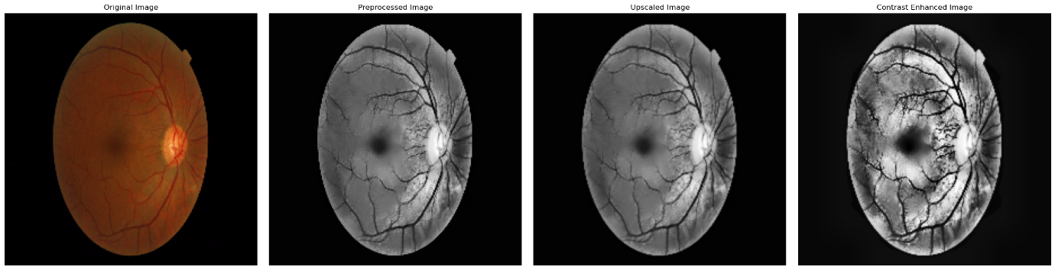
The provided image sequence illustrates the step-by-step enhancement of a Diabetic Retinopathy (DR) retinal image, applying various image processing techniques to improve diagnostic quality.

1. Original Image:

The original image is a colour fundus photograph of the retina, capturing all the raw data necessary for detecting DR-related abnormalities, such as micro aneurysms, haemorrhages, and exudates. This baseline image serves as the starting point for all subsequent pre-processing steps. The presence of colour information helps in distinguishing between different types of retinal lesions, but to focus on structural details, further pre-processing is required.

2. Preprocessed Image:

The original image is converted to grayscale to simplify the analysis, focusing on the essential structural features needed for DR detection. Background noise is reduced using the GrabCut algorithm, which isolates the retina by masking irrelevant elements, ensuring that the region of interest is analyzed. Further enhancement is performed through CLAHE, which improves local contrast, making subtle abnormalities like microaneurysms and early hemorrhages more visible. Non-Local Means Denoising is then applied to reduce noise while preserving important details, crucial for accurate DR detection.
- Methods Used:
  - Grayscale Conversion: cv.cvtColor(image, cv.COLOR_BGR2GRAY)
  - GrabCut Algorithm: For background masking
  - Adaptive Histogram Equalization (CLAHE): exposure.equalize_adapthist(img_cut, clip_limit=0.03)
  - Non-Local Means Denoising: cv.fastNlMeansDenoising(img_eq, None, 10, 7, 21)
    - Grayscale Conversion
$$I_{gray}(x,y)=0.2989×R(x,y)+0.5870×G(x,y)+0.1140×B(x,y)$$
• R, G, B: These represent the red, green, and blue color channels of the original retinal image.
• Gray: The output grayscale intensity value.
- In terms of DR: The grayscale image simplifies the visual information, allowing the algorithm to focus on intensity variations that indicate the presence of DR-related abnormalities like microaneurysms or hemorrhages, which are better detected through contrast than color differences.

2.GRAY CUT Algorithm:
$E\left(x\right)=\sum_{i∈foregroud}{-logP(x_{i }}\left|θ_{F }\right)+\sum_{i∈backgroud}{-logP(x_{i }}\left|θ_{B }\right)$ )

$E\left(x\right)$: Energy function used by the GrabCut algorithm to classify pixels.
- In terms of DR: In DR detection, the energy function helps to distinguish between the retina (foreground) and other parts of the image (background). This separation is crucial because DR detection focuses on changes within the retina, not outside it.
• Foreground and Background: Refers to the areas that are part of the retina and those that are not, respectively.
- $P\left(x_{i} | θ_{F}\right)andP\left(x_{i} | θ_{B}\right)$: The probabilities of a pixel belonging to the foreground or background, respectively.
- In terms of DR: These probabilities help the algorithm to decide whether a pixel should be included in the analysis for DR signs or ignored as part of the non-relevant background.
3.Adaptive Histogram Equalization (CLAHE) Formula:
$$CLAHE\left(I_{masked}(x,y)\right)=\frac{\left(I_{masked}(x,y)\right)-min⁡(I)}{\max\left(I\right)-min⁡(I)}×255$$
• I: The intensity value of a pixel in the image.
- In terms of DR: This represents the brightness of a pixel, which is crucial for identifying DR features. Brightness variations can indicate abnormalities like lesions or exudates.
• min(I) and max(I): The minimum and maximum intensity values within a local region.
- In terms of DR: By focusing on local intensity ranges, CLAHE enhances local contrast, making subtle features like microaneurysms more visible against their surroundings.
• 255: Normalization factor to scale the intensity values.
- In terms of DR: Scaling to the full intensity range ensures that the contrast enhancement is effective, making DR signs stand out more prominently.
4. Non-Local Means Denoising Formula:
$$I_{denoised}\left(x,y\right)=\sum_{p∈patch around(x,y)}{w\left(p\right)∙I_{CLAHE}(p)}$$
• $I_{denoised}\left(x,y\right)$: The denoised intensity value at pixel (x, y).
- In terms of DR: This value represents the true retinal intensity, free from noise that might obscure small lesions or vessel abnormalities.
• $p∈patch$: Neighboring pixels in the local patch around (x, y).
- In terms of DR: Neighboring pixels provide context for what the pixel should look like if there were no noise, preserving important structures like blood vessels that could indicate DR.
• $w\left(p\right)$: Weight based on similarity to the central pixel.
- In terms of DR: Higher weights for similar pixels help retain important retinal features while smoothing out random noise, crucial for clear visibility of DR symptom

Upscale Image :
The pre-processed image is up scaled to enhance fine details, which is crucial for detecting early signs of DR, such as small blood vessels, microaneurysms, and other minute changes in the retina. By increasing the resolution through cubic interpolation, the method provides a clearer view of these small structures, aiding in early and accurate DR detection.
• Method Used: Cubic Interpolation for Super-Resolution Simulation
Formula:
$$I_{new}\left(x,y\right)=\sum_{i=-1}^{2}{\sum_{j=-1}^{2}{I(x+i,y+j)∙w(i)∙w(j)}}$$
• $I_{new}\left(x,y\right)$: The interpolated intensity value at the new resolution.
- In terms of DR: Upscaled intensity values provide a clearer, more detailed view of small retinal structures, enhancing the detection of microaneurysms or other small lesions.
• $I(x+i,y+j)$: The intensity values of neighboring pixels in the original image.
- In terms of DR: Using neighboring pixel values helps to maintain the continuity and appearance of retinal structures during upscaling.
• $w(i)∙w(j)$: Weights that determine the influence of each neighboring pixel based on distance.
- In terms of DR: These weights ensure that closer pixels have more influence, maintaining the sharpness and clarity of features crucial for detecting DR signs.

Contrast Enhanced Image:
The final step involves applying CLAHE again to the up scaled image to enhance contrast further Reapplying CLAHE after upscaling ensures that any subtle features made more visible by the increase in resolution are further enhanced by contrast adjustment. This final step highlights microaneurysms, hemorrhages, and other lesions even more, making them stand out against the retinal background. This is essential for accurately assessing the severity of DR, as the enhanced contrast makes it easier to differentiate between normal and pathological tissue.
‘Method Used: Adaptive Histogram Equalization (CLAHE) Reapplied
Formula:
$$CLAHE\left(I_{upscaled}(x,y)\right)=\frac{\left(I_{upscaled}(x,y)\right)-min⁡(I)}{\max\left(I\right)-min⁡(I)}×255$$
Reapplying CLAHE after upscaling ensures that the enhanced image fully leverages the increased resolution. It helps to further highlight any subtle DR symptoms that the upscaling process made more visible, such as faint microaneurysms or small hemorrhages. This final contrast adjustment improves the clarity of the image, aiding in more accurate DR grading.

Conclusion:
Each formula and method plays a crucial role in enhancing the image features that are relevant for DR detection. From isolating the retina to enhancing local contrast and reducing noise, every step is designed to improve the visibility of potential DR indicators, ensuring a robust and accurate automated detection process.
Anova:
ANOVA (Analysis of Variance) is a statistical method used to determine if there are any statistically significant differences between the means of three or more independent groups. In the context of Diabetic Retinopathy (DR) detection, ANOVA is employed to evaluate whether the preprocessing techniques applied to retinal images significantly affect image quality metrics—PSNR (Peak Signal-to-Noise Ratio), SSIM (Structural Similarity Index), and MSE (Mean Squared Error)—across varying levels of DR severity. These metrics are vital for maintaining consistent image quality, which is essential for the accurate diagnosis and grading of DR severity. By analyzing these differences, ANOVA helps in ensuring that the preprocessing does not bias the detection process, thereby supporting reliable and precise clinical outcomes..
Sample Data Table:
Label PSNR SSIM MSE
0 Class 0 20.024836 0.557328 85.369233
1 Class 0 19.993087 0.548871 85.085684
2 Class 0 20.032384 0.550338 84.942176
3 Class 0 20.076151 0.542876 84.849448
4 Class 0 19.988292 0.547278 84.260739
5 Class 1 19.998293 0.551555 84.740078
6 Class 1 20.088961 0.545245 84.869681
7 Class 1 20.048372 0.552878 85.628561
8 Class 1 19.986526 0.547997 85.271809
9 Class 1 20.037128 0.549542 84.218480
10 Class 2 19.996829 0.548991 85.362042
11 Class 2 19.996714 0.561261 85.007459
12 Class 2 20.032098 0.551933 84.861539
13 Class 2 19.924336 0.546711 85.505838
14 Class 2 19.933754 0.556113 85.715500
15 Class 3 20.001886 0.546896 85.765640
16 Class 3 19.979358 0.554044 84.880391
17 Class 3 20.045712 0.543202 85.145394
18 Class 3 19.984599 0.546359 85.465632
19 Class 3 19.959385 0.553984 85.787773

ANOVA Results:
Metric F-Value p-Value
0 PSNR 2.126616 0.136972
1 SSIM 0.768157 0.528464
2 MSE 1.721841 0.202714

Hypotheses
- Null Hypothesis (H0H_0H0​): Preprocessing does not significantly alter PSNR, SSIM, or MSE across different DR severity levels, indicating that any observed differences are due to random variation.
- Alternative Hypothesis (H1H_1H1​): Preprocessing significantly alters one or more metrics across DR severity levels, indicating a non-random effect.

Formulas Used in ANOVA
- F-Statistic: $F=\frac{Variance Between Groups(MSB)}{Variance Within Groups (MSW}$
- Between-Group Variance (SSB): Measures variability due to the difference between group means.
- Within-Group Variance (SSW): Measures variability within each group.

Results Interpretation
- PSNR: F-value = 2.13, p-value = 0.137. The high p-value (>0.05) suggests no significant impact on PSNR across severity levels.
- SSIM: F-value = 0.77, p-value = 0.528. The p-value indicates no significant change in SSIM due to preprocessing.
- MSE: F-value = 1.72, p-value = 0.203. The results show no significant effect on MSE across different severities.
Image Quality Metrics Distribution for Retinal Disease Detection:
The histograms and density plots show the distribution of image quality metrics (PSNR, SSIM, MSE) across different preprocessing techniques for retinal images in Diabetic Retinopathy (DR) detection. These plots help visualize the spread and central tendency of the metrics, ensuring the preprocessing methods maintain consistent image quality. This consistency is crucial for accurately detecting DR-related abnormalities and assessing disease severity.

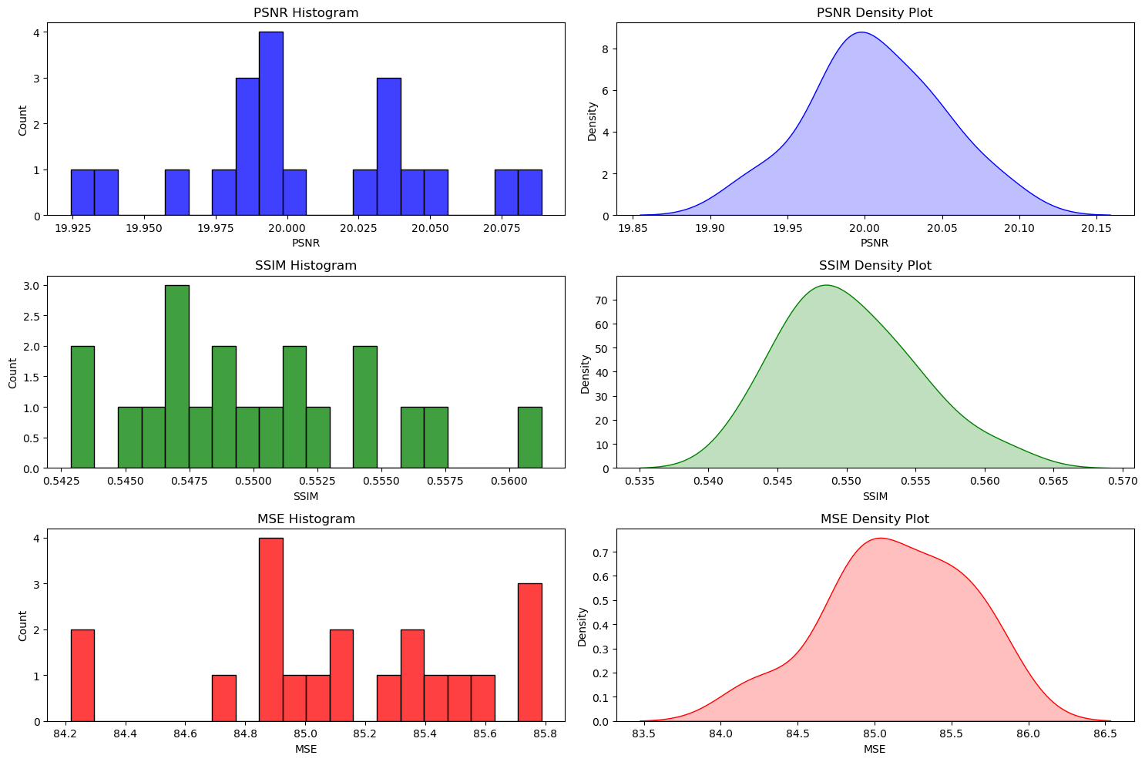

Diagram Inference

1. PSNR (Peak Signal-to-Noise Ratio)
- Histogram:
  - X-Axis: PSNR values, ranging from approximately 19.925 to 20.075.
  - Y-Axis: Count (Frequency) of occurrences of each PSNR value within specified bins.
  - Observation: The histogram shows the distribution of PSNR values for the different samples. The PSNR values are centered around 20, with most samples having PSNR values close to this mean. The spread of the data is relatively narrow, indicating that the PSNR values do not vary much between samples.
- Density Plot:
  - X-Axis: PSNR values.
  - Y-Axis: Density, representing the distribution of PSNR values in a continuous manner.
  - Observation: The density plot shows a smooth curve that peaks around 20, similar to the histogram. This suggests that the PSNR values are normally distributed around a mean of 20. The bell-shaped curve indicates a normal distribution, confirming the consistency in image quality across different samples.

2. SSIM (Structural Similarity Index)
- Histogram:
  - X-Axis: SSIM values, ranging from approximately 0.5425 to 0.5600.
  - Y-Axis: Count (Frequency) of occurrences of each SSIM value within specified bins.
  - Observation: The histogram shows the distribution of SSIM values for the different samples. The values are spread relatively evenly across the range, but most values cluster around the 0.55 mark. The spread is slightly wider compared to the PSNR, indicating a bit more variability in SSIM among the samples.
- Density Plot:
  - X-Axis: SSIM values.
  - Y-Axis: Density, representing the distribution of SSIM values in a continuous manner.
  - Observation: The density plot shows a smooth curve peaking around 0.55, suggesting that the SSIM values are approximately normally distributed around this value. The curve is slightly flatter than that of PSNR, indicating more variability in structural similarity across different images.

3. MSE (Mean Squared Error)
- Histogram:
  - X-Axis: MSE values, ranging from approximately 84.2 to 85.8.
  - Y-Axis: Count (Frequency) of occurrences of each MSE value within specified bins.
  - Observation: The histogram displays the distribution of MSE values, which are somewhat spread out but still centered around 85. The spread indicates some variation in MSE values, but the distribution is not overly wide, suggesting moderate consistency in MSE across samples.
- Density Plot:
  - X-Axis: MSE values.
  - Y-Axis: Density, representing the distribution of MSE values in a continuous manner.
  - Observation: The density plot shows a curve peaking around 85. The curve is slightly skewed to the right, indicating that while most MSE values are close to the mean, there are a few higher values that stretch the distribution slightly.

General Inference
The plots illustrate the distribution of PSNR, SSIM, and MSE values across different samples:
- PSNR: The close clustering of PSNR values around 20 with a narrow spread suggests that the image quality, in terms of signal-to-noise ratio, is consistent across different samples.
- SSIM: The clustering around 0.55 indicates that the structural similarity of the images is fairly consistent, though with slightly more variability than PSNR.
- MSE: The MSE values show a moderate spread, suggesting that while there is some variability in the error between the original and reconstructed images, it is not highly significant.
The overall distribution patterns, as shown by the histograms and density plots, support the conclusion that the differences in image quality metrics (PSNR, SSIM, MSE) across different classes are minimal, as confirmed by the ANOVA results with high p-values for each metric, indicating acceptance of the null hypothesis that there is no significant difference among groups.
Line Plot Analysis of Image Quality Using Smoothed PSNR, SSIM, and MSE Metrics:
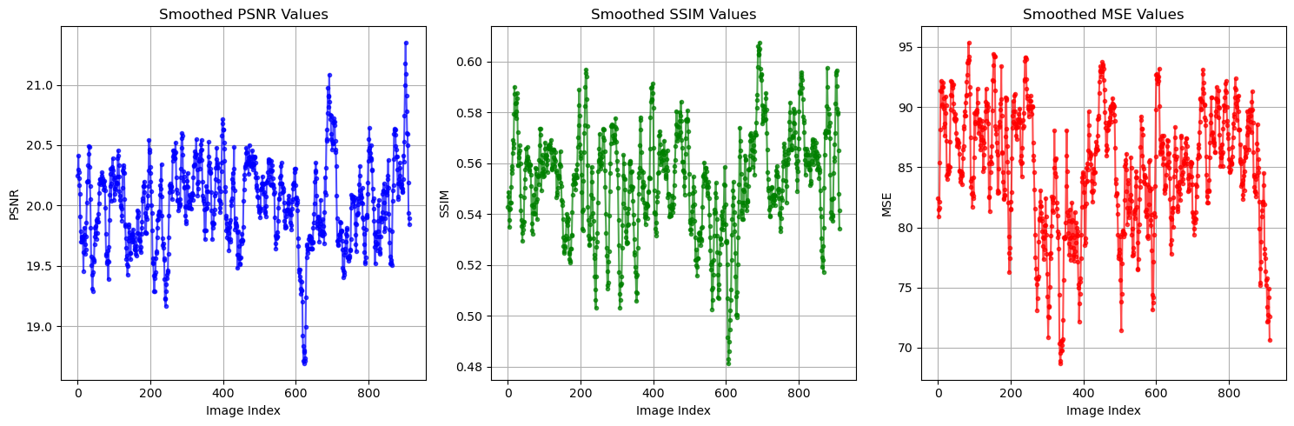
The graphs show the PSNR, SSIM, and MSE metrics for preprocessed images in a diabetic retinopathy (DR) detection workflow. With PSNR values ranging from 19 to 21.5, SSIM values between 0.48 and 0.60, and MSE values from 70 to 95, the preprocessing appears to enhance image quality to a moderate degree, maintaining structural information critical for DR analysis. The consistency of these metrics across images suggests that the preprocessing techniques used are effective in maintaining adequate image quality for reliable DR detection. Thus, these graphs indicate that the preprocessing methods employed are suitable and beneficial for use in DR detection tasks.

