"RetinoNet: An EfficientNet and Feature Pyramid Network-Based Framework for Accurate Diabetic Retinopathy Classification"
Abstract
Diabetic Retinopathy (DR) is a serious complication of diabetes, causing nerve damage in the eyes due to high blood sugar, often leading to vision loss. Early and accurate detection of DR stages is crucial for timely intervention as the retinal blood vessels deteriorate. The RetinaNet, a hybrid model that aims to enhance DR detection by increasing image quality and optimizing the diagnostic procedure. It solves critical problems like no uniform details in the image, fewer datasets available, overfitting, and bias arising from image enhancement, thus unlocking a pathway toward enhanced diagnosis optimization in areas with constrained access to expertise. EfficientNet-B0 is used as the feature extraction backbone, with a Feature Pyramid Network (FPN) to fuse multi-scale features and recover spatial information for precise detection. The pre-processing pipeline includes Adaptive Histogram Equalization, Non-Local Means De-noising, Grab Cut for background masking, and simulated super-resolution boosting of small details. These methodologies guarantee uniform image quality enhancement across all DR stages and address generalization problems, as well as overfitting in small datasets. The novelty of RetinaNet lays in that it utilized pre-trained models with Feature Pyramid Network (FPN) to extract multi-scale features for better DR detection. The model also uses simulated super-resolution to aid in up-sampling of small details to support a case when datasets are limited for an accurate diagnosis. RetinaNet was compared with two models providing lower accuracy compared to RetinaNet, which proves the strength of RetinaNet in DR detection. Achieving 96.8% accuracy on a dataset with four DR severity levels, the model is evaluated using F1 score, precision, recall, and specificity. Confusion matrices, ROC curves, and ANOVA analysis of PSNR, SSIM, and MSE validate its robust performance.
1 Introduction:
Diabetic retinopathy (DR) is a long-term complication of uncontrolled diabetes, which can damage small blood vessels in the retina and may eventually result in complete vision loss. Early diagnosis presents certain challenges. When data is cold-start and unbalanced, models tend to specialize in prevalent types but not generalize well across DR stages. Acquired images require meticulous pre-processing (e.g., Histogram Equalization) to sharpen images without introducing artifacts or biases that could lead to misdiagnoses. Statistical methods like ANOVA are necessary to ensure no bias across different DR levels, validating that enhancement methods consistently improve image quality. Moreover, limited ophthalmologists and diagnostic tools in rural areas make early detection challenging, as subtle retinal changes are difficult for clinicians to detect without proper image processing. This research offers a novel approach to overcome these obstacles and improve performance. Data augmentation techniques like rotation, zooming, and shifting help the model generalize better. Advanced pre-processing techniques such as adaptive histogram equalization, non-local means de-noising, and Grab-Cut are used to enhance image visibility without bias, preserving essential retinal structures. RetinaNet incorporates these pre-processing techniques into a deep-learning framework, overcoming dataset limitations and biases by using a Feature Pyramid Network (FPN) for multi-scale feature extraction and simulated super-resolution to emphasize small retinal structures. Image quality is evaluated using PSNR, SSIM, and Estimation Error, with ANOVA demonstrating improvements across all DR stages. Care must be taken when adding new data or features to ensure performance remains unbiased across all DR severity levels.
1.1 Objective and Motivation: The primary objective is to develop a high-performing, scalable framework for DR detection using hybrid multimodal representation learning models. By aligning task properties, feature processing methods, and optimization techniques, the research aims to improve diagnostic performance with RetinaNet. This work addresses critical challenges like small datasets, class imbalances, bias in image pre-processing, and diagnostic performance, aiming for an efficient and scalable solution by jointly optimizing image processing and classification.
1.2 Research Gaps:
- Limited expert annotation: DR detection models often suffer from limited expert-annotated data essential for training. In reality, only a small portion of data is annotated due to resource constraints, making it challenging to train reliable detection systems.
- Overfitting and generalization issues: Small, imbalanced datasets can lead to overfitting, restricting models from generalizing across different DR stages, limiting their use beyond healthcare settings.
- Bias in image enhancement: Modern image enhancement methods often introduce bias, distorting retinal features and affecting prediction accuracy. Bias-free enhancement methods are necessary for consistent and reliable detection across all DR severity levels.
1.3 Main Contributions:
- Multimodal Integration with RetinaNet: A segmentation framework combines a Feature Pyramid Network (FPN) and pseudo-super-resolution for multi-scale feature extraction, enabling detection of both small microaneurysms and larger retinal structures.
- Optimized Image Pre-processing: Bias-free image enhancement techniques like adaptive histogram equalization, non-local means de-noising, and Grab-Cut are applied to improve clarity while preserving diagnostic integrity.
- Validation: PSNR, SSIM, and MSE are used to evaluate image quality, while ANOVA ensures consistent improvements across DR stages without bias.
- Dataset Augmentation & Optimization: Data augmentation techniques enhance model generalization and performance, addressing dataset limitations and improving detection reliability.

Proposed Methodology:
The proposed model, a novel approach utilizing EfficientNet as its backbone, learns low, mid-, and high-level features from retinal images. These features are subsequently up-sampled with a Feature Pyramid Network (FPN) to enable the localization of both small and large retinal abnormalities. It illustrates advanced techniques like state-of-the-art pre-processing, multi-scale feature extraction, and classification, which can successfully predict DR stages, as shown in Figure 1. This method addresses significant challenges such as small datasets, generalization issues, and bias in image enhancement.
The system is build using Class-Wise input of fundus which are categorized using annotation table given by experts. They are categorized into four DR severity levels: Class 0 (No DR), Class 1 (Mild DR), Class 2 (Moderate DR), and Class 3 (Severe DR). These class-wise images are pre-processed and resized, ensuring consistency for feature extraction and enabling the model to learn patterns across different DR stages.
Data Pre-processing Pipeline
The pre-processing pipeline is utilized to enhance the quality of raw retinal images for accurate feature extraction in DR detection. The pipeline includes several image processing steps to remove noise, enhance contrast, and pre-process the images so that features can be reliably and accurately extracted. All the steps are explained step by step in pseudocode to ensure the images remain unbiased and suitable for numerical analysis. Statistical tests are conducted to ensure no bias is introduced during enhancement, ensuring consistency and reliability.
The raw retinal image is then converted to grayscale for further structural analysis and feature extraction. The grayscale conversion formula is:
$$I_{gray}(x,y)=0.2989×R(x,y)+0.5870×G(x,y)+0.1140×B(x,y)$$
This focuses on intensity variations, crucial for DR detection, simplifying the image while preserving structural details. The retina is segmented using the GrabCut algorithm to isolate the region of interest (ROI). The energy function for GrabCut is:
$E\left(x\right)=\sum_{i∈foregroud}{-logP(x_{i }}\left|θ_{F }\right)+\sum_{i∈backgroud}{-logP(x_{i }}\left|θ_{B }\right)$ for Background pixels.
This isolates the retina from the background, resulting in an in-focus image, I_masked. Next, Contrast Limited Adaptive Histogram Equalization (CLAHE) is applied to improve local contrast and highlight DR signs like microaneurysms. The CLAHE formula is:
$$CLAHE\left(I_{masked}(x,y)\right)=\frac{\left(I_{masked}(x,y)\right)-min⁡(I)}{\max\left(I\right)-min⁡(I)}×255$$
This produces a contrast-enhanced image, $I_{CLAHE}$.Non-local means denoising is applied to remove noise while preserving important details such as blood vessels and lesions. The formula for denoising is:
$$I_{denoised}\left(x,y\right)=\sum_{p∈patch around(x,y)}{w\left(p\right)∙I_{CLAHE}(p)}$$

This results in the denoised image, I_denoised, which retains essential DR features. Cubic interpolation is used to upscale the resolution for better visualization of DR features. The upscaling formula is:
$$I_{new}\left(x,y\right)=\sum_{i=-1}^{2}{\sum_{j=-1}^{2}{I(x+i,y+j)∙w(i)∙w(j)}}$$
This produces the upscale image$I_{upscaled}$,improving clarity for detecting subtle abnormalities.Finally, CLAHE is reapplied to the upscaled image for further contrast enhancement:
The upscale image $I_{upscaled}$ provides greater clarity for detecting subtle abnormalities. Finally, CLAHE is reapplied to the upscale image to further enhance contrast, using the formula:
$$CLAHE\left(I_{upscaled}(x,y)\right)=\frac{\left(I_{upscaled}(x,y)\right)-min⁡(I)}{\max\left(I\right)-min⁡(I)}×255$$
This generates the fully processed image, I_preprocessed, ready for feature extraction.
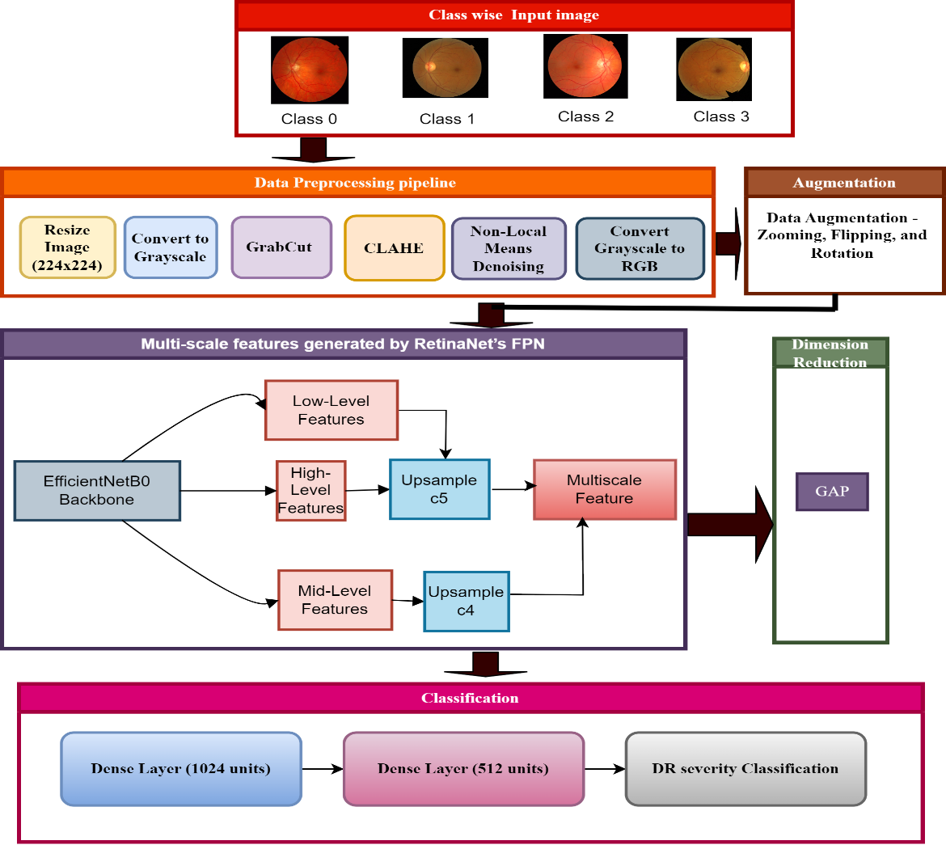
Figure 1: Proposed Model

Multiscale feature by RetinaNet:
The pre-processed retinal images $I_{preprocessed}$ are processed through the backbone of EfficientNet-B0 to model features. It extracts all the $F_{low}$, $F_{mid}$, and $F_{high }$ features that are essential to identify different DR abnormalities such as microaneurysms, hemorrhages, and blood vessel changes. This process is written as:
$F_{low},F_{mid},F_{high}={f EfficientNetBo(I}_{preprocessed}$)
Where $fEfficientNetBo$ denotes the EfficientNet feature extraction function. The Feature Pyramid Network (FPN) upscale and fuses these features to produce a comprehensive multi-scale feature map, making both small and large retinal abnormalities detectable.$F_{low}$, $F_{mid}$, and $F_{high }$are fused to generate the final feature map:
$F_{P5}={Conv(F}_{high})$
$F_{P4}={Conv(F}_{mid})+Upsample(F_{P5})$
$F_{P3}={Conv(F}_{low})+Upsample(F_{P4})$

The multi-scale feature map F_final is optimized for DR severity detection through a combination of Focal Loss for classification and Smooth L1 Loss for localization. Focal Loss, defined as:
${FL(p}_{t })=-α_{t}{\left(1-P_{t}\right)}^{γ}log⁡(P_{t})$
helps manage class imbalance inherent to DR detection, while Smooth L1 Loss:
$SmoothL1\left(x\right)=\left\{\begin{aligned} 0.5x^{2 } if∣x∣<1 \\ ∣x∣​-0.5 otherwise \end{aligned}\right.$
is used for precise localization of retinal features such as lesions. The total loss function is:
$L_{total}=L_{classification}+L_{localization}$
guaranteeing accurate classification and precise localization in detecting DR severity stages. The output of RetinaNet is a multi-scale feature map which further reduced in dimensionality using Global Average Pooling(GAP). This feed-forward network is then flattened from the reduced feature map and passed through a dense layer to combine features. It then performs Softmax activation to classify the severity of DR into its categories.

Result and discussion:
Visualization of the Image Enhancement
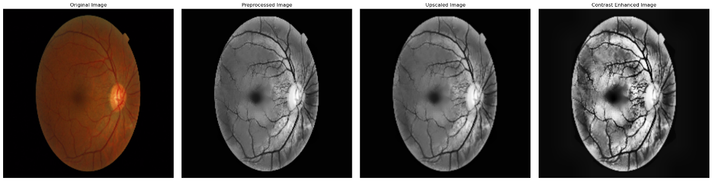
Figure: Retinal Image Enhancement and Segmentation Pipeline:
This sequence of images represents an example illustration from the pre-processing and segmentation stream for DR detection, where retinal images are enhanced for more clarity. It starts from the Original Image, which takes into account important retinal characteristics. The Pre-processed Image converts the image to grayscale, corrects it for higher contrast using CLAHE image enhancement, and reduces noise while preserving in-depth details with Non-Local Means De-noising. The Up-scaled Image increases resolution via cubic interpolation, creating better fine-detail representation, such as small blood vessels. Moreover, the Contrast Enhanced Image highlights important retinal structures, such as microaneurysms and hemorrhages, which are necessary for segmenting specific retinal features, contributing to accurate classification. The same uniform pipeline is applied to all images, guaranteeing unbiased image enhancement and compensating for DR severity heterogeneity. PSNR, SSIM, and MSE were used for image quality validation, and ANOVA was conducted to ensure consistent and unbiased enhancement across all DR stages, aiding in reliable segmentation and detection.
ANOVA (Analysis of Variance) for Diabetic Retinopathy (DR) Detection:
ANOVA (Analysis of Variance) tests if there are any significant differences between the means of multiple independent groups. In this research, ANOVA assesses whether the image quality metrics—PSNR, SSIM, and MSE—differ significantly after pre-processing and segmentation across different DR severity levels (Class 0, Class 1, Class 2, and Class 3). In the context of Diabetic Retinopathy (DR) detection, ANOVA ensures that the preprocessing and segmentation methods consistently improve image quality across all DR stages without introducing bias. ANOVA validates that the image enhancements are uniform and do not disproportionately benefit one severity class over others when comparing PSNR, SSIM, and MSE values across severity levels.

Hypotheses:
- Null Hypothesis (H₀): There are no significant differences in PSNR, SSIM, or MSE across DR severity levels.
- Alternative Hypothesis (H₁): There are significant differences in PSNR, SSIM, or MSE across DR severity levels.
The F-statistic in ANOVA compares the variance between groups (PSNR, SSIM, and MSE across DR severity levels) to the variance within each group.
The formula is:
$F=\frac{Variance Between Groups(MSB)}{Variance Within Groups (MSW}$
- Between-Group Variance (SSB): Measures the variability in PSNR, SSIM, and MSE across different DR severity levels (e.g., comparing Class 0 to Class 3).
- Within-Group Variance (SSW): Measures the variability within each DR class (e.g., how PSNR varies within Class 1).
Table 1: Random Samples for PSNR, SSIM, and MSE
Label | PSNR | SSIM | MSE
Class 0 | 20.024836 | 0.557328 | 85.369233
Class 0 | 19.993087 | 0.548871 | 85.085684
Class 0 | 20.032384 | 0.550338 | 84.942176
Class 0 | 20.076151 | 0.542876 | 84.849448
Class 0 | 19.988292 | 0.547278 | 84.260739
Class 1 | 19.998293 | 0.551555 | 84.740078
Class 1 | 20.088961 | 0.545245 | 84.869681
Class 1 | 20.048372 | 0.552878 | 85.628561
Class 1 | 19.986526 | 0.547997 | 85.271809
Class 1 | 20.037128 | 0.549542 | 84.21848
Class 2 | 19.996829 | 0.548991 | 85.362042
Class 2 | 19.996714 | 0.561261 | 85.007459
Class 2 | 20.032098 | 0.551933 | 84.861539
Class 2 | 19.924336 | 0.546711 | 85.505838
Class 2 | 19.933754 | 0.556113 | 85.7155
Class 3 | 20.001886 | 0.546896 | 85.76564
Class 3 | 19.979358 | 0.554044 | 84.880391
Class 3 | 20.045712 | 0.543202 | 85.145394
Class 3 | 19.984599 | 0.546359 | 85.465632
Class 3 | 19.959385 | 0.553984 | 85.787773

Table 2: ANOVA Test Results
Metric | F-Value | p-Value
PSNR | 2.126616 | 0.136972
SSIM | 0.768157 | 0.528464
MSE | 1.721841 | 0.202714
Table 1 presents random samples from the dataset with their respective PSNR, SSIM, and MSE values, while Table 2 provides the results of the ANOVA test. The results support the null hypothesis, indicating no significant differences in image quality metrics across various DR severity levels. Specifically, PSNR (F = 2.13, p = 0.137), SSIM (F = 0.77, p = 0.528), and MSE (F = 1.72, p = 0.203) have high p-values (> 0.05), suggesting that the pre-processing and segmentation methods consistently impact all DR stages (Class 0 to Class 3) without bias. This confirms that the system offers bias-free image enhancement, ensuring consistent and reliable performance across all stages of DR. The validation through these metrics and ANOVA demonstrates that image quality is improved uniformly, addressing the research gap by ensuring unbiased and consistent.
Visualization of Image Quality Metrics for Bias-Free Enhancement
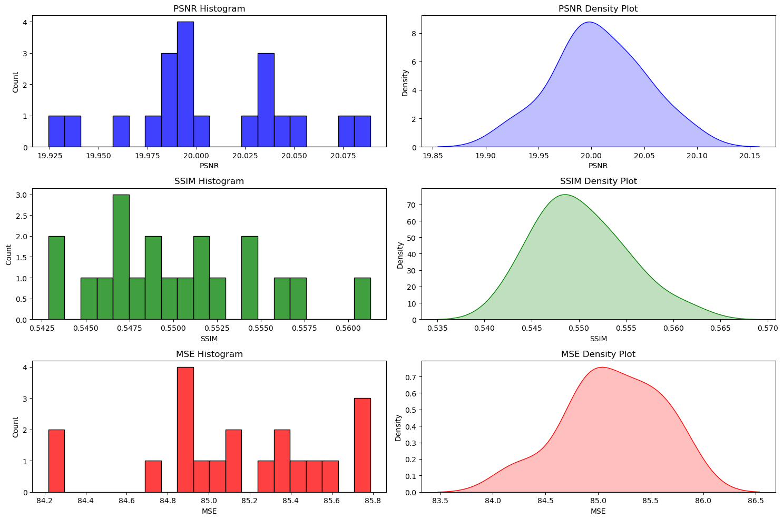
Figure :Distribution of PSNR, SSIM, and MSE for Bias-Free DR Image Enhancement
The histograms and density plots of PSNR, SSIM, and MSE illustrate the distribution of image quality metrics across different pre-processing techniques for retinal images in Diabetic Retinopathy (DR) detection. The x-axis in these plots represents the values of PSNR (ranging from 19.925 to 20.075), SSIM (ranging from 0.5425 to 0.5600), and MSE (ranging from 84.2 to 85.8), while the y-axis represents the count (for histograms) or density (for density plots) of occurrences within each bin. These plots demonstrate that the metrics maintain consistency across different samples, with minimal variation in PSNR values around 20, SSIM values clustering near 0.55, and MSE values centred around 85. The overall consistency, supported by the ANOVA results showing high p-values, confirms that the pre-processing methods used for image enhancement are bias-free. This visualization addresses the research gap of ensuring uniform image quality enhancement across all DR severity levels, avoiding bias in the diagnostic process and ensuring reliable performance across different DR stages.
Performance Metrics:
The table is very important for evaluating the performance of our DR detection model RetinaNet. These metrics; Precision, Recall, F1 Score, Specificity, and Accuracy give us a measure of how well the model is identifying underlying DR condition cases while keeping incorrect classification to a minimum. These metrics are founded on four pivotal cornerstones: True Positive (TP), True Negative (TN), False Positive (FP), and False Negative (FN), each of which contributes to model evaluation in many important ways.
Table 3: RetinaNet Performance Metrics for DR Detection
Class | Precision | Recall | F1 Score | Specificity | Accuracy
Class 0 | 0.935065 | 1 | 0.966443 | 0.97549 | 0.974
Class 1 | 0.803571 | 0.803571 | 0.803571 | 0.95 | 0.928
Class 2 | 0.836066 | 0.822581 | 0.829268 | 0.953271 | 0.95
Class 3 | 0.963415 | 0.918605 | 0.940476 | 0.984211 | 0.949

Confusion Matrix:
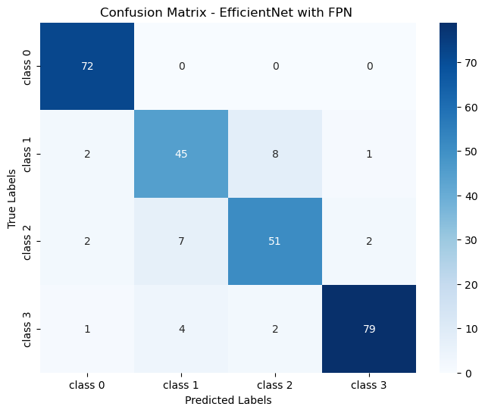
ROC:
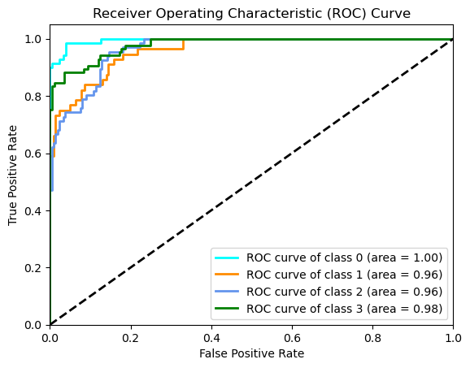:

Training and validation:


