Optimizing Fennel Production in Arid Climates: Integrating Micronutrient Mixtures for Enhanced Agronomic Performance, Quality, and Soil Sustainability
Chetan Kumar Jangir^{1*}, Murlidhar Meena¹, Om Prakash Aishwath¹, Sumer Singh Meena¹, Ravi Y¹ and Vinay Bhardwaj¹
¹Indian council of Agricultural Research- National Research Centre on Seed Spices, Ajmer (Rajasthan)
chetan.jangir@icar.gov.in, murlidhar.meena@icar.gov.in, om.aishwath@icar.gov.in, sumer.meena@icar.gov.in, ravi.y@icar.gov.in and vinay.bhardwaj@icar.gov.in
*Corresponding author: chetan.jangir@icar.gov.in
Abstract
Numerous multi-micronutrient mixtures have been developed during recent years to address the micronutrient deficiencies in crops and soil health problem to overcome the soil sustainability. The present field study was undertaken to know the effect of micronutrient mixtures on yield, quality, root studies in fennel and soil microbial enzymatic activities in arid climate. A randomized block design with eight treatments, including soil and foliar applications of Fe, Mn, Cu, Zn, and B in various combinations, was employed. Growth and yield of eggplant increased significantly with increasing levels of RDF. Similar trends were observed in available soil nutrient content and microbial activities. Likewise, 1.0 kg MMF ha⁻¹ increased growth and yield, and 0.75 kg MMF ha⁻¹ was also found at par with the highest dose. GGE biplot analysis revealed that the application of 0.75 or 1.0 kg ha⁻¹ MMF as foliar spray along with RDF is necessary to enhance micronutrient concentration in fruits. However, in shoot and leaves, higher levels of MMF improves nutrient content even without macronutrient application. Further, dehydrogenase activities and microbial biomass carbon was recorded significantly higher under 1.0 kg MMF ha⁻¹. Whereas, alkaline and acid phosphatases and urease activities were higher with 0.75 kg MMF ha⁻¹. Combined application of MMF (either 0.75 or 1.0 kg ha⁻¹) and RDF enhances yield (18.3–21.7%) and micronutrient concentration in eggplant fruits significantly, besides improving soil biological health.
Introduction
Fennel (Foeniculum vulgare Mill), a member of the Apiaceae family native to Southern Europe and the Mediterranean region, has become a prominent seed spice in India, primarily cultivated during the Rabi season. As the world's largest producer, India boasts an impressive cultivation area of 78,976 hectares, yielding 127,160 tonnes with a productivity of 1,610 kg/ha (Anonymous 2021). The country's dominance in fennel production is further reflected in its export performance, with values surging from Rs. 17,240 lakhs in 2015-16 to Rs. 41,186 lakhs in 2021-2022. This remarkable growth is evidenced by the annual average increase of 16.5% in export value and 11.3% in export quantity. The global demand for fennel extends to markets like Australia, which imported approximately 568 tonnes of spices, valued at US$1.37 million in 2018, primarily sourced from India and China (Rajah, 2023). However, realizing the full potential of fennel cultivation faces several challenges. Despite its economic promise, fennel productivity often falls short of its genetic potential due to various abiotic and biotic stresses, coupled with socioeconomic factors such as insufficient farmer knowledge regarding appropriate nutrient management protocols (Valiki et al., 2015).
Fennel's high nutrient requirements, exacerbated by its long growth duration, demand sophisticated fertilization strategies. Unfortunately, many farmers rely solely on primary nutrient fertilizers, resulting in suboptimal yields, poor nutritional quality, and long-term soil fertility decline (Diacono et al., 2023). This situation is further complicated by widespread micronutrient deficiencies in agricultural soils. To address these challenges and maximize fennel's productive capacity, it is crucial to implement comprehensive mineral fertilization strategies. These approaches should integrate both soil and foliar nutrition, alongside innovative management techniques, to overcome micronutrient deficiencies and enhance overall soil fertility (Shivay et al., 2019). By adopting such holistic nutrient management practices, farmers can potentially boost fennel yields, improve crop quality, and ensure sustainable soil health, thereby strengthening India's position in the global fennel market and opening new avenues for countries like Australia in commercial fennel production.
Micronutrient mixture fertilizers have emerged as a promising solution to address the complex nutritional needs of plants, offering a comprehensive approach to supplying essential micronutrients in various crop systems. Despite their potential, the efficacy of these mixtures in fennel cultivation remains largely unexplored, presenting a significant research opportunity in agricultural science. Fennel, an economically important crop in many regions, has not been the subject of scientific field trials investigating the effects of micronutrient mixture fertilizers on its agronomic performance or long-term soil sustainability. This knowledge gap extends to understanding how these complex fertilizers influence fennel's root behavior, a crucial aspect of plant health and nutrient uptake efficiency. Moreover, the impact of these fertilizer mixtures on soil microbiological parameters, which are key indicators of soil biological health, has yet to be thoroughly examined in fennel cultivation systems. This study aims to fill these critical knowledge gaps by investigating the effects of micronutrient mixture fertilizers on fennel growth, yield, root development, and soil microbial enzymatic activity under arid conditions.
By adopting a comprehensive research approach, this study not only promises to enhance our understanding of fennel nutrition but also has broader implications for sustainable crop management practices in similar agroecosystems. The findings from this research could potentially revolutionize nutrient management strategies for fennel and similar crops, contributing to improved agricultural productivity and soil health in the long term. Furthermore, this study may provide valuable insights into the complex interactions between plant nutrition, root development, and soil microbial activity, advancing our overall understanding of sustainable agricultural systems.
2 Materials and Methods
2.1. Field locations and Experimental design
The research experiment was conducted at ICAR-NRCSS (Indian Council of Agricultural Research - National Research Centre on Seed Spices) in Ajmer, Rajasthan, over a period of three years, from 2021 to 2024 (figure 1). The site was selected based on its suitability for fennel cultivation and availability of necessary facilities. A randomized block design (RBD) with three replications were adopted to minimize experimental error and account for potential variations in soil conditions and microclimatic factors across the experimental area. Soil samples were collected from a 0–15 cm depth at all locations following standard procedures to assess the basic chemical and physical properties of the soil (Table 1).
Table 1 Physico-chemical characteristics of experimental site soil (sandy loam)
Parameter | Value | Parameter | Value
pH | 7.67±0.2 | Zn2+ (mg kg–1) | 0.53±0.12
ECs (dS m–1) | 0.25±0.3 | B (mg kg–1) | 0.14±0.06
CEC | 6.87 | Cu2+ (mg kg–1) | 0.46±3.10
Organic matter (%) | 0.28±0.09 | Available N (kg ha–1) | 129.54±5.1
Mn2+ (mg kg–1 | 6.15±0.82 | Available K (kg ha–1) | 210.54±6.9
Fe2+ (mg kg–1) | 4.80±0.33 | Available P (kg ha–1) | 9.23±1.1
ECs –electrical conductivity of soil Paste; CEC: cation exchange capacity. Data are averaged values ± standard deviations
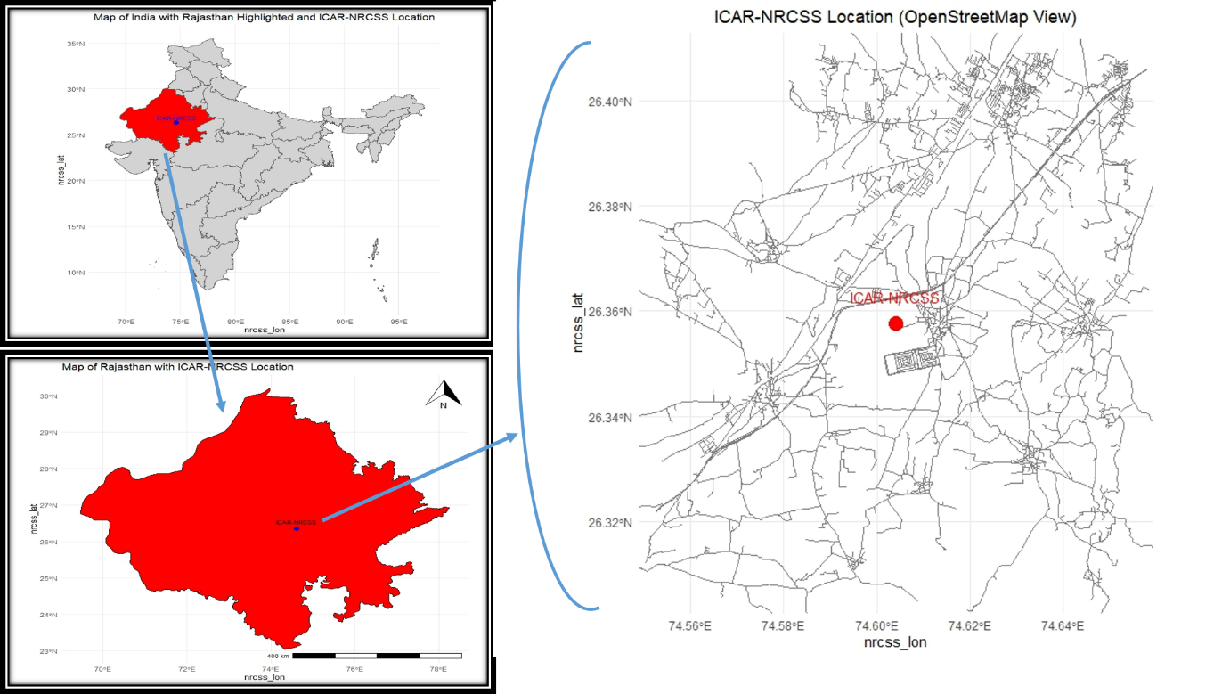
Figure: Field location map
2.2 Meteorological Data
Meteorological data for the years 2021-2024 were collected to assess the environmental conditions during the experimental period (Figure 1). The data were obtained from a local meteorological station located in close proximity to the experimental site at ICAR-NRCSS, Ajmer. The meteorological variables recorded include maximum and minimum temperature and relative humidity. Daily maximum and minimum temperatures were recorded using digital thermometers placed at the experimental site. Relative humidity was measured using a hygrometer placed in the vicinity of the experimental area.
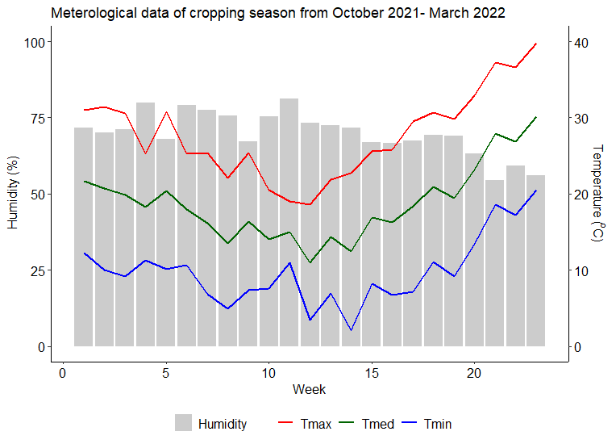
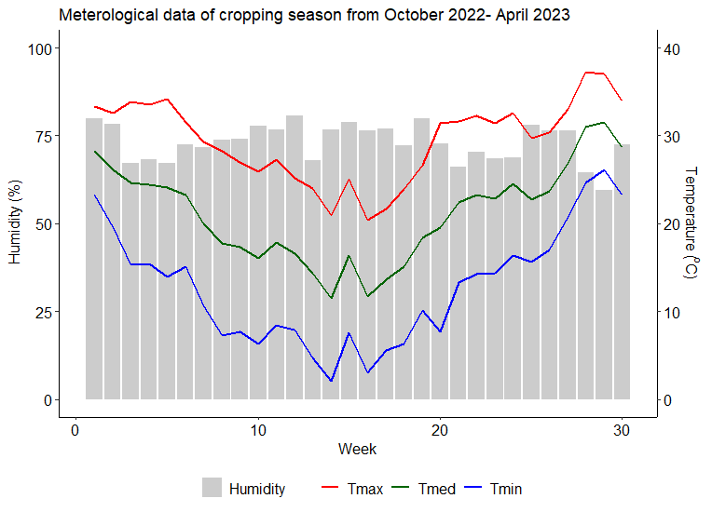
Figure 1: Meteorological data of cropping season (2021-22 and 2023-24)
2.3 Plant Material and Micronutrient Treatments
Fennel seeds of a locally adapted cultivar Ajmer fennel-2 were obtained from a ICAR-NRCSS. The seeds were treated with a fungicide Thiram@2gm/kg seed to prevent seed-borne diseases and ensure uniform germination. The experiment comprised a total of 8 different micronutrient treatments, including varying combinations and concentrations of micronutrients (Table 1). The treatment details are as follows: Treatments T1 to T3 involved only soil application with varying proportions of micronutrients (Fe, Mn, Cu, Zn, and B). Treatments T4 to T6 involved only foliar application, while treatments T7 to T8 involved a combined application of soil and foliar treatments with different proportions of micronutrient mixtures. NA was used to induce and regulate secondary metabolite accumulation, AA were included to promote plant growth, improve nutrient availability, and enhance plant quality, HA was utilized to increase root vitality, improve nutrient uptake, enhance chlorophyll synthesis, improve seed germination, and increase retention of micronutrient fertilizers, while FA was employed to stimulate plant metabolism, increase enzyme activity, and further enhance plant quality. These components were proportionally added to treatments to increase the efficiency of the micronutrient mixture.
Table 1: Treatment details of experiment
Treatments | Fe  (Kg/ha) | Mn  (Kg/ha) | Cu  (Kg/ha) | Zn  (Kg/ha) | B  (Kg/ha)
T1. Soil (150%) | 15 | 15 | 7.5 | 7.5 | 3.75
T2. Soil (100%) | 10 | 10 | 5 | 5 | 2.5
T3. Soil (50%) | 5 | 5 | 2.5 | 2.5 | 1.25
T4. Two Foliar@ 0.5% | 10 | 10 | 5 | 5 | 2.5
T5. Two Foliar@ 1% | 10 | 10 | 5 | 5 | 2.5
T6. Two Foliar@ 1.5% | 10 | 10 | 5 | 5 | 2.5
T7. | 50% soil application (100% RDMF) + 1% Foliar
T8. | 50% soil application (150% RDMF) + 1.5% Foliar

2.4 Plant data Collection
2.4.1 Yield and their attributes
At harvest, various agronomic parameters were measured to assess the effect of micronutrient treatments on fennel yield and their attributes. These parameters included yield components (such as number of seed per umbellate, number of umbellate per umbel, number of umbels per plant, fresh and dry shoot weight at different stage) were measured.
2.4.3 Quality parameters
The essential oil from dried seeds of each treatment was extracted through hydro-distillation, utilizing 30 g of ground seeds in triplicate using a Clevenger apparatus. The grain samples were carefully washed three times with de-ionized water and dried at 65°C. Samples were ground and digested by established methods described by Wolf (1982). The nitrogen concentration in digested samples was analysed by the micro-Kjeldahl procedure (Jackson 1962). Phosphorus was analysed according to the vanadate-molybdate spectrophotometric procedure (Jones et al. 1991). Potassium was determined by flame photometry (Chapman and Pratt 1961). Zn, Fe, Cu and Mg concentrations in di-acid digested solutions were determined by using atomic absorption spectrophotometry

Seed samples were harvested at physiological maturity to assess the micronutrient status of fennel plants. The samples were air-dried, finely ground using a wooden mortar, and then passed through a 2 mm stainless steel sieve. To prepare for analysis, the plant samples underwent sequential washing with tap water, 0.1 M HCl, and distilled water, followed by drying at 70°C. Once dried, the samples were further ground using a Wiley mill and passed through a 20-mesh stainless steel sieve. The plant material was digested in a mixture of nitric acid and perchloric acid (8:4), and the resulting digests were analyzed using an atomic absorption spectrophotometer to determine the micronutrient content. The formula for calculating micronutrient uptake in grams per hectare (Eq. 1) is:
Micronutrient uptake (g/ha) = Nutrient concentration (mg/kg) × seed yield (kg/ha) …. Eq. (1)
2.4.5 Statistical analysis
The marketable yield data were recorded and analysed statistically by using the ‘metan’ package (Olivoto and Lúcio, 2020) of ‘RStudio’, which is an integrated development environment for R software (https://www.R-project.org). Means were separated by Fisher’s protected least significance difference (LSD) at either P<0.01 (Steel et al. 1997). The experimental data was subjected to statistical analysis by using R Studio software (. Analysis of variance (ANOVA) and Duncan’s multiple range test was used to compare the least significant difference (LSD). The results from this study will contribute to our understanding of the interaction between micronutrient mixtures, environmental factors, and fennel yield and quality, aiding the development of sustainable fennel cultivation practices. GGE biplot and structural equation model also analysed for yield and essential oil of fennel.
Result
The study investigated the effects of various treatments on seed yield over a three-year period. The results are summarized in Table 1, which presents the seed yield (kg/ha) for each treatment across the three years, along with the mean yield and Sustainable Yield Index (SYI). The seed yield varied significantly among treatments and across years. In the first year, treatment T8 produced the highest yield (2658.33 kg/ha), followed closely by T6 (2562.22 kg/ha) and T7 (2510 kg/ha). The lowest yield was observed in T3 (1519.44 kg/ha). In the second year, all treatments except T3 showed comparable yields, with no statistically significant differences among T1, T2, T4, T5, T6, T7, and T8. T8 again produced the highest yield (2558.16 kg/ha), while T3 remained the lowest (1653.3 kg/ha). The third year saw a general decrease in yields across all treatments. T1 maintained the highest yield (2046.17 kg/ha), closely followed by T8 (2044.6 kg/ha). T3 continued to show the lowest yield (1569.53 kg/ha). When considering the three-year average, T8 emerged as the treatment with the highest mean yield (2420.36 kg/ha), although it was not statistically different from T6 (2319.63 kg/ha) and T1 (2315.95 kg/ha). T3 consistently produced the lowest mean yield (1580.76 kg/ha) over the three-year period. The Sustainable Yield Index provides insight into the long-term productivity and stability of each treatment. T8 demonstrated the highest SYI (0.87), indicating superior sustainability. T5 and T1 followed closely with SYI values of 0.84 and 0.83, respectively. Despite its low yield, T3 showed the poorest sustainability with an SYI of 0.53.

In summary, treatments T8, T6, and T1 consistently outperformed other treatments in terms of seed yield and sustainability. T3, while showing the lowest yields, also demonstrated the least sustainability over the three-year study period.
Treatment | Seed Yield (Kg/ha) |  |  |  | SYI
Treatment | 1st Year | 2nd Year | 3rd Year | Mean | SYI
T1 | 2450.56ab | 2451.13a | 2046.17a | 2315.95a | 0.83
T2 | 2303.33bc | 2237.66a | 1852.9ab | 2131.3bc | 0.75
T3 | 1519.44d | 1653.3b | 1569.53c | 1580.76e | 0.53
T4 | 1713.33d | 2234.03a | 1675.77bc | 1874.38d | 0.65
T5 | 2156.11c | 2353.72a | 1926.77ab | 2232.2ab | 0.84
T6 | 2562.22ab | 2462.03a | 1934.62a | 2319.63a | 0.83
T7 | 2510ab | 2443.23a | 1856.1ab | 2269.78ab | 0.81
T8 | 2658.33a | 2558.16a | 2044.6a | 2420.36a | 0.87

Treatment | Essential oil | Chlorophyll a | Chlorophyll b | Seed index
T1 | 1.697 a | 1.477 ab | 0.467 ab | 7.767 ab
T2 | 1.59 b | 1.397 cd | 0.443 bc | 7.367 bc
T3 | 1.557 b | 1.357 d | 0.363 d | 7.067 c
T4 | 1.657 a | 1.437 bc | 0.433 c | 7.5 ab
T5 | 1.697 a | 1.463 b | 0.44 bc | 7.567 ab
T6 | 1.7 a | 1.47 ab | 0.45 bc | 7.633 ab
T7 | 1.677 a | 1.46 b | 0.433 c | 7.5 ab
T8 | 1.703 a | 1.517 a | 0.483 a | 7.8 a
CV(%) | 1.366 | 1.206 | 2.229 | 1.924
P Value | p<0.001 | p<0.001 | p<0.001 | 0.001

The study examined the effects of various treatments on essential oil content, chlorophyll levels, and seed index over a three-year period. The pooled data from these years are presented in Table 1, showing the mean values for each parameter across treatments. Essential oil content varied significantly among treatments (p<0.001). Treatment T8 yielded the highest essential oil percentage (1.703%), although it was not statistically different from T1, T4, T5, T6, and T7, which ranged from 1.657% to 1.7%. Treatments T2 and T3 showed significantly lower essential oil contents (1.59% and 1.557%, respectively) compared to the other treatments.
Chlorophyll Content
Chlorophyll a
Chlorophyll a content showed significant differences among treatments (p<0.001). T8 exhibited the highest chlorophyll a content (1.517 mg/g fresh weight), which was statistically similar to T1 (1.477 mg/g) and T6 (1.47 mg/g). The lowest chlorophyll a content was observed in T3 (1.357 mg/g), which was significantly lower than all other treatments except T2.
Chlorophyll b
Chlorophyll b content also varied significantly among treatments (p<0.001). T8 again showed the highest content (0.483 mg/g fresh weight), which was statistically similar only to T1 (0.467 mg/g). The lowest chlorophyll b content was found in T3 (0.363 mg/g), which was significantly lower than all other treatments.
Seed Index
The seed index, which is an indicator of seed quality and size, showed significant differences among treatments (p=0.001). T8 had the highest seed index (7.8), although it was not statistically different from T1, T4, T5, T6, and T7, which ranged from 7.5 to 7.767. T3 exhibited the lowest seed index (7.067), which was significantly lower than all treatments except T2.

Treatment | Days to 50 % flowering | Days to maturity | Umbels per plant | Umbellate per umbel | Seeds per umbellate
T1 | 127.333 a | 160.333 ab | 51.667 a | 28.333 a | 29.333 a
T2 | 124.667 ab | 156.667 abc | 45 bc | 26 ab | 26 abc
T3 | 119.333 b | 151.333 c | 40.333 c | 23 b | 23 c
T4 | 121 ab | 152 c | 40.667 c | 23.667 ab | 25 bc
T5 | 123.333 ab | 154 bc | 46.333 b | 25 ab | 26 abc
T6 | 124.667 ab | 154.667 abc | 46.333 b | 26 ab | 27.333 ab
T7 | 122 ab | 155 abc | 44.667 bc | 24.667 ab | 26.333 abc
T8 | 126.667 ab | 161 a | 51.667 a | 27.333 ab | 29.333 a
CV(%) | 2.065 | 1.486 | 3.563 | 7.141 | 4.456
P Value | 0.022 | 0.001 | p<0.001 | 0.043 | p<0.001

This study investigated the effects of various treatments on phenological traits and yield components. The results are summarized in Table 1, presenting data on days to 50% flowering, days to maturity, umbels per plant, umbellate per umbel, and seeds per umbellate across different treatments.
Phonological Traits
Days to 50% Flowering
The treatments showed a significant effect on the number of days to 50% flowering (p=0.022). Treatment T1 resulted in the latest flowering (127.333 days), although it was not statistically different from most other treatments except T3. The earliest flowering was observed in T3 (119.333 days), which was significantly earlier than T1 but similar to the other treatments.
Days to Maturity
Days to maturity also varied significantly among treatments (p=0.001). T8 showed the longest maturity period (161 days), which was statistically similar to T1 (160.333 days) and T2 (156.667 days). The shortest maturity period was observed in T3 (151.333 days) and T4 (152 days), which were significantly earlier than T8 and T1.
Yield Components
Umbels per Plant
The number of umbels per plant was highly significantly affected by the treatments (p<0.001). Treatments T1 and T8 produced the highest number of umbels (51.667 each), significantly outperforming all other treatments. The lowest numbers were observed in T3 (40.333) and T4 (40.667), which were statistically similar to each other but significantly lower than the rest.
Umbellate per Umbel
There was a significant effect of treatments on the number of umbellate per umbel (p=0.043). T1 showed the highest number (28.333), although it was only significantly different from T3, which had the lowest (23). All other treatments showed intermediate values that were not statistically different from either extreme.
Seeds per Umbellate
The number of seeds per umbellate was highly significantly affected by the treatments (p<0.001). T1 and T8 produced the highest number of seeds (29.333 each), significantly outperforming most other treatments. The lowest number was observed in T3 (23), which was significantly lower than T1, T6, and T8, but not statistically different from T2, T4, T5, and T7.
Vegetative Stage
This study examined the effects of various treatments on plant growth parameters during both vegetative and flowering stages. The results are summarized in Table 1, presenting data on shoot length, root length, and the number of primary and secondary branches for each treatment across both growth stages.
Shoot Length
During the vegetative stage, shoot length varied significantly among treatments. T1 produced the longest shoots (53.3 cm), statistically similar to T2 (50.33 cm). The shortest shoots were observed in T4 (37.87 cm), which was significantly shorter than all treatments except T3 and T7.
Root Length
Root length also showed significant differences. T1 had the longest roots (22.23 cm), significantly outperforming all other treatments except T2 (19.93 cm). The remaining treatments (T3-T8) showed statistically similar root lengths, ranging from 14.9 cm to 16.33 cm.
Primary Branches
T1 produced the highest number of primary branches (7.33), although it was only significantly different from T3, T4, and T7 (4.67, 5, and 4.67 respectively). Other treatments showed intermediate values that were not statistically different from either extreme.
Secondary Branches
The number of secondary branches was generally low during the vegetative stage. T1 had the highest number (1.67), significantly more than T3 and T4 (both 0.67). Other treatments showed intermediate values not statistically different from the extremes.
Flowering Stage
Shoot Length
During the flowering stage, shoot length continued to show significant differences. T8 had the longest shoots (123.45 cm), statistically similar to T1, T5, and T6. T3 produced the shortest shoots (114.38 cm), significantly shorter than all other treatments except T2.
Root Length
Interestingly, root length differences became non-significant during the flowering stage, with values ranging from 14.53 cm (T3) to 16.33 cm (T1).
Primary Branches
T8 produced the highest number of primary branches (10.33), significantly more than T2, T3, and T4. T3 had the lowest number (6.33), significantly fewer than T1, T6, T7, and T8.
Secondary Branches
T8 also led in secondary branch production (44.33), although it was only significantly different from T3 and T4. T3 had the lowest number (34.33), significantly fewer than T1, T2, T6, T7, and T8.
In summary, treatments showed varying effects on plant growth parameters across vegetative and flowering stages. T1 and T8 consistently performed well across most parameters, particularly in the flowering stage. T3 and T4 generally resulted in lower values for most growth parameters. These results suggest that the choice of treatment can significantly influence plant growth and development, with effects varying between vegetative and flowering stages.
 | Vegetative |  |  |  | Flowering
Treatment | Shoot length | Root length | Primary branch | Secondary branch | Shoot length | Root length | Primary branch | Secondary branch
T1 | 53.3 a | 22.23 a | 7.33 a | 1.67 a | 122.3 a | 16.33 a | 9.33 ab | 42 ab
T2 | 50.33 a | 19.93 a | 6.33 ab | 1 ab | 118.17 b | 15.53 a | 8 bc | 41 ab
T3 | 40.74 cd | 16.13 b | 4.67 b | 0.67 b | 114.38 c | 14.53 a | 6.33 c | 34.33 c
T4 | 37.87 d | 15.83 b | 5 b | 0.67 b | 121.03 ab | 14.71 a | 7.67 bc | 37.67 bc
T5 | 45.49 b | 16.13 b | 6 ab | 1.33 ab | 122.6 a | 15.4 a | 8.33 abc | 39.33 abc
T6 | 46.5 b | 16.33 b | 6.33 ab | 1.33 ab | 122.99 a | 15.23 a | 8.67 ab | 40 ab
T7 | 40.63 cd | 14.9 b | 4.67 b | 1 ab | 119.82 ab | 14.9 a | 8.67 ab | 40.67 ab
T8 | 43.47 bc | 16 b | 6 ab | 1 ab | 123.45 a | 15.97 a | 10.33 a | 44.33 a

 | Vegetative |  |  |  | Flowering
Treatment | Fresh shoot weight | Fresh root weight | Dry shoot weight | Dry root weight | Fresh shoot weight | Fresh root weight | Dry shoot weight | Dry root weight
T1 | 39.57 a | 7.77 a | 14.4 a | 3.3 a | 514.63 a | 23.73 a | 117.27 a | 6.23 a
T2 | 33.83 b | 7 ab | 13.97 abc | 3.03 ab | 493.67 ab | 20.87 bc | 111.55 abc | 5.6 ab
T3 | 29.47 bc | 6.17 cd | 13.47 bcd | 2.93 ab | 439.73 d | 18.97 c | 100.64 d | 4.6 b
T4 | 22.93 d | 5.4 de | 12.63 d | 2.63 b | 474.28 bc | 20.23 bc | 102.72 d | 4.4 b
T5 | 23.73 d | 5.2 e | 13.37 cd | 2.83 ab | 494.93 ab | 21.55 abc | 108.23 bcd | 5.4 ab
T6 | 24.2 d | 6.07 cd | 13.33 cd | 3.2 a | 496 ab | 22 ab | 106.08 cd | 5.17 ab
T7 | 26.23 cd | 7.13 ab | 14.33 ab | 2.97 ab | 458.48 cd | 20.73 bc | 103.57 d | 5.27 ab
T8 | 30.63 bc | 6.6 bc | 13.73 abc | 3.03 ab | 510.67 a | 23.77 a | 115.72 ab | 6.23 a

This study investigated the effects of various treatments on plant biomass during both vegetative and flowering stages. The results are summarized in Table 1, presenting data on fresh and dry weights of shoots and roots for each treatment across both growth stages.
Vegetative Stage
Fresh Shoot Weight
During the vegetative stage, fresh shoot weight varied significantly among treatments. T1 produced the highest fresh shoot weight (39.57 g), significantly outperforming all other treatments. The lowest fresh shoot weights were observed in T4 (22.93 g), T5 (23.73 g), and T6 (24.2 g), which were statistically similar to each other but significantly lower than the rest.
Fresh Root Weight
Fresh root weight also showed significant differences. T1 had the highest fresh root weight (7.77 g), although it was statistically similar to T2 (7 g) and T7 (7.13 g). The lowest fresh root weight was observed in T5 (5.2 g), which was significantly lower than all treatments except T4.
Dry Shoot Weight
T1 produced the highest dry shoot weight (14.4 g), although it was only significantly different from T3, T4, T5, and T6. The lowest dry shoot weight was observed in T4 (12.63 g), which was significantly lower than T1, T2, and T7.
Dry Root Weight
T1 had the highest dry root weight (3.3 g), statistically similar to all treatments except T4. The lowest dry root weight was observed in T4 (2.63 g), which was significantly lower than T1 and T6.
Flowering Stage
Fresh Shoot Weight
During the flowering stage, fresh shoot weight continued to show significant differences. T1 had the highest fresh shoot weight (514.63 g), statistically similar to T8 (510.67 g), T2, T5, and T6. The lowest fresh shoot weight was observed in T3 (439.73 g), significantly lower than all treatments except T7.
Fresh Root Weight
T8 produced the highest fresh root weight (23.77 g), statistically similar to T1 (23.73 g) and T6 (22 g). The lowest fresh root weight was observed in T3 (18.97 g), which was significantly lower than T1, T6, and T8.
Dry Shoot Weight
T1 had the highest dry shoot weight (117.27 g), although it was only significantly different from T3, T4, T5, T6, and T7. The lowest dry shoot weights were observed in T3 (100.64 g), T4 (102.72 g), and T7 (103.57 g), which were statistically similar to each other but significantly lower than T1, T2, and T8.
Dry Root Weight
T1 and T8 produced the highest dry root weights (both 6.23 g), significantly higher than T3 (4.6 g) and T4 (4.4 g). Other treatments showed intermediate values that were not statistically different from either extreme.
In summary, treatments showed varying effects on plant biomass across vegetative and flowering stages. T1 consistently performed well across most parameters in both stages, while T8 showed particularly strong performance during the flowering stage. T3 and T4 generally resulted in lower biomass values, especially during the flowering stage. These results suggest that the choice of treatment can significantly influence plant biomass accumulation, with effects varying between vegetative and flowering stages.

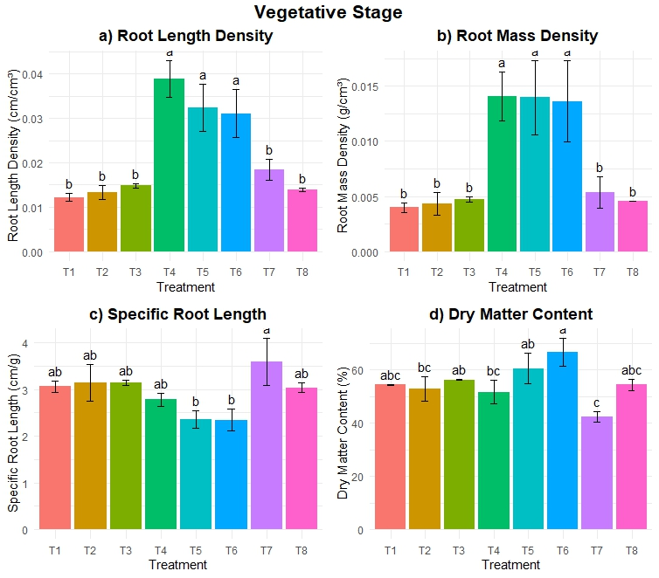

Results
The study examined various root characteristics during the vegetative stage across eight treatments (T1-T8). The results are presented in Figure 1, which shows root length density, root mass density, specific root length, and dry matter content.

Root Length Density
Root length density (Fig. 1a) showed significant variations among treatments. T4 exhibited the highest root length density, significantly outperforming all other treatments. T5 and T6 also showed relatively high values, though lower than T4. Treatments T1, T2, T3, T7, and T8 had significantly lower root length densities, with no substantial differences among them.

Root Mass Density
Root mass density (Fig. 1b) followed a similar pattern to root length density. T4, T5, and T6 demonstrated the highest root mass densities, with T4 showing a slight, though not statistically significant, advantage. The remaining treatments (T1, T2, T3, T7, and T8) exhibited significantly lower root mass densities, with no notable differences among this group.

Specific Root Length
Specific root length (Fig. 1c) showed a different pattern compared to the density measurements. T7 displayed the highest specific root length, significantly higher than most other treatments. T1, T2, T3, T4, and T8 showed intermediate values, not significantly different from each other. T5 and T6 exhibited the lowest specific root lengths, significantly lower than T7 but not statistically different from the intermediate group.

Dry Matter Content
Dry matter content (Fig. 1d) varied significantly among treatments. T6 showed the highest dry matter content, followed closely by T5. These two treatments were significantly higher than most others. T1, T2, T3, T4, and T8 displayed intermediate dry matter contents, not significantly different from each other. T7 exhibited the lowest dry matter content, significantly lower than T5 and T6 but not statistically different from the intermediate group.
In summary, treatments T4, T5, and T6 generally promoted higher root length and mass densities, while T7 led to greater specific root length. Dry matter content was highest in T5 and T6. These results suggest that different treatments can significantly influence various aspects of root development and composition during the vegetative stage.

Results
The study examined various root characteristics during the flowering stage across eight treatments (T1-T8). Figure 1 presents the results for root length density, root mass density, specific root length, and dry matter content.

Root Length Density
Root length density (Fig. 1a) showed significant variations among treatments during the flowering stage. T3 exhibited the highest root length density, significantly outperforming most other treatments. T4 also showed relatively high values, though lower than T3 and not statistically different from some other treatments. Treatments T1, T2, T5, T6, and T8 had significantly lower root length densities compared to T3, with no substantial differences among them. T7 showed an intermediate value, not significantly different from either the highest or lowest groups.

Root Mass Density
Root mass density (Fig. 1b) displayed a pattern similar to root length density, but with more pronounced differences. T3 demonstrated the highest root mass density, significantly higher than all other treatments. T4 and T7 showed intermediate values, lower than T3 but higher than the remaining treatments. T1, T2, T5, T6, and T8 exhibited the lowest root mass densities, with no notable differences among this group.

Specific Root Length
Specific root length (Fig. 1c) showed less variation among treatments compared to the density measurements. While there were some visible differences, the large error bars suggest that these differences may not be statistically significant for most treatments. T4, T5, and T6 appeared to have slightly higher specific root lengths, but the overlap in error bars with other treatments indicates that these differences may not be statistically significant.

Dry Matter Content
Dry matter content (Fig. 1d) varied significantly among treatments during the flowering stage. T3, T4, and T5 showed the highest dry matter content, significantly higher than T1 and T2. T6, T7, and T8 displayed intermediate dry matter contents, not significantly different from either the highest or lowest groups. T1 and T2 exhibited the lowest dry matter content, significantly lower than the top three treatments.
In summary, treatment T3 consistently promoted higher root length and mass densities during the flowering stage, while also maintaining high dry matter content. Specific root length showed less clear treatment effects. These results suggest that different treatments can significantly influence various aspects of root development and composition during the flowering stage, with some treatments showing more pronounced effects than others.

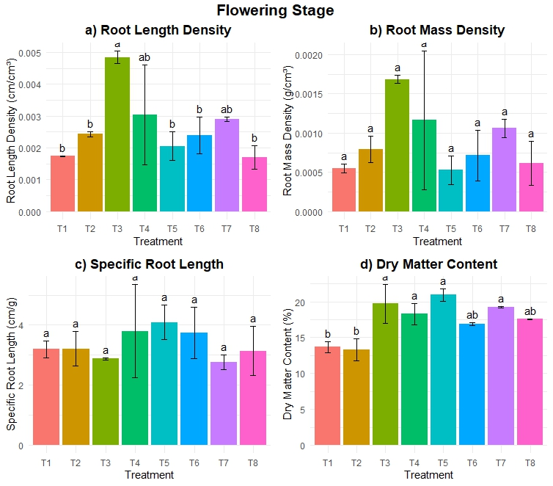
The study evaluated the impact of various treatments on soil enzyme activities, including urease, acid phosphatase, alkaline phosphatase, and dehydrogenase. Across all enzymes, treatment T1 consistently exhibited the highest activity, with significant values recorded for urease (21.76 μmole ammonia g⁻¹ h⁻¹), acid phosphatase (4.553 μg PNP g soil⁻¹ h⁻¹), alkaline phosphatase (14.167 μg PNP g soil⁻¹ h⁻¹), and dehydrogenase (3.413 μg TPF g soil⁻¹ day⁻¹). In contrast, treatment T4 showed the lowest enzyme activities across the board, indicating its lesser effect on soil biochemical properties. The results highlight that treatment T1 was the most effective in enhancing soil enzyme activities.
Treatment | Urease  (μmole ammonia g⁻ ¹ h⁻¹) | Acid  (μg PNP g soil⁻¹ h⁻¹) | Alkaline  (μg PNP g soil⁻¹ h⁻¹) | Dehydrogense  (μg TPF g soil⁻¹ day⁻¹)
T1 | 21.76 a | 4.553 a | 14.167 a | 3.413 a
T2 | 19.323 bc | 4.007 ab | 12.737 bc | 2.9 bc
T3 | 17.647 cd | 3.117 cd | 12.177 cd | 2.79 cd
T4 | 13.97 e | 2.08 e | 10.517 f | 2.293 f
T5 | 14.76 e | 2.403 e | 11.427 e | 2.537 e
T6 | 15.75 de | 2.63 de | 11.837 de | 2.617 de
T7 | 18.383 c | 3.467 bc | 12.45 c | 2.897 bc
T8 | 20.647 ab | 3.493 bc | 13.11 b | 3.077 b
CV(%) | 3.814 | 7.291 | 1.695 | 2.495
P value | p<0.001 | p<0.001 | p<0.001 | p<0.001

Anonymous 2021a. Spices statistics at a glance 2021. Directorate of Arecanut and Spices Development, Ministry of Agriculture & Farmers Welfare, Government of India, Kozhikode, Kerala, India, pp. 107.
Rajah, R. 2023. A Study on India’s Fennel Exports. International Journal of Research Publication and Reviews, Vol 4, no 6, pp 3790-3793.
Valiki, S. R. H., Ghanbari, S., Golmohammadzadeh, S., & Tat, O. F. (2015). The effect of vermicompost and npk fertilizer on yield, growth parameters and essential oil of fennel(Foeniculum vulgare). International Journal of Life Sciences, 9(4), 38–43. https://doi.org/10.3126/ijls.v9i4.12673
Diacono, M., Persiani, A., Alfano, V., Monteforte, A., & Montemurro, F. (2023). Fertilization strategies on fennel crop in the mediterranean environment: Agronomic performance, costs and sustainability assessment. Agriculture, 13(5), 1048. https://doi.org/10.3390/agriculture13051048
Sharad Sikandar Jadhav, Aniket Sunil Gaikwad, and Karape, P. J. (2023). Plant nutrition and fertilizer management in horticultural crops. Zenodo. https://doi.org/10.5281/ZENODO.8378468
Steel R G D, Torrie J H, Deekey D A. 1997. Principles and Procedures of Statistics, A Biometrical Approach. 3rd ed. McGraw Hill Book, New York, USA. pp. 400–428.

