ViT-GOA-XGB: Vision Transformation-Based Segmentation of Lung Cancer And XG-Boost Classifier
Arshad Hashmi¹
¹ Department of Information Systems, Faculty of Computing and Information Technology in Rabigh (FCITR)
King Abdulaziz University, Jeddah 21911
Saudi Arabia

Abstract- The study propose a new technique for lung cancer detection and segmentation using deep learning. Lung cancer is a common cause of death due to cancer diseases globally. Pulmonary nodules are an early stage of lung cancer which if recognized early results in better prognosis for the patient. Current diagnostic techniques are both imprecise and time consuming, which require the development of new and better techniques. The work exploits Vision Transformers (ViT) to improve the process of feature extraction from images. We use U-net in the segmentation part, and for the optimization of the segmentation, the Grasshopper Optimization Algorithm is used. Classification is done between malignant and benign nodules using the XGBoost algorithm for decision-making. The dataset, LUNA16, containing the thoracic CT scans, was employed for training and validation. The proposed model improved the performance of the metrics of accuracy, specificity, and sensitivity with values of 97.89%, 97.99%, and 96.44% respectively. This work was found to outperform other models such as WGAN and InfoGAN in both accuracy and AUC. Applying ViT for feature extraction, U-Net for enhancement of segmentation, and GOA for optimization enhanced the model’s performance. XGBoost was used to increase the classification’s accuracy. This approach has potential to enhance the performance of automated lung cancer detection. It is possible that future work will consider other architectures of deep learning to improve the performance of the proposed model.

Keywords- Deep Learning, Lung Tumor, Lung Cancer Detection, GAN-based augmentation, WGAN, VIT-GOA-XGB, InfoGAN.

I. INTRODUCTION

Lung cancer may begin in the windpipe, which is the primary airway of the lungs [1]. It occurs through unregulated proliferation and growth of specific lung cells. Individuals with respiratory disorders or emphysema have a higher risk of developing lung cancer [2]. There exist two primary types of lung cancer: non-small-cell lung carcinoma (NCLC) and small-cell lung carcinoma (SCLC) [3-4]. The later type (the small-cell malignancy) is closely associated with smoking, and its incidence is accelerating.

In contrast, the former type (the large-cell malignancy) is more prevalent and develops progressively. If these features common to both forms of lung cancer are present, then it becomes difficult for physicians to decide which form of the disease is prevailing. In 2022, the American Cancer Society estimated that 236,740 individuals were expected to be diagnosed with lung cancer and that nearly 130,180 would ultimately succumb to the disease [5]. The asymptomatic advancement of lung cancer is the primary determinant of its high fatality rate. Approximately 25% of the study population exhibited an absence of cancer indicators. It is well known that radiographic (X-ray) abnormalities in the lungs frequently accompany lung cancer. Due to the aggressiveness of lung cancer metastasis, timely detection is crucial. Recent advancements in the field of imaging, including low-dose computed tomography (CT), have enabled early detection of lung cancer [6].

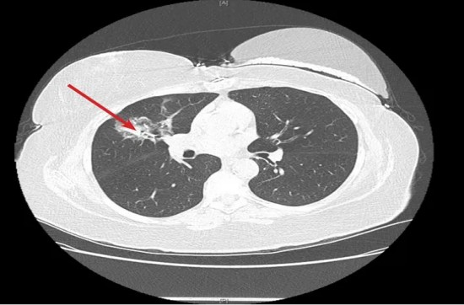
Figure 1. A Distinct Lung image [7]
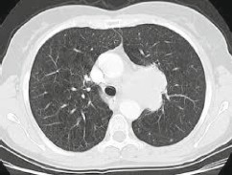
Figure 2. 2D CT imaging of a lesion in the early stages of Lung cancer [7].
Lung cancer is caused by the development of a tumor, specifically a nodule (a small, rounded lump of matter distinct from its surroundings), originating from the cells located in the air passages of the human respiratory tract. The spherical object in question consistently exhibits direct contrast in chest radiography. The timely identification of pulmonary nodules can greatly improve the likelihood of patient survival. The prompt identification highlights the challenge of detecting lung nodules through raw chest X-ray imagery. The interpretation of the resulting diagnostic images has become a repetitive and complex task, as per existing research [8,9]. The identification of a diminutive nodule from an extensive three-dimensional computed tomography (CT) scan of the lungs necessitates the utilization of a computer-aided diagnosis (CAD) system [10]. The provided illustration in Figure 1 depicts a lucid pulmonary image alongside a nascent pulmonary carcinoma nodule that is visible in a two-dimensional computed tomography scan. The utilization of artificial intelligence methods, specifically deep learning techniques, for the analysis of CT images can aid in the timely identification and assessment of pulmonary nodules. Multiple investigations have been conducted to identify lung cancer [11-15].

Regrettably, most diagnoses manifest advanced phases of the ailment, primarily attributable to the dearth of prodromal indications. Deep learning algorithms such as convolutional neural networks (CNN) and others have been utilized to construct prediction models [16-20]. Researchers have investigated deep-learning techniques to detect early-stage lung cancer tumors by analyzing histopathological images.
  - Gap in previous research work

The complex variations of lung nodules' size, shape, density, and disposition represent a great obstacle to their analysis through computational models. This variation makes it quite difficult to develop an identification and classification model that could work universally.
- Given the narrow scope of pre-trained networks, developing such models is a major challenge. Models that perform well in non-medical settings—like those trained on ImageNet—usually do not translate well to the domain of medical imagery because the properties of images and statistics of datasets they are trained on are very different [2] [3].
- Besides, most medical images, such as CT scans, are 3D in nature, which demands large computation power and memory. In some cases, it will limit the use of high level of sophistication in settings where such computational infrastructure is lacking [4] [5].
- The other major issue is the chance of overfitting, which is more with complex deep learning models and relatively small medical imaging datasets. Overfitting is a phenomenon where a model performs well beyond expectations over the training data, failing to generalize these results toward new, unseen data [6][7].
These are considered challenges but also reflective gaps toward the perfection of a model in identifying precise and reliable lung cancer. Addressing these gaps requires tailoring models to the unique nature of medical data, enhancing transfer learning techniques, optimizing computational efficiency, and devising strategies to combat overfitting, thereby improving model robustness and generalizability [7].
  - Contribution of the present research

- The proposed method uses Vision Transformers to divide the input medical images (CT scans) into patches in order to perform local and global feature extraction using self-attention mechanisms. This improves the model’s capacity to identify essential segments and differentiate between the lung nodule shapes.
- In this regard, U-Net architecture is used for pixel level lung nodule segmentation to precisely separate the nodules from other components of the lung. The U-Net design that consists of contracting and expansive paths results in better performance in spatial localization for medical image segmentation.
- GOA is incorporated to adjust the initial positions of the feature maps in order to achieve better hyperparameters in the network and to improve the segmentation of the social interaction, wind advection, and gravitational force parameters. This will make the segmentation process to be dynamic and give better results.
- After segmentation, shape, size, intensity and texture are some of the features used by XGBoost classifier in the differentiation of the lung nodule into being malignant or benign. XGBoost was selected for the experiment because it has been observed to produce accurate results within a short time especially for binary classification problems.
- Vision Transformers for feature extraction, U-Net for segmentation, GOA for optimization, and XGBoost for classification are preferable and effective in comparison with the previous methods. Combining these techniques leads to effective detection, segmentation and accurate classification of lung nodules from 3D CT scans.
- Unlike the other models, the proposed model uses an optimized threshold to segment out the nodules from non-nodule areas and generate a binary mask, thus enhancing the classification process.
The proposed model moves beyond the capability of amalgamating advanced features in existing algorithms. This, in turn, emerges as a more accurate and reliable solution for the segmentation and detailed analysis of lung nodules, one huge step in improving diagnostic procedures within pulmonary healthcare. The remaining part of this paper is structured as follows: Section 2 provides recent works related to lung cancer classification performance using deep learning techniques. In addition to this, Section 2 outlines the proposed methodology and elaborates the phases of proposed techniques. Section 3 presents the experimental results and discussions. Finally, the paper is concluded, and future work is recommended in Section 4.

2. Materials and Methods
2.1 Related Work

Medical imaging encompasses various modalities utilized to visualize the human anatomy to aid in the diagnosis, management, or therapeutic intervention of medical ailments. Multiple modalities of medical imaging, including positron emission tomography (PET/CT or simply PET), computed tomography (CT) scans (also referred to as CAT scans), X-ray, ultrasound, arthrogram, myelogram, and magnetic resonance imaging (MRI) are available for clinical use. In the case of lung carcinoma, CT is the preferred modality of diagnostic medical imaging since it is capable of detecting the presence of any abnormal growth in the pulmonary region. The abnormal proliferation has the potential to exhibit either malignant or benign characteristics. Hence, medical professionals specializing in radiology examine CT scans to ascertain the absence or presence of cancerous growths. The identification of lung cancer is of utmost significance in the medical field. Identifying lung nodules poses a significant challenge for radiologists, as there is a risk of false-negative/false-positive diagnoses. The classification of lung disease is of great significance in the realm of medical investigation. The classification of nodules in deep learning may be predicated on various factors, including but not limited to their size, location, consistency, and number.

The proposed algorithm by Bhattacharjee et al. [21] utilizes a two-fold connection-based Residual U-Net approach for segmenting lung nodules. This proposed methodology comprises various stages, including data-based augmentation, data-based normalization, input pre-processing, and utilizing the ResNet 150 U-Net dual skip connection-based approach to segment lung nodules. The data is subjected to two pre-processing processes. The introduction of multiple batch normalization layers is initially employed among conv2D and ReLU in order to accelerate the training process. Subsequently, the layer succeeding the activation function is occasionally augmented with zero-padding to prevent loss of information at the peripheries. Furthermore, using a residual U-Net architecture with an increased depth facilitates enhanced model training through a segmentation algorithm. Moreover, it effectively addresses the vanishing gradient issue in a deep neural network. The proposed methodology has yielded superior evaluation metrics and has demonstrated exceptional performance compared to both state-of-the-art techniques and the initially developed ResNet 152 U-Net model. Dutande et al. [22] suggested a DL methodology incorporating a preprocessing approach that utilizes maximum intensity representation, an ensemble approach, and two innovative DL networks. The Deep Residual Separable CNNs 1 and 2 (DRS-CNN1 and DRSCNN2) exhibited superior performance compared to the current leading U-net networks and additional segmentation networks. The study conducted by Sori et al. [23] demonstrated the efficacy of a two-path CNN in detecting the existence of lung tumors in CT scans that had undergone denoising. In an effort to improve lung cancer detection rates, various architectural approaches have been examined. The proposed DFD-Net improved upon the newly developed method for detecting lung cancer in terms of precision, specificity, and sensitivity in a research study done for the Kaggle Data Science Bowl 2017. An outline for recognizing pulmonary nodules in lung CT scans is presented by Majidpourkhoei et al. [24] along with a CNN method that can autonomously gather the characteristics from lung pictures and classify the suspicious areas as either non-nodule or nodule objects. The model under consideration is founded on the Le-Net design stylization and was formulated via a sequence of inventive phases, culminating in the creation of the lightweight model. To train and verify this method, the researchers employed a subset of the LIDC public dataset with N = 7072 CT slices of various nodule sizes (1-5 mm). The suggested framework automatically performs each stage of lung segmentation in addition to the diagnosis and classification of any nodules that are already present. Ahmed et al. [25] employed a 3D CNN classifier. The suggested CNN model consists of a fully connected layer in addition to two standard layers and two max-pooling layers. A total of one hundred (100) patients from the LUNA data set were employed, with eighty percent (80%) used for training and twenty percent (20%) for testing. On a test set of 400 photos, accuracy was at 80%. Hazrat Ali et al. [26] conducted a comprehensive analysis of 34 research studies that looked at the use of artificial intelligence techniques for imaging lung particularly using vision transformer models. We found that approaches based on visual transformers have been developed for lung cancer type classification and survival prediction. Artificial intelligence (AI) for lung cancer imaging has advanced thanks to most of the described methods. The Table 1, represents the summarized view of recent related work.

Table 1. Review of Lung cancer related research work using Deep learning techniques
Reference | Approach | Dataset | Limitation | Finding
[27] | CNN and an enhanced dial’s loading algorithm (IDLA) technique are used by DL | LUNA16 dataset | Advanced techniques can enhance accuracy. | The simulations conducted on the LUNA16 dataset demonstrate that the suggested strategy outperformed existing methods mentioned in the literature both subjectively and objectively
[21] | ResiU-Net approach | Iraq Oncology Teaching Hospital/National Center for Cancer Diseases (IQOTH/ NCCD) lung cancer CT dataset | The suggested model is limited by the fact that it can only be trained on a small amount of training data. | The proposed approach gets a 97.52% F score, a 95.02% overlap over union score, a 0.34% binary cross-entropy loss, a 94.87% dice score, and a 0.7585 combined binary focal loss and dice coefficient.
[28] | Mask-Guided Two-stream Attention Network (MGTA), a mask-guided attention system based on the DL framework, is used to forecast distant metastasis (DM). | Large-scale DM dataset. | This study data was obtained from one particular hospital. | With AUC of 0.822, a specificity of 0.743, and a sensitivity of 0.753 MGTA beats both conventional tumor-based techniques and the most advanced lung cancer diagnosis techniques.
[12] | A deep learning inception V3 model | The dataset contains 5000 photos  of each of the three  types of lung  cancer:  adenocarcinoma,  squamous  cell carcinoma, and  benign tissue. | Advanced methods can be employed to enhance precision. | The suggested model’s training accuracy was 94%, and its validation  accuracy was 95.33%.
[23] | A "denoising-first" CNN (DFD-Net) with two routes. | LUNA 16  and Kaggle Data  Science  Bowl 2017  challenge (KDSB) | Variability in the form of the nodules and the relationships between the neighboring pixels | Researchers  discovered that this kind of model makes it easy to minimize the noise in a picture, balancing the impact of the size of the field of reception, getting a better representation of features, and adapting to the different shapes and sizes of nodules.
[24] | CNN approach | Lung image  database consortium (LIDC) public dataset | Inadequate amount of labeled data from medical images. | The suggested model is flexible (fast and light) and performs well, making it suited for real-time clinical image processing.
[13] | An adaptive boosting strategy and a densely connected convolution neural network (DenseNet). | A collection of 201 lung images is used | Accuracy can be enhanced. | The proposed approach attained an accuracy of 90.85% based on experimental results.
[20] | A cascade of 3D CNNs, CAD i.e., (CADx) and (CADe) | Kaggle and LUNA16 Datasets | The LUNA16 dataset is missing big nodule annotations. | The results of the tests conducted on CADx and CADe systems suggest that a collaboration approach is necessary for developing and evaluating CADx and CADe modules to effectively utilize them as a comprehensive automated diagnostic tool for the detection of Lung cancer.
[9] | Deep Residual Separable CNN 1  and 2 | StructSeg and Medical Segmentation Decathlon (MSD) 2019 datasets | The initial seed location of the tumor necessitates manual input, while the velocity parameter needs to be configured in accordance with the tumor’s dimensions. | On several test sets, the DRS-CNN2 acquired a mean Sensitivity of 0.737, a mean 95 Hausdorff distance (HD95), a mean Dice Similarity Coefficient (DSC) of 0.649, and a mean Precision of 0.765

2.2 Description of LUNA16 dataset

The LUNA16dataset, short for Lung Nodule Analysis 2016, is a subset of the LIDC-IDRI (Lung Image Database Consortium and Image Database Resource Initiative) collection, specifically curated for the large-scale evaluation of automated pulmonary nodule detection algorithms using dataset features thoracic CT scans and expert annotations with an emphasis on early lung cancer detection. Radiologists provided these annotations, marking pulmonary nodules and assessing their malignancy likelihoods. The LUNA16 challenge, leveraging this dataset, aims to promote advancements in computer-aided diagnosis, potentially aiding early lung cancer identification. Those using the dataset for research or development are encouraged to refer to the official LUNA16 documentation for comprehensive details and are required to adhere to any associated usage terms [28]. The LUNA16 dataset, derived from the broader LIDC-IDRI collection, encompasses 888 high-resolution CT scans, specifically selected based on annotations from radiologists that harmonize in statement and opinion, thereby reaching a consensus. These CT scans were chosen to ensure automated nodule detection algorithms' consistent and standardized evaluation. Each CT scan comprises a series of slices, offering a detailed 3D view of the thoracic region. The exact dimensions of these slices can vary, but they typically conform to the standard resolutions found in the LIDC-IDRI dataset. Those interested in the precise dimensions and additional metadata are encouraged to consult the official LUNA16 documentation. [29]. The SPIE-AAPM Lung CT Challenge Dataset is a result of an initiative known as SPIE-AAPM-NCI Lung. This challenge was sponsored by the Society of Photo-Optical Instrumentation Engineers (SPIE), the American Association of Physicists in Medicine (AAPM) and the National Cancer Institute (NCI) with a dataset of thoracic CT scans with lung nodules. Every scan in the dataset is augmented with regional annotations provided by radiologists, which include measurements of size, location, and shape of lung nodules, and binary labels to indicate malignant or benign nature of the nodule. The data set was intended for the development of the computer-aided diagnosis of lung nodule detection, classification, and segmentation, and it will be useful for researchers who are engaged in the development of new methods for the early diagnosis of lung cancer based on imaging techniques. The data set was used by the participants of the challenge to build and validate. The challenge is over and the dataset is not available anymore at the site but possible to get it through contacting the people or the institutions that created it. Further details about the challenge can still be found on the AAPM website's archived page for the event: The NSCLC Radiogenomics Dataset is a large dataset of image and genomics data derived from non-small cell lung cancer (NSCLC) patients to investigate the correlation between radiomic features and molecular subtypes. This dataset combines **CT imaging data** with **genomic data** to enable identification of how certain radiomic features extracted from medical images are related to molecular phenotypes for instance gene mutations, gene expression and other genetic signatures. The dataset consists of both, clinical and genetic information along with detailed imaging scans of NSCLC patients to provide a comprehensive approach to the analysis of the disease. The authors employ the dataset to establish machine learning algorithms that can predict molecular signatures of tumours from imaging data without the need for a biopsy, which enhances the chances of accurate diagnosis and treatment. This set of data is extremely useful in radiogenomics, a field of study that seeks to develop a relationship between radiologic characteristics of tumors and molecular characteristics of lung cancer, with the hope of improving prognostication and treatment of affected patients. Data is also available through repositories like **The Cancer Imaging Archive (TCIA)** where the data is applied to enhance radiomics and precision oncology research.

2.3 Pre-processing and Segmentation

Pre-processing of the raw CT scan pictures improves their quality and, in most instances, eliminates the chaotic elements introduced by the image-collecting procedure. Additionally, very few models include pre-processing as a critical component of expanding the area limit and smoothing the noise [2]. Numerous examiners use contrast expansion, discrete wavelet changes, the Hough move, thresholding, morphological exercises, the unsharp ending procedure, smoothing, and center filtering as pre-processing techniques as depicted in Figure 3.

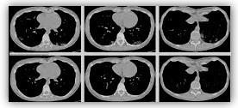
Figure 3. Pre-processing images.

2.4 Lung Nodule Segmentation Approach with Optimized Segmentation and Vision Transformers

2.4.1 Vision Transformers as a function for Image Segmentation
Vision transformers (ViTs) have rapidly transformed image processing by splitting an image into smaller sections and processing each section in its own right through the self-attention mechanism. The major strength of vision transformers is that it can identify both the local and the global dependencies in the image. Below, is the general flow of the ViT process:
- Patch Splitting: The received input image is then split into smaller regions.
- Patch Encoding: Every patch is then flattened and every patch is transformed into a fixed dimensional space with the help of embedding matrix E. Further, positional encoding E_pos is incorporated to the model to emit the position-based information.

Mathematically, the encoding can be expressed as follows:
$$\begin{matrix} & z_{0}=[x_{class};x_{p1}E;x_{p2}E;…;x_{pN}E]+E_{pos} & & \text{(1)}\end{matrix}$$
Where:
- $x_{pN}$ are flattened patches.
- $E$ is the embedding matrix
- $E_{pos}$ the positional encoding.

Subsequent to this stage, the transformer employs self-attention and feedforward neural networks for processing these patches to obtain meaningful features.

2. Improve Segmentation with Hybrid Deep Learning System

To improve the segmentation results based on the features obtained by the vision transformer, we substitute the GAN model for the segmentation with an optimized neural network model. Then, to obtain detailed boundaries of the lung nodules, we make use of U-Net. U-Net is a very popular network for medical image segmentation mainly in voxel-based applications such as the detection of lung nodules. It excels particularly at pixel level classification tasks through contracting path that captures the spatial context of the image and expansive path that provides accurate localization.
The method of binary classification uses the cross-entropy function in the training of the network to perform the task. It is stated as:
$$\begin{matrix} & L\left(θ\right)=-\frac{1}{N}\sum_{i=1}^{N}{\left[y_{i}log\left(y_{i}^{*}\right)+\left(1-y_{i}\right)log\left(1-y_{i}^{*}\right)\right]} & & \text{(2)}\end{matrix}$$
Where:
- $y_{i}$ stands of the true class label.
- $y_{i}^{*}$ captures the model's expected class probability.
- $θ$ involves the features of the stated model.

3. Optimized Segmentation via Grasshopper Optimization Algorithm (GOA)

To promote the efficiency of the segmentation, the Grasshopper Optimization Algorithm (GOA) is adopted as the search-based optimization technique for the fine-tuning of network hyperparameters and segmentation.

The movement of grasshoppers in GOA is described by the following factors; social interaction, wind advection, and gravitational force stated as:
$$\begin{matrix} & X_{i}=r_{1}S_{i}+r_{2}G_{i}+r_{3}A_{i} & & \text{(3)}\end{matrix}$$
Where:
- $X_{i}$ is the state of the $i$-th grasshopper.
- $G_{i}$ for the gravitational force, $S_{i}$ for social interaction, and $A_{i}$for the wind advection.
- $r_{1},r_{2},r_{3}$ are all random numbers and their value should be in the random number range that is [0, 1].

One can define the social interaction term $S_{i}$ as:
$$\begin{matrix} & S_{i}=\sum_{j=1}^{N}{s}\left(d_{ij}\right)\frac{d_{ij}}{∣d_{ij}∣} & & \text{(4)}\end{matrix}$$
Where $d_{ij}$ is the distance which set apart the $i$-th and $j$-th grasshopper and $s\left(r\right)$ is the strength of attraction and can be defined as:
$$\begin{matrix} & s\left(r\right)=fe^{\left(r/l\right)}-e^{-r} & & \text{(5)}\end{matrix}$$
Here, f is a constant which characterizing the strength of the attraction, and $l$ is the attractive length scale.
To simplify and use this optimization technique in nodule segmentation, the equation stated has the following simplified form;
$$\begin{matrix} & X_{i}^{d}=c\left(\sum_{j=1}^{N}{c}\left(\frac{ub_{d}-lb_{d}}{2}\right)s\left(x_{j}^{d}-x_{i}^{d}\right)\right)+T_{d} & & \text{(6)}\end{matrix}$$
Where:
- $X_{i}^{d}$ represents the optimizing location of a grasshopper.
- $lb_{d}$ and $ub_{d}$ are the lower and upper bounds of the search space.
- $T_{d}$ represents a controlling parameter.

4. Segmentation Workflow

The following are the major steps involved in segmentation;
- Transformer Processing and Patch Extraction: To extract features from the input image, it is first divided into patches employing the vision transformer.
- Segmentation Network (U-Net): To separate the nodules at the voxel level, the collected features are run through a U-Net.
- Thresholding: An objective function $O\left(τ\right)$is maximised by applying an appropriate threshold $τ$ to a probability map:
$$\begin{matrix} & τ^{*}=arg\max_{τ}O\left(τ\right) & & \text{(7)}\end{matrix}$$
- Optimization with GOA: The nature of segmentation map improves during the segmentation and the feature selection is accomplished with GOA.
- Evaluation Metrics: The output from the last segmented image is then assessed through Ratios such as; Accuracy, Precision, Recall and the F1 score.

In this way, this approach that uses vision transformers, grasshopper optimization, and U-Net segmentation produces high performance and accurate for lung nodule segmentation in medical images. Incorporation of GOA enhances the fine tuning of the segmentation thus improving the classification and feature extraction performances as indicated by the parameters of interest.When these techniques are incorporated together, this makes the approach applicable in clinics, and provides consistent and accurate results in cases of lung nodule detection and segmentation.

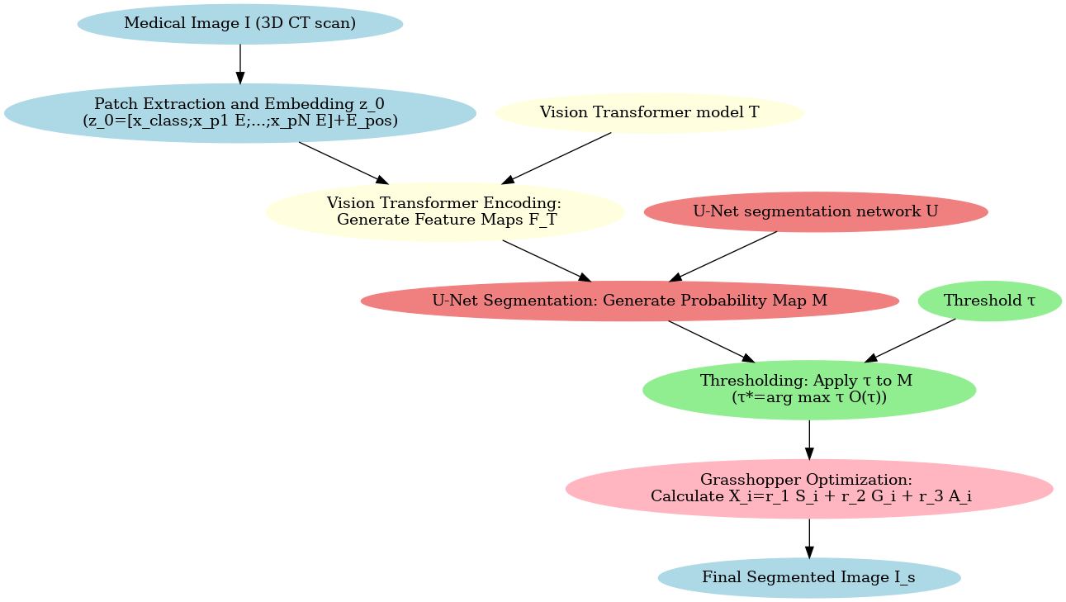
Figure 4: Lung Nodule Segmentation with Grasshopper Optimization and Vision Transformer

Algorithm 1: Lung Nodule Segmentation with Grasshopper Optimization and Vision Transformer

Algorithm 1: Lung Nodule Segmentation with Grasshopper Optimization and Vision Transformer
Input:
- Threshold $τ$
- Medical image $I$ (3D CT scan)
- U-Net segmentation network $U$
- Vision Transformer model $T$
- GOA constraints $S_{i},G_{i},A_{i}$
Output:
- Lung nodule image segmentation $I_{s}$

- Patch Extraction:
  - Partition the given image I into N local image patches P.
  - Every patch is flattened and then passed through novel positional encoding that is denoted as $E_{pos}$.
  - Produce patch-based embeddings $z_{0}$:
$$\begin{matrix} & z_{0}=[x_{class};x_{p1}E;x_{p2}E;…;x_{pN}E]+E_{pos} & & \text{(1)}\end{matrix}$$
- Vision Transformer Encoding:
  - Apply the vision transformer model T to each of the patch embedding $z_{0}$ and obtain the feature maps $F_{T}$.
- U-Net Segmentation:
  - The feature maps $F_{T}$ are then feed to the U-Net $U$ to perform voxel level segmentation to generate a probability map $M$.
- Thresholding:
  - The threshold $τ$ is applied to the probability map $M$:
$$\begin{matrix} & τ^{*}=arg\max_{τ}O\left(τ\right) & & \text{(2)}\end{matrix}$$
  - Derive a binary mask $M_{b}$ from the threshold value of $τ$ defined in equation.
- Grasshopper Optimization Algorithm (GOA) for Fine-Tuning:
  - For each grasshopper $i$:
    - Determine the position $X_{i}$ with the help of gravitational force $G_{i}$, wind advection $A_{i}$, and social interaction $S_{i}$:
$$\begin{matrix} & X_{i}=r_{1}S_{i}+r_{2}G_{i}+r_{3}A_{i} & & \text{(3)}\end{matrix}$$
    - Update the position based on the current standard set on the performance of segmentation.
    - Apply optimised segmentation to the binary mask $M_{b}$ in order to refine it.
- Return the ultimate segmented image $I_{s}$.
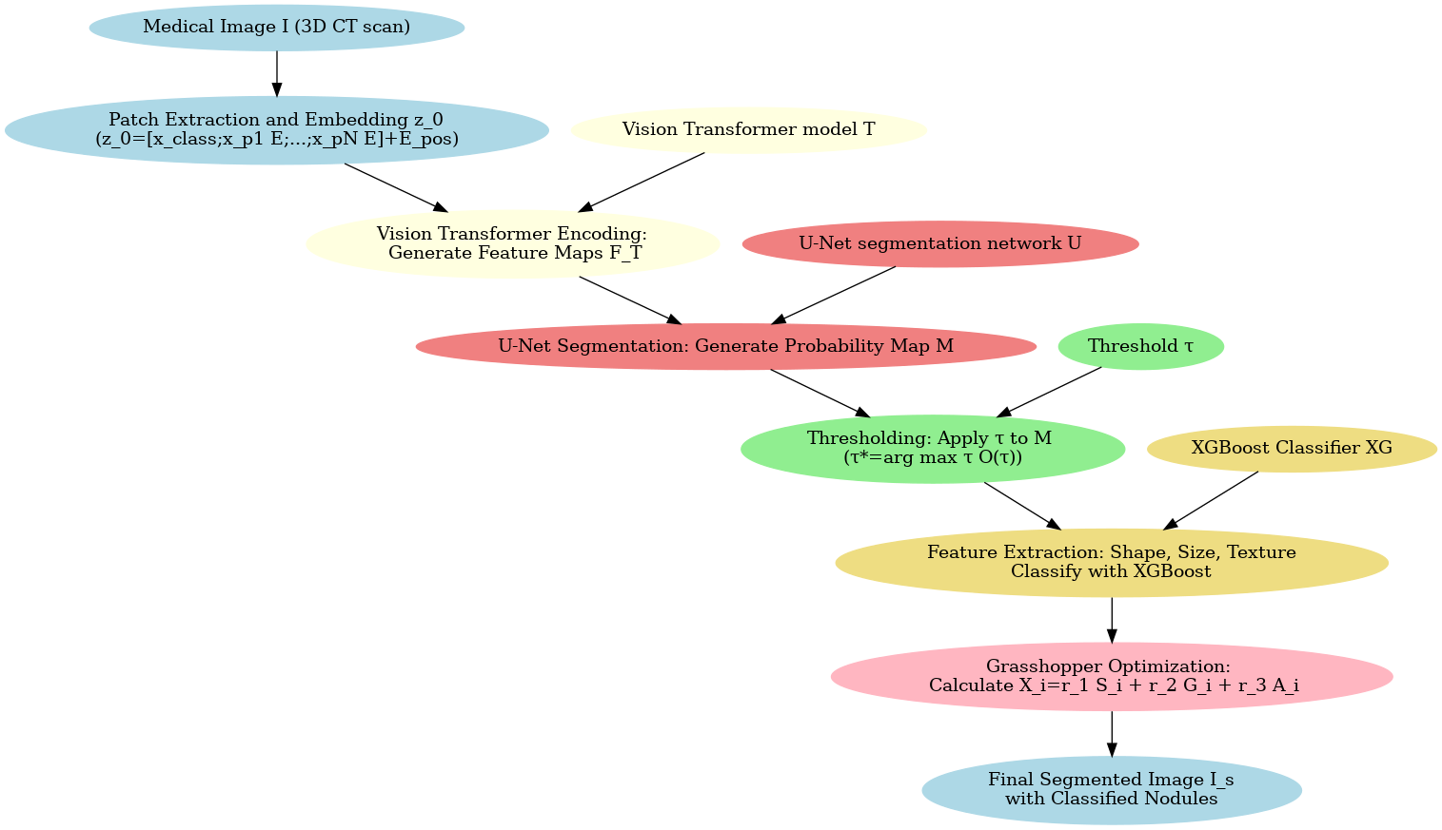
Figure 5: Lung Nodule Segmentation with XGBoost Classifier, Grasshopper Optimization, and Vision Transformer.

Algorithm 2: Lung Nodule Segmentation with XGBoost Classifier, Grasshopper Optimization, and Vision Transformer.
Input:
- Medical image $I$ (3D CT scan)
- Vision Transformer model $T$
- Threshold $τ$
- XGBoost Classifier $XG$
- U-Net segmentation network $U$
- GOA constraints $S_{i},G_{i},A_{i}$
Output:
- The segmented image of the lung nodule $I_{s}$
- The classification labels of lung nodules

- Patch Extraction:
  - Partition the given image I into N local image patches P.
  - Every patch is flattened and then passed through novel positional encoding that is denoted as $E_{pos}$.
  - Produce patch-based embeddings $z_{0}$:
$$\begin{matrix} & z_{0}=[x_{class};x_{p1}E;x_{p2}E;…;x_{pN}E]+E_{pos} & & \text{(1)}\end{matrix}$$
- Vision Transformer Encoding:
  - Apply the vision transformer model T to each of the patch embedding $z_{0}$ and obtain the feature maps $F_{T}$.

- U-Net Segmentation:
  - The feature maps $F_{T}$ are then feed to the U-Net $U$ to perform voxel level segmentation to generate a probability map $M$.

- Thresholding:
  - The threshold $τ$ is applied to the probability map $M$:
$$\begin{matrix} & τ^{*}=arg\max_{τ}O\left(τ\right) & & \text{(2)}\end{matrix}$$
  - Derive a binary mask $M_{b}$ from the threshold value of $τ$ defined in equation.

- Feature Extraction for Classification:
  - Extract the features defined by the binary segmentation mask $M_{b}$for each of the detected nodule.
  - Calculate its shape, size, intensity and texture for facilitating the classification process.

- XGBoost Classifier for Nodule Classification:
  - Train the XGBoost classifier XG on the extracted features to predict the outcomes of nodules either as malignant or benign.
  - Utilize derived predicted class label of the segmented nodules.

- Grasshopper Optimization Algorithm (GOA) for Fine-Tuning:
  - For each grasshopper $i$:
    - Determine the position $X_{i}$ with the help of gravitational force $G_{i}$, wind advection $A_{i}$, and social interaction $S_{i}$:
$$\begin{matrix} & X_{i}=r_{1}S_{i}+r_{2}G_{i}+r_{3}A_{i} & & \text{(3)}\end{matrix}$$
    - Update the position based on the current standard set on the performance of segmentation.
    - Apply optimised segmentation to the binary mask $M_{b}$ in order to refine it.

- Return the final segmented picture $I_{s}$ with classified labels generated by XGBoost.

The algorithms merge the XGBoost classification function, vision transformer for patch-based segmentation, as well as the Global Adaptive Optimizer (GOA). Basing on the above outlined steps, segmentation and feature extraction of lung nodules as well as their classification are improved.In this method, we propose a technique of how to segment and classify lung nodules from 3D medical images including CT scans using U-Net for voxel-level segmentation, XGBoost (XGB) for classification, Vision Transformer (ViT) for feature extraction, as well as the application of Grasshopper Optimization Algorithm (GOA) for the fine-tuning of the segmentation and classification. These coherent components contribute greatly to the segmentation of nodules and reliable classification of the same as malignant or benign making it a strong foundation for medical diagnosis.From the given 3D medical image $I$, the data pre-processing is done next followed by the division of some patches P and flattening of the patches. Next there is an embedding layer for positional encodings as $E_{pos}$ to bring out the spatial structure of the image. This is mathematically signified as:
$$z_{0}=\left[x_{class};x_{p1}E;x_{p2}E;…;x_{pN}E\right]+E_{pos} (4)$$
Here, $z_{0}$ means the vector representation of the patches added with the positional data. These patches are then processed by the ViT, these is where Self-attention mechanisms are utilized in order to extract both global and local features of the image. The self-attention enables the model to attend to critical areas within the image that indicates possible nodules.Following the extraction of features by the ViT, the refined feature maps are subsequently directed to a U-Net design, which undertakes voxel-level segmentation. This process of segmentation localizes likely nodule regions that we learnt from the previous steps and classifies every voxel in the given image as either nodule or background to produce a probability map M, in the following manner. To achieve binarization of the segmentation findings, a threshold τ is applied to the probability map, ensuring that areas with a similar substantial probability of being a nodule are preserved.
$$τ^{*}=arg\max_{τ}O\left(τ\right) (5)$$
Further, from the binary mask $M_{b}$ obtained after thresholding, features including, shape, size, intensity, and texture that describe the identified node are determined. These features are utilized in order to distinguish the segmented nodules into benign or malignant classes employing an XGBoost (XGB) classifier.XGB is an extremely fast and machine learning algorithm that is quite an appropriate model for binary classification tasks, wherein the aim is to segregate between different types of nodules using different features.To improve upon the performance of both the proposed segmentation and the classification steps, we use the Grasshopper Optimization Algorithm (GOA). GOA further refines the network’s structure by adjusting the placement of the feature maps in relation to social contact, wind advection factors, and the gravity attractions.
For every grasshopper $i$, the position is estimated as:
$$X_{i}=r_{1}S_{i}+r_{2}G_{i}+r_{3}A_{i} (6)$$
And here, $G_{i}$, $S_{i}$,and $A_{i}$ are the gravitational force, social interaction, and wind advection correspondingly. All of these parameters are fine tuned in a systematic manner to get better segmentation results and better classification accuracies by employing the features derived from segmented nodules.Hence, this method takes advantage of ViT for detailed image patch analysis, XGB for classification, GOA for optimization, and U-Net for segmentation. Altogether, these techniques guarantee accurate detection and segregation of lung nodules, which is why the overall method can be considered efficient for use in the medical image analysis and diagnosis. It is equally easy to extend this framework to other segmentation, and classification of other medical images or any other type of images.

III. RESULTS AND DISCUSSION

The finished-gathering models’ presentation is clear, exact, and easy, with a massive region under the bend (Area under the curve AUC). Additionally, the suggested system was evaluated using a variety of GAN designs, including DCGAN, CGAN, InfoGAN, and WGAN. The sensitivity, specificity, accuracy, and AUC values from different GAN approaches for the Inception-v4 network are as follows: sensitivity from 67 to 87 percent, specificity from 80 to 99 percent, accuracy from 76 to 94 percent, and AUC from 67 to 89 percent. The findings presented in Table 2 indicate that VIT-GOA-XGB, compared to several other techniques, has superior performance when combined with the Inception-v4 model. The VIT-GOA-XGB has favorable performance metrics, including sensitivity (96.44%), specificity (97.99%), accuracy (97.89%), and AUC (95%). The WGAN has notable performance in terms of sensitivity (87%), specificity (86.66%), and accuracy (85.33%); the InfoGAN performed well when compared to alternative approaches. Even though the InfoGAN strategy is significantly more susceptible to mistakes than the WGAN approach, VIT-GOA-XGB surpassed all GANs regarding identification, exactness, and AUC while leaving a large margin of error.

Table 2. Performance parameters inception of v4 as a classifier for differential diagnosis

TYPE | Sensitivity (%) | Specificity (%) | Accuracy (%) | AUC (%)
InfoGAN | 70.12 | 80 | 76 | 67
CGAN | 80 | 99.34 | 94.1 | 95
DCGAN | 67 | 70 | 87 | 80.23
WGAN | 87 | 86.66 | 85.33 | 89.12
ViT-GOA-XGB | 96.44 | 97.99 | 97.89 | 95
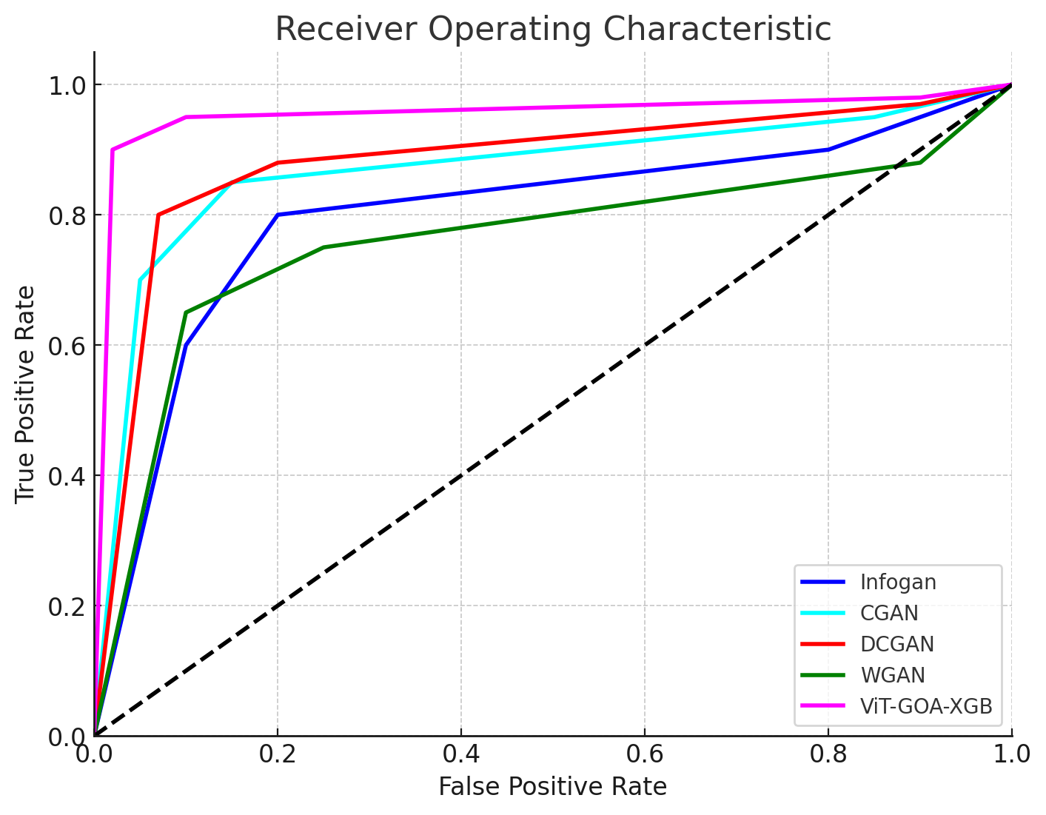
Figure 6: Comparison of proposed VIT-GOA-XGB with existing generative models
Figure 6 represents the comparative analysis of the proposed VIT-GOA-XGB and other existing generative models. The AUC value is a metric that varies between 0 and 1, with a value of 1 indicating a classifier that performs perfectly and a value of 0 indicating a classifier that performs poorly. The classifier exhibits low performance, as indicated by its AUC value 0.5. A classifier of high quality is characterized by an AUC value exceeding 0.5, and it is deemed exceptional when approaching a value of 1. The proposed VIT-GOA-XGB has a higher AUC value than existing techniques. The CGAN model achieves the second highest AUC value, with the WGAN, DCGAN, and InfoGAN models following in descending order. The InfoGAN model attained the lowest AUC value.Figure 7 presents the comparison of GAN’s performance with that of conventional classification methods. The various measures of classification performance, such as accuracy, sensitivity, specificity, Matthew correlation coefficient mean classification change, and F-score, are summarized in Table 3. The issue of data duplication due to overlapping pixel blocks is highlighted, as it contributed to the Alex net’s lower accuracy of 93.23% and increased memory usage. The pre-trained model was also optimized using the GoogleNet classifier, surpassing the VGG 16 by 91.23%. The Google Net model with restricted divergence saw a slight reduction in accuracy to 90.12%. Similarly, the VGG 16 network has substantial weights, but the GAN model, by reducing both, has significantly improved energy efficiency. This innovation has allowed the GAN model to achieve an impressive 97.89% accuracy rate with the same amount of data.
Table 3. Performance evaluation for the classification approaches in terms of Accuracy, Sensitivity, Specificity, MCC, and F 1-score
Nets | Accuracy (%) | Sensitivity (%) | Specificity (%) | MCC (%) | F1-score (%)
Alex net | 93.23 | 89.23 | 82.33 | 94.12 | 93.45
Google net | 90.12 | 88.65 | 92.69 | 92.12 | 93.45
VGG16 | 91.23 | 90.23 | 88 | 80 | 87.34
ViT-GOA-XGB | 97.89 | 96.44 | 97.99 | 95.43 | 96.33

Figure 7. Results of evaluation for GAN with existing classification approaches.
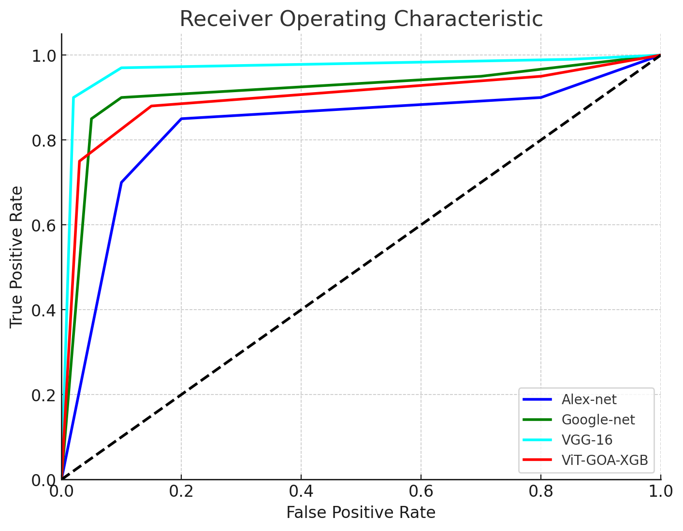
Figure 8. ROC Comparison Between Different Approaches
Figure 8 represents the ROC comparison between different approaches. The ROC curve is generated by graphing the true positive rate (TPR) about the false positive rate (FPR) across multiple threshold configurations. The proposed VIT-GOA-XGB has a higher ROC value than existing techniques. The VIT-GOA-XGB-16 model attains the second highest Receiver Operating Characteristic (ROC) value, with the subsequent models, namely Google-net and Alex-net, arranged in descending order. The Alex-net model attained the lowest ROC value.
Figure 7 illustrates the assessment of the results for GAN utilizing established classification techniques, according to the data presented in Table 3. The graph shows that the VIT-GOA-XGB exhibits superior performance in several metrics, such as Accuracy, Sensitivity, Specificity, MCC, and F1-score. Following the VIT-GOA-XGB, the Alexnet model, VGG16, and Google Net demonstrate progressively lower performance levels in the abovementioned metrics.
Table 4 presents a comparison study between the proposed technique and current models. The VISION+GAN achieved the maximum accuracy of 97.89% in 2024, followed by the SVM+CNN in 2022 with an accuracy of 94.5%. The CNN-2020S achieved an accuracy of 90.69%, while the CNN+SVM in 2021 achieved a slightly lower accuracy of 90.65%. The CNN models from 2020 and 2019 achieved accuracies of 85.8% and 85.2%, respectively. The CNN model in 2019 achieved the lowest accuracy of 69.2%.
Table 4. The comparative analysis of the proposed method with the existing models
Reference | Model | Year | Accuracy
[30] | CNN | 2019 | 69.2
[31] | CNN | 2019 | 85.2
[32] | CNN | 2020 | 90.69
[33] | CNN | 2020 | 85.8
[29] | CNN+SVM | 2021 | 90.65
[34] | SVM+CNN | 2022 | 94.5
Proposed | ViT-GOA-XGB | 2024 | 97.89

Figure 9. Annual evaluation of model performance
Figure 9 illustrates the yearly assessment of model performance, as derived from the data presented in Table 4. The graph reveals that VISION+GAN attained the highest level of accuracy in 2024, while the CNN (2019) model had the lowest accuracy among all models.

Table 5. The comparative analysis of different approaches using different datasets.

Approach | Dataset | Segmentation (IoU) | Segmentation (mAP) | Classification (Accuracy)
ViT-GOA-XGB | LUNA16 | 0.82 | 0.89 | 0.92
 | SPIE-AAPM Lung CT | 0.78 | 0.85 | 0.90
 | NSCLC Radiogenomics | 0.80 | 0.87 | 0.91
U-Net + CNN | LUNA16 | 0.75 | 0.83 | 0.88
 | SPIE-AAPM Lung CT | 0.72 | 0.81 | 0.86
 | NSCLC Radiogenomics | 0.74 | 0.82 | 0.87
3D CNN | LUNA16 | 0.77 | 0.84 | 0.89
 | SPIE-AAPM Lung CT | 0.73 | 0.80 | 0.87
 | NSCLC Radiogenomics | 0.75 | 0.83 | 0.88
FCN (Fully Convolutional) | LUNA16 | 0.70 | 0.78 | 0.85
 | SPIE-AAPM Lung CT | 0.68 | 0.75 | 0.83
 | NSCLC Radiogenomics | 0.69 | 0.77 | 0.84
ResNet + U-Net | LUNA16 | 0.79 | 0.86 | 0.90
 | SPIE-AAPM Lung CT | 0.76 | 0.84 | 0.88
 | NSCLC Radiogenomics | 0.78 | 0.85 | 0.89
DenseNet + U-Net | LUNA16 | 0.80 | 0.87 | 0.91
 | SPIE-AAPM Lung CT | 0.77 | 0.84 | 0.89
 | NSCLC Radiogenomics | 0.79 | 0.86 | 0.90

Table 5 shows a comparative analysis of various methodologies utilizing three distinct types of datasets. The data presented in the table indicates that the ViT-GOA-XGB approach has demonstrated notable performance improvements in Segmentation (IoU), Segmentation (mAP), and Classification (Accuracy) relative to the other methods evaluated. In the context of the LUNA16 dataset, the ViT-GOA-XGB approach demonstrates commendable performance, achieving a Classification (Accuracy) of 0.92, a Segmentation (mAP) of 0.89, and a Segmentation (IoU) of 0.82. In the context of NSCLC Radiogenomics, the ViT-GOA-XGB approach demonstrates worthy performance, achieving a Classification Accuracy of 0.91, a Segmentation (mAP) of 0.87, and a Segmentation (IoU) of 0.80. In a similar vein, the SPIE-AAPM Lung CT ViT-GOA-XGB approach demonstrates beneficial performance, achieving a Classification (Accuracy) of 0.90, a Segmentation (mAP) of 0.85, and a Segmentation (IoU) of 0.78. Secondly, the combination of DenseNet and U-Net on the LUNA16 dataset achieved beneficial results, attaining an accuracy of 0.91, a mAP of 0.87, and an IoU of 0.80. This was closely followed by the NSCLC Radiogenomics approach, which recorded an accuracy of 0.90, a mAP of 0.86, and an IoU of 0.79. In conclusion, the results from the SPIE-AAPM Lung CT indicate that DenseNet combined with U-Net achieves an accuracy of 0.89, a mean Average Precision (mAP) of 0.84, and an Intersection over Union (IoU) of 0.77. The table indicates that the ResNet + U-Net approach achieved a commendable third place, followed by the 3D CNN, U-Net + CNN, and FCN (Fully Convolutional) methods, respectively.

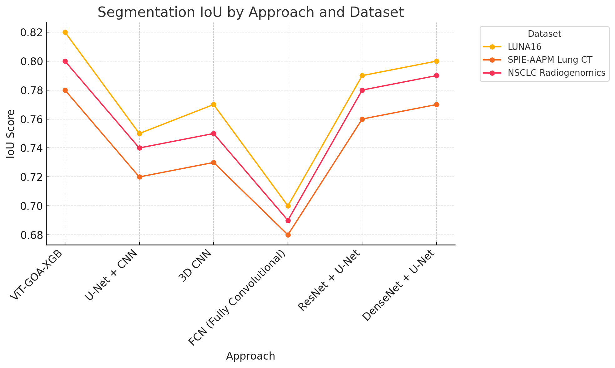

Figure 10. Comparsion of segmnetation IOU with proposed and existing approach

Figure 10 presents a comparison of segmentation IOU between the proposed approach and existing methods across the three datasets provided. The graph illustrates that the ViT-GOA-XGB approach outperforms all other aaproaches in context of LUNA16, SPIE-AAPM Lung CT, and NSCLC Radiogenomics datasets with DenseNet + U-Net and ResNet + U-Net following closely behind. In contrast, the 3D CNN, U-Net + CNN, and FCN (Fully Convolutional) methods rank lower in performance.

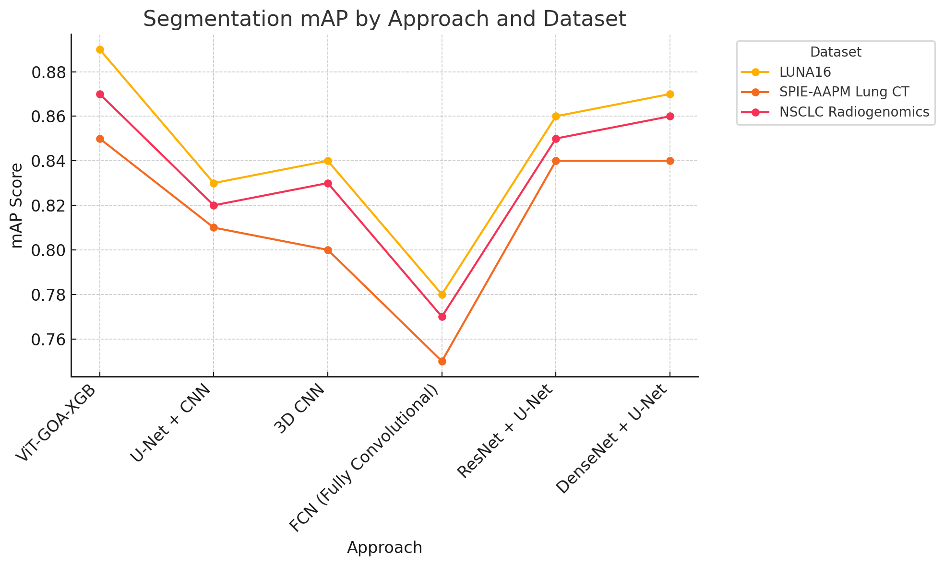

Figure 11. Comparsion of segmnetation MAP with proposed and existing approach

Figure 11 shows a comparison of segmentation MAP between the suggested and current methods on all three datasets that are available. The graph shows that the ViT-GOA-XGB method is better than all the others when it comes to the LUNA16, SPIE-AAPM Lung CT, and NSCLC Radiogenomics datasets. DenseNet + U-Net and ResNet + U-Net are very close behind. On the other hand, the 3D CNN, U-Net + CNN, and FCN (Fully Convolutional Network) methods have lower performance ranks.

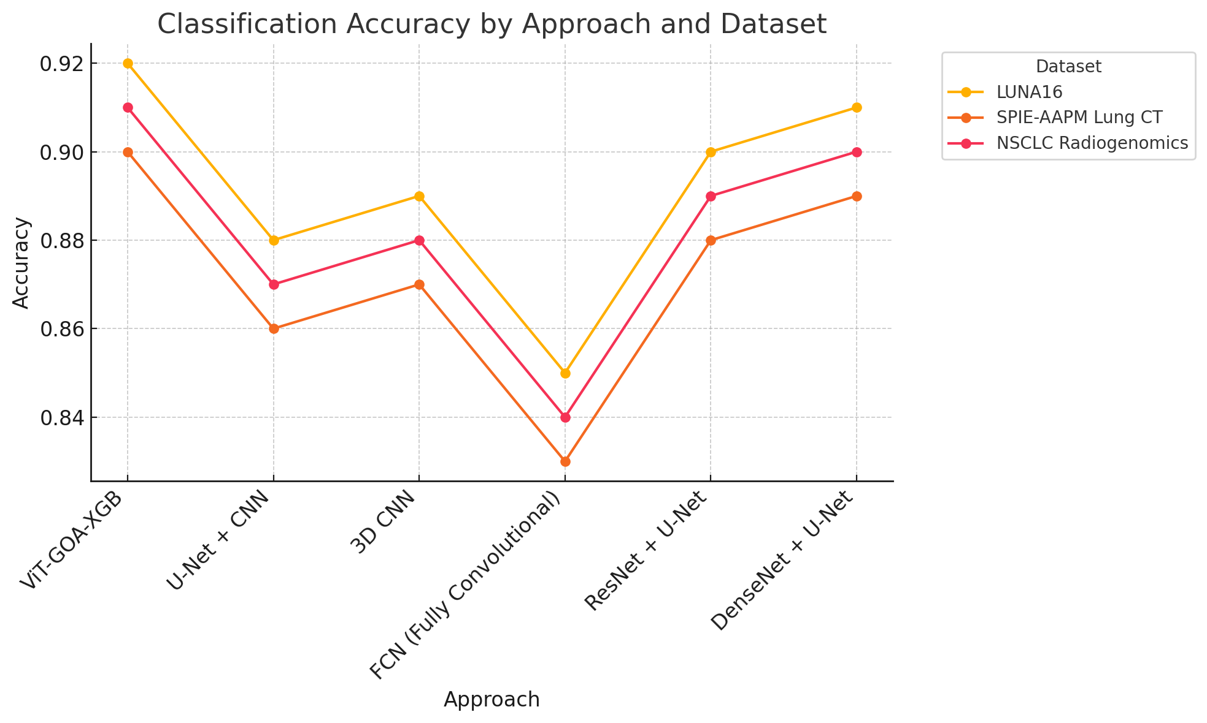

Figure 12. Comparsion of segmnetation accuracy with proposed and existing approach

Figure 12 illustrates a comparison of segmnetation accuracy between the proposed and existing approaches across the three available datasets. The graph demonstrates that the ViT-GOA-XGB method surpasses all other techniques, with DenseNet + U-Net and ResNet + U-Net trailing closely behind. Conversely, the 3D CNN, U-Net + CNN, and FCN (Fully Convolutional Network) methodologies exhibit inferior performance rankings.

The images have now been subjected to the process of image normalization, which involves changing the intensity values of the pixels to match the intensity values of pixels that are more typical. When performing the normalizing procedure, the Gaussian filter is required. Figures 13, 14, 15, and 16 display some of the example images after they have been filtered, representing the visual impact of the normalization process.

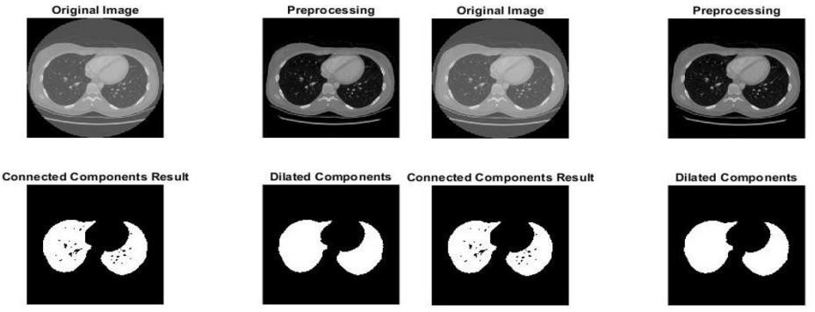
Figure 13. Sample images from the LIDC-IDRI dataset
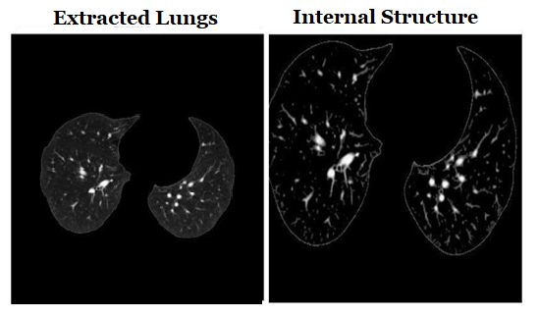
Figure 14. Extracted and Internal Structure of Lung
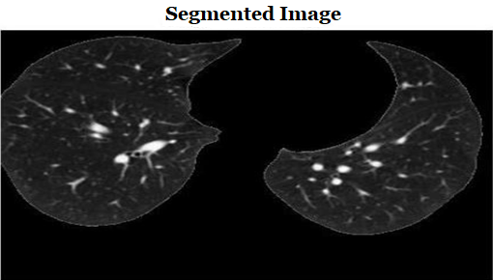
Figure 15. Segmented Images Benign
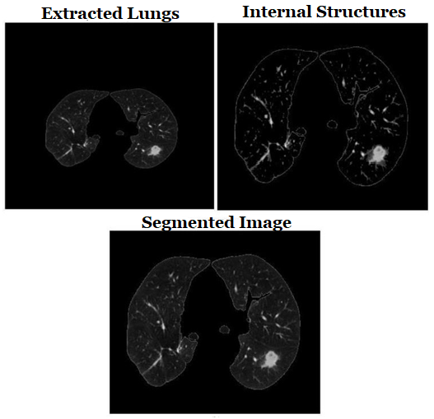
Figure 16. Segmented images Malignant

IV CONCLUSION AND FUTURE WORK

Lung cancer is still the critical issue of medical diagnostics, as it is one of the most frequent causes of death. The research has addressed the lung cancer segmentation and classification – this is one of the most complicated problems to be solved in this field, as the pulmonary nodules are characterized by numerous complicated peculiarities such as variations in shape, size, and density, as well as a need to carry out an accurate feature extraction and classify them. Thus, the use of conventional methods in these circumstances is connected with the possibilities of missing out on the required information, which leads to a low accuracy and sensitivity rates. The methodology suggested in the research implies the use of Vision Transformers (ViT), U-Net segmentation, the Grasshopper Optimization Algorithm and XGBoost, which turned out to be appropriate to solve the problem.The first challenge that had to be dealt with in the paper mainly concerned the inadequate feature extraction and pulmonary nodules. Hence, the use of Vision Transformers allowed to take into account the peculiarities of the nodule appearance, as this AI has been developed for the recognition of local and global features in the CT scans. Besides, U-Net segmentation was implemented to achieve more exact localization of nodules in the lung. Further, this process was aimed to be optimized by The Grasshopper Optimization Algorithm. Finally, the extracted features were classified into benign and malignant ones with the help of XGBoost. The final results of the experiments show that the suggested solution is much more efficient than the modern tools. Thus, the model demonstrates the highest rates in terms of sensitivity, accuracy, IoU, mAR, etc., as compared to WGAN, and InfoGAN. The overall accuracy reaches 97.89% according to the LUNA16 database. Moreover, the fact that the methodology provides appropriate purpose segmentation and classification implies that there is a high probability of not committing the errors related to false positive and false negative results. Thus, the ongoing study of the same issue will aim to expand the number of the used classification tools and their results. Also, it is possible to use larger and various databases for this purpose, as well as to concentrate on the possible use of the methodology in clinical facilities. In this regard, the use of 3D imaging analysis and transfer learning may also allow for an increase in the tool’s accuracy and computational efficiency.

