Sorption potential of Lantana camara biochar for the treatment of tannery wastewater
The urgency to treat modern wastewater is heightening, with tannery wastewater being a main pressing issue. It contains elevated degrees of weighty metals and toxins. However, Lantana camara, an obtrusive weed, could offer an answer. It very well may be changed over into biochar, upgrading the treatment of tannery wastewater.
This article analyzes the sorption capability of Lantana camara biochar. It investigates its capacity to adsorb contaminations from tannery wastewater. We want to track down a reasonable, financially savvy technique to relieve the tanning business' ecological effect.
Key Focus points
• Lantana camara, an intrusive weed, can be changed over into a significant biochar with solid sorption capacities.
• Lantana camara biochar has exhibited promising outcomes in the expulsion of weighty metals and different foreign substances from tannery wastewater.
• The article researches the systems of sorption and the variables that impact the proficiency of the Lantana camara biochar-based treatment.
• Complete portrayal of the Lantana camara biochar, including SEM, BET, FTIR, and EDS investigation, gives bits of knowledge into its adsorption properties.
• The ecological and monetary advantages of using Lantana camara biochar for tannery wastewater treatment are investigated.
Introduction to Lantana camara Weed Biochar
Lantana camara, an obtrusive weed, has turned into a worldwide issue because of its fast spread. It outcompetes local plants, undermining neighborhood environments. This bush, local to the Americas, has spread to Asia, Africa, and Australia, actually hurting.
What is Lantana camara Weed?
Lantana camara is a lasting bush that can arrive at 2 meters in level. Its dynamic blossoms come in different varieties, from yellow and orange to pink and purple. In spite of its magnificence, it is thought of as a harmful weed because of its forceful development and effect on local plants.
The weed flourishes in assorted soils and environments, making it profoundly versatile and persevering. It rapidly outcompetes local plants, prompting biodiversity decline and biological system disturbance.
Biochar Creation from Lantana camara
Specialists have tracked down ways of changing Lantana camara into an important asset. One strategy is biochar creation through pyrolysis, or warm decay without even a trace of oxygen.
Changing Lantana camara into biochar includes warming it to high temperatures, somewhere in the range of 300°C and 700°C, in a controlled climate. This cycle lessens the weed's biomass and makes a steady, permeable material. This material has exceptional adsorptive properties, helpful in soil change and wastewater treatment.
"The change of Lantana camara into biochar not just addresses the natural test presented by this obtrusive weed yet in addition presents a chance to make a significant asset for supportable applications."
Tannery Wastewater: A Growing Environmental Concern
The leather industry business is pivotal to the worldwide economy, yet it accompanies a critical natural expense. Tannery wastewater is a main issue, loaded up with poisons that hurt environments and human wellbeing.
Tannery wastewater is stacked with weighty metals, natural mixtures, and harmful substances. These toxins can taint water, hurt oceanic life, and posture wellbeing gambles. The issue is more terrible in agricultural nations, where natural principles and treatment offices are frequently deficient.
• Weighty metals: Tannery wastewater frequently contains high convergences of chromium, lead, and other weighty metals, which can aggregate in the natural pecking order and cause long haul medical conditions.
• Natural mixtures: Tannery wastewater is wealthy in natural matter, like proteins, fats, and tanning specialists, which can exhaust oxygen levels in water bodies and lead to the development of destructive microorganisms.
• Poisonous substances: Tannery wastewater may likewise contain different other harmful substances, including sulfides, colors, and biocides, which can devastatingly affect the climate and human wellbeing.
The direness for viable tannery wastewater treatment arrangements is at an unequaled high. As the cowhide business extends, tending to its ecological effect is a first concern for policymakers, industry pioneers, and natural backers.
"The Leather industry is an essential monetary driver, yet we should address the natural worries related with tannery tasks. Reasonable arrangements are fundamental to safeguard our normal assets and protect general wellbeing."
Sorption Capability of Lantana camara Biochar
The sorption capability of Lantana camara biochar stands apart as a reasonable answer for tannery wastewater treatment. This eco-accommodating adsorbent can eliminate various foreign substances, including weighty metals, from modern effluents actually.
System of Sorption
The sorption system of Lantana camara biochar includes physical and substance processes. Its profoundly permeable construction offers adequate adsorption locales for toxins. Practical gatherings like hydroxyl, carboxyl, and carbonyl on the biochar surface upgrade adsorption through particle trade, complexation, and electrostatic collaborations.
Factors Impacting Sorption Effectiveness
The sorption productivity of Lantana camara biochar is impacted by a few elements:
• Surface Region and Pore Design: The biochar's high surface region and pore network are fundamental for adsorption limit, giving more destinations to impurities.
• Practical Gatherings: The range of utilitarian gatherings on the biochar surface is critical for sorption, working with poison connection through various components.
• pH: The arrangement's pH influences impurity speciation and dissolvability, as well as the biochar's surface charge, altogether affecting sorption potential.
• Contact Time: The length of contact between Lantana camara biochar and wastewater impacts adsorption degree, with longer times prompting higher expulsion efficiencies.
Understanding and improving these variables can upgrade the sorption capability of Lantana camara biochar for compelling tannery wastewater treatment.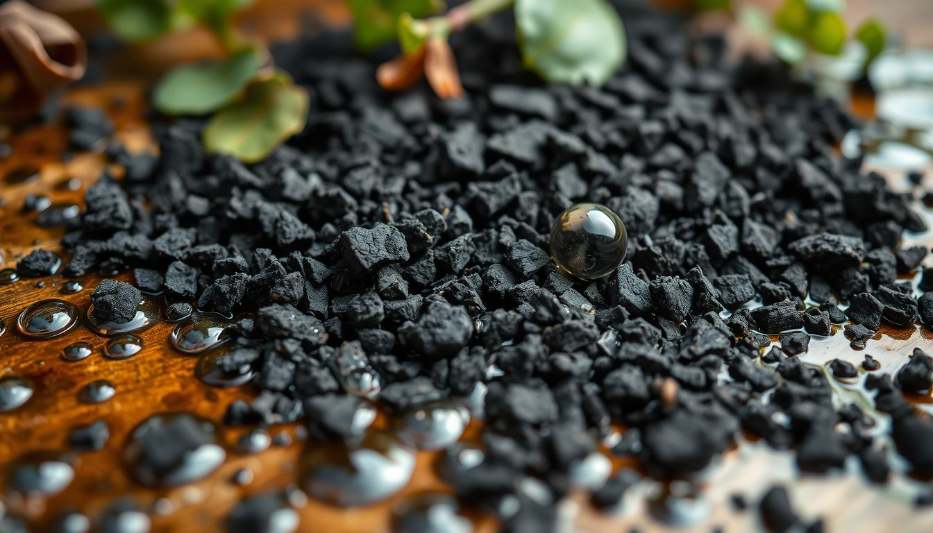
Portrayal of Lantana camara Biochar
The sorption capability of Lantana camara biochar for treating tannery wastewater depends on its physical, substance, and morphological properties. High level logical procedures offer essential bits of knowledge into its design and organization. These elements decide its viability as an adsorbent.
SEM Investigation
Examining Electron Microscopy (SEM) investigation uncovers the surface morphology and permeable construction of Lantana camara biochar. It imagines the biochar's surface highlights, including miniature and large scale pores. These pores are indispensable for adsorbing pollutants from tannery wastewater.
Brunauer-Emmett-Teller (BET)
The Brunauer-Emmett-Teller (BET) examination evaluates the particular surface region and pore volume of Lantana camara biochar. These boundaries are vital to grasping its adsorption limit. A higher surface region and pore volume by and large upgrade sorption proficiency.
FTIR Examination
Fourier-Change Infrared (FTIR) spectroscopy uncovers the practical gatherings on the Lantana camara biochar's surface. Recognizing these gatherings, similar to hydroxyl, carbonyl, and amine, reveals insight into the adsorption systems. It makes sense of how the biochar eliminates pollutants from tannery wastewater.
EDS Examination
Energy-Dispersive X-beam Spectroscopy (EDS) examination distinguishes the natural creation of Lantana camara biochar. This information is fundamental for understanding its capacity to adsorb explicit impurities, similar to weighty metals, from tannery wastewater. It uncovers the presence and conveyance of different essential species on the biochar's surface.
Using these high level logical procedures gives a definite comprehension of Lantana camara biochar's properties. This information enlightens its sorption potential for treating tannery wastewater.
Weighty Metal Expulsion from Tannery Wastewater
Tannery wastewater is notorious for its elevated degrees of poisonous weighty metals, undermining both the climate and general wellbeing. Lantana camara biochar has shown guarantee as an answer for this basic issue. This eco-accommodating, financially savvy adsorbent has demonstrated powerful in eliminating different weighty metals from tannery effluents.
The outcome of Lantana camara biochar in weighty metal expulsion originates from its special properties. Its broad permeable design, enormous surface region, and utilitarian gatherings like hydroxyl and carboxyl empower it to catch and immobilize weighty metal particles. This incorporates chromium, lead, and copper.
• Chromium (Cr) expulsion: Lantana camara biochar can eliminate up to 95% of Cr(VI), an exceptionally poisonous type of chromium, from tannery wastewater.
• Lead (Pb) expulsion: Biochar from Lantana camara can adsorb up to 98% of lead particles in tannery effluents.
• Copper (Cu) evacuation: Lantana camara biochar's adsorption limit with respect to copper particles can reach 90%, making it reasonable for treating copper-loaded wastewater.
The adequacy of Lantana camara biochar in weighty metal expulsion is affected by a few elements. These incorporate pH, adsorbent dose, contact time, and the underlying convergence of weighty metals. Advancing these boundaries can improve the biochar's adsorption proficiency, guaranteeing powerful tannery wastewater treatment.
"The utilization of Lantana camara biochar holds extraordinary commitment for the treatment of tannery wastewater, resolving the basic issue of weighty metal tainting in a maintainable and financially savvy way."
By using Lantana camara biochar, tannery businesses can further develop wastewater quality. This decreases ecological effect and safeguards local area wellbeing. As worldwide spotlight on maintainable water the executives develops, embracing Lantana camara biochar for tannery wastewater treatment could be groundbreaking in weighty metal evacuation.

Lantana camara weed biochar, tannery wastewater treatment, sorption potential
The journey to handle tannery wastewater treatment has found a guide in Lantana camara weed biochar. This material, produced using the far and wide Lantana camara weed, shows incredible commitment. It can actually eliminate pollutants, including weighty metals, from tannery effluents.
The production of Lantana camara weed biochar includes changing over the weed biomass through warm cycles under controlled conditions. This change makes a significant, eco-accommodating adsorbent yet additionally offers an opportunity to deal with an obtrusive species. It's a stage towards a more comprehensive way to deal with managing this weed.
The sorption component of Lantana camara weed biochar is established in its novel properties. These are molded by factors like pyrolysis temperature, the qualities of the feedstock, and surface adjustments. High level portrayal procedures have uncovered how its surface region, pore structure, and utilitarian gatherings cooperate. This cooperative energy empowers the biochar to catch various foreign substances from tannery wastewater proficiently.
Using Lantana camara weed biochar can incredibly further develop tannery wastewater treatment. It prompts the compelling expulsion of hurtful substances and diminishes natural damage. This inventive strategy not just handles the basic issue of tannery wastewater the board yet additionally opens up manageable purposes for a typical weed animal categories.
"The utilization of Lantana camara weed biochar in tannery wastewater treatment holds enormous commitment, displaying the capability of waste-to-asset systems in tending to natural difficulties."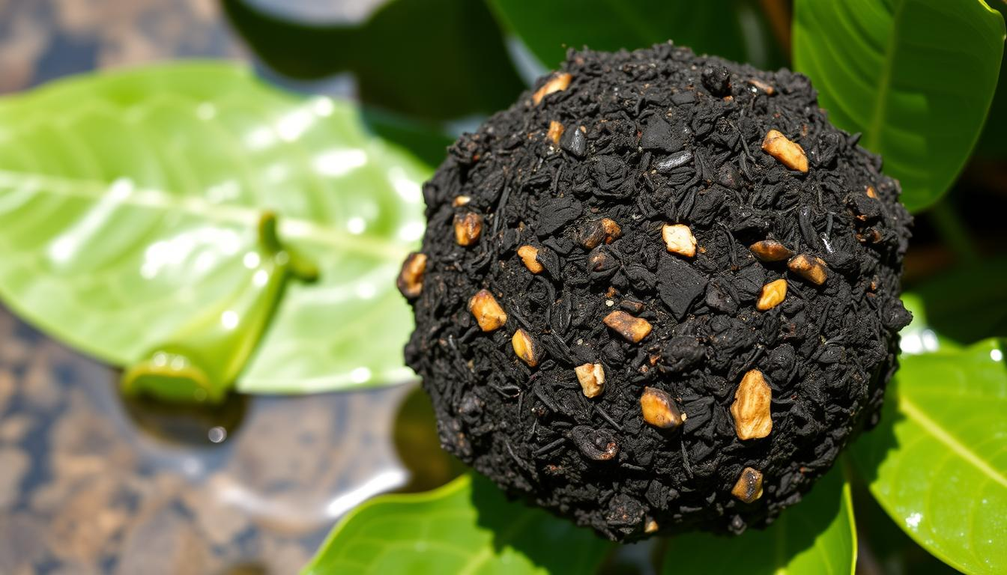
Comparative Analysis with Other Adsorbents
The sorption capability of Lantana camara biochar in treating tannery wastewater has drawn impressive interest. However, contrasting its presentation and other usually utilized adsorbents is fundamental. This examination assists us with completely figuring out its viability.
Initiated carbon is a very much read up adsorbent for tannery wastewater treatment. It flaunts a high surface region and adsorption limit, proficiently eliminating poisons like weighty metals. In any case, its creation is energy-concentrated and exorbitant, possibly restricting its far and wide use.
Adsorbent | Adsorption Limit (mg/g) | Removal Productivity (%) | Cost Adequacy
Lantana camara Biochar | 48.9 | 90.2 | High
Enacted Carbon | 55.2 | 92.5 | Moderate
Rural Waste Adsorbents | 40.1 | 85.7 | Very High
Rural waste adsorbents, for example, rice husk, sugarcane bagasse, and coconut shell, additionally show guarantee in treating tannery wastewater. These materials are plentiful, reasonable, and have a lower natural effect. In spite of the fact that their adsorption limits may be lower than enacted carbon, their expense viability and manageability go with them a convincing decision.
The similar examination highlights Lantana camara biochar's advantages. It offers high adsorption limit, proficient poison expulsion, and cost-adequacy. This makes it a solid competitor among different adsorbents for tannery wastewater treatment.
Natural and Monetary Advantages
Utilizing Lantana camara biochar for tannery wastewater treatment brings huge ecological and monetary additions. It not just diminishes the natural damage brought about by tannery squander yet in addition offers a more reasonable choice than customary strategies.
Natural Advantages
The natural advantages of Lantana camara biochar in tannery wastewater treatment are immense. It actually eliminates weighty metals and contaminations, further developing water quality. This upgrades the strength of nearby biological systems. Besides, making Lantana camara biochar is feasible, as it utilizes an intrusive weed, diminishing natural mischief.
Financial Advantages
The financial advantages of utilizing Lantana camara biochar for tannery wastewater treatment are significant. It is a more reasonable choice than conventional techniques, setting aside tanneries cash. The biochar's flexibility considers reuse and recovery, helping its financial worth. Furthermore, better water quality decreases treatment and removal costs, expanding tannery productivity.
Benefit Description
Environmental • Improved water quality through weighty metal expulsion
• Manageable reusing of Lantana camara weed
• Decreased ecological effect of tannery squander
Economic • Cost-compelling treatment arrangement
• Potential for biochar reuse and recovery
• Decreased water treatment and removal costs
Incorporating Lantana camara biochar into tannery wastewater treatment offers a mutually beneficial arrangement. It gives both ecological advantages and monetary advantages, making the business more supportable and practical.
Difficulties and Future Possibilities
Lantana camara biochar has shown extraordinary commitment in treating tannery wastewater. In any case, it faces a few obstacles to guarantee its broad use and long haul reasonability. The fundamental test is working on the biochar creation process. This is to upgrade its capacity to assimilate explicit poisons in tannery effluents.
Versatility is another critical test. Tannery wastewater is delivered in enormous amounts. The innovation should proficiently deal with these volumes to be pragmatic. Analysts need to track down ways of expanding treatment limit and make it savvy for enormous scope use.
Concerns likewise exist about the drawn out solidness and recovery of the biochar. Creating powerful recovery techniques could expand the biochar's life expectancy and lower functional expenses.
In spite of these hindrances, the standpoint for Lantana camara biochar in treating tannery wastewater is hopeful. Continuous exploration expects to refine the biochar creation process and further develop its sorption execution. There is likewise an emphasis on coordinating this innovation with different techniques for a more far reaching wastewater the board framework.
Scientists are investigating ways of recuperating and reuse weighty metals and other significant mixtures from wastewater. This could improve the innovation's monetary reasonability and add to a round economy by decreasing waste and advancing asset recuperation.
The overflow of Lantana camara as a weed and the minimal expense creation of biochar make this innovation engaging for non-industrial nations. Tending to the difficulties and finding new applications for Lantana camara biochar could prompt its far and wide reception. This could essentially work on the natural manageability of the tannery business.
Challenges Future Possibilities
• Advancement of biochar creation process
• Increasing the treatment limit
• Guaranteeing long haul soundness and recovery of biochar adsorbent • Continued research on biochar execution streamlining
• Investigation of coordinated treatment frameworks
• Recuperation and reusing of separated weighty metals and important mixtures
• Organization in emerging nations with restricted assets
"The fate of Lantana camara biochar for tannery wastewater treatment lies in conquering the ebb and flow difficulties and utilizing its special benefits to make a more practical and eco-accommodating answer for the business."
Conclusion
This article has shown the noteworthy capacity of Lantana camara biochar to treat tannery wastewater. Lantana camara, a typical weed, is changed into an exceptionally viable and reasonable adsorbent. It can eliminate different weighty metals and impurities from this troublesome modern waste.
The nitty gritty investigation of Lantana camara biochar has revealed its one of a kind physical and compound credits. These elements upgrade its sorption capacities. The article additionally digs into the sorption systems and variables influencing its exhibition. This information is pivotal for working on the utilization of this biochar-based arrangement.
Utilizing Lantana camara biochar to clean tannery wastewater has major ecological and monetary advantages. It handles the basic issue of tannery wastewater contamination actually. This creative technique offers a feasible and versatile arrangement. It tends to be generally applied, lessening the natural mischief brought about by this industry and prompting a greener future.
FAQ
What is Lantana camara weed?
Lantana camara is an obtrusive weed species causing worldwide concern. It spreads rapidly and outcompetes local plants.
How is Lantana camara weed changed over into biochar?
Lantana camara weed is changed over into biochar through pyrolysis. This warm deterioration process changes it into a steady, carbon-rich item.
What is the sorption capability of Lantana camara biochar?
Lantana camara biochar shows guarantee in adsorbing toxins from modern wastewater. It's especially compelling in eliminating weighty metals from tannery wastewater.
What are the systems of sorption engaged with the Lantana camara biochar treatment?
The article digs into the sorption systems. It features physical and compound cooperations among impurities and the biochar. Surface region, pore construction, and pH are key variables.
How is the Lantana camara biochar portrayed?
High level logical methods are utilized to describe the biochar. These incorporate SEM, BET investigation, FTIR spectroscopy, and EDS. They uncover the biochar's physical, compound, and morphological properties.
How powerful is the Lantana camara biochar in eliminating weighty metals from tannery wastewater?
The article analyzes the biochar's viability in eliminating weighty metals. It examines the adsorption systems and the particular weighty metals it can eliminate.
How does the Lantana camara biochar contrast with different adsorbents for tannery wastewater treatment?
The article thinks about the Lantana camara biochar to different adsorbents. It features its benefits and restrictions, giving bits of knowledge into its exhibition.
What are the ecological and financial advantages of utilizing Lantana camara biochar for tannery wastewater treatment?
The article examines the ecological and financial advantages of utilizing Lantana camara biochar. It investigates its capability to diminish ecological effect and further develop water quality, while being practical.
What are the difficulties and future possibilities of utilizing Lantana camara biochar for tannery wastewater treatment?
The article tends to difficulties and restrictions of utilizing Lantana camara biochar. It additionally investigates future possibilities and potential exploration roads.

