

AI-BASED MONITORING, MODELLING, AND CONTROL OF STRAY ANIMALS
A PROJECT REPORT

Submitted by
Suraj Patil (21 BAI10038)
Sannidhya Srivastava (21BAI10308)
Sakshi Sawarkar (21BAI10333)
Aviral Asthana (21 BAI10389)
Eeman Majumdar (21BAI10406)

in partial fulfilment for the award of the degree
of

BACHELOR OF TECHNOLOGY

In

COMPUTER SCIENCE ENGINEERING WITH SPECIALISATION IN ARTIFICIAL INTELLIGENCE AND MACHINE LEARNING

SCHOOL OF COMPUTING SCIENCE AND ENGINEERING
VIT BHOPAL UNIVERSITY
KOTHRI KALAN, SEHORE
MADHYA PRADESH - 466114

OCTOBER 2022

VIT BHOPAL UNIVERSITY, KOTHRI KALAN, SEHORE,MADHYA PRADESH – 466114

BONAFIDE CERTIFICATE

Certified that this project report titled “AI-BASED MONITORING, MODELLING, AND CONTROL OF STRAY ANIMALS'' is the bonafide work of “Suraj Patil (21BAI10038), Sannidhya Shrivastava (21BAI10309), Sakshi Sawarkar (21BAI10333), Aviral Asthana (21BAI10389), Eeman Majumdar (21BAI10406)” who carried out the project work under my supervision. Certified further that to the best of my knowledge the work reported at this time does not form part of any other project/research work based on which a degree or award was conferred on an earlier occasion on this or any other candidate.

PROGRAM CHAIR PROJECT GUIDE
Suthir S Suthir S, Program Chair
School of Computer Science and Engineering School of Computer Science and Engineering
VIT BHOPAL UNIVERSITY VIT BHOPAL UNIVERSITY

The Project Exhibition I Examination is held on 02-09-2022.

ACKNOWLEDGEMENT

First and foremost I would like to thank the Lord Almighty for His presence and immense blessings throughout the project work.
I wish to express my heartfelt gratitude to Dr. AVR Mayuri, Head of the Department, School of Computer Science and Engineering for much of her valuable support and encouragement in carrying out this work.
I would like to thank my internal guide Mr. S Suthir, for continually guiding and actively participating in my project, giving valuable suggestions to complete the project work.
I would like to thank all the technical and teaching staff of the School of Computer Science Engineering, who extended directly or indirectly all support.
Last, but not least, I am deeply indebted to my parents who have been the greatest support while I worked day and night for the project to make it a success.

LIST OF ABBREVIATIONS

YOLO (You Look Only Once) - employs Convolutional Neural Networks (CNN) to detect objects in real time
Agglomeration - a mass or collection of things
Explicitly - showing full detail
CNN- Convocational Neural Network

ABSTRACT

The purpose of this paper is to protect stray animals and reduce the social problems they cause through mobile devices. We wrote an app on the mobile device to explicitly identify the dog . The system combined with the backend repository and placed the GPS to show the geographic location of the animal. Through this app, users can know where the stray animals are, which type, and what kind of assistance is needed. At the same time, if the user finds that there are stray animals in his location, but the APP does not display. The user can identify the animals through the system and upload the location, and other issues to the database. In the part of the observation, we used You Look Only Once (Yolo)V7 to train and put the training module into the system for the identification of stray animals with a precision of 95%. The system can reduce the problems caused by stray animals to increase the willingness of people to adopt stray animals and let shelters reduce the cost of dealing with stray animals.

TABLE OF CONTENTS
CHAPTER NO. | TITLE | PAGE NO.
 | List of Abbreviations  Abstract | iv  v
1 | CHAPTER 1:  PROJECT DESCRIPTION AND OUTLINE  1.1 Introduction  1.2 Motivation for the work  1.3 [About Introduction to the project  including techniques]  1.5 Problem Statement  1.6 Objective of the work  1.7 Organisation of the project  1.8 Summary | 9 - 11
2 | CHAPTER 2:  RELATED WORK INVESTIGATION  2.1 Introduction  2.2 <Core area of the project>  2.3 Existing Approaches/Methods  2.3.1 Approaches/Methods -1  2.3.2 Approaches/Methods -2  2.3.3 Approaches/Methods -3  2.4 <Pros and cons of the stated Approaches/Methods >  2.5 Issues/observations from investigation  2.6 Summary | 12 - 15
3 | CHAPTER 3:  REQUIREMENT ARTEFACTS  3.1 Introduction  3.2 Hardware and Software requirements  3.3 Specific Project requirements  3.3.1 Data requirement  3.3.2 Functions requirement  3.3.3 Performance and security requirement  3.3.4 Look and Feel Requirements  3.4 Summary | 16
4 | CHAPTER 4:  DESIGN METHODOLOGY AND ITS NOVELTY  4.1 Methodology and goal  4.2 Functional modules design and analysis  4.3 Software Architectural designs  4.4 Subsystem services  4.5 User Interface designs  4.6 Summary | `
5 | CHAPTER 5:  TECHNICAL IMPLEMENTATION & ANALYSIS  5.1 Outline  5.2 Technical coding and code solution  5.3 Prototype submission  5.4 Test and validation  5.5 Performance Analysis(Graphs/Charts)  5.6 Summary
6 | CHAPTER 6:  PROJECT OUTCOME AND CONCLUSIONS  6.1 Outline  6.2 Key implementations of the System  6.3 Limitation/Constraints of the System  6.4 Future Enhancements  6.5 Conclusion
7 | CHAPTER 7:  CONCLUSIONS AND RECOMMENDATION

CHAPTER 1
PROJECT DESCRIPTION AND OUTLINE
1. Introduction
The human-dog bond has various theories in relation to its origin, the most representative being when humans were hunter-gatherers, due to the ease with which the dogs could have food, participating in activities together with humans, such as hunting and transportation. Which leads to the link being part of the history of both species . The dogs that after the bond were separated from the humans to continue on their own, were called stray dogs. By instinct, these dogs can survive without the human bond, but without some type of education or upbringing that allows them to have good health, it can be harmful to humans, because these dogs are one of the main causes affecting public health .
Investigations show that the number of stray dogs is increasing in different locations. Such is the case of the Affinity Foundation , which in its last report in 2016, estimated that approximately 138 thousand animals, between dogs and cats, were collected in the streets of Spain. The reason why they were abandoned was 15% due to unnecessary litter, 13% because of behaviour problems, 8% due to loss of interest in the animal, and 12% for economic factors. Also, according to the Ecuador Animal Protection Foundation, in 2014 there were 600,000 pets in Quito alone, 20% of which were found abandoned, another 20% were owned, and the remaining 60% lived on the streets. That's why different authors are looking for the reason why the number of stray dogs is increasing, in order to propose solutions that allow to decrease these amounts.
Our app was among the various solutions that were proposed, which was based on the interaction between owners and people to search for a dog through reports, using a mobile application which provides either a good or bad result after a decent interval of time; this may be very useful to some owners. Furthermore, applications that use external tools to provide information regarding the location of the dog, applications that allow us, via the use of GPS, to track the location of the dog, and at the same time look for places where the dog can be found, were created. This type of GPS is very useful for those owners who can, and wish to, opt for this type of complementary device to their application. In addition, applications such as "A Mobile App Engaging Citizens and Officials in Addressing the Stray Dog Crisis" , allows for communication between citizens, responsible officials, and animal control personnel, through reports of the location and agglomeration of street dogs, to have a better mapping and, then, taking the corresponding actions against public health, which at the same time is a way of finding dogs, if the owner gets in contact with these people.
What is remarkable about these investigations is the technological contribution that allows for the identification of a dog in different ways.

1.2 Motivation for the work
It's a well known fact that India has a problem with street animals. In recent years we have seen many cases of problems caused by street animals. There have been some attempts in fixing this by our government but they have been unsuccessful. Our objective is to provide the general public with a mobile application that will allow them to report the density of dogs in their area. And this will be done through AI- Based Modelling and Monitoring.

1.3 [About Introduction to the project including techniques]
We wrote an app on the mobile device to explicitly identify the dog . The system combined with the backend repository and placed the GPS to show the geographic location of the animal. Through this app, users can know where the stray animals are, which type, and what kind of assistance is needed. At the same time, if the user finds that there are stray animals in his location, but the APP does not display. The user can identify the animals through the system and upload the location, type, and other issues to the database. In the part of the observation, we used You Look Only Once (Yolo)V7 to train and put the training module into the system for the identification of stray animals with a precision of 95%. The system can reduce the problems caused by stray animals to increase the willingness of people to adopt stray animals and let shelters reduce the cost of dealing with stray animals.
1.5 Problem Statement

1.6 Objective of the work
The population of stray dogs increases every year, which is why technologies, protocols, and legislative projects have been implemented in different countries to stop it. The objective of this research is to make use of image recognition (machine learning) to optimise the identification of stray dogs that are in a state of loss.

1.7 Organisation of the project
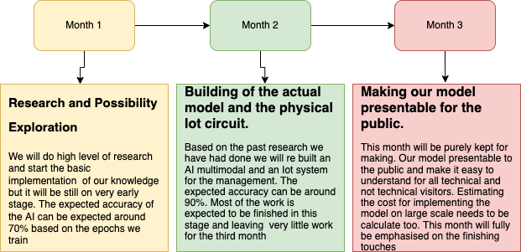

CHAPTER 2:
RELATED WORK INVESTIGATION
2.1 Introduction
A study conducted among 10 Indian metro cities investigates the impact of municipal solid waste and animal birth control programmes on stray dog population and its menaces. Its results show statistically strong and positive linkages among the variables such as human population, municipal solid waste, per capita solid waste, food waste, dog population and dogs per capita. People’s general awareness and the efforts of municipalities are inadequate to control the dog menace.
India has the largest number of strays in the world, with over 35 million. India faces about 18,000 to 20,000 reported cases of rabies every year but unreported is more than this. According to the WHO report an estimated 45 pc of all deaths from rabies occur in South- East Asia out of which about 36 pc of the world’s deaths from rabies happen in India itself. In case of rabid death in livestock which remains unnoticed, the condition is more horrible in India. Through infected cattle from rabies,the livestock owners and vets/para vets become more prone to rabies.
The incidents from rabies in India have been constant for a decade, without any obvious declining trend, and reported incidence is probably an underestimation of true incidence because in India rabies is still not a notifiable disease.
India could be fighting a lost battle against rabies, because with only 15% of all stray dogs vaccinated, a rabies-free South Asia by 2020, as is the WHO’s dream, looks far from reach. Nowadays, the population of stray dogs is increasing at break- neck speed. To stop this, the authorities should make shelters for stray dogs. There should be space for dogs, but they should not be allowed to roam freely. People should be aware about steps to be taken in case a dog tries to bite. An eye should be kept on stray dogs in the city.

2.2 Investigation
The domestic dogs are the most abundant terrestrial carnivores in the world (Young et al 2015; Vanak and Gompper 2009), almost 500 million dogs are there, and almost 75% of them are free-ranging, posing substantial threat to people as well as several wild species and livestock (Kumar and Paliwal 2015), especially the smaller and prey species. At times, it is seen that free-ranging dogs hunt smaller species even if they do not consume the hunted, perhaps an expression of their hunting instinct and behaviour. Domestic dog, Canis familiar is, one of the earliest domesticated species, could be in-house, stray or feral, progressively through a de-domestication process with potential for reversal, eminently portrayed, though much anthropomorphised, in the classic fiction The Call of the Wild by Jack London. It is projected that India’s cities and towns are home to about 30 million stray dogs and eight million people are forced to take treatment for dog bites every year. The stray dog population in India is increasing day by day. Regrettably, 30%–60% of the dog-bite victims are children under the age of 15 in countries where rabies is endemic. A study from Bhutan shows children of 5–9 years as the most common victims, reporting 2.3 times more dog bites than expected (Tenzin et al 2011). In Bengaluru, it is reported that 45% of dog bites are of slum children (David 2007). Universally, children are the most vulnerable to attacks by the dogs, and the risk of injury to the head and neck is greater in them, adding to increased severity (WHO 2013) and medical complications and deaths.
According to statistics:
- In 2018, more than 20,000 people across the country were attacked by dogs.
- In the first three months of 2019, 5,000 people were bitten by dogs and in some cases it led to a lethal outcome (death).
- Dogs belonging to special and rare breeds – these dogs are considered very valuable, they have a special regime and are carefully fed in homes and have all the necessary medical and culinary services.
- Dogs that are considered to be mass-growing and unpretentious (not requested and mostly big) – these animals partially belong to the 2nd and totally to the 3rd category we have mentioned above. All activities carried out are attributed to animals of this category.

2.3 Existing Approaches/Methods
Why removal of dogs doesn’t work ?
Most Indian civic bodies have been killing street dogs for decades, some since the last century. The concept was directly imported from the developed countries without any understanding of the very different urban conditions in the third world. In developing countries such as India, where exposed garbage and slums encourage the existence of street dogs, killing or removing street dogs has proved completely ineffective in controlling rabies or the dog population. This is because dogs removed are easily replaced
Dogs have extremely high breeding rates. According to one estimate, two dogs can multiply to over 300 (over a few generations) in three years. They are also highly territorial, with each dog having its fixed niche
Here is what happens when dogs are taken away:
- Their territories become vacant and dogs from neighbouring areas move in to occupy them
- The dogs who escape the catching squads also continue to multiply, so the territorial vacuums are soon filled again
- Dog fights increase, since every time a new dog enters a territory he is attacked by the dogs already in the neighbourhood
- Dog fights continue to take place over mating
- Dog bites also increase, as during dog fights many humans get accidentally bitten
- Rabies continues to spread to humans, since none of the dogs is vaccinated
- Rabies continues to spread because the dog-catchers are reluctant to pick up a rabid dog–so only healthy dogs get killed
As long as exposed garbage and slums continue to exist, dog-killing programmes cannot work. They only create an unstable, constantly changing, rapidly multiplying and rabies-carrying dog population
In Mumbai in the late 1980s and early 1990s, there were about 50 human rabies deaths every year in spite of a large-scale dog-killing programme. Government sources claim that over half of human rabies deaths are caused by unvaccinated pets, so the killing of street dogs had no impact on human rabies.
2.6 Summary
What do we conclude from this investigation?
From all the investigation about stray dogs and its problems, we can conclude that the current measures that are taken are not able to cope up with the problems that are caused by stray dogs. Hence we will try to solve this issue by our project.

CHAPTER 3:
Requirement Artefacts
3.1 Introduction
3.2 Hardware and Software requirements
Our Project “AI-BASED MONITORING, MODELLING, AND CONTROL OF STRAY ANIMALS” requires a basic functioning Camera, A Decent Speed Internet Connection, and a minimum of 4 Core CPU like Intel i5 5th Gen series or AMD Ryzen 5 2500U series processor clubbed along with at least 8 gigs of RAM. For Software requirements, we can use any Mobile / Compact browser like Chrome, Internet Explorer, or Microsoft Edge & Firefox.
3.3 Specific Project Requirements
3.3.1 Data Requirements
We Require a clear image for detecting any presence of Stray Dog in the Image and the IP of the user so that we can track the location of the report.
3.3.2 Functions Requirement
3.3.3 Performance and Security Requirements
Our App just needs the clarity in the image provided and a good internet connection.
3.3.4 Look and Feel Requirements
Our Web App can function in any type of device and in the smallest of the devices . It just needs a decent Internet connection and a decent type of Browser.

CHAPTER 5
TECHNICAL IMPLEMENTATION & ANALYSIS

Outline:
Our project has a minimal technical requirement as it was optimised to run on almost any device that supports the internet. The code already contains a requirements.txt file that automatically install the required technical drivers.

Technical Coding And Solutions:
First we install the imports required
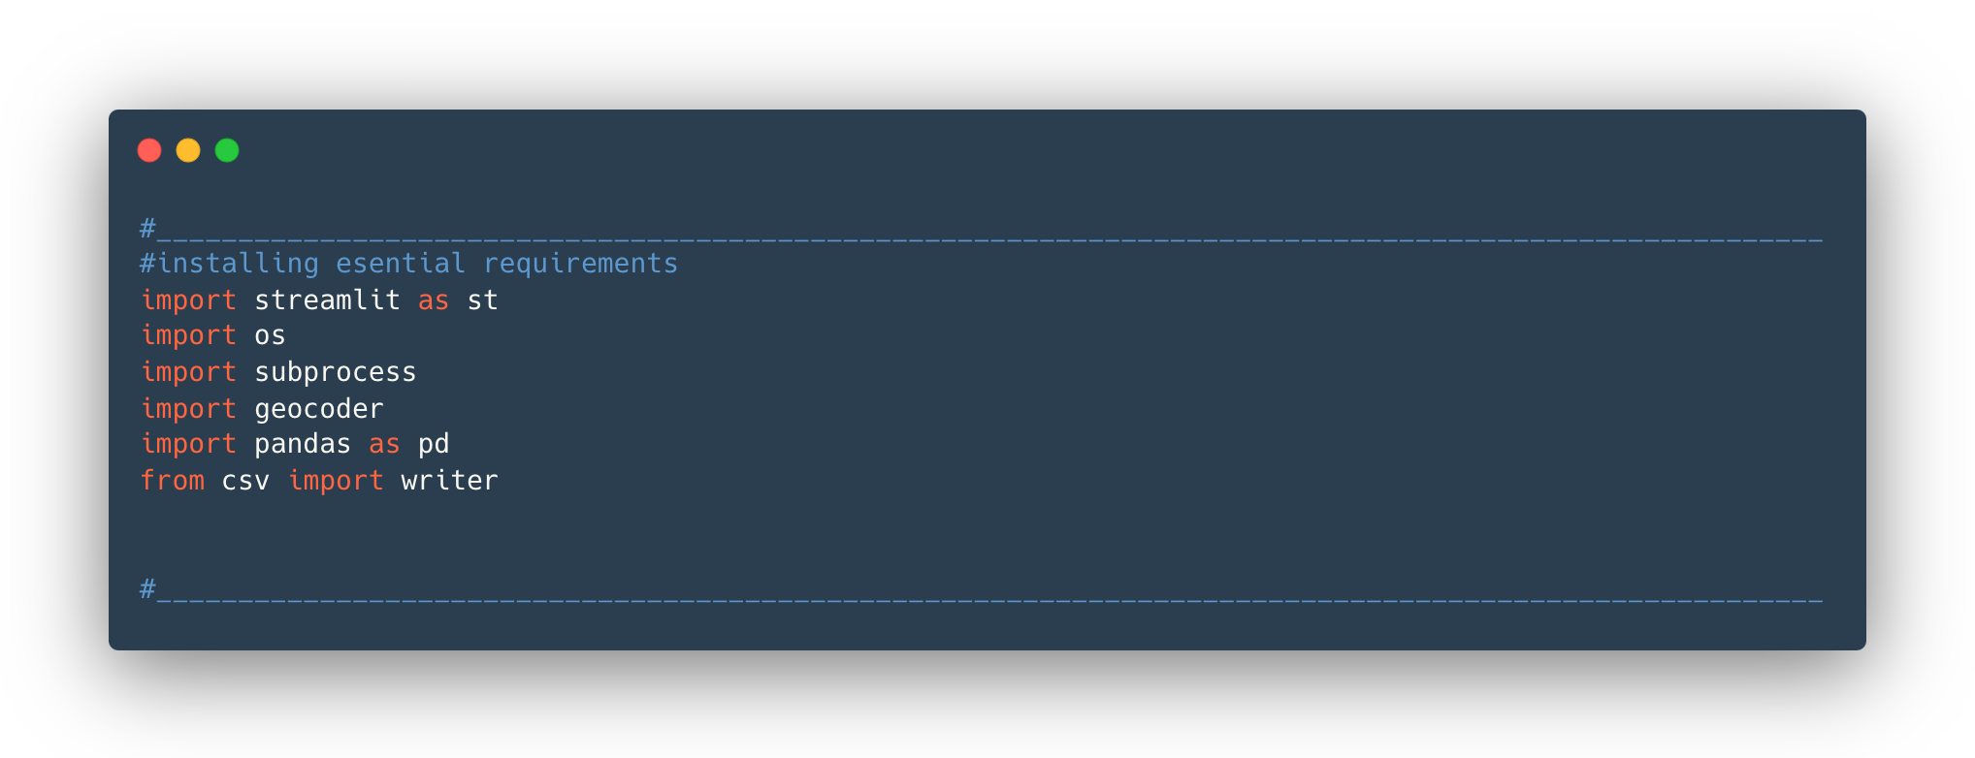
Adding the title
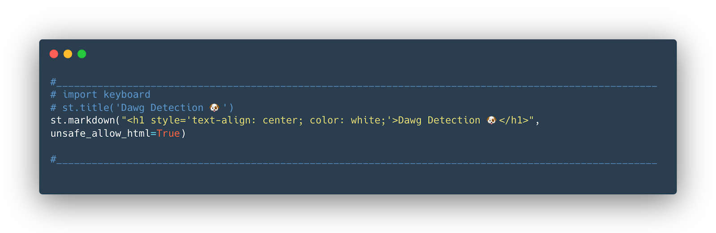

Setting up the configure button
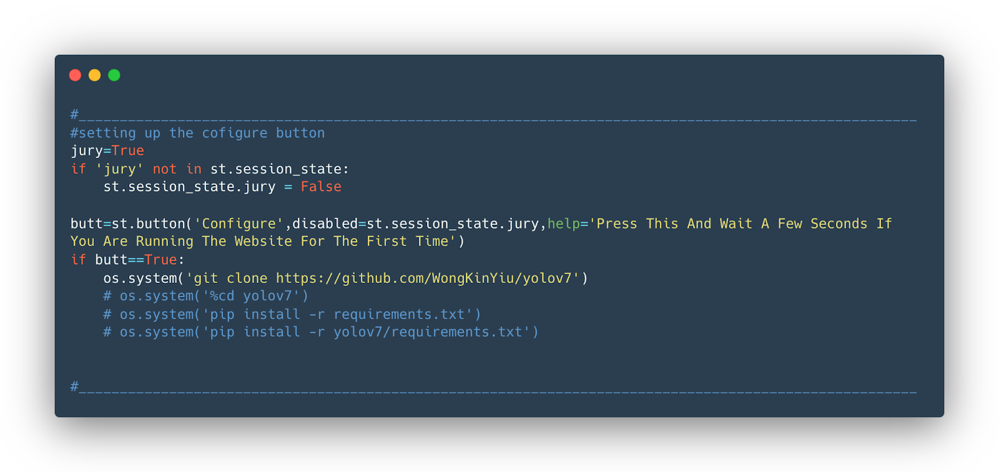
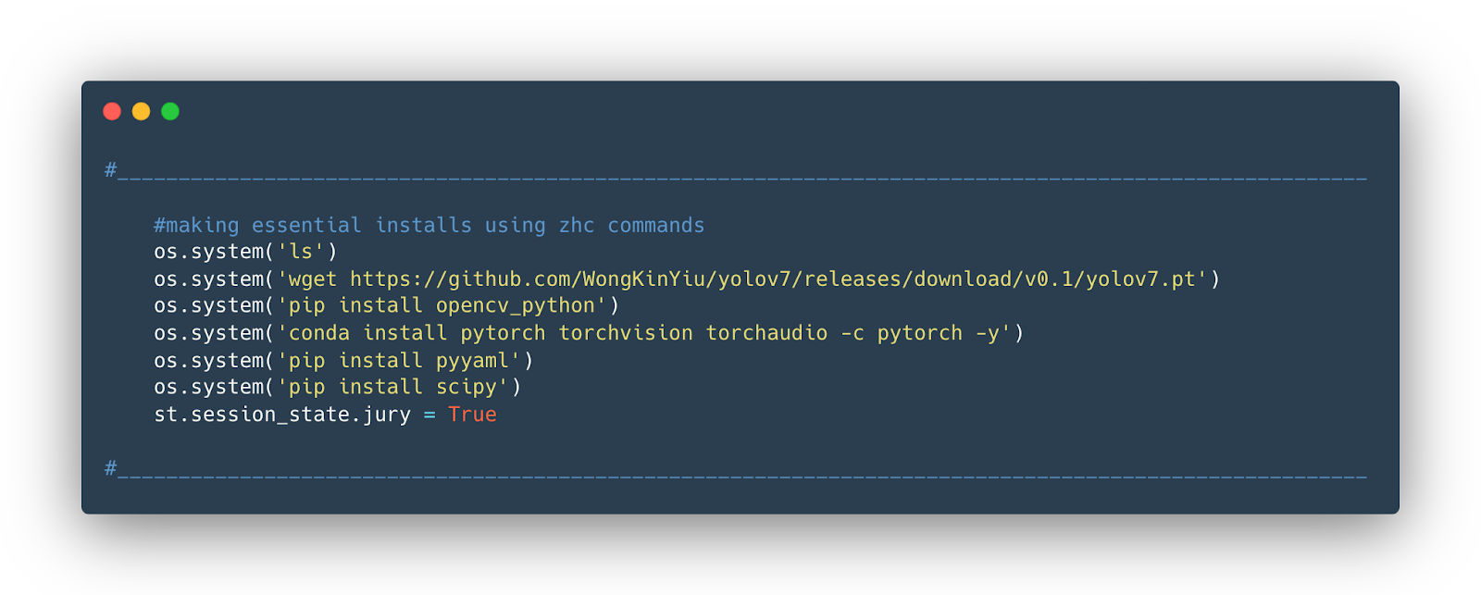
Making essential instals using zhc commands

Setting up the AI commands for running the AI
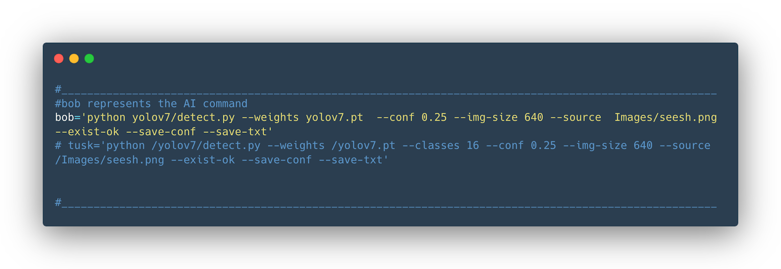
Getting the camera input
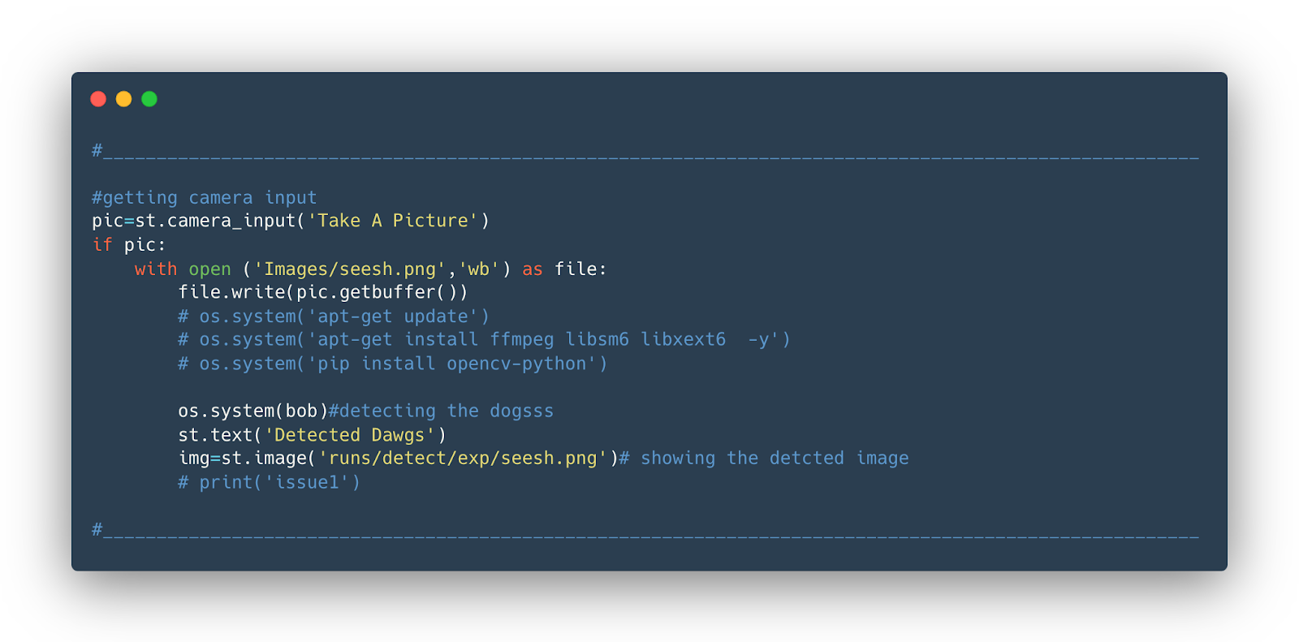

Counting the number of dogs
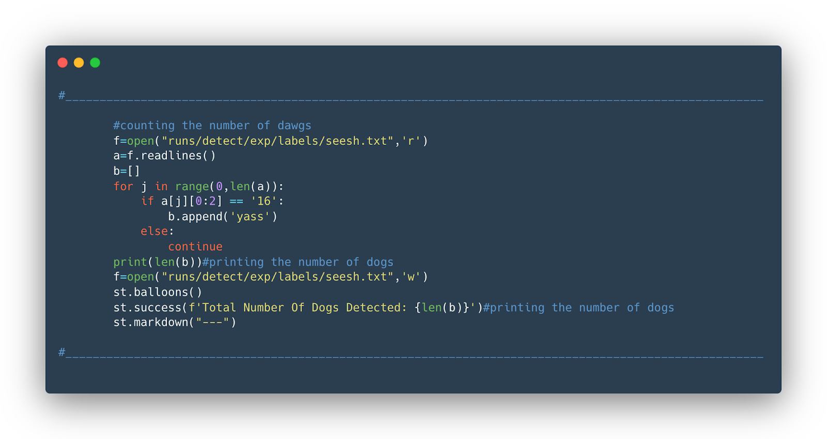
Setting up the map
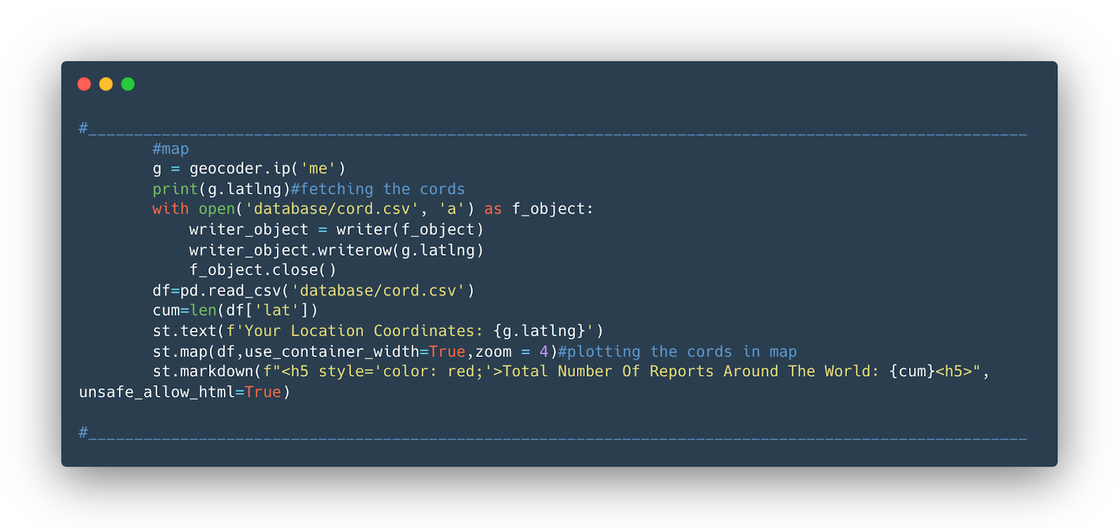

Setting up the balloon button
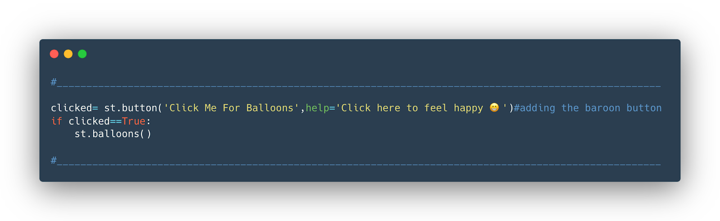

Prototype Submission
On PC:
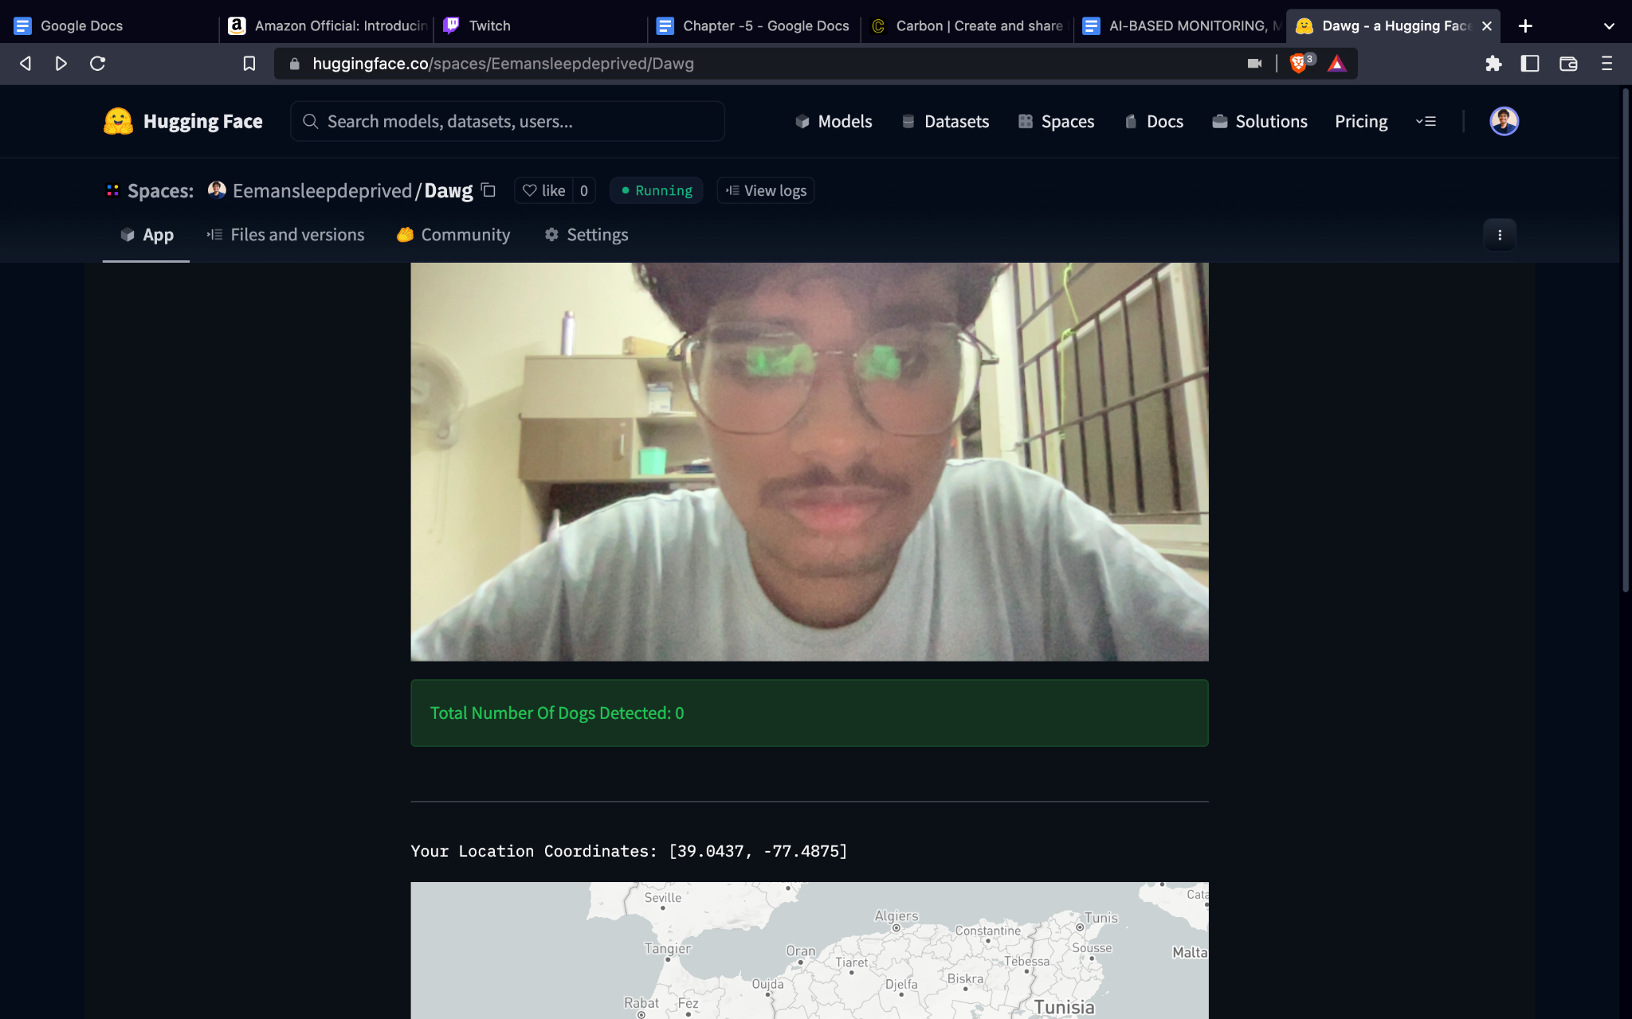

On Mobile
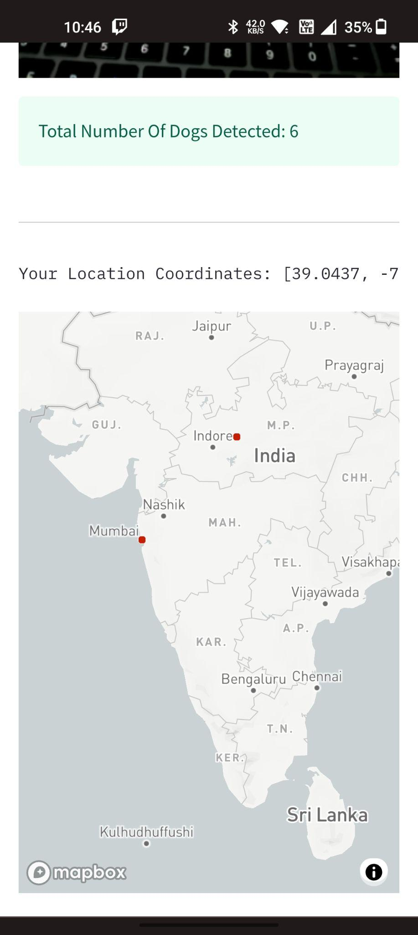
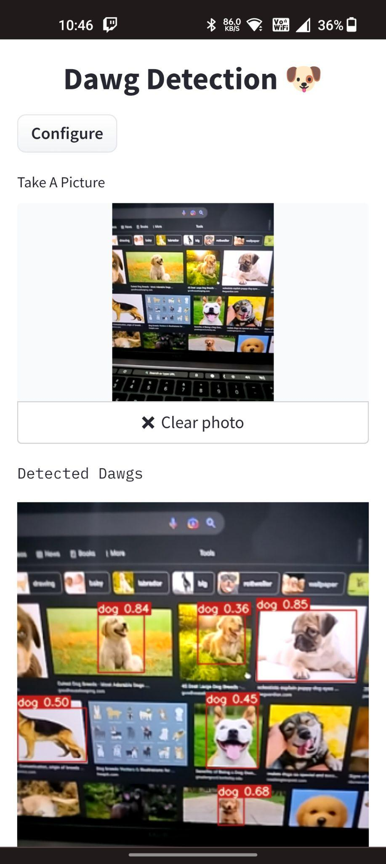

Link to the website/app: https://huggingface.co/spaces/Eemansleepdeprived/Dawg

Test and Validation
Our AI model currently has an accuracy of 97%. It can detect and recognise dogs from any angle at any resolution from 120p-2160p.
It is optimised to self heal and handle any exception if it occurs

Performance and Analysis (https://gtmetrix.com/reports/huggingface.co/Rye6Yy4n/)


CHAPTER 6 & CHAPTER 7
CHAPTER 6 & CHAPTER 7:

6.1 Outline,
In this project we will first of all expect the user to click a picture of a stray dog. Our AI will wait until the picture is clicked. After clicking the picture, the AI starts its job. We are basically using YOLO which is an algorithm used for object detection. We have customised YOLO for our project in such a way that it can identify a dog from any angle, whether it is a real dog or just an image of a dog from google.
Now, DAWG (our AI) will process the clicked picture and fetch the number of dogs in the clicked image by the user. This will simply display the number of dogs in the clicked image. After this, our task is to find the location of the dog. To find this, we need to track the IP address of the user who just sent this image. Using this IP address we will track the location of the user and this will thus provide us with the location of the stray dogs and the number of stray dogs in that particular location.
6.2 Implementation,
We will then provide this information to the municipal corporation of that particular area and then those dogs will be taken to our very own stray dog shelter ‘BARK HOUSE’. In these centres there will be a facility of de-fertilizing dogs after a specific age. The dogs will be vaccinated with anti-rabies injections. The pups will be monitored using AI and differentiated whether their mental health is good enough to be adopted. If their state is below the threshold set by experts, the pups will be given away for adoption and the dogs that are not safe to be adopted, will be released in the wild.

6.3 Limitation,
Our very first limitation in this project is funds. We currently do not have enough funds to publish this and make it available to the general public and also we will have to enhance our knowledge a bit more to be capable of achieving such a promising accomplishment. Another limitation is, we currently do not have the permission to use GPRS location since it requires permission from a government official.
6.4 Future Enhancements,
The project we are currently working on can be a gamechanger since this is the most efficient way to tackle this global issue of stray dogs. Our future vision is to convert this idea into a working application that one might be able to easily download from play store or app store. We are planning to optimise our AI to be more efficient and effective in identifying dogs,furthermore, in future we can also use the same AI to solve the issue of other stray animals as well.
In future, we will plan to get permissions required to access GPRS location from the user’s device.
In addition, we are planning to work on the server side of the website which will help us to manage the data fetched by the AI and prioritise it according to the location and the number of stray dogs in a particular area.

7. Conclusion,
Our vision is to solve the problem of stray dogs in the entire country as they are a menace for the society and killing them is against our moral values. We made this project so that we might be able to contribute towards society by bringing a change and we hope that this project might soon be available to the general public and our little idea will one day solve this global issue.
It is so true that,
“Dogs are man’s best friend”
We can at least do this much for our best friends. WOOF! WOOF!

