Exploring Antimicrobial Polyurethane Bionanocomposites, Synthesized with Curcumin
Noreen Abbasª,
ªDepartment of Chemistry, University of Agriculture, Faisalabad, Pakistan

ABSTRACT
Polyurethane belongs to a class of synthetic polymers, which was prepared by using a two-step methodology. The present project was designed to synthesize a novel set of polyurethane elastomers (PUs) for biomedical potential. The primary purpose of this research work is to examine the structural characteristics of polyurethane bio-nanocomposites containing mole ratios of nano curcumin, zinc oxide, and 1, 4-butanediol (1, 4-BDO). For this concern, a two-step reaction mechanism was carried out; in the first step, isocyanate (−NCO) terminated pre-polymer was synthesized by the reaction of Polycaprolactone (PCL) and isophorone diisocyanate (IPDI). The pre-polymer was further extended with 1, 4-BDO, nano curcumin, and zinc oxide nanocomposites in the second step. Five samples were synthesized by varying moles ratio of nano curcumin, zinc oxide NPs, and 1, 4- BDO. These samples were characterized by using Fourier transform infrared spectroscopy (FTIR), thermal gravimetric analyzer (TGA), and scanning electron microscope (SEM). The antibacterial properties were evaluated by using the agar diffusion technique. Their hydrophilicity and hydrophobicity were assessed through measurements of water absorption and swelling. Finally, the collected data was statistically analyzed using the mean ± standard deviation.
Keywords: Curcumin, Polyurethane elastomers, Zinc Oxide, Biocompatibility

Graphical Abstract
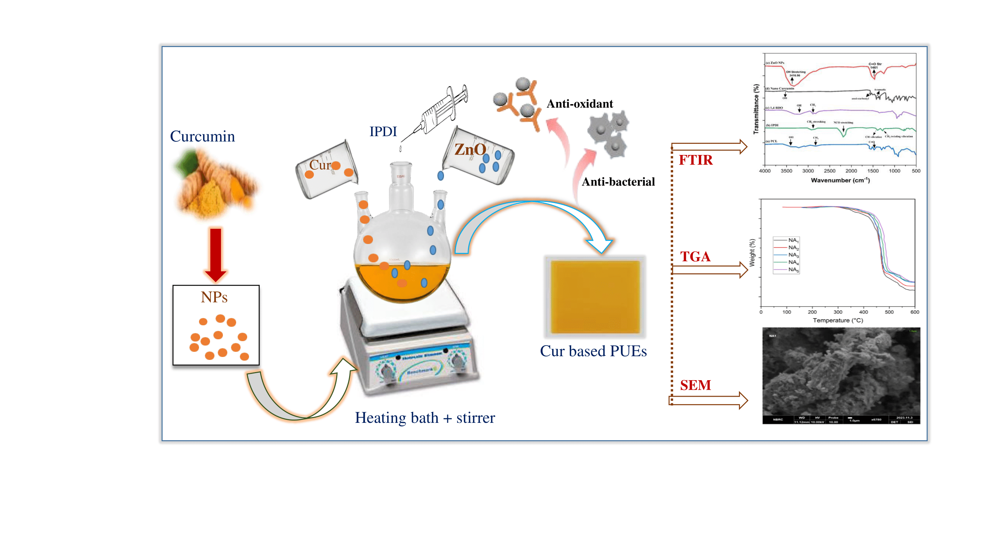

1. Introduction
Polyurethane is a distinctive type of synthetic material that encompasses a wide range of applications, including but not limited to flooring, medical devices, packaging, bedding, construction, and vehicle components, among others [1]. An appealing approach for the advancement of innovative synthetic polymeric materials involves the functionalization of these bio-based synthetic polymers with natural substances. This modification enhances the overall characteristics of the polymers and imparts greater biocompatibility compared to the intrinsic properties of individual polymers [2]. Numerous research endeavors are underway globally, focusing on the preparation of enhancement of structural features, and property refinement of novel applications of these materials. The future trajectory of polymers is poised to be shaped significantly by the strategic utilization of renewable resources [3]. Polyurethanes (PUs) exhibit distinctive attributes, including a notable strength-to-weight ratio, dimensional stability, low density, thermal conductivity, and moisture-absorption capabilities. Furthermore, PUs provide versatility in terms of formulation and reaction conditions, facilitating the synthesis of tailored materials with specific properties suitable for particular applications [4], [5]. Nonetheless, polyurethanes (PUs) exhibit certain limitations, including subpar degradability, limited biocompatibility, and adverse effects associated with isocyanates, which have spurred researchers to explore the development of more environmentally friendly materials. Native polymers, such as cellulose, chitin/chitosan, starch, alginate, and heparin, particularly polysaccharides, have proven to be effective in the creation of bio-functionalized PUs, resulting in high-performance biomaterials. Notably, studies by various researchers have delved into the examination of alginate, starch, and heparin-based PUs to elucidate the roles of natural polymers in imparting distinct attributes to Pus [6], [7]. Strategies such as copolymerization [8], grafting [9], and N-isopropyl acrylamide/glutaraldehyde cross-linker [10] are used to modify the chitosan-based PU materials. Curcumin, chemically known as 1,7-bis(4-hydroxy-3-methoxyphenyl)-1,6-hepadiene-3,5-dione, is a polyphenolic nutraceutical that constitutes a significant portion of the indigenous turmeric plant (Curcuma longa). This compound exhibits two distinct tautomeric forms, keto, and enol, owing to intramolecular hydrogen atom transfers along the β-diketone chain within curcumin. It has antioxidant [11], anticancer [12], anti-inflammatory [13] and wound healing [14] properties. Curcumin has shown its value by displaying antioxidant, antibacterial, and metal-chelating action, although its low bioavailability or poor solubility in water restricts its bioactivities [15]. Functional moieties linked to curcumin (-OH groups, double bonds, benzene rings, and diketone) play a vital role, particularly in the beneficial actions of curcumin [16]. The biological activity of curcumin is associated with several key chemical reactions, including oxidation through hydrogen donation, Michael reactions, hydrolysis, degradation, and enzymatic reactions. Chitin, an abundant polymer found in the exoskeletons of crustaceans, as well as in the cell walls of certain fungi and algae, is an amino polysaccharide. It consists of a β-(1 → 4)-linked polymer of 2-acetamido-2-deoxy-d-glucose (N-acetyl-d-glucosamine). It exhibits structural similarity to cellulose, albeit with an acetamide group at carbon position two instead of a hydroxy group, rendering it a crystalline polymer [17] and exhibiting non-toxicity, good biocompatibility, and biodegradable properties. This paper has provided a detailed characterization and synthesis of innovative elastomers based on polyurethane (PU) that incorporate curcumin. To the best of our knowledge, this marks the first instance where a specific quantity of curcumin has been introduced during the initial polymerization phase, in conjunction with poly(ε-caprolactone) (PCL), or isophorone diisocyanate (IPDI), and curcumin and 1,4-butanediol are employed as chain extenders. In our PU elastomers incorporating curcumin, we have observed significant antioxidant and antibacterial properties, favorable thermal characteristics, and hemocompatibility potential. These findings support the notion that further incorporation of bio-functional moieties is unnecessary. Furthermore, we have reported the development of curcumin-based polyurethane bio-nanocomposites for potential application in transdermal skin cancer treatment [18], [19]. The primary aim of this study is to produce bio-based polyurethane elastomers (PUEs) using a combination of poly(ε-caprolactone) (PCL), isophorone diisocyanate (IPDI), curcumin, zinc oxide (ZnO) and 1,4-butanediol (1,4-BDO). The fabricated samples are thoroughly characterized through the application of various analytical techniques including Fourier-transform infrared spectroscopy (FTIR), differential scanning calorimetry (DSC), thermogravimetric analysis (TGA), and scanning electron microscopy (SEM). The research primarily focuses on investigating the impact of the chain extender's structure on the crystalline properties, with a specific emphasis on DSC and XRD techniques. The main objective of this research is to advance the development of innovative elastomeric materials and bio-functional polyurethane modifications utilizing sustainable resources, with a particular focus on their potential applications within the biomedical field.
2. Experiments
2.1. Chemicals
All analytical grade chemicals. including 1,4-Butanediol (1,4-BDO ≥ 99.5%), polycaprolactone (PCL ≥ 99.0%), isophorone diisocyanate (IPDI ≥ 98.5%), and curcumin (99% were purchased by Sigma-Aldrich. The determination and molecular weight of curcumin was done by following a previously developed procedure [20]. While at standard temperature, the treatment of 1,4-BDO was done for gas exhaustion, the rest of the chemicals and diisocyanate were used without any treatment.
2.2. Synthesis of Curcumin into Nano curcumin
The synthesis of curcumin nanoparticles was carried out by adding curcumin to dichloromethane. Under ultrasonic conditions, this solution was added drop by drop to boiling water. The solution was sonicated and then stirred for an hour at room temperature, this was then turned into powdered form by centrifuging, washing, and drying [21]
2.3. Preparation of polyurethane (PU)
For the preparation of PU, pre-polymer synthesized via two-step polymerization of polyol and diisocyanate, extended with blends of chain extender such as 1,4-BDO, curcumin (CUR), and zinc oxide nanoparticles in the absence of catalyst by following the route as outlined by Barikani & Hepburn in 1986 [22].
2.4. Preparation of prepolymer
To synthesize the -NCO terminated prepolymer, poly (ε-caprolactone) (PCL) which was reacted with diisocyanate, specifically isophorone diisocyanate (IPDI), in a mole ratio of 1:3. The reaction was carried out using a four-neck glass kettle equipped with a reflux condenser, an oil heating bath, a mechanical stirrer, a syringe, and N2 inlet and outlet, the protocol followed for this reaction was a well-established one [23]. In the experimental procedure, 1 mole of a polyol, specifically poly (ε-caprolactone) (PCL), was introduced into the four-neck glass kettle. The temperature of the oil bath was incrementally raised to 60°C. Subsequently, 3 moles of isophorone diisocyanate (IPDI) were added, and the reaction media's temperature was further increased to 100°C. According to the reported findings, the synthesis of the -NCO-terminated prepolymer was achieved within 1 hour.
2.5. Chain extension of prepolymer
The final polyurethane elastomers (PUEs) polymer was synthesized through the chain extension of the pre-polymer. In this step, the pre-polymer PU was continuously stirred at a temperature of 80°C for 30-40 minutes. Following this, varying mole ratios of curcumin, ZnO nanoparticles, and 1 mole of 1,4-butanediol (1,4-BDO) were added to the reaction media. The completion of the chain extension reaction was indicated by the formation of a homogeneous mixture, to shape the prepared PUEs into uniform sheets, they were poured onto a Teflon plate. To remove any air bubbles present, the prepared PUE sample was subjected to a hot air circulating oven at a temperature of 70°C for 24 hours [24].
2.6. Synthesis of curcumin-based PU bio-nanocomposites (NA1–NA5)
A predetermined quantity of PCL was accurately measured and added to a four-necked glass kettle equipped with a mechanical stirrer. After a stirring time of 15 minutes, the temperature of the system was raised gradually until it reached 60°C. At this point, isophorone diisocyanate (IPDI) was introduced drop-wise through one of the kettle necks by injection, the formation of the pre-polymer took approximately one hour, and the pre-polymer was extended by adding curcumin or ZnO nanoparticles. Finally, a measured amount of 1,4-butanediol (1,4-BDO) was gently mixed with the blend until a homogeneous mixture was achieved. The resulting liquid polymer was transferred into a Teflon plate to form a 2-3 mm thick uniform sheet of polyurethane elastomer (PUE). The synthesized polymer was then subjected to a heat-circulating oven at a temperature of 70°C and cured for 24 hours to eliminate any remaining solvent from the prepared PUE.
Scheme 1: Synthesis of curcumin based PU bio nanocomposites

Table 1: Sample codes and different formations of biocompatible polyurethane elastomers (PUEs).
SR No | Sample Codes | IPDIª  (moles) | PCL^{b}  (moles) | ZnNPs  (moles) | Nano curcumin  (moles) | 1,4-BDO^{c}  (moles)
1 | NA₁ | 3 | 1 | 0.1 | 1.6 | 0.3
2 | NA₂ | 3 | 1 | 0.1 | 1.5 | 0.4
3 | NA₃ | 3 | 1 | 0.1 | 1.45 | 1.45
4 | NA₄ | 3 | 1 | 0.1 | 0.4 | 1.5
5 | NA₅ | 3 | 1 | 0.1 | 0.3 | 1.6

a Isophorone diisocyanate.
b poly (ε-caprolactone)
c 1,4-Butanediol analysis.
Table 1 is depicting the complete formulations of all polymer synthesized.
2.7. Characterization of biocompatible polyurethane elastomers (PUEs)
Characterization of polyurethane elastomers through spectroscopic studies i.e. FTIR was carried out to confirm the synthesis of purposed PUs. To check the effect of chain extenders on the thermal stability of proposed polyurethanes, thermogravimetric analysis was done to design effective polyurethanes with suitable properties for specific applications. Whereas, SEM analysis was performed to study the morphological features of polyurethane blends.
2.7.1. Molecular Characterization
FTIR and solid-state nuclear magnetic resonance spectroscopic analysis were employed for structural elucidation and monitoring of the reaction progress for prepared polyurethane elastomers.
2.7.1.1. FTIR (Fourier Transform Infrared) Spectroscopy
FTIR is a common technique employed for the determination of chemical structure, compositions of various compounds analysis of functional groups in organic compounds, polymers, and inorganic materials [25]. Through Infrared (IR) spectroscopy we can determine the absorption bands (stretching and bending vibration) that are present in different tested samples [26]. It was also employed to determine the possible reactions among various monomers to bind the suggested constitution of synthesized biocompatible polyurethanes with imperative chemical components. The composition of anticipated polyurethane elastomers were examined by a Shimadzu Fourier Transform Infrared Spectrophotometer furnished with ATR (in transmission mode). The spectra of purposed biocompatible polyurethane elastomers were monitored. During this study, 70 scans with 4.0 cm-1 resolution were recorded.
2.8. Thermal analysis
Thermal analysis is known as a crucial technique, especially in the research field of polymers. This analysis was conducted basically to check the crystallinity and thermal stability of prepared polyurethane elastomers.
2.8.1 Thermo gravimetric analysis (TGA)
Polymeric and inorganic materials are studied well using thermo gravimetric analysis, is a thermo-analytical technique concerned with sample weight change under examination because the increase in temperature is at a linear rate. It’s a well-known technique for studying the kinetics of thermal degradation in materials such as elastomers, and polymers hence provides valuable information about a sample’s thermal stability and its shelf life. TGA has been used widely in current years owing to its automatic availability at the commercial level. Thermal analysis using this technique gives reliable and accurate results. The results of TGA analysis are represented as curve and their shape is dependent on many factors like sample holder geometry, furnace atmosphere, and rate of heating. Also, sample characteristics i.e. nature, particle size, and amount can influence TGA curves. For recording the thermal degradation profile of synthesized films based on nano curcumin-1,4-BDO, a Thermo gravimetric analyzer (TGA) from Perkin Elmer was used under inert nitrogen atmosphere conditions with a 10°C/minute heating rate.
2.8.2 Differential scanning calorimetry (DSC)
It is employed for analyzing thermal transitions occurring in polymer samples (when they heat up or cool down under an inert atmosphere). It is also used for determining both glass and melting transition temperatures in liquid crystalline mesophase, the setup used for DSC analysis typically consists of two pans positioned identically which are attached to the furnace having a common path for heat flow. The polymer sample was placed on one pan whereas the alumina standard was placed on another pan, these pans undergo heating at a specific rate. A graph was plotted between the sample’s heat flow and temperature, heat flow is represented with unit ‘q’ supplied per unit time. It is mentioned in the literature that there is no phase transition occurring in the polymer so the plot became parallel to the x-axis [27]. In the current project, DSC analysis has been done basically to determine thermal variations in polyurethane elastomers using the DSC Diamond series, Perkin Elmer. Samples were carefully weighed before thermal analysis in conditions such as 50-200°C temperature range with a heating rate of 10°C/minute. In addition to the X-ray diffraction technique, differential scanning analysis is an effective tool for the examination of a polyurethane sample’s crystallization behavior. Analysis using DSC was done to scrutinize the impact of curcumin incorporation upon polyurethane properties and structure [28].
2.9. Surface features analysis
The morphological and hydrophilic/hydrophobic characteristics of designed polyurethane elastomers were investigated in this section.
2.9.1 Scanning electron microscopy (SEM)
Morphological features of prepared polyurethane films were assessed by scanning electron microscopy. SEM analysis was performed to observe surface characteristics of purposed polyurethane films and an image is produced when a focused beam of electron interacts with the sample surface. Samples were analyzed with a Nova nano SEM-EML-PK. Prepared polyurethane samples were attached to an SEM stub and sputter coated with gold, the digital image was then taken at different magnifications.
2.10. Biological evaluation of biocompatible polyurethane elastomers (PUEs)
A great interest has been developed recently in polyurethane modification through its blending with natural polymers to make it a potent candidate for biomedical applications. Thus, the biological activity of synthesized polyurethane elastomers has been evaluated using various biological assays like antibacterial tests, all the biological assays were performed in the Biochemistry Lab, at the University of Agriculture, Faisalabad.
2.10.1 Antibacterial activity
The antibacterial activity of synthesized polyurethane films was assessed via the Agar Diffusion method, microbial strains used for the evaluation of tested polyurethane films were Escherichia coli (E.coli, Gram-negative bacteria) and Bacillus subtilis (B.S., gram-negative bacteria) [29]. Pure culture of both index organisms (E.coli and B.Subtilus) was separately mixed with prepared and sterilized nutrient broth, and placed in a shaking incubator for the growth of the organism at 37°C [30]. Nutrient agar medium containing inoculums (E.coli and B.Subtilus) were transferred into the sterilized petri dishes according to established protocol, polyurethane films were then poured on petri dishes for 24 hours and incubated at 37 ºC. The zone of inhibition formed around PU films was then measured (in millimeters) by zone reader [31].
3. Results and discussion
The present study was conducted to synthesize blends of curcumin-based PUEs utilizing various components, including PCL, IPDI, 1, 4-BDO, nano curcumin, and zinc oxide nanoparticles. For certain other systems containing nano-CUR or CUR nano formulations, such as nanofibers, films, composites, scaffolds, gels, and hydrogels, it is evident that the incorporation of CUR-loaded NPs provides enhanced control over sustained release, thereby increasing the likelihood of CUR presence throughout the final stages of wound healing [32]. To synthesize PUE samples, three methodologies were employed, and PUE samples were synthesized by varying the molar ratios of nano-curcumin and ZnO NPs as a chain extender. The chemical alterations in the Curcumin/ZnO blend films were investigated using FT-IR [33]. A two-step methodology was utilized to synthesize the PUE samples as reported by Barikhani & Hepburn. According to the protocol specified in table 3.2, the -NCO terminated PUE pre-polymer was synthesized using three moles of diisocyanate and one mole of PCL. The resultant PU pre-polymer was subsequently extended with various molar ratios of chain extenders to synthesize final PUEs, and the reaction sequence is delineated above in scheme 1. The proposed structure of synthesized PUE samples was characterized through microscopy and spectroscopic techniques.
3.1. Molecular characterization
Molecular characterization of polyurethane elastomers blended with different mole ratios of nano curcumin by Fourier Transform Infrared Spectroscopy
FTIR has been utilized for the structural characterization of all the employed monomers and synthesized polymers. Infrared radiations of varying frequencies are absorbed by different functional groups, facilitating the identification of the chemical composition of the prepared samples. This spectroscopic technique enables both qualitative and quantitative analysis of the final polymer. Analogous to human fingerprints, the FTIR spectrum was observed to be distinct and unique for each chemical, hence referred to as the fingerprints of the compounds. All the employed monomers, pre-polymers, and final synthesis of PUEs have been confirmed through FTIR spectroscopy. FTIR serves as an effective tool to monitor the changes in functional groups during a chemical reaction. Spectral analysis of IPDI, PCL, ZnO NPs, 1,4-BDO, and nano curcumin as chain extenders and final curcumin-based PU products using FTIR are presented in Fig.3.1. The FTIR spectra of ZnO nanoparticles were presented in Fig. 3.1 (e). A strong band was observed at 3324.96 cm⁻¹ along with three other shoulder peaks at 1461.68 cm⁻¹, 1248.07 cm⁻¹, and 746.55 cm⁻¹. A significant peak at 2929.09 cm¹ and 2875.63 cm is attributed to regular and irregular elongation of the CH group. The appearance of a broad band in the spectrum of 1,4-BDO Fig. 3.1 (c) at 3288.98 cm⁻¹ is due to intra and inter-molecular H-bonding and corresponding OH groups. A prominent peak observed at 1041.83 cm is associated with the primary alcoholic group [34]. An intense peak at 2246 cm⁻¹ in the spectrum of IPDI in Fig 3.1b below is attributed to the stretching vibration of the isocyanate (–N=C=O) group [35]. Another band observed within the spectrum was assigned to (C-C) stretching of –C(CH₃)₂ group, along with a characteristic absorption peak near 1457 cm⁻¹ for bending vibration of C-H bond and peak at 2959 cm⁻¹ corresponding to stretching vibration of (C-H) bond in CH3 group [36][37]. A significant peak near 1713 cm⁻¹ is attributed to C=O vibrational stretching of urethane (-NHCOO) linkage, which confirmed urethane bond formation between polyol and diisocyanate. Additional peaks observed in the prepolymer spectrum were, the absorption band at 2839 cm⁻¹ due to the C-H symmetrical stretching of the CH₂ group, the vibrational band at 1433 cm⁻¹ assigned to the CH group bending vibration, and another band at 980 cm⁻¹ corresponding to the C-O-C vibrational stretching. A notable emergent peak in the prepolymer spectrum at 3315 cm⁻¹ indicates the presence of the urethane bond in prepolymer via PCL and IPDI reaction. In the subsequent step, prepolymer chain extension is achieved through the addition of chain extenders or crosslinkers to complete the polymerization reaction by following the well-documented and established protocol [19], [38].
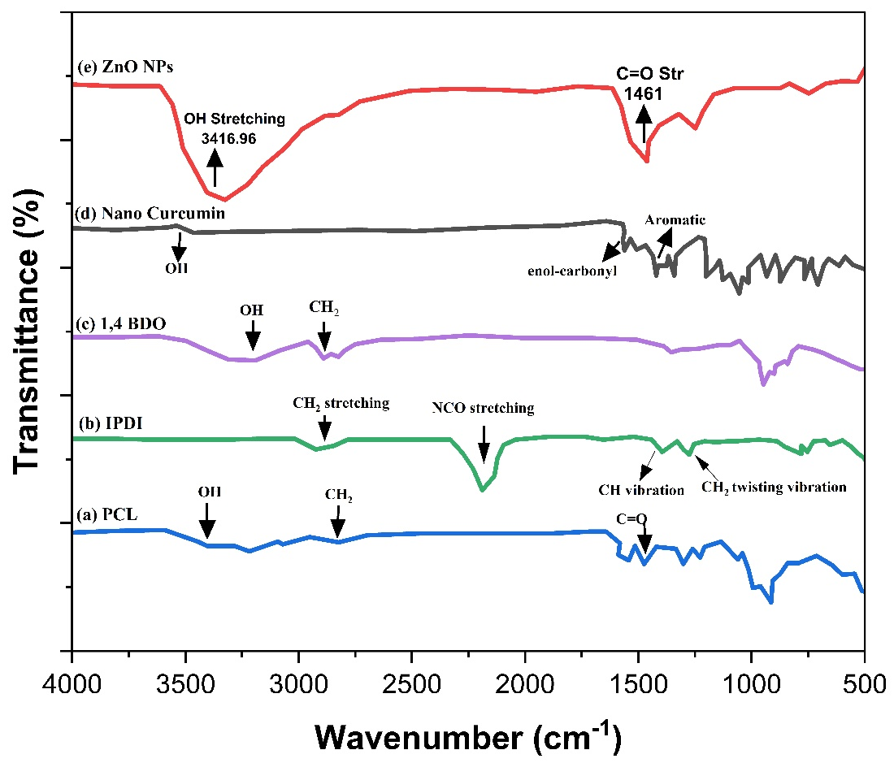
Figure 3. 1: FTIR spectrum for: (a) PCL (b) IPDI (c) 1,4 BDO (d) Nano Curcumin (e) ZnO NPs.
The spectrum of 1,4-BDO (Fig. 3.1c) showed a broad peak at 3288 cm-1 due to the vibrational stretching of the alcoholic group (OH). While other peaks were designated as 2860 cm-1 and 2942 cm-1 (CH asymmetrical and symmetrical stretching vibration for the CH2 group) due to intra and inter-hydrogen bonding. A prominent peak appeared at 1042 cm-1 due to the primary alcoholic group. The addition of 1,4-BDO (chain extender) in the polyurethane backbone caused a change in vibrational mode and was confirmed via the FTIR spectrum attained from cast film [39]. The IR spectrum of PCL showed the following bands in Fig. 3.1(a): OH stretching at 3553.92 cm and 3460 cm³, CH stretching at 2942.65 cm and 2861.26 cm, C stretching at 1720.93 cm. The functional groups present in PCL were thus confirmed by FTIR spectroscopy. In the FTIR spectrum of curcumin depicted in (Fig. 3.1d), a peak at 3507 cm-1 is attributed to the stretching vibration of the phenolic hydroxyl group whereas peaks corresponding to –COOH and asymmetrical CH2 stretching vibrations appeared at 1628 cm-1 respectively. A band in the range of 1410 cm-1-1610 cm-1 is assigned to the bending vibration of the benzene ring [40]. The stretching vibrations of C-C, C=O, and trembling of hydrocarbon (olefin bending) are allocated at 1507 cm-1, 1598 cm-1, and 1427 cm-1. FTIR spectra of curcumin-based polyurethanes bio nanocomposites after extension with a mixture of 1,4-BDO-nano curcumin and ZnO nanoparticles were noted and presented in spectra. FTIR is used broadly for studying the synthetic process of pre and finalized polyurethane products through monitoring attenuation at 2200–2300 cm-1 of the -NCO band. The -NCO band disappearance at 2260 cm-1 within the pre-PU spectrum after the reaction of chain extension is credited to additional polymerization reaction which utilized all pre-polyurethane -NCO group thus forming the final biocompatible polyurethane elastomers. Simultaneously, the increase in peak strength at 3366 cm-1 is designated as: -NH bond stretching vibrations whereas at 1696 cm-1 is ascribed to stretching -C=O bond vibrations of urethane linkage which confirms polyurethane elastomers confirmation. The appearance of bands at 1523 cm-1, 1237 cm-1, and 1037 cm-1 are endorsed due to CH2 bending, stretching C (CH3)2 group vibrations present in IPDI, and stretching vibrations of the C-O-C group. The presence of H-bonding among the hydroxyl group of curcumin and NH group of polyurethane is confirmed by the appearance of a broad NH stretching band in FTIR spectra of NA5 (extended with 1.75 mol nano curcumin) in comparison to NA1 (extended with 0.25 1,4-BDO) [41].
FTIR spectrum of all the five PUEs (NA1-NA5) based on PCL, IPDI, and 1,4-BDO extended with varying molar concentrations of nano curcumin are collectively given in Fig. 3.2. By FTIR analysis of PUE samples it is shown that -NCO peak disappeared around 2250 cm and NH peak appeared at 3351 cm implied the predesigned polymer synthesis and also supported its structure. The characteristics urethane group band are shown in the FTIR spectrum which relates to the overlapping of the OH group and stretching of the NH group observed in nano curcumin-based PUEs that showed the intermolecular hydrogen bonding between the NH group of PU and OH group of 1,4-BDO. Similarly, additional peaks obtained were designated as symmetrical and asymmetrical CH stretching vibrations of CH₂ group at 2944 cm¹ and 2884.5 cm, C=O stretching at 1718 cm³, peaks for C-N, C-O, and C-O-C stretching appeared at 1157,3 cm, 1233.7 cm¹, and 961 cm respectively. After the extension of PUE pre-polymer with different molar concentrations of nano curcumin and ZnO NPs, the FTIR spectra showed the following peaks: 1630 cm, 1722 cm", and 3351 cm which are assignable to absorption of C-O with hydrogen bonding, C=O indicates non-hydrogen bonding and NH, respectively which depicts that newly synthesized product exhibits formation of urethane group.
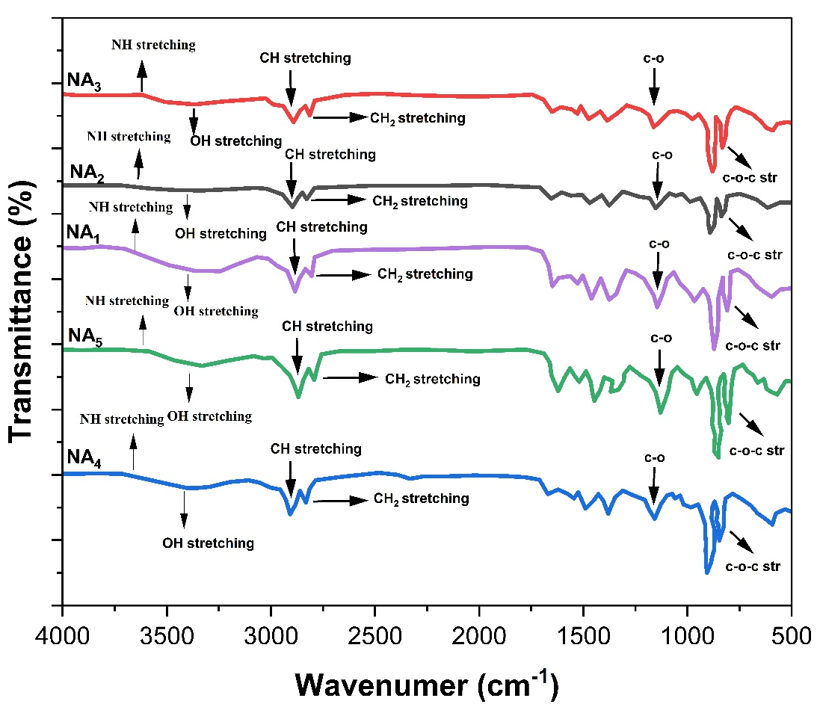
Figure. 3. 2: FTIR spectra of all the final PUEs (NAI, NA2, NA3, NA4, and NA5) based on nano curcumin and ZnO NPs.
Strong evidence regarding PUE formulation through observing bending vibrations of NH at 1597 cm and absorption band of C-O-C stretching at 960.44 cm which corresponds to the connection among -NCO and OH groups for urethane bond formation. Higher stretching of NH stretching band in NA2 extended with the equal concentration of nano curcumin and ZnO NPs. A slight increase in the peak intensity from NAI to NA5 suggests the H-bonding in the polymer chain. It is noteworthy that in PUE, the NH group could develop H-bonding of HS with oxygen of-C-O groups. This H-bonding works as a physical cross-linker which leads to restriction of motion in the polymeric chain segments.
3.2 Thermal analysis of polyurethane elastomers
Thermal stability and crystallinity index of polyurethane elastomers using aromatic isocyanate were determined by thermogravimetric analysis and differential scanning calorimetry.
3.2.1 Thermogravimetric analysis of polyurethane elastomers
TGA is a very helpful technique for examining the degradation profile of prepared PUEs with different mole ratios of chain extenders. The TGA analysis was employed to evaluate the thermal stability of designed PUEs [42]. The chain extender effect on the thermal stability of PUEs was carried out under an inert atmosphere of N₂ with a flow rate of 20 °C/minute. Thermogram profile of designed PUE formulations NA1, NA2, NA3, NA4, NA5 are depicted in Fig. 3.3 The thermal degradation of PUEs represents the two-step decomposition curve where a prominent loss in weight occurred [43]. Fig. 3.3 shows the TG curves of curcumin, ZnO NPs, 1,4-BDO-based PUEs i.e. NA1-NA5, and the % degradation of all the prepared products at different temperatures are shown in the table. Three prominent stages in curves of TGA were observed where prominent weight loss occurred due to chain scission. The polyurethane sample faced a 10% weight loss between 300-450˚C in the first stage, there was a little weight alteration owing to moisture loss or may be due to the scission of smaller chain segments. Whereas, polymer thermal degradation at 440- 475˚C caused weight loss of up to 20%, which may be ascribed to the decomposition of diisocyanate. Though, the rates of weight loss match in the first stage there is variation in the temperature of degradation in the second stage. It was reflected that stable polyurethane moieties were formed by curcumin’s keto-enol structure and H-bonding, which increased its degradation temperature. Curcumin decomposition occurs in two steps. In the first one, there is the decomposition of curcumin’s substituent group whereas that of the benzene ring starts in a subsequent step [44]. In the current project, the rise in the final decomposing temperature of PU based on curcumin is seen due to valuable stability interaction among polyurethane prepolymer and curcumin [45]. Data in Table 2 revealed that NA1 is thermally least stable and decomposition temperature is lower as compared to NA4 and NA3 which contain a greater amount of curcumin in their composition. The temperature at which 20 % weight loss occurred for NA5, NA4, NA3, NA2, and NA1 was 471ºC, 469ºC, 450ºC, 450ºC, and 440ºC, respectively. A mole ratio of nano curcumin: 1,4-BDO (0.3:1.6) in NA5, is responsible for maximum stability. It is, therefore, concluded that polyurethane materials with an increase in point of cross-linking, possess superior thermal stability. Slight variations in the thermal properties of thermoset polyurethane elastomers were noted by varying the type of diisocyanate from cycloaliphatic to aromatic isocyanate [46]. It is, therefore, concluded that polyurethane materials with an increase in point of cross-linking, possess superior thermal stability.
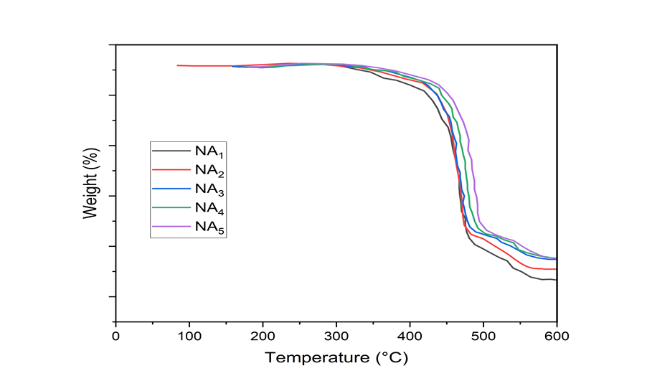
Figure 3. 3: TGA Thermo grams of all polyurethane elastomers synthesized with blends of nano curcumin bionanocomposites.
Table 2: TGA profile of all polyurethane elastomers blended with curcumin bionanocomposites
Sr.# | Sample code | Tonseta(˚C) | Tib(˚C) | c  T10  (˚C) | c  T20  (˚C) | c  T50  (˚C) | c  T60  (˚C) | c  T80  (˚C) | Residue^{d} (%) | Tg
1 | NA1 | 28 | 42 | 407 | 440 | 473 | 478 | 489 | 0 | 159
2 | NA2 | 30 | 45 | 429 | 450 | 473 | 478 | 495 | 3.751 | 161
3 | NA3 | 29 | 47 | 429 | 450 | 474 | 478 | 504 | 9.025 | 162
4 | NA4 | 29 | 47 | 443 | 461 | 475 | 490 | 521 | 10.49 | 167
5 | NA5 | 30 | 50 | 448 | 471 | 495 | 500 | 529 | 11.02 | 171
Where,
a- Initiation temperature for the start of TG analysis
b- Starting temperature of sample degradation
c- Temperatures at which 10%, 20%, 50%, 60%, 80% samples decomposition occurred
d- Percentage residual mass at 600 °C
3.3.3 Differential scanning calorimetric (DSC) analysis of polyurethane elastomers
Chain extender's (curcumin and 1, 4-BDO) influence on the backbone of polyurethanes was investigated using the DSC technique. In addition to XRD, DSC is an effective tool for inspecting the crystallization behaviour of thermoset polyurethanes. DSC curves of blended polyurethanes are depicted below in Fig. 3.4. The Tg (glass transition temperature) of synthesized material after the second heating is more reliable due to the melting of impurities in the first heating scan, therefore we can rely on the second heating scan. A prominent thermal change was observed in the range of 80 200˚C. In literature, it is reported that polyurethanes based on PCL have less hydrogen bonding between soft and hard segments as compared to other types of polyols. Normally, Tg obtained above the temperature may be ascribed to the hard contents of PUs and below the room temperature owing to the soft contents. Inclusion of curcumin into polyurethane resulting an increase in Tg values, due to keto and enol configuration of curcumin having intersegmental hydrogen bonding and crosslinking, which make polyurethanes more stable. It can be concluded that hydrogen bonding and crosslinking have a positive influence on the thermal degradation of polyurethane elastomers.
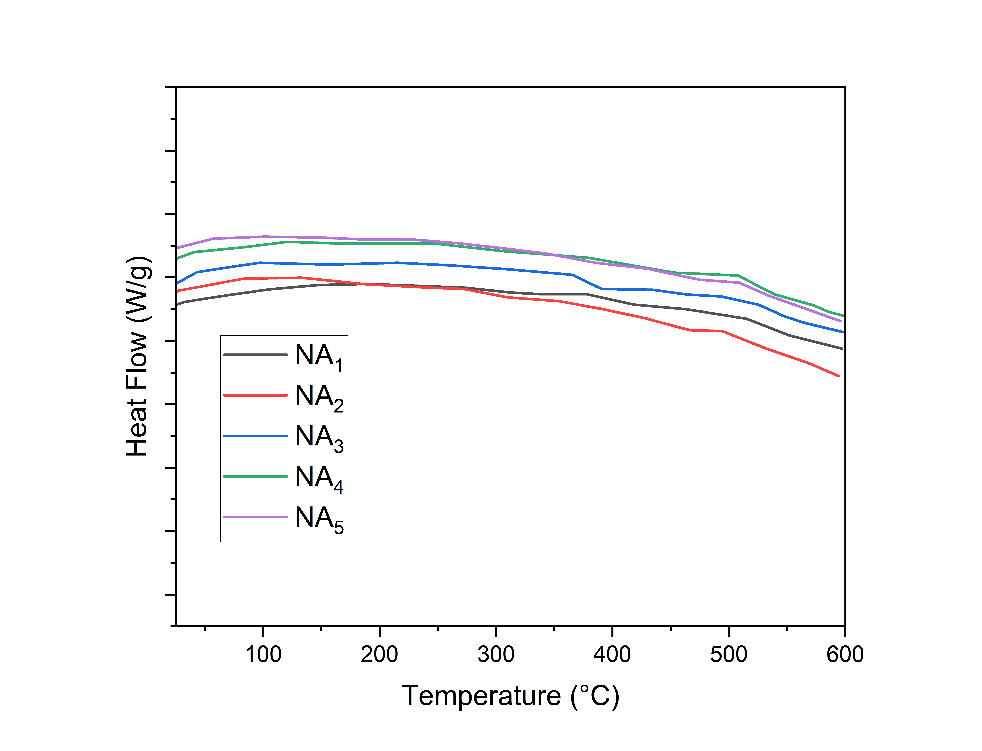
Figure 3. 4: DSC curves Thermograms of polyurethane elastomers
3.4 Surface features of thermoplastic polyurethanes based on curcumin and zinc oxide nanoparticles
Morphological aspects of thermoplastic polyurethanes were studied by scanning electron microscopy.
3.4.1 Scanning electron microscopy (SEM) of thermoplastic polyurethanes
Morphological features of aromatic based polyurethane elastomers were examined by SEM. Results shown in Fig. 3.5 for NA1, NA3 and NA5 inferred a transformation in morphology might be due to increasing contents of curcumin into PU backbone. This pattern might be generated due to good mixing of blend (curcumin and 1,4-BDO) within soft and hard contents. In NA1, uniform spherical particles were observed while in NA3 agglomeration of particles, or irregular lump might be heterogeneous mixture of PU matrix, moreover, in NA5 rod or needles like structure was depicted.
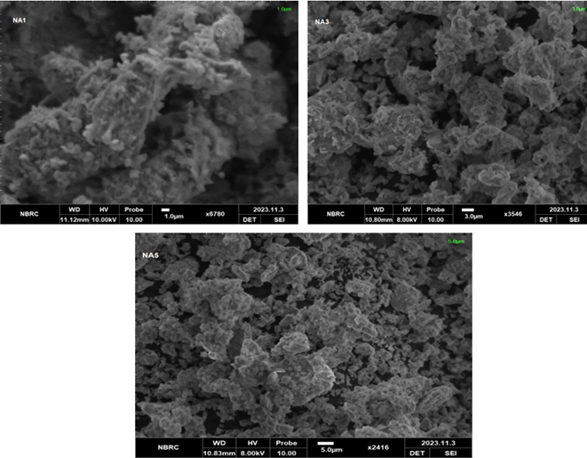
Figure 3.5: SEM images of polyurethane elastomers: (a) NA1 (b) NA3 (c) NA5
3.5 Biological evaluation of synthesized polyurethane elastomers
The performance of synthesized polyurethane elastomers comprised of aromatic backbone, was checked using biological tests e.g. antibacterial under biological conditions.
3.5.1 Antibacterial activity of polyurethane elastomers
Currently, several biocompatible polyurethane elastomers have been created for biomedical purposes. Using bacterial strains, prepared polyurethane samples were examined to determine their antimicrobial activity. The results are presented in Table 3 and the inhibition zones were measured in millimetres (mm). All synthesized compounds appear to have a bacteriostatic mechanism of action and significant antimicrobial activity against the gram-positive bacteria B. subtilis and the gram-negative bacteria E. coli. Polyurethane films' antimicrobial action was found to be more efficient against Bacillus subtilis than Escherichia coli, with measured zones of growth inhibition ranging from 20 to 31 mm, respectively when findings were compared to those obtained using the medication ampicillin as the standard above (Table 3). The maximum zone of inhibition up to 31±0.17 was reflected by PUB5 materials due to the higher concentration of curcumin. It has been determined that a high curcumin ingredient strengthens the substance's antimicrobial properties. Curcumin damages the cytokinetic Z-ring, which is in charge of organizing and aggregating nucleoids in bacterial cells, which eventually inhibits bacterial cell proliferation [47].
Table 3: Antimicrobial activity of polyurethane elastomers
Samples code | Escherichia coli | Bacillus subtilis
NA1 | 20±0.3 | 21±0.15
NA2 | 21±0.4 | 23±0.17
NA3 | 25±0.6 | 24±0.18
NA4 | 28±0.7 | 27±0.16
NA5 | 29±0.2 | 31±0.17

CONCLUSION
This project has been planned to synthesize curcumin based polyurethane bio nanocomposites. In the first part, five samples of curcumin based polyurethane bio nanocomposites were prepared with IPDI and PCL by varying the molecular weight of nano curcumin and zinc oxide nanoparticles. Step growth polymerization technique was employed for the synthesis of curcumin-based PU composites and characterization of samples has been carried out by FTIR, DSC, TGA, SEM and XRD to confirm the proposed structure of curcumin based polyurethane bio nanocomposites. From FTIR analysis, it was concluded that urethane group reaction mainly occurred at hydroxyl group of curcumin and-NCO group of isocyanates i.e., IPDI. Main peaks corresponding to NH-stretching at 3600-3400 cm-1, CH at stretching 2960-2450 cm-1 and C=O at 1600-1400 cm-1 were appeared in FTIR spectra. The effect of chain extenders upon thermal stability, hydrophilicity and crystallinity index was investigated. The results of XRD revealed that all synthesized samples possess crystalline pattern which was found to be increased by increasing the curcumin content in the PUs formulation. Thermal analysis revealed that curcumin based polyurethane samples were stable up to 240˚C. The first stage of decomposition ascribed to the breakdown of diisocyanate and second stage to the breakdown of polyol components. TGA data revealed slight variation in thermal stability of the proposed polyurethanes due to change in a structure from aliphatic isocyanate to aromatic isocyanate. The biological behavior of the synthesized specimen has been evaluated by using some biological tests e.g., antibacterial and antimicrobial activities.

References
[1] M. Shoaib et al., “Relationship of hard segment concentration in polyurethane-urea elastomers with mechanical, thermal and drug release properties,” J. Drug Deliv. Sci. Technol., vol. 37, pp. 88–96, 2017.
[2] A. Sionkowska, “Current research on the blends of natural and synthetic polymers as new biomaterials,” Prog. Polym. Sci., vol. 36, no. 9, pp. 1254–1276, 2011.
[3] C. K. Williams and M. A. Hillmyer, “Polymers from renewable resources: a perspective for a special issue of polymer reviews,” Polym. Rev., vol. 48, no. 1, pp. 1–10, 2008.
[4] T. AbiSaleh, M. Anderson, M. Barker, G. Biesmans, J. Bosman, and D. Daems, “Introduction to polyurethanes,” polyurethanes book, D. Randall, S. Lee Wiley, New York, pp. 1–8, 2003.
[5] H. Lim, S. H. Kim, and B. K. Kim, “Effects of silicon surfactant in rigid polyurethane foams,” Express Polym. Lett, vol. 2, no. 3, pp. 194–200, 2008.
[6] K. M. Zia, F. Zia, M. Zuber, S. Rehman, and M. N. Ahmad, “Alginate based polyurethanes: A review of recent advances and perspective,” Int. J. Biol. Macromol., vol. 79, pp. 377–387, 2015.
[7] F. Zia, K. M. Zia, M. Zuber, S. Tabasum, and S. Rehman, “Heparin based polyurethanes: a state-of-the-art review,” Int. J. Biol. Macromol., vol. 84, pp. 101–111, 2016.
[8] Y. Zhu, C. Gao, T. He, and J. Shen, “Endothelium regeneration on luminal surface of polyurethane vascular scaffold modified with diamine and covalently grafted with gelatin,” Biomaterials, vol. 25, no. 3, pp. 423–430, 2004.
[9] W. Lin, C. Tseng, and M. Yang, “In‐vitro hemocompatibility evaluation of a thermoplastic polyurethane membrane with surface‐immobilized water‐soluble chitosan and heparin,” Macromol. Biosci., vol. 5, no. 10, pp. 1013–1021, 2005.
[10] J. M. Yang, S. J. Yang, H. T. Lin, T.-H. Wu, and H.-J. Chen, “Chitosan containing PU/Poly (NIPAAm) thermosensitive membrane for wound dressing,” Mater. Sci. Eng. C, vol. 28, no. 1, pp. 150–156, 2008.
[11] R. V Tikekar, M. Hernandez, D. P. Land, and N. Nitin, “‘Click chemistry’ based conjugation of lipophilic curcumin to hydrophilic ε-polylysine for enhanced functionality,” Food Res. Int., vol. 54, no. 1, pp. 44–47, 2013.
[12] B. B. Aggarwal, A. Kumar, and A. C. Bharti, “Anticancer potential of curcumin: preclinical and clinical studies,” Anticancer Res., vol. 23, no. 1/A, pp. 363–398, 2003.
[13] J. Imm, G. Zhang, L.-Y. Chan, V. Nitteranon, and K. L. Parkin, “[6]-Dehydroshogaol, a minor component in ginger rhizome, exhibits quinone reductase inducing and anti-inflammatory activities that rival those of curcumin,” Food Res. Int., vol. 43, no. 8, pp. 2208–2213, 2010.
[14] V. Kant, A. Gopal, N. N. Pathak, P. Kumar, S. K. Tandan, and D. Kumar, “Antioxidant and anti-inflammatory potential of curcumin accelerated the cutaneous wound healing in streptozotocin-induced diabetic rats,” Int. Immunopharmacol., vol. 20, no. 2, pp. 322–330, 2014.
[15] A. Matei, M. Stoian, O. Brincoveanu, and V. Ţucureanu, “Preparation and characterization of nanocomposites based on chitosan with ZnO-Curcumin,” Ceram. Int., vol. 49, no. 12, pp. 19829–19839, 2023.
[16] K. Mahmood et al., “Synthesis and characterization of chitin/curcumin blended polyurethane elastomers,” Int. J. Biol. Macromol., vol. 113, pp. 150–158, 2018.
[17] G. Cárdenas, G. Cabrera, E. Taboada, and S. P. Miranda, “Chitin characterization by SEM, FTIR, XRD, and 13C cross polarization/mass angle spinning NMR,” J. Appl. Polym. Sci., vol. 93, no. 4, pp. 1876–1885, 2004.
[18] S. Mangalathillam, N. S. Rejinold, A. Nair, V.-K. Lakshmanan, S. V Nair, and R. Jayakumar, “Curcumin loaded chitin nanogels for skin cancer treatment via the transdermal route,” Nanoscale, vol. 4, no. 1, pp. 239–250, 2012.
[19] K. Mahmood et al., “Morphological and thermal studies of chitin-curcumin blends derived polyurethanes,” Int. J. Biol. Macromol., vol. 105, pp. 1180–1191, 2017.
[20] B. Q. Chen, K. Sun, Y. Z. Fan, and K. B. Zhang, “Initial rheological properties of chitin/dicholoacetic acid solutions,” J. Funct. Polym., vol. 15, pp. 311–314, 2002.
[21] R. R. Pillai, P. B. Sreelekshmi, and A. P. Meera, “Curcumin Nanoparticles as Promising Anticancer Agent Against Human Colorectal Cancer Cell Lines,” ECS Trans., vol. 107, no. 1, p. 19325, 2022.
[22] Y. Ye and Q. Zhu, “The development of polyurethane,” 2017.
[23] M. Rizwan, K. M. Zia, M. A. Javaid, M. Zuber, W. Aftab, and S. Rehman, “Synthesis and molecular characterization of chitosan/alginate blends based polyurethanes biocomposites,” Int. J. Biol. Macromol., vol. 180, pp. 324–331, 2021.
[24] M. A. Javaid et al., “Utilization of waxy corn starch as an efficient chain extender for the preparation of polyurethane elastomers,” Int. J. Biol. Macromol., vol. 148, pp. 415–423, 2020.
[25] B. C. Smith, Fundamentals of Fourier transform infrared spectroscopy. CRC press, 2011.
[26] M. Zuber, S. Tabasum, R. Hussain, M. B. Khan, and I. H. Bukhari, “Blends of polyurethane-polymethyl methacrylate/TiO 2-based composites,” Korean J. Chem. Eng., vol. 30, pp. 1652–1658, 2013.
[27] W. Wang, P. Ping, H. Yu, X. Chen, and X. Jing, “Synthesis and characterization of a novel biodegradable, thermoplastic polyurethane elastomer,” J. Polym. Sci. Part A Polym. Chem., vol. 44, no. 19, pp. 5505–5512, 2006.
[28] W. Wang, P. Ping, X. Chen, and X. Jing, “Polylactide-based polyurethane and its shape-memory behavior,” Eur. Polym. J., vol. 42, no. 6, pp. 1240–1249, 2006.
[29] L.-C. Xu and C. A. Siedlecki, “Antibacterial polyurethanes,” Adv. polyurethane Biomater., pp. 247–284, 2016.
[30] F. Kara, E. A. Aksoy, Z. Yuksekdag, N. Hasirci, and S. Aksoy, “Synthesis and surface modification of polyurethanes with chitosan for antibacterial properties,” Carbohydr. Polym., vol. 112, pp. 39–47, 2014.
[31] M. Villani et al., “Polyurethane-based composites: Effects of antibacterial fillers on the physical-mechanical behavior of thermoplastic polyurethanes,” Polymers (Basel)., vol. 12, no. 2, p. 362, 2020.
[32] L. Ansari, H. Mashayekhi‐Sardoo, V. Baradaran Rahimi, R. Yahyazadeh, M. Ghayour‐Mobarhan, and V. R. Askari, “Curcumin‐based nanoformulations alleviate wounds and related disorders: a comprehensive review,” Biofactors, vol. 49, no. 4, pp. 736–781, 2023.
[33] X. Fu et al., “Melt-blended PLA/curcumin-cross-linked polyurethane film for enhanced UV-shielding ability,” e-Polymers, vol. 23, no. 1, p. 20230009, 2023.
[34] N. Wingborg, “Increasing the tensile strength of HTPB with different isocyanates and chain extenders,” Polym. Test., vol. 21, no. 3, pp. 283–287, 2002.
[35] H. Sardon, L. Irusta, and M. J. Fernández-Berridi, “Synthesis of isophorone diisocyanate (IPDI) based waterborne polyurethanes: Comparison between zirconium and tin catalysts in the polymerization process,” Prog. Org. coatings, vol. 66, no. 3, pp. 291–295, 2009.
[36] K. M. Zia, S. Anjum, M. Zuber, M. Mujahid, and T. Jamil, “Synthesis and molecular characterization of chitosan based polyurethane elastomers using aromatic diisocyanate,” Int. J. Biol. Macromol., vol. 66, pp. 26–32, 2014.
[37] J. Wang et al., “Physicochemical and biological properties of a novel injectable polyurethane system for root canal filling,” Int. J. Nanomedicine, pp. 697–709, 2015.
[38] A. Atef El-Sayed, L. K. El Gabry, and O. G. Allam, “Application of prepared waterborne polyurethane extended with chitosan to impart antibacterial properties to acrylic fabrics,” J. Mater. Sci. Mater. Med., vol. 21, pp. 507–514, 2010.
[39] P. Wang, W. Hu, and W. Su, “Molecularly imprinted poly (methacrylamide-co-methacrylic acid) composite membranes for recognition of curcumin,” Anal. Chim. Acta, vol. 615, no. 1, pp. 54–62, 2008.
[40] K. K. Chereddy et al., “Combined effect of PLGA and curcumin on wound healing activity,” J. Control. release, vol. 171, no. 2, pp. 208–215, 2013.
[41] M. M. Yallapu, M. Jaggi, and S. C. Chauhan, “β-Cyclodextrin-curcumin self-assembly enhances curcumin delivery in prostate cancer cells,” Colloids surfaces B Biointerfaces, vol. 79, no. 1, pp. 113–125, 2010.
[42] I. Javni, Z. S. Petrović, A. Guo, and R. Fuller, “Thermal stability of polyurethanes based on vegetable oils,” J. Appl. Polym. Sci., vol. 77, no. 8, pp. 1723–1734, 2000.
[43] Z. Tang et al., “Thermal degradation behavior of rigid polyurethane foams prepared with different fire retardant concentrations and blowing agents,” Polymer (Guildf)., vol. 43, no. 24, pp. 6471–6479, 2002.
[44] S. S. Narine, X. Kong, L. Bouzidi, and P. Sporns, “Physical properties of polyurethanes produced from polyols from seed oils: II. Foams,” J. Am. Oil Chem. Soc., vol. 84, pp. 65–72, 2007.
[45] Z. Chen et al., “Thermal degradation kinetics study of curcumin with nonlinear methods,” Food Chem., vol. 155, pp. 81–86, 2014.
[46] H. Souguir, F. Salaün, P. Douillet, I. Vroman, and S. Chatterjee, “Nanoencapsulation of curcumin in polyurethane and polyurea shells by an emulsion diffusion method,” Chem. Eng. J., vol. 221, pp. 133–145, 2013.
[47] X.-Z. Sun, G. R. Williams, X.-X. Hou, and L.-M. Zhu, “Electrospun curcumin-loaded fibers with potential biomedical applications,” Carbohydr. Polym., vol. 94, no. 1, pp. 147–153, 2013.

