3.1. Molecular characterization
Molecular characterization of polyurethane elastomers blended with different mole ratios of nano curcumin by Fourier Transform Infrared Spectroscopy
FTIR has been utilized for the structural characterization of all the employed monomers and synthesized polymers. Infrared radiations of varying frequencies are absorbed by different functional groups, facilitating the identification of the chemical composition of the prepared samples. This spectroscopic technique enables both qualitative and quantitative analysis of the final polymer. Analogous to human fingerprints, the FTIR spectrum was observed to be distinct and unique for each chemical, hence referred to as the fingerprints of the compounds. All the employed monomers, pre-polymers, and final synthesis of PUEs have been confirmed through FTIR spectroscopy. FTIR serves as an effective tool to monitor the changes in functional groups during a chemical reaction. Spectral analysis of IPDI, PCL, ZnO NPs, 1,4-BDO, and nano curcumin as chain extenders and final curcumin-based PU products using FTIR are presented in Fig.3.1. The FTIR spectra of ZnO nanoparticles were presented in Fig. 3.1 (e). A strong band was observed at 3324.96 cm⁻¹ along with three other shoulder peaks at 1461.68 cm⁻¹, 1248.07 cm⁻¹, and 746.55 cm⁻¹. A significant peak at 2929.09 cm¹ and 2875.63 cm is attributed to regular and irregular elongation of the CH group. The appearance of a broad band in the spectrum of 1,4-BDO Fig. 3.1 (c) at 3288.98 cm⁻¹ is due to intra and inter-molecular H-bonding and corresponding OH groups. A prominent peak observed at 1041.83 cm is associated with the primary alcoholic group [34]. An intense peak at 2246 cm⁻¹ in the spectrum of IPDI in Fig 3.1b below is attributed to the stretching vibration of the isocyanate (–N=C=O) group [35]. Another band observed within the spectrum was assigned to (C-C) stretching of –C(CH₃)₂ group, along with a characteristic absorption peak near 1457 cm⁻¹ for bending vibration of C-H bond and peak at 2959 cm⁻¹ corresponding to stretching vibration of (C-H) bond in CH3 group [36][37]. A significant peak near 1713 cm⁻¹ is attributed to C=O vibrational stretching of urethane (-NHCOO) linkage, which confirmed urethane bond formation between polyol and diisocyanate. Additional peaks observed in the prepolymer spectrum were, the absorption band at 2839 cm⁻¹ due to the C-H symmetrical stretching of the CH₂ group, the vibrational band at 1433 cm⁻¹ assigned to the CH group bending vibration, and another band at 980 cm⁻¹ corresponding to the C-O-C vibrational stretching. A notable emergent peak in the prepolymer spectrum at 3315 cm⁻¹ indicates the presence of the urethane bond in prepolymer via PCL and IPDI reaction. In the subsequent step, prepolymer chain extension is achieved through the addition of chain extenders or crosslinkers to complete the polymerization reaction by following the well-documented and established protocol [19], [38].
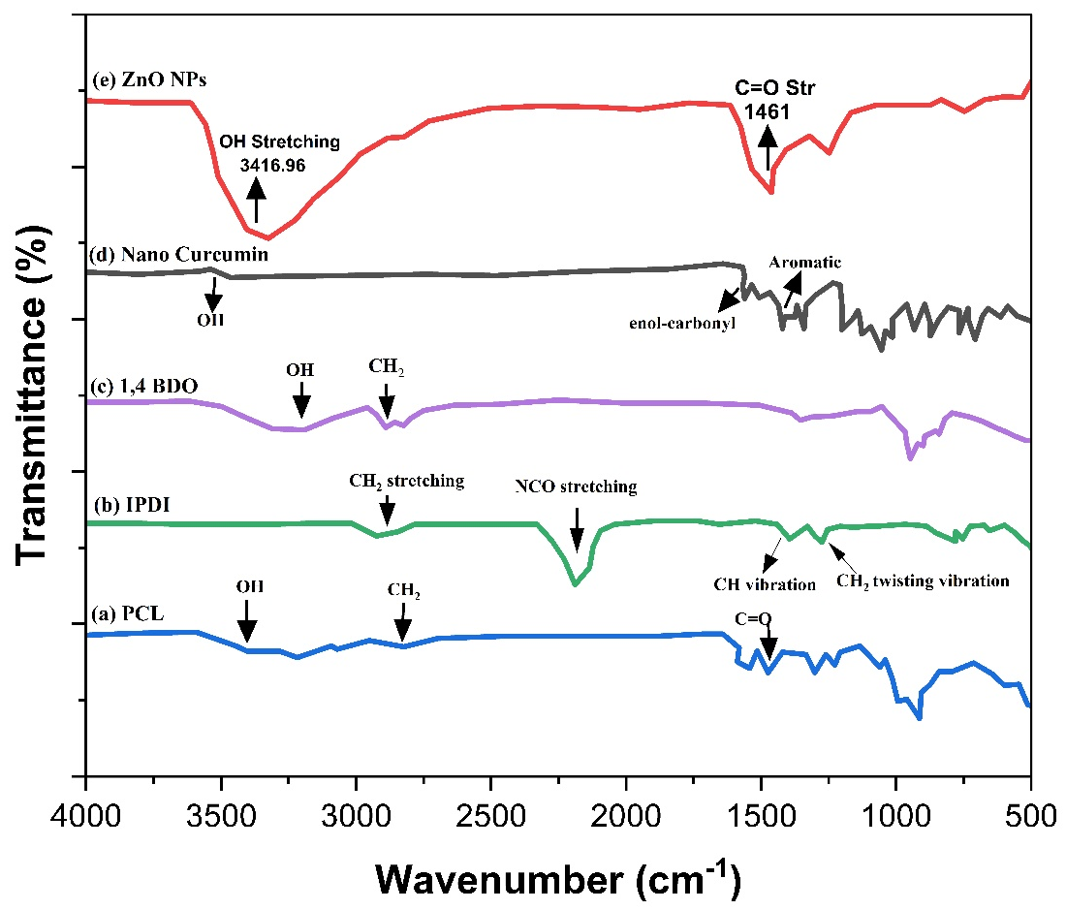
Figure 3. 1: FTIR spectrum for: (a) PCL (b) IPDI (c) 1,4 BDO (d) Nano Curcumin (e) ZnO NPs.
The spectrum of 1,4-BDO (Fig. 3.1c) showed a broad peak at 3288 cm-1 due to the vibrational stretching of the alcoholic group (OH). While other peaks were designated as 2860 cm-1 and 2942 cm-1 (CH asymmetrical and symmetrical stretching vibration for the CH2 group) due to intra and inter-hydrogen bonding. A prominent peak appeared at 1042 cm-1 due to the primary alcoholic group. The addition of 1,4-BDO (chain extender) in the polyurethane backbone caused a change in vibrational mode and was confirmed via the FTIR spectrum attained from cast film [39]. The IR spectrum of PCL showed the following bands in Fig. 3.1(a): OH stretching at 3553.92 cm and 3460 cm³, CH stretching at 2942.65 cm and 2861.26 cm, C stretching at 1720.93 cm. The functional groups present in PCL were thus confirmed by FTIR spectroscopy. In the FTIR spectrum of curcumin depicted in (Fig. 3.1d), a peak at 3507 cm-1 is attributed to the stretching vibration of the phenolic hydroxyl group whereas peaks corresponding to –COOH and asymmetrical CH2 stretching vibrations appeared at 1628 cm-1 respectively. A band in the range of 1410 cm-1-1610 cm-1 is assigned to the bending vibration of the benzene ring [40]. The stretching vibrations of C-C, C=O, and trembling of hydrocarbon (olefin bending) are allocated at 1507 cm-1, 1598 cm-1, and 1427 cm-1. FTIR spectra of curcumin-based polyurethanes bio nanocomposites after extension with a mixture of 1,4-BDO-nano curcumin and ZnO nanoparticles were noted and presented in spectra. FTIR is used broadly for studying the synthetic process of pre and finalized polyurethane products through monitoring attenuation at 2200–2300 cm-1 of the -NCO band. The -NCO band disappearance at 2260 cm-1 within the pre-PU spectrum after the reaction of chain extension is credited to additional polymerization reaction which utilized all pre-polyurethane -NCO group thus forming the final biocompatible polyurethane elastomers. Simultaneously, the increase in peak strength at 3366 cm-1 is designated as: -NH bond stretching vibrations whereas at 1696 cm-1 is ascribed to stretching -C=O bond vibrations of urethane linkage which confirms polyurethane elastomers confirmation. The appearance of bands at 1523 cm-1, 1237 cm-1, and 1037 cm-1 are endorsed due to CH2 bending, stretching C (CH3)2 group vibrations present in IPDI, and stretching vibrations of the C-O-C group. The presence of H-bonding among the hydroxyl group of curcumin and NH group of polyurethane is confirmed by the appearance of a broad NH stretching band in FTIR spectra of NA5 (extended with 1.75 mol nano curcumin) in comparison to NA1 (extended with 0.25 1,4-BDO) [41].
FTIR spectrum of all the five PUEs (NA1-NA5) based on PCL, IPDI, and 1,4-BDO extended with varying molar concentrations of nano curcumin are collectively given in Fig. 3.2. By FTIR analysis of PUE samples it is shown that -NCO peak disappeared around 2250 cm and NH peak appeared at 3351 cm implied the predesigned polymer synthesis and also supported its structure. The characteristics urethane group band are shown in the FTIR spectrum which relates to the overlapping of the OH group and stretching of the NH group observed in nano curcumin-based PUEs that showed the intermolecular hydrogen bonding between the NH group of PU and OH group of 1,4-BDO. Similarly, additional peaks obtained were designated as symmetrical and asymmetrical CH stretching vibrations of CH₂ group at 2944 cm¹ and 2884.5 cm, C=O stretching at 1718 cm³, peaks for C-N, C-O, and C-O-C stretching appeared at 1157,3 cm, 1233.7 cm¹, and 961 cm respectively. After the extension of PUE pre-polymer with different molar concentrations of nano curcumin and ZnO NPs, the FTIR spectra showed the following peaks: 1630 cm, 1722 cm", and 3351 cm which are assignable to absorption of C-O with hydrogen bonding, C=O indicates non-hydrogen bonding and NH, respectively which depicts that newly synthesized product exhibits formation of urethane group.
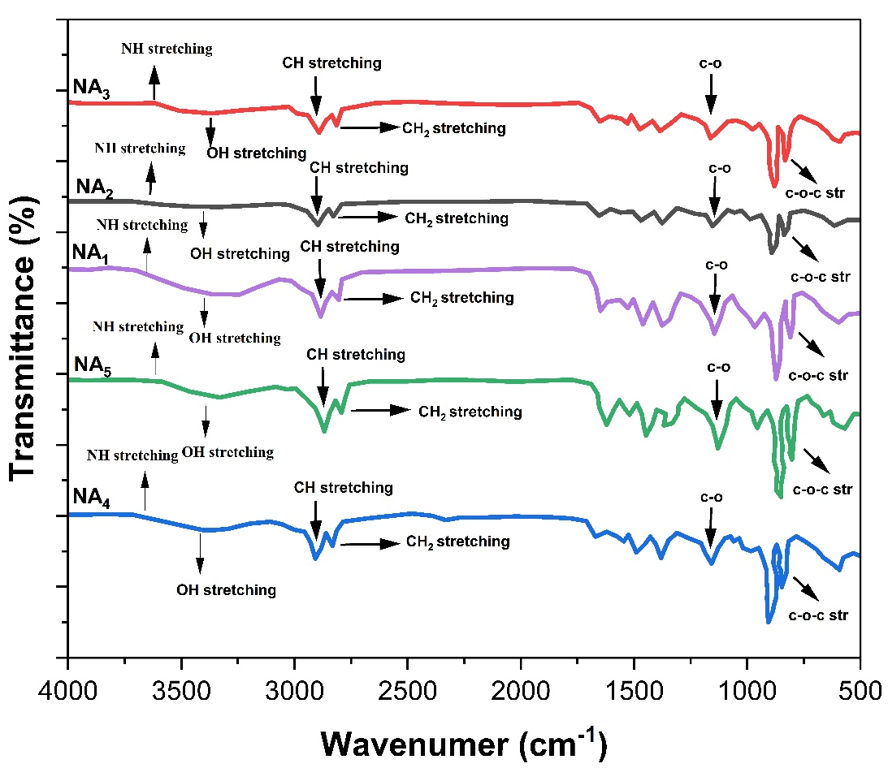
Figure. 3. 2: FTIR spectra of all the final PUEs (NAI, NA2, NA3, NA4, and NA5) based on nano curcumin and ZnO NPs.
Strong evidence regarding PUE formulation through observing bending vibrations of NH at 1597 cm and absorption band of C-O-C stretching at 960.44 cm which corresponds to the connection among -NCO and OH groups for urethane bond formation. Higher stretching of NH stretching band in NA2 extended with the equal concentration of nano curcumin and ZnO NPs. A slight increase in the peak intensity from NAI to NA5 suggests the H-bonding in the polymer chain. It is noteworthy that in PUE, the NH group could develop H-bonding of HS with oxygen of-C-O groups. This H-bonding works as a physical cross-linker which leads to restriction of motion in the polymeric chain segments.

