IDENTIFICATION OF BACTERIA FROM POULTRY (CHICKEN) MEAT
ABSTRACT

Chicken is a nutritious, healthy food which is low in fat and cholesterol compared to the other meats But an excellent source of protein. Meat must be of a high microbiological quality in order to ensure that the consumer receives a product that is not spoilt or does not carry food-borne disease. Food-borne diseases associated with the consumption of poultry meat and its processed products are of public health significance worldwide.
Poultry meat can be contaminated with variety of microorganisms, including those capable of spoiling the product during chill storage, and certain food-borne pathogens. Human illness may follow from handling of raw meat, undercooking or mishandling of the cooked product.
Chicken meat can be contaminated by microorganisms anywhere in the supply chain, from farm to market, and these microorganisms can be transmitted to humans through direct contact, contact with the environment, and food consumption. The microbial contamination has a serious impact on public health. This study aimed to analyze the microbial contamination of chicken meat sampled from local markets in Siddipet.
A total of 4 samples of fresh chicken meat obtained from 4 local markets (Fresh chicken market, Madhina chicken market, Sony chicken market, Quality chicken market) one sample per market were examined for the presence of bacteria. Salmonella spp., and Escherichia coli were identified using Gram staining, culturing, and biochemical tests.
Most chicken meat samples were positive for Salmonella spp. (75%), and E. coli (25%).
High microbial contamination was found in all the chicken meat sampled from local markets in Siddipet. Such contamination can lead to foodborne diseases. so, proper hygiene and sanitation standards should be followed from slaughterhouses to the end-users.

Keywords: Chicken meat, microbial contamination, local markets, public health.
INTRODUCTION
Poultry meat products are widely consumed worldwide due to their high nutrition level, relatively low-cost production, and short cooking process . Chickens are raised for meat and serve as a low-acid food that is rich in nutrients, phosphorus, other minerals, and B-complex vitamins . Chicken is an excellent source of animal protein with low lipid content and high biological value, which contains all the essential amino acids and unsaturated fatty acids required for a human diet . Chicken meat is widely popular in Indonesia, where an average of 1.11 million tons of it is consumed per year, with production reaching 1.48 million tons per year. Chicken meat is an affordable source of animal protein, yet it is also easily damaged, as the rapid growth of microorganisms can alter its quality.
Fresh chicken meat is highly perishable due to its physical and chemical properties. Its abundance of nitrogenous compounds, lipids, carbohydrates, and vitamins, and its high water holding capacity allow the establishment of a suitable environment for microbial growth . Several pathogenic microorganisms, such as Salmonella spp., Campylobacter spp., Staphylococcus aureus, Escherichia coli, and Listeria spp., have been found to contaminate poultry . Diseases originating from animals can spread to humans through indirect environmental contact, direct contact, and/or food consumption . Foodborne illnesses worldwide are caused by foodborne microbial pathogens, which endanger food safety due to the risk of ingesting food, primarily animal products, that are contaminated with vegetative pathogens or their toxins.
Most of these microbes have zoonotic importance, as they can significantly impact both public health and economic sectors . Rortana et al. reported the prevalence of Salmonella spp. and S. aureus in chicken meat in Cambodia at 40.4% and 46.2%, respectively. A study by Mashak revealed that 16.25% of chicken meat from Alborz, Iran, was positive for E. coli. The previous studies also stated that several chicken meat samples from local markets in Indonesia presented microbial contamination, which included S. aureus (6.7%) , Salmonella spp. (85%) , and E. coli (90.03%) . The contamination of poultry products including raw broiler meat by pathogenic microorganisms, especially bacteria, has become one of the most challenging problems in the food industry worldwide .
Poultry meat can be contaminated by different types of microorganisms during operations at meat-processing plants . Contamination can occur during processing, contact with the facility’s equipment (e.g., grinders, belts, and saws), contact with food handlers (e.g., hand contact and knives), and exposure to other environmental sources (e.g., air and water) . The number of bacteria contaminating poultry carcasses may decrease or increase between different processing steps at the plants .Various diseases caused by S. aureus, E. coli, and Salmonella spp. can develop due to a lack of public knowledge and awareness, especially among traders for safety, health, quality, and halal classification, during the process of meat handling and distribution .This study aimed to analyze microbial contamination in chicken meat samples from several local markets in the Siddipet region.
The main public health and economic problem is food borne disease which increase worldwide particularly in individuals eat meal outside their home ,due to uncontrolled hygienic preparation of these type of the food ,food borne disease was define according to WHO, infectious ortoxic nature of the disease occur through consumption of contaminated food (le Loir et al 2003). Food borne diseases(FBD) were affected one third population every year world wide. In the developing countries and developed countries such as in USA in which billions of dollars were spent in the treatment of food borne pathogens that affected approximately 48millions patients each year (Scallan et al., 2011). However, the main source of food borne disease are the animals (Busani et al 2006), these disease cause huge public health and economic problems (Gajadhar and Allen 2004), high mortality (2.2 million individual dead)in human population was occur by food and water borne diarrheal disease every year (FAO/WHO 2006).
Due to rapidly increasing in human population and changing in urbanization food habits, increasing in animal products consumption such as meats were recorded , at year 2030,FAO suspected consumption of meats and milk products would significantly increase associated with mass production and movement meat products, globally in meats production(FAO,2006), these condition may lead to give a good chance for food contamination and spread food borne pathogens that animal origin which including Sallmonella spp, Campylobacter, E.coli, Staphylococcus spp, Closytidium, Yersinia, Listeria, Acrobacter, Mycobacterium, Trichinella, Sarcocystis, Toxoplasma gondii and Cryptosporidium parvum (Dhama et al., 2013).
Beef and chicken meat contaminated with fecal organisms may considered essential food hygiene problem particularly Enterobacteriaceae including Salmonella spp, E.coli, Proteus as well as Klebsiella spp (Paterson 2006). Malpractices handling of poultry meat lead to food contamination with food borne microbes ,in addition poultry may considered important food borne pathogen reservoir such as Salmonella spp and Campylobacter enteritis.
Contamination of poultry meat with foodborne pathogens is an important public health problem, where many food poisoning bacteria contaminate chicken meat . Salmonella spp. and Escherichia coli (E. coli) causes health problems in the world because they are the two most important foodborne pathogens of Enterobacteriaceae family as a cause of foodborne illness which transmitted through poultry meat. Salmonella is the second most common cause of foodborne illness, it is responsible for millions of cases of foodborne illness every year. Salmonella could infect and caused food poisoning in humans through the handling of raw carcasses and their products, or through the consumption of undercooked poultry meat . E. coli, a natural inhabitant of the human intestinal tract and warm-blooded animals, is used as an indicator bacterium because these bacteria acquires antimicrobial resistance faster than other conventional bacteria .
Diarrheal diseases caused by E. coli account for more than 4% of the total daily global disease burden every day and about 1.8 million deaths occur every year, of which 90% are children . Food safety is an issue of growing public health concern , especially foodborne diseases associated with the consumption of poultry meat and its processed products . During and after slaughtering, the bacteria from animal microbiota, the slaughterhouse environment, and the equipment used contaminate carcasses, their subsequent cuts, and processed meat products. Carcasses and cuts after animal killing could be contaminated by animal microbiota and the slaughterhouse environment . Some of these bacterial contaminants can grow or survive during food processing and storage. Previous research , indicated that Salmonella spp. and E. coli found in chicken meat at traditional markets in Surabaya were resistant to some antibiotics. Thus, it is important to evaluate the source of Salmonella spp. and E. coli contamination at slaughtering place from traditional market. The purpose of this study was to compare the presence of Salmonella spp. and Escherichia coli in chicken meat, from traditional market in Siddipet.

METHODOLOGY
a. Collection of samples:
The samples were collected on the day of the experiment from the local chicken markets of Siddipet in the closed containers which were brought to the microbiology laboratory of Government Degree College (Autonomous), Siddipet and then slit the meat into small layers and isolations were done by the spread plate methods . The meat which is used in the experiment Were collected from Fresh chicken market, Madina chicken market, Sony chicken market, Quality chicken market near our college surroundings.
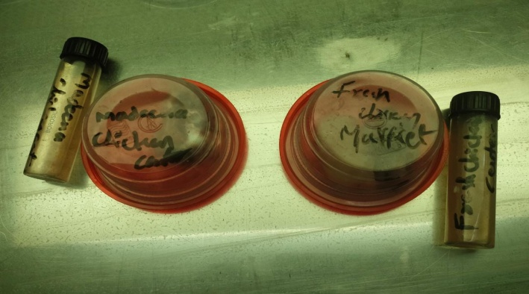
Fig : Samples of Poultry meat

b. Isolation and enumeration of bacteria:
The nutrient agar was prepared in 500ml flask and was sterilized by autoclaving at 121oC at 15 psi for 20 minutes. 20 ml of the media was poured in the petri plates before getting solidified. The chicken meat (layer) were placed on the petri plates. The plates were incubated at 37°C for 24 hours. The plates were then observed for growth and a colonial description of the isolates.
The nutrient agar medium was used in the study for isolation of the bacteria. The sampling was done at regular intervals of time as mentioned for each sample respectively. The cultures were incubated at 37C° and checked for bacterial growth at 24 hours. Separate colonies were sub cultured onto nutrient agar to obtain pure culture. Morphological Characteristics of colonies and gram stain tests and biochemical tests were , according (Ramos, 2004; Ekrakene and Igeleke 2009) that used for bacterial identification.
c. Maintenance of pure cultures:
Selected colonies were again sub‐ cultured on nutrient agar in petri‐ plates to isolate pure culture. After isolating pure cultures, bacterial isolates were further identified and characterized by size and shape and Gram staining of colonies. The bacterial colonies that appeared on the agar are transferred on to the slants of the same composition and incubated at the same optimized conditions.
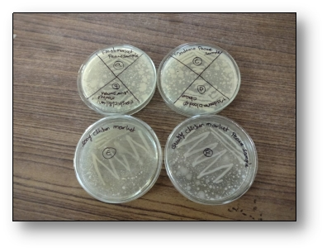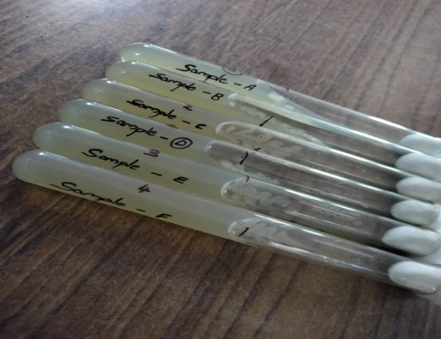
Fig : Cultured plates and slants

d. Characterization of bacterial isolates:
The isolates were characterized based on their morphological, biochemical, cultural and physiological features.
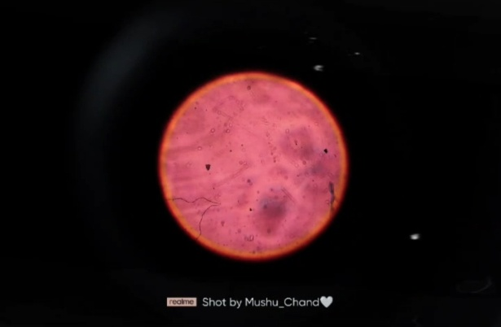
Fig : Cocci under Microscope

e. Biochemical characterization:
Biochemical characterization of isolates was done by conducting different biochemical tests including IMV_{i}C, H₂S production, casein hydrolysis, starch hydrolysis, gelatin hydrolysis, lipid hydrolysis, melanin production and nitrate reduction were performed.
f. Meat collection:
Meat samples collected from Fresh chicken market, Madina chicken market, Sony chicken market, Quality chicken market of siddipet, near our college surroundings.

FINDINGS
In the present investigation the samples are collected and were examined in the laboratory. On the day of sample collection the sample was examined and 100X 10⁶ CFU/ml colonies are observed after a day of incubation. Bacteria isolated from sample include Stayphylococcus aureus , E coli , Pseudomonas aeruginosa, Staphylococcus epidermidis, Salmonella typhi, Clostridium perfringens.
In the Table: 1 Four meat samples were collected in a closed container from our college surroundings. The meat samples were collected from Fresh chicken market, Madina chicken market, Sony chicken market, Quality chicken market. We have collected a single sample from each chicken market.
In the Table: 2 That the Quality chicken market meat has highest number of colonies ( 47X10⁶ CFU/ml), next was observed in Sony chicken market meat (43X 10⁶ CFU/ml), next was observed in Fresh chicken market meat (40X10⁶CFU/ml) and lowest number of colonies occupied by Madina chicken market meat (38X10⁶ CFU/ml).
The isolates were named from sample and are given in Table: 3 And they were identified as Poultry bacteria-1 (PB₁), Poultry bacteria-2 (PB₂), Poultry bacteria-3 (PB₃), Poultry bacteria-4 (PB₄), Poultry bacteria-5 (PB₅), Poultry bacteria-6 (PB₆), Poultry bacteria-7 (PB₇).
In the Table: 4 The isolates were characterized based on their morphological, biochemical and cultural, physiological features.
In the Table: 5 The isolates were identified as Staphylococcus Aureus, Pseudomonas aeruginosa, E.coli, Salmonella typhi, Staphylococcus epidermidis, Clostridium perfringens.
After pouring these samples into the wells, prepared in NAM plates using gel diffusion assay. They exhibited different zones of inhibitions.
In the Table: 6 Most of them have inhibitory zone 10mm other have shown moderate inhibitory action. Highest zone of inhibition (18mm) was shown by Fresh chicken market meat for Staphylococcus aureus. And lowest zone of inhibition (09mm) was shown by Quality chicken market meat for E coli.
In the Table: 7 Highest zone of inhibition (15mm) was shown by Madina chicken market meat for staphylococcus epidermidis And lowest zone of inhibition (08mm) was shown by Sony chicken market meat for salmonella typhi.
In the Table: 8 Highest zone of inhibition (17mm) was shown by Fresh chicken market meat for Staphylococcus aureus. And lowest zone of inhibition (09mm) was shown by Quality chicken market meat for E coli.
TABLE : 1 ISOLATION
S.No | Samples | Number of samples
 | Fresh Chicken Market | 1
 | Madina Chicken Market | 1
 | Sony Chicken Market | 1
 | Quality Chicken Market | 1

TABLE : 2 ENUMERATION OF BACTERIAL ISOLATES FROM POULTRY (CHICKEN) MEAT
S.No | Samples | Colonies X 10⁶(cfu/ml)
1. | Fresh Chicken Market | 40
2. | Madina Chicken Market | 38
3. | Sony Chicken Market | 43
4. | Quality Chicken Market | 47

TABLE : 3 SHOWING SOURCE DATA
S.No | Source
1. | Poultry bacteria-1(PB₁)
2. | Poultry bacteria-2(PB₂)
3. | Poultry bacteria-3(PB₃)
4. | Poultry bacteria-4(PB₄)
5. | Poultry bacteria-5(PB₅)
6. | Poultry bacteria-6(PB₆)
7. | Poultry bacteria-7(PB₇)

TABLE : 4 MORPHOLOGICAL AND BIOCHEMICAL CHARACTERISATION OF BACTERIAL ISOLATES
Isolates | Gram staining | Shape | Indole | Catalyse | Urease | Citrate | MR | VP | Oxidase | Glucose | Lactose
PB₁ | + | Cocci | - | + | + | + | + | + | - | + | +
PB₂ | - | Rod | - | + | - | + | - | - | + | - | -
PB₃ | - | Rod | + | + | - | - | + | - | - | + | +
PB₄ | + | Cocci | - | + | + | - | - | + | - | + | +
PB₅ | - | Rod | + | + | - | - | + | - | - | + | +
PB₆ | - | Rod | - | + | - | - | + | - | - | + | -
PB₇ | + | Rod | - | - | * | - | * | * | - | + | +
TABLE : 5 IDENTIFICATION OF BACTERIAL ISOLATES
S.No | Isolates | Identification
1. | PB₁ | Staphylococcus
2. | PB₂ | Pseudomonas
3. | PB₃ | E.coli
4. | PB₄ | Staphylococcus
5. | PB₅ | E.coli
6. | PB₆ | Salmonella
7. | PB₇ | Clostridium

TABLE : 6 ANTIBIOTIC SENSITIVITY TEST
S.No | Isolates | Inhibition zones of Amoxyllin(mm)
1. | PB₁ | 18(mm)
2. | PB₂ | 10(mm)
3. | PB₃ | 13(mm)
4. | PB₄ | 16(mm)
5. | PB₅ | 09(mm)
6. | PB₆ | 15(mm)
7. | PB₇ | 11(mm)
TABLE : 7 ANTIBIOTIC SENSITIVITY TEST
S.No | Isolates | Inhibition zones of Doxycycline(mm)
1. | PB₁ | 14(mm)
2. | PB₂ | 11(mm)
3. | PB₃ | 10(mm)
4. | PB₄ | 15(mm)
5. | PB₅ | 13(mm)
6. | PB₆ | 08(mm)
7. | PB₇ | 13(mm)
TABLE : 8 ANTIBIOTIC SENSITIVITY TEST
S.No | Isolates | Inhibition zones of Penicillin(mm)
1. | PB₁ | 17(mm)
2. | PB₂ | 10(mm)
3. | PB₃ | 14(mm)
4. | PB₄ | 15(mm)
5. | PB₅ | 09(mm)
6. | PB₆ | 11(mm)
7. | PB₇ | 10(mm)
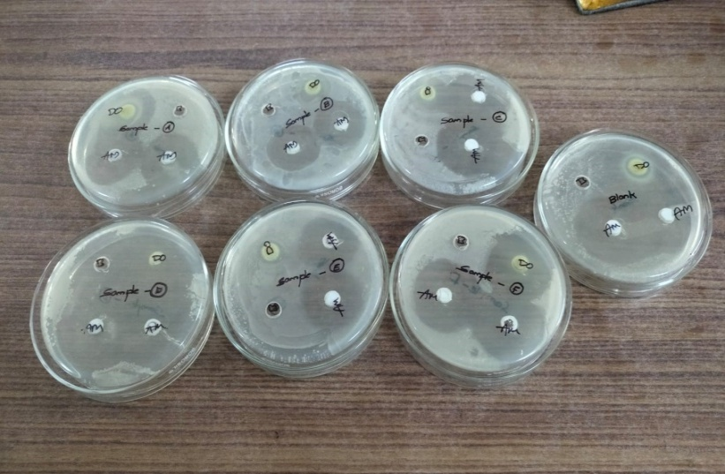
Fig 6: Antibiotic Sensitivity test

CONCLUSION
From the data acquired in this study, it can be concluded that the presence of Staphylococcus aureus is higher than the Escherichia coli in chicken meat. High microbial contamination was found in all the chicken meat sampled from local markets in Siddipet. Such contamination can lead to foodborne diseases. so, proper hygiene and sanitation standards should be followed from slaughterhouses to the end-users.
The poultry meat sector tends to provide ready to eat products, which are safe for the consumer and have a long shelf life. The biological hazards associated with poultry meat production and consumption have been well identiﬁed, ranking Campylobacter spp. and Salmonella spp. as a highrisk. Such ranking took the severity of the illnesses caused by these pathogens, their impact on human health, the number of cases, and the occurrence of the risk in the poultry meat production chain into account.
Consequently, the impact of various treatments (temperature, chemical treatment,marinade, or preservation processes) in reducing pathogens has been investigated. Many studies have also been conducted to test such treatments for extending the shelf life and avoiding spoilage.
The large number of publications dedicated to poultry meat microbiology and the variety of the results highlight the wide diversity of the microbiological status of poultry meat products. The bacterial loads can vary by several log CFU/g for similar cuts, stored under similar conditions. To date, the microbial ecology of poultry meat products has been considered mainly through cultural methods, which can introduce a bias because of the relative selectivity of the media used.

REFERENCES
1.Huang, X. and Ahn, D.U. (2018) The incidence of muscle abnormalities in broiler breast meat: A review. Korean J. Food Sci. Anim. Resour., 38(5): 835-850.
2. Gamble, H.R. (2015) Trends in food production practices relative to foodborne parasites. In: Foodborne Parasites in the Food Supply Web. Woodhead Publishing, Sawston, United Kingdom. p11-22.
3. Takma, D.K. and Korel, F. (2019) Active packaging films as a carrier of black cumin essential oil: Development and effect on quality and shelf-life of chicken breast meat. Food Packag. Shelf Life, 19 : 210-217.
4. Karamah, E.F. and Wajdi, N. (2018) Application of ozonated water to maintain the quality of chicken meat: Effect of exposure time, temperature, and ozone concentration. Vol. 67. In: E3S Web of Conferences. p04044.
5. Odeyemi, O.A., Alegbeleye, O.O., Strateva, M. and Stratev, D. (2020) Understanding spoilage microbial community and spoilage mechanisms in foods of animal origin. Compr. Rev. Food Sci. Food Saf., 19(2): 311-331.
6. Bhaisare, D.B., Thyagarajan, D., Churchil, R.R. and Punniamurthy, N. (2014) Bacterial pathogens in chicken meat: Review. Int. J. Life Sci. Res., 2(3): 1-7.
7. Chlebicz,A.and Sli Zewska, K.(2018) Campylobacteriosis,salmonellosis, yersiniosis, and listeriosis as zoonotic food-borne diseases: A review. Int. J. Environ. Res. Public Health, 15(5): 1-28.
8. Abebe, E., Gugsa, G. and Ahmed, M. (2020) Review on major foodborne zoonotic bacterial pathogens. J. Trop. Med., 2020 : 4674235.
9. Rortana C., Nguyen-Viet H., Tum S., Unger F., Boqvist S., Dang-Xuan S., Koam S., Grace D., Osbjer K., Heng T., Sarim S., Phirum O., Sophia R. and Lindahl J.F. (2021) Prevalence of Salmonella spp. and Staphylococcus aureus in chicken meat and pork from Cambodian markets. Pathogens, 10(5): 556.
10. Mashak,Z.(2018) Prevalence and antibiotic resistance of Escherichia coli O157: H7 isolated from raw meat samples of ruminants and poultry. J. Food Nutr. Res., 6(2): 96-102.
11. Karisma U., Wiqoyah N. and Pusarawati S. (2021) Prevalence of Escherichia Coli, Salmonella spp. Staphylococcus aureus bacteria in chicken meat of traditional market Surabaya city. J. Ilmu Teknol. Kesehatan, 8(2): 193-204.
12.Yulistiani R., Praseptiangga D., Supyani and Sudibya.(2019) Occurrences of Salmonella spp. and Escherichia coli in chicken meat, intestinal contents and rinse water at slaughtering place from traditional market in Surabaya, Indonesia. Vol. 633. In: IOP Conference Series: Materials Science and Engineering. p012007.
13. Wardhana, D.K., Effendi, M.H., Harijani, N. and Hong-Kean, O. (2020) Detection of extended-spectrum-beta-lact-amase (ESBL) producing Escherichia coli in meat chicken from traditional market in Surabaya, East Java, Indonesia. Indian J. Public Health Res. Dev., 11(1): 1353-1357.
14. Pesewu G.A., Quaynor E.B., Olu-Taiwo M.A., Anim-Baidoo I. and Asmah R.H. (2018) Bacterial contaminants of raw broiler meat sold at Korle-Gonno, Accra, Ghana. Int. Food Res. J., 25(4): 1758-1762.
15. Maharjan, S., Rayamajhee, B., Chhetri, V.S., Sherchan, S.P., Panta, O.P. and Karki, T.B. (2019) Microbial quality of poul-try meat in an ISO 22000: 2005 certified poultry processing plant of Kathmandu valley. Int. J. Food Contam.
16. Kim, J.H. and Yim, D.G. (2016) Assessment of the microbial level for livestock products in retail meat shops implementing HACCP system. Korean J. Food Sci. Anim. Resour., 36(5): 594-600.
17.Althaus, D., Zweifel, C. and Stephan, R.(2017) Analysis of a poultry slaughter process: Influence of process stages on the microbiological contamination of broiler carcasses. Ital. J. Food. Saf., 6(4): 7097.
18. Soepranianondo, K., Wardhana, D.K., Budiarto and Diyantoro. (2019)Analysis of bacterial contamination and antibiotic residue of beef meat from city slaughterhouses in East Java province, Indonesia. Vet. World, 12(2): 243-248.
19. Jawetz, E., Melnick, J.L. and Adelberg, E.A. (2007) Medical Microbiology. 24th ed. McGraw-Hill, New York.
20. Savariraj, W.R., Ravindran, N.B., Kannan, P. and Rao, V.A. (2020) Occurrence and enterotoxin gene profiles of Staphylococcus aureus isolated from retail chicken meat. Food Sci. Technol. Int., 27(7): 619-625.
21. Hassanein, R., El-Malek, S.F.H., Mohamed, A.M.A. and Elsayh, K.I. (2011) Detection and identification of Salmonella Species in minced beef and chicken meats by using multiplex PCR in Assiut city. Vet. World, 4(1): 5-11.
22. Ishihara, K., Nakazawa, C., Nomura, S.S., Elah, S., Yamashita, M. and Fujikawa, H. (2020) Effects of climatic elements on Salmonella contamination in broiler chicken meat in Japan. J. Vet. Med. Sci., 82(5): 646-652.
23. Supryatno, A., Hadi, U.K. and Murtini, S. (2018) Potency of cockroaches (Periplaneta americana and Blattella germanica) on the ship as vector of salmonellosis in Baubau port. J. Indones. Vet. Res., 2(2): 63-69.
24. The National Standardization Agency of Indonesia (Badan Standarisasi Nasional-BSN). (2009) Maximum Limit of Microbial Contamination in Food, SNI 7388: 2009. Jakarta, Indonesia: The National Standardization Agency of Indonesia (Badan Standarisasi Nasional-BSN). p10-11.
25. Álvarez-Astorga, M., Capita, R., Alonso-Calleja, C., Moreno, B., Del, M.and Garcı́a-Fernández, C. (2002) Microbiological quality of retail chicken by-products in Spain. Meat Sci., 62(1): 45-50.
26. Kim, Y.B., Seo, K.W., Jeon, H.Y., Lim, S.K. and Lee, Y.J. (2018) Characteristics of the antimicrobial resistance of Staphylococcus aureus isolated from chicken meat produced by different integrated broiler operations in Korea. Poult. Sci., 97(3): 962-969.
27. Seok, K. and Bohach, G.A. (2007) Staphylococcus aureus. In: Doyle, M.P. and Beuchat, R.L., editors. Food Microbiology: Fundamentals and Frontiers. 3rd ed. ASM Press, Washington DC. p493.
28. Capita, R. and Alonso-Calleja, C. (2013) Antibiotic-resistant bacteria: A challenge for the food industry. Crit. Rev. Food Sci. Nutr., 53(1): 11-48.
29. Buzon-Duran, L., Alonso-Calleja, C., Riesco-Pelaez, F. and Capita, R. (2017) Effect of sub-inhibitory concentrations of biocides on the architecture and viability of MRSA bio-films. Food Microbiol.,65 :294-301.
30. Endale, B.G. and Hailay, G. (2013) Assessment of bacterio-logical quality of meat contact surfaces in selected butcher shops of Mekelle city, Ethiopia. J. Environ. Occup. Sci., 2(2): 61-66.
31. Ruban, S.W. and Fairoze, N. (2011) Effect of processing conditions on microbiological quality of market poul-try meats in Bangalore, India. J. Anim. Vet. Adv., 10(2): 188-191.
32.Chen,T.,Jiang,J.,Ye,C.,Xie,J.,Chen,X.,Xu,D.,Zeng,Z.,Peng, Y., Hu, D.L. and Fang, R. (2019) Genotypic characterization and antimicrobial resistance profile of Salmonella isolated from chicken, pork and the environment at abattoirs and supermarkets in Chongqing, China. BMC Vet. Res., 15(1 ):456.
33. Zishiri, O.T., Mkhize, N. and Mukaratirwa, S. (2016)Prevalence of virulence and antimicrobial resistance genes in Salmonella spp. isolated from commercial chickens and human clinical isolates from South Africa and Brazil. Onderstepoort. J. Vet. Res. 83(1): a1067.
34. Pires, S.M., Vieira, A.R., Hald, T. and Cole, D. (2014) Source attribution of human salmonellosis: An overview of methods and estimates. Foodborne Pathog. Dis., 11(9): 667-676.
35. Fallah,S.H.Asgharpour,F.,Naderian,Z. and Moulana, Z.(2013) Isolation and determination of antibiotic resistance patterns in non-typhoid Salmonella spp isolated from chicken. Int. J. Enteric Pathog., 1(1): 17-21.
36. Cabral, C.C., Conte-Junior, C.A., Silva, J.T. and Paschoalin, V.M.F. (2014) Salmonella spp. contamination in fresh pork and chicken sausages marketed in Niteroi and Rio deJaneiro,Brazil. J. Verbrauch Lebensm., 9(3): 243-249.
37. Foley, S.L., Nayak, R., Hanning, I.B., Johnson, T.J., Han, J. and Ricke, S.C. (2011) Population dynamics of Salmonella enterica serotypes in commercial egg and poultry production. Appl. Environ. Microbiol., 77(13): 4273-4279.
38. Antunes, P., Mourao, J., Campos, J. and Peixe, L. (2016) Salmonellosis: The role of poultry meat. Clin. Microbiol. Infect., 22(2): 110-121.
39. Ayodele, O.A., Deji-Agboola, A.M., Akinduti, P.A. and Faneye, A.O. (2019) Phylo-diversity of prevalent human E. coli O157: H7 with strains from retailed meat and fish in selected markets in Ibadan Nigeria. J. Immunoassay Immunochem., 41(2): 117-131.
40. Rahman, M.M., Husna, A., Elshabrawy, H.A., Alam, J., Runa, N.Y., Badruzzaman, A.T.M., Banu, N.A., AlMamun, M., Paul, B., Das, S., Rahman, M.M., Mahbub-E-Elahi, A.T.M., Khairalla, A.S. and Ashour, H.M. (2020) Isolation and molecular characterization of multidrug-resistant Escherichia coli from chicken meat. Sci. Rep., 10(1): 21999.
41.Rahmahani, J., Salamah, Mufasirin, M., Tyasningsih W.,and Effendi M.H. (2020) Antimicrobial resistance profile of Escherichia Coli from cloacal swab of domestic chicken in Surabaya traditional market. Biochem. Cell Arch., 20(1): 2993-2997.

PHOTOGRAPHY
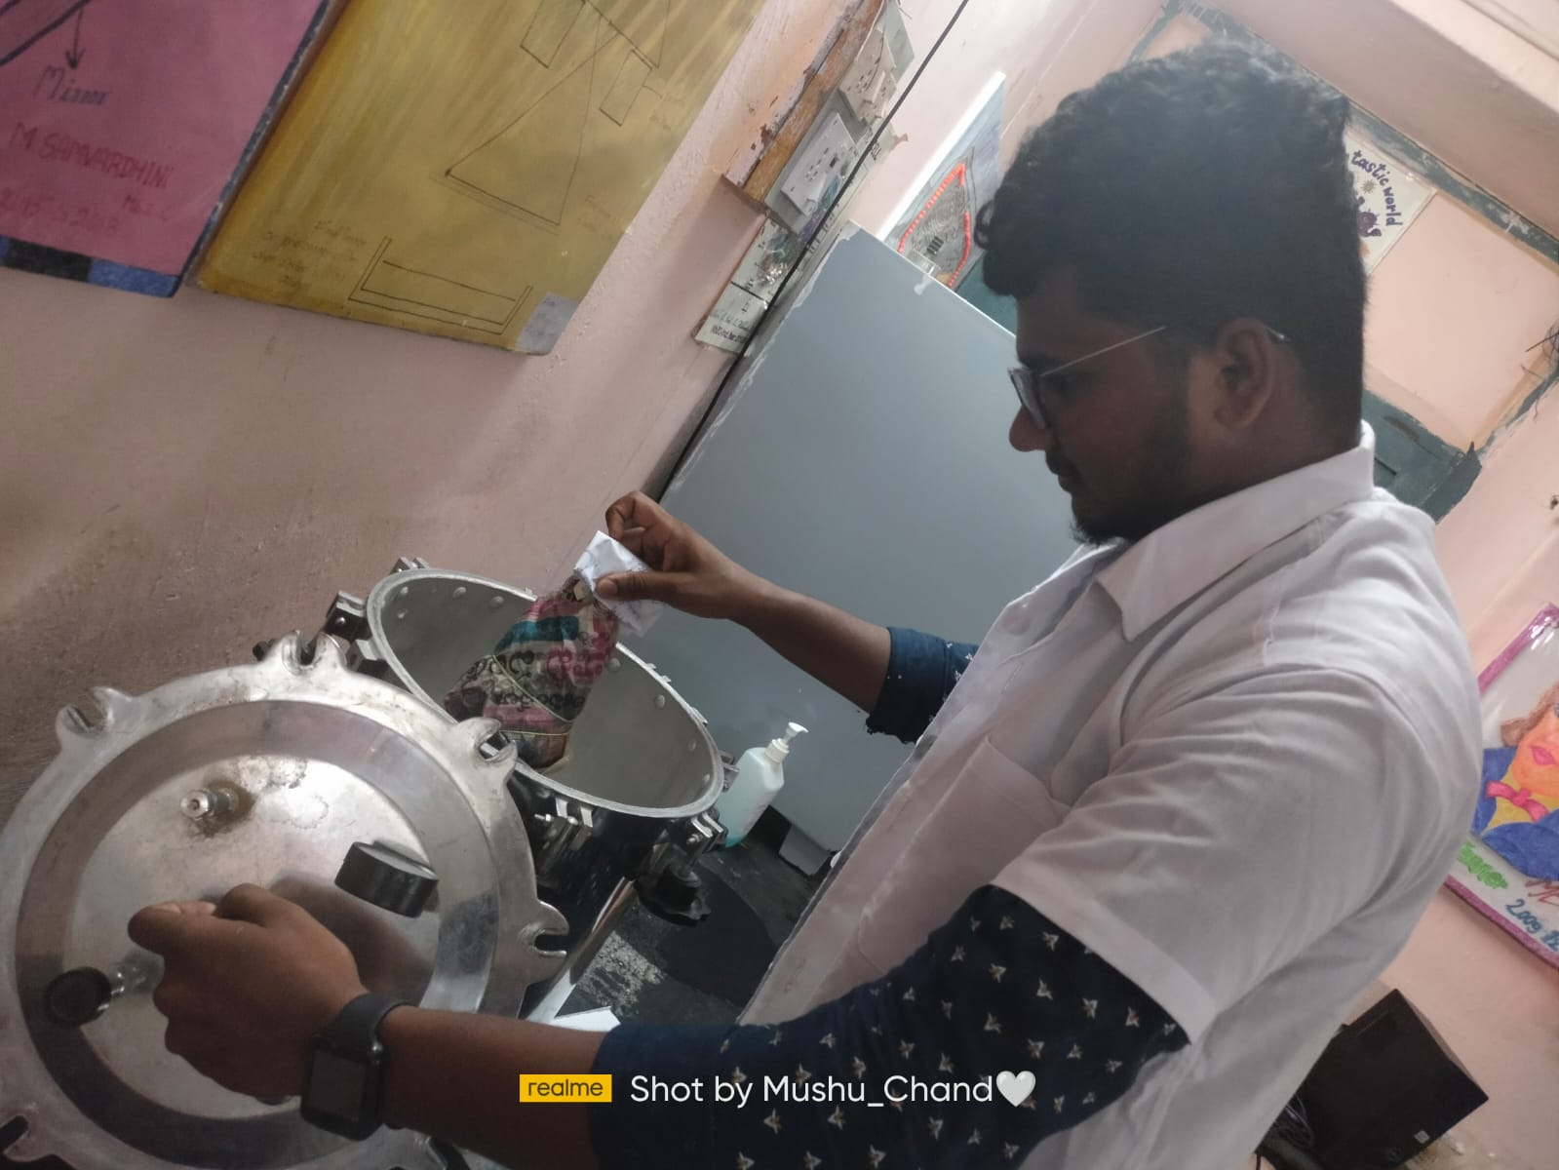
Fig 7 : Autoclaving
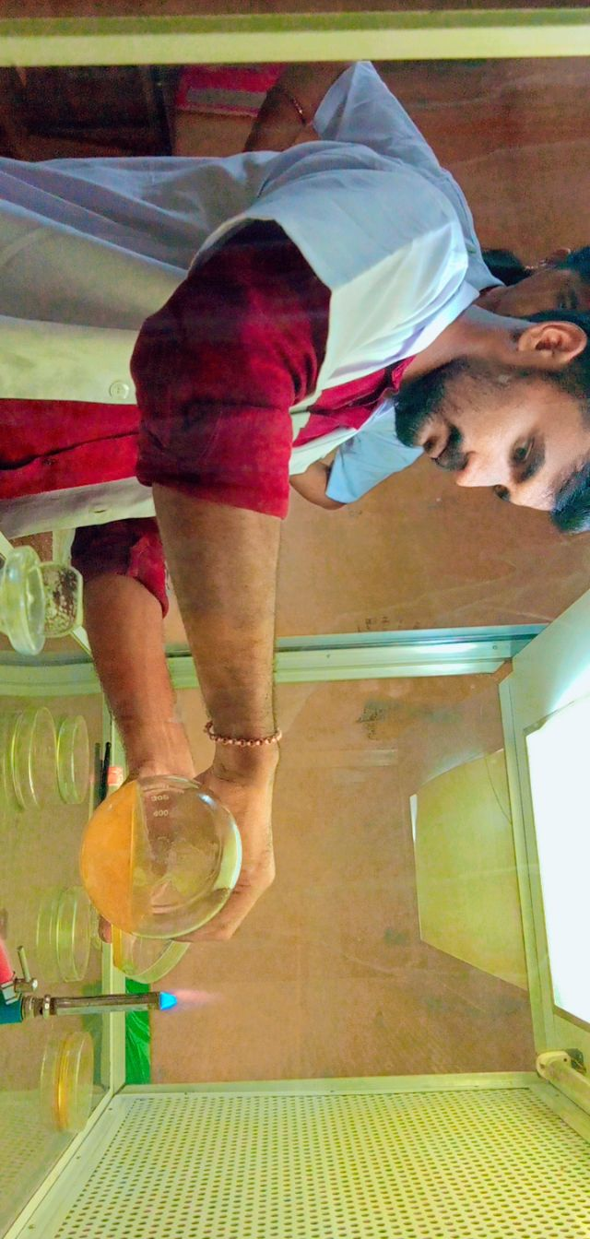
Fig 8 : Pouring media to plates
Fig 9 : Streaking on the plates

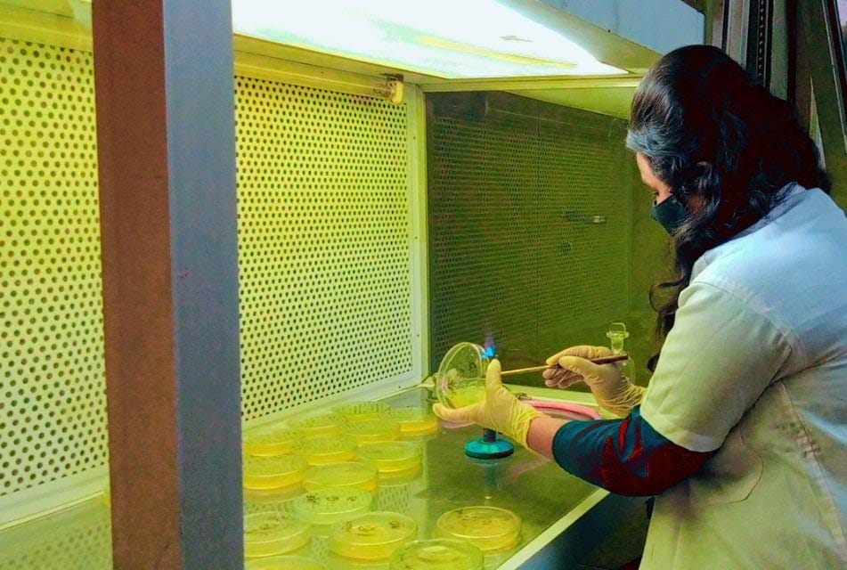
Fig 9 : streaking on the plates
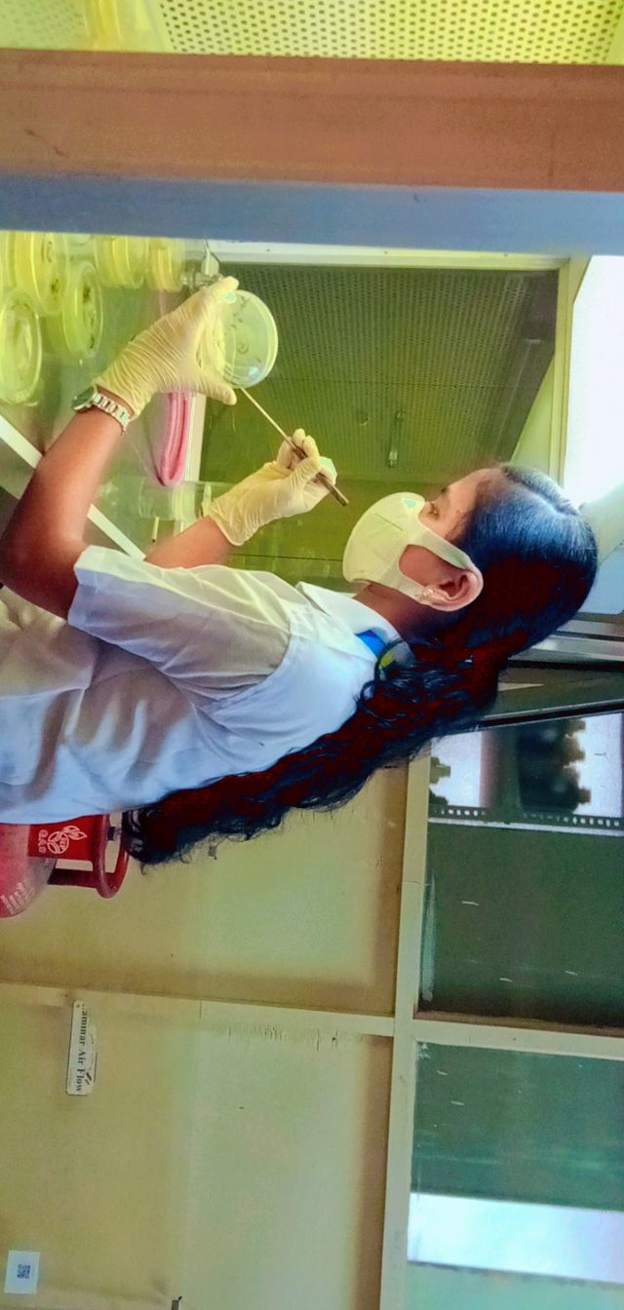
Fig 10 : Streaking on the plates

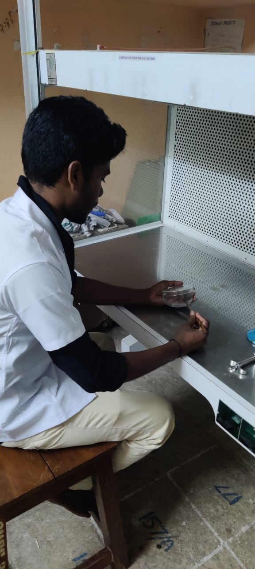
Fig 11 : Streaking

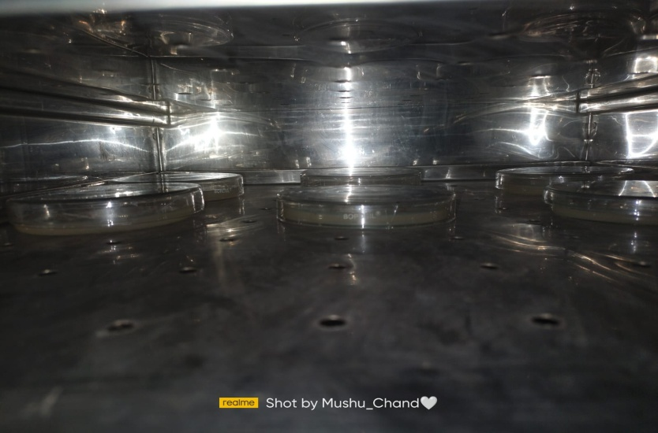
Fig 12 : Incubation

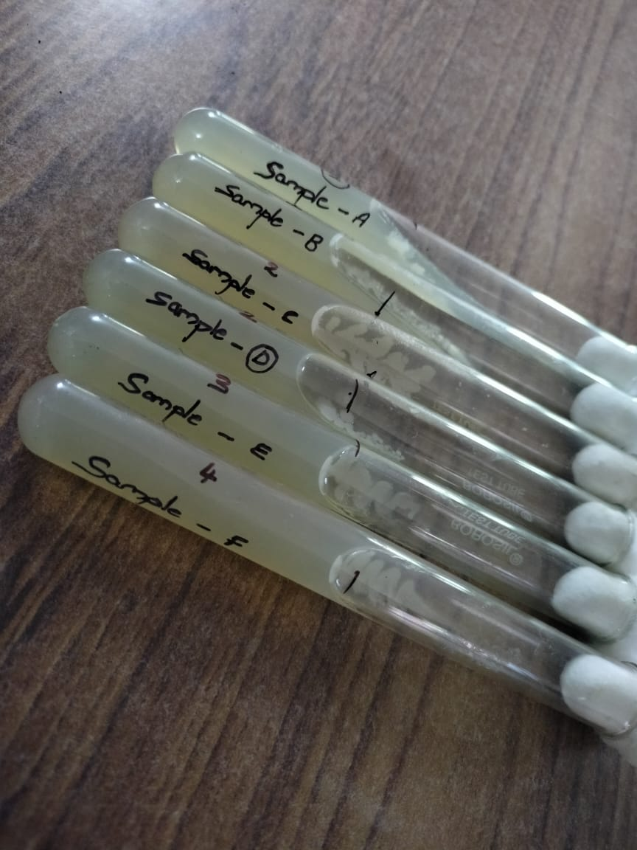
Fig 13 : Cultured Slants

Fig 14 : Cultured plates

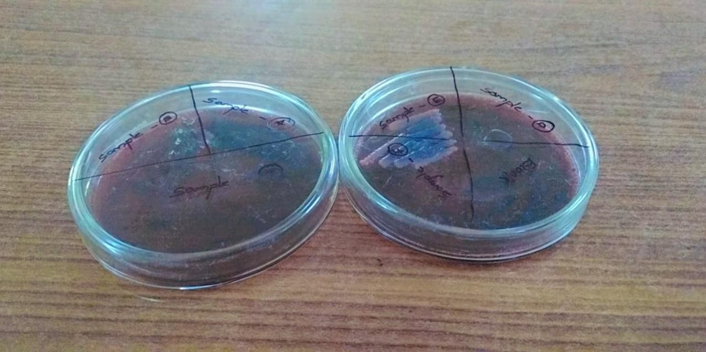
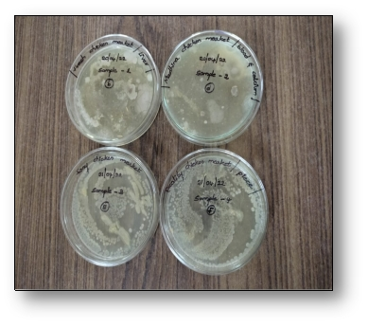
Fig 15 : Cultured plates

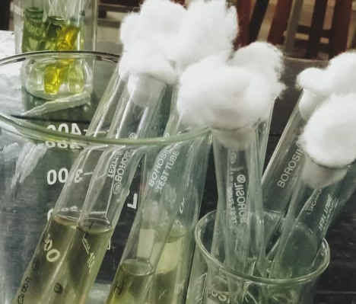
Fig 16 : Urease broth

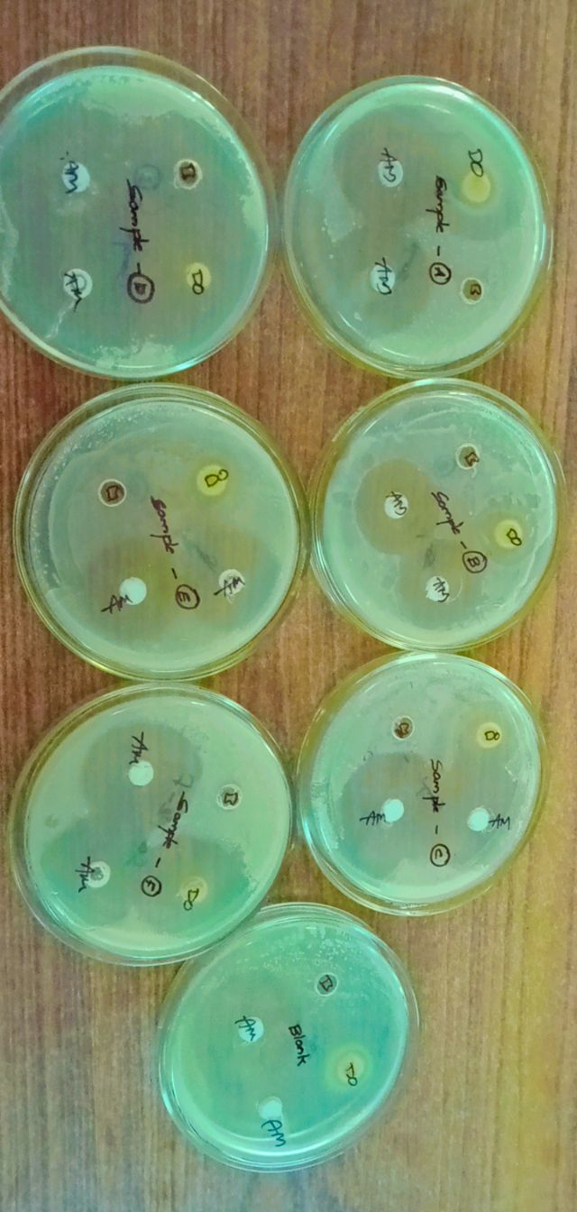
Fig 17: Antibiotic sensitivity test


Fig 18 : Observing slide under microscope

