Your Title
Your Name August 5, 2024

Abstract
This paper deals with chimera states, which result in multi-layer networks where FHN neurons serve as oscillatory units. Chimeras, remarkable creatures where well-synced and randomly synchronizing areas coexist, provide crucial clues about the behavior of complex systems. We use FHN neurons as simplified approximations of actual neuronal behavior to simulate the emerging of chimeras in multi-layer networks. In order to ensure the long-range connections between FHN neurons, we implement nonlocal connections. Hereby, intricate dynamic patterns are manifested. The basis of our evaluation is composed of frequency analysis, spatial correlations, Lyapunov exponent calculations, and phase response curve (PRC) studies. These studies address spatiotemporal properties, synchronization, spatial organization, and complexity of chimera states over the multilayer network structure. As well, we accentuate that our results cover a broad range of fields such as neuroscience for mapping the brain’s dynamic structure and network science for unraveling the complex behaviors in interconnected systems. The insights from our study have future ramifications which include social networks modeling and power grids analysis.
Keywords: Chimera states, FitzHugh-Nagumo (FHN) neurons, Frequency analysis, Spatial correla- tions, Lyapunov exponent, Phase response curve (PRC).

Introduction
The investigation of complex interaction systems, for instance, biologically autonomous neural network and social network tussles many scientific fields like math- ematics, computer science, medicine, psychology, and many more ¹⁻⁵. Note worthily, traveling across the components of these systems, there is the appearance of the chimeras, where regions of a synchronized os- cillators and others of a desynchronized oscillators coexist ⁶⁻⁸. From states of self-organization to emer- gent behaviors, it is in these systems where fasci- nation ensues and generates interdisciplinary cross- fertilization like neuroscience, physics, and network science⁹⁻¹¹.Through the study, we hope to look into
inter- and intra-layer relationships²⁷⁻²⁹. The inves- tigation provides an idea about the nature of multi- layer chimeras formed by FHN neurons hence let- ting us create a wonderful picture of complex sys- tem dynamics. Hence a more refined and higher level of awareness of the systems and their behavior will be acquired ³⁰⁻³². These notions kind of a techni- cal know-how may be used by field of neuroscience, physics and network science separately³³⁻³⁵.

Theoretical Framework
The system equations are
1
x

the chimera states formation on multi-layer nets using
x˙l,i = xl,i − 3
3
l,i
— yl,i + λCl,x,i

FitzHugh-Nagumo (FHN) neurons as the fundamen-
tal conditions of an analysis¹²⁻¹⁴. The novelty of the FHN model, arising from its ease of operation as well as its capabilities in dynamics analysis of the gen- eral neurons, makes it suitable for the evaluation of these states in the large-scale neural networks¹⁵⁻¹⁷. To achieve this, we think about implementing not only non-local links, but long-range interactions, I order to get more understanding about the patterns and behaviors that are inherent in multi-layer system ¹⁸⁻²⁰. We basically plan to give an overall assessment of the chimera states in multi-layer networks, apply- ing different datasets and mathematical methodolo- gies which we can use²¹⁻²³. With the help of fre- quency analysis, the spatiotemporal features and syn- chronization patterns can be comprehended and the spatial correlation analysis can give a better under- standing of the spatial arrangement of the chimera states (i.e., the spatial organization) ²⁴⁻²⁶. Simi- larly, calculation of the Lyapunov exponent will be advantageous to understand stability and complex- ity. Lastly, studying the response phase curve will be another tool to understand the dynamic phase
y˙_{l,i} = εx_{l,i} + 0.5 + λC_{l,y,i}
Where x˙_{l,i} and y˙_{l,i} are the time derivatives of x_{l,i} and y_{l,i} respectively. The value of ε remains con- stant. For the coupling between layers we use scaling factor λ. Within layer, oscillators are connected by the coupling terms, C_{l,x,i} and C_{l,y,i}, respectively In the model, the tide coupling in layer x and y has the following formulations:
For the x-direction, we define C_{l,x,i} as follows:

N
Σ
C_{l,x,i} = (cos(α)(x_{l,j} − x_{l,i}) + sin(α)(y_{l,j} − y_{l,i}))
j=1

For the y-coordinates, we define C_{l,y,i} by:

N
Σ
C_{l,y,i} = (− sin(α)(x_{l,j} − x_{l,i}) + cos(α)(y_{l,j} − y_{l,i}))
j=1

In the dictionary of layer attributes, (N ) stands for the number of oscillators in a given layer and α is used to refer to the significant parameter for representing the angle.

The x direction has an inter-layer coupling which equals:
ν}. The phase θ_{i} of the units who are limit cycle oscillators can be defined as θ_{i} = arctan(y_{i}/x_{i}).
The local order parameter helps to determine if an

1 3 oscillator is part of the coherent region–where it is

x˙l,i = xl,i + ε∆t(xl,i − 3 xl,i − yl,i + λ · Cl,x,i)
For the direction y, the interaction between layers is given by the following:
y˙_{l,i} = y_{l,i} + ∆t(x_{l,i} + 0.5 + λ · C_{l,y,i})
For numerical integration, ∆t represents the time in- crement used. A layer are the first equations consist- ing of x_{1,i} dynamics, which are represented by:
almost equal to one—or the incoherent domain with
significantly smaller values. Illustrate the chimera state obtained for N = 100 nonlocally coupled FHN units on a ring when P = 80, σ = 0.15, and β = ₂ − 0.1.
π

Results

Incoherent State

x˙_{1,i} = x

1,i
1 3
— 3 x1,i − y

1,i
+ λC

1,x,i
When σ = 0.0, the scenario shows an Incoherent state in the network of oscillators. The strengths of

And y_{1,i} is represented by:

= ϵx_{1,i} + 0.5 + λC_{1,y,i}
This is how the equation shows x dynamics for the first layer. It considers the impact from intrinsic dy- namics as well as nearby oscillators of the same layer and those in other layers. The second layer equations are similar: The following equation exemplifies x_{2,i}:
coupling between oscillators within a layer and be- tween layers, which are the intra-layer and inter-layer strengths, are insufficient to drive coherent. Hence, each oscillator behaves independently without align- ing their phases with those of the neighbor. The sim- ulator does not display a coherent global dynamic because no stimulus outside the network coerced the oscillators to coherence.

x˙ = x
2,i
1 3
— x − y
2,i
3
2,i
2,i

+ λC

= ϵx_{2,i} + 0.5 + λC_{2,y,i}
2,x,i
The expression for y_{2,i} is constructed in a similar manner and could possible include any other param- eters as well as coupling terms
In the following chapter, we will talk about the be- havior of a two-layer network consisting of intercon- nected FitzHugh-Nagumo neurons. Each layer has a circular structure where element has connections with remote ones, network consists of two interacting layers that are either driven by a fast (activator) or a slow (inhibitor) variable of the FitzHugh Nagumo. The network operates differently depending on the nature and strength of interactions between its dif- ferent layers, hence informing us on how the network synchronises and behaves over time. Hence, a com- mon characteristic of chimera states in non-locally coupled rings is a local order parameter whose region of definition is ν centered at i which quantifies how well coherent are the oscillators within this area in terms of space

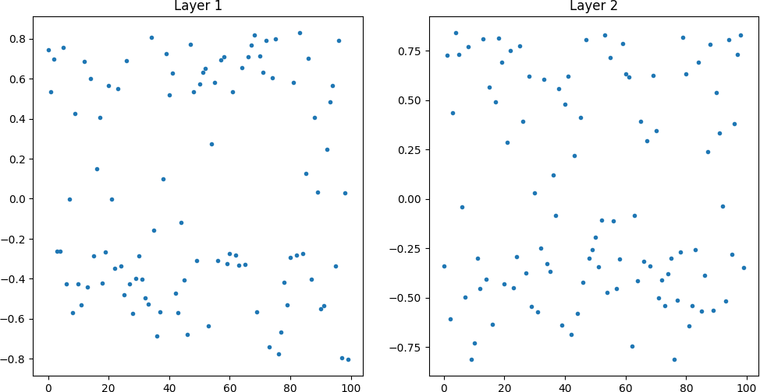
  - Snapshot

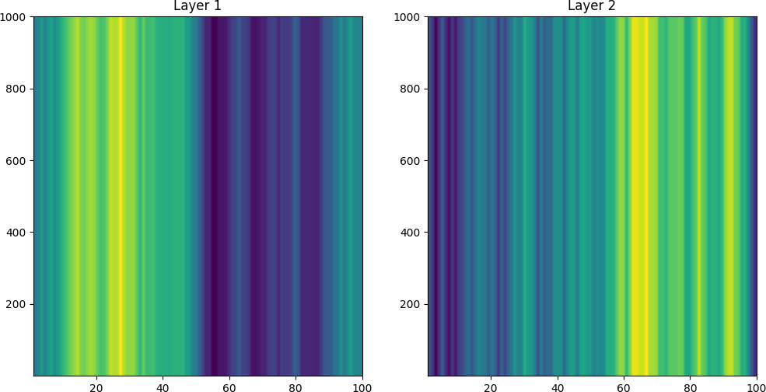
  - Spatio-temporal

Figure 1: Incoherent state.

R_{i}(t) =

1
. |Ni| j∈Ni
. Σ

eiθj
.
.

Multi Chimera State
The system shows a multi-chimera state if σ is fixed to 0.25. Despite, this who the system’s asymmetry

In the above equation, the phase variable of the i-th oscillator is denoted by θ_{i} andN_{i} = {j : |j − i| ≤
maintained through a reasonable amount of noise in- troduced; then distinct coherent or incoherent regions

appeared randomly. At 0.5 each, interaction weights of coupling within layers and between them help sus- tain chimeras. Chimera states are defined as sets of synchronized oscillators, where coherent behavior emerges in some regions and other parts exhibit in- coherence. That is to say, the observed network state is a multi-chimera state as it comprises regions that exhibit both coherent and incoherent dynamics.
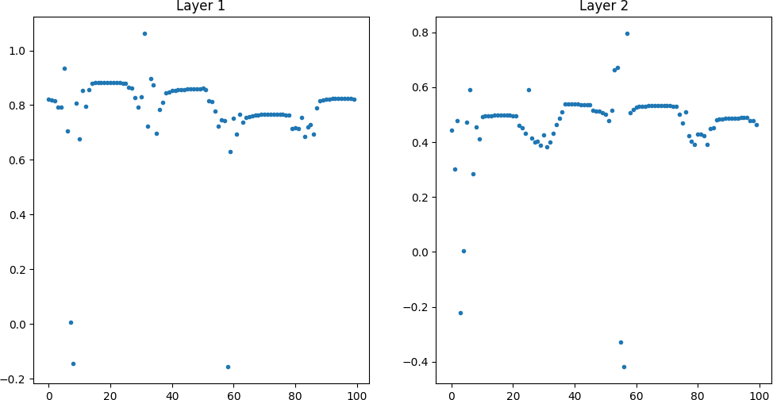
    - snapshot

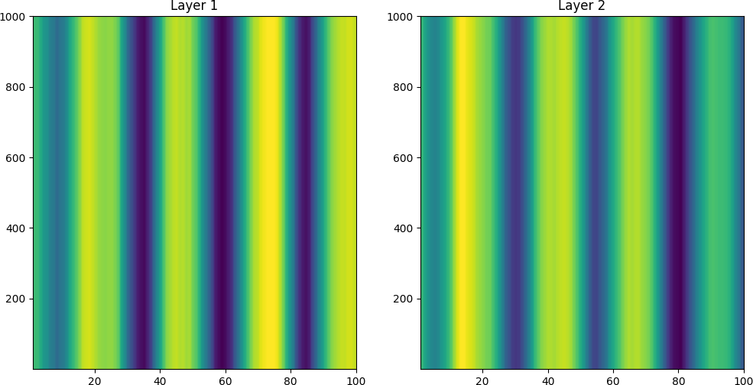
    - Spatio-temporal

Figure 2: Multi Chimera state.

Coherent State
If σ = 0.5, then the system turns into coherent state. Despite the noise level increase, Intra and inter-layer couplings remain strong enough to offset the distur- bances initiated by the noise and result in coherence over the whole network.After some time oscillators get in synchronized and therefore the entire network behaves coherently. This coherence is strong enough such that it can with stand any troublesome observa- tion or noise in the system.
Therefore, the results obtained from the simula- tions offer essential ideas concerning the behavior of complex oscillator networks and the dependent fac- tors behind coherent patterns. First, the level of noise, symbolized by σ , largely determines the net- work’s collectivism. As shown, moderate noise leads to elaborate chimaera states, in which the synchro- nized and incoherent areas coexist on the plane, and when the levels of noise are higher, all the areas of the plane become coherent. Furthermore, the bal- ance between intra and inter-layer coupling strengths

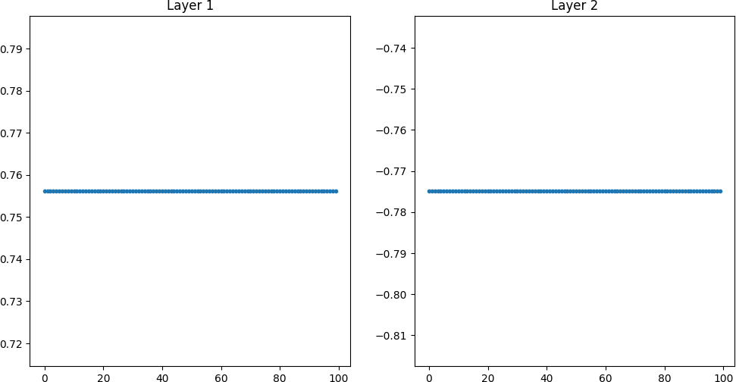

      - snapshot

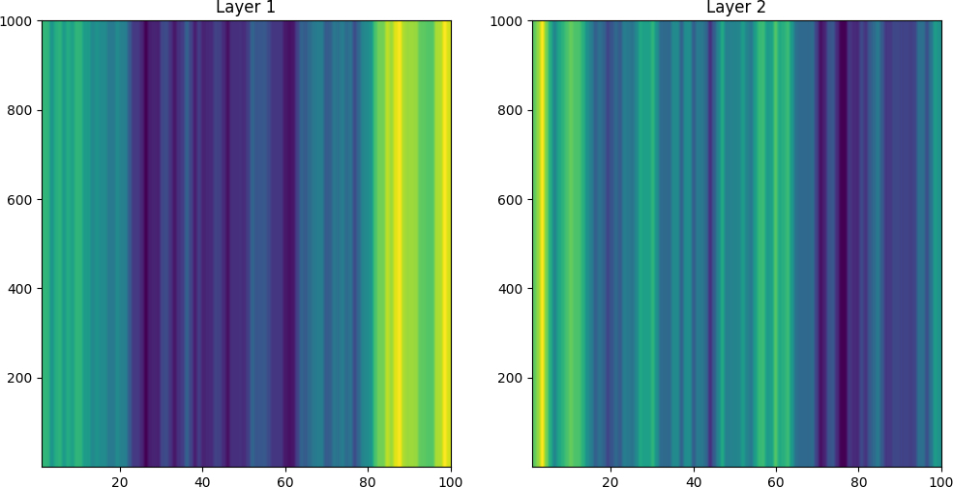
      - Spatio-temporal

Figure 3: Coherent state.

is critical in determining the stability and nature of coherence within the network. Strong coupling pro- motes coherent, while weaker coupling tends to favor incoherent. The interplay between these factors gives rise to a rich variety of dynamical states, ranging from incoherent to perfectly coherent states, with chimera states exhibiting intermediate behavior. The study shows the significance of addressing several parame- ters and their combinations to explain the intricate dynamics of oscillator networks spanning causal time lags. These novel insights are valuable for a wider understanding of the phenomenon of synchronization emerging in different systems and might have reper- cussions across a range of disciplines, such as neuro- science, physics, and engineering. On the other hand, a deeper investigation of oscillator networks, followed by more focused assessment, can also inform the con- trol and influence of synchronization structures for a range of purposes.

Quantification for measures

Oscillatory Frequency Investigation in Desynchronized States
In the absence of noise (σ = 0.0), the frequency anal- ysis exposes the existence of incoherent states in mul- tilayer networks of nonlocal-coupled FHN units’ net- work. This means that every FHN unit behaves inde- pendently of the others hence different parts will ex- hibit a broad span of frequencies. Consequently, there

is no presence of any significant spikes at all frequen- cies which are good indicators for lack-of synchro- nization needed for coherent behaviors in this type of system. In figure 4 can be seen, the frequency spec- tra is shown which demonstrates broad distribution of frequencies that are usual for incoherent states in the ring of non-local coupled FHN-units.
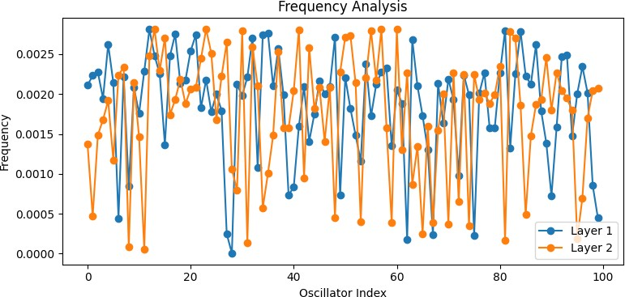

Figure 4: Oscillatory Frequency Investigation in Desynchronized States.

Oscillatory Frequency Investigation in Chimera States
You can detect chimera states in the network by analyzing frequencies at σ = 0.25 loudness. These chimera states show how some FHN units in the no- local coupled ring work in a coordinated as well as uncoordinated way. Specifically, a certain faction of these FHN oscillators becomes locked into a syn- chronous relationship while the others do not. A σ =
0.25 noise level may expose chimera states through frequency analysis, revealing some local neighbor- hoods in the non-locally connected ring where there is a mix of uniform and irregular regions for each individual neuron present. One can infer from this that in this subset of cells, some of them act unlike others. The frequency spectra have some peaks that are matched together as well as wide ranges in be- tween those peaks that make it impossible for any- one to predict their nature; this depicts how chimeric phenomenon is like. Figure 5 is an example on how different frequencies could be visible coming together at particular points while others seem much further apart indicating chimera state inside rings involving nonlocal FHN links.

Oscillatory Frequency Investigation in Synchronized States
When the noise reaches a level of σ = 0.50, the results of the frequency analysis show clearly defined clusters in the system. Sharp and clearly defined frequency spectra lines appear due to global synchronization in

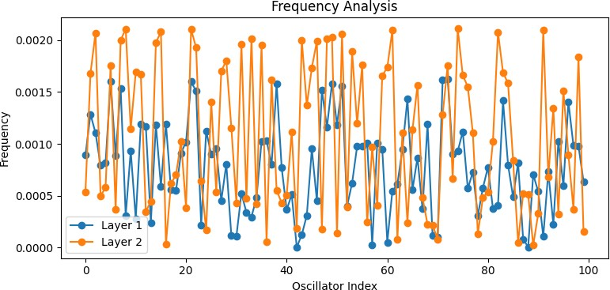

Figure 5: Oscillatory Frequency Investigation in Chimera States.

the non-locally connected ring of FHN units leading to coherent states. When there is more background noise the system becomes more stable. At this point, a coherent state will be reached for the entire net- work with each oscillator behaving in synchrony , see fig.6 for frequency spectra showing sharp peaks standing for such states at rings of non-locally con- nected FHN units. An analysis of the frequencies of
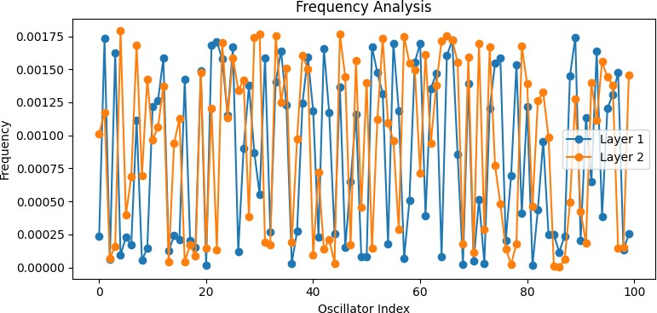

Figure 6: Oscillatory Frequency Investigation in Syn- chronized States.

the chimera, incoherent and coherent states gives use- ful information about the movement of linked oscilla- tor systems particularly in multi-layer networks with a ring of not-local linked FHN unit circuits. When different noise levels, distinct patterns are observed. This allows us to have a more subtle understanding about the place of noise in formation of commplexi- ties. Moreover, it also help researchers to investigate relationship among network topology, dynamics, and emergent phenomena in general.

Spatial correlation

Spatial Distribution of Incoherent Ac- tivity
If there was no noise in place (σ = 0) then most likely the spatial correlation study would unveil similar dis- tances across all the oscillators implying no spatial organization and correlations existed, as indicated in Figure 7.

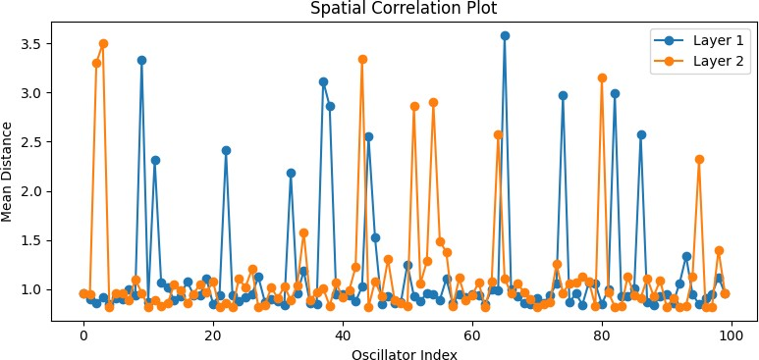

Figure 7: Spatial Distribution of Incoherent Activity.

Spatial Distribution of Chimera Activ- ity
For a moderate noise level equal(σ = 0.25), tiny chimera states are seen emerging, followed by spatial correlation analysis which demonstrates that there are areas with higher spatial correlations situated close together (fig 8), while those which have no cor- relation show weaker linkage between themselves.
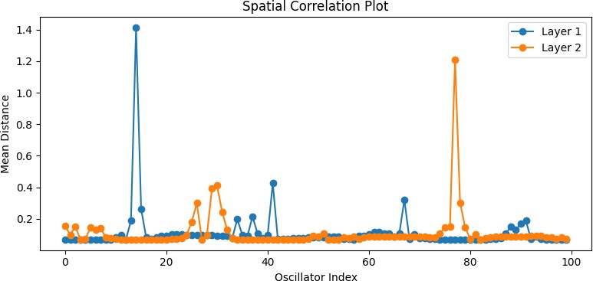

Figure 8: Spatial Distribution of Chimera Activity.

Spatial Distribution of Coherent States
In the scenario where noise increases with (σ = 0.5) leading towards state of coherence within the net- work, spatial correlations analysis of such coherently cycling system could yield increased synchrony – sug- gesting higher levels of organised patterns within space according to figure 9.
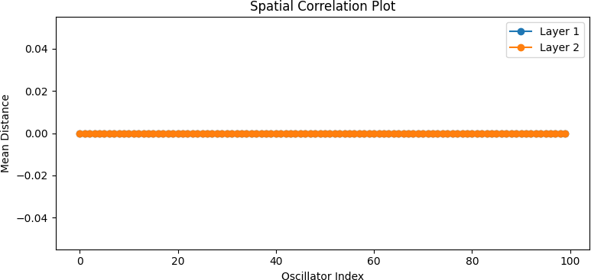

Figure 9: Spatial Distribution of Coherent States.

Incoherent Activity Phase Response Curves

When no external forces are acting (that is, when σ = 0), the stability of the web depends mostly on the combined effect of interactions that occur within different layers of the web. Changes in the phases of oscillations of any oscillatory system due to exter- nal interruptions are estimated with the Phase Re- sponse Curve (PRC) which explains its synchroniza- tion and stability characteristics. Looking at the cal- culated PRCs gives you an understanding about the network’s stability. Positively valued PRCs are those areas where the shocks result in forward changes. The negative ones mean that the changes will get delayed. Hence we can deduce from both the extent as well as form whether it is sensitive on perturbations there- fore inclined to divide itself into components (or syn- chronize). ”Analysis of the computed PRCs provides insights into the stability of the network. For positive values of PRCs, disturbances result in phase advance- ments, conversely, negative values denote phase lags. From such observation we can estimate how sensitive the system is to external sources of disturbance and whether it tends to synchronize or de-synchronise” If we visualize the PRCs for both layers, we can see how changes at different points in time affect the phase dy- namic of each layer and this will help us have better comprehension on what happens when there is syn- chronisation as well as its stability in case such an event occurs.
To sum up, the stability properties of a network and its response to internal interactions are well ex- plained through RPC analysis for σ = 0. The more so because RPC of individual layers helps in identify- ing phase response characteristics for understanding dynamical behavior and appraising of potential for synchronization of the network.
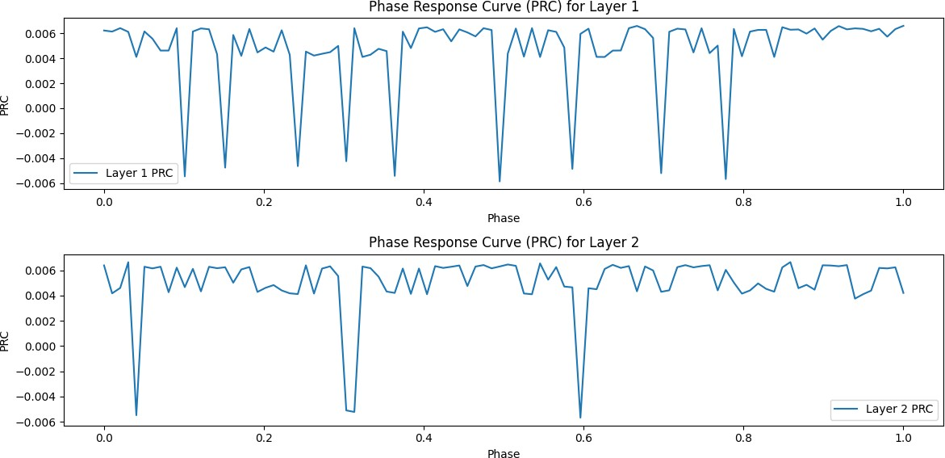

Figure 10: Incoherent Activity Phase Response Curves.

Chimera State Phase Response Curves
At σ = 0.25, external perturbations influence network stability and intra/inter-layer interactions. Phase Response Curve (PRC) quantifies the effect of perturbations on oscillation phases providing in- formation regarding synchronization and stability. Investigating the PRCs calculated reveals stability characteristics. The PRCs values are bigger in times of phase advances with perturbation and lesser when it comes to delays. However, the form and size of a PRC can contribute to understanding both net- work vulnerability in terms of disturbance tolerance or susceptibility, as well as its proclivity towards syn- chronizing. Showing the PRCs for each layer allows understanding the changes in phases caused by per- turbations made at different times. Understanding synchronisation behavior and stability is enhanced by the use of this visual aid. Conclusively, RPC analysis atσ = 0.25 offers important perspectives into network stability and responses to different internal and exter- nal influences. More insights come from being famil- iar with how each stratum responds in-phase and its impacts on the dynamic of the whole system, includ- ing potential for synchronization.
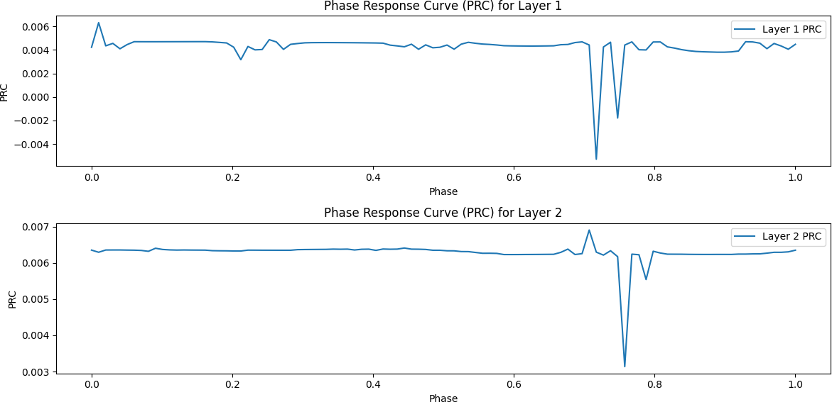

Figure 11: Chimera State Phase Response Curves.

Phase Response Analysis of Synchro- nized Activity
With σ = 0.5, the network stability is worsened by perturbations from the environment in addition to in- tra and inter layer interactions.Oscillation phases are very important in terms of understanding synchro- nization along with stability, parameters that a Phase Response Curve (PRC) describes these impacts. Sta- bility and properties of the PRC can be described with computed data: perturbations cause phase ad- vances when the PRC is positive and delays when the PRC is negative. The magnitude and shape of the PRC offer some information about how likely it is for network mechanisms that synchronize to be close at hand. When you represent PRCs for every layer, you can observe the way in which disturbances occur-
ring at stages which are various affect the phase dy- namics and this enhances the understanding regard- ing synchronization behavior and stability. Finally, it is worth noting that RPC analysis at σ = 0.5 in fact assists in the comprehension of the stability of the network as well as the network’s resilience in response to internal and external stimuli. Understanding the dynamics of the network through the character load- ing on phases in each layer improves Synchronization in the network.
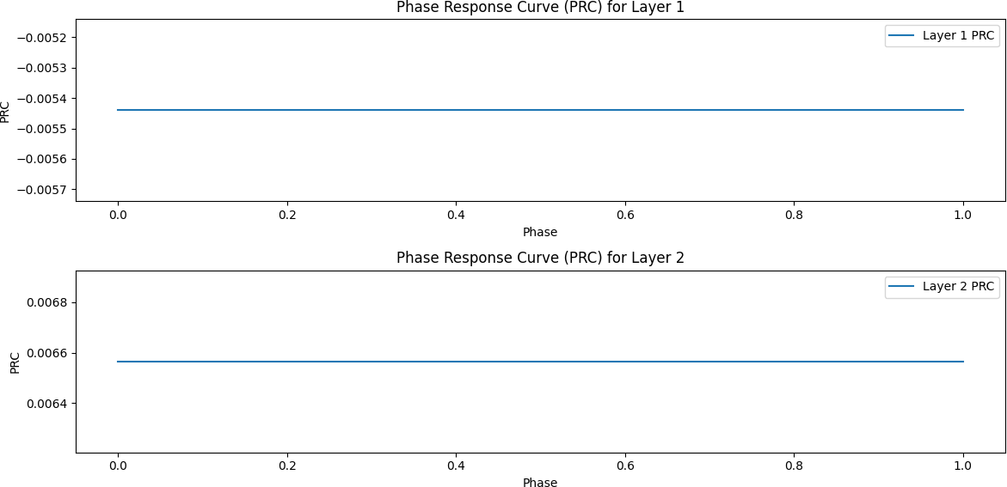
Response Analysis of Synchronized Activity.

Lyapunov Analysis of Desynchronized Dynamics
When there are no outside changes in the network (σ = 0), its stability is mainly governed by how inter- actions take place within or across layers. Lyapunov exponents provide a means of measuring how quickly nearby trajectories diverge which gives some ideas about how stable the network is. Patterns and ten- dencies of network stabilities are revealed when one considers its calculated Lyapunov exponents. Nodes having positive Lyapunov exponents signify that the region is unstable or chaotic because trajectories tend to diverge with time. Contrarily, in the case of nodes with negative Lyapunov exponents it suggests sta- bility in places nearby attractor. By using σ0 as a parameter, we can observe more about network’s inherent stability and disorder by conducting Lya- punov exponent investigation . A more profound un- derstanding of the way the network behaves and its ability to resist any changes can be facilitated by lo- cating areas of unstableness or stabilities.

Conclusion
This research investigates the fascinating subject of chimera states in multi-layer networks using FitzHugh-Nagumo (FHN) neurons as oscillators. We probed the onset and features of chimera states un- der different levels of noise and coupling strengths

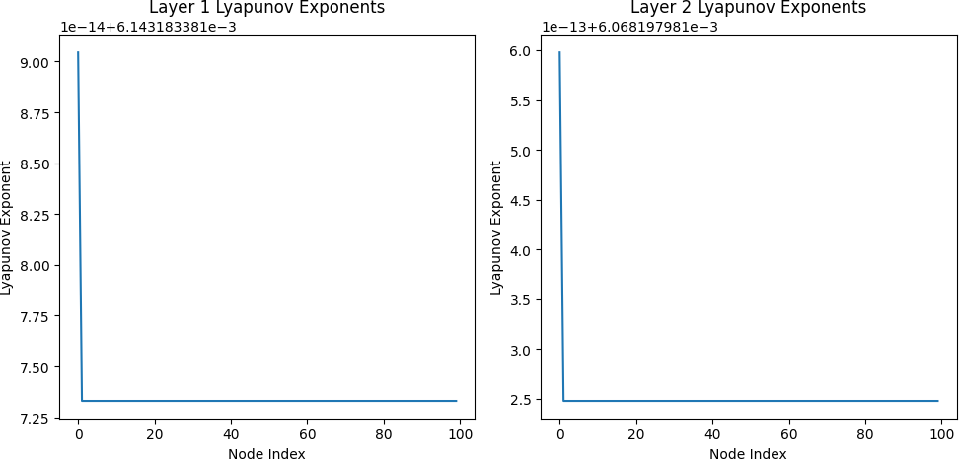

Figure 12: Lyapunov Analysis of Desynchronized Dy- namics.
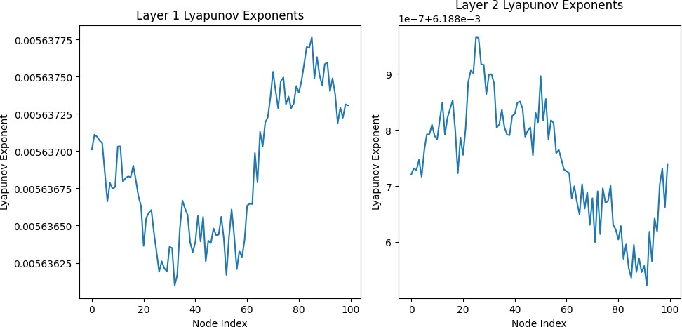

Figure 13: Lyapunov Analysis of Synchronized Dy- namics

by using mathematical models and computer simula- tions. While analyzing these systems we noticed that they can change behavior drastically from lack of co- ordination among the oscillators to multiple-chimera states as regions that are coherent coexist together with those that are not, as well as completely orga- nized systems where the whole system is in sync with each other. Our results demonstrate how stability and coherence type in a network depends on the lev- els of noise and coupling intensity used.
In addition, deeper understanding of spatial prop- erties, synchronization patterns, and stability fea- tures has been achieved for chimera states through quantitative analysis techniques such as frequency analysis, spatial correlation, Lyapunov exponent cal- culations, and phase response curve studies. This scientific research improves comprehension of com- plex systems behavior in different fields – neuro- science, physics or network science among others. Our research has sparked new openings and appli- cation ideas stretching from brain dynamics to mak- ing intricate networks in the event of revealing rea- sons for which chimeras occur. The intricate dy- namics of multi-layer networks are unveiled by this study as it gives valuable contributions to the un- derstanding of chimera state emergence and behav- ior, as well as opening up possibilities for future re- search and interdisciplinary collaborations in com- plex systems studies in the future. In addition to illuminating the mechanics of chimera states, our re-
search highlights the necessity to bear in mind various parameters like noise magnitudes alongside connec- tion strengths when studying complex systems’ be- haviors. The quantitative analysis carried out here offers complete description of chimera states includ- ing their stability, spatial coherence or sensitivity to- wards perturbations. Also, the implications of our findings go past fundamental research. Our findings could be useful in different fields due to the poten- tial of manipulating chimera states within multi-layer networks. For example, the understanding of how chimera states appear in brain networks may help di- agnose and treat neurological diseases better in neu- roscience. By studying chimera dynamics, engineers could infer how to build robust communication net- works and power grids. This highlights research on complex systems. Novel phenomena have been un- covered and our understanding of collective behavior in terms of systems that are connected is enhanced using tools and ideas from mathematical physics and computer science.

References
¹ S. Boccaletti, J. Kurths, G. Osipov, D. L. Val- ladares, and C. S. Zhou, Phys. Rep. 366, 1–101 (2002).
² C. R. Laing, Physica D 238, 1569 (2009).
³ A. E. Motter, Nat. Phys. 6, 164 (2010).
⁴ C. J. Stam, Clin. Neurophys. 116, 2266 (2005).
⁵ E. V. Rybalova, T. E. Vadivasova, G. I. Strelkova,
Chaos Solitons Fractals 163 (2022).
⁶ A. Pikovsky, M. Rosenblum, J. Kurths, and R. C. Hilborn, Am. J. Phys. 70, 6 (2002)
⁷ P. Ashwin and O. Burylko, Chaos 25, 1 (2015).
⁸ R. G. Andrzejak and A. Espinoso, Chaos 33, 5 (2023).
⁹ F. Bagnoli and F. Cecconi, Phys. Lett. A 282, 1–2
(2001).
¹⁰ S. Boccaletti, R. Criado, M. Romance, and J. J. Torres, Chaos 26, 6 (2016).
¹¹ A. C. Cevikel, A. Bekir, O. Abu Arqub, and M. Abukhaled, Front. Phys. 10 (2022).
¹² P. Chandran, R. Gopal, V. K. Chandrasekar, and
N. Athavan, Chaos 29, 5 (2019).
¹³ P. Chandran, R. Gopal, V. K. Chandrasekar, and
N. Athavan, Chaos 30, 6 (2020).
¹⁴ M. M. Danziger, O. I. Moskalenko, S. A. Kurkin,
Chaos 26, 6 (2016).
¹⁵ L. v. Gambuzza, M. Frasca, and J. G´omez- Garden˜es, EPL 110, 2 (2015).
¹⁶ S. Ghosh and S. Jalan, Int. J. Bifurcation Chaos
26, 7 (2016).

¹⁷ P. H¨ovel and I. Omelchenko, BMC Neurosci. 14, S1 (2013).
¹⁸ I. Hussain, D. Ghosh, and S. Jafari, Appl. Math. Comput. 410 (2021).
¹⁹ S. Jalan, S. Ghosh, and B. Patra, Chaos 27, 10
(2017).
²⁰ Y. Jiang, J. Wu, H. Yang, Chin. J. Phys. 66
(2020).
²¹ I. Hussain, S. Jafari, D. Ghosh, and M. Perc,
Nonlinear Dyn. 104, 3 (2021).
²² S. K. Joshi, Int. J. Dynamics Control 9, 3 (2021).
²³ A. D. Kachhvah and S. Jalan, Phys. Rev. E 104, 4 (2021).
²⁴ D. v. Kasatkin and V. I. Nekorkin, Chaos 28, 9
(2018).
²⁵ N. A. Kudryashov, R. B. Rybka, and A. G. Sboev,
Appl. Math. Lett. 76 (2018).
²⁶ S. Kundu, S. Majhi, B. K. Bera, Phys. Rev. E
97, 2 (2018).
²⁷ I. Hussain, S. Jafari, D. Ghosh, and M. Perc,
Nonlinear Dyn. 104, 3 (2021).
²⁸ J. Kurths, S. Boccaletti, C. Grebogi, and Y. C. Lai, Chaos 13, 1 (2003).
²⁹ C. R. Laing, Phys. Rev. E 92, 5 (2015).
³⁰ S. Majhi, B. K. Bera, D. Ghosh, and M. Perc,
Phys. Life Rev. 28 (2019).
³¹ V. A. Maksimenko, V. V. Makarov, B. K. Bera,
Phys. Rev. E 94, 5 (2016).
³² S. Majhi and D. Ghosh, Chaos 28, 8 (2018).
³³ S. G. N. Mbouna, T. Banerjee, and E. Sch¨oll,
Phys. Rev. E 107, 5 (2023).
³⁴ S. Majhi, B. K. Bera, D. Ghosh, and M. Perc,
Phys. Life Rev. 28 (2019).
³⁵ V. A. Maksimenko, V. V. Makarov, B. K. Bera,
Phys. Rev. E 94, 5 (2016).
³⁶ S. Majhi and D. Ghosh, Chaos 28, 8 (2018).
³⁷ S. G. N. Mbouna, T. Banerjee, and E. Sch¨oll,
Phys. Rev. E 107, 5 (2023).
³⁸ I. Omelchenko, T. Hu¨lser, A. Zakharova, and E. Sch¨oll, Front. Appl. Math. Stat. 4 (2019).
³⁹ S. Majhi, M. Perc, and D. Ghosh, Chaos 27, 7
(2017).
⁴⁰ I. Omelchenko, A. Provata, J. Hizanidis, Phys. Rev. E 91, 2 (2015).
⁴¹ S. Majhi, S. Rakshit, and D. Ghosh, Chaos 32, 4
(2022).
⁴² R. G. Andrzejak, G. Ruzzene, and I. Malvestio,
Chaos 27, 5 (2017).
⁴³ A. C. Cevikel, A. Bekir, O. Abu Arqub, and M. Abukhaled, Frontiers in Physics 10, 1028668 (2022).
⁴⁴ I. Omelchenko, A. Zakharova, P. H¨ovel, Chaos
25, 8 (2015).
⁴⁵ J. Ramadoss, S. Aghababaei, F. Parastesh,
Complexity (2021).
⁴⁶ E. v. Rybalova, A. Zakharova, and G. I. Strelkova,
Chaos Solitons Fractals 148 (2021).
⁴⁷ A. Schmidt, T. Kasimatis, J. Hizanidis, Phys. Rev. E 95, 3 (2017).
⁴⁸ A. Rontogiannis and A. Provata, Eur. Phys. J. B
94, 5 (2021).
⁴⁹ G. Ruzzene, I. Omelchenko, J. Sawicki, Phys. Rev. E 102, 5 (2020).
⁵⁰ E. Rybalova, V. S. Anishchenko, G. I. Strelkova, and A. Zakharova, Chaos 29, 7 (2019).
⁵¹ J. Sawicki, I. Omelchenko, A. Zakharova, et al.,
Eur. Phys. J. Spec. Top. 227, 10–11 (2018).
⁵² E. Sch¨oll, I. Omelchenko, and J. Sawicki, in
European Control Conference 2020 (2020).
⁵³ R. Sevilla-Escoboza, I. Sendin˜a-Nadal, I. Leyva,
Chaos 26, 6 (2016).
⁵⁴ I. A. Shepelev and T. E. Vadivasova, Chaos Solitons Fractals 147 (2021).
⁵⁵ A. Singh, S. Jalan, and S. Boccaletti, Chaos 27,
4 (2017).
⁵⁶ L. Skrzypek and Y. You, Appl. Math. Comput.
388 (2021).
⁵⁷ I. Hussain, S. Jafari, M. Perc, and D. Ghosh,
Phys. Lett. A 424 (2022).
⁵⁸ J. Sawicki, I. Omelchenko, A. Zakharova, Phys. Rev. E 98, 6 (2018).
⁵⁹ E. v. Rybalova, G. Strelkova, E. Sch¨oll, Chaos
30, 6 (2020).
⁶⁰ M. J. Panaggio and D. M. Abrams, Phys. Rev. E
91, 022909 (2015).
⁶¹ M. J. Panaggio and D. M. Abrams, Phys. Rev. Lett. 110, 094102 (2013).
⁶² R. G. Andrzejak, G. Ruzzene, I. Malvestio, K. Schindler, E. Sch¨oll, and A. Zakharova, Chaos 28, 9 (2018).
⁶³ C. Bick and E. A. Martens, New Journal of Physics 17, (2015). https://doi.org/10.1088/1367- 2630/17/3/033030
⁶⁴ I. Fateev and A. Polezhaev, Chaos 33, 10 (2023).
https://doi.org/10.1063/5.0168422
⁶⁵ P. Kalle, J. Sawicki, A. Zakharova, and E. Sch¨oll, Chaos 27, 3 (2017). https://doi.org/10.1063/1.4977866
⁶⁶ X. Li, T. Xu, and J. Li, European Physical Journal: Special Topics 228, 11 (2019).
⁶⁷ Z. Wang, S. Baruni, F. Parastesh, S. Jafari, D. Ghosh, M. Perc, and I. Hussain, Neurocomputing 406 (2020).
⁶⁸ N. Yao, Z. G. Huang, C. Grebogi, and Y. C. Lai,
Scientific Reports 5 (2015).
⁶⁹ P. D. Rungta and S. Sinha, Europhys. Lett. 112, 60004 (2015).
⁷⁰ A. Rothkegel and K. Lehnertz, New J. Phys. 16,
055006 (2014).

