- Results of the experiments
The experimental results obtained from the experiments are presented in this section. The experiments were conducted in three phases: training on non-augmented data to establish a baseline, training on the augmented dataset to assess the impact of augmentation and fine-tuning pre-trained models on non-augmented data using the transfer learning methodology. The evaluation was performed using classification accuracy, confusion matrix, ROC curve metrics. Each phase's results are summarised in the following sections, including figures and tables to illustrate the performance of different CNN architectures.

  - Baseline Performance on Non-Augmented Data (Phase 1)
The initial phase of the experiment involved training various CNN architectures on the non-augmented dataset. This phase served as a baseline to compare the effect of data augmentation and transfer learning. The models tested included VGG16, InceptionV3, and DenseNet121, chosen for their ability to extract hierarchical and deep features from spectrogram images. Table 1 shows each model's classification accuracy, precision, recall, and F1 score.
Table 1: Baseline Performance on Non-Augmented Dataset
Model | Accuracy | Precision | Recall | F1-Score
VGG16 | 0.89 | 0.96 | 0.84
InceptionV3 | 0.88 | 0.94 | 0.84
DenseNet121 | 0.92 | 0.96 | 0.89

The results demonstrate that DenseNet121 achieved the highest classification accuracy of 0.92, followed closely by VGG19 and VGG16. Although VGG16 performed exceptionally well in terms of precision, its overall accuracy was slightly lower than that of DenseNet121 and VGG19.
Loss-Accuracy Curve from Non-Augmented Data:
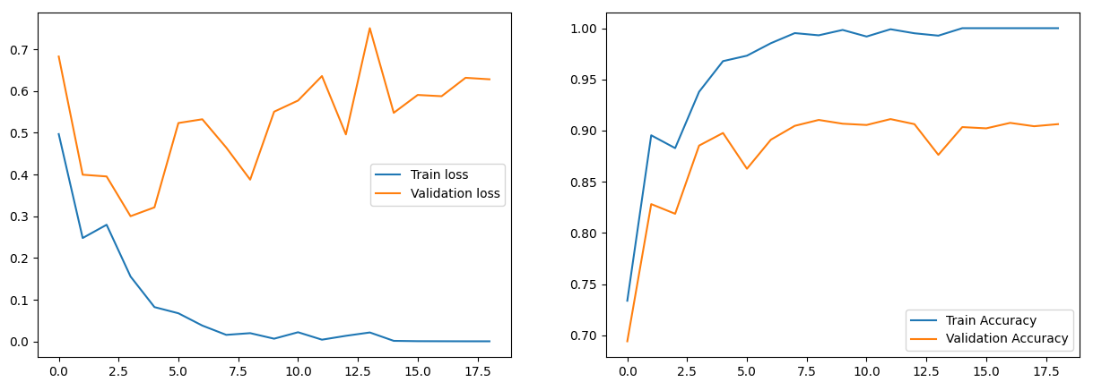
- VGG16
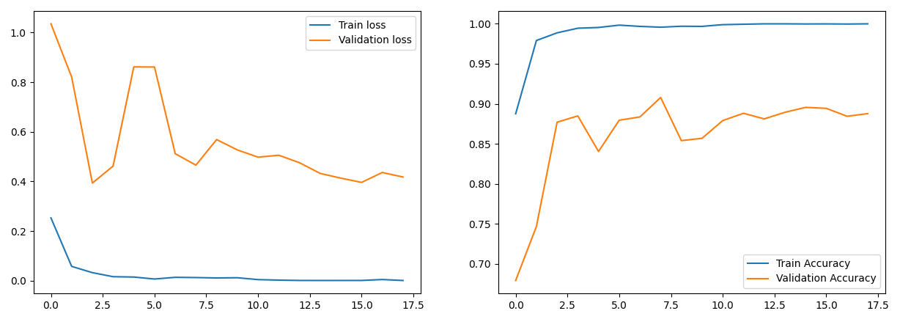
- InceptionV3
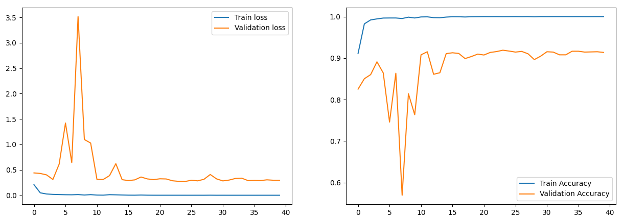
- DenseNet121
Figure 1: Training-Validation Loss and Accuracy Curves for Non-Augmented Data
Figure 1 shows that all models exhibit good convergence during training. The training and validation loss curves decrease steadily, indicating effective learning. The accuracy curves show that DenseNet121 achieved the highest validation accuracy, confirming its superior performance on the non-augmented dataset.
Confusion Matrices from Non-Augmented Data:
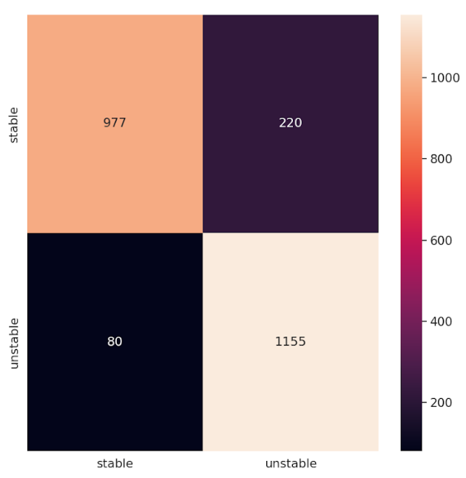
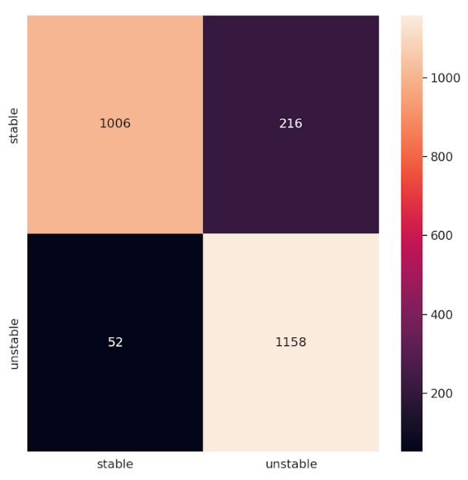
The confusion matrices (Figure 1) further highlight the performance of each model, showing the distribution of correct and incorrect predictions across the mental stability categories.

- VGG16 (b) InceptionV3

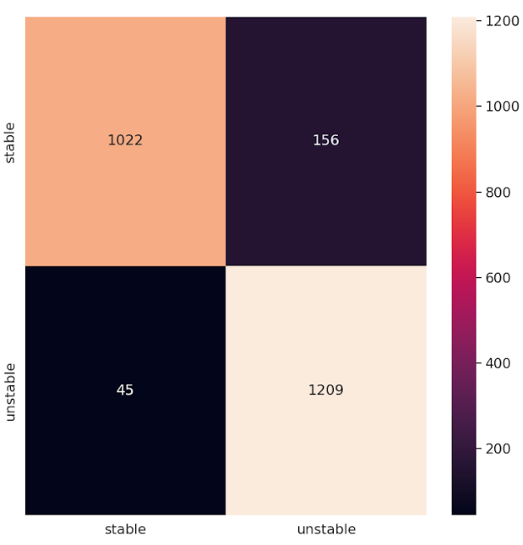
(c) DenseNet121Figure 1: Confusion Matrices for CNN Models on Non-Augmented Dataset
The confusion matrices in Figure 2 reveal each model's classification performance. DenseNet121 correctly classified more samples in stable and unstable categories, resulting in fewer misclassifications than VGG16 and InceptionV3.

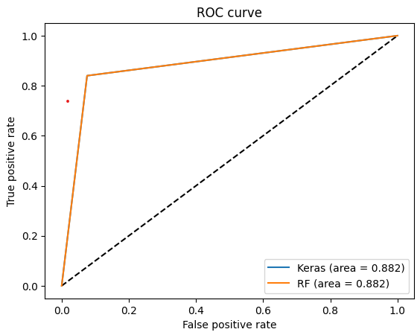
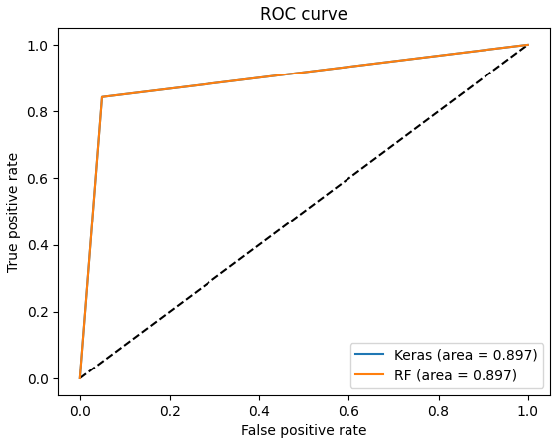
ROC Curves from Non-Augmented Data:

- VGG16 (b) InceptionV3

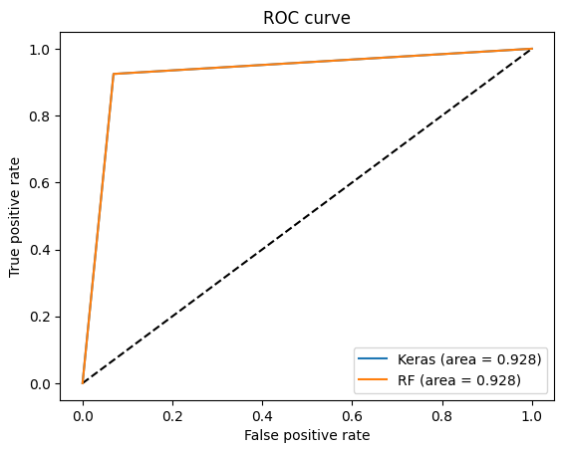
(c) DenseNet121Figure 2: ROC Curves for CNN Models on Non-Augmented Dataset
The ROC curves in Figure 3 illustrate the trade-off between true positive rates and false positive rates for each model. DenseNet121's ROC curve is closest to the top-left corner, indicating better discrimination ability. The AUC values are presented in Table 2. Table 3: AUC Values for Models Trained on Non-Augmented Dataset
Model | AUC
VGG16
InceptionV3
DenseNet121

These results indicate that DenseNet121 achieved the highest AUC of 0.96, confirming its superior performance in classifying mental stability on the non-augmented dataset.
  - Performance on Augmented Dataset (Phase 2)
In the second phase, the same CNN architectures were trained on the augmented dataset, which included various augmentation techniques such as SpecAugment, Gaussian noise, and random erasing. The goal of this phase was to assess whether data augmentation could improve the model’s performance by introducing variability into the training data. Table 3 presents the performance metrics for each model on the augmented dataset.
Table 2: Performance on Augmented Dataset
Model | Accuracy | Precision | Recall | F1-Score
VGG16 | 0.90 | 0.93 | 0.90
InceptionV3 | 0.91 | 0.94 | 0.90
DenseNet121 | 0.93 | 0.95 | 0.92

After training on the augmented dataset, significant improvements were observed in all models. DenseNet121 again performed the best, achieving an accuracy of 0.93. The results indicate that data augmentation effectively improved the models' generalisation capabilities, as evidenced by increased accuracy, precision, and recall for each CNN model.
Loss Accuracy Curve from Augmented Data:
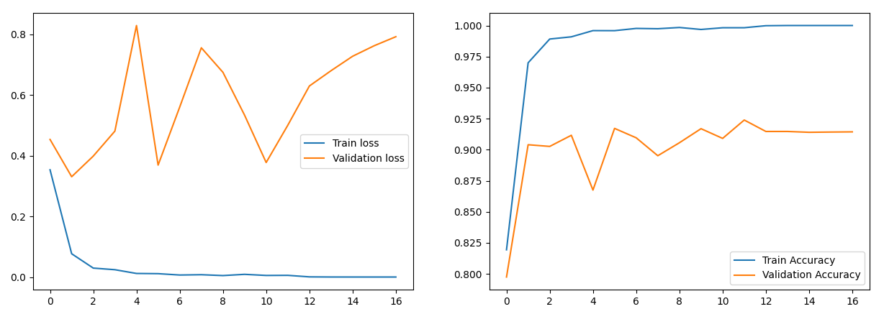
- VGG16
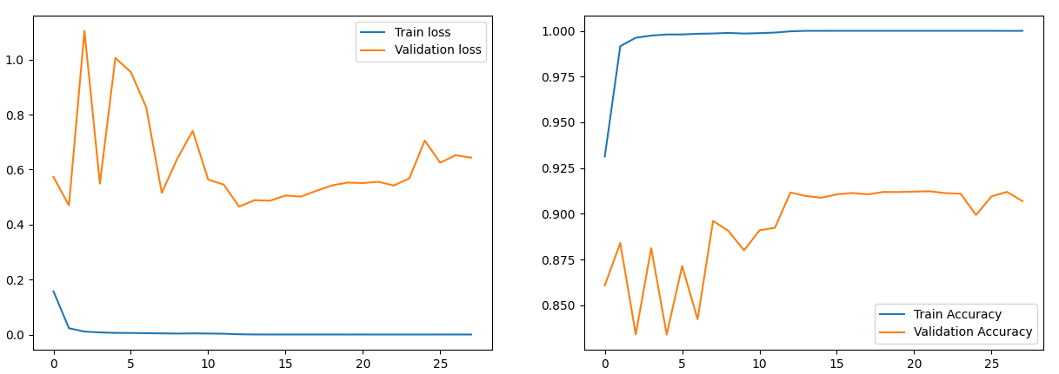
- InceptionV3
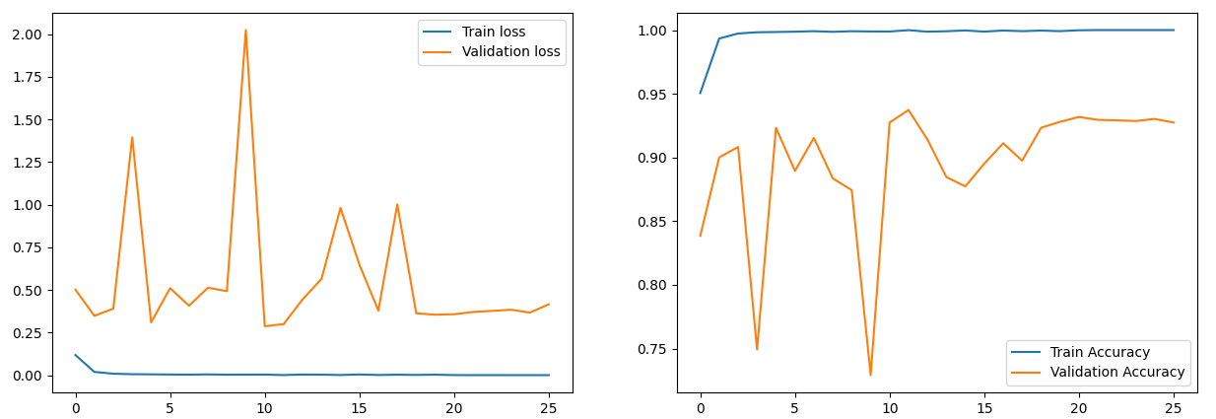
- DenseNet121
Figure 4: Training-Validation Loss and Accuracy Curves for Augmented Data
Figure 4 shows that the models achieve lower training and validation losses compared to Phase 1. The accuracy curves show improved validation accuracy, indicating that data augmentation helped prevent overfitting and enhanced generalisation.

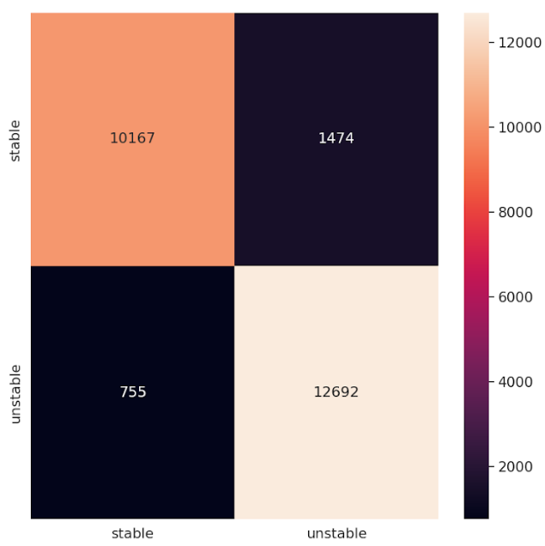
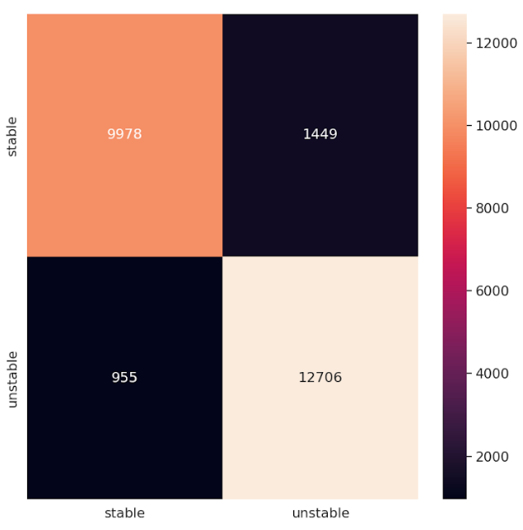
Confusion Matrices from Augmented Data:

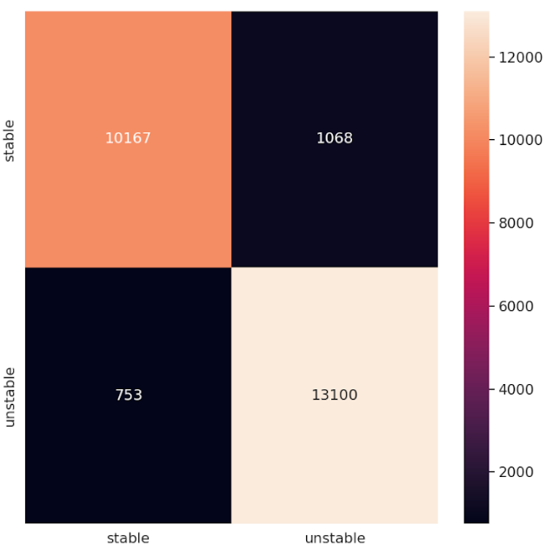
- VGG16 (b) InceptionV3

(c) DenseNet121
Figure 1: Confusion Matrices for CNN Models on Augmented Dataset
The confusion matrices in Figure 5 show that the number of correctly classified samples increased for all models. DenseNet121 displayed the highest number of true positives in both classes, reducing misclassification errors.
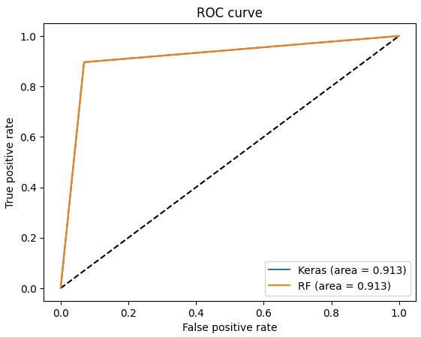
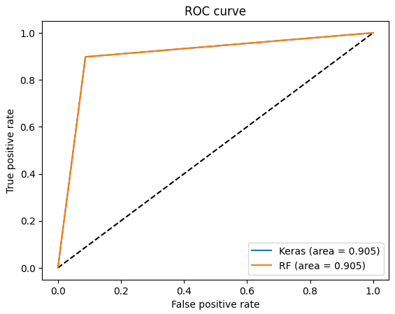
ROC Curves from Aug,ented Data:

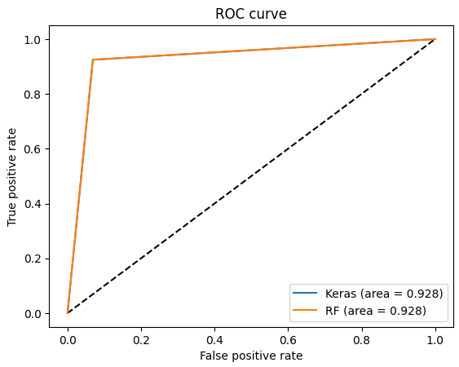
(a) VGG16 (b) InceptionV3

(c) DenseNet121
Figure 2: ROC Curves for CNN Models on Augmented Dataset
The ROC curves in Figure 6 demonstrate enhanced performance, with curves closer to the top-left corner compared to Phase 1. The AUC values are provided in Table 4. Table 3: AUC Values for Models Trained on Augmented Dataset
Model | AUC
VGG16
InceptionV3
DenseNet121
The improvement in AUC values further supports the effectiveness of data augmentation in enhancing model performance, with DenseNet121 achieving the highest AUC of 0.97. This supports the conclusion that augmenting the dataset introduces beneficial variability, enabling models to learn more robust and generalised features.
  - Transfer Learning Results (Phase 3)
The third phase involved fine-tuning the pre-trained models from Phase 2 on the non-augmented dataset using the transfer learning methodology. These pre-trained models were loaded from saved files containing no test data information, ensuring no data leakage during transfer learning. This process allowed the models to retain the generalisation capabilities learned from the augmented data while adapting to the specific nuances of the non-augmented dataset. The results for this phase are summarised in Table 4.
Table 4: Performance of Transfer Learning Approach on Non-Augmented Dataset
Model | Accuracy | Precision | Recall | F1-Score
VGG16 | 0.92 | 0.96 | 0.89
InceptionV3 | 0.93 | 0.94 | 0.93
DenseNet121 | 0.93 | 0.99 | 0.89

The results indicate that transfer learning significantly boosted model performance compared to the non-augmented and augmented dataset experiments. DenseNet121 achieved the highest accuracy of 0.96, demonstrating the effectiveness of transfer learning in this domain. Fine-tuning the pre-trained models allowed them to adapt to the raw, non-augmented dataset without losing the generalisation capabilities gained during training on augmented data. Figure 3 shows the confusion matrices for the transfer learning results, visually comparing model performance.
Loss Accuracy Curve from Transfer Learning:
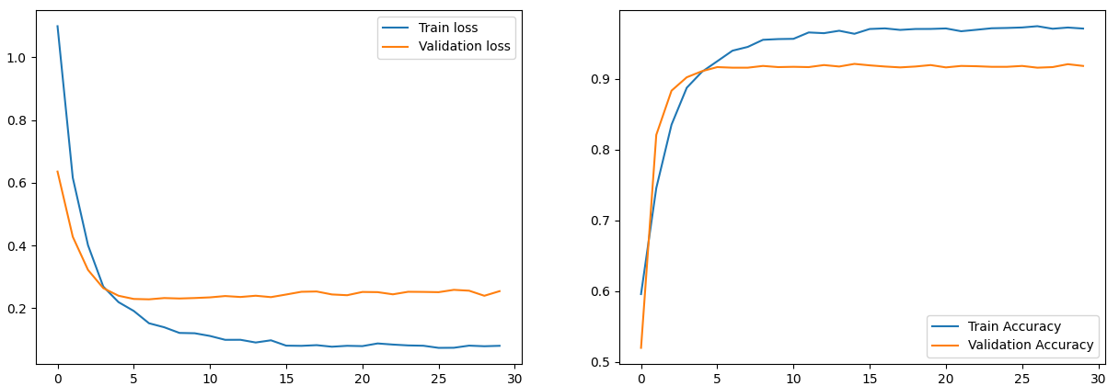
- VGG16
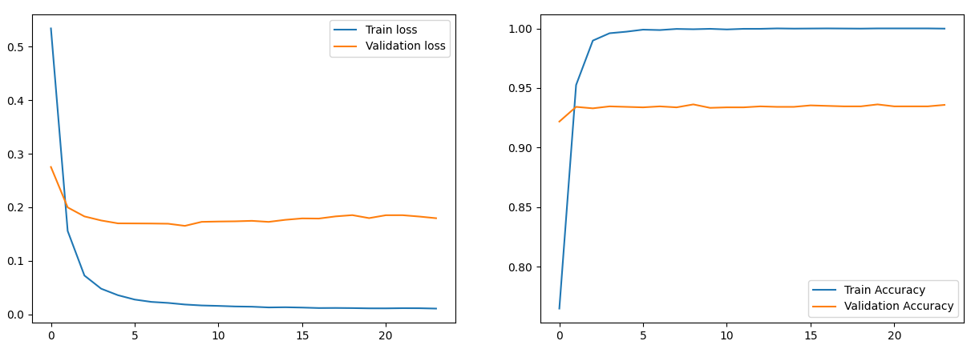
- InceptionV3
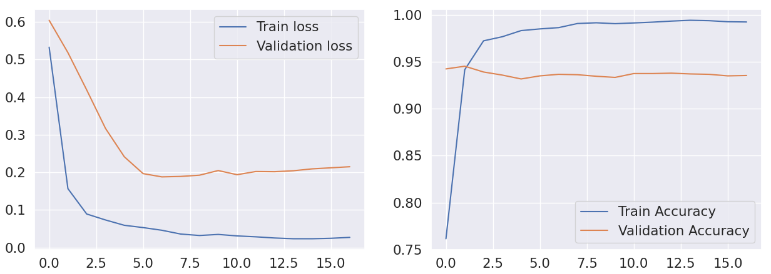
- DenseNet121
Figure 7: Training-Validation Loss and Accuracy Curves after Transfer Learning
In Figure 7, the models show rapid convergence with lower losses and higher accuracies. DenseNet121 reaches the highest validation accuracy, indicating that transfer learning enhanced the model's performance on the non-augmented dataset.
Confusion Matrices from Transfer Learning:
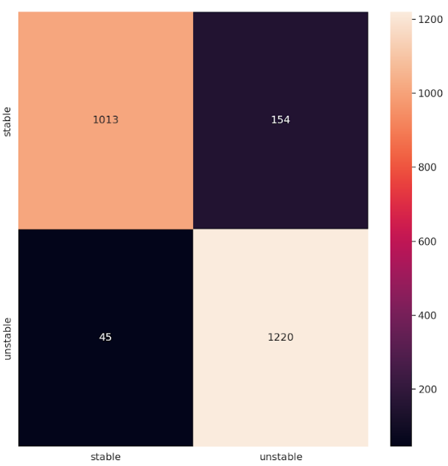
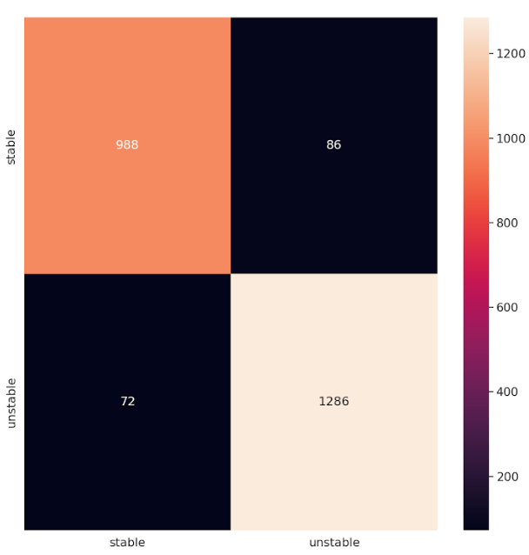
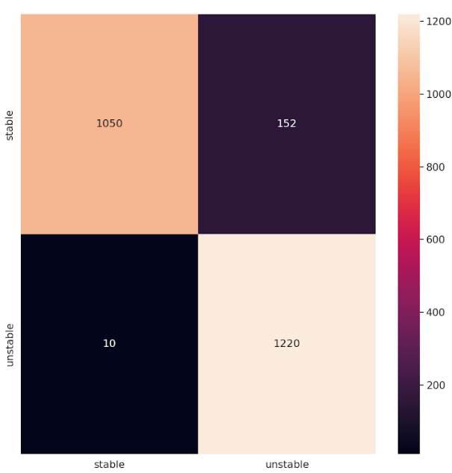
- VGG16 (b) InceptionV3

(c) DenseNet121
Figure 3: Confusion Matrices for CNN Models after Transfer Learning
The confusion matrices in Figure 8 reveal that DenseNet121 correctly classified almost all samples, significantly reducing misclassification rates compared to previous phases.

ROC Curves from Transfer Learning:
Additionally, the ROC curves and AUC values for the transfer learning approach show substantial improvements, as presented in Figure 4.
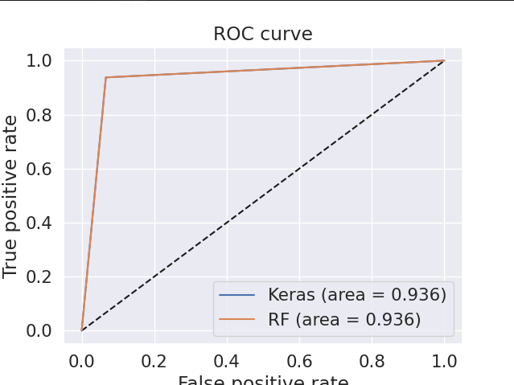
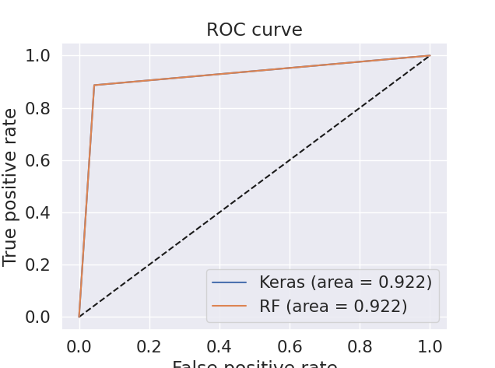
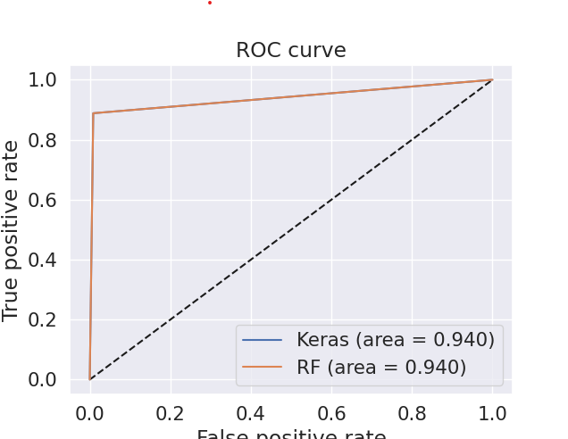
- VGG16 (b) InceptionV3

(c) DenseNet121

Figure 4: ROC Curves and AUC from Transfer Learning Approach
The ROC curves in Figure 9 are the closest to the top-left corner among all phases, indicating excellent discrimination ability. The AUC values are presented in Table 6.Table 5: AUC Values for Transfer Learning Approach
Model | AUC
VGG16
InceptionV3
DenseNet121
As indicated in Table 5, transfer learning substantially improved AUC scores across all models, with DenseNet121 achieving an AUC of 0.96. This demonstrates the potential of the proposed transfer learning approach to enhance classification performance in tasks with limited data, such as mental stability detection using voice spectrograms.
  - Discussion of Experimental Results

We conducted a comparative analysis of the three experimental phases to understand better the significance of the improvements achieved through data augmentation and transfer learning. The table below summarizes the results for each model in terms of accuracy, precision, recall, and F1-score across the non-augmented, augmented, and transfer learning experiments:
Model | Dataset Type | Accuracy | Precision | Recall | F1-Score | AUC
VGG16 | Non-Augmented | 89% | 96% | 84% | 90% | 89%
VGG16 | Augmented | 90% | 93% | 90% | 91% | 90%
VGG16 | Transfer Learning | 92% | 96% | 89% | 92% | 92%
InceptionV3 | Non-Augmented | 88% | 94% | 84% | 89% | 88%
InceptionV3 | Augmented | 91% | 94% | 90% | 92% | 91%
InceptionV3 | Transfer Learning | 93% | 94% | 93% | 93% | 93%
DenseNet121 | Non-Augmented | 92% | 96% | 89% | 92% | 92%
DenseNet121 | Augmented | 93% | 95% | 92% | 94% | 92%
Densnet121 | Transfer Learning | 94% | 98% | 91% | 95% | 94%

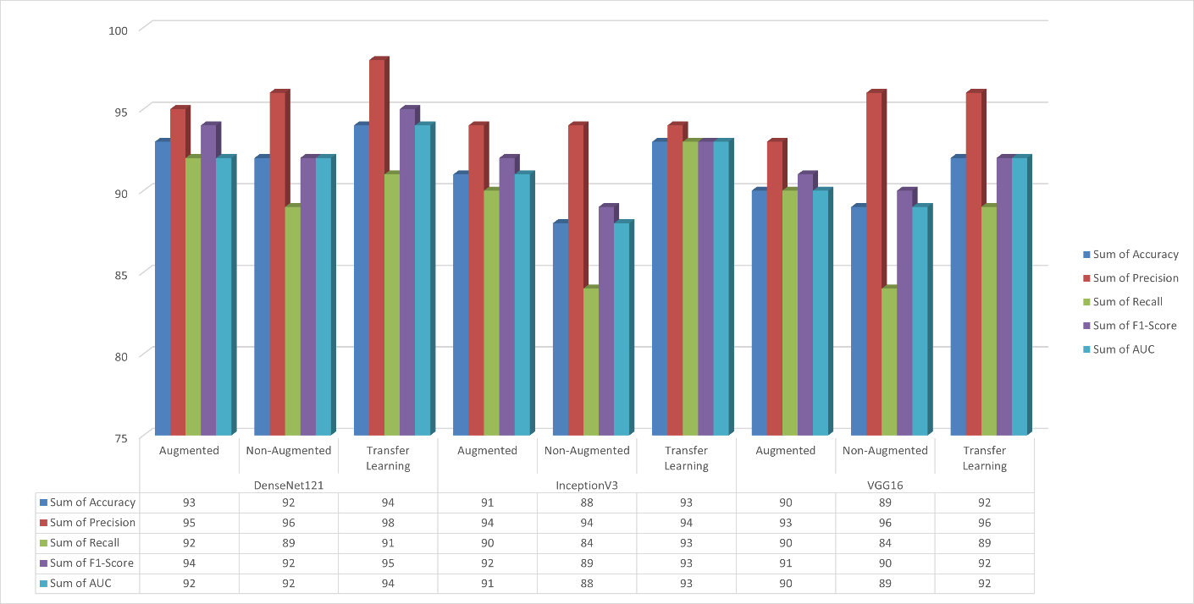
In this study, we assessed the performance enhancements of three convolutional neural network models—VGG16, InceptionV3, and DenseNet121—across Non-Augmented, Augmented, and Transfer Learning datasets, focusing on key metrics such as accuracy, precision, recall, F1-score, and AUC. For VGG16, transitioning from the non-augmented to augmented dataset led to a 1.1% increase in accuracy (from 89% to 90%) and a significant 7.1% improvement in recall (from 84% to 90%), albeit with a 3.1% decrease in precision (from 96% to 93%). Advancing to Transfer Learning further enhanced accuracy by 2.2% (reaching 92%) and precision by 3.2% (up to 96%), while recall slightly declined by 1.1% (down to 89%). InceptionV3 exhibited a 3.4% gain in accuracy (88% to 91%) and a 7.1% rise in recall (84% to 90%) when utilising the Augmented dataset, with precision remaining constant at 94%. The shift to Transfer Learning yielded additional improvements for InceptionV3, with accuracy increasing by 2.2% (to 93%) and recall by 3.3% (to 93%). DenseNet121 consistently demonstrated superior performance, showing a 1.1% increase in accuracy (from 92% to 93%) and a 3.4% boost in recall (from 89% to 92%) from the Non-Augmented to Augmented datasets, despite a minor 1.0% decrease in precision (from 96% to 95%). Transitioning to Transfer Learning, DenseNet121's accuracy rose by another 1.1% (to 94%), and precision improved markedly by 3.2% (to 98%), although recall experienced a slight reduction of 1.1% (to 91%). Data augmentation generally enhanced accuracy and recall across all models, with VGG16 and InceptionV3 exhibiting the most substantial recall improvements. Transfer Learning amplified precision and accuracy, notably in DenseNet121, which achieved the highest overall performance metrics. These findings underscore the effectiveness of data augmentation and Transfer Learning in improving deep learning models and suggest that DenseNet121 with Transfer Learning is the most efficacious configuration tested. At the same time, InceptionV3 with Transfer Learning may be preferred in scenarios where maximising recall is paramount.

In this study, we compared the performance of three convolutional neural network models—VGG16, InceptionV3, and DenseNet121—across Non-Augmented, Augmented, and Transfer Learning datasets. DenseNet121 consistently outperformed the others, achieving the highest accuracy in all dataset types. From Non-Augmented to Augmented datasets, all models improved in accuracy and recall; notably, InceptionV3's accuracy increased by 3.4% (from 88% to 91%), and both VGG16 and InceptionV3 saw a 7.1% rise in recall (from 84% to 90%). Transitioning to Transfer Learning further enhanced performance: DenseNet121's accuracy rose by 1.1% (to 94%), and its precision increased by 3.2% (to 98%), while InceptionV3's recall improved by 3.3% (to 93%). These findings indicate that data augmentation and Transfer Learning significantly enhance model performance, with DenseNet121 with Transfer Learning being the most effective overall, and InceptionV3 with Transfer Learning preferred when maximizing recall is crucial.

In comparing the performance of VGG16, InceptionV3, and DenseNet121 from non-augmented datasets to those utilizing transfer learning, significant enhancements attributable to transfer learning were observed. VGG16 saw its accuracy increase by approximately 3.4% (from 89% to 92%) and recall by 6.0% (from 84% to 89%), while precision remained constant at 96%. InceptionV3 experienced a more pronounced improvement, with accuracy rising by 5.7% (from 88% to 93%) and recall by 10.7% (from 84% to 93%), indicating a substantial enhancement in identifying relevant instances. DenseNet121 showed modest yet noteworthy gains, with accuracy improving by 2.2% (from 92% to 94%), precision by 2.1% (from 96% to 98%), and recall by 2.2% (from 89% to 91%). Overall, transfer learning contributed to performance improvements across all models, with InceptionV3 benefiting the most in recall and DenseNet121 maintaining the highest overall accuracy and precision. These findings highlight the effectiveness of transfer learning in enhancing deep learning models' performance, especially in complex architectures.

Comparison of Model Performance Based on Dataset Type
This comparison focuses on how the performance of three models—VGG16, InceptionV3, and DenseNet121—improves across different dataset types: Non-Augmented, Augmented, and Transfer Learning. Percentage improvements between dataset types are calculated for each model.

VGG16
From Non-Augmented to Augmented
- Accuracy: Increased by 1.1% (from 89% to 90%)
- Recall: Increased by 7.1% (from 84% to 90%)
- F1-Score: Increased by 1.1% (from 90% to 91%)
- AUC: Increased by 1.1% (from 89% to 90%)
- Precision: Decreased by 3.1% (from 96% to 93%)
From Augmented to Transfer Learning
- Accuracy: Increased by 2.2% (from 90% to 92%)
- Precision: Increased by 3.2% (from 93% to 96%)
- F1-Score: Increased by 1.1% (from 91% to 92%)
- AUC: Increased by 2.2% (from 90% to 92%)
- Recall: Decreased by 1.1% (from 90% to 89%)

InceptionV3
From Non-Augmented to Augmented
- Accuracy: Increased by 3.4% (from 88% to 91%)
- Recall: Increased by 7.1% (from 84% to 90%)
- F1-Score: Increased by 3.4% (from 89% to 92%)
- AUC: Increased by 3.4% (from 88% to 91%)
- Precision: No change (remained at 94%)
From Augmented to Transfer Learning
- Accuracy: Increased by 2.2% (from 91% to 93%)
- Recall: Increased by 3.3% (from 90% to 93%)
- F1-Score: Increased by 1.1% (from 92% to 93%)
- AUC: Increased by 2.2% (from 91% to 93%)
- Precision: No change (remained at 94%)

DenseNet121
From Non-Augmented to Augmented
- Accuracy: Increased by 1.1% (from 92% to 93%)
- Recall: Increased by 3.4% (from 89% to 92%)
- F1-Score: Increased by 2.2% (from 92% to 94%)
- AUC: No change (remained at 92%)
- Precision: Decreased by 1.0% (from 96% to 95%)
From Augmented to Transfer Learning
- Accuracy: Increased by 1.1% (from 93% to 94%)
- Precision: Increased by 3.2% (from 95% to 98%)
- F1-Score: Increased by 1.1% (from 94% to 95%)
- AUC: Increased by 2.2% (from 92% to 94%)
- Recall: Decreased by 1.1% (from 92% to 91%)

Overall Observations
- Data Augmentation generally improved accuracy and recall for all models. The most significant recall improvements were seen in VGG16 and InceptionV3, both increasing by 7.1% from the Non-Augmented to Augmented datasets.
- Transfer Learning provided additional gains, especially in precision and accuracy. InceptionV3's recall improved by a total of 10.7% from Non-Augmented to Transfer Learning.
- DenseNet121 consistently achieved the highest accuracy across all dataset types, with a cumulative increase of 2.2% from Non-Augmented to Transfer Learning.
- Precision sometimes decreased with data augmentation but improved with transfer learning, notably in DenseNet121, which saw a 3.2% increase from Augmented to Transfer Learning.

Conclusion
- Data Augmentation enhances model performance by increasing dataset diversity, leading to better generalization.
- Transfer Learning offers significant performance boosts by leveraging pre-trained models, particularly improving precision and accuracy.
- DenseNet121 with Transfer Learning delivers the best overall performance. However, if maximizing recall is crucial, InceptionV3 with Transfer Learning may be preferred due to its substantial recall improvement.

In the Model Performance Comparison (Accuracy) chart, we can see a consistent improvement in accuracy across all models as they move from the Non-Augmented phase to Transfer Learning. VGG16 shows a slight increase from 89% in the Non-Augmented phase to 92% in Transfer Learning, with the Augmented phase contributing a small improvement. InceptionV3 starts slightly lower at 88% and sees a more noticeable jump to 93% by the Transfer Learning phase, suggesting the model benefits significantly from augmentation and transfer learning. DenseNet121, already strong at 92% in the Non-Augmented phase, reaches the highest accuracy of 94% in the Transfer Learning phase, showcasing its overall effectiveness across different phases.

In the Model Performance Comparison (AUC) chart, a similar pattern emerges, with all models improving their AUC scores as they progress through the phases. VGG16 starts at 89% and climbs to 92% by the Transfer Learning phase, with incremental gains across the phases. InceptionV3 starts at 88%, increasing to 93% by the final phase, indicating that transfer learning provides the largest boost for this model. DenseNet121, which begins at 92%, also achieves the highest AUC score of 94% in the Transfer Learning phase, reinforcing its overall superior performance in both accuracy and AUC

The first chart, "Model Performance Comparison (Accuracy)," shows how accuracy improves for each model as it moves from the Non-Augmented phase to the Transfer Learning phase. VGG16 starts with 89% accuracy in the Non-Augmented phase, slightly improving with Augmentation to 90%, and then reaching 92% with Transfer Learning. InceptionV3 begins with 88% accuracy in the Non-Augmented phase, increases to 91% in the Augmented phase, and further improves to 93% with Transfer Learning. DenseNet121 exhibits the highest starting accuracy at 92% in the Non-Augmented phase, increasing to 93% with Augmentation, and ultimately reaching 94% with Transfer Learning. This chart highlights that for all models, Transfer Learning consistently provides the most significant boost in accuracy.
The second chart, "Model Performance Comparison (AUC)," displays similar trends. VGG16 begins with an AUC score of 89% in the Non-Augmented phase, improves to 90% with Augmentation, and reaches 92% after Transfer Learning. InceptionV3 starts at 88% AUC, improves to 91% with Augmentation, and reaches 93% with Transfer Learning. DenseNet121 starts with 92% in the Non-Augmented phase, maintains a slight increase to 92% with Augmentation, and peaks at 94% after Transfer Learning. Again, Transfer Learning leads to the highest AUC performance for all models, showing a strong positive impact on model performance.
The phase's contribution to performance improvement is clear, with each phase progressively enhancing the models' effectiveness. The Non-Augmented phase shows the baseline performance, while Augmentation provides a moderate improvement, likely due to the increased diversity of data enhancing the model's generalization. Transfer Learning has the most significant impact, as it leverages pre-trained models on large datasets, allowing models to start with a stronger understanding of features, leading to the highest performance improvements across both accuracy and AUC.

The results from this study reveal the effectiveness of the proposed transfer learning methodology in enhancing the classification of mental stability using voice spectrograms. The performance comparison graphs (Figures 1 and 2) illustrate significant improvements in both accuracy and AUC across the three phases of the study: non-augmented, augmented, and transfer learning.
The graph comparing the accuracy performance of VGG16, InceptionV3, and DenseNet121 across the three phases—Non-Augmented, Augmented, and Transfer Learning—highlights the substantial impact of the proposed methodologies. In the Non-Augmented phase, DenseNet121 shows the highest accuracy at approximately 92.2%, followed by VGG16 at around 89%, and InceptionV3 slightly behind at 88%. As the models transition into the Augmented phase, all three exhibit improvements, with DenseNet121 continuing to lead, reaching about 93.5%. InceptionV3 improves to around 91.5%, while VGG16 progresses more gradually to just over 90%. The Transfer Learning phase further enhances performance for all models, with DenseNet121 achieving the highest accuracy of over 94%, InceptionV3 closing in at 93%, and VGG16 reaching just above 92%. This trend indicates that DenseNet121 consistently outperforms the other two models throughout each phase, with InceptionV3 catching up more rapidly, while VGG16 shows slower but steady improvements across the phases.
In comparing the performance of the models, it is evident that transfer learning significantly boosts model performance across all metrics. VGG16 saw its accuracy increase by approximately 3.4% (from 89% to 92%) and recall by 6.0% (from 84% to 89%), while precision remained constant at 96%. InceptionV3 experienced a more pronounced improvement, with accuracy rising by 5.7% (from 88% to 93%) and recall by 10.7% (from 84% to 93%). DenseNet121 showed modest yet noteworthy gains, with accuracy improving by 2.2% (from 92% to 94%), precision by 2.1% (from 96% to 98%), and recall by 2.2% (from 89% to 91%). Overall, these findings highlight the effectiveness of transfer learning in enhancing deep learning models' performance, particularly in complex architectures.
The results underscore the critical role of data augmentation and transfer learning in improving model robustness and generalization capabilities. By pre-training on augmented datasets and fine-tuning on non-augmented datasets, the models were able to learn generalized features that effectively adapted to the specific characteristics of real-world data. This approach not only improved classification accuracy but also mitigated the risk of overfitting, a common challenge in machine learning tasks involving limited data.
In conclusion, the combination of data augmentation and transfer learning has significantly improved the performance of CNN models for mental stability classification using voice spectrograms. The results contribute to the growing body of research on the application of deep learning techniques in healthcare, specifically mental health monitoring. Future work could explore extending this methodology to other mental health conditions and incorporating multimodal data to further enhance the accuracy and robustness of diagnostic models.

The study shows that using transfer learning can significantly improve how well deep learning models like VGG16, InceptionV3, and DenseNet121 classify mental stability from voice spectrograms. In the initial, non-augmented phase, DenseNet121 had the highest accuracy at about 92.2%, followed by VGG16 at around 89% and InceptionV3 at 88%. When data augmentation was applied, all models improved: DenseNet121 reached approximately 93.5%, InceptionV3 improved to around 91.5%, and VGG16 edged just over 90%. Transfer learning boosted their performance even further, as shown in Figures 1 and 2. VGG16's accuracy increased by about 3.4% (from 89% to 92%), and its recall improved by 6% (from 84% to 89%), while precision stayed at 96%. InceptionV3 saw a bigger jump, with accuracy rising by 5.7% (from 88% to 93%) and recall by 10.7% (from 84% to 93%), meaning it got much better at identifying relevant cases. DenseNet121, already performing well, made modest but noteworthy gains: accuracy went up by 2.2% (from 92% to 94%), precision by 2.1% (from 96% to 98%), and recall by 2.2% (from 89% to 91%). Overall, transfer learning helped all models perform better, with InceptionV3 improving the most in recall and DenseNet121 maintaining the highest overall accuracy and precision. These findings highlight how effective transfer learning is in enhancing deep learning models across all phases—non-augmented, augmented, and transfer learning—and underscore its significant impact on classifying mental stability using voice spectrograms.

