A Novel Error Correction Approach for Enhancing Wind Power Forecasting Accuracy by Integrating Historical Data and Future Trends.

1st Given Name Surname, 2nd Given Name Surname, 3rd Given Name Surname
dept. name of organization (of Aff.), City, Country dept. name of organization (of Aff.), City, Country if needed

email address or ORCID of corresponding author(s)

Abstract—The integration of intermittent and unpredictable wind power into power systems and markets requires highly accurate forecasting methods. Traditional forecasting method- ologies frequently encounter difficulties associated with intricate non-linearity, non-stationarity, and multidimensional variability inherent in the temporal series of wind power. Although machine learning methodologies, including neural networks and support vector machines, have demonstrated potential, they continue to confront obstacles, such as gradient complications and the man- agement of large datasets. This study introduces an innovative framework for forecasting temporal series that integrates error- correction methodologies to increase the predictive accuracy and stability. By integrating the effects of finite past instances and trend estimation into the forecasting process, the method offers an optimal balance between past and future influences on the pre- dictions. In particular, this approach does not require parameter training, accelerates the computation, or requires modifications to the original forecasting model or hyperparameter tuning. The experimental results demonstrate the effectiveness of the proposed method in improving the accuracy of the predictions across various models. The findings highlight the potential of this method to significantly improve the reliability of wind power forecasting and other time-series prediction challenges by improving the Mean Absolute Percentage Error (MAPE).
Index Terms—Wind power forecasting; Variation Trend; At- tention temporal convolutional network

- Introduction
The challenges of integrating intermittent and unpredictable wind power into power systems and markets have led to an increasing need for accurate wind power forecasting. How- ever, the complex non-linearity and non-stationarity of wind power make forecasting particularly difficult. A time series of wind power exhibits both memory effects and dynamic characteristics that can be assessed through autocorrelation and heteroscedasticity [1]. Additionally, the wind power series display multidimensional variations throughout the day, week, and month. As a result, short-term wind-power forecasting must consider both memory effects and multidimensional variations [2]. However, most traditional forecasting methods for wind power do not adequately address memory effects or multidimensional variations through order selection or trend modelling. Although certain nonparametric statistical

This work is supported by the National Natural Science Foundation of China under Grant 62233006, 62173152.
techniques can handle memory effects by selecting the fea- tures, they tend to be linear and overlook the autoregressive relationships of series and intricate non-linear spatial structures [3]. Traditional machine learning approaches have been used in non-stationary wind energy time series analysis for a long time, which has raised a wave of interest in the academic community. In this field, advanced machine learning methods, including back-propagation neural networks (BPNN) [4], Re- current Neural Networks (RNN) [5], decision tree [6], and radial basis function neural network (RBFNN) [7], have been attempted. Some advanced machine learning methods have been proven to work well and achieve high accuracy. However, there are still problems, particularly for large-scale input data, and addressing this means dealing with the issue of vanishing and overshooting gradients. In response to these challenges, the integration of deep learning methodologies in the field of forecasting has seen a significant increase in prominence. Various deep learning techniques, such as deep belief networks (DBN) [8], convolutional neural networks (CNN) [9], long short-term memory networks (LSTM) [10], and deep residual learning (DRL) [11], are frequently employed. It is particularly important to highlight that CNN have been effectively utilized for the prediction of wind power [12]. Drawing from the CNN foundation, the temporal convolutional network (TCN) is often favored because of its ability to capture long-range de- pendencies, organize temporal hierarchies, facilitate effective parallel processing, and demonstrate versatility in managing sequences of different lengths [13]. Nonetheless, to enhance the forecasting precision, there is a need for algorithms with increased capacity. The adept and appropriate integration of multiple deep learning based algorithms has the potential to substantially improve the performance quality of forecasting models [14]. In addition to the aforementioned models, data pre-processing and post-processing techniques significantly improve the forecasting accuracy of wind power. Data pre- processing is geared towards identifying and selecting infor- mation, including feature selection. This primarily involves the application of methods such as the maximum information coefficient (MIC) [15], principal component analysis (PCA) [16], and conditional mutual information [17] to perform correlation sorting and dimension reduction. Nearly all post- processing approaches are concerned with the correction of predicted wind power output errors [18]. This can be achieved

by estimating the distribution of forecasting errors and using models to predict these errors [19], after which the predicted power values can be improved. Although load forecasting is only prone to volatility, any imprecision in wind power forecasts might have a disproportionately large effect because of the remaining weather uncertainty and the highly time- varying nature inherent. Using the initial predictions and error model, the error values that arise are added to the preliminary forecast value to obtain a new set of predictions, which helps to solve the discrepancies from the forecast [20]. Second, the use of distinct models for initial forecasts and follow-up error corrections can relieve this single-model constraint by combining diverse models to produce more accurate forecasts [21]. Applying error correction more broadly than to specific forecasting processes as a result, the subsequent multi-stage forecasting methodology that combines “input screening + model combination + error correction” has become a research hotspot and strives to maximize the prediction accuracy from the perspective of each link optimization.
In response to the above literature review, this study presents a novel approach to correct the result for time series fore- casting, which retains the effect of finite past instances and estimates the trend of future on the characteristics of the time series analyzed by the method, which is then combined with the predicted result. The accuracy and stability of the predic- tion models were improved by an optimal balance (balancing the past and future effects on the prediction results).
- This method does not require parameter training, and can improve the prediction performance of the model, along with a faster calculation rate. Meanwhile, it is more efficient to utilize because there is no requirement to remodify the original structure of the forecasting models,
grating advanced error correction techniques—like fluctuation- based adjustments and the fusion of trend and uncer- tainty—minimized deviations from actual data, leading to more precise forecasts. Additionally, the Attention Temporal Convolutional Network (ATCN) enhanced the model’s ability to capture both short-term fluctuations and long-term trends, providing a robust framework for wind power forecasting improvement. The methodology starts with ATCN layers ex- tracting temporal correlations from wind power data. The ATCN, designed to recognize temporal relationships, employs convolutional filters to analyze multiple temporal features such as X₁, X₂, . . . , X_{T} . Concurrently, the attention mechanism with ReLU activation focuses the model on relevant time steps, ensuring that feature representation E(t) highlights pertinent data points. This attention mechanism allows the model to proficiently identify patterns contributing to data fluctuations, such as those in wind power.

- Correction Mechanism
Our novel error correction approach is designed to address the unique challenges posed by wind power forecasting, partic- ularly the non-linear and non-stationary nature of wind power data. The method combines historical data analysis with future trend estimation, providing a robust framework for improving
forecast accuracy without the need for extensive parameter tuning. where the initial predictions Y ∗ generated by the ATCN were corrected to mitigate potential deviations. Two correction strategies were employed.
t
  - Fluctuation-based Correction: Here, prediction is adjusted by subtracting a factor derived from either the fluctuation (ρ_{t}) or the standard deviation (σ_{t}). This adjustment is
represented by y∗ −(w₁ρ_{t}) or y∗ −(w₂σ_{t}). This approach

and none of the hyperparameters are required, which ^{t} ^{t}

reduces the tuning time.
  - The proposed model used training data and the initial predictions of the hybrid predictive model (HFM) as input features. Its performance was evaluated across various models, including CNN, LSTM, and TPALSTM, with experimental results consistently demonstrating improved accuracy in several prediction models.
The remainder of this paper is organized as follows: Section II elaborates on the model construction, Section III time analysis function, Section IV Results and discussion. Finally, Section V concludes the study.

- MODEL CONSTRUCTION
This study proposes a novel strategy for improving wind power prediction by integrating individual components, that are critically important in both forecasting and correction. The proposed architecture aims to properly capture the intricate temporal dynamics underlying wind power generation and robustly incorporate forecasting uncertainties, as shown in Fig. 1.

A. Attention Temporal Convolutional Network (ATCN)
is particularly effective in compensating for short-term irregularities that could otherwise skew the forecasts.
- Fusion of Trend and Uncertainty: In addition to the fluctuation-based correction, we incorporate a fusion pro- cess that blends trend information, uncertainty, historical data, and error metrics. This fusion ensures that the prediction is not only aligned with the observed data, but also reflects the underlying physical phenomena, thereby improving the overall forecasting accuracy.

- Correction Fusion Module (CM)
Following the initial corrections, the predictions y∗ are refined using a series of Correction Fusion Modules (CM). Each CM integrates additional correction layers, balancing the
t
influence of past and future states on the final forecast. The fusion process involved several critical elements.
  - Trend Information (Z): This component ensures that the forecast remains consistent with the long-term trends observed in the wind power data, thereby providing a stable trajectory for predictions.
  - Uncertainty and Error Balancing (η_{t}) and (θ_{t}): These components manage the delicate trade-off between the forecast uncertainty and error correction. In dynamic

The proposed model’s forecasting results y∗
t
exhibit sig-
environments, this balance is crucial for maintaining the

nificant accuracy improvements over traditional models. Inte- robustness and reliability of the forecasts.

  - Historical Patterns (H): By incorporating past observa- tions, this element provides the necessary context to recognize and account for recurring patterns, further enhancing the predictive power of the model.

- Prediction and Correction Fusion
The final step in our methodology involves aggregating the outputs from the CM modules to produce the ultimate forecast yˆ∗. This stage ensures that the temporal patterns identified by the ATCN and the subsequent corrections are seamlessly integrated, resulting in a forecast that is not only accurate but
t
also resilient to inherent fluctuations in wind power generation.

- Balancing Past and Future
A distinctive feature of our approach is the balancing mechanism that harmonizes information from both the past and future states through a weighted combination of trends, uncertainties, and correction parameters. This balance is piv- otal for capturing the intricate temporal dynamics of wind power generation, particularly in scenarios where past events and future expectations interact in complex ways.

Variation Trend (VT)
To estimate the future status, a variation trend (VT) is proposed as new additional data that represents the status of the data. V_{T} ≥ 0 represents the status of the increase and vice versa. VT as additional data can effectively improve the correction result. The mathematical expression is as follows:.
X = {x_{t−n}} (n = 1, 2, · · · , N ) (1)

V TD = {x^{V} ^{T} } (n = 1, 2, · · · , N ) (2)
t−n

,0, t − n ≤ q
V T
N
incorporates a piecewise function to handle different temporal scenarios.
- When t−n ≤ q, VT is set to zero, indicating insufficient historical data for the trend calculation.
- When t− n > q, VT is computed as the normalized sum of the relative changes between consecutive data points within the reference horizon.
This formulation is designed to provide the VT with a sophis- ticated representation of the behavior of the data, effectively capturing both the direction and magnitude of recent changes. By incorporating the VT into existing predictive models, we posit that this additional trend information layer enhances the robustness and accuracy of the forecasts. This approach is particularly valuable in fields where a deep understanding of the dynamic behavior of time-series data is essential, including financial modeling, climate prediction, and demand forecasting. By offering a more detailed perspective on how data evolve, the VT can significantly improve the predictive capabilities of the models in these critical areas. Consequently, the integration of VT into predictive analytics not only pro- vides a more nuanced understanding of temporal patterns, but also strengthens the overall predictive power, making it an indispensable tool in the analysis of complex, time-sensitive phenomena.

- Time Analysis Function
Chaotic and fluctuating time series can often cause the fore- cast value to become too high or too low. The proposed method limits the predicted value to an appropriate range to improve the accuracy and stability of the model based on the time series characteristics. The proposed method, which combines the forecasting result, estimated future state and past effects, can correct the predicted result to suit the characteristics of the time series. Balancing past effects, the estimated future state, and the predicted results to achieve optimal balance may improve the accuracy and stability of the models. The process
of this function is illustrated in Fig. 2. The mathematical

xt−n = f (xt−n, q) = , 1 Σ xt−n−k−xt−n−(k+1)
t − n > q
expression is as follows:

q−1
k=1
xt−n−(k+1)
(3)
Inputs:

f (x_{t−q}) = y∗

(4)

Where X is the historical data, VTD is the trend dataset of X in t
which x^{T} ^{c} corresponds to the trend value of each data point,
t−n

and q is the reference horizon. It should be noted that the q
value should be reasonably small to better reflect the current
V TD = {x^{V} ^{T} , x^{V} ^{T} , . . . , x^{V} ^{T} } (q = 2, 3, . . . , N ) (5)

t−1
t−2
t−q

status. Predictive analytics and time series forecasting have one of the most important requirements, which is needs to forecast future states correctly. The new method for sharpening these estimation techniques is called VT. Thus, a new dimension of data (time series in the matrix) is added to indicate the dy- namics of the time records and to add stronger predictability to previous models. The reference horizon q plays a crucial role in the VT calculation. This determines the number of previous data points that are considered when computing the trend. A smaller q value allows VT to more accurately reflect recent changes in the data, making it more responsive to current trends. However, the choice of q should be carefully balanced
to avoid oversensitivity to short-term fluctuations while still
Where X, and q are the historical data and reference horizon, respectively; y∗ is the forecasting value of the model; and VTD is the VT value of the historical data.
- Calculate the numerical values:
t
α = max(X) (6)

β = min(X) (7)
where α and β are the maximum and minimum X values, respectively.
- Calculate the weighted numerical values:

capturing meaningful trend information. The VT calculation
t−1
US
t−1
x
= x_{t−1} 1 + x^{V} ^{T} (8)

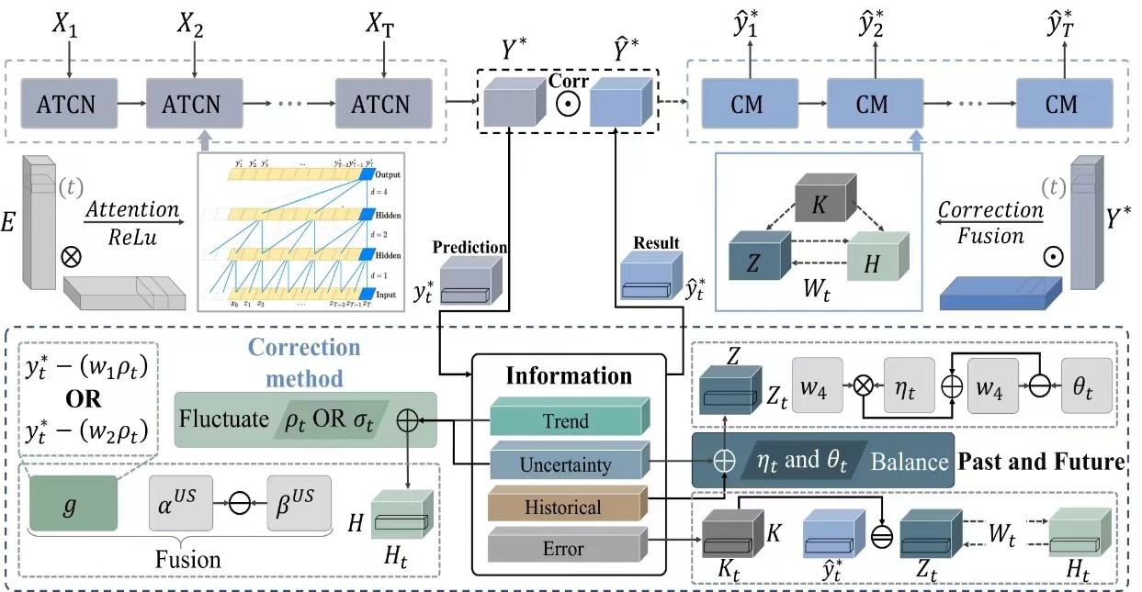
Fig. 1: Structure of the proposed model.

where

US ,

α^{US} = α 1 + x^{V} ^{T} (9)

β^{US} = β 1 + x^{V} ^{T} (10)
t−1
t−1

US and ^{US} are the estimated uncertainty
w₃ are fusion functions and coefficients, respectively, while g represents the state value at time t − 1, followed by w₁ and w₂ are the coefficients, ρ = y∗ − β^{US} and σ = y∗ − α^{US}.
- Calculate the Z value:
t t
η = G(y∗, x^{US} ) (17)

xt−1 α β
statuses.
t t−1

- Calculate the G value:
t
G(a, b) = w a + (1 − w )b (11)

θ = G
y∗,
xt−1 + xt−2
2

(18)

3 3

1
w3 = sigmoid(a, b) = 1 + e−((a)2+(b)2+(ab)+(a+b))
(12)
Z = w₄η + (1 − w₄)θ (19)

−((xt−1(1+xV T ))−xt−2) (20)

(y∗ − (w₁ρ) x^{V} ^{T} < 0
w₄ = e
t−1

g = ^{t}
t−1
(13) ∗

y∗ − (w₂σ) x^{V} ^{T} > 0
where θ, η are fused information of yt with future and past,

t t−1
H = G g, α^{US} − β^{US} (14)

w = qsin ρ + x^{V} ^{T} + x^{V} ^{T} ρ + (x^{V} ^{T} )2 + (ρ)2 2 (15)
respectively; Z is a weighted sum that balances the future and past, and the exponential weighting factor w₄ in (21), it is designed to give more weight to recent changes, which is appropriate for a system with potential rapid fluctuations such as wind power.

1 t−1
t−1
t−1
- Calculate the M value:
M = 0.99 × Z + 0.01 × H (21)

w = qcos σ + x^{V} ^{T} + x^{V} ^{T} σ + (x^{V} ^{T} )2 + (σ)2 2 (16)
2
t−1
t−1
t−1
where M is a weighted sum and its coefficients are constants.

The sigmoid function ensures that the weighting factor remains between 0 and 1, facilitating a smooth transition between the different states. Equation (13) incorporates a piecewise function, allowing for the differential handling of increasing and decreasing trends, which is crucial for capturing the asymmetry often observed in wind power data. G(a, b) and
The value of H represents future volatility. If the troppo is occupied, the predicted value may deviate from the actual data. Hence, the coefficient is set to 0.01.
- Calculate the K value:
K^{initial} = 0.1 (22)

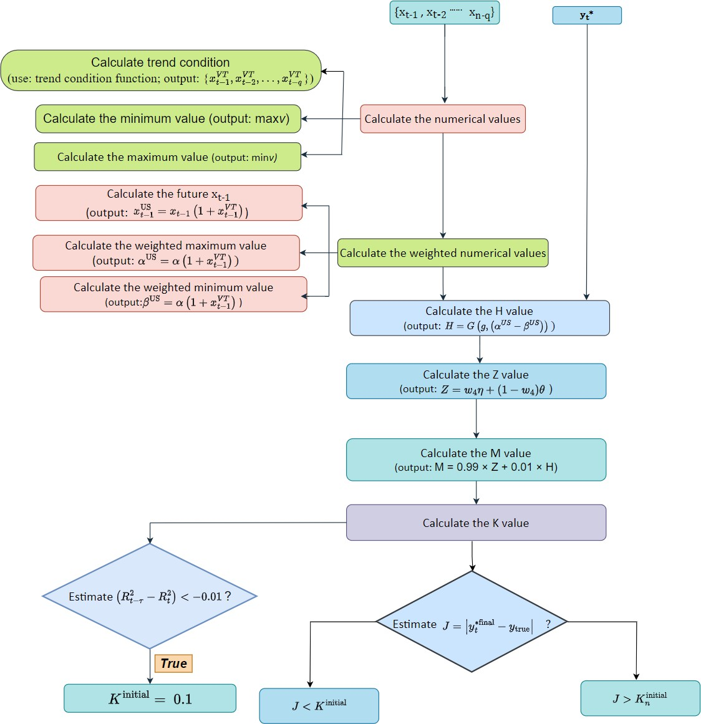
Fig. 2: Flowchart of the time analysis function.

10 len(testing data) ≤ 60

,
τ =
,
⌊7 · log₂(len(testing data)⌋ len(testing data) > 60
(23)
- Results and Discussion
The evaluation of various models using the same dataset should be performed using standardized evaluation methods. The outcomes of the modelling results were evaluated and benchmarked based on several core metrics: R-squared (R²), Root Mean Square Error (RMSE), Mean Absolute Error

R = R² (t = 1, . . . , N ) =
t

When (t ≥ τ ):
,0 t ≤ τ
,R² t > τ

(24)
(MAE) and Mean Absolute Percentage Error (MAPE). These are among the most commonly used regression metrics. These criteria collectively offer a complete overview of model per- formance and reliability.

2 2 ΣN
Σ
Rt−τ − Rt < −0.01 (n = 2, . . . , N ) (25)
R2 = 1 − t=1
(y∗(t) − y_{true}(t))²

Based on the recent performance, these equations implement an adaptive mechanism to adjust the model. Logarithmic scaling of τ in (24) is an effective way to handle different lengths of testing data efficiently.
,u, Σ
(26)
N
t=1

1 N
RMSE =
N
t=1
(ytrue(t) − y¯true)2 (y∗(t) − y_{true}(t))²

(27)

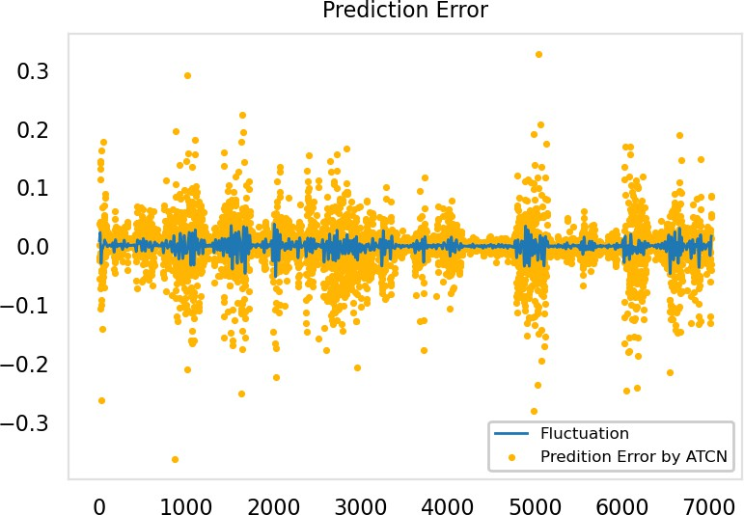
N
1 Σ
MAE = |y∗(t) − y_{true}(t)| (28)
N
t=1
1 Σ y∗(t) − y_{true}(t)
N

MAPE =
N
× 100% (29)
y_{true}(t)

t=1

where y_{true}(t) is the actual value, y∗(t) is the predicted value,
y¯_{true} is the average value of the observed data, and N is the
length of the data. The calculation of RMSE and MAE shows that a lower index value indicates a higher prediction accuracy. The value of MAPE is used to evaluate relative error. The R² is generally between [0 1]; thus, a result with a closer value to one will typically have better accuracy and vice versa. These four indices were used as references to evaluate the predictive model.
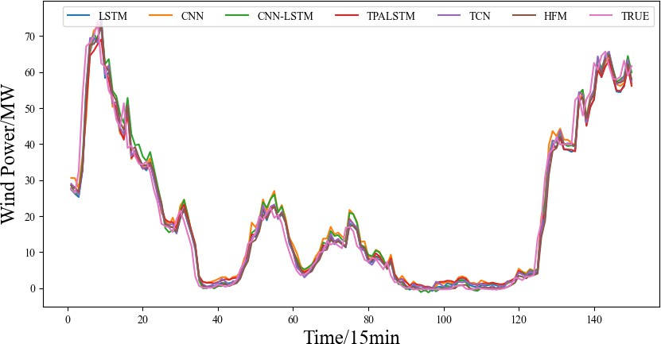
Fig. 3: Forecasting curves of six deep learning models.

A. Performance evaluation

TABLE I: Wind Power Forecasting Performance.
Model | R- | RMSE(MW) | MAE(MW) | MAPE
 | square(%)
DNN | 97.873 | 4.820 | 2.997 | 214.948
LSTM | 98.040 | 4.657 | 2.796 | 342.975
CNN | 98.026 | 4.689 | 2.891 | 85.349
CNN-LSTM | 97.929 | 4.908 | 2.969 | 116.264
TPALSTM | 98.084 | 4.548 | 2.682 | 93.765
TCN | 98.130 | 4.518 | 2.727 | 88.196
ATCN | 97.854 | 4.621 | 2.631 | 166.028
HFM(proposed) | 98.180 | 4.467 | 2.558 | 48.616

Table 1 shows the performance indices used to evaluate the initial proposed forecasting model along with several models from the literature. The best-performing values are highlighted in bold. The results indicate that the proposed model demonstrates superior accuracy compared with the other models. Fig. 3 illustrates the forecasting curves of the six deep learning models.
We performed a comparative analysis of the prediction errors and forecasting performance to evaluate how well our models can help make fruitful predictions. The error in the physical prediction of each model compared to the baseline fluctuation for the ATCN is shown in Fig. 4 and 5. The errors of both models are clustered around zero, which means

Fig. 4: Predictive Error by ATCN.
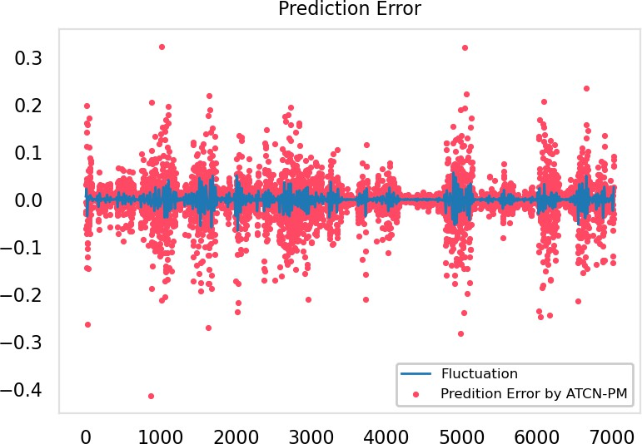

Fig. 5: Predictive Error by ATCN-CM.

that the predictions tend to be quite close; however, the error distribution of the ATCN-CM model is relatively centered with a slightly tighter variance among negative errors compared to the other models, which indicates better precision. The ATCN- CM errors exhibited a small positive bias, which warrants further investigation. A full illustration of the actual wind power data and their comparison with the predictions of both models are presented in Fig. 6. This visualization is in good agreement with the error analysis and shows that the models can correctly identify large-scale trends of wind generation power along with high-amplitude low-frequency variation. ATCN and ATCN-CM were notably fast in following the data, with ATCN-CM being able to track rapid drops marginally better than most algorithms. Nonetheless, minor deviations at the boundaries indicate several opportunities for improvement, where we explore error correction tools within traditional regression models (which utilize training data and original model outputs as input data).
Fig. 7 illustrates the corrected prediction result, where the mean absolute percentage error (MAPE) is an improved classifier with the prediction of the initial model, which shows

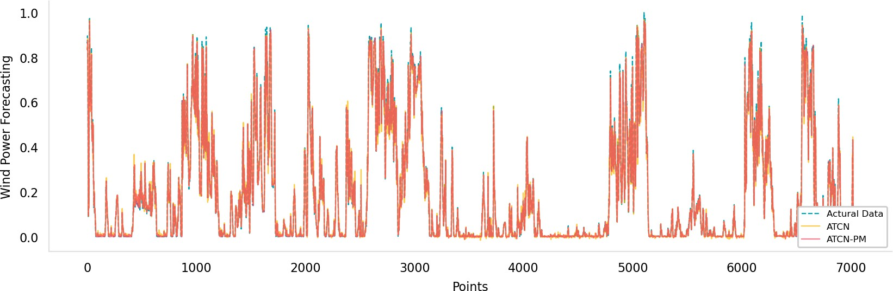
Fig. 6: Comparison between the original data, the predicted values and the corrected predicted values for the ATCN in the wind power forecasting.
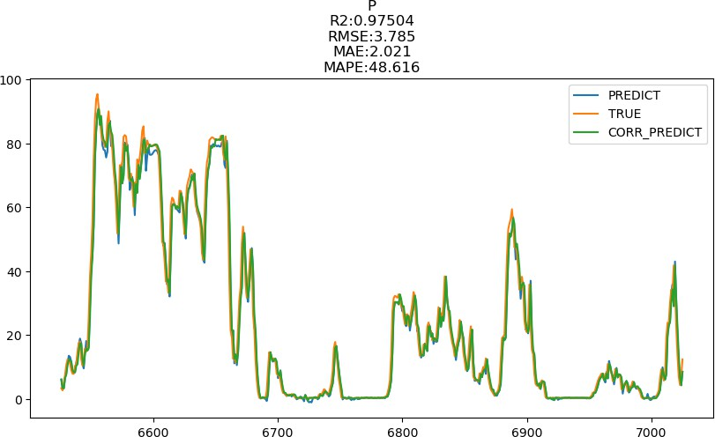
Fig. 7: Corrected prediction result.

the effectiveness of the proposed error correction approach.

- Conclusion

This study presents an innovative error correction methodol- ogy for time series forecasting that is, specifically designed to enhance the precision and stability of wind power estimates. The proposed technique tackles considerable challenges as- sociated with the non-linearity, non-stationarity, and multidi- mensional variability characteristics of wind power datasets. By adeptly incorporating historical information alongside prospective trends, the methodology not only enhances pre- dictive efficacy across a range of models, but also streamlines the forecasting process by obviating the necessity for parame- ter training and hyperparameter optimization. The empirical findings illustrate that this approach consistently surpasses conventional machine learning methodologies and cutting- edge models, achieving enhanced forecast accuracy in di- verse applications. This study advances predictive analytics by providing a robust, efficient, and adaptable framework that effectively equilibrates the impact of historical data with future trends, making it particularly advantageous in navi- gating the complexities of volatile and uncertain contexts. This methodology possesses substantial potential for extensive applicability across various sectors, thereby improving the precision and dependability of time series forecasts in real- world applications.
Acknowledgment
This work is supported by the National Natural Science Foundation of China under Grant 62233006, 62173152.
References
- J. Duan, P. Wang, W. Ma, S. Fang, and Z. Hou, ”A novel hybrid model based on nonlinear weighted combination for short-term wind power forecasting,” Int. J. Electr. Power Energy Syst., vol. 134, p. 107452, 2022.
- Y. Yang and Z. Liu, ”A novel probabilistic approach for driving the sustainable energy circular economy: Innovating efficiency in renewable resource markets,” Sustainable Cities Soc., vol. 108, p. 105461, 2024.
- S. Shahzad and E. Jasin´ska, ”Renewable Revolution: A Review of Strategic Flexibility in Future Power Systems,” Sustainability, vol. 16, no. 13, p. 5454, 2024.
- A. P. Maruga´n, F. P. G. Ma´rquez, J. M. P. Perez, and D. Ruiz - Herna´ndez, ”A survey of artificial neural network in wind energy systems,” Applied energy, vol. 228, pp. 1822-1836, 2018.
- C.-C. Wei and C.-S. Chiang, ”Assessment of offshore wind power potential and wind energy prediction using recurrent neural networks,”
J. Mar. Sci. Eng., vol. 12, no. 2, p. 283, 2024.
- M. Khan, C. He, T. Liu, and F. Ullah, ”A new hybrid approach of clustering based probabilistic decision tree to forecast wind power on large scales,” Journal of Electrical Engineering and Technology, vol. 16,
pp. 697-710, 2021.
- G. Sideratos and N. D. Hatziargyriou, ”Probabilistic wind power fore- casting using radial basis function neural networks,” IEEE Transactions on Power Systems, vol. 27, no. 4, pp. 1788-1796, 2012.
- K. Wang, X. Qi, H. Liu, and J. Song, ”Deep belief network based k- means cluster approach for short-term wind power forecasting,” Energy, vol. 165, pp. 840-852, 2018.
- M. Solas, N. Cepeda, and J. L. Viegas, ”Convolutional neural network for short-term wind power forecasting,” in 2019 IEEE PES Innovative Smart Grid Technologies Europe (ISGT-Europe), pp. 1-5, September 2019
- Z. Ouyang, J. Sun, X. Zhao, Y. Shen, and S. Li, ”Short-term wind power prediction model based on PCA-GA-LSTM neural network,” in 2023 IEEE 6th International Electrical and Energy Conference (CIEEC), pp. 148-153, May 2023.
- H. Li, ”Short-term wind power prediction via spatial temporal analysis and deep residual networks,” Frontiers in Energy Research, vol. 10, p. 920407, 2022.
- Y. Y. Hong and C. L. P. P. Rioflorido, ”A hybrid deep learning-based neural network for 24-h ahead wind power forecasting,” Applied Energy, vol. 250, pp. 530-539, 2019.
- J. Zhu, L. Su, and Y. Li, ”Wind power forecasting based on new hybrid model with TCN residual modification,” Energy and AI, vol. 10, p. 100199, 2022.
- S. F. Ahmed, M. S. B. Alam, M. Hassan, et al., ”Deep learning modelling techniques: current progress, applications, advantages, and challenges,” Artificial Intelligence Review, vol. 2023, pp. 1-97, 2023.
- S. M. J. Jalali, S. Ahmadian, M. Khodayar, A. Khosravi, M. Shafie- khah, S. Nahavandi, and J. P. S. Catala˜o, ”An advanced short-term wind power forecasting framework based on the optimized deep neural network models,” Int. J. Electr. Power Energy Syst., vol. 141, p. 108143, 2022.
- Y. Zhang, Y. Zhao, G. Pan, and J. Zhang, ”Wind speed interval prediction based on Lorenz disturbance distribution,” IEEE Trans. Sustain. Energy, vol. 11, pp. 807–816, 2020.
- S. Li, P. Wang, and L. Goel, ”Wind power forecasting using neural network ensembles with feature selection,” IEEE Trans. Sustain. Energy, vol. 6, pp. 1447–1456, 2015.
- A. Kisvari, Z. Lin, and X. Liu, ”Wind power forecasting–A data-driven method along with gated recurrent neural network,” Renewable Energy, vol. 163, pp. 1895-1909, 2021.
- Y. Hao and C. Tian, ”A novel two-stage forecasting model based on error factor and ensemble method for multi-step wind power forecasting,” Appl. Energy, vol. 238, pp. 368–383, 2019.
- F. Zhang, P. C. Li, L. Gao, Y. Q. Liu, et al., ”Application of au- toregressive dynamic adaptive (ARDA) model in real-time wind power forecasting,” Renew. Energy, vol. 188, pp. 56-70 2021.
- H. Liu, R. Yang, T. Wang, and L. Zhang, ”A hybrid neural network model for short-term wind speed forecasting based on decomposition, multi-learner ensemble, and adaptive multiple error corrections,” Renew. Energy, 2021.

