Reverse Osmosis (RO) Based Polymeric Membranes for Water Treatment

Abstract
Reverse osmosis (RO) membrane processes are a popular solution for recovering, recycling, and producing high-quality water for reuse. They help industries meet regulatory standards, reduce environmental impact, and improve water efficiency. RO membranes are the dense membranes and known for the lowest flux when compared to all other membranes, therefore operated at higher pressure. However, membranes encounter obstacles that can impact their function over time. Chemical and biological fouling lowers the membrane performance and results in its operation at higher pressure, whereas some chemicals like active chlorine exposure may damage the polyamide layer. For efficient separation, TFC membranes require high water permeability (flux), salt rejection, and resistance to temperature, pressure, and fouling. Efficient wastewater management is critical to adhering to regulations and economic sustainability. Sustainable developments, such as biodegradable membranes and renewable energy integration, offer promising approaches to lower the environmental and economic costs of RO processes. Bio-inspired membranes, such as those modeled after aquaporins, represent future advancements in selectivity and efficiency. Continuous innovation in RO technology is critical for meeting global water demands responsibly and effectively.

Keywords: Reverse osmosis, thin-film composite, polyamide, fouling, anti-fouling, Bio-inspired membranes, renewable energy.

1. Introduction
Desalination, called reverse osmosis (RO), is a sophisticated process designed to remove dissolved solutes from aqueous solutions, including ions and organic compounds. This demineralization technique employs a semi-permeable membrane, allowing water to pass through while retaining the majority of dissolved particles, effectively separating the impurities from the solvent [1]. RO involves forcing water to flow in the opposite direction of the automatic water flow in the forward osmosis (FO) process that is, from the side with a high solute concentration to the side with a low solute concentration by providing pressure that is greater than the osmotic pressure gradient. This process involves a semi-permeable membrane between solutions of low and high osmotic pressure. In contrast the preceding methods, pressure assisted osmosis (PAO), FO, and pressure retarded osmosis (PRO) are driven by osmotic pressure differences, causing water to flow from low to high pressure. Thus RO reverses this flow, enabling direct desalination [2]. The escalating demand for water treatment and desalination technologies has urged worldwide to supply people with clean, fresh water, particularly in water-stressed countries like Saudi Arabia, Qatar, and the United Arab Emirates [3], [4]. Increasing water shortage is one of the problems endangering humanity [5]. To meet the increasing population demands for clean water, regions facing scarcity require innovative solutions; since the commercialization of nanoporous membrane filtration systems in 1980, membrane separation technology has undergone rapid advancement, and has been applied across diverse industries, including food, petroleum, chemical processing, paper, pharmaceuticals, and electronics [6], [7], [8], [9]. Polymers utilized in membranes technology are currently predominant materials employed in the wastewater treatment desalination industries due to their highly developed properties and exceptional performance [10], [11], [12]. The inability to provide sufficient fresh water to meet demand is referred to as water shortage. As articulated by Thomas S. Eliot (1888–1965), Drought is the decay of the earth. Prolonged severe drought, often termed as Mega droughts, can devastate social order and agriculture systems, significantly influencing the cultural and temporal framework of various civilizations [13]. Internationally, millions of families continue to be at risk of water scarcity, facing lacking access to sufficient and clean drinking water. This imposes severe boundaries on both economic development and social cohesion. Agriculture, which consumes over 80 percent of worldwide freshwater resources, is the core industry effected by this disaster [14]. The crucial role of freshwater in human progress, highlights the global issue of water scarcity [15]. Moreover, human well-being is linked to the availability of clean water, which is crucial not only for drinking, but also for various industrial processes, cleanliness, leisure, and agriculture practices [16]. Consequently, sustainable water is compulsory to assure food security for both present and future generations. A critical inquiry in this context is how to increase water productivity so that more crops may be grown with less water. Conversely, uncontrolled groundwater pumping for irrigation is a major contributing factor to water scarcity [17]. It is anticipated that the world's water demand would rise by 55%, and 25% of major cities already face some degree of shortages of water [18]. According to a July 2022 report from National Drought Mitigation Center, there was a severe drought in the western United States, and it is predicted that in the years to come, there would be more frequent, severe, and extended droughts. While average annual rainfall has risen in the northern and eastern regions of the country, the quantity of precipitation level that drops annually in the Southwest has steadily declined since the start of the 20th century [19]. Khan et al. stated that water-related dangers and glacier surface melting contribute to water scarcity for agricultural use. In Bangladesh farmers faces severe difficulties as a result of the fluctuation in river flow brought on by varying weather patterns, as they endure low overflow from October to April and high overflow from May to September. Amid these challenges, desalination technologies offer potential solutions [20]. Greenlee et al., classify desalination techniques into thermal or membrane-based technologies [21]. While thermal desalination has continued to be the predominant technique in the Middle East, membrane methods particularly RO have quickly advanced since the 1960s and now often outperform thermal processes in newly constructed plants. The primary financial hurdle of desalination is the electricity consumption, with electricity accounting for approximately 30% of the overall cost of producing desalinated water via RO [22]. This review article focuses on the in depth understanding of RO technology and polymeric membranes applied for tackling worldwide water crisis. It will discuss the basics of RO membranes including their materials, structures and fabrication techniques along with their different applications especially in water treatment. The review will also investigate recent problems and progress in membrane technology, stressing the need of new developments to improve sustainability and effectiveness.
2. Fundamentals of RO Membranes
2.1. Definition and Structure of RO
RO is a water purification process that utilizes a semi-permeable membrane to separate molecules of water from other contaminants. To counteract osmotic pressure that supports equal distributions, RO achieve external pressure, given that RO has the benefits of low energy use, little cost, and quick operation, it has been employed extensively in seawater desalination [23]. This method is employed in industrial operations for the manufacture of drinkable water because it has the ability to remove biological contaminants, primarily bacteria, as well as both suspended or dissolved chemical species [24]. The advent of RO technology has significantly mitigated the global water crisis, demonstrating its impact on water availability [25]. Due to its great removal efficiency, this well-known RO technique has been extensively used in a variety of water treatment procedures, including desalination and facilities for reusing water [26], [27]. The dense structure of RO membrane can even filter out sodium ions (Na+ ionic radius = 1.16 Å), ensuring that the majority of pollutants in influents are removed [28]. Well-manufactured RO membranes can achieve substantial solute rejection rates by (>99%), meaning that after the RO process, more than 99% of the total dissolved solids are effectively eliminated [29]. Four osmotic membrane processes namely pressure aided such as RO, PRO, FO, and PAO are shown below in Figure. 1 shares a common semi-permeable membrane that is positioned between a low osmotic pressure solution and a high osmotic pressure solution. In these processes water moves from the low osmotic pressure side to the high osmotic pressure sides, which are (partially) driven by the osmotic pressure differential, however these processes are unable to accomplish desalination on their own. During the RO process clean and desalted water can only be directly obtained by this pressure-driven membrane method when the direction of water flow is reversed [1].
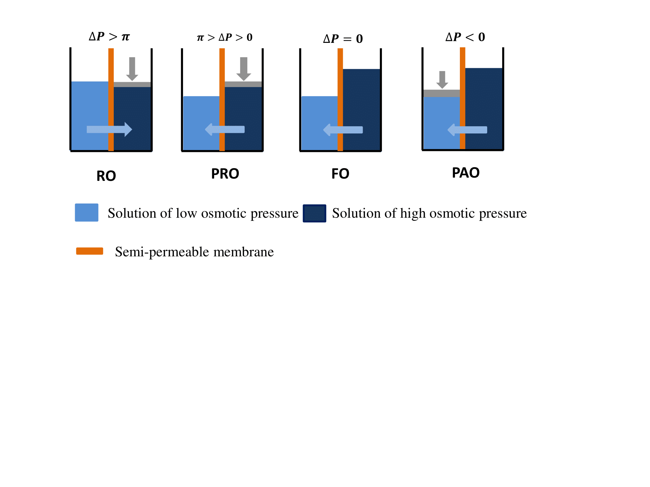
Figure. 1. Depicts osmotic membrane processes such as RO, PRO, FO, and PAO [2].
Polymeric membrane-based RO is a well-established method for both desalinating brackish and seawater. There are two distinct methods which have been used in the fabrication of these polymeric RO membranes: the interfacial polymerization for thin film composite (TFC) membranes and phase inversion for asymmetric membranes, such as cellulose acetate membrane [30]. RO membranes are basically non-porous, featuring pore sizes less than 1 nm [31]. The operational mechanism of RO membranes based on the solution-diffusion model, whereas solutes dissolve in the membrane matrix, and then diffuse under pressure [32]. In general, RO membranes are used to desalinate groundwater that is brackish and seawater. Consequently, they must fulfill four essential criteria: (i) a high water permeability and salt rejection rate (ii) a thin membrane layer with adequate mechanical integrity (iii) a large area per unit volume and (iv) both physical and chemical stability [33]. Among these, thin film composite (TFC) membranes based on aromatic polyamide (PA) are most widely employed reverse osmosis (RO) membranes in water treatment and seawater desalination processes [30].
  - Thin-film composite (TFC) membranes
Thin film composite (TFC) polyamide (PA) membranes utilize pressure to separate low molecular weight compounds, as well as monovalent and polyvalent ions [34]. Since Morgan (1965) suggested the use of interfacial polymerization (IP) to create a thin polymeric layer on a substrate, TFC membranes have developed rapidly. TFC membranes made by the interfacial IP technique are gaining a lot of interest in a variety of membrane products, particularly in the domains of RO membranes [35]. Due to their proven effectiveness and cost-efficiency, TFC membranes currently hold a leading position in the global market for RO and FO applications [34], [36], [37]. The manufacturing of TFC membranes, which consists of a porous support layer and an ultrathin but thick separation layer, is crucial to the advancement of high-performance membranes [38]. Three layers are typically found in TFC membranes as shown below in Figure 2, the bottom layer is frequently a readily accessible nonwoven fabric substrate composed of polyethylene terephthalate (PET/polyester), which adds additional mechanical strength; (i) the top barrier layer, also known as the (polyamide) active layer, particular layer, or separation layer, is an ultrathin dense layer formed through interfacial polymerization typically from the polyamide; (ii) a microporous promote serving as the middle layer, typically constructed from PSF [33].
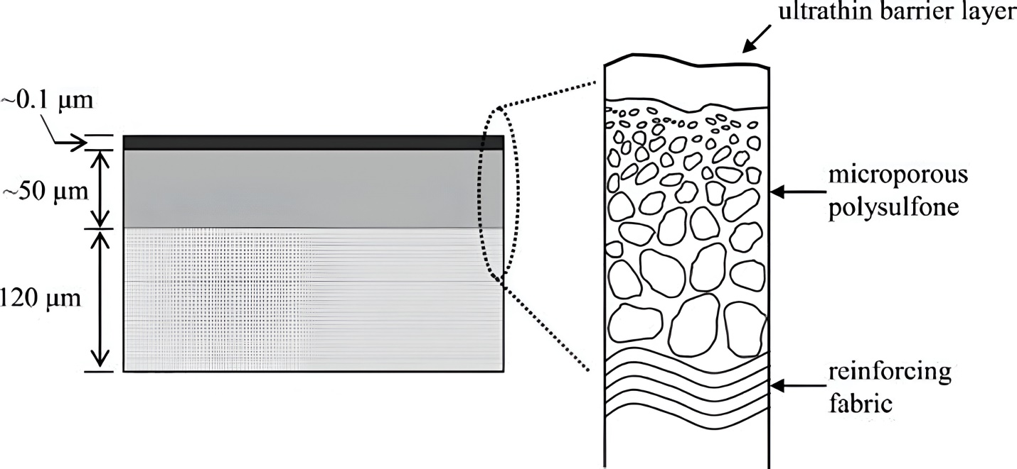
Figure. 2: Schematic diagram of a typical thin-film composite membrane [33].
TFC membranes are stable across a broad pH range of 2–11, and they show high water permeability and salt rejection (almost 100% NaCl removal) [39], [40]. Each layer's characteristics for TFC membranes can be specifically created and enhanced. Because at least two preparation stages are needed, their manufacturing costs are higher than those of traditional asymmetric cellulose-based RO membranes. Polyamide TFC membranes face some drawbacks viz flux-rejection tradeoff, limited chemical resilience, susceptibility to fouling, and low tolerance to chlorine [41]. Given that chlorine is the most widely used and economically viable disinfectant for ensuring water safety for human consumption, the development of TFC membranes with enhanced chlorine resistance is essential for effective drinking water purification.
2.2 Operating Principles
Under normal operating conditions, RO membranes show greater than 99% salt rejection. Commercially, these membranes, cellulose acetate (CA) and polyamides (PA) are used to create commercial RO membranes [42], with comparison of PA membranes, CA membranes show better salt and chlorine rejections, however their sensitivity to pH restricts their use in RO. To address these limitations, an ultra-thin cross-linked PA layer that is active is secured on top of a porous support layer via an interfacial polymerization (IP) reaction to create TFC PA membranes [43], [44]. RO can be operated in various modes, including continuous batch, semi-batch or closed-circuit desalination (CCD) methods. In batch RO (BRO), the concentrate stream is re-circulated back to the feed tank, necessitating an increase in applied pressure corresponding to the rising osmotic pressure as salt concentration increases [45]. BRO can offer operational flexibility to effectively manage a variety of water recovery tasks [46]. The raw feed water and RO concentrate are combined in a CCD process and delivered to the RO membranes. As the result, low pressure, significant water recovery, and high permeate flux are made possible by CCD, because recycled concentrate raises the feed's salt content, pressure is gradually increased to keep the permeate flow steady. Once the desired output capacity is reached or when the pressure required is too high, excess concentrate is flushed straight without recycling, and promoting a new cycle is started [47]. Swaminathan et al. demonstrated that employing a pressurized feed tank in BRO reduced energy consumption by up to 8%, and the BRO mode of operation enables energy recovery to occur in just one phase without the use of energy recovery equipment by returning pressurized concentrate to the feed [48]. Among the most popular membrane processes for treating wastewater, from pretreatment to post treatment, are pressure-driven membrane technologies are predominant, recycling on hydraulic pressure for separation. These procedures encompass four main types, which includes reverse osmosis (RO), nanofiltration (NF), ultrafiltration (UF), and microfiltration (MF), which differ primarily in their membrane pore diameters and corresponding pressure requirements [49]. The essential characteristics of these pressure-driven membrane processes are summarized below in Table 1.
Table 1. Some characteristics of pressure-driven membranes [50], [51].
Membrane Process | Pressure Required (bar) | Membrane Type | Average Permeability (L/m2 h bar) | Solutes Retained
RO | 15–75 | Asymmetric, semi-porous thin-film composite | 5–10 | All pollutants include monovalent ions.
NF | 5–15 | asymmetric, tight-pore, thin-film composite | 10–20 | pigments, sulphates, cations with divalent bonds, divalent anions, sucrose, lactose, and sodium chloride
UF | 2–5 | microporous and asymmetrical | 150 | Microplastics, proteins, oils, sugar, and pigments
MF | 1–3 | symmetric, asymmetric, or porous | 500 | Microparticles, colloids, organics, bacteria, fat, oil, and grease
Pressure-driven membrane processes such as RO, are well known for their ability to separate tiny particles, microorganisms, and monovalent ions up to 99.5% of the time, such as sodium and chloride ions [51]. For decades, RO has led the way in the reclamation of water through the treatment of wastewater and the desalination of seawater. During the RO process, a hydrostatic pressure powerful enough to surpass the feeds intrinsic osmotic pressure is produced, effectively reversing the natural osmosis phenomenon. Under this pressure, the molecules of water get absorbed onto the cell membrane's surface for the duration of the operation. These molecules eventually desorb at the permeate end of a membrane for collection after diffusing through the membrane material [21]. Various combinations of these membrane processes powered by pressure have been used in various wastewater treatment scenarios, often serving as pre-treatment stages for subsequent processes. For instance, Nataraj et al. treated distillery effluent with NF and RO in combination, and the removal of 98% of the pollutants was successful on average. In another application, reactive dye printing wastewater was treated using UF and RO together in a small size system [52]. Although the RO permeate was suitable for release and reuse even after the UF, but the permeate still didn't meet the discharge restrictions [53].
- Polymeric Materials for RO Membranes

In response to the significant investments in the development of RO polymeric membranes [54], [55], scientists have been investigating low-cost polymeric materials with suitable solubility, strong mechanical strength, and chemical stability for use in membrane construction. The primary goals are high water permeability, salt selectivity, enhanced antifouling capability, and chlorine resistance. Up until now, a variety of polymers, aside from conventional materials like Cellulose acetate (CA) and Polyamide (PA), have been studied for their viability as membrane materials. Below is a discussion of the primary polymeric materials used in RO membranes [56], [57], [58]. Polymeric/organic RO membranes have taken over the worldwide market since 1980, owing to their superior performance and inexpensive cost. Table 2 below lists some of the most advanced polymeric RO membrane, along with their supplier, selective layer composition, operating conditions, and purification performance [59].

Table.2. Commercial polymeric RO membranes for water purification [59].
Membrane | Manufacturer | Selective Layer | Maximum Temperature (°C) | pH Range | Salt Rejection (%)
SW30HRLE-400 | Dow Filmtec, USA | PA TFC | 45 | 2–11 | 99.8 NaCl
SWC4+ | Hydranautics, USA | PA TFC | 45 | 3–10 | >99.7 NaCl
TM820C-370 | Toray, USA | PA TFC | 45 | 2–11 | >99.5 NaCl
HB10255 | Toyobo, Japan | CTA hollow fiber | 40 | 3–8 | >99.4 NaCl
TS80 | Microdyn-Nadir, USA | PA TFC | 45 | 1-12 | 80 NaCl  >98.5 MgSO4
AD-90 | GE-Osmonics, USA | TFC | 50 | 4-11 | >99.5 NaCl  95% Boron
AG4040C | GE-Osmonics, USA | TFC | 50 | 4-11 | >99 NaCl
HL2540FM | GE-Osmonics, USA | TFC | 50 | 3-9 | >96 MgSO4
CK4040FM | GE-Osmonics, USA | CA | 30 | 5-6.5 | >94 MgSO4
8040-SW-400-34 | Koch, USA | Proprietary PA TFC | 45 | 4-11 | >99.5 NaCl
4040-HR | Koch, USA | Proprietary PA TFC | 45 | 4-11 | >99.2 NaCl
- 3.1 Common Polymeric Materials
Important polymers are utilized to fabricate RO membrane such as polyamides, cellulose acetate, cellulose diacetate, and cellulose triacetate. Polyamides, characterized by recurring amide (-CO-NH-) groups, can be synthesized both synthetically and naturally, with examples including angora, silk, and wool. Cellulose-based polymers, particularly cellulose acetate (CA), are typically produced through phase inversion techniques.
  - 3.1.1 Cellulose acetate (CA) materials for RO membranes
Cellulose acetate (CA) is produced industrially by esterifying cellulose molecules with acetic acid and acetic anhydride in the presence of sulphuric acid due to the availability of reactants, high reactivity, and controllability [60], [61], [62]. A significant cellulose ester is CA [63], [64] is shown below in scheme 1.
Scheme. 1. Illustrate the preparation of cellulose acetate [65].
From 1964 to the mid-1970s, the reverse osmosis membrane was the most commonly used in industry, it was typically made of CA, cellulose triacetate, or a combination of the two in varying ratios [66]. The most readily available natural polymer, cellulose, is used to create CA membranes through the acetylation process. The characteristics of CA membranes include a neutral surface, a relatively low cost, significant resistance against free salt (at low levels), a very hydrophilic surface, and significant water flux potential [67]. Nevertheless, there are a few drawbacks of CA membranes, including their limited pH operating range (4.5–7.5), susceptibility to biological assault, compressed at high pressure, and operation at a limited temperature range [68]. Phase inversion method is the general term for the manufacture of CA membranes. To create a casting solution, cellulose triacetate is first dissolved in an organic solvent or solvent mixture. After that, the solution is applied to a tubular or flat support. Ultimately, a non-solvent bath is used to submerge the support, causing polymer coagulation and the formation of a CA membrane. The growth of cellulose triacetate (CTA) membranes, which had marginally greater thermal, chemical, and biological stabilities, was sped up by the creation of CDA membranes [69]. Cellulose-based membranes feature anisotropic structures with asymmetric morphologies; they are made up of a porous sub layer and an upper skin layer [32]. The chemical makeup of the porous sub layer and the skin layer is the same. The level of acetylation affects how well CA membranes filter substances. For example, the salt rejection of a CA membrane with 40 weight percent acetate and 2.7 degrees of acetylation ranged from 98 to 99%. Selectivity will increase with increased acetylation, but water permeability will decrease. The pH range of 4-6 is stable for CA membranes. The hydrolysis reaction will occur in basic and acidic feed solutions, reducing the selectivity. Chou et al. discovered that distributing silver nanoparticles on the CA membrane surface will boost their biological stability while maintaining permeability and salt rejection [70]. TFC membranes have dominated the market for the past four decades, outperforming CA membranes in terms of permeability and rejection. However, CA membranes continue to exist due to their overall extraordinary salt resistance, which is determined by numerous characteristics such as polymer type, manufacturing technique, and feed solution pH. Since feed water disinfection is a necessary step in RO and NF installations, and chlorine is the most commonly used disinfectant, chlorine-tolerant membranes are crucial for water treatment.
3.1.2 Polyamide (PA) in thin-film composite membranes
TFC membranes are the foundation of thin-film nanocomposites (TFN) technology. These membranes are asymmetrical, with a dense top layer and a porous support made from various materials. Initially, commercial RO membranes were made from two types of materials, polyamide (PA) and cellulose acetate (CA). When nanomaterials are embedded into the membrane structure, they are referred to as TFN membranes, whereas TFC membranes are generally called composite because their three layers are not chemically linked [71], [72]. PA TFCs consist of two layers: a thin layer of polyamide produced on top of a porous substrate layer, which is often constructed of polysulfone, where the porous sub-layer offers mechanical strength and support, while the top layer is concerned with the membrane's permeability qualities. The dual-layer configuration allows for individual synthesis and customization of each layer, optimizing the overall performance of the membrane system [73]. The creation of a PA thin film composite (TFC) membrane represents a significant advancement in the field of RO. This membrane is made up of two layers, the top is an active PA film formed by the interaction of m-Phenylenediamine (MPD) and trimesoyl chloride (TMC) on a microporous polyether sulfone support (PES) at the bottom layer [74], as shown in Figure 3. The hydrophilicity of the membrane surface and the properties of the porous support layer determine water flux across composite membranes, whereas surface charges and PA structure influence salt rejection.
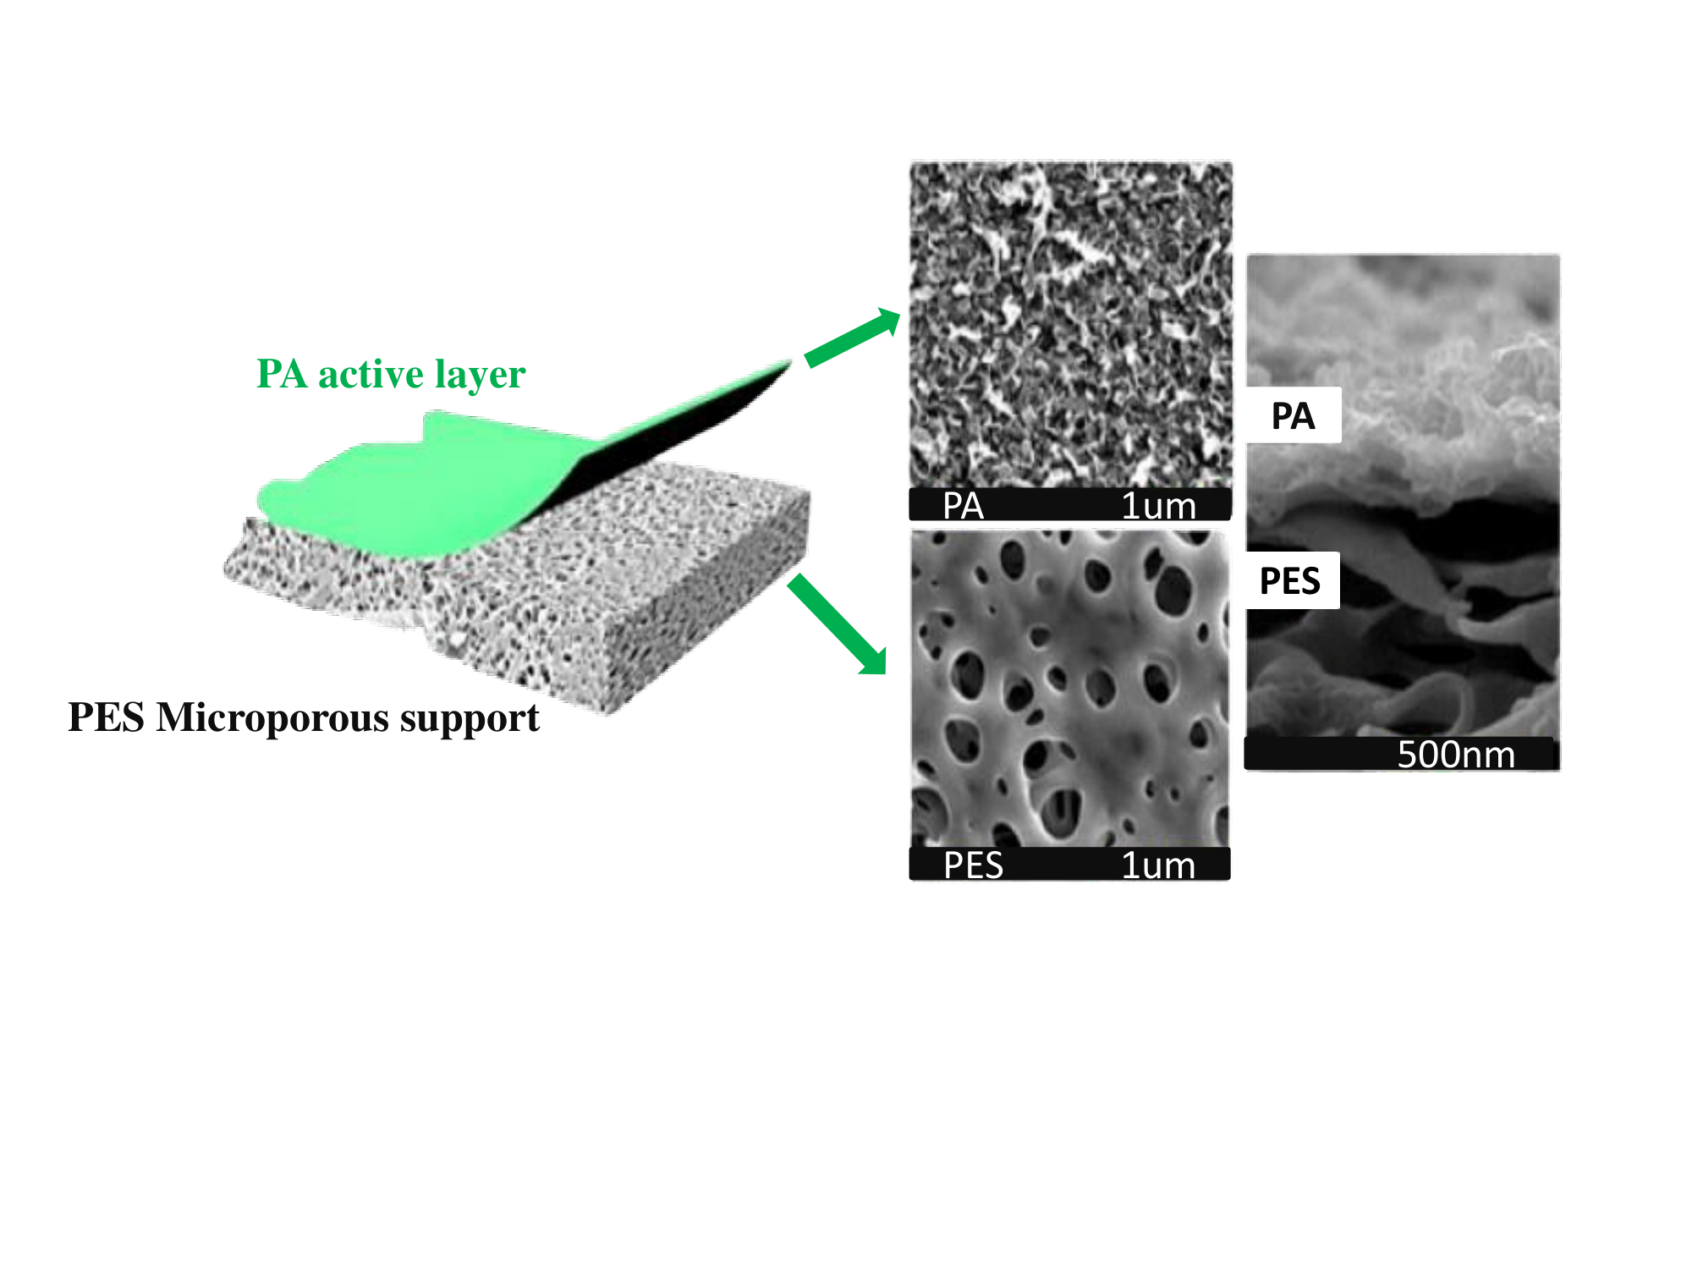
Figure. 3: Polyamide thin film composite membrane [74].
Several cutting-edge reviews were published to highlight different sorts of RO-TFC membranes including their capabilities. For example, Yin et al. described how integrating different nanoparticles improved the membrane's fluid flux, salt rejection, chlorine resistance, and antifouling capabilities [75]. Another evaluation, by Xu et al. examined the effects of sub-layer modification on a pressure gradient over the pores and subsequent performance [76]. Gohil et al. recently conducted a systematic assessment of the composition of the structure and separation characteristics of TFC membranes, addressing the effects of various chemicals and IP reaction parameters [77]. However, until recently, there wasn't clear distinction among the procedures that have been employed to improve the properties of RO-TFC membranes.
- 3.2. Properties of Polymeric Membranes
The water permeability, A (Lm⁻²h⁻¹bar⁻¹, LMH/bar), and salt rejection, R (%), of polyamide membranes were measured using a RO process. The membranes were tested under a transmembrane pressure (P) of 15–20 bar in a cross-flow setup at room temperature, as is common for RO systems, following prior investigations [78], [79], [80], [81]. In the test, the polyamide membrane was supported to endure the pressure by a PC track-etched membrane.
The pure water's permeability (PWP) was estimated using Eq. 1.
$J_{w}=\frac{∆m}{∆t}1/A_{m}∆P$ (1)
Where
- $J_{w}$ is he pure water flux (LMH/bar)
- $A_{m}$the effective area of the testing cell,
- $∆m \left(g\right)$ is the feed solution's absolute weight loss,
- $∆t \left(h\right)$is the evaluation duration,
- $∆P \left(bar\right)$ is the actual transmembrane pressure [82].
Since $∆m$is given in grams, we need to convert it to liters to express flux in LMH/bar. Assuming the density of water 𝜌 is approximately 1 g/mL (or 1000 g/L); the mass can be converted to volume by dividing Δ𝑚 by 1000 g/L in Eq. 2.
$J_{w}=∆m/∆t×A_{m}×∆P×1000$ (2)
For salt rejection testing, a saline feed solution was used. The salt rejection R was computed according to Eq. 3.
$R=\left( 1-\frac{C_{p}}{C_{f}}\right)×100\%$ (3)
Using a conductivity meter, the amounts of NaCl in $C_{f}$ and permeate $C_{p}$ were found [82]. In Table 3 below summarizes the basic features of RO membranes and other pressure-driven membranes, including nanofiltration (NF), ultrafiltration (UF), and microfiltration (MF), categorized by pore size or operational pressure range.
Table. 3 .Basic properties of RO membrane [2].
Reverse Osmosis | Nano filtration | Ultrafiltration | Microfiltration | Parameter
<2 | 2 | 1-100 | 50-10000
  Surface Pore Size (nm)
10-100 | 2.0-10 | 1.0-5.0 | 0.1-2.0
  Operating Pressure (bar)
0.5-10 | 5-50 | 20-500 | >500
  Water Permeability (L/m² h/bar)
>10 | >100 | 1,000–300,000 | - | Molecular Weight Cut-Off (Da)
Thin-film composite polyamide, cellulose acetate | Thin-film composite polyamide, cellulose acetate, etc. | Polymeric, inorganic | Polymeric, inorganic | Membrane Materials
The strong rejection comes at the expense of low water permeability (Lm⁻²h⁻¹bar⁻¹, LMH/bar) called flux-rejection trade off. In real operation, a high pressure of more than 60 bar is typically required to overcome the osmotic pressure of seawater and create a moderately high water flux. BWRO membranes feature a relatively low NaCl rejection (>95%) and a higher water permeability (1-10 L/m2 h/bar), making them ideal for water/wastewater treatment where the feed salt concentration is significantly lower than that of seawater. NF membranes are comparable to RO membranes, however the larger "pore" size of NF membranes in comparison to RO membranes results in higher water permeability and significantly lower rejection to monovalent ions (e.g., 10%-90% rejection to Na+ depending heavily on the membrane's surface charges [83].

4. Fabrication Techniques for RO Membranes
- 4.1 Interfacial Polymerization
Interfacial polymerization (IP), is a key technique that makes it simple to synthesize an ultrathin selective layer, is used to create TFC membranes. As illustrated in Figure 4, shows an example of a process for creating TFC RO membranes, to enable diamine penetration into the support, a microporous polysulfone membrane is first submerged in an aqueous diamine solution, m-phenylenediamine (MPD). The impregnated support comes into contact with trimesoyl chloride (TMC), an organic phase of acyl chloride, after the excess diamine on the surface has been removed. A thin polyamide layer forms on top of the polysulfone support as MPD monomers react with TMC as they diffuse to the interface between organic phases and water [84].
Figure 4: Schematic illustration of a standard interfacial polymerization procedure for TFC RO membrane production [84].
Although IP is an advanced process but there are still several useful and important problems that require attention. It is asserted that the selective surface and supporting structures can be separately adjusted to maximize TFC membrane performance from a practical standpoint. This isn't entirely accurate, though, as the prepared PA layer's structure and functionality rely heavily on the chemical and structural makeup of the support [85], [86], [87], [88].
- 4.2 Phase Inversion
Phase inversion is the process of changing from a single-phase casting solution to two distinct phases. From the liquid polymer solution, phase separation occurs into two distinct stages. It creates a polymer-rich solid membrane matrix, or membrane pores, while the liquid phase, which contains less polymer, forms membrane pores [89].The phase inversion approach involves the controlled transformation of a homogeneous polymeric solution from a liquid phase to a solid stage by immersing it in a water bath [90]. The phase inversion approach creates polymeric membranes as thin film layers or hollow fibers [91]. A variety of additives, including nanomaterials, surfactants, ionic liquid, and polymeric additives, are specifically used in several studies to modify the phase inversion prepared membranes [92], [93], [94]. The impact of titanium dioxide ( TiO₂) nanoparticles, organic acids, and various solvents on the thermal durability and membrane separating performance was examined in an investigation where the CA hybrid membrane was created using the phase inversion method with higher permeability and advanced antifouling characteristics [95]. It has been discovered that the chemical reaction between the organic acid in solution and the salt in the sedimentation tank results in a high porosity of 82.5% in the structure of the membrane and a more uniform pore size distribution. The most significant element contributing to greater heat stability has been found to be the creation of coordinate covalent connections between TiO₂ nanoparticles and CA polymer [95]. N-isopropyl acrylamide was employed as a monomer and N, N-methylene bisacrylamide as a crosslinker in a study to examine the impact of the CA/cellulose triacetate (CTA) ratio on the performance of grafted RO membrane. CA/CTA blend RO membrane was then created. The crosslinked and grafted membranes' surface roughness showed notable improvements. Elkony et al. found that grafting and crosslinking may lower the contact angle and that the grafted CA/CTA-RO membrane had the highest salt rejection value [96].
- 4.3 Surface Modification and Coating
The separation that takes place in the pressurized system during the RO process causes foreign particles to cling to the membrane's surface, causing fouling of the membrane and a drop in water flow or an increase in the pressure differential across the membrane. Membrane characteristics like surface roughness, hydrophilicity, surface charge, etc. are related to this fouling. As a result, numerous studies have been conducted to alter the active polyamide layer in order to enhance the membrane's antifouling property [97]. Surface adsorption and surface coating are the two subcategories of physical changes to the surface of TFC RO membrane. the Physical surface modification is depicted below in Figure 5.
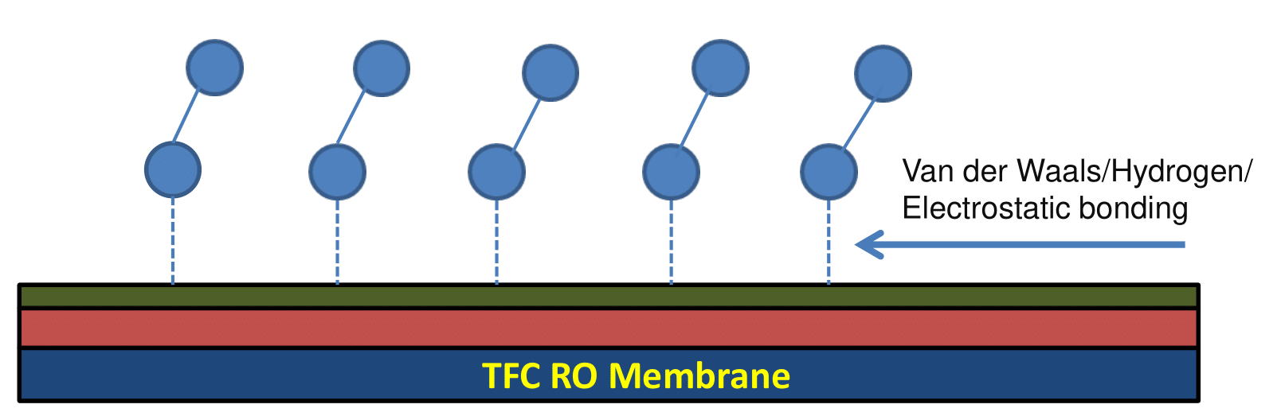
Figure. 5. Physical surface modification by surface adsorption or surface coating [98].
Kwon et al. found that covering RO membranes with poly (ethylene glycol) acrylate (PEGA) improved their antifouling capabilities. PEGA-coated RO membranes were linked together with glutaraldehyde (GA) solutions to increase coating durability. Surface modification improved RO membrane performance by reducing roughness and increasing hydrophilicity. The modified membranes for RO systems have improved antifouling capabilities and retained about 100% their initial flux of water following physical cleaning [99]. Wu et al. employed thermo-responsive copolymers (P(NIPAM-co-Am)) to modify membrane surfaces and improve their characteristics [100]. Zou et al. employed triethylene glycol dimethyl ether (Triglyme) to minimize organic fouling on RO membranes [101]. Yu et al. used coated NIPAm-co-AAc copolymers to improve salinity or sodium hydroxide rejections and fouling resistance [102]. Matin et al. combined hydroxyethylmethacrylate (HEMA) monomer with hydrophobic perfluorodecyl acrylate monomer to create an antifouling coating [103].

5. Applications of RO in Water Treatment
- 5.1 Seawater Desalination
The 1960s saw the development of seawater desalination techniques based on distillation, which produced freshwater by heating it. The most common use of RO nowadays is the creation of drinkable water from brackish and saltwater sources. Process improvements have resulted in a significant reduction in the use of energy of seawater reverse osmosis (SWRO) since the end of the 1970s [104]. These days, 60% of all plants in the world have RO membranes in their desalination facilities [105]. According to IDE technologies, a typical example of a huge SWRO desalination plant was put into service in 2013 at Saudi Arabia or the United Arab Emirates, with an annual capacity of 624,000 m₃ of potable water per day [106]. The total of the osmotic pressure of seawater and the pressure required for membrane permeation must be delivered to seawater in order to produce freshwater from seawater via an SWRO membrane. This pressure, which is currently between 5 and 7 MPa, is extremely high and has a big effect on the desalination plant's energy usage and running expenses. Phases 1 and 2 of the Jeddah SWRO plants began operations in 1989 and 1994, respectively, and had a production capacity of 15MGD (56,800 m₃ /d). The raw saltwater used in the facility was drawn from beneath the surface of the Red Sea and treated with an injection of sodium hypochlorite, which served as a disinfectant. Anthracite and sand were the two materials of a dual media filter (DMF) that received the chlorinated seawater. Prior to the dual media filter, a coagulant injection of ferric chloride was made. In order to avoid the production of scale, sulphuric acid (H₂SO₄) was injected into the filtered saltwater to regulate its pH [107]. A traditional method was used at the Doha Industrial Plant for treating the surface seawater needed to supply the RO lines. These RO lines featured their own extra initial treatment system, in contrast to the normal pre-treatment. The average SDI15 was greater than 6.5 and the TDS of 47,000 mg/L were found in Doha's surface saltwater. Filtration and flocculation were used to remove colloidal and suspended particles out of the untreated water [108].
- 5.2 Brackish Water Treatment
Ground water is a common source of brackish water. There may be originally saline wells or groundwater that have turned brackish as a result of anthropogenic factors (such as overuse and irrigation) or seawater intrusion. RO membrane techniques have made brackish groundwater an alternative water source for producing potable water in dry inland regions, such as the Middle East and the Southwestern U.S [109], [110], [111]. However, a significant amount of membrane concentrate, sometimes referred to as brine, is unavoidably produced during inland brackish water desalination; this brine makes up 15–60% of the feed water that must be disposed off [112]. Deep well injection, evaporative ponds, land application, pipeline ocean discharge, and advanced brine treatment are examples of conventional inland brine treatment solutions. Increased salinity and secondary contamination can result from deep well injection and land application, which can have a negative influence on the ecosystem [113], [114].
- 5.3 Industrial Wastewater Treatment
The use of RO for treating various industrial wastewaters, including cutting oil suspensions, chemically contaminated surface water, leachate, photography wastewater, and abattoir effluent. RO is operated at pressures below 60 bar with approximately 80% water recovery, showing strong rejection of organic and inorganic molecules. However, further post-treatment is required to enhance the removal of organic contaminants. The combined membrane-based bioreactor (MBR)–RO system has been thought to be a desirable method for recovering and reusing wastewater, such as that from semiconductor manufacturing, textile, thin-film transistors liquid crystal display, and municipal sources [115], [116]. Xiao et al. tested the effectiveness of combined MBR-RO methods for semiconductor water treatment. RO membrane autopsy examination revealed that loose inorganic deposits (e.g. BaSO₄, Ca, Mg, Si, Al, Fe, and Zn) were the main foulants, with minimal biofouling and organic fouling. Chemical cleaning with HCl-NaOH/EDTA successfully removes foulants and restores membrane permeability [117]. RO applications in wastewater treatment are listed below in Table 4. Chung et al. conducted a feasibility study on the combined RO-ferrite process for reclaiming plating wastewater and recovering heavy metals [118].
Table. 4. RO applications for treating wastewater.
Wastewater | Treatment of Target | Remarks | Ref.
Municipal wastewater | Drinking  water production | Integrated MF–RO–UV system with chlorine dosing before and after MF to control biofouling | [119]
Sugary wastewater | Sugar recovery | Combined RO–EDI system with over 99% sugar rejection | [120]
Dairy  industry wastewater | Water reuse | Achieves 95% water recovery | [27]
Tannery wastewater | Water reuse | Integrated microfilter–UF–RO system with 98% salt and COD rejection, RO flux of 40 LMH at 30 bar | [121]
Olive  mill wastewater | Water reuse | Centrifuge–UF–RO system, ~96% COD removal, ~95% conductivity removal, permeate flux of ~13 LMH | [122]
In this table municipal wastewater treatment for drinking water production uses an integrated MF–RO–UV system with chlorine dosing to control biofouling. For sugary wastewater, a combined RO–EDI system achieves over 99% sugar rejection. Dairy industry wastewater reuse sees 95% water recovery, while tannery wastewater treatment uses a micro filter–UF–RO system with 98% salt and COD rejection. Olive mill wastewater treatment involves a centrifuge–UF–RO system with ~96% COD and ~ 95% conductivity removals.

6. Challenges in RO Membrane Applications

Reverse osmosis produces water that is almost free of dissolved ions. Due to highly efficient rejection various challenges arise viz shorter membrane lifetimes, chemical and biological fouling, higher capital and operating expenses, pretreatment compulsion, and brine management [123].
- 6.1 Membrane Fouling
The primary limiting factor for RO applications is fouling, which must be taken into account while building and running RO plants because it has an impact on pre-treatment needs, operating conditions, cleaning needs, performance, and total operational cost. A membrane's fouling tendency is influenced by a number of variables, including its hydrophobicity, surface shape, roughness, and material’s chemistry. Colloidal, organic, inorganic, and biofouling fouling are the general categories into which fouling falls as shown below in Figure 6.
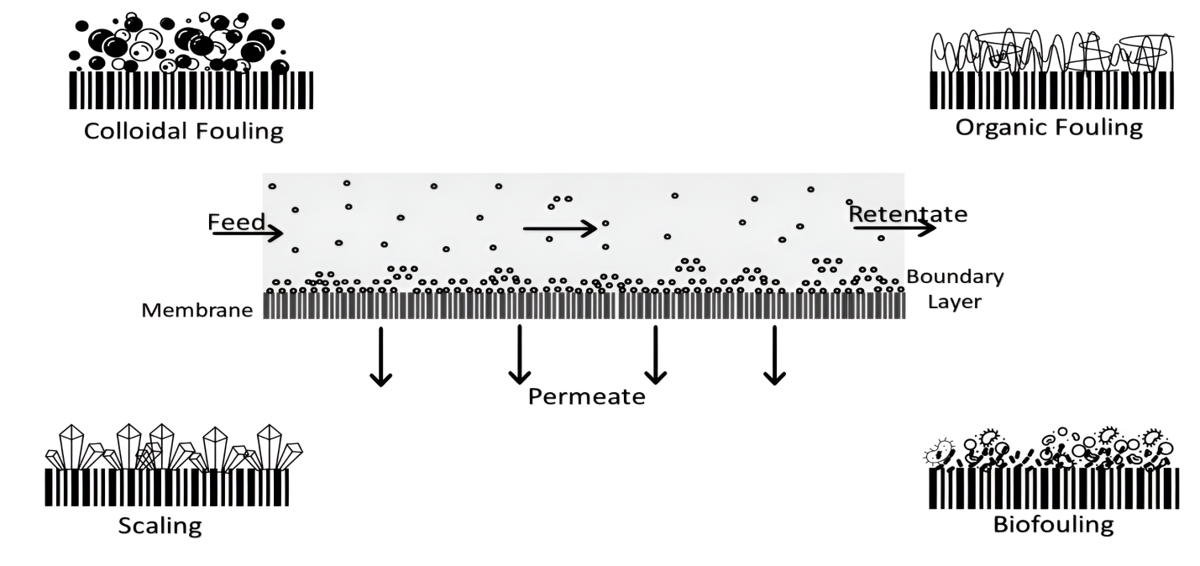
Figure 6: General categories of membrane fouling [124].
Inorganic fouling or scaling is the formation of inorganic substances on the membrane's surface or within the membrane pores. The development of scales on membrane surfaces can occur through two mechanisms, crystallization and particle fouling. The initial crystallization mechanism involves ion precipitation and subsequent membrane deposition, whereas the later particle fouling involves particle convection across the bulk of a solution to the membrane interface. Main inorganic substances responsible for scaling are hydroxides, sulphates, carbonates, calcium, magnesium, iron, ortho-phosphates, silicic acids, and silica [125], [126]. Membrane fouling is influenced by a number of variables, such as the physical and chemical characteristics of the membrane, feed water quality, and operating conditions. By partially obstructing the membrane's surface and pores, fouling creates additional flow resistances, as seen by a drop in permeability at steady pressure being applied or a higher pressure is forced to preserve a flux constant [127]. Organic fouling, caused by the accumulation of carbon-based organisms on the membrane surface, is another key challenge. The feed water may contain a variety of organic matter such as natural organic matter (NOM), which is a combination of aquatic HAs, fluvic acids (FAs), and others resulting from the decomposition of plant and animal materials [128]. By treating raw water initially and/or selecting a material for the membrane that can lessen organic compound adsorption on the membrane, the problem of organic fouling can be reduced [129], [130]. Among these, the pH of the feed water and the amount of divalent cations has a significant impact on the flux-drop behaviors during the development of organic fouling. Functional compounds like hydroxyl (-OH) and carboxyl (-COOH) groups are frequently found in organic materials and are closely correlated with the pH level and divalent cation content of feed water. Usually, decreasing pH and increasing divalent cation concentration speed up organic fouling [131], [132]. Biofouling, the most common and challenging issue in osmosis units, persists despite incredibly effective pre-treatment procedures that can eradicate 99.9% of all microorganisms, some cells can still colonise and form a biofilm, which lowers permeate flux and causes irreversible fouling. On the outer layers of RO membrane feed-spacers, a biofilm problem may develop. In this instance, the biofilm's thickness can be decreased by chemical cleaning techniques. However, chemical cleaning techniques are unable to totally eradicate biofilm beyond a certain point in its development, making the bio fouling issue partially irreversible. The detrimental effects of biofouling are not limited to the decrease in membrane flux and an increase in operating pressure but also lead to membrane biodegradation due to acidic compounds that are the byproducts concentrated at the surface of the membrane. Cellulose acetate membranes are the best example and found highly susceptible to biodegradation [133].
6.1.1 Fouling Mitigation method
Fouling mitigation in reverse osmosis (RO) systems requires that the feed water be purified, as this reduces the likelihood of contaminants damaging membranes, minimizes the need for frequent membrane cleaning, and extends the membrane's lifespan [21], [134]. Mitigating fouling is a strategic component of membrane processes because it requires innovative methods and intelligent procedures based on the characterization of intake water from a specific location and determining the fouling type. Pretreatment of feed water is the most viable step to increase the lifetime of the membrane processes. Different pretreatment plans can be created depending on the characteristics and chemical makeup of the feed water, these systems can be divided into conventional and nonconventional ways like disinfection, pH correction, in-line coagulation-flocculation, UV light, flotation, scale inhibition, hardness elimination with lime, particle removal using a coarse strainer, and medium filtering [135], [136], [137]. For example, Lee et al. investigated the efficacy of coupling MF and chlorination as a dual pretreatment setup and determined that the combination was initially successful in removing bacterial matter; however, bacterial regrowth and activity were subsequently seen due to chlorination by-products [138]. Additionally, Talaeipour et al. investigated the performance of NF and RO as stand-alone and hybrid procedures for brackish water treatment in Qom, Iran. The hybrid process was more efficient, with salt rejection approaching 79%, compared to 50% and 73% for the standalone NF and RO processes, respectively [139].
- 6.2 Energy Consumption
Energy consumption in seawater reverse osmosis (SWRO) systems is significantly impacted by the high-pressure pumping required to overcome the osmotic pressure of saline feed water, which results in the production of a highly pressurized saline concentrate stream. To recover this hydraulic energy and transmit it to the feed stream, ERDs are frequently utilized, this lowers the amount of energy, and the size of high-pressure pumps (HPPs) required for the process [140].
Centrifugal-type devices, like the Francis turbine, Pelton wheel, and turbocharger, were the first ERDs utilized in SWRO facilities. These devices convert the hydraulic energy of the concentrate into mechanical energy, which powers a piston or pump, returning hydraulic energy to the feed [141]. These apparatuses transform the concentrate's hydraulic energy into mechanical energy, which powers a piston or pump and returns hydraulic energy to the feed.
Efficiency level for various ERDs has been determined to be Turbine 75%, Turbocharger 80%, Pelton Wheel 85%, while isobaric chambers are about 95–97%, making them a highly efficient option [142]. Kim et al. documented the specific energy consumption (SEC) for SWRO facilities with different ERDs installed, such as Francis Turbines > 6 kWh m⁻³, Peltan Wheels 3.5–5.9 kWh m⁻³, piston-driven ERDs 3.5–4.6 kWh m⁻³, and PX 3.0–5.3 kWh m⁻³ [142]. According to Urrea et al. PX devices are most effective at recovery rates of up to 50%, demonstrating that energy savings from ERDs in SWRO systems can range from 25% to 40% compared to systems without ERDs [141], [143].
Energy recovery devices are incorporated into seawater RO desalination systems to lower energy consumption and increase the cost-effectiveness of desalination water [144]. The concentrate keeps the majority of the pressure energy from the feed water pump while the permeate (product) pressure is lowered to almost atmospheric pressure after passing through the membrane. By capturing the energy contained in this stream, an energy recovery device cuts the total process energy requirements in half [145], [146].
Centrifugal turbochargers and isobaric devices, which contain pressure exchangers, also known as work exchangers, are two types of energy recovery devices that are frequently utilized. To help the high-pressure pump motor, centrifugal turbochargers transform the hydraulic energy contained in the concentrate stream into mechanical energy. A pressure exchanger uses positive displacement technology to transfer hydraulic energy from the stream of concentrate to the incoming seawater via a piston. These devices can achieve energy recovery efficiency of up to 96%, though the natural tendency is to employ the most effective device feasible, it is vital to assess the system overall for each individual application as each device has advantages, some provide more operational flexibility, while others have a cheaper cost of capital or greater productivity [147].
Another approach to optimizing energy consumption in RO systems is Semi-batch or closed-circuit RO operation by recirculating the concentrate several times, flushing out the concentrate, and then reactivating the semi-batch or closed-circuit operation, this method has the potential to operate at nearly 100% recovery of freshwater. This method can reduce specific energy consumption by 15%–20%, achieving as low as 2.5 kWh/m⁻³ in SWRO systems [148].

7. Advances in RO Membrane Technology
- 7.1 High-Performance Polymeric Membranes
High-performance polymeric membranes, such as those incorporating graphene oxide (GO) into the polyethersulfone (PES) membrane structure and polyethylene into the active layer of nanofiltration membranes, have been developed for efficient separation of Mg²⁺ and Li⁺ ions [149]. After the creation and application of the PEI film, the membrane was submerged in trimesoyl chloride (TMC) to enhance the graphene's surface. This doping resulted in a significant increase in flow, approximately 119%, at a graphene oxide concentration of 0.05% by weight. This TMC enabled interactions between the graphene surface and the groups O=S=O of PES, allowing the membrane to retain its hydrodynamic stability (constant flow and rejection—R(Mg²⁺)=95.14%, R(Li⁺)=20.93%) even after seven days of nonstop operation. This system outperformed existing NF membranes that had to operate at much higher pressures than 3 atm, which is the needed pressure for operation for a composite membrane with doped GO pressures (16–20 atm) [150], [151].
- 7.2 Anti-fouling and Anti-scaling Technologies
The primary goal of development an antifouling membrane is to tailoring its surface qualities, such as hydrophobicity, toxicity against foulants, surface charge, and surface roughness, by including either organic molecules or nanoparticles (NP). A few of the techniques, including surface coating, matrix blending, chemically induced graft polymerization, photo induced graft polymerization, plasma graft copolymerization, initiated chemical vapor deposition (iCVD), interfacial polymerization (IP), and high energy photo irradiation have been used to modify membranes [152]. Kar et al. investigated the anti-biofouling effectiveness of single-walled carbon nanotube (SWCNT) (1.2-1.5 nm) and (multi-walled carbon nanotube) MWCNT (7-15 nm and 110-170 nm) impregnated polysulfone (PSf) membranes, with embedded SWCNTs and MWCNTs (7-15 nm) outperformed bare PSf membranes in terms of antibacterial properties. MWCNT-embedded membranes (110-170 nm) had the lowest anti-biofouling performance and increasing the diameter of CNTs decreases their anti-biofouling effectiveness on membrane surfaces [153]. Brady-Estévez et al. tested the survivability and ability of SWCNT-coated polyvinylidene fluoride (PVDF) membranes to retain viral and bacterial infections, observing that the SWCNTs (1.2 nm diameter, 10 to 20 µm length, 407 m2 g⁻¹ specific surface area) were suspended in DMSO and vacuum filtered to form a layer on the membrane. While carbon bundles in the SWCNT layer totally held E. coli, the appearance and size of E. coli cells inside the SWCNT layer differed dramatically from the control membrane. SWCNT-coated membrane resulted in 79% ± 9% cell inactivation, compared to just 10% inactivation in the control membrane have unusually high viral levels [154]. Hashaikeh et al. expanded on this concept by creating a self-cleaning MWCNT-coated PVDF MF membranes and using it in an electrochemical filtering cell, the membrane served as a cathode, removing the fouling layer by cathodic gas bubble production during the electrochemical process. During a 2-3 min electrochemical process at 2 V on the cathode, gas bubbles effectively removed the CaCO₃ and yeast fouling layer, retaining almost all of the flux [155]. Similarly, Dudchenko et al. applied conductivity CNT-polyvinyl alcohol (PVA), UF membranes, crosslinked with glutaraldehyde, to reduce fouling caused by alginic acid (AA) and poly ethylene oxide (PEO). They demonstrated that applying cell potentials of 3–5 V and field strengths of 9–15 V/cm successfully minimized AA fouling through electrostatic repulsive forces [156].
- 7.3 Energy-Efficient RO Systems
Energy recovery devices are widely used in large-capacity RO desalination plants to capture energy from the concentrated RO brine before it is discharged. According to Dimitriou et al. this energy is traded for a portion of the seawater supply to the RO system [146] as depicted below in Figure. 7. In the present investigation, using ERD with 80 and 98% efficiency, demonstrating the effectiveness of these devices in minimizing energy consumption from the RO brine [143].

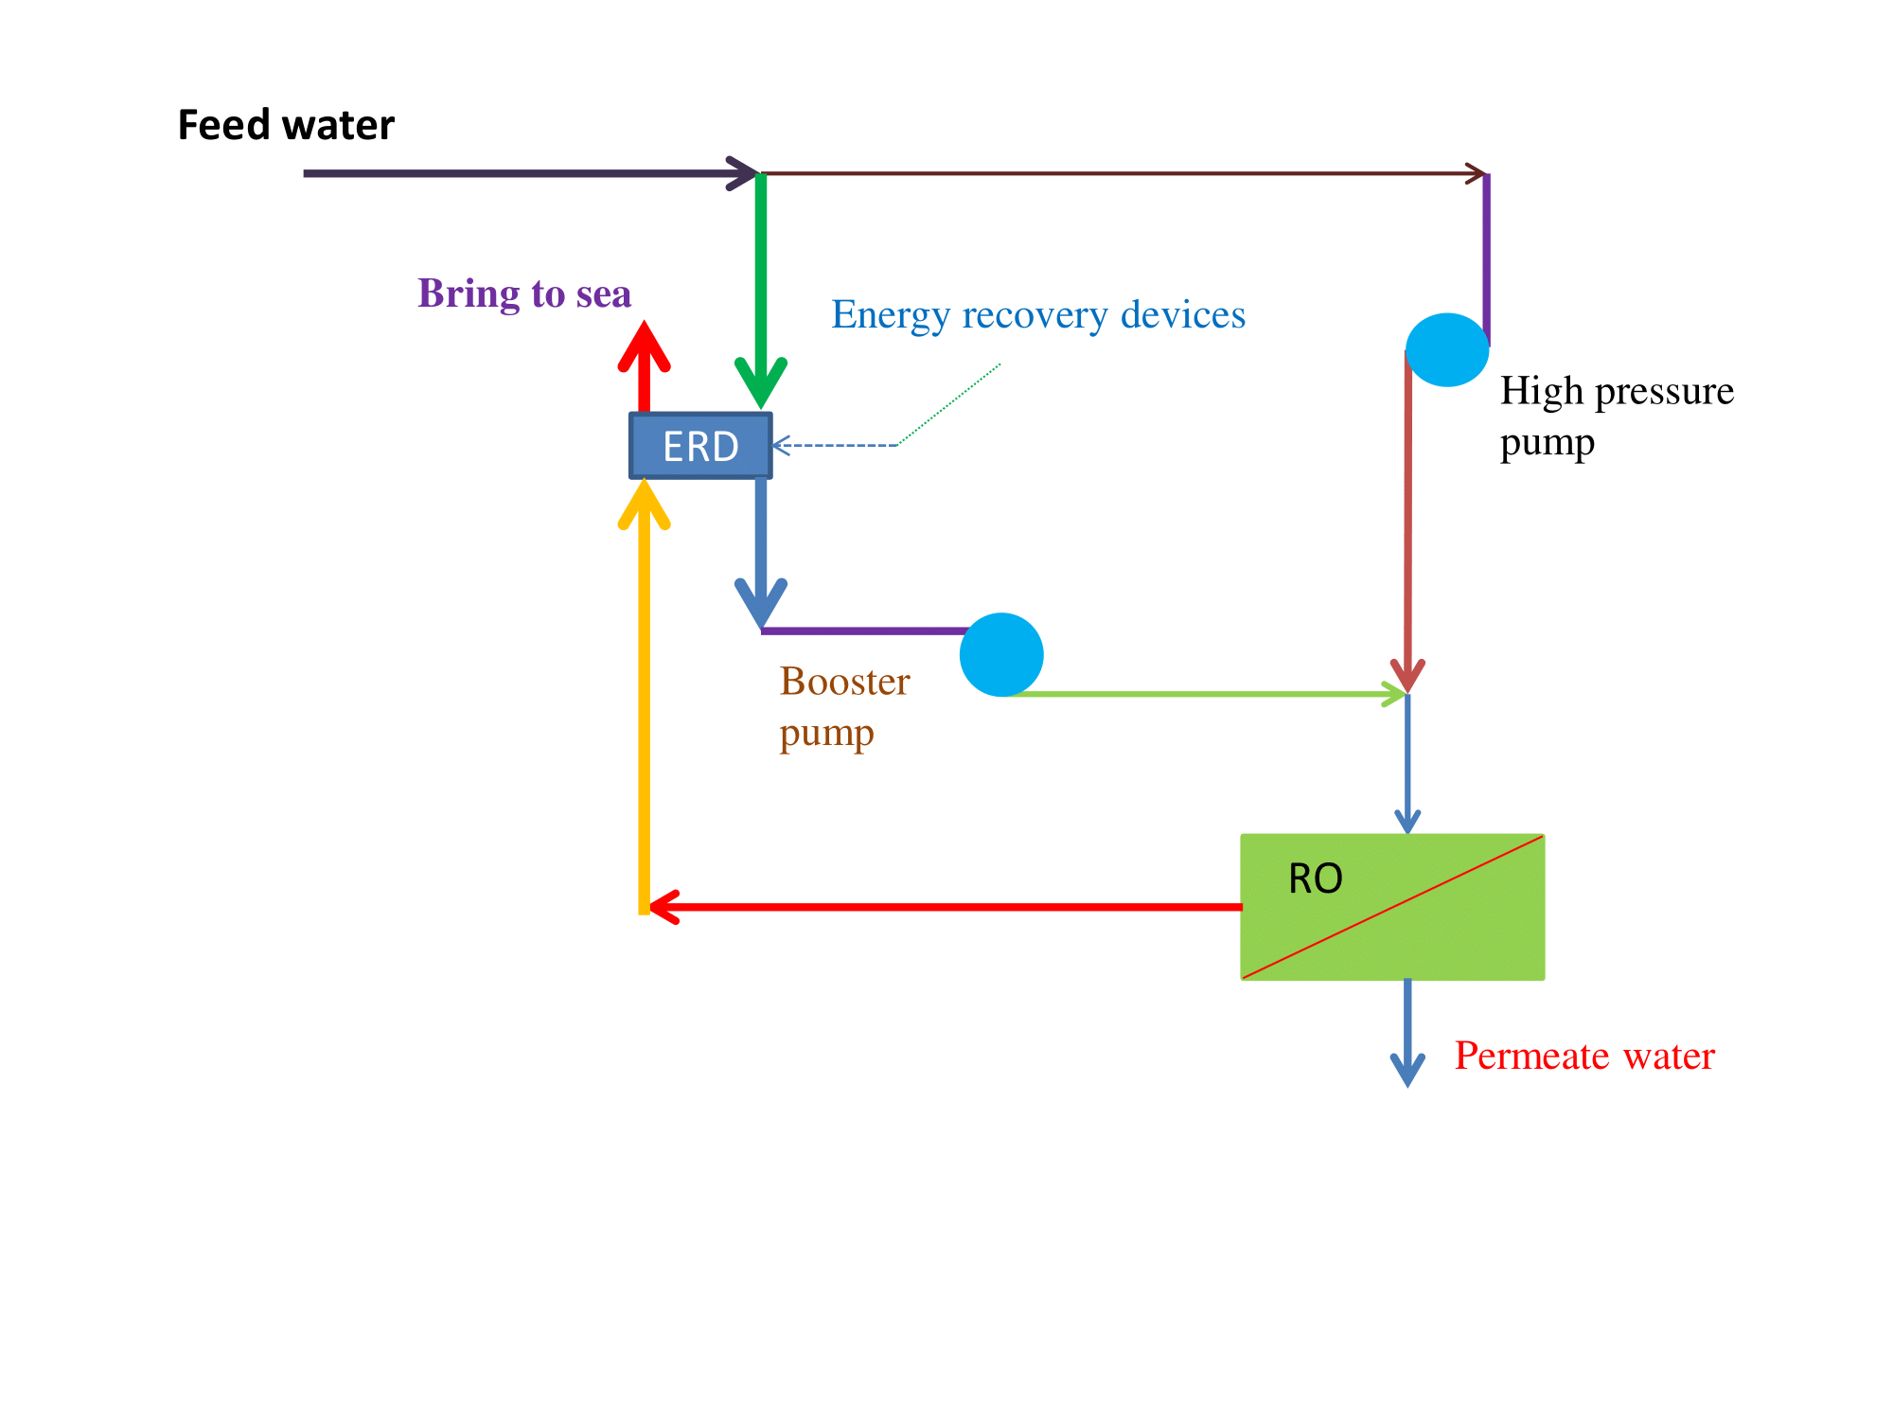
Figure 7: RO system with energy recovery device (RED) [157].
As demonstrated by Eq. 1, by the ERD, was generally a function of the RO saline pressure, the rate of flow, and the ERD efficiency [158].
$W_{ERD}=P_{c}×Q_{c}×η_{ERD}$ (1)
Where $P_{C}$the RO brine pressure (bar) is, $Q_{C}$ is the RO brine flow rate (m3/h), and gERD is the ERD efficiency. Eq. 2 is obtained by substituting Eq. 1 with the portion of the seawater input that goes to the ERD, which is how W_{ERD} energy is really exchanged in Figure. 7.
$P_{SWO}×Q_{SW}=P_{C}×Q_{C}×η_{ERD}$ (2)
Where $Q_{SW }$the wastewater is flow rate (m3/h) to the ERD and $P_{SWO}$ is the point of exit pressure of saltwater leaving the ERD (bar). The total volume flow rate of the seawater, $Q_{SW}$ (Eq. 2) and the RO saltwater,${ Q}_{C}$, in Eq. 3 were equivalent, ignoring leakage losses.
$P_{SWO}=P_{C}×η_{ERD}$ (3)
Using Equation 4, the specific energy, Es (kW h/m3), needed to desalinate saltwater using a RO system was calculated.
$E_{S}=(H_{HPP}+W_{BP}+W_{SP})/Q_{P}$ (4)

8. Environmental and Economic Considerations
- 8.1 Environmental Impact
The majority of industrial operations affect the society and environment in its all aspects. The surroundings bear high impact if the the natural environment is altered, whether by humans or by nature [159]. Some of the examples include heavy use of chemical products close to urban or rural areas, disrupting the natural resources viz soil, air, and water, significant changes in aquatic ecosystems and human resettlement, public health risks and landscape alteration [160], [161], [162]. Desalination waste produces highly concentrated retentive called brine that poses a number of environmental effects already evaluated. Additionally, brine may contain leftovers from various chemical processes, such as equipment washing, pretreatment, or post-treatment operations, which can be especially harmful to the health of marine organisms [163], [164], [165]. While brine salinity generated by thermal processes (i.e., MSF and MED) ranges from 55 g/L TDS to 65 g/L TDS, brine salinity produced by membrane-based technologies—primarily seawater reverse osmosis (SWRO)—ranges from 60 g/L TDS to 85 g/L TDS. This distinction from thermal-based plants can be ascribed to the greater recovery rates (40–45%) found in well-established, commercial RO systems. With respect to salinity in brine treatment, salinity relies on the recovering of the treatment-related technology (or technologies) and can be much higher than 150 g/L TDS [163], [166]. A strategy for impact mitigation can be started as soon as actual effects on marine life of concern are determined. One popular strategy is to start by reducing effects through the use of a subterranean intake or one of the more contemporary surface water intake systems. The establishment of marine wetland areas or other marina habitat that allows for greater areas for fish and invertebrates to spawn, payment of a fee based on the estimated economic loss caused by the operation of the facility, or restocking the marine system with fish and invertebrate eggs, larvae, juvenile or small adult forms, which can achieve a higher survival rate, are the three strategies that can be used if additional mitigation is required through the regulatory process [167]. The new Claude "Bud" Lewis Carlsbad SWRO facility in San Diego County, California, employed the wetlands re-creation technique. In order to rehabilitate roughly 150,000 m² of wetlands area within a local lagoon, this 190,000 m³/d plant was needed. Based on the idea of employing habitat restoration as a mitigating measure, the construction of bay or lagoon wetlands regions. The construction of a more intricate habitat, like an offshore rocky reef, can cost up to $35/m². The problem then becomes determining how much space has to be developed in order to offset the estimated environmental damage [168].
- 8.2 Economic Viability
An analysis of the costs associated with recycling RO membranes was conducted, taking into account energy, reagents, treatment, and disposal of effluents (depleted NaClO solutions). Next, a market cost comparison between new and recycled membranes was conducted. Furthermore, an initial investigation was carried out to assess the oxidative treatment system's capital and operating costs (CapEx and OpEx). A feed pump to transfer the oxidizing agent to the pressure vessel, a CIP (cleaning in place) tank equipped with chemical dosing units (acid and alkaline cleaning products), flow and pressure meters for measurement, and an effluent buffer tank to hold wastewater are all necessary components of this straightforward recycling system. The average life span of a recycled membrane is expected to be two years, whereas the typical lifespan of a new membrane is five years [169]. A major commercial membrane provider supplied the membrane costs. Commercial NaClO (10–12%) was employed as the oxidizing agent, and 0.1% w/w NaOH solution and 0.2% w/w HCl (37%) solution were used as cleaning agents. These products have approximate retail prices of US$0.50/kg, US$3.00/kg, and US$12.00/kg, respectively. To recycle a single spiral wound element, the volume of NaClO and cleaning chemicals utilized were measured. The cost of power was $0.04 per kilowatt-hour. Two employees were included in the personnel costs, an operator and a technician. The expected annual maintenance costs were derived from the initial cost of investment at a rate of 5% [170], [171].

9. Future Directions and Innovations
- 9.1 Bio-inspired and Biomimetic RO Membranes
The direct application of these biological building elements for membrane construction was the initial stage of biomimicry. Commercialization of AQP-based membranes has been accomplished by Aquaporin A/S following years of successful demonstration in laboratory-scale experiments. They render AQP-containing vesicles immobile in the selective layer of the present RO or FO membranes. This is a benchmark indicating that biomimetic membranes can be implemented in industry. But there are still concerns about long-term stability, safety concerns, the added expense of protein purification, and the functionality of AQPs within polymer membranes [172]. The ultimate objective of biomimetic membranes is to reimagine conventional separation membranes and give them these qualities by taking inspiration from nature's highly efficient and selective transport across cell membranes. We are confronting separation issues since the number of compounds generated today and in the future will only increase, and present membrane technologies may not be able to handle them all [28], [39], [173], [174]. Hence, while bio inspired materials for separation and other porous materials like COFs, MOFs, porous organic cages, and 2D materials follow different routes, they ultimately arrive at the same place, enhancing the overall efficiency of separation by designing the structure of membranes and transport at the molecular level [175], [176]. From a biomimetic standpoint, the key to pore engineering is identifying highly efficient biological transport channels that nature has evolved and creating synthetic methods that can closely imitate those transports. It is essential to have a basic understanding of molecules as well as high-yield, scalable synthesis processes. A trade-off is between cost and performance, often known as scalability is shown below in Figure. 8.
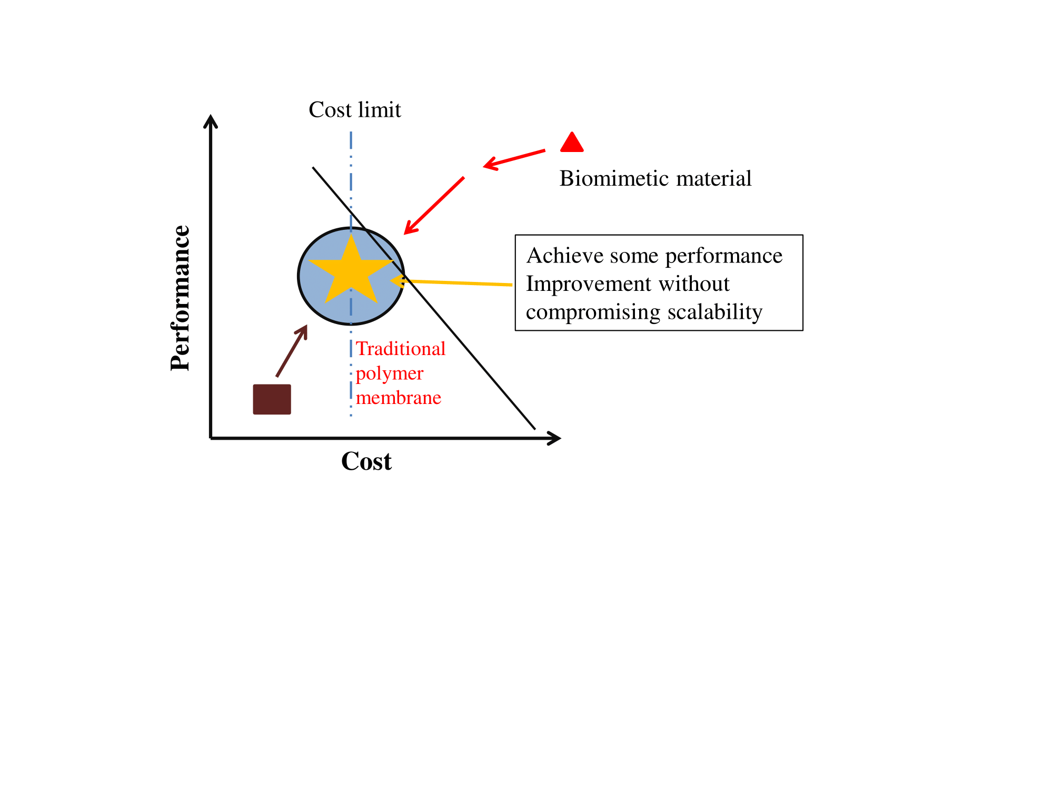
Figure. 8: Performance-cost trade-off for separation materials .
Although new materials frequently exhibit exceptional qualities (such as high selectivity and permeability), they are expensive, difficult to scale, and incompatible with conventional materials. The scalability of the tailored separation materials can be preserved while approaching, if not surpassing, the performance of innovative materials. The improvement might not be as noteworthy as those innovative materials [177]. However, the adoption of new technologies can lead to a large decrease in capital and operating expenses as long as they are revolutionary and scalable, and they can even improve selectivity by 10–20%. In this sense, it may be said that the bio inspired idea has been successful in large-scale industrial applications [178], [179], [180].
- 9.2 Modular and Portable RO Systems
For industrial membrane plants to accomplish the required separation, a sizable membrane area is required. There are many kinds of affordable membrane modules that can be employed to give an immense amount of membrane for effective and efficient separation [181]. Preventing membrane fraying is a critical function of different membrane module designs, particularly in wastewater and water treatment processes. Plate and frame modules, hollow fibre modules, tubular modules, and spiral wound modules are all included in these designs. Despite being one of the first membrane systems, the conventional plate and frame module is rapidly being replaced by the more affordable spiral wound and hollow fibre modules. Today, low-fouling techniques like RO and ultrafiltration are the main uses for plate and frame modules. Tubular modules, on the other hand, are especially useful in situations where a high level of protection against membrane fouling is required; these are usually associated with ultrafiltration applications. The particular needs and difficulties presented by the treatment procedure will determine which membrane module is best [182].
- 9.3 Sustainable and Green Membrane Materials
The development of RO membranes with better permeability and lower permeation pressure is essential to increase the energy efficiency of seawater RO systems and reduce the corresponding greenhouse gas emissions. The circular economy seeks to decrease, reuse, and recycle waste by using the connections among energy, food, and water [183]. Climate change is aided and abated by separation using environmentally friendly and sustainable membranes. Applying a circular economy-based strategy to the usage of agro-industrial waste material for the manufacturing of green films will be helpful to achieving of the several goals of organic waste elimination, conversion to high-value-added products and protecting the environment [184]. A potential area of research is the production of nanocomposite membranes with green materials as fillers. Because of their excellent performance in lowering environmental contaminants and the environmental sustainability and greenness of their production process, bio-nanoparticles are a promising material. Although the functionalization of materials by doping or depositing nanoparticles on their surfaces has great potential, there is also a risk involved because nanoparticles could be discharged into the environment, and accumulate over time. Furthermore, environmental responsibility, toxicity, and safety must all be taken into account when designing ecologically sustainable nanomembranes for production on an industrial and commercial scale. These elements are necessary to guarantee the safe and responsible application of green nanomembranes [182].

10. Conclusion

Reverse Osmosis (RO) membranes play an essential role in addressing worldwide water scarcity because they enable efficient desalination and purification. This review focuses on the fundamental characteristics of RO membrane technology, such as its multilayered structure, working principles, and essential performance measures. Thin-film composite membranes, typically comprised of polyamide, are preferred due to their excellent salt rejection, and chemical resistance. Advances in fabrication, such as interfacial polymerization and surface changes, have improved membrane performance, notably in terms of fouling and mechanical strength. Despite its widespread usage in desalination of seawater, brackish water filtration, and industrial wastewater purification, issues such as fouling of membranes, excessive use of energy, and inadequate ion selectivity persist. To overcome these difficulties, current research focuses on environmentally friendly RO systems, anti-fouling methods, and innovative membrane materials. Sustainable developments, like biodegradable membranes and renewable energy integration, offer promising approaches to lower the environmental and economic costs of RO processes. Bio-inspired membranes, those modeled after aquaporins, represent future advancements in selectivity and efficiency. Continuous innovation in RO technology is critical for meeting global water demands responsibly and effectively.
11. References:
[1] J. Kucera, Reverse osmosis. John Wiley & Sons, 2023.
[2] Y.-N. Wang and R. Wang, “Reverse osmosis membrane separation technology,” in Membrane separation principles and applications, Elsevier, 2019, pp. 1–45.
[3] F. Tortora, V. Innocenzi, M. Prisciandaro, I. De Michelis, F. Vegliò, and G. Mazziotti di Celso, “Removal of tetramethyl ammonium hydroxide from synthetic liquid wastes of electronic industry through micellar enhanced ultrafiltration,” J. Dispers. Sci. Technol., vol. 39, no. 2, pp. 207–213, 2018.
[4] Z. Wen, J. Di, and X. Zhang, “Uncertainty analysis of primary water pollutant control in China’s pulp and paper industry,” J. Environ. Manage., vol. 169, pp. 67–77, 2016.
[5] A. N. Beni, I. Ghofrani, A. Nouri-Borujerdi, A. Moosavi, and D. M. Warsinger, “Membrane properties overview in integrated forward osmosis/osmotically assisted reverse osmosis systems,” Desalination, vol. 569, p. 117008, 2024.
[6] S. Bhattacharyya, P. Das, and S. Datta, “Removal of ranitidine from pharmaceutical waste water using activated carbon (AC) prepared from waste lemon peel,” in Waste Water Recycling and Management: 7th IconSWM ̶̶ ISWMAW 2017, Volume 3, Springer, 2019, pp. 123–141.
[7] R. P. Lively and D. S. Sholl, “From water to organics in membrane separations,” Nat. Mater., vol. 16, no. 3, pp. 276–279, 2017.
[8] É. Hansen, M. A. S. Rodrigues, M. E. Aragão, and P. M. de Aquim, “Water and wastewater minimization in a petrochemical industry through mathematical programming,” J. Clean. Prod., vol. 172, pp. 1814–1822, 2018.
[9] K. Yamjala, M. S. Nainar, and N. R. Ramisetti, “Methods for the analysis of azo dyes employed in food industry–a review,” Food Chem., vol. 192, pp. 813–824, 2016.
[10] P. Hadi, M. Yang, H. Ma, X. Huang, H. Walker, and B. S. Hsiao, “Biofouling-resistant nanocellulose layer in hierarchical polymeric membranes: Synthesis, characterization and performance,” J. Memb. Sci., vol. 579, pp. 162–171, 2019.
[11] M. Bassyouni, M. H. Abdel-Aziz, M. S. Zoromba, S. M. S. Abdel-Hamid, and E. Drioli, “A review of polymeric nanocomposite membranes for water purification,” J. Ind. Eng. Chem., vol. 73, pp. 19–46, 2019.
[12] J. S. Beril Melbiah, P. Joseph, D. Rana, A. Nagendran, N. Nagendra Gandhi, and D. R. Mohan, “Customized antifouling polyacrylonitrile ultrafiltration membranes for effective removal of organic contaminants from aqueous stream,” J. Chem. Technol. Biotechnol., vol. 94, no. 3, pp. 859–868, 2019.
[13] D. W. Stahle, “Anthropogenic megadrought,” Science (80-. )., vol. 368, no. 6488, pp. 238–239, 2020.
[14] N. R. Dalezios, A. N. Angelakis, and S. Eslamian, “Water scarcity management: part 1: methodological framework,” Int. J. Glob. Environ. Issues, vol. 17, no. 1, pp. 1–40, 2018.
[15] N. P. B. Tan, P. M. L. Ucab, G. C. Dadol, L. M. Jabile, I. N. Talili, and M. T. I. Cabaraban, “A review of desalination technologies and its impact in the Philippines,” Desalination, vol. 534, p. 115805, 2022.
[16] M. Salehi, “Global water shortage and potable water safety; Today’s concern and tomorrow’s crisis,” Environ. Int., vol. 158, p. 106936, 2022.
[17] M. Haidera et al., “Water scarcity and climate change adaptation for Yemen’s vulnerable communities,” Local Environ., vol. 16, no. 5, pp. 473–488, 2011.
[18] J. A. Duran-Encalada, A. Paucar-Caceres, E. R. Bandala, and G. H. Wright, “The impact of global climate change on water quantity and quality: A system dynamics approach to the US–Mexican transborder region,” Eur. J. Oper. Res., vol. 256, no. 2, pp. 567–581, 2017.
[19] M. Khondoker, S. Mandal, R. Gurav, and S. Hwang, “Freshwater shortage, salinity increase, and global food production: A need for sustainable irrigation water desalination—A scoping review,” Earth, vol. 4, no. 2, pp. 223–240, 2023.
[20] M. Z. Khan, H. Abbas, and A. Khalid, “Climate vulnerability of irrigation systems in the Upper Indus Basin: insights from three Karakoram villages in northern Pakistan,” Clim. Dev., vol. 14, no. 6, pp. 499–511, 2022.
[21] L. F. Greenlee, D. F. Lawler, B. D. Freeman, B. Marrot, and P. Moulin, “Reverse osmosis desalination: water sources, technology, and today’s challenges,” Water Res., vol. 43, no. 9, pp. 2317–2348, 2009.
[22] A. Subramani and J. G. Jacangelo, “Emerging desalination technologies for water treatment: a critical review,” Water Res., vol. 75, pp. 164–187, 2015.
[23] H. Li, B. Zeng, J. Tuo, Y. Wang, G.-P. Sheng, and Y. Wang, “Development of an improved deep network model as a general technique for thin film nanocomposite reverse osmosis membrane simulation,” J. Memb. Sci., vol. 692, p. 122320, 2024.
[24] D. M. Warsinger, E. W. Tow, K. G. Nayar, and L. A. Maswadeh, “Energy efficiency of batch and semi-batch (CCRO) reverse osmosis desalination,” Water Res., vol. 106, pp. 272–282, 2016.
[25] S. F. Anis, R. Hashaikeh, and N. Hilal, “Functional materials in desalination: A review,” Desalination, vol. 468, p. 114077, 2019.
[26] M.-L. Pype, M. G. Lawrence, J. Keller, and W. Gernjak, “Reverse osmosis integrity monitoring in water reuse: The challenge to verify virus removal–A review,” Water Res., vol. 98, pp. 384–395, 2016.
[27] M. Vourch, B. Balannec, B. Chaufer, and G. Dorange, “Treatment of dairy industry wastewater by reverse osmosis for water reuse,” Desalination, vol. 219, no. 1–3, pp. 190–202, 2008.
[28] M. A. Shannon, P. W. Bohn, M. Elimelech, J. G. Georgiadis, B. J. Mariñas, and A. M. Mayes, “Science and technology for water purification in the coming decades,” Nature, vol. 452, no. 7185, pp. 301–310, 2008.
[29] Y. J. Lim, K. Goh, M. Kurihara, and R. Wang, “Seawater desalination by reverse osmosis: Current development and future challenges in membrane fabrication–A review,” J. Memb. Sci., vol. 629, p. 119292, 2021.
[30] B. J. A. Tarboush, H. A. Arafat, T. Matsuura, and D. Rana, “Recent advances in thin film composite (TFC) reverse osmosis and nanofiltration membranes for desalination,” J. Appl. Membr. Sci. Technol., vol. 10, no. 1, 2009.
[31] A. Lee, J. W. Elam, and S. B. Darling, “Membrane materials for water purification: design, development, and application,” Environ. Sci. Water Res. Technol., vol. 2, no. 1, pp. 17–42, 2016.
[32] R. W. Baker, Membrane technology and applications. John Wiley & Sons, 2023.
[33] G. M. Geise, H. Lee, D. J. Miller, B. D. Freeman, J. E. McGrath, and D. R. Paul, “Water purification by membranes: the role of polymer science,” J. Polym. Sci. Part B Polym. Phys., vol. 48, no. 15, pp. 1685–1718, 2010.
[34] W. J. Lau, A. F. Ismail, N. Misdan, and M. A. Kassim, “A recent progress in thin film composite membrane: A review,” Desalination, vol. 287, pp. 190–199, 2012.
[35] Y. Chen, Q. J. Niu, Y. Hou, and H. Sun, “Effect of interfacial polymerization monomer design on the performance and structure of thin film composite nanofiltration and reverse osmosis membranes: A review,” Sep. Purif. Technol., vol. 330, p. 125282, 2024.
[36] Y. Liu et al., “The role of carboxylated cellulose nanocrystals placement in the performance of thin-film composite (TFC) membrane,” J. Memb. Sci., vol. 617, p. 118581, 2021.
[37] M. Elimelech and W. A. Phillip, “The future of seawater desalination: energy, technology, and the environment,” Science (80-. )., vol. 333, no. 6043, pp. 712–717, 2011.
[38] W.-L. Li et al., “High-performance thin-film composite (TFC) membranes with 2D nanomaterial interlayers: An overview,” Results Eng., p. 101932, 2024.
[39] J. R. Werber, C. O. Osuji, and M. Elimelech, “Materials for next-generation desalination and water purification membranes,” Nat. Rev. Mater., vol. 1, no. 5, pp. 1–15, 2016.
[40] A. F. Ismail, M. Padaki, N. Hilal, T. Matsuura, and W. J. Lau, “Thin film composite membrane—Recent development and future potential,” Desalination, vol. 356, pp. 140–148, 2015.
[41] J. M. Gohil and A. K. Suresh, “Chlorine attack on reverse osmosis membranes: Mechanisms and mitigation strategies,” J. Memb. Sci., vol. 541, pp. 108–126, 2017.
[42] D.-J. Liaw, K.-L. Wang, Y.-C. Huang, K.-R. Lee, J.-Y. Lai, and C.-S. Ha, “Advanced polyimide materials: Syntheses, physical properties and applications,” Prog. Polym. Sci., vol. 37, no. 7, pp. 907–974, 2012.
[43] T. Fujioka, S. J. Khan, J. A. McDonald, and L. D. Nghiem, “Rejection of trace organic chemicals by a hollow fibre cellulose triacetate reverse osmosis membrane,” Desalination, vol. 368, pp. 69–75, 2015.
[44] M. T. Khan, P.-Y. Hong, N. Nada, and J. P. Croue, “Does chlorination of seawater reverse osmosis membranes control biofouling?,” Water Res., vol. 78, pp. 84–97, 2015.
[45] P. A. Davies, J. Wayman, C. Alatta, K. Nguyen, and J. Orfi, “A desalination system with efficiency approaching the theoretical limits,” Desalin. Water Treat., vol. 57, no. 48–49, pp. 23206–23216, 2016.
[46] Y. Cohen, R. Semiat, and A. Rahardianto, “A perspective on reverse osmosis water desalination: Quest for sustainability.,” AIChE J., vol. 63, no. 6, 2017.
[47] A. Efraty, “Closed circuit desalination series no-3: High recovery low energy desalination of brackish water by a new two-mode consecutive sequential method,” Desalin. water Treat., vol. 42, no. 1–3, pp. 256–261, 2012.
[48] J. Swaminathan, E. W. Tow, and R. L. Stover, “Practical aspects of batch RO design for energy-efficient seawater desalination,” Desalination, vol. 470, p. 114097, 2019.
[49] M. N. Chollom, “Treatment and reuse of reactive dye effluent from textile industry using membrane technology,” 2014.
[50] R. Singh and N. Hankins, Emerging membrane technology for sustainable water treatment. Elsevier, 2016.
[51] C. Muro, F. Riera, and M. del Carmen Díaz, “Membrane separation process in wastewater treatment of food industry,” Food Ind. Process. Equip., pp. 253–280, 2012.
[52] S. K. Nataraj, K. M. Hosamani, and T. M. Aminabhavi, “Distillery wastewater treatment by the membrane-based nanofiltration and reverse osmosis processes,” Water Res., vol. 40, no. 12, pp. 2349–2356, 2006.
[53] S. Šostar-Turk, M. Simonič, and I. Petrinić, “Wastewater treatment after reactive printing,” Dye. Pigment., vol. 64, no. 2, pp. 147–152, 2005.
[54] K. P. Lee, T. C. Arnot, and D. Mattia, “A review of reverse osmosis membrane materials for desalination—Development to date and future potential,” J. Memb. Sci., vol. 370, no. 1–2, pp. 1–22, 2011.
[55] S. S. Shenvi, A. M. Isloor, and A. F. Ismail, “A review on RO membrane technology: Developments and challenges,” Desalination, vol. 368, pp. 10–26, 2015.
[56] F. Peng, Z. Jiang, and E. M. V Hoek, “Tuning the molecular structure, separation performance and interfacial properties of poly (vinyl alcohol)–polysulfone interfacial composite membranes,” J. Memb. Sci., vol. 368, no. 1–2, pp. 26–33, 2011.
[57] S. G. Kim, S. Y. Park, J. H. Chun, B.-H. Chun, and S. H. Kim, “Novel thin-film composite membrane for seawater desalination with sulfonated poly (arylene ether sulfone) containing amino groups,” Desalin. Water Treat., vol. 43, no. 1–3, pp. 230–237, 2012.
[58] S. Bano, A. Mahmood, S. J. Kim, and K.-H. Lee, “Chlorine resistant binary complexed NaAlg/PVA composite membrane for nanofiltration,” Sep. Purif. Technol., vol. 137, pp. 21–27, 2014.
[59] Z. Yang, Y. Zhou, Z. Feng, X. Rui, T. Zhang, and Z. Zhang, “A review on reverse osmosis and nanofiltration membranes for water purification,” Polymers (Basel)., vol. 11, no. 8, p. 1252, 2019.
[60] J. Chen, J. Xu, K. Wang, X. Cao, and R. Sun, “Cellulose acetate fibers prepared from different raw materials with rapid synthesis method,” Carbohydr. Polym., vol. 137, pp. 685–692, 2016.
[61] M. D. Islam, F. J. Uddin, T. U. Rashid, and M. Shahruzzaman, “Cellulose acetate-based membrane for wastewater treatment—A state-of-the-art review,” Mater. Adv., 2023.
[62] M. Chen et al., “Solvent-free acetylation of cellulose by 1-ethyl-3-methylimidazolium acetate-catalyzed transesterification,” ACS Sustain. Chem. Eng., vol. 7, no. 20, pp. 16971–16978, 2019.
[63] S. Rimdusit, S. Jingjid, S. Damrongsakkul, S. Tiptipakorn, and T. Takeichi, “Biodegradability and property characterizations of methyl cellulose: effect of nanocompositing and chemical crosslinking,” Carbohydr. Polym., vol. 72, no. 3, pp. 444–455, 2008.
[64] M. Schilling, M. Bouchard, H. Khanjian, T. Learner, A. Phenix, and R. Rivenc, “Application of chemical and thermal analysis methods for studying cellulose ester plastics,” Acc. Chem. Res., vol. 43, no. 6, pp. 888–896, 2010.
[65] R. Abu-Zurayk, N. Alnairat, A. Khalaf, A. A. Ibrahim, and G. Halaweh, “Cellulose Acetate Membranes: Fouling Types and Antifouling Strategies—A Brief Review. Processes 2023, 11, 489,” 2023.
[66] A. E. Abdelhamid and A. M. Khalil, “Polymeric membranes based on cellulose acetate loaded with candle soot nanoparticles for water desalination,” J. Macromol. Sci. Part A, vol. 56, no. 2, pp. 153–161, 2019.
[67] L. A. Goetz, B. Jalvo, R. Rosal, and A. P. Mathew, “Superhydrophilic anti-fouling electrospun cellulose acetate membranes coated with chitin nanocrystals for water filtration,” J. Memb. Sci., vol. 510, pp. 238–248, 2016.
[68] M. A. A. El-Ghaffar, M. M. Elawady, A. M. Rabie, and A. E. Abdelhamid, “Enhancing the RO performance of cellulose acetate membrane using chitosan nanoparticles,” J. Polym. Res., vol. 27, no. 11, p. 337, 2020.
[69] E. Shaulsky, V. Karanikola, A. P. Straub, A. Deshmukh, I. Zucker, and M. Elimelech, “Asymmetric membranes for membrane distillation and thermo-osmotic energy conversion,” Desalination, vol. 452, pp. 141–148, 2019.
[70] W. Chou, D. Yu, and M. Yang, “The preparation and characterization of silver‐loading cellulose acetate hollow fiber membrane for water treatment,” Polym. Adv. Technol., vol. 16, no. 8, pp. 600–607, 2005.
[71] D. Li and H. Wang, “Recent developments in reverse osmosis desalination membranes,” J. Mater. Chem., vol. 20, no. 22, pp. 4551–4566, 2010.
[72] T. M. D. Rana, M. R. Qtaishat, and G. Singh, “Recent Advances in Membrane Science and Technology in Seawater Desalination–With Technology Development in the Middle East and Singapore,” Water Water Treat. Technol. Encycl. Life Support Syst. (EOLSS), Dev. under Auspices UNESCO, 2011.
[73] J. S. Louie, I. Pinnau, I. Ciobanu, K. P. Ishida, A. Ng, and M. Reinhard, “Effects of polyether–polyamide block copolymer coating on performance and fouling of reverse osmosis membranes,” J. Memb. Sci., vol. 280, no. 1–2, pp. 762–770, 2006.
[74] B. Khorshidi, T. Thundat, B. A. Fleck, and M. Sadrzadeh, “A novel approach toward fabrication of high performance thin film composite polyamide membranes,” Sci. Rep., vol. 6, no. 1, pp. 1–10, 2016.
[75] J. Yin and B. Deng, “Polymer-matrix nanocomposite membranes for water treatment,” J. Memb. Sci., vol. 479, pp. 256–275, 2015.
[76] G.-R. Xu, J.-M. Xu, H.-J. Feng, H.-L. Zhao, and S.-B. Wu, “Tailoring structures and performance of polyamide thin film composite (PA-TFC) desalination membranes via sublayers adjustment-a review,” Desalination, vol. 417, pp. 19–35, 2017.
[77] J. M. Gohil and P. Ray, “A review on semi-aromatic polyamide TFC membranes prepared by interfacial polymerization: Potential for water treatment and desalination,” Sep. Purif. Technol., vol. 181, pp. 159–182, 2017.
[78] S. Zhang, F. Fu, and T.-S. Chung, “Substrate modifications and alcohol treatment on thin film composite membranes for osmotic power,” Chem. Eng. Sci., vol. 87, pp. 40–50, 2013.
[79] J. Lee, A. Hill, and S. Kentish, “Formation of a thick aromatic polyamide membrane by interfacial polymerisation,” Sep. Purif. Technol., vol. 104, pp. 276–283, 2013.
[80] H. Yan et al., “The porous structure of the fully-aromatic polyamide film in reverse osmosis membranes,” J. Memb. Sci., vol. 475, pp. 504–510, 2015.
[81] Y. Cui, X.-Y. Liu, T.-S. Chung, M. Weber, C. Staudt, and C. Maletzko, “Removal of organic micro-pollutants (phenol, aniline and nitrobenzene) via forward osmosis (FO) process: evaluation of FO as an alternative method to reverse osmosis (RO),” Water Res., vol. 91, pp. 104–114, 2016.
[82] Y. Cui, X.-Y. Liu, and T.-S. Chung, “Ultrathin polyamide membranes fabricated from free-standing interfacial polymerization: synthesis, modifications, and post-treatment,” Ind. Eng. Chem. Res., vol. 56, no. 2, pp. 513–523, 2017.
[83] A. Giwa, N. Akther, V. Dufour, and S. W. Hasan, “A critical review on recent polymeric and nano-enhanced membranes for reverse osmosis,” Rsc Adv., vol. 6, no. 10, pp. 8134–8163, 2016.
[84] X. Lu and M. Elimelech, “Fabrication of desalination membranes by interfacial polymerization: history, current efforts, and future directions,” Chem. Soc. Rev., vol. 50, no. 11, pp. 6290–6307, 2021.
[85] C. Klaysom, T. Y. Cath, T. Depuydt, and I. F. J. Vankelecom, “Forward and pressure retarded osmosis: potential solutions for global challenges in energy and water supply,” Chem. Soc. Rev., vol. 42, no. 16, pp. 6959–6989, 2013.
[86] I. L. Alsvik and M.-B. Hägg, “Preparation of thin film composite membranes with polyamide film on hydrophilic supports,” J. Memb. Sci., vol. 428, pp. 225–231, 2013.
[87] L. Huang, N.-N. Bui, M. T. Meyering, T. J. Hamlin, and J. R. McCutcheon, “Novel hydrophilic nylon 6, 6 microfiltration membrane supported thin film composite membranes for engineered osmosis,” J. Memb. Sci., vol. 437, pp. 141–149, 2013.
[88] J. Wei, X. Liu, C. Qiu, R. Wang, and C. Y. Tang, “Influence of monomer concentrations on the performance of polyamide-based thin film composite forward osmosis membranes,” J. Memb. Sci., vol. 381, no. 1–2, pp. 110–117, 2011.
[89] M. Safarpour, A. Safikhani, and V. Vatanpour, “Polyvinyl chloride-based membranes: A review on fabrication techniques, applications and future perspectives,” Sep. Purif. Technol., vol. 279, p. 119678, 2021.
[90] A. K. Hołda and I. F. J. Vankelecom, “Understanding and guiding the phase inversion process for synthesis of solvent resistant nanofiltration membranes,” J. Appl. Polym. Sci., vol. 132, no. 27, 2015.
[91] M. R. Esfahani et al., “Nanocomposite membranes for water separation and purification: Fabrication, modification, and applications,” Sep. Purif. Technol., vol. 213, pp. 465–499, 2019.
[92] M. Sile-Yuksel, B. Tas, D. Y. Koseoglu-Imer, and I. Koyuncu, “Effect of silver nanoparticle (AgNP) location in nanocomposite membrane matrix fabricated with different polymer type on antibacterial mechanism,” Desalination, vol. 347, pp. 120–130, 2014.
[93] A. Khakpay, P. Scovazzo, and S. Nouranian, “Homogeneous and biphasic cellulose acetate/room temperature ionic liquid membranes for gas separations: Solvent and phase-inversion casting vs. supported ionic liquid membranes,” J. Memb. Sci., vol. 589, p. 117228, 2019.
[94] M. Sadrzadeh and S. Bhattacharjee, “Rational design of phase inversion membranes by tailoring thermodynamics and kinetics of casting solution using polymer additives,” J. Memb. Sci., vol. 441, pp. 31–44, 2013.
[95] B. Khan, W. Zhan, and C. Lina, “Cellulose acetate (CA) hybrid membrane prepared by phase inversion method combined with chemical reaction with enhanced permeability and good anti‐fouling property,” J. Appl. Polym. Sci., vol. 137, no. 47, p. 49556, 2020.
[96] Y. Elkony, E. Mansour, A. Elhusseiny, and S. Ebrahim, “Effect of cellulose acetate/cellulose triacetate ratio on reverse osmosis blend membrane performance,” Polym. Eng. Sci., vol. 60, no. 11, pp. 2852–2863, 2020.
[97] R. Zhang et al., “Antifouling membranes for sustainable water purification: strategies and mechanisms,” Chem. Soc. Rev., vol. 45, no. 21, pp. 5888–5924, 2016.
[98] D. Ankoliya, B. Mehta, and H. Raval, “Advances in surface modification techniques of reverse osmosis membrane over the years,” Sep. Sci. Technol., vol. 54, no. 3, pp. 293–310, 2019.
[99] Y. Kwon, S. Hong, H. Choi, J. Jung, J. Moon, and T. Tak, “Development of fouling-resistant RO membranes using PEGA macromer,” Desalin. Water Treat., vol. 15, no. 1–3, pp. 54–61, 2010.
[100] D. Wu, X. Liu, S. Yu, M. Liu, and C. Gao, “Modification of aromatic polyamide thin-film composite reverse osmosis membranes by surface coating of thermo-responsive copolymers P (NIPAM-co-Am). I: Preparation and characterization,” J. Memb. Sci., vol. 352, no. 1–2, pp. 76–85, 2010.
[101] L. Zou, I. Vidalis, D. Steele, A. Michelmore, S. P. Low, and J. Verberk, “Surface hydrophilic modification of RO membranes by plasma polymerization for low organic fouling,” J. Memb. Sci., vol. 369, no. 1–2, pp. 420–428, 2011.
[102] S. Yu, Z. Lü, Z. Chen, X. Liu, M. Liu, and C. Gao, “Surface modification of thin-film composite polyamide reverse osmosis membranes by coating N-isopropylacrylamide-co-acrylic acid copolymers for improved membrane properties,” J. Memb. Sci., vol. 371, no. 1–2, pp. 293–306, 2011.
[103] A. Matin, G. Ozaydin-Ince, Z. Khan, S. M. J. Zaidi, K. Gleason, and D. Eggenspiler, “Random copolymer films as potential antifouling coatings for reverse osmosis membranes,” Desalin. Water Treat., vol. 34, no. 1–3, pp. 100–105, 2011.
[104] B. Peñate and L. García-Rodríguez, “Current trends and future prospects in the design of seawater reverse osmosis desalination technology,” Desalination, vol. 284, pp. 1–8, 2012.
[105] M. Voith, “Membrane movers: water treatment businesses adapt their portfolios to meet new regulations and reduce costs,” 2010, ACS Publications.
[106] I. G. Wenten, “Reverse osmosis applications: Prospect and challenges,” Desalination, vol. 391, pp. 112–125, 2016.
[107] N. Prihasto, Q.-F. Liu, and S.-H. Kim, “Pre-treatment strategies for seawater desalination by reverse osmosis system,” Desalination, vol. 249, no. 1, pp. 308–316, 2009.
[108] S. Ebrahim, M. Abdel-Jawad, S. Bou-Hamad, and M. Safar, “Fifteen years of R&D program in seawater desalination at KISR Part I. Pretreatment technologies for RO systems,” Desalination, vol. 135, no. 1–3, pp. 141–153, 2001.
[109] M. R. Landsman et al., “Water treatment: Are membranes the panacea?,” Annu. Rev. Chem. Biomol. Eng., vol. 11, no. 1, pp. 559–585, 2020.
[110] E. Jones, M. Qadir, M. T. H. van Vliet, V. Smakhtin, and S. Kang, “The state of desalination and brine production: A global outlook,” Sci. Total Environ., vol. 657, pp. 1343–1356, 2019.
[111] S. Honarparvar, X. Zhang, T. Chen, A. Alborzi, K. Afroz, and D. Reible, “Frontiers of membrane desalination processes for brackish water treatment: A review,” Membranes (Basel)., vol. 11, no. 4, p. 246, 2021.
[112] B. C. McCool, A. Rahardianto, J. I. Faria, and Y. Cohen, “Evaluation of chemically-enhanced seeded precipitation of RO concentrate for high recovery desalting of high salinity brackish water,” Desalination, vol. 317, pp. 116–126, 2013.
[113] B. K. Pramanik, L. Shu, and V. Jegatheesan, “A review of the management and treatment of brine solutions,” Environ. Sci. water Res. Technol., vol. 3, no. 4, pp. 625–658, 2017.
[114] P. Xu, T. Y. Cath, A. P. Robertson, M. Reinhard, J. O. Leckie, and J. E. Drewes, “Critical review of desalination concentrate management, treatment and beneficial use,” Environ. Eng. Sci., vol. 30, no. 8, pp. 502–514, 2013.
[115] E. Dialynas and E. Diamadopoulos, “Integration of a membrane bioreactor coupled with reverse osmosis for advanced treatment of municipal wastewater,” Desalination, vol. 238, no. 1–3, pp. 302–311, 2009.
[116] S.-J. You, D.-H. Tseng, and J.-Y. Deng, “Using combined membrane processes for textile dyeing wastewater reclamation,” Desalination, vol. 234, no. 1–3, pp. 426–432, 2008.
[117] Y. Xiao et al., “Advanced treatment of semiconductor wastewater by combined MBR–RO technology,” Desalination, vol. 336, pp. 168–178, 2014.
[118] S. Chung, S. Kim, J.-O. Kim, and J. Chung, “Feasibility of combining reverse osmosis–ferrite process for reclamation of metal plating wastewater and recovery of heavy metals,” Ind. Eng. Chem. Res., vol. 53, no. 39, pp. 15192–15199, 2014.
[119] T. Wintgens et al., “The role of membrane processes in municipal wastewater reclamation and reuse,” Desalination, vol. 178, no. 1–3, pp. 1–11, 2005.
[120] I. N. Widiasa and I. G. Wenten, “Combination of reverse osmosis and electrodeionization for simultaneous sugar recovery and salts removal from sugary wastewater,” Reaktor, vol. 11, no. 2, pp. 91–97, 2007.
[121] M. Fababuj-Roger, J. A. Mendoza-Roca, M. V Galiana-Aleixandre, A. Bes-Piá, B. Cuartas-Uribe, and A. Iborra-Clar, “Reuse of tannery wastewaters by combination of ultrafiltration and reverse osmosis after a conventional physical-chemical treatment,” Desalination, vol. 204, no. 1–3, pp. 219–226, 2007.
[122] T. Coskun, E. Debik, and N. M. Demir, “Treatment of olive mill wastewaters by nanofiltration and reverse osmosis membranes,” Desalination, vol. 259, no. 1–3, pp. 65–70, 2010.
[123] E. M. V Hoek, T. M. Weigand, and A. Edalat, “Reverse osmosis membrane biofouling: causes, consequences and countermeasures,” Npj clean water, vol. 5, no. 1, p. 45, 2022.
[124] N. AlSawaftah, W. Abuwatfa, N. Darwish, and G. Husseini, “A comprehensive review on membrane fouling: Mathematical modelling, prediction, diagnosis, and mitigation,” Water, vol. 13, no. 9, p. 1327, 2021.
[125] S. Jiang, Y. Li, and B. P. Ladewig, “A review of reverse osmosis membrane fouling and control strategies,” Sci. Total Environ., vol. 595, pp. 567–583, 2017.
[126] W. Guo, H.-H. Ngo, and J. Li, “A mini-review on membrane fouling,” Bioresour. Technol., vol. 122, pp. 27–34, 2012.
[127] A. Al-Amoudi and R. W. Lovitt, “Fouling strategies and the cleaning system of NF membranes and factors affecting cleaning efficiency,” J. Memb. Sci., vol. 303, no. 1–2, pp. 4–28, 2007.
[128] H. Yang et al., “The approaches and prospects for natural organic matter-derived disinfection byproducts control by carbon-based materials in water disinfection progresses,” J. Clean. Prod., vol. 311, p. 127799, 2021.
[129] J. Xing et al., “Organic matter removal and membrane fouling mitigation during algae-rich surface water treatment by powdered activated carbon adsorption pretreatment: Enhanced by UV and UV/chlorine oxidation,” Water Res., vol. 159, pp. 283–293, 2019.
[130] Y. H. Cai, N. Galili, Y. Gelman, M. Herzberg, and J. Gilron, “Evaluating the impact of pretreatment processes on fouling of reverse osmosis membrane by secondary wastewater,” J. Memb. Sci., vol. 623, p. 119054, 2021.
[131] G. Amy, “Fundamental understanding of organic matter fouling of membranes,” Desalination, vol. 231, no. 1–3, pp. 44–51, 2008.
[132] S. Lee, W. S. Ang, and M. Elimelech, “Fouling of reverse osmosis membranes by hydrophilic organic matter: implications for water reuse,” Desalination, vol. 187, no. 1–3, pp. 313–321, 2006.
[133] T. Nguyen, F. A. Roddick, and L. Fan, “Biofouling of water treatment membranes: a review of the underlying causes, monitoring techniques and control measures,” Membranes (Basel)., vol. 2, no. 4, pp. 804–840, 2012.
[134] H. A. Mohammed, D. E. Sachit, and M. Al-Furaiji, “Applications and challenges of the Reverse Osmosis membrane process: A review,” J. Eng. Sustain. Dev., vol. 27, no. 5, pp. 630–646, 2023.
[135] P. S. Goh, W. J. Lau, M. H. D. Othman, and A. F. Ismail, “Membrane fouling in desalination and its mitigation strategies,” Desalination, vol. 425, pp. 130–155, 2018.
[136] N. Voutchkov, “Membrane Foulants and Saline Water Pretreatment,” Pretreat. Reverse Osmosis Desalination; Elsevier Amsterdam, Netherlands, pp. 11–41, 2017.
[137] S. Jamaly, N. N. Darwish, I. Ahmed, and S. W. Hasan, “A short review on reverse osmosis pretreatment technologies,” Desalination, vol. 354, pp. 30–38, 2014.
[138] J. Lee, B. S. Oh, S. Kim, S.-J. Kim, S. K. Hong, and I. S. Kim, “Fate of Bacillus sp. and Pseudomonas sp. isolated from seawater during chlorination and microfiltration as pretreatments of a desalination plant,” J. Memb. Sci., vol. 349, no. 1–2, pp. 208–216, 2010.
[139] M. Talaeipour, J. Nouri, A. H. Hassani, and A. H. Mahvi, “An investigation of desalination by nanofiltration, reverse osmosis and integrated (hybrid NF/RO) membranes employed in brackish water treatment,” J. Environ. Heal. Sci. Eng., vol. 15, pp. 1–9, 2017.
[140] M. J. Guirguis, Energy recovery devices in seawater reverse osmosis desalination plants with emphasis on efficiency and economical analysis of isobaric versus centrifugal devices. University of South Florida, 2011.
[141] S. A. Urrea, F. D. Reyes, B. P. Suárez, and J. A. de la Fuente Bencomo, “Technical review, evaluation and efficiency of energy recovery devices installed in the Canary Islands desalination plants,” Desalination, vol. 450, pp. 54–63, 2019.
[142] J. Kim, K. Park, D. R. Yang, and S. Hong, “A comprehensive review of energy consumption of seawater reverse osmosis desalination plants,” Appl. Energy, vol. 254, p. 113652, 2019.
[143] B. Peñate and L. García-Rodríguez, “Energy optimisation of existing SWRO (seawater reverse osmosis) plants with ERT (energy recovery turbines): Technical and thermoeconomic assessment,” Energy, vol. 36, no. 1, pp. 613–626, 2011.
[144] V. G. Gude, “Energy consumption and recovery in reverse osmosis,” Desalin. water Treat., vol. 36, no. 1–3, pp. 239–260, 2011.
[145] E. S. Mohamed, G. Papadakis, E. Mathioulakis, and V. Belessiotis, “A direct coupled photovoltaic seawater reverse osmosis desalination system toward battery based systems—a technical and economical experimental comparative study,” Desalination, vol. 221, no. 1–3, pp. 17–22, 2008.
[146] E. Dimitriou, E. S. Mohamed, C. Karavas, and G. Papadakis, “Experimental comparison of the performance of two reverse osmosis desalination units equipped with different energy recovery devices,” Desalin. Water Treat., vol. 55, no. 11, pp. 3019–3026, 2015.
[147] A. Drak and M. Adato, “Energy recovery consideration in brackish water desalination,” Desalination, vol. 339, pp. 34–39, 2014.
[148] G. Amy et al., “Membrane-based seawater desalination: Present and future prospects,” Desalination, vol. 401, pp. 16–21, 2017.
[149] P. Xu, J. Hong, X. Qian, Z. Xu, H. Xia, and Q.-Q. Ni, “‘Bridge’ graphene oxide modified positive charged nanofiltration thin membrane with high efficiency for Mg2+/Li+ separation,” Desalination, vol. 488, p. 114522, 2020.
[150] S.-Y. Sun, L.-J. Cai, X.-Y. Nie, X. Song, and J.-G. Yu, “Separation of magnesium and lithium from brine using a Desal nanofiltration membrane,” J. Water Process Eng., vol. 7, pp. 210–217, 2015.
[151] Y. Gang, S. Hong, L. Wenqiang, X. Weihong, and X. U. Nanping, “Investigation of Mg2+/Li+ separation by nanofiltration,” Chinese J. Chem. Eng., vol. 19, no. 4, pp. 586–591, 2011.
[152] F. Saffarimiandoab et al., “A review on membrane fouling: Membrane modification,” Desalin. Water Treat., vol. 216, pp. 47–70, 2021.
[153] S. Kar et al., “Preparation, characterisation and performance evaluation of anti-biofouling property of carbon nanotube-polysulfone nanocomposite membranes,” in AIP Conference Proceedings, American Institute of Physics, 2013, pp. 181–185.
[154] A. S. Brady-Estevez, S. Kang, and M. Elimelech, “Carbon nanotubes,” Small, vol. 4, no. 4, pp. 481–484, 2008.
[155] R. Hashaikeh, B. S. Lalia, V. Kochkodan, and N. Hilal, “A novel in situ membrane cleaning method using periodic electrolysis,” J. Memb. Sci., vol. 471, pp. 149–154, 2014.
[156] A. V Dudchenko, J. Rolf, K. Russell, W. Duan, and D. Jassby, “Organic fouling inhibition on electrically conducting carbon nanotube–polyvinyl alcohol composite ultrafiltration membranes,” J. Memb. Sci., vol. 468, pp. 1–10, 2014.
[157] A. Altaee, G. J. Millar, G. Zaragoza, and A. Sharif, “Energy efficiency of RO and FO–RO system for high-salinity seawater treatment,” Clean Technol. Environ. policy, vol. 19, pp. 77–91, 2017.
[158] R. L. Stover, “Seawater reverse osmosis with isobaric energy recovery devices,” Desalination, vol. 203, no. 1–3, pp. 168–175, 2007.
[159] A. S. Goudie, Human impact on the natural environment. John Wiley & Sons, 2018.
[160] M. A. Dawoud, “Environmental impacts of seawater desalination: Arabian Gulf case study,” Int. J. Environ. Sustain., vol. 1, no. 3, 2012.
[161] A. Karbassi, G. N. Bidhendi, A. Pejman, and M. E. Bidhendi, “Environmental impacts of desalination on the ecology of Lake Urmia,” J. Great Lakes Res., vol. 36, no. 3, pp. 419–424, 2010.
[162] R. Maliva and T. Missimer, Arid lands water evaluation and management. Springer Science & Business Media, 2012.
[163] A. Panagopoulos, K.-J. Haralambous, and M. Loizidou, “Desalination brine disposal methods and treatment technologies-A review,” Sci. Total Environ., vol. 693, p. 133545, 2019.
[164] H. Cooley and M. Heberger, “Key issues for seawater desalination in California: Energy and greenhouse gas emissions,” Pacific Institute, Oakl., 2013.
[165] G. Gude, “Emerging technologies for sustainable desalination handbook,” 2018.
[166] A. Panagopoulos, “A comparative study on minimum and actual energy consumption for the treatment of desalination brine,” Energy, vol. 212, p. 118733, 2020.
[167] T. M. Missimer and R. G. Maliva, “Environmental issues in seawater reverse osmosis desalination: Intakes and outfalls,” Desalination, vol. 434, pp. 198–215, 2018.
[168] M. S. Foster, G. M. Cailliet, J. Callaway, K. M. Vetter, P. Raimondi, and P. J. W. Roberts, “Desalination plant entrainment impacts and mitigation,” Rep. to State Water Resour. Control Board, 2013.
[169] W. Lawler, J. Alvarez-Gaitan, G. Leslie, and P. Le-Clech, “Comparative life cycle assessment of end-of-life options for reverse osmosis membranes,” Desalination, vol. 357, pp. 45–54, 2015.
[170] G. C. O. Neto, S. M. Souza, and E. A. Baptista, “Cleaner production associated with financial and environmental benefits: a case study on automotive industry,” Adv. Mater. Res., vol. 845, pp. 873–877, 2014.
[171] G. C. de Oliveira Neto, M. T. S. de Souza, D. da Silva, and L. A. Silva, “An assessment of the environmental and economic benefits of implementing reverse logistics in the textured glass sector,” Ambient. Soc., vol. 17, pp. 199–220, 2014.
[172] P. H. Jensen, J. S. Hansen, T. Vissing, M. E. Perry, and C. H. Nielsen, “Biomimetic membranes and uses thereof,” Apr. 05, 2012, Google Patents.
[173] D. S. Sholl and R. P. Lively, “Seven chemical separations to change the world,” Nature, vol. 532, no. 7600, pp. 435–437, 2016.
[174] H. B. Park, J. Kamcev, L. M. Robeson, M. Elimelech, and B. D. Freeman, “Maximizing the right stuff: The trade-off between membrane permeability and selectivity,” Science (80-. )., vol. 356, no. 6343, p. eaab0530, 2017.
[175] S. Qiu, M. Xue, and G. Zhu, “Metal–organic framework membranes: from synthesis to separation application,” Chem. Soc. Rev., vol. 43, no. 16, pp. 6116–6140, 2014.
[176] G. Liu, W. Jin, and N. Xu, “Two‐dimensional‐material membranes: a new family of high‐performance separation membranes,” Angew. Chemie Int. Ed., vol. 55, no. 43, pp. 13384–13397, 2016.
[177] Z. Wang et al., “Nanoparticle-templated nanofiltration membranes for ultrahigh performance desalination,” Nat. Commun., vol. 9, no. 1, p. 2004, 2018.
[178] M. R. Chowdhury, J. Steffes, B. D. Huey, and J. R. McCutcheon, “3D printed polyamide membranes for desalination,” Science (80-. )., vol. 361, no. 6403, pp. 682–686, 2018.
[179] Y. Liang et al., “Polyamide nanofiltration membrane with highly uniform sub-nanometre pores for sub-1 Å precision separation,” Nat. Commun., vol. 11, no. 1, p. 2015, 2020.
[180] Z. Tan, S. Chen, X. Peng, L. Zhang, and C. Gao, “Polyamide membranes with nanoscale Turing structures for water purification,” Science (80-. )., vol. 360, no. 6388, pp. 518–521, 2018.
[181] E. Obotey Ezugbe and S. Rathilal, “Membrane technologies in wastewater treatment: a review,” Membranes (Basel)., vol. 10, no. 5, p. 89, 2020.
[182] A. I. Osman et al., “Membrane technology for energy saving: principles, techniques, applications, challenges, and prospects,” Adv. Energy Sustain. Res., vol. 5, no. 5, p. 2400011, 2024.
[183] B. F. Giannetti, F. Agostinho, J. J. C. Eras, Z. Yang, and C. Almeida, “Cleaner production for achieving the sustainable development goals,” J. Clean. Prod., vol. 271, p. 122127, 2020.
[184] F. Lu and D. Astruc, “Nanocatalysts and other nanomaterials for water remediation from organic pollutants,” Coord. Chem. Rev., vol. 408, p. 213180, 2020.

