BE Project

Synopsis

Project Title
Text Echo: Dynamic Voice Generation

Project Option : Internal project

Submitted by
Shivprasad Waghmare
Ankur Bombarde
Chetan Lande
Omkar Raskar

Internal Guide
Dr.Pramod Patil
Mrs.Vasudha Phaltankar



Department of Computer Engineering
DR. D. Y. PATIL INSTITUTE OF TECHNOLOGY,
Sant Tukaram Nagar, Pimpri, Pune.
2024-2025

Technical Keywords (As per ACM Keywords)

1. I. Computing Methodologies
(a) I.2 ARTIFICIAL INTELLIGENCE
- I.2.7 Natural Language Processing
  - A. Machine translation
  - B. Speech recognition and synthesis
  - C. Language models
(b) I.5 PATTERN RECOGNITION
- I.5.1 Models
  - A. Neural networks
  - B. Statistical models
(c) I.2.10 Vision and Scene Understanding
- A. Speech processing

2. H. Information Systems
(a) H.5 INFORMATION INTERFACES AND PRESENTATION
- H.5.1 Multimedia Information Systems
  - A. Audio input/output
  - B. Speech
(b) H.5.2 User Interfaces
- A. User-centered design
- B. Voice I/O

3. H.4 Information Systems Applications
- H.4.3 Communications Applications
  - A. Multilingual issues
  - B. Speech communication

4. K. Computing Milieux
(a) K.4 COMPUTERS AND SOCIETY
- K.4.2 Social Issues
  - A. Assistive technologies for persons with disabilities
  - B. Accessibility

1. Project Title: Text Echo - Dynamic Voice Generation

2. Problem Statement:
The goal of this project is to develop an advanced Text-to-Speech (TTS) system that converts written text, such as notes or PDFs, in user specific voice in the same language. The primary objective is to enhance the accuracy, clarity, and naturalness of the speech output. This involves creating a voice that is not only clear and realistic but also adapts to different speech patterns and text inputs to deliver a personalized user experience.
The success of the project will be measured by the system's ability to generate high-quality, natural-sounding speech that enhances accessibility and provides a valuable tool for education and assistance.

3. Abstract:
This project aims to create a system that takes written text, like notes or PDFs, and turns it into speech in the same language as the text, without translating it into another language. The focus is on improving how accurately the system speaks and making the voice sound as natural as possible. The system will use Text-to-Speech (TTS) technology to generate speech that feels more human, with the right tone, emotion, and flow. Some of the key challenges include making sure the voice sounds clear, realistic, and personalized to fit different users. The project’s success will be judged by how well it can produce high-quality, natural-sounding speech, making the system useful for accessibility, education, and more.
In today's rapidly evolving digital world, the ability to convert written content into clear and natural-sounding speech has significant applications across multiple domains. This project focuses on developing an advanced Text-to-Speech (TTS) system that accurately transforms written text (e.g., notes or PDFs) into spoken words, without translating between languages.
Another challenge is making sure the system can function efficiently and quickly, delivering speech output in real-time for applications like reading digital books, learning tools, or providing assistance for people with disabilities.

4. Goals And Objective:
Project’s goal is to contribute to the advancement of personalized TTS systems, addressing challenges in voice cloning, naturalness, and scalability. The ultimate goal is to develop a prototype system capable of generating high-fidelity speech that closely resembles the voice of a specific individual, thereby enhancing user experience and usability across various technological applications.
Primary Objectives
- Enhance Accessibility:
- Develop a robust text-to-speech system that provides clear and natural-sounding audio output.
- Ensure the system is user-friendly and accessible to visually impaired individuals.
- Facilitate Multi-Language Communication:
- Implement accurate and contextually appropriate translation capabilities for multiple languages.
- Support a wide range of languages to cater to a global user base.
- Improve Educational Tools:
- Create an effective learning aid for students by providing auditory learning options and language translation.
- Support language acquisition and comprehension through high-quality speech synthesis and translations.

5. Relevant Mathematics Associated With The Project

System Description
- Input:
  - Notes, PDFs, or other text documents in a specific source language.
- Output:
  - Speech synthesis of the text in the target language (translated and spoken).

Mathematical Formulations and Strategies
- Mathematical Models Used:
  - Neural Networks: Deep learning models like Sequence-to-Sequence (Seq2Seq) for both speech synthesis and machine translation.
  - Natural Language Processing (NLP): Techniques like Word Embeddings (Word2Vec) and Attention Mechanisms to handle speech synthesis.
  - Language Modeling: Recurrent Neural Networks (RNNs), Transformer architectures for learning sentence structure, context, and sequence generation.

Data Structures & Classes
- Data Structures:
  - Graphs and Trees:
    - Used for parsing sentences (syntax trees) and managing hierarchical language structures.
    - Decision trees or dependency graphs for semantic analysis.
  - Matrices:
    - Represent weights in neural networks.
    - Handle embedding representations of words, sentences, and sound waveforms.
  - Tensors:
    - Multi-dimensional arrays used in deep learning models to represent data, specifically in speech synthesis and machine translation tasks.
- Classes:
  - TextHandler:
    - Handles input text, cleanses and pre-processes for translation or TTS.
  - SpeechSynthesizer:
    - Converts given text into synthesized speech using TTS models.

Divide and Conquer Strategies for Distributed/Parallel Processing
- Model Parallelism: Splitting the neural network into smaller sub-networks and distributing them across multiple machines. For example:
  - TTS engine on one server.
  - Use of cloud-based or GPU-driven resources for faster inference and real-time translations.
- Data Parallelism: Splitting the input data into smaller chunks for simultaneous processing.0
  - Multiple input documents or text files can be translated in parallel to optimize performance.
- Concurrent Processing:
  - Synthesize multiple sentences concurrently to handle large documents in real-time.

Functions:
- Identifying Objects:
  - Document, Paragraph, Sentence: These are objects derived from input text that go through the translation and speech synthesis process.
- Morphisms:
  - Functions that map text from the source language to the target language (translation) and from text to speech (synthesis).
- Functional Relations:
  - Input → Text-to-Speech (TTS) → Synthesized Speech.

Mathematical Formulation:
The problem can be formulated as two main mappings:
- Text-to-Speech (TTS):
S(y) = zS(y) = zS(y) = z
Where y y y is the translated text, and zzz is the synthesized speech in the target language.
The system would attempt to minimize the loss functions associated with accuracy and speech naturalness.

Constraints:
- Latency:
  - Real-time translation and speech synthesis might require significant computation power. The system should operate under limited latency for real-time applications.
- Speech Naturalness:
  - TTS must not only accurately given the text into speech but also retain the emotion to sound natural.

Success Conditions:
- Natural Speech: The synthesized speech must closely resemble natural human speech and the original voice for personalized cases.
- Low Latency: Achieving real-time processing for translation and speech synthesis.
- Scalability: The system should handle multiple requests simultaneously across different languages without performance degradation.

Failure Conditions:
- Unnatural Speech Synthesis: If the voice sounds too robotic or lacks the required intonation for conveying proper emotion.
- High Latency: If the processing time exceeds acceptable limits for real-time applications.
- Scalability Issues: If the system crashes or slows down significantly under a high load of users or languages.

6. Names Of Conferences / Journals Where Papers Can Be Published
- IEEE/ACM Conference/Journal 1
- Conferences/workshops in IITs
- Central Universities or SPPU Conferences
- IEEE/ACM Conference/Journal 2

7. Review Of Conference/Journal Papers Supporting Project Idea
[1] Zhichao Wang, Wenshuo Ge, Xiong Wang, Shan Wang, Wendong Gan, Haitao Chen, Hai Li, Lei Xie, Xiulin Li, “Accent and Speaker Disentanglement in Many-to-many Voice Conversion”, in 2021 12th International Symposium on Chinese Spoken Language Processing (ISCSLP) DOI: 10.1109/ISCSLP49672.2021, 24-27 Jan. 2021

[2] L.Lamel, G.Adda, L. Chen, H.Schwenk, O.Galibert . “Speech transcription in multiple languages”, 2004 IEEE International Conference on Acoustics, Speech, and Signal Processing

[3] Saadin Oyucu, Ferdi Dogan , “Improving Text-to-Speech Systems Through Preprocessing and Postprocessing Applications”, 2023 7th International Symposium on Multidisciplinary Studies and Innovative Technologies (ISMSIT) DOI: 10.1109/ISMSIT58785.2023

[4] Prashasthi K Kanchan, Sahana S, Shreya K Loni, R S Raksha, Tina Babu , “ Vocals - An App for Vocally Impaired using NLP Conversational Model”, 2023 IEEE 8th International Conference for Convergence in Technology (I2CT) DOI: 10.1109/I2CT57861.2023

[5] Anam Maqbool, Zeshan Afzal, “Audio Source Separation and Voice Conversion, an Application in Music Industry”, 2023 IEEE International Conference on Emerging Trends in Engineering, Sciences and Technology (ICES&T) DOI: 10.1109/ICEST56843.2023

[6] T.C.Sankar, T.N.Charanya, “Voice Assisted Text Summarizer Using NLP”, 2023 International Conference on Data Science, Agents & Artificial Intelligence (ICDSAAI)
DOI: 10.1109/ICDSAAI59313.2023

[7] K.Pawan Kumar, T.Vaishnavi, V.M Reddy, “Speech-to-Text and Text-to-Speech Recognition Using Deep Learning”, 2023 2nd International Conference on Edge Computing and Applications (ICECAA) DOI: 10.1109/ICECAA58104.2023

[8] Shengpeng Ji, Jialong Zuo, Minghui Fang, Ziyue Jiang, Feiyang Chen, Xinyu Duan, Baoxing Huai, Zhou Zhao, “Textrolspeech: A Text Style Control Speech Corpus With Codec Language Text-To-Speech Models”, ICASSP 2024 - 2024 IEEE International Conference on Acoustics, Speech and Signal Processing (ICASSP) DOI:10.1109/ICASSP48485.2024.10445879

[9] Yogesh Kumar, Apeksha Koul, Chamkaur Singh, “A deep learning approaches in text-to-speech system: a systematic review and recent research perspective”, Springer Science + Business Media, LLC, part of Springer Nature 2022

[10] Pratima Mohan Thorat, Prof. Dr.M.S. Bewoor, “A Novel Approach for Voice Based Text Summarizer”, Researchgate August 2022 DOI: 10.37896/aj9.6/021

8.Literature Review
Author | Methodology | Features | Challenges
Y. Wang et al. | Used deep learning to clone voices using advanced computer techniques. | Captured how people speak with special attention to tone and rhythm. | Voices varied in quality and size. Privacy was a concern when collecting voice data.
S. Gupta and M. Chen | Used learning from other speaking models to make new ones that sounded like a specific person. | Used sound data to find out how voices went up and down, and how the sound changed. | It was hard to make sure that the new voice really sounded like the person. Changing the voice to sound like different people from different places was also hard.
A. Patel and B. Johnson | Used putting sounds together with computer learning to make voices that sounded like a specific person. | Used a way to show sounds that changed and a way to make sure sounds started in the right way. | The new voice didn't always sound like a person, and it was hard to keep the voice's quality the same in different places.
X. Zhang et al. | Used a new way to make voices that could change how they sounded to be more like the person they were trying to sound like. | Found out how to make the voice's sound change by the way people used words and how they felt. | Making the voice sound right when you say it out loud was hard, and using someone's voice in a way that was not right was a problem.

9. Plan of Project Execution
- Data Flow Diagram

- Level 0 : Context Diagram
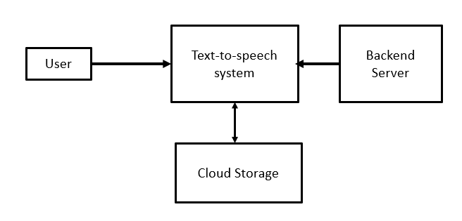

- Level 1 : System-Level DFD

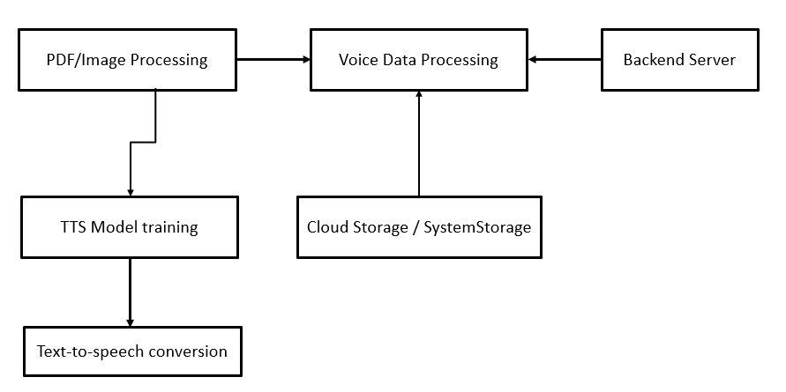

- Level 2 : Detailed Process-Level DFD

Detailed process-level
Data Flow Diagram

    - PDF Image Processing :
How to working / extract text from either pdf file or image.

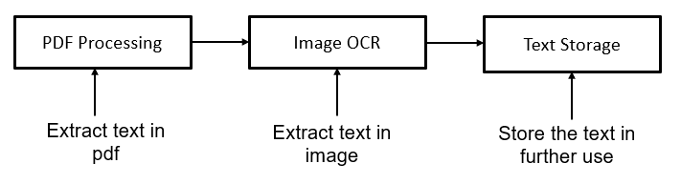

    - Voice Data Processing :
Providing by the Input in simple voice to recording & uploading using TTS training model.

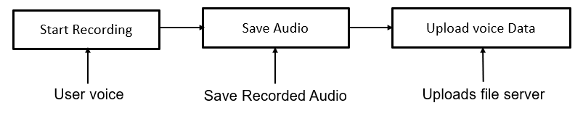

    - Text-to-speech training :
This process takes the uploaded voice data trains a text-to-speech model to Replicate the user’s voice.

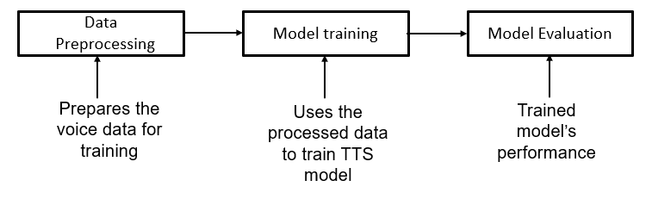

    - TTS Conversion :
This process takes the text and converts it into speech using the trained TTS model.
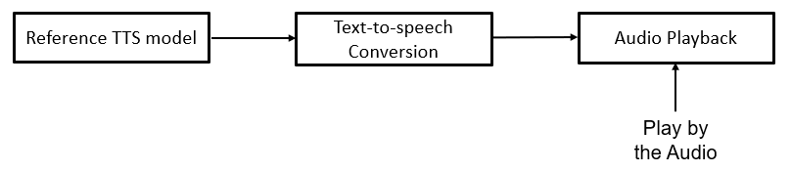

UML Diagram

  - Behavioral UML Diagram

- Use Case Diagram user
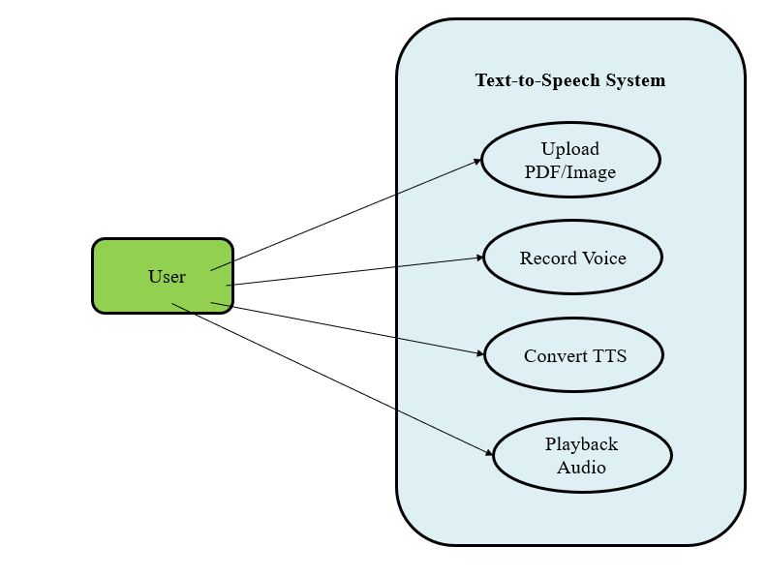

- Sequence Diagram user

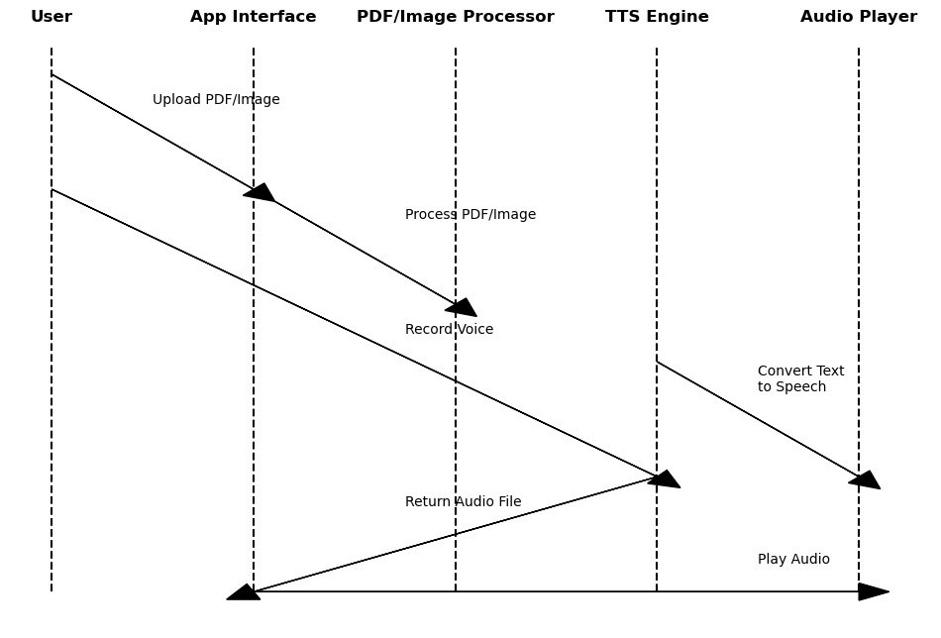

- Activity Diagram

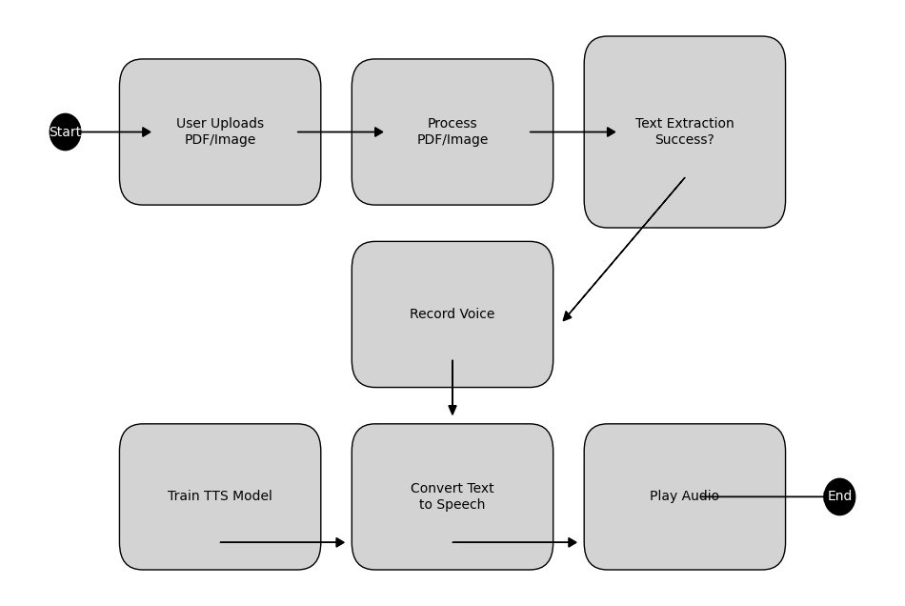

- Work-Flow Diagram

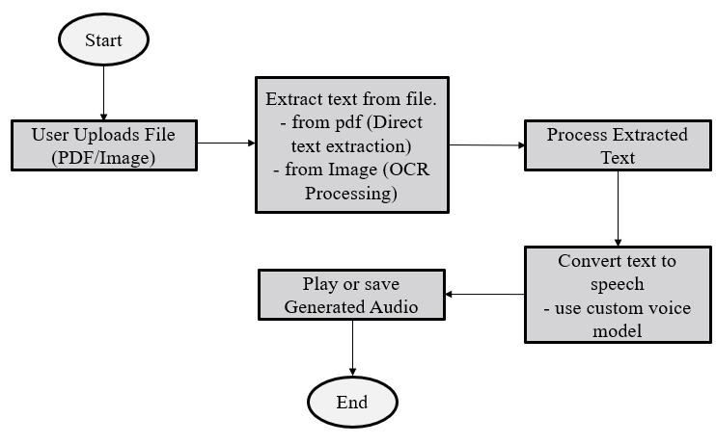

  - Structural UML Diagram

- Class Diagram



