Title: Performance Assessment of Diversion Head work; A Case Study on Abegaz Small Scale Irrigation Project, in Amahara Region, Ethiopia
Sentayehu Mekonnen Beyene¹ and Belete Adebabay Gessie²
¹ Lalibela Study Design & Supervision Works Plc. Bahir Dar Ethiopia Email: sent.4632@gmail.com
ORCID ID: 0000-0002-3136-5753,
² Lalibela Study Design & Supervision Works Plc. Bahir Dar Ethiopia Email: belete370@gmail.com

Corresponding author email: sent.4632@gmail.com

Abstract
This study evaluates the performance of the Abegaz Small Scale Irrigation Project by employing indicators of hydraulic and structural performance. The project features a diversion weir and supporting irrigation infrastructure to improve agricultural productivity. Through field measurements and site observations, we obtained primary data, and by analyzing secondary data from design documentation, we evaluated the current state of the weir. Findings indicate that sediment accumulation has significantly reduced the effective weir height from 1.20 m to 0.60 m, an issue attributed to the inadequately designed under-sluice gate, which has impaired the functioning of the diversion head work.
According to the hydraulic performance analysis, the weir does not have sufficient design to manage high flood events. The measurement of the weir's discharge capacity at 48.52 m³/s, compared to the peak design discharge of 50.07 m³/s from the catchment area, suggests a potential risk of failure during extreme floods. Structurally, the weir remains stable, with a safety factor against overturning of 1.51 under High Flood Level (HFL) conditions and 2.40 under Normal Pool Level (NPL) conditions, both exceeding the minimum required value of 1.50. They also found the factor of safety against sliding to be satisfactory. Stress analysis at critical points, such as the toe and heel of the foundation, showed that the maximum stress levels were within acceptable limits, confirming the overall structural integrity of the weir.
In conclusion, the results underscore the need for improved sediment management and enhanced flood capacity in the design and maintenance of small-scale irrigation infrastructure to ensure long-term sustainability and optimal performance.
Keywords: Hydraulic and Structural Performance, Sediment Management, Design Discrepancy, Flood Capacity

INTRODUCTION
Water scarcity is increasingly recognized as one of the most pressing global challenges, particularly in the context of agricultural productivity and food security [1]. According to the United Nations, nearly 40% of the global population faces some form of water scarcity, and this percentage is expected to rise with climate change and population growth [2]. Agriculture, which accounts for approximately 70% of global freshwater withdrawals, plays a critical role in ensuring food security, especially in regions where rainfall is inconsistent [3]. Improving irrigation practices, therefore, is essential to enhance water use efficiency and address food insecurity, particularly in developing countries like Ethiopia, where the agricultural sector is the backbone of the economy [4].
Ethiopia’s predominantly rain-fed agricultural system makes it highly vulnerable to climate variability, with unpredictable rainfall patterns causing fluctuating agricultural outputs [5]. Despite having abundant water resources, only a small portion of the country's arable land is under irrigation approximately 640,000 ha out of its vast potential [6]. The government has recognized irrigation as a key to stabilizing agricultural production and improving food security, which has led to significant investments in both small- and large-scale irrigation schemes [7]. However, these efforts have not fully addressed the persistent challenges faced by small-scale irrigation systems, such as inefficient water distribution, sediment accumulation, and poor maintenance practices [8].
Previous research on small-scale irrigation schemes has identified numerous challenges, particularly regarding the structural integrity of diversion works and the technical capabilities of local farmers in Ethiopia. Studies such as those by [9, 10] emphasize the need for effective management practices to enhance the sustainability of these systems, while [11, 12] highlight the socio-economic impacts of irrigation failures on local communities. However, these studies often focus on specific issues, such as management practices or socio-economic outcomes, without providing a comprehensive analysis that integrates both hydraulic performance and structural integrity.
This study seeks to bridge this gap by investigating both hydraulic and structural performance in the Abegaz small-scale irrigation scheme, providing insights into how these interconnected components influence the overall functionality and sustainability of irrigation systems. This comprehensive analysis not only enhances our understanding of operational challenges but also informs strategies for improving irrigation management across the region.
The Abegaz small-scale irrigation project, located in the South Gondar Zone, Ebinat Woreda, was designed to enhance water access for agriculture. However, like many other small-scale irrigation projects in Ethiopia, it has faced significant operational challenges, including sediment buildup at the diversion headwork and inefficient flood management [13]. These problems have negatively impacted water distribution efficiency and reduced the project's overall agricultural productivity. Addressing these challenges requires a comprehensive performance assessment to identify design flaws and operational bottlenecks, which can provide a basis for recommending improvements that would extend the scheme’s longevity and ensure its sustainability.
This research, therefore, aims to assess the design and performance of the Abegaz small-scale irrigation structures, focusing on (i) evaluating the hydraulic performance of the diversion weir and associated structures, (ii) examining the structural stability and integrity of the headworks, and (iii) identifying maintenance needs and operational challenges that affect long-term sustainability. By conducting this analysis, the study not only contributes to addressing the specific problems of the Abegaz irrigation system but also provides broader insights that can be applied to other small-scale irrigation systems facing similar challenges across Ethiopia and other developing regions.
The significance of this research lies in its potential to inform policymakers and engineers about the necessary improvements in the design and operation of small-scale irrigation systems. In particular, the study’s findings can help enhance the efficiency of existing irrigation schemes, reduce water wastage, and improve agricultural yields. Compared to previous research, which often emphasized either hydraulic performance or structural integrity in isolation, this study combines both aspects, making its findings particularly relevant for engineers, water resource managers, and farmers involved in small-scale irrigation projects. Ultimately, the research contributes to the ongoing efforts to improve water resource management and food security in Ethiopia and other water-scarce regions.
Moreover, the study's recommendations for maintenance strategies and operational adjustments could inform future research on irrigation management, particularly in resource-constrained environments. This research also highlights the need for further studies to explore innovative methods for maintaining and upgrading small-scale irrigation systems, ensuring their resilience in the face of climate change and evolving agricultural demands.

Methods and Materials

Description of the Study Area
The project area is located in Amhara National Regional State, South Gondar Administrative Zone, Ebinat Woreda, Gunaguna kebele, about 25 km from Woreda town. The watershed for the Abegaz small-scale irrigation project (ASSIP) covers an area of 14.5 km². The highest and lowest elevations are at 2290 m amsl and 2150 m amsl, respectively. The project area is located in the Weina-Dega agro-climatic zone. The proposed weir site is located at an elevation of about 2150 m amsl and UTM coordinates of 401000 E and 1325000 N. The Abegaz small-scale irrigation project was designed by the Amhara Design and Supervision Works Enterprise and constructed by a private limited company contractor. The whole command area is located on the right side of the river. The command area has a gross area of about 100 ha, with altitudes ranging from 2290 m to 2150 m amsl. The Abegaz irrigation headworks include a weir, under sluice, aprons, cutoff structures, and a canal head regulator. The total waterway of the diversion headwork structure is 26 m. The total length of the under-sluice and weir part is 26 m. The depth of the weir upstream and downstream cutoff is 1 m and 1.8 m, respectively. The under-sluice sill level is 2118.03 m (lowest river bed level at the weir axis). The canal head regulator has one gate with a height of 1.2 m. The head regulator sill level is 2118.73 m. The location of this study area is shown in Figure 1.
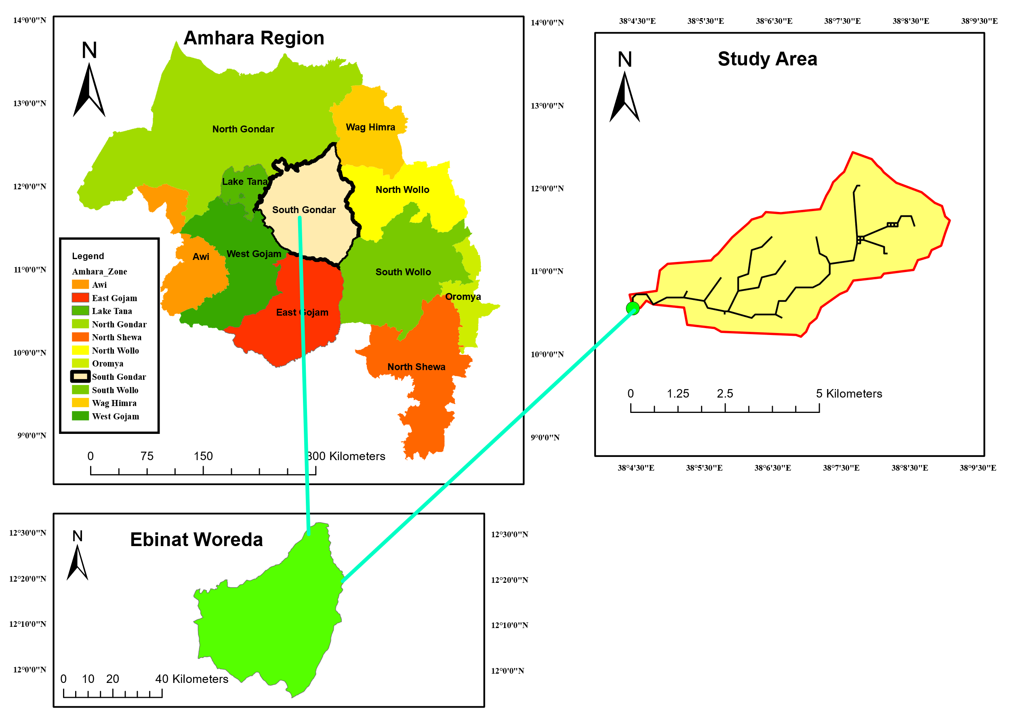
Figure 1Location map for Abegaz small-scale irrigation project

Primary data collection
Field observations were conducted at the Abegaz small-scale irrigation project to determine various headwork parameters. Collaborating with engineers from the Ebinat Woreda Agricultural Office and the Amhara National Regional State Water, Irrigation, and Energy Development Bureau, the following measurements were taken the value is shown below in Table 1. These measurements provide crucial insights into the operational efficiency and current condition of the headwork.

Table 1 Measured values in the filed
Variable Name | Value
Main Canal Discharge (m³/s) | 0.13
Sediment Depth Upstream of Canal Head Regulator (cm) | 40
Opening Height of Under Sluice Gate (cm) | 120
Opening Height of Canal Head Regulator Gate (cm) | 60

Secondary Data
For this study, secondary data were collected from design reports provided by the Amhara National Regional State Water, Irrigation, and Energy Development Bureau. These reports contained essential details regarding the design discharge of the Abegaz small-scale irrigation headwork and the structural dimensions of its components. Key parameters are summarized in Table 2. This analysis facilitated a thorough understanding of the headwork's design specifications and operational expectations.
Additionally, the design reports were examined to identify critical parameters that influence the headwork's functionality, including material properties necessary for structural analysis, as outlined in Table 3. This comprehensive examination of secondary data provides a vital foundation for understanding the performance challenges faced by the Abegaz irrigation system.
Table 2 Summary of Abegaz weir dimensions.
Variable Name | Value
Height of Weir(m) | 1.20
Weir Length (m) | 26
Top Width of Weir(m) | 1.00
Bottom width(m) | 2.5
D/S Glacis slope(H:1V) | 1H:1V

Table 3 Constant Parameter during a structural analysis of the weir body.
Material Properties | Value
Water(kN/m3) | 9.81
Silt Deposition (kN/m3) | 20
Weir Body (kN/m3) | 22
Apron Floor (kN/m3) | 22
Angle of internal friction of material(Degree) | 30
Active pressure coefficient(Ka) | 0.33

Methods of Data Analysis
The methodology commenced with a desk study, which involved reviewing previous research, documents, and papers related to diversion headworks. This analysis identified key issues by examining existing irrigation structures, such as the Abegaz small-scale irrigation headwork, alongside post-implementation review reports obtained from the Amhara National Regional State Water, Irrigation, and Energy Development Bureau. Field surveys were conducted to gather real-time data on the current condition of the Abegaz diversion headwork. During these surveys, critical measurements were taken at key points, including river cross-sections both upstream and downstream of the headwork. Interviews with farmers and administrative officials were also conducted to evaluate the operational efficiency of the headwork, yielding valuable insights into its practical functionality, operation, and maintenance.
In conjunction with primary data collection, secondary data were gathered from design documents and reports issued by the Amhara Water, Irrigation, and Energy Development Bureau. This documentation served as a benchmark for comparing the current state of the headwork against its original design specifications, including flood passage design, structural adequacy, and hydraulic performance parameters. The conceptual framework for analyzing the performance of the Abegaz irrigation project encompasses both hydraulic and structural assessments. The hydraulic analysis focused on evaluating the structure's capacity to manage design floods, ensuring it could effectively handle both regular and hazardous flood events. Parameters such as discharge capacity, peak design discharge, and sedimentation were assessed, comparing data from river cross-sections with design data to identify any discrepancies in current performance.
On the structural side, the stability of the headwork was evaluated under various loading conditions. The forces and moments acting on the structure were calculated, facilitating an assessment of its stability against overturning and sliding. This analysis considered two scenarios: the worst-case scenario, which involved the flood level on the upstream side while the downstream side remained empty, and the current existing conditions. A factor of safety ranging from 1.5 to 4 was applied to ensure structural integrity, as recommended by [14]. The evaluation accounted for factors such as hydrostatic pressure, silt weight, and uplift force. Specifically, stability against overturning required that the resultant force passes through the middle third of the structure’s base, while stability against sliding was verified by ensuring that vertical forces provided adequate frictional resistance against horizontal forces. This comprehensive methodology underscores the significance of both primary and secondary data in assessing the performance of the Abegaz small-scale irrigation headworks. The overall data collection and analysis are shown below in Figure 2.

Field Observation & measurements
Interviewing stake holders & beneficiaries
Field Data Analysis
Project Design Document & related materials
Secondary
Data
Design Document & analysis
Checking Design Gap

Problem Identification
Structural Consistency will be checked
Performance of the diversion Headwork evaluated

Hydraulic performance
Checked

Passage of sediment
Prevalence of Scouring
Flood passage & water withdrawal
Bed control at the intake
Flushing of settled sediment
Safe against Uplift, sliding
Safe against overturning

Input Data Collection
Primary Data
Figure 2 Conceptual Framework of the study

Hydraulic and Structural Performance Analysis
To assess the operation and effectiveness of the Abegaz Small Scale Irrigation Project, a variety of data analysis techniques were employed to achieve the study’s objectives. Performance indicators were utilized to evaluate different aspects of the irrigation scheme [13]. For hydraulic performance, key metrics included sediment passage and flood capacity [15]. Additionally, structural performance was examined through indicators such as stability against overturning and sliding, tension, and eccentricity of the resultant load [16].

Passage of Sediment
To determine how well the diversion weir handles sediment transport and accumulation. Field observations and sediment measurements were conducted to evaluate sediment buildup in front of the head regulator and within the upstream reservoir [17]. The analysis focused on assessing the effectiveness of the under-sluice gate and the ability of the weir to manage sediment load. Passage of sediment problem was checked through surveying of the bed level of head work components to check the prevalence of sedimentation which will occur due to not having enough passage [18]. The accumulation of high silt load at the head regulator, and high sediment entry to the main off-taking canal is prevalent as it is shown in Figure 3. The sediment load deposited in front of the head regulator was not regularly flushed out. Sediment deposition and formation of shoal in front of the weir proper is also prevalent.
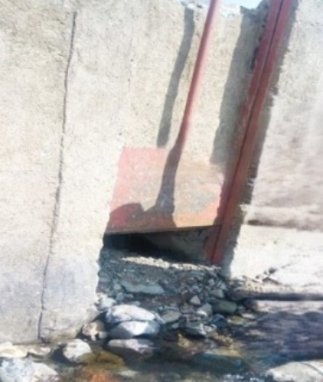
Figure 3 Sediment deposition at the entry of the canal

Passage of Flood Capacity
To assess the weir’s ability to manage flood events. Hydraulic performance was evaluated by comparing the weir’s discharge capacity against the design flood requirements [19]. Calculations were performed to determine whether the weir could safely handle peak flow conditions generated from the catchment area.
Discharge over the weir is calculated by:
$Q= Cd\left(L-nKHe\right){He}^{1.5}$ (1)
Where, Cd- Discharge coefficient
L- Net width of weir (waterway)
Q- Discharge over the weir
n- Number of end contraction
K- Coefficient of end contraction
But in our case, there are no piers between the weir bodies. So the coefficient of end contraction (k) and number of end contractions will be negligible. The equation becomes
$Q= CdL{He}^{1.5}$ (2)
Where, Cd- Discharge coefficient (take cd= 1.7, Novak, page 374)
L- Length of weir (waterway 26m)
H- Upstream water level mines downstream water level (1.064m)
Q- Discharge over the weir

Stability against Overturning
To ensure that the diversion weir does not fail due to overturning forces. The factor of safety against overturning was calculated by analyzing the moments acting on the weir under both High Flood Level (HFL) and Normal Pool Level (NPL) conditions [20]. This involved comparing destabilizing moments with stabilizing moments to verify structural stability. The forces that are applied on the diversion weir for High Flood Level (HFL) and Normal Pool Level (NPL) conditions as indicated in Figure 3 and Figure 4 respectively.
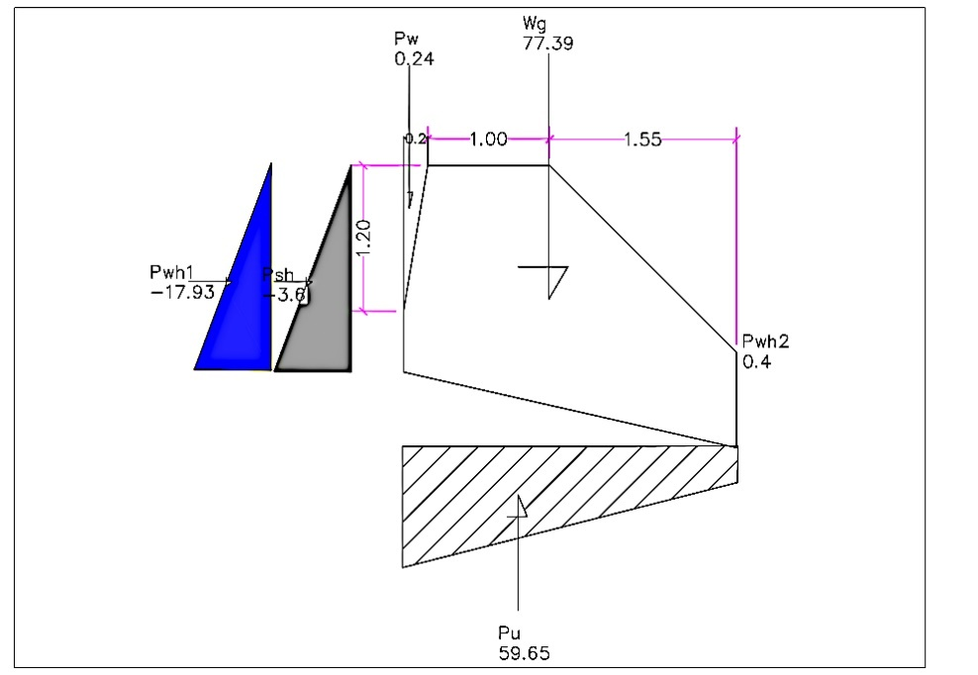

Figure 4 Loading diagram for Weir Body (HFL Condition)
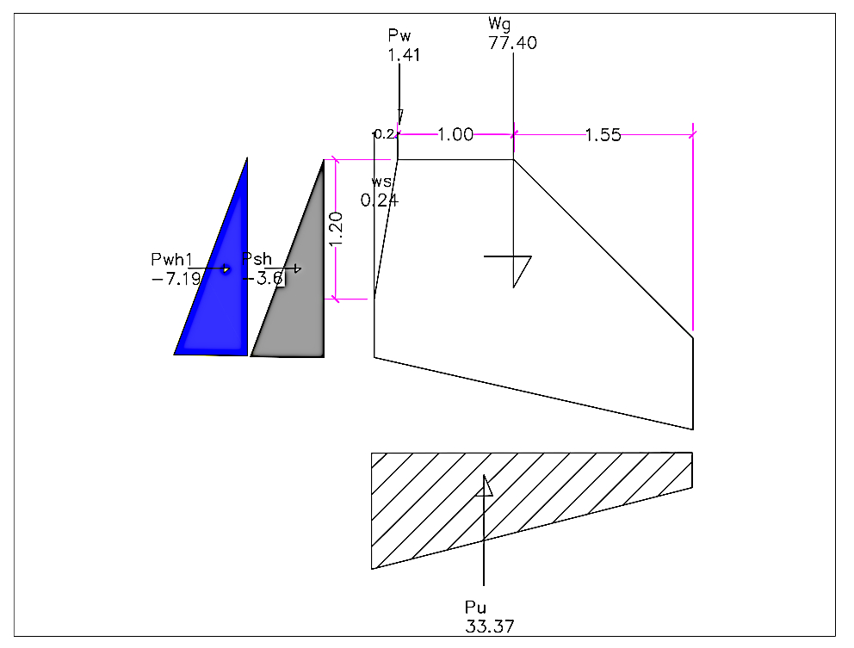
Figure 5 Loading Diagram for weir body (NPL Condition)
The combined effect of all forces should not have the threatening capacity to overturn the weir body. The factor of safety for this parameter is usually between 1.5 and 4[21]. The relation for determining overturning stability is represented by:
${FS}_{OT}= \frac{\sum{M_{+}}}{\sum{M_{-}}}≥1$ (3)
Where
M_{(-ve)} is the sum of all destabilizing moments
M_{(+ve)} is the sum of all stabilizing moments

The moments and the forces responsible for them are computed in tables for both HFL and NPL conditions.

Stability against Sliding
To assess the weir’s resistance to sliding along its base. The factor of safety against sliding was determined by evaluating the horizontal forces that could cause sliding and comparing them with the resisting vertical forces. This analysis ensures that the structure remains stationary under load [22].
The factor of safety against sliding is evaluated from
${FS}_{SL}= \frac{μ\sum{V}}{\sum{H}}≥1$ (4)
Where$μ$, The friction Coefficient (0.7 ~ 0.75) and friction coefficient value of 0.7 are used for this study.

Check for Eccentricity of Resultant Load:
To ensure that the resultant forces acting on the weir do not create excessive eccentricities that could lead to structural issues. The eccentricity of the resultant load was calculated by analyzing the distribution of vertical and horizontal forces [23]. This analysis confirms that the resultant force acts within the middle third of the base to prevent negative stresses in the structure. This indicator assessed whether the resultant forces acting on the weir were distributed evenly, ensuring that the load did not create excessive eccentricities that could lead to structural issues[24].Eccentricity due to a load combination is determined from the relationship:
$e=ȳ-\frac{B}{2}$ (5)
And $ȳ=\frac{∑M}{∑V}$
Where
e= eccentricity
B= Bottom width of weir (meters)
M= Moments
V= Vertical forces
In the final analysis, the condition required is represented by:
$$e=<\frac{B}{6}$$

Check for induced stress on Foundation material:
To evaluate whether the weir’s structural components are adequately designed to withstand tensile forces. Stress analysis was conducted to check the tensile stresses within the weir’s structure and its foundation, ensuring that these stresses do not exceed allowable limits. Stress analysis was conducted to evaluate whether the structural components of the weir could withstand tensile forces without exceeding acceptable stress limits. The ultimate bearing capacity of the foundation material must provide a safe medium to withstand the dead weight of the weir body and the static impact of forces induced by the surface and subsurface hydraulics[14].
Foundation stress is computed from the eccentricity of the loading combination determined previously. Thus
$σ_{Hell}= \frac{\sum{V}}{B}[1+\frac{6e}{B}]$ (6)
$σ_{Toe}= \frac{\sum{V}}{B}[1-\frac{6e}{B}]$ (7)
Where
$σ_{Hell}$, $σ_{Toe}$is computed stress for Hell and Toe respectively
e is eccentricity
B is the bottom width of the weir body
V is Vertical forces

Result and discussion

Hydraulic Performance Assessment

Passage of Sediment
Field observations indicated that the Abegaz diversion weir was designed with a scour sluice gate measuring 100 cm wide and 120 cm high. Due to poor management, the manually operated gate has become ineffective, resulting in complete obstruction by sediment. As a result, significant sediment deposition has occurred in the upstream reservoir of the diversion weir. Sediment depth measurements taken near the head regulator show that the current riverbed level is 0.6 m higher than the original level Table 4.

Table 4 Prevalence of sediment analysis result.
Parameters | Units | Elevation
Weir crest level | m | 2119.23
Constructed weir height | m | 1.20
Original u/s river bed level | m | 2118.03
Current u/s river bed level | m | 2118.63
The 0.6-m sediment accumulation has reduced the effective height of the weir by half, decreasing its functionality in controlling water flow. This sediment deposition has been a primary cause of the weir's reduced capacity to regulate the intake, leading to frequent clogging and disruptions in agricultural activities over time. Similar sedimentation issues have been noted in other small-scale irrigation systems, such as those analyzed by [15, 25], emphasizing the need for better sediment management strategies in Ethiopia's small-scale irrigation schemes.

Passage of Flood
The Abegaz diversion weir was designed to manage significant flood events; however, current observations suggest that it cannot accommodate the expected flood discharge. As shown in Table 5, the weir's discharge capacity (48.52 m³/s) is lower than the design flood capacity (50.07 m³/s), indicating that it may not withstand a 50-year return period flood event.
Table 5 Flood Passage Performance.
Parameters | Units | Amount
Discharge capacity of weir | m3/s | 48.52
Design Flood | m3/s | 50.07
This shortfall highlights a vulnerability in the structure’s ability to safely manage large flood events, increasing the risk of overtopping and structural damage. Previous studies [15] have raised similar concerns, emphasizing the necessity of robust flood management systems in irrigation schemes to prevent failure during extreme hydrological events.

Structural Performance Assessment

Stability Check on Diversion Weir at HFL Condition
The forces acting on the weir were calculated under High Flood Level (HFL) conditions, and the stability of the structure was analyzed against sliding, overturning, and stress. Table 6 provides a summary of the loading conditions and the resulting forces.

Table 6 Summary of Loading at HFL Condition
Load | Symbol | Magnitude (KN) |  | Arm (m) | Negative Moments (KN-m) | Positive Moments (KN-m)
Load | Symbol | Horizontal | Vertical | Arm (m) | Negative Moments (KN-m) | Positive Moments (KN-m)
Silt Pressure | Psh | -3.6 |  | 0.7 | -2.6 | 0.0
Water Pressure | Pwh1 | -17.9 |  | 0.9 | -15.3 | 0.0
Backwater Pressure | Pwh2 | 0.4 |  | 0.1 | 0.0 | 0.04
Weight of Water | Pwv |  | 18.6 | 1.7 | 0.0 | 31.2
Uplift Pressure | Pu |  | -59.7 | 1.3 | -75.2 | 0.0
Self-Weight | Wg |  | 77.4 | 1.4 | 0.0 | 109.2
Silt Weight | Ws |  | 0.2 | 2.7 | 0.0 | 0.6
∑ |  | -21.1 | 36.6 |  | -93.2 | 141.0

The analysis shows that the weir is generally stable under HFL conditions, with a factor of safety for sliding (Fs = 1.21) and overturning (Fo = 1.513) both within acceptable ranges.

Stability Check on Diversion Weir at NPL Condition
Under Normal Pool Level (NPL) conditions, the structural stability of the weir was similarly assessed Table 7. The weir remains stable under these conditions as well, with satisfactory safety margins for sliding and overturning.
Table 7 Summary of Loading at NPL Condition
Load | Symbol | Magnitude (KN) |  | Arm (m) | Negative Moments (KN-m) | Positive Moments (KN-m)
Load | Symbol | Horizontal | Vertical | Arm (m) | Negative Moments (KN-m) | Positive Moments (KN-m)
Silt Pressure | Psh | -3.6 |  | 0.7 | -2.6 | 0.0
Water Pressure | Pwh1 | -7.2 |  | 0.9 | -5.3 | 0.0
Back Water Pressure | Pwh2 | 0.0 |  | 0.1 | 0.0 | 0.0
Weight of Water | Pwv |  | 1.4 | 1.7 | 0.0 | 3.5
Uplift Pressure | Pu |  | -33.4 | 1.3 | -39.4 | 0.0
Self-Weight | Wg |  | 77.4 | 1.4 | 0.0 | 109.2
Silt Weight | Ws |  | 0.2 | 2.7 | 0.0 | 0.6
∑ |  | -10.8 | 45.7 |  | -47.3 | 113.3
Table 8 summarizes the results of both stability checks under HFL and NPL conditions. All criteria for sliding, overturning, and stress at both the heel and toe of the structure were met, ensuring the safety of the weir.

Table 8 Summary of structural analysis calculation results of the two cases.
Parameter | Symbol | Units | Conditions to be satisfied | HFL | NPL | Status
Safety for sliding | Fs | - | ≥ 1 | 1.21 | 2.96 | PASS
Safety for Overturning | Fo | - | ≥ 1.5 | 1.51 | 2.39 | PASS
Load Eccentricity | ECC | m | < B/6 | 0.06 | 0.078 | PASS
Stress @ Heel | qHeel | KN/m^2 | 490 | 11.58 | 13.85 | PASS
Stress @ Toe | qToe | KN/m^2 | 490 | 15.19 | 19.54 | PASS

Discussion
The sediment accumulation and flood capacity assessments suggest significant operational challenges for the Abegaz irrigation scheme. The sediment buildup has led to reduced weir height and impaired water regulation, aligning with findings in similar small-scale irrigation projects [15, 25]. Additionally, the inability to manage design flood capacity exposes the structure to potential failure during high flood events, echoing the concerns raised by [15].
The structural performance analysis shows that, despite these hydraulic challenges, the weir remains structurally sound under both High Flood Level (HFL) and Normal Pool Level (NPL) conditions. This finding is consistent with the results reported by [16], who also assessed the structural stability of diversion weirs and found them to be stable under design flood conditions. Both studies confirm that while the structural integrity of the weirs is maintained, operational inefficiencies, such as sediment buildup and inadequate flood management, pose significant risks to the long-term sustainability of the irrigation systems. This highlights the need for enhanced maintenance practices and flood management strategies rather than major structural modifications.
By integrating both hydraulic and structural evaluations, this study contributes to the literature on small-scale irrigation performance, addressing a gap identified in previous research. In line with [16], this analysis emphasizes the importance of comprehensive assessments that consider both hydraulic and structural aspects to ensure the long-term viability of irrigation infrastructure in Ethiopia.

Conclusion
This study provides a comprehensive evaluation of the hydraulic and structural performance of the Abegaz diversion weir through a combination of field investigations, measurements, and thorough reviews of design documents and relevant materials. The findings reveal a critical safety concern, as the peak discharge from the catchment area, calculated at 50.07 m³/s, exceeds the diversion weir's total discharge capacity of only 48.52 m³/s. This discrepancy underscores the inadequacy of the current design to handle severe hydrological events, particularly during high flood conditions.
The structural evaluation indicates that the diversion weir remains stable and sound, with safety factors exceeding the recommended thresholds. However, significant challenges arise from sediment accumulation in the upstream reservoir, primarily because of the ineffective design of the under-sluice gate, which has failed to facilitate adequate sediment passage. As a result, the effective height of the weir has diminished from its original 1.2 m to just 0.6 m, further jeopardizing its operational integrity and diminishing the overall effectiveness of the irrigation system.
Moreover, the current management practices for sediment inflow are insufficient, leading to prolonged flushing times that ultimately hinder the productivity and efficiency of the irrigation system. To address these pressing issues, future research should focus on optimizing the design of the under-sluice gate to enhance its sediment management capabilities. Investigating alternative design solutions for the diversion headworks, incorporating sediment transport principles and robust flood risk management strategies, is essential. Additionally, further studies could assess the implementation of advanced monitoring systems to track sediment accumulation in real time, facilitating timely interventions.
Expanding the scope of research to include comparative analyses of similar irrigation structures could yield valuable insights for future designs and modifications, ultimately contributing to improved water resource management and enhanced agricultural productivity in the region. This comprehensive approach not only addresses the current limitations of the Abegaz irrigation scheme but also enriches the literature on small-scale irrigation performance, paving the way for sustainable practices in the sector.
List of Notation and Dimensions
Symbol | Description | Dimension
Q | Discharge over the weir | m³/s
Cd | Discharge coefficient | -
L | Net width of the weir (waterway) | m
H | Upstream water level minus downstream water level | m
n | Number of end contractions | -
K | Coefficient of end contraction | -
Fo | Factor of safety against overturning | -
M_ | Sum of all destabilizing moments | kN·m
M+ | Sum of all stabilizing moments | kN·m
FS | Factor of safety against sliding | -
μ | Friction coefficient | -
V | Vertical forces | kN
e | Eccentricity of resultant load | m
B | Bottom width of the weir | m
σ_{Heel} | Computed stress at the heel | kN/m²
σ_{Toe} | Computed stress at the toe | kN/m²
Psh | Silt pressure | kN
Pwh1 | Water pressure at high flood level | kN
Pwh2 | Back water pressure | kN
Pw | Weight of water | kN
Pu | Uplift pressure | kN
W_{g} | Self-weight of the structure | kN
W_{s} | Silt weight | kN
Acknowledgments
We would like to express our sincere gratitude to the Amhara National Regional State Water Irrigation and Energy Development Bureau for their invaluable support in data collection and for providing essential design documentation. Our heartfelt appreciation extends to the Ebinat Woreda Agricultural Office for their critical assistance throughout the data collection process.
Disclosure Statement
There are no affiliations with or involvement in any organization or entity that has any financial or non-financial interest in the subject matter or materials discussed in this manuscript.
Conflict of Interest
There is no conflict of interest for this publication.
Availability of data and material
All data generated and analyzed during this study are included in this published article.
Authors’ contributions: Sentayehu Mekonnen Beyene. is working as a Senior Irrigation and Drainage Study Design’ Engineer in Lalibela Study Design & Supervision Works Plc. He has conceptualized, collected, and prepared the data analysis and result writing. Belete Adebabay Gessie is working as an Senior Irrigation and Drainage Study Design’ Engineer in Lalibela Study Design & Supervision Works Plc. He has edited the document.
Funding statement: There is no funding organization for publication.
Declaration
We here submitted the manuscript entitled “Performance Assessment of Diversion Head work; A Case Study on Abegaz Small Scale Irrigation Project, in Amahara Region, Ethiopia” to be considered for publication. We declare that this is our original research work.
No. | Name of Author | Affiliation | E-mail
1 | Sentayehu Mekonnen Beyene | Lalibela Study Design & Supervision Works Plc | sent.4632@gmail.com
2 | Belete Adebabay Gessie | Lalibela Study Design & Supervision Works Plc | belete370@gmail.com
I signed on behalf of all the authors
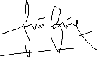
Author Name Signature Date
Sentayehu Mekonnen Beyene 08/24/2024

References
1. Mancosu, N., et al., Water scarcity and future challenges for food production. Water, 2015. 7(3): p. 975-992.
2. Boretti, A. and L. Rosa, Reassessing the projections of the world water development report. NPJ Clean Water, 2019. 2(1): p. 15.
3. Wang, X., Managing land carrying capacity: Key to achieving sustainable production systems for food security. Land, 2022. 11(4): p. 484.
4. Wendimu, A., T. Yoseph, and T. Ayalew, An overview of the role of irrigation in the attainment of sustainable development goals through hunger and poverty alleviation in Ethiopia. International Journal of Innovative Research and Scientific Studies, 2023. 6(4): p. 980-993.
5. Bedane, H.R., et al., The impact of rainfall variability and crop production on vertisols in the central highlands of Ethiopia. Environmental Systems Research, 2022. 11(1): p. 26.
6. Kassa, M. and T.G. Andualem, Review of irrigation practice in Ethiopia, lessons from Israel. Irrig. Drain. Syst. Eng, 2020. 9(1).
7. Umer, Y., et al., Small-Scale Irrigation Farming as a Climate-Smart Agriculture Practice; Its Adoption and Impact on Food Security for Ethiopian Smallholder Farmers: A Review. Asian Research Journal of Current Science, 2024. 6(1): p. 163-180.
8. Mekonnen, Z., et al., Performance Evaluation of Small-Scale Irrigation Scheme: a Case Study of Golina Small-Scale Irrigation Scheme, North Wollo, Ethiopia. Water Conservation Science and Engineering, 2022. 7(4): p. 491-503.
9. Gebremedhin Gebremeskel Haile, G.G.H., Irrigation in Ethiopia, a review. 2015.
10. Ketsela, Y.S., B.G. Reta, and A.T. Muche, Evaluation of Small‐Scale Irrigation Scheme Performance and Proposed Alternative Mitigation for Improved Water Management on Wezeqa and Gatto Irrigation Schemes, Southern, Ethiopia. Advances in Agriculture, 2024. 2024(1): p. 5884209.
11. Abera, A., et al., Performance of small-scale irrigation schemes in Lake Tana Basin of Ethiopia: technical and socio-political attributes. Physical Geography, 2019. 40(3): p. 227-251.
12. Awulachew, S.B. and D.J. Merrey, Assessment of small scale irrigation and water harvesting in Ethiopian agricultural development. International Water Management Institute (IWMI), 2007.
13. Kassa, E.T. and M. Ayana, Hydraulic performance assessment of Tahtay Tsalit small scale irrigation scheme, Tigray, Ethiopia. International Journal of Water Resources and Environmental Engineering, 2017. 9(11): p. 254-263.
14. Novak, P., et al., Hydraulic structures. 2017: CRC Press.
15. Mosisa, G. and A. Dereje, Hydraulic Performance Evaluation of Diversion Weir and Canal Structures: Case Study of Basaka Small Scale Irrigation Scheme, Wayu Tuka, East Wallaga, Oromia, Ethiopia. Am. J. Sci. Eng. Technol, 2023. 8(3): p. 152-161.
16. Mosisa, G., Structural Performance Evaluation of Diversion Weir Structure: Case Study of Basaka Small Scale Irrigation Scheme, Oromia, Ethiopia. Gemechu Mosisa.(2024). Structural Performance Evaluation of Diversion Weir Structure: Case Study of Basaka Small Scale Irrigation Scheme, Oromia, Ethiopia. American Journal of Civil Engineering, 2024. 12(1): p. 27-31.
17. TEMESGEN, D.K., Performance evaluation of Tibila irrigation based development project diversion headwork, Ethiopia. 2017.
18. Nora, M.B., Institute of Technology School of Civil and Environmental Engineering Postgraduate Program in Hydraulic Engineering. 2017, Institute of Technology School of Civil and Environmental Engineering ….
19. Hora, M.W., Assessment Of Design Practices And Performance Of Diversion Weir In Small Scale Irrigation (Case Study From Projects In Western Oromia, Ethiopia). 2016.
20. Baredo, B.B., Performance Evaluation Of Diversion Headwork Structures For Irrigation: Case Study On Agega-1, Agega-2 And Sana Irrigation Schemes In Kembata Tembaro Zone, Snnpr, Ethiopia. 2021.
21. Amanuel, B.S., Assessment of Design Practices and Performance of Small-Scale Diversion Weirs Constructed for Irrigation Project (a case study of Ashar and Upper Kuashini Small-Scale Irrigation Schemes in Awi zone, Dangla Woreda). 2022.
22. Abel, E., Investigation Of Causes Of Diversion Weir Failure (A Case Study On Marza Small-Scale Irrigation Scheme, South Gondar, Ethiopia). 2021.
23. Geressu, R.T., T.H. Tarekegn, and E.A. Demissie. Optimised multi-objective design of weir structures. in Proceedings of the Institution of Civil Engineers-Water Management. 2023. Emerald Publishing Limited.
24. Mulugeta, T. and W.T. Ayele, Assessment of irrigation scheme failure factors: a case study on Marza irrigation scheme Fogera, Amhara, Ethiopia. Water Conservation Science and Engineering, 2022. 7(4): p. 465-474.
25. Ertiro, F., S. Pingale, and N. Wagesho, Evaluation of failures and design practices of river diversion structures for irrigation: a revisit of two SSI schemes in Ethiopia. Int. J. Earth Sci. Eng, 2017. 10(03): p. 495-505.

