PROPERTY INFORMATION

Property Name | Harbour Court
Unique Property Reference Number (UPRN) | 354675 (it is a unique identifier number for the Council and Fire Brigade)
Address | Anchor Road, Bristol, BS1 5TP
Phone Number | 0117 925 5167 | Site Mobile No | 073 9169 8807
Site email | harbourcourt@abodusstudents.com

Entity Name | IUKFour Ltd
Address | c/o Abodus Ltd  Portland Green Student Village  Portland Road  Newcastle upon Tyne  NE2 1DT
Company Reg No | Not relevant
VAT No | Not relevant
Invoicing Address | IUKFour Ltd  c/o Abodus Ltd  Portland Green Student Village  Portland Road  Newcastle upon Tyne  NE2 1DT

OFFICE OPENING HOURS:
MONDAY | 0800-2000
TUESDAY | 0800-2000
WEDNESDAY | 0800-2000
THURSDAY | 0800-2000
FRIDAY | 0800-2000
SATURDAY | Closed
SUNDAY | Closed

SITE STAFF:
Job Title | Name | Contact Number
REGIONAL OPERATIONS MANAGER | Adam McDonnell | 07501 547855
SENIOR OPERATIONS MANAGER | Vacant position | Vacant position
ASSISTANT OPERATIONS MANAGER | Giovanni Distefano | 07543 408890
ASSISTANT OPERATIONS MANAGER | Martin Chandler | 07522 474348
CUSTOMER SERVICE ADVISOR (Full-time) | Mattia Buttarelli | 07423 080463
CUSTOMER SERVICE ADVISOR (Part-time) | Tayib Kamran | 07340 645873
MAINTENANCE TECHNICIAN | Laszlo Kovacs | 07885 302223
HOUSEKEEPER | Diana Lakatos | 07490 466889
HOUSEKEEPER | Marta Rosinska | 07928 067108

BRIEF OVERVIEW OF SITE
SITE SUMMARY
Harbour Court was constructed in 2014 by Andrew Wotton Associates (Chartered Architects). The building consists of a one block, L shape design, complete with a private Courtyard and two Lightwells.
A Seven Storey Building, with each storey, with the exception of the 5th Floor, is split into two levels, with a 850mm level change between the two (sub-levels). The roof is also split in two levels. Vertical circulation is provided by internal stairs and a passenger lift. Refuge spaces are not provided.
The site provides 133 bedrooms. The building operates a strategy of simultaneous evacuation by block.

EVACUATION & ASSEMBLY POINT
The building operates a strategy of simultaneous evacuation by block.
Assembly Point is Top of Lower Lamb Street, next to Library.

PIB, FP & MCP
Level 0 (G) - Located on the Ground Floor, the Lobby stores:
- Fire Panel (FP);
- Premises Information Box (PIB) or Red Box;
- Manual Call Point (MCP).

DRY RISERS
- DRY RISER INLET is located on Anchor Road Entrance (Stairs Landing Exterior)
- DRY RISER OUTLET on Every Floor by Stair Core 1

MEANS OF ESCAPE
- LEVEL -1 (LG) - Ramp to Anchor Road
- LEVEL 0 (G) – Ambulant Flight of steps to Anchor Rd
- LEVEL 0 – From Emergency Stair Core 2 on Lower Lamb St
- LEVELO 0 – Upper-end of Lower Lamb St (Stair Core 3), by Flat 19

SMOKE DETECTORS
All rooms, corridors and common areas have smoke detectors.

FIRE DOORS
All Fire Doors in communal areas have magnetically hold back devices (Door Retainer) and automatically release/open when the fire alarm goes off, with the exceptions of:
- Cross corridor doors do not have magnetic hold back device installed. Cross corridor doors are fitted with a self-closing device (“Door Closer”) and are kept close. Cross corridor doors are found in Rear split level corridors (e.g. door n. “0D7”)
- Fire Door by Plant Room Corridor (door number “-1D2”)
- Fire Door in Cleaner’s Store, which does not swing close, because is not fitted with a release mechanism or a “Door Closer” (door number “Coshh/workshop”)

EVACUATION CHAIR - LEVEL 5 - The evacuation chair is located on the 5th Floor

EMERGENCY SHUT OFFs,
LEVEL -1 (LG) - are located in Plant Rooms A & B, as described in Premises Information Box (PIB) located in the Lobby.

EMERGENCY ACCESS TO ROOMS
Emergency access to Studios and Cluster Apartments is discussed below.

FLOORS
A Seven Storey Building, with each storey, with the exception of the 5th Floor, is split into two levels, with a 850mm level change between the two (sub-levels). The roof is also split in two levels.

BUILDING IS SPLIT IN TWO
The building consists of a one block, L shape design, complete with a private Courtyard.
Because of the L shape configuration, the building is split in two parts by Stair Core 1 and the passenger lift, with each side being served by an additional Stair Core.

FRONT & REAR OF THE PROPERTY
The Rear of the building is located at the northern end of site, between Grosvenor Casino and the Courtyard. It is served both by Stair Core 1 and Stair Core 3, which is a general circulation stair.
The Front of the building is located at the southern end of site, between Anchor Road and the Courtyard. It is served both by Stair Core 1 and Stair Core 2, which is an emergency escape stair only. Stair Core 2 is only accessible through the Sharing Apartments’ corridor (e.g. Flat 12, Flat 13).

ROOF
The roof is located in the rear of the building and can be accessed by the Fifth Floor descending stairs that lead to the door to the roof. The roof is also split in two levels.

STAIRS
There are Three Stair Core:
- Stair Core 1, main vertical circulation stair that
Includes a Passenger Lift and Dry Risers Outlet
- Stair Core 2 is an emergency escape stair only,
leading onto the southern end of Lower Lamb Street
- Stair Core 3, is a general circulation stair located
at the northern end of site

LIFT
The passenger lift is located by the main vertical circulation stair, Stair Core 1. The passenger lift is the only lift on site. The engine cupboard for the lift is located on the Fifth Floor.
There are no Evacuation, Firefighting or Platform Lift on site.

PASSENGER LIFT STOPS
The Passenger Lift serves every floor. Because all seven Floors are split into two levels, except the 5th Floor, there are 13 Lift stops on site, as per chart below.

Lift Number | Floor | Flat Number
10 | 5th Front | 65-68
9 | 4th Front | 54-57
8 | 4th Rear | 58-64
7 | 3rd Front | 43-46
6 | 3rd Rear | 47-53
5 | 2nd Front | 32-35
4 | 2nd Rear | 36-42
3 | 1st Front | 21-24
2 | 1st Rear | 25-31
1 | Ground Front | Flat 11-13
0 | Ground Rear | 14-20
-1 | Lower Ground Front | Flat 1-4
-2 | Lower Ground Rear | Flat 5-10

ENTRANCES
Two Entrances are located on Anchor Road:
- LEVEL 0 (G), Stepped access on Ground Floor
- LEVEL -1 (LG), Ramped Access on Lower Ground Floor

LOBBY (FP, PIB, MCP)
Located in the Ground Floor, the Lobby is both accessible via Anchor Rd entrance and Stair Core 1. The Lobby holds the Fire Panel (FP), Manual Call Point (MCP) and the Premises Information Box (PIB) or Red Box. The Lobby also holds the Post Boxes for the site.

OFFICE, COMMON ROOM & DISABLE WC
Located in the Ground Floor, the Office and the Common Room are accessible via Anchor Rd entrance (via the Lobby) and Stair Core 1.
The Office and the Lobby are separated by a glazed window. The Office is operated 24/7, holds Key Safe, First Aid, Eyewash Station and the Architectural Plans of the building.
The Common Room is adjacent to Stair Core 1 and Disable WC.

CLEANER’S STORE & LIGHTWELLS
Located in LOWER GROUND (-1) east side of the building, are the Cleaner’s Store, Lightwell A and Lightwell B.
The CLEANER’S STORE is located by Stair Core 1, accessible by the lift landing.
There are two Lightwells on site, located between the East side of the property and our neighbour, Grosvenor’s Casino.
- LIGHTWELL A, is accessible by Cleaner’s Store.
- LIGHTWELL B, is accessible by Flat 20C.

PLANT ROOMS
Plant rooms are located in LOWER GROUND (-1), south west of the building and adjacent to the Emergency Stair Core 2. Plant Rooms are divided in three sections:
- Plant Room A,
- Plant Room B,
- IT Store

Plant rooms are accessible by:
- Ramped Access on Lower Ground Floor
- Emergency Escape Door at the bottom of Lower Lamb Street, trough Stair Core 2
- Stair Core 1
- Courtyard (Plant Room A)

BIN STORE
Is located in the west side of the building, by Lower Lamb Street. Can be accessed by secure doors on Lower Lamb Street and the Courtyard via external steps.

COURTYARD
It is located in the west of the building, by Lower Lamb Steet. It is accessible via Stair Core 1, Plant Room B and Lower Lamb Street, via the BIN STORE.

EXCLUSIONS, NOT AVAILABLE ON SITE
No Refuge Point on site;
No Evacuation, Firefighting or Platform Lift are available on site;
No Sprinklers System and Wet Risers are available on site;
No Air conditioning (or HVAC) is available on site, except in IT STORE (Plant Room B)

FLOORPLANS
See section below, after Useful Contacts

ROOMS ON SITE
The building is consisting of one block and has 133 bedrooms.
A list of room numbers, by floors and room types is included in “Section. 0” of the Site Bible.

OCCUPANCY
Occupancy on site is provided depending on two main room categories:
- n. 46 Self-Contained Flats (Studio Rooms and One-Bedroom Apartment)
- n. 87 Ensuite Rooms (Apartment Sharing)

Single occupancy is provided in Ensuite Rooms (Apartment Sharing)
Single or Double Occupancy is provided in Self-Contained Flats, such as Studio Rooms and One-Bedroom Apartment.

ROOM TYPES
Harbour Court offers three room types, as summarised in chart below.

Room Type | Room Category | Number of Rooms
Studio Room | Self-Contained Studio | 45
One-Bedroom Apartment | Self-Contained Apartment | 1
Ensuite Room | Single Room in Flat Sharing | 87
3 | Total | 133

ONE-BEDROOM APARTMENT
There is n. 1 One Bedroom Apartment on site.
A Self-contained Apartment including corridor, kitchen room and ensuite bedroom.
The ensuite bedroom is provided with desk, chair, tv monitor, wardrobe and storage.
The Living Room is provided with table, chairs, sofa, fridge and kitchenette with storage cabinets.

STUDIO ROOM
A Self-contained room including sleeping area with double bed, a kitchenette and bathroom for sole use. We also provide desk, chair, tv monitor, wardrobe and storage.
There are n. 45 Studio Rooms on site, 80% of those Studio Rooms are located towards the Rear of the property.

EN SUITE ROOM
A single room with own bathroom (shower, toilet, basin) in an Apartment Sharing a kitchen and common area with other students. Ensuite room is provided with a double bed and a desk with chair, tv screen, wardrobe and storage.
There is a total of n. 87 En Suite Rooms on site, 75% of those En Suite Rooms are located towards the Front of the property. Ensuite Rooms are positioned in a Sharing Apartment or Cluster.

APARTMENT SHARING (CLUSTER)
The building has n. 22 Cluster Apartments or sharing Apartments.
Every Cluster Apartment includes: ensuite rooms, corridor, and kitchen & common area.

Cluster Apartments on site may differ in terms of number of ensuite rooms within the Cluster.
As such we can draw three Cluster Apartment’s sub-categories:
- n. 5 ensuite room sub-category
- n. 4 ensuite room sub-category
- n. 3 ensuite room sub-category

A clear breakdown of sub-categories within Cluster Apartments is provided below.

Cluster Apartments on site | Sub-categories, by ensuite | Ensuite Rooms on site
6 Cluster Aparments | 5 Ensuite Rooms | 30 Ensuite Rooms
9 Cluster Aparments | 4 Ensuite Rooms | 36 Ensuite Rooms
7 Cluster Aparments | 3 Ensuite Rooms | 21 Ensuite Rooms
22 Cluster Aparments | Total | 87 Ensuite Rooms

BREAKDOWN OF ACCOMMODATION
Number of Rooms | Room Type | Maximum Occupancy
87 | Ensuite Rooms (sharing in Cluster Apartment) | 1
45 | Studios (Self Contained) | 2
1 | One-Bedroom Apartment (Self Contained) | 2
133 | 3 | Total

EMERGENCY ACCESS TO FLATS AND CLUSTER APARTMENTS
Door Locks to Flats and Apartments are battery powered and using the NSP System.

To open the door you must use:
- either a Master FOB (NSP)
- or the NSP Metal Override Key

If batteries are dead, NSP Door Lock will not open with the Master FOB (NSP):
Open using the NSP Metal Override Key, located in the Office.
You must return this key after use, there is only one for the property.

EMERGENCY ACCESS TO FLATS AND CLUSTER APARTMENTS (NSP SYSTEM)
NSP Door Lock | NSP Metal Override Key | Master Fob (NSP)
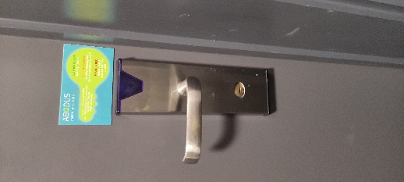 | 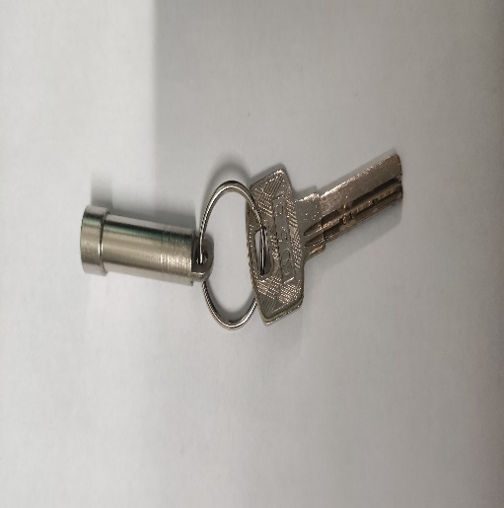 | 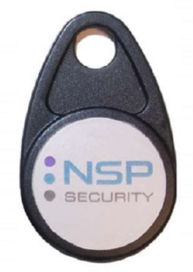

EVACUATION CHAIR
Is located on Fifth Floor

Evacuation Chair | Evacuation Chair
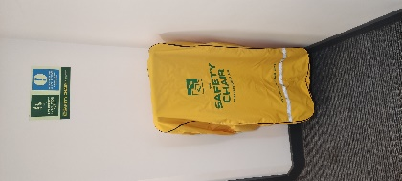 | 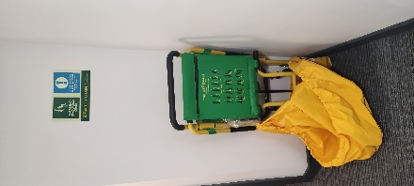

Additional Keys
Additional keys will be found in the Office, in Safe Key Box (clearly labelled).

For Key images, refer to Site Bible > Section 2 > FIRE > Key Images

INDEX OF KEYS
Key | Location | Use
Master Fob (NSP) | Premises Information Box (PIB) | Opens Flats
Master Key | Premises Information Box (PIB); | Opens plant rooms and Cleaner’s Store
NSP Metal Override Key | Key Safe in Office, n. 35 | Opens Flats doors
Fire Panel (FP) | Key Safe in Office, n. 30 | Opens Fire Panel
Premises Information Box (PIB) /Fire Box | Key Safe in Office, n. 30 | Opens Fire Box
Manual Call Point (MCP) Reset Key | Key Safe in Office, n. 30 | Resets MCP in Lobby, Ground Floor (GF)
Lift Keys | Key Safe in Office, n. 14; Lift Room on 5th Floor | to disable the lift/hand to lift contractors
Dry Risers | Key Safe in Office, n. 23 | for fire brigade to access dry risers on each floor
Windows Restrictors | Key Safe in Office, n. 15 | for restrictors in rooms.
Disable Toilet (GF) | Key Safe in Office, n. 31 | Red Key
Any Other Keys | Key Safe in Office | Ask Reception
Master Key | Key Safe in Office, n. 27 | for all store cupboards

PASSWORDS
Item | Username (if applicable) | Password/Code
Wi-Fi | Harbour Court Staff | quohZaejah0e
Site Mobile Phone Passcode | n/a | 019148
Fire alarm (monitoring centre) | Custodian Monitoring Services | 0844 879 1703
Fire Panel (control panel) | In Lobby | Key in Office’s Key Safe
Secure/Premises Information Box (SIB, FIB) | In Lobby | Key in Office’s Key Safe
CCTV | n/a | 634600
Site Landline Voicemail | None | 853265
Second PC (Key fob cutter) |  | HarbourCourt
NSP (Key fob system) Software – SIL02B | hcstaff | HarbourCourt
Gates | Contact Avon Armour Group | 0117 9826288

OTHER BRISTOL SITES
4 Dighton Street, Bristol BS2 8AU |  | King Square Studios
Phone | 01173 329382 | Email | kss@abodusstudents.com
Bell Lane, Bristol BS1 2HF |  | Saint Lawrence House
Phone | 01179 279242 | Email | stlawrencehouse@abodusstudents.com

USEFUL CONTACTS
Regional Operations Manager |  | Adam McDonell
Phone | 07501 547855 | Email | adamcdonell@abodusstudents.com
Director of Operations |  | Katherine Austin
Phone | N/A | Email | katherineaustin@aboduscm.com
Estates Manager |  | Darren Hastings
Phone | 07340 902016 | Email | darrenhastings@aboduscm.com
Director of Asset Management |  | Charles Kerr
Phone | 07990 648047 | Email | charleskerr@aboduscm.com
Sales & Marketing Manager |  | Kate Stephenson
Phone | N/A | Email | katestephenson@aboduscm.com
Security Company Contact |  | Sector Security
Phone | 01772 794729 | Email | Controller@sector-security.net

FLOOR PLANS
The Floor Plans were designed by Andrew Wotton Associates (chartered Architects).
The Architects have made a series of Floor Plans and related information which is stored in paper and digital form. A collection of Floor Plan is enclosed in Section 1 of the Floor Plans, which comprises of all seven Floors, and the Roof.

