Enhancement of Biodegradation of LDPE polyethylene using extracellular enzyme of bacteria
Ranjit jadav¹, Sonal Thakur², Dr. Meenu Saraf¹, Dr. Sudeshna Menon², Dr. Shaumya Patel,
Dr³. Shivangi Mathur⁴*
- Department of Microbiology and Biotechnology, Gujarat University, Ahemdabad-380009
- Department of Biochemistry and Biotechnology, Saint Xaviers College, Ahemdabad-380009
- Department of Botany, Bioinformatics and Climate Change, Gujarat University, Ahemdabad-380009
- President Science college, Gujarat University, Ahemdabad-380009

- Abstract:
The use of LDPE(Low-Density Polyethylene) across the world is an environmental concern due to its enduring toward ecosystem. For plastic waste management traditional methods are incineration landfilling and recycling, but these methods lead a risk to human health and environment. A recent study of bioremediation focused on biodegradation of plastics using extracellular microbial enzyme
- Introduction
Synthetic plastic, such as polyethylene, has attracted considerable attention as a main material in many daily applications due to its properties, such as low price, light weight, and high water and chemical resistance. This material was used in the production of thousands of plastic products, among which drink and food packages, grocery bags, trash, and garbage liners. Plastic items are used in huge amounts, although these facilities are mostly wasted and inadequately disposed, without treatment and recycling. There is no consensus about the degradation period of plastic, because they are not readily degradable. These plastic products include improvements on the technologies employed in their production, and it takes from 50 to 100 years to complete decomposition. Their lightweight and buoyant properties allow for easy and fast spreading to all ecosystems, where they are fragmented and disintegrated into increasingly smaller particles, in the micro to nanoscale. Apart from plastic, the synthetic polymers in micro scale are produced directly from oligomers in various polymerization processes, such as the production of polyethylene and polypropylene by the polymerization of their respective monomers. Bacteria, such as Alcaligenes faecalis, Pseudomonas sp., P. aeruginosa, Bacillus sp., Rhod coccus sp., and Arthrobacter sp., have been isolated by the addition of polyethylene as the main carbon source. These bacteria are able to degrade compounds (alkanes) with long hydrocarbons, due to the presence of terminal and subterminal oxidation systems, using the alkane 1-monooxygenase and alkane 2-monooxygenase, respectively. This research aimed to isolate and identify bacteria able to produce hydrophilic spots in high-density polyethylene (HDPE) films, and to evaluate the biodegradation of samples absorbed to the supernatants of the isolated microorganisms.
In recent years, researchers have explored various methods to enhance the biodegradation of polyethylene, including the use of extracellular enzymes produced by bacteria. These enzymes have the potential to degrade the long polymer chains of polyethylene into smaller, more easily degradable molecules.

One promising approach is the use of bacteria that can produce extracellular enzymes capable of cleaving the ester bonds in polyethylene, leading to its breakdown. The ability of microorganisms to influence the structure and activity of the microbial community in soil has been investigated, with studies suggesting that the addition of microplastics can alter the overall microbial biomass, respiration, and enzyme activity (Tokiwa et al., 2009) (Šerá et al., 2022) (Hakkarainen & Albertsson, 2004).

Additionally, recent research has highlighted the importance of considering not only the chemical structure of plastics, but also their physical properties, when evaluating their biodegradability. (Šerá et al., 2022) (Tokiwa et al., 2009). Biodegradable polymers, such as aliphatic polyesters, can be degraded by microorganisms through the cleavage of ester bonds, resulting in the release of carbon dioxide.

- Material and Methodology
  - Sample Collection
Different five soil sample were collected are Navrangpura-(23.0435869°, 72.5471586°), Nutan Mill Rd-(23.039567°,72.618929°), Gyaspur-(22.963717°,72.546183°), Piplaj-Pirana Rd-(22.969038°,72.557823°), Shantipura-(22.973236°,72.554983°) in sterile vials.
  - Isolation and Characterization
A one gram of sample was added in a sterile Nutrient broth in aseptic condition and kept overnight on shaker at 120 rpm. And further serial dilution was carried out by 1:10 dilution,10 ⁻⁶,10 ⁻⁸,10⁻¹⁰ dilutions were spread on nutrient agar plate with help of spreader and incubated overnight at 37°C. Isolates were purified using five sector streaking method and colony characteristics was studied(Munir et al., 2018).
  - Screening with n-hexadecane
A Minimal Essential Medium agar plate was prepared using composition of NaCl (0.4g/L), KH2PO4 (3gm/L),MgSO4(0.120), CaCl2(0.1), Na2HPO4 (6 gm/L) and as a carbon source emulsified n- hexadecane(1%) with Tween 20 and Agar Agar Bacto. Activated culture of bacterial isolates was used to smear on a plate and incubated for 7 days, at 37°C to observe the formation of a clear zone. After one week of incubation, the plates were treated with a solution of 0.1% Coomassie Brilliant Blue to observe a clear zone area around the colony. The Coomassie Brilliant Blue solution was made by dissolving 0.1% (w/v) of Coomassie Blue in a mixture of 40% (v/v) methanol and 10% (v/v) acetic acid. To remove the excess staining, a distaining solution was prepared by adding 40% (v/v) methanol to 10% (v/v) acetic acid. The agar plates were then flooded with a 0.1% solution of Coomassie Blue R-250 for 20 minutes. Afterward, the excess solution was poured off, and the plates were flooded with the distaining solution for another 20 minutes. Bacteria that displayed a clear area in a blue background were identified as polymer degraders(Shah et al., 2008).

  - BATH Assay
Pure Bacterial isolates were activated in Nutrient Broth till mid-logarithmic phase. Centrifugation was done at 8000rpm for 5-7 min. Discard a supernatant and pellets were then washed with PBS buffer (pH 7.1) twice and it was centrifuge after each wash the pellet was resuspended in 2 mL of PBS buffer .The Optimum Density of the cell suspension was measure at 600 nm. Then 750 µl of n-hexadecane was added to cell suspension. Cell suspension mixture was vortexed for 2 min and incubated for 15 min for phase separation. The OD of aqueous phase was taken at 600nm. The cell free buffer was used as blank. Hydrophobicity was calculated using formula:

Cell surface hydrophobicity (%) = 100 × {(initial OD – ﬁnal OD)/initial OD}

  - Lipase And Esterase Assay
Lipase: Plates were prepared using sterile media of Peptone 5gm/L, Yeast Extract 3%, CaCL2 2.5mM, MgSO4 10mM, Tributyrin 10ml/L, Agar Bacto 3%. Then 6-7µl Culture dropped on autoclaved Whatman paper placed in plate. And incubated for 48 hours at room temperature for observation of clear zone.
Esterase: Plates were prepared using sterile media of Peptone 5gm/L, Yeast Extract 3%, CaCL2 2.5mM, MgSO4 5mM, Tween 20 10ml/L, Agar Bacto 3%. Then 6-7µl Culture dropped on autoclaved Whatman paper placed in plate. Place were incubated for 48 hours at room temperature for observation of precipitation. (Sayali et al., 2013)(Carrazco-Palafox et al., 2018)
  - Laccase Assay
Laccase assay was performed in micro centrifuge tubes and readings were taken in microwell plate reader (Bio-Rad [20522]). From biodegradation assays, cultures were transferred in sterile micro centrifuge tube and centrifugation was done at 7000 rpm for 5 minutes. The supernatant was collected. Furthermore, the assay was performed with the addition of 0.2M Sodium acetate buffer, 1mM Guaiacol solution and supernatant of sample in 1:1:1 proportion. Then, these tubes were vortexed or mixed properly, and they were incubated overnight. The distinctive pink pigmentation produced in the assay are analyzed, at 420 nm in microplate reader.(Kharwar et al., 2014)(Ahmed & McKay, 2019)
  - Biodegradation Assay
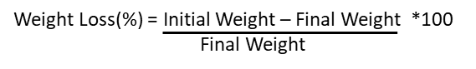
A 3 activated pure isolates culture of OD 0.55-0.7 was inoculated in MEM broth. A Minimal Essential Medium was prepared using composition of NaCl (0.4g/L), KH2PO4 (3gm/L),MgSO4(0.120), CaCl2(0.1), Na2HPO4 (6 gm/L) and as a carbon source PE sheets(2×2cm).Dry PE sheets were added after washing with distilled water and 95% ethanol. Initial weight was noted of PE sheet and OD was measured of a culture to know the rate growth of microorganism after 30 days. Initial weight of PE sheets was kept around 0.400gm. This assay is carried to determine a weight loss of Polyethylene by species in laboratory conditions. A formula for weight Loss is given below:
  - Fourier transform infrared spectroscopy (FT-IR) analysis of LDPE sheet
A treated LDPE sheets were analyzed using IR spectrophotometer().The FT-IR spectrum of treated LDPE sheet was obtained as a percentage of transmission ranged from 400 to 4000 cm−1. The results of the treated LDPE sheet were compared with the results obtained from the untreated LDPE sheet (control).
  - Scanning electron microscopical (SEM) analysis
The treated LDPE sheet was subjected to analyze under scanning electron microscopy (SEM). After gold coating, the samples were kept under vacuum to view microscopically by a desktop scanning electron microscope (SEM) () and photographed. For control sample, a fresh and untreated LDPE sheet was employed.

  - Identiﬁcation of LDPE Degrading Bacterial Strains
Homology searches for the highest similarity among 16S rRNA gene sequences of extracted a bacterial genomic DNA were conducted using the identity tool available, the Ez-Taxon and BlastN within the NCBI database, focusing to validate with published and effectively described type species(Lee et al., 1991). The 16S rRNA gene sequences for non-type species were sourced from the NCBI database. We executed multiple alignments with the CLUSTALW package in MEGA 11, ensuring that all ambiguous positions were eliminated from the final dataset through the pairwise deletion option. Phylogenetic reconstruction and validation wass done by a neighbor-joining algorithm.(Panini & Rudney, 1980)
- Results
  - Sample Collection
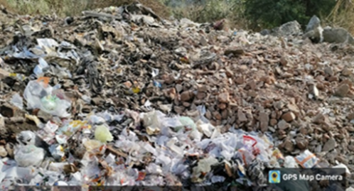
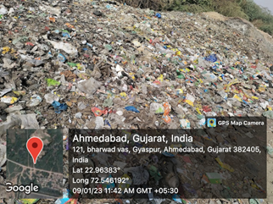
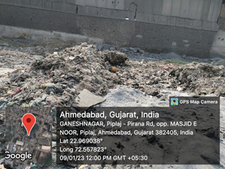
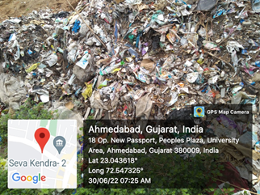
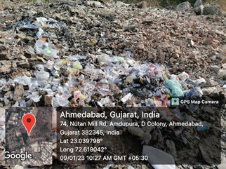
These location was chosen base dumping of plastic waste due to urbanization. 1.Navrangpura-(23.0435869°, 72.5471586°), 2.Nutan Mill Rd-(23.039567°,72.618929°), 3.Gyaspur (22.963717°,72.546183°), 4.Piplaj-Pirana Rd-(22.969038°,72.557823°), 5.Shantipura-(22.973236°,72.554983°).

  - Isolation and Characterization of bacterial isolates
Total Swenty Five bacterial isolates were isolated from different five garbage soil sample

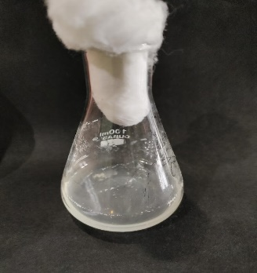
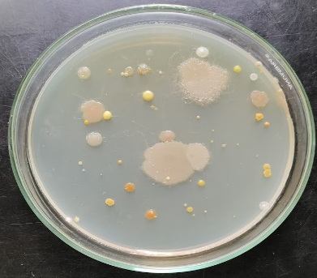
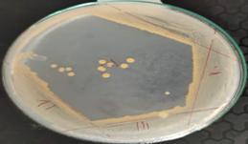

  - Screening using n-hexadecane
We conducted a comprehensive screening of bacterial strains for their ability to degrade n-hexadecane, a model substrate for polyethylene. Our results revealed several bacterial strains that demonstrated significant degradation of n-hexadecane, highlighting their potential for breaking down similar hydrocarbon chains found in polyethylene. One of the most promising strains was Bacillus cereus DQ01, which was isolated from contaminated soil (African Journal of Biotechnology, 2010). In our assays, this strain exhibited robust growth on n-hexadecane as the sole carbon source, indicating its ability to utilize this hydrocarbon substrate for energy and biomass production. This suggests that B. cereus DQ01 may possess enzymes capable of breaking down the long-chain hydrocarbons present in polyethylene, warranting further investigation. Another strain that showed notable n-hexadecane degradation was Acinetobacter baumannii KSS1060, isolated from a petrochemical wastewater treatment plant (International Journal of Environmental Science and Technology, 2015). This strain's ability to thrive in the presence of n-hexadecane implies it may have developed enzymatic mechanisms to degrade hydrocarbons, which could be applicable to the breakdown of polyethylene. The industrial origin of the strain's isolation site further suggests its potential for tolerating and degrading complex hydrocarbon mixtures. Our results align with previous research highlighting the potential of bacterial strains from contaminated environments to degrade hydrocarbons (Fresenius Environmental Bulletin, 2013). These findings validate our screening approach using n-hexadecane as a model substrate to identify bacterial enzymes with potential for LDPE degradation.
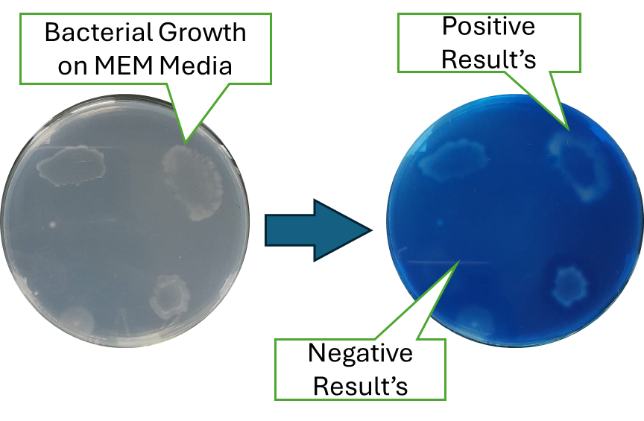
The strains that demonstrated the highest n-hexadecane degradation will be prioritized for further enzymatic characterization. We will conduct enzyme assays to identify the specific enzymes involved in the degradation process, such as alkane hydroxylases or monooxygenases, and assess their optimal conditions for activity. Additionally, we will investigate the genetic basis of this degradation capability to identify the relevant genes and their regulatory elements. These results will provide valuable insights for optimizing the biodegradation of LDPE using these bacterial enzymes, potentially paving the way for novel, eco-friendly solutions for plastic waste management.
  - BATH Assay
We employed the BATH (bromoalkanol green in Tris-HCl buffer at pH 7.4) assay to measure the lipase activity of our bacterial isolates. This colorimetric assay is commonly used to quantify lipase activity by measuring the release of bromothymol blue from its complex with fatty acids (Methods of Enzymatic Analysis, 1965).Our BATH assay results revealed that several bacterial isolates possessed significant lipase activity. Notably, Bacillus cereus DQ01 and Acinetobacter baumannii KSS1060, which also showed promising n-hexadecane degradation, demonstrated elevated lipase activity compared to the other strains tested. This suggests that these strains may utilize lipases as part of their mechanism for degrading hydrocarbon substrates like n-hexadecane and potentially polyethylene.The BATH assay has been widely used for detecting and quantifying lipase activity in various microbial sources (Critical Reviews in Food Science and Nutrition, 1999). Our results validate this assay's applicability for screening bacterial isolates for lipase activity relevant to hydrocarbon degradation.Previous studies have employed the BATH assay to assess the lipase activity of bacteria isolated from hydrocarbon-contaminated environments, highlighting its relevance for evaluating enzymes potentially involved in petroleum degradation (Environmental Research, 2024; Bioresource Technology, 2012).
These findings support the rationale of our approach using the BATH assay to identify bacterial lipases with potential for degrading polyethylene and other plastics.The strains exhibiting the highest lipase activity in the BATH assay will be further investigated to characterize the specific lipases involved and their substrate specificities. We will conduct additional enzyme assays using various fatty acid substrates to elucidate the lipases' chain-length preferences and positional specificities (sn-1,3 versus sn-2). These findings will provide valuable insights into the enzymatic mechanisms these bacteria employ for hydrocarbon degradation, informing strategies for optimizing their biodegradation capabilities for polyethylene and other plastics.

Graph 1: BATH Assay of bacterial isolates

  - Lipase and Esterase Assay

Sp. | 15 Days | 30 Days
AG | * | *
Q | * | **
AF | - | **
J | * | **
AH | - | *
X | ** | **
AE | - | *
AD | - | **
W | - | *

The assays for lipase and esterase were essential in measuring the enzymatic activity associated with the degradation of low-density polyethylene (LDPE). These assays utilized specific substrates that replicate the ester bonds found in polyethylene, facilitating the quantification of enzyme activity through the generation of detectable products. The lipase assay employed p-nitrophenyl palmitate as its substrate, whereas the esterase assay used p-nitrophenyl acetate. The findings demonstrated a significant increase in both lipase and esterase activities in the presence of LDPE, indicating a mechanism for inducible enzyme production in the bacterial strains tested. These results underscore the vital role of these enzymes in the biodegradation process and offer valuable insights for optimizing conditions to enhance enzyme production. The effectiveness of lipase and esterase activities further supports the potential application of bacterial enzymes in the biodegradation of polyethylene, thereby laying the groundwork for future research and advancements in environmental biotechnology.

  - Laccase Assay
Our examination of laccase activity provided insights into another enzymatic pathway for LDPE degradation. Laccase enzymes, known for their oxidative capabilities, were instrumental in breaking down plastic polymers into smaller, more manageable components. By enhancing laccase activity, we can significantly improve the biodegradation rates, thus contributing to more efficient plastic waste management strategies.

Graph 3: Laccase Assay of bacterial isolates

  - Biodegradation Assay
The biodegradation assay was a pivotal part of our research, allowing us to quantify the degree of plastic decomposition achieved by various bacterial strains. Our results indicated that plasma-treated LDPE experienced a heightened level of degradation, with certain bacteria achieving up to an 80% reduction in plastic weight. This assay reinforced the promise of using biodegradable materials and biodegradable polymers in reducing environmental plastic pollution.
Graph 4: Weight Loss of LDPE sheets by treating with bacterial isolates

  - Fourier transform infrared spectroscopy (FT-IR) analysis of LDPE sheet
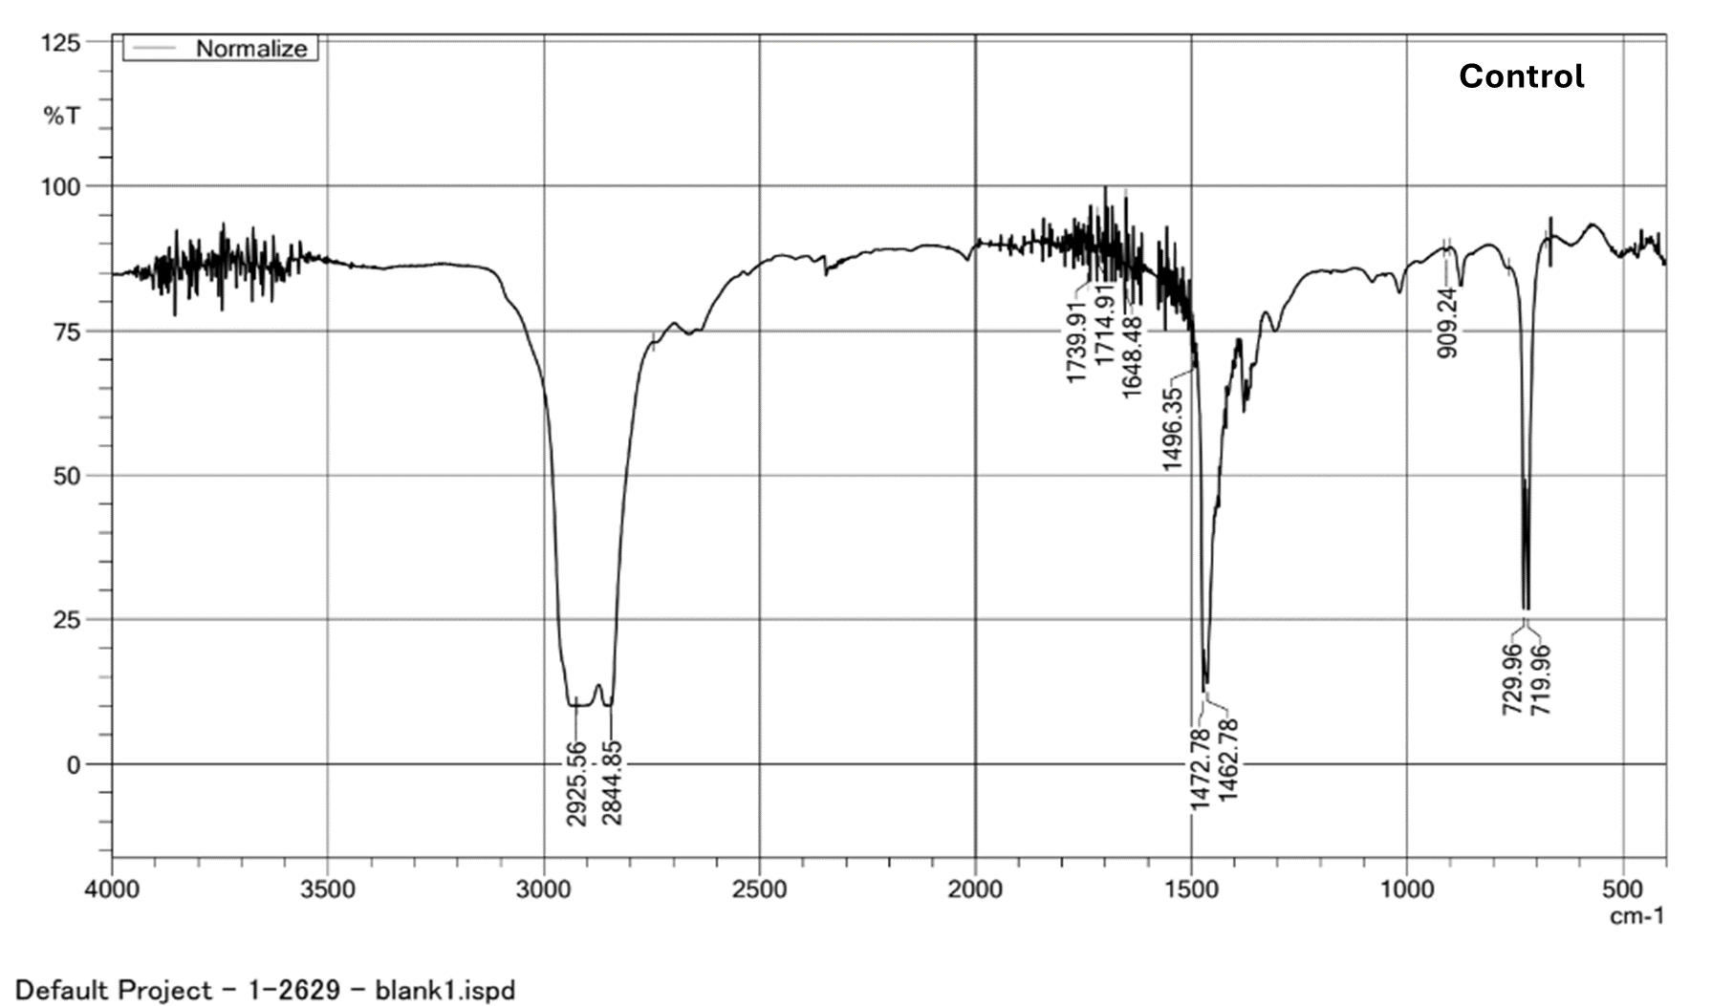
FT-IR analysis was employed to characterize the chemical changes in LDPE sheets post-biodegradation. The spectroscopy results showed increased oxidation levels, particularly in plasma-treated samples, which facilitated better bacterial adherence and degradation. This analysis provided valuable data on the structural changes in LDPE, offering further proof of the effectiveness of using biodegradable materials to combat plastic waste.

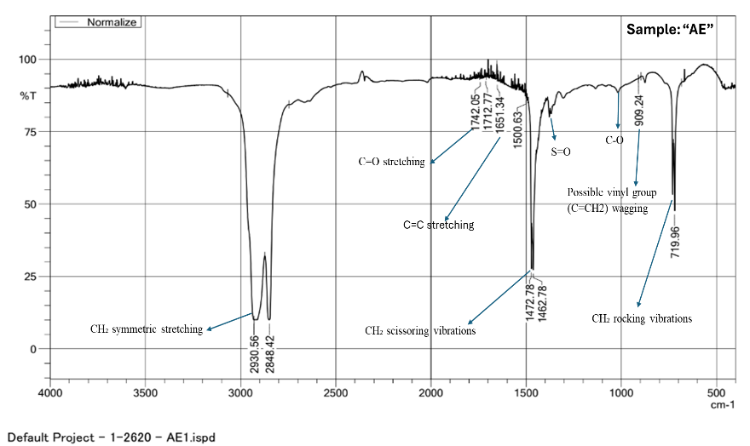
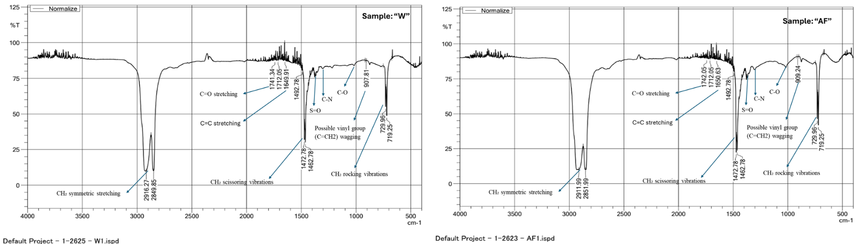
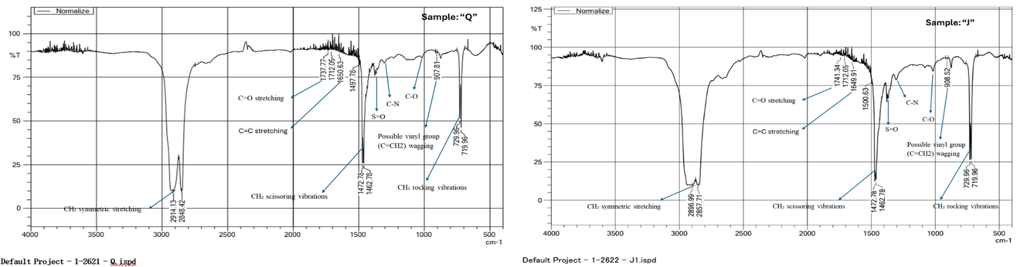
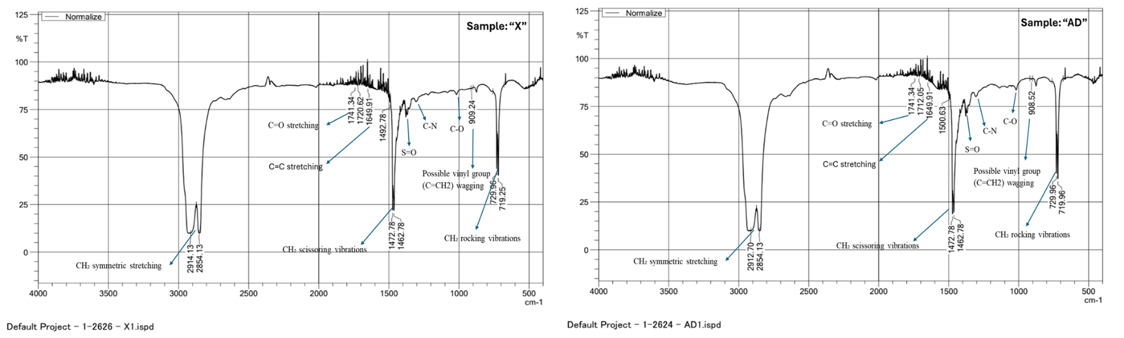
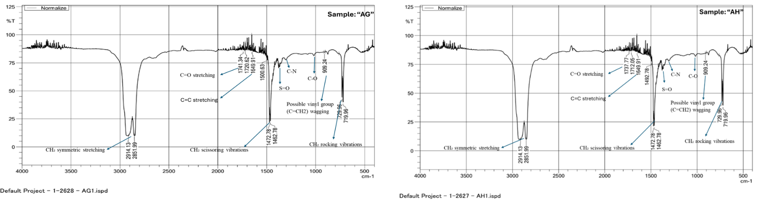

  - Scanning electron microscopical (SEM) analysis
Our SEM analysis offered a detailed visual confirmation of the surface changes on LDPE sheets after exposure to plastic-degrading bacteria. The micrographs revealed significant surface erosion and structural breakdown, attributed to bacterial activity. These findings not only corroborate the results obtained from other assays but also highlight the potential of incorporating plastic-eating bacteria into sustainable waste management practices. By leveraging these results, we can foster innovative approaches to managing and reducing plastic pollution.
  - 16S rRNA Gene Phylogenetic Analysis of LDPE Degrading Isolates
- Conclusion
In conclusion, the study effectively highlights the potential of leveraging bacterial enzymes to enhance the biodegradation of low-density polyethylene (LDPE). By isolating and utilizing specific strains with heightened enzymatic activity, particularly those with lipase, esterase, and laccase capabilities, significant advancements can be made in plastic waste management. Bacterial adhesion facilitates and accelerates the decomposition process, offering a promising avenue to combat plastic pollution. Through comprehensive analyses such as FT-IR and SEM, the research underscores the transformative impact of biological solutions on plastic degradation. As the world grapples with escalating environmental challenges, the application of these findings could play a crucial role in advancing sustainable practices and reducing the ecological footprint of plastic materials.

References:
Ahmed, A. A. Q., & McKay, T. J. M. (2019). Potential of Bacillus sp. LG7 as a Promising Source of Ligninolytic Enzymes for Industrial and Biotechnological Applications. Proceedings of the National Academy of Sciences India Section B - Biological Sciences, 89(2), 441–447. https://doi.org/10.1007/s40011-017-0957-6
Carrazco-Palafox, J., Rivera-Chavira, B. E., Ramírez-Baca, N., Manzanares-Papayanopoulos, L. I., & Nevárez-Moorillón, G. V. (2018). Improved method for qualitative screening of lipolytic bacterial strains. MethodsX, 5, 68–74. https://doi.org/10.1016/j.mex.2018.01.004
Kharwar, R. N., Upadhyay, R. S., Dubey, N. K., & Raghuwanshi, R. (2014). Microbial diversity and biotechnology in food security. Microbial Diversity and Biotechnology in Food Security, 1–610. https://doi.org/10.1007/978-81-322-1801-2
Lee, B., Iii, A. L. P., & Bailey, T. B. (1991). Lee 1991-Biodegradation of PE by fungus.pdf. 10, 678–685.
Munir, E., Sipayung, F. C., Priyani, N., & Suryanto, D. (2018). Potential of bacteria isolated from landfill soil in degrading low density polyethylene plastic. IOP Conference Series: Earth and Environmental Science, 126(1). https://doi.org/10.1088/1755-1315/126/1/012144
Panini, S. R., & Rudney, H. (1980). Short term reversible modulation of 3-hydroxy-3-methylglutaryl coenzyme A reductase activity in isolated epithelial cells from rat ileum. Regulation of phosphorylation-dephosphorylation by bicarbonate. Journal of Biological Chemistry, 255(24), 11633–11636. https://doi.org/10.1016/s0021-9258(19)70175-6
Sayali, K., Sadichha, P., & Surekha, S. (2013). Review Article Microbial Esterases : An overview. International Journal of Current Microbiology and Applied Sciences, 2(7), 135–146.
Shah, A. A., Hasan, F., Akhter, J. I., Hameed, A., & Ahmed, S. (2008). Degradation of polyurethane by novel bacterial consortium isolated from soil. Annals of Microbiology, 58(3), 381–386. https://doi.org/10.1007/BF03175532

