IMPACT OF VERNACULAR RESIDENTIAL COURTYARD CHARACTERISTICS ON POSITIVE EMOTIONS OF OCCUPANTS: A COMPARATIVE CORRELATIONAL STUDY ACROSS DIFFERENTIAL CULTURAL SETTINGS IN TAMILNADU
Komagal Anupama K, Post-Doctoral Research Scholar,
Lincoln University College, Malaysia
Introduction
This research seeks to explore the nuanced impact of vernacular residential courtyard characteristics on the emotional well-being of occupants within the diverse cultural landscapes of Tamilnadu, India. Rooted in traditional architectural principles, courtyards have been a fundamental element of vernacular design, serving as spaces that facilitate social interaction, promote a connection to nature, and foster a strong sense of identity and community. The primary hypothesis of this study posits that specific architectural features of courtyards—such as their proportion, scale, color, and texture (PSCT)—contribute significantly to the positive emotional well-being of occupants.
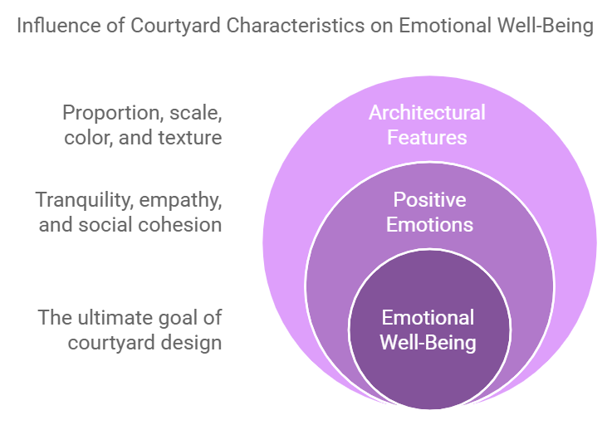

These features are studied to determine its potential to evoke various positive emotions, including a sense of tranquillity, empathy, social cohesion, and an overall feeling of well-being, which are crucial for fostering healthy living environments.
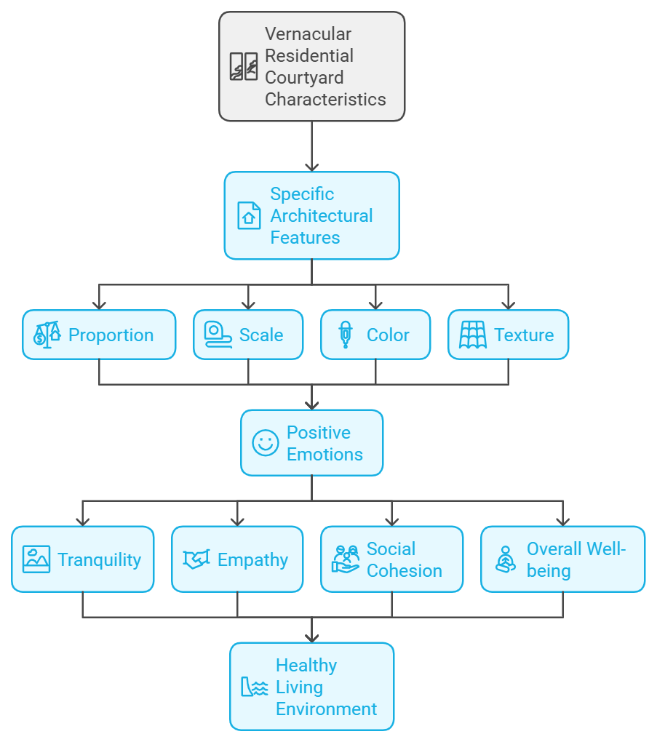

Background of Study

The architectural design of residential spaces has profound implications for the psychological and emotional well-being of its inhabitants. Vernacular architecture, a form of architecture that has evolved organically over generations in response to the local climate, culture, and available materials, is deeply embedded in the socio-cultural fabric of regions around the world. In the context of Tamilnadu, India, traditional residential courtyards are a prominent feature that embodies these vernacular principles. Courtyards in these homes are not just structural elements but spaces that enable social interaction, promote environmental harmony, and offer psychological comfort.

The incorporation of courtyard spaces in vernacular architecture stems from ancient practices that focused on creating a harmonious relationship between humans and their environment. Such spaces allow for natural light, ventilation, and thermal comfort, contributing to a sense of serenity. These courtyards have also served as venues for family gatherings, rituals, and communal bonding, fostering social cohesion and cultural continuity. Despite the documented benefits of these spaces, the impact of specific courtyard characteristics on the emotional well-being of occupants has not been extensively analyzed. This study aims to bridge this research gap by focusing on the positive emotions elicited by architectural features of residential courtyards across differential cultural settings in Tamilnadu.
The theoretical framework guiding this study is Kurt Lewin’s Field Theory, which underscores the importance of environmental contexts in shaping human behaviors and emotional states. By understanding how courtyard influences psychological well-being, this research aims to fill a critical gap in contemporary house study.
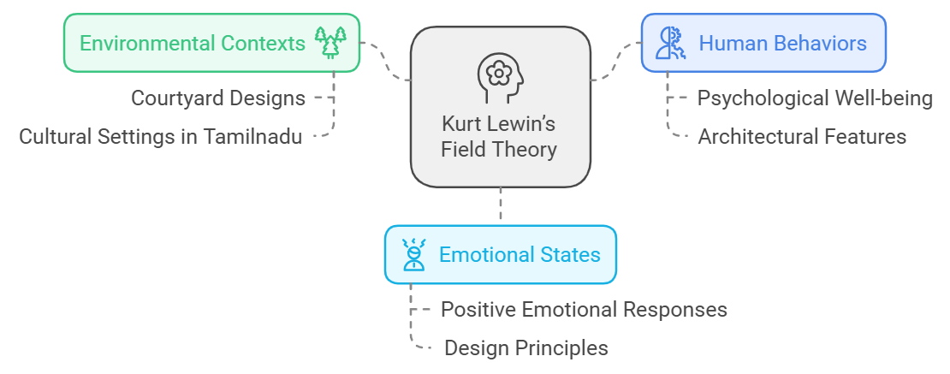

Research Problem

In the face of rapid urbanization and the adoption of modern architectural designs, the integration of nature and communal spaces into residential environments is diminishing. High-density housing models often prioritize economic efficiency and space utilization over emotional and psychological well-being. The absence of emotionally supportive design elements has led to increased stress, reduced social interactions, and a general feeling of disconnection from nature.
Moreover, while studies on the psychological impact of residential architecture have grown, there remains a significant gap in understanding how traditional architectural elements, such as courtyards, influence the emotional states of residents. Existing research has not comprehensively examined the cross-cultural variations in these effects within regions like Tamilnadu, where cultural and social practices vary widely. This research addresses these problems by examining how architectural features of courtyards impact positive emotions and how these insights can inform contemporary residential designs to foster well-being.

Research Question
How do the architectural features of vernacular residential courtyards—specifically proportion, scale, color, and texture—affect the positive emotions and psychological well-being of occupants across diverse cultural settings in Tamilnadu?

Research Gap
While previous studies have explored the psychological impacts of residential architecture and the cultural significance of courtyards in vernacular design, there is a lack of comprehensive, empirical research specifically addressing how individual architectural features of residential courtyards influence emotional well-being. Additionally, the cross-cultural variations in these effects within Tamilnadu, a region with diverse cultural practices, remain under examined. This study aims to bridge this gap by analysing the psychodynamic effects of courtyards across different cultural settings and codifying specific design principles for promoting emotional well-being in contemporary architecture.
Objectives
- Differential-Cultural Analysis: To conduct a comprehensive comparative analysis of the psychodynamic effects of courtyards across different cultural settings within Tamilnadu. This objective aims to uncover how various cultural components, perceptions and traditions interact with the built environment to influence emotional well-being.
- Design Principles Identification: To identify and codify specific architectural features of courtyards that consistently evoke positive emotional responses among occupants. Understanding these elements will provide a design blueprint for architects aiming to incorporate emotional well-being into their projects.
- Conceptual Framework Development: To develop a robust design framework that integrates traditional courtyard principles into different context. This framework will serve as a guide for creating emotionally supportive living environments that align with modern needs.
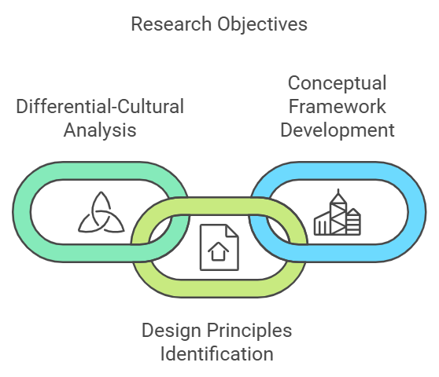
Hypothesis
H1: The architectural features of vernacular residential courtyards in Tamilnadu—specifically proportion, scale, color, and texture (PSCT)—positively correlate with the emotional well-being of occupants.
H2: Courtyards designed with optimal PSCT characteristics evoke significantly higher levels of positive emotions, such as tranquility, empathy, and social cohesion, compared to courtyards that lack these features.

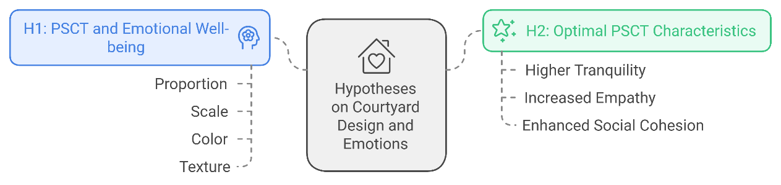
Significance of the Study
This study holds both academic and practical significance. Academically, it contributes to the fields of architecture, environmental psychology, and cultural studies by offering empirical evidence on how traditional architectural elements affect emotional well-being. It enriches the discourse on vernacular architecture by emphasizing its psychological benefits, advocating for the preservation and adaptation of culturally rooted design principles.
Practically, the research aims to guide architects and urban planners in designing spaces that prioritize the emotional and psychological health of residents. By offering a blueprint for incorporating courtyard elements into modern housing designs, the study can influence the creation of built environments that promote social interaction, reduce stress, and foster a sense of belonging. Additionally, this research addresses contemporary mental health challenges by demonstrating how architectural design can enhance the quality of life.
Scope of the Research
The research focuses on traditional residential courtyards in Tamilnadu, encompassing various cultural and social settings to ensure a comprehensive understanding of the architectural and emotional dynamics. The study examines architectural features such as proportion, scale, color, and texture, and their impact on occupants' emotional well-being. Data will be collected from regions within Tamilnadu known for their diverse cultural heritage, capturing variations in courtyard design and usage. The research adopts a mixed-methods approach, combining qualitative insights from interviews and focus groups with quantitative data from psychometric assessments, ensuring a holistic analysis of the research problem.

Methodology
The study employs a mixed-methods approach, combining both qualitative and quantitative research methodologies. This comprehensive approach ensures that the findings are both statistically significant and rich in cultural and social insights.
- Literature Review: A detailed literature review will establish the theoretical foundation, drawing from existing studies on vernacular architecture, environmental psychology, and the psychodynamic affects of vernacular residential settings. This review will help in identifying gaps and setting the research parameters.

- Field Studies: Extensive fieldwork will be conducted in culturally diverse regions of Tamilnadu known for their distinct variations in courtyard architecture. Data collection methods will include structured surveys, in-depth interviews, and psychometric assessments. Occupants from a variety of social and cultural backgrounds will be invited to participate, ensuring a comprehensive and representative sample.
- Data Collection Techniques: Emotional responses to courtyard features will be measured using psychometric tools such as Likert scales and Henry Garrett’s ranking method. Interviews will provide qualitative depth, allowing participants to express their subjective experiences and emotional connections to their living environments. The study will also include photographic documentation of courtyards to capture architectural details.
- Statistical Analysis: Data will be analyzed using statistical techniques such as ANOVA (Analysis of Variance) to compare emotional well-being across different groups and Pearson's correlation coefficient to identify significant relationships between courtyard features and emotional states. The study will also employ regression analysis to predict emotional outcomes based on specific architectural elements.
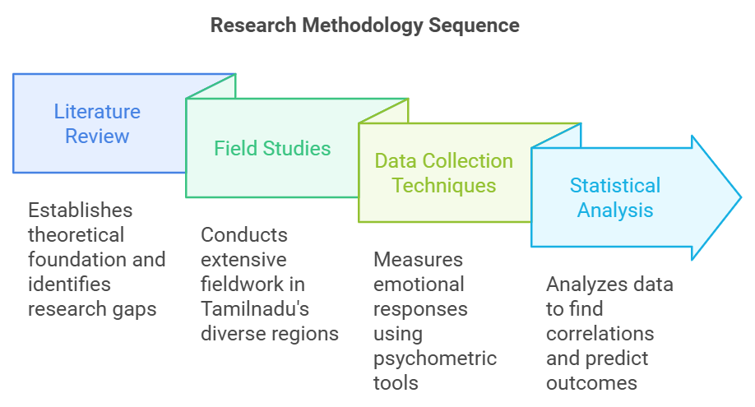

Data Sources and Emotional Survey Methodology
The data will be collected through multiple avenues to ensure a holistic understanding of the affect of courtyard physical setting. Photographs and sketches will be used to document the design elements of courtyards. These visual materials will be sourced directly from field observations and, with consent, from occupant-provided images. Emotional surveys will be designed to capture the subjective experiences of occupants, measuring their feelings of relaxation, happiness, and social connectedness. The surveys will include both quantitative and open-ended questions, allowing for a detailed understanding of how occupants emotionally engage with their living spaces.
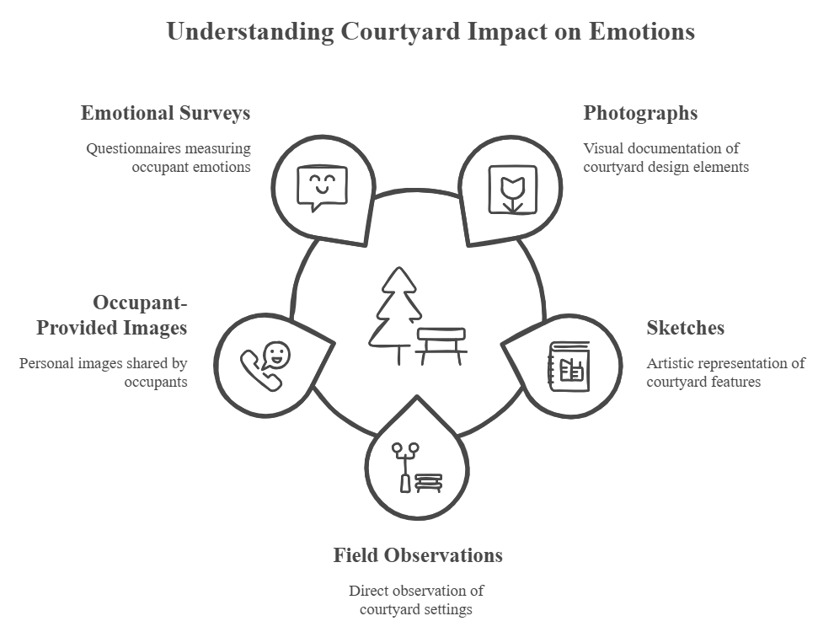
To further strengthen the validity of the research, the emotional survey will be based on well-established psychometric instruments, ensuring that the data collected is reliable and consistent. Additionally, focus group discussions will be organized to gain deeper insights into how cultural and social factors influence occupant’s emotional experiences within courtyard settings.
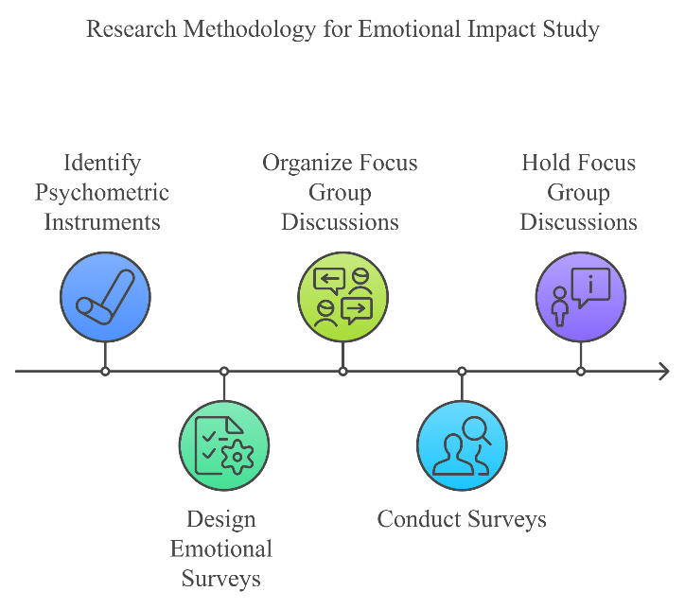

Comparative Analysis
A critical component of the research design is the inclusion of a different occupational group. This group will consist of occupants living in different occupational house settings and by comparing the emotional well-being of occupants, the study will provide empirical evidence of the psychological benefits associated with traditional courtyard architecture. This comparative analysis will highlight the unique emotional advantages offered by courtyard designs and offer insights into how these principles can be adapted for contemporary use.
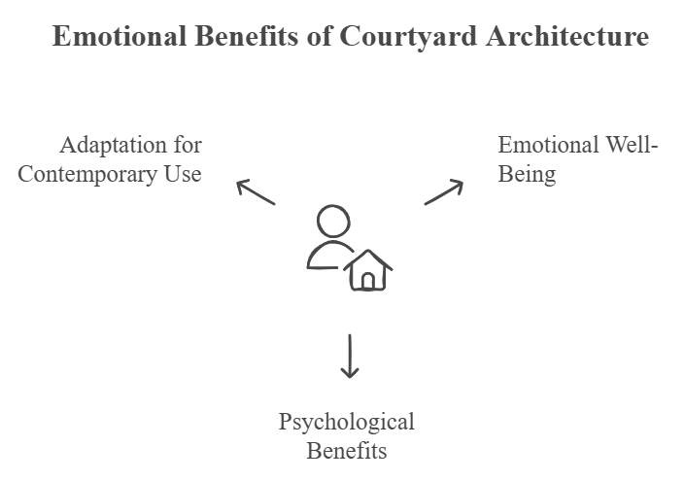

Anticipated Outcomes and Implications
The study is expected to yield significant findings that will have multiple implications for both design and mental health. First, it will provide empirical evidence supporting vernacular architectural principles which can promote emotional well-being. Second, it will contribute to the discourse on vernacular architecture by demonstrating the value of preserving cultural components through design.
The research is particularly relevant in addressing the growing concerns about mental well-being of the people who live in high-density environments with limited access to natural and communal spaces. By showcasing the psychological benefits of traditional courtyard designs, attempts to revolutionize residential architecture, promoting designs that are both culturally sensitive and emotionally uplifting.
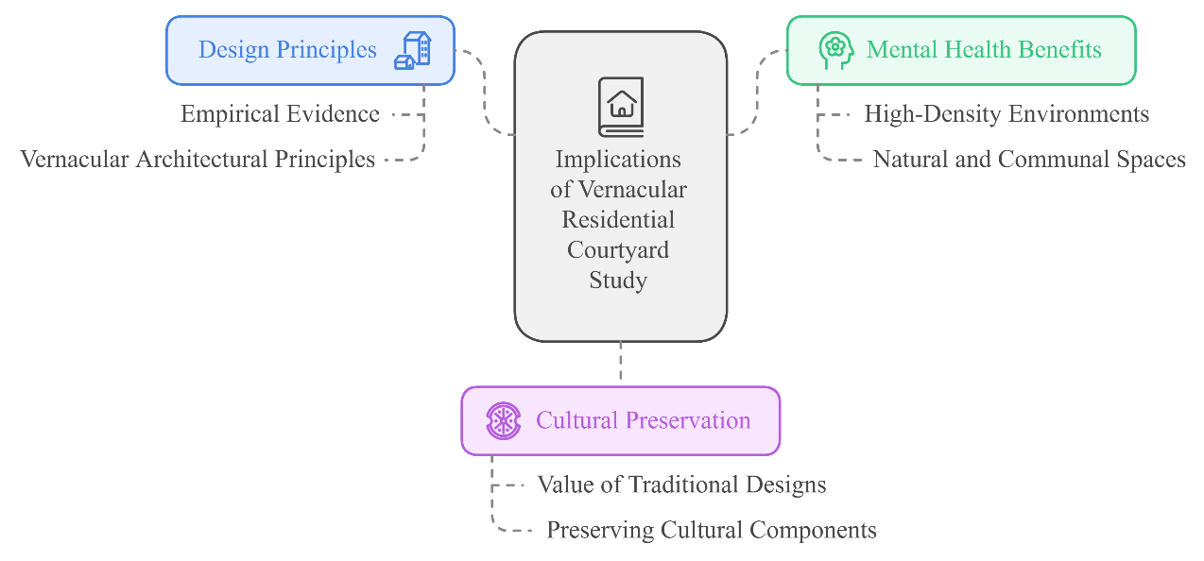
Limitations of the Study
Several limitations may affect the study. First, the research is geographically confined to Tamilnadu, which may limit the generalizability of findings to other cultural settings or architectural styles. Second, emotional responses are inherently subjective, and while psychometric tools can provide measurable data, they may not capture the full depth of individuals' experiences. Third, the reliance on self-reported data may introduce biases, such as social desirability bias, where participants may respond in a way they believe is expected or socially acceptable. Lastly, the study's findings are dependent on the accuracy and richness of the data collected, which may be influenced by the availability and willingness of participants from diverse backgrounds.

Dissemination and Future Research
The findings will be disseminated through academic journals, international conferences, and architectural forums. A design framework will be developed by emphasizing the practical application of courtyard principles in contemporary architecture. Future research could extend this study to other regions or explore the affect of courtyard physical setting in different cultural contexts, further broadening the scope of this work.

Conclusion
This research holds the potential to transform our understanding of residential architecture by demonstrating how courtyard physical setting can be leveraged to enhance emotional well-being. By bridging the gap between the features of built environment and its impact on the well-being of the occupants. Through a comprehensive analysis of courtyard characteristics and their emotional impact, this research will contribute to a more human-centered approach to architectural design and to achieve desirable mental well-being.


