For decades, cancer biology research has focused on the role of protein-coding genes. It was only recently that an entire class of molecules known as non-coding RNA (ncRNA) was discovered. Six decades ago, Francis Crick’s ‘central dogma’ (Crick, 1970) affirmed that genetic information travels from DNA through RNA toward protein synthesis. Human genome sequencing revealed that only about 2% of our genes code for proteins, leading many scientists to speculate that the remaining 98% were simply non-functional and were considered "junk." (Slack & Chinnaiyan, 2019).

Non-coding RNA discovery

The discovery of the first small RNAs was by Victor Ambros in Caenorhabditis elegans, which are single-stranded, 18-25 nucleotides long, RNA molecules (Lee et al., 1993). However, (Reinhart et al., 2000) demonstrated the importance of the regulatory non-coding RNA after the rediscovery.
Lineage defective 4 (lin-4), the novel miRNA to be discovered, negatively regulates the level of LIN-14 protein translation, therefore, creating a temporal decrease in LIN-14 protein in Caenorhabditis elegan (Lee et al., 1993). Lin-4 functions by binding to LIN -14 mRNA complementary sequence in the 3' untranslated region (3'UTR), which alter the normal translation without affecting its stability (Olsen & Ambros, 1999).

Sequencing technologies advances have resulted in the discovery of a variety of non-coding RNA (ncRNA) molecules, some of which is highly conserved, such as microRNAs (miRNAs), and others lack conservation, such as long ncRNAs (lncRNAs) (Anastasiadou et al., 2018).

Long non-coding RNA

Long non-coding RNAs (lncRNAs) are RNA molecules with a transcript length of 200 nucleotides or longer. Although lncRNAs have no protein coding potential due to the lack of an open reading frame (ORF), their role in gene expression regulation and cell differentiation (Soudyab et al., 2016) at the transcriptional and /or post transcriptional levels is distinctive (Zuo et al., 2017). Dysregulation and unique expression of lncRNAs are widely seen in differentiated tissues and wide spectrum of diseases (Xing et al., 2021).

Long non-coding RNA discovery

In 1984, (Pachnis et al., 1984) were cloning and studying genes with tissue-specific and temporal patterns of expression utilising differential hybridization screens of cDNA libraries. Initially, studies were focused on genes that produce known proteins; later, a posteriori method was applied disregarding RNA's coding potential, led to the discovery of the first non-coding gene, H19, in spite of the fact that it was initially classified as an mRNA.

H19, The Very First Eukaryote lncRNA Gene, despite the presence of small open reading frames, H19 was notable for its lack of translation. H19 has shown remarkable sequence conservation in mammals and its expression in transgenic mice demonstrated to be lethal in prenatal stages. Suggesting its high importance in embryonic development and not necessarily in encoding proteins (Brannan et al., 1990).
The mystery revolving around the function of lncRNA was practically cleared in early 1990s by (Marahrens et al., 1998), studying the functional characterization of another lncRNA X-inactive-specific transcript (Xist), showing that not only does it play a function in chromatin remodelling, but it also contains an element essential for X chromosome selection.
H19 and Xist's pioneering studies revolutionised our understanding of non-protein coding gene functions and the biological significance of lncRNAs in general. They also stimulated the discovery and identification of other non-coding transcripts (Jarroux et al., 2017).

As of January 2016, 294 lncRNAs have been identified and annotated in LncRNAdb, 184 of them are identified in humans (Haldar et al., 2017). By 2020, 30000-60000 human lncRNAs transcripts have been reported in lncRNA annotations (Ruan et al., 2020).
https://www.gencodegenes.org/
As of March 2020, the human GENCODE (Release 33) database had 18 lncRNA genes and 53,009 lncRNA transcripts.????????????? How to search for the latest numbers by 2022????

According to nature publication 30000-60000 human lncRNAs have been reported in recent lncRNA annotations ( this number is confirmed by another nature publication in 2022but according to lncRNAWIKI 2056 human lncRNA annotated only?????????????

LncRNA structure

Most annotated lncRNAs are RNA polymerase II (Pol II) transcribed; hence, they are similar in structure to mRNA and may have cap structures and poly A tails but contains fewer exons and are shorter in length compares to mRNAs. Moreover, due to lncRNA’s lengths are more than 200 nucleotides, allowing them to fold into three-dimensional structures (Delpu et al., 2016).

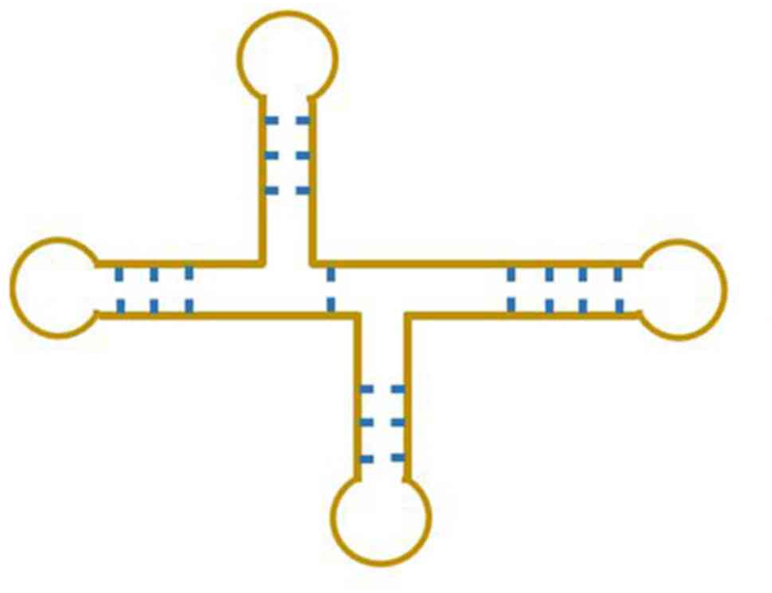
Figure () lncRNA structure (Jiang et al., 2021).

LncRNA function

According to the current understanding of lncRNA identification and function, these transcripts are classified as:
- Epigenetic regulation: through mediating chromatin modifications and DNA methylation.
- Transcriptional and post-Transcriptional modification: proteins (primarily transcription factor) and DNA interactions involved in transcriptional level regulation, and in mRNA processing at the post-transcriptional level.
- Direct interactions with proteins: to regulate protein translation and post-translation modification.
- LncRNAs Act as miRNA Sponges: sequestering miRNAs and so inhibit the miRNA mediated gene repression (Zhang et al., 2019).

LncRNA and diseases:
LncRNAs play a role in a wide range of cellular mechanisms, from gene expression to protein translation and stability. Recent research suggests that lncRNAs play important roles in cellular differentiation, organogenesis, and tissue homeostasis. Furthermore, lncRNAs play a role in pathological conditions such as cancer and cardiovascular disease, providing novel biomarkers and therapeutic targets (Schmitz et al., 2016).

- LncRNA and cardiovascular diseases:

LncRNAs have been linked to cardiovascular diseases (CVD) and have been studied in both patient data and mouse models. Several genomic regions associated with myocardial infarction, such as MIAT and ANRIL, were found to encode lncRNAs (Schmitz et al., 2016).

The lncRNA MIAT (myocardial infarction-associated transcript) has been identified as a risk allele for myocardial infarction, nevertheless, the precise function of MIAT in heart tissue remains unknown. There is evidence, however, that MIAT acts as a molecular sponge for miR-150. (Lucas et al., 2018).

In cardiac hypertrophy, the lncRNA CHRF (cardiac hypertrophy-related factor) functions as a miRNA sponge. CHRF can bind miR-489 directly and regulate MyD88 expression and hypertrophy. Several other lncRNA transcripts are deregulated during pressure overload-induced cardiac hypertrophy in mice, according to global lncRNA expression profiling (Lucas et al., 2018).

- LncRNA and nervous system diseases:

LncRNAs have key roles in ischemic stroke by regulating cell survival, inflammation, and angiogenesis (Bao et al., 2018).

Neuronal development and differentiation programmes, such as neural line limitation, cell fate determination, and progressive stage differentiation, are mediated by lncRNAs. lncRNA-AK053922, which is transcribed from the Gli3 gene, has been demonstrated in the early stages to assist designate diverse neuronal cell types by serving as a bifunctional transcriptional switch that can either repress or stimulate sonic hedgehog (Shh) signalling (Wu et al., 2013).

Recent research has revealed that lncRNAs have a direct role in gene regulation involved in synaptic plasticity, cognitive function, and memory (Wu et al., 2013).

- LncRNA and liver diseases:

LncRNA expression data revealed that over than 3600 lncRNAs were particularly characterised in hepatic stellate cells (HSCs), with several lncRNAs strongly related to many proteins and collagen genes that modulate the extracellular matrix during fibrotic scar formation. (He et al., 2020).
- LncRNA and cancer:

LncRNAs are newly discovered regulators involved in gene expression, as well as several physiological and pathological processes. Increasing evidences suggest that lncRNAs, through acting as oncogenes or tumour suppressors, play complicated and critical role in the regulation of cancer genesis and development. LncRNAs can control not just cancer cell proliferation, differentiation, invasion, and metastasis, but also their metabolic reprogramming (Tan et al., 2021).

Dysregulated lncRNA expression has been associated to the development of several types of cancers and has been discovered in patient bodily fluids for numerous cancer types (Reggiardo et al., 2022).

In fact, several lncRNAs were discovered in cancer cells, and numerous more lncRNA molecules were eventually shown to be related to cancer. Without a doubt, the number of lncRNA molecules associated in cancer will increase in the future (Isin & Dalay, 2015).

LncRNAs have been reported to directly regulate the metastatic process of many human malignancies both in vitro and in vivo (Li et al., 2016).
MALAT1 was the first lncRNA shown to be significantly related with high metastatic potential and poor prognosis in patients with early stage non-small cell lung cancer. MALAT1 upregulation has been observed in a number of malignancies, including colorectal, pancreatic, prostate, glioma, and bladder cancers(Li et al., 2016).
More lncRNAs and their association with different types of cancer are listed in figure?
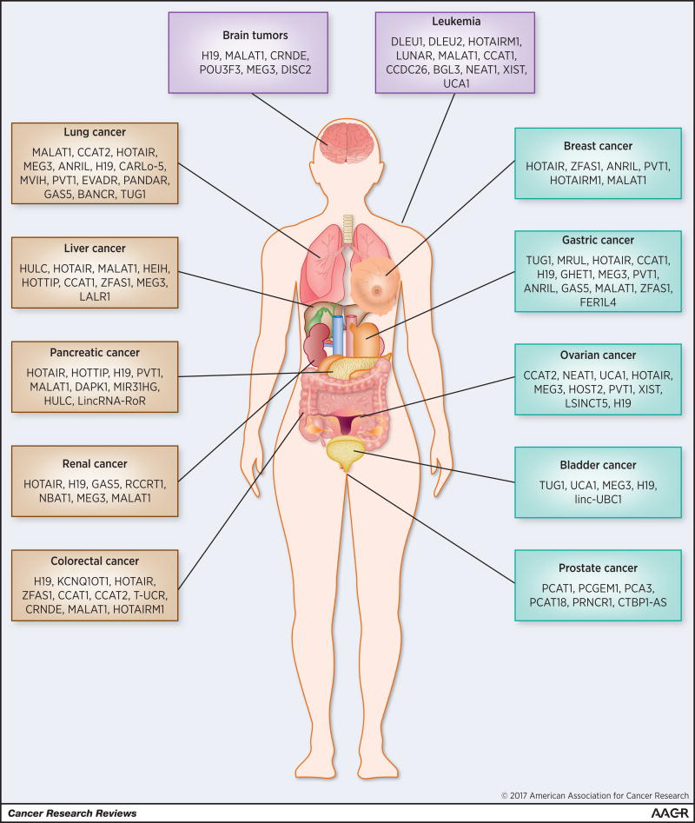
LncRNAs associated with various types of cancer (Bhan et al., 2017)

LncRNA as biomarkers:

The remarkable stability of lncRNAs while circulating in body fluids, particularly when incorporated in exosomes or apoptotic bodies, is one of the key advantages that makes them valuable as cancer diagnostic and prognostic biomarkers. Because of their relative non-invasiveness, these lncRNA properties provide an opportunity to develop effective and accessible lncRNA-based biomarkers that are less invasive and may be more tolerated by patients when compared to conventional biopsies (Bolha & Ravnik-Glavač, 2017).

Although it is still unclear how lncRNA extracellular release operates. So far, it has been demonstrated that lncRNAs are packed in vesicles, although more characterisation is needed (Beermann et al., 2016).
The US Food and Drug Administration has authorised LncRNA PCA3 as a urine biomarker for prostate cancer. Because of its increased expression in prostate cancer patients, this lncRNA has higher sensitivity and specificity than the commonly used prostate-specific antigen (PSA) blood test (Reggiardo et al., 2022).

HOTAIR is another lncRNA found in saliva samples from patients with oral squamous cell cancer (OSCC). Furthermore, increased HOTAIR lncRNA expression in salivary samples is a significant indication of metastatic oral cancer (Reggiardo et al., 2022).

These findings suggest that lncRNA may be a promising target for cancer diagnostics and therapeutics.

LncRNA Identification Techniques:
Currently available lncRNA detection methods include quantitative real-time polymerase chain reaction (qPCR) and microarray analysis. Targets with low copy numbers are challenging to identify using microarray and qPCR techniques. It has been found that the content of lncRNAs in extracellular vesicles (EVs) is extremely low; significantly lower than the amount of mRNA. As a result, a more sensitive, precise, and easy quantitative approach for studying low-abundance EV-lncRNA is required (Bai et al., 2019) .

LncRNA and breast cancer:
The functional characterization and knowledge of the underlying mechanisms driving lncRNA-mediated regulation in human disorders may open up new avenues for revolutionising our current diagnostic and therapeutic armament. These transcripts have various properties that make them appropriate for cancer therapy.
LncRNAs are detectable in tissue samples and can be used alone or in conjunction with other biomarkers to assess a patient's condition or potential response to certain medications.
Considering their critical role in controlling malignant transformation and disease development in breast cancer, these transcripts have become particularly important targets in the fight against this complicated disease. Their lower overall expression levels relative to protein-coding genes, along with distinct expression patterns, make them excellent for nucleic acid-based techniques (Sideris et al., 2022).

References

Anastasiadou, E., Jacob, L. S., & Slack, F. J. (2018). Non-coding RNA networks in cancer. Nat Rev Cancer, 18(1), 5-18. https://doi.org/10.1038/nrc.2017.99
Bai, Y., Qu, Y., Wu, Z., Ren, Y., Cheng, Z., Lu, Y., . . . Chen, C. (2019). Absolute quantification and analysis of extracellular vesicle lncRNAs from the peripheral blood of patients with lung cancer based on multi-colour fluorescence chip-based digital PCR. Biosensors and Bioelectronics, 142, 111523.
Bao, M. H., Szeto, V., Yang, B. B., Zhu, S. Z., Sun, H. S., & Feng, Z. P. (2018). Long non-coding RNAs in ischemic stroke. Cell Death Dis, 9(3), 281. https://doi.org/10.1038/s41419-018-0282-x
Beermann, J., Piccoli, M. T., Viereck, J., & Thum, T. (2016). Non-coding RNAs in Development and Disease: Background, Mechanisms, and Therapeutic Approaches. Physiol Rev, 96(4), 1297-1325. https://doi.org/10.1152/physrev.00041.2015
Bhan, A., Soleimani, M., & Mandal, S. S. (2017). Long Noncoding RNA and Cancer: A New Paradigm. Cancer Res, 77(15), 3965-3981. https://doi.org/10.1158/0008-5472.can-16-2634
Bolha, L., & Ravnik-Glavač, M. (2017). Long Noncoding RNAs as Biomarkers in Cancer. 2017, 7243968. https://doi.org/10.1155/2017/7243968
Brannan, C. I., Dees, E. C., Ingram, R. S., & Tilghman, S. M. (1990). The product of the H19 gene may function as an RNA. Mol Cell Biol, 10(1), 28-36. https://doi.org/10.1128/mcb.10.1.28-36.1990
Crick, F. (1970). Central dogma of molecular biology. Nature, 227(5258), 561-563.
Delpu, Y., Larrieu, D., Gayral, M., Arvanitis, D., Dufresne, M., Cordelier, P., & Torrisani, J. (2016). Noncoding RNAs: clinical and therapeutic applications. In Drug discovery in Cancer epigenetics (pp. 305-326). Elsevier.
Haldar, A., Mitra, S., & Chakrabarti, J. (2017). Perspective on long noncoding RNA functionality. Translational Cancer Research, S1049-S1053. https://tcr.amegroups.com/article/view/15283
He, Z., Yang, D., Fan, X., Zhang, M., Li, Y., Gu, X., & Yang, M. (2020). The Roles and Mechanisms of lncRNAs in Liver Fibrosis. 21(4). https://doi.org/10.3390/ijms21041482
Isin, M., & Dalay, N. (2015). LncRNAs and neoplasia. Clin Chim Acta, 444, 280-288. https://doi.org/10.1016/j.cca.2015.02.046
Jarroux, J., Morillon, A., & Pinskaya, M. (2017). History, Discovery, and Classification of lncRNAs. Adv Exp Med Biol, 1008, 1-46. https://doi.org/10.1007/978-981-10-5203-3_1
Jiang, J., Sun, Y., Xu, G., Wang, H., & Wang, L. (2021). The role of miRNA, lncRNA and circRNA in the development of intervertebral disk degeneration. Experimental and Therapeutic Medicine, 21(6), 1-9.
Lee, R. C., Feinbaum, R. L., & Ambros, V. (1993). The C. elegans heterochronic gene lin-4 encodes small RNAs with antisense complementarity to lin-14. Cell, 75(5), 843-854. https://doi.org/10.1016/0092-8674(93)90529-y
Li, J., Meng, H., Bai, Y., & Wang, K. (2016). Regulation of lncRNA and Its Role in Cancer Metastasis. Oncol Res, 23(5), 205-217. https://doi.org/10.3727/096504016x14549667334007
Lucas, T., Bonauer, A., & Dimmeler, S. (2018). RNA Therapeutics in Cardiovascular Disease. Circ Res, 123(2), 205-220. https://doi.org/10.1161/circresaha.117.311311
Marahrens, Y., Loring, J., & Jaenisch, R. (1998). Role of the Xist gene in X chromosome choosing. Cell, 92(5), 657-664.
Olsen, P. H., & Ambros, V. (1999). The lin-4 Regulatory RNA Controls Developmental Timing in Caenorhabditis elegans by Blocking LIN-14 Protein Synthesis after the Initiation of Translation. Developmental Biology, 216(2), 671-680. https://doi.org/https://doi.org/10.1006/dbio.1999.9523
Pachnis, V., Belayew, A., & Tilghman, S. M. (1984). Locus unlinked to alpha-fetoprotein under the control of the murine raf and Rif genes. Proceedings of the National Academy of Sciences, 81(17), 5523-5527.
Reggiardo, R. E., Maroli, S. V., & Kim, D. H. (2022). LncRNA Biomarkers of Inflammation and Cancer. Adv Exp Med Biol, 1363, 121-145. https://doi.org/10.1007/978-3-030-92034-0_7
Reinhart, B. J., Slack, F. J., Basson, M., Pasquinelli, A. E., Bettinger, J. C., Rougvie, A. E., . . . Ruvkun, G. (2000). The 21-nucleotide let-7 RNA regulates developmental timing in Caenorhabditis elegans. Nature, 403(6772), 901-906.
Ruan, X., Li, P., Chen, Y., Shi, Y., Pirooznia, M., Seifuddin, F., . . . Cao, H. (2020). In vivo functional analysis of non-conserved human lncRNAs associated with cardiometabolic traits. Nature Communications, 11(1), 45. https://doi.org/10.1038/s41467-019-13688-z
Schmitz, S. U., Grote, P., & Herrmann, B. G. (2016). Mechanisms of long noncoding RNA function in development and disease. Cell Mol Life Sci, 73(13), 2491-2509. https://doi.org/10.1007/s00018-016-2174-5
Sideris, N., Dama, P., Bayraktar, S., Stiff, T., & Castellano, L. (2022). LncRNAs in breast cancer: a link to future approaches. Cancer Gene Therapy, 1-12.
Slack, F. J., & Chinnaiyan, A. M. (2019). The Role of Non-coding RNAs in Oncology. Cell, 179(5), 1033-1055. https://doi.org/10.1016/j.cell.2019.10.017
Soudyab, M., Iranpour, M., & Ghafouri-Fard, S. (2016). The Role of Long Non-Coding RNAs in Breast Cancer. Arch Iran Med, 19(7), 508-517.
Tan, Y. T., Lin, J. F., Li, T., Li, J. J., Xu, R. H., & Ju, H. Q. (2021). LncRNA-mediated posttranslational modifications and reprogramming of energy metabolism in cancer. Cancer Commun (Lond), 41(2), 109-120. https://doi.org/10.1002/cac2.12108
Wu, P., Zuo, X., Deng, H., Liu, X., Liu, L., & Ji, A. (2013). Roles of long noncoding RNAs in brain development, functional diversification and neurodegenerative diseases. Brain Res Bull, 97, 69-80. https://doi.org/10.1016/j.brainresbull.2013.06.001
Xing, C., Sun, S. G., Yue, Z. Q., & Bai, F. (2021). Role of lncRNA LUCAT1 in cancer. Biomed Pharmacother, 134, 111158. https://doi.org/10.1016/j.biopha.2020.111158
Zhang, X., Wang, W., Zhu, W., Dong, J., Cheng, Y., Yin, Z., & Shen, F. (2019). Mechanisms and functions of long non-coding RNAs at multiple regulatory levels. Int J Mol Sci, 20(22), 5573.
Zuo, Y., Li, Y., Zhou, Z., Ma, M., & Fu, K. (2017). Long non-coding RNA MALAT1 promotes proliferation and invasion via targeting miR-129-5p in triple-negative breast cancer. Biomed Pharmacother, 95, 922-928. https://doi.org/10.1016/j.biopha.2017.09.005

