HISTORY
Heat pipes can be traced back to the early 1960s, as they were developed for space applications. The idea was conceived because of the need to manage heat within spacecraft; the existing management techniques were perceived to be less than satisfactory. It has been found that a very efficient, passive transfer device can be built by exploiting principles of phase change and capillary action. Throughout these years, heat pipes have undergone a vast and significant development history and have found their place in electronics cooling, HVAC systems, and even renewable energy technologies. Because they can transport heat without mechanical pumps, they are necessary in many modern engineering solutions, especially for enhancing their performance and energy efficiency in various sectors. In the present era, the advancement of heat transfer is increasing, and much research is being conducted on performance enhancement and technology development. Heat pipes are one of the most popular devices in heat transfer. As the sizes of the electronic devices were reduced, the challenges of transferring heat also became a significant issue. Therefore, heat pipes have been developed to solve this issue at the micro and nano scales. Heat pipes are undergoing extensive research, development, and commercialization in developed countries worldwide.
BASIC DETAILS
Working on the principle of the phase change phenomenon, these compact devices have better thermal conductance than any solid metal used, making them indispensable devices in the field of engineering. The rising demand for effective heat dissipation and control of temperature in various industries, including but not limited to electronics, aerospace, and alternative energies, has highlighted the importance of heat pipes as customizable and efficient solutions. Passive cooling systems, in which fluid motion is achieved without auxiliary electrical equipment such as pumps, can significantly reduce electrical energy consumption. Figure 1 shows the various applications of heat pipes. The functioning of contemporary passive heat transfer devices relies on the interplay of three fundamental physical processes: phase change, gravitational forces, and capillary action, efficiently leading to thermal dissipation of the working fluid inside the heat pipe. The working fluid is the medium for transporting heat from evaporator to the condenser. Capillary forces are thought to be insignificant in some passive systems, such as thermosyphons (wickless devices), however the influence of gravitational forces may be less evident in other systems, specifically wicked devices like Heat Pipes (HPs) and Loop Heat Pipes (LHPs).

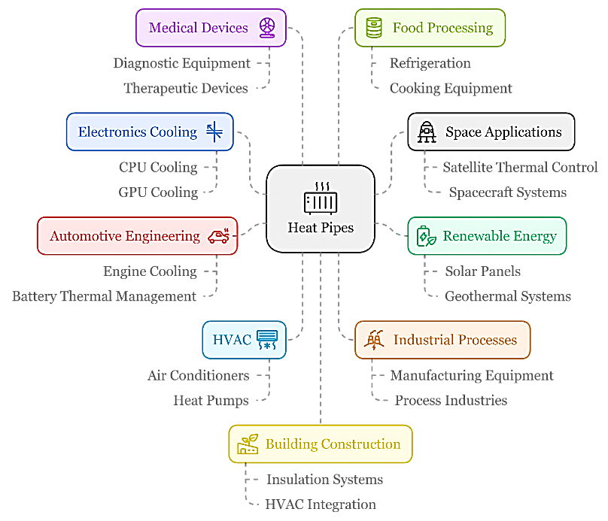

Figure 1 Various Applications of Heat Pipe

TYPES OF HEAT PIPE:
S.No | Heat Pipe Type | Applications | Advantages
1. | Conventional Heat Pipes | Electronics Cooling, Heat Recovery Systems, Aerospace | High thermal conductivity, Passive operation (no pumps), Compact size, Lightweight
2. | Loop Heat Pipes | Spacecraft thermal control, High-power electronics, Laser cooling | Higher heat transfer capacity than conventional heat pipes, Can operate against gravity over longer distances
3. | Micro Heat Pipes | Microelectronics cooling (smartphones, tablets), Medical devices | Minimal size, Can be integrated into complex geometries, High heat flux capability
4. | Variable Conductance Heat Pipes | Temperature regulation in satellites, Thermal management of sensitive equipment | Ability to control heat transfer rate, Maintain a stable temperature despite varying heat loads
5. | Pulsating Heat Pipes | Waste heat recovery, Cooling of high-power LEDs | Simple design, Can operate against gravity, High heat transfer coefficient
6. | Capillary Heat Pipe | electronic cooling, computer cooling systems, and aerospace applications. | Efficient thermal management, relatively simple construction, Suitable for various orientations, including horizontal and vertical.

Table 1 Various types of HP, Applications & Advantages
Various types of heat pipes are listed in Table 1, which are generally used in the application mentioned and their advantages. Many more heat pipes are modified for these HPs in other applications like CLPHP, OLPHP, Thermosyphon, Flat HP, etc. The types of heat pipes are generally used based on requirements of applications such as thermal performance, operating environment, etc. Some are optimized according to large-scale industrial applications with a unique design like distance, orientation, etc. Overall, HPs are used in every field of engineering applications where heat decapitation is needed, and thermal stability is essential.
WHY PHP?
A pulsating heat pipe provides multiple advantages over conventional heat pipes, making it an effective device for specific heat transfer applications, especially where high heat flux, compact size, and versatility are essential.

