FIRST EDITON
SHELTER
Options for living outdoors.
Backpacking, Overlanding, and Van Life.

J Patrick Bewley
Copyright © 2021 System Physics, LLC.
All rights reserved. No part of this book may be reproduced in any form by any means without the author’s permission.

Direct all inquiries to:
info@systemphysics.com

All photos are by the author unless otherwise credited.

CAUTION

Travel, exploration, and camping in the backcountry are potentially dangerous activities that pose risks. The author assumes no responsibility or liability for any damages, losses, accidents, inconveniences, or injuries incurred from using this book. It is the reader’s responsibility to be aware of all risks and take the necessary precautions to mitigate those risks.
While the author has made a considerable attempt to make this book as accurate as possible, errors may exist. Remember that conditions in the wilderness change rapidly.

This book does not:
- Direct you for every situation you may encounter while spending time outdoors.
- Replace your responsibility to do your own research.

Table of Contents
About the Author
Preface

Introduction

Natural Shelters
Ponchos and Tarps
Bedrolls and Bivy Sacs
Ground Tents
Hammocks and Tree Tents
Tent Cots and Swags
Soft Sided Roof Top Tents
Hard Sided Roof Top Tents
Camper Shells
Slide in Campers
Teardrops and Trailers
Vans
RVs and Busses

Conclusions
Useful Resources.

ABOUT THE AUTHOR

J Patrick Bewley is an entrepreneur, explorer, father, and all-around camping nerd who has traveled more than 30 countries and all 50 states searching for adventure. Over the years, he has been wet, cold, injured, and other forms of miserable in wildernesses ranging from the Alaskan and Canadian Arctic, the Himalayan, Carpathian, Dolomite, Alp, Andean, Appalachian, Ozark, and Beartooth mountain ranges to the Mojave, Sonoran and other deserts.

Some of his most remarkable exploits include backpacking the Simatai section of China’s Great Wall, mountain biking across the United States and Eastern Europe, and scorching his beard and arm hair on random campfires almost everywhere.

Bewley is always eager to go camping, dream about camping or chat about camping and can be reached through his YouTube channel at http://www.bigsexybeast.com.

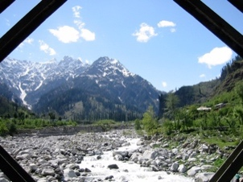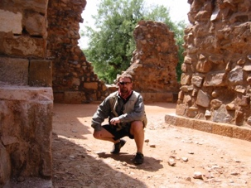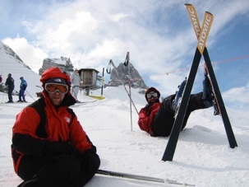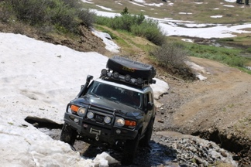
PREFACE

One of my most vivid childhood recollections is nestled in the heart of the Ozark National Forest. I'd find myself with my father in an old, green canvas army hospital tent. This tent wasn't just our shelter; it became the backdrop to many an adventure during our deer camping excursions. Within its walls, my father and I, accompanied by a few of his hunting buddies, found respite each night on our cots. A wood stove stood as our primary source of warmth and cooking, filling the tent with an unmistakable aroma of burning logs.

Even as a three-year-old, my perceptions were keen. I recall the brisk cold that seeped in as the wood stove's fire dwindled during the nights. Yet, what remained constant was the morning ritual—sizzling bacon and eggs, a prelude to the day’s hunt. And while the pine needles scattered across the tent's floor irked my toddler self, urging me to dream of vacuuming the wilderness floor. I never once bore witness to the intricacies of setting up and dismantling such an extensive camp. It was as if by magic, everything was in place year after year.

It took years for me to recognize that these experiences were not mere childhood adventures. They were formative moments. Cruising in dad’s 4x4 International Scout or Club Cab Dodge Power Wagon, I was subconsciously sculpting my life's passions. Nature has been my home for over four decades. I've braved the elements, sometimes unprepared, often comfortable, and on occasion, facing sheer misery. But the call of the wild, the allure of untamed terrains, always beckons me.

This book is a culmination of those myriad experiences. It's a reflection of my journey, a guide to the many ways one can embrace the great outdoors. As you turn the pages, I hope to not only equip you with knowledge but also to ignite that same spark of adventure. The world outside is vast, waiting to be explored. Whether this is your first journey into the wild or you are a seasoned adventurer, I hope you find this book a valuable resource.

INTRODUCTION

The allure of the great outdoors has been a timeless siren's call, beckoning adventurers to explore, discover, and connect with nature. But, as any seasoned traveler will tell you, exploration doesn't come without its challenges. Among the essential concerns of any expedition is the question: Where will I rest my head tonight?

Enter the vast and intriguing world of shelters and mobile living—a realm where necessity and innovation intertwine to provide refuge against the elements. Whether you're navigating the rugged trails of the Himalayas, immersing in the tranquility of the Mojave desert, or charting new terrains somewhere in between, the shelter you choose can profoundly shape your experience.

In this comprehensive guide, we delve deep into the varied facets of outdoor accommodations. From the minimalist hammock strung between trees to the grandeur of fully-equipped RVs and buses, this book seeks to demystify, enlighten, and inspire. Drawing on years of travel experience spanning 32 countries and all across the USA, I hope to share a wealth of knowledge, seasoned with personal anecdotes, misadventures, and the occasional singed beard. I hope my passion for outdoor adventure is palpable on every page.

But this book is more than just a guide to shelters; it's a tribute to the spirit of exploration and the myriad ways humans have adapted to the world's diverse landscapes. As you turn the pages, you'll embark on a journey that bridges the gap between ancient survival techniques and modern innovations, revealing the rich tapestry of human ingenuity.

A journey into the wilderness, done correctly is like a healing therapy. Enveloped by the sounds, smells and textures you will find the best place to leave anxiety behind and manage your mental wellbeing.

So, whether you're a novice camper gearing up for your first expedition or a veteran traveler searching for new insights, you're in for an enlightening adventure. Join us as we explore the many ways humanity has sought shelter amidst the wild, and perhaps, discover the perfect haven for your next journey.

CHAPER 1 - NATURAL SHELTERS

In the vast tapestry of the wild, nature herself has crafted shelters long before humankind ever embarked on constructing dwellings. These natural refuges, carved by time and the elements, have provided safety and solace to countless species, including our ancient ancestors. Natural shelters — from the sprawling embrace of cave mouths to the cozy nooks beneath fallen logs or rock overhangs — speak to an intrinsic human desire to seek harmony with the environment. They represent the purest form of cohabitation with the land, where the line between living space and the natural world blurs. Delving into the realm of natural shelters is not just an exploration of survival techniques, but also a journey into a deeper, primal connection with the earth that cradled civilization.

HISTORY

Natural shelters have played an integral role in the tapestry of human history, acting as the earliest form of refuge and home for prehistoric humans. Archaeological evidence across continents has offered insights into the pivotal moments of our shared history within these shelters.

- Early Hominoid Caves in Southern Africa (c. 2.6 million years ago): The cradle of humankind, as Southern Africa is often termed, boasts a rich tapestry of early human history. Sites like the Sterkfontein Caves, near Johannesburg, have unveiled fossils of early hominids such as Australopithecus africanus. These caves likely served as natural shelters against the region's harsh elements and potential predators. They became sites not just of habitation but of early human evolution.

- Shanidar Cave in Iraq (c. 65,000-35,000 years ago): Located in the Bradost Mountain, this cave stands out for the archaeological discovery of Neanderthal remains. The findings suggest that Neanderthals might have had burial rituals, showcasing a sophisticated cognitive ability. The cave's protective embrace served not just as a home but also as a final resting place.

- Lascaux Caves in France (c. 17,000 years ago): This complex of caves in southwestern France is renowned for its Paleolithic cave paintings. These artistic depictions serve as a testament to early human culture and beliefs. The caves, apart from being a dwelling, became a canvas that recorded their observations, rituals, and daily life.

- Cappadocia in Turkey (c. 4th century AD): While natural caves abound in this region, what's remarkable is the integration of human ingenuity with nature. Early Christians, seeking refuge from Roman persecution, expanded these caves into vast underground cities.

- Uplistsikhe Cave Town in Georgia (c. early 1st millennium BC): This ancient rock-hewn town stands as one of the earliest urban settlements in the region. It showcases a complex blend of natural caves and man-made tunnels, chambers, and passageways.

These shelters, spanning different epochs, highlight humanity's intrinsic reliance on nature, especially in its formative stages. Beyond mere survival, these natural retreats played host to the blossoming of culture, rituals, and societal structures, cementing their significance in the annals of human history.

TYPICAL SIZE AND WEIGHT

Natural shelters, by virtue of their organic formation, don’t fit the mold and exhibit a wide diversity in size and configuration. Unlike man-made counterparts, they don't adhere to standardized dimensions, yet some patterns and generalities can be observed across different types of natural refuges:

- Caves: The size of caves varies tremendously, from small alcoves just big enough for a single individual to vast chambers capable of housing entire communities. Some famous cavern systems stretch for miles, with chambers that can span up to 650 feet in width and over 150 feet in height, as seen in the Sarawak Chamber in Malaysia, one of the world's largest. In contrast, early hominoid caves in Southern Africa often consist of smaller chambers and narrow passages suitable for small groups.

- Rock Overhangs and Ledges: These natural formations, often resulting from erosion, provide a sheltered space beneath. They can range from a few feet in depth and width, perfect for a lone individual, to expansive ledges that can shield larger groups from rain or sun.

- Hollowed Trees: Old or ancient trees, especially in rainforests or old-growth forests, can have sizable hollows. These spaces can be several feet in diameter and height, accommodating one to two individuals.

- Undergrowth Dens: Formed within thick bushes or foliage, these shelters are typically small, often just spacious enough for an individual to crawl into and lie down. They provide camouflage and some protection against elements.

- Natural Trenches and Depressions: These ground formations, whether carved out by water flow or formed through other geological processes, can be several feet deep and wide. They offer a natural barrier against wind and can be further dug or modified for added protection.

While these descriptions offer a general idea, it's crucial to understand that nature's variability means each shelter is unique. Factors like geological history, climate, and ecosystem play a role in determining the exact dimensions and configurations. The beauty of natural shelters lies in their unpredictability and the opportunity they provide for adaptability and resourcefulness.

BEST SUITED FOR

Natural shelters, with their organic formations, have played a pivotal role in human survival and stealth throughout history. Here's a deeper dive into their most fundamental applications:

- Primitive Survival and 'Home Base': For early humans and even today's wilderness enthusiasts, natural shelters have served as essential sanctuaries against the unpredictable elements and potential threats. Beyond temporary refuge, these formations often became 'home bases' for our ancestors. A cave or a spacious rock overhang could provide not just protection, but a central location for communal living, storing food, and crafting tools. Its permanence allowed for more settled living, enabling the inhabitants to familiarize themselves with nearby water sources, food availability, and potential dangers. Establishing such a home base could transform a nomadic existence into one with a semblance of stability, fostering the growth of early communities and kinships.

- Stealth, Concealment, and Known Routes: Natural shelters have long been invaluable for those needing to remain unnoticed, be it early hunters stalking their prey or scouts observing distant activities. The inherent camouflage offered by these shelters meant they could lie in wait undetected or rest without drawing attention. Moreover, as early communities grew around 'home bases,' known routes connecting various natural shelters would have been established. Traveling these paths, be it for trade, communication, or migration, individuals or groups would have recognized and utilized specific natural shelters along the way. These known refuges provided predictable and safe resting points, ensuring that even when away from the primary base, there was always a concealed spot to retreat to if needed.

The allure of natural shelters lies in their multifaceted applications, intertwining with the human narrative of survival, community-building, and stealth. Even as we have evolved, the primal appeal and practicality of these shelters remain undeniable.

NOTABLE LIMITATIONS

While natural shelters have been essential to human survival throughout history, they come with inherent limitations that can make them less appealing for modern use. Unlike manufactured shelters, natural ones can be unpredictable, with hidden dangers like unstable ceilings in caves, resident wildlife, or precarious rock overhangs. The ground in these shelters can be hard, cold, and uneven, often lacking the comfort that modern camping equipment provides. Caves, especially, can present issues with dampness and high humidity, leading to potential health concerns like fungal infections. Natural shelters might also confine users to a smaller space, hindering tasks that require movement. Since adapting to an existing structure provides less control over the shelter's features, finding a suitable spot demands more knowledge and effort, particularly in unfamiliar terrains. Moreover, the growing awareness of the ecological impact of human activities raises concerns about disturbing local ecosystems. Plus, many natural shelters have historical or cultural significance, and using them without proper knowledge can risk damaging invaluable sites. As romantic as the idea of natural shelters might seem, these practical and ethical considerations can make some individuals hesitant to use them.

MAJOR FOUL WEATHER CONSIDERATIONS

Natural shelters, while being a primary source of refuge for millennia, have varied performance when facing adverse conditions. Their effectiveness largely depends on their type, location, and the specific challenges posed by the worsening conditions.

In the face of heavy rainfall, a deep cave or rock overhang might provide adequate protection, ensuring its inhabitants remain dry. However, a shallower recess or an undergrowth den could easily become waterlogged or offer minimal protection from driving rain. Furthermore, caves situated in low-lying areas are at risk of flooding, which could be catastrophic for anyone inside.

During snowfalls or cold snaps, natural shelters like caves can provide a buffer against chilling winds, making them relatively warmer than the outside environment. However, without additional insulation from materials like leaves or grasses, the cold, hard ground can rapidly sap body heat, leading to hypothermia.

Windstorms present another challenge. While a cave or a deep rock recess can offer significant protection against strong winds, not all natural shelters are oriented optimally. An incorrectly aligned shelter might funnel the wind, making conditions inside nearly as bad as those outside.

Natural shelters also come with the risk of housing or attracting wildlife. In worsening conditions, other animals might also seek refuge in these shelters, leading to potential conflicts or dangers.

Lastly, in areas prone to earthquakes, natural shelters, especially caves or rock overhangs, pose the risk of collapse or rockfall, potentially trapping or injuring its occupants.

In essence, while natural shelters can offer immediate and sometimes substantial protection against deteriorating conditions, their reliability is inconsistent. Their performance is heavily influenced by their specific type, the particular adverse condition faced, and the shelter's relationship to the surrounding environment. It's a reminder of nature's unpredictable character and the need for humans to remain adaptable and vigilant.

STEALTH

Sleeping undetected in a natural shelter hinges on several factors, including the inherent camouflage provided by the shelter itself and the individual's behaviors. Caves, rock overhangs, and undergrowth dens naturally blend with their surroundings, often allowing occupants to remain concealed from casual observers. The minimal footprint left behind when using such shelters, devoid of the telltale signs like pegs or cleared ground that come with tents, adds to this stealth. Additionally, the barriers of these shelters, whether they're dense undergrowths or rock walls, can help muffle sounds, reducing the chances of detection. However, challenges arise with activities like using light or fire; even a dim flashlight can betray one's presence in the darkness. Similarly, cooking or any activity that produces a strong odor might not only alert other humans but could also attract wildlife. Constant movement in and out of the shelter can increase the risk of detection, especially if it leaves a noticeable trail or disturbs nearby vegetation. It's also worth noting that these natural shelters might already be occupied by wildlife, and any disturbances they cause can inadvertently draw attention. In essence, while natural shelters offer a promising environment for undetected rest, success hinges on both the shelter's characteristics and the occupant's discretion and awareness.

ANECDOTE NOT TO BE CONFUSED WITH ANTIDOTE ALTHOUGH SOMETIMES OTHERWISE REQUIRED

A funny story involving the use of this type of shelter

CHAPTER 2 - PONCHOS AND TARPS

The wilderness beckons with its allure of uncharted territories and the promise of adventure. Yet, as seasoned explorers know, nature's beauty is often matched by its unpredictability. For millennia, the challenge of shelter amidst the vast expanse has driven human ingenuity to devise solutions that are both functional and lightweight. Among these, ponchos and tarps stand out, not just for their simplicity but for their adaptability. These minimalist shelters, with origins tracing back to ancient civilizations and indigenous cultures, have been redefined and repurposed over the ages. Serving dual roles as protection from the elements and as discreet cover, they embody the spirit of versatile wilderness survival and are the best choice for “Fast and Light” adventures. Whether you're a backpacker aiming to shave ounces off your load or a stealth camper seeking to blend into the backdrop, understanding the nuances of ponchos and tarps can be pivotal to your outdoor experience.

HISTORY

Since time immemorial, humans have sought to protect themselves from the vagaries of the weather. Ponchos and tarps stand out as two of the most versatile and ancient solutions to this perennial problem. Dating back to ancient civilizations, the earliest documented uses of tarps were seen in the form of large leaves, animal skins, or woven plant fibers, serving as rudimentary shelters or ground covers. Ponchos, with their origins in the indigenous cultures of South America, were fashioned from various materials to serve as both garments and makeshift shelters. Throughout history, these simple yet effective tools have played pivotal roles: tarps provided shelter for soldiers in war zones, while ponchos were indispensable for ancient Andean people during seasonal migrations. Both, in their essence, encapsulate humanity's ingenuity in crafting protective solutions from available resources.

TYPICAL SIZE AND WEIGHT

The adaptability of ponchos and tarps is in part due to their varied sizes and potential configurations. On average, a standard camping tarp might range from 5x7 feet to 10x10 feet, though larger sizes are available for group settings or more extensive coverage. When it comes to weight, there's a notable spectrum: tarps made of ultralight silnylon can weigh as little as a few ounces, making them a favorite among lightweight backpackers, while robust waxed canvas tarps can tip the scales at several pounds, prized for their durability and weather resistance. Tarps can be set up in multiple configurations, from a simple A-frame to more complex setups like the flying diamond or the lean-to, each tailored to specific environmental conditions and user needs. Ponchos, designed primarily as wearables, usually measure roughly 4x6 feet, enough to cover the wearer and their backpack adequately. Their design often includes hooded sections and grommets or eyelets at the corners, enabling them to be transformed into makeshift shelters. Whether draped, tied, staked, or suspended, the malleability of these items means they can be molded to fit a multitude of scenarios and landscapes.

BEST SUITED FOR

Ponchos and tarps are prized for their versatility, making them invaluable in a myriad of scenarios. One of the most common uses is in the realm of backpacking and hiking, where lightweight silnylon tarps offer a minimalist approach to shelter, maximizing protection with minimal weight. For outdoor enthusiasts, tarps provide a quick and adjustable refuge during unpredictable rain showers or as a sunshade during scorching days. Military personnel, too, have long favored them for their adaptability in various terrains and climates. Ponchos, beyond their role as rainwear, can serve as emergency shelters, ground covers, or even makeshift bivouacs when the situation demands. In more permanent camp setups, the heftier waxed canvas tarps offer rugged reliability, often used as windbreaks or additional weatherproofing for tents. From survivalists in the wild to casual campers at a weekend getaway and even vendors at outdoor events seeking protection for their goods, the applications of these shelters are as varied as they are numerous.

NOTABLE LIMITATIONS

While ponchos and tarps offer notable advantages, they come with their own set of limitations that can deter some users. One of the primary concerns is the lack of full enclosure. Unlike tents, tarps and ponchos do not typically provide a complete barrier against insects, pests, or curious wildlife, which can be particularly bothersome in areas with a high mosquito or tick presence. The open design also offers less privacy, which can be a disadvantage in crowded camping areas or for those who prefer seclusion.

Additionally, while tarps can be configured in various ways, achieving a sturdy, weather-resistant setup requires a certain skill level and experience. Inconsistent or improper setups can result in inadequate protection during unexpected downpours or wind gusts. For those unfamiliar with different tarp configurations, there's a steeper learning curve compared to the straightforward setup of modern tents.

Furthermore, the minimalist nature of tarps means that they provide little to no insulation. In colder environments, this can be a significant disadvantage, as they don't retain heat as effectively as a fully enclosed tent. Lastly, some users simply prefer the feeling of security and comfort that comes with being in a more traditional shelter. The psychological comfort of a walled space, however thin those walls might be, can be a deciding factor for many when weighing the pros and cons of tarps and ponchos as shelters.

MAJOR FOUL WEATHER CONSIDERATIONS

When Mother Nature displays her more tempestuous side, the efficacy of ponchos and tarps as shelters truly gets tested. Properly configured, a tarp can offer commendable protection against rainfall. The angle and tightness of the setup, combined with waterproof materials like silnylon or waxed canvas, can effectively divert rainwater away, keeping the occupants relatively dry. Furthermore, a well-stretched tarp can resist moderate wind gusts, especially if anchored securely with stakes, guylines, and natural features like trees or boulders.

However, in extreme weather conditions, the limitations become apparent. During heavy windstorms, the open sides of a tarp setup can expose its occupants to the elements, and the tarp itself may flap violently or even become airborne if not anchored properly. In areas with heavy snowfall, tarps can sag or collapse under the weight of accumulated snow, unless regularly cleared. Ponchos, being even more minimalist, can offer only rudimentary protection in sudden downpours and might be impractical in sustained heavy rain.

Temperature regulation is another challenge. Tarps and ponchos provide minimal insulation. In cold weather, while they might shield you from direct wind or precipitation, they don't trap heat as effectively as a fully enclosed shelter, potentially leaving occupants vulnerable to the cold.

In summary, while ponchos and tarps can serve effectively as shelters in mild to moderate conditions, they require skillful handling and additional precautions in more severe weather. Their performance in adverse conditions is highly contingent on the user's expertise in setup and site selection.

STEALTH

One of the unsung advantages of using ponchos and tarps as shelters is their potential for stealth camping, a method where campers set up and break down camp with the aim of leaving little trace and remaining unnoticed.

Firstly, tarps and ponchos have a lower profile than traditional tents. When pitched close to the ground in a low configuration, they can blend seamlessly with the natural surroundings, especially if one opts for earth-toned or camouflaged materials. This makes them less conspicuous and can be particularly useful in areas where one wants to minimize visual impact or avoid drawing attention.

Secondly, the simplicity and flexibility of these shelters allow for quick setup and takedown. A practiced user can establish or dismantle a tarp shelter in a matter of minutes, reducing the window of exposure and the chances of being detected.

However, the success of sleeping undetected in a tarp or poncho shelter isn't just about the shelter itself. It involves a combination of factors:

Location Selection: Opt for remote, less-trafficked areas. Being away from popular paths or clearings and tucking oneself into natural alcoves or under tree canopies can greatly enhance concealment.

Noise Discipline: The process of setting up and breaking down should be as quiet as possible. This means being familiar with one's gear and possibly avoiding noisy equipment like rustling plastics or loud velcros.

Light Discipline: Avoid using bright flashlights or campfires that can give away one's position. If light is necessary, opt for low-lumen settings or red-light modes that are less visible from a distance.

In summary, with careful planning and practice, sleeping under a tarp or poncho can offer a highly discreet and unobtrusive shelter option. When done right, it allows one to merge with the environment and remain virtually undetected.

ANECDOTE NOT TO BE CONFUSED WITH ANTIDOTE ALTHOUGH SOMETIMES OTHERWISE REQUIRED

A funny story involving the use of this type of shelter

CHAPTER 3 - BEDROLLS AND BIVY SACS

The allure of the great outdoors entices many with visions of starry nights and the sounds of nature. Venturing into the wilderness demands not only a spirit of adventure but also the right gear to endure nature's unpredictability. Bedrolls and bivy sacs, in this context, emerge as quintessential gear for those who prioritize mobility and simplicity. These compact shelters, with roots deep in nomadic and military histories were popularized in more modern times by cowboys and alpine climbers. They offer a solution for minimalists who crave an unfiltered connection with the wilderness. They are particularly well-suited for lone travelers and those traversing challenging terrains. Delving into the world of bedrolls and bivy sacs opens up a realm of efficient wilderness survival, essential for trekkers looking to travel light or solo adventurers desiring a streamlined experience.

HISTORY

The quest for protection from the elements while sleeping under the stars has long driven human innovation. Bedrolls and bivy sacs offer some of the most compact and simple solutions to this quest. Bedrolls, which are essentially sleeping pads often with blankets or coverings, have been used since the days of nomadic tribes and cowboys roaming the open plains. Bivy sacs, or "bivouac sacks," have military origins, designed for soldiers who needed quick, lightweight shelter options during missions. They've been indispensable for mountaineers and alpinists who, during their daring ascents (earliest use likely around 1961 on El Capitan), required a shelter that's both lightweight and protective. Both bedrolls and bivy sacs embody human adaptability, revealing our capacity to create comfort even in the most austere environments.

TYPICAL SIZE AND WEIGHT

Bedrolls and bivy sacs are cherished for their compactness. A traditional bedroll might be a few feet in width and length, depending on the user's size, and rolls up into a cylindrical shape, making it easily attachable to a backpack or a horse's saddle. Bivy sacs, designed to envelop a sleeping bag, typically mirror the dimensions of regular sleeping bags but add a mere few ounces to a pound, depending on material and features. While modern bedrolls, especially those with inflatable pads or memory foam, can vary in weight, they still prioritize portability. Bivy sacs made of ultralight materials like Gore-Tex are feather-light and compressible, while those designed for severe weather may be slightly heftier but offer more protection.

BEST SUITED FOR

The prime territory for bedrolls and bivy sacs lies in scenarios where speed, simplicity, and weight are paramount. Alpinists attempting rapid ascents in high mountains often turn to bivy sacs, valuing their lightweight protection against the elements. Long-distance hikers or bikepackers, covering vast distances and often changing camp spots daily, find the quick setup of bedrolls ideal. For those undertaking journeys in regions with established shelters or huts, a bedroll might suffice as the primary bedding. The solo traveler, moving stealthily and looking for an unobtrusive shelter, might lean towards the low-profile nature of a bivy sac. In essence, these shelters shine in settings where traditional tents might be cumbersome or unnecessary.

NOTABLE LIMITATIONS

Despite their advantages, bedrolls and bivy sacs present some challenges. A significant limitation of bivy sacs is condensation; the narrow confines can lead to moisture buildup inside, particularly in colder or more humid environments. The close quarters of a bivy might also feel claustrophobic to some, offering limited space to maneuver. Bedrolls, while providing cushioning, don't offer much in terms of protection from the elements, leaving the sleeper exposed unless combined with other shelters. Moreover, most bedrolls nor the bivy sacs provides protection from insects or critters, which might be concerning in certain locales.

MAJOR FOUL WEATHER CONSIDERATIONS

In harsh weather, the performance of bedrolls and bivy sacs becomes crucial. Bivy sacs with waterproof and windproof materials can offer a commendable barrier against rain and wind, especially those with a hooped design that keeps the fabric off the face. However, in heavy rainfall or snow, the limited space and potential for condensation can make the experience less than comfortable. Bedrolls, on the other hand, offer no protection against precipitation unless made from a heavier material such as waxed canvas. The user would need an overhead shelter or tarp to shield from rain or snow, making it essential to pair with other gear in inclement weather. In cold climates, a well-insulated bedroll or a bivy with a robust sleeping bag can provide warmth, but exposure to the open air or ground chill remains a factor to consider.

STEALTH

When it comes to stealth camping, bedrolls and bivy sacs shine due to their low-profile design. Their compactness allows adventurers to set up in inconspicuous spots, hidden from the usual trails or clearings. The lack of structural components, like poles or guylines, reduces the visual footprint. Moreover, the swift setup and takedown time enhance the stealth factor, enabling quick moves with minimal trace. However, the effectiveness of stealth camping with these shelters isn't solely about the gear. Choosing remote spots, minimizing noise, and limiting light emissions are crucial for a discreet outdoor sleeping experience.

ANECDOTE NOT TO BE CONFUSED WITH ANTIDOTE THOUGH SOMETIMES ESSENTIAL

rewrite

CHAPTER 4 - GROUND TENTS

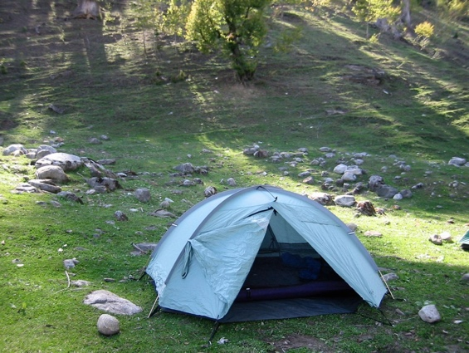
The symphony of nature—the chirping of crickets, the whisper of the wind through trees, and the distant call of wildlife—is experienced most intimately when one camps amidst it. Among the myriad shelter options available to outdoor enthusiasts, ground tents remain the most popular. These portable homes, with their iconic silhouettes dotting countless landscapes, epitomize the camping experience. The history, versatility, and evolving design of ground tents showcase humanity's enduring relationship with the wild, as we continually strive to harmonize the comforts of shelter with the raw beauty of nature.

HISTORY

The inception of ground tents traces back to ancient civilizations where nomadic tribes utilized animal skins stretched over bones or wooden poles to create rudimentary shelters. From the Bedouin tribes of the desert to the Native Americans on the plains, tents have evolved in tandem with human migration and exploration. The design and materials have been refined over millennia, culminating in today's sophisticated and varied selection suitable for every imaginable outdoor endeavor.

TYPICAL SIZE AND WEIGHT

Ground tents come in a plethora of sizes, catering to solo backpackers up to large groups. A solo tent typically weighs around 2 to 4 pounds and offers a snug sleeping space. In contrast, a spacious family tent might weigh upwards of 20 pounds, providing room for multiple sleepers and gear storage. Modern innovations in materials, such as lightweight nylon and aluminum poles, have drastically reduced tent weights over the years, making backpacking and long-distance trekking more accessible.

BEST SUITED FOR

Ground tents are versatile, catering to a wide range of outdoor activities. Backpackers often choose ultralight, one or two-person tents that prioritize weight and packability. Family campers or festival-goers might lean towards larger, roomier models with multiple compartments and added comforts. Those venturing into harsh climates may opt for four-season tents, designed to withstand heavy snowfall, fierce winds, or torrential rains. Essentially, with the myriad of designs available, there's likely a ground tent suited for every environment and purpose.

NOTABLE LIMITATIONS

While ground tents are versatile, they do come with their set of challenges. They require relatively flat and debris-free ground for setup. In rocky or uneven terrains, pitching a tent can be cumbersome. Additionally, while most tents are designed to handle moderate weather, prolonged exposure to heavy rains, snow, or high winds can strain their structural integrity. Ground tents also require regular maintenance, especially in ensuring that the fabric remains waterproof and the zippers function smoothly.

MAJOR FOUL WEATHER CONSIDERATIONS

When the skies turn grim, a ground tent's design and setup become paramount. Tents with a full-coverage rainfly and a bathtub-style floor help prevent water ingress. Ventilation is crucial; without it, condensation can accumulate inside, dampening gear and reducing comfort. In windy conditions, it's essential to fully stake out the tent and utilize guy-lines to enhance stability. Four-season tents, with their sturdier pole structures and durable materials, are designed specifically to withstand snow loads and chilling alpine winds.

STEALTH

Ground tents can be discreet if chosen with stealth camping in mind. Earth-toned or camouflaged tents blend into natural surroundings, making them less noticeable. For the ultimate in low-impact camping, one must also consider location—setting up in less-traveled areas, away from trails or clearings, and ensuring the tent is pitched and dismantled without leaving any trace.

ANECDOTE NOT TO BE CONFUSED WITH ANTIDOTE THOUGH SOMETIMES ESSENTIAL

rewrite

CHAPTER 5 - HAMMOCKS AND TREE TENTS

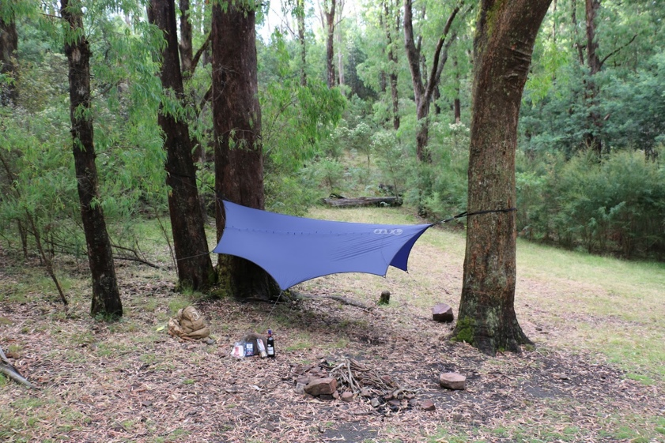
Suspended between trees, blending seamlessly into nature's canopy, hammocks and tree tents offer an elevated camping experience, both literally and figuratively. These airy shelters, which defy the constraints of rocky or uneven ground, are not just a symbol of relaxation; they embody a rich history and a unique approach to outdoor dwelling. As we delve into their evolution and nuances, we unearth their transformative impact on the relationship between humanity and the wilderness.

HISTORY

The origin of the hammock dates back over a thousand years. Indigenous cultures from Central and South America, notably the Mayans around 1,000 A.D., are credited with the creation of the hammock. Initially crafted from woven tree bark or plant fibers, these hanging beds were both practical for keeping off the ground, away from insects and potential threats, and for their comfort in the humid climate.

Tree tents, a more recent innovation, emerged in the late 20th century, combining the concept of hammocks with the protection and structure of tents. These structures offer a more contained and sheltered environment, making treetop camping viable in various conditions and climates.

TYPICAL SIZE AND WEIGHT

Hammocks range from lightweight, compact designs favored by backpackers to larger, more intricate setups with built-in bug nets and rainflies. A typical camping hammock will weigh between 1 to 3 pounds, though this can vary based on materials and features.

Tree tents, with their more intricate designs, often weigh a bit more, ranging from 4 to 7 pounds for a two-person shelter. Their weight accounts for the additional poles, rainfly, and often more robust fabric used in their construction.

BEST SUITED FOR

Hammocks shine in wooded environments where trees are abundant. They're ideal for areas with challenging or wet ground conditions where traditional ground tents might struggle. Backpackers, in particular, appreciate lightweight hammocks for their ease of setup and footprint-free impact.

Tree tents, on the other hand, offer an elevated camping solution suitable for families or those seeking a novel outdoor experience. With their more enclosed design, tree tents can handle a broader range of climates and provide enhanced protection from insects and weather.

NOTABLE LIMITATIONS

While the off-the-ground appeal of hammocks and tree tents is undeniable, they do come with challenges. The most apparent limitation is the requirement for sturdy trees, appropriately spaced. In environments devoid of trees, such as alpine areas or open plains, these shelters are unsuitable.

Moreover, while hammocks provide comfort for many, not everyone finds the curved sleeping position comfortable for extended periods. Some users also report feeling colder due to the increased airflow underneath, making insulation, like an underquilt, essential in cooler climates.

MAJOR FOUL WEATHER CONSIDERATIONS

For hammocks and tree tents to withstand inclement weather, appropriate setup and accessories are crucial. A tautly pitched rainfly or tarp is essential in preventing rainwater from seeping in. Wind can also present challenges; hammocks, when exposed, can sway excessively, so finding a sheltered location or adjusting the tarp to block the wind is beneficial.

Tree tents, with their more enclosed structure, generally offer better foul weather protection. However, like any shelter, their performance is contingent on the quality of the setup and the gear itself.

STEALTH

Due to their elevated nature and smaller footprint, both hammocks and tree tents can be rather discreet, making them suitable for stealth camping. Opting for earth-toned or forest-colored gear can further enhance their inconspicuous nature. Their quick setup and takedown also aid in minimizing impact and ensuring a low-profile presence.

ANECDOTE NOT TO BE CONFUSED WITH ANTIDOTE, THOUGH HAVING BOTH MIGHT BE HANDY

rewrite

CHAPTER 6 - TENT COTS AND SWAGS

A seamless blend of comfort and convenience, tent cots and swags offer a unique vantage point in the world of outdoor accommodations. Merging the benefits of off-ground sleeping platforms with the protective elements of tents and canvas, these shelters provide a cozy and elevated experience. Whether it’s the structured elegance of tent cots or the rugged simplicity of swags, understanding their history, design, and applications opens doors to diverse camping possibilities.

HISTORY

The concept of tent cots isn't particularly ancient. It is more of a modern fusion, combining the structure of a cot with the protective qualities of a tent. Designed to elevate the sleeper from the ground, these setups are a response to the desire for comfort, convenience, and safety in varied terrains.

Swags, on the other hand, have deep historical roots. Originating from Australia in the 1800s, swags were the bedrolls of the bushmen, drovers, and itinerant workers who traveled long distances for work opportunities. Traditionally made of canvas, a swag provided shelter, bedding, and warmth during cold desert nights. Rolled and easily transported on one's back or via horseback, it was an all-in-one sleeping solution. Today, while the design has seen refinements, the essence of the swag remains, particularly in regions like Australia where it continues to be an iconic piece of camping gear.

TYPICAL SIZE AND WEIGHT

Tent cots typically resemble standard camping cots in size, but with the added weight of the tent material and poles. Most are designed to accommodate a single person, though larger models exist. They usually weigh between 15 to 30 pounds, depending on materials and features.

Swags come in various sizes, with single and double being the most common. They can weigh anywhere from 8 to 20 pounds. The weight largely depends on the thickness of the canvas, the quality of the mattress, and any additional features like mosquito netting or poles.

BEST SUITED FOR

Tent cots shine in environments where uneven, rocky, or damp ground conditions could prove challenging for traditional tents. Their elevated design ensures airflow underneath, reducing condensation issues and enhancing comfort during warmer nights.

Swags, with their rugged construction, are particularly suited for the varied and sometimes harsh conditions of the Australian outback. However, their simplicity and durability make them apt for any rugged adventure, especially for solo travelers or those looking for a no-fuss setup.

NOTABLE LIMITATIONS

While tent cots offer the luxury of elevation, their bulkier size and weight might not be ideal for backpackers or those with space constraints. Setting them up on particularly uneven ground can also be a challenge.

Swags, though simple, can be heavy, especially the traditional ones made of robust canvas. They also offer limited space, which might feel confining for some campers, and typically lack the standing room or additional space for gear storage that tents provide.

MAJOR FOUL WEATHER CONSIDERATIONS

Tent cots, being off the ground, provide an advantage during rainy conditions by keeping the sleeper dry from potential water run-off. However, their exposure to wind, if not well-shielded, can lead to chilly nights.

Swags, with their close-to-ground design and sturdy canvas, fare well in both rainy and windy conditions. The thick canvas provides insulation, and their low profile reduces wind exposure. However, in heavy rain, it's essential to ensure that the swag isn't set up in a depression where water might pool.

STEALTH

Tent cots, due to their elevation, might be more visible in open terrains. However, when set up amidst foliage or in wooded areas, they can be relatively discreet.

Swags, given their low profile and earthy tones, are naturally stealthy and can easily blend into their surroundings, making them excellent for inconspicuous camping.

ANECDOTE NOT TO BE CONFUSED WITH ANTIDOTE, THOUGH CERTAINLY ENTERTAINING

rewrite

CHAPTER 7 - SOFT SIDED ROOF TOP TENTS

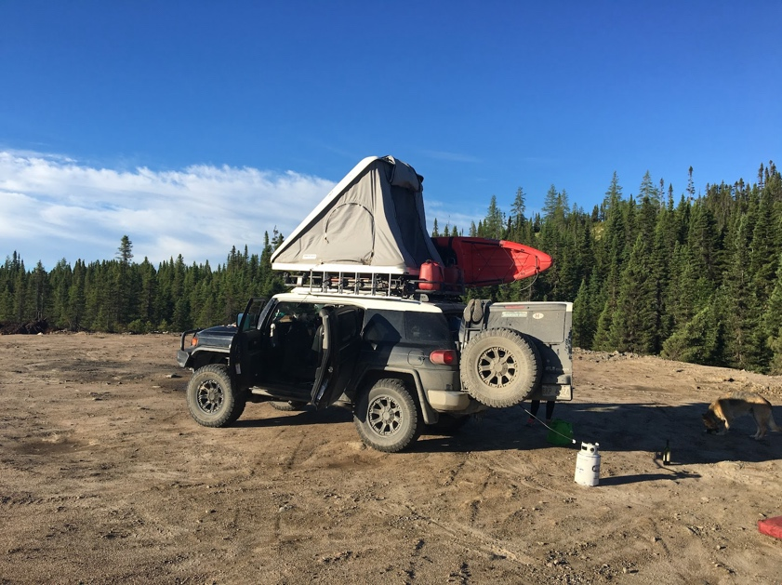
For the true wanderlust-driven souls and overlanders, soft-sided rooftop tents (RTTs) offer a perfect blend of adventure and convenience. These tents, perched atop 4x4s and other suitable vehicles, grant campers a unique perspective, elevate them from ground-based nuisances, and facilitate near-instant camp setups in diverse environments. As the popularity of vehicle-based exploration grows, the soft-sided RTT emerges as a practical and sought-after choice for many.

HISTORY

The roots of rooftop camping can be traced back to the mobile safaris of Africa in the early to mid-20th century. Adventurers and hunters, looking for an elevated vantage point safe from wildlife, improvised platforms on their vehicles. By the latter half of the century, these improvised solutions began to evolve into the commercial rooftop tents we see today, especially in regions like Australia where overlanding became a popular recreational activity. The soft-sided RTT, characterized by its collapsible canvas or fabric walls, combines the principles of traditional tent camping with the advantages of elevation.

TYPICAL SIZE AND WEIGHT

Soft-sided rooftop tents come in sizes ranging from those suitable for solo travelers to spacious models that can comfortably accommodate families. They typically weigh between 100 to 200 pounds, depending on their size, materials, and included features. Most are designed to fit securely atop a variety of vehicles, from trucks and SUVs to smaller crossovers, provided they are equipped with suitable roof racks.

BEST SUITED FOR

Rooftop tents excel in terrains where traditional tents might face challenges, such as sandy deserts, rocky grounds, or marshy areas. They also offer an additional layer of security in regions with wildlife concerns. RTTs are particularly popular among overlanders, off-roaders, and those undertaking long road trips who appreciate the convenience of setting up camp anywhere their vehicle can take them.

NOTABLE LIMITATIONS

While RTTs offer many advantages, they do come with some limitations. The added weight on the vehicle's roof can impact its center of gravity and fuel efficiency. Packing up can be slightly more time-consuming than ground tents, especially if bedding and accessories are stored inside. Additionally, once the tent is set up, it limits the vehicle's mobility unless it's packed away again.

MAJOR FOUL WEATHER CONSIDERATIONS

Soft-sided RTTs, being elevated, are naturally less prone to issues like water pooling or flooding. Many models are equipped with robust rainflys and weather-resistant materials. However, their position atop a vehicle might expose them to winds more than ground tents, so it's essential to ensure they're securely anchored and oriented in a way that minimizes wind resistance.

STEALTH

While their elevation might make them more visible than ground tents, their ability to set up camp virtually anywhere allows users to find secluded spots away from popular camping zones. Opting for earth-toned or natural-colored tents can also help them blend better with the surroundings.

ANECDOTE NOT TO BE CONFUSED WITH ANTIDOTE, BUT SURELY A BREATH OF FRESH AIR

Insert story about lightning storm in backcountry of Badlands national park sleeping in passenger seat

CHAPTER 8 - HARD SIDED ROOF TOP TENTS

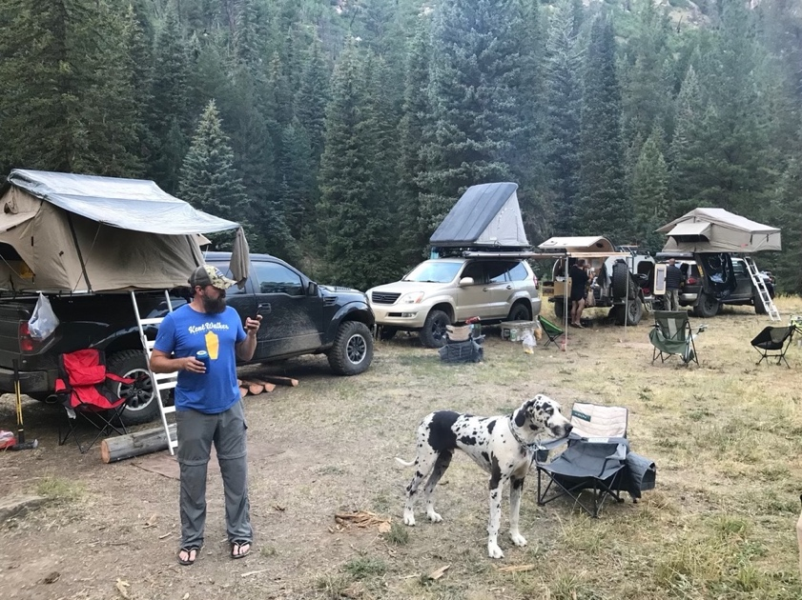
For the modern nomad or the intrepid explorer, hard-sided rooftop tents (RTTs) represent the pinnacle of vehicle-based camping. These tents, securely attached to the roofs of 4x4s and other vehicles, provide a sanctuary in the sky, away from ground-based annoyances. Hard-sided RTTs, distinguished by their rigid top and bottom shells, have become an increasingly popular choice for those seeking a blend of adventure and convenience.

HISTORY

The concept of rooftop camping has been around since the days of early African safaris in the early 20th century. Early adventurers would set up camp on top of their vehicles to stay safe from wildlife. Over time, this practice evolved into the commercial rooftop tents we see today, with Australia playing a significant role in their development due to the popularity of overlanding in the region. The hard-sided RTT is a more recent innovation, designed to provide enhanced protection and insulation compared to its soft-sided counterpart.

TYPICAL SIZE AND WEIGHT

Hard-sided rooftop tents come in various sizes, from compact models suitable for solo travelers to larger options that can comfortably sleep a family. They typically weigh between 150 to 300 pounds, depending on their size and features. They are designed to fit on a range of vehicles, provided they are equipped with suitable roof racks.

BEST SUITED FOR

Hard-sided RTTs are well-suited for environments where additional protection from the elements is necessary. These tents excel at ease of setup and take down and their rigid shells offer enhanced insulation, making them ideal for colder climates. They are also popular among overlanders, off-roaders, and long-distance travelers who appreciate the convenience of a ready-made campsite wherever their vehicle takes them.

NOTABLE LIMITATIONS

While hard-sided RTTs provide many advantages, they do have their limitations. The added weight can affect the vehicle's fuel efficiency and handling. Setting them up and packing them away can be more cumbersome compared to ground tents. Additionally, the vehicle's mobility is restricted once the tent is deployed unless it is stowed away again.

MAJOR FOUL WEATHER CONSIDERATIONS

Hard-sided RTTs offer superior protection in foul weather conditions compared to their soft-sided counterparts. Their rigid shells provide better resistance to wind and snow, and many models are equipped with robust weather sealing. However, their elevated position can still expose them to stronger winds, so proper anchoring and orientation are crucial.

STEALTH

While hard-sided RTTs are more visible than ground tents, their ability to set up camp in secluded spots away from popular camping areas can provide a degree of stealth. Planning for how one gets into and out of a RTT without being noticed requires additional consideration. Opting for natural-colored tents can also help them blend in better with the surroundings.

ANECDOTE NOT TO BE CONFUSED WITH ANTIDOTE, THOUGH IT MAY WELL BE ONE FOR THE WEARY TRAVELER

Insert story

CHAPTER 9 - TRUCK CAMPER SHELLS

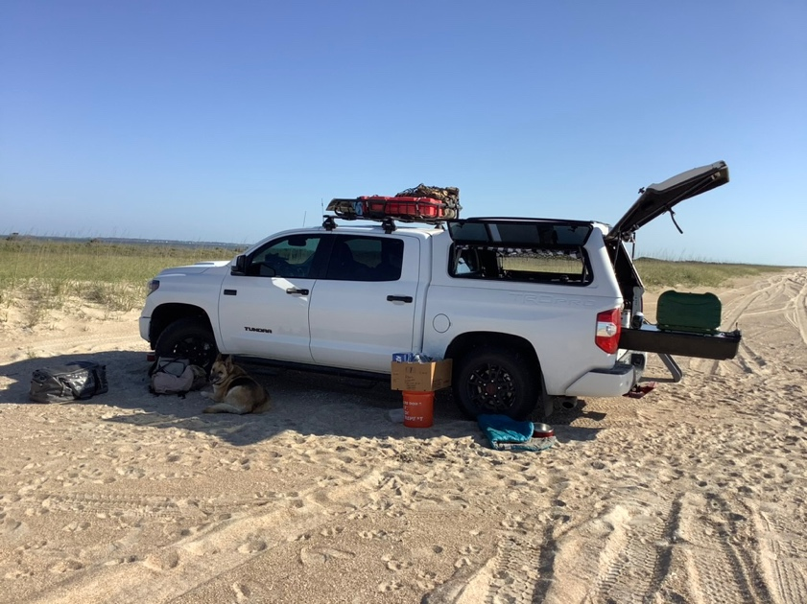
When it comes to maximizing the functionality of a pickup truck, few additions are as transformative as the camper shell. These structures, fixed to the truck bed, transform the vehicle into a mobile campsite, offering shelter, storage, and in some cases, full living amenities right in the truck's footprint. Truck camper shells are a testament to the ingenuity of outdoor enthusiasts who value the freedom to roam without sacrificing the comforts of home.

HISTORY

The origins of truck camper shells can be traced back to the post-World War II era. As roads improved and recreational travel became more popular in the 1950s and 1960s, adventurous souls began seeking ways to convert their trucks into makeshift campers. Early versions were rudimentary, often homemade structures built from wood or metal. Over time, these evolved into the professionally manufactured, feature-rich camper shells we see today, designed to fit seamlessly onto various truck models.

TYPICAL SIZE AND WEIGHT

Camper shells are designed to fit snugly onto the bed of a pickup truck, so their size is largely determined by the truck's dimensions. They can range from compact models for smaller trucks to extended versions for full-size pickups. The weight varies depending on materials and features, but most camper shells weigh between 100 to 500 pounds, with some fully-equipped models weighing considerably more.

BEST SUITED FOR

Truck camper shells are ideal for those who want a balance between mobility and comfort. They're popular among long-term travelers, overlanders, and anyone looking to explore off-the-beaten-path locations without the constraints of a larger RV or trailer. Their compact size makes them great for navigating tougher terrains and tight spots, all while providing a secure and comfortable sleeping area.

NOTABLE LIMITATIONS

While camper shells add significant versatility to a pickup truck, they also come with constraints. The added weight can affect the vehicle's fuel efficiency, handling, and payload capacity. Additionally, space is at a premium, making it crucial to optimize storage and living areas. Unlike larger RVs, amenities might be limited, and users may have to compromise on certain comforts.

MAJOR FOUL WEATHER CONSIDERATIONS

Camper shells offer a sturdy and weather-resistant shelter, making them suitable for various environments, from scorching deserts to chilly mountain terrains. However, their effectiveness during foul weather largely depends on the quality of the shell, its sealing, and insulation. Premium models offer robust weatherproofing, ensuring that occupants remain dry and warm even in heavy rain or snow.

STEALTH

One of the significant advantages of camper shells is their discretion. They don't stand out as much as traditional RVs or trailers, allowing users to camp in more urban or populated areas without drawing too much attention. The compactness and ability to blend in with everyday vehicles make them a favored choice for stealth camping.

ANECDOTE NOT TO BE CONFUSED WITH ANTIDOTE, THOUGH NOSTALGIA CAN SOMETIMES SERVE AS BOTH

Years ago, a young couple embarked on a cross-country road trip in their old pickup truck, equipped with a newly installed camper shell. They had poured their heart into customizing the interior, creating a cozy nest complete with a bed, curtains, and even a tiny kitchenette. One evening, while camped out in a forest clearing, they were caught in an unexpected rainstorm. As the rain poured down, they lay snugly inside their camper shell, listening to the rhythmic patter of raindrops on the roof. It was moments like these, they realized, that the camper shell was worth every penny. Not just a shelter, but a vessel of memories, adventures, and intimate moments in the heart of nature.

CHAPTER 10 - TRUCK SLIDE-IN CAMPERS

Venturing into the vast outdoors, many travelers seek a blend of mobility and the comforting embrace of a home away from home. Enter the truck slide-in camper, a self-contained unit that slides into the bed of a pickup truck. This innovation harnesses the power of adaptability, transforming a simple truck into an all-terrain RV, ready to tackle both highways and backroads with ease.

HISTORY

The truck slide-in camper traces its origins back to the 1940s and 1950s when the first commercial models started appearing in the U.S. market. As Americans grew more enamored with the allure of road trips, the need for versatile and compact camping solutions became evident. These early campers, though primitive by today's standards, marked the beginning of a love affair between the great American road and the freedom to camp anywhere the heart desired.

TYPICAL SIZE AND WEIGHT

The size and weight of slide-in campers depend on the design, features, and the size of the pickup they're intended for. Ranging from compact models for short bed trucks to more expansive ones for long bed trucks, they can weigh from 1,000 to 5,000 pounds or more. Modern campers come equipped with amenities like kitchens, bathrooms, and sleeping quarters, contributing to their weight.

BEST SUITED FOR

Truck slide-in campers are a boon for travelers seeking flexibility. They are particularly popular among off-grid adventurers, overlanders, and those with an inclination to wander without being tethered to established campgrounds. Whether you're beachcombing along the coast, navigating mountain trails, or traversing desert landscapes, slide-in campers provide a cozy respite at the end of a long day.

NOTABLE LIMITATIONS

While slide-in campers offer a bevy of benefits, they're not without their challenges. They can significantly alter a truck's center of gravity, potentially affecting handling, especially on rugged terrains. The added weight can strain the vehicle's suspension and decrease fuel efficiency. Furthermore, while they do offer more amenities than camper shells, space is still limited compared to larger RVs, necessitating thoughtful storage solutions and space-saving designs.

MAJOR FOUL WEATHER CONSIDERATIONS

Most slide-in campers are designed to withstand the rigors of various weather conditions. Their solid construction offers protection against rain, snow, and wind. Many come insulated, ensuring warmth in colder climates and some semblance of coolness in hotter ones. However, as with any camping solution, the effectiveness against inclement weather depends on the camper's quality and its maintenance.

STEALTH

Slide-in campers, while more conspicuous than camper shells, still maintain a certain level of discretion compared to full-sized RVs. When parked, they don't necessarily scream "campsite," allowing for more stealthy overnight stays in places where subtlety is a boon. This is especially true for models with a more streamlined design that closely matches the profile of the truck.

ANECDOTE NOT TO BE CONFUSED WITH ANTIDOTE, THOUGH A TASTE OF ADVENTURE CAN BE ITS OWN CURE

Insert story

CHAPTER 11 - TEARDROP TRAILERS AND PULL BEHIND CAMPER TRAILERS

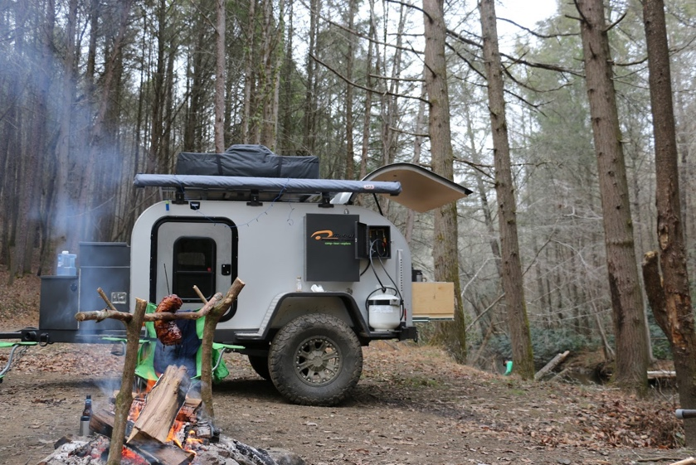
As wanderlust captures the hearts of many, the ways in which adventurers explore the great outdoors have diversified. Two popular means are teardrop trailers and typical pull behind camper trailers. While both offer unique advantages and embody the spirit of the open road, they cater to different tastes and requirements, each with its distinct charm.

HISTORY

Teardrop trailers first made their appearance in the 1930s, with their streamlined design and compact nature making them an instant hit among road-trippers of that era. Magazines even offered DIY plans, allowing enthusiasts to craft their very own teardrop trailers. On the other hand, the larger pull behind camper trailers, often termed as "caravans" outside North America, have a lineage dating back to the late 1800s and early 1900s, initially used by showmen and circus performers as mobile homes.

TYPICAL SIZE AND WEIGHT

Teardrop trailers are defined by their compactness. Averaging around 4 to 6 feet in width, 8 to 10 feet in length, and with a weight of 500 to 1,200 pounds, they're designed for minimalistic travel. Pull behind camper trailers, conversely, can vary significantly in size, ranging from 10 to 35 feet in length, and can weigh anywhere from 1,500 to 8,000 pounds or more. They are built to offer more amenities, resembling a home on wheels.

BEST SUITED FOR

Teardrop trailers are ideal for solo travelers or couples seeking a simple, lightweight solution for weekend getaways or longer road trips where the journey is as significant as the destination. Their small footprint allows them to be towed by most cars and be maneuvered with ease.

Pull behind camper trailers, given their larger size and broader range of amenities, are suited for families or those desiring extended stays with the comforts of home. They often come equipped with full kitchens, bathrooms, and sleeping areas, making them perfect for more extended vacations or even full-time living.

NOTABLE LIMITATIONS

The teardrop's charm lies in its simplicity. However, this means sacrificing certain amenities. Their cozy interiors primarily offer a sleeping space, and maybe a basic kitchenette accessible from the rear. Larger pull behind campers, with all their amenities, demand a suitable towing vehicle and can be trickier to navigate, especially in tighter spaces or off-road settings.

MAJOR FOUL WEATHER CONSIDERATIONS

Teardrop trailers, with their limited space, can be cozy during inclement weather but might feel confining if the weather forces occupants indoors for prolonged periods. On the bright side, their streamlined shape makes them fairly resistant to winds. In contrast, the more spacious pull behind campers offer ample room to move around, entertain, or even cook a meal inside, making them more comfortable during extended rainy or snowy days.

STEALTH

When it comes to blending in, teardrop trailers, due to their petite size, are less conspicuous, making them a bit more stealthy for overnight stays in varied locales. Larger pull behind campers, with their more pronounced presence, might stand out more in certain settings.

ANECDOTE NOT TO BE CONFUSED WITH ANTIDOTE, THOUGH ADVENTURE IS OFTEN THE BEST MEDICINE

rewrite

CHAPTER 12 - CAMPER AND SPRINTER VANS

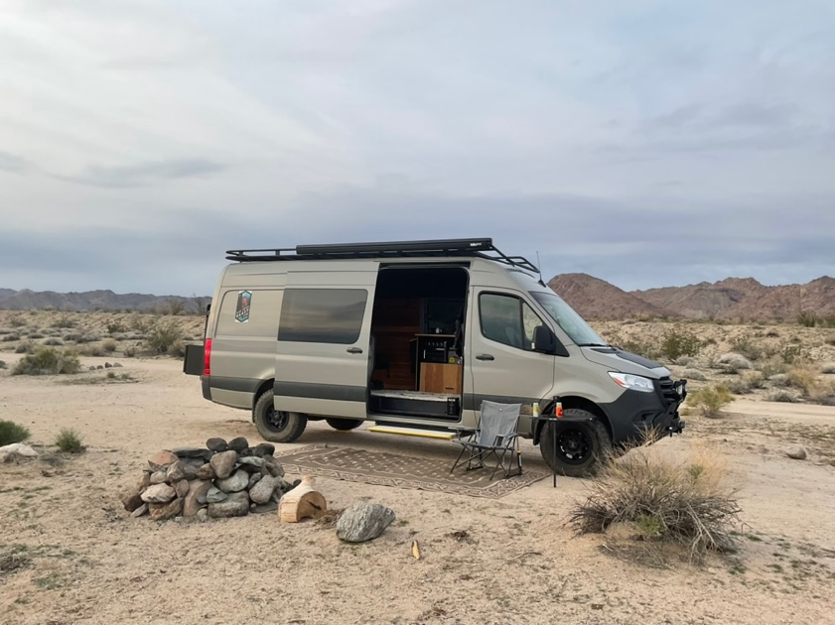
As travel landscapes evolve and wanderlust remains an evergreen sentiment, there's an increasing draw towards self-sufficient, mobile dwellings that grant both freedom and comfort. In this milieu, camper and Sprinter vans have emerged as powerful contenders, distinct from the typical RV setup. These vehicles provide a synthesis of mobility, off-grid capabilities, and efficiency that makes them a choice pick for modern explorers.

HISTORY

The romance with camper vans started back in the 1950s and 60s, with the iconic Volkswagen Type 2 leading the charge. They became not just vehicles, but symbols of an unbridled, free-spirited lifestyle. Sprinter vans, introduced by Mercedes-Benz in the 1990s as utility vehicles, soon morphed into adventurers' favorite canvases, transformed into mobile homes equipped for both comfort and journeying to the unknown.

TYPICAL SIZE AND MOBILITY

Generally smaller than RVs, camper and Sprinter vans range from about 17 to 24 feet in length. This compactness offers unparalleled mobility. Whether it's winding mountain roads, narrow city streets, or tucked-away camping spots, these vans maneuver with an agility RVs often can't match.

BEST SUITED FOR

These vans are perfect for those prioritizing mobility and spontaneity. Their smaller footprint allows for stealthy urban camping and easier access to remote locations. The customization options cater to off-grid enthusiasts, with many vans boasting solar panels, efficient batteries, and water filtration systems. And, for those with a penchant for rugged terrains, several models offer 4x4 capabilities.

NOTABLE LIMITATIONS

While they excel in many areas, camper and Sprinter vans might feel cramped for some, especially during extended travels. Storage can be limited, and unlike larger RVs, there might be a trade-off between amenities. The initial investment for a well-outfitted van can also be steep.

MAJOR TRAVEL CONSIDERATIONS

Fuel efficiency is a significant upside. These vans often deliver better miles per gallon compared to larger RVs, ensuring longer stretches between refuels. But it's also vital to be aware of the weight added with modifications; overloading can affect performance and safety.

DISTINCTION FROM RVs

Though both provide mobile living solutions, camper and Sprinter vans differ from RVs in several ways. Their compactness affords them better fuel efficiency and greater mobility. The potential for off-grid setups and 4x4 capabilities sets them apart. And while RVs might offer a more "home-like" feel, vans often provide a closer connection to the surrounding environment, bridging the gap between indoor comfort and outdoor adventure.

STEALTH

One of the notable features of these vans is stealth camping. Their unobtrusive profile, especially when compared to larger RVs, makes it easier to blend into urban settings or secluded spots, providing a quiet, undisturbed night's sleep.

ANECDOTE

Insert story

CHAPTER 13 - RVS AND BUSES

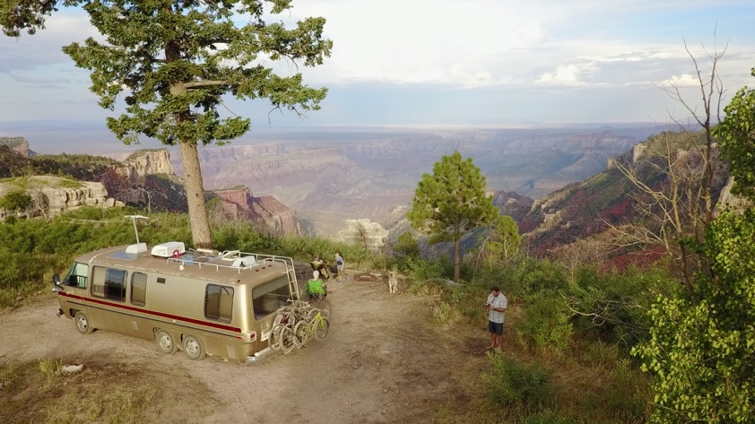
When it comes to hitting the open road, with all the comforts of home in tow, RVs and converted buses have become emblematic of expansive, self-contained travel. These vehicles, with their size and range of amenities, offer a unique blend of mobility and luxury, providing travelers with a way to explore without ever leaving "home" behind.

HISTORY

Recreational vehicles (RVs) have a long history, with origins that can be traced back to the early 20th century. Initially, they were simple campers attached to cars, but they've evolved dramatically. The 1960s and 70s marked a surge in their popularity in America, coinciding with a booming highway infrastructure and a growing middle class. Buses, while initially meant for public transport, began to be seen as potential mobile homes by the 1980s, with many choosing to convert old school buses (affectionately termed "Skoolies") into custom living spaces.

TYPICAL SIZE AND MOBILITY

RVs come in various sizes, from compact Class B campervans to the more massive Class A motorhomes that can stretch up to 45 feet in length. Buses, especially when considering full-size school or city buses, can be similar in size to Class A RVs. This size offers a spacious living area but can also mean reduced mobility, making it challenging to navigate narrow roads or densely populated areas.

BEST SUITED FOR

Families, retirees, or anyone seeking extensive road trips with minimal compromises on living space and amenities often gravitate towards RVs and buses. Their size allows for larger kitchens, bathrooms, and even entertainment areas, making long-term travel more comfortable.

NOTABLE LIMITATIONS

The size that provides comfort can also be a hindrance. RVs and buses can be challenging to maneuver, particularly in tight spaces. They also come with higher fuel consumption and often require specialized maintenance. Campsites or parking areas that can accommodate their bulk might also be limited.

MAJOR TRAVEL CONSIDERATIONS

Driving an RV or a bus requires more attention to road conditions, overhead clearances, and turn radii. Additionally, these vehicles are not always suited for impromptu off-road excursions. Planning ahead for stops, campsites, and fuel is paramount.

DISTINCTION FROM VANS

Unlike camper and Sprinter vans, which are built for agility and efficiency, RVs and buses lean more towards providing expansive living spaces. They may lack the stealth and off-grid capabilities of vans but make up for it in comfort and amenities.

STEALTH

Given their prominent size, RVs and buses don't offer much in the way of stealth. They're easily recognizable and are better suited for designated camping grounds or RV parks than discreet urban camping.

ANECDOTE

Insert story

CONCLUSION

The quest for shelter is as old as humanity itself. Whether seeking refuge from the elements or crafting a temporary home amidst wanderlust-filled adventures, the spaces we inhabit reflect our needs, our technology, and our connection to the environment around us. This book has journeyed through the vast tapestry of shelter options, from the simplest ground covers to mobile homes that encapsulate modern luxury on the move.

We've traversed the annals of history, seeing how ancient civilizations used rudimentary materials like leaves and animal skins, evolving to today's technologically advanced and often environmentally-conscious options. The humble poncho and tarp, reminiscent of bygone eras, highlight adaptability and minimalism. In contrast, the grandeur of RVs and converted buses showcases the human desire for comfort without boundaries.

Each shelter type, with its unique features, advantages, and limitations, offers a lens into the priorities and preferences of its users. The stealth and mobility of hammocks and bivy sacs appeal to the wilderness wanderer. At the same time, the security and expansiveness of camper vans or teardrop trailers resonate with those seeking a balanced blend of the familiar and the adventurous.

What binds all these varied shelters together is the age-old human spirit of exploration and adaptability. Our environments, terrains, and circumstances might differ, but the core pursuit remains the same: to find a place of solace, safety, and, at times, a hint of serendipity.

As you close this book, may you be inspired not only by the myriad of shelter options available but also by the underlying stories they tell. Stories of innovation, resilience, and the timeless human yearning to explore, all while knowing there's a cozy corner waiting, wherever the journey leads.

May your adventures be boundless, and your shelters, no matter their form, always feel like home.

Useful Resources for Further Exploration

The journey into the world of shelters and outdoor living is an expansive one. To further your knowledge and make informed decisions, it's essential to delve into a variety of resources that cater to both novices and seasoned explorers. Here are some curated resources to kickstart or enhance your exploration:

Books:

The Camper's Guide" by Samantha Green: A comprehensive look into the nuances of camping, from selecting the right shelter to mastering the art of campsite cooking.

"History of Mobile Dwellings" by Jonathan Redwood: Dive deep into the evolution of mobile shelters, from ancient nomadic tents to modern-day RVs.

Websites:

CampingWorld.com: One of the largest online retailers for camping gear, offering a wide variety of tents, campers, and related accessories.

RoofTopTentGuide.com: A dedicated site offering reviews, tutorials, and insights specifically for rooftop tent enthusiasts.

YouTube Channels:

"Big Sexy Beast Adventures": Join the hosts as they embark on thrilling expeditions, reviewing various shelters and sharing invaluable tips along the way.

"Nomadic Chronicles": Delve into the world of mobile living with comprehensive guides, reviews, and personal anecdotes.

Apps:

Campsites Near Me: Locate campgrounds and understand the type of shelters best suited for each site.

VanLife Locator: Aimed at the camper van community, find safe overnight parking spots, amenities, and user reviews.

iOverlander: A globally recognized tool used by overlanders and campers. Locate places to stay, amenities, and read user reviews.

Park4Night: Widely used in Europe, discover places for overnight parking, ranging from official campgrounds to serene spots, complete with user photos and reviews.

Podcasts:

"On the Road Again": Weekly episodes delve into traveler stories, gear reviews, and expert interviews focused on the mobile dwelling community.

By immersing yourself in these resources, you'll gain a comprehensive understanding of the multifaceted world of shelters, equipping yourself with the knowledge to make your outdoor adventures both safe and memorable.

