Drought Vulnerability Assessment and mapping using Multi-criteria Decision Making (MCDM) and Application of Analytical Hierarchical Process( AHP) for watershed area of Lake Bolsena of Central Italy.

Abstract
Drought is an unique natural disaster as it has a slow onset, evolves over months or even years, affects a large spatial extent, recurring in nature and yet cause little structural damage. Multi-criteria decision analysis (MCDA) provides a rich collection of techniques and procedures for structuring decision problems, designing, evaluating and prioritizing alternative decisions (Malczewski, 2006). Among the collection of techniques, one of the most promising techniques is the pairwise comparison method developed by (Lakshmi et al., 2021) in the context of a decision-making process known as the Analytic Hierarchy Process (AHP). In the present study, ten parameters, namely, monthly rainfall, elevation, LULC, (stream power index)SPI, soil, NDTI, NDWI, NDVI, and NDCI were chosen for drought risk assessment in the watershed area of lake Bolsena for the year 2022 which is one of the highest draught driven year in the history of the country and the related datasets were used for the development of the study. The Drought severity map of the area is classified as severe, moderate, and mild drought. Based on the parameters chosen, the drought severity map shows that 39% of the total area of Bolsena Lake District is classified under severe drought category. 40% of the area is classified as mild drought area, and 21% of area experiences moderate drought category. AHP with GIS provides a good solution for drought risk modeling. Hence, from this study, it is learned that the assessment of the spatial distribution of drought and mapping of any region is feasible with proposed datasets and methods suggested in the study and helps in alleviating the severity of the drought using various parameters and to tackle with drought management initiatives.
Introduction
Draught is one of the major climate emergencies that we currently facing right now. Italy has had eight episodes of severe drought since 2000. The losses to the country's economy from the agriculture sector alone during the 2000 drought ranged from 0.5 billion euros to over 6 billion euros. Over 20 billion euros are projected to be spent on public and private damages during emergencies.
Differences in hydro meteorological variables and socioeconomic factors as well as the stochastic nature of water demands in different regions around the world have become an obstacle to having a precise definition of drought. (Abdelaziz Belal Belal et al, 2014) stated that widely diverse views of drought definitions are one of the principal obstacles to investigations of droughts.
A drought is a complex phenomenon that can be defined as the shortage of water which in turn affects availability of food and fodder, thereby leading to displacement and loss to economies as a whole. On the other hand, drought is a normal, recurrent feature of climate, although often erroneously considered an unexpected and extraordinary event.
Droughts can also pose a serious threat to food security. Droughts can affect agriculture in a region and can have devastating effects that change crop yield and production and may vary depending on the crop type, growth, and conditions prevailing in the region (R.L. Ray et. al, 2018). Composite and nano-particles have immense potential in alleviating the drought conditions existing in the crops as observed in (N. Taran, et. al, 2017) monitoring droughts is a difﬁcult as it is a complex phenomenon dependent on several parameters. Drought in a region may set in due to lack of precipitation or temperature and humidity (meteorological drought),or due to the changes in the availability of surface or groundwater (hydrological drought), or due to changes in land use/land cover, soil texture and moisture, and its slope leading to water insufﬁciency thereby affecting crop health, growth and production subsequently (agricultural drought), and ﬁnally, population density and the economic status in a region (socio-economic drought).
As the remote sensing technology makes more and more process, with the development of geographic information system (GIS) and Global Positioning System, the real-time monitoring of drought over the large areas can be achieved. Remote sensing and GIS techniques are increasingly being regarded as a useful drought detection techniques, as evidenced by its use across many parts of the world. Some indices developed from the remote sensing data, such as the Normalized Difference Temperature Index (NDTI), Normalized Difference Chlorophyll Index (NDCI), and Normalized Difference Water Index (NDWI) etc., have been used to monitor the droughts. (Wang et al. 2003) developed the Vegetation Temperature Condition Index (VTCI) based on the information of the LST versus the NDVI scatter plot falling into a triangular shape. It is testified that the VTCI index can be used to effectively monitor the drought of an area in the real time. The objective of this review paper is to provide the reader with useful information about impacts of drought, drought risk evaluation methods using GIS and remote sensing techniques, and finally, drought indices (NDTI, NDWI, NDCI etc.). Lake Bolsena and its surrounding watershed in Central Italy are particularly vulnerable to drought events, necessitating effective drought vulnerability assessment and mapping strategies. This paper presents a novel approach utilizing Multi-Criteria Decision Making (MCDM) techniques, specifically the Analytic Hierarchy Process (AHP), to assess and map drought vulnerability in the Lake Bolsena watershed.
- Study Area
Lake Bolsena (Italian: Lago di Bolsena) is a lake of volcanic origin in the northern part of the province of Viterbo called Alto Lazio ("Upper Latium") or Tuscia in central Italy. It is the largest volcanic lake in Europe and holds tremendous cultural and social values. Roman historic records indicate activity of the Vulsini volcano occurred as recently as 104 BC; it has been dormant since then. The water body surface is about 114 ${km}^{2}$. The lake has no tributaries, and the only effluent is the Marta River
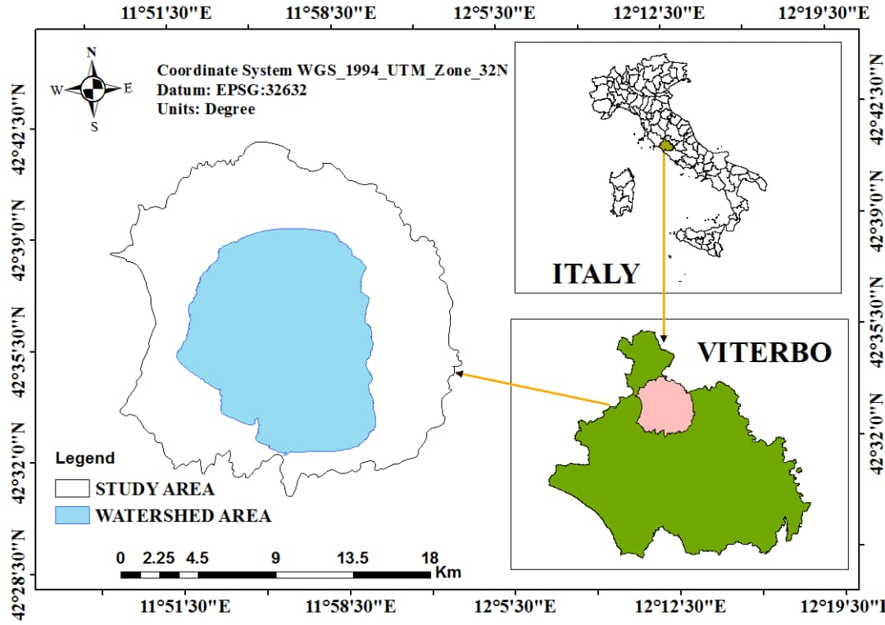

Fig. 1 District map of Lake Bolsena.

2.1. Geography and demography
The catchment area of the Bolsena Lake (42° 35’41.05” N; 11° 56’11.39” E) is in the northern part of the Lazio Region, in Central Italy and presents an area of 271 ${km}^{2}$. Lake Bolsena has an elliptical shape with a maximum depth of 151 m and a perimeter of 44 km. The entire lake is surrounded by hills on the flanks and summits of which are the community. The watershed was home to 22,000 permanent residents in 2004, and 35,000 in the summer season. [5]
2.2. Soil map
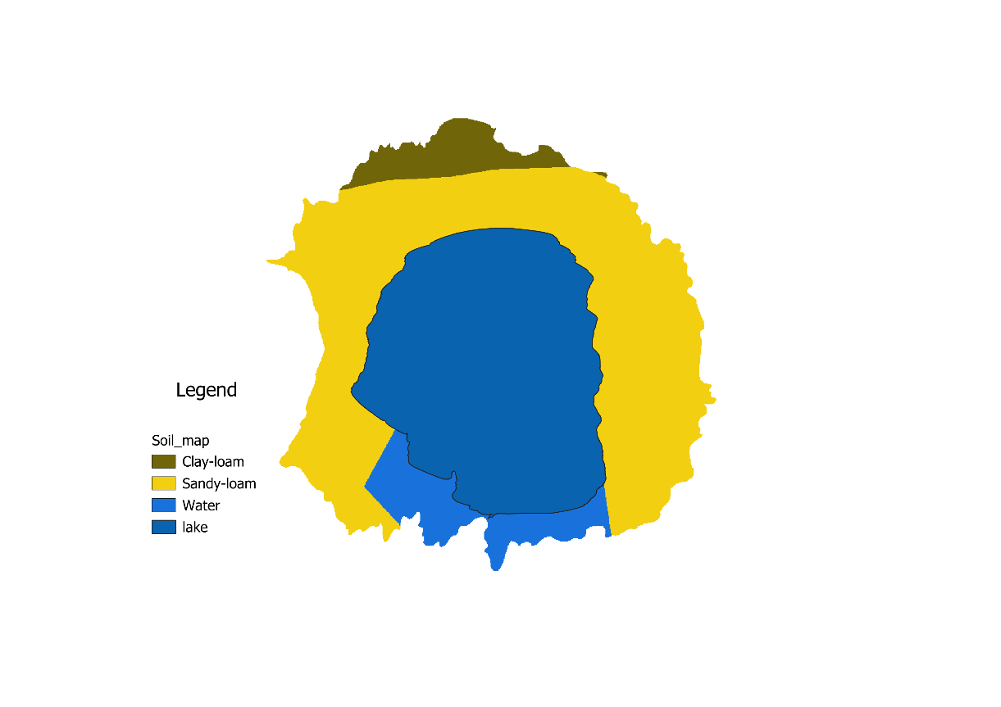
The study region is predominantly covered by clay, loamy and sandy soil. The soil map of the study area is shown in Fig. 2. The areas of different types of soil present in the study area are summarized.

Fig. 2 Soil map

  - Elevation
Figure 3 shows the elevation of the study area, the map indicates the area with higher and lower altitude of 686m and 302m respectively. Therefore, high areas with gentle or flat area were influenced in drought severity.
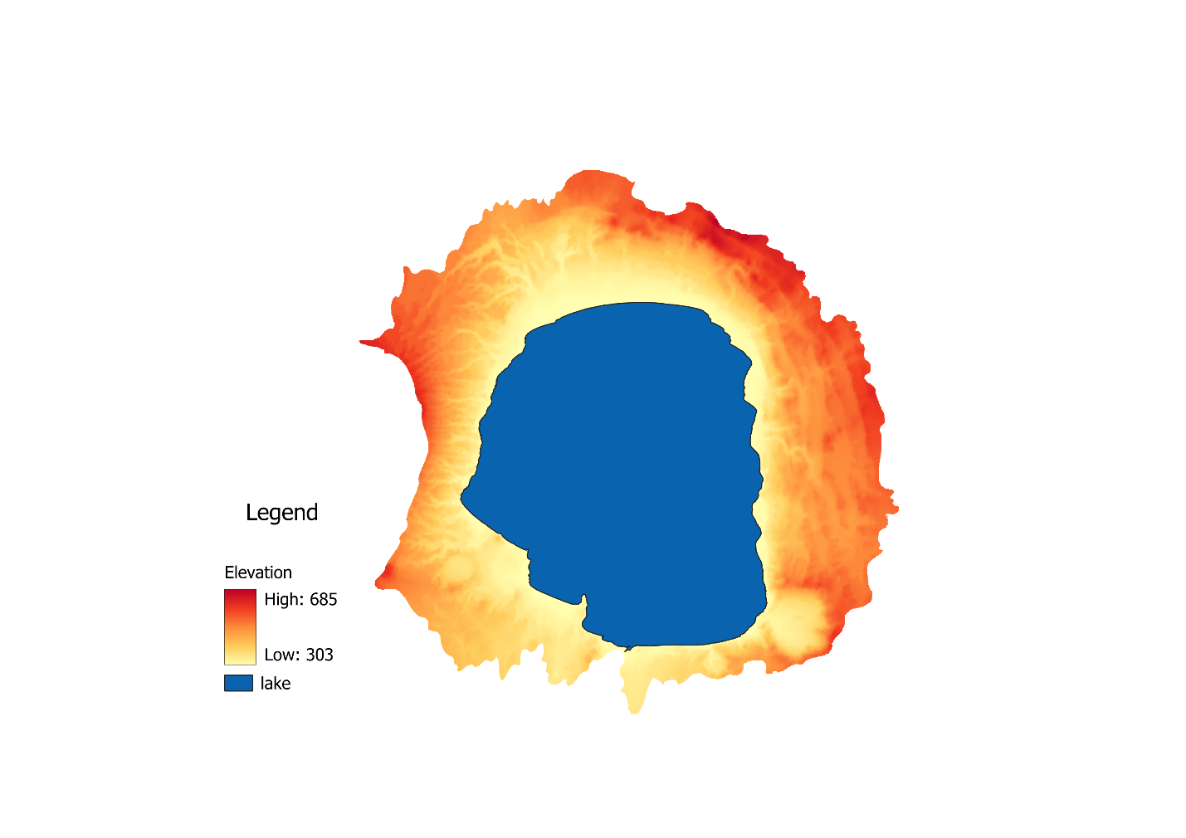
Fig. 3 Elevation map
  - Rainfall
We collected the daily and monthly rainfall fall data for the entire year and we found that the month November is the driest month in the entire year and we consider the monthly rainfall data for the three rainfall station data surrounding the watershed namely Marta ,San Lorenzo Nuovo and Valentano and prepared an Rainfall map for the study area.
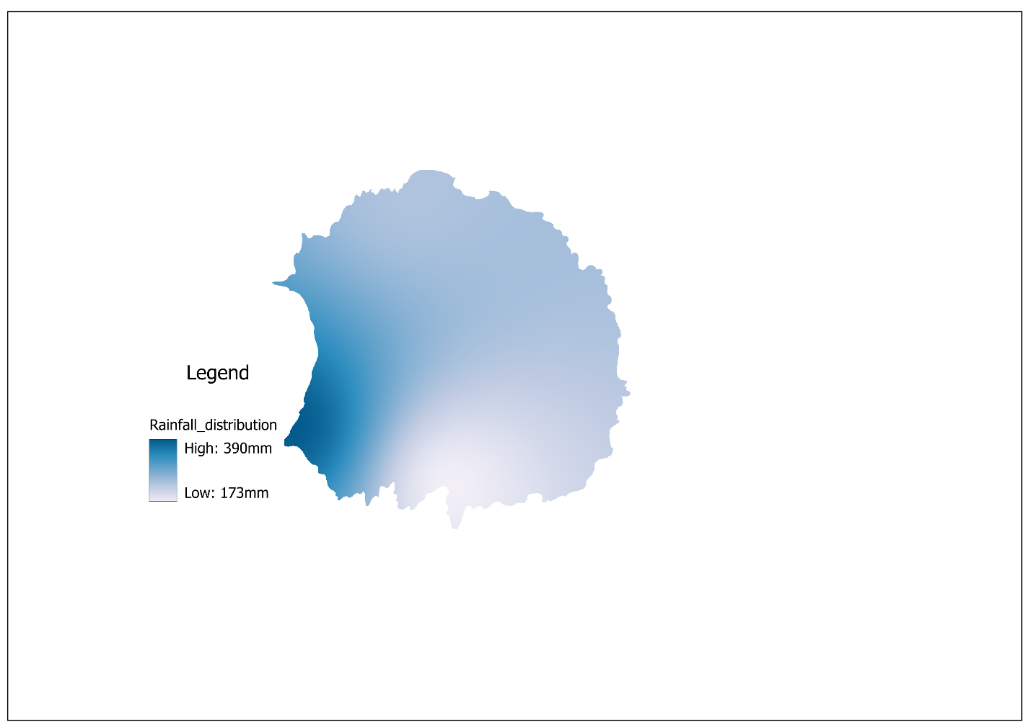
Fig. 4 Rainfall map
  - Remote Sensing Indices _NDTI, NDVI, NDWI, NDVI

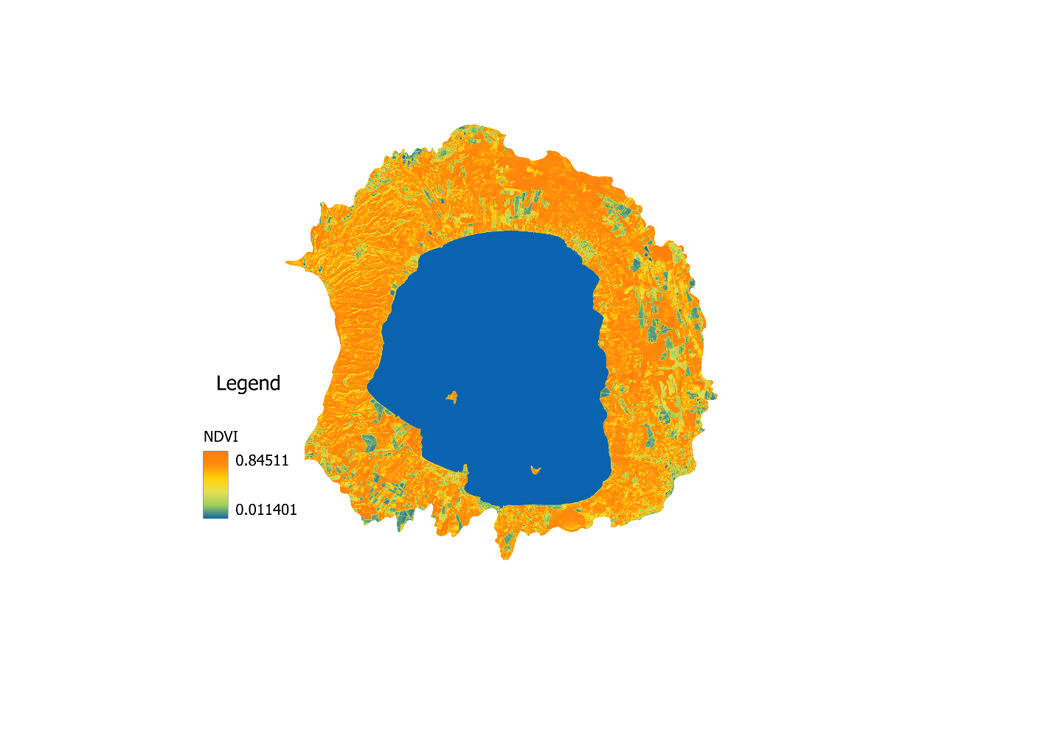

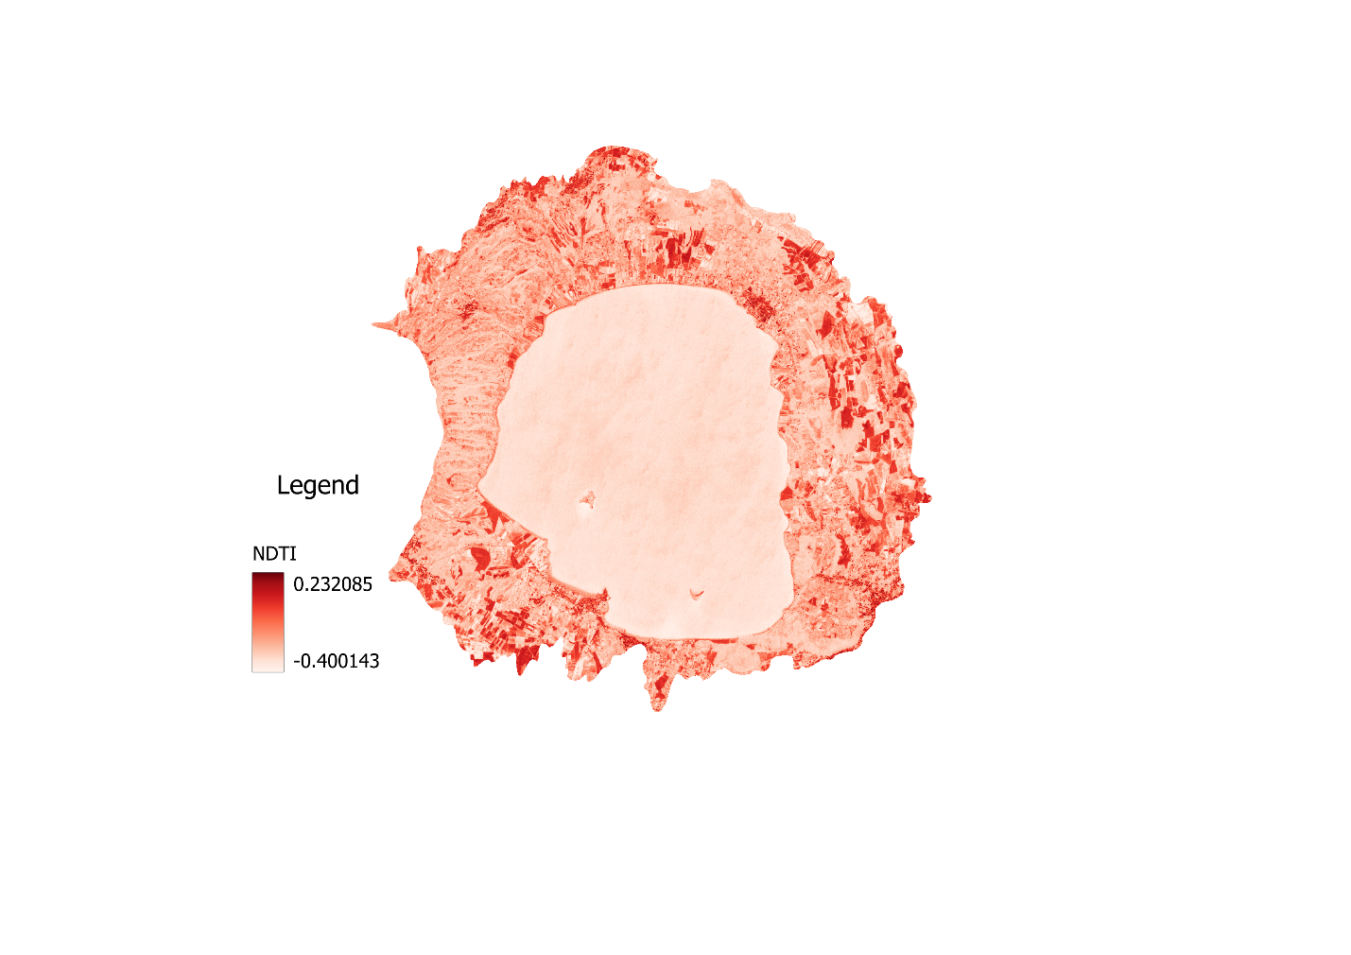

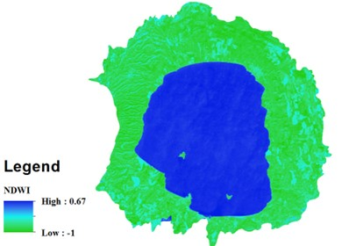

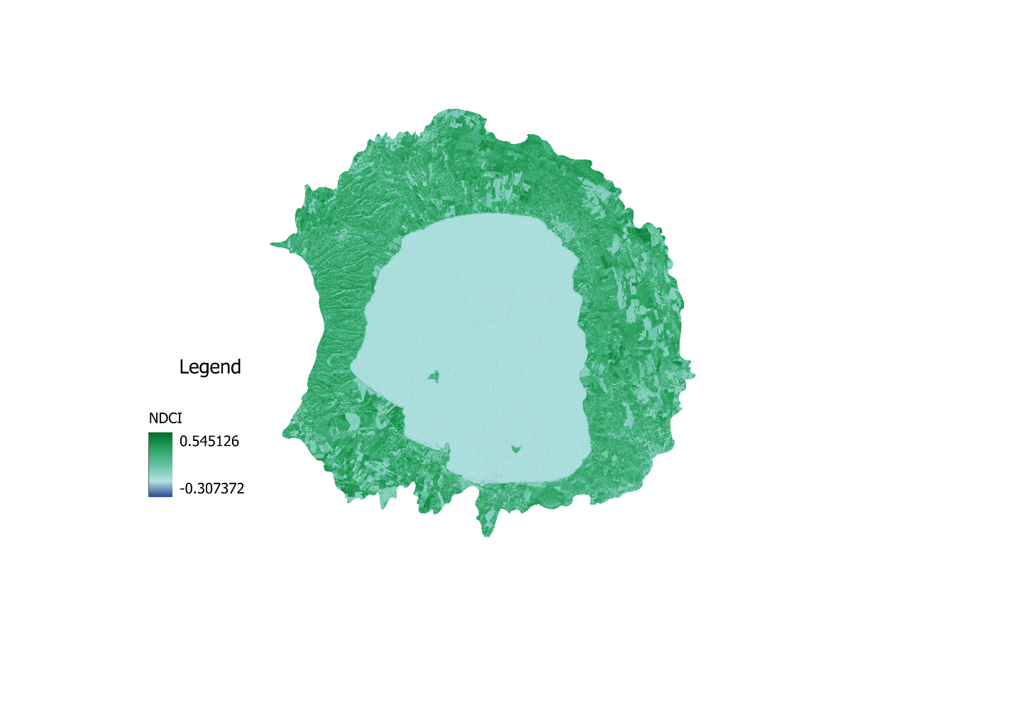
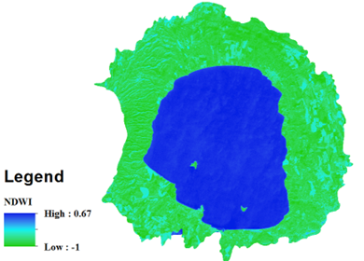

Fig. 5 (a) NDCI (b) NDTI (c) NDWI, NDVI map
  - Stream power index_(SPI)

In this study we also consider The Stream Power Index (SPI) which serves as a crucial metric in hydrology and geomorphology, offering insights into the erosive potential of flowing water within stream and river systems. By integrating factors such as stream discharge, slope, and channel width, the SPI provides a comprehensive assessment of water's ability to transport sediment and shape landscapes over time. This index aids in understanding channel morphology, predicting channel changes under varying hydrological conditions, and guiding river management strategies, including restoration efforts and erosion control measures
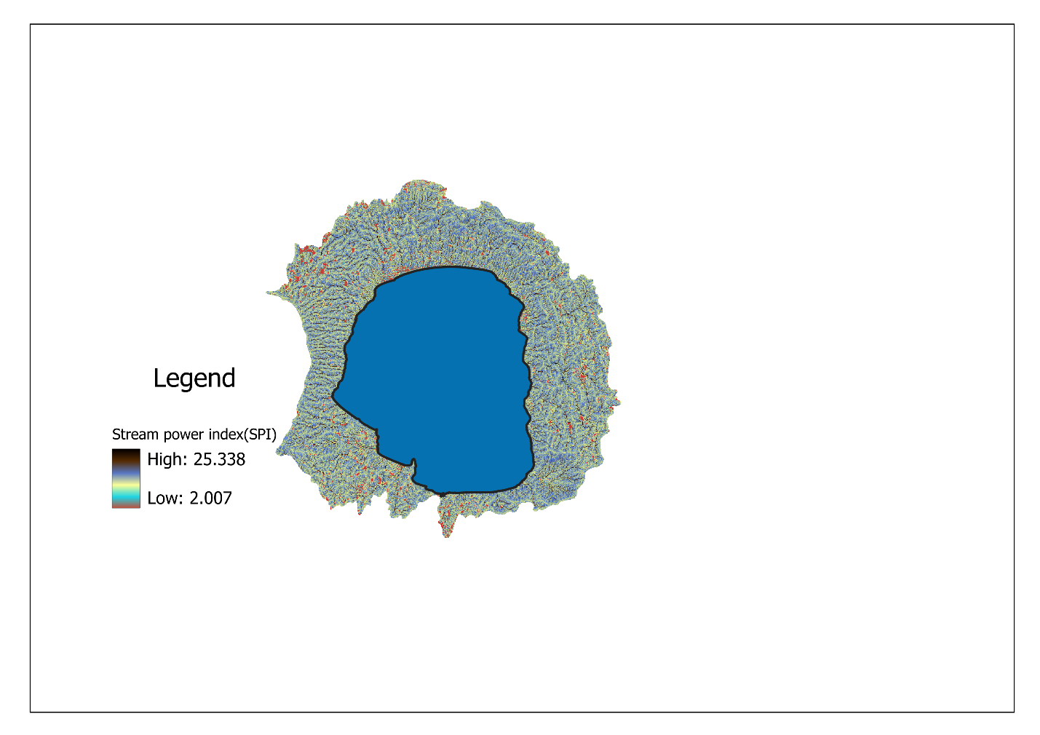

LULC

Figure 6 SPI map
  - Land Use Land Cover (LULC)
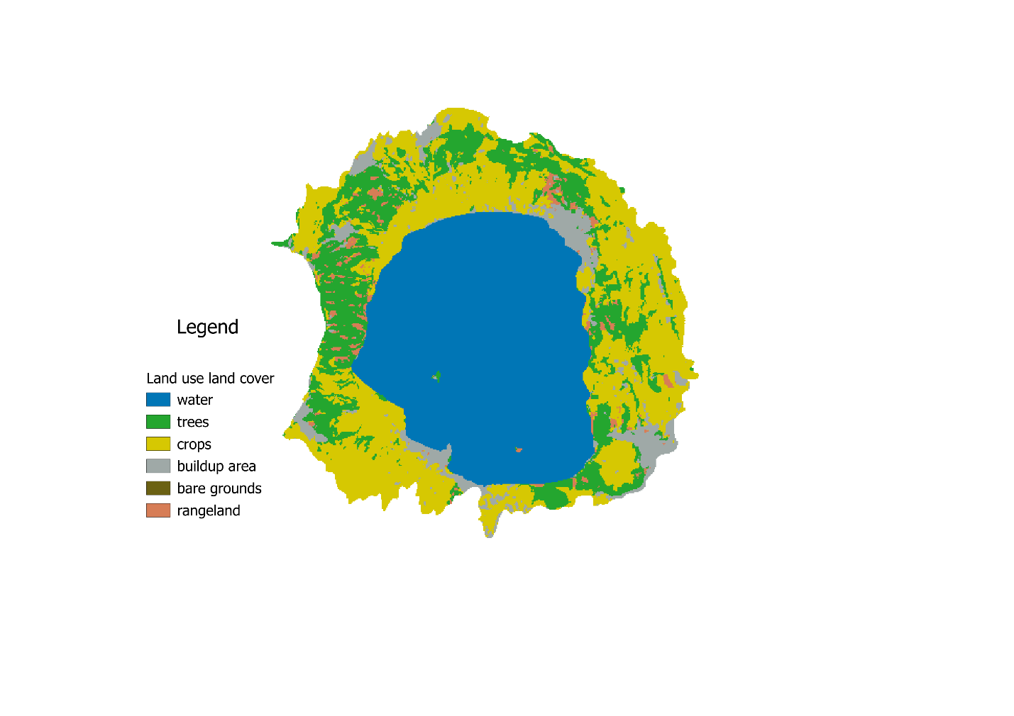

Fig. 6 LULC map
- Methodology
  - Weighted Overlay Analysis
The weighted overlay process consists of three conceptual steps. First, each raster layer is assigned a percentage weight (the criteria weights determined in the AHP), to underscore the relative importance of each layer in the analysis. Second, the values within each raster layer are ranked (suitability scale) to allow comparison of the different types of information in each raster layer and then third, all raster layers in the analysis are overlaid. The ranking value of individual raster cells is multiplied by its layer weight and totaled with the values of other raster cells it overlays. In ranking step, every criterion used to carry out the Drought Severity map such as was ranked in the order of preference. There are two typical ways of ranking; straight ranking (that is; most important = 1, least important = 9) or the inverse ranking (most important = 9, least important = 1). The ranking applied to this analysis corresponds to the level of drought, which are, very high = 1; high = 2, moderate = 3; low = 4 and very low = 5
AHP is used to GIS is then used to produce spatial–temporal maps of the factors indicative of the vulnerable zones [27].In the present study, nine parameters namely, monthly rainfall, elevation, LULC, NDVI, SPI, soil, NDTI, NDWI, and NDCI were chosen for drought risk assessment and the related datasets were used for the development of the study [28]. These maps are then categorized into various intensities of drought risk based on the calculated weights. The parameters are then ranked according to their importance in classifying the study area into various drought categories (Table 2). The computations are made in two stages. The ﬁrst stage is to determine the weightage of the factors considered with the help of AHP using pairwise matrices and the second stage is to generate maps showing various drought categories using GIS.

Table 1 Rating each parameters according to drought intensity
Parameters | Categories | Potential for Drought | Ranking from (1-5)  1= v. high, 5= v.low
NDTI | -0.027451 - 1 | 1 | Very high
NDTI | -0.129412 - -0.027451 | 2 | High
NDTI | -0.215686 - -0.129412 | 3 | Moderate
NDTI | -0.286275 - -0.215686 | 4 | Low
NDTI | -1 - -0.286275 | 5 | Very low
NDCI | 0.278431 - 1 | 1 | Very high
NDCI | 0.152941 - 0.278431 | 2 | High
NDCI | 0.003922 - 0.152941 | 3 | Moderate
NDCI | -0.082353 - 0.003922 | 4 | Low
NDCI | -1 - -0.082353 | 5 | Very low
ELEVATION | 551 – 686 | 1 | Very high
ELEVATION | 483 – 551 | 2 | High
ELEVATION | 410 – 483 | 3 | Moderate
ELEVATION | 339 – 410 | 4 | Low
ELEVATION | 302 – 339 | 5 | Very low
NDWI | -1 - -0.547077 | 1 | Very high
NDWI | -0.547077 - -0.422359 | 2 | High
NDWI | -0.422359 - -0.258256 | 3 | Moderate
NDWI | -0.258256 - 0.181538 | 4 | Low
NDWI | 0.181538 - 0.673846 | 5 | Very low
SOIL | Andosols | 2 | High
SOIL | Planosols | 4 | Low
LULC | Construction site | 2 | High
LULC | Green urban area | 3 | Moderate
LULC | Pasture | 2 | High
LULC | Irrigated land | 3 | Moderate
LULC | Agricultural land | 3 | Moderate
LULC | Permanent crop | 3 | Moderate
LULC | Lake | 4 | Low
RAINFALL | 173.642 - 221.046 | 1 | Very high
RAINFALL | 221.046- 265.911 | 2 | high
RAINFALL | 265.911 - 320.934 | 3 | Moderate
RAINFALL | 320.934- 389.502 | 4 | low
NDVI | 0.663866 - 1 | 1 | Very high
NDVI | 0.501594 - 0.663866 | 2 | High
NDVI | 0.281368 - 0.501594 | 3 | Moderate
NDVI | -0.060562 - 0.281368 | 4 | Low
NDVI | -0.477833 - -0.060562 | 5 | Very low
SPI | 18.8454 - 27.265278 | 1 | Very high
SPI | 16.136454 - 18.8454 | 2 | High
SPI | 14.434389 - 16.13645 | 3 | Moderate
SPI | 9.459655 - 14.434389 | 4 | Low
SPI | 2.007833 - 9.459655 | 5 | Very low

Table 2 Weights computed and assigned to the parameters.
Parameters | Weighted %
Rainfall | 15
LULC | 12
Soil | 8
SPI | 7
NDVI | 17
NDTI | 10
NDWI | 8
NDCI | 10
Elevation | 13
TOTAL | 100

Parameter | NDVI | Rainfall | Elevation | LULC | NDTI | NDCI | NDWI | SOIL | SPI
NDVI | 1 | 5 | 1 | 2 | 3 | 1 | 1 | 1 | 1
Rainfall | 0.2 | 1 | 4 | 3 | 3 | 1 | 1 | 1 | 1
Elevation | 1 | 0.25 | 1 | 3 | 3 | 2 | 1 | 1 | 1
LULC | 0.5 | 0.33 | 0.33 | 1 | 3 | 4 | 2 | 2 | 1
NDTI | 0.33 | 0.33 | 0.33 | 0.33 | 1 | 3 | 4 | 2 | 1
NDCI | 1 | 1 | 0.5 | 0.25 | 0.33 | 1 | 3 | 2 | 3
NDWI | 1 | 1 | 1 | 0.5 | 0.25 | 0.33 | 1 | 2 | 2
SOIL | 1 | 1 | 1 | 0.5 | 0.5 | 0.5 | 0.5 | 1 | 3
SPI | 1 | 1 | 1 | 1 | 1 | 0.33 | 0.5 | 0.33 | 1

DATA

NDTI, NDCI, NDWI, NDVI, SPI, SOIL, RAINFALL,
ELEVATION, LULC

RECLASSIFICATION OF THE PARAMETERS

WEIGHTED OVERLAY

DROUGHT SEVERITY MAP

Fig. 8 Flow chart
- Result and Discussion
In this study, nine pairwise comparison matrices were developed, one for the criteria with respect to the goal. The criteria listed on the left are one by one compared with each criterion listed on top depending on which one is more important with respect to the goal (determination of drought risk areas). Finally, the rankings of the alternatives against the nine parameters were obtained. The weights for each matrix were obtained using eigenvalue method.
The Drought severity map was classified as severe, moderate, and mild drought. Based on the parameters chosen, the drought severity map shows that 39% of the total area of bolsena Lake district is classified under severe drought category. 40% of the area is classified as mild drought area, and 21% of area experiences moderate drought category. Hence, results of statistical evaluation show that major part of the study area region experienced moderate drought severity.
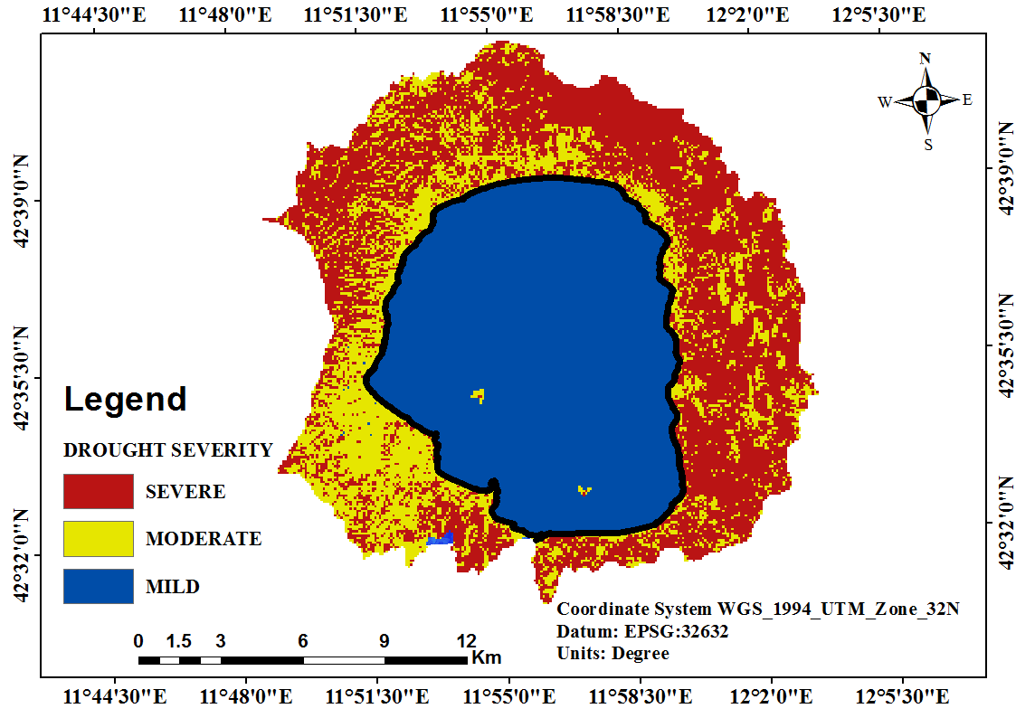
Fig. 8 Drought Severity map

Fig. 9 Drought Severity statistics
The drought risk map thus generated using AHP and GIS effectively indicates the portion of the lake with less intensity of drought which conforms well to the actual scenario. The study can be further explored by generation of temporal drought severity map using different dated LULC map and incorporation of various agricultural drought indices as one of the parameters. The climatic data also contribute to the drought vulnerability in the region. Hence, others factors such as SPI, NDVI, LULC, NDTI, NDCI, NDWI, elevation soil, play a vital role in assessment and vulnerability drought prone zones in the study region. The present drought study was carried out using AHP and GIS which provides useful insight on drought monitoring. Weighted overlay analysis for the drought mapping was carried out and in comparison; AHP provides a robust and accurate method of mapping drought in the district.
- Conclusion
This paper presents a novel approach utilizing Multi-Criteria Decision Making (MCDM) techniques, specifically the Analytic Hierarchy Process (AHP), to assess and map drought vulnerability in the Lake Bolsena watershed. The proposed methodology was applied to the district to test its feasibility of the derived drought-prone map. The output of the combined approach proves successful in producing the drought map. The present study aimed to evaluate the spatial extent and characteristics of drought with the help of AHP in combination with GIS. Weights for each parameter are evaluated using pairwise comparison method (AHP). GIS techniques provide a suitable framework for integrating and analyzing the nine parameters and ﬁnally help to generate the drought risk assessment map by incorporating the weights and rating.
The area with mild drought is found to dominate the majority portion 40% of the study area. Entire lake areas were found to be reeling under mild drought. The model provides an overall idea of drought risk associated with the district in block level. Thus AHP with GIS provides a good solution for drought risk modeling. Hence, from this study, it is learned that the assessment of the spatial distribution of drought and mapping of any region is feasible with proposed datasets and methods suggested in the study and helps in alleviating the severity of the drought using various parameters and to tackle with drought management initiatives.
Limitations and Future Research: Address any limitations of the study such as data availability, uncertainties in criteria weighting, or model assumptions. Propose avenues for future research to refine the methodology and improve the accuracy of drought vulnerability assessment.

REFERENCES
- Lakshmi, V., Radha, R., & Nallanathel, M. (2021). Materials Today : Proceedings Drought vulnerability assessment and mapping using Multi-Criteria decision making ( MCDM ) and application of Analytic Hierarchy process ( AHP ) for Namakkal District , Tamilnadu, India. Materials Today:Proceedings, 43, 15921599, https://doi.org/10.1016/j.matpr.2020.09.657
- Malczewski J (2006) GIS based multi criteria decision analysis: a survey of the literature. Int. J. Geogr. Inf .Sci. 20(7):703–726, https://doi.org/10.1080/13658810600661508
- Saaty TL (1977) A scaling method for priorities in hierarchical structures. J Math Psychology 15(3):234–281, https://doi.org/10.1016/j.matpr.2020.09.657
- R.L. Ray, A. Fares, E. Risch, Effects of drought on crop production and cropping areas in Texas, Agric. Environ. Lett. 3 (1) (2018) 170037,https://doi.org/10.2134/ael2017.11.0037
- N. Taran, V. Storozhenko, N. Svietlova, L. Batsmanova, V. Shvartau, M. Kovalenko, ‘Effect of Zinc and Copper Nanoparticles on Drought Resistance of Wheat Seedlings’, Nanoscale Res. Lett., vol. 12, no. 1, 2017, DOI: https://doi.org/10.1186/s11671-017-1839-9
- P. Ashkavand, M. Tabari, M. Zarafshar, I. Tomášková, D. Struve, Effect of SiO2 nanoparticles on drought resistance in hawthorn seedlings, For. Res. Pap. 76 (4) (2018) 350–359, doi:10.1515-frp-2015-0034
- Wang PX, Wan ZM, Gong JY, Li XW, Wang JD (2003) Advances in drought monitoring by using remotely sensed normalized difference vegetation index and land surface temperature products. Adv Earth Sci 18(4):527–533 (in Chinese and cited from Han et al. 2010), doi: 10.11867/j.issn.1001-8166.2003.04.0527.
- https:en.m.wikipedia.org/wiki/lake_bolsena.
- Abdelaziz Belal Belal, Hassan Ragab El-Ramady E.s. Said Mohamed Ahmed Saleh Drought Risk Assessment Using Remote Sensing and GIS Techniques, 2012, DOI 10.1007/s12517-012-0707-2
- Moumita Palchaudhuri1, Sujata Biswas1, Application of AHP with GIS in drought risk assessment for Puruliya district, India, 2016, http://link.springer.com/article/10.1007/s11069-016-2526-3

