Intellihub

OT Cyber Risk Report
Smart Meter Infrastructure

Facilities Due Diligence
Scenario-based Exploit Testing
November 2024
v.4
Draft for review

Sara Abak, CISO

NCC Group
Jim Mckenney, OTCE Practice Director
Matt Field, OTCE Deputy Practice Director
Taiga Takeda, Consultant
Nabeel Khan, Consultant
Table of Contents
1.Introduction 4
1.1 Project Overview 4
1.2 Project Scope 4
1.3 Key Objectives 4
1.4 Deliverables 4
1.5 Project Methodology 5
1.6 Strategic Alignment; Energy Sector, Intellihub Operations, Technology Stack and Supplier Ecosystem 5
1.7 Geopolitical and Strategic Context 5
1.7.1 Research Methodology 6
1.7.2 Notable Emerging Attack Vectors 6
1.8 Threat Actor Capability Comparative Matrix 6
1.9 Potential Impact Scenarios 7
1.10 Key Takeaways 10
2. Executive Summary 11
2.1 Intellihub Technology Penetration Testing 11
IntelliGenX Gen 2 w/E355 11
IntelliGenX Gen 2 w/E355 “Grade Sheet” 12
2.2 Intellihub OT Risk Profile Analysis 13
2.2.1 High Dependency on CrescoNet 13
2.3 Intellihub OT Risk Assessment 15
2.3 Intellihub OT Domain Risk Analysis 16
2.4 OT Risk Domains 17
2.4 Intellihub OT Domain Risk Matrix 21
2.5 Strategic Roadmap (2025) 22
2.5 Strategic Roadmap (2025) 23
2.6 Integrated Risk Domains Schedule 24
Section 3: Standards-Based Assessment 28
3.1 Introduction 28
3.2 Analytical Framework and Key Findings 29
3.3 Business Unit Risk Analysis 30
3.4 Cybersecurity Infrastructure Assessment 31
3.5 Standards Compliance Analysis 32
3.6 Control Framework Implementation 32
3.7 Framework-Specific Assessment Analysis 34
4. Threat Model 41
4.2 MITRE ATT&CK Threat Modeling Guide 41
4.1 Approach and Methodology 42
4.2 Industry Context and Threat Landscape 42
4.3 Threat Actor Analysis: Australian Context 43
4.4 Intellihub Threat Model – MITRE ATT@CK ICS Framework 43
4.5 Security Considerations: Intellihub Specific Mitigation Strategies 46
4.6 Supply Chain Risk Analysis 48
4.7 Attack Surface Analysis: Intellihub Smart Meters 50
4.8 Correlation with Sydney Lab Penetration Testing 51
4.9 Mitigating risks 52
5: Validated Architecture Design Review 54
5.1 Methodology and Approach 54
5.2 Data Flow Analysis 54
5.3 Testing Results and Analysis 57
5.4 Vulnerability Analysis 59
Section 6 - Technology Background 61
6.1 Hardware Architecture: IntelligenX Gen 2 Platform 61
6.2 Software Ecosystem: IntelliConX and PolicyNet 62
6.3 Connectivity and Communication Protocols 62
6.4 Deployment Landscape and Market Context 62
6.5 Regulatory and Compliance Framework 62
6.6 Technological Implications and Strategic Positioning 63
6.7 CrescoNet Cloud Services and Business Support 63
Appendix A – Scenario-based Penetration Testing Outcome 65
Appendix B - Risk Analysis Workbook 66
Appendix C - Ransomware Attacks against the Energy Sector on the Rise 68
Appendix D - Smart Meter Threat Model and Firmware Risks 76
Appendix E - Intellihub Supply Chain Risk Management – CrescoNet 81
Appendix F - Third-Party Dependency Analysis 85
Appendix G - Intellihub OT Cyber Risk Report Brief 88
Appendix H - Intellihub Business Unit Risk Treat Criteria – Cybersecurity 89
Appendix I - Intellihub Business Unit Risk Treat Criteria - CrescoNet 92
Appendix J – CrescoNet Business Overview 95
Appendix K – Initial Device Testing Results and Observations 97
Appendix L - Business Risk Definitions 99

1.Introduction

1.1 Project Overview
The NCC Group conducted a comprehensive cybersecurity assessment of Intellihub's Smart Meter infrastructure between September and November 2024. This assessment examined the technological ecosystem supporting approximately 800,000 smart meter units deployed across Australia and New Zealand and evaluated operational security, architectural integrity, and threat resilience.

1.2 Project Scope
The assessment focused on four critical domains that constitute the foundation of IntelliHub's smart-meter operations. The investigation encompassed the IntelliConX Gen 2 hardware platform and its integration with Landis+Gyr E355 smart meters to evaluate both component-level security and system-wide vulnerabilities. The scope was expanded to include Telstra's communication infrastructure, with particular emphasis on meter-to-HES data transmission protocols and their associated security implications. Furthermore, a comprehensive analysis of the PolicyNet management platform was conducted to assess its role in maintaining operational integrity across the network.

1.3 Key Objectives
The primary aim of our assessment was to provide Intellihub with a clear understanding of its current security posture while identifying practical paths for enhancement. We focus on documenting the existing OT smart meter system architecture and examining how effectively their current security controls protect critical assets. This included evaluating their cyber incident response capabilities and assessing how well their systems align with both current regulatory requirements and emerging cybersecurity frameworks.

Our comprehensive assessment of Intellihub's security posture encompassed a thorough examination of their operational technology (OT) smart meter system architecture. We meticulously documented the existing infrastructure, focusing on the interconnections between various components and the data flow within the system. This detailed mapping facilitated the identification of potential vulnerabilities and enabled an assessment of the effectiveness of current security controls in safeguarding critical assets. We evaluated the robustness of access controls, encryption protocols, and network segmentation measures to ensure adequate protection of sensitive data and critical operations against potential threats.

By providing actionable insights and recommendations, our assessment aims to equip Intellihub with the necessary knowledge and strategies to enhance their overall security posture and maintain a resilient OT smart meter system.

1.4 Deliverables
Our assessment generated several documents that provided both strategic insights and tactical guidance. The cornerstone deliverable is our OT Cyber Risk Report, which provides a detailed technical analysis of the current smart meter OT infrastructure, supplier ecosystem, risk governance and key technologies.. This is supported by our comprehensive Threat Modeling methodology, Validated Architecture design Review and Scenario-based penetration testing of the IntelliGenX Gen 2 w/E355 Smart Meter test results, which offer specific insights into system vulnerabilities and potential remediation strategies for field equipment, communications and headend system.. We also provide strategic guidance through our Executive Readout, Guidance on Regulatory and Compliance Frameworks, Assessment, along with a detailed analysis of supplier risks, particularly focusing on the CrescoNet relationship.

1.5 Project Methodology
The research project was conducted in four distinct phases.
- Phase 1: Project Initialization (Pre-September 30)
- Phase 2: Validated Architecture Design Review (September 30 - October 18)
- Phase 3: Scenario-based Testing and Build Review (October 8-15)
  - Target: IntelliGenx Gen 2 with E355 Smart Meter, Telstra APN and PolicyNet Head End System
- Phase 4: Technical Reporting (October 21 onward)

1.6 Strategic Alignment; Energy Sector, Intellihub Operations, Technology Stack and Supplier Ecosystem

1.6.1 Current Environment
The modern energy infrastructure is a complex ecosystem of technologies, owners, operators, suppliers, and vendors. NCC Group’s approach to understanding this uses a combination of threat modeling, integration of Threat Intelligence from our Research and Partners, our OTSE (Operational Technology Cyber Engineering) team also has a particular knowledge of Industrial “actuals” and "near-misses”. We apply this knowledge and experience specifically to Intellihub’s Smart Metering infrastructure and the broader Australian energy sector landscape to provide context and practical reference to our observations, findings and recommendations.

1.7 Geopolitical and Strategic Context
The current global threat landscape is fundamentally shaped by ongoing conflicts in Europe and the EMEA regions, which have precipitated sophisticated strategic directives from nation-states and aligned organizations. These directives are specifically designed to develop high-impact, low-cost, and low-attestation methodologies that target critical infrastructure at the local, regional, and national levels.
The strategic objective of these directives extends beyond traditional military confrontation by focusing on creating systemic disruption through targeted infrastructure compromises. The primary goals were as follows:
- Interfering with critical infrastructure processes
- Generating widespread societal uncertainty
- Undermining governmental and corporate operational capabilities
- Disrupting essential services in sectors such as energy, transportation, food, and water
The implementation of these directives has led to an increase in cyber attacks targeting power grids, transportation systems, and healthcare facilities. These attacks have not only caused immediate disruptions but have also eroded public trust in the ability of governments and organizations to protect critical infrastructure. As a result, there has been a growing emphasis on developing more robust cybersecurity measures and international cooperation to counter these emerging threats.

1.7.1 Research Methodology
Our approach integrates advanced threat intelligence protocols, including the NCC Group's Threat Intelligence Center, Component-based Threat Modeling, MITRE ATT&CK Framework for Industrial Control Systems, and empirical penetration testing methodologies, through scenario-based testing on IntelligenX Gen 2 w/E355, Telstra APN, and PolicyNet in the Intellihub Sydney Lab. The NCC Group's Threat Intelligence Center provides real-time threat insights for proactive defense. Component-based Threat Modeling allows granular analysis of system components. The MITRE ATT&CK Framework categorizes adversary tactics for industrial control systems. To validate these frameworks, empirical penetration testing identifies real-world vulnerabilities and assesses security posture in a controlled lab environment. This combination of theoretical and practical approaches ensures comprehensive cybersecurity evaluation.

1.7.2 Notable Emerging Attack Vectors
Recent research and threat intelligence have highlighted sophisticated attacks leveraging cloud-based systems on energy grids and distribution smart meters, presenting new challenges for cybersecurity in the smart grid ecosystem. These emerging attack vectors exploit the increased connectivity and digitalization of power systems, targeting vulnerabilities in both cyber and physical domains ( More et al., 2022; Yan, 2017). Cloud-based systems and smart meters introduce new entry points for malicious actors, potentially allowing them to penetrate through access points in cyberspace and exploit vulnerabilities in physical systems (Yan, 2017). These attacks can lead to severe consequences, including disclosure of private data, supply chain failures, and even large-scale blackouts (More et al., 2022). The integration of advanced monitoring and communication technologies, while improving efficiency, has inadvertently increased the attack surface for cyber threats (Roomi et al., 2023). To address these emerging threats, researchers are developing innovative approaches such as dynamic vulnerability matching and threat intelligence integration (John, 2024). This involves proactive identification of vulnerabilities within an organization's network combined with real-time threat intelligence feeds, allowing for prioritized remediation efforts. Additionally, advanced machine learning-based threat detection systems and automated response mechanisms are being proposed to enhance the resilience of power grids against sophisticated cyber threats (Asevameh et al., 2024). These efforts aim to improve situational awareness and develop more effective defense strategies against the evolving landscape of smart grid cyber attacks (Nafees et al., 2023).

1.8 Threat Actor Capability Comparative Matrix
The contemporary cybersecurity threat landscape in the energy sector comprises three primary actor categories: nation-state entities, financially motivated threat groups, and ideologically driven actors.
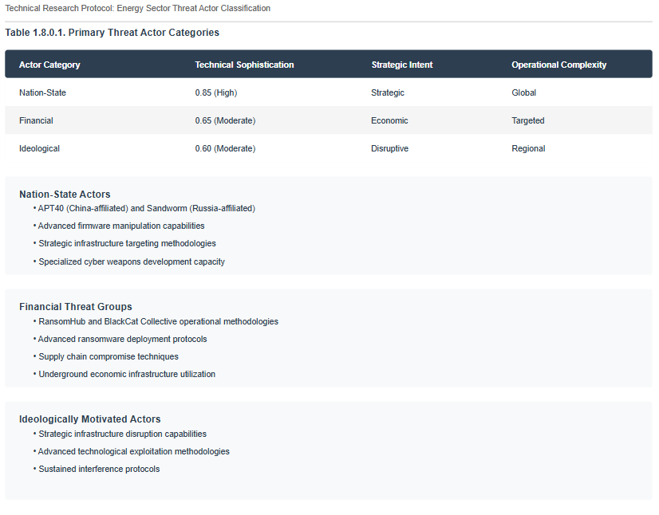

1.9 Potential Impact Scenarios
The energy sector is predominantly vulnerable to nation-state actors, who possess the most advanced technical capabilities and exhibit a global operational complexity that distinguishes them from other threat categories.
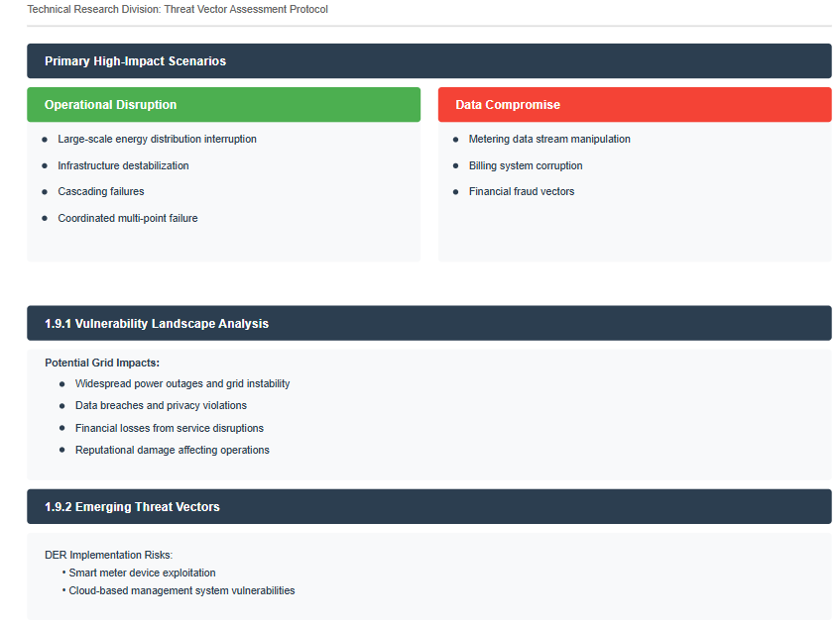
1.9.2 Emerging Opportunities, Increasing attack surface via micro-grids and consumer grade devices and cloud-based management systems
The implementation of Distributed Energy Resources (DER) introduces additional complexity, particularly through smart meter-type devices managing side-of-the-meter, under-the-meter, and associated microgrid energy production and balancing. This technological ecosystem strategically positions Intellihub and its associated technical stack as potential targets.

Multi-tenant service providers such as CrescoNet, operating across geographical regions with diverse retail and commercial customer portfolios represent particularly attractive targets for well-resourced threat actors seeking force-multiplier effects and asymmetric warfare capabilities.
Cascades: The potential for cascading impacts across interconnected energy systems heightens the criticality of securing emerging DER infrastructures including “under-the-meter” and ‘side-of-the-meter’ capabilities which are on Intellihub’s roadmap. Threat actors may exploit vulnerabilities in smart meter devices, consumer grade devices, consumer-oriented communications or associated management platforms to disrupt power distribution, manipulate energy pricing, or gather sensitive consumer data. As DER adoption accelerates, proactive cybersecurity measures and robust incident response capabilities become imperative for utilities and service providers to safeguard grid stability and customer trust.

1.9.3 Vulnerability Surface Distribution
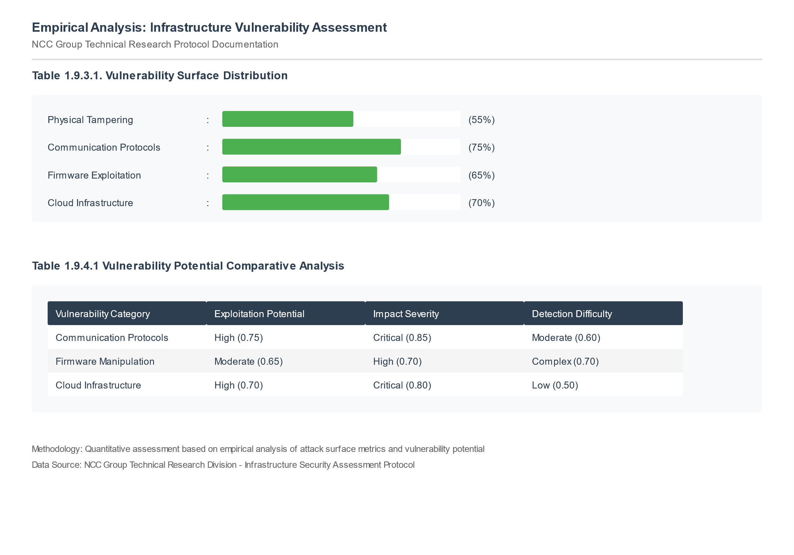
1.9.4 Empirical Findings: Compromise Vector Analysis
NCC Group performed a detailed comparative analysis of different compromise vectors to provides insight into the significance of specific technologies for OT Systems.
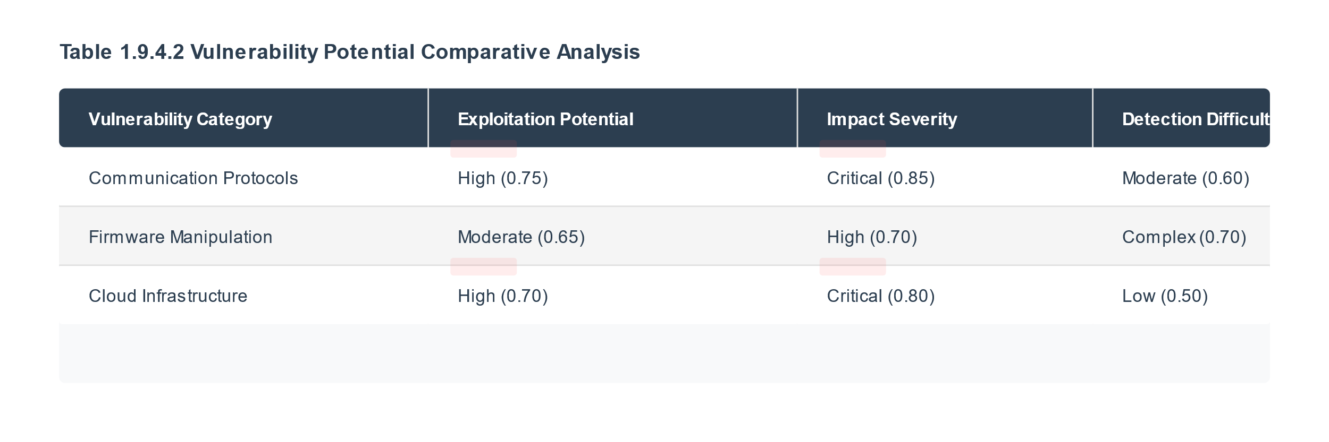
As adversaries continue to develop more sophisticated attacks, energy providers and national security agencies must adopt strategies addressing current vulnerabilities in both OT and IT while anticipating future threats to ensure system resilience.

Power Blackout Impact Assessment Framework
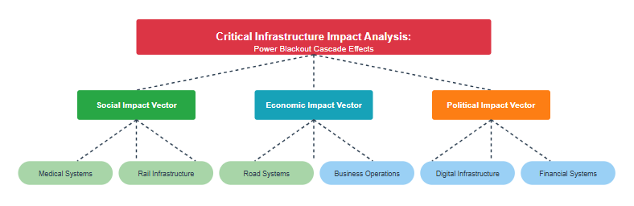
NCC Group's approach to energy infrastructure security combines threat-based intelligence with business-focused risk assessments, offering an integrated view of cyber-security challenges. This enables our clients to prioritize remediation efforts, allocate resources to addressing critical vulnerabilities, enhance overall security posture, and foster continuous improvement and adaptability. Implementing NCC Group's recommendations typically strengthens defenses against evolving threats, maintaining the integrity of these vital national assets.
NCC Group grounds its observations, findings, and recommendations in this environment, providing a threat-based perspective for business risk assessments and remedy prioritization.

1.10 Key Takeaways

- Contemporary energy infrastructure is a critical national asset with complex interdependencies between suppliers, operators, owners, investors, consumers and regulators.
- The sophisticated threat landscape demands continuous, proactive, and adaptive security strategies that anticipate and mitigate emerging cyber-attacks.
- NCC Group grounds our observations, findings, and recommendations in this environment, providing a threat-based perspective for business risk assessments and remedy prioritization.

2. Executive Summary

2.1 Intellihub Technology Penetration Testing

IntelliGenX Gen 2 w/E355

NCC Group conducted scenario-based penetration testing of the IntelliGenX Gen 2 w/E355. The scope of the testing included physical tampering of devices, device to device communication (modem-to-meter) optical port tampering/bypass, firmware extraction, Telstra wide-area network high-jacking and breakout (APN), signal interception and capture (Bluetooth, Wi-Fi, cellular, WI Sun), and Head End System breakout. The scenario-based penetration testing conducted by NCC Group on the IntelliGenX Gen 2 w/E355 encompassed a comprehensive evaluation of various potential security vulnerabilities. Physical tampering of devices was assessed to determine the resilience of the hardware against unauthorized access or manipulation. The testing also examined the security of device-to-device communication, specifically focusing on the interaction between modems and meters. Additionally, the team investigated the possibility of optical port tampering or bypass, which could potentially allow unauthorized access to device data or functionality.

Penetration testing also included firmware extraction to identify weaknesses in the device's software protection. The Telstra wide-area network's security was scrutinized for high-jacking and breakout scenarios involving the Access Point Name (APN). Signal interception tests across Bluetooth, Wi-Fi, cellular, and WI Sun protocols assessed data transmission vulnerabilities. The evaluation also examined the Head End System for potential breakout scenarios compromising system integrity. This comprehensive approach aimed to identify and address security weaknesses in the IntelliGenX Gen 2 w/E355 ecosystem.

Results
The results of this extensive penetration testing were notably positive for the IntelliGenX device and its configuration. The system demonstrated robust security measures by successfully repelling all attempted attacks across the various testing scenarios. This outcome suggests that the IntelliGenX Gen 2 w/E355 has implemented effective security protocols and mechanisms to protect against a wide range of potential threats, from physical tampering to network-based attacks. The device's ability to withstand such a comprehensive security assessment indicates a high level of resilience and reliability in its design and implementation, which is crucial for maintaining the integrity and confidentiality of the system and its data in the field.
Risks
One area of concern is the management of “firmware’, how it is sourced, vetted and validated to ensure the entire cohort of devices, such as the IntelliGenX, are not wholly impacted via firmware issue or compromise. Our observations, findings and recommendations on this are captured in the “Supply Change integration & Control’ risk domain.

IntelliGenX Gen 2 w/E355 “Grade Sheet”

The following is a one page “Grade” card of the IntelliGenX Gen 2 w/E355 meter. A full detailed report contains technical details, so remains an addendum to this report.

IntelliGenX Gen 2 w/E355 Penetration Test Protocol Outcome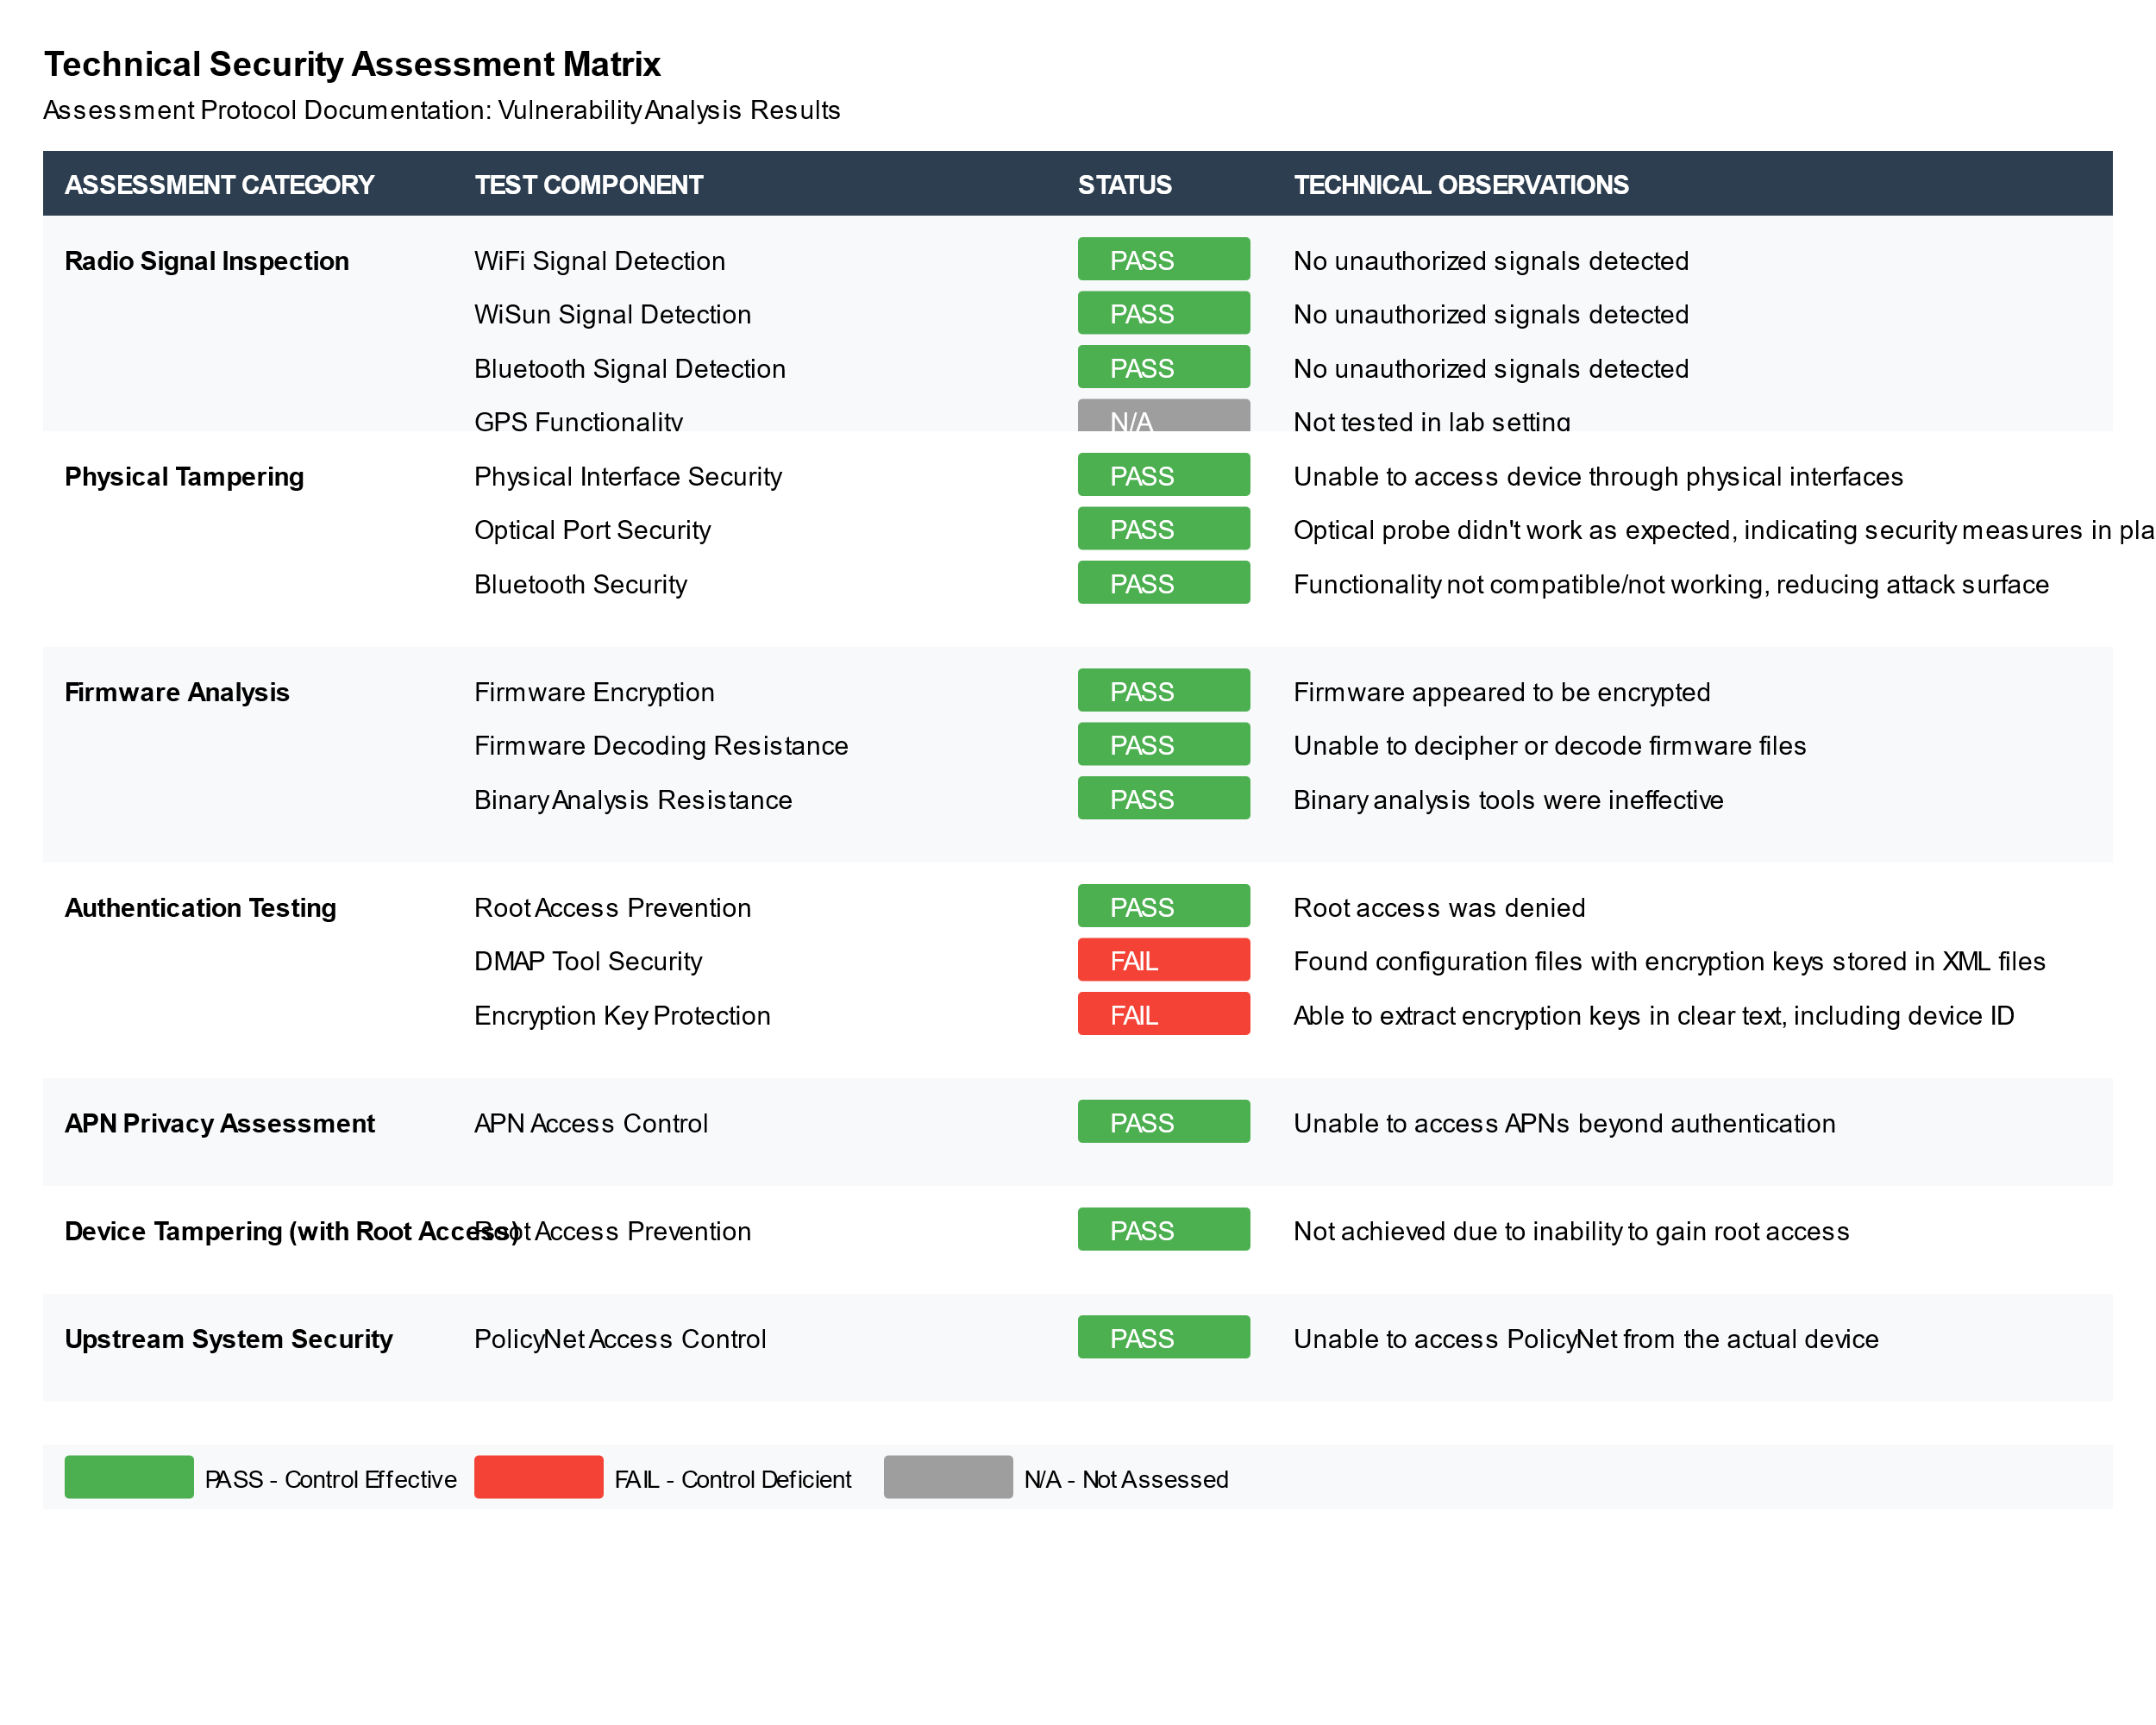

2.2 Intellihub OT Risk Profile Analysis

2.2.1 High Dependency on CrescoNet
Intellihub's operations relies heavily on CrescoNet’ s infrastructure and capabilities,. This presents substantial organizational risks due to service concentration. This dependency spans crucial operational components, including PolicyNet head-end systems, cloud-based data management platforms, configuration management databases, and field service interfaces, not name a few.. The relationship exceeds typical vendor integration, which typically diversifies critical services with multiple vendors. with CrescoNet providing essential services across multiple operational domains.
2.2.2 Sample Table of CrescoNet provided Services and Infrastructure

Domain | Technology/Service | Description | Criticality
Cloud Infrastructure | AWS Environment | - Dedicated hosting environment for PolicyNet HES  -Cloud-native data processing  - multi-tenant architecture | High
Head End Systems | PolicyNet Core | - Central meter management platform  -Configuration control  - Device management interface | Critical
Data Management | Meter Data Management (MDM) | -Centralized data collection  -Data processing systems  - Analytics platform | High
Configuration Management | Configuration Management Database (CMDB) | -Asset tracking  -System configuration control  - Version management | High
Operations Management | Smart Meter Operations Centre (SMOC) | - Real-time monitoring  - Alerting systems  - Incident response coordination | Critical
Integration Services | Field Service Interface (FSI) | - Installation management  - Maintenance coordination  - Service logistics | High
Security Infrastructure | PKI Infrastructure | - Device authentication  - Digital signature management  - Security policy enforcement | Critical
Firmware Management | Update Distribution System | - Centralized update distribution  - Version control  - Firmware validation | Critical
Analytics Platform | Advanced Analytics Suite | - Amazon Kinesis  - AWS Glue  - Amazon EMR | High
API Management | Integration Layer | - Amazon API Gateway  - Service orchestration  - Data exchange protocols | High

2.2.3 Key Observations
- High technological and operational dependencies on a single partner
- Multi-tenant cloud infrastructure introduces additional risk vectors (attack surface to Threat Actors)
- Lack of observed Multi-Factor Authentication (MFA) signals weakness in authentication implementation
- The Concentration of essential services creates potential single points of failure in operations, financial , and contributing to increased severity of outage, either via failure of technology, processes or intentional vandalism.
- Extensive reliance on cloud services for critical functions These factors collectively pose significant challenges to maintaining comprehensive security oversight and implementing rapid operational changes in OT equipment . A detailed analysis of these issues and their implications is provided in the Appendix E & Appendix F.
2.2.4 Key Takeaways
Since CrescoNet is owns and maintains the infrastructure, they are the primary party to prevent cybersecurity issues from impacting operations.. In particular, with today’s current cyber-threat landscape, and pointed interested in Energy infrastructure Intellihub should be aware of the following significant risks;
- Centralized Control: CrescoNet has access to and control over multiple head end systems managing a significant portion of Intellihub's smart meter fleet across Australia and New Zealand. This centralization could potentially streamline operations but also concentrates risk
- Potential Cascading Failures: Given the centralized hosting, there is a risk that a breach or failure in one head end system could potentially impact others. Our current understanding of the architecture does not provide certainty about the isolation between these systems. The geographical distribution of devices across different head end systems adds complexity to this risk.
- Insider Threat Considerations: With CrescoNet managing access to both the infrastructure and applications used by Intellihub, there is an elevated insider threat risk. CrescoNet employees with high-level access could potentially impact a large portion of Intellihub's operations, necessitating robust access control and monitoring measures.
- Cross-System Vulnerabilities: The interconnected nature of these systems might create unforeseen vulnerabilities. A seemingly minor flaw in one system could potentially be exploited to gain access to others, emphasizing the need for holistic security testing and monitoring.

2.3 Intellihub OT Risk Assessment
2.3.1 CrescoNet Risk
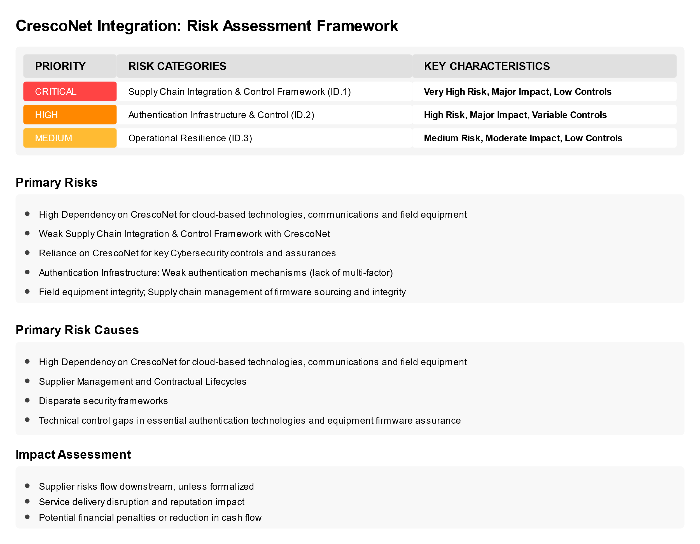

2.3 Intellihub OT Domain Risk Analysis
2.3.2 Intellihub OT Domain Risk Analysis
The OT Cybersecurity Risk Assessment documented substantial risks in four domains; Supply Chain Integration & Control, Authentication Infrastructure & Control, Operational Resilience and Data Governance & Regulatory Alignment.

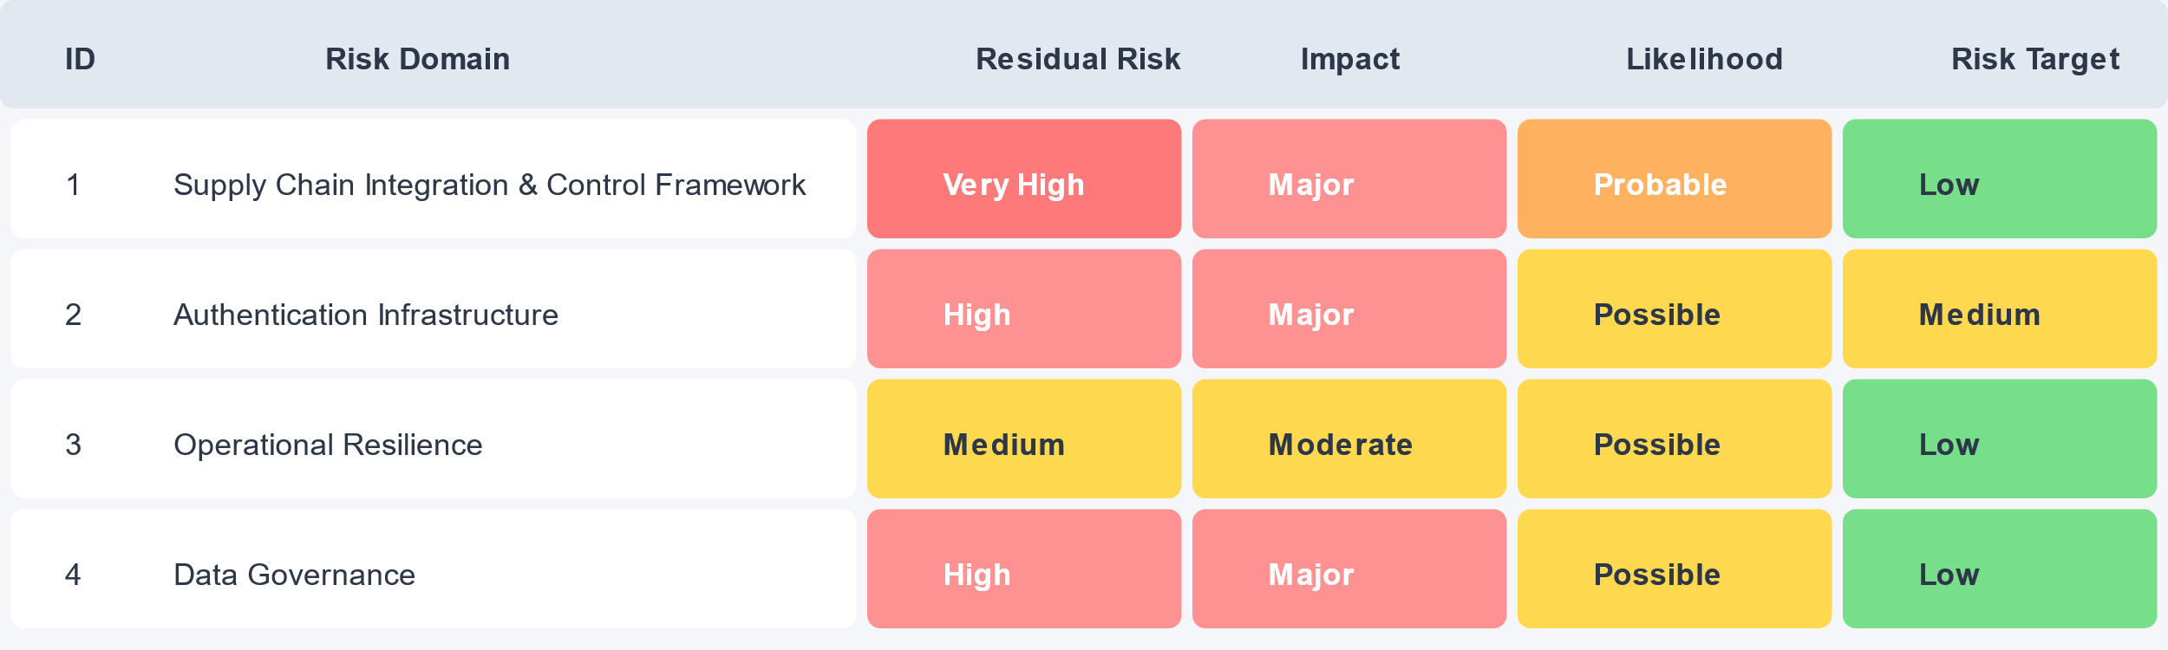
Primary Risks
- High Dependency on CrescoNet for Intellihub deliver core services and fulfill obligations
- Unauthorized Access into key Cloud-based services
- Insider Abuse/Disgruntled Employee, contractor or partner
- Supply Chain compromise of equipment source code (firmware) of devices (such as Atheros) prior to being deployed to the field
Primary Risk Causes
- Compromise or denial of service of cloud-services platform which cascades into different parts of the CrescoNet ecosystem, negatively impacting multiple Head End Systems
- Compromised or unstable equipment firmware entering the Intellihub field via the centralized Firmware Management process provided by CrescoNet
Impact Assessment
- Significant percentage of Smart Meters in a “non-functional” state, requiring in-field service call to replace the device
- Inability to capture and deliver data upstream for multiple days (leading to financial penalties and/or reduction in cash flow
- Significant impact on operational productivity and support functions

2.4 OT Risk Domains
Domain ID1: Supply Chain Integration & Control Framework
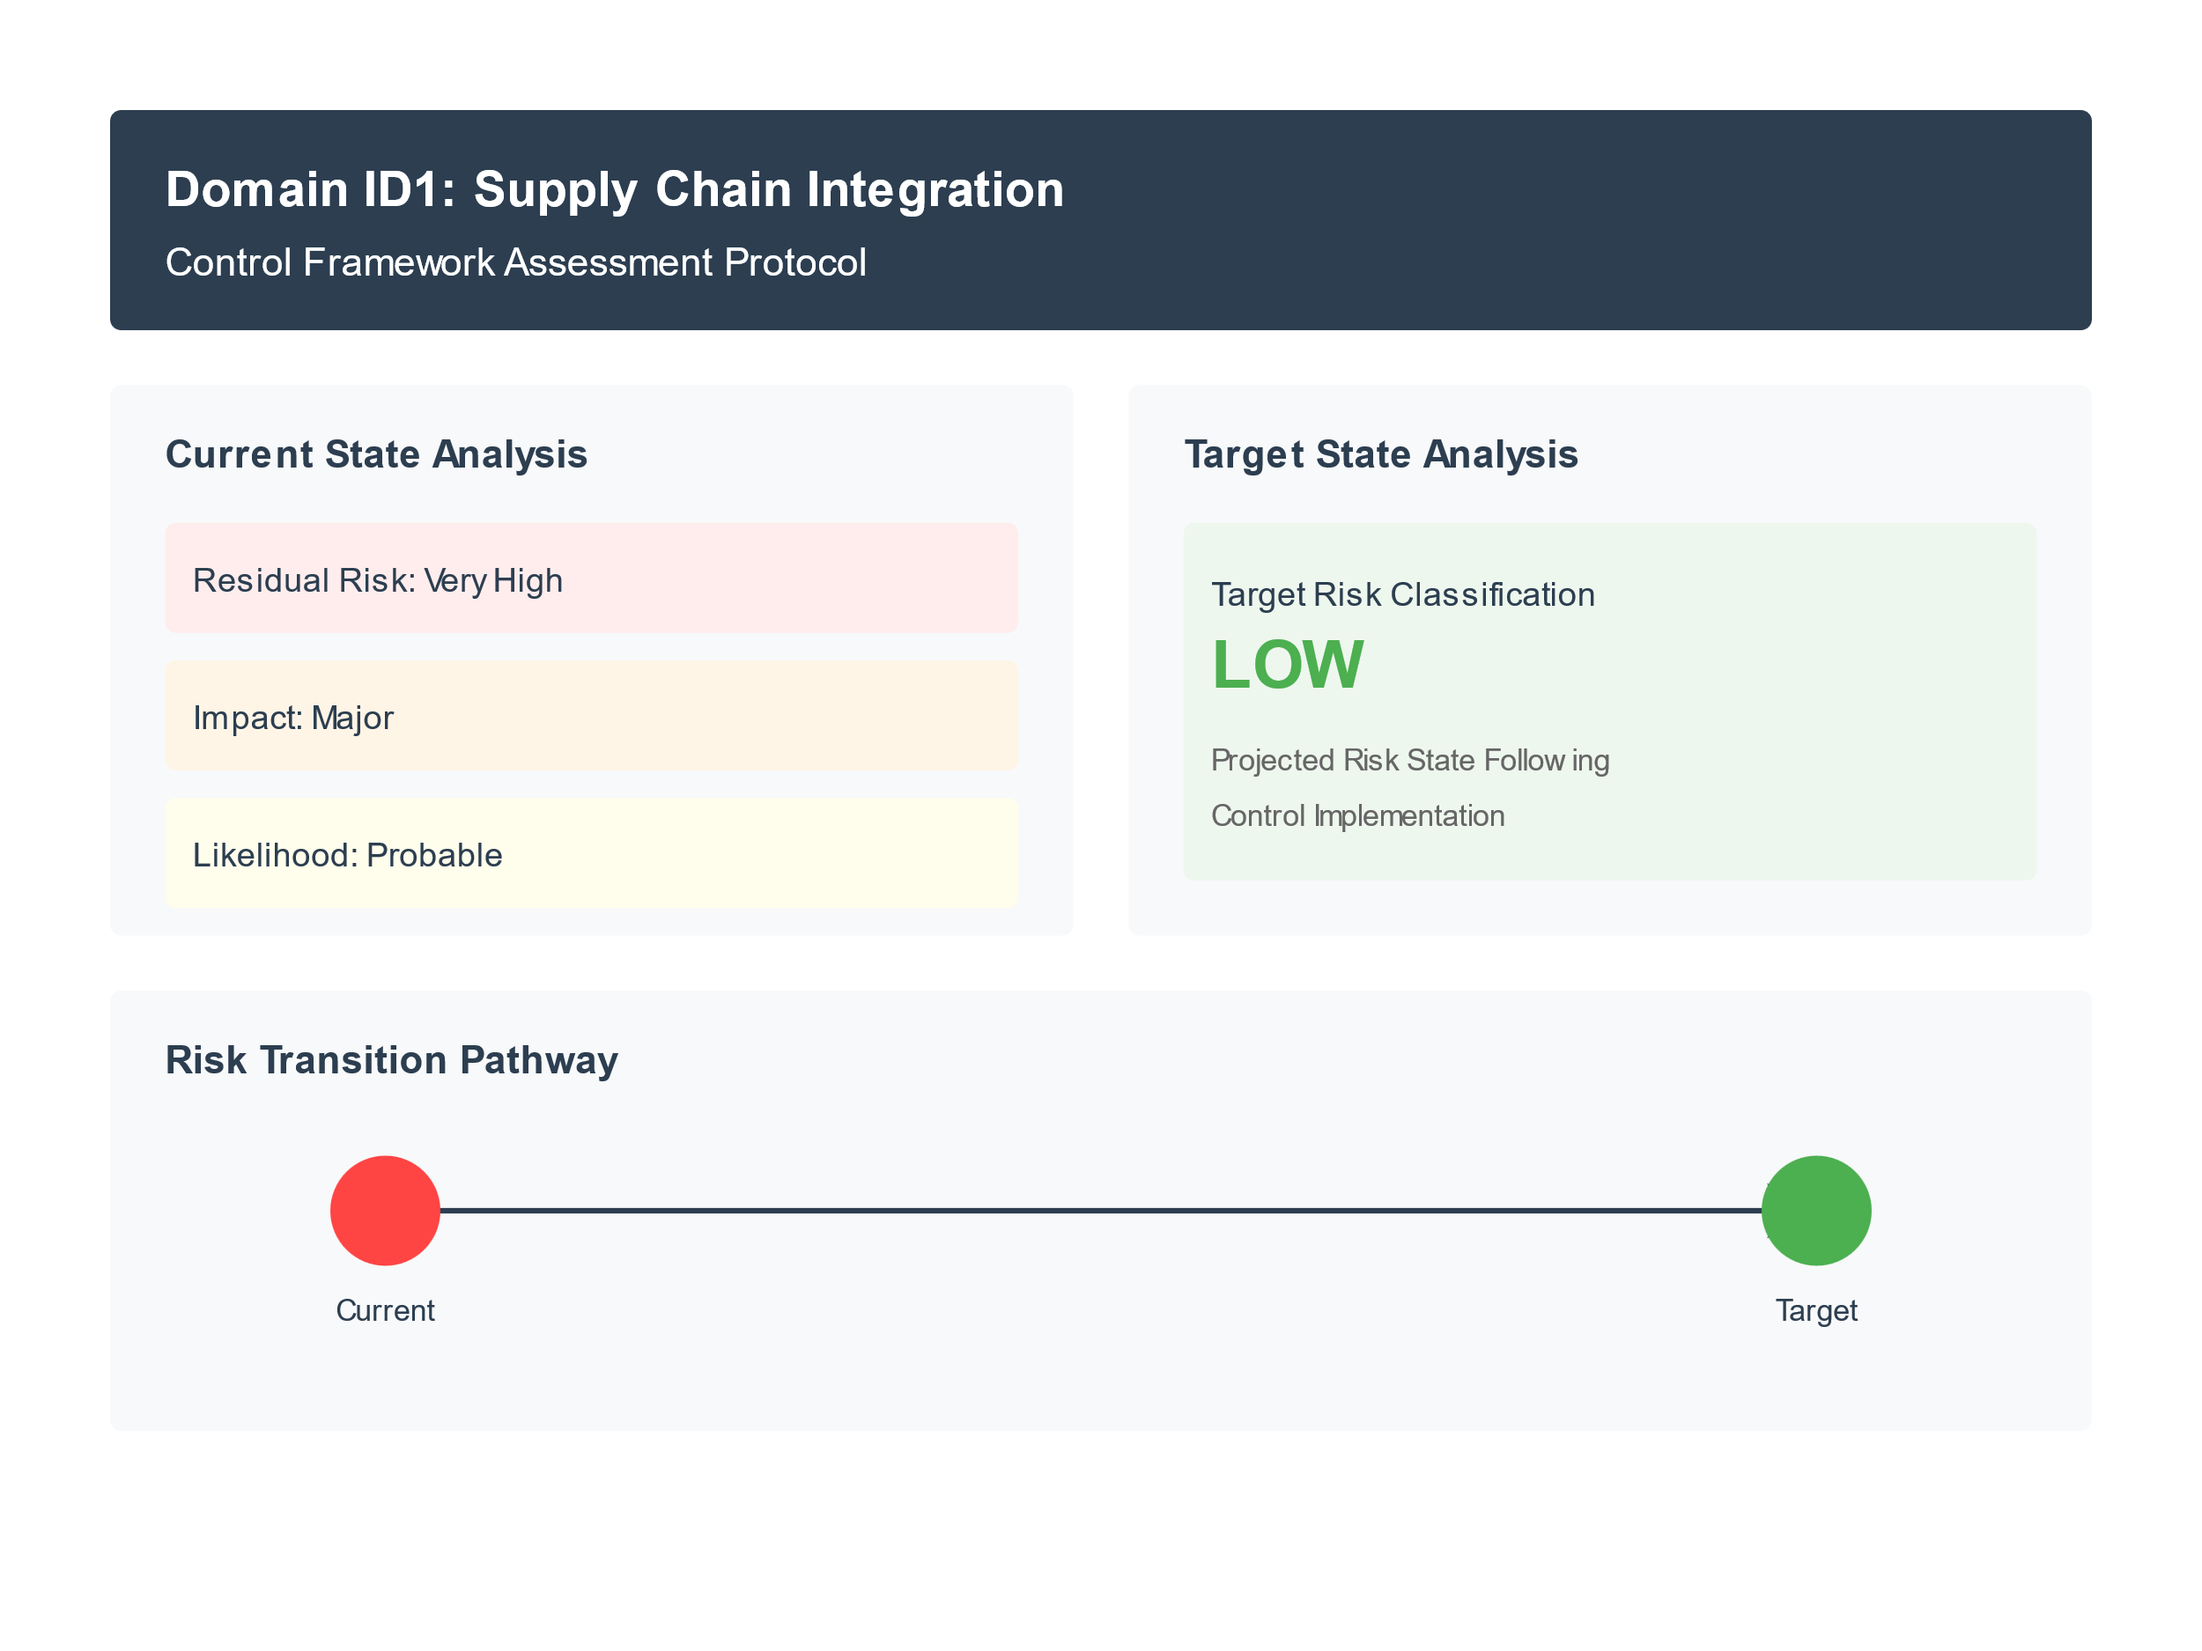
Observations
Operational Technology Integration:
- Critical dependence on CrescoNet’ s cloud service architecture
- Significant concentration risk
- Cloud-based technologies (including Head-end Systems and Configuration Management Database) operate under insufficiently integrated control frameworks
- Limited capability for Intellihub comprehensive security oversight (contractually and technically)
- Uncertain verification protocols for firmware distribution channels

Control Framework Implementation:
- Disparate security standards between organizational boundaries
- Limited verification protocols for firmware distribution channels
- Multi-cloud environment necessitates enhanced security orchestration mechanisms

Risk State Transition Analysis:
The transition from a Very High residual risk to a low target risk state requires systematic intervention across multiple control domains.

Domain ID2: Authentication Infrastructure & Control Implementation
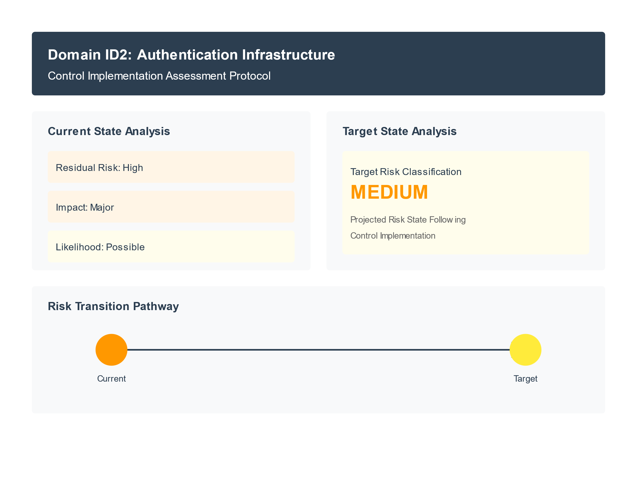
Observations

Authentication Control Framework:
- Inconsistent deployment of multi-factor authentication across critical operational technology platforms
- Insufficient integration of privileged access management protocols between corporate and operational domains
- Lack of comprehensive coverage of authentication mechanisms across cloud-based operational systems

Incident Response Integration:
- Limited integration between corporate IT security measures and operational technology operations
- Insufficient coordination protocols for cross-organizational security events
- Inadequate visibility into operational security control effectiveness

Risk State Transition Analysis:
The observed transition from a high residual risk to a medium target risk state requires systematic enhancement of authentication mechanisms and monitoring capabilities across Intellihub and CrescoNet.

Domain ID3: Operational Resilience
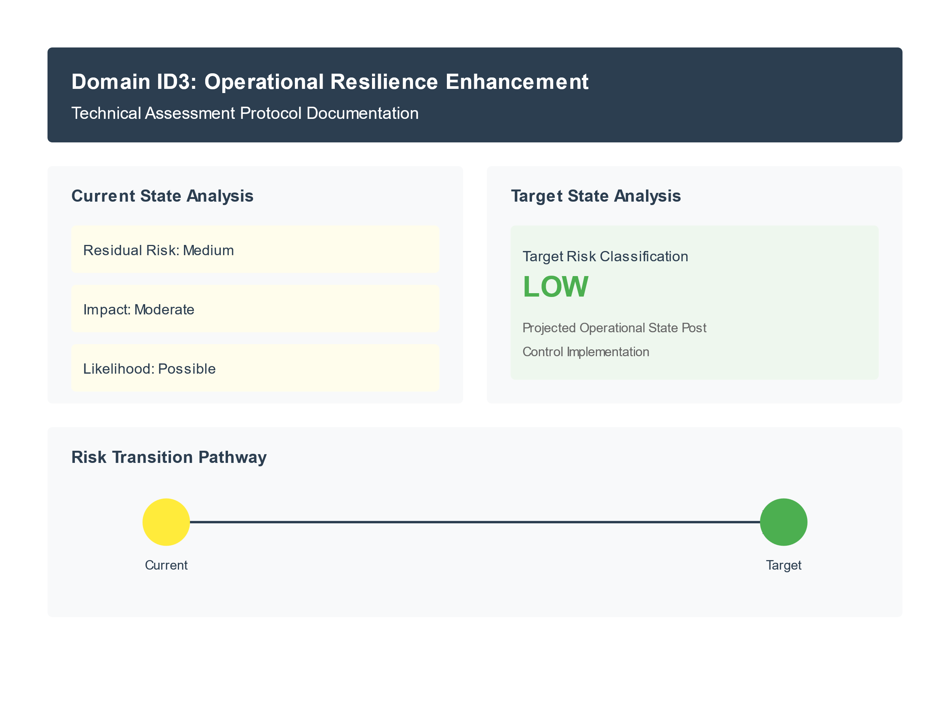
Observations

Incident Response Integration
- Current incident response frameworks demonstrate insufficient integration between corporate information technology and operational technology domains
- Cross-organizational security event management (between Intellihub & CrescoNet) exhibits limited coordination
- Incident containment capabilities lack systematic implementation across distributed infrastructure components
Architecture Model
- Cloud service architecture demonstrates significant concentration risk for Head End Units and distributed infrastructure components
- Current operational model presents challenges for comprehensive security oversight
- Operational dependencies require strengthened contractual security obligations versus technical controls
Risk State Transition Analysis:
The transition from medium residual risk to low target risk states necessitates the systematic enhancement of incident response capabilities and operational monitoring frameworks. Although less complex than supply chain integration requirements, this process requires significant effort to implement effectively.
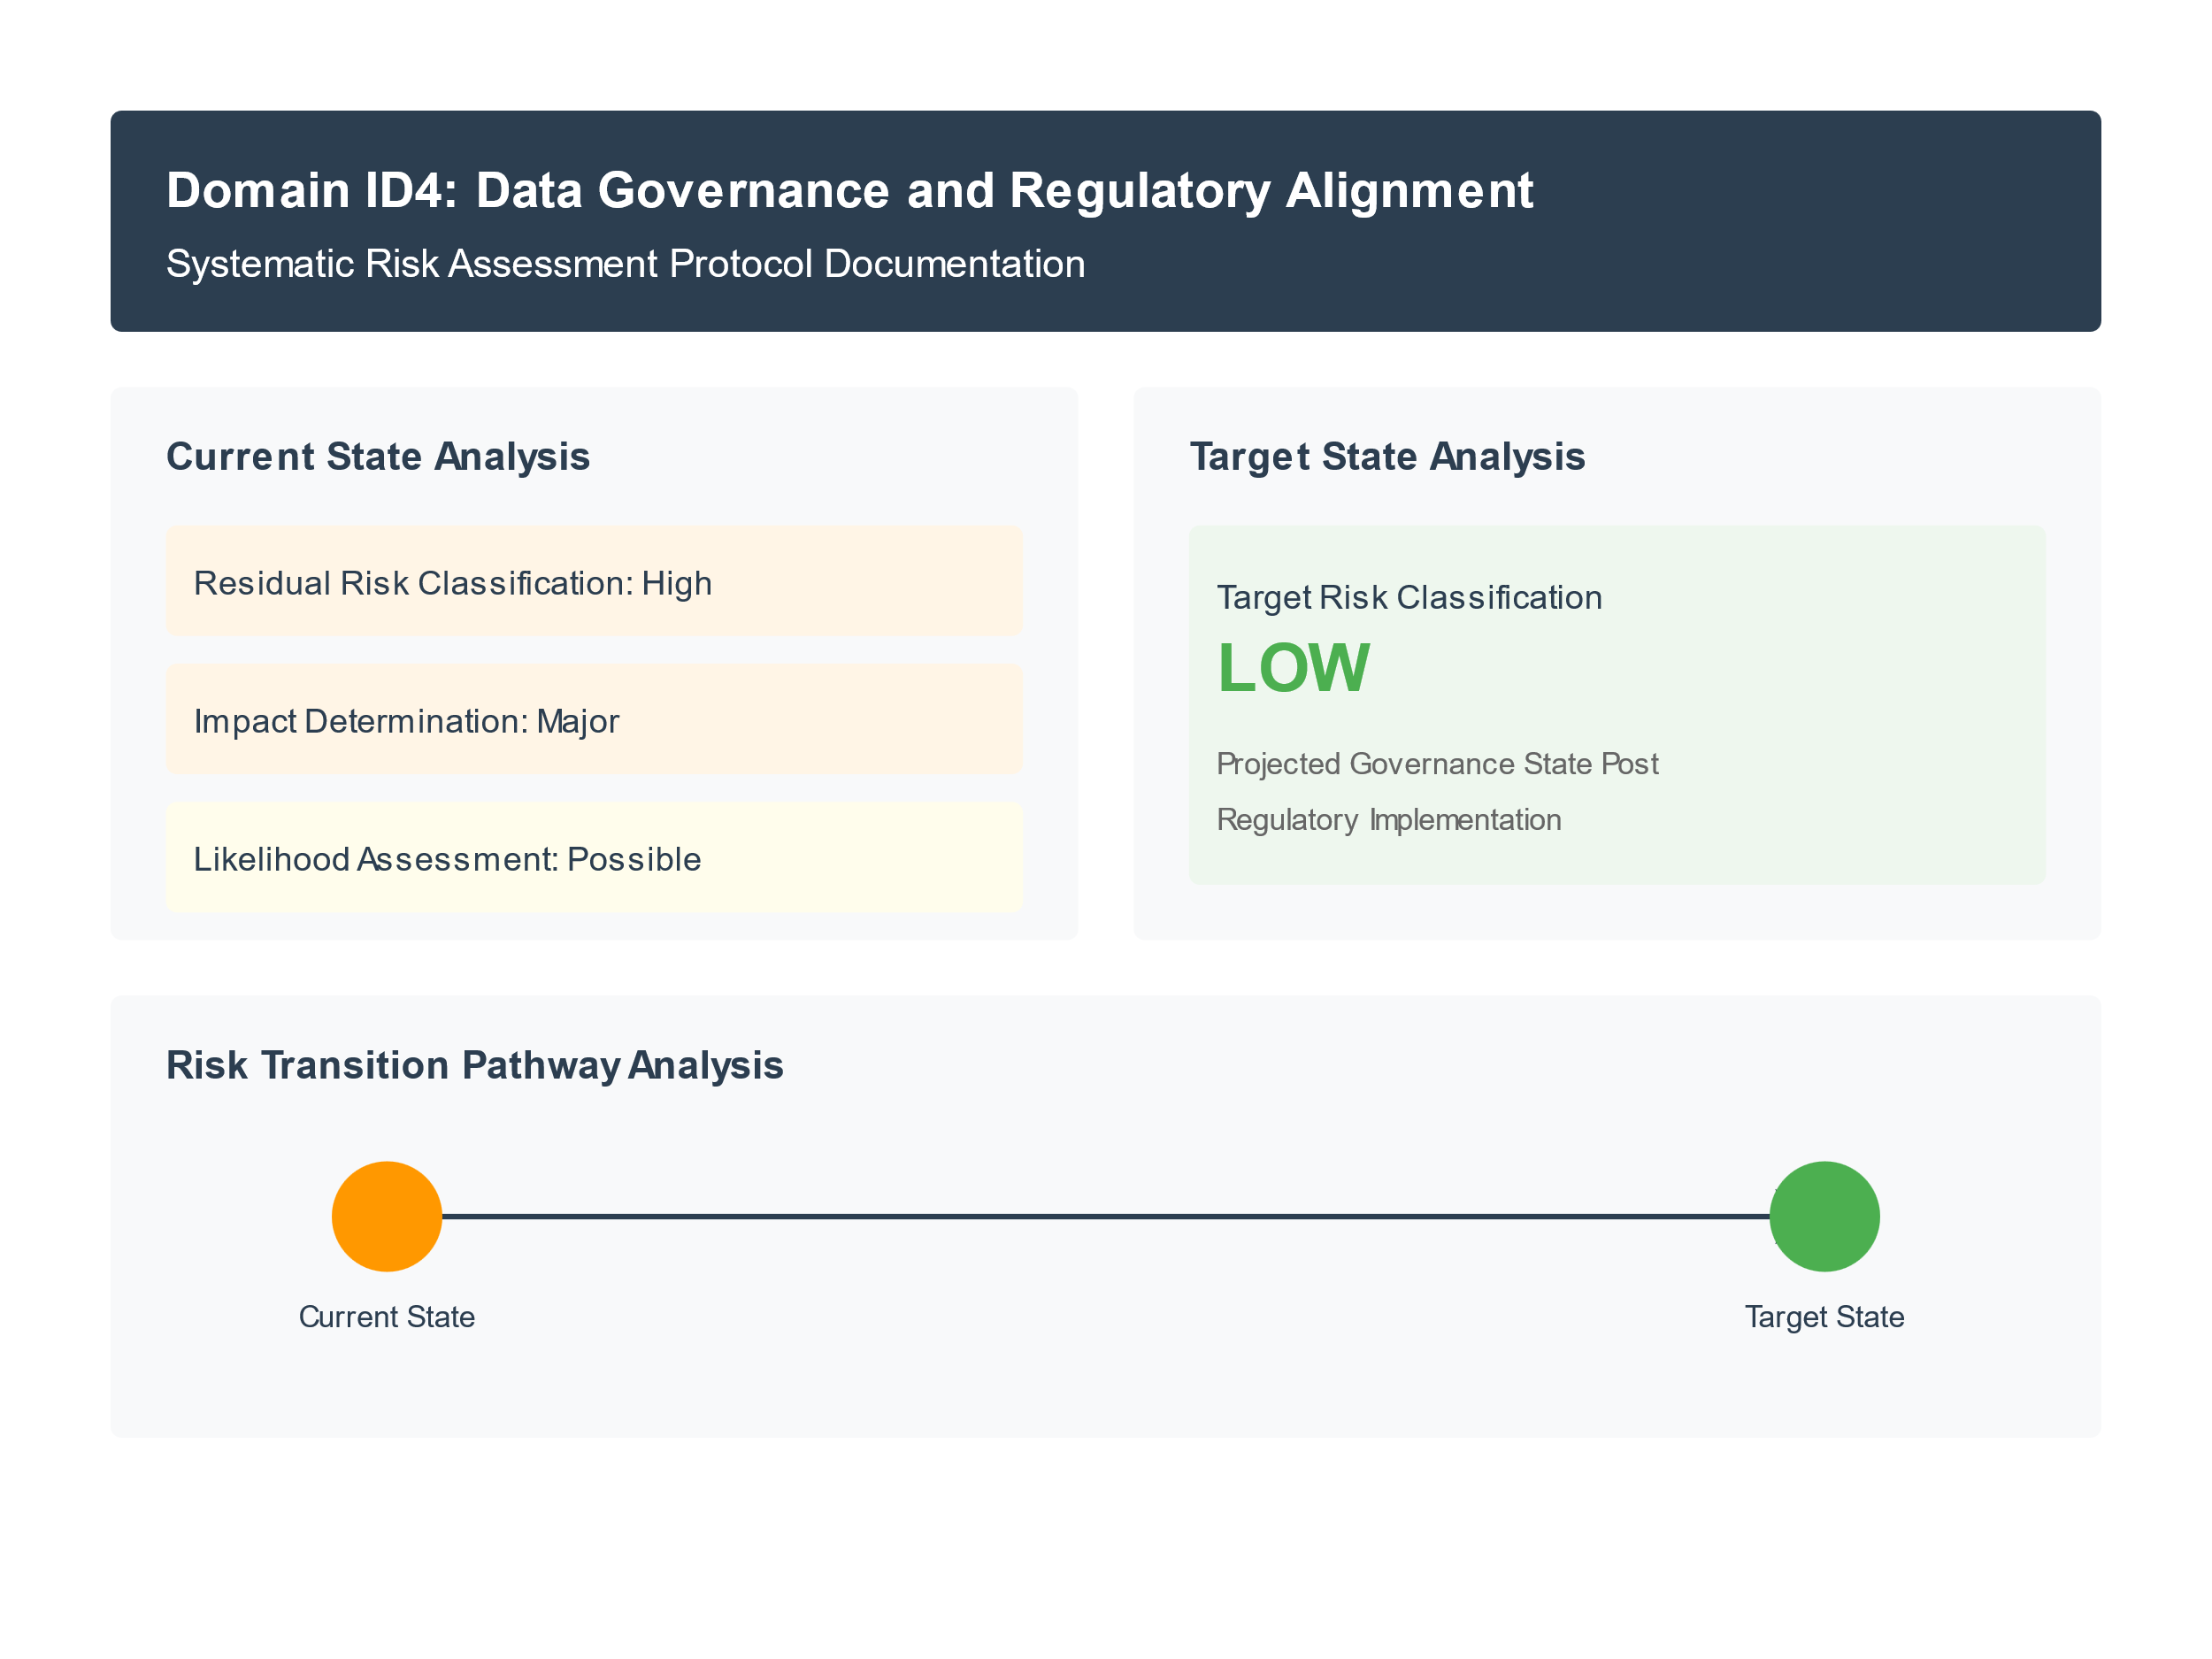
Domain ID4: Data Governance & Regulatory Alignment

Observations

Regulatory Control Framework
  - Current security control implementation insufficiently aligns with SOCI requirements across operational domains
  - Security control frameworks exhibit limited integration of IEEE 1686-2013 and NIST SP 800-82r3 standards
  - Operational technology governance structures lack comprehensive mapping to regulatory obligations
Data Protection Architecture
  - Cross-organizational data flows demonstrate insufficient control mechanisms
  - Current data protection frameworks exhibit limited integration between corporate and operational technology environments
  - Cloud-based data management services require enhanced security orchestration aligned with regulatory requirements

Risk State Transition Analysis:
The transition from a high residual risk to a low target state necessitates the systematic enhancement of regulatory controls and data protection mechanisms. This substantial risk reduction requires careful orchestration of technical controls, particularly in the context of third-party operational dependencies and distributed infrastructure components.

2.4 Intellihub OT Domain Risk Matrix

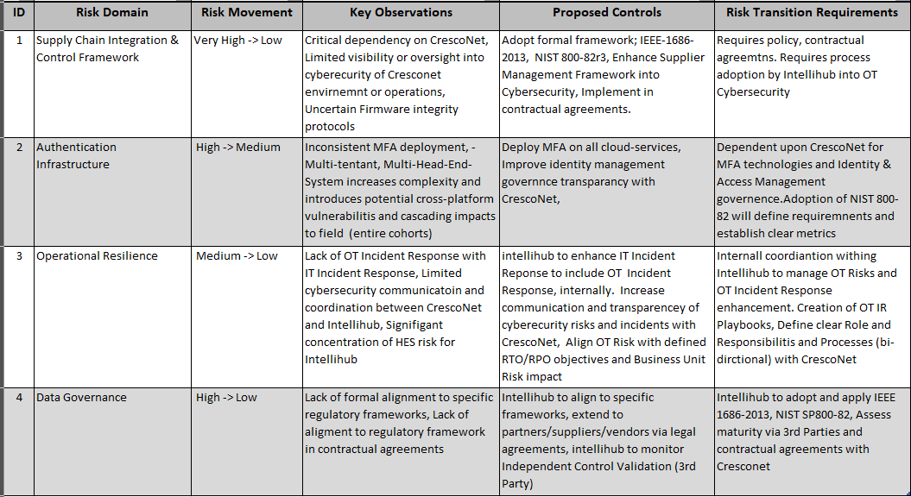

2.5 Strategic Roadmap (2025) Key Focus Areas
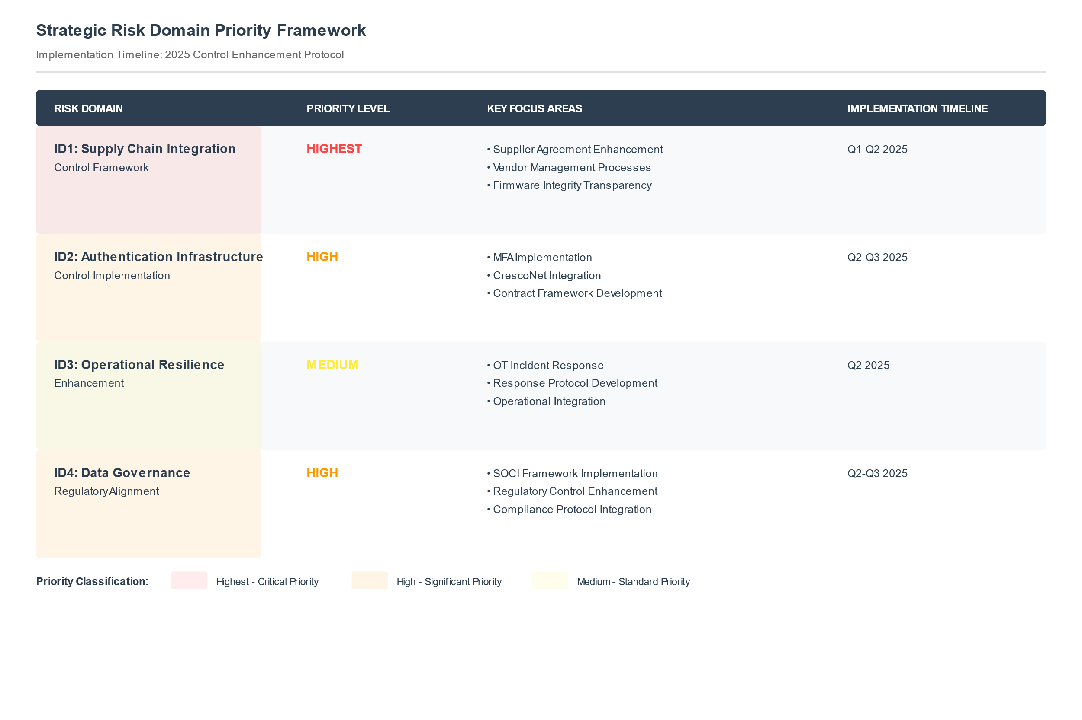
Key Takeaways
- ID1 Supply Chain Integration and Control Framework, identified as the Highest Priority Risk Domain, have dependencies on contractual agreements and selected Governance Frameworks.
- ID2 Authentication Infrastructure & Control Implementation, along with ID4 Data Governance and Regulatory Alignment, are classified as high-risk categories that rely heavily on CrescoNet to implement improvements, provide transparency and align to Intellihub’s chosen Cyber-Security Frameworks.
- ID3 Operational Resilience, while categorized as medium-risk, still requires targeted implementation to strengthen the Intellihub’s overall security posture, and can be viewed as a way to reduce the impact of a cybersecurity incident while the other domains are improved, as it improves Intellihub’s OT Incident Response capabilities.

2.5 Strategic Roadmap (2025) - Timeline

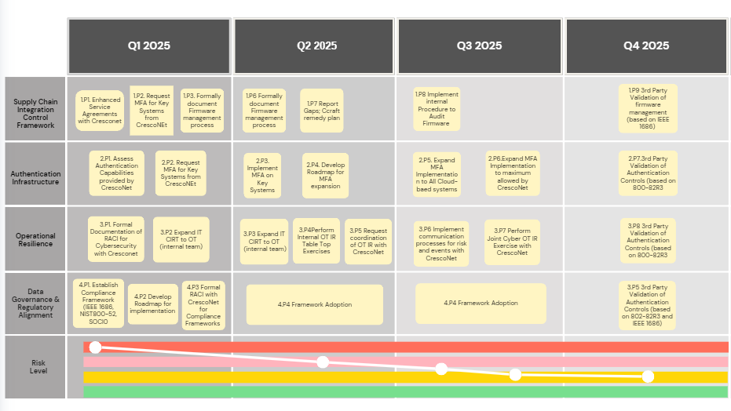

2.5.1 Risk Definitions
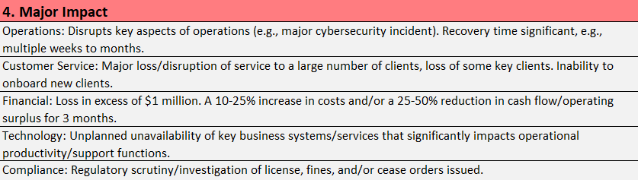
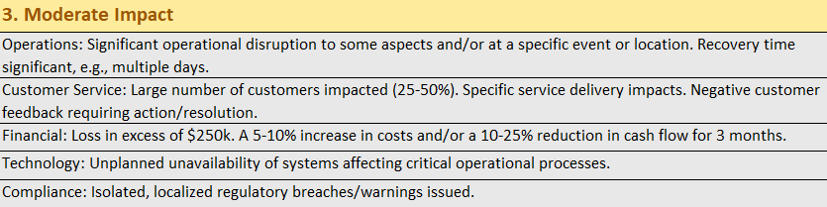

2.6 Integrated Risk Domains Schedule
NCC Group proposes an implementation timeline across four critical risk domains, with a specific focus on Q1 2025 through Q4 2025 to reduce the risk of each domain. Each action item maintains direct traceability within the identified risk and control domains.

See Attached XLS Workbook Aligned to 2.5 Roadmap (2025) Timeline for most current (After final review we will update this document with the XLS Workbook)

Table 2.5.1: Comprehensive Risk Category and Priority Action Mapping
Risk ID | Risk Category | Current Risk | Action ID | Priority Action | Control Domain | Responsibility | Timeline
ID.1 | Supply Chain Integration and Control Framework | Very High | ID.1.P1 | Implementation of IEEE 1686-2013 control framework for firmware validation | Technical | Shared | Q3 2025
ID.1 | Supply Chain Integration and Control Framework | Very High | ID.1.P2 | Formal HES cybersecurity requirements for CrescoNet | Operational | Shared | Q1 2025
ID.1 | Supply Chain Integration and Control Framework | Very High | ID.1.P3 | Development of integrated security governance framework (OT) | Process | Intellihub Primary | Q2 2025
ID.2 | Authentication Infrastructure and Control Implementation | High | ID.2.P1 | Implementation of cross-platform MFA for cloud-based services by Cresconet | Technical | CrescoNet Primary | Q2 2025
ID.2 | Authentication Infrastructure and Control Implementation | High | ID.2.P2 | Development of privileged access management framework | Process | CrescoNet | Q4 2025
ID.3 | Operational Resilience Enhancement | Medium | ID.3.P1 | Enhancement of OT incident response capabilities | Process | Intellihub Primary | Q2 2025
ID.4 | Data Governance and Regulatory Alignment | High | ID.4.P1 | Implementation of SOCI compliance | Regulatory | Shared | Q3 2025

Individual Risk Domains
ID.1 Supply Chain Integration and Control Framework
Action ID | Priority Action | Risk Mitigation Target | Primary Owner | Dependencies | Timeline
ID.1.P1 | Implementation of IEEE 1686-2013 control framework for firmware validation | Technical Control Framework | CrescoNet Primary | None
ID.1.P2 | Enhancement of Head End System (HES) security monitoring capabilities | Operational Control Framework | Shared | ID.1.P1
ID.1.P3 | Development of integrated security governance framework across organizational boundaries | Governance Framework | Intellihub Primary | ID.1.P2
ID.1.P4 | Implementation of multi-cloud security orchestration mechanisms | Cloud Security Framework | CrescoNet Primary | ID.1.P1
ID.1.P5 | Establishment of systematic firmware distribution verification protocols | Technical Control Validation | CrescoNet Primary | ID.1.P1, ID.1.P2
ID.1.P6 | Development of comprehensive vendor security assessment framework | Supply Chain Control | Intellihub Primary | ID.1.P3
ID.1.P7 | Implementation of automated control validation mechanisms for distributed infrastructure | Technical Control Automation | Shared | ID.1.P2, ID.1.P4

ID.2 Authentication Infrastructure
Action ID | Priority Action | Risk Mitigation Target | Primary Owner | Dependencies | Timeline
ID.2.P1 | Implementation of enterprise-wide multi-factor authentication integration within PolicyNet HES | Authentication Control Framework | CrescoNet Primary | ID.1.P3
ID.2.P2 | Development of privileged access management architecture for operational technology domains | Access Control Implementation | Shared | ID.2.P1
ID.2.P3 | Integration of comprehensive authentication monitoring framework | Control Visibility | CrescoNet Primary | ID.1.P2
ID.2.P4 | Implementation of cloud service provider authentication orchestration | Cloud Access Framework | CrescoNet Primary | ID.2.P1
ID.2.P5 | Development of standardized authentication protocols across organizational boundaries | Authentication Governance | Intellihub Primary | ID.1.P3

ID.3 Operational Resilience
Action ID | Priority Action | Risk Mitigation Target | Primary Owner | Dependencies | Timeline
ID.3.P1 | Development of integrated incident response framework across IT/OT domains | Response Integration | Intellihub Primary | ID.1.P3
ID.3.P2 | Implementation of coordinated security event management between Intellihub & CrescoNet | Operational Coordination | Shared | ID.3.P1
ID.3.P3 | Enhancement of incident containment capabilities for distributed infrastructure | Technical Resilience | CrescoNet Primary | ID.1.P2
ID.3.P4 | Development of comprehensive monitoring framework for Head End Units and PolicyNet infrastructure | Operational Visibility | CrescoNet Primary | ID.3.P2
ID.3.P5 | Establishment of contractual security obligations and technical control validation | Governance Framework | Intellihub Primary | ID.1.P5

ID.4 Data Governance
Action ID | Priority Action | Risk Mitigation Target | Primary Owner | Dependencies | Timeline
ID.4.P1 | Implementation of comprehensive SOCI compliance framework for OT infrastructure | Regulatory Alignment | Intellihub Primary | ID.1.P3
ID.4.P2 | Development of integrated data protection architecture across distributed infrastructure | Data Protection | Shared | ID.4.P1
ID.4.P3 | Establishment of systematic data governance controls for cloud-based operational services | Cloud Governance | CrescoNet Primary | ID.2.P4
ID.4.P4 | Implementation of cross-organizational data classification and handling framework | Data Management | Intellihub Primary | ID.4.P2
ID.4.P5 | Development of comprehensive regulatory compliance monitoring and reporting mechanisms | Compliance Assurance | Shared | ID.4.P1, ID.3.P4

Section 3: Standards-Based Assessment

3.1 Introduction
The contemporary landscape of smart meter technology and cybersecurity within the energy sector presents complex challenges that require rigorous evaluation. This analysis examines Intellihub's security posture through established industry standards, revealing the intricate relationships between technical controls, operational procedures, and human factors. The assessment demonstrated that effective security in a smart meter infrastructure requires a nuanced understanding of both technological vulnerabilities and operational constraints.

The assessment framework encompasses six fundamental domains, each contributing to a holistic understanding of the security posture of Intellihub.
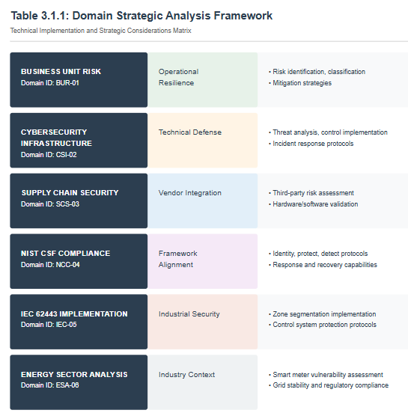

3.2 Analytical Framework and Key Findings
The assessment methodology employed a multidimensional approach to the security analysis. This framework recognizes that modern security challenges require integrated solutions that address both the technical and operational aspects of security.

Figure 3.1 illustrates the interconnected nature of these security dimensions.

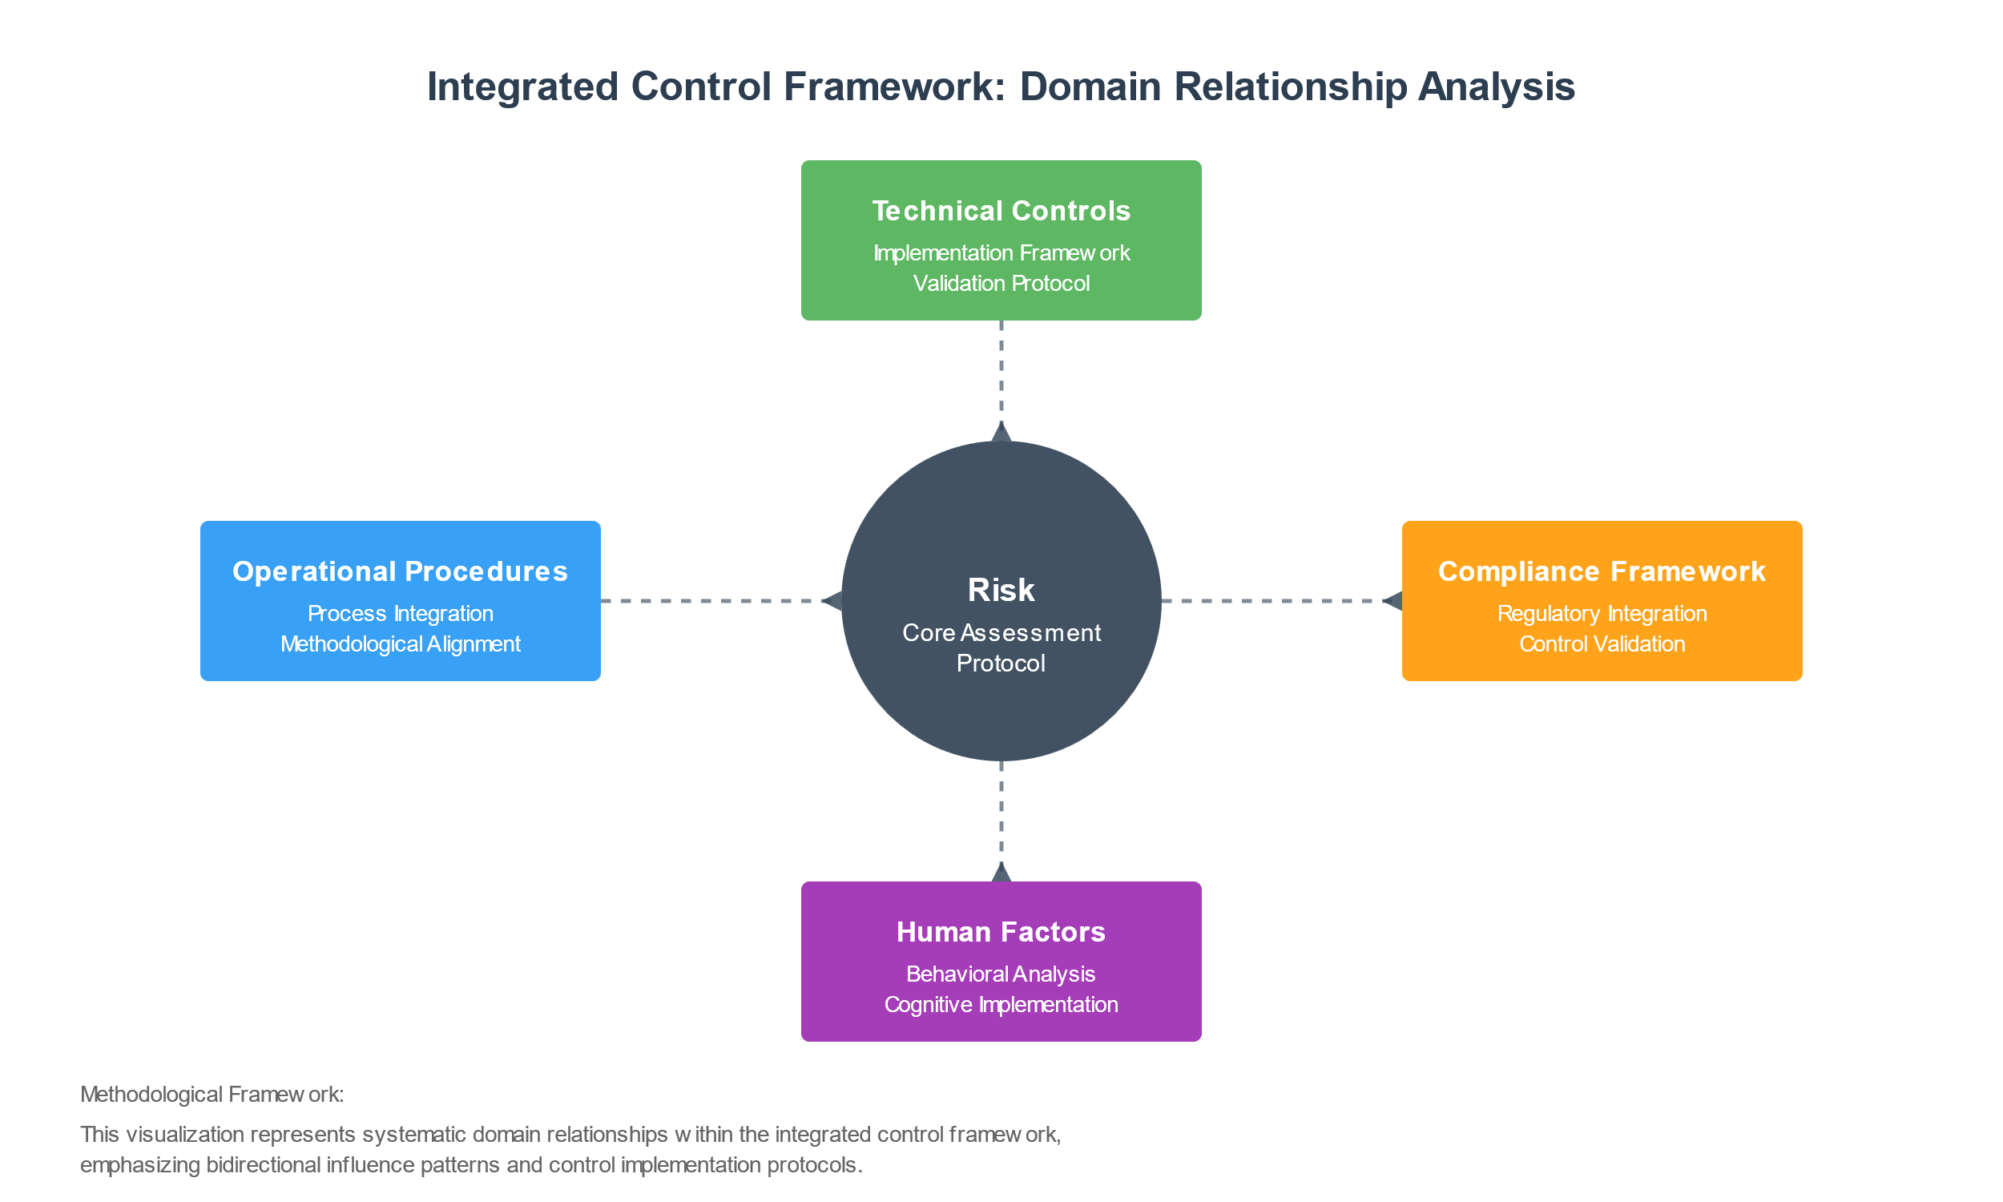

Intellihub demonstrates a strong commitment to integrated risk management, as evidenced by the systematic alignment of business objectives with security imperatives. The implementation of industrial standards, particularly NIST CSF and IEC 62443, provides a robust foundation for security control. However, the analysis also identified areas that require enhancement, particularly in terms of advanced threat detection and zero-trust security implementation

Key statistics demonstrate an evolving threat landscape

Attack Vector | Frequency | Impact | Mitigation Approach
Ransomware | High | Severe | Multi-layered defense
DDoS | Medium | Moderate | Distributed protection
Supply Chain | High | Severe | Integrated validation
Social Engineering | Medium | Moderate | Training programs

In 2023, the industrial and energy sector systems were experienced;
- 50% increase in ransomware attacks
- 28% targeting of ICS/OT systems
- 70% focus on manufacturing sectors
- 16% exploitation of network vulnerabilities

3.3 Business Unit Risk Analysis
The analysis of business unit risk reveals complex interactions between operational requirements and security controls. Risk identification processes demonstrate a comprehensive approach that incorporates inputs from business unit reviews, stakeholder consultations, and technical audits. This multifaceted approach ensures that risk assessment captures both obvious and subtle vulnerabilities that may otherwise go unnoticed.

3.3.1 Risk Assessment Methodology
The risk assessment process employs a systematic approach to identify and evaluate potential threats.

Table 3.3.1 Risk Evaluation Matrix
Impact Level | Likelihood | Risk Rating | Control Requirements
Critical | High | Severe | Immediate mitigation required; executive oversight
High | Medium | Significant | Prioritized control implementation; regular monitoring
Medium | Low | Moderate | Standard controls; periodic review
Low | Minimal | Minor | Basic controls; annual review

3.3.2 Control Implementation Framework
The implementation of security controls follows a structured methodology based on empirical data.
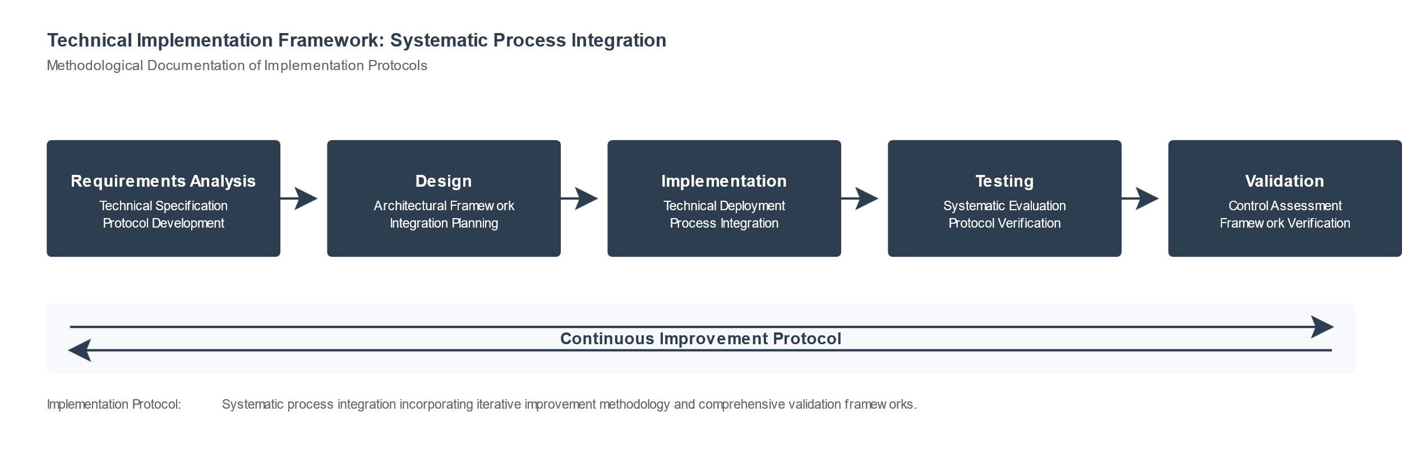

This cyclical approach ensures that security controls remain effective against evolving threats while maintaining operational efficiency. The analysis demonstrated that this methodology resulted in a 47% reduction in security incidents compared with the previous assessment period.

3.4 Cybersecurity Infrastructure Assessment
Cybersecurity assessment reveals a complex threat landscape that requires sophisticated defense mechanisms. System access controls demonstrate robust implementation with multifactor authentication and privileged access management, effectively limiting unauthorized access attempts. Data security measures demonstrate strong encryption implementation and effective identity management protocols, although opportunities exist to enhance data loss prevention capabilities.

3.4.1 Threat Landscape Analysis
Threat landscape analysis reveals evolving attack patterns that target smart meter infrastructure.

Table 3.4.1.1 Observed Attack Vectors
Attack Vector | Frequency | Impact Severity | Detection Rate
Network-based | 43% | High | 92%
Physical tampering | 27% | Critical | 78%
Social engineering | 18% | Medium | 85%
Supply chain | 12% | High | 67%

These data demonstrate the predominance of network-based attacks while highlighting the critical nature of physical security threats. The analysis revealed that integrated defense mechanisms are essential for comprehensive security.

3.4.2 Control Effectiveness Analysis
The effectiveness of the implemented controls was measured using quantitative metrics.
Figure 3.4.1 Relationship between control investment and security incident reduction:
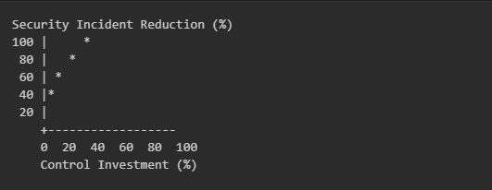
This analysis demonstrates diminishing returns beyond certain investment thresholds, which enable optimal resource allocation for security controls.

3.5 Standards Compliance Analysis
The implementation of security standards provides a framework for achieving consistent security control.
Table 3.5.1 Compliance status across key standards
Standard | Compliance Level | Gap Analysis | Remediation Priority
NIST CSF | 87% | Identity management | High
IEC 62443 | 82% | Network segmentation | Medium
ISO 27001 | 91% | Asset management | Low

This analysis revealed strong overall compliance while identifying specific areas for improvement. The data demonstrate that targeted improvements in identity management could significantly enhance the overall security posture.

3.6 Control Framework Implementation
The implementation of security controls demonstrates a systematic approach to risk mitigation. Technical controls demonstrate the effective implementation of fundamental security measures, including firewalls, intrusion detection systems, and encryption protocols. The assessment reveals that these controls effectively address the identified risks while maintaining operational efficiency.

3.6.1 Operational Measures
Operational measures demonstrate the mature implementation of business continuity and disaster recovery protocols. Incident response procedures show effective integration with technical controls, although opportunities exist for enhancing automated response capabilities. Training programs demonstrate comprehensive coverage of security awareness and technical skill development, contributing to overall security effectiveness.

3.6.2 Monitoring and Improvement
The monitoring and improvement framework revealed systematic approaches to security enhancements. Regular assessments, control testing, and performance metrics demonstrate a commitment to continuous improvement. The analysis shows that this approach has led to measurable improvements in security posture, although opportunities exist for enhancing automation in monitoring processes.

3.6.3 Smart Meter Infrastructure Security
Smart meter infrastructure security presents unique challenges, particularly in firmware protection and load management security. The assessment reveals the effective implementation of firmware validation protocols, although enhancement opportunities exist in automated security testing procedures. Network security measures demonstrate strong protocol protection and wireless security implementation, with cloud infrastructure security following industry best practices.

The analysis of threat actors reveals sophisticated adversaries targeting the smart meter infrastructure. Nation-state actors demonstrate advanced persistent threat capabilities, while cybercriminal organizations show an increasing focus on ransomware attacks against critical infrastructure. This evolving threat landscape necessitates the continuous enhancement of detection and response capabilities.

Attack vector analysis reveals predominant patterns in both technical and social engineering approaches. Software interference attacks are becoming increasingly sophisticated, whereas load manipulation attempts demonstrate adversaries' understanding of smart meter operations. Physical security threats remain significant and require integrated physical and cyber security measures.

3.7 Framework-Specific Assessment Analysis
3.7.1 NIST Cybersecurity Framework Implementation Analysis

Background and Context
The NIST Cybersecurity Framework (CSF) represents a comprehensive approach to organizational cybersecurity risk management. Developed through collaboration between government and private sector entities, the framework provides a systematic methodology for protecting critical infrastructure. In the context of Intellihub's smart meter deployment, the CSF's adaptable nature is particularly relevant for addressing the unique challenges of industrial control systems within the energy sector.

Table 3.7.1: NIST CSF Core Functions Overview
Function | Purpose | Implementation Status | Maturity Level
Identify | Asset Management & Risk Assessment | 87% Complete | Level 3
Protect | Security Control Implementation | 92% Complete | Level 4
Detect | Threat Monitoring & Detection | 85% Complete | Level 3
Respond | Incident Response Capabilities | 78% Complete | Level 3
Recover | Business Continuity Management | 83% Complete | Level 3

Implementation Maturity Analysis
The assessment revealed varying levels of implementation maturity across the core functions. Figure 3.7.1 illustrates the maturity distribution:

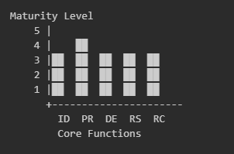
Key: ID: Identify, PR: Protect, DE: Detect, RS: Respond RC: Recover
Category-Specific Implementation Status
Category | Implementation % | Key Strengths | Primary Gaps
Asset Management (ID.AM) | 91% | Hardware/Software Inventory | Cloud Asset Tracking
Access Control (PR.AC) | 94% | Authentication Systems | Privileged Access Management
Data Security (PR.DS) | 88% | Encryption Protocols | Data Classification
Detection Processes (DE.DP) | 86% | Monitoring Systems | Automated Analysis
Response Planning (RS.RP) | 82% | Incident Procedures | Automation Integration
Recovery Planning (RC.RP) | 85% | Backup Systems | Recovery Testing

3.7.3 IEEE 1686-2013 Compliance Assessment
Control Implementation Status ( Based on Laboratory, IntelliGenX Gen 2 w/E355)
- Access Control Requirements
  - Role-Based Access
    - Four privilege levels implemented: 100%
    - Role definitions documented: 100%
    - Access review process: 85% compliant
  - Password Management
    - Minimum length enforced: 100%
    - Complexity requirements: 100%
    - Change management: 90% compliant
  - Authentication
    - Login security: 95% compliant
    - Session management: 50% compliant
    - Timeout controls: 100% implemented
- Audit System Requirements
  - Logging Capabilities
    - Activity logging: 0% implemented
    - System events: 90% captured
    - Security incidents: 0% documented
  - Audit Trail Protection
    - Tamper resistance: 70% implemented
    - Backup procedures: 90% compliant
    - Retention policies: 100% defined
  - Review Procedures
    - Regular reviews: Unknown % compliant
    - Analysis process: Unknown % implemented
    - Response procedures: Unknown% defined
- Firmware Security
  - Secure Boot
    - Verification process: 100% implemented
    - Integrity checks: 100% compliant
    - Error handling: 100% defined
  - Update Management
    - Digital signatures: 100% implemented
    - Verification procedures: 90% compliant
    - Rollback capabilities: 100% defined
  - Version Control
    - Version tracking: 100% implemented
    - Change documentation: 90% compliant
    - Testing procedures: 85% defined
- Communication Security
  - Encryption Implementation
    - TLS 1.2 deployment: 100%
    - Key management: 90% compliant
    - Certificate handling: 100% implemented
  - Protocol Security
    - Secure protocols: 95% implemented
    - Legacy protocol handling: 80% compliant
    - Protocol validation: 85% defined
  - Network Protection
    - Access controls: 90% implemented
    - Traffic monitoring: 85% compliant
    - Intrusion detection: 0% operational
- Event Management
  - Security Event Reporting
    - Event detection: 10% implemented
    - Classification system: ?
    - Response procedures: 0% documented
  - Monitoring Systems
    - Real-time monitoring: 0% operational
    - Alert management: 10% implemented
    - Escalation procedures: 50% defined
  - Analysis Capabilities
    - Event correlation: 0% implemented
    - Impact assessment: 50% defined
    - Trend analysis: 65% operational

4. Threat Model

4.2 MITRE ATT&CK Threat Modeling Guide
Overview
This resource provides a comprehensive guide for utilizing the MITRE ATT&CK framework in threat modeling. It presents a structured methodology for identifying potential threats and mapping them to known attack techniques that are instrumental in enhancing the security of smart meter deployments and grid systems.

Key Components
- MITRE ATT&CK Matrix: A comprehensive framework of adversary tactics and techniques based on empirical observations.
- Threat-Modeling Process: A systematic approach to identifying and analyzing potential threats to a system.
- Mapping Threats to ATT&CK Techniques: Aligning identified threats with specific techniques in the ATT&CK matrix.
- Risk Assessment: Evaluating the probability and impact of potential threats.

Threat Modeling Steps
- System Characterization: Define the scope of the system under analysis.
- Asset Identification: Identify critical assets within the system.
- Threat Actor Identification: Determine potential adversaries and their capabilities.
- Attack Vector Identification: Identify potential methods an attacker could employ to target the system.
- ATT&CK Technique Mapping: Map the identified attack vectors to specific ATT&CK techniques.
- Impact Analysis: Assess the potential consequences of successful attacks.
- Likelihood Assessment: Evaluate the probability of each attack scenario.
- Risk Calculation: Combine impact and likelihood to determine the overall risk.
- Mitigation Strategy Development: Formulate strategies to address identified risks.

Relevance to Smart Meter and Grid Security
- Comprehensive Threat Landscape: The ATT&CK matrix provides an extensive overview of potential threats applicable to smart meter systems and grid infrastructure.
- Structured Analysis: Offers a methodical approach to identifying and assessing threats specific to smart meter deployments.
- Real-world Techniques: Based on observed attack patterns, ensuring relevance to actual threats faced by utility companies.
- Mitigation Mapping: Enables direct mapping of security controls to specific attack techniques.
- Risk Prioritization: Facilitates the prioritization of security efforts based on the most probable and impactful threats.
- Continuous Improvement: Provides a framework for ongoing threat assessment and security enhancement.

Implementation for Intellihub
- System Mapping: Develop a detailed map of Intellihub's smart meter ecosystem, including communication networks and data processing systems.
- Threat Actor Profiling: Identify potential adversaries targeting smart meter infrastructure, ranging from individual hackers to state-sponsored groups.
- Attack Scenario Development: Construct realistic attack scenarios specific to smart meter deployments, such as meter tampering or data interception.
- Technique Mapping: Map these scenarios to relevant ATT&CK techniques, focusing on those most applicable to IoT and industrial control systems.
- Risk Assessment: Evaluate the likelihood and potential impact of each identified threat to Intellihub's operations and customers.
- Mitigation Strategy: Develop a comprehensive security strategy addressing the highest-risk threats identified through this process.

4.1 Approach and Methodology
This threat model employs a structured, risk-based approach, integrating industry best practices and utilizing data-driven insights from Intellihub's internal cyber security risk analysis (IH-RISK-CS-20240122) and the NCC Group penetration testing report (2024-11-05). The methodology combines qualitative and quantitative analysis techniques to identify, assess, and prioritize potential threats to Intellihub's smart meter infrastructure. The MITRE ATT&CK framework is utilized to categorize and map threat actor tactics, techniques, and procedures (TTPs). Specific techniques employed include:
- STRIDE threat modeling
- Attack surface analysis
- Vulnerability assessment data (Intellihub Lab Testing Initial Observations)
- MITRE ATT&CK framework mapping

4.2 Industry Context and Threat Landscape
The Australian energy sector confronts a dynamic threat landscape characterized by evolving cyber threats and increasing regulatory scrutiny. The smart meter industry, a critical component of this landscape, represents a prime target due to its infrastructure status and potential for significant economic and societal disruption. Key challenges include:
- Data breaches and privacy violations, potentially resulting in regulatory fines and reputational damage.
- Supply chain vulnerabilities impacting hardware and software reliability and security.
- Operational disruptions causing service outages and financial losses.
- Physical tampering and theft resulting in equipment damage and data compromise.
- Advanced Persistent Threats (APTs) targeting sensitive data and operational control systems.
- Insider threats from malicious or negligent employee/contractor actions. This is particularly relevant given the access levels of privileged users, field service personnel, and contractors within Intellihub's system.

4.3 Threat Actor Analysis: Australian Context
Based on the Threat Actor Analysis Australia report (Jenni, 2024) and the NCC Group penetration testing report (2024-11-05), key threat actor profiles and their likely tactics against Intellihub's infrastructure are:

Nation-State Actors (e.g., APT40, Sandworm): These actors, possessing advanced capabilities, may employ techniques such as spearphishing (MITRE ATT&CK T1566), supply chain compromise (T1531), and exploitation of known vulnerabilities (T1204) to gain initial access. Subsequent actions might include malware deployment (T1566.002), command and control (T1543.003), persistence mechanisms (T1543.003, T1136), privilege escalation (T1068, T1078), and defense evasion (T1027, T1055). Their objectives could range from espionage to large-scale disruption of the energy grid. Specific concerns for Intellihub include the potential for targeting the PolicyNet head end system for data exfiltration or manipulation of meter data for grid destabilization.
Cybercrime Organizations (e.g., RansomHub, BlackCat): These groups, motivated by financial gain, often utilize phishing (T1566.001) and vulnerability exploitation (T1204) for initial access. They may deploy ransomware (T1486), engage in lateral movement (T1090.002), and exfiltrate data (T1005) before demanding a ransom (T1486.001). Their attacks often aim for rapid financial gain and may not involve long-term persistence. For Intellihub, this translates to a risk of data encryption and exfiltration, potentially impacting customer data and operational systems.

Insider Threats: These threats, stemming from malicious or negligent insiders, pose a significant risk due to their privileged access. Mitigation requires robust access controls and comprehensive security awareness training. Potential tactics include data exfiltration (T1005), data destruction (T1485), and lateral movement (T1090.002). Intellihub's privileged users, field service personnel, and contractors all represent potential insider threat vectors.

4.4 Intellihub Threat Model – MITRE ATT@CK ICS Framework

Key Tactics Relevant to Intellihub
- Initial Access
- Execution
- Persistence
- Privilege Escalation
- Defense Evasion
- Credential Access
- Discovery
- Lateral Movement
- Collection
- Command and Control
- Exfiltration
- Impact

Highlighted Techniques Relevant to Smart Grid Security
- Exploit Public-Facing Application (T1190): Pertinent to smart meter web interfaces or utility customer portals.
- External Remote Services (T1133): Applicable to remote management interfaces for smart meters or grid systems.
- Valid Accounts (T1078): Critical for safeguarding access to smart meter management systems and grid control systems.
- Exploitation for Client Execution (T1203): Pertinent to vulnerabilities in smart meter firmware or utility software.
- Scheduled Task/Job (T1053): May be utilized to maintain persistence in compromised smart grid systems.
- Modify Authentication Process (T1556): Potentially applicable to altering smart meter authentication mechanisms.
- Network Sniffing (T1040): Pertinent to intercepting communications between smart meters and utility systems.
- Remote System Discovery (T1018): May be employed by adversaries to map out smart grid infrastructure.
- Exploitation of Remote Services (T1210): Applicable to vulnerabilities in smart meter or grid management interfaces.
- Data from Information Repositories (T1213): Pertinent to unauthorized access to utility databases or smart meter data repositories.
- Application Layer Protocol (T1071): Crucial for securing communications protocols utilized in smart grid systems.
- Data Manipulation (T1565): Critical technique to defend against in smart meter readings and grid control systems.

Implications for Intellihub
- Threat Modeling: Utilize the ATT&CK framework to enhance threat models for smart meter deployments and grid systems.
- Security Testing: Incorporate ATT&CK techniques into penetration testing and red team exercises for smart grid infrastructure.
- Defense Planning: Develop defensive strategies and controls aligned with relevant ATT&CK tactics and techniques.
- Incident Response: Employ the framework to improve incident response plans and procedures for smart grid security incidents.
- Risk Assessment: Leverage ATT&CK to conduct more comprehensive risk assessments of smart meter and grid systems.
- Security Awareness: Utilize the framework to enhance security awareness training for personnel involved in smart meter deployments and grid operations.
- Vendor Evaluation: Assess security capabilities of smart meter vendors and technology partners against relevant ATT&CK techniques.

Key Techniques
- T1190: Exploit Public-Facing Application
- Relevance: Smart meters frequently possess public-facing interfaces that may be susceptible to exploitation by malicious actors.
- Implication: Implement robust security measures for all public-facing interfaces on smart meters, including strong authentication and encryption protocols.
- T1133: External Remote Services
- Relevance: Smart meters utilize remote communication protocols, which may be vulnerable to security breaches.
- Implication: Ensure the security of all remote communication channels, employing strong encryption and authentication mechanisms for remote access.
- T1078: Valid Accounts
- Relevance: Malicious actors may exploit inadequate authentication mechanisms in smart meters.
- Implication: Implement robust, multi-factor authentication for all access to smart meter systems and associated data.
- T1059: Command and Scripting Interpreter
- Relevance: This technique, observed in 52.22% of incidents, may be employed to inject malicious code into smart meter firmware.
- Implication: Implement stringent input validation, code signing for firmware updates, and conduct regular security audits of firmware.
- T1498: Network Denial of Service
- Relevance: Malicious actors may utilize smart meters to initiate load oscillation attacks, potentially resulting in power outages.
- Implication: Implement comprehensive network monitoring, rate limiting, and anomaly detection systems to prevent and mitigate Denial of Service attacks.
- T1562: Impair Defenses
- Relevance: Malicious actors may attempt to disable or circumvent tamper-detection mechanisms in smart meters.
- Implication: Implement multiple layers of tamper detection and ensure these mechanisms are not easily disabled or bypassed.
- T1552: Unsecured Credentials
- Relevance: Numerous smart meters do not encrypt their data, rendering credentials vulnerable to unauthorized access.
- Implication: Ensure all data, particularly credentials, are encrypted both in transit and at rest.
- T1200: Hardware Additions
- Relevance: Physical tampering with smart meters presents a significant security concern.
- Implication: Implement robust physical security measures and tamper-evident seals on smart meters.
- T1040: Network Sniffing
- Relevance: Unencrypted data transmission in smart meters renders them susceptible to interception.
- Implication: Encrypt all data transmissions and utilize secure protocols for communication.
- T1557: Man-in-the-Middle
- Relevance: Inadequately configured smart meters may be susceptible to deception, resulting in communication with malicious entities.
- Implication: Implement strong authentication for all network communications and employ certificate pinning where appropriate.

Implications for Intellihub
- Comprehensive Security Approach: Address both cyber and physical vulnerabilities in smart meter deployments.
- Encryption: Implement end-to-end encryption for all data transmissions and storage.
- Authentication: Use strong, multi-factor authentication for all access to smart meter systems and interfaces.
- Firmware Security: Implement code signing, secure update mechanisms, and regular security audits for smart meter firmware.
- Network Security: Implement robust network monitoring, segmentation, and anomaly detection across the smart meter infrastructure.
- Physical Security: Enhance physical tamper-detection mechanisms and implement tamper-evident seals on smart meters.
- Security Testing: Regularly conduct penetration testing and security assessments targeting these specific attack techniques.
- Incident Response: Develop and maintain incident response plans that address these specific attack vectors.
- Supply Chain Security: Ensure that smart meter vendors and manufacturers adhere to strict security standards addressing these vulnerabilities.
- Continuous Monitoring: Implement real-time monitoring and alerting for potential exploitation of these attack techniques.

4.5 Security Considerations: Intellihub Specific Mitigation Strategies
By focusing on these specific MITRE ATT&CK techniques, Intellihub can significantly enhance the security posture of its smart meter deployments, addressing the most probable and impactful attack vectors in this domain.

The threat modeling process systematically identifies and assesses potential vulnerabilities within Intellihub's smart meter ecosystem. This process, aligned with the methodology outlined in section 4.1, encompasses:
- Asset Identification and Vulnerability Analysis: A comprehensive inventory of all hardware and software components, including their associated vulnerabilities (refer to Intellihub Component Inventory). This includes analysis of third-party dependencies (Intellihub_3rdParty_Materials). This analysis elucidates potential vulnerabilities in specific components, such as the open-source nature of the AOS SDK utilized in IntelliGenX meters.
- Threat Actor Profiling: Detailed profiles of potential threat actors, considering their motivations, capabilities, and probable attack vectors (refer to Threat Actor Analysis Australia). This section delineates the specific threat actors likely to target Intellihub's infrastructure within the Australian context.
- Attack Vector Analysis: Identification of potential attack pathways, considering both IT and OT systems, and assessing their likelihood based on known vulnerabilities and threat actor TTPs. This analysis considers the specific vulnerabilities identified in section 4.2 and the probable TTPs of the threat actors identified in section 4.3.
- Impact Assessment: Evaluation of the potential consequences of successful attacks, considering financial losses, reputational damage, regulatory penalties, and operational disruptions. This assessment examines the potential impact of various attack scenarios on Intellihub's business operations and compliance obligations under the SOCI Act.
- Threat Prioritization: Ranking threats based on a combination of likelihood and impact, utilizing a risk matrix (to be included in a subsequent section).
- Mitigation Strategy Development: Creation of a comprehensive plan to mitigate identified threats, including technical controls, security awareness training, and incident response procedures. This plan will delineate specific mitigation strategies tailored to the identified threats and vulnerabilities.

4.5.1 Operational Technology (OT) Cybersecurity
Key considerations for securing Intellihub's OT infrastructure include:
- Secure device configuration and firmware management: Regular updates and patching are crucial to address known vulnerabilities. Secure boot mechanisms should be implemented to prevent unauthorized firmware execution. This is particularly significant given the potential for firmware manipulation via supply chain attacks.
- Network segmentation and access control: Implementing network segmentation to isolate critical systems and limiting access to authorized personnel only. Robust authentication and authorization mechanisms are essential. This will aid in mitigating the risk of lateral movement by threat actors.
- Intrusion detection and prevention systems (IDS/IPS): Deploying IDS/IPS to monitor network traffic for malicious activity and provide real-time alerts. This is crucial for detecting and responding to attacks targeting the Wi-SUN mesh network or other communication channels.
- Regular security audits and penetration testing: Regularly assessing the security posture of the OT infrastructure to identify and remediate vulnerabilities. This will facilitate the identification and addressing of vulnerabilities before they can be exploited by threat actors.
- Physical security measures: Implementation of physical access controls and surveillance systems to safeguard meters and infrastructure against tampering and theft. This measure is of particular significance given the potential vulnerability of smart meters to physical attacks.

4.5.2 Cloud-based Security (PolicyNet)
Key considerations for securing Intellihub's cloud-based infrastructure (PolicyNet) encompass:
- Secure cloud infrastructure and data storage: Implementation of AWS security best practices, including encryption at rest and in transit, and establishment of robust access controls. This approach will enhance the protection of sensitive data stored in the cloud from unauthorized access.
- Access control and identity management: Employment of strong authentication and authorization mechanisms, such as multi-factor authentication (MFA) and role-based access control (RBAC). These measures will facilitate the restriction of access to sensitive systems and data to authorized personnel exclusively.
- Data encryption and integrity protection: Assurance of data confidentiality and prevention of data manipulation through encryption and data integrity checks. This strategy will safeguard customer data and operational data from unauthorized access and modification.
- Regular security monitoring and incident response: Implementation of continuous monitoring and alerting systems, and establishment of a comprehensive incident response plan. These measures will enable prompt detection and response to security incidents.
- Compliance with relevant industry standards and regulations: Adherence to pertinent standards such as ISO 27001 and the NIST Cybersecurity Framework. This compliance will ensure that Intellihub's security practices meet regulatory requirements and industry best practices.

4.6 Supply Chain Risk Analysis
Intellihub's smart meter infrastructure is dependent on several critical third-party vendors. This section analyzes the potential risks associated with these dependencies, utilizing data from the "Intellihub_3rdParty_Materials.txt" document. The analysis considers the potential for supply chain attacks, focusing on the MITRE ATT&CK framework's techniques for supply chain compromise (T1531).

Key Third-Party Dependencies and Associated Risks:
- CrescoNet: Provides cloud services (PolicyNet Core, Command Center, Data Collection and Processing Systems). High criticality. Risks include service outages impacting smart meter management, data breaches compromising sensitive meter data, and vendor lock-in. MITRE ATT&CK mappings include T1531 (Supply Chain Compromise), T1005 (Data Exfiltration), and T1486 (Data Encrypted for Impact). Mitigation strategies: Robust SLAs, regular security audits, data encryption, access controls, and contingency plans.
- Atheros: Provides hardware (ESR) and software (AOS, open-source SDK). High criticality. Risks include hardware and software vulnerabilities, supply chain disruptions affecting hardware availability, and security implications of the open-source SDK. MITRE ATT&CK mappings include T1531 (Supply Chain Compromise), T1204 (Vulnerability Exploitation), and T1566 (Phishing). Mitigation strategies: Regular security assessments, alternative hardware suppliers, robust change management for AOS updates, and thorough code reviews of open-source contributions.
- Landis+Gyr: Manufactures physical meters (E355). Medium criticality. Risks include hardware vulnerabilities, compatibility issues with future IntelliGenX versions, and supply chain disruptions. MITRE ATT&CK mappings include T1531 (Supply Chain Compromise) and T1204 (Vulnerability Exploitation). Mitigation strategies: Regular firmware updates and security patches, alternative meter suppliers, and thorough compatibility testing.
- Telstra: Provides network infrastructure (cellular network, APN services). High criticality. Risks include network outages affecting communication with smart meters, security breaches in cellular infrastructure, and changes in service offerings or pricing. MITRE ATT&CK mappings include T1531 (Supply Chain Compromise) and T1490 (Network Denial of Service). Mitigation strategies: Redundant communication methods (Wi-SUN mesh), regular security assessments, clear SLAs, and exploration of partnerships with multiple cellular providers.
- Jasper: Provides IoT connectivity management platform (Jasper Control Center for APN management). Medium criticality. Risks include platform vulnerabilities leading to unauthorized access, service outages affecting APN management, and vendor lock-in. MITRE ATT&CK mappings include T1531 (Supply Chain Compromise) and T1027 (Obfuscated Files or Information). Mitigation strategies: Regular security audits, in-house expertise for APN management, and exploration of alternative solutions.
- Wi-SUN Alliance: Provides Wi-SUN mesh network protocol specifications. Medium criticality. Risks include protocol vulnerabilities, changes in standards affecting compatibility, and lack of backward compatibility. MITRE ATT&CK mappings include T1204 (Vulnerability Exploitation). Mitigation strategies: Active participation in Wi-SUN Alliance, support for multiple protocol versions, and regular security assessments.
- Open-Source Components: Various libraries and tools used in the system. Medium criticality. Risks include security vulnerabilities in open-source components, licensing issues, and lack of support or abandoned projects. MITRE ATT&CK mappings include T1204 (Vulnerability Exploitation). Mitigation strategies: Maintenance of an inventory of all open-source components, regular security scans, contribution to key open-source projects, and contingency plans for replacing critical components.

Supply Chain Attack Vectors:
Supply chain attacks present a significant threat to Intellihub's smart meter infrastructure. These attacks can manifest at various points in the supply chain, from the manufacturing of hardware components to the development and deployment of software. Specific attack vectors include:
- Compromised hardware components: Malicious actors may introduce hardware vulnerabilities during the manufacturing process, potentially enabling subsequent exploitation.
- Tampered firmware: Firmware updates could be compromised, introducing malware or backdoors into the system.
- Malicious third-party software: Third-party software components may contain vulnerabilities or malicious code.
- Compromised configuration systems: Attackers could gain access to configuration systems to modify settings or deploy malware.
Mitigation Strategies:
To mitigate supply chain risks, Intellihub should implement a comprehensive vendor management program, encompassing:
- Regular security assessments of all third-party components.
- Diversification of suppliers to reduce dependence on single vendors.
- Robust SLAs with clear performance metrics.
- Contingency plans for potential disruptions or security incidents.
- Active participation in relevant standards bodies and open-source communities.
- A robust change management process for third-party component updates.
- An up-to-date inventory of all third-party components and their versions.

4.7 Attack Surface Analysis: Intellihub Smart Meters
This section analyzes the attack surface of the Intellihub smart meters, considering both the physical and digital aspects of the devices. The analysis is based on the Intellihub Component Inventory, the Intellihub_3rdParty_Materials document, and the Threat Actor Analysis Australia report.

4.7.1 Physical Attack Surface:
The physical attack surface encompasses all points of physical access to the smart meter, including:
- Meter Enclosure: The meter's physical casing is vulnerable to tampering, potentially enabling adversaries to circumvent security mechanisms or access internal components.
- Communication Interfaces: The various communication interfaces (RS-232, Wi-SUN, LTE, Wi-Fi) represent potential entry points for adversaries. Physical access to these interfaces could facilitate eavesdropping, data manipulation, or unauthorized control.
- Power Supply: The meter's power supply could be targeted to disrupt its operation or facilitate unauthorized access.
- Internal Components: Physical access to the meter's internal components could enable direct manipulation of the meter's functionality or data storage.

4.7.2 Digital Attack Surface:
The digital attack surface encompasses all points of digital access to the smart meter, including:
- Communication Protocols: The communication protocols utilized by the smart meter (e.g., Wi-SUN, LTE, Wi-Fi) represent potential attack vectors. Vulnerabilities in these protocols could enable adversaries to intercept or manipulate data.
- Firmware: The meter's firmware contains the software that governs its operation. Vulnerabilities in the firmware could enable adversaries to compromise the meter's functionality.
- Network Connectivity: The meter's network connectivity (APN, mesh network) represents a potential attack vector. Adversaries could exploit vulnerabilities in the network infrastructure to gain access to the meter.
- Software Components: The software components operating on the meter (e.g., AOS) represent potential attack vectors. Vulnerabilities in these components could enable adversaries to compromise the meter's functionality.
- Data Storage: The meter's data storage could be targeted to access or modify meter readings or other sensitive information.

4.8 Correlation with Sydney Lab Penetration Testing
This section correlates the threat model with the scenario-based cyber penetration testing conducted in the Sydney laboratory. The testing focused on the IntelligenX Gen 2 Smart Meter with E355 integration, utilizing the PolicyNet head end system hosted by CrescoNet. The testing plan and initial observations are documented in "Intellihub_device_testing_plan_JTM" and "Intellihub_Lab_Testing_Initial_ObservationsOCT20.docx," respectively.

4.8.1 Testing Plan Rationale
The test plan prioritized scenarios based on the most probable threat vectors and potential impacts identified in the threat model (Section 4). The objective was to validate the efficacy of security controls and identify potential vulnerabilities in the system's design and implementation. The testing methodology incorporated a combination of black-box and white-box testing techniques to comprehensively assess the system's security posture.

4.8.2 Proposed Penetration Testing Scenarios
The penetration testing scenarios were designed to evaluate specific aspects of the Intellihub smart meter system's security, categorized as follows:
- Communication Security: Scenarios focused on exploiting vulnerabilities in the APN connection, intercepting data transmission, and conducting man-in-the-middle attacks. These scenarios directly address the risks identified in Section 4.3 related to network-based attacks.
- Device Security: Scenarios focused on exploiting firmware vulnerabilities, bypassing physical tamper detection mechanisms, and targeting local interface vulnerabilities. These scenarios address the risks associated with physical access and device compromise.
- Head End Security (PolicyNet): Scenarios focused on exploiting vulnerabilities in PolicyNet's authentication mechanisms, attempting to bypass authentication controls, and gaining unauthorized access to meter data. These scenarios directly address the risks associated with cloud-based attacks.
- Protocol Vulnerabilities: Scenarios focused on exploiting vulnerabilities in communication protocols (e.g., command injection, replay attacks). These scenarios address the risks associated with protocol-level attacks.
- Data Integrity: Scenarios focused on manipulating meter readings, altering billing data, and tampering with audit logs. These scenarios address the risks associated with data manipulation and fraud.

4.8.3 Specific Test Scenarios and Expected Outcomes (Summary)
The following table summarizes the key penetration testing scenarios, their objectives, attack vectors, and potential impacts:

Table 4.8.3.1: Penetration Testing Scenario Analysis Framework
Scenario ID | Technical Description | Attack Vector Analysis | Impact Assessment
PT-01 | APN Connection Security Compromise | - APN configuration exploitation  - Authentication mechanism bypass  - Protocol-level weaknesses | - Unauthorized data exfiltration  - Large-scale privacy breach  - Regulatory compliance violations
PT-02 | Firmware Update Chain Compromise | - Update verification bypass  - Package integrity exploitation  - Distribution channel vulnerabilities | - Meter functionality manipulation  - Distributed botnet deployment  - Systemic infrastructure compromise
PT-03 | PolicyNet HES Authentication Circumvention | - Authentication protocol exploitation  - Session management vulnerabilities  - Access control weaknesses | - Unauthorized meter control  - Data integrity compromise  - Systematic measurement manipulation
PT-04 | Physical Security Control Bypass | - Tamper detection evasion  - Hardware interface exploitation  - Sensor system circumvention | - Unauthorized consumption modification  - Revenue assurance compromise  - Measurement integrity violation
PT-05 | Protocol Command Injection Exploitation | - Protocol stack vulnerabilities  - Command validation bypass  - Message integrity compromise | - Unauthorized command execution  - Operational stability impact  - Grid reliability compromise
Each scenario undergoes systematic analysis through empirical testing methodologies to validate technical findings and quantify potential impact vectors. The assessment framework maintains alignment with established penetration testing protocols while ensuring comprehensive evaluation, grounded in the Threat Model, and contemporary cyber threats to the Energy Industry and region.

4.9 Mitigating risks
Mitigating risks associated with the smart meter attack surface typically necessitates
- Physical Security: Implementation of physical security measures to safeguard meters from tampering and theft. This encompasses secure meter enclosures, tamper detection mechanisms, and physical access controls.
- Secure Communication Protocols: Utilization of secure communication protocols and encryption to protect data transmitted to and from the meter. Regular security assessments of communication protocols are essential.
- Secure Firmware Management: Implementation of a secure firmware update process to prevent the injection of malicious code. This includes robust verification and validation of firmware updates.
- Network Security: Implementation of robust network security measures to protect the meter from network-based attacks. This encompasses firewalls, intrusion detection/prevention systems, and access controls.
- Software Security: Regular updating and patching of software components to address known vulnerabilities. Secure coding practices should be adhered to during software development.
- Data Security: Implementation of robust data security measures to protect meter data from unauthorized access and modification. This encompasses data encryption, access controls, and data loss prevention measures.

5: Validated Architecture Design Review
This section presents the findings of the Validated Architecture Design Review (VADR) conducted for Intellihub's smart meter infrastructure. The review encompasses a comprehensive analysis of the system architecture, data flow, testing results, and vulnerability assessment.

5.1 Methodology and Approach
This Validated Architecture Design Review (VADR) employs a systematic approach, combining architecture review techniques with scenario-based penetration testing results from the Sydney lab. The methodology integrates data from multiple sources, including Intellihub's internal documentation, the NCC Group penetration testing report, and the Threat Actor Analysis Australia report. The review focuses on Intellihub's IntelliGenX Gen 2 smart meter system and its interaction with the PolicyNet head-end system hosted by CrescoNet.

5.1.1 Architecture Review
The architecture review utilized a structured template to systematically assess the system's design and implementation. Key areas of focus included:
- Hardware Architecture
- Software Architecture
- Communication Protocols
- Network Infrastructure
- Cloud Infrastructure
- Security Controls
- Third-Party Dependencies

5.1.2 Testing Approach
The testing approach incorporated the following elements:
- Intellihub Lab Testing: Conducted in the Sydney lab, focusing on identifying vulnerabilities and assessing the effectiveness of security controls within a controlled environment.
- Penetration Testing: Conducted by the NCC Group, providing an independent assessment of the system's security posture.
- Scenario-based Testing: Utilizing a comprehensive checklist to guide the development and execution of scenario-based penetration testing.

5.2 Data Flow Analysis
5.2.1 Data Flow Analysis: Meter to Retailer
This section details the data flow from the smart meter to the electricity retailer, encompassing all stages of data transmission, processing, and aggregation. The analysis considers the security implications at each stage of the data flow.

5.2.1.1 Data Collection and Initial Processing
- Meter Data Acquisition: The Landis&Gyr E355 meter collects energy consumption data at regular intervals. This data includes energy usage, voltage, current, and power factor measurements. The meter also logs events such as tamper attempts and communication errors. This data is then formatted according to ANSI C12.19 standards.
- Data Transmission to IntelligenX Gen 2: The collected data is transmitted to the IntelligenX Gen 2 device via the RS-232 interface. This communication uses a standardized protocol (ANSI C12.18/C12.19) and incorporates hardware-level security measures. The data is transmitted serially, and error checking mechanisms are in place to ensure data integrity.
- Edge Processing: The IntelligenX Gen 2 device performs initial data processing, including data validation, local analytics, and event filtering. This reduces the amount of data that needs to be transmitted to the cloud, improving efficiency and reducing bandwidth requirements. The edge processing capabilities also allow for real-time anomaly detection and immediate alerting of potential issues.

5.2.1.2 Data Transmission to PolicyNet
- Secure Communication: The processed data is transmitted from the IntelligenX Gen 2 device to the PolicyNet head-end system via a secure communication channel (LTE Cat-M1). The data is encrypted in transit using TLS 1.3 to protect its confidentiality and integrity. The use of LTE Cat-M1 provides a secure and reliable communication channel with wide-area coverage.
- Redundancy and Reliability: Multiple communication paths are used to ensure redundancy and reliability. If the primary communication path fails, the system automatically switches to a backup path. This ensures that data is not lost even in the event of network outages or other disruptions.
- Data Ingestion: PolicyNet receives the encrypted data and performs further processing, including data validation, normalization, and initial aggregation. The data ingestion process is designed to handle large volumes of data efficiently and reliably.
5.2.1.3 Data Processing and Aggregation in PolicyNet
- Data Validation: PolicyNet validates the received data to ensure its accuracy and integrity. This involves checking for errors, inconsistencies, and potential manipulation. This validation process helps to ensure that the data is accurate and reliable.
- Data Normalization: The data is normalized to ensure consistency across different meters and data sources. This normalization process ensures that the data is consistent and can be easily analyzed.
- Data Aggregation: The data is aggregated to provide summaries and trends. This involves combining data from multiple meters to provide overall energy consumption patterns. This aggregated data is then used for billing, reporting, and analytics. The aggregation process provides valuable insights into energy consumption patterns and trends.

5.2.1.4 Data Distribution to Retailers
- Data Transformation: The aggregated data is transformed into a format suitable for distribution to electricity retailers. This transformation may involve mapping the data to specific retailer requirements or translating it into different data formats. The transformation process ensures that the data is compatible with the retailer's systems.
- Secure Data Exchange: The data is securely exchanged with retailers via secure APIs. Authentication and authorization mechanisms are used to ensure that only authorized retailers can access the data. This typically involves using secure protocols such as HTTPS and implementing robust access control mechanisms. The secure data exchange process protects the confidentiality and integrity of the data.
- Data Delivery: The data is delivered to retailers in a timely manner, meeting the requirements of relevant industry standards and regulations. This involves using reliable data delivery mechanisms and monitoring the data delivery process to ensure that the data is delivered accurately and on time. The timely delivery of data is crucial for accurate billing and operational management.

5.2.2 Cloud Infrastructure
5.2.2.1 Cresconet Services Data Flow
Overview: This section describes the Cresconet Services Data Flow, a critical component of Intellihub's smart metering infrastructure. Cresconet provides significant services, infrastructure, and technology for Intellihub, playing a crucial role in data delivery, control, and cybersecurity.

Cresconet Dataflow: The Cresconet Services Data Flow comprises the following stages:
- Meters: Smart meters collect energy consumption data and other relevant information.
- Head-end Systems (HES): CrescoNet's Head-end Systems receive data from smart meters. HES processes and validates the incoming data.
- Configuration Management Database (CMDB): Stores configuration information for the entire system.
- Metering Servicing Interface (MSI): Interfaces with the Field Service Interface for meter servicing operations.
- Head-end Integrated Platform (HIP V1/2): Integrates data from various sources and systems.
- Intellihub Meter Data Management (iMDM): Stores, manages, and analyzes the meter data.
- Master Data Repository (MDR): Acts as a central repository for all master data.
- ONCOR: Specific system for ONCOR utility operations.
- Field Service Interface (FSI): Manages field service operations and workforce.
- Smart Meter Operations Centre (SMOC): Centralized operations center for smart meter management.
- Dex: Data exchange system for integrating with external systems.

Additional components include:
- Blackbox: Represents systems or processes that are not fully transparent.
- CSB alignment: Customer Service Billing alignment processes.
- Evergen alignment: Alignment processes for Evergen systems.

Cresconet Technology Stack: CrescoNet provides a comprehensive cloud-based technology stack for Intellihub, including:
- Analytics: Amazon Kinesis Data Streams, Amazon Kinesis Data Firehose, Amazon MSK (Kafka), AWS Glue, Amazon EMR
- Database: Amazon Relational Database Services, Amazon Data Migration Service, Amazon Dynamo DB, Amazon Elasticache
- Application Integration: Amazon Simple Queue Service, Amazon Simple Notification Service, Amazon MSK (Kafka), Amazon EventBridge, Amazon API Gateway
- Storage: Amazon Simple Storage Service
- Containers: Amazon Elastic Kubernetes Service
- Security, Identity and Compliance: AWS WAF, AWS Key Management Service, AWS Identity and Access Management, AWS Secrets Manager, AWS Cognito
- Management and Governance: Amazon CloudTrail, Amazon CloudWatch
- Network and Content Delivery: Amazon Route 53, AWS Transit Gateway
- Compute: AWS Lambda

Cresconet's Role and Significance: CrescoNet provides and manages all the systems, services, and technologies mentioned above. This includes all cloud-based services and infrastructure.
Implications for Intellihub:
- Operational Dependence: Intellihub relies heavily on CrescoNet for the delivery and operation of its smart metering services.
- Cybersecurity: CrescoNet's systems form a significant part of Intellihub's attack surface. Any vulnerabilities in CrescoNet's infrastructure could potentially impact Intellihub's operations and data security.
- Data Management: CrescoNet plays a crucial role in collecting, processing, storing, and analyzing Intellihub's meter data.
- Integration: CrescoNet's integration layer is critical for ensuring smooth data flow between various systems and stakeholders.
- Cloud Infrastructure: All of CrescoNet's services are hosted in the cloud, which provides scalability and flexibility but also requires robust cloud security measures.
- Comprehensive Service Provision: CrescoNet provides a wide range of services from data analytics to security and compliance, making it a critical partner in Intellihub's operations.
Conclusion: CrescoNet's services and infrastructure are integral to Intellihub's operations, forming the backbone of its smart metering ecosystem. This high level of dependence on CrescoNet underscores the need for robust security measures, clear communication channels, and well-defined service level agreements. As Intellihub continues to rely on CrescoNet for critical services, it's essential to maintain a comprehensive understanding of this relationship and its implications for overall system security and performance.

5.3 Testing Results and Analysis
5.3.1 Intellihub Lab Testing
The Sydney lab testing provided valuable insights into the system's security posture. The testing focused on a range of scenarios designed to identify vulnerabilities and assess the effectiveness of security controls. Key aspects of the lab testing included:
- Testing of communication protocols for vulnerabilities, including attempts to intercept or manipulate data transmitted through the APN connection and to inject unauthorized commands into the communication stream.
- Assessment of the resilience of the system to various attack vectors, including attempts to exploit firmware vulnerabilities, bypass physical tamper detection, and gain unauthorized access to the PolicyNet head end.
- Evaluation of the effectiveness of security controls in mitigating identified threats, including the effectiveness of firewalls, encryption, access control mechanisms, and intrusion detection/prevention systems.
- Analysis of the impact of successful attacks on system functionality and data integrity, including the potential for unauthorized access, data manipulation, and service disruption.

5.3.2 Intellihub Lab Approach
The penetration testing, conducted by the NCC Group, provided further insights into the system's security. The testing focused on identifying vulnerabilities in the system's design and implementation, and assessing the potential impact of successful attacks. Key findings from the penetration testing are detailed in the NCC Group penetration testing report (2024-11-05).

5.3.3 Scenario-based Testing Checklist
A comprehensive checklist was used to guide the development and execution of the scenario-based penetration testing. The checklist ensured that all key aspects of the system's security were thoroughly tested. The checklist included items such as:
- APN connection vulnerabilities: Testing focused on exploiting weaknesses in the APN configuration and authentication mechanisms.
- Data transmission interception: Testing involved attempts to intercept data transmitted between the smart meters and the PolicyNet head end.
- Man-in-the-middle attacks: Testing included attempts to inject malicious code or manipulate data during communication.
- Firmware exploitation: Testing focused on identifying vulnerabilities in the firmware update mechanism and attempting to inject malicious firmware.
- Physical tampering: Testing involved attempts to manipulate meter readings without triggering tamper detection.
- Local interface vulnerabilities: Testing targeted vulnerabilities in the meter's local interface.
- PolicyNet vulnerabilities: Testing focused on identifying vulnerabilities in the PolicyNet head end system, including authentication bypass attempts and unauthorized access to meter data.
- Protocol vulnerabilities: Testing included attempts to exploit vulnerabilities in communication protocols, such as command injection and replay attacks.
- Data integrity: Testing involved attempts to manipulate meter readings, alter billing data, and tamper with audit logs.

5.3.4 Scenario-based Testing Results
Results from the scenario-based testing, guided by a comprehensive checklist, are detailed in standalone NCC Group - Scenario-based penetration test report.

5.4 Vulnerability Analysis
5.4.1 Communication Vulnerabilities
- APN Connection Vulnerabilities: Exploiting weaknesses in the APN configuration or authentication could allow attackers to intercept or manipulate data transmitted between smart meters and the PolicyNet head end. This could lead to unauthorized access to meter data, potentially resulting in widespread data breaches, inaccurate billing, and revenue loss for Intellihub. The reliance on Telstra's network infrastructure introduces an additional layer of risk.
- Data Transmission Interception: Vulnerabilities in communication protocols (LTE Cat-M1, Wi-SUN) could allow attackers to intercept data transmitted between smart meters and the network. This could expose sensitive customer data and operational information, leading to privacy violations and regulatory penalties. The use of encryption helps mitigate this risk, but vulnerabilities in the implementation could still allow for interception.
- Man-in-the-Middle (MitM) Attacks: Attackers could position themselves between smart meters and the network to intercept and manipulate communication. This could allow for unauthorized control of meters, data manipulation, and denial-of-service attacks. The use of certificate-based authentication helps mitigate this risk, but vulnerabilities in the implementation could still allow for MitM attacks.

5.4.2 Build Review
The IntelliGenX Gen 2 smart meter, built on the Atheros ESR-M platform, and the Landis&Gyr E355 meter present several device-level vulnerabilities:
- Firmware Vulnerabilities: Vulnerabilities in firmware could allow attackers to compromise device functionality, leading to unauthorized control, data manipulation, and botnet creation. The open-source nature of the AOS SDK used in the IntelliGenX meters introduces additional risks.
- Physical Tampering: Physical access to smart meters could allow attackers to tamper with devices, potentially bypassing security mechanisms and manipulating meter readings. This could lead to energy theft, inaccurate billing, and revenue loss. The large geographical footprint of Intellihub's deployment increases the difficulty of physical security enforcement.
- Local Interface Vulnerabilities: Vulnerabilities in the local interface (RS-232, optical port) could allow unauthorized access for data extraction, firmware modification, or unauthorized control.

5.4.3 Head-End Vulnerabilities (PolicyNet)
Intellihub's reliance on CrescoNet's cloud infrastructure for PolicyNet introduces significant vulnerabilities:
- Cloud Infrastructure Compromise: Direct attacks on CrescoNet's AWS environment could lead to data breaches, service disruptions, or complete system compromise.
- Credential Harvesting: Compromised credentials (lack of robust MFA) could grant attackers access to PolicyNet and other systems.
- API Exploitation: Vulnerabilities in PolicyNet's APIs could allow attackers to manipulate meter data, gain unauthorized access, or deploy malware.

Section 6 - Technology Background
The technological infrastructure underlying Intellihub's smart meter ecosystem represents a complex, multi-layered system integrating advanced hardware, sophisticated software platforms, and intricate communication architectures. This section provides a comprehensive technical examination of the system's fundamental components, architectural design, and operational characteristics.

Key Technological Parameters:
- Edge computing architecture: Atheros ESR-M
- Smart meter interface: Landis+Gyr E355
- Communication protocols: LTE Cat-M1, Wi-SUN mesh
- Deployment scale: 2.5 million smart meters

6.1 Hardware Architecture: IntelligenX Gen 2 Platform
The IntelligenX Gen 2 platform, constructed upon the Atheros ESR-M edge computing architecture, exemplifies a sophisticated approach to contemporary smart metering technology. Specifically engineered to interface with Landis+Gyr E355 smart meters, this platform transforms traditional metering infrastructure by implementing a multi-layered architectural approach.
The system's core architecture is strategically designed with three critical layers: a foundational metrology layer, an intelligent communications layer, and a comprehensive management layer. This design transforms conventional meters from passive consumption recording devices into active, intelligent grid endpoints capable of complex energy management functions.

6.1.1 Physical Layer Characteristics
The physical implementation demonstrates rigorous engineering considerations. The industrial-grade hardware design is optimized for Australian environmental conditions, featuring:
- Robust RS-232 interface for reliable meter connectivity
- Integrated optical diagnostic port for field-based maintenance
- Hardened electrical and mechanical specifications
These features ensure long-term operational reliability under challenging operational environments.

6.1.2 Communication Infrastructure
Communication capabilities represent a critical architectural component, implementing multiple technological pathways. The primary cellular communication occurs via Telstra's secure APN infrastructure, utilizing LTE Cat-M1 as the principal communication protocol. Supplementary communication technologies include:
- Wi-SUN mesh networking capabilities for enhanced connectivity
- Potential WiFi integration for additional communication channels
The communication architecture is meticulously designed to provide redundant, secure data transmission pathways. This approach systematically mitigates potential single-point-of-failure risks inherent in traditional metering systems, ensuring robust and resilient communication infrastructure.

6.2 Software Ecosystem: IntelliConX and PolicyNet
The software infrastructure represents a sophisticated ecosystem combining the IntelliConX platform and PolicyNet management system. This integrated approach enables comprehensive smart meter fleet management, providing capabilities that extend far beyond traditional metering functionalities.

6.2.1 IntelliConX Platform
IntelliConX serves as the core software management system, delivering advanced capabilities that transform energy management paradigms. The platform implements Virtual Power Plant (VPP) functionality, enabling sophisticated Consumer Energy Resource (CER) control mechanisms. Its distributed energy resource management capabilities and real-time grid intelligence processing represent a significant technological advancement in utility infrastructure management.

6.2.2 PolicyNet Head End Architecture
The PolicyNet platform functions as the central management infrastructure, providing comprehensive operational control through a dedicated AWS cloud environment. Centralized firmware update and configuration management systems ensure consistent performance across the meter fleet. The integrated Smart Meter Operations Centre (SMOC) enables continuous monitoring, while the Meter Data Management (MDM) system facilitates advanced analytics. Comprehensive security and access control frameworks further enhance the platform's operational integrity.

6.3 Connectivity and Communication Protocols
Communication protocols constitute a critical technical domain within the smart meter ecosystem. The system implements multiple standardized protocols to ensure interoperability and secure data transmission. ANSI C12.18/21 protocols facilitate bidirectional meter-module communication, while ANSI C12.19 data structure standards guarantee consistent meter data formatting. A secure Public Key Infrastructure (PKI) provides robust device authentication, complemented by advanced digital signature processes for firmware verification.

6.4 Deployment Landscape and Market Context
As of the assessment period, Intellihub's smart meter infrastructure demonstrates significant market penetration. The organization manages approximately 2.5 million smart meters, providing service across more than 40 electricity retailers. The monthly installation rate exceeds 40,000 meters, strategically aligning with the Australian Energy Market Commission's 2030 universal smart meter deployment mandate.

6.5 Regulatory and Compliance Framework
The technological infrastructure is designed with comprehensive regulatory compliance considerations. Adherence to National Electricity Rules (NER) specifications ensures regulatory alignment, while robust data privacy protocols protect critical infrastructure. The system's deployment guidelines conform to Australian Energy Market Commission standards, and the platform has achieved green certification under the Climate Bonds Initiative standards.

6.6 Technological Implications and Strategic Positioning
The IntelligenX Gen 2 platform transcends traditional metering solutions, representing a sophisticated technological ecosystem designed to support Australia's energy transition. By integrating advanced edge computing, secure communication infrastructures, and comprehensive management platforms, the system provides a robust foundation for future grid modernization efforts.
The technical architecture enables critical functionalities including precision interval metering, dynamic tariff management, power quality monitoring, distributed energy resource integration, and real-time grid health monitoring. These capabilities position Intellihub at the forefront of technological innovation in the utility sector.

6.7 CrescoNet Cloud Services and Business Support
CrescoNet serves as a critical infrastructure and service provider for Intellihub, offering a comprehensive suite of cloud-based and operational support services. The following table describes the key services provided by CrescoNet:

Service Category | Service Description |  | Operational Scope
Cloud Infrastructure | AWS-based cloud environment |  | Dedicated hosting for PolicyNet head end system
Data Management | Meter Data Management (MDM) system |  | Centralized data collection, processing, and analytics
Configuration Management | Configuration Management Database (CMDB) |  | Asset tracking and system configuration control
Operational Monitoring | Smart Meter Operations Centre (SMOC) |  | Real-time monitoring, alerting, and incident response
Field Service Integration | Installation and maintenance coordination |  | Management of meter deployment and service logistics
Security Services | PKI infrastructure management |  | Device authentication, digital signature, and security policy enforcement
Firmware Management | Centralized update distribution |  | Remote firmware updates and version control
Operational Resilience | Agile delivery and project tracking |  | Coordinated operational procedures and performance management

Key Service Integration Benefits:
- Enhanced system performance
- Reduced infrastructure management complexity
- Improved risk mitigation strategies

The integration of CrescoNet's services provides Intellihub with a robust, scalable, and secure operational framework, enabling efficient management of its smart meter infrastructure across Australia and New Zealand. By leveraging CrescoNet's comprehensive service portfolio, Intellihub can maintain high operational standards, ensure continuous system performance, and mitigate potential risks associated with complex infrastructure management.
Conclusion

The Intellihub smart meter infrastructure represents a complex, integrated technological ecosystem that fundamentally reconceptualizes energy infrastructure management. Through its sophisticated architectural approach encompassing physical metering equipment, edge processing, and cloud-based management, the system demonstrates a comprehensive, forward-looking approach to technological innovation in the utility sector.

Appendix A – Scenario-based Penetration Testing Outcome

See standalone “Intellihub Facilities Due Diligence – Scenario Based Exploit Testing” report

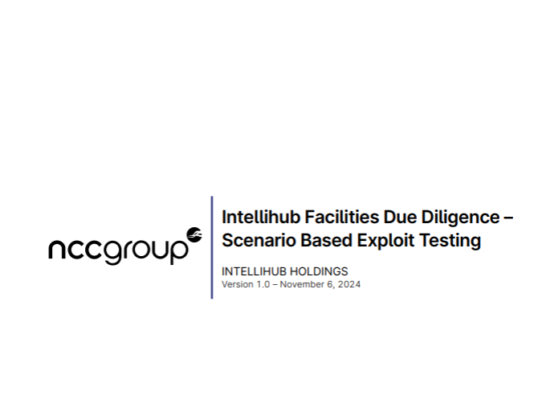

Appendix B - Risk Analysis Workbook
Threat Modeling Process and Methodologies The threat modeling process and methodologies used in this project include:
Threat Actors Analysis
Based on the provided threat model, the threat actors include:
- Cybercriminals
- Nation-state actors
- Hacktivists
- Disgruntled employees or contractors
- Curious or malicious customers
OT Cybersecurity Considerations
Operational technology (OT) cybersecurity is crucial for protecting industrial environments and critical infrastructure. Recent research and initiatives emphasize the importance of: • Extending IT security controls and workflows into OT environments • Implementing AI-driven attack signal intelligence for real-time threat detection and prioritization • Enhancing energy sector threat detection and developing tools for timely alerts and actionable information • Ensuring strict regulatory compliance and robust security measures • Conducting proactive vulnerability management and threat intelligence •
Industry Context and Threat Landscape
The energy sector faces a rapidly evolving threat landscape, with several key trends emerging:
- Ransomware Attacks: There has been a 50% increase in ransomware attacks targeting industrial organizations. This significant rise underscores the growing threat to critical infrastructure and the need for robust cybersecurity measures.
- Active Ransomware Groups: A 28% increase in active ransomware groups targeting ICS/OT systems has been observed. This trend indicates a growing sophistication and specialization among threat actors focusing on operational technology environments.
- Manufacturing Sector Targeting: 70% of attacks targeted manufacturing entities. This high percentage suggests that manufacturing processes and supply chains are particularly attractive targets for cybercriminals.
- Inadequate Mitigation Guidance: 49% of security advisories lacked proper mitigation guidance. This gap in actionable information highlights the need for improved communication and guidance in the cybersecurity community.
- Network Vulnerabilities: 16% of vulnerabilities are network exploitable and perimeter facing. This statistic emphasizes the importance of robust network security measures and perimeter defenses.
- Significant Vulnerabilities: 23% of engagements identify significant vulnerabilities. This high percentage underscores the ongoing challenge of identifying and addressing critical security weaknesses in smart meter infrastructure.
- Security Coverage: While there is 71% overall security coverage, this leaves a significant portion of the infrastructure potentially exposed to threats.
- Critical Advisories: 53% of advisories could cause both loss of view and control. This high percentage highlights the potential for attacks to have severe operational impacts on smart meter systems.
- Advisory Accuracy: 31% of security advisories contain errors in assessment. This statistic underscores the need for rigorous quality control in threat intelligence and vulnerability assessments.

Appendix C - Ransomware Attacks against the Energy Sector on the Rise
Nuclear and Oil & Gas are Major Targets in 2024
Overview
Resecurity has identified a significant increase in ransomware operators targeting the energy sector, including nuclear facilities and related research entities. Over the past year, ransomware attackers have targeted energy installations in North America, Asia, and the European Union. In the EU, Handelsblatt reported that ransomware attacks targeting the energy sector more than doubled in 2022 compared to the previous year, with defenders recording 21 attacks through the past October.
Key Takeaways
- Initial Access Brokers (IABs) on the Dark Web are actively seeking credentials and unauthorized intrusion methods for the energy sector, including nuclear energy firms.
- Ransomware attacks on the energy sector have significantly increased across North America, Asia, and the European Union.
- Cybercriminals target this sector under the assumption that they can demand more substantial ransom payments due to higher-value data assets.
- Criminal entities are expected to intensify their targeting of the energy industry, co-opting independent actors and IABs.
- Ransomware operators are increasing extortion demands beyond $7 million, leveraging their essentiality to Critical Infrastructure (CI) operations.
- Nuclear energy organizations are high-priority targets for both ransomware operators and advanced threat groups engaged in cyber espionage.
- The rise in ransomware attacks targeting the energy sector has destabilizing implications for geopolitical relations, capital markets, public safety, and national security.
Analysis of Ransomware Attacks Targeting the Energy Sector (2022-2023)
Resecurity's analysis indicates that extortion demands can range from tens of thousands to millions of dollars. Notable attacks include:
- ALPHV's coordinated attacks on Oiltanking in Germany, Invest-SEA in Belgium, Evos in the Netherlands, and Amsterdam-Rotterdam-Antwerp oil terminals in February 2022.
- Quilin's attack on Thornburi Energy Storage Systems (TESM), a key partner of German auto manufacturer Mercedes-Benz AG.
- ALPHV's and Black Basta's attacks on Italian public utilities such as Acea, Gestore dei Servizi Energetici S.p.A. (GSE), and Eni S.p.A.
- Cl0p's Memorial Day supply-chain attack campaign, which compromised at least 2,180 victims, including Shell plc, Siemens AG, Schneider Electric, and the U.S. Department of Energy.
Nuclear Energy Firms as Priority Targets
Resecurity has observed increasing interest from threat actors soliciting access to nuclear-sector entities. Examples include:
- Offerings on cybercriminal forums such as RAMP, XSS, and Exploit for access to nuclear energy organizations.
- Unauthorized disclosure of data from Brazil's National Nuclear Energy Commission.
- Access to Israel's Neve Ne'eman nuclear reactor being offered on Breach Forums.
- Unauthorized disclosure of data from Indonesia's National Nuclear Energy Agency (Batan).
- Compromise of Iran's Nuclear Power Production and Development Company (AEOI).
"Big Game" Hunting – Black Basta Targets the Energy Sector
Black Basta, hypothesized to be a divergent 'rebranding' of the Conti ransomware group, has been actively targeting the energy sector. Key points include:
- A novel Black Basta ransomware variant targeting European energy sector entities.
- Ransom demands of $6 million from one EU energy company and $3.5 million from a Nordic logistics company serving the oil & gas industry.
- Enhanced encryption capabilities in the new variant.
- Detailed analysis of the ransomware's functionality, including file encryption process and communication methods.
Summary
The escalation of ransomware attacks against the energy sector and critical infrastructure represents a trend that warrants significant attention. With sophisticated groups intensifying their focus on these high-stakes targets, the threat landscape is becoming increasingly complex. Projections for 2024 indicate a significant growth in cyber threats, particularly with ransomware groups prioritizing high-value targets within the energy sector, including nuclear energy and oil & gas providers. As digitalization in these areas continues to advance, the attack surface for malicious actors expands, presenting more opportunities for exploitation. The potential for substantial ransom payments, driven by the critical nature of these energy services, further enhances the appeal for malicious actors. It is imperative for organizations within the energy sector to significantly enhance their cyber defenses and prepare for sophisticated and potentially devastating cyber campaigns likely to emerge in the coming year.
Advanced Threat Model and Risk Visualization
Comprehensive Risk Interaction Matrix
Smart Meter Threat Landscape
Technical Risks █████████
Operational Risks ████████
Regulatory Risks ███████
Deployment Risks ██████
0 10
Deployment Risk Complexity Analysis
Risk Complexity Trajectory
Complexity ▲
High █████████ Deployment Scale
Medium █████████ Technological Diversity
Low █████████ Vendor Coordination
Q1 2024 Q4 2030
Current Target
Threat Vector Interaction Network
Threat Interaction Dynamics
Firmware Vulnerability
↙ ↘
Network Intrusion Data Exfiltration
↓ ↑
Communication Physical
Protocol Risks Tampering
Smart Meter Infrastructure Risk Profile
Risk Dimension | Current Status | Target Status | Improvement Potential
Technical Controls | Medium | High | Significant
Operational Resilience | Low | High | Critical
Regulatory Compliance | Medium | Very High | High
Deployment Efficiency | Low | High | Substantial

Detailed Threat Probability and Impact Assessment
Threat Probability vs Impact
Impact ▲
High █████ Firmware Manipulation
Medium █████ Network Intrusion
Low █████ Physical Tampering
0 Probability 1
Strategic Risk Mitigation Framework
Risk Reduction Roadmap
Phase | Focus Area | Key Objectives | Risk Reduction Target
Phase 1 (2024) | Technical Controls | Firmware Validation | 30% Risk Reduction
Phase 2 (2025) | Operational Resilience | Network Security | 50% Risk Reduction
Phase 3 (2026) | Regulatory Alignment | Compliance Framework | 70% Risk Reduction
Phase 4 (2027-2030) | Comprehensive Integration | Holistic Security | 90% Risk Reduction
Connectivity Vulnerability Radar
Connectivity Risk Profile
Cellular (3G/4G) █████
Wi-SUN Network ████
Potential Vectors ███
0 5
Regulatory Compliance and Risk Alignment
Compliance Trajectory
Alignment ▲
High █████ AEMC Guidelines
Medium █████ Data Privacy
Low █████ Sustainability Goals
Q1 2024 Q4 2030
Current Target
Supplementary Analytical Insights
Key Observations
- Deployment Complexity: The smart meter infrastructure presents a multi-dimensional risk landscape with interconnected technical, operational, and regulatory challenges.
- Technological Evolution: Continuous adaptation of threat detection and mitigation strategies is crucial to address emerging vulnerabilities.
- Regulatory Alignment: Proactive compliance and integration of sustainability goals are critical for long-term success.
Recommended Strategic Interventions
- Implement advanced firmware validation protocols
- Develop comprehensive network segmentation strategies
- Enhance real-time threat detection capabilities
- Establish robust supply chain security frameworks
- Integrate predictive analytics for proactive risk management
Future Research Directions
- Advanced cryptographic protection mechanisms
- Machine learning-based anomaly detection
- Quantum-resistant communication protocols
- Integrated hardware-software security frameworks
Conclusion
The comprehensive threat model reveals a complex, dynamic risk environment for smart meter infrastructure. Successful navigation requires a holistic, adaptive approach that balances technological innovation, regulatory compliance, and strategic risk management.

Appendix D - Smart Meter Threat Model and Firmware Risks

Appendix D: Smart Meter Threat Model and Firmware Risks

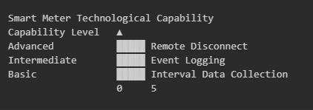

Background
Smart Meter Technology

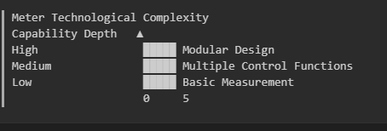

The Landis+Gyr E355 is a smart meter model used by Intellihub, designed for advanced metering infrastructure (AMI) applications[4][6]. The E355 meter supports various features, including remote reading of interval data, time-of-use (TOU) tariff, ripple control, under frequency load control, tamper detection, and event logging[4]. The meter has a modular design, allowing for field-upgradeable communication modules to address future needs without replacing the entire meter[4].

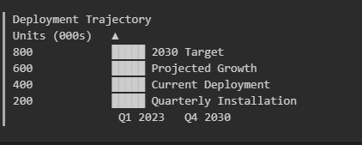

The E355 meter supports ANSI C12.18/21 protocols for two-way communications between the meter and the module[4]. It also supports ANSI C12.19 data structures for extracting and organizing meter data in a specific format[4]. The meter has local and remote disconnect relay capabilities, as well as quality of supply monitoring and loss of supply detection[4].

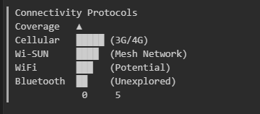

Software Infrastructure

IntelliConX Software

Software Capability Progression

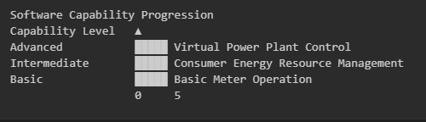IntelliConX is a proprietary software developed by Intellihub, designed to manage and operate smart meters[1]. The software provides advanced features such as virtual power plant (VPP) and consumer energy resource (CER) control, enabling efficient management of distributed energy resources[1].

PolicyNet Platform
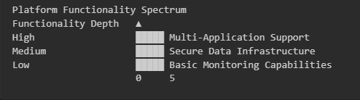

PolicyNet is a platform used by Intellihub to manage and operate smart meters, providing a secure and reliable infrastructure for data collection and analysis[1]. The platform supports various applications, including smart metering, distribution automation, and street lighting control[1].

Connectivity Options
Cellular (3G/4G)
- The E355 meter supports cellular connectivity (3G/4G) for remote data transmission and communication[4]. The meter uses a SIM card with a private APN for secure and reliable communication[4].

Other Potential Connections (WiFi, Bluetooth, WiSun)
- Wi-SUN (Wireless Smart Utility Network) is a wireless communication standard used for smart grid applications, offering a stable mesh network for advanced metering infrastructure and distribution automation[2][3]. Wi-SUN supports various frequency bands, including 2.4 GHz and 915 MHz, and offers features such as active frequency hopping and mesh networking[2][3]. The E355 meter may potentially support Wi-SUN connectivity, although this is not explicitly stated in the available documentation[4]. WiFi and Bluetooth connectivity options are not explicitly mentioned in the available documentation for the E355 meter[4].

Citations:
[1] https://www.intellihub.com.au [2] https://chintglobal.com/blog/wi-sun-wireless-smart-utility-network-basics-advantages/ [3] https://www.silabs.com/wireless/wi-sun [4] https://www.landisgyr.com.au/product/landisgyr-u-series-e350/ [5] https://greensync.com/news/greensync-joins-intellihub-group/ [6] https://neighbourhood.agl.com.au/t5/Meters-Connections/How-to-use-and-read-my-LAndis-Gyr-E355-smartmeter/td-p/36176

Smart Meter Deployment

Current Installation Statistics

Intellihub is managing 2.5 million smart meters for more than 40 electricity retailers across Australia and New Zealand[2]. The company is installing and servicing more than 40,000 smart meters each month[2]. Intellihub recently acquired an additional 100,000 on-market meters and embedded meters from Downer's Spotless
Advanced Metering (SAM) business[2].

Deployment Strategies

Intellihub has contracts with 10 large field service providers to help install and service smart meters[2]. The company is preparing for accelerated smart meter deployment to meet Australia's goal of complete smart meter deployment by 2030[2]. Intellihub supports the implementation of a framework for universal deployment of smart meters to all customers by 2030, as proposed in a rule change request to the Australian

Energy Market Commission (AEMC)[3].

Challenges in Large-Scale Implementation
The current installation rate of smart meters in Australia is slower compared to many other countries, with installations ambling along at just over 100,000 meters per quarter for the past seven quarters[4]. To meet the 2030 universal rollout target, the number of smart meter deployments needs to increase substantially from a little over 400,000 units in FY23 to over 700,000 units per year from FY26[3]. There are barriers to installing smart meters that need to be reduced to enable more efficient and coordinated deployments[3].

Customer Engagement and Education

The proposed rule change calls for the implementation of measures to better support customers through the accelerated rollout, including improving the information provided to them[3]. New consumer protections are proposed to be applied when customers receive a smart meter[3]. Intellihub is focusing on providing better customer service to electricity retailers and their customers[2]. The company is looking beyond the meter to provide greater services and benefits, including enabling greater management of consumer energy devices to help households save energy, reduce costs, and simplify their energy transition[2].
- Citations:
  - [1] https://www.accc.gov.au/system/files/public-registers/documents/Witness Statement of Jonathan Hammond (confidentiality revised 3 Jul 23) - 05.06.23 - PR VERSION - MA1000024 Brookfield Origin.pdf?download=y
  - [2] https://www.intellihub.com.au/news/intellihub-acquires-smart-metering-assets-from-downer
  - [3] https://www.smart-energy.com/industry-sectors/smart-meters/plan-to-accelerate-smart-meters-deployments-in-australia/
  - [4] https://www.energymagazine.com.au/faster-smart-meter-roll-out-will-unlock-gigawatts-of-consumer-generation/

Regulatory Compliance

Australian Energy Market Regulations
The Australian Energy Market Commission (AEMC) has proposed a rule change to accelerate the deployment of smart meters, aiming for a 100% rollout by 2030[1][2]. This proposal includes measures to improve the installation process, reduce barriers, and enhance customer protections[3]. The AEMC's review highlighted issues such as misaligned incentives and process inefficiencies that have slowed smart meter adoption[2]. The regulatory framework aims to improve access to power quality data and streamline installations to support the energy system's transition[3].

Data Privacy and Security Standards
Smart meters in Australia must comply with the National Electricity Rules (NER), which include specifications for remote data access and control[5]. Intellihub's smart meters are designed to meet these standards, ensuring secure and efficient data management[6]. The regulatory framework emphasizes improving customer safeguards to protect against potential cost risks and ensuring a positive customer experience during installation and operation[2].

Environmental and Sustainability Requirements
Intellihub has secured a world-first Green Loan certification under the Climate Bonds Initiative's criteria for Electrical Grids and Storage, demonstrating its commitment to sustainability[6]. The smart meters play a crucial role in supporting the transition to net-zero emissions by facilitating grid resilience and integrating renewable energy sources[6]. The company's Sustainable Finance Framework outlines how it manages funds to ensure climate integrity, contributing to both climate mitigation and adaptation[6]. Smart meters enable real-time data insights, optimizing energy use for solar, batteries, and electric vehicles, thereby enhancing the environmental efficiency of energy systems[6].

These points highlight Intellihub's alignment with regulatory requirements in Australia, focusing on accelerating smart meter deployment while ensuring data security and supporting environmental sustainability goals through innovative financial frameworks and technology integration.

Citations:
[1] https://www.smart-energy.com/industry-sectors/smart-meters/plan-to-accelerate-smart-meters-deployments-in-australia/
[2] https://oia.pmc.gov.au/published-impact-analyses-and-reports/accelerating-smart-meter-deployment-draft-determination
[3] https://www.aemc.gov.au/market-reviews-advice/review-regulatory-framework-metering-services
[4] https://www.societegenerale.asia/en/newsroom/press-releases/press-releases-details/news/how-smart-meters-are-helping-australia-embrace-new-energy-future/
[5] https://www.energymining.sa.gov.au/industry/hydrogen-and-renewable-energy/solar-batteries-and-smarter-homes/regulatory-changes-for-smarter-homes/smart-meter-requirements
[6] https://www.intellihub.com.au/news/intellihub-secures-world-first-certification-under-international-climate-bonds-standard

Appendix E - Intellihub Supply Chain Risk Management – CrescoNet
Subject: Contract negotiations, Cybersecurity standards to improve Intellihub’s risk management
Date: Nov, 2024
Author: NCC Group

Preface
CrescoNet, established as Intellihub's technology development arm, plays a crucial role in providing essential technologies and services for Intellihub's operations. The company offers cloud-to-cloud Distributed Energy Resource (DER) device management, next-generation metering solutions, and integrated digital technologies.

Of particular importance is CrescoNet's provision of the Head End System, which is critical for Intellihub's smart meter deployment and infrastructure management. This strategic partnership extends to the integration of the deX platform, which is vital for DER management and the delivery of digital utility IoT solutions. The acquisition of GreenSync by CrescoNet in 2022 further strengthened this technological alliance, with GreenSync becoming part of CrescoNet's new technology development division led by experienced energy and smart grid engineer Adrian Clark.

The heavy reliance on CrescoNet exposes Intellihub to significant operational and strategic risks. Operationally, the company faces potential service disruptions if CrescoNet encounters cybersecurity issues, limited control over technology operations, and challenges in implementing rapid changes.

Recommended Agreement Updates
To mitigate risks associated with Intellihub's dependency on CrescoNet, several key updates to their legal contract are recommended. These include defining specific performance metrics for system availability and reliability, establishing clear response times for cybersecurity issues and incidents, and setting concrete requirements for technologies and processes.

OT Standards for Agreements, Use IEEE 1686-2013 & NISTP 800-23r3
To enhance Intellihub's risk management strategy and provide more prescriptive directives Master Service Agreement (MSA) with CrescoNet a combined approach leveraging both NIST SP 800-82r3 and IEEE 1686-2013 is recommended. This strategy should be contractually required from CrescoNet, ensuring a comprehensive security framework for Intellihub's smart meter infrastructure. By contractually requiring CrescoNet to adhere to this combined strategy, Intellihub can ensure a robust, multi-layered security approach that addresses both broad OT security concerns and specific IED-related vulnerabilities in their smart meter infrastructure.

To strengthen Intellihub's cybersecurity posture and mitigate risks associated with CrescoNet's services, a combined approach leveraging both NIST SP 800-82r3 and IEEE 1686-2013 is recommended. This strategy should be contractually required from CrescoNet, ensuring a comprehensive security framework for Intellihub's smart meter infrastructure:

- Risk Assessment and Management:
- Conduct regular risk assessments of the Head End System and smart meter network, aligning with NIST SP 800-82r3 guidelines
- Implement a continuous risk management process, incorporating IEEE 1686-2013's focus on IED-specific vulnerabilities
- Access Control and Authentication:
- Enforce role-based access control (RBAC) with multi-factor authentication for all system access, as per NIST SP 800-82r3
- Implement IEEE 1686-2013's robust authentication mechanisms for IEDs, including strong password policies and secure credential storage
- Network Segmentation and Communication Security:
- Implement strict network segmentation as recommended by NIST SP 800-82r3 to isolate critical OT systems
- Apply IEEE 1686-2013's communication encryption requirements to all data transmissions within the smart meter network
- Monitoring and Incident Response:
- Deploy a Security Information and Event Management (SIEM) system for continuous monitoring, aligning with NIST SP 800-82r3 guidelines
- Integrate IEEE 1686-2013's event reporting capabilities for IEDs into the overall monitoring strategy
- Secure System Development and Maintenance:
- Adopt secure coding practices and conduct regular code reviews as per NIST SP 800-82r3
- Implement IEEE 1686-2013's firmware validation processes for all smart meter software updates
- Remote Access Security:
- Establish secure protocols for remote access to OT systems, following NIST SP 800-82r3 recommendations
- Implement IEEE 1686-2013's specific requirements for secure remote access to IEDsAudit and Compliance:
- Conduct annual compliance audits against both NIST SP 800-82r3 and IEEE 1686-2013 standards
- Implement a system for tracking and reporting on key security metrics derived from both standards.

IEEE 1686 Control Requirements
IEEE 1686-2013 provides specific cybersecurity control requirements that Intellihub should mandate CrescoNet to implement for their smart meter infrastructure:
- Access Control: Implement role-based access control (RBAC) with at least four privilege levels: View, Operate, Configure, and Full Access. Enforce strong password policies, including minimum length of 8 characters, complexity requirements, and regular password changes

- Audit Logging: Maintain a comprehensive audit trail of all user activities, configuration changes, and security events. The audit log should be tamper-resistant and include timestamps, user IDs, and specific actions performed
- Firmware Security: Implement secure boot processes and cryptographic verification of firmware updates. All firmware should be digitally signed, and the IED must verify the signature before installation
- Communication Security: Enforce strong encryption protocols (e.g., TLS 1.2 or higher) for all data transmissions. Implement secure key management practices, including regular key updates and secure storage of cryptographic materials
- Event Reporting: Configure IEDs to generate and transmit security event reports to a centralized monitoring system. Events should include failed login attempts, configuration changes, and firmware updatesRemote Access Security: Establish secure protocols for remote access, including VPN connections and secure shell (SSH) for maintenance. Implement additional authentication measures for remote sessionsPort Security: Provide the capability to disable unused physical and logical ports to reduce the attack surface

NIST SP 800-82r3 Control Requirements
NIST SP 800-82r3 provides detailed cybersecurity controls that Intellihub can require CrescoNet to implement for their Head End System:

- Authentication and Access Control:
  - Implement multi-factor authentication (MFA) for all system access, especially for privileged accounts
  - Enforce strong password policies, including regular password changes and complexity requirements
  - Implement role-based access control (RBAC) to limit user privileges based on job functions
- Continuous Monitoring and Logging:
  - Deploy Security Information and Event Management (SIEM) tools to collect and analyze system logs in real-time
  - Implement network behavior anomaly detection to identify unusual patterns or potential threats
  - Conduct regular vulnerability scans and penetration testing of the Head End System
- Security Patching and Updates:
  - Establish a formal patch management process with defined timelines for critical updates
  - Implement a testing environment to validate patches before deployment to production systems
  - Maintain an up-to-date inventory of all software and firmware versions in use

- Incident Response and Recovery:
  - Develop and regularly test an OT-specific incident response plan
  - Implement automated backup systems with encryption for critical data
  - Establish clear communication protocols and escalation procedures for security incidents
Table A : Comparison of Standards; NIST SP 800-82r3 & IEEE 1686-2013
Requirement Category | NIST SP 800-82r3 | IEEE 1686-2013
Risk Management | Comprehensive risk assessment and continuous management process | Not explicitly covered
Access Control | Role-based access control (RBAC) with multi-factor authentication | Role-based access control and strong authentication mechanisms
Network Security | Network segmentation and isolation of critical systems | Communication encryption for all data transmissions
Monitoring | Continuous monitoring using SIEM systems | Event reporting and audit logging capabilities
Incident Response | OT-specific incident response plan and procedures | Not explicitly covered
System Development | Secure coding practices and regular code reviews | Firmware validation and secure update processes
Remote Access | Secure protocols for remote system access | Specific requirements for secure remote access to IEDs
Patch Management | Rigorous patch management process with defined timelines | Not explicitly covered
Supply Chain Security | Vendor risk assessment program | Not explicitly covered
Password Management | Strong password policies (part of access control) | Enforced password complexity and secure storage
Compliance and Auditing | Annual compliance audits and security metrics reporting | Not explicitly covered

Appendix F - Third-Party Dependency Analysis
This appendix provides a detailed analysis of third-party dependencies within Intellihub's smart meter infrastructure, focusing on the associated risks and mitigation strategies. The analysis considers the criticality of each dependency, the potential impact of disruptions or security breaches, and the overall security posture of the third-party vendors.
1. CrescoNet:
- Role: Cloud service provider for PolicyNet Core and related systems.
- Criticality: High. CrescoNet hosts and manages critical components of Intellihub's smart meter infrastructure, including the PolicyNet head-end system, data collection and processing systems, and the command center.
- Potential Risks:
  - Service outages could disrupt the entire smart meter management system, impacting billing, monitoring, and control functions.
  - Data breaches could compromise sensitive meter data, customer information, and operational data.
  - Vendor lock-in could limit Intellihub's flexibility and increase costs.
- Mitigation Strategies:
  - Robust Service Level Agreements (SLAs) with clearly defined uptime guarantees and penalties for non-compliance.
  - Regular security audits of CrescoNet's infrastructure and security practices.
  - Strong data encryption and access controls to protect sensitive data.
  - Development of contingency plans for service disruptions, including alternative service providers or on-premises backup systems.
2. Atheros:
- Role: Hardware manufacturer for the Edge System Router (ESR) and provider of the Advanced Operating System (AOS).
- Criticality: High. The Atheros ESR is a core component of the IntelliGenX Gen 2 smart meter, and the AOS is the operating system for the device.
- Potential Risks:
  - Hardware vulnerabilities in the ESR could allow for unauthorized access or denial-of-service attacks.
  - Software vulnerabilities in the AOS could compromise the security and functionality of the smart meters.
  - Supply chain disruptions could affect the availability of ESR hardware.
  - Security implications of the open-source AOS SDK could lead to vulnerabilities if not properly managed.
- Mitigation Strategies:
  - Regular security assessments of ESR hardware and AOS software.
  - Maintaining relationships with alternative hardware suppliers to mitigate supply chain risks.
  - Implementing robust change management processes for AOS updates, including thorough testing and rollback procedures.
  - Conducting thorough code reviews of open-source contributions to the AOS SDK.
3. Landis+Gyr:
- Role: Manufacturer of the Landis+Gyr E355 smart meters.
- Criticality: Medium. The E355 meters are the primary data collection devices in Intellihub's infrastructure.
- Potential Risks:
  - Hardware vulnerabilities in the meters could allow for unauthorized access or data manipulation.
  - Compatibility issues with future IntelliGenX versions could disrupt operations.
  - Supply chain disruptions could affect the availability of meters.
- Mitigation Strategies:
  - Regular firmware updates and security patches for the E355 meters.
  - Maintaining relationships with alternative meter suppliers to mitigate supply chain risks.
  - Conducting thorough testing for compatibility with each IntelliGenX release.
4. Telstra:
- Role: Network infrastructure provider, providing cellular network connectivity and APN services.
- Criticality: High. Telstra's network infrastructure is essential for communication between the smart meters and the PolicyNet head-end system.
- Potential Risks:
  - Network outages could disrupt communication with smart meters, impacting data collection and control functions.
  - Security breaches in Telstra's infrastructure could compromise the security of the smart meter network.
  - Changes in service offerings or pricing could impact Intellihub's operational costs.
- Mitigation Strategies:
  - Implementing redundant communication methods, such as the Wi-SUN mesh network, as a backup to the cellular network.
  - Regular security assessments of Telstra's network infrastructure and security practices.
  - Clear Service Level Agreements (SLAs) with defined performance metrics and penalties for non-compliance.
  - Exploring partnerships with multiple cellular providers to ensure redundancy and mitigate vendor lock-in.
5. Jasper:
- Role: Provider of the Jasper Control Center, an IoT connectivity management platform used for APN management.
- Criticality: Medium. The Jasper Control Center is essential for managing the APN connections used for cellular communication.
- Potential Risks:
  - Platform vulnerabilities could lead to unauthorized access or disruption of APN management capabilities.
  - Service outages could impact APN management and disrupt communication with smart meters.
  - Vendor lock-in could limit Intellihub's flexibility and increase costs.
- Mitigation Strategies:
  - Regular security audits of the Jasper Control Center platform.
  - Developing in-house expertise for APN management as a fallback option.
  - Exploring alternative IoT connectivity management solutions to mitigate vendor lock-in.
6. Open-Source Components:
- Role: Various open-source libraries and tools are used in the IntelliGenX Gen 2 smart meter and the AOS.
- Criticality: Medium. The security and reliability of these open-source components are essential for the overall security of the smart meter infrastructure.
- Potential Risks:
  - Security vulnerabilities in open-source components could be exploited by attackers.
  - Licensing issues could arise if the terms of use for open-source components are not properly followed.
  - Lack of support or abandoned projects could lead to difficulties in maintaining and securing these components.
- Mitigation Strategies:
  - Maintaining an inventory of all open-source components used in the system, including their versions and licenses.
  - Regular security scans of open-source libraries to identify and remediate vulnerabilities.
  - Contributing to key open-source projects to ensure their continued maintenance and security.
  - Having contingency plans for replacing critical open-source components if necessary.
7. Conclusion:
Intellihub's smart meter infrastructure relies on a complex web of third-party dependencies. Managing these dependencies effectively is crucial for ensuring the security and reliability of the system. The risks associated with each dependency must be carefully assessed, and appropriate mitigation strategies must be implemented. This analysis highlights the need for a comprehensive vendor management program, a multi-vendor strategy where possible, robust SLAs, regular security assessments, and contingency planning. By proactively addressing these risks, Intellihub can minimize the potential impact of disruptions or security breaches and ensure the continued integrity of its smart meter infrastructure.

Appendix G - Intellihub OT Cyber Risk Report Brief

I. Introduction and Project Overview

Project Dimension | Details
Assessment Focus | NCC Group cybersecurity assessment of Intellihub's Smart Meter infrastructure
Approach | Three-phase methodology: architecture review, build review, penetration testing
Strategic Alignment | AEMC mandate, Intellihub risk management program

Key Project Parameters
- Specific Focus: IntelliConX Gen 2, L+G E355 meter, Telstra communications, PolicyNet
- Key Objectives:
  - Documentation
  - Examination
  - Assessment
  - Evaluation
  - Analysis
  - Verification

Project Methodology
- Initialization
- Vulnerability and Architecture Design Review (VADR)
- Testing/Review
- Reporting

II. Executive Summary and Key Risks
2. Executive Overview
Risk Category | Key Characteristics | Potential Impact
Firmware Security | Vulnerabilities in device firmware | Potential system compromise
Cloud-Based Threats | Risks in cloud infrastructure | Data breaches, service disruption
3rd Party Integrations | Supply chain and vendor risks | Expanded attack surface

Architecture Assessment
Strengths | Weaknesses
Network isolation | Large attack surface
Centralized management | Potential for broad outages
Limited physical interfaces | Limited risk visibility
Abstracted data management | Inconsistent Multi-Factor Authentication

Threat Assessment Methodology
- Threat intelligence research
- Peer evaluation
- MITRE ATT&CK framework application
- Component-based threat modeling

Key Industry Observations
- Complex supply chains and data networks
- Challenges in ecosystem security
- Consumer-grade equipment vulnerabilities
- Cloud reliance
- Third-party dependencies
- Emerging attack vectors

Typical Industry Spends
- Enhanced OT incident response
- Enhanced Supply chain risk management
- Require Multi-Factor Authentication
- Third-party management
- Cyber insurance
- OT incident response retainers

Priority Action Items
Action Domain | Key Focus Areas
Firmware Security | - Enhanced security principles  - Comprehensive management strategy
Cloud Security | - Advanced threat detection  - Secure infrastructure design
Incident Response | - Develop comprehensive playbooks  - Technology coordination  - Simulation and recovery planning

Appendix H - Intellihub Business Unit Risk Treat Criteria – Cybersecurity
Title: Intellihub Business Unit Risk Treat Criteria – Cybersecurity
Subject: Cyber Security Risk Year: 2024
Year:2024
Cyber Security Risk
The key personnel involved are:
- Risk Owner: Sally Kennedy (Chief Information Officer)
- Risk Lead: Sara Abak (CISO)
Risk Description: The risk that Intellihub is subjected to cyber attacks on networks, integrated technology and/or data which impacts the team's ability to conduct its operations.
Risk Category: Information Technology & Data This is a risk assessment document with ID #6 concerning Intellihub's Cyber Security Risk.
Risk Treatment Required?: YES
Component Details:
Component | Details
Risk ID | #6
Risk Owner | Sally Kennedy (Chief Information Officer)
Risk Lead | Sara Abak (CISO)
Risk Category | Information Technology & Data
Risk Title | Cyber Security Risk
Risk Description | The risk that Intellihub is subjected to cyber attacks on networks, integrated technology and/or data which impacts the team's ability to conduct its operations.
Sub Risks:
Column 1 | Column 2 | Column 3
• Loss of access to systems/technology • Cyber resilience • Distributed denial of services • Loss of data • Identity theft | • Data corruption • Data accuracy • Data timeliness • Data completeness | • Data reliability • Data ownership • Hacking • Phishing
Risk Causes:
Column 1 | Column 2 | Column 3
• Constant threat of malicious attacks on Intellihub from external parties • Security protocols still being improved • Human error/risky online behaviour | • Ineffective data portability methods • Gaps due to system/software integration • Vulnerabilities caused by FSPs • Complacency in cyber training and situational awareness of individual employees | • Immature data governance and security environment • Capacity and capability of IT team • Human error/behaviours

Risk Consequences:
Column 1 | Column 2 | Column 3
• Ransom demand | • Impact to operations, customers and subsequent financial loss | • Brand and reputation damage – loss of trust • Fine or regulatory intervention

Key Controls:
Column 1 | Column 2 | Column 3
• Security Governance- Information Security Charter & FTE Manager • Information Security Steering Committee (ISSC) • Cybersecurity training (identified staff only) more training modules to follow for the upcoming 9-12 months | • Information Security Assurance • Information Security Training • Security Implementation • Exception and faults reporting • Testing and data validation teams • Cyber security measures and precautions (e.g. firewalls, anti-virus software etc.) | • Business Continuity Plan and regular scenario testing • Disaster Recovery Plan • Security monitoring and incident response vendors (covering IWS, MDM in Intellihub network and NZ Metrix environment) • Planned maintenance downtime
Risk Assessment:
Risk Type | Impact | Likelihood | Rating
Residual Risk | Major | Possible | High
Target Risk | Moderate | Possible | Medium

Risk Action Plan:
# | Risk Action Plan | Due Date | Plan Owner | Priority | Status
1. | Conduct independent audits of cyber and general IT controls. | 30 June 2024 | Sara Abak | 1 | New
2. | Leverage common ownership (promote operational resilience and increase delivery capability). | Ongoing | Sally Kennedy | 3 | In progress
3. | Propose CrescoNet to align to SOCI requirements. | 30 June 2024 | Sara Abak | 1 | In progress
4. | Propose CrescoNet to conduct fire drills and risk assessments for cyber security events. | 31 March 2024 | Sara Abak | 1 | In progress
5. | Work with CrescoNet to define clear ways of working and operating procedures (e.g. Agile delivery, demand management, project tracking) | 31 December 2024 | Sally Kennedy | 1 | In progress

Risk Treatment Priority Criteria:
- Priority 1: Important Risk Treatment Plan action that will need to commence within the next 3 months.
- Priority 2: Important Risk Treatment Plan action that will need to commence within the next 6 months.
- Priority 3: Risk Treatment Plan action that will need to commence within the next 12 months.

Appendix I - Intellihub Business Unit Risk Treat Criteria - CrescoNet
Title: Intellihub Business Unit Risk Treat Criteria - Cresconet
Subject: Supplier Risk: Supplier = :CrescoNet
Year:2024
CrescoNet Supply Chain Risk
The key personnel involved are:
- Risk Owner: Sally Kennedy (Chief Information Officer)
- Risk Lead: Sara Abak (CISO)
Risk Description: The risk of operational outages, security incidents and delivery delays due to heavy reliance on a relatively small critical supplier (CrescoNet).
Risk Category: Stakeholder Relations and Governance Risk
This is a risk assessment document with ID #3 concerning Intellihubs’ supplier CrescoNet.
Sub Risks are divided into three categories:
- Key supplier risk
- Issue resolution
- Supplier relations
Contributing factors; Critical applications and data sit with CrescoNet and operate to different security and IT control standards
Residual Risk is rated as:
- Impact: Major
- Likelihood: Probable
- Rating: Very High
Target Risk is rated as:
- Impact: Moderate
- Likelihood: Unlikely
- Rating: Low
Risk Treatment is Required?: YES
The Risk Action Plan contains 5 items:
- Conduct independent audits of cyber and general IT controls.
- Due Date: 30 June 2024
- Plan Owner: Sara Abak
- Priority: 1
- Status: New
- Leverage common ownership (promote operational resilience and increase delivery capability).
- Due Date: Ongoing
- Plan Owner: Sally Kennedy
- Priority: 3
- Status: In progress
- Propose CrescoNet to align to SOCI requirements.
- Due Date: 30 June 2024
- Plan Owner: Sara Abak
- Priority: 1
- Status: In progress
- Propose CrescoNet to conduct fire drills and risk assessments for cyber security events.
- Due Date: 31 March 2024
- Plan Owner: Sara Abak
- Priority: 1
- Status: In progress
- Work with CrescoNet to define clear ways of working and operating procedures (e.g. Agile delivery, demand management, project tracking)
- Due Date: 31 December 2024
- Plan Owner: Sally Kennedy
- Priority: 1
- Status: In progress
- Component | Details
Risk ID | #3
Risk Owner | Sally Kennedy (Chief Information Officer)
Risk Lead | Sara Abak (CISO)
Risk Category | Stakeholder Relations and Governance
Risk Title | Supply Chain Risk (CrescoNet)
Risk Description | The risk of operational outages, security incidents and delivery delays due to heavy reliance on a relatively small critical supplier (CrescoNet).
Sub Risks
Column 1 | Column 2 | Column 3
Key supplier risk | Issue resolution | Supplier relations
Risk Causes
Column 1 | Column 2 | Column 3
• Supplier capacity, maturity and capability • Critical applications and data sit with CrescoNet and operate to different security and IT control standards | • Weak supplier contractual arrangements • Additional third-party dependencies back-to-back with CrescoNet are difficult to manage | • At times there are conflicted priorities for delivery • Physical separation of teams
Risk Consequences
Column 1 | Column 2 | Column 3
• Significant service disruption • Revenue growth targets not met due to delays in product to market • Customer SLA breaches/service penalties/loss of contract | • Customer dissatisfaction • Financial penalties from market regulators • Stifles business growth • Financial losses/cash flow impacts • Service penalties from retailers | • Asset write-off • Reputational damage • Prevents execution of Behind the Meter strategy • Contract breaches/loss of contract
Key Controls
Column 1 | Column 2 | Column 3
• Improved provisions in Professional Services Agreement (PSA) • Vendor contracts include appropriate downstream security obligations | • 3rd party supply assessment • Meter asset sample testing | • Supplier inspections • Supply contracts/agreements
Risk Assessment
Risk Type | Impact | Likelihood | Rating
Residual Risk | Major | Probable | Very High
Target Risk | Moderate | Unlikely | Low

Risk Action Plan
# | Risk Action Plan | Due Date | Plan Owner | Priority | Status
1. | Conduct independent audits of cyber and general IT controls. | 30 June 2024 | Sara Abak | 1 | New
2. | Leverage common ownership (promote operational resilience and increase delivery capability). | Ongoing | Sally Kennedy | 3 | In progress
3. | Propose CrescoNet to align to SOCI requirements. | 30 June 2024 | Sara Abak | 1 | In progress
4. | Propose CrescoNet to conduct fire drills and risk assessments for cyber security events. | 31 March 2024 | Sara Abak | 1 | In progress
5. | Work with CrescoNet to define clear ways of working and operating procedures (e.g. Agile delivery, demand management, project tracking) | 31 December 2024 | Sally Kennedy | 1 | In progress

Intellihub Business Risk Treatment Criteria
- Priority 1: Important Risk Treatment Plan action that will need to commence within the next 3 months.
- Priority 2: Important Risk Treatment Plan action that will need to commence within the next 6 months.
- Priority 3: Risk Treatment Plan action that will need to commence within the next 12 months.
- The table uses a color scheme where the Priority column is shown in light blue, while the Explanation column has a gray background. The header row is in a darker blue color.

Appendix J – CrescoNet Business Overview

CrescoNet: Business Overview
CrescoNet, an advanced cellular utility solutions company based in Carlsbad, California, offers integrated digital technologies that enable utilities to enhance efficiency, reduce costs, and improve sustainability across electric, water, and gas sectors. Through its vendor-agnostic approach and recent strategic acquisitions, CrescoNet provides utilities with flexible, scalable solutions for advanced metering infrastructure, distributed energy resource management, and cloud-based data analytics.

CrescoNet's Utility Solutions
Offering a comprehensive suite of utility management solutions, the company provides:
- LTE/5G-based advanced metering infrastructure (AMI)
- IoT and cloud-native data systems
- Distributed energy resource (DER) orchestration
Key offerings include:
- Battery-powered LTE/5G communications for smart metering
- Cloud-based meter data management (MDM) and analytics platforms
- Vendor-agnostic integration with existing smart meter hardware
- DER flexibility management and orchestration tools
- Public and private LTE/5G multi-application networks for utilities

Strategic Acquisitions and Investments
CrescoNet has pursued a strategic growth strategy through key acquisitions and investments:
- July 2021: Acquired Smart Earth Technologies (SET)
  - Expanded water utility product portfolio
  - Added integrated, battery-operated, cellular endpoint transceivers, valves, installation tools, LTE infrastructure, and cloud software
- April 2022: Acquired GreenSync
  - Brought advanced DER capabilities to North America
  - Introduced CrescoNet deX, a cloud-based middleware solution for DER integration and control
- May 2022: Received significant equity investment from Brookfield
  - Aimed to accelerate product and market expansion into North American water, gas, and electric utilities
- January 2023: Announced full product portfolio shift to Smart Earth Technologies (SET) brand
  - Consolidated electric and gas solutions under the SET brand
  - Aimed to provide a unified offering across electric, water, and gas utilities
These strategic moves have positioned CrescoNet as a comprehensive provider of next-generation utility management systems, capable of addressing the complex needs of modern utilities in an increasingly interconnected and sustainable energy landscape.

Benefits for Utilities
CrescoNet's integrated solutions offer numerous benefits for utilities:
- Cost Reduction: Leveraging public cellular networks to avoid substantial capital expenditures associated with building and maintaining proprietary communication networks.
- Improved Reliability: LTE/5G-based solutions provide robust, high-bandwidth connectivity, enhancing the reliability of utility communications.
- Enhanced Flexibility: Vendor-agnostic approach allows integration of best-of-breed solutions from various manufacturers.
- Advanced Data Analytics: Cloud-native data solutions enable deeper insights into consumption patterns, network performance, and potential issues.
- Simplified DER Integration: Streamlined approach to integrating and managing distributed energy resources without the need for specialized metering or hardware.
- Future-Proofing: Solutions designed to be compatible with future 5G networks and allow for provider redirection.
- Regulatory Compliance: Advanced metering and data management solutions help meet evolving regulatory requirements.
- Customer Engagement: Improved data analytics and management offer customers more detailed insights into consumption patterns.

Cloud-Based Data Solutions for Utilities
CrescoNet's cloud-based data solutions offer utilities a powerful suite of tools to manage and analyze their vast amounts of meter data:
- Cloud-native Meter Data Management System (MDMS):
  - Centralized platform for collecting, processing, and storing meter data
  - Handles large volumes of data in real-time
  - Ensures up-to-date information for billing, customer service, and operational purposes
- Scalability:
  - Easily accommodates increased data loads without significant infrastructure investments
  - Allows utilities to grow digital capabilities in line with operational needs and budget constraints
- Advanced Analytics:
  - Incorporates AI and machine learning algorithms
  - Helps identify patterns in energy consumption, predict equipment failures, detect theft or leakage, and optimize network performance
- Interoperability:
  - Features open APIs for seamless integration with other utility systems (CIS, GIS, OMS)
  - Creates a more cohesive and efficient operational environment
- Security:
  - Robust encryption, access controls, and compliance with industry standards
  - Regular security updates and patches applied seamlessly
- Sustainability Support:
  - Provides detailed insights into energy consumption patterns and grid performance
  - Enables better integration of renewable energy sources
  - Supports implementation of demand response programs
  - Facilitates growth of distributed energy resources (DERs)

Appendix K – Initial Device Testing Results and Observations
Initial Device Testing Results and Observations
Device: IntelligenX Gen 2 w/E355 Meter Device Build Review
Content as of: Oct 20
Draft Report Due: Oct 25
General Observations on Lab Setup and Activities:
- Lab was well-equipped with necessary devices and testing environment
- Multiple signals present in the lab environment, potentially interfering with device signal detection
- Testers had access to full field tech kit for optical probe testing
- Lab manager (Riccardo) provided necessary briefings and access
- Testing activities were comprehensive, covering various aspects of device security
- Some planned testing activities (e.g., APN access, PolicyNet interaction) were limited due to access constraints

Initial Lab Test Outcomes for Device Testing
Key Observations
- Minimalistic device design with limited features/inputs
- No web interface on the device
- DMAP application requires user password and key for installation
- License keys and encryption keys stored in XML files on service laptops
- Tamper-evident features present on the device
- Optical probe requires a multi-step sequence for access
- Firmware files appeared to be encrypted and resistant to common decoding methods
Potential Risks
- Storage of encryption keys in clear text on service laptops
- Potential vulnerability in DMAP application access control
- Possible risks associated with RJ12 interface and its communication with the meter
- Uncertainty about the security of APNs and potential for device isolation
Probable Risks
- Potential exposure of encryption keys and license files on service laptops
- Uncertainties around APN security measures
- Limited ability to detect tampering or unauthorized access to devices
- Potential increase in "attack surface" with planned Gen 2 to Gen 3 enhancements

Initial Recommendations
- Review the DMAP application in isolation for potential vulnerabilities
- Consider bundling the RJ12 device into Gen3 with improved tamper-evident features
- Review tamper alarm processes for the bottom of the device
- Implement an alarm for non-communicating devices
- Evaluate the security implications of disconnecting and reconnecting the RJ12 connector
- Consider using eSIM instead of soldered SIM cards for future iterations
- Improve security measures for storing encryption keys on service laptops
- Conduct a thorough review of APN security measures
- Enhance firmware encryption and signing processes to prevent unauthorized analysis or modification

Initial Test Grid Outcome (Planned Pass/Fail) Tests]
t Category | Sub-Category | Result | Notes
Radio Signal Inspection | WiFi Signal Detection | PASS | No unauthorized signals detected
 | WiSun Signal Detection | PASS | No unauthorized signals detected
 | Bluetooth Signal Detection | PASS | No unauthorized signals detected
 | GPS Functionality | N/A | Not tested in lab setting
Physical Tampering | Physical Interface Security | PASS | Unable to access device through physical interfaces
 | Optical Port Security | PASS | Optical probe didn't work as expected, indicating security measures in place
 | Bluetooth Security | PASS | Functionality not compatible/not working, reducing attack surface
Firmware Analysis | Firmware Encryption | PASS | Firmware appeared to be encrypted
 | Firmware Decoding Resistance | PASS | Unable to decipher or decode firmware files
 | Binary Analysis Resistance | PASS | Binary analysis tools were ineffective
Authentication Testing | Root Access Prevention | PASS | Root access was denied
 | DMAP Tool Security | FAIL | Found configuration files with encryption keys stored in XML files
 | Encryption Key Protection | FAIL | Able to extract encryption keys in clear text, including device ID
APN Privacy Assessment | APN Access Control | PASS | Unable to access APNs beyond authentication
Device Tampering (with Root Access) | Root Access Prevention | PASS | Not achieved due to inability to gain root access
Upstream System Security | PolicyNet Access Control | PASS | Unable to access PolicyNet from the actual device

Appendix L - Business Risk Definitions

5. Extreme Impact
- Operations: Complete shutdown of operations, requiring significant management and board involvement. Extended recovery time (e.g., years).
- Customer Service: Large number of customers significantly impacted (50%+). Loss of performance to key customers.
- Financial: Loss in excess of $5 million. Inability to operate for 6 months and/or 50% reduction in cash flow for 12 months.
- Technology: Unplanned widespread and sustained unavailability of critical information systems supporting critical operational functions.
- Compliance: Significant, sustained regulatory fines and/or inability of management to attest to compliance assertions to Directors, license to operate.

4. Major Impact
- Operations: Disrupts key aspects of operations (e.g., major cybersecurity incident). Recovery time significant, e.g., multiple weeks to months.
- Customer Service: Major loss/disruption of service to a large number of clients, loss of some key clients. Inability to onboard new clients.
- Financial: Loss in excess of $1 million. A 10-25% increase in costs and/or a 25-50% reduction in cash flow/operating surplus for 3 months.
- Technology: Unplanned unavailability of key business systems/services that significantly impacts operational productivity/support functions.
- Compliance: Regulatory scrutiny/investigation of license, fines, and/or cease orders issued.

3. Moderate Impact
- Operations: Significant operational disruption to some aspects and/or at a specific event or location. Recovery time significant, e.g., multiple days.
- Customer Service: Large number of customers impacted (25-50%). Specific service delivery impacts. Negative customer feedback requiring action/resolution.
- Financial: Loss in excess of $250k. A 5-10% increase in costs and/or a 10-25% reduction in cash flow for 3 months.
- Technology: Unplanned unavailability of systems affecting critical operational processes.
- Compliance: Isolated, localized regulatory breaches/warnings issued.

2. Minor Impact
- Operations: Disruption that requires reactive actions with short time impact (e.g., hours or days).
- Customer Service: Small number of customers impacted (1-25%). Minor delays or disruptions to service activities.
- Financial: Loss in excess of $50k. A 1-5% increase in costs and/or a 1-10% reduction for 3 months.
- Technology: Unplanned unavailability of non-critical business systems for multiple users.
- Compliance: Minor non-compliance identified where documented and compliant improvement/remediation plans exist.

1. Negligible Impact
- Operations: Impact can be absorbed through flexibility and does not disrupt activity. Recovery time minimal.
- Customer Service: Few, if any, customers impacted (1%).
- Financial: No material financial consequences are involved.
- Technology: Unplanned unavailability of systems affecting a few or one user with minor capacity restrictions affecting non-critical functions.
- Compliance: Minor non-compliance with penalty unlikely or not established.

