Hybrid Model Based on Temporal Convolutional Network and Attention Mechanism for Short-term Wind Power Forecasting
3.1 Introduction
3.1.1 Background and Motivation
Increasing reliance on renewable energy sources, particularly wind power, has become a pivotal aspect of global efforts to mitigate climate change and enhance energy sustainability. As wind energy generation is inherently variable and subject to rapid fluctuations, accurate short-term forecasting of wind power output is essential for effective grid management and operational efficiency. Traditional forecasting methods, including Back-Propagation Neural Networks (BPNN) [2], Support Vector Machines [3], Decision Trees [4], Radial Basis Function Neural Networks (RBFNN) [5], Gaussian Process Regression (GPR) [6], Kalman Filter (KF) [7] and other related methods often struggle to capture the complex temporal dynamics and spatial correlations inherent in wind data, leading to significant challenges in ensuring grid stability and reliability. This challenge has led to increased research interest in advanced machine learning techniques, particularly deep learning models, which have shown promising results in capturing non-linear patterns and long-term dependencies in time series data.
Recent advancements in machine learning and deep learning have significantly transformed the domain of complex time-series forecasting. Long Short-Term Memory (LSTM) networks have exerted a substantial influence by addressing the vanishing gradient problem through specialized gates, demonstrating exceptional capability in modelling long-term patterns within sequential data [8]. The application of Convolutional Neural Networks (CNNs) to time-series analysis, utilizing one-dimensional convolutions, has further revolutionized the field [9], Recurrent Neural Networks (RNNs) have achieved notable progress in capturing temporal dynamics due to their recursive structure [10]. Within this evolving landscape, Temporal Convolutional Networks (TCNs) have emerged as a potent approach for modelling sequential data, exhibiting unparalleled efficiency in capturing extended dependencies and temporal patterns [11]. The principal innovation in TCNs is utilizing dilated causal convolutions, which maintain temporal causality while exponentially expanding the receptive field across multiple layers. This design has significantly enhanced time-series data processing by employing specialized convolutional layers with causal padding and dilated convolutions, enabling efficient parallel processing and substantially reducing the computational burden typically associated with recurrent neural networks (RNNs) [12]. TCNs offer a significant improvement over RNNs by enabling parallel processing, which enhances the efficiency of training and inference. However, while TCNs have demonstrated remarkable capability in extracting temporal features through their hierarchical convolutional structure, they exhibit certain limitations in fully capturing the contextual significance of specific time points during forecasting. This limitation arises from the static nature of convolutional kernels, which apply uniform weight distributions across time. Consequently, TCNs may inadequately address the varying importance of different temporal elements within the input sequence.

Ref. | Insights | Literature Review | Research Gap
Hybrid Deep Learning Model with Temporal Attention for Short-term Wind Power Forecasting | Proposed a hybrid model integrating LSTM and a temporal attention mechanism, demonstrating enhanced accuracy and efficiency in short-term wind power forecasting compared to LSTM and other benchmark models. | LSTM models are popular for wind power forecasting because they capture long-term dependencies in time series data, and attention mechanisms improve their performance by focusing on relevant temporal features. | Research on integrating LSTM and temporal attention mechanisms for wind power forecasting is limited, highlighting the need to examine how various attention mechanisms impact hybrid deep learning model performance.
Spatio-Temporal Modeling for Short-term Wind Power Forecasting using Convolutional LSTM | Proposed a ConvLSTM model to capture spatial and temporal dependencies in wind power data, yielding superior forecasting accuracy over standalone LSTM and CNN models. | Both spatial and temporal information are essential for accurate wind power forecasting, though existing studies have primarily explored CNNs and LSTMs independently. | Limited research on integrating spatial-temporal modeling with ConvLSTM for wind power forecasting necessitates performance evaluation against other hybrid deep learning models.
Attention-based Transformer Model for Short-term Wind Power Forecasting | Proposed an attention-based transformer model for short-term wind power forecasting, demonstrating superior performance over traditional machine learning and deep learning models. | Transformer models have proven effective in time series forecasting by capturing long-range dependencies, with attention mechanisms further enhancing their performance. | The potential of attention-based transformer models to capture intricate spatio-temporal patterns in wind power data remains underexplored, necessitating further research.
Hybrid Model with Temporal Convolutional Network and Residual Attention for Short-term Wind Power Forecasting | Developed a hybrid model combining TCN and a residual attention mechanism for short-term wind power forecasting, achieving superior accuracy and robustness compared to standalone TCN and other benchmark models. | TCN models effectively capture long-term dependencies in time series data, including wind power, while residual attention mechanisms help the model focus on the most relevant temporal features while preserving the original input information. | Limited research exists on integrating TCN and residual attention for wind power forecasting, necessitating an investigation into the performance of residual attention-based hybrid models versus other attention mechanisms.
The evolving field of computational intelligence has witnessed an increasing emphasis on the incorporation of attention mechanisms, which have been extensively investigated to enhance the predictive capabilities of Temporal Convolutional Networks (TCNs). These attention-based systems function by dynamically assessing and weighting the relevance of individual elements within input sequences, evaluating their potential impact on forecasting based on contextual significance [13]. This approach facilitates a more nuanced interpretation of temporal data, capturing the intricacies of sequential information with greater precision. In the domain of wind power forecasting, the implementation of attention mechanisms has transformed the processing and interpretation of historical data. By employing a differential weighting system, these advanced computational methods prioritize historical data points deemed more significant for prediction. This approach enables more comprehensive modeling of the stochastic nature of wind power generation, recognizing certain temporal instances as having a disproportionate influence on future output predictability. The methodological advancement of attention-enhanced TCNs lies in their capacity to overcome the limitations of conventional uniform data processing techniques [14]. Rather than treating all temporal data points equally, these architectures facilitate a more nuanced, context-sensitive analysis that dynamically and mathematically evaluates the relative importance of each historical data point. This method represents a significant advancement in the computational modeling of complex, non-linear energy generation systems, particularly in fields characterized by high variability and intricate temporal dependencies.
Recent progress in wind power prediction is examined in this chapter, focusing on hybrid deep learning techniques. The research investigates the interplay between various neural network designs, aiming to enhance the incorporation of renewable energy sources. A hybrid model integrates TCN and attention mechanisms, capitalizing on their respective strengths. This approach incorporates historical data across multiple time scales and implements adaptive weighted summation. The model forecasts differences in power generation rather than absolute output, resulting in more precise predictions with reduced training iterations.
3.1.2 Chapter Objectives
- Design and implement a novel hybrid forecasting model:
  - Synergistically integrate Temporal Convolutional Networks (TCN) with attention mechanisms
  - Leverage the complementary strengths of both architectures to capture complex temporal dependencies and relevant feature interactions
  - Optimize the model architecture to effectively process multi-dimensional time series data characteristic of wind power systems
- Advance the state-of-the-art in short-term wind power forecasting accuracy:
  - Develop innovative techniques to mitigate the inherent volatility and intermittency of wind power generation
  - Implement adaptive learning strategies to enhance the model's robustness across diverse meteorological conditions
  - Perform comparative analyses against benchmark models to quantify improvements in forecasting precision
- Enhance model interpretability and feature importance analysis:
  - Devise novel visualization techniques to elucidate the internal decision-making processes of the hybrid model
  - Employ advanced statistical methods to quantify the relative importance of various input features across different temporal scales
  - Investigate the model's attention patterns to gain insights into critical factors influencing wind power generation
- Contribute to the broader field of renewable energy integration:
  - Explore the scalability and generalizability of the proposed model across different wind farm configurations and geographical locations
  - Assess the potential impact of improved forecasting accuracy on grid stability, energy market operations, and renewable energy policy
  - Identify future research directions and potential applications of the developed methodologies in related domains of sustainable energy systems
- Advance the theoretical understanding of deep learning applications in time series forecasting:
  - Investigate the synergistic effects of integrating different neural network architectures for complex time series prediction tasks
  - Analyze the trade-offs between model complexity, computational efficiency, and forecasting accuracy in the context of wind power prediction
  - Develop new metrics and evaluation frameworks specifically tailored to assess the performance of hybrid deep learning models in renewable energy forecasting
3.1.3 Chapter Structure
This chapter is systematically organized to address the objectives outlined above comprehensively:
- Theoretical Framework (Section 3.2):
  - Provides a rigorous examination of Temporal Convolutional Networks (TCN) and attention mechanisms
  - Discusses the mathematical foundations and architectural nuances of these deep learning approaches
  - Analyzes their respective strengths and limitations in the context of time series forecasting
  - Explores the theoretical basis for their synergistic integration in wind power prediction tasks
- Proposed Hybrid Model Architecture (Section 3.3):
  - Presents a detailed description of the novel hybrid model, integrating TCN and attention mechanisms
  - Explains the rationale behind key design decisions and architectural choices
  - Describes the data flow and information processing stages within the model
  - Discusses optimization strategies and training methodologies specific to the hybrid architecture
- Data Preprocessing and Feature Engineering (Section 3.4):
  - Outlines comprehensive data preparation techniques tailored for wind power forecasting
  - Explores advanced feature extraction methods to capture relevant temporal and meteorological patterns
  - Discusses normalization and standardization approaches to enhance model performance and generalizability
- Experimental Setup and Methodology (Section 3.5):
  - Describes the experimental design, including dataset characteristics and partitioning strategies
  - Introduces a suite of evaluation metrics specifically chosen for wind power forecasting tasks
  - Describes the selection and implementation of baseline models for comparative analysis
  - Outlines rigorous cross-validation and hyperparameter tuning procedures
- Results and Analysis (Section 3.6):
  - Presents a thorough comparative analysis of the proposed hybrid model against state-of-the-art baselines
  - Provides in-depth examination of model performance across various temporal scales and meteorological conditions
  - Incorporates comprehensive ablation studies to quantify the contribution of each model component
  - Offers visualizations and interpretations of the model's internal mechanisms and feature importance
- Discussion (Section 3.7):
  - Contextualizes the findings within the broader landscape of renewable energy integration and grid management
  - Critically examines the model's strengths, limitations, and potential areas for improvement
  - Explores the implications of improved forecasting accuracy on energy market operations and policy frameworks
  - Addresses computational efficiency and scalability considerations for real-world deployment
- Conclusion (Section 3.8):
  - Synthesizes key findings and contributions of the research
  - Reiterates the significance of the work in advancing both theoretical understanding and practical applications in wind power forecasting
  - Proposes promising avenues for future research and potential extensions to other domains in renewable energy systems
3.2 Theoretical Framework
3.2.1 Temporal Convolutional Networks (TCN)
3.2.1.1 Principles and Architecture
Temporal Convolutional Networks (TCNs) represent an advanced evolution of traditional Convolutional Neural Networks (CNNs), specifically tailored for sequence modeling tasks. Several key innovations characterize the architecture of TCNs:
- Dilated Causal Convolutions: In TCNs, dilated convolutions are employed to exponentially expand the receptive field without a corresponding increase in computational complexity. This approach allows the network to capture long-range dependencies while maintaining efficiency effectively. The causal nature of these convolutions ensures that the model only utilizes past and present inputs for prediction, thereby preserving the temporal order of the data.
- Residual Connections: To mitigate the vanishing gradient problem often encountered in deep networks, residual connections are incorporated into the TCN architecture. These skip connections facilitate the flow of information across layers, enabling the training of deeper networks and enhancing the model's ability to learn complex temporal patterns.
- Architectural Comparison with Traditional CNNs: While traditional CNNs excel in spatial feature extraction, TCNs are specifically designed for temporal sequence modeling. The key distinctions lie in the causal nature of convolutions and the dilated structure, which allow TCNs to maintain temporal coherence and capture long-range dependencies more effectively than their traditional counterparts.
3.2.1.2 Advantages in Time Series Analysis
The adoption of TCNs in time series analysis is motivated by several compelling advantages:
- Capturing Long-range Temporal Dependencies: Through the use of dilated convolutions, TCNs can be constructed with exponentially large receptive fields. This characteristic enables the model to capture dependencies across extensive temporal ranges, a critical feature in wind power forecasting where long-term weather patterns may significantly influence power generation.
- Parallelization Capabilities: Unlike recurrent architectures, TCNs can process entire sequences in parallel. This parallelization potential translates to significant computational efficiency, particularly when handling large-scale wind power datasets with high temporal resolution.
- Flexibility in Receptive Field Size: The receptive field of TCNs can be precisely controlled through the careful selection of kernel size, dilation factor, and network depth. This flexibility allows for the fine-tuning of the model to capture relevant temporal scales in wind power dynamics, from short-term fluctuations to longer-term trends.
3.2.2 Attention Mechanism
3.2.2.1 Self-Attention and Its Variants
The attention mechanism has revolutionized sequence modelling by enabling models to dynamically focus on relevant parts of the input sequence. Several variants of attention have been developed:
- Scaled Dot-Product Attention: The foundational scaled dot-product attention mechanism can be mathematically formulated as Attention $\left(Q,K,V\right)= softmax(QK^T/√d_k)V$, where Q, K, and V represent queries, keys, and values respectively, and d_k denotes the dimensionality of the keys. The scaling factor 1/√d_k is introduced to mitigate the vanishing gradient problem encountered when input dimensionality increases. In wind power forecasting, this mathematical framework is utilized to compute correlation matrices between different temporal points in the input sequence. The attention weights that are derived through this process can be interpreted as a measure of temporal relevance, whereby certain historical patterns are given greater prominence in the prediction framework. It has been demonstrated that this mechanism is particularly effective when long-range dependencies in wind patterns must be captured.
- Multi-Head Attention: The multi-head attention mechanism is implemented through h parallel attention layers, where h represents the number of heads. The outputs from these parallel heads are concatenated and linearly transformed to produce the final output. In wind power forecasting applications, this architecture has been demonstrated to be especially advantageous, as different attention heads can be observed to specialize in distinct meteorological patterns. For instance, certain heads may focus on short-term wind speed fluctuations, while others may capture longer-term seasonal patterns or geographical dependencies. The ability to simultaneously process multiple types of relationships has been shown to significantly enhance forecasting accuracy, particularly in complex terrain where wind patterns are influenced by various geographical and atmospheric factors.
- Temporal Attention Mechanisms: Specialized temporal attention mechanisms have been developed to address the unique characteristics of time series data in wind power forecasting. These mechanisms are augmented with sinusoidal positional encodings, Recent advancements have led to the development of relative positional representations, which can be expressed as $R_ij = f(i-j)$, where f is a learned function mapping temporal distances to attention biases. These temporal adaptations have been demonstrated to significantly improve the model's ability to capture both short-term turbulence and long-term weather patterns. Furthermore, the incorporation of causal masking in these attention mechanisms has been shown to prevent information leakage from future time steps, thereby ensuring the physical realizability of the forecasting system.
3.2.2.2 Role in Capturing Long-range Dependencies
Attention mechanisms offer distinct advantages in modelling long-range dependencies:
- Dynamic Context-Based Feature Weighting: Dynamic Context-Based Feature Weighting in attention mechanisms offers a significant advantage over fixed-window approaches in wind power forecasting. This adaptability allows the model to assign varying levels of importance to historical data points based on their relevance to the current prediction task. As meteorological conditions can change rapidly and unpredictably, the ability to dynamically adjust feature weights becomes crucial for accurate forecasting. The dynamic nature of attention mechanisms enables the model to capture complex temporal dependencies and patterns in wind power data. For instance, during stable weather conditions, recent historical data might be given more weight, while in rapidly changing conditions, the model might draw information from a broader range of historical data points. This flexibility allows the model to adapt to different scenarios, such as sudden weather shifts, seasonal variations, or unusual atmospheric phenomena, potentially leading to more accurate and robust wind power predictions across diverse environmental conditions.
- Overcoming Limitations of Fixed-Size Windows: Attention mechanisms in time series modeling offer a dynamic approach to handling temporal dependencies. Unlike traditional models that rely on fixed context windows, attention allows the model to weigh the importance of different historical points adaptively. This flexibility enables the capture of both short-term and long-term patterns without being constrained by a predetermined time frame. By assigning varying levels of importance to different time steps, the model can effectively filter out irrelevant information while emphasizing crucial data points, regardless of their temporal position. The adaptability of attention mechanisms makes them particularly valuable in complex time series scenarios. For instance, in financial forecasting, certain economic events from the distant past might have significant implications for current predictions, while more recent but less relevant data can be downplayed. Similarly, seasonal patterns from previous years might be more informative in weather forecasting than recent fluctuations. Attention automatically allows the model to learn these intricate relationships, potentially uncovering hidden patterns that fixed-window approaches might miss. This capability enhances prediction accuracy and improves model interpretability, as the attention weights can provide insights into which historical data points are most influential for a given prediction.
3.2.3 Synergy of TCN and Attention in Wind Power Forecasting
The integration of TCNs and attention mechanisms in wind power forecasting leverages the complementary strengths of both approaches:
- Synergistic Advantages: Temporal Convolutional Networks (TCNs) are characterized by their exceptional ability to identify hierarchical patterns in time-based data through their layered, expanded convolutional structure. This architecture enables TCNs to efficiently process sequential information with extended dependencies while maintaining computational efficacy. Conversely, attention mechanisms provide a flexible system for focusing on the most significant portions of historical data. By assigning varying levels of importance to diverse temporal elements, attention mechanisms enhance the model's capacity to concentrate on critical information. The integration of these complementary approaches results in a hybrid structure that efficiently processes extended time sequences (via TCNs) while dynamically emphasizing the most relevant temporal features (through attention). This synergistic design represents a substantial advancement in the capacity to model complex temporal dynamics.
- Enhanced Feature Extraction and Temporal Dependency Modeling: The combined structure utilizes the optimal characteristics of Temporal Convolutional Networks (TCNs) and attention mechanisms to provide a more comprehensive understanding of temporal relationships. By integrating TCNs' capacity to extract localized features with attention mechanisms' ability to model global context, the system can identify both precise, short-term variations and broader, long-term patterns. This dual-level feature extraction is particularly advantageous for wind power prediction, where accurately modeling temporal dynamics at multiple scales is crucial. Accurate wind power generation forecasts depend on both brief fluctuations induced by temporary weather shifts and extended patterns influenced by seasonal and atmospheric trends. The integration of TCNs and attention mechanisms establishes a flexible and robust framework for wind power forecasting. This approach not only addresses the complex, multi-scale temporal dependencies inherent in wind power generation but also enhances predictive accuracy by dynamically refining feature representations. The result is a scalable and interpretable solution to the challenges presented by intricate temporal data, facilitating new avenues for advancement in energy forecasting techniques.
Through the synergistic integration of these advanced deep learning techniques, a more robust and accurate framework for wind power forecasting can be developed, capable of capturing the complex, multi-scale temporal dynamics inherent in wind power generation.
3.3 Proposed Hybrid Model Architecture
3.3.1 Overall Model Structure
The proposed hybrid model architecture integrates the capabilities of Temporal Convolutional Networks (TCN) and attention mechanisms to address the complexities of short-term wind power forecasting. TCNs excel at capturing long-term temporal dependencies through dilated convolutions, enabling effective analysis of historical wind data and meteorological patterns. Concurrently, the attention mechanism enables the model to prioritize the most salient features and periods, enhancing its ability to identify critical patterns influencing wind power generation. This synergistic combination facilitates a more nuanced understanding of the temporal dynamics in wind power systems, potentially yielding more accurate and reliable predictions. Figure X presents a comprehensive illustration of the model's architecture, demonstrating the seamless integration of its components. The schematic depicts the processing of input data, comprising historical wind power measurements and meteorological variables, through multiple TCN layers. These layers systematically extract and refine temporal features at various scales. The attention mechanism is strategically incorporated to evaluate the relevance of different time steps and features, allowing the model to adjust its focus based on the specific forecasting scenario. This architectural approach enhances the model's predictive accuracy and improves interpretability, as the attention weights can elucidate which historical data points or features are most influential in generating the forecast.
A key innovation in the proposed architecture is integrating the true power generation from the previous time step as a baseline. This approach, wherein the model predicts the difference between the current and previous power generation rather than absolute values, has been empirically demonstrated to enhance forecasting accuracy and convergence speed.
3.3.2 Self-Attention Mechanism
The attention mechanism generates an attention vector that assigns weights to specific input elements or features. These weights denote their importance in the current prediction or output generation process. The weighted features are subsequently combined into a single vector that propagates through the subsequent layers of the neural network. By incorporating attention, neural networks can effectively manage long sequences of data, identifying connections and relationships among various input components. This enhancement increases the model's robustness and improves its capacity to generalize when presented with novel data. Figure 1 illustrates the attention structure, and the calculation is described by the following formula. Let the model inputs be represented as i = [i1, i2,…, in]. The initial step involves computing attention weights using the input data:
$\left(α_{1, }{ α}_{2,}…, α_{n}\right)=f\left(i_{1,} i_{2, }…,i_{n}\right)$ (1)
${\tilde{α}}_{i}= \frac{exp\left(a_{i}\right)}{\sum_{j=1}^{n}{exp\left(α_{j}\right)}}$ (2)
In this context, f represents the function of the fully connected layer, while α denotes the computed intermediate variable. The attention distribution is subsequently derived by applying the softmax function for normalization purposes. To obtain the final output, the input data is multiplied by the calculated attention weights and then summed.
$$o= \sum_{j}^{n}{{\tilde{α}}_{j, }}i_{j} \left(3\right)$$
In this methodology, the final output generated by attention mechanisms is denoted by o. This approach enables self-attention mechanisms to dynamically select pertinent information, thereby enhancing the accuracy of predictions.
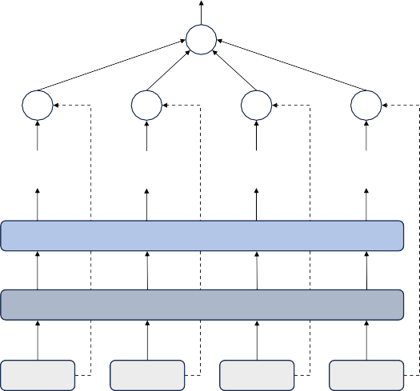
+
×
×
×
×
···
Softmax
Fully Connected
i1
i2
···
in
Fig. 1. The steps to calculate the value of self-attention.
3.3.3 Attention Temporal Convolutional Network
Temporal convolutional network (TCN) is a deep learning model for processing time series data. TCN combines the advantages of convolutional neural network (CNN) and recurrent neural network (RNN). Traditional CNNs often fail to capture long-term dependencies when dealing with time series, while RNNs can handle long-term dependencies but suffer from vanishing or exploding gradients [15]. Using a structure with residual connections and dilated convolutions, TCN can effectively capture long-term dependencies and is less susceptible to gradient issues. Considering that the various layers of TCN encompass diverse observation ranges, the attention temporal convolutional network (ATCN) employs the attention mechanism to automatically extract the pertinent information from different observation fields, This integration enables the effective capture of valid information across varying temporal contexts within the network.
Building upon the TCN architecture, the attention temporal convolutional network (ATCN) introduces an attention mechanism to enhance the model's capabilities further. Recognizing that different TCN layers encompass various observation ranges, ATCN employs attention to select and prioritize relevant information from diverse temporal scales automatically. This approach allows the network to efficiently extract valid information across multiple time horizons, adapting to the specific requirements of the input data. The attention mechanism, illustrated in Figure 2, enables ATCN to focus on the most salient aspects of the input sequence, potentially improving performance on tasks that require understanding complex temporal relationships. By combining the strengths of TCN with attention, ATCN represents a powerful tool for analyzing sequential data in various domains, such as time series forecasting, natural language processing, and signal processing.

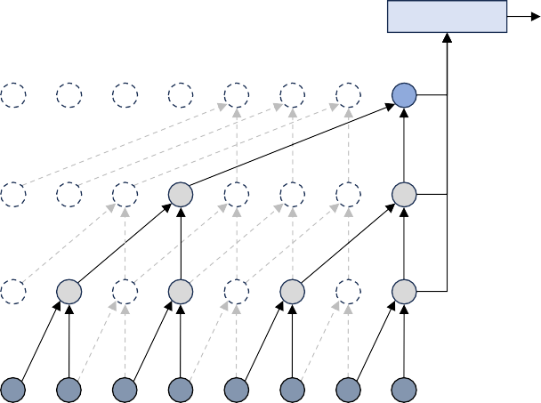
Attention
H_{t}
h1,t
Residual Block (K, D)
+
h2,t
h3,t
{m , y}t-C · · ·
· · ·
· · ·
· · · {m , y}_{t-2}{m , y}_{t-1} {m , y}_{t}
(optional)
1×1 Conv
Dilated Conv
WeightNorm
Softplus
Dropout
Dilated Conv
WeightNorm
Softplus
Dropout
Softplus

- Architecture of ATCN (b) Residual Block
Fig. 2. The structure of attention temporal convolutional network (ATCN).
The proposed Attention Temporal Convolutional Network (ATCN) builds upon the foundation of Temporal Convolutional Networks (TCN), with dilated convolution serving as its core module. Each layer of the TCN comprises a residual module, as illustrated in Fig. 2(b), where K denotes the kernel size and D represents the dilation factor. The dilated causal convolution, a key component of this architecture, performs a skip operation on the input sequence, enabling the network to capture long-range dependencies efficiently.
The dilated causal convolution expands the receptive field of the network without increasing the number of parameters or computational complexity. This is achieved by introducing gaps between the elements of the convolutional kernel, with the gap size increasing exponentially with each layer. Consequently, the network can process long sequences effectively while maintaining a relatively shallow architecture. The ATCN further enhances this capability by incorporating attention mechanisms, which enable the network to focus on the most relevant parts of the input sequence when making predictions or generating outputs. This combination of dilated convolutions and attention mechanisms allows the ATCN to capture both local and global temporal dependencies, and the process can be expressed by the formula:
$$F\left(t\right)= \sum_{k=0}^{k-1}{f\left(k\right)}X\left(t-D∙k\right) (4)$$
In this context, X denotes the input sequence, and f signifies the filter. The network's receptive field is expanded through the layering of multiple residual blocks, enabling it to capture long-range dependencies more effectively. Following each dilated convolution, weight normalization, ReLU activation, and a dropout layer are applied to mitigate overfitting. As illustrated in Figure 2(a), the output of individual layers concentrates on distinct historical ranges, with c indicating the conditioning range, m representing meteorological variables, and y denoting power. Assuming a three-layer TCN, the outputs of these layers can be expressed as h₁,_{t}, h₂,_{t} and h₃,_{t}. These outputs are then processed through an attention mechanism, which calculates weights for different information types. The final output is derived from the weighted sum of these processed layers.
$$H_{t}=\sum_{j=1}^{3}{{\tilde{α}}_{j}h_{j,t}} (5)$$
In this equation, H_{t} represents the final output of ATCN. By implementing this method, the model enhances its capability to integrate information from various temporal perspectives, thereby improving the precision of the results.
A critical feature of the TCN design is the implementation of dilated causal convolutions. The dilation rates are exponentially increased across successive layers this exponential dilation strategy enables the model to achieve an expansive receptive field without a corresponding increase in computational complexity. Consequently, the TCN can effectively capture long-range dependencies, which are crucial in wind power forecasting where distant past events may significantly influence future power generation. The filter sizes for the convolutional operations are carefully selected based on extensive experimentation. These filters are designed to extract relevant features at various temporal scales, allowing the model to capture both short-term fluctuations and longer-term patterns in wind power generation. Activation functions are crucial in introducing non-linearity to the model, enhancing its capacity to learn complex patterns. The Rectified Linear Unit (ReLU) is predominantly employed due to its effectiveness in mitigating the vanishing gradient problem and promoting sparse activations. Furthermore, weight normalization is applied after each dilated convolution, a technique that has been demonstrated to stabilize training dynamics and accelerate convergence.
3.3.3 Attention Mechanism Integration
The integration of an attention mechanism into the hybrid model architecture represents a significant advancement in the field of wind power forecasting. Attention layers are strategically positioned after the TCN layers, as depicted in Fig. 3 This placement allows the attention mechanism to refine and reweight the features extracted by the convolutional layers, focusing on the most salient temporal patterns for the current prediction task. A self-attention mechanism enables the model to dynamically assess the relevance of different time steps and features in the input sequence. This self-referential approach allows the model to capture complex, non-linear relationships between different points in the time series. The calculation of attention scores is performed utilizing a scaled dot-product approach. This methodology facilitates efficient computation of attention weights, which are subsequently applied to the input features to generate a context-aware representation. The resultant attention-weighted features provide a refined input for subsequent layers, enhancing the model's capacity to focus on each prediction's most salient historical information.
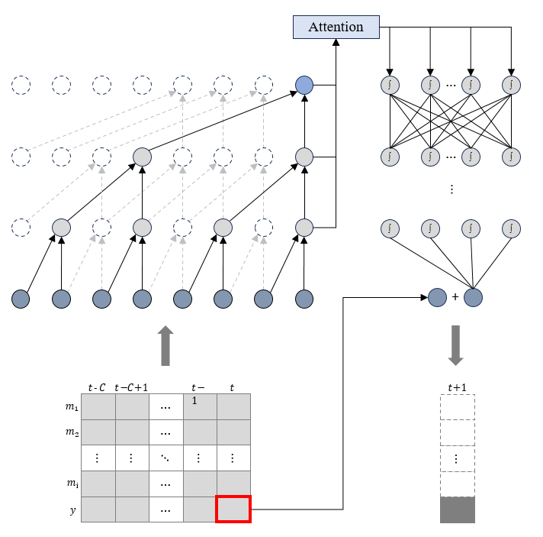

Fig. 3. The hybrid wind power forecasting model (HFM)
Fig. 3 illustrates the hybrid wind power forecasting model (HFM). This approach utilizes the actual power generation from the previous time step as a baseline and combines ATCN and DNN hybrid models to predict the difference between the subsequent time step's power generation and the preceding one. The findings indicate that this method yields more accurate forecasting outcomes with fewer training iterations compared to directly predicting the power generation for the subsequent time step.
3.3 Data Preprocessing and Feature Engineering
3.3.1 Feature Extraction and Selection
The model's feature extraction and selection process employ a multi-layered approach to capture and synthesize relevant information from complex, high-dimensional input data. The initial convolutional layers serve as the foundation, focusing on extracting low-level features from the raw input. These layers are adept at identifying local patterns, textures, and spatial correlations within the data, which are crucial for understanding the intricate relationships between meteorological variables and power output. By utilizing kernel size and stride, these convolutional layers can detect features at different scales, ensuring a comprehensive analysis of the input data. As the data progresses through the network, subsequent layers build upon these low-level features to construct more abstract and higher-level representations, enabling the model to grasp increasingly complex concepts and relationships within the data. The deeper layers of the network can identify composite features that represent higher-order interactions between meteorological variables, potentially capturing phenomena such as weather fronts, pressure systems, or seasonal patterns that influence power output.
The model's feature fusion strategy represents a critical advancement in processing and interpreting multi-modal data. By intelligently combining information from various meteorological variables and historical power data, the model can capture intricate interactions and dependencies that might not be apparent when considering each data stream in isolation. This fusion approach allows for a more comprehensive understanding of the factors shaping power output, potentially uncovering non-linear relationships and subtle patterns that traditional models might overlook. The feature fusion process may employ techniques such as attention mechanisms or gating networks to dynamically weight the importance of different features based on the current context, further enhancing the model's ability to adapt to varying conditions and scenarios. The synergy between different input streams enhances the model's predictive capabilities, enabling it to make more accurate and robust forecasts by leveraging the supplementary nature of diverse data sources. For instance, the model might combine temperature and humidity data to infer the likelihood of cloud formation, which in turn affects solar radiation and, consequently, power output. Similarly, wind speed and direction data can be integrated with topographical information to account for terrain-induced effects on wind patterns and their impact on power generation.
Furthermore, the model's feature selection mechanism plays a crucial role in identifying the most informative and relevant features for the prediction task. This process helps to reduce dimensionality and mitigate the risk of overfitting by focusing on the most salient aspects of the input data. Advanced techniques such as regularization, dropout, or feature importance analysis may be employed to ensure that the model generalizes well to unseen data and maintains its performance across various operational conditions. The iterative nature of the feature extraction and selection process allows the model to continually refine its understanding of the underlying patterns and relationships in the data. As the model is trained on diverse datasets and exposed to a wide range of meteorological conditions, it can adapt its feature representations to capture both common and rare phenomena that influence power output. This adaptability is particularly valuable in the context of renewable energy forecasting, where the complex interplay between weather patterns and power generation can vary significantly across different geographical locations and time scales.
3.3.2 Dataset Construction
For the simulation purpose, data from three wind farms in southern China were collected in 2020. The acquired data set comprises meteorological and power output measurements. Meteorological data include wind speed, direction, temperature, air pressure, and humidity. All data points were recorded at 15-minute intervals. A data imputation technique is used to mitigate the impact of missing data on the accuracy of the forecast, where the absent values were replaced by those of the previous time step. Given the heterogeneous scales inherent in the dataset, Z-score normalization was subsequently applied to standardize the feature values across disparate scales and units. This transformation is executed according to the following formula:
$$x^{'}= \frac{x-mean\left(x\right)}{std\left(x\right)}$$
where X represents the original data sequence, mean(x) and std(x) denote the arithmetic mean and standard deviation of x, respectively, and x' signifies the resultant normalized sequence. Data filling replaces missing values with the last observed value using the last observation carried forward (LOCF) technique, assuming data continuity over time. Although efficient, LOCF may introduce bias if the missing data mechanism is non-random, but it is effective for time-series data where trends are consistent. After filling in missing values, Z-score normalization adjusts each feature to have a mean of 0 and a standard deviation of 1, placing all variables on a common scale. Scaling features to a common range prevents larger values from dominating the analysis and ensures equal contribution to subsequent modeling, which is crucial for scale-sensitive machine learning techniques like neural networks and k-nearest neighbors. The adjusted data x' facilitates consistent feature comparisons, enhancing optimization algorithms during model training. In the prediction of short-term wind power output prediction, meteorological variables s is linked to power generation Y for the next period using past data X. The data set for analysis and forecasting was constructed using a sliding window methodology as shown in Fig. 3. It updates the data set with new data points, using historical data to predict future levels of power generation. Lastly, the yearly data is split into training and testing sets for each month, with an 80% to 20% distribution ratio.
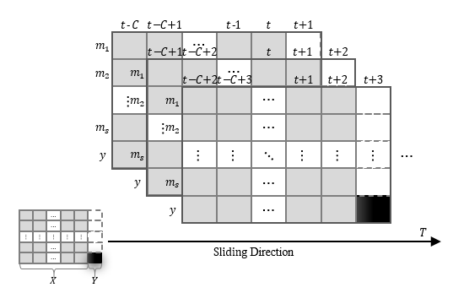

Fig. 3: The method of sliding window to construct dataset

3.4 Experimental Results and Discussions
3.4.1 Model Training and Optimization Strategies
The evaluation of forecasting models is essential for assessing their performance and reliability. This study employs three widely recognized evaluation metrics: R-square (R2), root mean square error (RMSE), and mean absolute error (MAE). These metrics provide complementary insights into the model's accuracy and predictive capacity. R-square (R2) quantifies the proportion of variance in the dependent variable that is predictable from the independent variable. It ranges from 0 to 1, with higher values indicating superior fit. RMSE quantifies the standard deviation of the residuals, providing a measure of the average magnitude of prediction errors. It is susceptible to large errors due to its squared term. MAE, conversely, calculates the average absolute difference between predicted and actual values, offering a linear interpretation of prediction accuracy. By utilizing these three metrics in conjunction, this study provides a comprehensive evaluation of the proposed hybrid forecasting model, facilitating a nuanced understanding of its strengths and limitations across various aspects of predictive performance.

In these equations, y_{i} represents the observed power output, while y'_{i} denotes the predicted power value. The symbol ȳ signifies the mean power, and N indicates the sample set's total number of data points.
3.4.2 Simulation of Power Forecasting Results
The proposed wind power forecasting model undergoes thorough validation to assess its performance. The optimization process employs the Adam algorithm with a learning rate 0.001, while mean square error is used as a loss function. Each model is subjected to 100 epochs of training to ensure thorough learning. To evaluate the effectiveness of the proposed model, a comprehensive comparison is conducted against several established deep learning architectures. These include the deep neural network (DNN) as a benchmark, along with more specialized models such as long short-term memory network (LSTM), convolutional neural network (CNN), a hybrid CNN-LSTM model, temporal pattern attention LSTM (TPALSTM), and temporal convolutional network (TCN).
Extensive hyperparameter tuning is performed for each model to ensure a fair and robust comparison. This process involves systematically adjusting various parameters to optimize the performance of each architecture. By fine-tuning these hyperparameters, we aim to achieve optimal forecasting results for each model, allowing for a more accurate assessment of their relative strengths and weaknesses in wind power prediction. This comprehensive approach to model evaluation and comparison provides valuable insights into the effectiveness of different deep learning techniques for wind power forecasting, ultimately contributing to advancing renewable energy prediction methodologies.
3.4.3 Performance Analysis of Forecasting Models
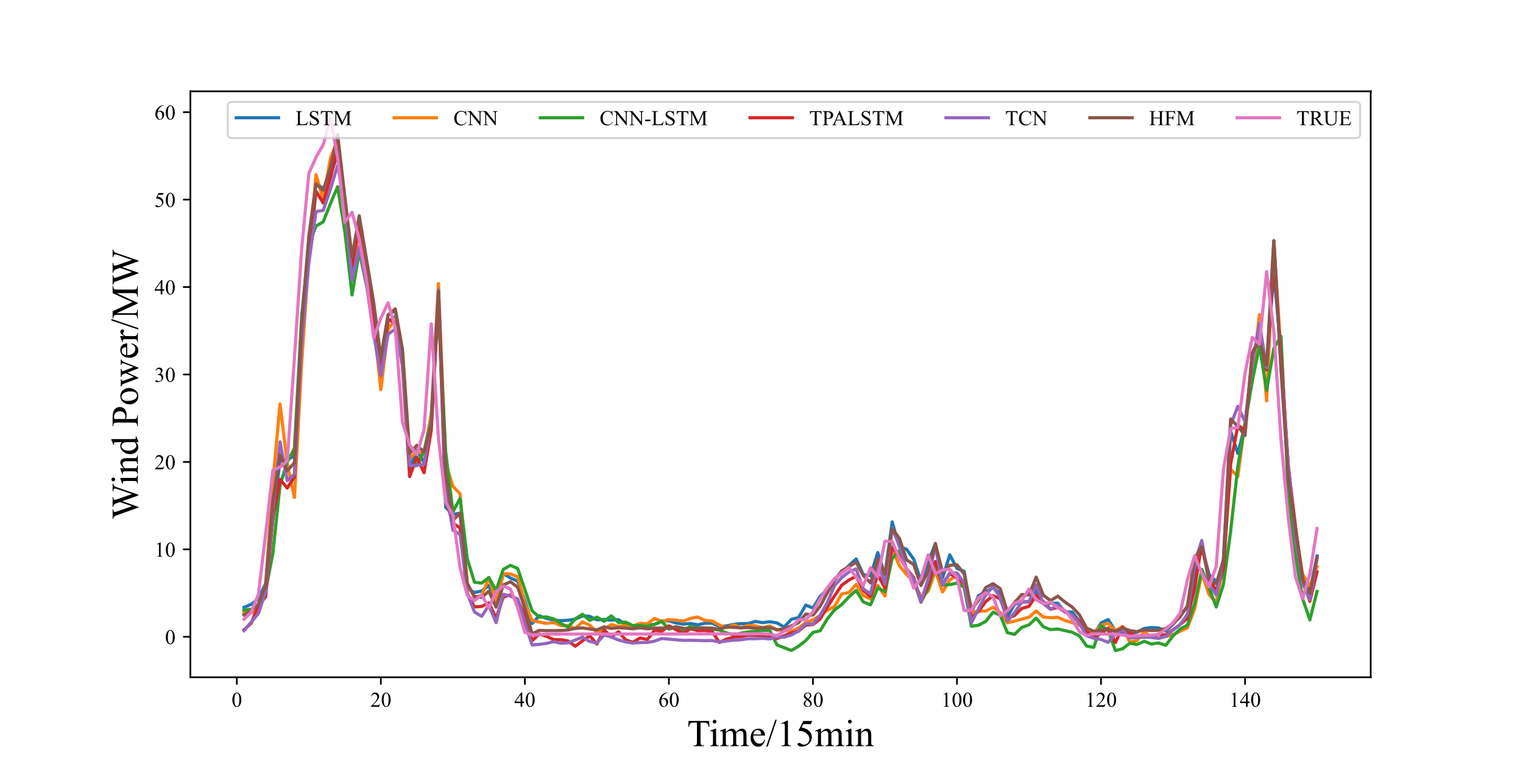
The prediction curves for six models on the test set, as depicted in Fig. x-x, provide a visual representation of their forecasting capabilities across three wind farms. While HFM demonstrates strong performance, a comprehensive evaluation of each model is necessary to draw meaningful conclusions. Table X presents the wind power predictions for the three sites, with the top performance highlighted in bold and the second-best underlined. This detailed comparison allows for a nuanced understanding of each model's strengths and weaknesses. The analysis reveals interesting insights into the performance of various models. LSTM and CNN show comparable results, but their combination in the CNN-LSTM model unexpectedly leads to decreased forecasting accuracy. This underscores the potential pitfalls of poorly designed hybrid models, which may introduce unnecessary complexity and increase the risk of overfitting, ultimately compromising prediction quality. TPALSTM, an enhanced LSTM variant, exhibits exceptional forecasting abilities but at the cost of increased inference time. In contrast, TCN, a CNN-based architecture, excels in wind power forecasting while offering the advantage of parallel computing capabilities, resulting in faster inference than LSTM. The HFM model, an improved version of TCN, demonstrates substantial gains in forecasting precision, outperforming TCN by 0.05%, 1.13%, and 6.20% across three respective metrics. These findings highlight the importance of carefully considering model architecture and potential trade-offs between accuracy and computational efficiency when selecting the most appropriate forecasting approach for wind power prediction.

Fig. x. Forecasting curves of six deep learning models on wind farm 1.
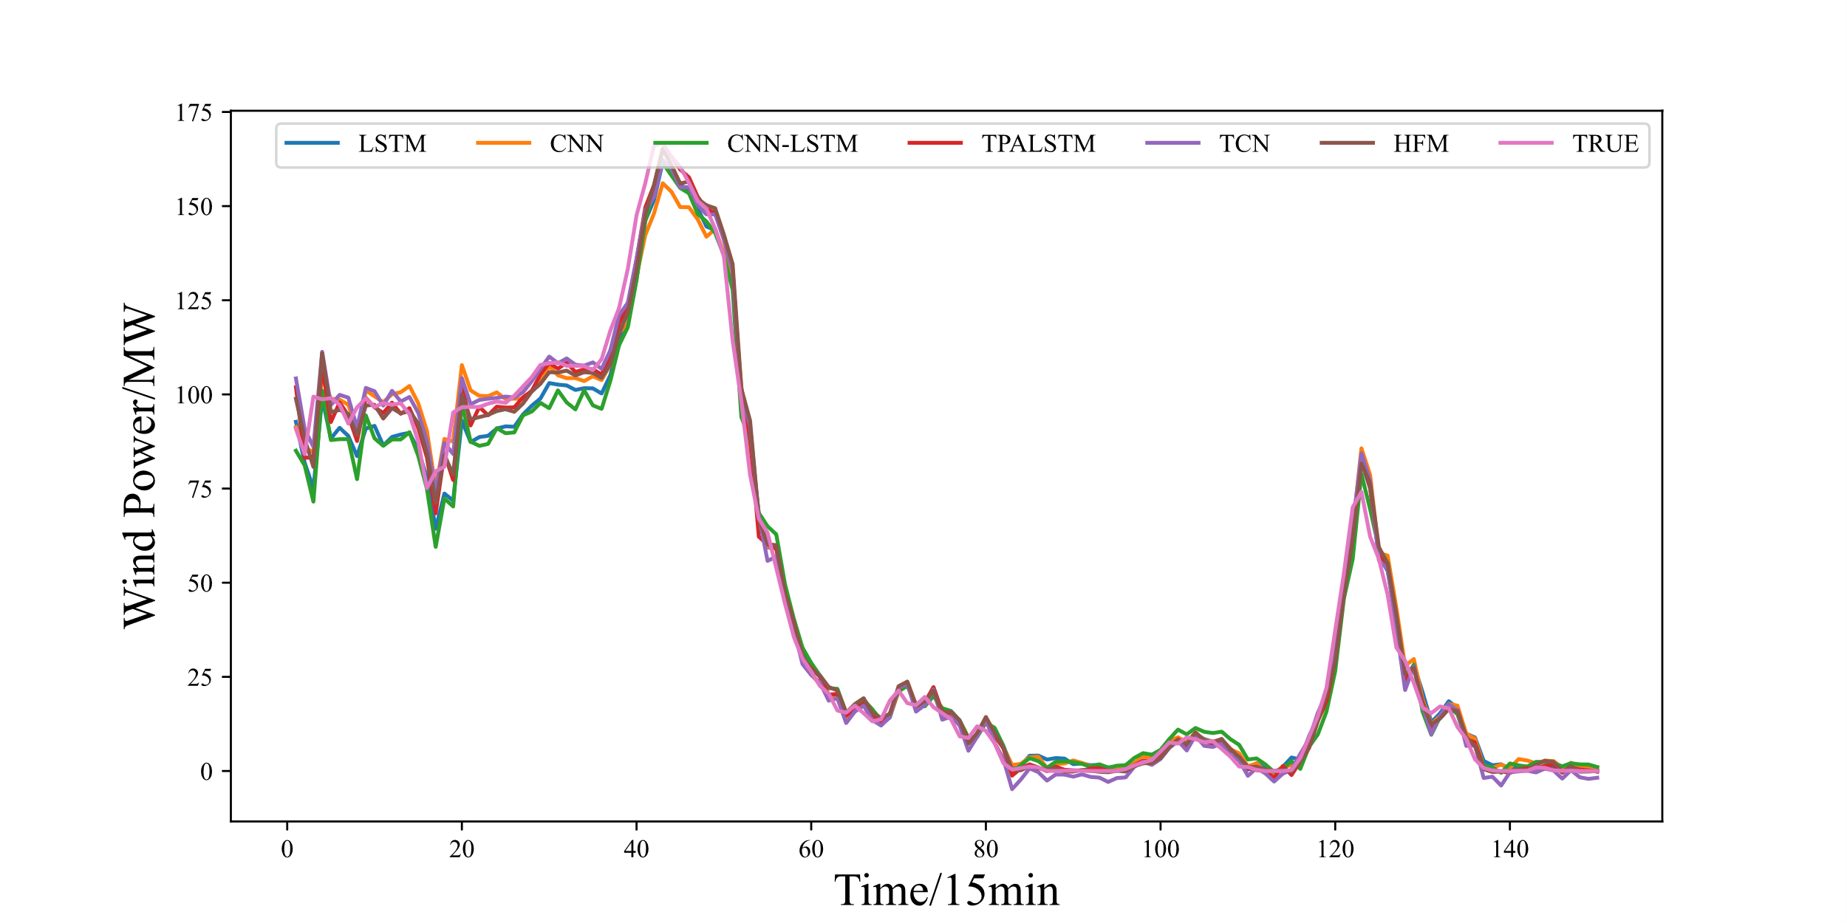

Fig. x. Forecasting curves of six deep learning models on wind farm 2.
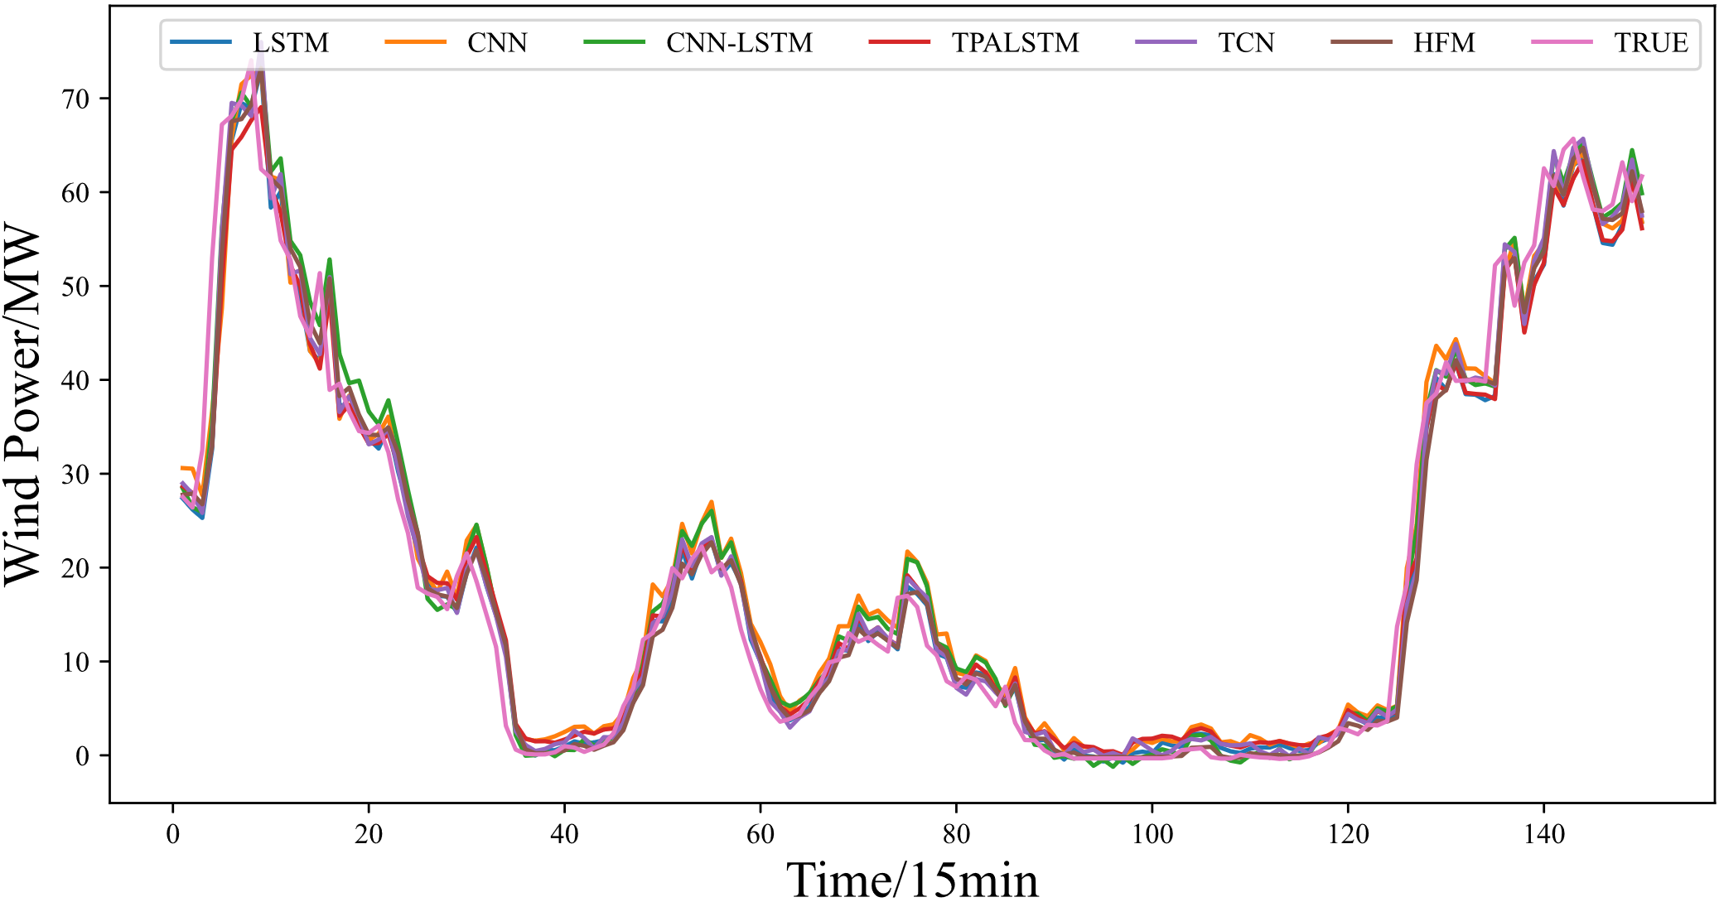

Fig. x. Forecasting curves of six deep learning models on wind farm 3.
TABLE X. WIND POWER FORECASTING PERFORMANCE OF SEVEN MODELS AT THREE WIND FARMS
Model | R- square(%) | RMSE(MW) | MAE(MW)
DNN | 97.873 | 4.820 | 2.997
LSTM | 98.040 | 4.657 | 2.796
CNN | 98.026 | 4.689 | 2.891
CNN-LSTM | 97.929 | 4.908 | 2.969
TPALSTM | 98.084 | 4.548 | 2.682
TCN | 98.130 | 4.518 | 2.727
HFM(Proposed) | 98.180 | 4.467 | 2.558

3.4.4 Ablation Simulation
The structure of the proposed Hybrid Forecasting Model, as illustrated in Fig. 3, demonstrates a dual-component architecture. The model's output synthesizes two critical elements: the historical power generation value from the preceding time step (t-1) and the differential value computed by the ATCN. This innovative framework necessitates rigorous validation through comparative analysis. To systematically evaluate the efficacy of the proposed HFM, we established a comparative framework incorporating two distinct benchmark models. The first benchmark is a standalone ATCN model, which generates direct forecasts of future power generation values. The second is the Persistence model, which operates under the assumption that future power generation values will precisely mirror those of the immediate preceding time step. This selection of benchmark models enables comprehensive performance assessment across varying levels of computational sophistication. It is imperative to emphasize the fundamental methodological distinction between the HFM and the standalone ATCN approach. While both utilize similar neural network architectures, their forecasting strategies differ significantly. The HFM employs the ATCN to predict the differential between current and future power generation values, subsequently combining this with historical data to produce the final forecast. In contrast, the standalone ATCN directly generates absolute power generation predictions. This architectural difference represents a key innovation in our approach to time series forecasting in power generation systems.
Ablation simulation forecasting results are presented in Table X. Autoregressive time series forecasting models frequently exhibit a lag in their predictions, particularly in single-step forecasting tasks. This has led to a widespread belief that using the actual power generation from the preceding moment as the forecast would yield accurate results based on evaluation metrics. However, simulations have demonstrated that this assumption is flawed, especially in the highly volatile domain of wind power forecasting, where such lagged outputs prove inadequate. The proposed HFM enhances its performance ceiling while maintaining a degree of forecasting precision by effectively capturing power differentials. Compared to direct power generation forecasts (ATCN), the HFM shows improved accuracy, with a notable 3.14% enhancement in MAE metrics.
TABLE X. FORECASTING RESULTS OF ABLATION SIMULATION
Model | R- square(%) | RMSE(MW) | MAE(MW)
Persistence | 97.872 | 4.923 | 2.640
ATCN | 98.139 | 4.513 | 2.641
HFM | 98.180 | 4.467 | 2.558
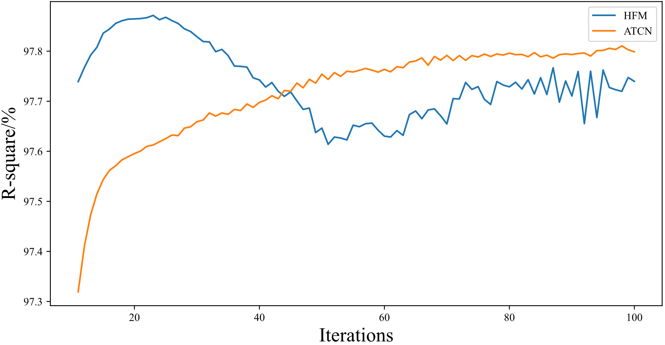
A significant advantage of the Hybrid Forecasting Model (HFM) lies in its superior computational efficiency, demonstrating accelerated convergence and enhanced forecasting accuracy with notably fewer training iterations compared to traditional approaches. To empirically validate this claim, we conducted an extensive analysis using Wind Farm 1 as our primary case study. Fig. 8 presents a comparative visualization of the coefficient of determination (R-square) trajectories on the testing dataset for both HFM and the standalone ATCN model, with observations beginning from the tenth training iteration. The empirical results reveal a remarkable feature of the HFM: it achieves optimal forecasting performance at approximately 20 iterations, as evidenced by the convergence of its R-square value. Beyond this critical point, the model exhibits classical symptoms of overfitting, suggesting that additional training iterations not only become superfluous but potentially detrimental to model performance. This rapid convergence represents a significant advancement in computational efficiency, as the model requires merely 20 iterations to generate highly accurate forecasting results.

Fig. 8. The variation of R-square on the testing set of wind farm 1 with the number of training iteration.
The exceptional efficiency of the HFM can be attributed to its innovative architectural design, specifically its incorporation of the previous time step's power generation as a baseline forecasting benchmark. This methodological approach substantially reduces the model's learning burden, as it only needs to optimize the prediction of incremental changes rather than absolute values. The utilization of this historical benchmark effectively serves as a form of intelligent initialization, dramatically accelerating the model's convergence rate and, consequently, enhancing overall forecasting efficiency. This finding has significant implications for both practical applications and computational resource allocation in power generation forecasting systems. The reduced training requirements minimize computational overhead and potentially enable more frequent model updates and adaptations to changing environmental conditions, thereby maintaining forecasting accuracy in dynamic operational scenarios.
3.5 Summary
This chapter addresses a critical challenge in renewable energy integration, the necessity for accurate short-term wind power forecasting to mitigate wind energy's inherent variability and ensure grid stability. Current methodologies struggle to fully capture the complex temporal and spatial dynamics of wind power data. To address this limitation, the chapter introduces an innovative hybrid forecasting framework that combines Temporal Convolutional Networks (TCNs) with residual attention mechanisms. This architectural integration leverages TCNs' capacity to model extended temporal dependencies while utilizing attention mechanisms to dynamically emphasize relevant temporal features. The novel implementation of differential prediction between successive time intervals enhances forecasting accuracy while reducing computational costs during model training, representing a significant methodological advancement.
The empirical investigation employed a rigorous methodological approach, encompassing comprehensive data preprocessing, feature engineering, and systematic model evaluation protocols. The dataset, comprising observations from three wind farm facilities in southern China, underwent meticulous preprocessing through imputation and normalization to ensure data integrity. The proposed hybrid architecture was benchmarked against established models, including Long Short-Term Memory (LSTM), Convolutional Neural Network (CNN), and CNN-LSTM architectures, using standard performance metrics coefficient of determination (R²), Root Mean Square Error (RMSE), and Mean Absolute Error (MAE). The hybrid model consistently outperformed baseline models across all evaluation criteria, demonstrating enhanced accuracy, stability, and computational efficiency. Detailed ablation studies highlighted the crucial contributions of both TCN and attention components, while attention weight visualization provided valuable insights into feature importance, improving model interpretability.
The empirical results validate the model's efficacy in addressing the complexities of renewable energy forecasting, with significant implications for grid management optimization and energy market operations. By enhancing the scalability and interpretability of wind power predictions, this research advances the systematic integration of renewable energy resources into existing infrastructure. While acknowledging limitations, particularly the need for diverse data sources, this study establishes a robust foundation for future developments in predictive modeling. The innovative hybrid architecture not only represents a substantial improvement in forecasting accuracy but also contributes significantly to the broader field of sustainable energy systems, offering promising applications across various meteorological and geographical contexts.

3.1 Introduction
3.1.1 Background and Motivation 3.1.2 Chapter Objectives 3.1.3 Chapter Structure

3.2 Theoretical Framework
3.2.1 Temporal Convolutional Networks (TCN) 3.2.1.1 Principles and Architecture 3.2.1.2 Advantages in Time Series Analysis 3.2.2 Attention Mechanism 3.2.2.1 Self-Attention and Its Variants 3.2.2.2 Role in Capturing Long-range Dependencies 3.2.3 Synergy of TCN and Attention in Wind Power Forecasting

3.3 Proposed Hybrid Model Architecture
3.3.1 Overall Model Structure 3.3.2 TCN Component Design 3.3.3 Attention Mechanism Integration 3.3.4 Feature Extraction and Selection 3.3.5 Model Training and Optimization Strategies

3.4 Data Preprocessing and Feature Engineering
3.4.1 Data Collection and Quality Assessment 3.4.2 Temporal Feature Extraction 3.4.3 Meteorological Variable Integration 3.4.4 Normalization and Standardization Techniques

3.5 Experimental Setup and Methodology
3.5.1 Dataset Description and Partitioning 3.5.2 Evaluation Metrics 3.5.3 Baseline Models for Comparison 3.5.4 Hyperparameter Tuning and Cross-validation

3.6 Results and Analysis
3.6.1 Performance Comparison with Baseline Models 3.6.2 Ablation Studies 3.6.3 Model Interpretability and Feature Importance 3.6.4 Sensitivity Analysis to Input Parameters

3.7 Discussion
3.7.1 Implications for Short-term Wind Power Forecasting 3.7.2 Model Limitations and Potential Improvements 3.7.3 Computational Efficiency and Scalability

3.8 Conclusion
3.8.1 Summary of Key Findings 3.8.2 Future Research Directions

3.1 Introduction
3.1.1 Background and Motivation
- Importance of accurate short-term wind power forecasting in renewable energy integration
- Challenges in wind power prediction due to its intermittent and volatile nature
- Limitations of traditional forecasting methods
3.1.2 Chapter Objectives
- Develop a novel hybrid model combining TCN and attention mechanism
- Improve short-term wind power forecasting accuracy
- Enhance model interpretability and feature importance analysis
3.1.3 Chapter Structure
- Brief overview of each subsequent section

3.2 Theoretical Framework
3.2.1 Temporal Convolutional Networks (TCN) 3.2.1.1 Principles and Architecture - Dilated causal convolutions - Residual connections - Comparison with traditional CNNs
Copy
3.2.1.2 Advantages in Time Series Analysis
- Ability to capture long-range temporal dependencies
- Parallelization capabilities
- Flexibility in receptive field size
3.2.2 Attention Mechanism 3.2.2.1 Self-Attention and Its Variants - Scaled dot-product attention - Multi-head attention - Temporal attention mechanisms
Copy
3.2.2.2 Role in Capturing Long-range Dependencies
- Dynamic context-based feature weighting
- Overcoming limitations of fixed-size windows
3.2.3 Synergy of TCN and Attention in Wind Power Forecasting
- Complementary strengths of TCN and attention
- Potential for improved feature extraction and temporal dependency modeling

3.3 Proposed Hybrid Model Architecture
3.3.1 Overall Model Structure
- High-level diagram of the proposed model
- Data flow and information processing stages
3.3.2 TCN Component Design
- Number and configuration of TCN layers
- Dilation rates and filter sizes
- Activation functions and normalization techniques
3.3.3 Attention Mechanism Integration
- Placement of attention layers within the model
- Type of attention mechanism used (e.g., self-attention, multi-head)
- Attention score calculation and feature weighting
3.3.4 Feature Extraction and Selection
- Initial convolutional layers for low-level feature extraction
- Feature fusion strategies
- Dimensionality reduction techniques (if applicable)
3.3.5 Model Training and Optimization Strategies
- Loss function design
- Optimization algorithm selection
- Learning rate scheduling and regularization techniques

3.4 Data Preprocessing and Feature Engineering
3.4.1 Data Collection and Quality Assessment
- Description of wind power and meteorological data sources
- Data cleaning and outlier detection methods
- Handling missing data and erroneous measurements
3.4.2 Temporal Feature Extraction
- Time-based features (e.g., hour of day, day of week, season)
- Lag features and rolling statistics
- Fourier transformations for capturing periodicity
3.4.3 Meteorological Variable Integration
- Selection of relevant weather variables
- Correlation analysis with wind power output
- Spatial interpolation techniques (if applicable)
3.4.4 Normalization and Standardization Techniques
- Comparison of different scaling methods (e.g., min-max, z-score)
- Handling of non-stationary time series
- Techniques for preserving temporal dependencies during normalization

3.5 Experimental Setup and Methodology
3.5.1 Dataset Description and Partitioning
- Detailed description of the wind farm(s) and data collection period
- Train-validation-test split ratios and justification
- Handling of temporal dependencies in data partitioning
3.5.2 Evaluation Metrics
- Mean Absolute Error (MAE)
- Root Mean Square Error (RMSE)
- Mean Absolute Percentage Error (MAPE)
- Skill scores relative to persistence model
3.5.3 Baseline Models for Comparison
- Persistence model
- Statistical models (e.g., ARIMA, exponential smoothing)
- Machine learning models (e.g., Random Forest, Support Vector Regression)
- Deep learning models (e.g., LSTM, GRU)
3.5.4 Hyperparameter Tuning and Cross-validation
- Description of hyperparameters considered for tuning
- Cross-validation strategy (e.g., time series cross-validation)
- Hyperparameter optimization technique (e.g., grid search, random search, Bayesian optimization)

3.6 Results and Analysis
3.6.1 Performance Comparison with Baseline Models
- Tabular and graphical presentation of results
- Statistical significance testing of performance differences
- Analysis of model performance under different weather conditions and time horizons
3.6.2 Ablation Studies
- Impact of removing TCN or attention components
- Effect of varying key architectural elements (e.g., number of layers, attention heads)
- Analysis of different feature subsets on model performance
3.6.3 Model Interpretability and Feature Importance
- Visualization of attention weights
- Analysis of learned TCN filters
- Feature importance ranking and discussion
3.6.4 Sensitivity Analysis to Input Parameters
- Effect of input sequence length on forecasting accuracy
- Impact of meteorological variable inclusion/exclusion
- Model robustness to noisy or missing data

3.7 Discussion
3.7.1 Implications for Short-term Wind Power Forecasting
- Potential impact on grid integration and energy market operations
- Comparison with state-of-the-art forecasting techniques in literature
- Generalizability to different wind farm locations and layouts
3.7.2 Model Limitations and Potential Improvements
- Discussion of scenarios where the model underperforms
- Potential enhancements to model architecture or training process
- Integration of additional data sources or domain knowledge
3.7.3 Computational Efficiency and Scalability
- Analysis of training and inference times
- Comparison of computational requirements with baseline models
- Potential for model deployment in real-time forecasting systems

3.8 Conclusion
3.8.1 Summary of Key Findings
- Recap of major contributions and innovations
- Synthesis of experimental results and their implications
3.8.2 Future Research Directions
- Exploration of transfer learning for multi-site forecasting
- Integration with probabilistic forecasting techniques
- Application to other renewable energy forecasting domains

