LIGHT is at the centre of all Creation.

Tools of true power -intent, words and shape.

There are many logic paths confirming this:
The formula: 6/5 x phi²=pi (see All begins with 144)

Numbers:
1, in the beginning was the source (1)not and from the source came the 2
1+ 1 and from the 2 came the 10000 things
1(1 dimension)
11 (11+11 = second or 2 dimensions) =22
33 third dimension
From a singularity life spirals through higher imensions to create matter.

Genesis tells us that ‘In the beginning was the Word’ (sound, vibration, alphanumeric resonance) and from this came Light –‘Let there be Light’ (through a process of geometric and logical resonance exposure to Light leads to the creation of matter geometric, physical structure of matter).

273
Gematria (reverse reduction, pythagorean) informs us that the phrase ‘In the beginning was the Word’ equates to the creation of humanity. Through its association with the number 273. This number, it seems, encapsulates everything that pertains to the relationship of the Sun to the Earth to the Moon -the most immediate, important and life sustaining physical factors in our existence. The relationship between these objects is so perfect that it clearly implies they were intentionally constructed. Without such cosmic precision, such perfection, we would simply cease to exist.

The relationship among the Earth, Sun and Moon is artificial: orbits, sizes and times of revolution and rotation. Constructed. Altered from some previous unknown configuration. All the connections that share a factor of .273 or 3.66, or a decimal multiple of these factors have been engineered to have the values they do. They are too improbable, too absurd, to be natural. (Cameron 2009)

110

In more scientific terms, matter emerges from the space-time continuum and crystallizes to generate the first shape, the tetrahedron, along with its dual form, the rhombus.

When Undifferentiated Consciousness, or the Void, separates from a Singularity into duality, transforming one dimension into two, it leads to the creation of all matter. Thus, we see that from its fundamental geometry, that Light and only Light, above all else, precedes and sustains the very existence of this dualistic universe.

The Formation and Geometry of the ‘Womb of Creation’ (the Vesica Piscis)
The Universe begins with a singularity -a dot. Zero dimensions, infinite.

The singularity than expands in all directions to from a circle

The singularity then expands to form a line – 2 dimensions, a straight one-dimensional figure having no thickness and extending infinitely in both directions.”

It’s a little tricky to follow this process but once a few assumptions are understood everything becomes much clearer. Firstly, quantum science informs us that our universe is conscious and we know the presence of consciousness implies movement or action.

For, we know things are alive because they move -evidence of life is movement -whether it be actual physical movement, growth or even just thoughts (movement of consciousness). Therefore, the expansion i.e. movement, of the singularity outwards is due to the presence of the life force (consciousness).We recognize that things are alive because they exhibit movement, which serves as evidence of life. This movement can manifest as physical motion, growth, or even thoughts. Consequently, the outward expansion of the singularity is attributed to the presence of the life force, or consciousness.

Without life things simply stop moving. Life, being a form of energy, as its rate of vibration slows it become more ‘dense’ until ultimately it transforms into matter ( a denser form of energy).
Secondly, the movement of the life force is always spiral in nature.
The life force, often referred to as energy or vital energy, inherently follows a spiral pattern in its movement. This spiral nature can be observed in various aspects of life and the universe, from the growth patterns of plants and the structure of galaxies to the flow of water and the formation of weather systems. The spiral movement signifies a dynamic and continuous process of expansion, contraction and transformation, reflecting the interconnectedness and cyclical nature of existence. The expression if life itself is therefore not linear but rather a series of spirals, each turn representing growth, change, and the perpetual flow of energy.

From there the line comes to ‘know itself’, becoming self-aware and thus conscious, expanding out but simultaneously returning to its source. In other words, like Ouroboros (symbolic serpent with its tail in its mouth) it ‘returns to meet itself’ and thus forms a circle, enclosing primordial consciousness (Pleroma) within a defined space (the circle). Most mythologies symbolize God as dot within a circle. The circle symbolizes perfect balance, representing divine symmetry. It encompasses the universe, with pure potential perfectly centered.

Pleroma (Koinē Greek: πλήρωμα, literally "fullness") generally refers to the totality of all creation.

Introducing motion generated by consciousness to a line inevitably leads it to follow trajectory governed by the energy if life itself (consciousness), transforming it into a spiral.

The nautilus shell beautifully illustrates how a simple starting point—a dot, under the influence of the lie forced, can evolve into intricate circular forms through a spiralling growth pattern, beginning with a dot (the cell) transforming into a line, a spiral to form a circle. This phenomenon not only highlights geometric principle but also showcases nature's ability to create complex structures from simple beginnings on autopilot as it where.

Boundary creates identity
To know itself, the Universal Conscious (defined by the circle) divides into two. The concept of self-awareness entails a process in which consciousness, symbolized metaphorically by a circle, divides to achieve greater understanding of itself, in other words, to know itself.

As Undifferentiated Consciousness (represented by the circle) separates into duality a second circle is formed. This process is represented by the circle manifesting into two circles and in the process of separation the a vesica piscis is formed at the centre or union of the resulting duality. The geometry of the vesica piscis is the tetrahedron and rhombus.

When undifferentiated consciousness, symbolized by a circle, divides into duality, a second circle emerges. This division results in the formation of a vesica piscis at the center, representing the union of the two circles. The geometry of the vesica piscis is characterized by the tetrahedron and rhombus.

The existence of this ‘first’ shape, therefore, symbolises and confirms the fact that all matter in this universe is preceded and thus generated by Light. The existence of this initial shape symbolizes and confirms that all matter in the universe is both preceded by and generated by Light.

LIGHT c 144

The rhombus alphanumerically resonates with, and is geometrically equivalent to the word ‘light’

Thus:

Alphanumeric resonance (vibrational equivalence) :
The word ‘rhombus’ reduces to a number (in this case 6) that is a harmonic of, and thus resonates with, the number 144 as seen in the a simple arithmetic expression:

RHOMBUS 6 ≡ (√144)/2

Geometric equivalence (logical resonance)
The rhombus is constructed out of 2 tetrahedrons.
The tetrahedron is the first of the Platonic solids to be ‘created’ and represents fire/light.
Each tetrahedron geometrically resonates with light thus:
- 1 x tetrahedron has 4 sides containing 180 ° per side
- 4 x 180 = 720
- 2 x tetrahedron form the rhombus created by the central vesica piscis
- 720 x 2 = 1440 ≡ 144 (the number of LIGHT)

KEY
: reduces to
≡: alphanumeric equivalence (i.e. has a numerological association)
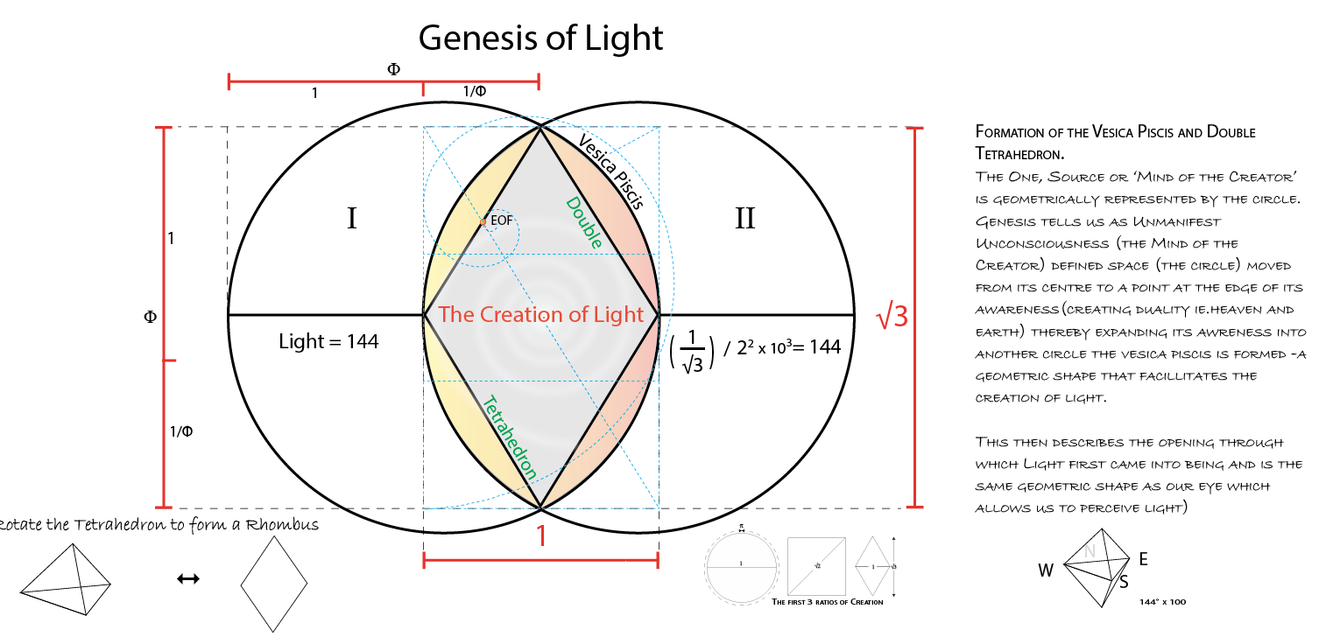
AI:
Light is central to all creation. Genesis states, "In the beginning was the Word" (sound, vibration, alphanumeric resonance), from which Light emerged—"Let there be Light" (geometric and logical resonance leading to the geometric, physical structure of matter).

In the crystallization of matter from the space-time continuum, the tetrahedron and its dual form, the rhombus, are the first shapes generated. As Undifferentiated Consciousness or the Void transitions from singularity to duality, it results in the creation of all matter. Primordial geometry shows that Light, and nothing else, precedes and sustains the universe's duality.

As Undifferentiated Consciousness (symbolized by the circle) divides into duality, a second circle forms. This process is depicted by the circle manifesting into two circles, and during separation, a vesica piscis forms at the center or union of the resulting duality. The geometry of the vesica piscis is the tetrahedron and rhombus.

The existence of this 'first' shape symbolizes and confirms that all matter in this universe is preceded and generated by Light.

The rhombus alphanumerically resonates with, and is geometrically equivalent to, the word 'light.'

Alphanumeric resonance (vibrational equivalence):
The word 'rhombus' reduces to a number (6) that harmonizes with the number 144, as shown in a simple arithmetic expression:

RHOMBUS (6 ≡ (√144)/2)

Geometric equivalence (logical resonance):
The rhombus is constructed from 2 tetrahedrons. The tetrahedron, the first of the Platonic solids to be 'created,' represents fire/light. Each tetrahedron geometrically resonates with light as follows:
1 tetrahedron has 4 sides, each containing 180°
4 x 180 = 720
2 tetrahedrons form the rhombus created by the central vesica piscis
720 x 2 = 1440 ≡ 144 (the number of LIGHT)

