An Eco-epidemiological Model of Banana Disease with the Impact of Cultural Controls and Measuring Disease Causes
C. Pooja¹ and A. Sabarmathi²
^{1,2}Department of Mathematics, Auxilium College (Autonomous), Vellore-632006,
(Affiliated with Thiruvalluvar University, Serkadu, Vellore-632115),
Email: rosariyodedi@gmail.com¹, sabarmathi.a@auxiliumcollege.edu.in²

ABSTRACT

This paper discusses a mathematical model for Panama wilt with cultural controls, and the model is constructed on the basis of the two major causes of the disease. Disease-free and endemic equilibrium points were identified. The reproduction number is calculated via the next-generation matrix. The local and global stability of the equilibrium points are studied. Bifurcation analysis is carried out. Numerical simulations are performed in MATLAB.
Keywords: Global stability, Bifurcation, Equilibrium points, Panama wilt, Cultural controls.

1 INTRODUCTION

The existence of living and nonliving things in the world is determined by their relationships with each other. On a larger scale, living things include humans, animals, and plants. In addition, humans are always dependent on plants for oxygen, food, etc. [1]. Therefore, plants are considered essential for human existence. This process involves consuming plant products such as vegetables, fruits, and leaves, which are rich in proteins, vitamins, minerals, fiber, etc. There are two types of plants consumed by humans. They can be used as food or for medicinal purposes. Some plants serve two purposes and are therefore called healing foods.
Among many plants, banana is a medicinal plant in which all parts are used for specific purposes. For example, the fruit is eaten as a diet food, the flower helps treat breast cancer and diabetes and maintain the menstrual cycle, and banana leaves are used as dishes in countries such as South India and Thailand. Banana sprouts balance blood sugar levels and are good for kidneys, etc. Bananas are considered a favorite food for many people around the world. For these reasons, bananas are grown in many countries, such as India, Brazil, Ecuador, China, the Philippines, Indonesia, Costa Rica, Mexico, Thailand, and Colombia. Among them, India is the largest producer of bananas, which are also economically important crops.
Banana plants are affected by many pathogens, such as fungi, bacteria, and viruses, and diseases, such as airborne diseases and soil diseases. The most destructive disease of bananas in all seasons is Panama wilt or Fusarium wilt. The pathogen causing this disease is Fusarium oxysporum f. sp. Cubence (Foc) [3, 5]. It is a vascular wilt disease that affects the woody part of the vascular tissue, causing discoloration and wilting of leaves [5, 12].
There are two types of symptoms
- External symptoms: The most common symptom is yellow browning of leaves. This starts at the margin of the leaves and becomes yellow, and at first, it looks like a potassium deficiency, after which it spreads all over the leaf. Eventually, the leaf becomes bright yellow in color. This results in leaf wilt, and the plants die. It spreads to all the leaves in the plant, and the wilt of the leaves appears to be a brown skirt.
- Internal symptoms: Internal symptoms are severe. It affects the xylem vessels. This forms a fungus in the stem tissues, which is reddish-brown in color. These discolors are observed only when the plant is cut longitudinally. This may produce infected suckers, but the fruits do not necessarily show any symptoms [14].
During the disease cycle, infection initially occurs with the fungus Fusarium oxysporum f. sp. Cubence (Foc), and plants next to infected plants are also affected by this fungus. It can be spread through tools used for cleaning. Climate changes such as temperature, storm damage, and wet or dry conditions (humidity) also affect the spread of the disease to other plants [12].
Disease transmission was studied via a mathematical model in the 19th century. A mathematical model assists in detecting the transmission of diseases. The mathematical model has become a powerful tool that acknowledges the influences of transmittable disease [7]. Recently, mathematical models have been developed for the analysis of controls with diseases. The diseases that cause disease worldwide have been analyzed on the basis of outbreak and deterioration via mathematical models and computational mechanisms [9]. In accordance with computational modeling, many appease strategies have been developed for these models. The study of plant disease is known as epidemiology. Many researchers, epidemiologists and mathematicians are interested in predicting disease spread and control via mathematical models. Academicians have built an epidemiological model that intimately reflects the relationship of disease transmission from one to another. The SIR model is used for infectious diseases in susceptible (S), infected (I) and recovered (R) populations [17]. Many researchers subsequently developed and improved the SIR model according to the disease. The model is explained via ordinary differential equations.
B. Nanyonga et al. studied a mathematical model for contaminated tools that help in the spread of disease. He used the Runge–Kutta algorithm to identify the spread of the disease [18]. Juliet Nakakawa et al. investigated a model with controls that addresses debudding and roughening. Researchers have analyzed how these controls help limit disease in mixed cultivation [10]. He also built a model to study disease spread through vertical transmission [11].
Kweynaga Eliab Horub et al. analyzed a host-vector model for Xanthomonas wilt in bananas [13]. Eliab Horub J et al. built a new mathematical model with asymptomatic and symptomatic stages of disease [6]. Giovanni Bubici studied fusarium wilt and how to control fusarium wilt via biological agents [8]. Muhammed Akmal Zawawi et al. performed a statistical analysis of the soil properties associated with Fusarium wilt and its economic importance for banana production in many countries [13]. Sanburi Tansah Tresna et al. investigated the transmission of soybean mosaic disease with aphid interventions and photo periodicity [20]. In the following sections, we analyzed Fusarium wilt via cultural controls to curb the disease.

2 MATHEMATICAL MODEL
In this section, a mathematical model is formulated via ordinary differential equations. The system of equations is given below:
$\left.\begin{aligned}\frac{dS}{dt}=Λ+\left(γ_{1}+γ_{3}+α-\left(ϕ+ρ\right)\right)S-\left(π_{1}+π_{2}\right)β_{1}SI_{0} \\ \frac{dI_{0}}{dt}=\left(π_{1}+π_{2}\right)β_{1}SI_{0}-\left(π_{1}+π_{2}\right)β_{2}I_{0}-\left(γ_{2}+ω_{2}\right)I_{0} \\ \frac{dI_{1}}{dt}=\left(π_{1}+π_{2}\right)β_{2}I_{0}-{(γ}_{2}+ω_{3})I_{1} \\ \frac{dN}{dt}=ρS-ω_{1}N \\ \frac{dP}{dt}=ω_{1}N+ω_{2}I_{0}+ω_{3}I_{1}-hP \end{aligned}\right\}$ (1)

$\left.\begin{aligned}\frac{dS}{dt}=Λ+\left(γ_{1}+γ_{3}+α-\left(a\right)\right)S-\left(b\right)β_{1}SI_{0} \\ \frac{dI_{0}}{dt}=\left(b\right)β_{1}SI_{0}-\left(b\right)β_{2}I_{0}-\left(γ_{2}+ω_{2}\right)I_{0} \\ \frac{dI_{1}}{dt}=\left(π_{1}+π_{2}\right)β_{2}I_{0}-{(γ}_{2}+ω_{3})I_{1} \\ \frac{dN}{dt}=ρS-ω_{1}N \\ \frac{dP}{dt}=ω_{1}N+ω_{2}I_{0}+ω_{3}I_{1}-hP \end{aligned}\right\}$ (1)
where$ϕ+ρ=a; π_{1}+π_{2}=b$
The model’s graphical representation is shown in Figure 1.
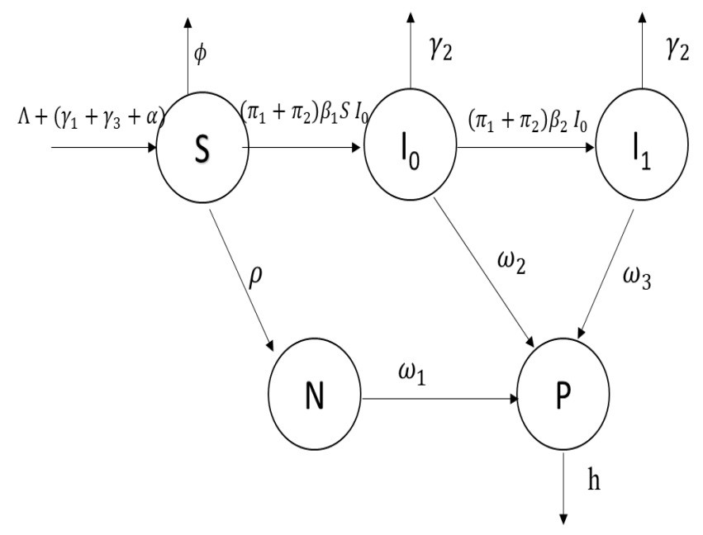
Figure 1: Model’s pictorial representation
Parameters | Representation | Parameters | Representation
Λ | Sampling rate | π₁ | Humidity
π₂ | Temperature and climate change | α | Suckers rate
φ | Degeneration rate | ρ | Disinfected plant rate
β₁ | Initial infection of disease | β₂ | Severe infection of disease
γ₁ | Proper drainage | γ₂ | Removing the infected crop
γ₃ | Intercropping, to avoid and reduce infection | ω₁ | High and healthy production of fruits
ω₂ | Low production of fruits | ω₃ | Unhealthy production of fruits
h | Total harvest
Table 1: Parameter descriptions
The model describes how cultural controls help prevent and prevent the spread of the disease in the field. The model is built with five populations: (i) susceptible (S), (ii) initial infection (I₀), (iii) severe infection (I₁), (iv) nondiseased (N) and (v) fruit production (P) plants.
Here, the assumptions are
- The susceptible plants are considered to have a seedling rate (Λ) and a sucker rate (α). While the plants were being planted, we added cultural controls such as proper drainage (γ₁) and intercropping (γ₃) to avoid infection. Here, we have two different stages if the plant becomes infected, which may be the initial infection (β₁), leading to secondary infection (β₂); otherwise, the plant will not be infected (ρ), resulting in healthy fruits (ω₁).
- The initial infection occurs when the plants come in contact with the fungus. This causes initial infection (β₁) in the plant, and the infection may be caused by humidity (π₁) and temperature (π₂). Some plants may not resist infection, which can lead to severe infection., i.e.,, secondary infection (β₂). Therefore, plants may result in low fruit production from initially infected plants (ω₂) and yield unhealthy fruit production from severely infected plants (ω₃).
- If vulnerable plants are not infected and produce only good, healthy fruits, they may lead to nondisease outcomes.
- Fruits produced from various states are represented in the previous assumption, and the total harvest is taken as ’h’.

2.1 Existence and uniqueness of the solution
Theorem 2.1. If we assume that R(Y) is a function of S,I₀,I₁,N and P, the initial condition is Y₀ = (S₀,I₀₀,I₁₀,N₀,P₀) ∈ R_{j}(Y),j = 1,2,3,4,5. Then, for all $Y_{0}$, $\left\|R(Y)-R(\overline{Y})\right\|≤L|Y-\overline{Y}|$ satisfies the unique solution Y(t) ∈ R_{j}, where L is the Lipchitz constant.

Proof. Let us consider R_{j} as follows:

R₁(Y) = Λ + (γ₁ + γ₃ + α − (φ + ρ))S − (π₁ + π₂)β₁SI₀
R₂(Y) = (π₁ + π₂)β₁SI₀ − (π₁ + π₂)β₂I₀ − (γ₂ + ω₂)I₀
R₃(Y) = (π₁ + π₂)β₂I₀ − γ₂I₁ − ω₃I₁ (2)
R₄(Y) = ρS − ω₁N
R₅(Y) = ω₁N + ω₂I₀ + ω₃I₁ – hP

Rewriting (2) as

R₁(Y) = Λ + AS − Bβ₁SI₀
R₂(Y) = Bβ₁SI₀ − Bβ₂I₀ − CI₀
R₃(Y) = Bβ₂I₀ − DI₁ (3)
R₄(Y) = ρS − ω₁N
R₅(Y) = ω₁N + ω₂I₀ + ω₃I₁ – hP

Here,
- = (γ₁ + γ₃ + α − (φ + ρ))
- = (π₁ + π₂) (4)
- = γ₂ + ω₂
- = γ₂ − ω₃
Then,
|R(Y)−R(Y¯)|= |(R₁(Y)+R₂(Y)+R₃(Y)+R₄(Y)+ R₅(Y))−(R₁(Y¯)+R₂(Y¯)+ R₃(Y¯)+R₄(Y¯)+R₅(Y¯))|
= |(R₁(Y)−R₁(Y¯)|+|R₂(Y)−R₂(Y¯)|+|R₃(Y)−R₃(Y¯)|+|R₄(Y)−R₄(Y¯)|+|R₅(Y)−R₅(Y¯)|
≤ |Λ+AS−Bβ₁SI₀−Λ−AS¯+Bβ₁S¯I¯₀|+|Bβ₁SI₀−Bβ₂I₀−CI₀|
+|Bβ₂I₀ −DI₁−Bβ₂I¯₀+DI¯₁+|ρS− ω₁N− ρS¯+ω₁N¯|
+ |ω₁N + ω₂I₀ + ω₁I₁−hP − ω₁N¯−ω₂I¯₀ − ω₃I¯₁ + hP¯|
= (A + 2Bβ₁η₁+ρ) |(S − S¯)| + (2Bβ₁η₂ + 2Bβ₂ + C + ω₂)|I₀ − I¯₀|
+ (D + ω₃)|I₁ − I¯₁| + 2ω₁|N − N¯| + h|P − P¯|
≤ L|(S − S¯) + (I₀ − I¯₀) + (I₁ − I¯₁) + (N − N¯) + (P − P¯)|
≤ L|(S,I₀,I₁,N,P) − (S,¯ I¯₀,I¯₁,N,¯ P¯)|
≤ L|Y − Y¯| (5)
where L = max{A + 2Bβ₁η₁,2Bβ₁η2 + 2Bβ₂ + C + ω₂,D + ρ + ω₃,2ω₁,h}. This shows that
there exists a unique solution.

- Model Analysis
3.1 Equilibrium point
The equilibrium points are found in two scenarios: the first involves finding the points without incorporating infections called disease-free equilibrium, and the second involves locating the points while accounting for the infections, called endemic equilibrium.
- (1) Disease-free Equilibrium:$E\left(S, I_{0}, I_{1}N, P\right)$
$=\left(\frac{Λ}{\left(a\right)-(γ_{1}+γ_{3}+α)},0,0,\frac{ρΛ}{ω_{1}(\left(a\right)-\left(γ_{1}+γ_{3}+α\right))},\frac{ρΛ}{h(\left(a\right)-(γ_{1}+γ_{3}+α)}) \right)$, S>0, N>0
and P>0 only if (φ + ρ) > γ₁ + γ₃ + α.
- (2) Endemic Equilibrium: E∗(S, I₀, I₁, N, P)
$=\left(\frac{\left(b\right)β_{2}+γ_{2}+ω_{2}}{\left(b\right)β_{1}},\frac{Λ}{\left(b\right)β_{2}+γ_{2}+ω_{2}}+\frac{\left(γ_{1}+γ_{3}+α\right)-a}{bβ_{1}},\frac{\left(b\right)β_{2}I_{0}}{γ_{2}+ω_{3}},\frac{ρ(\left(b\right)β_{2}+γ_{2}+ω_{2)}}{ω_{1}bβ_{1}},\frac{1}{h}\left(ω_{1}N+\left(ω_{2}+\frac{ω_{3}\left(b\right)β_{2}}{γ_{2}+ω_{3}}\right)\right)I_{0} \right)$. Here, I₀ is positive only if γ₁ + γ₃ + α > a.

3.2 Basic Reproduction Number
The reproduction number is used to find the subsidiary infections of the plant disease. This is calculated via the next-generation matrix [22], i.e., R₀ = FV ⁻¹. Here, F is the infectious value and
V ⁻¹ is the noninfectious value. The basic reproduction number is calculated as follows:
$F=\left(\begin{matrix}bβ_{1}S & 0 \\ 0 & 0\end{matrix}\right)$ and $V=\left(\begin{matrix}bβ_{2}+γ_{2}+ω_{2} & 0 \\ -\left(b\right)β_{2} & γ_{2}+ω_{3}\end{matrix} \right)$ (6)
Let us find V ⁻¹,
$$V^{-1}=\frac{1}{(bβ_{2}+γ_{2}+ω_{2})(γ_{2}+ω_{3})}\left|\begin{matrix}γ_{2}+ω_{3} & bβ_{2} \\ 0 & bβ_{2}+γ_{2}+ω_{2}\end{matrix}\right|$$
After simplification,
$$V^{-1}=\left|\begin{matrix}\frac{1}{(bβ_{2}+γ_{2}+ω_{2})} & \frac{bβ_{2}}{(bβ_{2}+γ_{2}+ω_{2})(γ_{2}+ω_{3})} \\ 0 & \frac{1}{(γ_{2}+ω_{3})}\end{matrix}\right|$$
$$FV^{-1}=\left(\begin{matrix}bβ_{1}S & 0 \\ 0 & 0\end{matrix}\right)\left(\begin{matrix}\frac{1}{(bβ_{2}+γ_{2}+ω_{2})} & \frac{bβ_{2}}{(bβ_{2}+γ_{2}+ω_{2})(γ_{2}+ω_{3})} \\ 0 & \frac{1}{(γ_{2}+ω_{3})}\end{matrix}\right)$$
$$FV^{-1}=\left(\begin{matrix}\frac{bβ_{1}S}{(bβ_{2}+γ_{2}+ω_{2})} & \frac{b^{2}β_{2}β_{1}S}{(bβ_{2}+γ_{2}+ω_{2})(γ_{2}+ω_{3})} \\ 0 & 0\end{matrix}\right)$$

Hence, the basic reproduction number is $R_{0}=\frac{bβ_{1}S}{(bβ_{2}+γ_{2}+ω_{2})}$. After the disease-
free Equilibrium $R_{0}=\frac{\left(π_{1}+π_{2}\right)β_{1}Λ}{(bβ_{2}+γ_{2}+ω_{2})(a-(γ_{1}+γ_{3}+α))}$.

3.3 Local Stability of the Model

Theorem 3.1. The disease-free equilibrium is stable only if R₀ < 1; otherwise, it is unstable.
Proof. From system (1), the Jacobian matrix is
$J=\left(\begin{matrix}γ_{1}+γ_{3}+α-a-bβ_{1}I_{0} & -bβ_{1}S & 0 & 0 \\ bβ_{1}I_{0} & bβ_{2}+γ_{2}+ω_{2} & 0 & 0 \\ 0 & bβ_{2} & -(γ_{2}+ω_{3}) & 0 \\ ρ & 0 & 0 & -ω_{1}\end{matrix}\right)$ (7)
At the disease-free equilibrium point,
$J(E)=\left(\begin{matrix}γ_{1}+γ_{3}+α-a & -bβ_{1}S & 0 & 0 \\ 0 & bβ_{2}+γ_{2}+ω_{2} & 0 & 0 \\ 0 & bβ_{2} & -(γ_{2}+ω_{3}) & 0 \\ ρ & 0 & 0 & -ω_{1}\end{matrix}\right)$ (8)
The characteristic equation is
(γ₁ + γ₃ + α − a − λ)(bβ₁S − ((bβ₂ + γ₂ + ω₂) − λ)(−(γ₂ + ω₃) − λ)(−ω₃ − λ) = 0
(−(γ₂ + ω₃)(−ω₁ − λ){(γ₁ + γ₃ + α − a − λ)(bβ₁S − (bβ₂ + γ₂ + ω₂) − λ)} = 0 (9)
From (10), the two eigenvalues are λ₃ = −(γ₂+ω₃) and λ₄ = −ω₁. Here, the two eigenvalues are negative. Other eigenvalues are found as follows:
(γ₁ + γ₃ + α − a − λ)(bβ₁S − (bβ₂ + γ₂ + ω₂) − λ) = 0 (10)
(γ₁+γ₃+α−a)bβ₁S−((γ₁+γ₃+α−a))(bβ₂+γ₂+ω₂)−λ(γ₁+γ₃+α−a)
− λaβ₁S + λ(bβ₂ + γ₂ + ω₂) + λ² = 0 (11)
λ² + λ(bβ₂ + γ₂ + ω₂ − bβ₁S − (γ₁ + γ₃ + α − a))
+((γ₁ +γ₃ +α−a)bβ₁S −(γ₁+γ₃+α−a)(aβ₂ +γ₂ +ω₂)) = 0 (12)

Rewriting equation (12) as
λ² + A₀λ + A₁ = 0 (13)
where
A₀ = bβ₂ + γ₂ + ω₂ − bβ₁S − (γ₁ + γ₃ + α −a)
A₁ = (γ₁ + γ₃ + α − a)bβ₁S − (γ₁ + γ₃ + α − a)(aβ₂ + γ₂ + ω₂)

Now, using the Routh–Hurwitz criteria, A₀ > 0 only if (γ₁ +γ₃ +α) > a and A₁ > 0 only if R₀ < 1. This is locally stable at disease-free equilibrium.

Theorem 3.2. The endemic equilibrium is stable if R₀ > 1; otherwise, it is unstable.
Proof:
The Jacobian matrix in (8) with endemic equilibrium points is
$$J(E^{*})=\left(\begin{matrix}γ_{1}+γ_{3}+α-a-bβ_{1}I_{0} & -bβ_{1}S & 0 & 0 \\ bβ_{1}I_{0} & bβ_{2}+γ_{2}+ω_{2} & 0 & 0 \\ 0 & bβ_{2} & -(γ_{2}+ω_{3}) & 0 \\ ρ & 0 & 0 & -ω_{1}\end{matrix}\right)$$

Then, the characteristic equation i$s$
$\left(-\left(γ_{2}+ω_{3}\right)-λ\right)\left(-ω_{1}-λ\right)\left\{\left(γ_{1}+γ_{3}+α-a-bβ_{1}I_{0}^{*}-λ\right)\left(bβ_{1}S^{*}-\left(bβ_{2}+γ_{2}+ω_{2} \right)-λ\right)+b^{2}β_{2}^{2} S^{*}I_{0}^{*}\right\}=0$ (14)
From (14), the two eigenvalues are λ₃ = −(ω₃ +γ₂) and λ₄ = −ω₁ and are negative. Now, the other roots are
$( γ_{1}+γ_{3}+α-a-bβ_{1}I_{0}^{*}-λ)(bβ_{1}S^{*}-\left(bβ_{2}+γ_{2}+ω_{2}\right)-λ)+b^{2}β_{2}^{2}S^{*}I_{0}^{*}=0$ (15)
$\left(γ_{1}+γ_{3}+α-a\right)\left(bβ_{1}S^{*}\right)-\left(γ_{1}+γ_{3}+α-a\right)\left(bβ_{2}+γ_{2}+ω_{2}\right)-λ\left(γ_{1}+γ_{3}+α-a\right)-b^{2}β_{1}β_{2}S^{*}I_{0}^{*} +bβ_{2}I_{0}^{*}\left(bβ_{2}+γ_{2}+ω_{2}+bβ_{2}I_{0}^{*}λ-\left(bβ_{2}+γ_{2}+ω_{2}\right)λ+λ^{2}+b^{2}β_{2}^{2}S^{*}I_{0}^{*}\right)=0$ (16)
After simplification,
$λ^{2}+λ\left\{bβ_{2}+γ_{2}+ω_{2}\right)-bβ_{1}S^{*}+bβ_{2}I^{*}-(γ_{1}+γ_{3}+α-a)\}+\{\left(γ_{1}+γ_{3}+α-a\right)\left(bβ_{1}S^{*}\right)-\left(γ_{1}+γ_{3}+α-a\right)\left\{bβ_{2}+γ_{2}+ω_{2}\right)-b^{2}β_{1}β_{2}S^{*}I_{0}^{*}+bβ_{2}I_{0}^{*}\left(bβ_{2}+γ_{2}+ω_{2}\right)+{\left(b\right)}^{2}β_{2}^{2}S^{*}I_{0}^{*}=0$ (17)
Rewriting (17) as
λ² + B₀λ + B₁ = 0 (18)

Here,
$$B_{0}=\left\{bβ_{2}+γ_{2}+ω_{2}\right)-bβ_{1}S^{*}+bβ_{2}I^{*}-(γ_{1}+γ_{3}+α-a)$$
$$B_{1}=\left(γ_{1}+γ_{3}+α-a\right)\left(bβ_{1}S^{*}\right)-\left(γ_{1}+γ_{3}+α-a\right)\left\{bβ_{2}+γ_{2}+ω_{2}\right)-{ b}^{2}β_{1}β_{2}S^{*}I_{0}^{*}+bβ_{2}I_{0}^{*}\left(bβ_{2}+γ_{2}+ω_{2}\right)+b^{2}β_{2}^{2}S^{*}I_{0}^{*}$$
Now, using the Routh–Hurwitz criteria, B₀ > 0 and B₁ > 0 only if R₀ > 1. This strain is locally stable at endemic equilibrium.

3.4 Global Stability of Endemic Equilibrium
Theorem 3.3. The endemic equilibrium of system (1) is globally stable if and only if $\frac{dV}{dt}<0$.
Proof. Let V(t) be
$\left(S-S^{*}\ln{\frac{S}{S^{*} }}\right)+ζ_{1}\left(I_{0}-I_{0}^{*}ln\frac{I_{0}}{I_{0}^{*} }\right)+ζ_{2}\left(I_{1}-I_{1}^{*}ln\frac{I_{1}}{I_{1}^{*} }\right)+ζ_{3}\left(N-N^{*}ln\frac{N}{N^{*} }\right)+ζ_{4}\left(P-P^{*}ln\frac{P}{P^{*} }\right)$ (19)
Differentiating V(t),
$$\frac{dV}{dt}=\frac{S-S^{*}}{S}\frac{dS}{dt}+ζ_{1}\frac{I_{0}-I_{0}^{*}}{I_{0}}\frac{dI_{0}}{dt}+ζ_{2}\frac{I_{1}-I_{1}^{*}}{I_{1}}\frac{dI_{1}}{dt}+ζ_{3}\frac{N-N^{*}}{N}\frac{dN}{dt}+ζ_{4}\frac{P-P^{*}}{P}\frac{dP}{dt}$$
$$\frac{dV}{dt} =\frac{S-S^{*}}{S}\left(Λ+\left(γ_{1}+γ_{3}+α-\left(ϕ+ρ\right)\right)S-\left(π_{1}+π_{2}\right)β_{1}SI_{0}\right)$$
$$+ζ_{1}\frac{I_{0}-I_{0}^{*}}{I_{0}}(\left(π_{1}+π_{2}\right)β_{1}SI_{0}-\left(π_{1}+π_{2}\right)β_{2}I_{0}-\left(γ_{2}+ω_{2}\right)I_{0})$$
$+ζ_{2}\frac{I_{1}-I_{1}^{*}}{I_{1}}(\left(π_{1}+π_{2}\right)β_{2}I_{0}-{(γ}_{2}+ω_{3})I_{1})+ζ_{3}\frac{N-N^{*}}{N}(ρS-ω_{1}N)$
$$+ζ_{4}\frac{P-P^{*}}{P}{(ω}_{1}N+ω_{2}I_{0}+ω_{3}I_{1}-hP)$$
$$\frac{dV}{dt}=\left(S-S^{*}\right)\left(\frac{Λ}{S}+\left(γ_{1}+γ_{3}+α-\left(ϕ+ρ\right)\right)-\left(π_{1}+π_{2}\right)β_{1}I_{0}\right){+ζ}_{1}\left(I_{0}-I_{0}^{*}\right)\left(\left(π_{1}+π_{2}\right)β_{1}-\left(π_{1}+π_{2}\right)β_{2}-\left(γ_{2}+ω_{2}\right)\right)+{+ζ}_{2}\left(I_{1}-I_{1}^{*}\right)(\left(π_{1}+π_{2}\right)β_{2}\frac{I_{0}}{I_{1}}-{(γ}_{2}+ω_{3}))$$
${+ζ}_{3}\left(N-N^{*}\right)(ρ\frac{S}{N}-ω_{1}){+ζ}_{4}\left(P-P^{*}\right){(ω}_{1}\frac{N}{P}+ω_{2}\frac{I_{0}}{P}+ω_{3}\frac{I_{1}}{P}-h)$
From (1),
$\left.\begin{aligned}\frac{-Λ}{S^{*}}=\left(γ_{1}+γ_{3}+α-\left(ϕ+ρ\right)\right)-\left(π_{1}+π_{2}\right)β_{1}I_{0}^{*} \\ \left(π_{1}+π_{2}\right)β_{1}S^{*}=\left(π_{1}+π_{2}\right)β_{2}+\left(γ_{2}+ω_{2}\right) \\ \frac{\left(π_{1}+π_{2}\right)β_{2}I_{0}^{*}}{I_{1}^{*}}={(γ}_{2}+ω_{3}) \\ ρ\frac{S^{*}}{N^{*}}=ω_{1} \\ ω_{1}\frac{N^{*}}{P^{*}}+ω_{2}\frac{I_{0}^{*}}{P^{*}}+ω_{3}\frac{I_{1}^{*}}{P^{*}}=h\end{aligned}\right\}$ (21)

Substituting (21) into (20), we obtain
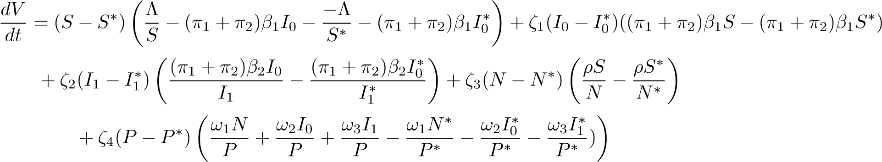
(22)
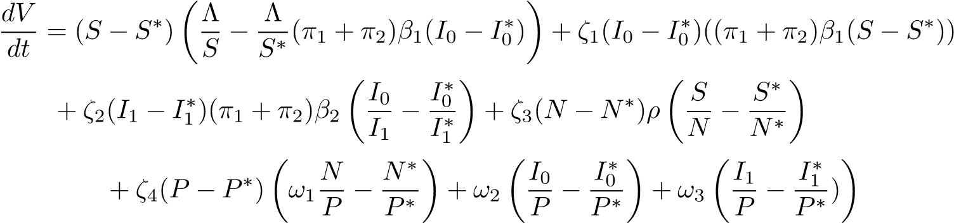 (23)
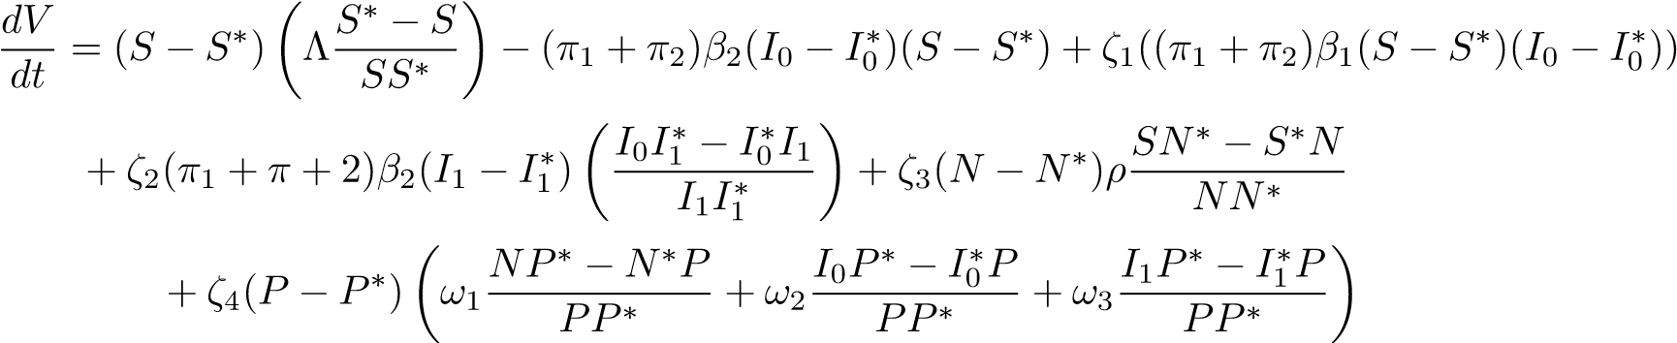 (24)
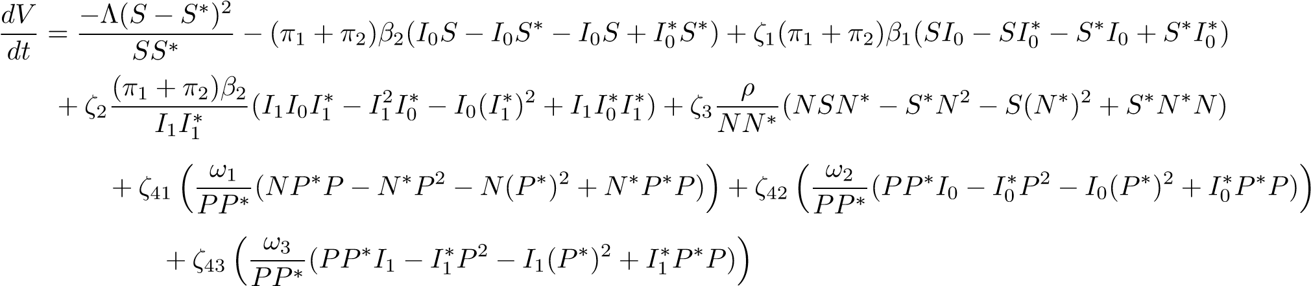
(25)
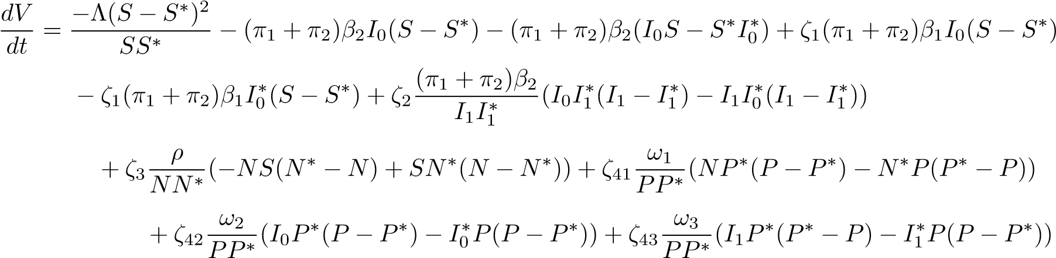
(26)
Now replacing
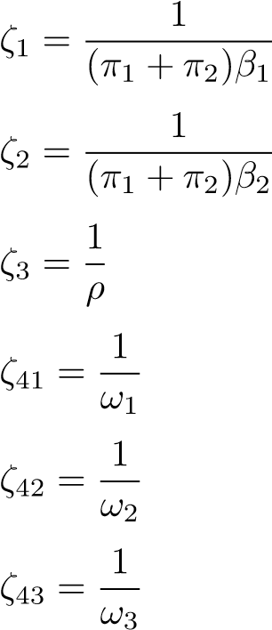 (27)
The following is obtained:
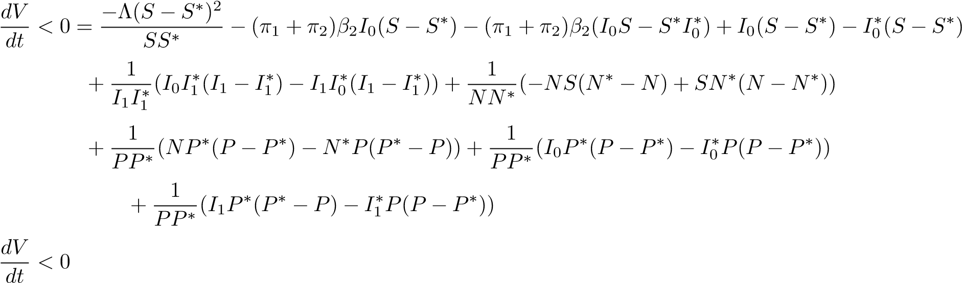
(28)
Hence, system (1) is globally stable at endemic equilibrium.

3.5 Bifurcation
Bifurcation analysis helps to recognize the changes in the solution. Here, the center manifold theory is used to identify the change by considering the coefficient of system (1)[4]. If the coefficients a and b are positive, then it becomes backward bifurcation, and if a is positive, b is nonpositive, then it is forward bifurcation or transcritical bifurcation.
The bifurcation behavior of system (1) is explained by the following theorem:

Theorem 3.4. If a is positive and b is nonpositive, then the system exhibits transcritical bifurcation.
Proof. When R₀ = 1, the bifurcation parameter β₁ is
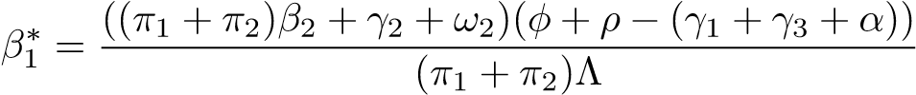 (29)
From the Center manifold, consider S,I₀,I₁ as x₁,x₂ and x_{3,} respectively. Then, the equations become
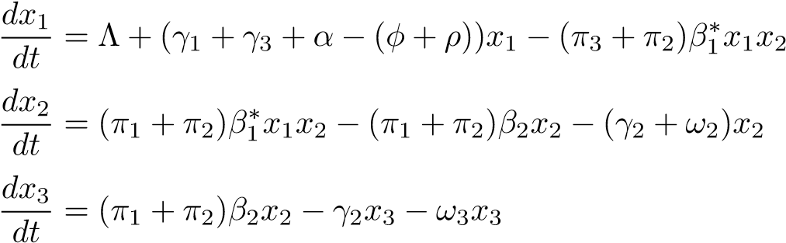 (30)
The disease-free equilibrium points for x₁, x₂, and x₃ are 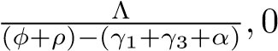 and 0, respectively. Now, the
The Jacobian matrix of (30) is
$J=\left(\begin{matrix}γ_{1}+γ_{3}+α-\left(ϕ+ρ\right)-\left(π_{1}+π_{2}\right)β_{1}^{*}x_{2} & -\left(π_{1}+π_{2}\right)β_{1}^{*}x_{1} & 0 & 0 \\ \left(π_{1}+π_{2}\right)β_{1}^{*}x_{2} & \left(π_{1}+π_{2}\right)β_{1}^{*}x_{1}-\left(π_{1}+π_{2}\right)β_{2}+γ_{2}+ω_{2} & 0 & 0 \\ 0 & {(π}_{1}+π_{2})β_{2} & -(γ_{2}+ω_{3}) & 0 \\ ρ & 0 & 0 & -ω_{1}\end{matrix}\right)$ (31)
Substituting the values of x₁, x₂ and x₃ in (31), we obtain
$$J=\left(\begin{matrix}γ_{1}+γ_{3}+α-\left(ϕ+ρ\right) & \frac{-\left(π_{1}+π_{2}\right)β_{1}^{*}Λ}{\left(ϕ+ρ\right)-(γ_{1}+γ_{3}+α)} & 0 & 0 \\ 0 & \frac{-\left(π_{1}+π_{2}\right)β_{1}^{*}Λ}{\left(ϕ+ρ\right)-(γ_{1}+γ_{3}+α)}-\left(π_{1}+π_{2}\right)β_{2}+γ_{2}+ω_{2} & 0 & 0 \\ 0 & {(π}_{1}+π_{2})β_{2} & -(γ_{2}+ω_{3}) & 0 \\ ρ & 0 & 0 & -ω_{1}\end{matrix}\right)$$
To determine the right eigenvector, u=(u₁,u₂,u₃)^{T}) and Ju = 0,
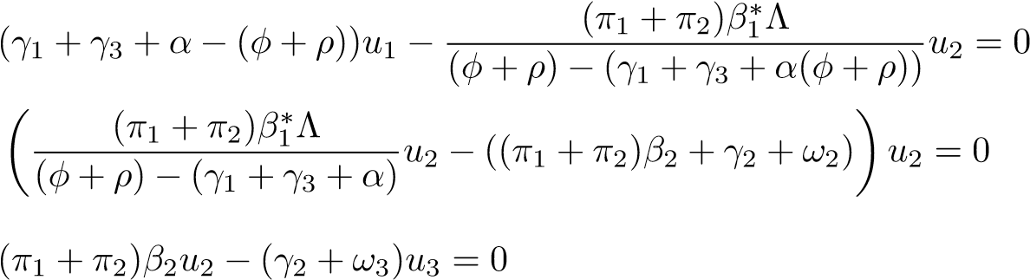 (33)
From (33), the values are
(34)
To compute the left eigenvectors, v = (v₁,v₂,v₃) and vJ = 0,
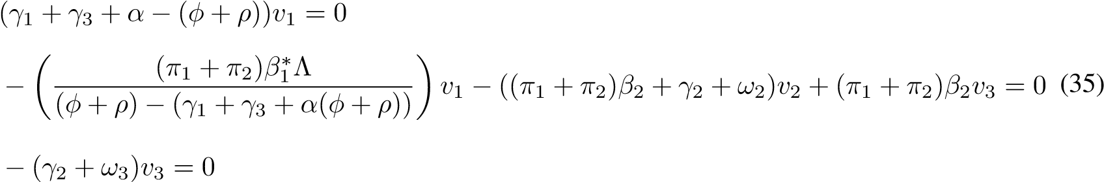
From (35), the values are
v₁ = v₃ = 0;v₂ = 1 (36)
Thus, the value of v₂ should be calculated with the condition v.u=1. The function f₂ and its partial derivatives are considered. The only nonzero partial derivatives are given below:
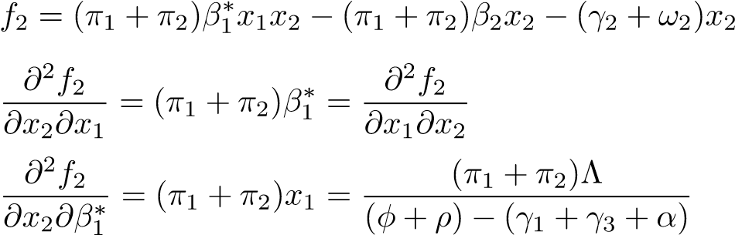 (37)
Now, to find the coefficient signs ‘a’ and ‘b’:
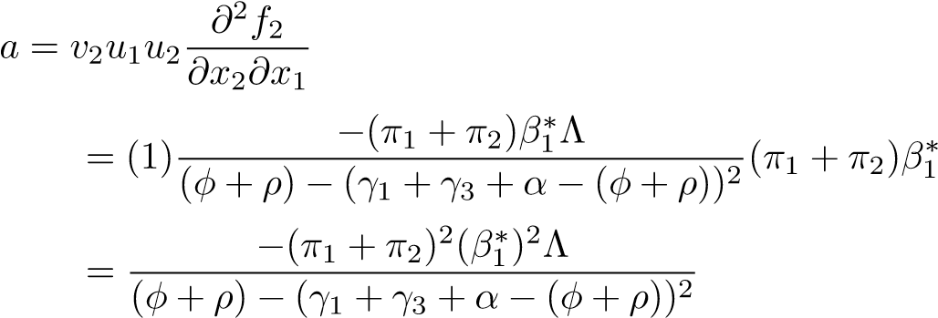 (38)
- < 0
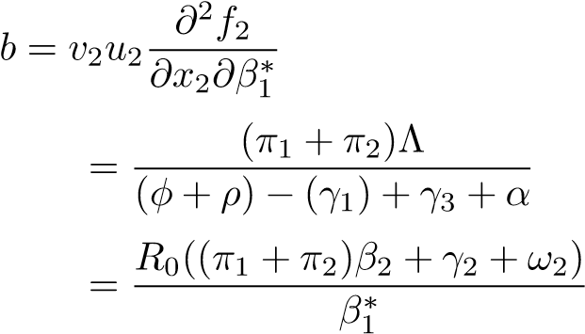 (39)
- > 0
Therefore, the system exhibits transcritical bifurcation., i.e., forward bifurcation.

4 NUMERICAL SIMULATION
The parameter values are calculated and presented in Table (3). Here, T(total number of plants) = 1000, S = 900, I₀ = 300, I₁ = 500, N = 900 and P = 500. The values
are assigned to the parameters by the survey conducted in the Tiruvannamalai area. In Figure (2), the graph
Parameters | Values | Parameters | Values
Λ | 0.9 | α | 0.05
π₁ | 0.5 | π₂ | 0.5
φ | 0.01 | ρ | 0.7
β₁ | 0.5 | β₂ | 0.8
γ₁ | 0 or 0.5 | γ₂ | 0 or 1
γ₃ | 0 or 0.5 | ω₁ | 0.9
ω₂ | 0.3 | ω₃ | 0.5
h | 0.8
Table 2: Values of the parameters
represents all state variables with cultural controls. When R₀ < 1, the initial and severe infection decreases, whereas the other populations increase. Figure (3) depicts the graph of the susceptible population with four cases: 1. Without cultural controls, 2. With cultural controls, 3. If γ₁ and γ₂ are applied and 4. Only γ₂ is applied. This graph shows that using all the culture controls in the susceptible state increases the plant population.
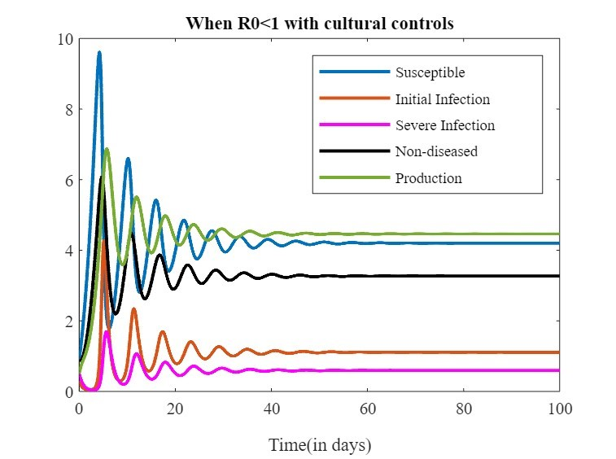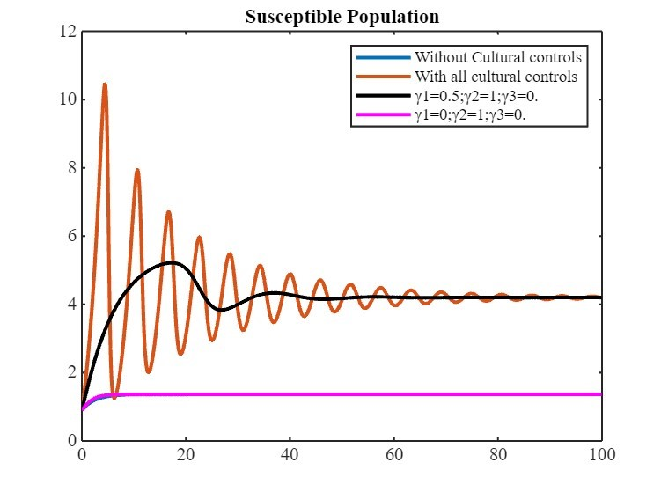
Figure 2: When R0 < 1 with cultural controls Figure 3: Susceptible population
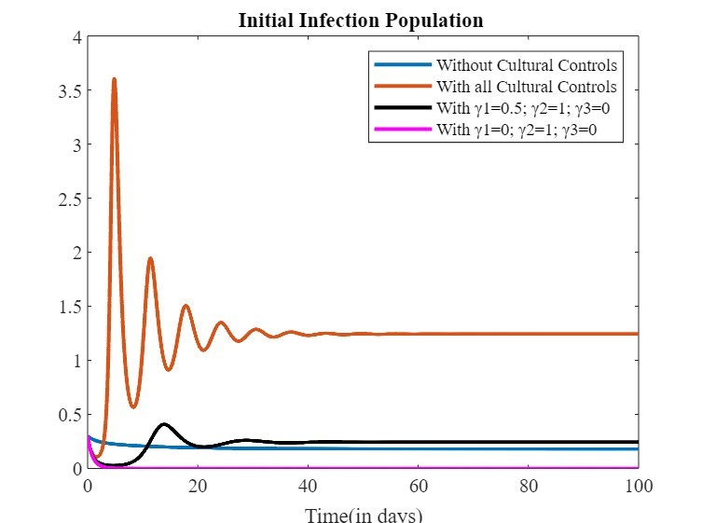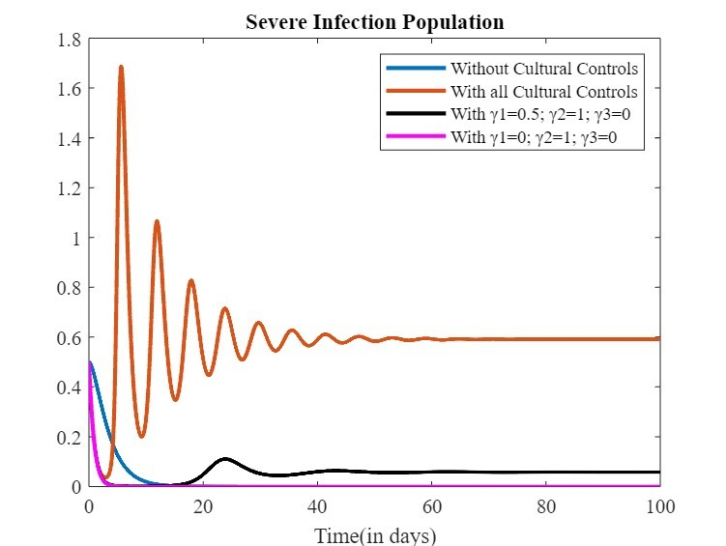
Figure 4: Initial Infection Population Figure 5: Severe Infection Population
Figure (4) and Figure (5) show the graphs of the initial and severe infection populations from various perspectives. The four cases in the graphs are as follows: 1. Without cultural controls 2. With all the cultural controls, 3. When only two cultural controls, γ₁ and γ₂ and 4, are used. If γ₃ is applied, only. Both graphs indicate that if the infection is present in the plant population, the use of γ₂ alone decreases the initial and severe infection in the plant population. The other two cultural controls increased the population of infected plants.
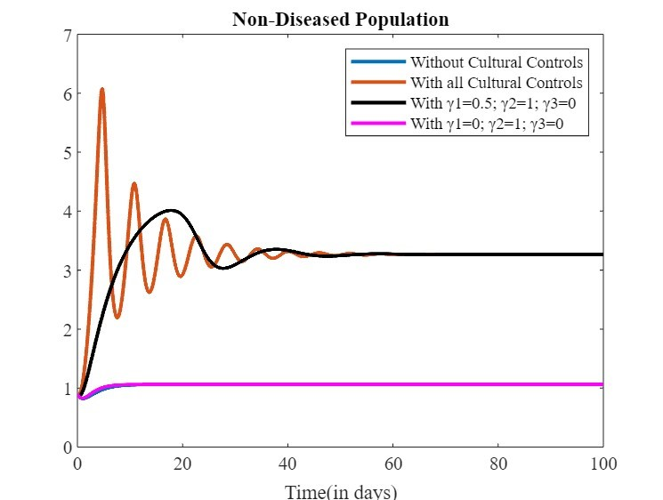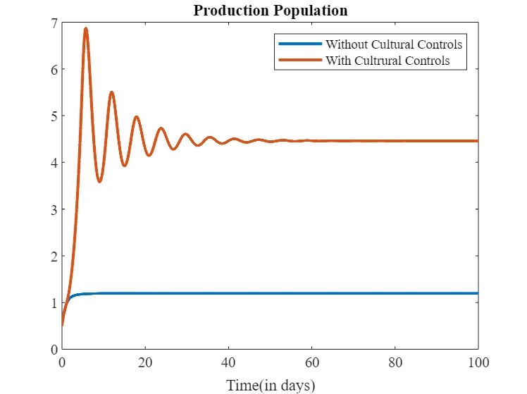
Figure 6: Nondiseased population without Figure 7: Production population without
and with controls γ₁ and γ₂ controls for different values of γ₁ and γ₂
The graph of the nondiseased cases is displayed in Figure (6), which includes the same four cases as Figures (4) and (5). The nondiseased population increases in two cases: one in which all cultural controls are used and the other in which only two cultural controls, γ₁ and γ_{2, are used}. Figure (7) presents the graph of the production population, which shows that using all cultural control increases the production in the plant population.
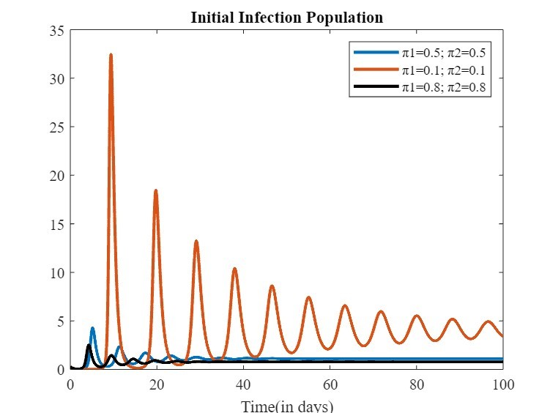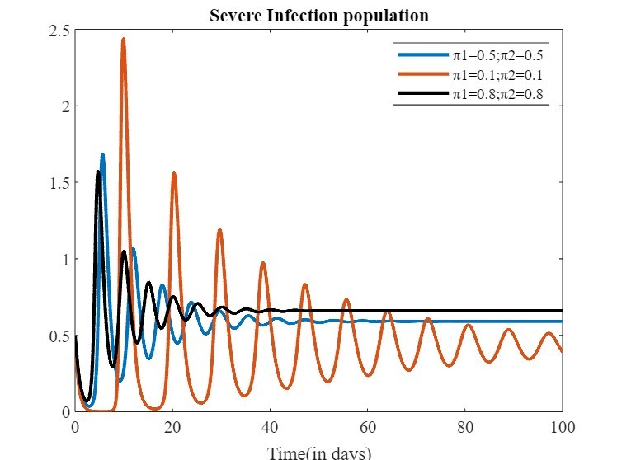
Figure 8: Initial infection population for Figure 9: Severe infection population for
Different values of π₁ and π₂ Different values of π₁ and π₂
Figure (8) and Figure (9) show the graphs of initial and severe infection with the causes of disease π₁ and π₂. In the two scenarios, π₁ = π₂ = 0.5 and π₁ = π₂ = 0.8, and the initial and severe infections are stable.
In the alternative scenario, π₁ = π₂ = 0.1 reveals fluctuations in the initial and severe infections.

5 CONCLUSION
In this study, the two main causes of banana wilt disease were developed via a mathematical model along with cultural controls. From the two equilibrium points, if (φ+ρ) > γ₁ +γ₃ +α, the illness is not prevalent in the plant population if the percentage of noninfected plants (ρ) is higher than the percentage of suckers (α); if not, the disease will be endemic to the plant population. The reproduction number is determined by the next-generation matrix. The reproduction number is used to examine the local stability of both equilibria. The global stability was examined through the Lyapunov function. Bifurcation is shown to be transcritical. Numerical simulation is performed to validate the theoretical analysis. Thus, this study aims to demonstrate the effects of applying cultural controls, which significantly help susceptible, nondiseased and productive populations without infection. Specifically, if the cultural controls γ₁ (proper drainage) and γ₂ (removal of the infected plants) are used in the early stages, the number of infected plants decreases. As a result, γ₃ (intercropping) in the initial and severe infection states increases the number of infected individuals. The diseased population may be stable if the two main causes, π₁ (humidity) and π₂ (temperature and climatic change), are low and balanced. If not, the population will be unstable.

REFERENCES
- Alexandratos, N. and Bruinsma, World agriculture: toward 2015/2030: and FAO perspective: Jelle Briunsma (Ed. ), FAO/Earthscan, 2003. 432 pp. ISBns: 92 5 104835 5 (FAO paperback), 1 84407 007 7 (Earthscan paperback) and 1 84407 008 57 (Earthscan hardback) Land Use Policy, 2013, 20(4):375, https://doi.org/10.1016/S0264-8377(03)00047-4.
- Abubakar Abubakar Ismaila, Khairulmazmi Ahmad, Yasmeen Siddique, Muhammad Aswad Abdul Wahab, Abdulaziz Bashir Kutawa, Adamu Abdullahi, Syazwan Afif Mohd Zobir, Arifin Abdu and Siti nor Akmar Abdullah, Fusarium wilt of banana: Current update and sustainable disease control using classical and essential oils approaches, Horticultural Plant Journal, 2023, 9(1):1-28, https://doi.org/10.1016/j.hpj.2022.02.004.
- Archith T. C., Devappa V., Mesta R. K and Honnabyraiah M. K., Survey on Panama Wilt Disease
(Fusarium oxysporum f.sp. cubense) of Banana in the Mysuru, Mandya and Chamarajanagar Districts of Karnataka, International Journal of EcoDomic Plants, 2021, 8(2):073-080.
- Carlos Castillo-Chavez, Sally Blower, Pauline Driessche, Denise Kirschner and Abdul-Aziz Yakubu, Mathematical Approaches for Emerging and Reemerging Infectious Diseases: Models, Methods and Theory, The IMA Volumes in Mathematics and its Applications(Springer), 126:97-118, (2002).
- Daly A. and Walduck G., Fusarium Wilt of Bananas (Panama Disease) (Fusarium oxysporum f. sp.cubense), no: I51 November 2006, https://dpir.nt.gov.au/-data/assets/pdf-file/0011/233795/786.pdf.
- Eliab Horub Kweyunga, Julius Tumwiine and Eldad Karamura, Modeling the Dynamics of Banana Xanthomonas Wilt Transmission Incorporating an Infectious Force in both Asymptomatic and
Symptomatic Stages, Journal of Advances in Mathematics and Computer Science, 29(3): 1-17, 2018, ISSn: 2456-9968.
- Getachew Teshome Tilahun, Getinet Alemayehu Wolle and Mohammed Tofik, Eco-epidemiological model and analysis of potato leaf roll virus using fractional differential equation, Arab Journal of Basic and Applied Sciences, 28(1):41-50, 2021, https://doi.org/10.1080/25765299.2020.1865621.
- Giovanni Bubici, Manoj Kaushal, Maria Isabella Prigigallo,Carmen Gómez-Lama Cabanás and Jesús Mercado-Blanco, Biological Control Agents Against Fusarium Wilt of Banana, Frontiers in Microbiology, 10, 2019, https://doi.org/10.3389/fmicb.2019.00616.
- Isacc Owusu-Mensah, Lanre Akinyemi, Bismark Oduro and Olaniyi S. Iyiola, A Fractional Order Approach to Modeling and Simulations of the novel COVID-19, 683,
2020,https://doi.org/10.1186/s13662-020-03141-7.
- Juliet nakakawa, Joseph Y. T. Mugisha, Michael W. Shaw, William Tinzaara and Eldad Karamura, Banana Xanthomonas Wilt Infection: The Role of Debudding and Roguing as Control Options within a Mixed Cultivar Plantation, International Journal of Mathematics and Mathematical Sciences, 2017, https://doi.org/10.1155/2017/4865015.
- Juliet nakakawa and Joseph Y. T. Mugisha,A Mathematical Model for the Dynamics of Banana Xanthomonas Wilt with Vertical Transmission and Inflorescence Infection, Journal of Biological Systems, 24(1):147–165, 2016, https://doi.org/10.1142/S021833901650008X.
- Kenneth G. Pegg1, Linel M. Coates, Wayne T. O’neill and David W. Turner, The Epidemiology of Fusarium Wilt of Banana, Frontiers in Plant Science, 10, 2019,
https://doi.org/10.3389/fpls.2019.01395.
- Kweyunga Eliab Horub and Tumwiine Julius, A Mathematical Model for the Vector Transmission and Control of Banana Xanthomonas Wilt, Journal of Mathematics Research, 9(4): 101-113, 2017, E-ISSn 1916-9809.
- Luis Pérez-Vicente, Miguel A. Dita, Einar Martínez- de la Parte, Technical Manual Prevention and diagnostic of Fusarium Wilt (Panama disease) of banana caused by Fusarium oxysporum f. sp. cubense Tropical Race 4 (TR4), Food and Agriculture Organization of the United nations, 2014,
https://www.fao.org/3/br126e/br126e.pdf.
- Muhammad Rafiq Ch.,Muhammad Tariq Mahmood, Mushtaq Ahmad, Imtiaz Ali, Sadia Kaukab, Muhammad Shafiq, Muhammad Saleem and Umer Iqbal, Fusarium wilt’s pathogenic studies and disease management: A review, Genetics and Molecular Research 19 (1): gmr16039974,
https://www.researchgate.net/publication/339229221-Fusarium-wilt’s-pathogenic-studies-anddisease-management-A-review.
- Muhammad Akmal Mohd Zawawi, Marinah Muhammad, nurul Syaza Abdul Latif, Laila naher and Mohd Fauzie Jusoh, Statistical Analysis between Soil Properties and Fusarium Wilt Disease in Banana, Universal Journal of Agricultural Research 11(1): 166-173, 2023, https://doi:
10.13189/ujar.2023.110116.
- Mustapha El Jarroudi, Hasan Kajoun, Louis Kouadio and Moussa El Jarroudi, Mathematical Modeling of non-Local Spore Dispersion of Win-borne Pathogens causing Fungal Diseases, Applied Mathematics and Computation, 376:125107, 2020, https://doi.org/10.1016/j.amc.2020.125107.
- Nannyonga B., Luboobi L. S. and P. Tushemerirwe, Using contaminated tools fuels outbreaks of Banana Xanthomonas wilt: and optimal control study within plantations using Runge–Kutta fourth-order algorithms, International Journal of Biomathematics,2015, 8(5):1550065-1-20, https://DOI: 10.1142/S1793524515500655.
- Oerke. E. C and Dehne. H.-W, Safeguarding production—losses in major crops and the role of crop protection, Crop Protection, 2004, 23(4): 275-285,https://doi.org/10.1016/j.cropro.2003.10.001.
- Sanubari tansah Tresna, nursanti Anggriani and Asep K. Supriatna, Mathematical Model for Soyabean Mosaic Disease Transmission with Entomopathogen Interventions and Photoperiodicity, Communications in Mathematical Biology and neuroscience, 4, 2023,
https://scik.org/inex.php/cmbn/article/view/7812.
- Thukkaram Damodaran, Shailenra Rajan, Muthukumar Manoharan, Ram Gopal, Kavita Yadav,
Saneep Kumar, Israr Ahmad, nidhi Kumari, Vinay K. Mishra and Sunil K. Jha, Biological Management of Banana Fusarium Wilt Caused by Fusarium oxysporum f. sp. cubense Tropical Race 4 Using Antagonistic Fungal Isolate CSR-T-3 (Trichoderma reesei), Frontiers in Microbiology, 2020, 11,https://doi.org/10.3389/fmicb.2020.595845.
- Van Den Driesschea. P and James Watmough, Reproduction numbers and subthreshold enemic equilibria for compartmental models of disease transmission, Mathematical Biosciences,
180(1–2):29-48, (2002).

