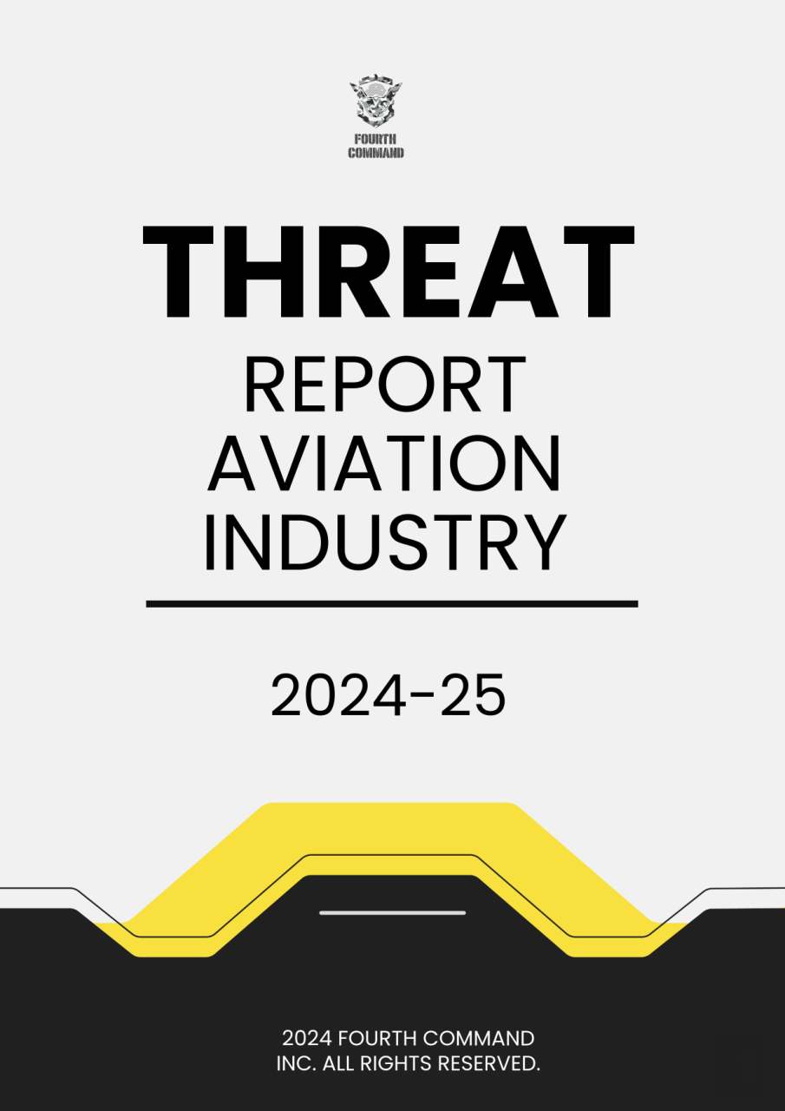

A recent study by Security Scorecard revealed that the aviation industry scores an average of "B" on cybersecurity assessments, indicating that organizations rated with this score are 2.9 times more likely to suffer data breaches compared to those with higher ratings. Moreover, vulnerabilities within IT vendors and software providers exacerbate these risks, as they often represent the weakest links in the security chain. The report found that aviation-specific software vendors scored particularly low, posing substantial third-party risks that can have cascading effects on airlines.
Regulatory bodies are responding to these challenges with heightened cybersecurity mandates. The U.S. Transportation Security Administration introduced new regulations in March 2023 aimed at improving cybersecurity across the aviation sector. Similarly, the European Union's upcoming Implementing Regulation set to take effect in 2026 will establish stricter standards for information security risk management within aviation.

Key Survey Findings

- Cybersecurity Grade: The aviation industry scores an average of "B" on cybersecurity assessments, indicating that organizations rated with this score are 2.9 times more likely to experience data breaches compared to those rated "A."
- Ransomware Threats: 55% of aviation organizations reported experiencing a ransomware attack in the past year, highlighting the prevalence of this type of cyber threat.
- Data Breaches: 7% of surveyed companies publicly acknowledged data breaches, while 17% had evidence of at least one compromised machine in the past year.
- Drone Threats: Aviation organizations faced an average of 21 drone threats per respondent over the last year, signaling a growing concern regarding unauthorized drone activities.
- Third-Party Risks: Aviation-specific software and IT vendors received the lowest cybersecurity scores, posing significant third-party risks for airlines. Breaches at airlines have exposed sensitive information related to their vendors.
- Identity Management Concerns: Identity management, authentication, and access control are identified as the most significant areas of concern within the aviation cybersecurity community, with supply chain risk management following closely behind.
- Geopolitical Threats: Advanced economies exhibit better cybersecurity outcomes compared to emerging markets, with nation-state threats, particularly from China-based APT groups, posing major risks to the global aviation sector

As the aviation industry navigates the complexities of emerging cyber threats, we hope this report, informed by industry insights and best practices, provides valuable guidance for strengthening your cybersecurity posture. By addressing the challenges outlined and prioritizing the recommended strategies, we are confident that your organization will be well-equipped to mitigate risks and safeguard critical aviation systems and data in the years ahead.

Thank You,

Anshul Pareek

Founder, Fourth Command

- High Target for Cybercrime: The real estate sector is increasingly targeted by cybercriminals due to the sensitive personal and financial data it handles, making it a prime target for identity theft and fraud.
- Data Breaches: Data breaches are one of the most significant risks, with real estate companies storing large volumes of sensitive information. A breach can led to severe financial losses, reputational damage, and legal consequences.
- Ransomware Attacks: Ransomware has become a major concern, where attackers encrypt company data and demand ransom for its release. This can disrupt business operations and result in substantial financial losses.
- Phishing Attacks: Phishing remains prevalent in the real estate industry, with cybercriminals using deceptive emails and social engineering tactics to trick employees into revealing sensitive information.
- Third-Party Vulnerabilities: Collaborations with third-party service providers can introduce additional cyber risks, as these vendors may not have robust cybersecurity measures in place.

57%
Excessive data access, overprivileged accounts

50%
No visibility into the sensitive data that exists in the environment

46%
Data management, managing large amounts of data

43%
Need to deal with sensitive personal data

The aviation industry is increasingly targeted by cybercriminals due to the sensitive passenger and operational data it handles, making it a prime target for identity theft and fraud. Data breaches remain a major risk, leading to financial losses, reputational harm, and legal consequences. Ransomware attacks disrupt operations by encrypting critical data and demanding payment for its release. Phishing attacks exploit employees through deceptive tactics to access sensitive information. Additionally, third-party vulnerabilities expose the industry to risks from vendors with inadequate security. These challenges highlight the urgent need for comprehensive cybersecurity measures in aviation.

Risks:

- Ransomware Attacks: Disrupt operations and compromise sensitive data, becoming a leading concern in aviation.
- Data Breaches: Target vast amounts of personal and operational data, leading to financial, reputational, and regulatory consequences.
- IoT Vulnerabilities: Exploitation of IoT devices (e.g., sensors, biometric readers) expands the attack surface.
- Third-Party Risks: Vendors with inadequate cybersecurity measures introduce vulnerabilities.
- Phishing and Social Engineering: Deceptive tactics targeting employees to access systems or data.

Mitigation Measures:

- Access Controls: Enforce role-based access and restrict system access to authorized personnel.
- Multi-Factor Authentication (MFA): Require multiple verification steps for system access.
- Endpoint Security: Deploy anti-virus, anti-malware, and regular updates for IT devices.
- Mobile Device Management (MDM): Manage mobile device security policies and enable remote wiping.
- Network Defenses: Use next-generation firewalls, intrusion detection, and prevention systems (IDS/IPS).
- Network Segmentation: Isolate critical systems to prevent lateral movement in case of an attack.
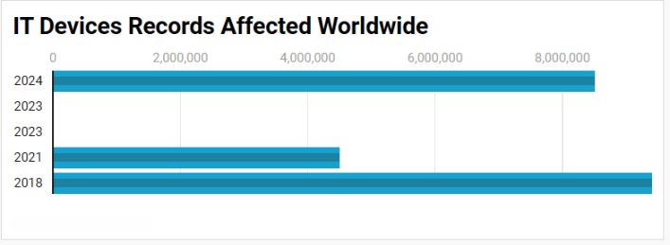

The aviation industry faces significant cybersecurity risks due to its reliance on interconnected IT devices and systems. Ransomware attacks are a major concern, as they disrupt operations and compromise sensitive data, leading to substantial financial losses. Data breaches are another critical risk, exposing large amounts of personal and operational data, which can result in reputational damage and regulatory penalties. The integration of Internet of Things (IoT) devices has expanded the attack surface, with vulnerabilities in devices like sensors and biometric readers being exploited by cybercriminals.
Risks:

- Expanded Attack Surface: Increasing IoT devices like sensors and cameras create more entry points for cyberattacks, making endpoint security critical.
- Ransomware Threats: IoT devices can be targeted for ransomware attacks, leading to operational disruptions and data loss, with incidents rising by 600% in 2022.
- Data Breaches: IoT devices collect sensitive data, such as passenger and operational information, which, if breached, can result in financial and reputational damage.
- Insecure Devices: Many IoT devices lack adequate security features, making them easy targets for hackers.
- Third-Party Vulnerabilities: Dependence on third-party vendors for IoT solutions can expose weaknesses in security if those vendors don't follow strong practices.

Mitigating Measures:

- Implement strong authentication (e.g., multi-factor authentication).
- Change default credentials to unique, strong passwords.
- Regularly update firmware to patch vulnerabilities.
- Encrypt data in transit and at rest.
- Segment networks to isolate IoT devices from critical systems.
- Maintain an updated inventory of all connected IoT devices.

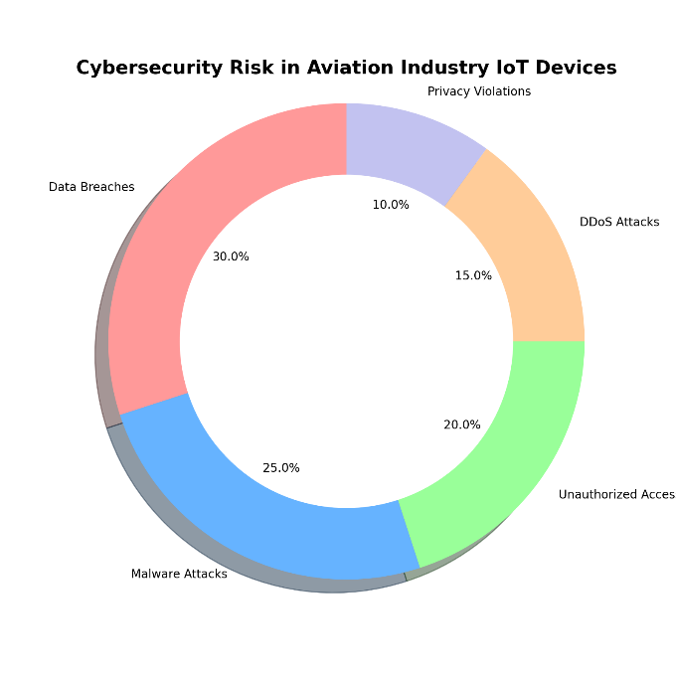
The integration of Internet of Things (IoT) devices in the aviation industry has brought significant operational benefits, but it also introduces a range of cybersecurity risks. The increasing number of connected devices, such as sensors and cameras, expands the attack surface, providing more potential entry points for cybercriminals. Ransomware attacks are rising, with IoT devices often being targeted to disrupt operations and steal data. Data breaches are a major concern as IoT devices collect sensitive passenger and operational data, which can be exposed if compromised.

Attack Overview:
- Breach Discovery: Cathay Pacific revealed that hackers had accessed sensitive personal information of 9.4 million passengers, including names, birthdates, and passport details.
- Attack Vector: The attackers gained access to the airline’s IT systems through compromised credentials, allowing them to bypass security.
- Duration of Breach: The breach was discovered in 2018, but the unauthorized access to the data had been occurring for several months prior.
- Scope of Impact: Besides passenger data, the attackers also accessed flight information, which raised concerns about the vulnerability of aviation-related systems.
- Delayed Response: The breach was not immediately detected, and the public disclosure came several months after the initial attack.

Mitigation Steps:
- Enhanced Data Encryption: Implement stronger encryption methods to protect sensitive data both in transit and at rest, ensuring that even if data is compromised, it remains unreadable.
- Multi-Factor Authentication (MFA): Enforce MFA across all access points to prevent unauthorized access, especially for privileged accounts.
- Regular Security Audits: Conduct regular security audits and vulnerability assessments to detect and mitigate potential weaknesses in the system.
- Employee Training: Provide cybersecurity awareness training to employees to reduce the risk of social engineering attacks and improve internal response to security threats.
- Incident Response Plan: Establish and test an incident response plan to ensure a timely and efficient response to any future breaches, minimizing potential damage.

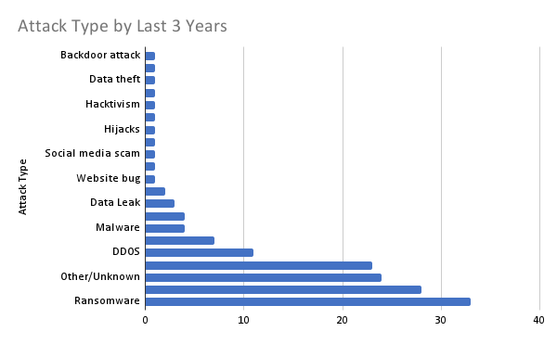

In 2018, Cathay Pacific experienced a cyber-attack that exposed the personal information of 9.4 million passengers, including names, birthdates, and passport details. Hackers gained access to the airline's IT systems through compromised credentials, allowing unauthorized data access over several months. The breach also involved sensitive flight data. The attack went undetected for months before being publicly disclosed. In response, Cathay Pacific implemented stronger encryption, multi-factor authentication, and enhanced security measures to prevent future incidents.
Attack Overview:
- Breach Discovery: In May 2021, Air India revealed that its systems were breached by a cyber-attack, exposing personal data of over 4.5 million passengers.
- Attack Vector: The breach occurred through a vulnerability in the SITA (Societe Internationale de Telecommunications Aeronautiques) server, which was used for passenger services.
- Compromised Data: Data exposed included passengers' names, contact details, passport numbers, and flight information, but payment details were not affected.
- Duration of the Attack: The attackers gained access to the data between August 2011 and February 2021, going undetected for years.
- Delayed Notification: Air India only informed the public of the breach several months after it was discovered, raising concerns about response times.

Mitigation Steps:
- Strengthening Third-Party Security: Air India should enhance the security measures of its third-party vendors like SITA to prevent future vulnerabilities.
- Regular System Audits: Conduct frequent security audits and vulnerability assessments to identify and address potential weaknesses in IT systems.
- Enhanced Data Encryption: Implement stronger encryption protocols for sensitive data, both in transit and at rest, to protect it in case of a breach.
- Incident Detection and Response: Improve incident detection mechanisms and establish quicker response protocols to detect and mitigate attacks earlier.
- Customer Notification Protocols: Establish a clearer process for timely notification of affected customers to comply with data protection regulations and maintain trust.

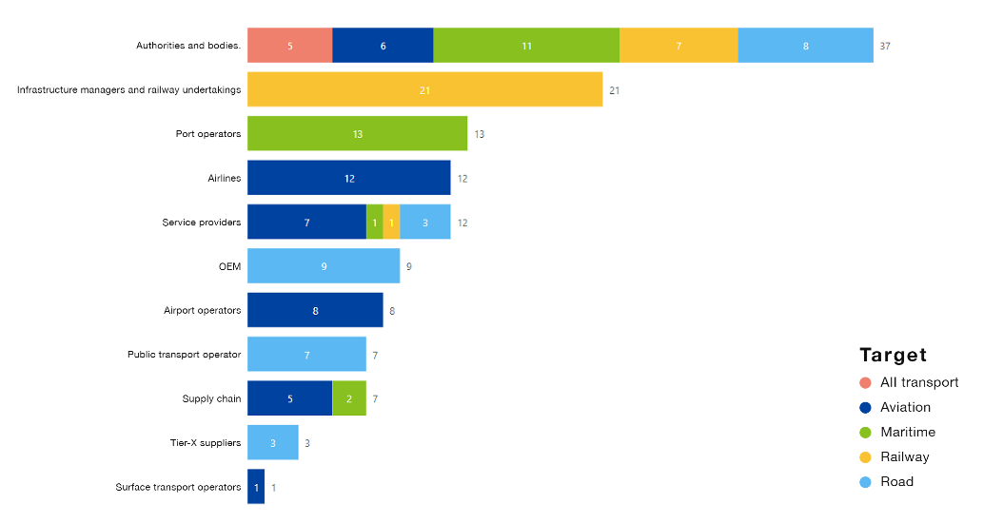
In 2021, Air India suffered a cyber-attack through a vulnerability in the SITA server, compromising the personal data of over 4.5 million passengers. The breach exposed sensitive information, including names, contact details, passport numbers, and flight data, but payment information remained unaffected. The attackers had access to the data from August 2011 to February 2021, going undetected for years. Air India notified the public months later, raising concerns about its response. In response, the airline focused on enhancing third-party security, encryption, and incident detection measures to prevent future breaches.

Attack Overview:
- Breach Discovery: In 2020, Turkish Airlines disclosed that it had suffered a cyber-attack, though the exact details were not fully disclosed to the public.
- Attack Type: The attack was believed to be a data breach involving the theft of customer data from the airline’s internal systems and possibly its websites.
- Compromised Data: Personal passenger information, including names, passport details, and flight data, were reported to have been accessed by the attackers.
- Attack Method: The attackers exploited a vulnerability in the airline’s IT systems to infiltrate sensitive databases and exfiltrate data.
- Delayed Public Disclosure: Turkish Airlines was criticized for its delayed public announcement and lack of transparency about the scale of the breach.

Mitigation Steps:
- Improved System Security: Implement stronger security measures, such as enhanced firewalls and intrusion detection systems, to prevent unauthorized access to sensitive data.
- Regular Vulnerability Assessments: Perform periodic security assessments and penetration tests to identify weaknesses and improve overall IT infrastructure security.
- Data Encryption: Encrypt all sensitive data, both in transit and at rest, to ensure it remains protected even in the event of a breach.
- Stronger Access Controls: Enforce stricter access control policies, including multi-factor authentication (MFA), to limit unauthorized access to internal systems.
- Faster Incident Response: Establish and test an incident response plan to ensure a quicker and more effective response to potential cyber incidents, including immediate public disclosure.

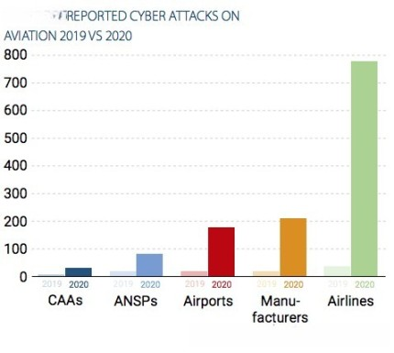

In 2020, Turkish Airlines experienced a cyber-attack that targeted its internal systems, leading to the potential theft of customer data. Personal information, including names, passport details, and flight data, was compromised by exploiting a system vulnerability. The airline faced criticism for the delayed public disclosure and lack of transparency regarding the breach’s scale. The attack highlighted weaknesses in the airline’s cybersecurity protocols and incident response. Turkish Airlines has since focused on improving security measures, including encryption, access controls, and faster incident response processes.

- Comprehensive Cybersecurity Frameworks: Establish frameworks like ISO/IEC 27001 and NIST to manage cyber risks in aviation operations.
- Advanced Threat Detection Technologies: Use machine learning and AI for real-time anomaly detection to identify cyber threats.
- Micro segmentation: Divide networks into smaller segments to isolate critical systems and reduce attack surfaces.
- Identity and Access Management (IAM): Implement IAM with multi-factor authentication (MFA) to restrict unauthorized access to sensitive systems.
- End-to-End Encryption: Protect data in transit and at rest with encryption to safeguard communication between aircraft and ground control.
- Regular Risk Assessments: Conduct assessments to identify vulnerabilities in critical systems and develop targeted risk management strategies.
- Incident Response Planning: Develop and test incident response plans to improve readiness for potential cyber-attacks.
- Cloud Security Measures: Ensure robust cloud security through encryption, access controls, and regular security audits.
- Employee Training Programs: Continuously educate employees about cybersecurity threats, including phishing attacks.
- Collaboration with Regulatory Bodies: Work with ICAO, EASA, and other bodies to stay informed about cybersecurity best practices and regulations.
These technologies and projects strengthen cybersecurity in aviation, improving resilience against evolving cyber threats.

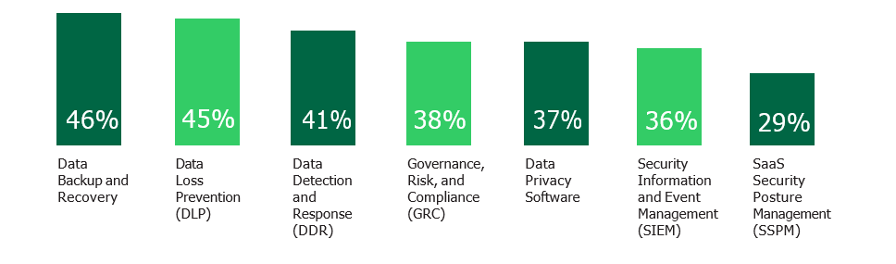

To enhance cybersecurity in aviation, it's crucial to implement frameworks like ISO/IEC 27001, leverage AI for threat detection, and adopt micro segmentation to reduce attack surfaces. Strong identity and access management, along with end-to-end encryption, protects sensitive data. Regular risk assessments and incident response planning help improve readiness. Cloud security measures and employee training are essential for safeguarding operations. Collaboration with regulatory bodies ensures compliance with cybersecurity standards and best practices.

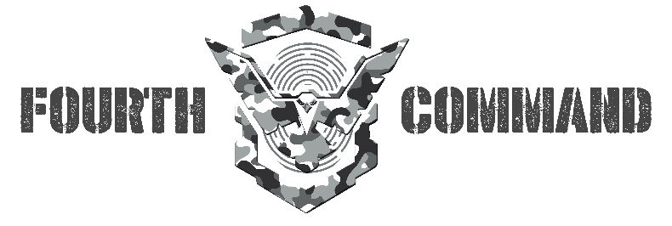


Fourth Command is a next generation Cyber Defence Consultancy, embracing cutting edge technology, modern tools and industry's best practices to provide businesses with highly tailored cyber security and risk management solutions empowering them to create a robust, secure, and trustworthy digital footprint: thereby inspiring a brand their customers can trust.
We are fully committed and driven to bringing solutions that our clients need, to meet or even exceed their business objectives. We work with companies in every sector to protect them from cyber-attacks.
Today, Cyber Defense has become the FOURTH COMMAND for every nation, enterprise and for its people.

Contact:
ANSHUL PAREEK
FOUNDER, CTO
FOURTH COMMAND
a.pareek@thefourthcommand.com

