Advancements in Electrolysis Technologies: Exploring the Potential of Oxyhydrogen as a Clean Energy Source
Graphical Abstract:

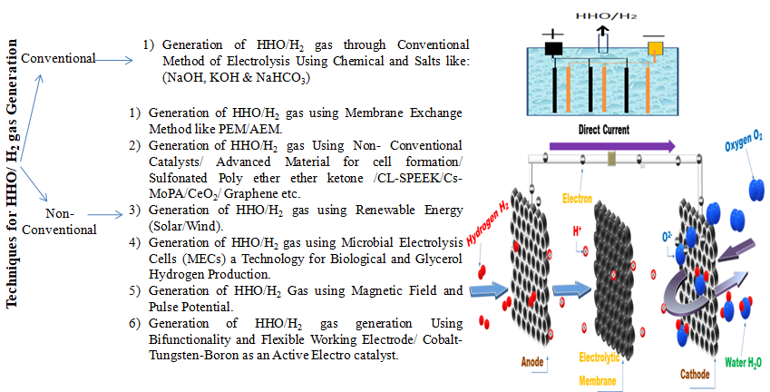
Abstract: This review paper provides a comprehensive analysis of the latest electrolysis techniques for producing HHO and H₂ gas. It highlights key electrolysis techniques, including alkaline water electrolysis (AWE), proton exchange membrane electrolysis (PEM), and microbial electrolysis cells (MEC), focusing on their efficiencies, challenges, and applications in promoting sustainable energy solutions. The environmental benefits of utilizing HHO gas as an alternative fuel are discussed, particularly its role in reducing harmful emissions from internal combustion engines and enhancing overall energy efficiency. Recent innovations in catalyst development, especially the use of non-noble metal catalysts, are explored for their potential to improve electrolysis performance and lower production costs. The integration of renewable energy sources, particularly solar energy, is emphasized as a critical factor in establishing a sustainable hydrogen economy. The review concludes that while significant progress has been made, further optimization of electrolysis technologies is essential to meet the increasing energy demands sustainably. Future research should focus on cost reduction strategies, advanced electrolysis techniques, and the integration of artificial intelligence to enhance efficiency and output in HHO and H₂ gas production.
Keywords: Oxyhydrogen, Hydrogen Production, Electrolysis Techniques, Renewable Energy, Alkaline Water Electrolysis, Proton Exchange Membrane, Microbial Electrolysis Cells, Sustainable Energy.

