BOOK ABOUT PRACTICE

My earliest memories of music go back to when I was three or four years old, at my parents’ house in Nanuque, Brazil. I remember listening to a vinyl record titled Turma do Balão Mágico, a children’s band with songs about balloons, teddy bears, friendship, and even a child with a runny nose. Around that time, someone snapped a photo of me holding my dad’s guitar—the same guitar that would later become my first instrument. By the time I was seven or eight, I was already singing. I vividly recall performing songs by a country music duo while my dad accompanied me on that same guitar. I sang for my entire family, and the excitement of their claps and cheers was unforgettable. That’s where it all begins.
Today, I’m 33 years old, married, and a father. My life is music. I hold two degrees in music performance, with guitar as my primary focus. My specialties are classical guitar and Brazilian Bossa Nova—genres in which I believe I perform well. My work revolves around music: teaching elementary music from 9 to 5, working as an adjunct instructor at two colleges, giving private lessons, playing gigs of all kinds—if you have a budget, I’m your guy—and, most importantly, practicing. Looking back, I see that everything started with practice. From when I picked up the guitar in fourth grade to now, practicing has been the core of my journey. Of course, my understanding of practice has evolved over time. Great teachers, mentors, and personal experiences have taught me how to practice effectively and how to grow as a musician.
Sometimes, I wish I had known back then what I know now, and I suspect that five or ten years from now, I’ll look back on this book and realize how much I still had to learn. That’s the beauty of music: it’s a lifelong journey.
While much of this book is rooted in my experiences as a guitarist, it also reflects the broader realities of being a professional musician. Whether you play guitar, sing, or compose, there are lessons here about navigating a career in music—how to manage time, connect with audiences, and balance the creative with the practical. These are skills that transcend the instrument and speak to the essence of being a musician.
This book is a guide for anyone who wants to play the guitar—or any instrument. It’s about practicing effectively and turning small goals into masterpieces. It’s not the absolute truth or the only way to do things. Instead, it’s a collection of lessons learned from teachers, colleagues, and countless hours spent on stage and in the practice room.
Let’s begin.

CHAPTER 1:
THE DAILY ROUTINE

The process of improving on the instrument may be my favorite part of being a musician. This is where the hard work, discipline, and small victories that lead to bigger accomplishments come into play. During the 2011-2012 school year, when I was a sophomore at Clarke University, I had the chance to prepare a solo recital with a mix of old and new repertoire. Preparing for this recital forced me to become more aware of my daily routine. It meant making choices, like deciding whether to take a nap on a Saturday afternoon or spend a few hours in the practice room. I had to be smart about scheduling practice around work, school duties, exercise, and sleep. Creating a practice schedule was crucial for making progress.It’s simple: I need to learn and improve on the instrument. How do I do that? Practice the guitar! When do I practice the guitar? What do I practice? The answer is clear: find the hours and make the time.
Creating a daily schedule will vary depending on your level of learning or what’s on the agenda—gigs, recitals, or other commitments. In a perfect world, I’d spend 30 to 45 minutes practicing technique. I wouldn’t practice the exact same technique drills or arpeggios every day; instead, I’d alternate every other day. Later, I’ll discuss how to organize technique practice and deal with the overwhelming amount of information available to musicians about practicing.
In addition to technique, I would spend one hour sight-reading new material. The older I get, the more I realize how important sight-reading and actually reading music are, especially for guitarists. After that, I’d move on to the repertoire I’m currently working on. This could include pieces ranging from easy to intermediate to challenging. During this part of my daily routine, I perform either for myself, my family upstairs, or—if I want a good challenge—for my iPhone’s recording app. This repertoire practice usually lasts about an hour. If you’re still with me, that’s roughly three hours of practice so far, and I’d say I’m only halfway through my “perfect” daily routine. For the rest of the day, I’d spend another hour and a half working on a new piece of music—something I’m trying to add to my repertoire or need to prepare by a specific deadline. Finally, I’d spend an hour arranging or composing a piece of music. By the end of the day, I’d have practiced for about five and a half hours. Multiply that by five weekdays, and that’s roughly 23 hours of practice per week. If I didn’t have a day job teaching general music at an elementary school, a three-year-old son, university duties, private students, and gigs to play, this would be my schedule every single day. Instead, my days are unbalanced. I might manage more than five hours of practice on a Tuesday but only two on a Friday. As a result, I have to make choices, stay organized, and carve out time to focus solely on the guitar. Remember: make your own time! In college, I often complained about not having enough time to practice, feeling that general classes and choir rehearsals were stealing time from the practice room. In graduate school, a professor joked that I should enjoy it because the final graduate recital might be the best I’d ever sound. He wasn’t wrong. In grad school, I had time to practice five or more hours a day. There were no general classes or choir performances to worry about—just my studio apartment, coffee, grilled cheese sandwiches, and the guitar.
But once you’re out of school and start working to make a living as a musician, things change again. During my first few years out of graduate school, I was focused on keeping a roof over my head, establishing myself as a musician in the community, and teaching. This required learning new skills, like how to develop a guitar teaching studio. Unfortunately, this shift caused me to lose the grip and discipline of a structured practice routine. I was playing plenty of gigs and staying in close touch with the instrument, but I wasn’t necessarily learning anything new or challenging myself. As rewarding as it was to play electric guitar in musicals or perform West Side Story with the Dubuque Symphony Orchestra, I wasn’t making progress in technique or playing the music I truly wanted to play. Don’t get me wrong—I love playing musicals, recording for other artists, and taking on various gigs. There’s a lot of value and learning in those experiences. They’re essential for growing your career and building connections. But they also impacted my daily routine and the time I had to focus on the things I truly needed to practice.

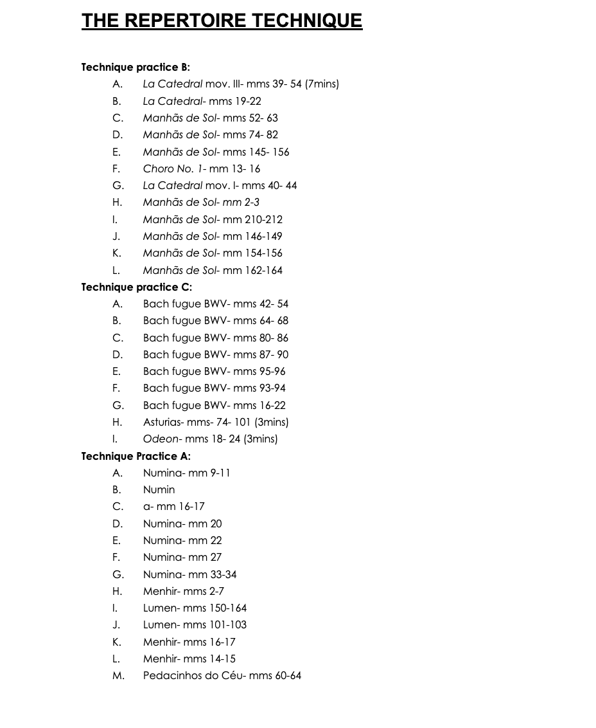

In the list above is the first part of my practice schedule. It includes pieces I’ve been playing for three to four years, as well as works that have been in my repertoire for over a decade. One thing I’ve noticed is that no matter how long you’ve had a piece in your fingers, there will always be passages that remain challenging and phrases that feel intimidating to play. If you don’t keep these spots in shape, they can cause problems during a performance. Think of it this way: are you afraid to play a C chord in front of an audience? Of course not! That’s because it’s easy, and if you play guitar regularly, you play a C chord all the time. So why not make those difficult passages feel as comfortable as playing a C chord? Through repetition, slow practice with a metronome, and what I call “manipulation” of the tempo—playing it fast, slow, off the beat, backwards, “underwater,” or in other imaginative ways—you can build the confidence needed to tackle challenging sections. However, the moment you decide these musical excerpts aren’t important anymore, they can quickly become problematic again.
The frequency with which I study repertoire techniques can vary depending on my schedule. If I don’t have a recital coming up, I’ll practice each repertoire technique twice per a week. And I always have a timer with me. The timer is one of my most important practice tools.
It’s easy to believe that running measures 39 through 54 of the last movement of La Catedral three times is enough, or to fool yourself into thinking you’ve spent a long time practicing them. But a timer reveals the exact amount of time you’ve spent on a task. It also helps you determine how much time a specific section or technique drill truly requires. Over time, you’ll learn exactly how many minutes—whether it’s five, seven, or ten—you need to dedicate to measures 39 through 54 of the Allegro Solemne to make your practice more efficient and productive.
As of today, I have three repertoire lists that I am working to maintain. Together, they amount to roughly 75 minutes of music that I feel comfortable performing for any audience—whether it’s a large-scale recital, a cocktail party, a church service, a wedding, or another event. I’ve divided the repertoire into three sets, and I aim to work through each set twice per week unless I need to pull pieces from different lists to create a larger program for a specific performance.
Each repertoire list includes a mix of difficulty levels: challenging pieces, easier ones, and those that fall somewhere in between. Additionally, every list features at least one piece that demands significant right-hand technique. For example, List A contains Recuerdos de La Alhambra, a piece renowned for its tremolo, while List C includes Asturias, which requires fast and precise right-hand execution. The idea is to avoid overworking your right hand within a single set.
Each piece in the repertoire has a metronome marking that I’ve determined is comfortable for both practice and performance. Some pieces, such as the Fugue BWV 1000, require being played through twice. Because of that, each repertoire list is intentionally designed to total less than one hour of music to allow flexibility and adaptability in performances.

SIGHT READING

This is an area where many guitarists struggle, myself included. I didn’t begin learning to read music until the end of high school, which, if you think about it, is like trying to fix an airplane while flying it. I’ll delve deeper into the importance of sight reading in other chapters, exploring its many benefits from different perspectives. However, since this chapter focuses on building a healthy daily practice routine, I’ll limit myself to saying this: sight reading helps guitarists react to the music rather than decode a phrase they’ve been studying for weeks.
When I choose a new piece of music to add to my repertoire, I typically read through each page a few times and then start making decisions, such as adding fingerings for both hands. I quickly identify challenging spots and make notes to practice them slowly with a metronome. At this point, I’m no longer truly sight reading; I’m decoding the music instead of fully reacting to it. Sight reading, by contrast, forces you to think on your feet and develop a deep familiarity with the fretboard. It also gives you greater control over tempo, which in turn allows for better control of melodic phrasing. If you’ve ever wondered how great musicians maintain control over a fast-moving piece without rushing, constant sight reading is one of the answers.
Sight reading also complements other aspects of your practice, such as decoding and integrating new repertoire. The more you sight read, the more patterns you’ll recognize, which helps you solve fingering challenges for both hands more efficiently. As a result, you’ll play with greater ease and confidence. If there’s one part of a daily practice routine I’d never skip, it’s sight reading new material every day.
So, how do you start? What should you sight read? The answer is: a little bit of everything! Here are some resources I’ve found invaluable:
• The Isaias Savio books: These are excellent for scale exercises of all kinds.
• The Henrique Pinto books: Similar in approach to Savio’s, but with more repertoire pieces included.
• Bach Invention duets: A fantastic way to familiarize yourself with the fretboard through single-note melodies.
• Progressive Sight-Reading for Guitar by Dr. Simon Powis: This modern resource is great for improving sight-reading skills. You can work on pieces with a partner or use a recording track to play one voice against the other.
• Solo Guitar One by Frederick Noah: Ideal for beginners and teachers, this book provides duet exercises that gradually increase in difficulty. It’s perfect for lessons and for building confidence in sight reading.
No matter your level, dedicate time each week to finding sight-reading material that challenges you without feeling overwhelming. And remember to take breaks—sight reading is a true mental workout. Ultimately, sight reading teaches us to react to the music, rather than decode what’s in front of us.

NEW REPERTOIRE AND THE REST

I’ll discuss how to build a repertoire list and study new pieces in greater detail in other chapters. However, spending an average of 1 to 2 hours studying a new piece is crucial for several reasons:
• Building a repertoire list.
• Avoiding boredom with your current repertoire.
• Constantly challenging yourself to find new ways to be expressive with your art.
You might find yourself learning multiple pieces in the same genre, and some may even sound similar to those you’re currently studying. Nevertheless, they are not the same, and each piece offers something new to learn. This is where understanding how to build a repertoire becomes important—but I’ll save that discussion for another chapter.

DAILY PRACTICE

What kind of technique practice should I do every day?Currently, I’m revisiting Villa-Lobos Etude No. 1 to improve agility and freedom in my right hand. In addition, I’ve been working through a set of mode scales I designed years ago, which I practice a few times a week. I also include slur exercises from Scott Tennant’s Pumping Nylon. I don’t do all the exercises every day; instead, I alternate between them throughout the week. Typically, I spend 30 to 45 minutes each day combining a few of these exercises. A month from now, I might switch to a different set, based on what I’ve observed in my playing and what I feel needs improvement.
For example, before revisiting Villa-Lobos Etude No. 1, I was practicing off-beat tremolo exercises inspired by a David Russell masterclass I watched on YouTube earlier this year. During my mode scale practice, I also vary my right-hand technique. Instead of always using i and m, I’ll alternate between all the fingers or sometimes practice scales exclusively with p.

ARRANGING AND COMPOSING

Arranging or composing a piece of music is a moment where you bring all your knowledge as a musician into creating something unique. While I don’t consider myself a composer, I love arranging music. I wouldn’t call myself a jazz musician either, but for the past 13 years, I’ve played in jazz duos with singers. One of these collaborations even led to recording my first album, Blu Flame Duo, with my dear friend and vocalist Brian Eiffes.
When arranging for duos, I try to keep things simple. In the words of Michael Scott from The Office: “Keep It Simple, Stupid.” I’m not selling paper, but I aim to recreate what a piano does so easily—melody and accompaniment at the same time. A piano has 10 fingers and 88 keys, while I’m limited to a few octaves and 7 or 8 fingers!
Here’s my process for arranging jazz standards:
1. Pick a jazz standard with a lead sheet.
2. Choose a key that’s friendly for both you and the singer, if possible. (Sometimes, arranging in keys like Ab or Db can be a great challenge.) Remember: KISS!
3. Standards with many chords and complex melodies are often easier to arrange. The material is already laid out, so there’s no need to create a complicated bass line to support the melody. Paradoxically, more complexity in the original material often means less effort on your part.
4. Once you have the framework, let your creativity take over.

I like to jump between octaves when possible. As Andrés Segovia once said, “The guitar is like a miniature orchestra.” To me, jumping between octaves and timbres feels like passing the melody from the flutes to the cellos, and then to the violins.There’s much more to arranging than these four steps, but the main rule is this: keep the melody and the bass going somehow. This could be through arpeggios, bass lines, chord substitutions, or other techniques. The more you practice arranging, the more natural the process will feel. Finally, don’t be afraid to skip the lead sheet and rely solely on your ears to arrange a piece. It’s a great exercise for ear training. While using a lead sheet speeds up the process, ear-based arranging develops skills that are just as valuable. As I’ll discuss in later chapters, delivering work quickly and efficiently is an essential part of building a career as a professional musician.

BE REALISTIC ABOUT YOUR GOALS

The 5-6 hours of practice is my ideal plan for a daily routine but it does not have to be yours. I am a professional musician who is not even a full time performer. What it has to be yours is a real plan of study that fits your schedule, goals and enjoyment for music. This became very clear to me, the moment that I became a teacher and started working with musicians from different ages, backgrounds, financial situations and level of interests. Listening to their playing and needs quickly helped me understand something that was outside of my realm: not everyone wants to be a professional musician. I have students that are taking lessons for their enjoyment of music, or because they want to keep their minds sharp. Other students take lessons but they only perform for themselves. Some students are taking lessons because their parents want them to take lessons and therefore, their level of commitment and excitement is not the same as a teenager that wants to major in guitar performance. At whatever level or reason why you are studying the guitar, you need to have realistic expectations of how much time you can put in each week. Some students do not put the 6 hours of practice between lessons that I try to put in every day. Others want to keep learning but enjoying the experience so they don’t want to spend a lot of time practicing technique. Some students are not willing to do any hard work but hope to be playing high level repertoire. I could go forever in providing examples from current and past students but the goal of this chapter is to help you establish a healthy practice routine that fits you. Therefore, step 1: how many hours per week can I practice? Step 2: Where would I like to be in 3-4 months? Step 3: What skills do I need to learn in order to achieve my goal? Step 4: Is the amount of hours that I am willing to practice enough? Step 5: How can I track my progress? Step 6: After each day, week or two weeks establish if I am actually doing what I set myself to do. Step 7: Constantly be problem solving the situation. Perhaps I need to spend more time practicing my scales and less time on arpeggios. These are simple questions that you need to ask yourself. For me this is similar to the idea of getting in shape or losing weight. Metabolisms are different and not everyone's the same but, you have to start somewhere and create realistic goals about your progress such as what you eat, sleep and how much time you can spend exercising.

THE PRACTICE THAT IS RIGHT FOR YOU

Beginner Level: I’ve been teaching students of all ages for over ten years, ranging from beginner guitarists to musicians aiming for professional careers. Over time, I’ve learned how much to ask of each student based on their individual goals. If you’re just starting on the guitar or as a musician, it’s likely because you enjoy listening to music and have developed a deep appreciation for the arts. This is an exciting yet challenging time because you want quick results. After all, in 2024, we live in a society that expects instant gratification for any project or task. As a teacher, my goal is to help the student quickly begin making music in the hopes that something magical will spark further interest and dedication to the craft.
The challenge lies in getting past the frustration period—obstacles like choosing the right guitar or simply learning how to make a note sound clear. Unlike the piano, where pressing a key produces a tone, the guitar demands physical effort. This can make the initial stages of learning intimidating. For example, nearly every household has a guitar, but in many cases, it’s because someone thought they could pick up a book or watch YouTube videos to teach themselves. Often, they didn’t learn how to hold the instrument properly or weren’t aware that steel strings make fingers hurt. This frustration often leads to the guitar being abandoned, left sitting in a corner, unplayed. So, how do you determine a healthy daily practice routine for a beginner? Here’s what I’ve found:
• Decide if you want to play instrumental music or strum and sing.
• To see real progress and overcome frustration, aim for 5-6 hours of practice per week.
• Attend your lessons—longer lessons can be especially helpful at the beginning.
• Learn proper technique and how to hold the guitar correctly.
• Consult your teacher about choosing the right guitar if you’re open to investing in a good instrument.
Learning how to hold the guitar properly is critical for beginner students. It’s the equivalent of learning how to shoot basketball hoops, swing a baseball bat, or hit a golf ball. Without this foundation, efficient playing won’t come easily, and progress will rely on luck. In the first 3-4 weeks, focus on exercises that build foundational skills, like the Spider Exercise found at the end of this book. Work on right-hand arpeggios, open strings, and the first 4-6 closed notes on the B and E strings. These basics will allow you to play simple melodies like “Ode to Joy,” giving you the satisfaction of making music early on. This process also strengthens finger independence and improves the left-hand arch and angle, essential skills for playing chords. Why do beginners need to practice more at the start? Think of it like weight loss: you work harder initially to achieve your goal, and then transition to maintenance. Similarly, beginners need consistent practice to build muscle memory, after which skills like playing a C chord or holding the guitar become second nature. Dedicated students often progress to intermediate levels after a year, seeking new challenges as they master the basics.
INTERMEDIATE LEVEL

Intermediate students typically know how to:
• Play basic chords and strum patterns.
• Perform ALL arpeggio sequences.
• Play bar chords and maintain proper left-hand positioning.
• Navigate the fretboard to find notes.
• Sing and play simultaneously.
• Produce clear, buzz-free tones.
• Read music up to the 8th fret.
• Play basic scales.
Reaching this level usually takes 1-2 years of disciplined practice, though it can happen faster with consistent effort. Students often start to specialize, focusing on specific areas like singing while playing or refining technical skills. For instance, when I started guitar, my primary goal was to sing while playing. Learning songs from the radio and tackling their challenges—like new chord voicings or strumming patterns—helped me build a strong chord vocabulary. By age 13 or 14, my focus shifted to technique as my voice changed.
At this level, practicing 7-8 hours per week is typical. Pushing to 10 hours signals a desire to move to advanced levels. The goal for an intermediate musician is to develop technique, efficiency, and musicality. This includes:
• Playing cleanly with mature left-hand fingering decisions.
• Increasing speed and sound projection.
• Executing simple skills with control and precision.

Control is the key. For example, a well-played song using a basic I-IV-V progression is far more enjoyable than a sloppy performance with complex chords and substitutions. The more control you have, the better your ideas translate to your audience.

Skills to add at this level:
• Mode scales (for speed, agility, and fretboard knowledge).
• Left-hand slurs (daily practice for strength and independence).
• Arpeggio sequences 7-12 (introducing melody and accompaniment).

ADVANCED LEVEL

If you’ve reached this level, your practice routine likely mirrors the one I described earlier. This may vary depending on your focus—for example, jazz musicians may prioritize improvisation. However, a combination of daily sight reading, maintaining repertoire, and exploring new material is essential. An average of 18-23 hours per week is necessary to maintain and refine a high level of performance skill. This is not the only method, but it’s a framework that has worked for me and my students. The goal at this stage is to refine your artistry and maintain consistent growth.

CHAPTER 2:
“Perfect Practice, Makes Perfect”

WHEN YOU KNOW BETTER, DO BETTER

When I began studying guitar at age 10, most of my time was spent practicing basic chords, strumming, and playing arpeggio sequences without worrying much about how I was doing them. My only goal was to switch between chords at a good speed and be able to sing and play at the same time. There were no footstools, sheet music, metronomes, or any of the tools I rely on in my daily practice today. Instead, I relied on hard work to figure out how to practice and discover what worked for me.
I can’t say exactly how many hours a day I spent practicing at age 10, but within a few months, I reached my initial goal: I could strum and sing through a few folk songs. Along the way, I made some important discoveries. For instance, when switching between chords on the left hand, it was crucial to start forming the new chord with the finger that went on top. For example, when transitioning from a G chord to a C chord, it helped to move finger “3” from the G on the 3rd fret of the first string to the C on the 3rd fret of the fifth string. This led me to think of the fretboard from top to bottom: 6th string to 1st string.
I also noticed that finding the “common denominator” between chords made transitions smoother. This meant identifying which finger could stay in place or slide to the next chord position. These observations and constant repetition helped me improve. Is this the only way to learn? No. Am I the only one to follow this concept? Absolutely not. But there was no book or teacher guiding me through these discoveries; they came through trial and error. However, there were things I didn’t know at the time that could have made my learning more efficient and saved me from developing bad habits:
• How to hold the instrument properly.
• The value of using a metronome.
• How to read music (I’ll discuss this more in later chapters).
• The importance of placing my left-hand fingers closer to the fret bar.

Did the lack of these tools stop me from playing? No! The practice I did on my own, along with guidance from a teacher with limited pedagogical knowledge, was still valuable in sparking my desire to learn. But this book is about the journey of practice. If I had known about those tools in my first year of playing, I could have avoided some bad habits that still affect me today. It’s important to note that I grew up in a rural Brazilian town more than 20 years ago, with limited access to higher education, cultural diversity, or resources like YouTube or fast internet.
Today, we live at the opposite extreme—there’s so much information available that it can be overwhelming to know where to start. It’s like opening Netflix after a long day of work: you have so many options that it’s hard to decide. Often, you end up rewatching something familiar because it’s easier than making a decision. The key takeaway is this: “Once you know better, do better.” When you learn a more efficient way to practice or discover a new tool, use it to your advantage.

PRACTICE VS. ENTERTAINMENT

The first time I heard the expression about the practice room being a sacred space was during my freshman year at Clarke University. In a studio class, one of the professors emphasized the sanctity of practice time and the difference between stepping out of your comfort zone and simply reinforcing your strengths. Almost any crucial skill begins in a place of discomfort. In other words, learning something unfamiliar is never easy. For guitarists, it might be the first time you learn to play a tremolo, use a footstool to hold the guitar properly, or explore chord voicings you’ve never encountered before. Later, in graduate school, Dr. Lausell shared a story about one of his teachers at the conservatory in Puerto Rico. The teacher scolded his students during a studio class, saying, “You cats sound too good in the practice room, and that’s not good.” True practice is not about showing off your skills or playing what you already know. Raw, honest practice is about vulnerability. It’s about confronting your fears. I’ve often found that the things I resisted practicing were the same things I didn’t want to discuss in lessons. They were reality checks—fears about my own abilities. The questions in my head would always start with:
• Am I capable of doing that?
• Can I play this loud?
• Am I good enough?
• What if someone hears me struggling?

At Clarke, the practice rooms were old—some say the Eliza Kelly building is the oldest education building in Iowa. The rooms had wooden doors, small windows, and thin walls. Since the arts building also connected to other departments like English, Math, and Science, students and faculty were constantly walking by, creating a double-edged sword: Do I let the entire school know I’m struggling, or do I try to let them think I’m a genius? For a time, the practice rooms became informal performance spaces for me. Occasionally, I’d work on a polished piece just to let others hear it, hoping for informal feedback during lunch. But as my practice habits matured, I came to understand the importance of facing my fears in the practice room—working on passages that exposed my weaknesses, confidence gaps, or lack of understanding. It’s okay to feel frustrated or even angry during practice. Last year, at the International Guitar Festival of Espírito Santo in Brazil, the renowned guitarist Fabio Zanon told me, “A bit of anger is welcomed during a performance.” That resonated with me because the same is true for practice. When tackling a challenging piece—especially one with complex rhythms—the frustration becomes part of the transformation. After days or weeks of struggle, the rewards are immense:
• Satisfaction from mastering a new tool.
• Strengthening skills you already possess.
• Learning how to learn.
• Willingness to listen to your teacher.
• Comfort in vulnerability.
• Hunger for more.
The ultimate goal of this chapter is to help you recognize that, like in life, we can always strive for better. Practicing what you already know is fine occasionally—it’s a good way to remind yourself how far you’ve come. But if you’re serious about improving as a musician, practice is your time to work efficiently and face your fears. You won’t forget what you already know. In fact, learning new skills only enhances your existing strengths. For example, once I became more aware of sound projection, tone, and challenging rhythms, I gained greater control when playing Bossa Nova. I stopped rushing the tempo and played solo passages with more clarity. Overcoming something difficult in the practice room is empowering. It shows you’re capable of learning new tools, no matter how challenging they seem. Most importantly, it fosters a deeper bond between teacher and student, as you learn to trust their guidance and embrace the journey of studying.

KEEP TRACK OF YOUR PROGRESS

The part that we did not discuss in the last section is that patience and perseverance is essential in order to practice what you don’t know and be vulnerable. Nevertheless, I’ve had many days that I felt discouraged, unmotivated and wanted to give up. I can’t say that those days don’t happen anymore and that from time to time the feeling of overwhelm takes place. In moments like this, it is important to do two things:

- Keep track of your progress
- Remember how far you’ve come

I’ve showed up to guitar lessons in college feeling prepared and leaving almost in tears. It was not because my teacher at the time did not like me, he just was real! Part of the reason I’d get upset was because I came into the lesson with a badge of honor that I had practiced many hours and was ready to showcase what I knew. Then, the things that usually happen in a performance also take place when you enter a room and is about to be evaluated:

- You forget how to play passages that were easy.
- The challenging parts you worked through the week, did not happen.
- Hands began to shake.
- What your teacher asked you to focus on, seemed to either be ignored or did not show results.

The bottom line was that I wasn’t truly prepared for the lesson—or so it felt to me. Even if I managed to do a few things correctly, the frustration of spending countless hours in the practice room without seeing significant results was deeply discouraging. It was during this time that I began to understand the power of organized practice. Part of the problem stemmed from something I’ve discussed earlier in this chapter: I was probably spending more time entertaining myself rather than genuinely practicing. Another issue was my approach to specific tasks—I lacked realistic goals. For example, when I was a junior in college, I had the illusion that I could perform Bach’s BWV 1000 fugue at full speed after just three or four weeks of practice. Looking back now, even with my current level of experience, I doubt I could achieve that in such a short timeframe, let alone at age 20.
In my rush to “master” the piece, I skipped over critical foundational work. I didn’t take the time to find the most efficient fingerings, practice the piece slowly, focus on my breathing, or experiment with the metronome at different beat patterns. I certainly didn’t prepare for the physical and mental stamina needed to perform it—like playing it while drinking tea or running a marathon. Instead, I dove in headfirst, ignoring what truly needed to be done during practice. It was as if I had a treasure map but was trying to claim the gold without digging for it. I blame this misstep on the excitement that comes when a piece of music speaks to you. I’d had my eye on this fugue for nearly a year before my teacher at the time, Dr. Miles McConnell, gave me the green light to start practicing it. Within one or two weeks, I began to hear glimpses of what the piece could sound like, and that became the real trap. I got swept up in the excitement of the idea and the little melodic lines I could already play. It’s a lot like hearing a new song you love on the radio. After a few listens, you start to hum or mumble along, but that doesn’t mean you truly know the song—let alone that you’re ready to perform it for an audience. Predictably, after four weeks of poorly planned practice, I completely tanked the performance of the fugue.

THE POWER OF TIMED PRACTICED

I began to question how much time I was really spending on challenging sections, like measures 42-54. In my mind, I thought I was spending hours each week on it, but in reality, it was only a few minutes. That’s when I started practicing with a timer.
Here’s how I approach it:
1.Block off specific sections of the music and assign practice times. For example, I might schedule 10 minutes per day on measures 42-54 for Tuesday’s practice.
2.Evaluate and adjust. If it goes well, I might note that the same section only needs 8 minutes on Wednesday.
3.Increase difficulty gradually. On Thursday, I might try playing the passage slightly faster with a metronome. If I notice that left-hand fingering choices are slowing me down, I’ll pause the timer (if I have extra time) to find a solution.
4.Allocate time for problem-solving. If I don’t have time to problem-solve that day, I’ll block 20 minutes the next day for the same section. The first half will be dedicated to finding more efficient ways to play the passage, and the second half will focus on regular practice with the timer. By the end of the week, my practice log might show that I’ve spent 1-2 hours on that specific section. More importantly, I’ll know I’ve been intentional and aware of what needed to be done.

Why is this important? If true practice is about being vulnerable, you’re not going to walk into a practice room and come out sounding like Julian Bream on the first day. However, with careful planning, observation, documentation, and a problem-solving mindset, you’ll begin to notice the progress you’re making. At first, things might not move as quickly as you’d like—and that’s okay! Progress doesn’t always come at the pace we expect. What matters is that you’re not held back by inefficiency or the illusion that you’re practicing effectively when you’re not. Instead, with an intentional approach, you’ll improve little by little each day. Like any skill we aim to master, some things will come more easily than others. Certain abilities take time to mature, and that’s part of the journey. The naked truth is this: eventually, you’ll discover what works best for you. Learning how you learn is one of the most important lessons in becoming a better musician. That’s partly what this book is about—helping you find an honest path to learning and growing as a musician.

HOW TO IMPROVE YOUR PIECE GRADUALLY

There are many steps involved in learning a challenging piece of music. However, I like to begin with three key steps:
1. Read the piece without any worries.
2. Make decisions on fingering for both hands.
3. Play it slowly and accurately using a metronome.

These steps may seem simple, but they are often overlooked—and that’s usually why progress stalls. Let’s revisit the concept that “Once you know better, you will do better” and apply it to how we approach a new piece of music.

READ THE PIECE WITHOUT ANY WORRIES

The first few times you read a brand-new score, don’t worry about fingerings or rhythm. This initial stage is your chance to get a feel for what’s happening under your fingers. Often, we’ve already listened to a piece before looking at the score, so it can be helpful to listen again while following along with the sheet music.
After 3-4 run-throughs, start making some notes:
• What seems to be the most challenging part to play?
• How would you like to interpret a certain section?
• Depending on the length of the piece, is there a better part to begin with?

Treat a piece of music like a research paper, a math equation, or a poem that needs to be decoded. Resist the urge to let yourself be carried away by how challenging—or how easy—a certain phrase or section might seem. Likewise, don’t let your passion for the piece overshadow the task of study and discovery. Approach it methodically, and let the process guide you.

MAKE DECISIONS FOR BOTH HANDS

The second stage of learning a piece—what I call the “drawing of the plans”—isn’t a strict formula, but it’s a critical step after the initial study of the piece. Deciding on fingering for specific passages is essential if you want to play them at a certain speed or phrase them in the way you desire.
Making decisions about fingering is also one of the first steps toward efficiency. To excel at anything in life, you need to approach it with focus, clear intent, and purposeful energy. One reason I love playing Bach is that his music often offers more than one solution to a technical problem, and both solutions can be correct—it all depends on what works best for you. Finger choices can also evolve. You might start with one plan and, after a few practice sessions, decide to make adjustments. Years later, as your understanding of technique grows, you may revisit the same passage and create an entirely new plan. The purpose here is not to impose strict rules about fingering but to emphasize one essential point: you need to have a plan!

PLAY IT SLOW, ACCURATELY USING THE METRONOME

If I had one catchphrase for this section, it would be: “Play at the speed of NO mistakes.” That said, let me be clear: the goal is to always practice slowly with accurate rhythm, not to practice slowly with questionable rhythm. It’s far more work to learn a piece at a fast speed riddled with rhythmic mistakes and then try to fix them later. Accurate rhythm is more important than speed. As Scott Tennant writes in Pumping Nylon, “Speed is a consequence, not a goal.”
Of course, certain pieces—like Asturias, Recuerdos de La Alhambra, or La Catedral—require speed to achieve their intended sound. But the journey to speed begins with slow, accurate, and efficient practice. Don’t forget the second step: making decisions about fingering. If you find yourself struggling to speed up, it’s worth revisiting those fingering choices. Poor fingerings can hold you back from achieving fluidity and precision. Mastering rhythm and learning to control it with a metronome is one of the most critical steps if you’re aiming for the following:
• Increasing your speed.
• Building performance stamina.
• Accurately communicating the composer’s intentions.
• Achieving total control of your movements.

If I could hang a neon sign with fireworks in my teaching studio, it would simply say: CONTROL! The more control you have over every aspect of your playing—sound, phrasing, rhythm—the better your musical ideas and emotions will translate to an audience. Too often, I see performers with brilliant ideas but lacking the control to express or execute them effectively. Control is the key factor in determining whether you’re ready to perform a piece of music. I’ll dive deeper into the importance of control and its relationship to rhythm in Chapter 3, “The Metronome.”

CHAPTER 3:
The Metronome

MY BEST FRIEND

I love soccer, and one of my favorite things about the game is analyzing its stats—how many goals or assists a player had in their career, the titles they won, the opponents they faced, and the significance of certain matches. Music, by contrast, is a sacred art, and it feels wrong to make it competitive by rating performers’ skills. However, competition in music does exist, and it plays an important role in career development. It keeps musicians motivated and, in some circles, is essential if you aspire to become a world-renowned artist. I came late into the game. Before college, my music reading skills were poor, I didn’t own a luthier-built instrument until my senior year of undergraduate studies, and, most importantly, I had no idea how many exceptional musicians were out there. During my first three years of college, I had a lot to catch up on, which brought insecurities, dreams, and unrealistic goals. At the time, all I wanted was to become a better musician and guitarist, gain some local recognition for my work, and maybe meet a nice girl. One of my dreams was to spend a full year dedicated entirely to guitar competitions and lessons, fully sponsored by my parents. I envisioned being surrounded by incredible musicians, focusing solely on practicing, sleeping, and studying guitar. In my mind, this would either lead to winning a competition or, at worst, improving significantly. Even if nothing else came of it, I figured I could secure a good scholarship to a graduate school afterward.
This dream never materialized. Instead, I auditioned at two schools and accepted a full-ride scholarship with a teaching assistant position at one of them. For someone who was still catching up, this was proof that my hard work as an undergraduate had paid off. At the time, I didn’t spend much energy researching who my teachers would be or what kind of education I’d receive. My focus was simple: work hard wherever I went, and graduate debt-free.
Why does all this matter in a chapter about the metronome? Because the metronome is like a ruler—it provides musical stats. It gives musicians tangible parameters for measuring their skills and a tool to help them improve.For instance, college jury sheets often include requirements like “play a diatonic major scale at 125 bpm.” Similarly, in some music competitions, speed can be a deciding factor, even if it’s at the expense of musicality. While I disagree that speed should ever outweigh the music itself, the metronome remains invaluable for providing structure and helping musicians develop a sense of pulse. Metronome markings in a piece are essential, especially when preparing for a performance with a large ensemble. These markings guide how fast or slow you need to play, ensuring that you’re in sync with the group. When I was 22, I was invited to perform Vivaldi’s Concerto RV 93 with the Dubuque Symphony Orchestra. I had only one 10-15 minute rehearsal with the orchestra on the day of the performance. Despite my limited experience in large ensembles, the gig went well, and we performed for a large audience at the arboretum in Dubuque. How did I pull it off? I relied on the metronome. I studied the metronome markings and conditioned myself to perform the piece at the required speed. I practiced until I felt comfortable with the tempo and had complete control over the movements. The metronome was my guide, providing the discipline and structure necessary to meet the demands of that performance.

CONTROL…CONTROL…CONTROL…

This book won’t go into the depths of developing a musical interpretation vocabulary, how to become more intimate with a certain genre, or how to be expressive—whether it’s smelling the flowers or the stinky fart across the room. While there’s a chapter about music listening and expanding your palate, my focus here is to describe how the metronome is an essential tool for gaining control over rhythm, sound, technique, and speed. With that control, you can make deliberate decisions about how something should sound based on precise execution.
I like to begin working with the metronome by setting it to the smallest rhythmic figure of a piece. For example, if the piece is in 3/4 and has many eighth-note phrases, I set the metronome to click on every eighth note. Start at a slow speed—40 bpm on the eighth note, if possible. After reading through the piece a few times (or over several days, depending on its complexity), gradually increase the speed. Once you reach 80 bpm on the eighth note, reset the metronome to 40 bpm, but now focus on the quarter note. At first, you’ll still be playing at the same speed as before, but you’ll quickly notice a new challenge. With fewer clicks, the metronome no longer provides the “cushion” of telling you exactly when to play. This forces you to think more deeply—not faster—about phrasing. Initially, it may even feel like you’re hearing a different melody. As you adjust to this new approach, begin increasing the speed of the quarter note as your confidence grows.
The next step is to reach 80-100 bpm on the quarter note or aim for the tempo you plan to use for performance, whether it’s 100-120 bpm or slower, depending on the piece’s marking. For most works in my repertoire, I have a specific metronome marking that I know allows me to play well. This marking is invaluable for maintaining repertoire and preparing for performances. If you’re aiming for even more control over the piece, manipulate the metronome to click even less frequently. For instance, shift from the quarter note to the half note, or set the metronome to click just once per measure. This increases the difficulty and forces you to phrase the piece with greater independence.
It’s an interesting progression: at first, you want as much structure as possible, setting the metronome to click on every eighth note. Later, you reduce the clicks, using the metronome only as a guide to check the pulse, while giving yourself more freedom to make phrasing decisions. By the time you reach this stage, the piece is truly on its way to being performance-ready.

IT NEVER LIES

Oftentimes, the patience and understanding required to let music mature can be overtaken by the rush to just get out there and play the damn thing! Sometimes, you might be ready, and the risk is worth taking. Nevertheless, stick to your plans—because the metronome never lies. Let’s think back to that performance I had with the Dubuque Symphony, which went well thanks to disciplined preparation. Now, fast forward to 2016 when I was working on the Villa-Lobos Guitar Concerto. This was the focus of my master’s thesis and my final year of graduate school. It’s my favorite guitar concerto and by far the most challenging work I’ve ever studied. The first movement is a beast. It begins with incredibly difficult passages: fast scales across the fingerboard, syncopated entrances, and a real test of controlling pulse and speed while maintaining clean technique. Unfortunately, my first rehearsals with my accompanist didn’t go well. I couldn’t think, couldn’t count, and couldn’t play much of anything. I was gasping for air and struggling to keep up. Those rehearsals forced me to remain grounded and constantly return to the metronome, inching up the speed slowly. At times, it felt like weightlifting:
1.Slow practice: Focus on form, stamina, and reading.
2.Push to fail: Practice at performance speed (or even above) with the goal of finishing, no matter what.
Slow practice reinforced my fingerings, helped me truly read the music, and forced me to stay focused during pauses. It’s more challenging to play something slowly than quickly. If you can play a piece fast after mastering it through slow practice, you gain total control—like becoming the pilot of the Millennium Falcon. But if you try to play fast without mastering it slowly, you’re letting Darth Vader and the dark side crash your Falcon into a rock on Tatooine. This concept mirrors weightlifting. In some workouts, you focus on form during the first set, but by the third set, your muscles are tired, and the goal shifts to “pushing to fail.” At that point, form takes a back seat, and it’s all about endurance. Your trainer might yell, “Give me one more!” Similarly, with music, practicing at performance speed or slightly faster—despite minor mistakes—trains your body to push through and build the endurance needed for the next “speed stage.” Slow practice forces us to concentrate. Fast practice forces us to remain calm when things go wrong. Have you ever noticed that when you’re on stage or performing for a teacher, you tend to play faster than usual? How many times have you or someone else said, “I played it perfectly at home” or “It didn’t sound like this this morning”?
The first thing I ask my students to do in such situations is to start again—this time slower. I remind them to breathe and keep their body relaxed. Nerves never lie; they get in the way, and the first thing they affect is speed. That’s why slow practice must be the priority, and practicing slightly faster helps you build the mental strength to handle those nerve-induced speed jumps during performances. By the way, it took me the entire semester to get the Villa-Lobos concerto performance-ready, and to be honest, this piece still gives me nightmares because of its complexity. Without the metronome, I would never have been able to make progress. I became a better musician when I realized that true practice doesn’t happen without the metronome.

CHAPTER 4:
Creating a Repertoire

PLAY WHAT YOU THINK IT’S BEAUTIFUL

I truly believe that everyone who decides to study, play, or even pursue music as a career does so because of some kind of passion. I grew up in Brazil listening to the classics of MPB (Música Popular Brasileira), Serestas, and my dad playing the guitar for us. Family gatherings wouldn’t have been the same without endless hours spent around the table with food, drinks, and lots of music. To this day, music is what brings us all together. Naturally, my passion for music grew from these experiences. In moments of uncertainty or pain, music provided comfort and inspiration. After moving to the U.S., I was amazed by the structure, skill levels, and career opportunities that music could offer. Unfortunately, growing up in rural Brazil, becoming a musician didn’t seem like a viable option. There were no jobs, no teachers, and no realistic way to make a living as a musician. As a result, I became even more focused on my studies and dedicated to growing as a guitarist, hoping to someday immerse myself in this career. The only problem? Once music becomes a job—a career you depend on—part of the magic is lost. The more you learn about the business and what it takes to make a living, the more you begin to separate the passion from the job. Think of it this way: I teach kids and college students, rehearse to accompany church services, help kids learn to jam, and prepare for recitals and professional recordings year-round. Oftentimes, I don’t get to choose the repertoire I work on. I’m surrounded by music all day. By the time I get in my car to drive, the last thing I want to do is listen to or analyze more music. And yet, there’s one aspect of my job that always reignites the spark: choosing repertoire for solo recitals and gigs. That’s what reminds me why what I do is special.
After finishing graduate school, I no longer felt the pressure to learn specific works just to open the next door. By that point, I’d explored many different genres, stepped out of my comfort zone, and developed a clear idea of what I wanted to play. Choosing repertoire became an exciting and personal process. Bach and Brazilian music quickly became favorites. I loved the thrill of playing a good choro, and there’s no better pastime than problem-solving a Bach fugue. Counterpoint is where my heart is! Eventually, I started prioritizing music I felt passionate about rather than what the industry suggested I should learn. Of course, over the years, I’ve performed other genres and kept a repertoire large enough to accommodate all types of venues. But choosing music that resonates with me remains one of the greatest joys of my career.

CHOOSE A REPERTOIRE TO HELP YOU GROW

An artist usually has preferences for what they enjoy playing and what they know sounds good. This comfort zone is often where a career begins. When I was 18 and starting college, Brazilian Bossa Nova was my comfort zone. I had Antonio Carlos Jobim’s entire catalog well-rehearsed, polished, and ready to perform for any audience. In my first semester of college, I was introduced to the works of Villa-Lobos, Matteo Carcassi, and Julio Sagreras. Studying Villa-Lobos Etude No. 1 helped me develop agility in my right hand, especially on the middle strings where the harmonies often lie. With Carcassi’s Etude No. 7, I encountered tremolo for the first time and learned to chase countermelodies woven into the middle part of the piece. These works were outside my comfort zone, but the challenges felt attainable. The result? My Bossa Nova skills became even stronger. Suddenly, I had more control over technique, rhythm, and pulse. It was an incredible feeling to practice at Villa-Lobos for an hour or two, then take a break and return to playing Luiz Bonfá’s Manhã de Carnaval. Honestly, I felt like Superman! Everything improved—tone, phrasing, speed, control. That’s when I realized that these new studies were making me a better musician. From then on, I was always open to new challenges, whether it was tackling a composer I’d never played before or exploring a period of music I hadn’t studied.
When I first studied the entire Bach BWV 1000 (a process that took more than a year), I began to understand the fretboard more deeply. I learned where every note was located, the unique sound each one offered, and the pros and cons of different fingering decisions. Years later, I participated in a baroque music festival. After the event, a piano colleague asked a memorable question at the bar: “Does anyone here actually enjoy baroque music?” The group’s response, despite having spent the day performing and discussing baroque composers, was somewhat humorous: “No, not really.”The colleague replied, “I understand. But if you want to truly learn how your instrument works, baroque music is the best way to do it.” That moment stuck with me because it was true. After studying multiple Bach works, I began to understand the guitar’s capabilities in ways I never had before. It was through Bach that I learned how to better coordinate my right and left hands and make more thoughtful fingering choices. During my second year of college, my teacher assigned me Asturias by Isaac Albéniz to prepare for my sophomore recital. At first, I felt overwhelmed—it’s a famous piece, it sounds impressive, and up to that point, I’d never had the ambition to tackle anything like it.
Working on Asturias pushed me to understand guitar technique at a new level. I had to focus on details I had previously overlooked: posture, sound projection, the positioning of my right hand, and how to properly angle my fingers to pluck each note. The piece demanded physical power, but the challenge was to perform it comfortably. I had to build stamina, muscles, and precision I didn’t have before. The metronome became an essential tool in helping me achieve the speed required for the piece. Learning Asturias felt like training for a marathon. Imagine someone who’s not a runner trying to prepare for a 5K. If they start too fast, they won’t be able to keep running for long. They need to find a sustainable pace, slowly increase speed, and pay attention to their form—how their feet hit the ground, their breathing, and whether they might need better shoes. Similarly, with Asturias, I had to approach it methodically, developing control over every detail while gradually increasing speed and endurance. That process taught me not just how to play the piece but also how to approach challenges with patience and discipline—skills that have stayed with me throughout my career.

FIND YOUR NICHE

Forget everything I’ve told you in this chapter and focus on making a living as a musician! After all, it’s money that keeps you in the business—and pays for those guitar strings. I was fortunate to spend over six years in deep study. During that time, I didn’t have much room for dating, traveling, or being social—especially in graduate school. I didn’t always get to choose my repertoire, and sometimes I bit off more than I could chew. Those years were full of firsts: my first solo recital, my first time playing in a pit orchestra, my first experience composing for ensembles, giving presentations, and traveling to study abroad. I was hungry to improve, earn respect for my craft, and see tangible signs that I could build a career in music. I didn’t have much time to make friends, chase girls, or sneak in a Netflix show here and there, but as my knowledge grew, so did my understanding of the sound I had to offer. This understanding came from audience feedback, the time it took me to learn certain works, and how naturally some repertoire fit me compared to others. It was a bit like joining a soccer club as a kid—trying out different positions until a coach finally said, “You have the speed of Roberto Carlos and the technical skills of Marcelo. You’re a left-winger.” Finding your niche as a musician works the same way. It requires exploring different repertoire, stepping far outside your comfort zone, and taking risks. But if you’re serious about making a career in music, there will come a time when you need to identify your best product. That doesn’t mean you can’t be adventurous or take on diverse gigs. For example, a few times a year, I’m hired to play electric guitar in pit orchestras for musicals. I love these gigs, and I usually get the call because I can read and learn the music quickly. It’s a combination of basic skills I’ve developed over time that allows me to branch into different areas of music. That said, I’m not an electric guitarist by trade. I have just enough knowledge to operate the instrument, recreate the sounds the ensemble needs, and, to put it bluntly, “bullshit with efficiency.”
If you look at my résumé, you’ll see a wide variety of gigs I’ve done. But if you look at my two recorded albums—the true samples of my best work—you won’t find electric guitar solos or interpretations of Fernando Sor’s Gran Solo. Instead, you’ll hear Brazilian music, my arrangements of Jobim’s Wave, and the Bach Fugue BWV 1000. The gigs that consistently help pay the bills are those where I’m hired to play Bossa Nova or write solo jazz guitar arrangements. These are the areas where I receive the most compliments and where the work comes naturally to me. This is my product. Most of these gigs require little practice—I can show up and deliver a competent, polished performance. Determine what makes you sound good, what feels natural to you, and how you can market that as your best sound. That’s the key to building a sustainable career in music.

PLAY DIFFERENT REPERTOIRE IN CONTRASTING STYLES

The last major recital season I had was in the spring of 2023 when I was invited to Brazil for one of the biggest guitar festivals in South America. The audience consisted of guitarists and scholars, making it a high-pressure environment. As I’m not a full-time college professor, the purpose of these festivals is to showcase the instrument, which meant I couldn’t just show up and play Brazilian choros and Bach. Instead, I created a repertoire spanning different styles of Brazilian music, from Villa-Lobos to Jobim, Garoto to Pixinguinha. However, a recital needs more than a collection of pieces; it requires a beginning, middle, and end. A story must be told. Audiences, especially those at academic festivals, are looking for variety, contrast, and different levels of interpretation. This was something instilled in us during my undergraduate studies. For my sophomore recital, 75% of the program was dedicated to Brazilian music. By my senior recital, only one piece was by a Brazilian composer. The program ranged from works composed in the 1600s to pieces by living composers. That’s how you grow as a musician—stepping outside your comfort zone and using new challenges to improve what you’re already good at.
For the FIVES recital in 2023, my program began with works by Andrew York, followed by Bach, Barrios, and ended with a piece by the Russian composer Nikita Koshkin. I also included my arrangement of the Brazilian early 19th-century popular song Ontem ao Luar. The set was a mix of Brazilian, Spanish, German, American, and Russian music, balancing physical playing challenges with repertoire complexity. Some pieces came naturally to me, as they’d been in my fingers for years. Others, like the Russian work, pushed me to focus on musical areas and showcase extended techniques for the guitar. Just as we discussed earlier in this chapter, exploring different repertoire helps guitarists become more aware of the instrument’s details, techniques, and capabilities. Performing pieces from contrasting styles not only expands your understanding of music literature but also connects audiences to a broader musical story. Contrasting pieces in a recital showcase everything the instrument can do, creating a program that feels complete and engaging. Playing music from different countries and styles prepares you for more professional opportunities. As much as I love Bossa Nova—and it may be my strongest product—there are only so many gigs each year where I can perform The Girl From Ipanema. Expanding your repertoire to include contrasting styles increases your portfolio, keeping your gig calendar busy and your career diverse.

CHAPTER 5:
Maintaining a Repertoire

CREATING A REPERTOIRE TROUBLE SPOT

The DREAM is to make even the most challenging sections of a piece feel as effortless as playing a simple C chord. The DREAM is to be in the middle of a performance and never have that nagging thought in the back of your mind: “That hard part is coming! It’s coming!” Any great performance, to be successful, must aim for these goals. The reality, however, is that challenging repertoire—and honestly, any repertoire—needs time to mature. No matter how hard you practice, those tough sections will never feel truly “easy.” They’ll get more manageable, but they’ll always require attention. That’s why, in my daily practice schedule, I include a dedicated “trouble spot” practice session for every piece in my repertoire. Some of these works have been part of my life for years, while others are newer additions from recent concert seasons. Certain tricky spots will always remain challenging, and—whether I like it or not—they sometimes haunt my thoughts during a performance. To stay on top of them, I work on these sections at least once a week. I play through them slowly with a metronome, forcing myself to focus on precision and control. Sometimes, I’ll even reread the score as if I were seeing it for the first time. Additionally, I have recordings of myself playing these spots, which I use to analyze phrasing and refine my interpretation. If I stop practicing these trouble spots, the piece might get by for a while—but it’s as certain as monkeys loving bananas that the problems will come creeping back.

PRACTICE TECHNIQUE USING YOUR REPERTOIRE

This method is especially useful when you’re in a time crunch. If you have limited hours to practice but a mountain of repertoire to tackle, identify sections of your pieces that can double as technical exercises. For instance, take La Catedral by Barrios. Measures 39–54 in the last movement Allegro Soleme are a notoriously difficult spot. The melody moves quickly and delivers quite a punch! To navigate this section, I use a combination of arpeggios, slurs, and single-note melody phrases. The main challenge is maintaining stamina through the numerous slurs without rushing. On top of that, I aim for a clean, consistent tone that seamlessly blends the arpeggios and slurs. It’s no easy task, especially since this section follows a high-energy, fast-paced arpeggio theme that takes me all over the fretboard. Because of its difficulty, I like to start my day with this spot. I dedicate about 7–10 minutes daily to playing these measures slowly with a metronome. Sometimes I turn off the metronome and sing the melody as I play it on the guitar, which helps internalize the phrasing. Other times, I play the section before it to tire out my hands, testing whether I can still execute the passage cleanly when fatigued. My goal is to prepare for every possible scenario. That’s what great performers do! Even if they’re struggling, the listener won’t always notice. And if they do, it often comes across as an honest, vulnerable moment from the performer—and I like that! Incorporating this spot into my daily routine means I can occasionally substitute it for standalone slur practice. Approaching it outside the context of the full piece also allows me to focus on fundamentals like posture, breathing, and efficiency.

BALANCING YOUR REPERTOIRE

Until my late 20s, I hardly felt that fatigue or tiredness affected my playing—or at least that’s what I told myself. Nowadays, when I’m in the midst of a busy season of practicing or juggling gigs, I have to carefully consider what I’ll play. In a recital, creating tension and curating a thoughtful repertoire list is what keeps the audience engaged. However, crafting a program that includes Recuerdos de la Alhambra, Asturias, and La Catedral all in one set might be overkill. All three are iconic works for classical guitar. Recuerdos is fantastic for maintaining tremolo technique, but what shape will your right hand be in afterward? And if you do plan to perform all three in the same set, where do you place each piece? While the audience may love all three because of their brilliance, overloading the program with “big” pieces can make the experience less impactful. Sometimes, it’s better to perform only two out of the three or to spread them across different sets.
By the time I was a senior in college, my recital repertoire had become complex—some might say “too scholarly.” It was impressive, featuring concerto movements, complete Bach works, and harmonically challenging pieces that required mature ears to fully appreciate. At that stage, playing such repertoire was necessary. I was building a portfolio to audition for schools, secure scholarships, and enter competitions. Most of the work pushed me out of my comfort zone, and staying in shape to perform them all was grueling. Through this process, I realized that recital programs are all about balance. A good program includes a few challenging works to showcase your technical prowess, but also pieces that are simply beautiful. Playing something simple and doing it well goes a long way. It helps you connect with your entire audience, demonstrates humility, and saves your energy for the more demanding pieces. Never underestimate “easier” repertoire just because it sounds simple. Play it because you love it, and keep it in your rotation—it’s invaluable for last-minute gigs or lighter sets when you need to conserve energy.
One of the most profound lessons I learned about program balance came during the FIVES Guitar Festival in Vitoria in 2016. Gilson Antunes, a professor of classical guitar, was the spotlight performer on the third evening of the event. On the opening night, my former teacher and friend, Dr. Lausell, performed an extraordinary program: all of Bach’s BWV 996 and Ginastera’s Sonata for Guitar, Op. 47. About a third of the audience—those with deeper knowledge of classical guitar—rose to applaud his remarkable performance. The rest of the theater recognized it was impressive but lacked the musical maturity to fully appreciate it. On the second evening, it was my turn to perform. Just a week earlier, I had played the Villa-Lobos Concerto during my final master’s recital. I could reuse part of that repertoire, but without an accompanist, I couldn’t perform the concerto itself. I included some crowd favorites, particularly pieces beloved in Brazil, and closed with more complex works like Koshkin’s Usher Waltz, Op. 29 and Bach’s BWV 998. The balance paid off. The audience enjoyed the technically demanding pieces but fell in love with the more accessible works by Dilermando Reis and Paulinho Nogueira. That program allowed me to maintain my physical and mental stamina while connecting deeply with the audience.
As for Gilson Antunes, his recital was a masterclass in reading the room. After Dr. Lausell’s demanding program, Gilson apologized in advance, explaining he’d have to miss my recital to “study.” I later realized the real reason—he was reworking his entire program.
At his recital, I sat with my dad in the audience. If I’m a musician today, much of the credit belongs to him. However, my father is not a classical guitar aficionado, and Ginastera’s piece had left him bewildered. Gilson, sensing the need to engage the broader audience, made adjustments. He included a few classics by non-Brazilian composers but focused primarily on accessible Brazilian repertoire, like Sons dos Carrilhões and Abismo de Rosas. The result? Gilson received the warmest reception of the festival. My father was in tears. That performance taught me the importance of balance, preparation, and maintaining a flexible repertoire. Someday, I hope to be able to adapt my program on short notice with the same finesse—to have multiple options ready to go, ensuring a meaningful connection with any audience.

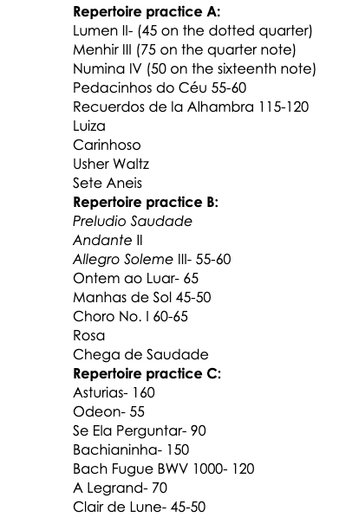

Above is my current repertoire list. Each set includes a mix of “heavy hitters” and easier pieces that are no less important. I aim to play through each set twice a week. Most, if not all, of the pieces have trouble spots that I’ve integrated into my daily routine.To keep things fresh and comprehensive, I alternate my focus. For example, I might play through Repertoire A while practicing all the trouble spots from Repertoire B on the same day. This way, in one form or another, I can revisit my entire repertoire—or at least the most challenging sections—daily. On the following day, I might practice Repertoire B and work on the trouble spots of Repertoire C. This approach is flexible and often adapts based on my notes and observations during practice. However, I’ve found it to be a highly effective way to stay connected to my repertoire while maintaining a balance between technical refinement and musicality.

ROTATING REPERTOIRE

In addition to building a repertoire list, the pace at which you can practice and learn new material often varies. I miss the days of graduate school when most of my time was devoted to practicing. Each semester, I’d learn 40–45 minutes of new music. Some of that repertoire has stayed with me to this day, but much of it—like the pieces I studied in undergrad—has fallen out of my fingers. If I decided to revisit some of that music, it would eventually come back, but it would take time. I wish I had done a better job maintaining some of those works, but life inevitably gets in the way. These days, I don’t have nearly as much time to practice. I typically learn 10–20 minutes of new repertoire each year, and I’ve become very selective about what makes it onto my list. That said, revisiting older repertoire with the goal of improving on past performances is always an option. Sometimes, despite your best efforts, a piece just doesn’t come together the way you hoped. In those cases, it’s perfectly fine to take a break from it and set it aside. Revisiting it later, after you’ve grown through other works, can offer a fresh perspective. Time and maturity have a remarkable way of reshaping how you approach a piece, often revealing new possibilities. It’s also crucial to maintain a rotating repertoire, consistently seeking something fresh—whether big or small—to keep yourself motivated.
These past few months, my primary project is completing and publishing this book, which has naturally limited my practice time. Even so, I already have ideas for new additions to my repertoire. As always, my choices are guided by what we’ve discussed: selecting pieces I find beautiful, identifying works that will enhance my technique, and filling gaps in my repertoire. For instance, during college and graduate school, I studied several Villa-Lobos works and even performed his concerto. However, the only piece by him currently in my repertoire is Choro No. 1. I have plenty of choros, waltzes, and bossa nova pieces, but if I were to prepare a program exclusively reflecting Brazilian music, I’d need a major Villa-Lobos work, like Etudes X, XI, or XII. Additionally, there are other subgenres of Brazilian music, such as baião and forró, which I’d like to explore further. Filling gaps in your repertoire while staying true to your values as a musician is a delicate but rewarding process. With experience, it’s become one of my favorite aspects of the job. It feels a bit like picking out a new outfit, buying furniture, or even choosing a new car—it’s personal, exciting, and deeply satisfying.

CHAPTER 6:
Getting Ready For A Recital

DEFINE A REPERTOIRE LIST

The first time I had the chance to prepare for a solo recital was in the fall of 2011, during my sophomore year of college—a pivotal time in my life and career. I was fortunate to have a new teacher, Dr. Miles McConnell, who played a significant role in shaping my development. It was the perfect combination: a mentor with a wealth of knowledge and a student hungry to learn. Miles pushed me to new levels in a short time, challenging my abilities, frustrating me, and inspiring me through his empathy and exceptional mentorship. In November of that year, my other mentor, Dr. Amy Dunker—my “momma” and the department chair at the time—greenlit a solo recital for the spring of 2012. With that, the preparation began!
Choosing a recital repertoire months in advance allows you to strike a balance between works you’re comfortable with and new material. A well-rounded program should balance challenge with familiarity. Attempting to learn an entirely new repertoire in just a few months is risky; it’s better to include 25–35% new pieces, perform them well, and draw the rest from works that are already solid or near-ready. The goal is to exude confidence in your performance, as this helps you communicate effectively with the audience. That said, including 1–2 pieces that showcase vulnerability is equally valuable—it reminds the audience that you’re human. For me, vulnerability is part of the recital journey, and it’s in those moments of struggle that growth happens—even on stage. I’m far from a John Williams or David Russell, two of the most flawless performers I’ve ever heard. But I’ve learned that a bit of imperfection makes the journey exciting, and a recital is more about the journey than the applause or the hour spent on stage.
The sooner you choose your repertoire, the more time you’ll have to prepare effectively, incorporating techniques like those discussed in earlier chapters: time management, metronome practice, taking notes, and breaking down trouble spots.There are also different types of recitals and audiences to consider, but these are a few general rules I follow when planning a repertoire list:

1. Start with something EASY. Begin with a piece you know inside and out—something that feels effortless to play. It might not be “easy” in the grand scheme of repertoire, but it should be familiar and comfortable. This helps calm your nerves and sets the tone for the recital. I usually start with a piece that has been in my fingers for at least 2–3 years.

2. Pay attention to style, period, and key. Guitarists often gravitate toward certain keys like C, G, D, F, and A. For example, half my repertoire seems to be in G major! To avoid monotony, I aim to vary the keys throughout the program. Similarly, while academic recitals often follow a historical progression—Renaissance, Baroque, Classical, Romantic, 20th century—you don’t always need to adhere strictly to this format, especially in less formal settings.

3. Place challenging, newer works in the first half. The first half of a recital is a good place for pieces that are newer or outside your comfort zone. You’ll still be fresh and focused, making it easier to navigate vulnerable moments. If something goes wrong (and it might), you’ll have time to recover. Remember: beginnings and endings are the most important parts of a recital.

4. Be mindful of physically demanding pieces. Avoid programming too many demanding pieces back-to-back. Even seasoned guitarists understand the importance of balance. When I first added La Catedral to my repertoire, I made the mistake of using it as a closer. While it’s a fantastic piece for ending a recital, its physical demands left me struggling with concentration and energy by the final movement. I’ve since found that La Catedral works better in the middle of a program, when I still have the stamina to do it justice. The last piece should leave a lasting impression—not drain you entirely.

5. End with a punch! The final piece should combine confidence, excitement, and impact. For singers, especially in popular music, this might be a well-known piece the audience can sing along to. For guitarists, the “punch” comes from a work that highlights your strengths and showcases the instrument. Choose a challenging piece that demonstrates your skill, with just enough vulnerability to be engaging—but avoid programming a piece you can “only kind of play.” Close with something that leaves the audience thinking, Wow, that was incredible!

CREATE A TEST DRIVE

There are different levels of performance, challenges, and audiences. Depending on the significance of your goal, it’s crucial to go through trials leading up to the big day. It all starts with practicing a few recital runs on your own.When I was in graduate school, I had a tradition: a few nights before a major performance, I would dress up in a suit, set up a camera, and run through my program as if it were a real recital. Later, I’d watch the recording and analyze what went well and what needed improvement. Wearing performance attire and knowing I was being recorded shifted my level of concentration. Mistakes I hadn’t noticed before became obvious, the suit sometimes felt awkward, and the sound wasn’t always what I wanted. These small revelations helped me feel more prepared for the actual performance day.
Whenever I’m invited to perform at a festival, conference, or event that feels like both an honor and a challenge, I schedule a few “trial” recitals at the institution where I teach. Playing at Janse Hall at Clarke College, for example, always brings back memories and allows me to gauge my progress. These trial performances can feel intimidating, but having played there countless times, I know the space well. Even if I’m nervous, it’s a familiar environment, and that helps.Interestingly, playing for an audience that knows you—peers, colleagues, or students—can feel scarier than performing for strangers. Your peers have expectations of you, and you don’t want to let them down. At the same time, they’re people you trust, so I’ve always valued their insights. After a trial recital, I love asking former teachers or students for their honest feedback. Their perspective often highlights details I might have overlooked. Trial performances don’t have to be elaborate. They can be for one person or 150. The key is to perform as much as possible—it’s the only way to get better. When I was an undergraduate, I’d often wait for people walking by the practice rooms and ask if they could listen to something I was working on. It didn’t matter who they were; I just needed someone to hear it.

BE REALISTIC

Never expect good results if you’re not fully prepared for a recital. In some subjects or tasks, you can cram the night before and still manage to deliver a decent presentation or pass a test. I’ve been there and done that. But music performance is entirely different. You will NOT learn a Bach fugue three days—or even a week—before a performance. There are no all-nighters or last-minute bursts of learning when it comes to something this demanding. Of course, this depends on the level of skill required. With enough experience, you may be able to glance at certain pieces minutes before walking on stage and still perform them well. The better you become as a musician, the easier it gets to showcase your musicianship and showmanship. But for something as significant as a recital, where the audience is there to hear your intentional artistry, pulling an “all-nighter” simply won’t cut it. In fact, preparing for something this big requires the opposite approach. I know a performance will go well if, three weeks before the recital, my sound begins to mature. By that point, test-drive performances are running smoothly. When I can control every aspect of the music, even under pressure or nerves, I know I’m in good shape. Checkboxes in my practice notes start getting ticked off, metronome markings are consistently met, and my sound projection and stamina feel solid. That’s how you become a dependable performer. Even with proper preparation, things may not go perfectly on the day of the recital. You might have an off day where things don’t sound as good as they did the week before—that happens. I can live with mistakes as long as I’ve taken the right journey of study and preparation. Growth happens through struggle. What I can’t accept is walking offstage feeling I could have prepared better. Respect the music and the journey it takes to get recital-ready. Respect the growth process and know your limits.
Understanding your limits is key. Sometimes, it’s better to pull the plug on a piece that isn’t ready. Especially for less experienced performers, delivery and outcome are everything. Walking onto the stage with a high chance of failure is not an option. The stage is a place to grow and be vulnerable, yes—but professional performers are there to deliver high-quality communication and artistry. I learned this the hard way during my second semester of graduate school, the only time I ever received a “B” in applied lessons. My mentor and friend, Dr. Lausell, insisted I perform the first movement of the Villa-Lobos Guitar Concerto. My mistake was waiting until halfway through the semester to start studying the piece. I had six weeks to prepare—plenty of time under normal circumstances—but the first movement of the Villa-Lobos Concerto remains one of the most challenging pieces I’ve ever tackled. At the same time, I was preparing Bach’s BWV 998 for recitals and juggling other gigs. My plate was too full. Realistically, there was no way I could have performed the concerto well by the semester jury. I didn’t want to risk failing in front of the string department at SIUC. My proposal was to perform the BWV 998 Allegro and an intermediate piece for the jury instead. After some back and forth, Dr. Lausell agreed but told me my grade would not be an “A.” Looking back, I’m not sure if he was trying to push me or teach me a lesson about priorities. Either way, I believe I made the right decision. Tanking at that jury could have crushed my confidence. Instead, I learned the importance of balancing ambition with realism. If I’m still thriving as a performer today, it’s because I’ve made good decisions about challenging myself while respecting my current abilities. Knowing your limits is just as important as being bold and courageous. It’s this balance that helps you grow and sustain your career as a musician.

BE WELL RESTED

A big recital is like a sporting event. If you did your work (no all nighters), don’t over do it. Enjoy the day of the performance. Study a bit but do something fun. I love food so on recital days, I try to eat a huge meal, take a big nap, and watch a movie. Perhaps go for a walk in the morning and only touch the guitar for the morning slow practice and the 1hr of slow warm ups and sound checks prior to the performance. If you did your job well during the journey of getting ready. The music is in your brain, ready to be played and I may say… you can feel slightly bored with the repertoire because you know it so well. Take care of small things such as programs, set up, clothes to wear, thank cards in advance so that your mind can be focused on rest and on the music. Nowadays, I like to do a little meditation for 10-15 mins before I go on stage. I put on my airpods with noise cancelling and listen to a short guided meditation. Find what works for you but remember, if you did your job…use the day of the recital to save your energy for the performance!

CHAPTER 7:
How To Prepare For A Lesson

GET RID OF THE JITTERS

Not everyone who takes private lessons dreams of becoming a professional musician, performing on stage, or sharing their knowledge outside of the lesson setting. This became clear to me early in my teaching career when I suddenly found myself working with students from diverse backgrounds, ages, and aspirations. Over more than a decade of teaching, I’ve learned to adapt to my students’ needs and become a better teacher. Still, there’s something inherently nerve-wracking about showing up to a lesson. I hear it almost weekly from my students: “I sounded so much better at home.” A guitar lesson can be uniquely challenging because it’s an intimate moment of focus. The teacher listens to every note, watches every movement, and evaluates progress to determine what will be most beneficial during their time together. For the student, all the insecurities from their practice sessions throughout the week seem to come back stronger in that setting. And then there’s the unspoken reality—they know they’re being judged. For me, lessons didn’t feel comfortable until the second semester of my junior year as an undergraduate. Before that, they were stressful and intimidating. By the time I was in my master’s program, lessons were my least favorite part of the week. I put enormous pressure on myself to perform well and leave with minimal corrections. To me, a long list of notes meant I hadn’t done my job. Too many suggestions felt like a failure in my practice routine. I’d often think, How could I be so stupid?
The worst part was that I’d sometimes walk into a lesson feeling confident, thinking I understood where I stood with a piece. I could even predict what my teacher might ask me to fix. But knowing what needs to be done and actually executing it are two very different things. I often felt like I just needed more time. After some lessons, I’d walk down the steps in tears, frustrated that I couldn’t achieve the correct sound, articulation, or speed. Those moments left me questioning if music was the right path for me. Doubts about the viability of a music career—those societal whispers that it’s “not a real job” or “impossible to make a living from”—would flood my mind.How does this get better? Consistency, planning, a willingness to be vulnerable, and understanding that the teacher is there to help were the key game-changers for me. During my junior year, I signed up for two-hour lessons each week. It was an investment, but the increased lesson time helped lessons feel less daunting. Hearing the same instructions more than once in a week reinforced my understanding and allowed me to anticipate what my teacher, Dr. Miles McConnell, might suggest. On lesson days, I made sure to dedicate at least an hour beforehand to warm up and review my material. After the lesson, I’d set specific goals for what I wanted to achieve by the next session. If, two days before the lesson, I realized I couldn’t meet my original goal, I’d adjust it to something more realistic. This strategy helped me feel more confident walking into lessons.Sometimes my teacher would challenge me, asking why I didn’t push further or complete everything he assigned. As a teacher now, I realize that this is part of the job—to push students beyond their comfort zones. At the time, though, it often left me feeling incompetent. In hindsight, I can see that my progress—while slower than my teachers may have wanted—was still progress.
Did these habits completely eliminate the jitters or guarantee that every lesson was productive? No. Unproductive or nerve-wracking lessons still happened occasionally, but they became far less frequent. These strategies gave me the tools to navigate lessons with more confidence and, ultimately, to grow as both a musician and a teacher.

TREAT THE LESSON LIKE A PERFORMANCE

Apply everything we’ve discussed so far about recital and performance preparation to your weekly lesson—just on a smaller scale. Think of the lesson as a mini-performance with its own set of goals. For example, if your goal is to study the first three pages of a Bach piece and play it at half speed by your next lesson, treat that as your performance. That is your focus, and that is what you can control right now. Celebrate the small goals, as they lead to bigger accomplishments over time.
The first 5–10 minutes of a lesson are crucial—not just for your morale but also for training yourself to become a confident performer. As we discussed earlier, the jitters of playing for a teacher who knows you're playing inside and out can be terrifying. In fact, it’s often easier to perform in a packed concert hall than in the intimate, quiet space of a lesson. To combat this, walk into your lesson grounded and focused on what you’re about to do. If possible, play for someone beforehand—anyone who will listen—or record yourself on your phone. There’s no shame in performing something slowly with the metronome if that’s where you are in your progress. What matters is executing it with absolute control.There’s that word again: control. In a lesson, control over your movements will carry you through, even when nerves kick in. Well-practiced movements become second nature, providing a solid foundation when the jitters arise.
I found that if I played my proposed goal well in the first 5–10 minutes of a lesson, the rest of the hour would go smoothly. A strong start not only sets the tone for the lesson but also proves that my week of practice was productive. When those first minutes go well, the teacher sees consistency in your work, and you gain confidence in your abilities.Even better, a strong start allows the teacher to feel more comfortable challenging you further. Over time, this dynamic helps you learn not just the music, but also how to approach the process of learning music effectively. That’s where the real growth happens—both as a musician and as a lifelong learner.

TREAT YOUR TEACHER LIKE A BOSS

Working in the world of music can be tricky because music is an art form. How does someone rate art? How can you objectively say one thing is better than another? Or that someone is more talented? At the highest levels of competition, like the final rounds of the GFA (Guitar Foundation of America), it often comes down to personal taste rather than raw skill. However, at the “earth” stage of being a musician, it’s usually more evident what constitutes “better” or “worse.” There’s a difference between talent and hard work, as with anything in life. Talent paired with hard work is a powerful combination and often leads to success. But hard work almost always surpasses natural talent alone.
If you’re an aspiring musician aiming to make a living as a performer, it’s essential to understand where you stand and respect your mentors. You don’t need to be a world-class performer to be a good teacher. In fact, some of the best teachers I’ve had weren’t the best performers. They were good, no doubt, but not Grammy nominees or international stars. What made them exceptional teachers was their understanding of the practice process—they had to work harder to get where they were, which gave them deeper insights into guiding others. Please note that this perspective is based on my personal experience, not absolute truth. This entire book, in fact, is not meant to be definitive—it’s my journey and what I’ve learned along the way.
Speaking of experience, do you know how I landed my first good gigs in college? By treating my teachers like they were my bosses. Oftentimes, I didn’t fully understand why they asked me to do certain things, but I gave my absolute best effort regardless.
I came into college with my parents’ support and my mother’s firm caution: “Are you sure you want to be a musician? How are you going to make money?” I loved music, but I also knew love alone wouldn’t be enough. I had to be competitive, earn respect for my craft, and meet deadlines. Playing mediocre in recital class was not an option. Not being chosen for solos or leaving the stage without impressing my professors was not an option. Fortunately, I was lucky to attend a small liberal arts college during a time when we had an incredible group of students. Though I was the only guitar major, I arrived with a significant responsibility: as a freshman, I received the largest music scholarship ever awarded at Clarke College. For a boy from rural Brazil, this was monumental. It meant I had to deliver, and the professors expected me to lead. Since I don’t like letting people down, and the stakes were high, I became “Johnny on the Spot.” Later, the school’s president even nicknamed me “the poster child.”
By treating my professors like managers at a professional institution, I earned their trust and respect. When real opportunities arose, they recommended me for the job. By the end of my freshman year, I had played in pit orchestras, funerals, solo and combined recitals, weddings, cocktail parties, and more. Now, think of this in simple terms: I have ten students in my guitar studio. Two of them are outstanding musicians. Student “A” is always on time, never loses their music, completes assignments between lessons, takes direction well, and shows initiative. Student “B” is naturally more talented but is less reliable. They occasionally miss lessons or show up unprepared, and they don’t go the extra mile. Initially, Student “B” was ahead, but over time, Student “A” worked harder and is now almost at the same skill level. One day, I got a call for a gig that I couldn't do, but one of my students could easily handle. Who do you think I’ll recommend? Without hesitation, Student “A.” They’ll also be the first to receive letters of recommendation and other professional opportunities. The takeaway? Respect your mentors. Treat your applied lesson teacher like a boss. Be on time, be prepared, and act professionally. Your effort and attitude matter just as much as your talent, if not more.

PROGRESS IS ALL THAT MATTERS

This is a small reminder: during a lesson, things can go wrong. When you tell your teacher, “I sounded a lot better at home,” they usually believe you! A good teacher is there to push you while adapting to your needs. They know when to be strict and when to offer support. An experienced teacher can tell whether you’re making progress and practicing as instructed. One of the strategies I use during lessons is to break down a passage when it’s played inconsistently or poorly. We dissect the passage and play it extremely slowly with a metronome. Once the student gains control and consistency, I gradually increase the tempo using the metronome while timing the process. When the student successfully plays the passage correctly 5–7 times in a row, I show them how long it actually took to fix the excerpt. Then I ask: “How did you practice during the week? Did you follow ALL the instructions from the last lesson?” The answers usually fall into one of three categories:
1. “I practiced, but not like that.”
2. “I practiced like you asked, but not every day.”
3. “I need to do what we just did more often.”

Here’s what I love about these responses: when students see the timer and realize that fixing the passage only took 5–10 minutes—what felt like an eternity—they start to grasp the power of efficient, organized practice (as discussed in previous chapters). This builds their awareness of how to practice effectively. I also understand and expect these patterns, particularly in the first year or two of lessons. Part of being a good teacher is teaching students how to learn and practice better. However, if these habits persist after two years, we need to reassess based on the student’s goals.

1. For aspiring professionals If you want to become a professional musician, this needs to change—yesterday. Professionals are expected to deliver on a deadline. Period.

2. For hobbyists If you’re taking lessons for enjoyment, the teacher should still be honest while understanding that your goals are different. Yes, boring drills at home are necessary, but you’re not trying to pay the bills by performing Asturias in a concert hall next week. There’s a balance to be struck, and the teacher and student should find that together.

Progress—no matter how small—is better than no progress at all. If you didn’t meet your proposed goal but still made some progress, learn to respect your own pace of learning. When the teacher’s expectations feel overwhelming, step back and look at how far you’ve come. A good teacher will remind you of where you were a few weeks ago versus where you are now.
A teacher’s job isn’t just to point out flaws but also to track and celebrate progress. This doesn’t mean lowering expectations or sugar-coating reality. I’m honest with my students, and if necessary, I’ll tell them when they’ve lost sight of their goals or aren’t making the most of their lessons—especially to parents of teenage students. But I also highlight what they’re doing well and the progress they’ve made. In my private studio, I’m proud to say that I keep students engaged for many years. On average, my students stay with me for 4–6 years, and I’ve had two students take lessons for 7 straight years, rarely missing a week. Why do they keep coming back? An hour-long lesson with me isn’t cheap. I can’t say for sure, but I believe it’s because of everything we’ve discussed in this book: effective teaching, honest feedback, motivation, and fostering growth.

CHAPTER 8:
What To Do After A Lesson

APPLY NOTES AND CHANGES ASAP

People often say that as you get older, it becomes harder to remember things. That might be true—my memory isn’t what it used to be, and even when I was younger, I missed details and notes from my teachers all the time. By the time I was a sophomore in college, I realized I needed to be much more careful with my notes. I even started audio recording my guitar lessons. While that might seem extreme, it was incredibly effective. The bottom line is this: the sooner you can pick up your guitar and begin applying the notes and feedback from your lesson, the more likely you are to remember and retain the information. If you let too much time pass, you risk forgetting key details.
In the summers of 2008 and 2009, I was back in Brazil, taking 2–3 guitar lessons per week with my old teacher. It was the first time I treated guitar not just as a hobby but as a serious commitment. I still couldn’t read music, but I had a solid understanding of theory and harmony. It was also the first time I made a conscious effort to follow my teacher’s instructions to the letter. If he had told me to wear an orange T-shirt because it would make me sound better, I would have done it without question. Most importantly, I left each lesson actively trying to remember every specific detail about how to play the pieces we worked on. Because there was no formal notation to rely on, attention to detail was even more critical. I believe this early focus on detail is why my muscle memory is so strong today—though, as we’ll discuss in later chapters, that’s both a blessing and a curse. If you wait more than 24 hours to review and apply the new fingerings, techniques, or notes your teacher gave you, chances are you’ll forget something. When that happens, it’s not just your memory at stake—it’s time and money wasted. Worse, if you practice incorrectly, you risk reinforcing bad habits or introducing mistakes in rhythm or technique. For aspiring professional musicians, showing up to a lesson with the same mistakes you had the week before, or failing to demonstrate progress on what your teacher pointed out, is a serious red flag.
Classical guitarists often play solo, which means you’re solely responsible for making magic happen on stage. That’s great, but if you play in an ensemble, band, or orchestra, you have other musicians depending on you. The longer it takes you to fix mistakes, the more it affects the entire group. Ensemble directors often expect musicians to adjust their playing on the spot or within one or two rehearsals. That’s why they’re paying someone with a degree—someone who can adapt quickly. If you can’t make those adjustments, you simply won’t get hired again. This is one reason I love playing electric guitar in musical pit orchestras. The pay isn’t great, but the experience is invaluable. It’s an opportunity to play in an ensemble, work on challenging (but manageable) music, and develop teamwork skills. Pit orchestras require flexibility, focus, and the ability to adapt—all of which start during and immediately after the lesson. The sooner you make adjustments based on your teacher’s directions, the more efficient and effective you’ll become as a musician. Whether you’re a soloist or a team player, the key to growth is in how quickly and accurately you respond to feedback.

ADAPT YOUR GOALS AFTER THE LESSON

Before a lesson, we often have a certain idea of how a piece is sounding and what needs to be done. That’s why I like to set predictions for when and how I’ll play my repertoire. Deadlines and goals are excellent for keeping practice organized and motivation high. However, it’s not uncommon to show up to a lesson, hear a flurry of feedback from your teacher, and leave feeling overwhelmed.
This has happened to me many times. It’s often a mixture of emotions: frustration because I’d been practicing something wrong for days, anxiety because I wasn’t sure I could play the way my teacher envisioned, and even a sense of loss—like someone had just robbed my savings.
But make no mistake: goals and plans can be adapted. You might feel discouraged after a lesson for any number of reasons. Sometimes, taking a step back is necessary. Put the music away, take a break, and return with a fresh perspective.This might seem contradictory to the advice earlier in this chapter about reviewing notes promptly. That’s where recording the lesson can be invaluable. Listening back allows you to process everything at your own pace. If possible, don’t let yourself get upset about the amount of feedback you receive. Instead, embrace it as a challenge. As a teacher, I often tell my students that if I’m giving them a lot of notes, it’s because I’m impressed with their progress and ready to push them further. That’s 100% true! When a student is struggling, I keep my feedback simple and concise—they may not be ready for more, or they might need encouragement to build their morale. This is where the teacher’s sensitivity to a student’s emotional state is crucial. At the end of the day, people have feelings and need to be understood. Remember: small progress is always better than no progress.
If you can review your teacher’s notes and suggestions within 24 hours of your lesson, start by creating a new plan. Adapt your goals as needed, and approach the feedback with an open mind—whether it’s a little or a lot.Looking back to my time as a full-time student, I realize the feedback I received, even when overwhelming, was always a reality check. Sometimes, the most frustrating notes were about things I already knew needed improvement but hadn’t addressed. Hearing these things from someone else can feel scary, even annoying, because it forces you to confront what you’ve been avoiding. That’s why attending lessons is so important—especially when you feel discouraged or afraid. A good teacher is like a coach: they’ll tell you what you need to hear, not just what you want to hear. They’re there to guide you toward your goals, even when the path feels challenging.

CHAPTER 9:
Memorizing vs Reading

WHY IS IT IMPORTANT TO DO BOTH?

The cliché joke about guitarists and pianists is true: How do you make a guitarist stop playing? Put a music score in front of them. How do you make a pianist stop playing? Take the score away. I’m not sure who came up with this, but it’s generally accurate. I only know one guitarist who started with classical guitar at a young age and went on to become a professional musician—my former teacher, Dr. Miles McConnell. He once told me he was spoiled as a child, playing on an Augustino Loprinzi guitar at age three. Most guitarists, however, start in informal settings, learning chords, playing by ear, and enjoying genres that don’t rely heavily on reading music. Historically, this makes sense: the guitar’s ancestor, the lute, was the instrument of troubadours, designed for storytelling and improvisation rather than strict adherence to written music. The guitar is portable, affordable, and approachable—but reading music for guitar is, to put it bluntly, freaking hard. Unlike the piano, the guitar’s fretboard is not linear, and most notes can be played in multiple positions. Notes we use constantly might appear in 3–4 different places. This complexity makes guitarists hesitant to embrace reading. That said, if you want to grow as a musician, learn to read music.

THE STRUGGLE OF NOT READING

Not being a strong reader early on probably cost me many opportunities. I didn’t seriously start learning to read music until my final year of high school. Before that, I relied heavily on my ear, my understanding of harmony, and my attention to musical cues. This worked well enough in jazz band, where knowing chord symbols and keeping up with the score were my primary responsibilities. I even made the top band and won a few awards, though one judge did note: “Rhythm section is great, but the guitar player is too loud.” However, my lack of reading held me back. I couldn’t play written solo excerpts well or fully understand how to improvise from the melody on the page. My technical skills were strong, but they weren’t tied to the written music.
In college, I relied on memorization. I would decode the score, practice until I had the piece memorized, and then set the score aside. This worked for shorter pieces and lighter repertoire. But over time, problems emerged. Small “compositions” would creep into my playing—unintentional changes in fingerings, rhythms, or notes. My teacher would ask me to start from the middle of a piece, but I couldn’t do it because my muscle memory required me to start from the beginning.
This inefficiency became a major obstacle. Scores provide shortcuts, revealing better fingerings or structural insights. Memorizing music solely by ear is like trying to learn a monologue through listening alone—it can be done, but it’s harder and risks losing essential details.Additionally, relying solely on memory limits your repertoire. It’s much faster to learn and maintain a broader range of pieces when you can play while reading.

THE POWER OF MEMORIZATION

That said, playing by memory has unique benefits. I call it absolute art. When you perform from memory, it’s just:
1. You
2. The instrument
3. The music
4. Your body
5. Your emotions

This combination creates a deep connection to the music. Without devoting part of your attention to a page, you can focus more on:
• Left-hand technique
• Posture
• Breathing between phrases
• Dynamics
• Relaxation

While these aspects can also be addressed when reading, playing from memory frees up mental space to refine them further.

BALANCING BOTH SKILLS

I admit I’m biased toward memorization because it has been central to my own approach. But I’ve also spent years improving my reading, and I see the value of mastering both. Many virtuoso guitarists excel at reading and performing from memory. What I’ve learned is that the more ways you learn a piece, the better the outcome. Reading the score gives you insights that muscle memory alone can’t provide. Even after you’ve memorized a piece, revisit the score regularly. It’s like running with a 20-pound weight—once you shed the extra load, your performance becomes faster and more efficient. Muscle memory is a powerful tool, but it’s not perfect. For shorter pieces, it might suffice, but for an hour-long recital, you’ll need more. Performing from memory is fine—even encouraged—but keep the score nearby during practice to reinforce your understanding.
Ultimately, reading and memorizing complement each other. Together, they allow you to deepen your connection to the music, expand your repertoire, and grow as a versatile musician.

PERFORMANCES WITH THE SCORE IS NOT SIGHT-READING

You can absolutely perform music while sight-reading. However, performing challenging recital music that you’ve been studying for a while with the score in front of you is NOT sight-reading—for obvious reasons. By the time you bring such a piece to the stage, the score should feel like an extension of your practice. When a piece isn’t overly difficult, and I’m confident that reading won’t compromise my ability to control my movements, I’ll sometimes perform with the music in front of me. There may even be specific excerpts where I rely more on watching my hands than the page. Make no mistake, though—if you choose to perform while reading, the score should already be deeply familiar to you. It should be full of notes, cues, and markings that you’ve reviewed daily in your practice sessions. The goal is for the score to support your performance, not distract from it.

FIRST AND FOREMOST, LEARN HOW TO READ

This has already been discussed, but it bears repeating: DO NOT. DO NOT. DO NOT try to learn or memorize a piece without truly learning how to read it first. Even if you can only read it slowly while playing faster without the music in front of you, the score is your key to understanding the piece fully.Think of the music score as the map to the treasure! The violinist Itzhak Perlman said it best: “If you practise slowly, you forget slowly. If you practise very quickly, maybe it will work for a day or two and then it will go away, because it has not been absorbed by your brain. It’s like putting a sponge in the water. If you let it stay there it retains a lot of water.” In addition to what Perlman so wisely said, the score is where you return when you begin to “forget slowly.” It provides clues, context, and a deeper understanding of the music. If you study a piece thoroughly, take detailed notes on the score, and then put the piece aside for a few years, all that information will still be there when you come back to it. Instead of starting from scratch, you’ll have a head start. The music score is your guide, your reference, and your safety net. Do not lose it. Do not ignore it. Just… don’t. Okay?

LOOK AT SCORE, THEN AT YOUR HAND & RIGHT BACK AT THE SCORE

That might be a long title, but it’s direct and to the point: don’t hesitate to play while reading the score in front of an audience—just know that certain passages may require more attention on your left hand. For instance, you might need to read measures 1–6, glance at your hands between measures 7–12, and return to the score at measure 13. Practicing this skill is just as important as learning the music itself. Beginner guitarists often struggle with this because they lose their place in the score once they glance at their hands. To prevent this, highlight your score, make notes, and practice alternating between looking at the page and your hands until it feels natural.
When performing with a music stand, always consider placement and height. Here are some tips:

1. Place the stand on your left side.Most guitarists tend to look at their left hand more, so placing the stand on your left side reduces the “ping pong” effect of glancing between the score and your hands. This setup keeps your movements more fluid and natural.
2. Avoid blocking the audience’s view.The audience wants to see your hands and your movements on the guitar—it’s part of the visual appeal of a performance. Many people find classical guitar more engaging when they can watch the intricate movements of your fingers across the fretboard. Blocking the audience’s view with a music stand also means you’re potentially blocking the sound. The sound hole of the guitar needs to project freely. Any barrier, such as a poorly placed music stand, can muffle the sound or affect its quality.

3. Keep the stand at eye level or below. The standard Manhasset music stands commonly found in concert halls and music schools are sturdy and reliable, but they’re not ideal for guitarists. They often can’t be lowered enough to avoid obstructing the audience’s view. Manhasset does make stands that can be adjusted to a lower height, and there are plenty of other options on the market. Look for a stand that allows you to adjust the height to meet your specific needs.

Performing with a score is perfectly fine, but it’s crucial to practice transitioning between reading and glancing at your hands where necessary. Thoughtful placement of your music stand is equally important—it should enhance, not detract from, the audience’s experience. Classical guitar is not just about the sound; it’s also a visual art form. I’ve had audience members tell me they might not listen to classical guitar recordings on their own, but seeing the intricate movements of my hands completely changed their perspective. They loved watching how my fingers moved across the fretboard, and it deepened their appreciation for the music. This feedback highlights an essential point: people hear with their eyes too. When the music stand blocks the audience’s view of your hands, you’re taking away part of that experience. Additionally, if the stand blocks the sound hole, it can diminish the sound quality, further affecting how the audience perceives the performance.
By positioning your stand at eye level or below, and slightly to the left, you ensure the audience can see your hands, hear your best sound, and enjoy the full artistry of your performance. When done thoughtfully, performing with a score can still create a powerful connection with your listeners.

SPECIFIC MUSIC SHOULD BE PLAYED ONLY BY MEMORY

If I started this section by saying that there’s “music” and then there’s “deep music,” you might think I’d had too much to drink or was speaking in riddles. It doesn’t seem to make much sense when written on a page. However, certain music can—and often should—be performed with the score in front of you, either as a guide or for full-on reading. But I believe there’s another type of repertoire: music that demands to be played from memory because it requires more than technical mastery—it demands a fusion of precise body movements, mental control, and emotional connection. This is what I call “deep music.” Composers like Villa-Lobos, Agustin Barrios, Nikita Koshkin, and Pixinguinha have written some of the most incredible melodies imaginable. Take Villa-Lobos’s Choro No. 1, for example. The left hand moves constantly, shifting positions with glissandos and challenging chord voicings. It’s a piece that, in my opinion, only a seasoned guitarist can perform without constantly looking at their left hand. I chose this piece because it was the first “big boy” work I learned entirely by reading the score slowly, and it didn’t take long to transport it from the practice room to the stage. Its complexity—syncopation, chord voicings, and intricate phrasing—demands the performer’s full attention, especially on their hands.

THE READER VS. THE MEMORIZER

Guitarists who aren’t strong readers often get frustrated when their advanced technique doesn’t translate to reading music. They may have the skill to play challenging pieces but struggle to comprehend even simple melodies on the page. On the flip side, some musicians rely entirely on reading and can only play what’s written, often missing the chance to internalize the music.
This contrast brings us back to the earlier joke about pianists and guitarists. Generally, pianists are strong readers; even if their technique isn’t exceptional, their reading ability allows them to tackle difficult music. Guitarists, however, often depend more on muscle memory and their ears, which has its own benefits. Memorizing music fosters a deeper understanding of technique because it forces you to constantly observe your movements. Guitarists who memorize often adapt technical concepts from books or teachers to their unique physical abilities. For example, they learn to apply general advice about posture, relaxation, and string attack in ways that work best for their bodies.

THE TEACHER’S ROLE AND STUDENT’S RESPONSIBILITY

As a teacher, I can guide students on issues like holding the instrument, improving sound projection, refining tone quality, right-hand attack, and relaxation. But my fingers, body shape, and height aren’t the same as theirs. Ultimately, it’s up to the student to take my guidance, use available resources, and adapt it to their own physicality. The process of learning and memorizing “deep music” inherently pushes students to observe their hands and movements closely. It forces them to problem-solve:
• How can I play this passage more efficiently?
• What’s causing tension in my body?
• What adjustments can I make to fix it?

Memorization doesn’t just help you connect with the music on an emotional level—it also encourages self-discovery and technical refinement. This combination of introspection and adaptation is one of the keys to mastering a truly challenging repertoire.

SING THE PIECE, VISUALIZE THE SCORE

One of my favorite movies to watch is Rush (2013), which tells the story of the intense rivalry between Formula 1 drivers James Hunt and Niki Lauda. There’s a scene I love where James Hunt, played by Chris Hemsworth, sits in the cockpit of his car with his eyes closed, mimicking certain movements. Later, he explains to his girlfriend that he was visualizing the racetrack where they would compete the next day—imagining every curve, the order of the turns, and the speed required at each moment of the lap. I found this fascinating and realized it’s something I could apply to my own practice. If 5–10 minutes of a guitar piece is like a lap, where are the moments you need to conserve energy? Where are the most challenging “curves”? What “speed” do you need at each section? How do you blend muscle memory with the score to ensure precision and expression?
It all ties back to what we’ve discussed before: the better you know the music, the easier it is to communicate and express it to your audience. For the past seven years, I’ve incorporated this visualization technique into my practice, especially with shorter pieces. I close my eyes, think of the score, and imagine the positions my fingers will need to take. I also visualize the energy required and even the sound I expect to produce. It’s almost funny: imagining music-making in complete silence. A good friend of mine from my master’s program once told me that he would visualize music while running, which is why he never listened to anything while exercising. At the time, I didn’t fully understand, but now I do.

SING THE MUSIC

Another important skill is being able to sing the piece you’re working on. For instrumentalists—especially those playing polyphonic instruments—this is invaluable. When faced with challenging rhythms, singing or speaking the rhythm can help you internalize it more effectively.
For instruments like the trumpet or violin, the primary responsibility in an ensemble is often carrying the melody. This makes sense because phrasing is the heart of their role. But as classical guitarists, our fingers are the ensemble. We manage the melody, the accompaniment, and often the counterpoint—all at once.This multitasking can cause the melody to get overshadowed by the other elements. To counteract this, learn to separate the melody from the accompaniment. Sing the melody of any piece you’re working on. If it’s Bach, congratulations—you’ve just performed brain surgery on yourself! The more you sing the melody without the guitar, the better you’ll be able to unify:
1. What’s on the page?
2. Muscle memory.
3. Your interpretation.
4. How you want the music to be delivered.

ACHIEVING TRUE ARTISTRY

When you can control and integrate all these skills, you move beyond simply playing the correct notes and rhythms. You control your body, understand the music deeply, and start creating absolute art. Enjoy the ride—that’s the essence of true artistry!

CHAPTER 10:
Respect the Mistake

I’VE NEVER HAD A FLAWLESS PERFORMANCE

Some people who have seen me play the guitar in recitals have said they thought I was a great performer. I once received a note from a classmate in college saying I was the best performer at the school. Compliments like these are deeply appreciated—they make the ego feel good, even make it explode a little. If you’re a serious musician, pride in your craft is natural. When you respect the music, study it honestly and diligently, and dedicate yourself to improvement, you develop a healthy ego. I’m not sure how it works for a banker or a lawyer, but for an athlete, the medal, high score, or championship is a symbol of a job well done. For selling-out musicians like Taylor Swift or Michael Jackson, success might mean press coverage, Grammy awards, or a ton of money. (I wouldn’t mind a ton of money either.) In the academic world, being a musician comes with some recognition—competitions, applause, and feedback from audiences. But at the end of the day, most of us perform because we love the journey, and we want to make meaningful music that earns respect. A healthy ego, in this sense, isn’t about making others feel small. It’s about standing by the importance and difficulty of what we do. If it were easy, everyone would be doing it.

THE MEANING OF A PERFORMANCE

A performance is the culmination of countless hours of work and sacrifice. It’s the finish line of a long journey. Being on stage means sharing what you’ve learned, but it also means being vulnerable.For some performers, it’s their entire livelihood. Others are so inspiring that people name their children after them. On a smaller scale, I also depend on performance—it’s part of my life. I’ve had seasons where my focus was entirely on performing. And I firmly believe that to be a good music teacher, you must also be a good performer and musician. That said, I’ve never had a flawless performance. No matter how prepared I’ve been, something always goes slightly off. As I’ve grown older and more experienced, I’ve made fewer mistakes, learned to cover them better, and figured out how to avoid certain issues on stage. Much of this is due to preparation—something we’ve discussed extensively in earlier chapters.The more prepared you are for a recital, gig, or recording, the easier it is to handle the unexpected. Professionals practice to the point where they can’t do it wrong anymore—or at least, they come close. But no matter how well you prepare, things will still go wrong.Nowadays, I’ve reached a level of skill where most people in the audience wouldn’t notice if something went wrong during a performance, whether it’s five minutes or an hour long. That’s the result of experience and high-level musicianship. Yet, it’s almost impossible to walk off stage without thinking of at least one thing you wish you’d done better. True artists are always seeking improvement, no matter how small the flaws.

STAYING GROUNDED DURING SIMPLE GIGS

One of my current gigs is assisting with mass services at Divine Word College. I meet with 2–3 cantors about an hour before the service to arrange the repertoire for guitar. My role is to play the melody and accompaniment while adapting to their tempo changes or cues. The music for these services isn’t very challenging, and that can sometimes be a problem. Because it’s easy, I can get distracted or even have too much fun with it. Over the years, I’ve learned to stay grounded, but sometimes my mind still plays tricks on me. When that happens, I might miss an obvious cue or fail to respect the simplicity of the music.

CONSISTENCY AND HABIT

Consistency and habit are the keys to becoming a better performer. The more you perform, the more confident you become. There have been periods in my career where I had a multiple gigs every week—playing jazz, classical guitar, leading church services, and subbing for musicals. The warm, nervous feeling in your belly never completely goes away, but with practice, you learn to manage it better. Don’t let fear or discouragement keep you from performing. If you want to improve, make performance a habit. Play for anyone willing to listen, and embrace every opportunity to grow.

THE BETTER YOU GET, THE EASIER IT GETS TO HIDE THE MISTAKES

Seasoned musicians learn to understand their limits and how to manage their body, feelings, and emotions on any given day. They also become adept chameleons, adjusting these factors for the stage. For example, if you’re well-rested, you might feel confident pushing the tempo a bit more. On days when you’re run down or over-practiced, your chops may not be as sharp, and it’s wise to take fewer risks, playing everything a little slower. These fluctuations happen to even the best performers—it’s all about finding equilibrium. As I mentioned earlier, with age and experience, I’ve become better at hiding mistakes. I believe this adaptability stems from my willingness to embrace all aspects of working with music. Lessons learned in one type of gig often transfer to another.
For instance, playing jazz taught me how to make a wrong note sound right if I played it convincingly enough times. Accompanying musical theater singers taught me that a fermata can feel like a gray area between a stop sign and a yield sign. Classical guitar recitals, however, remain the most challenging because the audience is silent, listening to every note. These performances demand 100% focus.
In contrast, transitioning to informal club gigs is like stepping into a different world. I can quickly spot when a singer makes a mistake, improvises a solo to cover it up, or skips a section of the song without warning. Over time, I’ve developed the ability to stay calm, adapt quickly, and not let mistakes rattle me. If a mistake is minor and unlikely to be noticed by the audience, I might even play it off as intentional—people hear with their eyes, after all. Confidence can convince the audience that you’re in control, even when you’re covering up an error.

RESPECT AND EMBRACE THE MISTAKE

Always respect and embrace mistakes. As discussed in the chapter on recital repertoire, I like to include a piece that still needs a few “test drives.” This is an open invitation for something to go wrong! Walking on stage with this piece, I’m aware of the risks, but that’s part of the journey. Mistakes are integral to the learning process, and the piece won’t improve unless you program it.
Respecting a mistake means reflecting on it after a performance. Where and when did it occur? What caused it? Begin the problem-solving process as soon as possible. This approach is similar to reviewing notes after a lesson, but this time, the stage is the teacher. Each performance provides insights into your skills and what it takes to deliver a piece successfully.

A RULE FOR MOVING ON

I used to get frustrated and angry about mistakes during performances—and sometimes I still do. But experience has taught me to follow a simple rule after every gig:
1. Did I do a good job preparing for this performance?
2. How much and how well did I practice?
3. What was the journey like?

If I can honestly say I gave my best effort, then I can’t let myself feel discouraged or frustrated. At the end of the day, you can only take from a performance what you put into it.
I’m a big believer in the laws of the universe: What comes around, goes around. Do good, and something good will come out of it. It might not happen immediately or in the way you expected, but in my experience, it always does.

PLAY HONEST MUSIC, YOU DON’t HAVE TO BE VIRTUOSO TO PERFORM

My wife often says I’m overly specific about things to the point of being a complicated person to live with. My response? I’m just “simply complicated.”Jokes aside, being a professional musician comes with significant responsibilities. You’re expected to play the correct solo, in tune, at the right tempo, volume, and phrasing—sometimes for hundreds of people. If you don’t, you risk letting down a lot of people. It’s like hitting the post during a soccer playoff game, except you might not get another chance to redeem yourself. For example, in musicals, your solo cues are critical. They help tell the story, guide actors’ movements, or cue them to deliver a line. What happens if you miss that cue or play it incorrectly? That’s why professional musicians place such a high value on precision and perfection—it’s often what the job demands. But here’s the catch: if you take perfection too literally, it can stop you from making art.

THE INFLUENCE OF RECORDINGS

When music recording became a thing over a century ago, the concept of “mistakes” in performance began to fade. After working on professional recordings myself, I’ve seen how easy it is to fix mistakes with edits—something you can’t do in live performance. That’s one reason I value live recordings so much: that’s the real thing. Studio recordings have their place too. They allow you to craft a polished, industrialized sound, which has value. Listening to artists like Segovia, Julian Bream, and David Russell taught me what kind of sound I needed to aspire to in this business.
But here’s where it gets tricky: when us mere mortals listen to these icons, it can be intimidating. We think, I can’t play that piece like them. If I try, I’ll make a fool of myself. The reality is, we have to be honest with ourselves and where we are as musicians. There are pieces I wouldn’t dare play or attempt to learn with a short deadline. But there are also pieces that may not sound like David Russell’s interpretation but sound pretty good in the hands of Marcus DeJesus. Maybe it’s slower, maybe it emphasizes different details, or maybe it lacks some of the nuance Russell would bring. And that’s okay! You have to take the skills you have in the moment and make music with them.

THE VALUE OF REAL-TIME MUSICIANSHIP

One thing I love about gigging with bands and accompanying singers is the rawness of it. Many of these gigs happen with little or no rehearsal because it’s not cost-effective to spend hours preparing for certain jobs. You have to be ready to apply your skills on the spot and be honest about what you can deliver. This is an invaluable experience for any musician. At every level, I think musicians should be tested like this—thrown into situations where they have to make music with what they have, flaws and all.

FEAR OF PERFORMING

Whatever level you’re at, don’t be afraid to perform. Don’t be afraid to explore different genres. And most importantly, learn to embrace mistakes. They’re part of the process, part of the music, and part of your growth. How do you get better at performing? Perform every week for a year and then come talk to me.

CHAPTER 11:
Trust Your Instincts

FOLLOW YOUR TEACHER BUT TRUST YOUR INSTINCTS

If it weren’t for my teachers, I wouldn’t be where I am today. Every mentor has served a different purpose in my career, and each has left a unique imprint. Dr. Amy Dunker was my first serious mentor, someone who not only believed in me but also gambled on my capacity to deliver.
Remember how I came to undergraduate studies with the single highest scholarship ever awarded to a music student at Clarke University? Amy was the chair of the department, and years later, she confided that she had to borrow money from the theater department to make it possible for me to attend. She was the one who made it all happen. To this day, Amy has become a sort of godmother to me. While I didn’t learn much from her about playing the guitar, I owe her a great deal for always helping me find job opportunities, challenging me to reach new levels of professionalism, and being there when I needed someone to vent to about the struggles of the job. Over the last 15 years, Amy has been one of the most important people in my life.
As for Dr. Miles McConnell, I owe him for teaching me patience, dedication, attention to detail, and the value of hard work. Miles is the person who truly taught me how to be a guitarist. Many of the lessons in this book come from my time working with him.
I’ll never forget the first Friday of the fall semester of my sophomore year back in 2011. It was the first time I felt truly happy in the United States. I was attending school for music, the work was challenging but rewarding, and for the first time, I felt like I belonged to a community that respected my efforts. I had just gotten a new guitar, a Cordoba C9. It was the year of firsts!
Every Friday at 3:00 p.m., we had studio class—a time for all music teachers and students to come together, perform, and receive critiques. Secretly, it was my favorite time of the week because I loved preparing something to showcase. Typically, no one expects performances from students on the first day of class, but during the summer, I had worked on Choro No. 1 by Villa-Lobos and couldn’t wait to play it for an audience.
The performance went really well, judging by the rave reviews I received from everyone. Being the only serious guitarist at Clarke had its advantages; I received all the praise and rarely faced arguments about technique or performance practices. But it also came with challenges—without competition, I didn’t have much to push me to improve.
After the applause died down, Miles raised his hand. Keep in mind, we’d only had one lesson earlier that day—our first face-to-face meeting. The first words out of his mouth? “If I had to judge your performance in a guitar audition or competition, I would have to fail you.”
Not exactly encouraging words, and definitely not what you’d expect to hear from someone you’d just met. He then came down to the stage and challenged aspects of my technique, interpretation, and more. He treated the studio class for what it was: a masterclass. Miles was perceptive enough to see exactly what I needed that year:
1. Structure.
2. Learning the rules.
3. How to avoid shortcuts.
4. Keeping my ego in check.
As the only guitarist at Clarke, I had no real competition. While I was dedicated, ambitious, and driven to improve, the lack of peers to measure myself against could have been my downfall. I’ve seen talented students lose their way because they realized too late that they had no one better than them to learn from. Some stagnate; others transfer to a different school. Would I have been a better musician if I’d had more competition? Perhaps. Who knows?
Working with Miles was challenging because, to the rest of the department, I was already seen as a “virtuoso,” which was far from the truth. I was passionate and hardworking, but I also enjoyed the constant compliments and the trust placed in me. Sometimes, that trust clouded my perception of reality. Lessons with Miles were a reality check—a way to learn how to become a true musician. Much of what I share in this book about technique, caring for your craft, and staying grounded comes directly or indirectly from him.

ALWAYS ASK THE REASON FOR THE ASSIGNMENT

As I’ve expressed in other chapters, trust your teachers! They are your bosses. It can be challenging to embrace their concepts unless you trust them—even when you don’t yet see the final outcome. As a teacher today, I try to make the reasons behind my lessons as clear as possible: why I expect certain attitudes, and what the intended outcome of their work will be. When I was a student, I often felt that teachers didn’t always explain the reasons behind their actions. It took me some time to start asking more questions and taking the initiative to understand concepts outside of the lesson. Even now, I occasionally find myself finally understanding the purpose of some of those lessons. That delayed clarity has taught me the importance of staying curious and proactive.
If you don’t ask why—or in some way learn how to take charge of your own learning—the main goal can easily be lost. As a teacher, I strive to meet students where they are. It’s essential if I want to keep my job! I also encourage my students to frequently reflect on their goals and evaluate whether the lessons are helping them meet those goals. I’m proud to say that I’ve retained the same students for a long time—something that wouldn’t happen unless their needs were consistently being met. Simply asking why a teacher is instructing you to place your right hand in a specific position or assigning you a particular piece can open the door to deeper understanding. Asking questions helps you develop a critical and analytical mind toward your craft. Remember, being a musician is, at its core, learning how to solve problems.

DEFINE WHAT WORKS FOR YOU

Hopefully, there will come a time when you’ve gained enough experience in music study, taken lessons from different teachers, and spent time reading and learning on your own to begin making decisions for yourself. This book is not the absolute truth! There’s more than one solution to most challenges in music. What you’ve read so far is a blend of lessons and insights from my teachers and mentors, combined with things I’ve learned on my own through experience. That said, there are certain lessons, tips, and methods my teachers suggested that didn’t work for me—not for lack of trying, but because they simply didn’t yield the results I needed. Over time, I learned to listen to their advice, respect their approaches, but ultimately make decisions based on what worked best for me.
It’s important to follow what your mentors are teaching for a considerable amount of time before you start making adjustments or forming your own methods. The reason is simple: having a solid foundation and something to compare with is invaluable. After years of study, you’ll hopefully begin to notice how you learn best and distinguish between bad habits and personal preferences that work for you. For example, poor technique, posture, or an improper way of operating your instrument—those are bad habits. But how you choose to learn a piece of music, whether it’s through constant listening, learning a page at a time, or reading the full score daily, is entirely up to you. Personally, I like to choose a piece, find a few recordings I enjoy, and listen while looking at the score. As I listen, I identify potential challenges and decide which sections to tackle first. (For more details on my practice habits, see Chapters 2 and 3.) Some teachers have asked me to approach learning music differently, and I’ve tried their methods for a while. But in the end, they didn’t work for me. That’s okay. Their approach is likely just as effective, but after years of experience, I’ve found my own path. With time, you’ll find yours too.

STUDY WITH MANY DIFFERENT PEOPLE

After more than three years of studying with Miles, there was always something new to learn from him, though some lessons started to feel naturally repetitive. I had a good idea of what he would say and how he would address the challenges I faced. The really cool part was that during graduate school, I would come home and take lessons with him on the same pieces I was working on with Dr. Lausell during my master’s studies. This gave me the benefit of two distinct perspectives on my playing. Sometimes their opinions aligned, but other times they couldn’t have been more different. Miles always emphasized tone quality, precision, and control—values that now resonate deeply with my own priorities. Dr. Lausell, on the other hand, was a master of phrasing and teaching how to create and release tension in music. Miles would dive into the fine details of guitar fundamentals, ensuring my technical foundation was rock solid. Dr. Lausell, however, focused on elevating my existing skills to craft meaningful, expressive music. I think a lot of this reflects the different stages of my career when I studied with each of them. Miles was training me as a musician, teaching me the essential “dos and don’ts.” Dr. Lausell, in contrast, encountered a more mature musician and, as a result, his lessons were centered on interpretation. That’s not to say lessons with Miles weren’t about the music—they certainly were. But he had to spend a great deal of time helping me play correctly and follow the rules of performance before we could dive deeply into interpretation.
Another teacher who has been a lifelong mentor to me is Moacyr Teixeira Neto, a former teacher from Brazil. Moacyr’s greatest strength is dynamic contrast. Over the years, I’ve had many opportunities to see him perform—both during trips to Brazil and when I arranged concerts for him in the United States. His repertoire choices have always stood out as unique and challenging.
Moacyr has a special talent for performing new works, which adds an extra layer of creativity to his artistry. It’s one thing to select a piece of music with hundreds of recordings and transcriptions to reference; it’s another to perform a brand-new piece and create the benchmark recording others will one day analyze. I’ve always been impressed by how well he performs in any setting, quickly adapting his sound to the room and captivating audiences through his mastery of dynamics.
The ultimate goal, as with any craft, is to take something valuable from each teacher and, over time, develop your own voice—something that works uniquely for you.

A JEDI AND THEIR MASTER

While studying with many teachers can broaden your perspective and introduce you to a wealth of knowledge and techniques, it’s just as important to have one teacher who serves as your coach or mentor—someone you can consistently return to. This mentor becomes a cornerstone of your growth, a steady influence amidst the variety of approaches you may encounter.
Having a long-term mentor means having someone who truly knows you as a musician. They understand your habits, both good and bad. They’ve seen your learning process evolve over time, and they can anticipate what will work for you and what won’t. Perhaps most importantly, they’re someone you trust deeply to guide you, especially during moments of doubt or plateau. This isn’t to say that other teachers or workshops aren’t valuable—they absolutely are. Exploring different perspectives is essential for your growth. However, having a mentor who knows your journey from the beginning ensures you have a home base, a place to recalibrate when you feel overwhelmed or unsure. They can help you filter through the vast array of advice you’ll receive and decide what aligns with your goals and strengths.
For me, Miles McConnell became that mentor. Even during my graduate studies with Dr. Lausell, I returned to Miles for lessons. He knew my tendencies, my strengths, and my blind spots. His feedback was always grounded in years of understanding my playing, and that made his guidance invaluable. Similarly, my lifelong mentor, Moacyr Teixeira Neto, has been someone I can rely on to offer perspective when I need it most. Whether it’s refining a piece of music or making career decisions, these mentors have always been there as my anchors.
The relationship with your coach or mentor also allows for deeper trust and openness. You’re not just another student in their studio; you’re someone they’ve invested in over time. This dynamic creates a safe space for experimentation, growth, and even failure, knowing they are there to help you navigate through it all. So, yes—study with many people. Gather knowledge from as many sources as you can. But always keep a coach or mentor close. They’re the ones who will help you stay grounded and guide you toward becoming the best musician you can be.

HOW TO INSPIRE YOUR STUDENTS

Inspiring your students begins with giving them your honest work. It’s not about projecting perfection or pretending to know everything—it’s about authenticity, humility, and a genuine desire to help them grow. A great teacher is not someone who holds all the answers, but someone willing to admit when they don’t. There’s a timeless line from the 1978 classic Superman movie, spoken by Superman’s father, Jor-El, to his son Kal-El: “The son becomes the father, and the father becomes the sun.” That line holds profound truth for teaching. There will come a time when your students surpass you in certain areas—whether in knowledge, technique, or perspective. They may master concepts in ways you never did. And that’s okay. In fact, it’s something to celebrate. By remaining humble, staying committed to learning, and continuing to guide them with sincerity, you not only keep them engaged but also earn their respect. Inspiration isn’t about being flawless; it’s about being real and demonstrating that the journey of growth never truly ends.
Dr. Lausell holds a unique and irreplaceable place in my journey as a musician. Unlike most teachers who focus solely on instruction within the walls of a classroom, Dr. Lausell had a profound ability to make you feel seen—not just as a student but as an equal on the path to artistry. At just 22 years old, I remember how empowering it was to be treated like a professional, a colleague. That kind of respect didn’t just boost morale; it cultivated a sense of responsibility and confidence that made me want to rise to the occasion. He showed us how much he believed in our potential, and that belief was transformative. Part of what made our connection so genuine was his Puerto Rican heritage and his broader multicultural perspective. Being someone of mixed cultural influences myself, I found a unique sense of understanding in his guidance. His openness and ability to connect made him not just a teacher, but a mentor in the fullest sense. It felt natural, then, that Dr. Lausell eventually married a Brazilian musician, bridging yet another cultural layer into his life. He wasn’t just an incredible musician; he was a reflection of how the beauty of diversity can enrich a life and career. Dr. Lausell also had a charisma that left an indelible impression on all of us. He gave off this “James Bond” aura—cool, composed, and always impressive. Whether it was the way he carried himself or the stories he shared, there was an undeniable sense of admiration among his students. It’s funny because Dr. Lausell often spoke of his own teacher, Luis Enrique Julia, with the same reverence and awe that we had for him. It’s as though there’s a legacy of mentorship being passed down, a tradition of inspiring greatness and connection.
As a performer, Dr. Lausell is unparalleled. He is, without question, the most extraordinary musician I’ve had the privilege of knowing personally. Watching him play wasn’t just inspiring—it was a masterclass in itself. Every note carried intention, every performance was a story. That level of excellence set the bar for what I aspired to in my own playing. To have that kind of talent in close proximity, to witness it not from a distance but from the vantage point of a student and mentee, was an immeasurable gift.
What truly set Dr. Lausell apart, however, were the small but profound lessons he imparted in studio class. He had this way of grounding lofty concepts into practical, actionable advice. One of the most valuable lessons I learned from him was the idea of taking what you have—your current resources, your present skill level—and finding a way to create something meaningful. It was never about waiting until you were “ready” or “perfect”; it was about making music now, with what you have. That mindset didn’t just shape my approach to music—it shaped my approach to life.
Looking back, I realize how much of his influence I’ve carried into my own teaching. I strive to treat my students the way he treated us: with respect, with humanity, and with a belief in their potential. I also try to build real connections with them, something I learned from watching him. The aspiration to be a little more like Dr. Lausell—to reflect his kindness, professionalism, and artistry—is something that I’ll always hold close. He wasn’t just a teacher; he was a model of what it means to be a musician, a mentor, and a human being.

CHAPTER 12:
Listen to Music

YOU NEED TO KNOW WHAT MUSIC SOUNDS LIKE

There was a time not too long ago when music was not taken for granted. Imagine a world without electricity, where none of the devices we use to listen to music existed. If you wanted to hear music, you either had to attend a live concert or learn to play it yourself. Music wasn’t just background noise; it was an event, a cherished experience.Today, music has become a constant companion, but it’s often reduced to a tool—something we consume passively rather than engage with as art. We hear it everywhere: on the radio, in grocery stores, at parties, schools, and more. Yet, how often are we actually listening?If you’ve ever ridden in the car with me, you’ll know I don’t listen to the radio. In fact, I don’t really enjoy what mainstream music has become. It’s often too simple, lacking the contrast and depth that make music engaging. Everything sounds the same, and instruments are barely distinguishable. As someone trained to be an active listener, I find most popular music far too predictable. That’s not to say there’s no great music being made in 2025—there are plenty of incredible artists and recordings out there—but what dominates the mainstream is, in my opinion, mostly garbage.
To become a real musician, you must learn how to be an active listener. Start with your niche. If it’s guitar, dive into the greats across all genres: from John Williams and Berta Rojas to Baden Powell and Joe Pass. Explore the worlds of Steve Vai and Joe Satriani, and end the day with Andy McKee or Diego Figueiredo. If you’re serious about the guitar, you need to understand what the field has to offer, what sound the industry expects, and how much you can learn simply by listening. I grew up immersed in Brazilian guitarists like Paulinho Nogueira, Toquinho, Baden Powell, Nonato Luiz, Dilermando Reis, Raphael Rabello, and Yamandu Costa, who played our traditional music. But I’m a bit ashamed to admit that I didn’t know who Julian Bream, David Russell, Fábio Zanon, Manuel Barrueco, or John Williams were until I began my studies at Clarke University. As a result, it took me a while to grasp what kind of sound the industry required, what the standard repertoire for classical guitar was, and how I could align my playing with those expectations.
No matter what craft you’re pursuing, you need to know who has succeeded, how they did it, and what you can learn from their careers and artistry. This seems obvious, but I’ve encountered students—even during graduate school—who didn’t know some of these icons or didn’t think it was important to listen to their music. For me, listening to these legends was as essential as taking a class.
Being a musician goes far beyond what happens in the practice room or on stage. It’s about understanding how to choose repertoire and interpret the literature. How can you do that without listening? Paying attention to how musicians achieve their sound, interpret phrases, and deliver performances is a form of practice. Moreover, being a musician isn’t just about being “good” or showing up on time. A great musician has a depth of knowledge about repertoire and history. This knowledge is invaluable, especially when collaborating with other musicians. It’s often how others gauge whether you truly know your craft. For instance, you might one day receive a call from a music director wanting to incorporate guitar into a concert program and seeking your input on repertoire. If you’re well-informed, you’ll be able to offer thoughtful suggestions, and that expertise will make you more valuable to them—and more likely to land the gig. Think of it like being a sports agent. Agents need to know the athletes in the market, their costs, what it would take to sign them, and what’s most cost-effective. As a musician, your “market” is repertoire and industry trends. When a director or colleague asks for recommendations, the better you know the landscape, the easier it will be for them to trust your judgment—and for you to secure opportunities.

LISTEN TO EVERYTHING

I’ll admit, I’m guilty of often sticking to music that features the guitar. Part of it comes from wanting to imagine myself playing what I’m hearing, and as much fun as that is, it’s important to listen to everything. Becoming familiar with different instruments, ensembles, genres, and styles will expand your understanding of music and challenge your palate.Think of it like exercising outside your comfort zone to build new strengths. Don’t stop listening to what makes you happy or challenges your abilities, but don’t limit yourself to just a few genres, instruments, or artists. Push yourself to explore. Give yourself the challenge of listening to one to three albums each week that you’ve never heard before. It could be a jazz quintet, a string quartet, a symphony, or even experimental electronic music. As you listen, pay attention to their sound. How do the instruments interact? What makes their phrasing or dynamics compelling? The active listening you apply to something like a Beethoven symphony can often translate into fresh insights for your guitar repertoire. By broadening your horizons, you’ll find connections and inspiration in places you never expected, enriching your approach to music as a whole.

WRITERS LEARN FROM READING….MUSICIANS BECOME BETTER BY LISTENING

There’s nothing wrong with listening to and “stealing” from a variety of artists. In fact, it’s one of the best ways to grow as a musician. During the summers of 2008 and 2009, I would put on my headphones and jam with my “pals.” My companions ranged from Jobim and Toquinho to Paulinho da Viola and Marisa Monte. What started as a simple listening exercise became my gateway into learning how to play Bossa Nova and Samba. Through these sessions, I figured out Joao Gilberto’s signature right-hand groove and paused recordings to dissect Nelson Faria’s intricate chord voicings. These were skills that, while a good teacher might guide you toward them, I found more productive to learn at my own pace. Spending time with these recordings allowed me to explore, experiment, and internalize their techniques without pressure.
As I listened more deeply, I started noticing subtleties in the recordings—things like minor intonation issues or moments where the speed subtly shifted, even when it shouldn’t have. These observations became lessons in how to interpret music and shape it to sound the way I wanted. It’s much like cooking a favorite family dish: every time you make it, you tweak it—a little more garlic here, a little less Tabasco there, maybe a pinch more salt for the steak. Over time, you develop your own tastes, your own style. This autonomy, this ability to craft your voice as a musician, comes from active listening.I’m reminded of a story about Pepe Romero and his daily routines on the guitar. If I’m not mistaken, part of his routine includes spending one to two hours every day simply listening to music. Think about that: one of the greatest guitarists in history considers listening an essential part of his practice. That alone speaks volumes about the importance of engaging with music on a deeper level. Without active listening, I don’t know how you’ll develop the autonomy and artistry required to truly master your craft. So go ahead—listen widely, imitate, and learn. Every artist you study becomes a stepping stone toward finding your own voice.

WHAT THE HECK IS ACTIVE LISTENING?

Active listening is when you engage with music without distractions or interruptions. The music isn’t serving as background noise—you’re giving it your full attention, intentionally focusing on what’s happening in the performance. As an active listener, you’re tuning into key aspects like these:
1.Tone Quality: How does the instrument sound? What kinds of timbres does the performer create?
2.Dynamic Contrast: How is the performer using volume to build and release tension?
3.Melody: What does the melody remind you of? What story or theme is the piece trying to convey?
4.Tempo: What’s the speed or groove of the piece? How does it shape the energy?
5.Harmonic Progression: What’s the chord progression? Does the piece modulate to different keys? How does the harmony support the melody?

You don’t have to catch all of this in one listening session. In fact, it’s often better to choose one or two areas to focus on at a time. For larger ensembles or complex compositions, you may need to revisit the piece multiple times to grasp the full picture. Active listening is rewarding but not always easy—it requires effort and concentration. Ask a musician if they use music to relax or fall asleep, and the answer is usually no. The reason? We’re trained to analyze. For better or worse, the moment we hear music, we start actively listening. It’s second nature to dissect tone, phrasing, dynamics, and everything in between. But here’s the fun part: active listening transforms the way you experience music. It deepens your appreciation, improves your musicianship, and sharpens your ability to interpret and create. So, the next time you hit play on a recording or attend a concert, try turning off the distractions and diving in. You’ll discover layers of artistry you might have missed otherwise.

CHAPTER 13:
You Are An Athlete Not Just A Musician

HOW YOUR BODY RESPONDS TO THE INSTRUMENT

As I’ve mentioned before, there are plenty of books and resources with detailed pictures of how to hold the guitar and position your body to get the best sound out of the instrument. Your teacher can also observe your playing, make corrections, and guide you toward better posture. These days, with everyone carrying a phone equipped with a camera, I often use my students’ phones to take pictures or short videos of them playing in the revised positions. This way, they can study their own posture later, review the adjustments, and decide what works best for their body through observation and practice.
Interestingly, I didn’t start using a footstool until halfway through my freshman year of college. Even then, it wasn’t until my sophomore year that I began using it in the conventional way. Since then, I’ve spent a great deal of time figuring out how to hold the guitar properly and discovering what works for me. For a while, I used a special cushion to raise the guitar and ease the strain on my left leg after long practice sessions. Eventually, I went back to the footstool, but over time, I realized I preferred chairs with back support. Piano benches might look great, but they don’t suit me—I’ve had bad posture since childhood and need some support for my lower back to maintain energy during extended practice sessions.During graduate school, when I had long hours to practice, my body would often feel fatigued by the end of the day. To preserve my energy, I developed a system: I’d start the day with the most physically demanding guitar activities and, by evening, I’d sometimes abandon the footstool and play in a less conventional way. It was a compromise that helped me conserve energy for the following day. These days, I use Sageworks guitar support, which has become my go-to solution. Most of my guitars are fitted with magnets inside the body that allow me to attach the support. This setup keeps both my feet flat on the floor while still angling the guitar perfectly for my playing. I still use a footstool occasionally, but it’s becoming less suitable for my body as time goes on.
However, playing the guitar efficiently and with ease goes beyond finding the perfect tool to position the instrument. During my last two years of college, I began each practice session by holding the guitar in front of a mirror, focusing on my breath and body relaxation. This almost meditative state helped me identify tension points in my body. A professional performer understands that tension is wasted energy—energy that should be redirected into the music and the physical demands of playing. Paying close attention to how you execute each movement is essential for taking your skills to the next level. When you see performers accomplishing incredible feats on stage, their bodies are typically relaxed. Just because a passage looks or sounds difficult doesn’t mean you have to strain or sweat to play it. Nowadays, I notice that when I feel tension—whether it’s due to a tricky passage or nerves—it often manifests in my jaw and mouth. When I catch myself clenching or moving unnecessarily, I can refocus that energy back into the music. Guitarists moving their mouths while playing is a common sight. It’s as if we redirect tension to our faces when preparing for a challenging section. I had a teacher back in Nanuque who nicknamed me “Zé Boquinha” because I used to move my mouth so much while playing. It’s a funny memory, but also a telling one—an experienced musician can often tell at a glance if another guitarist is struggling or playing at their limits just by watching their jaw and mouth. It’s a fascinating little detail that always makes me smile.

YOU’RE AN ATHLETE

What makes music so unique is that it engages your entire brain in a full-body workout every time you play an instrument. There’s a fantastic TED Talk titled “How Playing an Instrument Benefits Your Brain” that I highly recommend. Honestly, governments should watch it and take note—music education should be a core subject in all schools. If it were up to me, every school would have a team of music teachers, with students receiving both group and individual lessons regularly. The main point of this chapter, though, is to emphasize the importance of taking care of your body as a musician. Physical activity, therapy, and preserving the muscles you need to perform are just as critical as practicing your instrument.

A PERSONAL JOURNEY IN HEALTH AND MUSIC

Food is one of my greatest joys! I love cooking on weekends, traveling to discover new cuisines, and celebrating any big event with amazing meals. But this love for food has also caused my weight to fluctuate significantly during different seasons of my life. After my son was born, time management became a challenge, and healthy eating and exercise fell by the wayside.
A year and a half ago, I decided to put an end to my bad habits. I returned to a routine that helped me feel confident in my appearance but, more importantly, prioritized my health. In 2024, I probably missed no more than ten days of working out. Running at least four miles a day—and sometimes as much as eight miles on Saturdays—helped me regain physical shape. Alongside running, I improved my diet, and the changes quickly showed up in my guitar playing. I noticed an increase in my stamina and focus while practicing. I could play for 30–40 minutes without tiring, and my sense of rhythm and pulse improved. Some of my best days were when I ran a few miles and then practiced repertoire—I felt like a speedster on the guitar! Exercise not only boosted my physical performance but also revitalized my self-confidence. As a performer, I like to dress up, check the mirror before stepping on stage, and feel good about how I present myself. When I wasn’t exercising or taking care of myself, I started losing confidence. To be clear, you don’t have to be slim, muscular, or fit into any particular body type to be a performer. What matters is what feels right for you. Taking care of yourself is important regardless of your profession. For me, exercising and making an effort to look and feel my best on stage is essential.

AVOIDING INJURIES AND STAYING MINDFUL

I’ll admit I’m clumsy—I’m the type to trip over just about anything. And as a musician, an injury like a broken arm or finger could mean losing the ability to perform and pay the bills. Because of this, you won’t catch me ice skating, skydiving, rock climbing, or playing soccer. Instead, I stick to activities like running and weight lifting that feel manageable and safe for me. Understanding the anatomy of your body and how it relates to your instrument is also crucial. I’m lucky to have a wife who’s a physical therapist, so I have professional guidance at home if I overpractice or feel discomfort. When you’re younger, practicing for hours without breaks may not seem like a problem, but over time, it catches up with you. By their early thirties, I’ve seen many musicians develop issues like tendonitis, back pain, or repetitive strain injuries. Some of them took precautions—stretching, exercising, and resting—but still found themselves facing injuries. This is why it’s so important to listen to your body. Pay attention to signs like fatigue, muscle aches, or poor posture. Take breaks, get plenty of rest, and stay mindful while practicing—especially during busy gig seasons. Remember, playing music isn’t just about sitting in a chair and plucking a few notes. Professional musicians are athletes, too. We rely on our bodies to create art, and taking care of them should be a top priority.

CHAPTER 14:
Learn The Rules, Then Go Break Them

WHAT IS THE ROLE OF AN ARTIST

The role of an artist is to master the rules of their craft before daring to break them. Only by thoroughly understanding these rules can an artist break them with intention and purpose. This deep knowledge allows the artist to recognize the reason behind a specific rule and, through thoughtful judgment, decide that breaking it is the most effective way to communicate their vision and express their art. If you have stuck with this book thus far, perhaps you noticed that the first few chapters were about establishing rules, insights and the do’s and don’ts. As we progressed, in the book the topics became more broad and less structured. I am not totally sure that this book will make sense but it tries to follow the role of artistry. The journey of being a musician is not perfect and not linear. Just like the role of an artist.
To break the rules in music doesn’t mean being different just to draw attention—that’s the wrong approach. In the world of guitar, breaking the rules means applying new interpretations to a known piece of music while respecting the foundation and intentions of the composer. It’s about redefining the limits of left-hand fingering to fit the needs of your creative vision. To break the rules is to demonstrate control over an unconventional technique, using it as a deliberate and purposeful choice for your instrument. There’s that word again, control!
During my undergraduate years, when I had the opportunity to perform solo recitals, I wanted to showcase the guitar in a way that felt unique and, honestly, a little “cool.” One of my ideas was to create a performance in total darkness, with a single spotlight focused on me and the guitar. The intimate sound of the classical guitar inspired this vision—I wanted the audience to see nothing but the instrument and the movement of my fingers across the fretboard.
This idea, however, became a point of disagreement during my senior recital. My professors thought it was absurd and unprofessional, and they ultimately rejected it. At the time, I interpreted their reaction as an effort to bring my ego down and refocus me on other aspects of being a professional. They never said as much, but that’s how it felt to me. I understood their perspective and respected their guidance, but it still felt like a missed opportunity to express my artistic identity. If I had the chance to make that choice again, I wouldn’t bend. That vision wasn’t just about being “different”—it was about honoring the instrument and sharing an intimate experience with the audience.

WHAT ARE THE TECHNICAL RULES OF YOUR INSTRUMENT?

If breaking the rules in artistry means understanding your craft, then what are the technical rules of playing the guitar? Like I mentioned in previous chapters, “when you know better, you do better.” I did not start learning the guitar with many restrictions on technique, the ability to read music, or knowledge of the metronome. I was ignorant of the many books and resources available at the time. As a result, I developed some bad habits that needed to be fixed. In addition, certain resources were not as readily available as they are today. Classical guitar is like learning how to dance ballet. Some say that ballet is the foundation of Western dances. Similarly, classical guitar serves as the foundation for much of the technique used in other guitar genres. The physical strength required, the concept of always playing with relaxation and control, arpeggio movements, scale runs, and even chord voicings can all be applied to jazz, rock, folk, and other styles.
This chapter is not meant to teach you all the rules of technique and classical guitar. There are far better scholars and musicians with published works who can do that much more effectively than I can. The point of this section is to emphasize that it doesn’t matter what type of guitarist you aspire to be—following the foundational rules of classical guitar will give you the versatility to sit in many different circles. I often joke that I’m not a jazz guitarist, a rock musician, or a folk expert, but I can sit in their circles and “bullshit” really well. The same cannot be said for guitarists who are tied to one style of playing or who don’t apply the foundational principles essential to mastering the instrument. Because of the nature of my many roles, I treat every student with the same level of regard, whether they aspire to be the next Jimi Hendrix or Andrés Segovia. Once I feel they have a solid foundation in technique and a general understanding of the instrument, we focus on what they truly want to become. That doesn’t mean I ignore their interests until they reach a certain level of playing. Instead, I try to adapt what they want to learn by integrating it with the important fundamentals of classical guitar. This approach keeps them motivated while teaching the lifelong lessons that will shape their musicianship for bigger and better achievements.

CHAPTER 15:
Showing Professionalism

BE A MUSICIAN, NOT A “GUITAR WEAR”

If you follow the guidance in this book, rest assured—you are a real musician! This chapter is for everyone, but it’s especially relevant for guitarists aspiring to call themselves professionals and earn a living through music. While some in society may not view being a musician as a “real” profession, being a guitarist often faces even greater skepticism. After all, the guitar was not originally designed for reading music, and during its lute days, it was often seen as a troubadour’s pastime. Fortunately, history is full of scholars, performers, luthiers, and composers who have demonstrated that the guitar is far more than just a casual instrument. Yet, the stigma persists. Part of the solution lies in demanding respect as musicians—but we must also do our part to prove that we deserve to be recognized as real musicians.
How to proceed? Leave no trace in your work! When I was in high school, I often felt frustrated seeing certain students celebrated as musical “geniuses” simply because they were chosen as “All-State” musicians. Meanwhile, my abilities as a guitarist were often overlooked or dismissed. Part of this was due to how I carried myself. I didn’t always adhere to the marching band mantra: “To be early is to be on time, to be on time is to be late, and to be late is to be early for the next rehearsal.” I sometimes showed up unprepared or didn’t dress appropriately for gigs. I had a habit of playing guitar while the music director or teacher was trying to give important instructions. I didn’t know how to attend a masterclass or ask meaningful questions. When I was given tasks, I didn’t always follow through or strive to exceed expectations. In contrast, those “All-State” musicians did the opposite. They were respectful, responsible, and dedicated. They worked hard under their teachers’ guidance for weeks, taking full advantage of the resources and direction provided. It frustrated me to see how much their teachers practically handed them everything they needed on a silver platter. Still, I couldn’t deny the effort and commitment those students put into their success.
When I got to college and was given a trust card, my approach to music changed dramatically. As I mentioned earlier, it became a competition, and to succeed, I had to be more prepared than everyone else. The outcomes of that shift have been discussed in previous chapters, but here’s a story that illustrates how I turned things around in just a few years. It was the summer of 2012, and I found myself in Brazil studying with Moacyr—a remarkable guitarist and entrepreneur in the academic music world. Beyond his prowess as a musician, Moacyr had a knack for business. He had recordings, books, a private music school, and even worked as a sales representative for luthier-crafted guitars. Simply talking to him taught me invaluable lessons about self-promotion and earning a living as a guitarist. After my studies with him concluded, we went out for coffee, and he casually brought up the idea of performing at Clarke College. I was immediately enthusiastic but hesitant, unsure if Clarke had the budget for such an event. Moacyr reassured me, explaining that all he needed was an invitation letter from the school and its various departments. Given the strong relationships I had built with the faculty during my first two years, I felt a letter might be possible.
Still, I was only 20 years old and didn’t know much of anything. Throughout the year, Moacyr and I stayed in touch, and I expressed my hopes to Dr. LaDonna Manternach, the chair of Clarke’s music department. Dr. Manternach worked diligently to secure the necessary documentation. To my surprise, Clarke not only provided the invitation letter but also arranged funds to cover Moacyr’s recital, masterclass, and accommodations. In the fall of 2013, Moacyr spent a week in Dubuque. During that time, I had the privilege of taking him out for meals, discussing guitar, asking questions, and he even invited me to perform with him at his recital. It was an incredible experience! This opportunity wouldn’t have materialized without the professional relationships I nurtured both in Brazil and at Clarke. The event significantly boosted my resume, introduced me to a lifelong mentor and friend, and taught me how powerful connections can be in shaping a career. While Moacyr’s primary lessons that summer were about guitar, he’s become someone I turn to for advice on almost any aspect of my career.

GET ALONG WITH PEOPLE

Being a musician often comes with the glamour of applause and admiration for the skills you display on stage. Receiving respect and recognition for your work is a deeply satisfying reward. In smaller communities, being known as “the singer,” “the guitarist,” “the drummer,” or whatever instrument you play carries great honor because it is earned through dedication, not something that can be bought. However, with recognition comes responsibility—never let it go to your head! Avoid becoming a diva. What is a diva? In my view, it’s a musician with incredible skills but an attitude that makes them difficult to work with. A diva imposes excessive demands, disrespects their colleagues, refuses to take direction, craves all the attention, and is unwilling to compromise.
In over a decade of work in this business, I’ve encountered incredible performers with natural skill but not always the ability to take direction or build upon their knack for the arts. I’ve seen great performers whose attitudes disrupted large ensemble works, compromised the environment around them, and made collaboration difficult. Their inability to work as a team often overshadowed their abilities. As a result, these performers might land a gig or two, but they are eventually replaced by musicians with the opposite attitude—those who are collaborative and easy to work with. Whenever I’ve been tasked with directing ensembles or hiring musicians, my priority has always been to find colleagues who, yes, can perform the job well but also function as team players. While it’s not always possible to avoid hiring a “diva,” I make every effort to do so. Maintaining a pleasant and cooperative team dynamic not only keeps the work environment enjoyable but also allows everyone to shine in their respective roles.
If you want to be a professional, learn how to differentiate between musicians who are good to work with and those who are talented but challenging. Yes, work with a diva if it means the overall quality of the sound will improve. Just because someone is a diva doesn’t mean they don’t know what they’re doing. However, be aware of who they are and what it will be like to work with them. In addition, learn to respect where they come from. They may act like a diva to you, but perhaps what they bring to the table is beyond your current understanding. What makes a “diva” special is that they often work only with the best. This might sound contradictory to earlier paragraphs, but then again, this chapter is about learning how to get along with people. Divas are people too.
The point is that, with time and experience, you’ll learn to always treat everyone with respect—whether it’s shaking hands after attending a live performance, meeting new colleagues, or showing appreciation for other musicians. These actions not only demonstrate respect but also help you build valuable connections. As you grow in your musicianship and gain more respect for your craft, you’ll begin to recognize who you’d like to work with and who you can be friendly with but need to decline when collaboration opportunities arise. For instance, you might meet a vocalist who is nice and reliable, but their level of skill is far below what you expect to deliver on stage. You may work for them in a capacity where they hire you to accompany them, but that doesn’t mean you’re obligated to reciprocate the offer just because they’re nice. Performance and the arts are also a business. If you feel this vocalist would compromise one of your projects, it’s okay to respect their work but recognize that their musicianship isn’t at the level you require. In such cases, do not hire them. This is not to say that musicians can’t grow or don’t deserve opportunities. However, only offer such opportunities to those you truly believe can rise to the challenge and demonstrate consistent growth. And yes, this is one of those moments where getting along with people is critically important—choose those who don’t act like divas. There’s nothing worse than a musician who acts better than they actually are. Honestly, I’d rather work with a real diva, because at least they know what they’re doing.

GET GOOD GEAR

I got accepted to Clarke playing a $100 “slightly out of tune” guitar. Between my sophomore and junior years, I upgraded to a $1,000 Cordoba, and during my last three years of academic studies, my parents finally got me my first hand-crafted, luthier-built instrument. Honestly, it wasn’t until Dr. Miles McConnell came into my life that I truly began to understand what good guitars were all about. I didn’t know much about sound projection, color, or intonation at the time. I also believed amplification was the solution to an instrument with such an intimate sound. Good guitars and decent gear are a real investment. Playing guitars built by certain luthiers is like being asked who designed your outfit at an Oscars party. Comments like, “I only play guitars built by this person,” “I prefer double-top guitars,” or “My guitar has Brazilian rosewood,” are common in guitar circles. When it comes to amplification, invest in quality equipment like amplifiers, microphones, and cameras—and always bring your own gear to the gig. One of my biggest frustrations when I first started was realizing that a bad performance wasn’t always due to my playing or skills. Often, it was the venue’s sound system that compromised the gig. If you trust the venue and they have a reliable sound technician, you’ll usually sound just fine. Nevertheless, I always keep my gear in the car, just in case.
Make no mistake—good gear won’t provide shortcuts or instantly make you a better musician. Remember how I got accepted to college and received a historic scholarship? It was with a cheap guitar. If you don’t have the skills to make the most of a good instrument, it won’t matter whether you’re playing a $100 guitar or a $10,000 one. That said, I believe students should, if possible, have an instrument slightly above their current skill level. This ensures that as they grow, their instrument doesn’t hold them back from making progress. In the early stages, the teacher can help the student assess whether it’s time for a new instrument because the current one is no longer meeting their needs or supporting their growth. For beginner musicians, the most expensive instrument isn’t the answer—but the old guitar your father owned and left in the basement for twenty years probably isn’t the solution either. The reason I don’t recommend parents purchase the most expensive guitar right away is simple: we don’t know if the student will stick with lessons. However, making an initial investment in a guitar that is the correct size and has low action is absolutely essential. In the United States, sports activities are often promoted at an early age as a way to teach kids discipline and help them build friendships. Many of these sports, like baseball or football, require equipment that costs a few hundred dollars, even for mid-range options. The same principle applies to music. If you’re signing your child up for guitar lessons—or lessons on any other instrument—be prepared to spend a few hundred dollars to give them a decent chance to succeed. I’ve had too many students show up to lessons with guitars that aren’t suited to their needs. In the past, I struggled to convince parents to invest in better instruments for their children. A poor-quality instrument can make learning more frustrating than it needs to be and can even discourage a budding musician from continuing altogether.
Top-of-the-line instruments and gear can be incredibly expensive. As I mentioned before, my first guitars weren’t great compared to what a professional would use, but that didn’t stop me from “making rain.” In fact, it may have made me work even harder to achieve results and truly appreciate the guitar collection I have today. At 33, I’m fortunate to say I have no complaints about the gear I own. My home office—my “man cave”—is filled with lots of cool “toys.” Some of my guitars hardly get used, but since I don’t need to sell them, or I don’t think I’d get what they’re truly worth, I’ve kept collecting more over time. Some of these instruments have real market value—like owning a painting by a renowned artist—where the value increases as time goes on. That said, it took years to reach this level of comfort. While I was in school, I had only the bare essentials: a classical guitar, an electric guitar, two microphones, and an amplifier. Once I started earning steady paychecks and booking more gigs, I gradually began expanding my arsenal of gear based on my needs. One resource that really helped me during that time was the website zzounds.com. They offered financing options for instruments and accessories without requiring a credit history. For someone just out of school, starting to earn money but unable to spend a lot on gear upfront, this was a lifesaver. Keep in mind, that was nearly a decade ago, and there are other websites today that offer similar financing options.

I like to think that having good gear—just enough to suit your needs—serves the musician for the variety of gigs they do. As I’ve mentioned before, I teach full-time elementary general music, work at two universities, record for different artists, gig with various ensembles, and perform solo. It’s a diverse line of work, which we’ll discuss more later. My gear serves different purposes. For example, the playing and teaching I do with elementary school students doesn’t require my “top-shelf” guitars because the music isn’t too challenging, and we’re not dissecting timbre or sound projection. Also, have you ever been in an elementary school? Kids are all over the place, touching things they shouldn’t. Why would I bring expensive instruments only to see them get damaged? For this reason, I use an older Cordoba guitar that costs a few hundred dollars and does the job just fine. If a student touches it or it stays in my car for days, I won’t be too upset. For my church gigs, I use a nice solid-wood Cordoba Flamenco guitar. It has excellent amplification features, holds its intonation well, and eliminates the need for extra instrumental microphones. It’s versatile for sound production and suits these performances perfectly. I also have a Gibson Les Paul electric guitar, which I use to teach my “rock ’n’ roller” students and for studio recordings or pit orchestras. This guitar was a gift from my sister many years ago. It used to be hers, and if she ever wants it back, she can have it—but it’s been 15 years, so I consider it mine now! Of course, my bread and butter are my luthier-built classical guitars. These instruments are valuable and are what I use for solo recitals. The challenge with these guitars is the climate. I live in Iowa and work in Wisconsin—two states with extreme seasons—which means they require a lot of maintenance and care. Some of my guitars were built in Brazil with rare, solid wood, making them especially sensitive to extreme cold. In my office, I carefully monitor humidity levels, and when these guitars need to leave the house for a performance, they don’t stay in the car. They come with me wherever I go. I use these instruments plenty, but I also respect their value and craftsmanship. I want to ensure they remain in excellent condition for years to come.
I remember after my first performance with the guitar orchestra in graduate school, Dr. Lausell took all of us out for burgers in Carbondale, Illinois. It was the first time I had a chance to socialize with the undergraduate guitarists and get to know them. What happens at a table full of musicians? They start discussing guitars and all the cool gear out there.As I listened, it struck me how much their conversations mirrored car shopping. “I like that blue one,” someone said. Another chimed in, “This guitar comes with airbags, but the other ones have all-wheel drive.” It was fascinating to observe, but it also made me reflect on how gear shouldn’t just be about what’s flashy or cool. You don’t need to “car shop” for gear just to follow trends. If you’re a professional, the focus should be on ongoing investments that genuinely support and improve your craft. After just a few weeks in the department, I started to notice a clear divide: the dedicated musicians who were serious about their craft, and those who didn’t yet realize that someday they’d graduate with degrees but likely wouldn’t work in music—because, frankly, they just weren’t very good. In my mind, these folks didn’t understand that owning a shiny, luthier-built guitar wouldn’t automatically make them better musicians. For a professional musician, having top-of-the-line equipment is an ongoing investment in your art and your product. It’s not about the flash; it’s about using the right tools to elevate your craft.

CHAPTER 16:
How to Make Real Money As Musician

WORK…WORK HARD!

This chapter could lead to an entirely different book, but for lack of time, I’ll focus on the most important lessons and tips for those of you who’ve made it this far. The secret to success is a combination of smart decisions, patience, a willingness to make sacrifices, and hard work.
When we’re students or dreaming of becoming artists, it’s easy to forget or take for granted certain wishes and comforts we might desire later in life. In the beginning, music was a passion and a form of expression. Today, music is also my livelihood—a means of income. That being said, you absolutely can make a decent and comfortable living as a musician, despite what society might tell you. However, it requires letting go of a few things, starting with pride. You won’t always get to do what you want. We’ve already established that I understand a great deal about the guitar and its complex world. If I were lucky enough to win the lottery tomorrow, after plenty of traveling and catching up on sleep, my full-time job would be to study the guitar and perform recitals. But in reality, all the knowledge and skills I’ve built over the years as a musician have enabled me to hold the jobs I have today. These jobs allow me to work only in music, but my career isn’t just about practicing and performing. It’s about applying the expertise I’ve developed in a variety of ways to sustain my livelihood. To reach this point and enjoy some level of comfort in life, I had to let go of that word again—pride!
One of my favorite teachers during my undergraduate studies was Dr. Brian Burns. He was the choir director and a guy who treated me like a professional from the very beginning. Beyond that, Brian’s class was always more than just music theory, history, or singing—he taught us about life. At the time, he was at a similar stage in life to where I find myself now: married, working constantly, and raising a small child. Brian was also the first to help me realize that you need to be prepared for just about anything in the world of music. Trust me, this guy was ready for it all. As he often said, “Since I’ve moved to Dubuque, I’ve done gigs on just about any instrument.” But he’d quickly add, “I’m really a music conductor, and my wife is a piano accompanist.” The way he carried himself and spoke to students was humbling. Being from New York, he had a sharp sense of humor and would joke, “Instead of becoming mediocre on a bunch of different instruments, I should’ve just become an expert on one of them. Good thing my wife is the real musician of the family.” Jokes aside, Brian always spoke the truth and avoided the fluff. He often shared insights about the constant battle for respect and recognition that the music department faced from administrators. It was during one of these candid conversations that Brian said something I’ll never forget: “Do you know what real musicians do? They work. They’re always working.” That resonated with me deeply. It was the first time I really started to think about the countless hours I spent in the practice room between lessons, only to have all those hours count as a single credit course. It made me question: How much are your skills worth? What does it truly mean to work? And why was Dr. Burns, a full-time professor at Clarke, also directing a church music program and taking on fill-in gigs on the side?
More than a decade later, I find myself in a similar position to where Brian was when we first met. I officially work at three different schools, teaching general music and guitar. I have a small studio with private students and perform regularly. My average workload is anywhere between 60 and 70 hours per week. Some days, I barely see my family—I leave before they wake up and don’t get home until everyone’s asleep. It’s rare to find a weekend where I’m not working at least a few hours. When I’m not carrying a heavy teaching load, I’m in the practice room polishing my skills or working on solo performance projects. Do I love it all? Yes and no. Not every day. Some days feel endless, and there are times I feel completely burned out. Have I taken on more than I could handle at times? Absolutely. Before I was married and had a family, balancing work, quality of life, and health was already a constant struggle. Now, it’s even more challenging. Nevertheless, if anyone asks—or happens to notice—despite what society might think of musicians, I am always working. Are there perks to all of this? Yes. I make good money. It took several years, but since 2024, the combined income from all my jobs has earned me a six-figure annual salary. I’m not saying this to brag or flaunt a bank account; rather, it frustrates me when society doesn’t view artists as a productive and essential part of the community. I don’t need to reiterate how much studying, growth, and development it takes to become a professional musician—that’s already been well established in previous chapters. One of my fears, however, is that the profession of being a full-time musician is becoming a dying art. Then again, perhaps I’m in the wrong line of work. There are certainly other professions that require fewer than 40 hours per week and pay just as much—if not more—than this so-called “slave musician” life of multiple jobs. And yet, what I do, and the depth of knowledge and skills I’ve developed, is no less demanding than professions that pay far more.
Aside from the challenges, there are many perks to this profession. Most days, I get to work with what I love: music. No, I didn’t begin my career or train specifically to become a public school music teacher, but teaching elementary school has provided me with several key benefits:
1.Steady Income: Unless you’re a performer larger than life, gigs alone won’t cut it. I’ve had seasons where I was overwhelmed with gigs, unable to take on more. At the same time, I’ve experienced dry seasons where the income wasn’t steady. Teaching provides financial consistency.
2.Health Benefits: The importance of having insurance and not being afraid of getting sick cannot be overstated.
3.Retirement Plan: As a freelance musician, I’ve always allocated a percentage of my earnings to savings and taxes, like any responsible contractor. However, being a public school teacher for nine years has provided me with a career path, steady salary increases, and a future retirement plan—an additional source of income when I retire.
4.Paid Vacation: I get 15 weeks of paid vacation each year. While teachers often bring work home, I refuse to work outside of contract hours except on rare occasions. The holidays, summer, and winter breaks are my time. If you think about it, I only work nine months out of the year—there aren’t many jobs that offer that kind of schedule.

Another perk of teaching elementary school is that the workload, while demanding in terms of energy and repetition, isn’t intellectually overwhelming. I’m fortunate to work in a large district and at a big school where roles and expectations are well-established. All my concerts take place during the school day, and there are no extracurricular activities that require me to stay late. This setup gives me time to practice and manage my other jobs. Initially, I went into teaching out of necessity—a way to make money after graduate school. In the romanticized world of performance-based music degrees, you envision a life as a scholar and performer: teaching at a university, practicing, researching, and performing. But for my instrument of choice, the guitar, there are very few jobs in the world that allow you to do just that. It’s something I didn’t fully understand when I began my journey at 18. By the time I reached my master’s program, I realized two things. First, I was competent—my work was good and honest. But second, even with all the hard work I put in, I wasn’t a virtuoso. And maybe I didn’t love being a musician to the level required to push myself even harder in hopes of making it to that level.
Nevertheless, I believe the universe rewards those who work hard and make sacrifices. For those unfamiliar, a degree in music performance is quite different from one in music education. If your goal is to become a public school teacher, you typically pursue a music education degree, which is essentially a double major. It requires not only more classes but also a full semester of student teaching—a significant commitment. To this day, my mom believes I should have studied music education since that’s where I eventually ended up. But to my defense, if I had pursued a double major more than a decade ago, I wouldn’t have had the time to develop the skills I needed to become the musician and performer I am today. A double major would have left me with less time to practice, take extra lessons, perform gigs, and refine my craft. Those hours were essential in shaping my artistry and reaching the level of excellence required to earn a full scholarship to graduate school. That time also allowed me to become a teacher’s assistant, gain valuable teaching experience, and ultimately land opportunities to teach at universities. Along the way, I built a name for myself as a performer, which I believe wouldn’t have been possible without the singular focus I gave to performance during my undergraduate and masters years. The sacrifices I made back then laid the foundation for everything I’ve achieved today.

THE UNEXPECTED TURN

In fact, my journey into teaching in the public school system began in an unexpected way. I was initially hired by the district to teach guitar and create an outreach program—an exciting opportunity to bring the instrument to a broader audience. I must have made a strong impression as a musician and professional because, on just my second day on the job, a full-time teaching position opened up, and they threw me into it. That role quickly expanded beyond just teaching guitar. I now teach general music as well, working to engage students in a wide variety of musical experiences. From theory to rhythm, singing to composing, I’ve embraced the opportunity to teach music in its many forms. Of course, this shift came with challenges. I had to navigate the system and find loopholes to secure a full teaching license—all without having a formal degree in music education.
It wasn’t easy, but I was determined to make it work. And here I am, nearly a decade later, still teaching, growing, and building a career I’m proud of. Sometimes, the path you take isn’t the one you planned, but with hard work and persistence, it can lead to opportunities you never imagined.

SELF PROMOTION

When I say that my sophomore year of college was magical, it goes far beyond meeting Dr. Miles McConnell, being at Clarke University, or making friends and music. That spring recital in 2012 was a turning point, the moment I truly made a name for myself within the community. Once the repertoire was decided and preparation began, everything moved at full speed. By the time the recital was a month away, I felt ready. I knew I had something special to offer, and I wanted a full house to showcase my skills. There’s nothing wrong with seeking promotion and visibility. Remember, while the arts are rooted in passion, they’re also a business. If you hope to establish yourself as a leading professional, people need to know what you have to offer. Dubuque, despite being a small town, has a remarkably vibrant arts scene. The city boasts a professional symphony, an abundance of local theaters, ensembles, and a community of talented teachers and performers. Some of these individuals have made an international impact, proving that great artistry can thrive anywhere. Dubuque’s arts culture demands excellence, and it provides a supportive audience eager to engage with meaningful work. One of the city’s greatest assets for promoting the arts is the Telegraph Herald, which happens to employ my favorite reporter, Megan Gloss. Megan, a Clarke alum and an exceptional musician, has always been someone I admired. She seemed to follow a similar career path to mine, balancing life as a performer, teacher, and writer. At the time, I knew who Megan was, but I don’t think she knew me. Taking a bold step, I messaged her on Facebook one morning, introducing myself and describing my sophomore recital repertoire. I asked her to write an article for the Telegraph Herald. It was a shot in the dark—she could’ve ignored the message or thought, “Who’s this pretentious kid?” But Megan believed in me. She likely did her research before committing, but a few weeks later, I found myself featured in a two-page article in the Sunday edition of the newspaper. That article changed everything. Megan later invited me to perform Bachianas Brasileiras No. 5 by Villa-Lobos (our signature piece), and over time, we became friends and colleagues. On April 21, 2012, I had a full house for my recital. It was my first professional performance for such a large audience, and I delivered well enough to earn a standing ovation. Local musicians, art enthusiasts, friends, and classmates filled the space with their presence and support, allowing me the privilege of sharing meaningful music with them. That day marked the beginning of something incredible for me, and I owe a big thanks to Megan for believing in me and sharing my story with the community. She not only gave me a platform but also reinforced the idea that when you work hard, take risks, and put yourself out there, people will notice.
Back in 2012, social media was already a part of our lives, but not nearly at the scale it is today. Local press, like the Telegraph Herald in my case, was—and still is—an invaluable asset to the arts. But now, artists have more tools at their disposal to showcase their work. With social media platforms, your reach is no longer limited to your town or city—you have the potential to connect with audiences worldwide. That being said, talent and skill alone are no longer enough to guarantee success in this business. We don’t need to dive into how too much media access has brought out the good, the bad, and the ugly, but like with anything, it’s essential to take the good and leave the rest behind. Your art, your product, can now be promoted and shared with the world like never before. If you’re trying to build a career as a musician in 2025 and aren’t using social media, I have to question whether you truly understand the business side of things. Having an Instagram account, Facebook page, TikTok, YouTube channel, or other forms of online presence is no longer optional—it’s essential. These platforms are your modern-day portfolio and can open doors you never thought possible. Now, I’ll be the first to admit I’m not the best at this aspect of the business. But I do my best to share something regularly, whether it’s a music excerpt, a quick lesson, or a performance video. Even sharing a small clip once a day or a full piece once a week can make a difference. You’d be surprised how many gigs I’ve landed simply because people found my videos online. The beauty of this strategy is that you don’t need to create new material every day. Over time, as your library of content grows, you can recycle and refresh what you already have. I’ve built up enough videos over the years that I don’t always need to produce something new—I can share something from the past that’s still relevant today. Social media may seem overwhelming at first, but with consistency and creativity, it can be a powerful ally in building your career.

DO SOMETHING FOR THE INSTRUMENT AND RECEIVE SOMETHING IN RETURN

This insight isn’t originally mine—it was borrowed from Moacyr. Don’t wait for big opportunities, like recording an album, organizing a festival, or sharing your knowledge in a book, to come knocking at your door for free. More than ever, the cost and accessibility of these projects have come down. Yes, they are investments, but they’re also contributions to the literature of your craft. Sometimes, you’ll face dry seasons with fewer chances to showcase your work. For example, even if I wanted to perform a solo recital in Dubuque every other week—with the best press and promotion—I doubt I could consistently fill the seats. Why? Because for local musicians, a fan base only goes so far. If your craft becomes overly exposed or doesn’t offer something fresh, it stops being an event. Crafting a coherent and valuable concert program takes time. Sure, you can recycle works from one recital to the next, but staying in demand for an extended period is a challenge. Add to that the fact that there are plenty of other local artists competing for the same spaces to share their work. So, what do you do in between performances? How do you continue creating and reaching new communities? The answer lies in developing a meaningful portfolio that amplifies and spreads your voice. It’s an investment, yes, but it doesn’t have to happen all at once. You don’t need to record and publish everything in a single year. However, as your career grows and your financial stability improves, remember to reinvest some of those resources back into your craft. Doing so helps sustain your artistry and ensures your contributions remain relevant and impactful. The better your portfolio, the more opportunities you’ll have to secure gigs, demonstrate professionalism, and share your skills. That said, I always want to remind readers that I’m not a full-time performer, teacher, or Power Ranger. What I am is someone who has learned how to make a living as a musician, acquired good knowledge, built a network, and developed competence on stage. That doesn’t make me an expert—it makes me someone who’s figured out how to survive and seize opportunities when they arise. Many of the great gigs I’ve landed came through a combination of everything we’ve discussed in this book so far. My “secret” is simple: I keep crossing the necessary boxes to reach the next stage. Here’s how:
1.Learn the Craft: Spend years honing your skills and developing your unique voice as an artist.
2.Begin a Career: Start somewhere—anywhere. Even if it’s teaching at a Guitar Center, get your foot in the door.
3.Continue to Invest: Upgrade your tools. Buy a guitar that really suits you, invest in a professional website, and make quality recordings.

Sometimes, the gamble and risk is the investment itself. I’ve taken on projects for the instrument where the results didn’t come right away. You may not always get everything right, but the reward or opportunity often comes from something you’ve done for the instrument. At 33, I’ve been fortunate to achieve many of the things I’ve always dreamed of in the arts: performing at great venues, acquiring instruments that elevated my artistry, working with dedicated students, recording albums, playing with outstanding ensembles, teaching in higher education, judging competitions, and being invited to festivals. In my local community, people know who I am and what I do to the point that when opportunities arise, the process is rarely a formal interview. For example, about a year ago, I applied for a teaching position at a college almost on a whim. I didn’t think too much about it or even know if I wanted the gig. I figured it couldn’t hurt to go through the interview process and learn more about the job. To my surprise—though not for the first time—the “interview” was practically non-existent. It went something like this: “Hi, nice to meet you. We’ve looked at your resume and spoken with your references. Here’s a contract if you’re interested in working for us.” This experience isn’t unique. I believe having built a comprehensive and credible resume has often positioned me as the first choice for many employers. To be honest, that has always been my goal: to create “mic drop” job opportunities whenever possible. One employer even told me that after hearing about me and watching my professional videos—an investment I made years ago—there was no doubt in their mind about who they wanted to hire.

HOW TO SEAL THE DEAL ON A GIG

Remember the beginning of this chapter, where we discussed that to make money as a musician, you often have to let go of one thing: pride. More often than not, the most meaningful gigs—the ones that demand the most preparation and truly challenge you as an artist—don’t pay well. However, the less “meaningful” gigs, the ones where you may need to set your pride aside, often do. These gigs can be real cash grabs, and while they might not satisfy your artistic soul, they serve an important purpose. They help fund the gigs that require preparation, elevate your musicianship, and bring you deeper fulfillment—even if they aren’t financially rewarding. It’s a balancing act, and finding that balance is key to building a sustainable career in music.
The better your portfolio and documentation of your skills, the easier it becomes to secure “mic drop” offers for certain gigs. For instance, I regularly receive offers to play at weddings, cocktail parties, and private events. These clients usually find me through referrals, seeing me perform elsewhere, or discovering my online presence. It seems straightforward, but when they reach out, it’s crucial to have a professional and prepared response that makes booking you as seamless as shopping on Amazon. Here’s how you can create that experience for your clients:
1.Reply with everything you have to offer as a service. Be clear about what you can provide and how you can meet their needs.
2.Include samples of your work. Videos or recordings help showcase your professionalism and skill.
3.Specify your time of arrival. Clear communication about logistics builds trust.
4.Detail the gear you will bring. This reassures clients that you’re prepared and self-sufficient.
5.Provide a contract ready to be signed. A professional contract not only protects you but also gives clients confidence in your reliability.

You want your client to feel and know that you’re a seasoned professional. Your presence will be essential to their event, and all they have to do is “swipe the card” to make it happen. Personally, these gigs don’t require me to let go of my pride, because even though I’m not the focus of attention, my presence is still needed and valued. I’m happy to play a role in helping people celebrate, even if my art serves as the “background noise.” In addition, you’d be surprised at how many people are actively listening to you in these settings and truly look forward to your presence. Many clients who hire you for these events were once part of your audience during big recitals or special gigs. They’ve already seen what you can do, appreciate your skills, and genuinely value your time. It’s a rewarding reminder that even in the most casual-seeming settings, your artistry can leave a lasting impression.

CREATE YOUR OWN GIG

It should go without saying that good work often leads to more good work, but there will be times when you need to actively seek out opportunities. Just like investing in quality products to showcase your skills or dedicating time to improve your craft, you sometimes have to step out and ask for those opportunities. Early in my career, many of these opportunities came without any financial compensation. There were moments when I pursued experiences purely for the sake of growth—and yes, for exposure. Much like the story of how I landed a major article written by Megan Gloss, if you have a great product or an idea in need of a platform, don’t hesitate to reach out to the connections you’ve built over the years. This instinct to “knock on doors” started for me back at my sophomore recital and is something I’ve seen both Moacyr and Dr. Lausell do exceptionally well.
Now, as someone who juggles a busy life of teaching, performing, and raising a child, I’m always on the move. Burnout is a real challenge, and there are times when it feels overwhelming. I’ve learned that if I don’t have a project or a goal that genuinely excites me—something that makes my eyes light up—it’s hard to even pick up the guitar. Finding those meaningful opportunities isn’t just about furthering your career; it’s about keeping your passion alive.

HOW MUCH MONEY IS YOUR ART WORTH

When I had a $100 guitar, the price required to get me out the door to perform was minimal. As my resume and skill set grew, so did my minimum rate. Like I mentioned before, there are gigs that can be prestigious and meaningful but aren’t financially rewarding. Unfortunately, there are still plenty of people who believe musicians don’t “work” and should be grateful for the “exposure.”
When I was at Clarke, the demand for my services grew as I continued to develop my craft and build a name for myself. Thankfully, my professors taught me how to recognize the difference between a genuine performance opportunity and someone trying to take advantage of my services. One example that stands out involved a lady in the registrar’s office who asked me to play background music for lunch with prospective honors students. I had no issue showing up on a Saturday morning and doing what I love. The problem arose when she began asking me to do it repeatedly, without ever showing genuine appreciation or recognizing that, yes, I was a student at Clarke—but I didn’t work for them. In one of her messages, she asked, “Can you play this upcoming Saturday? It’s just nice to have music, and it's a great exposure for you.” No thank you. No mention of payment. And let’s be honest—what exposure? Playing background music at a lunch for parents from out of town and incoming students doesn’t exactly build a professional reputation. It was a clear example of someone undervaluing the work and time musicians put into their craft.
Great exposure happens when you perform with someone better than you, someone who pushes you to learn and grow. It’s when you play in a theater where the audience is silent, fully engaged, and actively listening to your music. Great exposure also happens when you play a gig as a favor for a fellow musician—not a collaboration, but a genuine act of support that they may one day return. One gig I do every year stands out as a prime example of great exposure. It’s called Fabulous Fridays, held at a beautiful church in Dubuque with state-of-the-art sound equipment and professional sound technicians. I bring my best guitars because the space and setup truly deserve the effort. The performance is short, but the preparation it demands is substantial. When people attend specifically to hear the guitar, with no distractions, it requires a high level of artistry and focus.
Although this gig doesn’t pay me, the benefits have been remarkable. Last year, a former student I hadn’t seen in years was in the audience. After the recital, he approached me and said, “I’d like to take lessons again.” He’s an excellent student, pays top dollar, and is a pleasure to teach—a no-brainer for me. Indirectly, this free gig has earned me hundreds of dollars over the past few months. And opportunities like this often lead to even more. That’s what I call great exposure. Sometimes, playing a gig like this opens doors to other job opportunities you never could have anticipated.
As you grow as a musician and start earning more from gigs, it’s essential to truly value how much your craft is worth. Cathy Goodman, a local artist and friend, taught me a great deal about professionalism and understanding the value of what we do. Cathy is a true artist in every sense of the word—she moves seamlessly between design, marketing, acting, and singing. Honestly, she could probably conduct a submarine too, though I haven’t heard those stories yet. Cathy has been an incredible colleague over the years, showing remarkable patience with me as I learned the ropes. For a while, we had a jazz duo that performed weekly at a winery and did other events. Our group, “Blu Flame,” landed some amazing gigs at clubs and even did a few short-term cruise ship performances along the Mississippi. Cathy always impressed me with her professionalism, especially when she returned with contracts in hand and ensured we were both paid fairly. If it weren’t for Cathy, I would likely still be undercharging for gigs and undervaluing my time. In her words: “How many people can do what you do? It’s your time and skill. Don’t be afraid to charge what you truly deserve. If they say no, it was probably for the better.” Now, after more than a decade as a professional musician, I’m in a position to say no to gigs that don’t align with my worth, without worrying about the financial impact. That freedom didn’t come overnight—it required years of growth and development. Still, it’s important to remember just how much effort it takes to maintain your skills, how costly quality equipment can be, and that even though music is a form of entertainment, it’s also a service. A plumber, lawyer, or dentist charges what they believe their expertise is worth, whether the job takes five minutes or two hours. Your craft is no different.So, know your value, and don’t be afraid to stand by it.

SACRIFICE AND CONSISTENCY

For almost eight years, Saturdays were work days for me. My schedule was packed with private students from 8 a.m. to noon, sometimes longer. Even now, I often find myself working on Sundays, whether it’s teaching a single lesson or directing music during Mass. At one point in my life, I lived in Madison, Wisconsin, and would drive to Dubuque just to teach for an hour before making the long drive back. I saw these efforts as essential to cultivating good relationships and building consistent habits for my students. For me, canceling a lesson or failing to find an alternative time was never an option. Students need consistency, even when the circumstances are inconvenient for you as a teacher. That’s part of the responsibility of being an educator. If you’re a teacher who constantly cancels lessons or fails to meet your students’ needs, you risk failing them and hindering their growth. Of course, there were times when I had to cancel lessons—if I was out of town or playing a gig. But there were many more occasions when I’d cut trips short or completely rearrange my schedule to accommodate a student. This wasn’t about the money. Financially, canceling a lesson doesn’t always make a big difference, especially after a long day or when the temptation to sleep in on a weekend is strong. However, if students occasionally cancel and you’re also inconsistent, the lack of regular lessons can derail their progress. Instead of having four or more lessons a month, they might end up with only one or two—and that inconsistency can be discouraging. This is the sacrifice of being in the arts and working as a gig worker. Reliability is a cornerstone of effective teaching. Most of my students stay with me for years, not just because of my pedagogical knowledge or understanding of the instrument, but because they know they can count on me. Being dependable is just as important as being skilled.

WHAT MUSIC SCHOOL SUITS YOU?

Obviously you understand by now that I did not attend Julliard, Berkeley or a super prestigious school for music. If I did, then I would certainly be a rock star! Jokes aside, I’ve had colleagues and classmates that made it to some of these institutions with a history of excellency. What I want to emphasize is that you do not need to go into one of these places to learn what you need to know and be a good musician. I believe that what you bring to the table is what will determine success. Nevertheless, I had two different experiences in my career when I was a full time student: a small liberal arts college during undergrad and a big state school during my master’s program. Here are the takeaways:

Small School: Attending Clarke University was exactly what I needed, both professionally and personally. I moved to the United States from Brazil at the age of 15 in 2007. By the time I started at Clarke in the fall of 2010, I had been living in Dubuque, Iowa, for a few years but wasn’t quite ready for the bigger change of moving to a different city for college. On a professional level, I had many fundamental skills to learn and felt like I was playing catch-up on the ladder of becoming a musician. Because of this, I needed a lot of one-on-one attention from professors. The Clarke music department was conveniently compact—just two long hallways lined with offices and practice rooms. Whenever I needed help, it was easy to knock on David Resnick’s door or seek guidance from Dr. Amy Dunker. Their accessibility made a huge difference in my growth as a musician. These professors went beyond providing extra help; they gave me real job opportunities by referring me for gigs and jobs they couldn’t take on themselves. Thanks to their support, I graduated from Clarke not only with solid skills but also with some real-world experience and an understanding of how to monetize my craft.
The disadvantages of small schools often stem from the lack of competition and accountability. If you don’t actively work on improving yourself, it’s entirely possible to walk away with a degree without having truly grown. I’ve seen classmates who didn’t develop their sound after years of study, taking for granted the unique opportunities available at a small school.
A blessing—and simultaneously a curse—of these institutions is the high likelihood of being involved in everything. Because there aren’t enough students to fill every role, you might find yourself cast as the lead in an opera, ensemble, or play simply because you’re the best option available, whether or not you truly deserve it. While this can be a valuable learning opportunity, it also creates a safety net: students who show up unprepared or miss rehearsals are unlikely to be replaced. Unfortunately, this can lead to complacency, with some students failing to grasp that these experiences are their chance to grow and learn how to be professionals. On the other hand, the ability to explore different areas of music at a small school can be a huge advantage. I had the chance to take voice lessons for two to three years, participate in choir, play in the jazz band, and even study composition. These experiences helped me understand music as a whole, not just my instrument, and were incredibly enriching. However, the challenge lies in maintaining focus and balance. During my senior year, I found myself struggling with this balance. Choir, led by one of my favorite people at Clarke, Dr. Brian Burns, was a significant commitment. While I admired him greatly, the sheer number of rehearsals and performances began to interfere with the time I needed to refine my guitar skills. Feeling overwhelmed, I made the mistake of quitting choir without notifying anyone, which eventually forced me to return during my final semester. This taught me an important lesson: while it’s valuable to explore other areas of music, you must prioritize your primary craft and allow yourself time to rest and focus. If it had been up to me, I wouldn’t have returned to choir—but having Dr. Burns as the director made it a much more enjoyable experience.

Bigger School: It was backstage at Shryock Auditorium at Southern Illinois University, during my first year as a graduate student, that I realized something important: just because I had completed my undergraduate studies at a small school didn’t mean my skills were inferior. During my time at Clarke, I occasionally struggled with an inferiority complex, feeling as though what I had learned paled in comparison to what students from larger institutions might know. That first studio class was a turning point. The director asked the five graduate students performing for the entire School of Music if we could explain what we were playing. To my surprise, several classmates complained and seemed overwhelmed by the idea. For me, however, this was second nature. At Clarke, this kind of preparation was an expectation—common sense, even. In that moment, I realized the value of the foundation Clarke had given me. Bigger schools do have their advantages. The constant competition is a reality check that can push you to grow, and the sheer number of talented musicians provides endless opportunities for collaboration. At Clarke, I was fortunate to be part of what was arguably the department’s best era. Many of my classmates went on to graduate school or built successful careers in composition and teaching. We supported each other and pushed each other to improve. Still, the level of competition at Southern Illinois University was on another level. There were plenty of guitarists with exceptional skills, including one who became both a mentor and a collaborator, challenging me in ways that helped me grow tremendously. Another benefit of a larger program is the ability to focus on your primary instrument. At Clarke, the small size of the department often meant participating in multiple ensembles out of necessity. At Southern Illinois, the program’s size gave me the freedom to prioritize my guitar studies without feeling stretched too thin. This balance allowed me to refine my craft while still benefiting from the collaborative opportunities a larger school provides.
The disadvantage of attending a big school is that it lacks the personal attention and patience that small institutions like Clarke excel at providing. At Clarke, professors were readily available, offering one-on-one guidance whenever I needed it. In contrast, while the teachers at Southern Illinois University were accessible, they had more students to manage and often had their own packed schedules, which naturally limited the individualized attention they could provide.
Another downside was the distribution of performance opportunities. At Clarke, professors frequently passed gigs onto students, giving us invaluable real-world experience. At Southern Illinois, however, these opportunities were more evenly spread among the larger student body, and in some cases, professors took the gigs themselves. One of the biggest draws of larger schools is their ability to hire leading professionals in the music field. It’s inspiring to study under Grammy-nominated instructors or experts who are at the forefront of their disciplines. However, this can be a double-edged sword. These instructors often juggle demanding performance schedules alongside their teaching responsibilities. As a result, students might not see them in class as often as they’d like—or even need. While their guidance is invaluable when they’re present, the limited face-to-face time can leave students craving more mentorship and consistency.

CONCLUSION

If you’ve made it all the way to the end, thank you! Thank you for allowing me to share the insights and stories that have shaped my journey as a musician. I hope this book has helped you understand its purpose: to share how I’ve learned to navigate life as a musician. I was fortunate to meet great mentors, seize opportunities when they came my way, and, most importantly, embrace the hard work. Has it always been perfect? Heck no! But it has led to meaningful results and accomplishments, even if on a local scale. I believe that the combination of personal stories and common-sense advice is the greatest asset of this book. Honesty and humility are traits that not only shape character but also build trust, and I’ve tried to embody those traits in my writing. My views and experiences aren’t the only path to success, nor are they definitive. If you want to dive deeper into any subject we’ve discussed, I encourage you to seek out expert resources. For example, if you’re looking to understand practice and become a problem-solver, I highly recommend Ricardo Iznaola On Practicing or Denis Azabagic On Competitions. For a book that shares some of the same concepts as this one but offers even more detail, check out Lessons From the Streetwise Professor by Ramon Ricker. If you’re looking for practice drills, Pumping Nylon by Scott Tennant is a classic. And if you want to explore the psychology and anatomy behind playing the instrument, Classical Guitarists: Unlock Your Potential by Jean-François Desrosby is an excellent resource.
These are just a few of the books on my shelf that have directly or indirectly influenced how I view music and our role as artists in the craft.
At the end of this book, you’ll find a few of my own “scrambles” that I’ve developed for students who study with me. These include four exercises for the left hand, called “Spider,” as well as arpeggio sequences and scale charts. Originally, I created these exercises for myself, but since good teaching starts with sharing what feels natural and effective, I began using them with my students. They’ve since become an integral part of my teaching approach. When reading Chapter One, please refer to these exercises for clarification on technique and expectations. They’re designed to complement the concepts discussed and provide practical tools to help you develop your skills.In addition, my website, marcusdejesus.com, contains information about the guitars I play, videos of performances, my YouTube channel with free guitar lessons, and details on how to hire my services.
Finally, I would like to thank everyone who has helped me grow as a professional over the years—those who gave me opportunities to showcase my work, took a chance on my ability to rise to the occasion, and stood by my side during failures. To all the students who trusted me to share what I’ve learned and allowed me to guide them on their journey, thank you. To the teachers and mentors who have shaped me in immeasurable ways—from teaching me how to navigate this thing called being a musician to showing me how to be a good human—your influence has been invaluable. To my family, thank you for always supporting my projects, for understanding the absences that this career sometimes demands, and for enduring the long hours. If music is my job, my family is my purpose—the reason I continue to swim.

THE TECHNIQUE

As I’ve mentioned before, if you’re looking for specific technical drills, scales, arpeggios, or repertoire pieces, I encourage you to explore other specialized resources. However, in Chapter 1, I aim to outline the different levels of learning and the skills necessary to transition between them. My conclusions are drawn from years of teaching experience, and the tools I use to measure progress—such as left-hand exercises, scale charts, and arpeggio sequences—are methods I’ve developed for my own students. While this book isn’t a technical manual, I hope these insights will serve as a helpful starting point for your guitar journey. They’re designed to guide you in building a solid foundation, allowing you to seek out more specific resources as you grow on your instrument.

THE SPIDER EXERCISE

1.Finger Independence: This drill teaches students how to move their fingers individually without one interfering with the movement or attack of another. This is essential for precision and clarity on the fretboard.
2.Fingertip Muscles: Guitarists are similar to ballerinas in that we use the tips of our fingers to make contact with the strings. This positioning allows for better hand angling and arching, ensuring that we don’t block the sound of other strings, whether they are open or fretted. Additionally, this process helps build the infamous calluses that are crucial for effective playing.
3.Synchronization: Initially, this exercise is adapted for students to focus solely on moving their fingers up and down the fretboard, laying the groundwork for the first two skills. Once those fundamentals are in place, the next step is developing synchronization between both hands. The ultimate goal of the “spider exercise” is to align finger movement with picking or plucking to produce clean and consistent sound—a key takeaway from this drill.

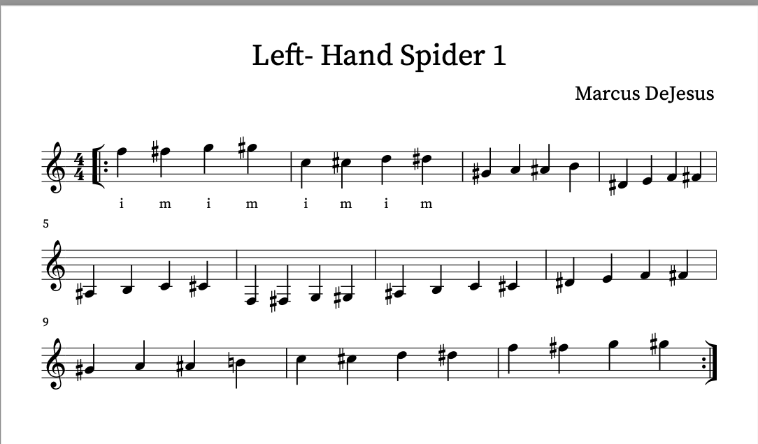

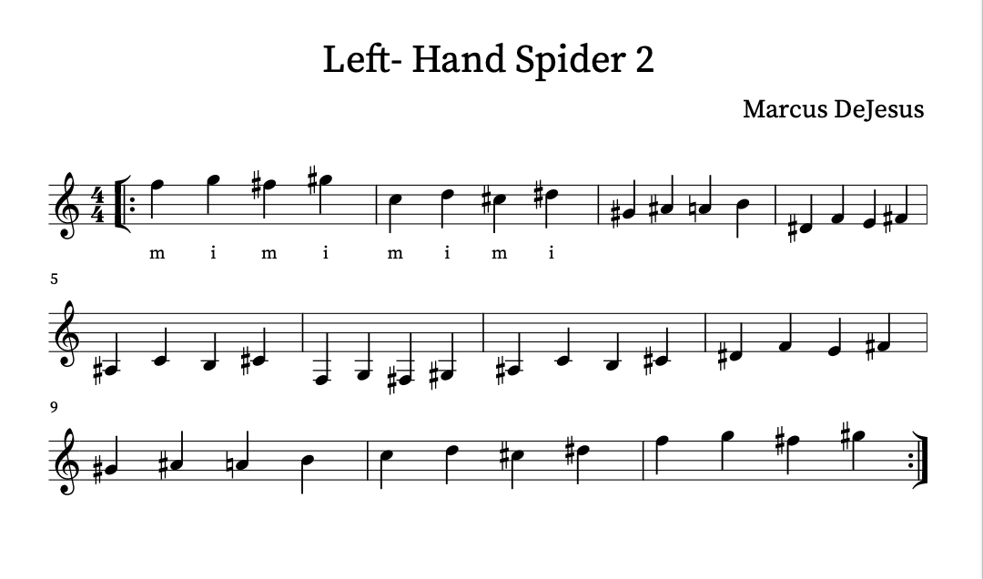
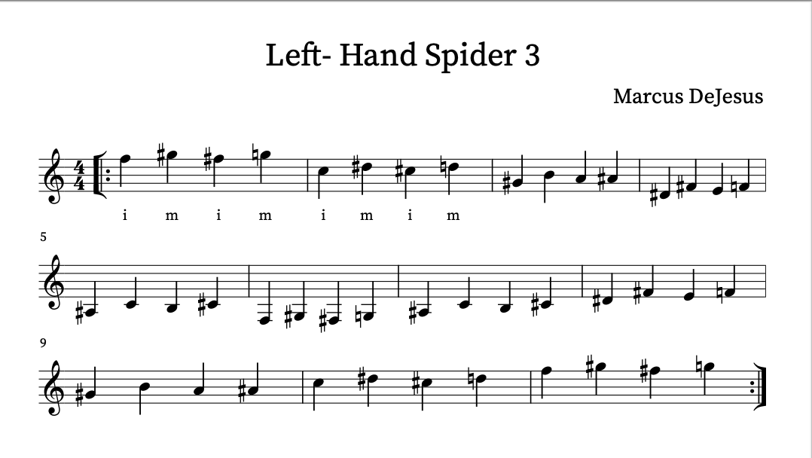

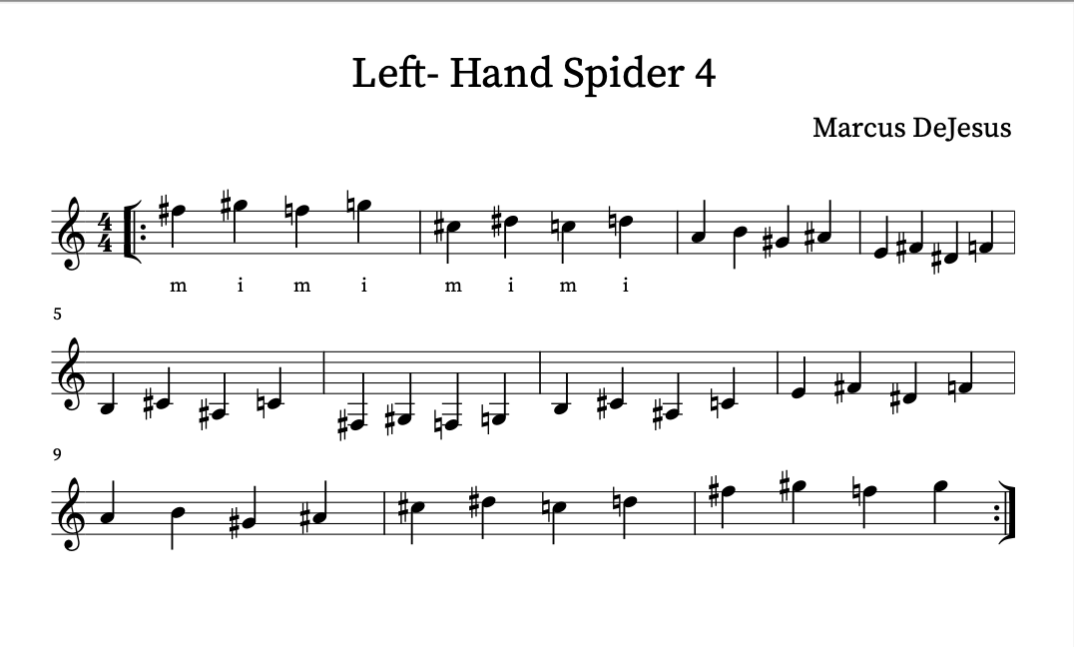
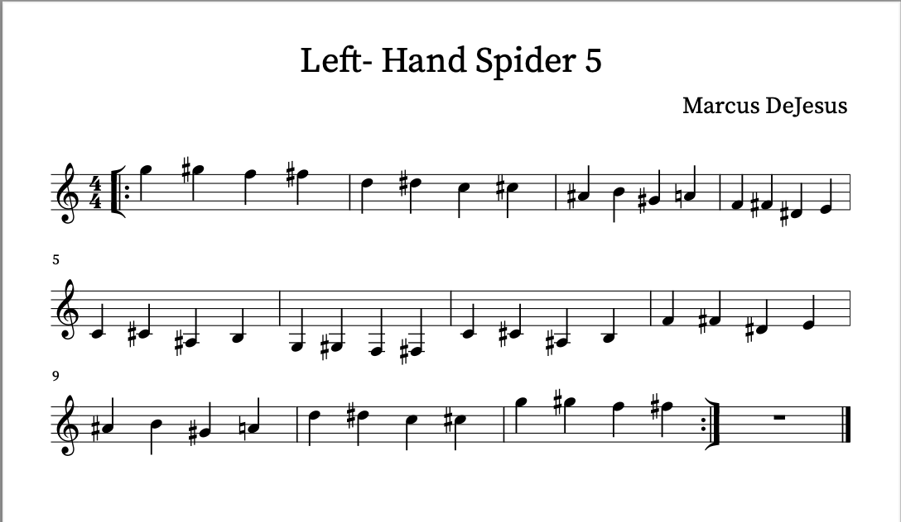

ARPEGGIO SEQUENCES

- Arching of the Right Hand: These drills are designed to help students properly position their right hand, setting a solid foundation for sound production. The correct arch ensures efficient movement and prevents unnecessary tension, allowing for greater control over the strings.

- Sound Production: Beyond hand positioning, these drills emphasize the importance of string attack. The focus is on pulling the finger in a natural motion, almost as if touching the palm of your hand, while utilizing the tips of your fingers to produce a clear, resonant tone. This technique not only improves sound quality but also builds the tactile awareness needed for precision.

- Finger Independence: These exercises teach the guitarist the primary role and “home base” positions of the right-hand fingers—P (thumb), i (index), m (middle), and a (ring). Developing finger independence ensures that each finger can move and function autonomously, allowing for smoother transitions and more dynamic playing.

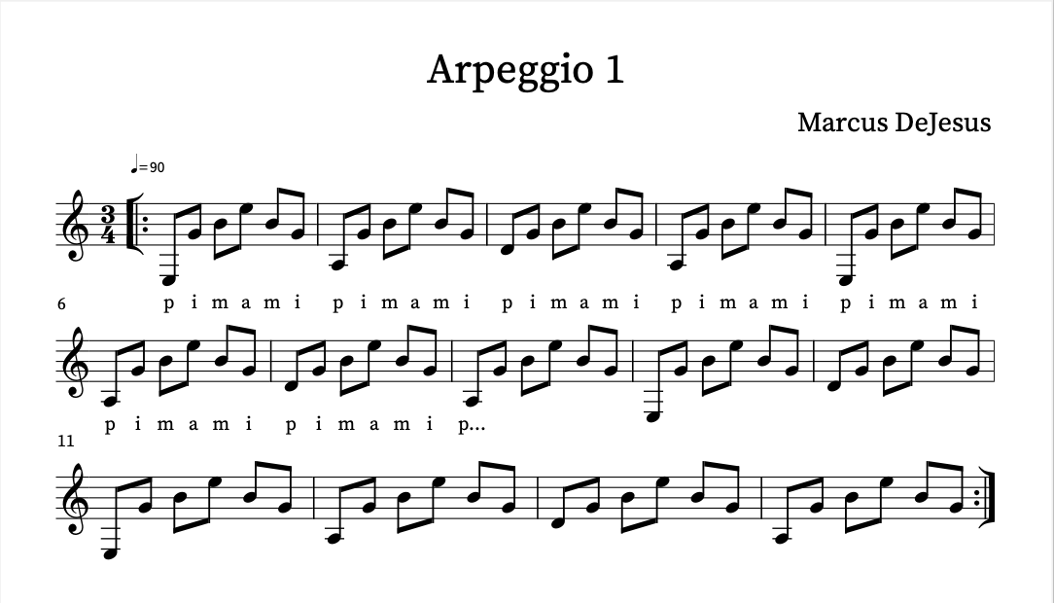

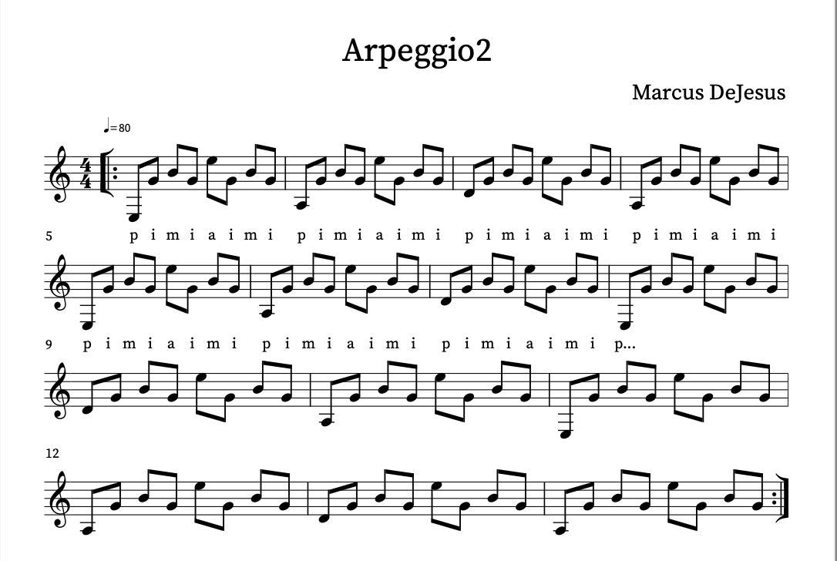

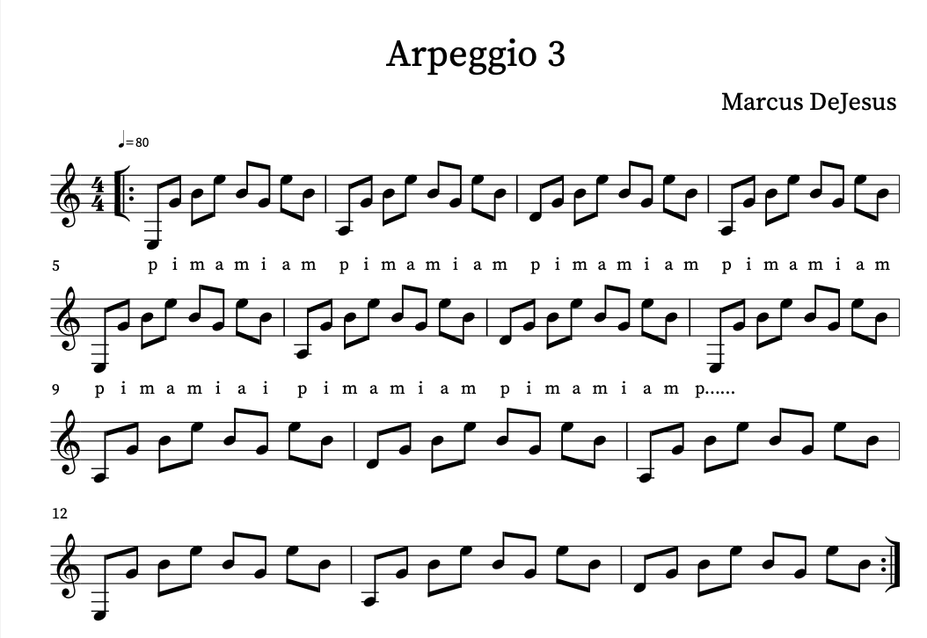
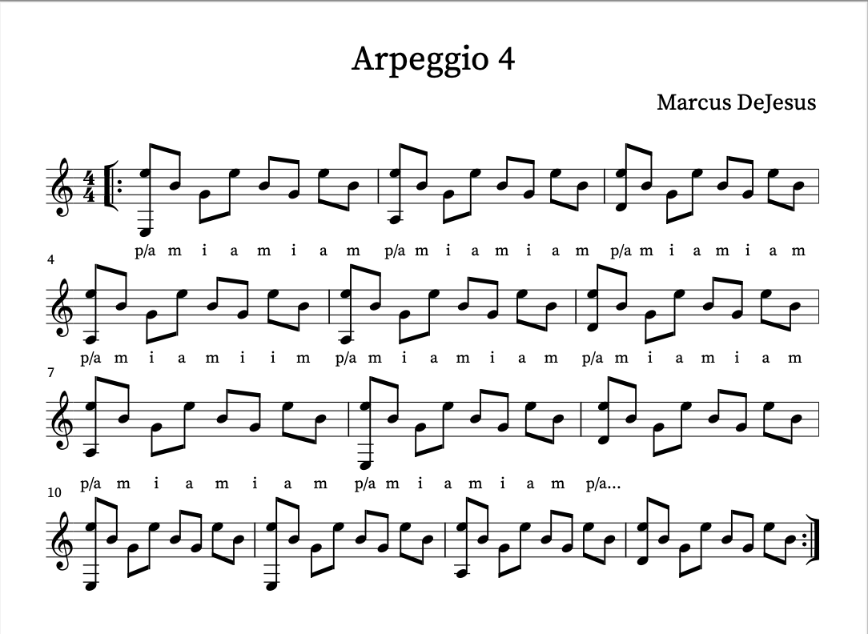
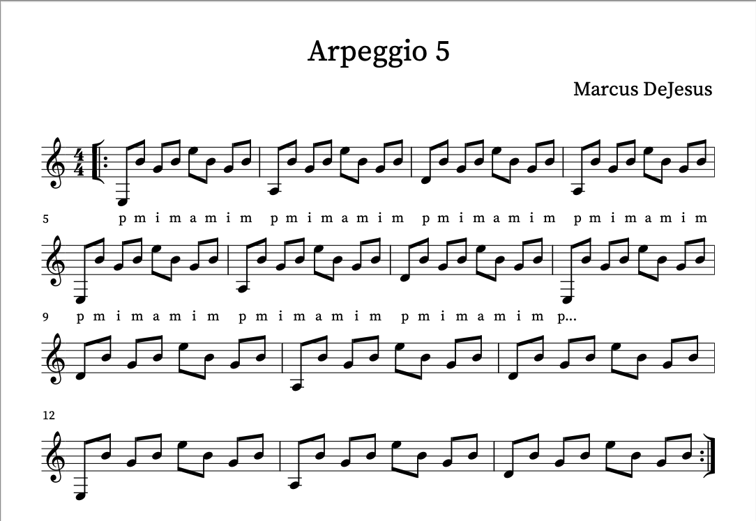

SCALES

The scales in this section are presented without formal notation, relying instead on a graphic representation of the guitar fretboard. This approach is intentional, designed to help students memorize shapes, develop finger independence, build speed, and gain the ability to move effortlessly across the entire fretboard. While students may not initially learn the name of every note they play, this method prioritizes practical skills over theoretical understanding—perfect for those not yet aiming for advanced stages of playing. However, practicing these scales will serve as a gateway to greater freedom on the instrument, encouraging improvisation and expanding musical expression and ideas. Over time, this foundational work can inspire students to dive deeper into understanding what they’re playing, bridging the gap between technique and theory.

CONCLUSION

If you’ve made it all the way to the end, thank you! Thank you for allowing me to share the insights and stories that have shaped my journey as a musician. I hope this book has helped you understand its purpose: to share how I’ve learned to navigate life as a musician. I was fortunate to meet great mentors, seize opportunities when they came my way, and, most importantly, embrace the hard work. Has it always been perfect? Heck no! But it has led to meaningful results and accomplishments, even if on a local scale. I believe that the combination of personal stories and common-sense advice is the greatest asset of this book. Honesty and humility are traits that not only shape character but also build trust, and I’ve tried to embody those traits in my writing. My views and experiences aren’t the only path to success, nor are they definitive. If you want to dive deeper into any subject we’ve discussed, I encourage you to seek out expert resources. For example, if you’re looking to understand practice and become a problem-solver, I highly recommend Ricardo Iznaola On Practicing or Denis Azabagic On Competitions. For a book that shares some of the same concepts as this one but offers even more detail, check out Lessons From the Streetwise Professor by Ramon Ricker. If you’re looking for practice drills, Pumping Nylon by Scott Tennant is a classic. And if you want to explore the psychology and anatomy behind playing the instrument, Classical Guitarists: Unlock Your Potential by Jean-François Desrosby is an excellent resource.
These are just a few of the books on my shelf that have directly or indirectly influenced how I view music and our role as artists in the craft.
At the end of this book, you’ll find a few of my own “scrambles” that I’ve developed for students who study with me. These include four exercises for the left hand, called “Spider,” as well as arpeggio sequences and scale charts. Originally, I created these exercises for myself, but since good teaching starts with sharing what feels natural and effective, I began using them with my students. They’ve since become an integral part of my teaching approach. When reading Chapter One, please refer to these exercises for clarification on technique and expectations. They’re designed to complement the concepts discussed and provide practical tools to help you develop your skills.In addition, my website, marcusdejesus.com, contains information about the guitars I play, videos of performances, my YouTube channel with free guitar lessons, and details on how to hire my services.
Finally, I would like to thank everyone who has helped me grow as a professional over the years—those who gave me opportunities to showcase my work, took a chance on my ability to rise to the occasion, and stood by my side during failures. To all the students who trusted me to share what I’ve learned and allowed me to guide them on their journey, thank you. To the teachers and mentors who have shaped me in immeasurable ways—from teaching me how to navigate this thing called being a musician to showing me how to be a good human—your influence has been invaluable. To my family, thank you for always supporting my projects, for understanding the absences that this career sometimes demands, and for enduring the long hours. If music is my job, my family is my purpose—the reason I continue to swim.

