THE USEFULNESS OF OXYGEN SATURATION HISTOGRAMS IN ASSESSING THE READINESS AND SUCCESS OF OXYGEN WEANING IN NICU PATIENTS

Phornphat Rasamimari, MD¹; Ameer Khilfeh²; Luna Nasry, MD³; Amy Pham, DO⁴; Shannon Murphy, DO⁵

Neonatal-Perinatal Physician Attending, University of Illinois Chicago ¹
Undergrade Student, University of Michigan²
Pediatric resident, University of Illinois Chicago³
Neonatal-Perinatal Physician Attending, University of Illinois Chicago ⁴
Neonatal-Perinatal Hospitalist, University of Illinois Chicago ⁵

Abstract
Here's a summary of the document:
The document explores the significance of oxygen saturation histograms in evaluating the readiness and success of oxygen weaning in NICU patients, particularly late preterm and term infants.
- Challenges in Oxygen Weaning: Oxygen weaning in NICU patients faces high failure rates and varying methods across centers, with both hyperoxia and intermittent hypoxia negatively impacting outcomes, increasing risks of conditions like retinopathy of prematurity and bronchopulmonary dysplasia.12
- Impact of Oxygen Therapy: Excessive or insufficient oxygen therapy affects patient outcomes, with high oxygen levels and invasive ventilation increasing risks of bronchopulmonary dysplasia and retinopathy of prematurity, while low oxygen saturation is linked to higher mortality and morbidity.34
- Oxygen Saturation Targets: Preferred oxygen saturation ranges differ for preterm and term infants, with preterm infants typically kept between 90-95% and term infants above 95% while on oxygen support.56
- Benefits of Histograms: Histograms provide a more objective and precise method for maintaining target oxygen saturation ranges compared to subjective methods, helping to avoid extreme hypoxemia and hyperoxia.78
- Current Use and Research: Histograms are used for objective monitoring and clinical quantification to predict oxygen dependency and chronic lung disease severity, but there is a lack of studies for term infants.910
- Research Questions and Hypothesis: The study aims to determine if histogram trends of oxygen saturation can predict the success of room air trials for late preterm and term infants in NICU, and to establish a normal acceptable range for these histograms.1112
- Methodology: The study follows a systematic review and meta-analysis approach, including study design, selection criteria, data collection, quality assessment, and statistical analysis using the QUIPS tool for bias assessment.1314
I can help you with that. Let's start by outlining the key sections of the manuscript based on the document content. Here's a draft structure for the manuscript:

Title: The Usefulness of Oxygen Saturation Histograms in Assessing the Readiness and Success of Oxygen Weaning in NICU Patients
Authors:
- Phornphat Rasamimari, MD1
- Ameer Khilfeh2
- Luna Nasry, MD3
- Amy Pham, DO4
- Shannon Murphy, DO5
Affiliations:
- Neonatal-Perinatal Physician Attending, University of Illinois Chicago
- Undergraduate Student, University of Michigan
- Pediatric Resident, University of Illinois Chicago
- Neonatal-Perinatal Physician Attending, University of Illinois Chicago
- Neonatal-Perinatal Hospitalist, University of Illinois Chicago
Abstract: The document explores the significance of oxygen saturation histograms in evaluating the readiness and success of oxygen weaning in NICU patients, particularly late preterm and term infants. Challenges in oxygen weaning include high failure rates and varying methods across centers, with both hyperoxia and intermittent hypoxia negatively impacting outcomes. Excessive or insufficient oxygen therapy affects patient outcomes, with high oxygen levels and invasive ventilation increasing risks of bronchopulmonary dysplasia and retinopathy of prematurity, while low oxygen saturation is linked to higher mortality and morbidity. Preferred oxygen saturation ranges differ for preterm and term infants. Histograms provide a more objective and precise method for maintaining target oxygen saturation ranges compared to subjective methods. The study aims to determine if histogram trends of oxygen saturation can predict the success of room air trials for late preterm and term infants in NICU, and to establish a normal acceptable range for these histograms. The study follows a systematic review and meta-analysis approach.

Introduction: Oxygen weaning in NICU patients faces challenges such as high failure rates, with methods varying across centers. Both hyperoxia and intermittent hypoxia negatively affect outcomes, increasing risks of conditions like retinopathy of prematurity and bronchopulmonary dysplasia. Oxygen therapy, whether excessive or insufficient, affects patient outcomes. High oxygen levels and invasive ventilation increase the risk of bronchopulmonary dysplasia and retinopathy of prematurity, while low oxygen saturation is associated with higher mortality and morbidity. Preferred oxygen saturation ranges differ for preterm and term infants, with preterm infants typically kept between 90-95% and term infants above 95% while on oxygen support.

Benefits of Histograms: Histograms provide a more objective and precise method for maintaining target oxygen saturation ranges compared to subjective methods, helping to avoid extreme hypoxemia and hyperoxia. Histograms are used for objective monitoring and clinical quantification to predict oxygen dependency and chronic lung disease severity. Various studies have established nomograms and criteria for preterm infants, but there is a lack of studies for term infants.

Research Questions and Hypothesis: The study aims to determine if histogram trends of oxygen saturation can predict the success of room air trials for late preterm and term infants in NICU, and to establish a normal acceptable range for these histograms.

Methodology: The study follows a systematic review and meta-analysis approach, including study design, selection criteria, data collection, quality assessment, and statistical analysis using the QUIPS tool for bias assessment. The study design is divided into two parts: a comprehensive systematic review to answer the hypothesis, followed by a meta-analysis if enough information is available. The inclusion criteria select articles that include all NICU patients on oxygen therapy, while exclusion criteria include congenital anomalies, muscular and neurological diseases, and infants older than 3 months corrected age. Data collection involves systematic reviews and analysis of relevant papers, with data extracted from eligible studies and incorporated into Covidence and Excel. Quality assessment is conducted using the modified QUIPS tool, and statistical analysis is performed using a tool specific to meta-analysis.

Discussion and Findings: Various studies have shown the effectiveness of histograms in predicting respiratory support needs and weaning success, but there are gaps in research for term infants. The document discusses the need for further studies to establish reliable criteria for this group.

Conclusion: The study highlights the importance of oxygen saturation histograms in evaluating the readiness and success of oxygen weaning in NICU patients. Further research is needed to establish reliable criteria for term infants.
References:
- Afshar, N., Baier, R. J., Tagin, M., Cabo, C. d., Minski, J., & Elsayed, Y. N. (2018). The Impact of Hypoxemia on the Development of Retinopathy of Prematurity in Infants Less Than 29 Weeks of Gestation. Am J Perinatol, 35(12), 1148-1153.
- Ahmed, A., Dhungel, P., & Paria, A. (2022). 1234 Improving compliance of accurate oxygen saturation limits on NICU. Archives of Disease in Childhood, 107(Suppl 2), A189-A189.
- Ali, S. K. M., Mohammed, N., Qureshi, N., & Gupta, S. (2021). Oxygen therapy in preterm infants: recommendations for practice. Paediatrics and Child Health, 31(1), 1-6.
- Bachman, T. E., Onland, W., van Kaam, A. H., Roubik, K., Hummler, H. D., Lal, M., Lista, G., & Fajardo, C. A. (2022). Frequency and duration of extreme hypoxemic and hyperoxemic episodes during manual and automatic oxygen control in preterm infants: a retrospective cohort analysis from randomized studies. BMC Pediatr, 22(1), 350.
- Borenstein-Levin, L., Haj, A., Riskin, A., Dinur, G., Littner, Y., Hochwald, O., & Kugelman, A. (2024). Oxygenation Instability during Bolus versus Continuous Feeding among Very Low Birth Weight Premature Infants, Supported by Noninvasive Ventilation: a Randomized Prospective Study. American Journal of Perinatology, 41(S 01), e2341‐e2347.

Would you like to add or modify any sections? Let me know if you need further assistance! 😊Here's a summary of the document:

The document explores the significance of oxygen saturation histograms in evaluating the readiness and success of oxygen weaning in NICU patients, particularly late preterm and term infants.
- Challenges in Oxygen Weaning: Oxygen weaning in NICU patients faces high failure rates and varying methods across centers, with both hyperoxia and intermittent hypoxia negatively impacting outcomes, increasing risks of conditions like retinopathy of prematurity and bronchopulmonary dysplasia.
- Impact of Oxygen Therapy: Excessive or insufficient oxygen therapy affects patient outcomes, with high oxygen levels and invasive ventilation increasing risks of bronchopulmonary dysplasia and retinopathy of prematurity, while low oxygen saturation is linked to higher mortality and morbidity.
- Oxygen Saturation Targets: Preferred oxygen saturation ranges differ for preterm and term infants, with preterm infants typically kept between 90-95% and term infants above 95% while on oxygen support.
- Benefits of Histograms: Histograms provide a more objective and precise method for maintaining target oxygen saturation ranges compared to subjective methods, helping to avoid extreme hypoxemia and hyperoxia.
- Current Use and Research: Histograms are used for objective monitoring and clinical quantification to predict oxygen dependency and chronic lung disease severity, but there is a lack of studies for term infants.
- Research Questions and Hypothesis: The study aims to determine if histogram trends of oxygen saturation can predict the success of room air trials for late preterm and term infants in NICU, and to establish a normal acceptable range for these histograms.
Methodology: The study follows a systematic review and meta-analysis approach, including study design, selection criteria, data collection, quality assessment, and statistical analysis using the QUIPS tool for bias assessment.
This document discusses the importance of oxygen saturation histograms in evaluating the readiness and success of oxygen weaning in NICU patients, particularly late preterm and term infants.
- Introduction to Oxygen Weaning Challenges: Oxygen weaning in NICU patients faces challenges such as high failure rates, with methods varying across centers. Both hyperoxia and intermittent hypoxia negatively affect outcomes, increasing risks of conditions like retinopathy of prematurity and bronchopulmonary dysplasia.
- Impact of Oxygen Therapy: Oxygen therapy, whether excessive or insufficient, affects patient outcomes. High oxygen levels and invasive ventilation increase the risk of bronchopulmonary dysplasia and retinopathy of prematurity, while low oxygen saturation is associated with higher mortality and morbidity.
- Oxygen Saturation Targets: Preferred oxygen saturation ranges differ for preterm and term infants, with preterm infants typically kept between 90-95% and term infants above 95% while on oxygen support. Normal levels for term infants are detailed in Goetz’s study.
- Benefits of Histograms: Histograms provide a more objective and precise method for maintaining target oxygen saturation ranges compared to subjective methods, helping to avoid extreme hypoxemia and hyperoxia.
- Current Use and Research: Histograms are used for objective monitoring and clinical quantification to predict oxygen dependency and chronic lung disease severity. Various studies have established nomograms and criteria for preterm infants, but there is a lack of studies for term infants.
- Research Questions and Hypothesis: The study aims to determine if histogram trends of oxygen saturation can predict the success of room air trials for late preterm and term infants in NICU, and to establish a normal acceptable range for these histograms.
- Methodology: The study follows a systematic review and meta-analysis approach, including study design, selection criteria, data collection, quality assessment, and statistical analysis. The QUIPS tool is used for bias assessment.
- Discussion and Findings: Various studies have shown the effectiveness of histograms in predicting respiratory support needs and weaning success, but there are gaps in research for term infants. The document discusses the need for further studies to establish reliable criteria for this group.

Introduction
-Incidence of failure extubation / O2 discontinuation. Failure rate exceed 50%(Gentle et al., 2020), methods to wean vary from center to center

- hyperoxia is associated withretinopathy of prematurity and bronchopulmonary dyspla-sia,1,2 whereas intermittent hypoxia is associated with in-creased mortality, severe retinopathy of prematurity, and pulmonary hypertension. (Mascoll 2016**

-Disadvantage/side effect of O2 therapy. Either too much or too little affects the patients’ outcomes. Invasive ventilation and high O2 increased risk of BPD, ROP. The sooner weaning off, the less effect of the oxygen toxicity based on this context. However, low sat group (85-89%) had higher mortality and morbidity (NEC), but not ROP (Manja et al., 2017). Apnea/Bradycardia/desaturation has significant impact on length of stay, cost and quality of life in the very low birth weight infant (Poets et al., 2015), and in the late preterm and term infant.(Montenegro et al., 2018)
-When consider failed RA trial, respiratory failure (endpoint??). Generally, for preterm infants, prefer to keep O2 sat range 90-95, and for term infant prefer >95 while on O2 support. What is the normal level on RA? In the term infant details found in Goetz’s study (Goetz et al., 2024) as mentioned below (only term infant)
-Superiority of histogram. It is very difficult to keep O2 sat at target range, more obvious if using histogram, proving objective better than subjective; more tolerate lower O2 than higher O2
- Definition Extreme hypoxemia < 80%, extreme hyperoxia > 98% (T. E. Bachman et al., 2022)
One study found that high cumulative time of extreme hypoxemia (less than 80%) had negative impact on severe ROP (Afshar et al., 2018)
-Current use of histogram. One is for objective monitoring, another is for creating clinical quantification for predicting the prognosis of O2 dependent and severity of chronic lung disease.
-What article use for weaning and result. So far, all for preterm, none for term
For preterm, in the study conducted by Harigopal (Harigopal et al., 2011), the author created nomogram used for weaning
For preterm (less than 30 wk, less than 1250g), the study conducted by Gentle (Gentle et al., 2020). The author used the readiness as follows: FiO2 IQR 21-25 (less than 30%), NCPAP 4-5. They found that the success case spent 20% of time in 97-100% O2 sat, 35% of the time in 95-97%O2 sat, (60% of time in =>95%O2 sat)
Expremie discharge criteria are mean sat >93% and O2 sat <90% less than 5% of the time (Ahmed et al., 2022)
- Any standard/normal (nomogram) range of O2 sat established. For healthy term infant, In one small study by Goetz et al in 2024 (Goetz et al., 2024) on 74 healthy term infant, the author found that median O2 sat was 95.4% and nearly one quarter of newborns spent the highest percentage of time in O2 sat of 90-94%. Might be able to apply in NICU after disease of exclusion ruled out?. For the sick preterm infant (on oxygen support), the study in 2017 (Manja et al., 2017) on comparison of low O2 sat group (85-89%) and high O2 sat group (91-95%) has found that no difference in developmental outcomes at 18-24 months, but the former had higher mortality and higher NEC incidence.
For healthy preterm (on room air) median 33 wk (29-36), in small study (43 preterm infant) by Harigopal et al (Harigopal et al., 2011), the author found that mean O2 sat 95%, 2% of them between 85-90%, 1% of them less than 85%. And created a nomogram for use in their practice.
For sick preterm <34 wk, a study done by Borenstein-Levin in 2020 (Borenstein-Levin et al., 2023) on 73 infants, 6016 histograms, the author created a histogram classification system. They divided it into 5 types and found that higher % time of class type 3-5 had higher mortality and BPD
For sick preterm <32 week, a study by Moscall 2016 on 35 infants, The infant had pretransition O2sat (O2 sat prior to wean) less than 86%, less than 15% of time, and O2 sat 90-95%O2sat 30% of time or more, and O2 sat>96%O2 sat 50% of time or more having high success rate (Mascoll-Robertson et al., 2016)
-Percentage of O2 sat per day, and what cut off? Do can we adopt all information above
- (used Nellcorr pulse OX?)
-The last study by Mense & Waitz), the author stated that decision to wean could not be based on a single parameter only, especially since the outcome parameter of this study has very high specificity but low sensitivity. Judgment on how to wean should be based on the overall clinical condition of the baby and may also include parameters such as respiratory effort, apneic episodes, gestational age and FiO2 (Mense & Waitz, 2016).
Of notes, for improve success rate of weaning oxygen support for the infant 34 weeks or more GA/PMA, we are wondering that we can use clinical readiness plus either <86% O2 sat < 15% time, and/or 86-90% O2 sat> 15% time and/or 90-95% O2 sat > 40% time, and/or >96% O2sat > 50% time or the trends of histogram over 24-48 hr.
- prevention of too much or too little by using a Novel Closed-Loop Inspired Oxygen Fraction Controllers(Rafl et al., 2019)
- Infants with monitor-recorded hypoxia for > 5%/day (p < 0.0001) or tachypnea for > 30%/day (p < 0.0001) were more likely to require an increase in respiratory support within next 3 days. Monitor-recorded hypoxia and tachypnea were also associated with poor weight gain(Warburton et al., 2019)
- Changing feeding mode from bolus to continuous or vice versa did not significantly change the oxygenation instability of the group, though individual infants did show a consistence response to feeding length changes, seeing the trends (Borenstein-Levin et al., 2024)
- Intermittent hypoxia: Oxygen saturations ,80% for >1 minute and the proportion of time per day with hypoxemia >11%(Di Fiore et al., 2021; Jensen et al., 2021)
- In general, prefer to keep O2 target around 75% -80% of the time, below target less than 10-15% of the time (Ali et al., 2021; Borenstein-Levin et al., 2023). New technologies as automatic oxygen control combined with histogram is proved to help to maintain O2 target better than manual (Ali et al., 2021; Thomas E Bachman et al., 2022; Nair et al., 2023; Srivatsa et al., 2021). Outcomes of different O2 target in preterm 85-89% and 91-95% for mortality with development but mortality/NEC in lower group; recommend 89 -96% (Manja et al., 2017). One of literature review addresses safe and sound oxygen therapy(Schmidt & Kirpalani, 2022)
-Knowledge gap. Taken into account, histogram has been well established in clinical use for the preterm infants (<34 weeks) in NICU. However, there are no studies on histogram using for weaning oxygen support on the late preterm (34 -36 wk) and/or on the term infants (37 weeks and more) in NICU. The aim of our study to establish the relationship between oxygen saturation histogram and the readiness of NICU patients at 34 weeks and more for weaning off oxygen support.

Research questions
Can histogram trends of oxygen saturation predict the success of room air trial for the late preterm and the term infants in NICU?

Hypothesis/Aims
AIM1. To determine that the histogram trends of oxygen saturation can be used as the readiness of room air trial in the late preterm and the term infants in NICU.
AIM2. To determine that the normal acceptable range of histogram of oxygen saturation can be used in practice for late preterm and term infants in NICU

Part I: Methodology (Systematic reviews, plus meta-analysis)
1.1. Study design: We divide the study in two parts, the first part is a comprehensive systematic review to answer our hypothesis. We will then proceed to the second part of the study which included the meta-analysis if we have enough information to do so. This is done to assess the results of previous research to derive conclusions about that body of research. It follows the guidelines of Cochrane handbook for systematic reviews including planning the review, searching and selecting studies, collecting data, as well as the risk of bias and prospective meta-analysis

1.2. Study selection criteria: For our inclusion criteria we select articles that included all NICU patients who are on oxygen therapy. Among oxygen therapy, our inclusion criteria are the following: NCPAP, HFNC and low NC. For exclusion criteria, there are the following: congenital anomalies especially airway malformation, muscular and neurological diseases, infant older than 3 months corrected age, intubation and tracheostomy
1.3. Obtain and collect data
Information sources and study design
Systematic reviews and analysis of relevant papers in the English language which include all types of study designs such as meta-analysis, retrospective cohort, prospective cohort, retrospective case-control, article reviews, case reports, case series etc. Electronic search of online databases- Google Scholar, Embase, Pubmed, Cochrane and Cinhal, using the following search terms:: ‘Oxygen histogram’, ‘Oxygen saturation’,’Oxygen’, ‘Histogram’, ‘neonate’, ‘newborn’, ‘preterm’, ‘prematurity’, ‘term’, ‘full term’ weaning’ performed in collaboration of our librarian specializing in systematic reviews.

Search strategy and Selection process
All studies found through the search algorithms are placed in a reference management program (Endnote) and a systematic reviews production tool (Covidence). All searched studies undergo screening to identify studies that meet the inclusion criteria. This is initially done with an abstract screen performed by two independent reviewers (PR, SM) and follows by a full text screen to assess study eligibility. Reasons for exclusion are documented and reported using a PRISMA flow diagram.

Data collection process
All data are extracted from eligible study and incorporated into Covidence and Excel. Data do not require a codebook for this descriptive analysis. The outcome measures were recorded as discrete numbers to indicate count or sample size. The variables in excel are clearly defined. This process is conducted independently by two reviewers (PR, NM) and any inconsistencies or queries are resolved with the assistance of a biostatistician. Records and data are managed using Microsoft word and excel and share with the team. The extracted data include the following: title/authors, study design, date of study, number of subjects, maternal/neonatal factors, clinical conditions and/or interventions (infectious/non-infectious), number of subjects in control group /study group maternal/neonatal demographic characteristics, infant clinical course/intervention prior to perforation.

1.4. Quality assessment
Modified QUIPS (Quality in Prognosis Studies) tool (Hayden, van der Windt et al. 2013) was used for assessing bias and was conducted by 2 reviewers (PR, NM). The six domains assessed are bias due to participation, bias due to attrition, bias due to prognostic factor measurement, bias due to outcome measurement, bias due to confounding, and bias in statistical analysis and reporting. Each domain will be judged as either high, medium or low bias. Each independent reviewer subjectively judge the article and consensus is reached.

1.5. Statistical analysis (Quantitative analysis /Meta-analysis if applicable)
We work with a statistician and use a tool specific to meta-analysis to conduct a random-effects using R (Vienna Austria) and the metafor package to make plots from our data such as forest and funnel plots.

1.6. Results from literature review
Flowchart
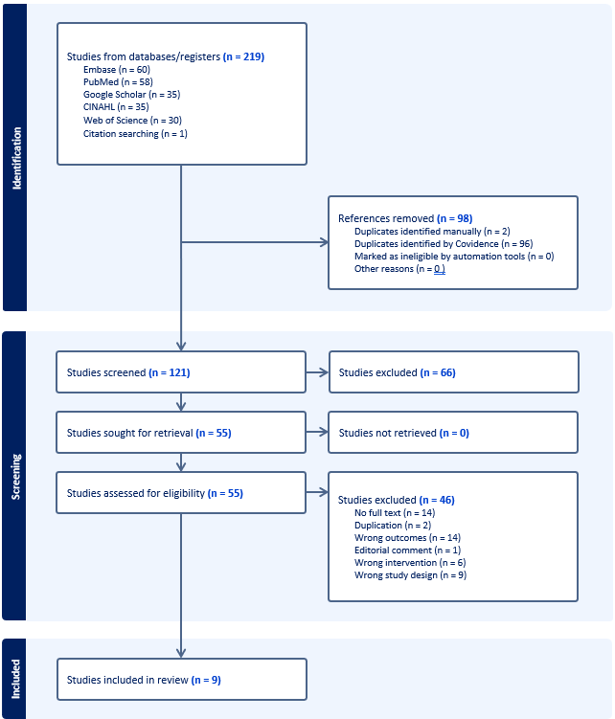
The flowchart you've shared illustrates the meticulous journey undertaken to identify, screen, and ultimately include studies in a review. The process is systematic and rigorous, ensuring that only the most relevant and high-quality studies are considered.
Identification
The process begins with the identification of potential studies from various databases and registers. A total of 219 studies are gathered from several sources, including Embase, PubMed, Google Scholar, CINAHL, Web of Science, and even citation searching. However, this initial pool is refined by removing 98 references. Duplicate entries are meticulously identified both manually and through Covidence, an automation tool, ensuring that no redundancy clouds the review.
Screening
From the 121 studies that remain after the initial refinement, each one is carefully screened. Unfortunately, 66 studies are excluded at this stage, but the rigorous scrutiny continues for the remaining 55 studies. This part of the process is crucial, as the team seeks to retrieve and assess these studies for their eligibility. Impressively, all 55 studies are successfully retrieved and evaluated. During this evaluation, another 46 studies are excluded for various reasons, such as lack of full text, duplication, incorrect outcomes or interventions, and unsuitable study designs.
Inclusion
Finally, the journey culminates with the inclusion of 9 studies in the review. These studies have withstood the thorough examination and meet all necessary criteria, ensuring that the review is built on a foundation of reliable and pertinent research.
The entire process underscores the dedication and precision required in conducting a comprehensive review. From casting a wide net to methodically narrowing it down to the most relevant studies, each step is essential in maintaining the integrity and quality of the review.

QUIPS
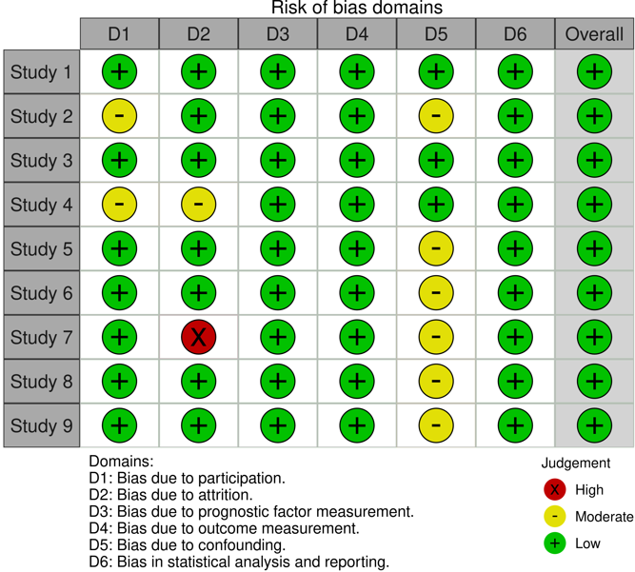

The QUIPS table provides a summary of the risk of bias across nine studies, assessed in six domains: participation, attrition, and outcome measurement. Low bias is indicated by a green plus sign, moderate bias by a yellow minus sign, and high bias by a red X. Most studies show low bias in all domains, with a few exceptions, such as Study 7, which has high bias in participation and moderate bias in confounding. This table helps quickly evaluate the reliability and validity of the studies included in the review, all of which are observational studies.

Comparable tables

1.7. Discussion
Preterm infant
Term infant
Mechanism-Physiology – O2 sat and O2 sat monitor.
For study by Mascoll 2016 (Mascoll-Robertson et al., 2016), it was prospective cohort and had appropriate sample size (35 total cases) based on their stat calculation. Histogram target of success rate was modified version of Todd (Todd et al., 2012) which was < 86% O2 sat and they added 15 % time of 24 hours. They stated clearly the criteria of both stable clinical criteria pretransition and failed clinical criteria in discussion section. However, they didn’t mention what to do for the excluded and limitation by doctor discretion which varies person to person. They concluded that clinical criteria plus histogram will improve the success rate of weaning.
For study by Mohsen (Mohsen et al., 2022), it was retrospective case-control and had appropriate and large sample size. The author concluded that the success group spent majority of time (>90%) in O2 sat >89% supported by AUC 0.68. Also, they found that in success group, the lower GA at birth is (22-24; 25-26; 27-28; >28), the higher PMA and the higher weight are (35.5; 34.5; 34; 31 wks and 2100; 1975; 1895; and 1380g, respectively.

For study by Sur (Sur & Paria, 2021) recommended specific clinical findings and O2 sat target to adjust setting using 20% of time spent O2 sat outside of the target.

For study by Warburton (Warburton et al., 2019), the author concluded that RR >70 more than 20% of the time or O2 sat <90% more than 5% of the time in 24 hours were predicting factors for increase in respiratory support within next 3 days. However, if RR>70 more than 30% time, it would affect weight gain.

For study by Rath (Rath & Kluckow, 2016), the author found that Term infant spent O2 sat less than 90% at 0% of the time, and O2 sat 90-95% at 4% of the time in 24 hr. And preterm infant spent 4% of the time at O2 sat less than 90% and spent 8% of the time at O2 sat between 90-95%. They concluded that we should not use the same parameters for either preterm or term infant.

For study by Borenstein-Levin (Borenstein-Levin et al., 2023), the author created a nice classification and nomogram of histogram, using cumulative data for preterm infant.

For the study by Goetz (Goetz et al., 2024), the author found that the healthy term infants have median SpO2 was 95.4%; Percentage time spent in each of the five SpO2 intervals was as follows: 0.07% ( O2 sat 80%), 0.15% (O2 sat 81–84%), 0.88% (O2 sat 85–89%), 26.9% (O2 sat 90–94%), and 67.3% (O2 sat 95–100%); 24% of them spent the highest percentage of time in SpO2 of 90 to 94%.

An acute decrease in O2 sat was defined as a decrease in absolute O2 sat of at least 10% from a stable preceding baseline interval (ie, from 93% to 83%) that was sustained below 90% for > 5 seconds, may considered normal physiology. (Hunt et al., 2011)

After edited by Copilot
For the study by Mascoll-Robertson et al. (2016), it was a prospective cohort with an appropriate sample size of 35 cases. The histogram target of success rate was a modified version of Todd et al. (2012), which was <86% O2 saturation, adding 15% time of 24 hours. They clearly stated the criteria for both stable clinical criteria pretransition and failed clinical criteria in the discussion section. However, they did not mention what to do for the excluded cases and limitations by doctor discretion, which varies from person to person. They concluded that clinical criteria plus histogram would improve the success rate of weaning.
For the study by Mohsen et al. (2022), it was a retrospective case-control with an appropriate and large sample size. The authors concluded that the success group spent the majority of time (>90%) in O2 saturation >89%, supported by AUC 0.68. They also found that in the success group, the lower gestational age (GA) at birth (22-24; 25-26; 27-28; >28 weeks), the higher postmenstrual age (PMA), and the higher weight (35.5; 34.5; 34; 31 weeks and 2100; 1975; 1895; and 1380g, respectively).
For the study by Sur & Paria (2021), they recommended specific clinical findings and O2 saturation targets to adjust settings using 20% of time spent outside the target.
For the study by Warburton et al. (2019), the authors concluded that respiratory rate (RR) >70 more than 20% of the time or O2 saturation <90% more than 5% of the time in 24 hours were predicting factors for an increase in respiratory support within the next 3 days. However, if RR >70 more than 30% of the time, it would affect weight gain.
For the study by Rath & Kluckow (2016), the authors found that term infants spent 0% of the time with O2 saturation less than 90% and 4% of the time with O2 saturation between 90-95% in 24 hours. Preterm infants spent 4% of the time with O2 saturation less than 90% and 8% of the time with O2 saturation between 90-95%. They concluded that different parameters should be used for preterm and term infants.
For the study by Borenstein-Levin et al. (2023), the authors created a classification and nomogram of histograms using cumulative data for preterm infants.
For the study by Goetz et al. (2024), the authors found that healthy term infants had a median SpO2 of 95.4%. The percentage of time spent in each of the five SpO2 intervals was as follows: 0.07% (O2 saturation 80%), 0.15% (O2 saturation 81-84%), 0.88% (O2 saturation 85-89%), 26.9% (O2 saturation 90-94%), and 67.3% (O2 saturation 95-100%). 24% of them spent the highest percentage of time in SpO2 of 90-94%.
An acute decrease in O2 saturation was defined as a decrease in absolute O2 saturation of at least 10% from a stable preceding baseline interval (e.g., from 93% to 83%) that was sustained below 90% for more than 5 seconds, which may be considered normal physiology (Hunt et al., 2011).

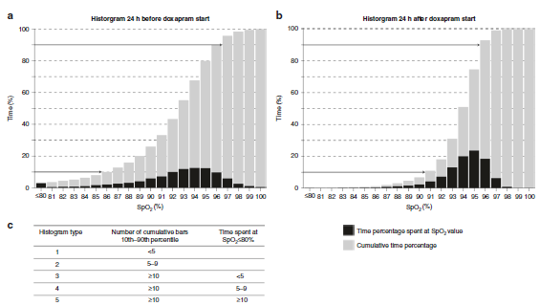
The image shows two histograms comparing the percentage of time spent at different SpO2 levels before and after doxapram treatment. The table categorizes these histograms into types based on the number of cumulative bars at the 10th-90th percentile and time spent at SpO2 levels below 80%. This helps in understanding how doxapram affects oxygen saturation over a 24-hour period
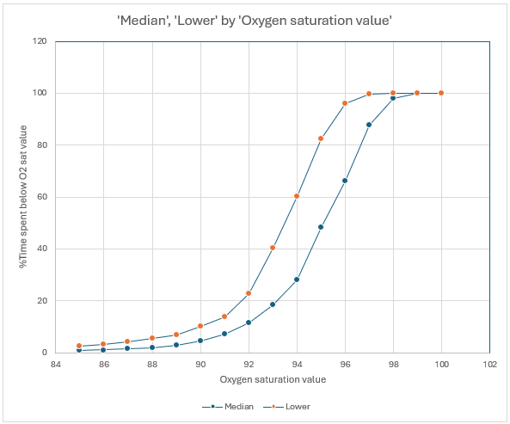
Figure x. NOMOGRAM OF OXYGEN SATURATION (Harigopal 2011)
This graph reveals how often oxygen saturation levels fall below certain thresholds. The median line, representing the 50th percentile of infants, starts increasing steeply around an SpO2 value of 90, reaching near 100% around a value of 96, then levels off. The lower line, representing the 5th percentile of infants, shows an increase slightly earlier around an SpO2 value of 88, also reaching near 100% around a value of 96. Both lines highlight critical points for monitoring and intervention in conditions affecting blood oxygen levels while on oxygen support. This objective graphic tool helps in adjusting the oxygen support. For instance, if the patient curve shifts to the left, we should increase respiratory support. In contrast, if the patient curve shifts to the right, we should decrease the respiratory support.

1.8. Limitation

1.9.Conclusion

1.10. Ethical issues: not applicable

References:

Afshar, N., Baier, R. J., Tagin, M., Cabo, C. d., Minski, J., & Elsayed, Y. N. (2018). The Impact of Hypoxemia on the Development of Retinopathy of Prematurity in Infants Less Than 29 Weeks of Gestation. Am J Perinatol, 35(12), 1148-1153. https://doi.org/10.1055/s-0038-1641588
Ahmed, A., Dhungel, P., & Paria, A. (2022). 1234 Improving compliance of accurate oxygen saturation limits on NICU. Archives of Disease in Childhood, 107(Suppl 2), A189-A189. https://doi.org/10.1136/archdischild-2022-rcpch.302
Ali, S. K. M., Mohammed, N., Qureshi, N., & Gupta, S. (2021). Oxygen therapy in preterm infants: recommendations for practice. Paediatrics and Child Health, 31(1), 1-6. https://doi.org/10.1016/j.paed.2020.10.001
Bachman, T. E., Onland, W., van Kaam, A. H., Roubik, K., Hummler, H. D., Lal, M., Lista, G., & Fajardo, C. A. (2022). Frequency and duration of extreme hypoxemic and hyperoxemic episodes during manual and automatic oxygen control in preterm infants: a retrospective cohort analysis from randomized studies. BMC Pediatr, 22(1), 350. https://doi.org/10.1186/s12887-022-03407-x
Bachman, T. E., Onland, W., van Kaam, A. H., Roubik, K., Hummler, H. D., Lal, M., Lista, G., & Fajardo, C. A. (2022). Frequency and duration of extreme hypoxemic and hyperoxemic episodes during manual and automatic oxygen control in preterm infants: a retrospective cohort analysis from randomized studies. BMC pediatrics, 22(1), 350.
Borenstein-Levin, L., Haj, A., Riskin, A., Dinur, G., Littner, Y., Hochwald, O., & Kugelman, A. (2024). Oxygenation Instability during Bolus versus Continuous Feeding among Very Low Birth Weight Premature Infants, Supported by Noninvasive Ventilation: a Randomized Prospective Study [Journal article]. American Journal of Perinatology, 41(S 01), e2341‐e2347. https://doi.org/10.1055/s-0043-1771257
Borenstein-Levin, L., Poppe, J. A., Van Weteringen, W., Taal, H. R., Hochwald, O., Kugelman, A., Reiss, I. K. M., & Simons, S. H. P. (2023). Oxygen saturation histogram classification system to evaluate response to doxapram treatment in preterm infants. Pediatric Research, 93(4), 932-937. https://doi.org/10.1038/s41390-022-02158-w
Di Fiore, J. M., Martin, R. J., & Raffay, T. M. (2021). Intermittent Hypoxemia and Bronchopulmonary Dysplasia: Manifestations of Immature Respiratory Control and the Preterm Lung. American Journal of Respiratory and Critical Care Medicine, 204(10), 1126-1127. https://doi.org/10.1164/rccm.202109-2077ED
Gentle, S. J., Ambalavanan, N., & Carlo, W. A. (2020). Oxygen saturation histograms predict nasal continuous positive airway pressure-weaning success in preterm infants. Pediatric Research, 88(4), 637-641.
Goetz, E. M., Tomlin, B. D., Rinaldo, K. E., Baumann-Blackmore, N. L., Petro, R. L., Smith, B. B., Zapata, J. Y., Lasarev, M. R., McBride, E. B., & Kaluarachchi, D. C. (2024). Oxygen Saturation Profiles in Healthy Term Infants in Early Postnatal Life. Am J Perinatol, 41(9), 1269-1274. https://doi.org/10.1055/s-0042-1749630
Harigopal, S., Satish, H., Taktak, A., Southern, K., & Shaw, N. (2011). Oxygen saturation profile in healthy preterm infants. Archives of Disease in Childhood-Fetal and Neonatal Edition, 96(5), F339-F342.
Hunt, C. E., Corwin, M. J., Weese-Mayer, D. E., Ward, S. L., Ramanathan, R., Lister, G., Tinsley, L. R., Heeren, T., & Rybin, D. (2011). Longitudinal assessment of hemoglobin oxygen saturation in preterm and term infants in the first six months of life. J Pediatr, 159(3), 377-383.e371. https://doi.org/10.1016/j.jpeds.2011.02.011
Jensen, E., Whyte, R., Schmidt, B., Bassler, D., Vain, N., Roberts, R., Shah, P., Brown, L., Wenger, L., Frye, S., Imbesi, F., Kelly, E., D’Ilario, J., Roy, M., Dix, J., Adams, B., Cairnie, J., Gillie, P., Asztalos, E., . . . Nelson, H. (2021). Association between Intermittent Hypoxemia and Severe Bronchopulmonary Dysplasia in Preterm Infants. American Journal of Respiratory and Critical Care Medicine, 204(10), 1192-1199. https://doi.org/10.1164/rccm.202105-1150OC
Manja, V., Saugstad, O. D., & Lakshminrusimha, S. (2017). Oxygen Saturation Targets in Preterm Infants and Outcomes at 18–24 Months: A Systematic Review. Pediatrics, 139(1), e20161609. https://doi.org/10.1542/peds.2016-1609
Mascoll-Robertson, K. K., Viscardi, R. M., & Woo, H. C. (2016). The objective use of pulse oximetry to predict respiratory support transition in preterm infants: An observational pilot study [Article]. Respiratory care, 61(4), 416-422. https://doi.org/10.4187/respcare.04102
Mense, L., & Waitz, M. (2016). Spo2 histograms in preterm infants: A helpful tool for neonatologists? [Article]. Respiratory care, 61(4), 569-570. https://doi.org/10.4187/respcare.04771
Mohsen, N., Nasef, N., Elkhouli, M., Ghanem, M., Dalby, A., Yoon, E. W., Finan, E., Shah, P. S., & Mohamed, A. (2022). Predictors of successful trial off continuous positive airway pressure and high flow nasal cannula in preterm infants <30 weeks' gestation: A retrospective study [Article]. Pediatric Pulmonology, 57(4), 1000-1007. https://doi.org/10.1002/ppul.25827
Montenegro, B., Freiberger, C., Veit, L., Amberson, M., Mukhopadhyay, S., & Rhein, L. (2018). An occurrence of apnea, bradycardia, and desaturation events resulting in a delay of discharge in late preterm and full term infants. Pediatrics &amp; Neonatology, 59(6), 630-631. https://doi.org/10.1016/j.pedneo.2016.11.007
Nair, V., Kannan Loganathan, P., Lal, M., Pringleton, H., Bachman, T., Brodlie, M., & Dixon, P. (2023). Automatic oxygen control for reducing extremes of oxygen saturation: a randomised controlled trial. Archives of Disease in Childhood - Fetal and Neonatal Edition, 108(2), 136-141. https://doi.org/10.1136/archdischild-2022-324160
Poets, C. F., Roberts, R. S., Schmidt, B., Whyte, R. K., Asztalos, E. V., Bader, D., Bairam, A., Moddemann, D., Peliowski, A., Rabi, Y., Solimano, A., Nelson, H., & Investigators, f. t. C. O. T. (2015). Association Between Intermittent Hypoxemia or Bradycardia and Late Death or Disability in Extremely Preterm Infants. Jama, 314(6), 595-603. https://doi.org/10.1001/jama.2015.8841
Rafl, J., Bachman, T. E., Martinek, T., Tejkl, L., Huttova, V., Kudrna, P., & Roubik, K. (2019). Design and Demonstration of a Complex Neonatal Physiological Model for Testing of Novel Closed-Loop Inspired Oxygen Fraction Controllers. World Congress on Medical Physics and Biomedical Engineering 2018: June 3-8, 2018, Prague, Czech Republic (Vol. 1),
Rath, C., & Kluckow, M. (2016). Oxygen saturation profile of term equivalent extreme preterm infants at discharge – comparison with healthy term counterparts. Acta Paediatrica, 105(3), undefined-undefined. https://doi.org/10.1111/apa.13306
Schmidt, B., & Kirpalani, H. (2022). Safe and sound oxygen therapy for extremely preterm infants: a literature review. Pediatric Medicine, 5.
Srivatsa, B., Malcolm, K., Clark, R. H., & Kupke, K. G. (2021). Effect of a novel oxygen saturation targeting strategy on mortality, retinopathy of prematurity, and bronchopulmonary dysplasia in neonates born extremely preterm. The Journal of Pediatrics, 234, 33-37. e33.
Sur, A., & Paria, A. (2021). Histogram analysis for bedside respiratory monitoring in not critically ill preterm neonates: a proposal for a new way to look at the monitoring data [Article]. European Journal of Pediatrics, 180(1), 283-289. https://doi.org/10.1007/s00431-020-03732-2
Todd, D., Wright, A., Broom, M., Chauhan, M., Meskell, S., Cameron, C., Perdomi, A. M., Rochefort, M., Jardine, L., Stewart, A., & Shadbolt, B. (2012). Methods of weaning preterm babies < 30 weeks gestation off CPAP: a multicentre randomised controlled trial. Archives of Disease in Childhood - Fetal and Neonatal Edition, 97(4), F236-F240. https://doi.org/10.1136/adc.2011-300133
Warburton, A., Monga, R., Sampath, V., & Kumar, N. (2019). Continuous pulse oximetry and respiratory rate trends predict short-term respiratory and growth outcomes in premature infants. Pediatric Research, 85(4), 494-501. https://doi.org/10.1038/s41390-018-0269-4

An acute decrease in Spo2 was defined as a decrease in absolute Hbo2SATofatleast10%fromastableprecedingbaselinein terval (ie, from 93% to 83%) that was sustained below 90% for $5 seconds.

