Development, validation and preliminary results from a patient-centred evaluation of risk factors for cardiovascular and malignant diseases

Background: Cardiovascular and malignant diseases are the major causes of morbidity and mortality. The diseases are multifactorial, with modifiable factors influencing development and progression. Despite intensive efforts, the risk profile of the general population is far from ideal and remains largely unregulated.
Purpose: There is a lack of information on the current risk factor-related situation in the general population. This includes knowledge about risk factors, individual circumstances, levels of risk awareness and health responsibility. The questionnaire was designed to assess these factors from the perspective of patients and potential patients.
Method: The items for the risk factor-related knowledge, attitude, situation, and components of the health belief model were developed, validated, and pilot tested. Development was conducted by an expert panel after extensive literature research. Validation was conducted using the content validity index (CVI) and content validity ratio (CVR). A pilot test was conducted by surveying patients and potential patients at a tertiary hospital. An explanatory factor analysis (EFA) was conducted to assess the underlying factors and identify items with relevant loading (>.32). Corresponding items were identified and grouped into the aforementioned factor categories. The factor consistency was evaluated using Cronbach's alpha (α), the correlation between factors was assessed using Pearson's r correlation.
Results: A total of 34 items were developed, expert validation showed high representativeness (3.87 ± 0.22, scale 0-4), clarity (3.90 ± 0.17) and importance (1.78 ± 0.27, scale 0-2), resulting in a CVI of 0.97 for representativeness and 0.99 for clarity, and a CVR for importance of 0.53. 503 individuals participated in the pilot test, of whom 285 completed the survey and were included in the analyses (46 ± 16 years; 47% female). The EFA yielded 11 factors with eigenvalues >1 (Figure 1), of which 7 were finally used. Items with low factor loading were excluded from analysis, leaving 16 items for consideration. The mean α for the 7 factors was 0.642 ± 0.054, ranging from 0.559 to 0.699. Please refer to Figure 2 for the respective correlations and P values. Further, in response to a question about desired improvements to health status, 11.6% of respondents indicated no desired changes. The remaining proportion expressed a desire for increased physical activity (33.8%), improved diet (28.2%), reduced stress (13.6%), and weight loss (9.4%). These findings indicate an unmet need in these sectors.
Conclusion: This newly developed questionnaire is valid and consistent. Interestingly, health responsibility correlated with self-related risk factor knowledge and perceived barriers, but not with general risk factor knowledge, suggesting that health responsibility depends on self-perception. Further analysis is needed to gain a deeper understanding of the relationship between risk factors and personal circumstances.

Figure 1: Scree plot of eigenvalues after factor.
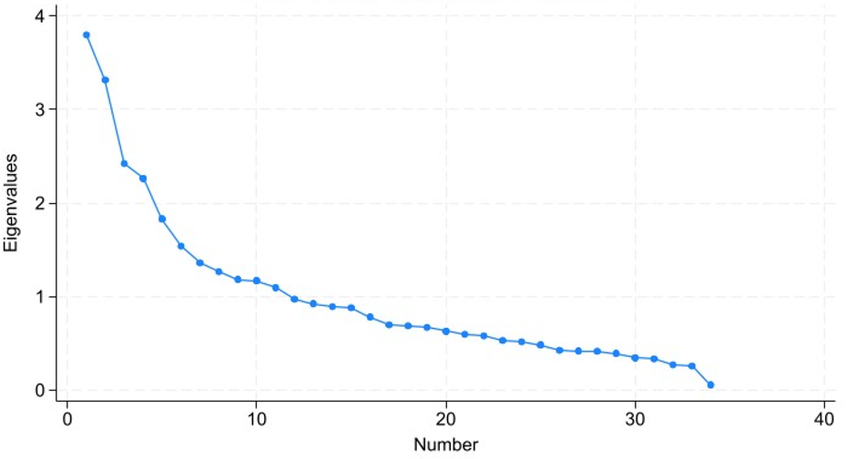

Figure 2: Correlation matrix of the queried factors.


