Exploring the Role of Social Enterprises in Enhancing Financial Inclusion and Environmental Sustainability: A Cross-National Study of Emerging Economies
BY MUHAMMAD USMAN

Introduction
  - Context and Rationale:
In recent decades, the global push towards sustainable development has prompted a rethinking of traditional business models. As countries strive to meet the United Nations Sustainable Development Goals (SDGs), the need for enterprises that can generate both social impact and financial returns has become more urgent. Social enterprises (SEs)
— businesses that focus on creating positive social and environmental outcomes alongside financial profitability — have emerged as key players in addressing poverty, environmental degradation, and social exclusion. However, the balance between generating profit and creating social/environmental value remains a significant challenge, particularly in the context of emerging economies.
Financial inclusion has been a major focus of policy interventions globally, especially in the developing world, where a large portion of the population still lacks access to essential financial services. Microfinance institutions (MFIs) and mobile banking platforms have been pivotal in improving access to credit and savings for marginalized communities (Sarma & Pais, 2011). However, despite these advancements, financial exclusion continues to persist in many regions due to factors such as high interest rates, limited access to financial literacy, and systemic barriers in traditional banking systems. Simultaneously, environmental sustainability has become a critical issue, with rapid urbanization, industrialization, and climate change accelerating the degradation of natural resources. Addressing environmental challenges requires businesses that prioritize sustainable practices, such as reducing carbon emissions, promoting

renewable energy, and minimizing waste. Green entrepreneurship has emerged as a potential solution, with businesses seeking innovative ways to combine economic success with environmental stewardship (Dean & McMullen, 2007).
Despite the growing recognition of social enterprises as a tool for addressing these dual challenges, limited research exists on how social enterprises can effectively combine the goals of financial inclusion and environmental sustainability. Previous studies have primarily focused on either financial inclusion (e.g., microfinance) or environmental sustainability (e.g., green entrepreneurship) in isolation, while research that links these two domains remains underdeveloped. This research seeks to fill this gap by exploring how social enterprises in emerging economies are innovatively balancing financial and environmental goals and what factors contribute to their success.

Research Question
The central research question guiding this study is:
- How do social enterprises in emerging economies simultaneously foster financial inclusion and environmental sustainability, and what are the key factors influencing their success?
- This overarching question will be explored through several sub-questions:
- What business model innovations allow social enterprises to balance financial inclusion with environmental sustainability?
- How do institutional frameworks, policy support, and regulations affect the operational success of these enterprises?
- What role does technology adoption play in enhancing the efficiency, scalability, and sustainability of social enterprises?
- How do local culture and community dynamics influence the operational success of these enterprises, especially in diverse emerging market contexts?
The answers to these questions will contribute to an understanding of how social enterprises can become engines of socio-economic change in emerging economies,

promoting both environmental sustainability and financial inclusion.

Literature Review
The literature on social enterprises, financial inclusion, and environmental sustainability is extensive, but the intersection of these domains remains largely underexplored. This section reviews the current state of research in these areas and highlights the gaps that this study will address.

- Social Enterprises:
Social enterprises have gained significant attention in recent years as businesses that blend profit generation with social missions (Mair & Marti, 2006). They differ from traditional businesses in that they measure success not just by profitability, but by their social impact and environmental outcomes. These enterprises often use hybrid business models that combine elements of nonprofits (focused on social goals) and for-profits (focused on financial performance) (Perrini et al., 2010). While much of the research has focused on their role in promoting social causes like education, healthcare, and poverty alleviation, little attention has been given to their role in environmental sustainability and financial inclusion.

- Financial Inclusion:
Financial inclusion is critical for reducing poverty and empowering marginalized communities. Microfinance institutions (MFIs) and mobile banking initiatives have significantly advanced financial inclusion, especially in developing countries (Morduch, 1999). However, these efforts have primarily focused on credit access and savings, with limited attention paid to entrepreneurial solutions that integrate environmental and financial outcomes. Social enterprises that address both financial inclusion and environmental sustainability have been less studied, and their potential to transform the financial inclusion landscape remains underexplored.

- Environmental Sustainability:

Environmental sustainability and green entrepreneurship are vital to addressing the global environmental crisis. Green businesses focus on minimizing environmental impacts, adopting sustainable practices, and utilizing clean technologies (Dean & McMullen, 2007). Research in this domain has predominantly focused on the technical and operational aspects of green entrepreneurship, with less emphasis on how these businesses can also address social challenges such as poverty and exclusion. A few studies have explored the role of social enterprises in environmental protection (Fletcher, 2017), but this research has yet to systematically integrate both the financial and environmental components of social enterprises in emerging economies.

- Intersection of Social Enterprises, Financial Inclusion, and Environmental Sustainability:
Although there are a few studies that examine the role of social enterprises in addressing environmental goals and financial inclusion separately, comprehensive research on how these enterprises navigate the dual objectives of financial and environmental sustainability is scarce. Scholars such as Battilana & Lee (2014) have argued that hybrid organizations (such as social enterprises) represent a new model that combines economic sustainability with environmental or social outcomes. However, these studies have largely remained theoretical, with few empirical studies examining the practical implications of this hybrid model in real-world contexts, especially in developing economies.
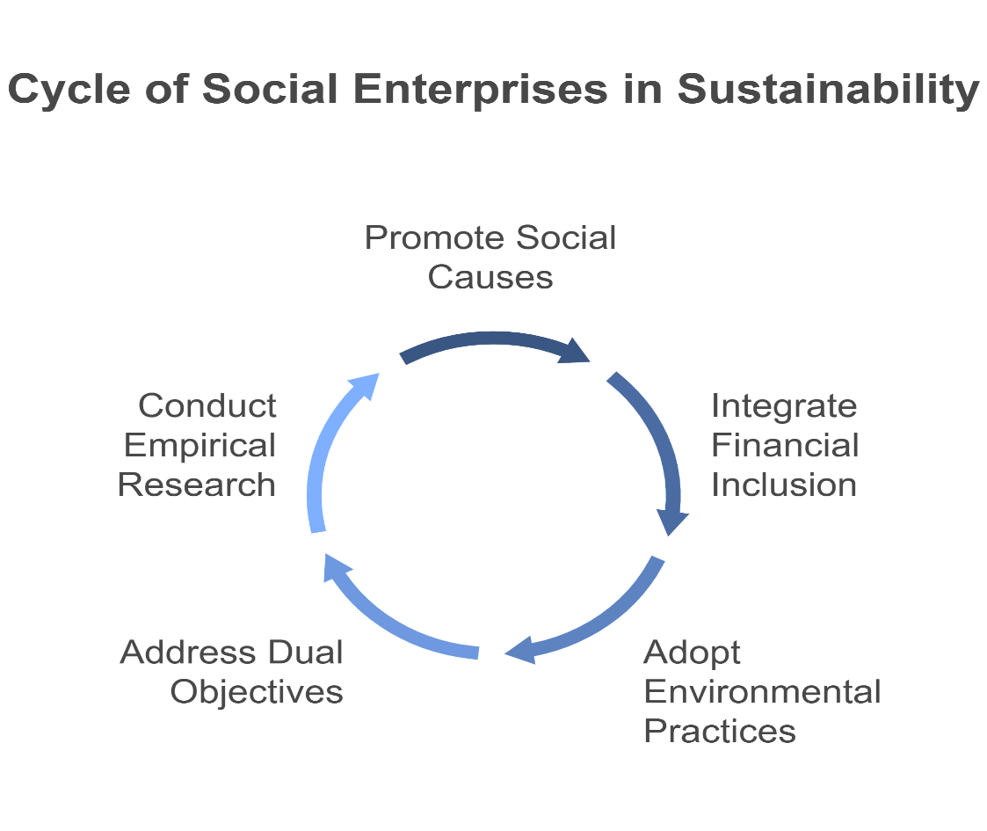
Figure 1. Social Enterprises, Financial Inclusion, and Environmental Sustainability

Research Methodology
To explore the research questions and objectives, this study will employ a mixed- methods approach. The combination of qualitative and quantitative data will allow for a deeper understanding of the mechanisms by which social enterprises achieve both financial inclusion and environmental sustainability.
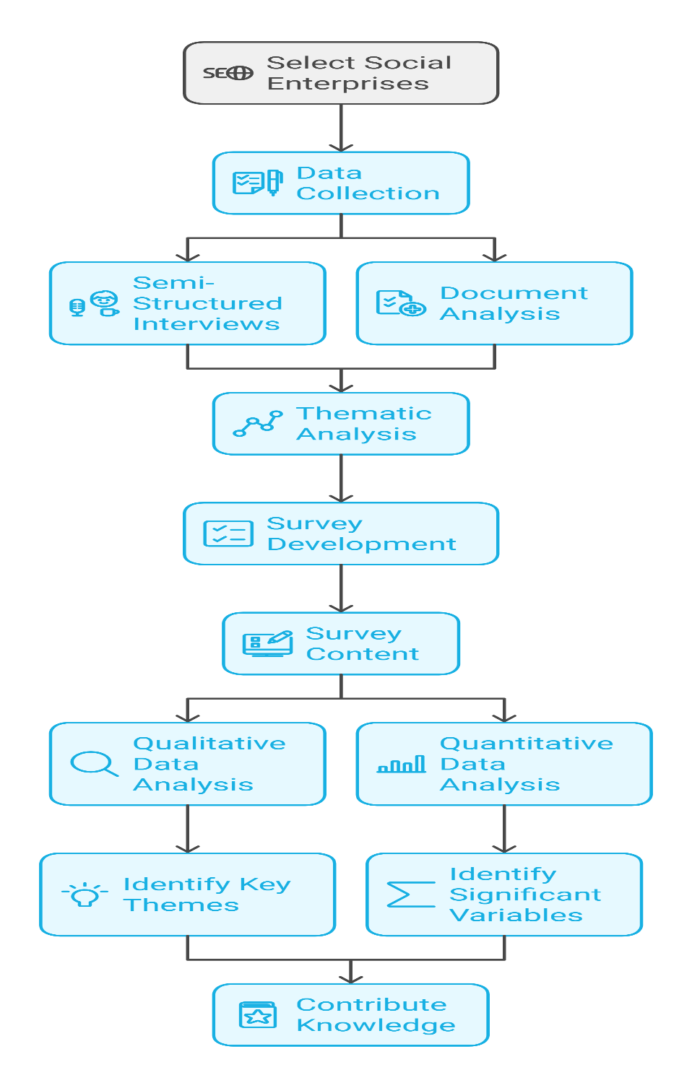
Figure 2. The details flowchart of the Research and methodology

Phase 1: Qualitative Case Studies
A qualitative case study approach will be used to explore social enterprises operating

in emerging economies. The sample will include 5-7 social enterprises from each of the BRICS countries (Brazil, Russia, India, China, South Africa), focusing on enterprises that explicitly address both financial inclusion and environmental sustainability. Data will be collected through:

Semi-structured interviews with key stakeholders, including founders, managers, and beneficiaries.
Document analysis of company reports, impact assessments, policy documents, and public-facing materials.
These interviews will explore the strategies and challenges faced by these enterprises in balancing financial inclusion and environmental sustainability. A thematic analysis will be used to identify key themes and patterns across the cases.

Phase 2: Quantitative Survey
A quantitative survey will be developed and distributed to a larger sample of social enterprises (approximately 100+) across emerging economies. This survey will assess:

Business model characteristics, including financial strategies, environmental goals, and social objectives.
Operational challenges faced in balancing the dual goals of financial inclusion and environmental sustainability.
Impact measurement techniques used to evaluate both social and environmental outcomes.
Phase 3: Data Analysis
The qualitative data will be analyzed using thematic analysis, identifying key themes related to business model innovations, success factors, and barriers. The quantitative data will be analyzed using regression analysis to identify significant variables that influence the success of social enterprises in achieving both financial inclusion and environmental sustainability.

Expected Contributions and Practical Implications
This research is expected to make several important contributions:
- Theoretical Contribution:
This study will contribute to the literature on social entrepreneurship, financial inclusion, and environmental sustainability by proposing a new conceptual framework that integrates these domains. It will enhance existing theories of hybrid entrepreneurship and business model innovation, offering insights into how enterprises in emerging economies can balance economic, social, and environmental objectives. The framework will be designed to help future researchers explore the nuanced dynamics of social enterprises operating in resource-constrained environments.

- Practical Contribution:
The findings of this study will have significant implications for policymakers, NGOs, and development agencies that support social enterprises in emerging economies. By understanding the key success factors for enterprises that tackle both financial inclusion and environmental sustainability, this research will provide actionable recommendations for:
Designing effective support policies for social enterprises, including financial incentives, regulatory frameworks, and institutional partnerships.
Scaling social enterprises through targeted investments and capacity-building programs. Promoting technology adoption to improve operational efficiency and impact measurement.

Conclusion
This research aims to explore how social enterprises in emerging economies can simultaneously promote financial inclusion and environmental sustainability, two pressing global challenges. By bridging these two domains, this study fills an important gap in the existing literature, which has traditionally treated them as separate issues. The findings will contribute to the development of a new framework for hybrid business

models, showing how enterprises can integrate social, financial, and environmental objectives in ways that benefit both communities and the environment.
The study is timely, as both financial exclusion and environmental degradation continue to impede growth in developing regions. The proposed research will not only advance academic understanding but also offer practical insights for policymakers, social entrepreneurs, and international development organizations. By identifying key factors that drive success, the research will help scale social enterprises and improve their effectiveness in addressing global challenges.
Ultimately, this research will provide a roadmap for social enterprises to thrive in emerging economies, delivering sustainable value while contributing to inclusive growth and environmental protection. The insights generated will be valuable for designing better support systems for social enterprises and advancing the global agenda of sustainable development.

References
- Battilana, J., & Lee, M. (2014). Advancing research on hybrid organizing – Insights from the study of social enterprises. Academy of Management Annals, 8(1), 397-441.
- Dean, T. J., & McMullen, J. S. (2007). Toward a theory of sustainable
entrepreneurship: Reducing environmental degradation through entrepreneurial action. Journal of Business Venturing, 22(1), 50-76.
- Fletcher, R. (2017). Green entrepreneurship: A study of the relationship between environmental and social impact. Journal of Environmental Economics and
Management, 73, 104-122.
- Mair, J., & Marti, I. (2006). Social entrepreneurship research: A source of
explanation, prediction, and delight. Journal of World Business, 41(1), 36-44.
- Mordeuch, J. (1999). The microfinance promise. Journal of Economic Literature, 37(4), 1569-1614.
- Perrini, F., Vurro, C., & Costanzo, L. A. (2010). The role of social enterprises in the transformation of capitalism. Business Ethics Quarterly, 20(3), 527-549.
- Sarma, M., & Pais, J. (2011). Financial inclusion and development. Journal of International Development, 23(5), 613-624.

